UNITED STATES
SECURITIES AND EXCHANGE COMMISSION
Washington, D.C. 20549
FORM 10-Q

☒ QUARTERLY REPORT PURSUANT TO SECTION 13 OR 15(d) OF THE SECURITIES EXCHANGE ACT OF 1934

For the quarterly period ended June 30, 2023

OR

o TRANSITION REPORT PURSUANT TO SECTION 13 OR 15(d) OF THE SECURITIES EXCHANGE ACT OF 1934

For the transition period from _____to_____
Commission file number: 814-01035
NEWTEKONE, INC.
(Exact name of registrant as specified in its charter)

Maryland |  |  |  |  |  | 46-3755188
(State or other jurisdiction of incorporation or organization) |  |  |  |  |  | (I.R.S. Employer Identification No.)
4800 T Rex Avenue, Suite 120, Boca Raton, Florida |  |  |  |  |  | 33431
(Address of principal executive offices) |  |  |  |  |  | (Zip Code)
(212) 356-9500
(Registrant’s telephone number, including area code)
Not Applicable
(Former name, former address and former fiscal year, if changed since last report)
Securities registered pursuant to Section 12(b) of the Act:
Title of each class |  |  |  |  |  | Trading Symbol(s) |  |  |  |  |  | Name of each exchange on which registered
Common Stock, par value $0.02 per share |  |  |  |  |  | NEWT |  |  |  |  |  | Nasdaq Global Market LLC
5.75% Notes due 2024 |  |  |  |  |  | NEWTL |  |  |  |  |  | Nasdaq Global Market LLC
5.50% Notes due 2026 |  |  |  |  |  | NEWTZ |  |  |  |  |  | Nasdaq Global Market LLC

Indicate by check mark whether the registrant: (1) has filed all reports required to be filed by Section 13 or 15(d) of the Securities Exchange Act of 1934 during the past 12 months (or for such shorter period that the registrant was required to file such reports), and (2) has been subject to such filing requirements for the past 90 days. Yes x No ☐
Indicate by check mark whether the registrant has submitted electronically every Interactive Data File required to be submitted pursuant to Rule 405 of Regulation S-T (Section 232.405 of this chapter) during the preceding 12 months (or for such shorter period that the registrant was required to submit and post such files). Yes x No ☐
Indicate by check mark whether the registrant is a large accelerated filer, an accelerated filer, a non-accelerated filer, a smaller reporting company or an emerging growth company. See definitions of “large accelerated filer,” “accelerated filer,” “smaller reporting company,” and “emerging growth company” in Rule 12b-2 of the Exchange Act.

Large accelerated filer |  |  |  |  |  | o |  |  | Accelerated Filer |  |  |  |  |  | x
Non-accelerated filer |  |  |  |  |  | o |  |  | Smaller reporting company |  |  |  |  |  | o
 |  |  |  |  |  |  |  |  | Emerging growth company |  |  |  |  |  | o
If an emerging growth company, indicate by check mark if the registrant has elected not to use the extended transition period for complying with any new or revised financial or accounting standards provided pursuant to Section 13(a) of the Exchange Act. o

Indicate by check mark whether the registrant is a shell company (as defined in Rule 12b-2 of the Exchange Act). Yes ☐ No x

As of August 4, 2023, there were 24,670,890 shares outstanding of the registrant’s Common Stock, par value $0.02 per share.

TABLE OF CONTENTS

 |  |  |  |  |  | Page
 |  |  | Defined Terms |  |  | 4
PART I - FINANCIAL INFORMATION
Item 1. |  |  | Financial Statements:
 |  |  | Consolidated Statements of Financial Condition as of June 30, 2023 (Unaudited) and December 31, 2022 |  |  | 7
 |  |  | Consolidated Statements of Income for the three and six months ended June 30, 2023 and 2022 (Unaudited) |  |  | 9
 |  |  | Consolidated Statements of Comprehensive Income for the three and six months ended June 30, 2023 and 2022 (Unaudited) |  |  | 10
 |  |  | Consolidated Statements of Changes in Stockholders’ Equity for the three and six months ended June 30, 2023 and 2022 (Unaudited) |  |  | 12
 |  |  | Consolidated Statements of Cash Flows for the six months ended June 30, 2023 and 2022 (Unaudited) |  |  | 16
 |  |  | Notes to Consolidated Financial Statements (Unaudited) |  |  | 18
Item 2. |  |  | Management’s Discussion and Analysis of Financial Condition and Results of Operations |  |  | 59
Item 3. |  |  | Quantitative and Qualitative Disclosures About Market Risk |  |  | 95
Item 4. |  |  | Controls and Procedures |  |  | 97
PART II - OTHER INFORMATION
Item 1. |  |  | Legal Proceedings |  |  | 98
Item 1A. |  |  | Risk Factors |  |  | 98
Item 2. |  |  | Unregistered Sales of Equity Securities and Use of Proceeds |  |  | 98
Item 3. |  |  | Defaults Upon Senior Securities |  |  | 98
Item 4. |  |  | Mine Safety Disclosures |  |  | 99
Item 5. |  |  | Other Information |  |  | 99
Item 6. |  |  | Exhibits |  |  | 99
 |  |  | Signatures |  |  | 100

Table of Contents

Defined Terms

We have used “we,” “us,” “our,” “our company,” and “the Company” to refer to NewtekOne, Inc. and its subsidiaries in this report. We also have used several other terms in this report, which are explained or defined below:
Terms
1940 Act |  |  | Investment Company Act of 1940, as amended
2016-1 Trust |  |  | Newtek Small Business Loan Trust, Series 2016-1, terminated in December 2021
2017-1 Trust |  |  | Newtek Small Business Loan Trust, Series 2017-1, terminated in February 2023
2018-1 Trust |  |  | Newtek Small Business Loan Trust, Series 2018-1
2019-1 Trust |  |  | Newtek Small Business Loan Trust, Series 2019-1
2021-1 Trust |  |  | Newtek Small Business Loan Trust, Series 2021-1
2022-1 Trust |  |  | Newtek Small Business Loan Trust, Series 2022-1
2023-1 Trust |  |  | Newtek Small Business Loan Trust, Series 2023-1
2022 Notes |  |  | 7.50% Notes due 2022, redeemed in August 2019
2024 Notes |  |  | 5.75% Notes due 2024
2025 6.85% Notes |  |  | 6.85% Notes due 2025, redeemed in May 2022
2025 5.00% Notes |  |  | 5.00% Notes due 2025
2025 8.125% Notes |  |  | 8.125% Notes due 2025
2025 Notes |  |  | Collectively, the 2025 6.85% Notes, the 2025 5.00% Notes and the 8.125% Notes due 2025
2026 Notes |  |  | 5.50% Notes due 2026
ABL |  |  | Asset based lending
ACL |  |  | Allowance for credit losses
Acquisition |  |  | The Company’s Acquisition of NBNYC, pursuant to which the Company acquired from the NBNYC shareholders all of the issued and outstanding stock of NBNYC
ASC |  |  | Accounting Standards Codification, as issued by the FASB
ASU |  |  | Accounting Standards Updates, as issued by the FASB
2020 ATM Equity Distribution Agreement |  |  | Equity Distribution Agreement, dated June 25, 2020 by and among the Company and the placement agents, as amended on July 20, 2022
BDC |  |  | Business Development Company under the 1940 Act
Board |  |  | The Company's board of directors
Capital One |  |  | Capital One Bank, National Association
C&I |  |  | Conventional commercial and industrial loans
Code |  |  | Internal Revenue Code of 1986, as amended
CRE |  |  | Conventional commercial real estate lending
Deutsche Bank |  |  | Deutsche Bank AG
DIF |  |  | Deposit Insurance Fund of the FDIC
DRIP |  |  | The Company's dividend reinvestment plan
EBITDA |  |  | Earnings before interest, taxes, depreciation and amortization
2015 Stock Incentive Plan |  |  | The Company's 2015 Stock Incentive Plan
2023 Stock Incentive Plan |  |  | The Company’s 2023 Stock Incentive Plan
Exchange Act |  |  | Securities Exchange Act of 1934, as amended
FASB |  |  | Financial Accounting Standards Board
Federal Reserve |  |  | Board of Governors of the Federal Reserve System
FDIC |  |  | Federal Deposit Insurance Corporation
LIBOR |  |  | London Interbank Offered Rate
NAV |  |  | Net Asset Value
SPV I Capital One Facility |  |  | Revolving Credit and Security Agreement between NBL SPV I, LLC, a wholly-owned subsidiary of Holdco 6, and Capital One
SPV II Deutsche Bank Facility |  |  | Revolving Credit and Security Agreement between NBL SPV II, LLC, a wholly-owned subsidiary of Holdco 6, and Deutsche Bank
4

SPV III One Florida Bank Facility |  |  | Revolving Credit and Security Agreement between NBL SPV III, LLC, a wholly-owned subsidiary of Holdco 6, and One Florida Bank
NBNYC |  |  | National Bank of New York City, which has been renamed Newtek Bank, National Association
Receivable and Inventory Facility |  |  | Loan and Security Agreement between NBC and Webster, as successor by merger to Sterling National Bank, as lender, to fund accounts receivable and inventory financing arrangements.
Related Party RLOC |  |  | Unsecured revolving line of credit agreement between NMS as lender and Newtek as borrower
OCC |  |  | Office of the Comptroller of the Currency
PLP |  |  | Preferred Lenders Program, as authorized by the SBA
PPP |  |  | Paycheck Protection Program
RIC |  |  | Regulated investment company under the Code
S&P |  |  | Standard and Poor's
SBA |  |  | United States Small Business Administration
SBLC |  |  | Small Business Lending Company
SEC |  |  | U.S. Securities and Exchange Commission
SMB |  |  | Small-and-medium sized businesses
Stock Purchase Agreement |  |  | Stock Purchase Agreement dated August 2, 2021, between the Company, NBNYC and certain NBNYC shareholders to acquire all of the issued and outstanding stock of NBNYC, as amended through December 12, 2022
Trustee |  |  | U.S. Bank, National Association
TSO II |  |  | TSO II Booster Aggregator, L.P.
U.S. GAAP or GAAP |  |  | Generally accepted accounting principles in the United States
Webster |  |  | Webster Bank, N.A.
Subsidiaries and Joint Ventures
NSBF |  |  | Newtek Small Business Finance, LLC, a consolidated subsidiary
NBL |  |  | Newtek Business Lending, LLC, a wholly-owned subsidiary of Newtek Bank; NBL was merged into SBL on May 2, 2023
NCL |  |  | Newtek Commercial Lending, Inc, a consolidated subsidiary
NCL JV |  |  | Newtek Conventional Lending, LLC, a 50% owned joint venture
Newtek Bank |  |  | Newtek Bank, National Association
TSO JV |  |  | Newtek TSO II Conventional Credit Partners, LP, a 50% owned joint venture
Exponential |  |  | Exponential Business Development Co., Inc., a taxable subsidiary
NMS |  |  | Newtek Merchant Solutions, LLC (formerly Universal Processing Services of Wisconsin LLC), a consolidated subsidiary
Mobil Money |  |  | Mobil Money, LLC, a consolidated subsidiary
NTS |  |  | Newtek Technology Solutions, Inc., a consolidated subsidiary
IPM |  |  | International Professional Marketing, Inc., a former wholly-owned controlled portfolio company which merged into NTS on July 1, 2021
SIDCO |  |  | SIDCO, LLC dba Cloud Nine Services, a subsidiary of NTS
EWS |  |  | Excel WebSolutions, LLC, a consolidated subsidiary
NBC |  |  | CDS Business Services, Inc. dba Newtek Business Credit Solutions, a consolidated subsidiary
SBL |  |  | Small Business Lending, LLC, a wholly owned subsidiary of Newtek Bank
NPS or PMT |  |  | PMTWorks Payroll, LLC dba Newtek Payroll and Benefits Solutions, a consolidated subsidiary
NIA |  |  | Newtek Insurance Agency, LLC, a consolidated subsidiary
TAM |  |  | Titanium Asset Management LLC, a consolidated subsidiary
EMCAP |  |  | EMCAP Loan Holdings, LLC
POS |  |  | POS on Cloud, LLC, dba Newtek Payment Systems, a 59.7% consolidated subsidiary
5

Explanatory Note:

On January 6, 2023, the Company completed the Acquisition of NBNYC, a national bank regulated and supervised by the OCC. In addition, on January 6, 2023, the Company filed with the SEC a Form N-54C, Notification of Withdrawal of Election to be Subject to the 1940 Act, and has ceased to be a BDC effective as of January 6, 2023. As a result of the foregoing, the Company is now a financial holding company, no longer qualifies as a regulated investment company (RIC) for federal income tax purposes, and no longer qualifies for accounting treatment as an investment company. As a result, comparisons to periods prior to March 30, 2023 include adjustments made to reconcile prior investment company accounting to the current financial holding company accounting requirements. (See NOTE 1—DESCRIPTION OF BUSINESS AND BASIS OF PRESENTATION)

6

NEWTEKONE, INC. AND SUBSIDIARIES
CONSOLIDATED STATEMENTS OF FINANCIAL CONDITION
(In Thousands, except for Per Share Data)
 |  |  | June 30, 2023 |  |  |  |  |  | December 31, 2022
ASSETS |  |  | Financial Holding Company Accounting (Unaudited) |  |  |  |  |  | Investment Company Accounting
Cash and due from banks |  |  | $ | 48,673 |  |  |  |  | $ | 53,692
Restricted cash |  |  | 66,741 |  |  |  |  |  | 71,914
Interest bearing deposits in banks |  |  | 140,920 |  |  |  |  |  | —
Total cash and cash equivalents |  |  | 256,334 |  |  |  |  |  | 125,606
Debt securities available-for-sale, at fair value |  |  | 32,907 |  |  |  |  |  | —
Loans held for sale, at fair value |  |  | 106,231 |  |  |  |  |  | 19,171
Loans held for sale, at amortized cost |  |  | 41,641 |  |  |  |  |  | —
Loans held for investment, at fair value |  |  | 512,418 |  |  |  |  |  | 505,268
Loans held for investment, at amortized cost, net of deferred fees and costs |  |  | 218,265 |  |  |  |  |  | —
Allowance for credit losses |  |  | (4,764) |  |  |  |  |  | —
Loans held for investment, at amortized cost, net |  |  | 213,501 |  |  |  |  |  | —
Federal Home Loan Bank and Federal Reserve Bank stock |  |  | 3,012 |  |  |  |  |  | —
Settlement receivable |  |  | 119,857 |  |  |  |  |  | —
Joint ventures, at fair value (cost of $25,315 and $23,314), respectively |  |  | 27,722 |  |  |  |  |  | 23,022
Controlled investments (cost of $0 and $131,495), respectively |  |  | — |  |  |  |  |  | 259,217
Non-control investments (cost of $1,360 and $1,360), respectively |  |  | 1,360 |  |  |  |  |  | 1,360
Goodwill and intangibles |  |  | 27,595 |  |  |  |  |  | —
Right of use assets |  |  | 7,002 |  |  |  |  |  | 6,484
Derivative instruments |  |  | 562 |  |  |  |  |  | —
Deferred tax asset, net |  |  | 4,622 |  |  |  |  |  | —
Servicing assets |  |  | 35,754 |  |  |  |  |  | 30,268
Other assets |  |  | 48,593 |  |  |  |  |  | 28,506
Total assets |  |  | $ | 1,439,111 |  |  |  |  | $ | 998,902
LIABILITIES AND NET ASSETS
Liabilities:
Deposits:
Noninterest-bearing |  |  | $ | 38,233 |  |  |  |  | $ | —
Interest-bearing |  |  | 409,124 |  |  |  |  |  | —
Total deposits |  |  | 447,357 |  |  |  |  |  | —
Borrowings |  |  | 697,387 |  |  |  |  |  | 539,326
Dividends payable |  |  | 4,766 |  |  |  |  |  | —
Lease liabilities |  |  | 8,552 |  |  |  |  |  | 7,973
Deferred tax liabilities, net |  |  | — |  |  |  |  |  | 19,194
Due to participants |  |  | 19,820 |  |  |  |  |  | 35,627
Accounts payable, accrued expenses and other liabilities |  |  | 40,501 |  |  |  |  |  | 21,424
Total liabilities |  |  | 1,218,383 |  |  |  |  |  | 623,544
Shareholders' Equity:
Preferred stock (par value $0.02 per share; authorized 20,000 shares, 20,000 and 20,000 shares issued and outstanding, respectively) |  |  | 19,738 |  |  |  |  |  | —
Common stock (par value $0.02 per share; authorized 199,980 shares, 24,615 and 24,609 shares issued and outstanding, respectively) |  |  | 491 |  |  |  |  |  | 492
7

Additional paid-in capital |  |  | 192,114 |  |  |  |  |  | 354,243
Retained earnings |  |  | 9,075 |  |  |  |  |  | 20,623
Accumulated other comprehensive loss, net of income taxes |  |  | (203) |  |  |  |  |  | —
Total NewtekOne shareholders’ equity |  |  | 221,215 |  |  |  |  |  | 375,358
Non-controlling interest |  |  | (487) |  |  |  |  |  | —
Total shareholders' equity |  |  | 220,728 |  |  |  |  |  | 375,358
Total liabilities and shareholders' equity |  |  | $ | 1,439,111 |  |  |  |  | $ | 998,902

8
See accompanying notes to consolidated financial statements.

NEWTEKONE, INC. AND SUBSIDIARIES
CONSOLIDATED STATEMENTS OF INCOME (UNAUDITED)
(In Thousands, except for Per Share Data)
 |  |  | Three Months Ended June 30, |  |  |  |  |  |  |  |  |  |  |  | Six Months Ended June 30,
 |  |  | 2023  Financial Holding Company Accounting |  |  |  |  |  | 2022  Investment Company Accounting |  |  |  |  |  | 2023  Financial Holding Company Accounting |  |  |  |  |  | 2022  Investment Company Accounting
Interest income
Loans and fees on loans |  |  | $ | 19,607 |  |  |  |  | $ | 8,032 |  |  |  |  | $ | 37,109 |  |  |  |  | $ | 15,111
Debt securities available-for-sale |  |  | 415 |  |  |  |  |  | — |  |  |  |  |  | 647 |  |  |  |  |  | —
Interest from affiliates |  |  | — |  |  |  |  |  | 670 |  |  |  |  |  | — |  |  |  |  |  | 1,334
Other interest earning assets |  |  | 2,531 |  |  |  |  |  | — |  |  |  |  |  | 3,512 |  |  |  |  |  | —
Total interest income |  |  | 22,553 |  |  |  |  |  | 8,702 |  |  |  |  |  | 41,268 |  |  |  |  |  | 16,445
Interest expense
Notes and securitizations |  |  | 9,083 |  |  |  |  |  | 4,809 |  |  |  |  |  | 17,801 |  |  |  |  |  | 8,945
Bank and FHLB borrowings |  |  | 3,746 |  |  |  |  |  | 939 |  |  |  |  |  | 7,685 |  |  |  |  |  | 1,364
Notes payable related party |  |  | — |  |  |  |  |  | 80 |  |  |  |  |  | — |  |  |  |  |  | 186
Deposits |  |  | 4,051 |  |  |  |  |  | — |  |  |  |  |  | 5,526 |  |  |  |  |  | —
Total interest expense |  |  | 16,880 |  |  |  |  |  | 5,828 |  |  |  |  |  | 31,012 |  |  |  |  |  | 10,495
Net interest income |  |  | 5,673 |  |  |  |  |  | 2,874 |  |  |  |  |  | 10,256 |  |  |  |  |  | 5,950
Provision for loan credit losses |  |  | 2,575 |  |  |  |  |  | — |  |  |  |  |  | 3,893 |  |  |  |  |  | —
Net interest income after provision for loan credit losses |  |  | 3,098 |  |  |  |  |  | 2,874 |  |  |  |  |  | 6,363 |  |  |  |  |  | 5,950
Noninterest income
Dividend income |  |  | 505 |  |  |  |  |  | 4,981 |  |  |  |  |  | 1,009 |  |  |  |  |  | 12,827
Loan servicing asset revaluation |  |  | (534) |  |  |  |  |  | (781) |  |  |  |  |  | 385 |  |  |  |  |  | (2,340)
Servicing income |  |  | 4,299 |  |  |  |  |  | 3,175 |  |  |  |  |  | 8,702 |  |  |  |  |  | 6,356
Net gains on sales of loans |  |  | 13,208 |  |  |  |  |  | 19,891 |  |  |  |  |  | 19,734 |  |  |  |  |  | 35,186
Net gain on derivative transactions |  |  | 674 |  |  |  |  |  | — |  |  |  |  |  | 179 |  |  |  |  |  | 628
Net gain (loss) on loans accounted for under the fair value option |  |  | 4,363 |  |  |  |  |  | (5,789) |  |  |  |  |  | 10,268 |  |  |  |  |  | (8,507)
Net unrealized appreciation (depreciation) on joint ventures |  |  | 698 |  |  |  |  |  | (12) |  |  |  |  |  | 2,700 |  |  |  |  |  | (2,333)
Net unrealized appreciation on controlled investments |  |  | — |  |  |  |  |  | 1,578 |  |  |  |  |  | — |  |  |  |  |  | 1,875
Technology and IT support income |  |  | 6,459 |  |  |  |  |  | — |  |  |  |  |  | 13,168 |  |  |  |  |  | —
Electronic payment processing income |  |  | 10,676 |  |  |  |  |  | — |  |  |  |  |  | 21,004 |  |  |  |  |  | —
Other noninterest income |  |  | 6,080 |  |  |  |  |  | 2,368 |  |  |  |  |  | 12,066 |  |  |  |  |  | 3,947
Total noninterest income |  |  | 46,428 |  |  |  |  |  | 25,411 |  |  |  |  |  | 89,215 |  |  |  |  |  | 47,639
Noninterest expense
Technology services expense |  |  | 3,466 |  |  |  |  |  | — |  |  |  |  |  | 7,269 |  |  |  |  |  | —
Electronic payment processing expense |  |  | 4,838 |  |  |  |  |  | — |  |  |  |  |  | 9,342 |  |  |  |  |  | —
Salaries and employee benefits expense |  |  | 19,418 |  |  |  |  |  | 4,499 |  |  |  |  |  | 38,537 |  |  |  |  |  | 9,608
Professional services expense |  |  | 3,156 |  |  |  |  |  | 1,512 |  |  |  |  |  | 6,596 |  |  |  |  |  | 2,813
Other loan origination and maintenance expense |  |  | 3,559 |  |  |  |  |  | 7,121 |  |  |  |  |  | 6,386 |  |  |  |  |  | 13,604
Depreciation and amortization |  |  | 832 |  |  |  |  |  | 60 |  |  |  |  |  | 1,705 |  |  |  |  |  | 123
Loss on extinguishment of debt |  |  | — |  |  |  |  |  | 417 |  |  |  |  |  | — |  |  |  |  |  | 417
Other general and administrative costs |  |  | 4,911 |  |  |  |  |  | 2,043 |  |  |  |  |  | 9,542 |  |  |  |  |  | 3,796
Total noninterest expense |  |  | 40,180 |  |  |  |  |  | 15,652 |  |  |  |  |  | 79,377 |  |  |  |  |  | 30,361
Net income before taxes |  |  | 9,346 |  |  |  |  |  | 12,633 |  |  |  |  |  | 16,201 |  |  |  |  |  | 23,228
Income tax expense (benefit) |  |  | 2,524 |  |  |  |  |  | (886) |  |  |  |  |  | (2,339) |  |  |  |  |  | 57
Net income |  |  | 6,822 |  |  |  |  |  | 13,519 |  |  |  |  |  | 18,540 |  |  |  |  |  | 23,171
Less: Net loss attributable to noncontrolling interests |  |  | (31) |  |  |  |  |  | — |  |  |  |  |  | (31) |  |  |  |  |  | —
9
See accompanying notes to consolidated financial statements.

NEWTEKONE, INC. AND SUBSIDIARIES
CONSOLIDATED STATEMENTS OF INCOME (UNAUDITED)
Net income attributable to NewtekOne, Inc. |  |  | 6,853 |  |  |  |  |  | 13,519 |  |  |  |  |  | 18,571 |  |  |  |  |  | 23,171
Dividends to preferred shareholders |  |  | (400) |  |  |  |  |  | — |  |  |  |  |  | (649) |  |  |  |  |  | —
NewtekOne net income available to common shareholders |  |  | $ | 6,453 |  |  |  |  | $ | 13,519 |  |  |  |  | $ | 17,922 |  |  |  |  | $ | 23,171
Earnings per share:
Basic |  |  | $ | 0.26 |  |  |  |  | $ | 0.56 |  |  |  |  | $ | 0.72 |  |  |  |  | $ | 0.96
Diluted |  |  | $ | 0.26 |  |  |  |  | $ | 0.56 |  |  |  |  | $ | 0.72 |  |  |  |  | $ | 0.96

10
See accompanying notes to consolidated financial statements.

NEWTEKONE, INC. AND SUBSIDIARIES
CONSOLIDATED STATEMENTS OF COMPREHENSIVE INCOME (UNAUDITED)
(In Thousands, except for Per Share Data)
 |  |  | Three Months Ended June 30, |  |  |  |  |  |  |  |  |  |  |  | Six Months Ended June 30,
 |  |  | 2023  Financial Holding Company Accounting |  |  |  |  |  | 2022  Investment Company Accounting |  |  |  |  |  | 2023  Financial Holding Company Accounting |  |  |  |  |  | 2022  Investment Company Accounting
Net income |  |  | $ | 6,822 |  |  |  |  | $ | 13,519 |  |  |  |  | $ | 18,540 |  |  |  |  | $ | 23,171
Other comprehensive loss before tax:
Net unrealized loss on debt securities available-for-sale during the period |  |  | (197) |  |  |  |  |  | — |  |  |  |  |  | (310) |  |  |  |  |  | —
Other comprehensive loss before tax |  |  | (197) |  |  |  |  |  | — |  |  |  |  |  | (310) |  |  |  |  |  | —
Income tax benefit |  |  | 76 |  |  |  |  |  | — |  |  |  |  |  | 107 |  |  |  |  |  | —
Other comprehensive loss, net of tax |  |  | (121) |  |  |  |  |  | — |  |  |  |  |  | (203) |  |  |  |  |  | —
Total comprehensive income |  |  | 6,701 |  |  |  |  |  | 13,519 |  |  |  |  |  | 18,337 |  |  |  |  |  | 23,171
Less: Comprehensive loss attributable to noncontrolling interests |  |  | (31) |  |  |  |  |  | — |  |  |  |  |  | (31) |  |  |  |  |  | —
Comprehensive income attributable to NewtekOne, Inc. |  |  | $ | 6,732 |  |  |  |  | $ | 13,519 |  |  |  |  | $ | 18,368 |  |  |  |  | $ | 23,171

11
See accompanying notes to consolidated financial statements.

NEWTEKONE, INC. AND SUBSIDIARIES
CONSOLIDATED STATEMENTS OF CHANGES IN SHAREHOLDERS’ EQUITY (UNAUDITED)
(In Thousands, except for Per Share Data)
 |  |  | Common stock |  |  |  |  |  |  |  |  |  |  |  | Preferred stock |  |  |  |  |  |  |  |  |  |  |  | Addition-al paid-in-capital |  |  |  |  |  | Accumul-ated other comprehe-nsive income |  |  |  |  |  | Accumul-ated undistrib-uted earnings |  |  |  |  |  | Retained earnings |  |  |  |  |  | Equity attributabl-e to non-controlling interest |  |  |  |  |  | Total equity
 |  |  | Shares |  |  |  |  |  | Amount |  |  |  |  |  | Shares |  |  |  |  |  | Amount
Balance at March 31, 2023 |  |  | 24,609 |  |  |  |  |  | $ | 491 |  |  |  |  | 20 |  |  |  |  |  | $ | 19,738 |  |  |  |  | $ | 191,316 |  |  |  |  | $ | (82) |  |  |  |  | $ | — |  |  |  |  | $ | 7,047 |  |  |  |  | $ | (472) |  |  |  |  | $ | 218,038
Consolidation of controlled investments adjustment |  |  | — |  |  |  |  |  | — |  |  |  |  |  | — |  |  |  |  |  | — |  |  |  |  |  | — |  |  |  |  |  | — |  |  |  |  |  | — |  |  |  |  |  | — |  |  |  |  |  | 16 |  |  |  |  |  | 16
DRIP shares issued |  |  | 4 |  |  |  |  |  | — |  |  |  |  |  | — |  |  |  |  |  | — |  |  |  |  |  | 73 |  |  |  |  |  | — |  |  |  |  |  | — |  |  |  |  |  | — |  |  |  |  |  | — |  |  |  |  |  | 73
Stock-based compensation expense |  |  | — |  |  |  |  |  | — |  |  |  |  |  | — |  |  |  |  |  | — |  |  |  |  |  | 685 |  |  |  |  |  | — |  |  |  |  |  | — |  |  |  |  |  | — |  |  |  |  |  | — |  |  |  |  |  | 685
Dividends declared related to RSA |  |  | 3 |  |  |  |  |  | — |  |  |  |  |  | — |  |  |  |  |  | — |  |  |  |  |  | 59 |  |  |  |  |  | — |  |  |  |  |  | — |  |  |  |  |  | (59) |  |  |  |  |  | — |  |  |  |  |  | —
Purchase of vested stock for employee payroll tax withholding |  |  | (2) |  |  |  |  |  | — |  |  |  |  |  | — |  |  |  |  |  | — |  |  |  |  |  | (19) |  |  |  |  |  | — |  |  |  |  |  | — |  |  |  |  |  | — |  |  |  |  |  | — |  |  |  |  |  | (19)
Dividends declared common shares ($0.18/share) |  |  | — |  |  |  |  |  | — |  |  |  |  |  | — |  |  |  |  |  | — |  |  |  |  |  | — |  |  |  |  |  | — |  |  |  |  |  | — |  |  |  |  |  | (4,366) |  |  |  |  |  | — |  |  |  |  |  | (4,366)
Dividends declared preferred shares ($12.27/share) |  |  | — |  |  |  |  |  | — |  |  |  |  |  | — |  |  |  |  |  | — |  |  |  |  |  | — |  |  |  |  |  | — |  |  |  |  |  | — |  |  |  |  |  | (400) |  |  |  |  |  | — |  |  |  |  |  | (400)
Net income (loss) |  |  | — |  |  |  |  |  | — |  |  |  |  |  | — |  |  |  |  |  | — |  |  |  |  |  | — |  |  |  |  |  | — |  |  |  |  |  | — |  |  |  |  |  | 6,853 |  |  |  |  |  | (31) |  |  |  |  |  | 6,822
Other comprehensive loss, net of tax |  |  | — |  |  |  |  |  | — |  |  |  |  |  | — |  |  |  |  |  | — |  |  |  |  |  | — |  |  |  |  |  | (121) |  |  |  |  |  | — |  |  |  |  |  | — |  |  |  |  |  | — |  |  |  |  |  | (121)
Balance at June 30, 2023 |  |  | 24,614 |  |  |  |  |  | $ | 491 |  |  |  |  | 20 |  |  |  |  |  | $ | 19,738 |  |  |  |  | $ | 192,114 |  |  |  |  | $ | (203) |  |  |  |  | $ | — |  |  |  |  | $ | 9,075 |  |  |  |  | $ | (487) |  |  |  |  | $ | 220,728
12
See accompanying notes to consolidated financial statements.

NEWTEKONE, INC. AND SUBSIDIARIES
CONSOLIDATED STATEMENTS OF CHANGES IN SHAREHOLDERS’ EQUITY (UNAUDITED)
(In Thousands, except for Per Share Data)
 |  |  | Common stock |  |  |  |  |  |  |  |  |  |  |  |  |  | Additional paid-in-capital |  |  |  |  |  |  |  | Accumulated undistributed earnings |  |  |  |  |  |  |  |  |  |  |  | Total equity
 |  |  | Shares |  |  |  |  |  | Amount |  |  |  |  |  |  |  | Additional paid-in-capital |  |  |  |  |  |  |  | Accumulated undistributed earnings |  |  |  |  |  |  |  |  |  |  |  | Total equity
Balance at March 31, 2022 |  |  | 24,161 |  |  |  |  |  | $ | 483 |  |  |  |  |  |  |  |  | $ | 368,299 |  |  |  |  |  |  | $ | 29,698 |  |  |  |  |  |  |  |  |  |  | $ | 398,480
DRIP shares issued |  |  | 21 |  |  |  |  |  | — |  |  |  |  |  |  |  |  |  | 373 |  |  |  |  |  |  |  | — |  |  |  |  |  |  |  |  |  |  |  | 373
Stock-based compensation expense |  |  | — |  |  |  |  |  | — |  |  |  |  |  |  |  |  |  | 467 |  |  |  |  |  |  |  | — |  |  |  |  |  |  |  |  |  |  |  | 467
Dividends Declared related to RSA |  |  | 5 |  |  |  |  |  | — |  |  |  |  |  |  |  |  |  | 91 |  |  |  |  |  |  |  | (91) |  |  |  |  |  |  |  |  |  |  |  | —
Purchase of vested stock for employee payroll tax withholding |  |  | (12) |  |  |  |  |  | — |  |  |  |  |  |  |  |  |  | (299) |  |  |  |  |  |  |  | — |  |  |  |  |  |  |  |  |  |  |  | (299)
Restricted stock awards |  |  | 12 |  |  |  |  |  | — |  |  |  |  |  |  |  |  |  | — |  |  |  |  |  |  |  | — |  |  |  |  |  |  |  |  |  |  |  | —
Dividends declared common shares ($0.75/share) |  |  | — |  |  |  |  |  | — |  |  |  |  |  |  |  |  |  | — |  |  |  |  |  |  |  | (18,008) |  |  |  |  |  |  |  |  |  |  |  | (18,008)
Net increase resulting from operations: |  |  | — |  |  |  |  |  | — |  |  |  |  |  |  |  |  |  | — |  |  |  |  |  |  |  | — |  |  |  |  |  |  |  |  |  |  |  | —
Net investment loss |  |  | — |  |  |  |  |  | — |  |  |  |  |  |  |  |  |  | — |  |  |  |  |  |  |  | (2,254) |  |  |  |  |  |  |  |  |  |  |  | (2,254)
Net realized gain on investments |  |  | — |  |  |  |  |  | — |  |  |  |  |  |  |  |  |  | — |  |  |  |  |  |  |  | 19,891 |  |  |  |  |  |  |  |  |  |  |  | 19,891
Net unrealized depreciation on investments |  |  | — |  |  |  |  |  | — |  |  |  |  |  |  |  |  |  | — |  |  |  |  |  |  |  | (4,118) |  |  |  |  |  |  |  |  |  |  |  | (4,118)
Balance at June 30, 2022 |  |  | 24,187 |  |  |  |  |  | $ | 483 |  |  |  |  |  |  |  |  | $ | 368,931 |  |  |  |  |  |  | $ | 25,118 |  |  |  |  |  |  |  |  |  |  | $ | 394,532

13
See accompanying notes to consolidated financial statements.

NEWTEKONE, INC. AND SUBSIDIARIES
CONSOLIDATED STATEMENTS OF CHANGES IN SHAREHOLDERS’ EQUITY (UNAUDITED)
(In Thousands, except for Per Share Data)
 |  |  | Common stock |  |  |  |  |  |  |  |  |  |  |  | Preferred stock |  |  |  |  |  |  |  |  |  |  |  | Addition-al paid-in-capital |  |  |  |  |  | Accumul-ated other comprehe-nsive income |  |  |  |  |  | Accumul-ated undistrib-uted earnings |  |  |  |  |  | Retained earnings |  |  |  |  |  | Non-controlling Interest |  |  |  |  |  | Total equity
 |  |  | Shares |  |  |  |  |  | Amount |  |  |  |  |  | Shares |  |  |  |  |  | Amount
Balance at December 31, 2022 |  |  | 24,609 |  |  |  |  |  | $ | 492 |  |  |  |  | — |  |  |  |  |  | $ | — |  |  |  |  | $ | 354,242 |  |  |  |  | $ | — |  |  |  |  | $ | 20,624 |  |  |  |  | $ | — |  |  |  |  | $ | — |  |  |  |  | $ | 375,358
Conversion from BDC to Bank Holding Company Adjustments: |  |  |  |  |  |  |  |  |  |  |  |  |  |  |  |  |  |  |  |  |  |  |  |  |  |  |  |  |  |  |  |  |  |  |  |  |  |  |  |  |  |  |  |  |  |  |  |  |  |  |  |  |  |  |  |  | —
Change in presentation |  |  | — |  |  |  |  |  | — |  |  |  |  |  | — |  |  |  |  |  | — |  |  |  |  |  | 20,624 |  |  |  |  |  | — |  |  |  |  |  | (20,624) |  |  |  |  |  | — |  |  |  |  |  | — |  |  |  |  |  | —
Removal of fair value adjustments |  |  | — |  |  |  |  |  | — |  |  |  |  |  | — |  |  |  |  |  | — |  |  |  |  |  | (138,044) |  |  |  |  |  | — |  |  |  |  |  | — |  |  |  |  |  | — |  |  |  |  |  | — |  |  |  |  |  | (138,044)
Consolidation of controlled investments |  |  | — |  |  |  |  |  | — |  |  |  |  |  | — |  |  |  |  |  | 245 |  |  |  |  |  | (65,215) |  |  |  |  |  | — |  |  |  |  |  | — |  |  |  |  |  | — |  |  |  |  |  | (456) |  |  |  |  |  | (65,426)
Reassessment of deferred tax assets and liabilities |  |  | — |  |  |  |  |  | — |  |  |  |  |  | — |  |  |  |  |  | — |  |  |  |  |  | 19,266 |  |  |  |  |  | — |  |  |  |  |  | — |  |  |  |  |  | — |  |  |  |  |  | — |  |  |  |  |  | 19,266
DRIP shares issued |  |  | 10 |  |  |  |  |  | — |  |  |  |  |  | — |  |  |  |  |  | — |  |  |  |  |  | 146 |  |  |  |  |  | — |  |  |  |  |  | — |  |  |  |  |  | — |  |  |  |  |  | — |  |  |  |  |  | 146
Stock-based compensation expense |  |  | — |  |  |  |  |  | — |  |  |  |  |  | — |  |  |  |  |  | — |  |  |  |  |  | 1,423 |  |  |  |  |  | — |  |  |  |  |  | — |  |  |  |  |  | — |  |  |  |  |  | — |  |  |  |  |  | 1,423
Dividends declared related to RSA |  |  | 8 |  |  |  |  |  | — |  |  |  |  |  | — |  |  |  |  |  | — |  |  |  |  |  | 119 |  |  |  |  |  | — |  |  |  |  |  | — |  |  |  |  |  | (119) |  |  |  |  |  | — |  |  |  |  |  | —
Purchase of vested stock for employee payroll tax withholding |  |  | (13) |  |  |  |  |  | (1) |  |  |  |  |  | — |  |  |  |  |  | — |  |  |  |  |  | (447) |  |  |  |  |  | — |  |  |  |  |  | — |  |  |  |  |  | — |  |  |  |  |  | — |  |  |  |  |  | (448)
Restricted stock awards |  |  | — |  |  |  |  |  | — |  |  |  |  |  | — |  |  |  |  |  | — |  |  |  |  |  | — |  |  |  |  |  | — |  |  |  |  |  | — |  |  |  |  |  | — |  |  |  |  |  | — |  |  |  |  |  | —
Issuance of Preferred stock |  |  | — |  |  |  |  |  | — |  |  |  |  |  | 20 |  |  |  |  |  | 20,000 |  |  |  |  |  | — |  |  |  |  |  | — |  |  |  |  |  | — |  |  |  |  |  | — |  |  |  |  |  | — |  |  |  |  |  | 20,000
Allocation of preferred stock proceeds to warrants |  |  | — |  |  |  |  |  | — |  |  |  |  |  | — |  |  |  |  |  | — |  |  |  |  |  | — |  |  |  |  |  | — |  |  |  |  |  | — |  |  |  |  |  | — |  |  |  |  |  | — |  |  |  |  |  | —
Preferred stock issuance costs |  |  | — |  |  |  |  |  | — |  |  |  |  |  | — |  |  |  |  |  | (507) |  |  |  |  |  | — |  |  |  |  |  | — |  |  |  |  |  | — |  |  |  |  |  | — |  |  |  |  |  | — |  |  |  |  |  | (507)
Allocation of issuance costs to warrants |  |  | — |  |  |  |  |  | — |  |  |  |  |  | — |  |  |  |  |  | — |  |  |  |  |  | — |  |  |  |  |  | — |  |  |  |  |  | — |  |  |  |  |  | — |  |  |  |  |  | — |  |  |  |  |  | —
Dividends declared common shares ($0.18/share) |  |  | — |  |  |  |  |  | — |  |  |  |  |  | — |  |  |  |  |  | — |  |  |  |  |  | — |  |  |  |  |  | — |  |  |  |  |  | — |  |  |  |  |  | (8,728) |  |  |  |  |  | — |  |  |  |  |  | (8,728)
Dividends declared preferred shares ($12.27/share) |  |  | — |  |  |  |  |  | — |  |  |  |  |  | — |  |  |  |  |  | — |  |  |  |  |  | — |  |  |  |  |  | — |  |  |  |  |  | — |  |  |  |  |  | (649) |  |  |  |  |  | — |  |  |  |  |  | (649)
Net income (loss) |  |  | — |  |  |  |  |  | — |  |  |  |  |  | — |  |  |  |  |  | — |  |  |  |  |  | — |  |  |  |  |  | — |  |  |  |  |  | — |  |  |  |  |  | 18,571 |  |  |  |  |  | (31) |  |  |  |  |  | 18,540
Other comprehensive loss, net of tax |  |  | — |  |  |  |  |  | — |  |  |  |  |  | — |  |  |  |  |  | — |  |  |  |  |  | — |  |  |  |  |  | (203) |  |  |  |  |  | — |  |  |  |  |  | — |  |  |  |  |  | — |  |  |  |  |  | (203)
Balance at June 30, 2023 |  |  | 24,614 |  |  |  |  |  | $ | 491 |  |  |  |  | 20 |  |  |  |  |  | $ | 19,738 |  |  |  |  | $ | 192,114 |  |  |  |  | $ | (203) |  |  |  |  | $ | — |  |  |  |  | $ | 9,075 |  |  |  |  | $ | (487) |  |  |  |  | $ | 220,728

14
See accompanying notes to consolidated financial statements.

NEWTEKONE, INC. AND SUBSIDIARIES
CONSOLIDATED STATEMENTS OF CHANGES IN SHAREHOLDERS’ EQUITY (UNAUDITED)
(In Thousands, except for Per Share Data)
 |  |  | Common stock |  |  |  |  |  |  |  |  |  |  |  |  |  | Additional paid-in-capital |  |  |  |  |  |  |  | Accumulated undistributed earnings |  |  |  |  |  |  |  |  |  |  |  | Total equity
 |  |  | Shares |  |  |  |  |  | Amount |  |  |  |  |  |  |  | Additional paid-in-capital |  |  |  |  |  |  |  | Accumulated undistributed earnings |  |  |  |  |  |  |  |  |  |  |  | Total equity
Balance at December 31, 2021 |  |  | 24,159 |  |  |  |  |  | $ | 483 |  |  |  |  |  |  |  |  | $ | 367,663 |  |  |  |  |  |  | $ | 35,741 |  |  |  |  |  |  |  |  |  |  | $ | 403,887
DRIP shares issued |  |  | 30 |  |  |  |  |  | — |  |  |  |  |  |  |  |  |  | 598 |  |  |  |  |  |  |  | — |  |  |  |  |  |  |  |  |  |  |  | 598
Stock-based compensation expense |  |  | — |  |  |  |  |  | — |  |  |  |  |  |  |  |  |  | 1,248 |  |  |  |  |  |  |  | — |  |  |  |  |  |  |  |  |  |  |  | 1,248
Dividends Declared related to RSA |  |  | 9 |  |  |  |  |  | — |  |  |  |  |  |  |  |  |  | 201 |  |  |  |  |  |  |  | (201) |  |  |  |  |  |  |  |  |  |  |  | —
Purchase of vested stock for employee payroll tax withholding |  |  | (30) |  |  |  |  |  | — |  |  |  |  |  |  |  |  |  | (779) |  |  |  |  |  |  |  | — |  |  |  |  |  |  |  |  |  |  |  | (779)
Restricted stock awards |  |  | 19 |  |  |  |  |  | — |  |  |  |  |  |  |  |  |  | — |  |  |  |  |  |  |  | — |  |  |  |  |  |  |  |  |  |  |  | —
Dividends declared common shares |  |  | — |  |  |  |  |  | — |  |  |  |  |  |  |  |  |  | — |  |  |  |  |  |  |  | (33,593) |  |  |  |  |  |  |  |  |  |  |  | (33,593)
Net increase resulting from operations: |  |  | — |  |  |  |  |  | — |  |  |  |  |  |  |  |  |  | — |  |  |  |  |  |  |  | — |  |  |  |  |  |  |  |  |  |  |  | —
Net investment loss |  |  | — |  |  |  |  |  | — |  |  |  |  |  |  |  |  |  | — |  |  |  |  |  |  |  | (1,281) |  |  |  |  |  |  |  |  |  |  |  | (1,281)
Net realized gain on investments |  |  | — |  |  |  |  |  | — |  |  |  |  |  |  |  |  |  | — |  |  |  |  |  |  |  | 35,631 |  |  |  |  |  |  |  |  |  |  |  | 35,631
Net unrealized depreciation on investments |  |  | — |  |  |  |  |  | — |  |  |  |  |  |  |  |  |  | — |  |  |  |  |  |  |  | (11,179) |  |  |  |  |  |  |  |  |  |  |  | (11,179)
Balance at June 30, 2022 |  |  | 24,187 |  |  |  |  |  | $ | 483 |  |  |  |  |  |  |  |  | $ | 368,931 |  |  |  |  |  |  | $ | 25,118 |  |  |  |  |  |  |  |  |  |  | $ | 394,532

15
See accompanying notes to consolidated financial statements.

NEWTEKONE, INC. AND SUBSIDIARIES
CONSOLIDATED STATEMENTS OF CASH FLOWS (UNAUDITED)
(In Thousands)
 |  |  | Six Months Ended June 30,
 |  |  | 2023 |  |  |  |  |  | 2022
Cash flows from operating activities: |  |  | Financial Holding Company Accounting |  |  |  |  |  | Investment Company Accounting
Net income |  |  | $ | 18,571 |  |  |  |  | $ | 23,171
Adjustments to reconcile net income to net cash (used in) provided by operating activities:
Net unrealized (appreciation) depreciation on joint ventures |  |  | (2,700) |  |  |  |  |  | 2,333
Net unrealized appreciation on controlled investments |  |  | — |  |  |  |  |  | (1,875)
Net (gain) loss on loans accounted for under the fair value option |  |  | (10,268) |  |  |  |  |  | 8,507
Net unrealized (appreciation) depreciation on servicing assets |  |  | (385) |  |  |  |  |  | 2,340
Net unrealized appreciation on derivative transactions |  |  | (179) |  |  |  |  |  | (183)
Net gains on loans held for sale |  |  | (19,734) |  |  |  |  |  | (29,035)
Loss on extinguishment of debt |  |  | — |  |  |  |  |  | 417
Amortization of deferred financing costs |  |  | 1,927 |  |  |  |  |  | 1,250
Allowance for credit losses on loans |  |  | 3,893 |  |  |  |  |  | —
Stock compensation expense |  |  | 1,436 |  |  |  |  |  | 1,248
Deferred income taxes |  |  | (2,339) |  |  |  |  |  | 60
Depreciation and amortization |  |  | 1,705 |  |  |  |  |  | 123
Proceeds from sale of loans held for sale |  |  | 157,177 |  |  |  |  |  | 345,510
Purchase of loans from affiliate |  |  | (6,467) |  |  |  |  |  | —
Funding of loans held for sale |  |  | (199,744) |  |  |  |  |  | (363,904)
Funding of controlled investments |  |  | — |  |  |  |  |  | (19,750)
Principal received on loans held for sale |  |  | 6,159 |  |  |  |  |  | 47,459
Principal received from controlled investments |  |  | — |  |  |  |  |  | 2,026
Return of investment from controlled investments |  |  | — |  |  |  |  |  | 9,741
Contributions to joint ventures |  |  | (2,000) |  |  |  |  |  | —
Other, net |  |  | (310) |  |  |  |  |  | 275
Changes in operating assets and liabilities:
Settlement receivable |  |  | (119,857) |  |  |  |  |  | (34,184)
Capitalized servicing asset |  |  | (5,101) |  |  |  |  |  | (6,152)
Due to/from related parties |  |  | 185 |  |  |  |  |  | 2,919
Other assets |  |  | 4,976 |  |  |  |  |  | 1,767
Dividends payable |  |  | 4,766 |  |  |  |  |  | —
Due to participants |  |  | (15,807) |  |  |  |  |  | (63,175)
Accounts payable, accrued expenses and other liabilities |  |  | (22,504) |  |  |  |  |  | 3,923
Other, net |  |  | 1,748 |  |  |  |  |  | 8
Net cash used in operating activities |  |  | (204,852) |  |  |  |  |  | (65,181)
Cash flows from investing activities:
Net increase in loans held for investment, at fair value |  |  | (44,815) |  |  |  |  |  | —
Net increase in loans held for investment, at cost |  |  | (9,462) |  |  |  |  |  | —
Purchase of fixed assets |  |  | (129) |  |  |  |  |  | (11)
Net increase in Federal Home Loan Bank stock |  |  | (1,489) |  |  |  |  |  | —
Purchases of available-for-sale securities |  |  | (27,903) |  |  |  |  |  | —
Acquisitions, net of cash acquired |  |  | 11,252 |  |  |  |  |  | —
Net cash used in investing activities |  |  | (72,546) |  |  |  |  |  | (11)
16
See accompanying notes to consolidated financial statements.

NEWTEKONE, INC. AND SUBSIDIARIES
CONSOLIDATED STATEMENTS OF CASH FLOWS (UNAUDITED)
(In Thousands)
 |  |  | Six Months Ended June 30,
 |  |  | 2023 |  |  |  |  |  | 2022
Cash flows from financing activities:
Net (paydowns) borrowings on bank notes payable |  |  | (38,219) |  |  |  |  |  | 77,414
Net increase in deposits |  |  | 310,342 |  |  |  |  |  | —
Repayment of Federal Home Loan Bank advances |  |  | (3,887) |  |  |  |  |  | —
Proceeds from preferred stock, net of offering costs |  |  | 19,493 |  |  |  |  |  | —
Net repayments under related party line of credit |  |  | — |  |  |  |  |  | (11,250)
Proceeds from 2025 5.00% Notes |  |  | — |  |  |  |  |  | 30,000
Proceeds from 2025 8.125% Notes |  |  | 50,000 |  |  |  |  |  | —
Redemption of 2025 6.85% Notes |  |  | — |  |  |  |  |  | (15,000)
Payments on Notes Payable - Securitization Trusts |  |  | (45,898) |  |  |  |  |  | (42,168)
Issuance of Notes Payable - Securitization Trusts |  |  | 101,364 |  |  |  |  |  | —
Dividends paid, net of dividend reinvestment plan |  |  | (4,612) |  |  |  |  |  | (32,995)
Additions to deferred financing costs |  |  | (1,087) |  |  |  |  |  | (864)
Capitalized loan costs |  |  | (1,228) |  |  |  |  |  | —
Purchase of vested stock for employee payroll tax withholding |  |  | (448) |  |  |  |  |  | (779)
Net cash provided by financing activities |  |  | 385,820 |  |  |  |  |  | 4,358
Net increase (decrease) in cash and restricted cash |  |  | 108,422 |  |  |  |  |  | (60,834)
Cash and restricted cash—beginning of period (Note 2) |  |  | 125,606 |  |  |  |  |  | 186,860
Consolidation of cash from controlled investments |  |  | 22,306 |  |  |  |  |  | $ | —
Cash and restricted cash—end of period (Note 2) |  |  | $ | 256,334 |  |  |  |  | $ | 126,026
Non-cash operating, investing and financing activities:
Foreclosed real estate acquired |  |  | $ | 2,218 |  |  |  |  | $ | 676
Dividends declared but not paid during the period |  |  | $ | 4,366 |  |  |  |  | $ | 2,003
Issuance of common shares under dividend reinvestment plan |  |  | $ | 146 |  |  |  |  | $ | 598

17
See accompanying notes to consolidated financial statements.

NEWTEKONE, INC. AND SUBSIDIARIES
NOTES TO CONSOLIDATED FINANCIAL STATEMENTS

NOTE 1—DESCRIPTION OF BUSINESS AND BASIS OF PRESENTATION:

The Company is a financial holding company that is a leading provider of business and financial solutions to SMBs and provides SMBs with the following Newtek® branded business and financial solutions: Newtek Bank, Newtek Lending, Newtek Payments, Newtek Insurance, Newtek Payroll and Newtek Technology.

On January 6, 2023, the Company completed the Acquisition of NBNYC, a national bank regulated and supervised by the OCC, pursuant to which the Company acquired from NBNYC’s shareholders all of the issued and outstanding stock of NBNYC for $20 million, plus reimbursement of certain expenses. NBNYC has been renamed Newtek Bank, National Association and has become a wholly owned subsidiary of the Company. In connection with the completion of the Acquisition, the Company contributed to Newtek Bank $31 million of cash and two of the Company’s subsidiaries, NBL and SBL (NBL was subsequently merged into SBL). Upon the consummation of the Acquisition, Newtek Bank entered into an operating agreement with the OCC concerning certain matters including capital, liquidity and concentration limits, and memorializing the business plan submitted to the OCC.

In addition, on January 6, 2023, the Company filed with the SEC a Form N-54C, Notification of Withdrawal of Election to be Subject to the 1940 Act, and has ceased to be a BDC effective as of January 6, 2023. As a result of the Acquisition, the Company is now a financial holding company subject to the regulation and supervision of the Federal Reserve and the Federal Reserve Bank of Atlanta. The Company no longer qualifies as a regulated investment company (RIC) for federal income tax purposes and no longer qualifies for accounting treatment as an investment company. As a result, in addition to Newtek Bank and its consolidated subsidiary, SBL, the following NewtekOne portfolio companies and subsidiaries are now consolidated non-bank subsidiaries in the Company’s financial statements: NSBF; Newtek Merchant Solutions, LLC; Mobil Money, LLC; CDS Business Services, Inc. d/b/a Newtek Business Credit Solutions; PMTWorks Payroll, LLC d/b/a Newtek Payroll and Benefits Solutions; Newtek Insurance Agency, LLC; Titanium Asset Management LLC; Newtek Business Services Holdco 6, Inc; Newtek Commercial Lending, Inc.; Excel WebSolutions, LLC; and Newtek Technology Solutions, Inc. Our investment in POS on Cloud, LLC, d/b/a Newtek Payment Systems is treated as a non-controlling interest and is included on our consolidated financial statements. In addition, as a result of commitments made to the Federal Reserve, the Company will divest or otherwise terminate the activities conducted by Excel WebSolutions, LLC and Newtek Technology Solutions, Inc., including its subsidiary SIDCO, LLC d/b/a/ Cloud Nine Services, within two years of becoming a financial holding company, subject to any extension of the two-year period.

Moreover, on April 13, 2023, the Company, NSBF and the SBA entered into an agreement in connection with NSBF’s and Newtek Bank’s participation in the SBA 7(a) loan program (the "Wind-down Agreement"). The Company’s business plan prepared in connection with the Acquisition provided for all SBA 7(a) loan originations to be transitioned to Newtek Bank and for NSBF to cease originations of SBA 7(a) loans. Pursuant to the Wind-down Agreement, NSBF has begun to wind-down its operations and NSBF’s SBA 7(a) pipeline of new loans has been transitioned to Newtek Bank during the second quarter of 2023. During this wind-down process, NSBF will continue to own the SBA 7(a) loans and PPP Loans currently in its SBA loan portfolio to maturity, liquidation, charge-off or (subject to SBA’s prior written approval) sale or transfer. NSBF will continue to service and liquidate its SBA loan portfolio, including processing forgiveness and loan reviews for PPP Loans, pursuant to an SBA approved lender service provider agreement with SBL. In addition, during the wind-down process, NSBF will be subject to minimum capital requirements established by the SBA, be required to continue to maintain certain amounts of restricted cash available to meet any obligations to the SBA, have restrictions on its ability to make dividends and distributions to the Company, and remain liable to the SBA for post-purchase denials and repairs on the guaranteed portions of SBA 7(a) loans originated and sold by NSBF. The Company has guaranteed NSBF’s obligations to the SBA and has funded a $10 million account at Newtek Bank to secure these potential obligations.
As a result of the Acquisition and its effects as described above, comparisons to prior periods include adjustments made to reconcile prior investment company accounting to the current financial holding company accounting requirements. For example, the statement of changes in stockholders’ equity includes adjustments for changes in presentation between accumulated undistributed earnings and additional paid in capital, removal of fair value adjustments on entities that are now consolidating entities, and the reassessment of deferred tax assets and liabilities relating to the consolidation of the previous portfolio companies investments. The statement of cash flows includes an adjustment to the opening cash balance for the cash from the previously unconsolidated subsidiaries.
18
See accompanying notes to consolidated financial statements.
Table of Contents

On January 17, 2023, the Company changed its name from Newtek Business Services Corp. to NewtekOne, Inc.

Except as otherwise noted, all financial information included in the tables in the following footnotes is stated in thousands, except per share data.

The accompanying notes to the unaudited consolidated financial statements should be read in conjunction with NewtekOne’s Annual Report on Form 10-K for the year ended December 31, 2022, filed on March 15, 2023. The unaudited consolidated financial statements of the Company have been prepared in accordance with U.S. GAAP and pursuant to the requirements for reporting on Form 10-Q and Article 10 of Regulation S-X and, therefore, do not include all information and footnotes necessary for a fair presentation of the consolidated financial statements in accordance with U.S. GAAP. In the opinion of management, the consolidated financial statements reflect all adjustments and reclassifications that are necessary for the fair presentation of financial results as of and for the periods presented. The results of operations for an interim period may not give a true indication of the results for the entire year. The December 31, 2022 consolidated statement of assets and liabilities has been derived from the audited financial statements as of that date. All intercompany balances and transactions have been eliminated in consolidation.

NOTE 2—SIGNIFICANT ACCOUNTING POLICIES:
Use of Estimates in the Preparation of Financial Statements

The preparation of consolidated financial statements in conformity with U.S. GAAP requires management to make estimates and assumptions that affect the reported amounts of assets and liabilities and disclosures of contingent assets and liabilities at the date of the consolidated financial statements, and the reported amounts of revenue and expense during the reporting period. The level of uncertainty in estimates and assumptions increases with the length of time until the underlying transactions are complete. Actual results could differ from those estimates.
Fair Value

The Company applies fair value accounting to certain of its financial instruments in accordance with ASC Topic 820 — Fair Value Measurement (“ASC Topic 820”). ASC Topic 820 defines fair value, establishes a framework used to measure fair value and requires disclosures for fair value measurements. In accordance with ASC Topic 820, the Company has categorized its financial instruments carried at fair value, based on the priority of the valuation technique, into a three-level fair value hierarchy. Fair value is a market-based measure considered from the perspective of the market participant who holds the financial instrument rather than an entity-specific measure. Therefore, when market assumptions are not readily available, the Company’s own assumptions reflect those that management believe market participants would use in pricing the financial instrument at the measurement date.

The availability of observable inputs can vary depending on the financial instrument and is affected by a wide variety of factors, including, for example, the type of product, whether the product is new, whether the product is traded on an active exchange or in the secondary market and the current market conditions. To the extent that the valuation is based on models or inputs that are less observable or unobservable in the market the determination of fair value requires more judgment. Accordingly, the degree of judgment exercised by the Company in determining fair value was greatest for financial instruments classified as Level 3.

Any changes to the valuation methodology are reviewed by management to confirm that the changes are appropriate. As markets change, new products develop and the pricing for products becomes more or less transparent, the Company will continue to refine its valuation methodologies. See further description of fair value methodology in NOTE 9—FAIR VALUE MEASUREMENTS.

19
Table of Contents
Debt securities, available for sale

The Company’s securities portfolio primarily consists of available for sale debt securities held by Newtek Bank that are classified as “available for sale” and carried at their estimated fair value, with any unrealized gains or losses, net of taxes, reported as accumulated other comprehensive income or loss in stockholders’ equity. The fair values of our instruments are affected by changes in market interest rates and credit spreads. In general, as interest rates rise and/or credit spreads widen, the fair value of instruments will decline. As interest rates fall and/or credit spreads tighten, the fair value of instruments will rise. The Company evaluates available-for-sale instruments in unrealized loss positions at least quarterly to determine if an allowance for credit losses is required. Based on an evaluation of available information about past events, current conditions, and reasonable and supportable forecasts that are relevant to collectability, the Company has concluded that it expects to receive all contractual cash flows from each instrument held in its available-for-sale portfolio.

Consolidation

Assets related to transactions that do not meet ASC Topic 860 — Transfers and Servicing (“ASC Topic 860”) requirements for accounting sale treatment are reflected in the Company’s consolidated statements of assets and liabilities as investments. Those assets are owned by the securitization trusts and are included in the Company’s consolidated financial statements. The creditors of the special purpose entities have received security interests in such assets and such assets are not intended to be available to the creditors of the Company.

Business Combinations

Business combinations are accounted for under the acquisition method, in which the identifiable assets acquired and liabilities assumed are generally measured and recognized at fair value as of the acquisition date, with the excess of the purchase price over the fair value of the net assets acquired recognized as goodwill. Items such as acquired income-tax related balances are recognized in accordance with other applicable GAAP, which may result in measurements that differ from fair value. Business combinations are included in the consolidated financial statements from the respective dates of acquisition. Historical reporting periods reflect only the results of legacy Newtek operations. Acquisition-related costs are expensed in the period incurred and presented within the applicable non-interest expense category. Additional information regarding the Company’s acquisitions can be found within NOTE 3—BUSINESS COMBINATION.

Allowance for Credit Losses – Loans

Accounting Standards Update (“ASU”) 2016-13, Financial Instruments - Credit Losses (Topic 326): Measurement of Credit Losses on Financial Instruments (“CECL”) approach requires an estimate of the credit losses expected over the life of a loan (or pool of loans). It replaces the incurred loss approach’s threshold that required the recognition of a credit loss when it was probable a loss event was incurred. The allowance for credit losses is a valuation account that is deducted from, or added to, the loans’ amortized cost basis to present the net, lifetime amount expected to be collected on the loans. Loan losses are charged off against the allowance when management believes a loan balance is confirmed to be uncollectible. Expected recoveries do not exceed the aggregate of amounts previously charged-off and expected to be charged-off.

Management estimates the allowance balance using relevant available information, from internal and external sources, related to past events, current conditions, and reasonable and supportable forecasts. Historical credit loss experience provides the basis for the estimation of expected credit losses. Company historical loss experience was supplemented with peer information when there was insufficient loss data for the Company. Peer selection was based on a review of institutions with comparable loss experience as well as loan yield, bank size, portfolio concentration and geography. Adjustments to historical loss information are made for differences in current loan-specific risk characteristics such as differences in underwriting standards, portfolio mix, delinquency level, or term as well as changes in environmental conditions, such as changes in unemployment rates, production metrics, property values, or other relevant factors. Significant management judgment is required at each point in the measurement process.

Portfolio segment is defined as the level at which an entity develops and documents a systematic methodology to determine its allowance for credit losses. Management developed segments for estimating loss based on type of borrower and collateral which is generally based upon federal call report segmentation and have been combined or sub-segmented as needed to ensure loans of similar risk profiles are appropriately pooled. These portfolio segments are as follows:

Commercial Real Estate: The commercial real estate portfolio is comprised of loans to borrowers on small offices, owner-occupied commercial buildings, industrial/warehouse properties, income producing/investor real estate properties, and multi-family loans secured by first mortgages. The Company’s underwriting standards generally target a loan-to-value ratio of 75%, depending on the type of collateral, and requires debt service coverage of a minimum of 1.2 times.
20
Table of Contents

Commercial & Industrial: The commercial & industrial portfolio consists of loans made for general business purposes consisting of short-term working capital loans, equipment loans, and unsecured business lines. This includes 32 loans as of March 31, 2023.

SBA 7(a): The SBA 7(a) portfolio includes loans originated under the federal Section 7(a) loan program. The SBA is an independent government agency that facilitates one of the nation’s largest sources of SMB financing by providing credit guarantees for its loan programs. SBA 7(a) loans are partially guaranteed by the SBA, with SBA guarantees typically ranging between 50% and 90% of the principal and interest due. Under the SBA’s 7(a) lending program, a bank or other lender may underwrite loans between $5,000 and $5.0 million for a variety of general business purposes based on the SBA’s loan program requirements.

Allowance for Credit Losses – Available-for Sale (“AFS”) Debt Securities

The impairment model for AFS debt securities differs from the CECL approach utilized for financial instruments measured at amortized cost because AFS debt securities are measured at fair value. For AFS debt securities in an unrealized loss position, Newtek Bank first assesses whether it intends to sell, or it is more likely than not that it will be required to sell the security before recovery of its amortized cost basis. If either of the criteria regarding intent or requirement to sell is met, the security’s amortized cost basis is written down to fair value through income. For debt securities AFS that do not meet the aforementioned criteria, in making this assessment, management considers the extent to which fair value is less than amortized cost, any changes to the rating of the security by a rating agency, adverse conditions specifically related to the security, failure of the issuer of the debt security to make scheduled interest or principal payments, among other factors. If this assessment indicates that a credit loss exists, the present value of cash flows expected to be collected from the security are compared to the amortized cost basis of the security. The cash flows should be estimated using information relevant to the collectability of the security, including information about past events, current conditions and reasonable and supportable forecasts. If the present value of cash flows expected to be collected is less than the amortized cost basis, a credit loss exists and an allowance for credit losses is recorded for the credit loss, limited by the amount that the fair value is less than the amortized cost basis. Any impairment that has not been recorded through an allowance for credit losses is recognized in other comprehensive income.

Changes in the allowance for credit losses are recorded as provision for (or reversal of) credit loss expense. Losses are charged against the allowance when management believes the AFS security is uncollectible or when either of the criteria regarding intent or requirement to sell is met. As of March 31, 2023, the Company determined that the unrealized loss positions in the AFS securities were not the result of credit losses, and therefore, an allowance for credit losses was not recorded.

Accrued Interest Receivable

Upon the Acquisition and adoption of CECL, the Company made the following elections regarding accrued interest receivable: (1) presented accrued interest receivable balances separately within other assets balance sheet line item; (2) excluded interest receivable that is included in amortized cost of financing receivables from related disclosures requirements and (3) continued our policy to write off accrued interest receivable by reversing interest income. For loans, write off typically occurs upon becoming over 90 to 120 days past due and therefore the amount of such write offs are immaterial. Historically, the Company has not experienced uncollectible accrued interest receivable on investment securities.

Distributions

Dividends and distributions to the Company's common stockholders are recorded on the declaration date. The timing and amount to be paid out as a dividend or distribution is determined by the Company's Board each quarter.

Cash

The Company considers all highly liquid instruments with maturities of three months or less when purchased to be cash equivalents. Invested cash is held exclusively at financial institutions of high credit quality. As of June 30, 2023, cash deposits in excess of insured amounts totaled $55.8 million. The Company has not experienced any losses with respect to cash balances in excess of insured amounts and management does not believe there was a significant concentration of risk with respect to cash balances as of June 30, 2023.
Restricted cash

Restricted cash includes amounts due on SBA loan-related remittances to third parties, cash reserves established as part of a voluntary agreement with the SBA, cash reserves associated with securitization transactions, and cash margin as collateral for derivative instruments. As of June 30, 2023, total restricted cash was $66.7 million.
21
Table of Contents

Interest bearing deposits in banks

The Company’s interest bearing deposits in banks reflects cash held at other financial institutions that earn interest.

The following table provides a reconciliation of cash and restricted cash as of June 30, 2023 and 2022 and December 31, 2022 and 2021:
 |  |  | June 30, 2023 |  |  |  |  |  | June 30, 2022 |  |  |  |  |  | December 31, 2022 |  |  |  |  |  | December 31, 2021
Cash and due from banks |  |  | $ | 48,673 |  |  |  |  | $ | 4,165 |  |  |  |  | $ | 53,692 |  |  |  |  | $ | 2,397
Restricted cash |  |  | 66,741 |  |  |  |  |  | 121,861 |  |  |  |  |  | 71,914 |  |  |  |  |  | 184,463
Interest bearing deposits in banks |  |  | 140,920 |  |  |  |  |  | — |  |  |  |  |  | — |  |  |  |  |  | —
Cash and restricted cash |  |  | $ | 256,334 |  |  |  |  | $ | 126,026 |  |  |  |  | $ | 125,606 |  |  |  |  | $ | 186,860

Broker Receivable

Broker receivable represents amounts due from third parties for guaranteed portions of SBA 7(a) loans which have been sold at period-end but have not yet settled.
Transfers of Financial Assets
For a transfer of financial assets to be considered a sale, the transfer must meet the sale criteria of ASC 860, which, at the time of the transfer, requires that the transferred assets qualify as recognized financial assets and the Company surrender control over the assets. Such surrender requires that the assets be isolated from the Company, even in bankruptcy or other receivership, the purchaser have the right to pledge or sell the assets transferred and the Company not have an option or obligation to reacquire the assets. If the sale criteria are not met, the transfer is considered to be a secured borrowing, the assets remain on the Company’s consolidated balance sheets and the sale proceeds are recognized as a liability.
From 2010 through June 30, 2023, NSBF engaged in thirteen (13) securitizations of the unguaranteed portions of its SBA 7(a) loans. A securitization uses a special purpose entity (the “Trust”), which is considered a variable interest entity. Applying the consolidation requirements for VIEs under the accounting rules in ASC Topic 860, Transfers and Servicing, and ASC Topic 810, Consolidation, which became effective January 1, 2010, the Company determined that as the primary beneficiary of the securitization vehicles, based on its power to direct activities through its role as servicer for the Trust and its obligation to absorb losses and right to receive benefits, it needed to consolidate the Trusts. The Company therefore consolidated the entities using the carrying amounts of the Trusts’ assets and liabilities and reflects the assets in SBA Unguaranteed Loans and reflects the associated financing in Notes Payable - Securitization trusts on the Consolidated Statements of Assets and Liabilities.
Servicing Assets
The Company accounts for servicing assets in accordance with ASC Topic 860-50 - Transfers and Servicing - Servicing Assets and Liabilities. Servicing assets are measured at fair value at each reporting date and the Company reports changes in the fair value of servicing assets in earnings in the period in which the changes occur. The Company and Newtek Bank earn servicing fees from the guaranteed portions of SBA 7(a) loans they originate and sell. The valuation model for servicing assets incorporates assumptions including, but not limited to, servicing costs, discount rate, prepayment rate, and default rate. Considerable judgement is required to estimate the fair value of servicing assets and as such these assets are classified as Level 3 in our fair value hierarchy.
Due to Participants
Due to participants represents amounts due to third party investors in the SBA guaranteed portion of SBA 7(a) and PPP loans. When the Company receives principal payments, including PPP loan forgiveness, after the loan has been either partially or fully sold to the participant, the remittances received by the Company are either owed in part of in full to the participant and amounts are recorded as a liability on the consolidated statements of assets and liabilities.
22
Table of Contents
Derivative Instruments
The Company uses derivative instruments primarily to economically manage the fair value variability of fixed rate assets and liabilities caused by interest rate fluctuations. Derivative instruments consist of interest rate futures and are held at fair value on the balance sheet. Collateral posted with our futures counterparties is segregated in the Company’s books and records. Interest rate futures are centrally cleared by the Chicago Mercantile Exchange (“CME”) through a futures commission merchant. Interest rate futures that are governed by an ISDA agreement provide for bilateral collateral pledging based on the counterparties’ market value. The counterparties have the right to re-pledge the collateral posted but have the obligation to return the pledged collateral, or, if the Company agrees, substantially the same collateral as the market value of the interest rate futures change.
The Company is required to post initial margin and daily variation margin for interest rate futures that are centrally cleared by CME. CME determines the fair value of our centrally cleared futures, including daily variation margin. Effective January 3, 2017, CME amended its rulebooks to legally characterize daily variation margin payments for centrally cleared interest rate futures as settlement rather than collateral. As a result of this rule change, variation margin pledged on the Company’s centrally cleared interest rate futures is settled against the realized results of these futures.
Income Taxes

Deferred tax assets and liabilities are computed based upon the differences between the financial statement and income tax basis of assets and liabilities using the enacted tax rates in effect for the year in which those temporary differences are expected to be realized or settled. These differences stem from net unrealized gains and losses generated by the Company and on the book value of intangible assets held by the Company. If available evidence suggests that it is more likely than not that some portion or all of the deferred tax assets will not be realized, a valuation allowance is required to reduce the deferred tax assets to the amount that is more likely than not to be realized. Such deferred tax assets and liabilities recorded on the statement of financial condition were a deferred tax asset, net of $4.6 million at June 30, 2023 and a deferred tax liability, net of $19.2 million at December 31, 2022, respectively.

The Company’s U.S. federal and state income tax returns prior to fiscal year 2019 are generally closed, and management continually evaluates expiring statutes of limitations, audits, proposed settlements, changes in tax law and new authoritative rulings.

Formerly, as a RIC ending with the Company’s December 31, 2022 fiscal year end, the Company was not subject to corporate level income tax. Beginning with the January 1, 2023 fiscal year, the Company no longer qualifies as a RIC and will be subject to corporate level income tax. See NOTE 18—INCOME TAXES.

Loans and Loan Interest Income Recognition

Held for Investment

Loans receivable that management has the intent and ability to hold for the foreseeable future or until maturity or pay-off are classified as held for investment and generally reported at their principal amount outstanding, net of charge-offs, deferred origination costs and fees and purchase premiums and discounts, unless the fair value option has been elected. Prior to the acquisition, management evaluated retained participating interests in government guaranteed loans for the fair value option election. For loans not carried at fair value, loan origination and commitment fees and certain direct and indirect costs incurred in connection with loan originations are deferred and amortized to income over the life of the related loans as an adjustment to yield. Premiums or discounts on purchased portfolios are amortized or accreted to income using the level yield method over the remaining period to contractual maturity.

Interest on loans is generally recognized on a daily accrual basis at the applicable interest rate. Interest is not accrued on loans that are more than 90 days delinquent on payments, and any interest that was accrued but unpaid on such loans is reversed from interest income at that time, or when deemed to be uncollectible. Interest subsequently received on such loans is recorded as interest income or alternatively as a reduction in the amortized cost of the loan if there is significant doubt as to the collectability of the unpaid principal balance. Loans are returned to accrual status when principal and interest amounts contractually due are brought current and future payments are reasonably assured.

23
Table of Contents
Held for Sale

Management designates loans as held for sale based on its intent to sell loans, or portions of loans, in established secondary markets or to participant banks and credit unions. Salability requirements of government guaranteed portions include, but are not limited to, full disbursement of the loan commitment amount. Loans held for sale are carried at either fair value, if the fair value option is elected, or the lower of cost or estimated fair value determined on a loan-by-loan basis. Net unrealized losses, if any, on loans without a fair value election, are recognized through a valuation allowance and recorded as a charge to noninterest income. The cost basis of loans held for sale includes unamortized loan origination fees and costs. The pro-rata portion, based on the percent of the total loan sold, of the remaining deferred fees and costs are recognized as an adjustment to the gain on sale.

If the transfer is accounted for as a sale, the loans are derecognized from the Company’s consolidated balance sheet and a gain or loss is recognized in net gains on sales of loans line item on the consolidated statements of income. The gain on sale recognized in income is the sum of the premium on the guaranteed loan and the fair value of the servicing assets recognized, less the discount recorded on the unguaranteed portion of the loan retained, and any fair value fluctuations in associated exchange-traded interest rate futures contracts. If the transfer does not satisfy the aforementioned control criteria, the transaction is recorded as a secured borrowing with the transferred loans remaining on the Company’s consolidated balance sheet and proceeds recognized as a liability.

The Company occasionally transfers loans between the held for sale and held for investment classifications based on its intent and ability to hold or sell loans. Management’s intent to sell may be impacted by secondary market conditions, loan credit quality, or other factors.

Fair Value Option

Those loans for which the fair value option were elected are measured at fair value and classified as either held for sale or held for investment, as outlined above. Not electing fair value generally results in a larger discount being recorded on the date of the sale. This discount will subsequently be accreted into interest income over the underlying loan’s remaining term using the effective interest method. Management made this change of election in alignment with its ongoing effort to reduce volatility and drive more predictable revenue. In accordance with accounting standards, any loans for which fair value was previously elected continue to be measured as such. Interest income is recognized in the same manner on loans reported at fair value as on non-fair value loans, except in regard to origination fees and costs which are recognized immediately upon fair value election. The changes in fair value of loans are reported in noninterest income. Fair value of loans includes adjustments for historical credit losses, market liquidity, and economic conditions.

Non-Interest Income
Dividend income is recognized on an accrual basis for equity securities to the extent that such amounts are expected to be collected or realized. In determining the amount of dividend income to recognize, if any, from cash distributions on equity securities, we assess many factors, including the joint ventures’ and non-controlled equity investments’ cumulative undistributed income and operating cash flow. Cash distributions from equity securities received in excess of such undistributed amounts are recorded first as a reduction of our investment and then as a realized gain on investment.

The Company earns servicing income related to the guaranteed portions of SBA 7(a) loan investments sold into the secondary market. These recurring servicing fees are earned and recorded daily. Servicing income is earned for the full term of the loan or until the loan is repaid.

The Company earns a variety of fees from borrowers in the ordinary course of conducting its business, including packaging, legal, late payment and prepayment fees. All other income is recorded when earned. Other income is generally non-recurring in nature and earned as “one time” fees in connection with the origination of new loans with non-affiliates.

Investment transactions are accounted for on a trade-date basis. Realized gains or losses on joint ventures are measured by the difference between the net proceeds from the disposition and the cost basis of investment, without regard to unrealized gains or losses previously recognized. The Company reports current period changes in the fair value of joint venture investments as a component of the net change in unrealized appreciation (depreciation) on joint ventures in the consolidated statements of operations.

24
Table of Contents
Stock – Based Compensation

The Company accounts for its equity-based compensation plan using the fair value method, as prescribed by ASC Topic 718 – Stock Compensation. Accordingly, for restricted stock awards, the Company measures the grant date fair value based upon the market price of the Company’s Common Stock on the date of the grant and amortizes this fair value to salaries and benefits ratably over the requisite service period or vesting term.

Recently Adopted Accounting Pronouncements

Beginning in 2023, the Company applies accounting standards applicable to our current status as a financial holding company.

In June 2016, FASB issued ASU No. 2016-13, “Financial Instruments - Credit Losses - Measurement of Credit Losses on Financial Instruments” (Topic 326) and in April 2019, the FASB issued ASU 2019-04 “Codification Improvements to Topic 326, Financial Instruments-Credit Losses, Topic 815, Derivatives and Hedging, and Topic 825, Financial Instruments” (collectively, “CECL”). CECL changed how entities measure potential credit losses for most financial assets and certain other instruments that are not measured at fair value. CECL replaced the “incurred loss” approach under existing guidance with an “expected loss” model for instruments measured at amortized cost. While ASU 2016-13 does not require any particular method for determining the CECL allowance, it does specify the allowance should be based on relevant information about past events, including historical loss experience, current portfolio and market conditions, and reasonable and supportable forecasts for the duration of each respective loan. CECL was effective for the Company beginning January 1, 2023; however, the Company continues to measure NSBF’s SBA 7(a) loan portfolio at fair value and intends to do so until the portfolio is completely runoff. Following the Acquisition on January 6, 2023, the Company owns and consolidates Newtek Bank, which applies CECL.

New Accounting Standards

In June 2022, the FASB issued ASU No. 2022-03, “Fair Value Measurement (Topic 820),” which clarifies the guidance in Topic 820 when measuring the fair value of an equity security subject to contractual restrictions that prohibit the sale of an equity security and introduces new disclosure requirements for equity securities subject to contractual sale restrictions that are measured at fair value in accordance with Topic 820. The amendments affect all entities that have investments in equity securities measured at fair value that are subject to a contractual sale restriction. ASU 2022-03 is effective for public business entities for fiscal years beginning after December 15, 2023, and interim periods within those fiscal years. For all other entities the amendments are effective for fiscal years beginning after December 15, 2024, and interim periods within those fiscal years. Early adoption is permitted for both interim and annual financial statements that have not yet been issued or made available for issuance. An entity that qualifies as an investment company under Topic 946 should apply the amendments in ASU No. 2022-03 to an investment in an equity security subject to a contractual sale restriction that is executed or modified on or after the date of adoption. The Company does not expect any material impact from adopting ASU No. 2022-03 on the consolidated financial statements.

Segments

Operating segments are components of an enterprise about which separate financial information is available that is evaluated regularly by the chief operating decision maker in deciding how to allocate resources and in assessing performance. Management has determined that the Company has four reportable operating segments: Banking, Non-Bank SBA 7(a) Lending, Technology, Payments, and Other as discussed more fully in NOTE 19—SEGMENTS. In determining the appropriateness of a segment definition, the Company considers the criteria of FASB ASC 280, Segment Reporting.

Reclassifications

Certain prior period amounts have been reclassified to conform to the current period presentation.

Accounts Receivable

Accounts receivable represent amounts owed to the Company by third parties for electronic payment processing, technology services and related residuals. The Company estimates losses on accounts receivable based on known troubled accounts and historical experience of losses incurred.

25
Table of Contents
Allowance for Doubtful Accounts

The allowance for doubtful accounts is established by management through provisions for bad debts charged against income. Amounts deemed to be uncollectible are charged against the allowance for doubtful accounts and subsequent recoveries, if any, are credited to income.

The amount of the allowance for doubtful accounts is inherently subjective, as it requires making material estimates which may vary from actual results. Management’s ongoing estimates of the allowance for doubtful accounts are particularly affected by the performance of the client in their ability to provide the Company with future receivables coupled with the collections of their current receivables.

The allowance consists of general and specific components. The specific component relates to a client’s aggregate net balance that is owed to the Company that is classified as doubtful. The general component covers non-classified balances and is based on historical loss experience.

A client’s aggregate net balance is considered uncollectible when, based on current information and events, it is probable that the Company will be unable to collect the receivable payments or the Company has greatly reduced the amount of receivables to be purchased.

The Company’s charge-off policy is based on a client-by-client review for which the estimated uncollectible portion is charged off against the corresponding client’s net balance and the allowance for doubtful accounts.

At June 30, 2023 the allowance for doubtful accounts was $0.8 million. There was no allowance for doubtful accounts as of December 31, 2022 prior to the Acquisition.

Inventory

Inventory consists primarily of equipment to be installed in NMS merchant locations to enable the NMS merchants to process electronic transactions. Inventory is stated at the lower of cost or net realizable value, which is determined on a FIFO (first in-first out) basis.

Fixed Assets

Fixed assets, which are composed of merchant processing terminals, software, telephone systems, computer equipment, automobile, website and leasehold improvements, are stated at cost less accumulated depreciation and amortization. Depreciation of fixed assets is provided on a straight-line basis using estimated useful lives of the related assets ranging from three to seven years. Amortization of leasehold improvements is provided on a straight-line basis using the lesser of the useful life of the asset, which is generally three to five years, or lease term.

Software Development Costs

The Company capitalizes certain software development costs for internal use. Costs incurred during the preliminary project stage are expensed as incurred, while application stage projects are capitalized. The latter costs are typically employee and/or consulting services directly associated with the development of the internal use software. Software and website costs are included in fixed assets in the accompanying consolidated balance sheets. Amortization commences once the software and website costs are ready for their intended use and are amortized using the straight-line method over the estimated useful life, typically three years.

Goodwill and Customer Merchant Accounts

Goodwill is an indefinite lived asset, which is not amortized and is instead subject to impairment testing, at least annually. Customer merchant accounts with finite lives are amortized over an estimated useful life of 30 or 66 months (See NOTE 8—GOODWILL AND INTANGIBLE ASSETS).

26
Table of Contents
The Company considers the following to be some examples of indicators that may trigger an impairment review outside of its annual impairment review: (i) significant under-performance or loss of key contracts acquired in an acquisition relative to expected historical or projected future operating results; (ii) significant changes in the manner or use of the acquired assets or in the Company’s overall strategy with respect to the manner or use of the acquired assets or changes in the Company’s overall business strategy; (iii) significant negative industry or economic trends; (iv) increased competitive pressures; (v) a significant decline in the Company’s fair value for a sustained period of time; and (vi) regulatory changes. In assessing the recoverability of the Company’s goodwill and customer merchant accounts, the Company must make assumptions regarding estimated future cash flows and other factors to determine the fair value of the respective assets. These include estimation of future cash flows, which is dependent on internal forecasts, estimation of the long-term rate of growth for the Company, the period over which cash flows will occur, and determination of the Company’s cost of capital. Changes in these estimates and assumptions could materially affect the determination of fair value and conclusions on impairment.

Revenue Recognition

Electronic payment processing and fee income

Revenues are recognized when control of the promised goods or services is transferred to the Company's customers, in an amount that reflects the consideration the Company expects to be entitled to in exchange for those goods or services. To achieve this core principle, the Company applies the following five steps:

1. Identify the contract with a customer
2. Identify the performance obligations in the contract
3. Determine the transaction price
4. Allocate the transaction price to the performance obligations in the contract
5. Recognize revenue when or as the Company satisfies a performance obligation

Revenue is recognized net of taxes collected from customers, which are subsequently remitted to governmental authorities.

NMS’ revenue is primarily derived from electronic payment processing and related fee income.

Electronic payment processing and fee income is derived from NMS’ electronic processing of credit and debit card transactions that are authorized and captured through third-party networks. Typically, merchants are charged for these processing services by applying a percentage to the dollar amount of each transaction plus a flat fee per transaction. Certain merchant customers are charged miscellaneous fees, including fees for handling charge-backs or returns, monthly minimum fees, statement fees and fees for other miscellaneous services. Revenues derived from the electronic processing of MasterCard®, Visa®, American Express® and Discover® sourced credit and debit card transactions are reported gross of amounts paid to sponsor banks.

NMS's performance obligations are to stand ready to provide holistic electronic payment processing services consisting of a series of distinct elements that are substantially the same and have the same pattern of transfer over time. NMS’s promise to its customers is to perform an unknown or unspecified quantity of tasks and the consideration received is contingent upon the customers’ use (i.e., number of payment transactions processed, number of cards on file, etc.); as such, the total transaction price is variable. The Company allocates the variable fees charged to the day in which it has the contractual right to bill under the contract.

ASU 2014-09, "Revenues from Contracts with Customers (“Topic 606”)" (“ASC 606”) requires that the Company determine for each customer arrangement whether revenue should be recognized at a point in time or over time. For the quarter ended June 30, 2023, substantially all of the Company’s revenues were recognized at a point in time.

ASC 606 requires disclosure of the aggregate amount of the transaction price allocated to unsatisfied performance obligations; however, as permitted by ASC 606, the Company has elected to exclude from this disclosure any contracts with an original duration of one year or less and any variable consideration that meets specified criteria. As described above, the Company’s most significant performance obligations consist of variable consideration under a stand-ready series of distinct days of service. Such variable consideration meets the specified criteria for the disclosure exclusion; therefore, the majority of the aggregate amount of transaction price that is allocated to performance obligations that have not yet been satisfied is variable consideration that is not required for this disclosure. The aggregate fixed consideration portion of customer contracts with an initial contract duration greater than one year is not material.

27
Table of Contents

Receivable fees

Receivable fees are derived from the funding (purchase) of receivables from the Company’s finance clients. The Company recognizes revenue on the date receivables are purchased at a percentage of face value as agreed to by the client. The Company also has arrangements with certain of its clients whereby it purchases the client’s receivables and charges a fee at a specified rate based on the amount of funds advanced against such receivables. The funds provided are collateralized and the income is recognized as earned which occurs as time passes.

Billing fees

Billing fees are derived from billing-only (non-finance) clients. These fees are recorded when earned, which occurs when the service is rendered.

Reserve for Losses on Merchant Accounts

Disputes between a cardholder and a merchant periodically arise as a result of, among other things, cardholder dissatisfaction with merchandise quality or merchant services. Such disputes may not be resolved in the merchant’s favor. In these cases, the transaction is “charged back” to the merchant, which means the purchase price is refunded to the customer through the merchant’s acquiring bank and charged to the merchant. If the merchant has inadequate funds, the Company or, under limited circumstances, the Company and the acquiring bank, must bear the credit risk for the full amount of the transaction. The Company evaluates its risk for such transactions and estimates its potential loss for chargebacks based primarily on historical experience and other relevant factors.

The Company records reserves for charge-backs and contingent liabilities when such amounts are deemed to be probable and estimable. The required reserves may change in the future due to new developments, including, but not limited to, changes in litigation or increased charge-back exposure as the result of merchant insolvency, liquidation, or other reasons. The required reserves are reviewed periodically to determine if adjustments are required.

Electronic Payment Processing Costs

Electronic payment processing costs consist principally of costs directly related to the processing of merchant sales volume, bank processing fees and costs paid to third-party processing networks. Such costs are recognized at the time the merchant transactions are processed or when the services are performed.

In addition to costs directly related to the processing of merchant sales volume, electronic payment processing costs also include residual expenses. Residual expenses represent fees paid to third-party sales referral sources. Residual expenses are paid in accordance with contracted terms. These are generally linked to revenues derived from merchants successfully referred to the Company and that begin using the Company for merchant processing services.

Such residual expenses are recognized in the Company’s consolidated statements of income. During the quarter ended June 30, 2023, the Company partnered with two sponsor banks for substantially all merchant transactions. Substantially all merchant transactions were processed by one merchant processor.

NOTE 3—BUSINESS COMBINATION:

Acquisition of NBNYC

On January 6, 2023, the Company completed the Acquisition of NBNYC, a national bank regulated and supervised by the OCC, pursuant to which the Company acquired from the NBNYC shareholders all of the issued and outstanding stock of NBNYC for $20 million, in an all-cash transaction. The Company also agreed to pay the seller’s acquisition costs of approximately $1.3 million. NBNYC has been renamed Newtek Bank and has become a wholly owned subsidiary of the Company. In connection with the completion of the Acquisition, the Company contributed to Newtek Bank $31 million of cash and two of the Company’s subsidiaries, NBL and SBL (NBL was subsequently merged into SBL). Upon the consummation of the Acquisition, Newtek Bank entered into an operating agreement with the OCC concerning certain matters including capital, liquidity and concentration limits, and memorializing the business plan submitted to the OCC.

28
Table of Contents
The NBNYC transaction is accounted for in accordance with ASC 805, Business Combinations, and the Company has performed a purchase price allocation under the acquisition method. Under ASC 805, if the initial accounting for a business combination is incomplete by the end of the reporting period in which the combination occurs, the acquirer shall report in its financial statements provisional amounts for the items for which the accounting is incomplete. During the measurement period, which shall not exceed one year from the acquisition date, the acquirer shall adjust the provisional amounts recognized at the acquisition date to reflect new information obtained about facts and circumstances that existed as of the acquisition date that, if known, would have affected the measurement of the amounts recognized as of that date.

Pursuant to the above, the Company recorded the estimate of fair value of the consideration paid for the fair value of assets acquired and liabilities assumed from NBNYC, based on initial valuations at January 6, 2023. Due to the timing between the Acquisition and the Company’s filing of this quarterly report on Form 10-Q, these fair values are considered preliminary as of June 30, 2023, and subject to adjustment for up to one year after January 6, 2023. While the Company believes that the information available on January 6, 2023 provided a reasonable basis for estimating fair value, the Company expects that it may obtain additional information and evidence during the measurement period that would result in changes to the estimated fair value amounts. Management believes that final goodwill will not be materially adjusted. Valuations subject to change include, but are not limited to, loans and leases, certain deposits, intangibles, deferred tax assets and liabilities, and certain other assets and other liabilities.

The Company’s results of operations for the three and six months ended June 30, 2023 include the results of operations of Newtek Bank on and after January 6, 2023. Results for the period prior to January 6, 2023 do not include the results of operations of NBNYC.

The following table provides a preliminary allocation of consideration paid for the fair value of assets acquired and liabilities assumed from NBNYC as of January 6, 2023:

(in thousands)
Purchase price consideration |  |  | $ | 21,322
Fair value of assets acquired:
Cash and cash equivalents |  |  | 32,574
Securities |  |  | 6,527
Loans held for investment:
Commercial |  |  | 2,017
Mortgage |  |  | 157,040
Total loans held for investment |  |  | 159,057
Goodwill |  |  | 1,224
Core deposit intangible |  |  | 1,040
Deferred tax asset |  |  | 760
Other Assets |  |  | 927
Total assets acquired |  |  | 202,108
Fair value of liabilities assumed:
Deposits |  |  | 137,015
Borrowings |  |  | 27,972
Other liabilities |  |  | 15,799
Total liabilities assumed |  |  | 180,786
Fair value of net assets acquired |  |  | $ | 21,322

29
Table of Contents
In connection with the Acquisition, the Company recorded $1.2 million of goodwill, which represents the excess of the purchase price over the fair value of the net assets acquired. Goodwill is an asset representing the acquired future economic benefits such as synergies that are not individually identified and separately recognized (i.e., it is measured as a residual). The amount of goodwill recognized is also impacted by measurement differences resulting from certain assets and liabilities not being recorded at fair value (e.g., income taxes, employee benefits). In accordance with ASC 805-30-30-1, the measurement of goodwill occurs on the Acquisition Date and, other than qualifying measurement period adjustments, no adjustments are made to goodwill recognized as of the Acquisition Date until and unless it becomes impaired. Information regarding the allocation of goodwill to the Company’s reportable segments, as well as the carrying amounts and amortization of the core deposit intangible, can be found within NOTE 19—SEGMENTS and NOTE 8—GOODWILL AND INTANGIBLE ASSETS, respectively.

Fair Value of Assets Acquired and Liabilities Assumed

Fair value is defined as the price that would be received to sell an asset or paid to transfer a liability in an orderly transaction between market participants at the measurement date, reflecting assumptions that a market participant would use when pricing an asset or liability. In some cases, the estimation of fair values requires management to make estimates about discount rates, future expected cash flows, market conditions, and other future events that are highly subjective in nature and are subject to change. Described below are the methods used to determine the fair values of the significant assets acquired and liabilities assumed in the NBNYC Acquisition.

Cash and cash equivalents. The estimated fair values of cash and cash equivalents approximate their stated face amounts, as these financial instruments are either due on demand or have short-term maturities.

Investment securities available-for-sale. Quoted market prices for the securities acquired were used to determine their fair values. If quoted market prices were not available for a specific security, then quoted prices for similar securities in active markets were used to estimate the fair value.

Loans. Each loan was assessed individually. The fair values for loans were estimated using a discounted cash flow methodology that considered factors including the type of loan and the related collateral, classification status, fixed or variable interest rate, remaining term, amortization status, and current discount rates. In addition, the probability of default, loss given default, and prepayment assumptions that were derived based on loan characteristics, historical loss experience, comparable market data, and current and forecasted economic conditions were used to estimate expected credit losses. The discount rates used for loans and leases were based on current market rates for new originations or comparable loans and leases and include adjustments for liquidity. The discount rate did not include credit losses as that was included as a reduction to the estimated cash flows. We determined the fair value of the PCD loans using the asset and income approach. We used the income approach for PCD loans where there was evidence that the borrower may be able to continue to service the loan and more likely than not continue to pay. We used the asset approach for PCD loans when the loan is on non-accrual status. Acquired loans were marked to fair value and adjusted for any PCD gross up as of the Acquisition Date.

Core Deposit Intangible. CDI is a measure of the value of non-interest-bearing and interest-bearing checking accounts, savings accounts, and money market accounts that are acquired in a business combination. The fair value of the CDI stemming from any given business combination is based on the present value of the expected cost savings attributable to the core deposit funding, relative to an alternative source of funding. The CDI relating to the NBNYC Acquisition will be amortized over an estimated useful life of 10 years using the sum of years digits depreciation method. The Company evaluates such identifiable intangibles for impairment when an indication of impairment exists.

Deposit Liabilities. The fair values used for the demand and savings deposits by definition equal the amount payable on demand at the Acquisition date. The fair values for time deposits were estimated using a discounted cash flow methodology that applies interest rates currently being offered to the contractual interest rates on such time deposits.

Borrowings. The estimated fair value of borrowed funds is based on bid quotations received from securities dealers or the discounted value of contractual cash flows with interest rates currently in effect for borrowed funds with similar maturities.

30
Table of Contents
PCD loans

Purchased loans that reflect a more-than-insignificant deterioration of credit from origination are considered PCD. For PCD loans and leases, the initial estimate of expected credit losses is recognized in the ACL on the date of acquisition using the same methodology as other loans and leases held-for-investment. The following table provides a summary of loans and leases purchased as part of the NBNYC Acquisition with credit deterioration and associated credit loss reserve at acquisition:

(in thousands)
Par value (unpaid principal balance) |  |  | $ | 42,443
ACL at acquisition |  |  | (871)
Non-credit (discount) |  |  | (2,688)
Fair Value |  |  | $ | 38,884

Transaction costs describe the broad category of costs the Company incurs in connection with signed and/or closed acquisitions. Transaction costs include expenses associated with legal, accounting, regulatory, and other transition services rendered in connection with acquisition, travel expense, and other non-recurring direct expenses associated with acquisitions.

The Company incurred transaction costs of $0.2 million during the six months ended June 30, 2023, related to the NBNYC Acquisition. These costs have been included in the Consolidated Statement of Operations in Professional Services Expense.

NOTE 4—INVESTMENTS:

Investments consisted of the following at:
 |  |  |  |  |  | June 30, 2023 |  |  |  |  |  |  |  |  |  |  |  | December 31, 2022
 |  |  |  |  |  | Cost |  |  |  |  |  | Fair Value |  |  |  |  |  | Cost |  |  |  |  |  | Fair Value
Non-controlled equity investments |  |  |  |  |  | $ | 1,360 |  |  |  |  | $ | 1,360 |  |  |  |  | $ | 1,360 |  |  |  |  | $ | 1,360
Joint Ventures |  |  |  |  |  | 25,315 |  |  |  |  |  | 27,722 |  |  |  |  |  | 23,314 |  |  |  |  |  | 23,022
Controlled investments:
Equity |  |  |  |  |  | — |  |  |  |  |  | — |  |  |  |  |  | 99,195 |  |  |  |  |  | 241,113
Debt |  |  |  |  |  | — |  |  |  |  |  | — |  |  |  |  |  | 32,300 |  |  |  |  |  | 18,104
Total investments |  |  |  |  |  | $ | 26,675 |  |  |  |  | $ | 29,082 |  |  |  |  | $ | 156,169 |  |  |  |  | $ | 283,599

The Company’s Non-Conforming Conventional Loan Program

Newtek Conventional Lending, LLC (NCL JV): On May 20, 2019, the Company and its joint venture partner launched NCL JV to provide non-conforming conventional commercial and industrial term loans to U.S. middle-market companies and small businesses. NCL JV is a 50/50 joint venture between NCL a wholly-owned subsidiary of Newtek, and Conventional Lending TCP Holding, LLC, a wholly-owned, indirect subsidiary of BlackRock TCP Capital Corp. (Nasdaq: TCPC). NCL JV ceased funding new non-conventional conforming loans during 2020. On January 28, 2022, NCL JV closed a conventional commercial loan securitization with the sale of $56.3 million of Class A Notes, NCL Business Loan Trust 2022-1, Business Loan-Backed Notes, Series 2022-1, secured by a segregated asset pool consisting primarily of NCL JV’s portfolio of conventional commercial business loans, including loans secured by liens on commercial or residential mortgaged properties, originated by NCL JV and NBL. The Notes were rated “A” (sf) by DBRS Morningstar. The Notes were priced at a yield of 3.209%. The proceeds of the securitization were used, in part, to repay the Deutsche Bank credit facility and return capital to the NCL JV partners.

31
Table of Contents
The following tables show certain summarized financial information for NCL JV:
Selected Statement of Assets and Liabilities Information |  |  | June 30, 2023 |  |  |  |  |  | December 31, 2022
 |  |  | (Unaudited)
Cash |  |  | $ | 778 |  |  |  |  | $ | 791
Restricted cash |  |  | 2,269 |  |  |  |  |  | 2,362
Investments in loans, at fair value (amortized cost of $77,313 and $78,785, respectively) |  |  | 79,053 |  |  |  |  |  | 78,595
Other Assets |  |  | 1,725 |  |  |  |  |  | 1,807
Total assets |  |  | $ | 83,825 |  |  |  |  | $ | 83,555
Bank notes payable |  |  | $ | 47,111 |  |  |  |  | $ | —
Securitization notes payable |  |  | 974 |  |  |  |  |  | 49,273
Other liabilities |  |  | 104 |  |  |  |  |  | 1,109
Total liabilities |  |  | 48,189 |  |  |  |  |  | 50,382
Net assets |  |  | 35,636 |  |  |  |  |  | 33,173
Total liabilities and net assets |  |  | $ | 83,825 |  |  |  |  | $ | 83,555

Selected Statements of Operations Information |  |  | Three Months Ended June 30, |  |  |  |  |  |  |  |  |  |  |  | Six Months Ended June 30,
 |  |  | 2023 |  |  |  |  |  | 2022 |  |  |  |  |  | 2023 |  |  |  |  |  | 2022
Interest and other income |  |  | $ | 1,641 |  |  |  |  | $ | 1,753 |  |  |  |  | $ | 3,285 |  |  |  |  | $ | 3,514
Total expenses |  |  | 650 |  |  |  |  |  | 745 |  |  |  |  |  | 1,309 |  |  |  |  |  | 1,486
Net investment income |  |  | 991 |  |  |  |  |  | 1,008 |  |  |  |  |  | 1,976 |  |  |  |  |  | 2,028
Unrealized appreciation (depreciation) on investments |  |  | 1,217 |  |  |  |  |  | (37) |  |  |  |  |  | 1,929 |  |  |  |  |  | (2,046)
Net increase (decrease) in net assets resulting from operations |  |  | $ | 2,208 |  |  |  |  | $ | 971 |  |  |  |  | $ | 3,905 |  |  |  |  | $ | (18)

Newtek-TSO II Conventional Credit Partners, LP (TSO JV): On August 5, 2022, NCL and TSO II Booster Aggregator, L.P. (“TSO II”) entered into a joint venture, TSO JV, governed by the Amended and Restated Limited Partnership Agreement for the TSO JV. TSO JV began making investments in non-conforming conventional commercial and industrial term loans during the fourth quarter of 2022. NCL and TSO II each committed to contribute an equal share of equity funding to the TSO JV and each have equal voting rights on all material matters. TSO JV intends to deploy capital over the course of time with additional leverage supported by a warehouse line of credit. The intended purpose of TSO JV is to invest in non-conforming conventional commercial and industrial term loans made to middle-market companies as well as small businesses.
32
Table of Contents
The following tables show certain summarized financial information for TSO JV:
Selected Statement of Assets and Liabilities Information |  |  | June 30, 2023 |  |  | December 31, 2022
 |  |  | (Unaudited)
Cash |  |  | $ | 1,426 |  | $ | 1,046
Restricted cash |  |  | 654 |  |  | 498
Investments in loans, at fair value (amortized cost of $22,492) |  |  | 23,711 |  |  | 22,449
Other assets |  |  | $ | 1,833 |  | $ | 2,034
Total assets |  |  | $ | 27,624 |  | $ | 26,027
Bank notes payable |  |  | $ | 11,238 |  | $ | 12,950
Other liabilities |  |  | 341 |  |  | 206
Total liabilities |  |  | 11,579 |  |  | 13,156
Net assets |  |  | 16,045 |  |  | 12,871
Total net assets |  |  | $ | 27,624 |  | $ | 26,027

Selected Statements of Operations Information |  |  | Three Months Ended June 30, |  |  |  |  |  | Six Months Ended June 30,
 |  |  | 2023 |  |  |  |  |  | 2023
Interest and other income |  |  | $ | 711 |  |  |  |  | $ | 1,326
Total expenses |  |  | 1,068 |  |  |  |  |  | 1,618
Net investment loss |  |  | (357) |  |  |  |  |  | (292)
Unrealized appreciation (depreciation) on investments |  |  | 319 |  |  |  |  |  | (194)
Realized loss on investments |  |  | — |  |  |  |  |  | (16)
Realized gain (loss) on derivative transactions |  |  | (108) |  |  |  |  |  | 167
Unrealized gain on derivative transactions |  |  | 442 |  |  |  |  |  | 6
Net increase (decrease) in net assets resulting from operations |  |  | $ | 296 |  |  |  |  | $ | (329)

Debt Securities Available-for-Sale

The following tables summarize the amortized cost and fair value of available-for-sale securities by major type:
At June 30, 2023
 |  |  | Amortized Cost |  |  |  |  |  | Unrealized Gains |  |  |  |  |  | Unrealized Losses |  |  |  |  |  | Fair Value
U.S. Treasury notes |  |  | $ | 29,217 |  |  |  |  | $ | — |  |  |  |  | $ | 109 |  |  |  |  | $ | 29,108
Government agency debentures |  |  | 4,000 |  |  |  |  |  | — |  |  |  |  |  | 201 |  |  |  |  |  | 3,799
Total available for sale securities |  |  | $ | 33,217 |  |  |  |  | $ | — |  |  |  |  | $ | 310 |  |  |  |  | $ | 32,907
There was $0.2 million accrued interest receivable on available-for-sale securities at June 30, 2023, and is included in other assets in the accompanying Unaudited Consolidated Statements of Financial Condition.

During the three and six months ended June 30, 2023, no securities were sold or settled.

33
Table of Contents

Unrealized Losses

The following tables summarize the gross unrealized losses and fair value of Newtek Bank’s available-for-sale securities by length of time each major security type has been in a continuous unrealized loss position:

 |  |  | At June 30, 2023
 |  |  | Less Than 12 Months |  |  |  |  |  |  |  |  |  |  |  | 12 Months or More |  |  |  |  |  |  |  |  |  |  |  | Total
 |  |  | Fair Value |  |  |  |  |  | Unrealized Losses |  |  |  |  |  | Fair Value |  |  |  |  |  | Unrealized Losses |  |  |  |  |  | Number of Holdings |  |  |  |  |  | Fair Value |  |  |  |  |  | Unrealized Losses
U.S. Treasury notes |  |  | $ | 29,108 |  |  |  |  | $ | 109 |  |  |  |  | $ | — |  |  |  |  | $ | — |  |  |  |  | $ | 2 |  |  |  |  | $ | 29,108 |  |  |  |  | $ | 109
Government agency debentures |  |  | 998 |  |  |  |  |  | 2 |  |  |  |  |  | 2,801 |  |  |  |  |  | 199 |  |  |  |  |  | 3 |  |  |  |  |  | 3,799 |  |  |  |  |  | 201
Total |  |  | $ | 30,106 |  |  |  |  | $ | 111 |  |  |  |  | $ | 2,801 |  |  |  |  | $ | 199 |  |  |  |  | $ | — |  |  |  |  | $ | 32,907 |  |  |  |  | $ | 310
Management evaluates available-for-sale debt securities to determine whether the unrealized loss is due to credit-related factors or non-credit-related factors. The evaluation considers the extent to which the security’s fair value is less than cost, the financial condition and near-term prospects of the issuer, and intent and ability of Newtek Bank to retain its investment in the security for a period of time sufficient to allow for any anticipated recovery in fair value. These unrealized losses are primarily the result of non-credit-related volatility in the market and market interest rates. Since none of the unrealized losses relate to marketability of the securities or the issuers' ability to honor redemption obligations and Newtek Bank has the intent and ability to hold the securities for a sufficient period of time to recover unrealized losses, none of the losses have been recognized in the Company’s Unaudited Consolidated Statements of Income.

Contractual Maturities

The following table summarizes the amortized cost and fair value of available-for-sale securities by contractual maturity:

 |  |  | At June 30, 2023
 |  |  | Amortized Cost |  |  |  |  |  | Fair Value
Maturing within 1 year |  |  | $ | 30,217 |  |  |  |  | $ | 30,106
After 1 year through 5 years |  |  | 3,000 |  |  |  |  |  | 2,801
Total available for sale securities |  |  | $ | 33,217 |  |  |  |  | $ | 32,907

Other information

The following table summarizes Newtek Bank’s available-for-sale securities pledged for deposits, borrowings, and other purposes:

 |  |  | At June 30, 2023
Pledged for deposits |  |  | $ | —
Pledged for borrowings and other |  |  | 30,501
Total available for sale securities pledge |  |  | 30,501

34
Table of Contents

NOTE 5—LOANS HELD FOR INVESTMENT:

Loans held for investment included SBA 7(a) loans originated by NSBF and Newtek Bank, as well as mortgage and commercial loans originated by Newtek Bank. The following tables shows the Company’s loan portfolio by industry for loans held for investment, at fair value and loans held for investment, at amortized cost:

 |  |  |  |  |  | Loans Held for Investment, at Fair Value
 |  |  |  |  |  | June 30, 2023 |  |  |  |  |  |  |  |  |  |  |  | December 31, 2022
 |  |  |  |  |  | Cost |  |  |  |  |  | Fair Value |  |  |  |  |  | Cost |  |  |  |  |  | Fair Value
Food Services and Drinking Places |  |  |  |  |  | $ | 47,282 |  |  |  |  | $ | 47,094 |  |  |  |  | $ | 47,012 |  |  |  |  | $ | 47,198
Specialty Trade Contractors |  |  |  |  |  | 44,786 |  |  |  |  |  | 40,416 |  |  |  |  |  | 42,082 |  |  |  |  |  | 38,059
Professional, Scientific, and Technical Services |  |  |  |  |  | 38,954 |  |  |  |  |  | 37,374 |  |  |  |  |  | 39,910 |  |  |  |  |  | 38,086
Ambulatory Health Care Services |  |  |  |  |  | 29,068 |  |  |  |  |  | 27,564 |  |  |  |  |  | 27,275 |  |  |  |  |  | 25,151
Amusement, Gambling, and Recreation Industries |  |  |  |  |  | 24,009 |  |  |  |  |  | 25,318 |  |  |  |  |  | 23,812 |  |  |  |  |  | 24,928
Merchant Wholesalers, Durable Goods |  |  |  |  |  | 23,366 |  |  |  |  |  | 23,162 |  |  |  |  |  | 22,164 |  |  |  |  |  | 22,004
Administrative and Support Services |  |  |  |  |  | 23,259 |  |  |  |  |  | 21,829 |  |  |  |  |  | 22,352 |  |  |  |  |  | 20,827
Truck Transportation |  |  |  |  |  | 18,817 |  |  |  |  |  | 13,517 |  |  |  |  |  | 23,673 |  |  |  |  |  | 18,071
Repair and Maintenance |  |  |  |  |  | 17,805 |  |  |  |  |  | 18,293 |  |  |  |  |  | 16,993 |  |  |  |  |  | 17,165
Merchant Wholesalers, Nondurable Goods |  |  |  |  |  | 17,464 |  |  |  |  |  | 16,811 |  |  |  |  |  | 16,183 |  |  |  |  |  | 15,312
Personal and Laundry Services |  |  |  |  |  | 13,130 |  |  |  |  |  | 13,762 |  |  |  |  |  | 12,949 |  |  |  |  |  | 13,333
Fabricated Metal Product Manufacturing |  |  |  |  |  | 12,834 |  |  |  |  |  | 13,441 |  |  |  |  |  | 13,483 |  |  |  |  |  | 14,032
Motor Vehicle and Parts Dealers |  |  |  |  |  | 11,048 |  |  |  |  |  | 10,954 |  |  |  |  |  | 10,071 |  |  |  |  |  | 9,536
Food Manufacturing |  |  |  |  |  | 10,715 |  |  |  |  |  | 8,911 |  |  |  |  |  | 10,756 |  |  |  |  |  | 8,873
Construction of Buildings |  |  |  |  |  | 10,567 |  |  |  |  |  | 10,335 |  |  |  |  |  | 11,252 |  |  |  |  |  | 10,194
Accommodation |  |  |  |  |  | 10,551 |  |  |  |  |  | 11,292 |  |  |  |  |  | 11,476 |  |  |  |  |  | 10,428
Social Assistance |  |  |  |  |  | 9,599 |  |  |  |  |  | 10,467 |  |  |  |  |  | 9,150 |  |  |  |  |  | 9,857
Support Activities for Mining |  |  |  |  |  | 9,260 |  |  |  |  |  | 8,451 |  |  |  |  |  | 10,426 |  |  |  |  |  | 8,615
Transportation Equipment Manufacturing |  |  |  |  |  | 8,656 |  |  |  |  |  | 8,973 |  |  |  |  |  | 8,272 |  |  |  |  |  | 8,445
Building Material and Garden Equipment and Supplies Dealers |  |  |  |  |  | 8,472 |  |  |  |  |  | 8,079 |  |  |  |  |  | 8,098 |  |  |  |  |  | 7,689
Food and Beverage Stores |  |  |  |  |  | 8,005 |  |  |  |  |  | 8,082 |  |  |  |  |  | 5,711 |  |  |  |  |  | 5,857
Rental and Leasing Services |  |  |  |  |  | 7,011 |  |  |  |  |  | 7,374 |  |  |  |  |  | 7,417 |  |  |  |  |  | 7,647
Nursing and Residential Care Facilities |  |  |  |  |  | 6,276 |  |  |  |  |  | 6,758 |  |  |  |  |  | 8,187 |  |  |  |  |  | 8,697
Educational Services |  |  |  |  |  | 5,714 |  |  |  |  |  | 5,854 |  |  |  |  |  | 5,838 |  |  |  |  |  | 6,133
Other |  |  |  |  |  | 114,331 |  |  |  |  |  | 108,307 |  |  |  |  |  | 118,251 |  |  |  |  |  | 109,131
Total |  |  |  |  |  | $ | 530,979 |  |  |  |  | $ | 512,418 |  |  |  |  | $ | 532,793 |  |  |  |  | $ | 505,268

 |  |  |  |  |  | Loans Held for Investment, at Amortized Cost
 |  |  |  |  |  | June 30, 2023 |  |  |  |  |  | December 31, 2022
Commercial Real Estate |  |  |  |  |  | $ | 163,561 |  |  |  |  | $ | —
Commercial & Industrial |  |  |  |  |  | 6,418 |  |  |  |  |  | —
SBA 7(a) |  |  |  |  |  | 48,416 |  |  |  |  |  | —
Total Loans |  |  |  |  |  | 218,395 |  |  |  |  |  | —
Deferred fees and costs |  |  |  |  |  | (130) |  |  |  |  |  | —
Loans held for investment, at amortized cost, net of deferred fees and costs |  |  |  |  |  | $ | 218,265 |  |  |  |  | $ | —

35
Table of Contents
Past Due and Non-Accrual Loans

The following tables summarize the aging of accrual and non-accrual loans by class:
 |  |  | As of June 30, 2023
 |  |  |  |  |  | 30-59 Days Past Due and Accruing |  |  |  |  |  | 60-89 Days Past Due and Accruing |  |  |  |  |  | 90 or more Days Past Due and Accruing |  |  |  |  |  | Non- accrual |  |  |  |  |  | Total past Due and Non-accrual |  |  |  |  |  | Current |  |  |  |  |  | Total Carried at Amortized Cost |  |  |  |  |  | Total Loans Accounted for Under the Fair Value Option |  |  |  |  |  | Total Loans
Commercial Real Estate |  |  |  |  |  | $ | 1,271 |  |  |  |  | $ | — |  |  |  |  | $ | — |  |  |  |  | $ | 3,350 |  |  |  |  | $ | 4,621 |  |  |  |  | $ | 158,940 |  |  |  |  | $ | 163,561 |  |  |  |  | $ | — |  |  |  |  | $ | 163,561
Commercial & Industrial |  |  |  |  |  | — |  |  |  |  |  | — |  |  |  |  |  | — |  |  |  |  |  | — |  |  |  |  |  | — |  |  |  |  |  | 6,418 |  |  |  |  |  | $ | 6,418 |  |  |  |  | — |  |  |  |  |  | 6,418
SBA 7(a) |  |  |  |  |  | — |  |  |  |  |  | 24,530 |  |  |  |  |  | 7,780 |  |  |  |  |  | 43,138 |  |  |  |  |  | 75,448 |  |  |  |  |  | 485,386 |  |  |  |  |  | $ | 48,416 |  |  |  |  | 512,418 |  |  |  |  |  | 560,834
Total loans |  |  |  |  |  | $ | 1,271 |  |  |  |  | $ | 24,530 |  |  |  |  | $ | 7,780 |  |  |  |  | $ | 46,488 |  |  |  |  | $ | 80,069 |  |  |  |  | $ | 650,744 |  |  |  |  | $ | 218,395 |  |  |  |  | $ | 512,418 |  |  |  |  | $ | 730,813
Deferred fees and costs |  |  |  |  |  |  |  |  |  |  |  |  |  |  |  |  |  |  |  |  |  |  |  |  |  |  |  |  |  |  |  |  |  |  |  |  |  |  |  |  |  | (130) |  |  |  |  |  | — |  |  |  |  |  | (130)
Allowance for credit losses |  |  |  |  |  |  |  |  |  |  |  |  |  |  |  |  |  |  |  |  |  |  |  |  |  |  |  |  |  |  |  |  |  |  |  |  |  |  |  |  |  | $ | (4,764) |  |  |  |  | $ | — |  |  |  |  | $ | (4,764)
Total loans, net |  |  |  |  |  |  |  |  |  |  |  |  |  |  |  |  |  |  |  |  |  |  |  |  |  |  |  |  |  |  |  |  |  |  |  |  |  |  |  |  |  | $ | 213,501 |  |  |  |  | $ | 512,418 |  |  |  |  | $ | 725,919

 |  |  | As of December 31, 2022
 |  |  |  |  |  | 30-59 Days Past Due and Accruing |  |  |  |  |  | 60-89 Days Past Due and Accruing |  |  |  |  |  | 90 or more Days Past Due and Accruing |  |  |  |  |  | Non- accrual |  |  |  |  |  | Total past Due and Non-accrual |  |  |  |  |  | Current |  |  |  |  |  | Total Carried at Amortized Cost |  |  |  |  |  | Loans Accounted for Under the Fair Value Option |  |  | Total Loans
SBA 7(a) |  |  |  |  |  | $ | 18,681 |  |  |  |  | $ | 12,754 |  |  |  |  | $ | — |  |  |  |  | $ | 34,432 |  |  |  |  | $ | 65,867 |  |  |  |  | $ | 439,401 |  |  |  |  | $ | — |  |  |  |  | $ | 505,268 |  | $ | 505,268

The Company identified one loan that did not share similar risk characteristics with the loan segments identified in NOTE 2—SIGNIFICANT ACCOUNTING POLICIES and evaluated them for impairment individually. The unpaid contractual principal balance and recorded investment with no allowance for the loan individually assessed was $3.3 million as of the six months ended June 30, 2023.

Credit Quality Indicators

Newtek Bank uses internal loan reviews to assess the performance of individual loans. An independent review of the loan portfolio is performed annually by an external firm. The goal of Newtek Bank’s annual review of each borrower’s financial performance is to validate the adequacy of the risk grade assigned.

Newtek Bank uses a grading system to rank the quality of each loan and lease. The grade is periodically evaluated and adjusted as performance dictates. Loan and lease grades 1 through 4 are passing grades and grade 5 is special mention. Collectively, grades 6 through 7 represent classified loans in Newtek Bank’s portfolio. The following guidelines govern the assignment of these risk grades:

Exceptional (1 Rated): These loans are of the highest quality, with strong, well-documented sources of repayment. These loans and leases will typically have multiple demonstrated sources of repayment with no significant identifiable risk to collection, exhibit well-qualified management, and have liquid financial statements relative to both direct and indirect obligations.

Quality (2 Rated): These loans are of very high credit quality, with strong, well-documented sources of repayment. These loans and leases exhibit very strong, well defined primary and secondary sources of repayment, with no significant identifiable risk of collection and have internally generated cash flow that more than adequately covers current maturities of long-term debt.

36
Table of Contents
Satisfactory (3 Rated): These loans exhibit satisfactory credit risk and have excellent sources of repayment, with no significant identifiable risk of collection. These loans and leases have documented historical cash flow that meets or exceeds required minimum Bank guidelines, or that can be supplemented with verifiable cash flow from other sources. They have adequate secondary sources to liquidate the debt, including combinations of liquidity, liquidation of collateral, or liquidation value to the net worth of the borrower or guarantor.

Acceptable (4 Rated): These loans show signs of weakness in either adequate sources of repayment or collateral but have demonstrated mitigating factors that minimize the risk of delinquency or loss. These loans and leases may have unproved, insufficient or marginal primary sources of repayment that appear sufficient to service the debt at this time. Repayment weaknesses may be due to minor operational issues, financial trends, or reliance on projected performance. They may also contain marginal or unproven secondary sources to liquidate the debt, including combinations of liquidation of collateral and
liquidation value to the net worth of the borrower or guarantor.

Special mention (5 Rated): These loans show signs of weaknesses in either adequate sources of repayment or collateral. These loans and leases may contain underwriting guideline tolerances and/or exceptions with no mitigating factors; and/or instances where adverse economic conditions develop subsequent to origination that do not jeopardize liquidation of the debt but substantially increase the level of risk.

Substandard (6 Rated): Loans graded Substandard are inadequately protected by current sound net worth, paying capacity of the obligor, or pledged collateral. Loans and leases classified as Substandard must have a well-defined weakness or weaknesses that jeopardize the liquidation of the debt; are characterized by the distinct possibility that the Bank will sustain some loss if the deficiencies are not corrected. These loans and leases are consistently not meeting the repayment schedule.

Doubtful (7 Rated): Loans graded Doubtful have all the weaknesses inherent in those classified as Substandard, plus the added characteristic that the weaknesses make collection or liquidation in full on the basis of currently existing facts, conditions, and values highly questionable and improbable. The ability of the borrower to service the debt is extremely weak, overdue status is constant, the debt has been placed on non-accrual status, and no definite repayment schedule exists. Once the loss position is determined, the amount is charged off.

Loss (8 Rated): Loss rated loans are considered uncollectible and of such little value that their continuance as assets is not warranted. This classification does not mean that the asset has absolutely no recovery or salvage value, but rather that it is not practical or desirable to defer writing off this credit even though partial recovery may be affected in the future.

37
Table of Contents
The following tables present asset quality indicators by portfolio class and origination year.

 |  |  |  |  |  | Term Loans Held for Investment by Origination Year
 |  |  |  |  |  | 2023 |  |  |  |  |  | 2022 |  |  |  |  |  | 2021 |  |  |  |  |  | 2020 |  |  |  |  |  | 2019 |  |  |  |  |  | Prior |  |  |  |  |  |  |  |  |  | Total
Commercial Real Estate
Risk Grades 1-4 |  |  |  |  |  | $ | 40,002 |  |  |  |  | $ | 28,441 |  |  |  |  | $ | 14,759 |  |  |  |  | $ | — |  |  |  |  | $ | 10,650 |  |  |  |  | $ | 61,624 |  |  |  |  |  |  |  |  | $ | 155,476
Risk Grades 5-6 |  |  |  |  |  | — |  |  |  |  |  | — |  |  |  |  |  | 956 |  |  |  |  |  | 919 |  |  |  |  |  | 1,589 |  |  |  |  |  | 4,621 |  |  |  |  |  |  |  |  |  | 8,085
Risk Grade 7 |  |  |  |  |  | — |  |  |  |  |  | — |  |  |  |  |  | — |  |  |  |  |  | — |  |  |  |  |  | — |  |  |  |  |  | — |  |  |  |  |  |  |  |  |  | —
Total |  |  |  |  |  | $ | 40,002 |  |  |  |  | $ | 28,441 |  |  |  |  | $ | 15,715 |  |  |  |  | $ | 919 |  |  |  |  | $ | 12,239 |  |  |  |  | $ | 66,245 |  |  |  |  |  |  |  |  | $ | 163,561
Commercial & Industrial
Risk Grades 1-4 |  |  |  |  |  | $ | 4,401 |  |  |  |  | $ | — |  |  |  |  | $ | — |  |  |  |  | $ | — |  |  |  |  | $ | — |  |  |  |  | $ | 2,017 |  |  |  |  |  |  |  |  | $ | 6,418
Risk Grades 5-6 |  |  |  |  |  | — |  |  |  |  |  | — |  |  |  |  |  | — |  |  |  |  |  | — |  |  |  |  |  | — |  |  |  |  |  | — |  |  |  |  |  |  |  |  |  | —
Risk Grade 7 |  |  |  |  |  | — |  |  |  |  |  | — |  |  |  |  |  | — |  |  |  |  |  | — |  |  |  |  |  | — |  |  |  |  |  | — |  |  |  |  |  |  |  |  |  | —
Total |  |  |  |  |  | $ | 4,401 |  |  |  |  | $ | — |  |  |  |  | $ | — |  |  |  |  | $ | — |  |  |  |  | $ | — |  |  |  |  | $ | 2,017 |  |  |  |  |  |  |  |  | $ | 6,418
SBA 7(a)
Risk Grades 1-4 |  |  |  |  |  | $ | 84,036 |  |  |  |  | $ | 163,126 |  |  |  |  | $ | 61,474 |  |  |  |  | $ | 30,219 |  |  |  |  | $ | 64,335 |  |  |  |  | $ | 111,922 |  |  |  |  |  |  |  |  | $ | 515,112
Risk Grades 5-6 |  |  |  |  |  | — |  |  |  |  |  | 4,845 |  |  |  |  |  | 5,853 |  |  |  |  |  | 994 |  |  |  |  |  | 9,125 |  |  |  |  |  | 23,978 |  |  |  |  |  |  |  |  |  | 44,795
Risk Grade 7 |  |  |  |  |  | — |  |  |  |  |  | — |  |  |  |  |  | — |  |  |  |  |  | — |  |  |  |  |  | — |  |  |  |  |  | 70 |  |  |  |  |  |  |  |  |  | 70
Risk Grade 8 |  |  |  |  |  | — |  |  |  |  |  | 101 |  |  |  |  |  | 17 |  |  |  |  |  | 22 |  |  |  |  |  | 10 |  |  |  |  |  | 707 |  |  |  |  |  |  |  |  |  | 857
Total |  |  |  |  |  | $ | 84,036 |  |  |  |  | $ | 168,072 |  |  |  |  | $ | 67,344 |  |  |  |  | $ | 31,235 |  |  |  |  | $ | 73,470 |  |  |  |  | $ | 136,677 |  |  |  |  |  |  |  |  | $ | 560,834
Total |  |  |  |  |  | $ | 128,439 |  |  |  |  | $ | 196,513 |  |  |  |  | $ | 83,059 |  |  |  |  | $ | 32,154 |  |  |  |  | $ | 85,709 |  |  |  |  | $ | 204,939 |  |  |  |  |  |  |  |  | $ | 730,813
 |  |  |  |  |  | Term Loans Held for Investment by Origination Year
December 31, 2022 |  |  |  |  |  | 2022 |  |  |  |  |  | 2021 |  |  |  |  |  | 2020 |  |  |  |  |  | 2019 |  |  |  |  |  | 2018 |  |  |  |  |  | Prior |  |  |  |  |  |  |  |  |  | Total
SBA 7(a)
Risk Grades 1-4 |  |  |  |  |  | $ | 171,948 |  |  |  |  | $ | 66,113 |  |  |  |  | $ | 34,116 |  |  |  |  | $ | 69,563 |  |  |  |  | $ | 55,376 |  |  |  |  | $ | 70,669 |  |  |  |  |  |  |  |  | $ | 467,785
Risk Grades 5-6 |  |  |  |  |  | 698 |  |  |  |  |  | 3,633 |  |  |  |  |  | 595 |  |  |  |  |  | 5,400 |  |  |  |  |  | 6,772 |  |  |  |  |  | 20,273 |  |  |  |  |  |  |  |  |  | 37,371
Risk Grade 7 |  |  |  |  |  | — |  |  |  |  |  | — |  |  |  |  |  | — |  |  |  |  |  | — |  |  |  |  |  | — |  |  |  |  |  | 112 |  |  |  |  |  |  |  |  |  | 112
Total |  |  |  |  |  | $ | 172,646 |  |  |  |  | $ | 69,746 |  |  |  |  | $ | 34,711 |  |  |  |  | $ | 74,963 |  |  |  |  | $ | 62,148 |  |  |  |  | $ | 91,054 |  |  |  |  |  |  |  |  | $ | 505,268

38
Table of Contents
Allowance for Credit Losses

See NOTE 2—SIGNIFICANT ACCOUNTING POLICIES for a description of the methodologies used to estimate the ACL.

The following table details activity in the ACL for the three months ended June 30, 2023:

 |  |  | Commercial Real Estate |  |  |  |  |  | Commercial & Industrial |  |  |  |  |  | SBA 7(a) |  |  |  |  |  | Total
Beginning Balance |  |  | $ | 1,960 |  |  |  |  | $ | 223 |  |  |  |  | $ | 6 |  |  |  |  | $ | 2,189
Charge offs |  |  | — |  |  |  |  |  | — |  |  |  |  |  | — |  |  |  |  |  | —
Recoveries |  |  | — |  |  |  |  |  | — |  |  |  |  |  | — |  |  |  |  |  | —
Provision |  |  | 865 |  |  |  |  |  | 19 |  |  |  |  |  | 1,691 |  |  |  |  |  | 2,575
Ending Balance |  |  | $ | 2,825 |  |  |  |  | $ | 242 |  |  |  |  | $ | 1,697 |  |  |  |  | $ | 4,764

The following table details activity in the ACL for the six months ended June 30, 2023:

 |  |  | Commercial Real Estate |  |  |  |  |  | Commercial & Industrial |  |  |  |  |  | SBA 7(a) |  |  |  |  |  | Total
Beginning Balance |  |  | $ | — |  |  |  |  | $ | — |  |  |  |  | $ | — |  |  |  |  | $ | —
Adjustment to Beginning Balance due to PCD marks1 |  |  | 775 |  |  |  |  |  | 96 |  |  |  |  |  |  |  |  |  |  |  | 871
Charge offs |  |  | — |  |  |  |  |  | — |  |  |  |  |  | — |  |  |  |  |  | —
Recoveries |  |  | — |  |  |  |  |  | — |  |  |  |  |  | — |  |  |  |  |  | —
Provision |  |  | 2,050 |  |  |  |  |  | 146 |  |  |  |  |  | 1,697 |  |  |  |  |  | 3,893
Ending Balance |  |  | $ | 2,825 |  |  |  |  | $ | 242 |  |  |  |  | $ | 1,697 |  |  |  |  | $ | 4,764

(1)Given the January 6, 2023 transition to a financial holding company, the Company established an ACL with the beginning balance representing the purchased credit deteriorated loans acquired through the NBNYC Acquisition. There were no charge-offs or recoveries on the loans held for investment, at amortized cost during the three and six months ended June 30, 2023.

Loan Modifications Made to Borrowers Experiencing Financial Difficulty

The Company did not make any loan modifications to borrowers experiencing financial difficulty that would require disclosure, such as principal forgiveness, term extension, or interest rate reductions as of the three and six months ended June 30, 2023. Additionally there were no troubled debt restructurings under legacy U.S. GAAP as of the period ended December 31, 2022.

39
Table of Contents
NOTE 6—TRANSACTIONS WITH AFFILIATED COMPANIES AND RELATED PARTY TRANSACTIONS:

Transactions with Affiliated Companies

An affiliated company is an unconsolidated entity in which the Company has an ownership of 5% or more of its voting securities. Transactions related to our joint ventures and non-controlled investments for the six months ended June 30, 2023 were as follows:
Company |  |  |  |  |  | Fair Value at December 31, 2022 |  |  |  |  |  | Purchases (Cost) |  |  |  |  |  | Principal Received |  |  |  |  |  | Net Realized Gains/(Losses) |  |  |  |  |  | Net Unrealized Gains/(Losses) |  |  |  |  |  | Fair Value at June 30, 2023 |  |  |  |  |  | Interest and Other Income |  |  |  |  |  | Dividend Income
Joint Ventures
Newtek Conventional Lending, LLC |  |  |  |  |  | $ | 16,587 |  |  |  |  | $ | 250 |  |  |  |  | $ | — |  |  |  |  | $ | — |  |  |  |  | $ | 2,865 |  |  |  |  | $ | 19,700 |  |  |  |  | $ | — |  |  |  |  | $ | 971
Newtek TSO II Conventional Credit Partners, LP |  |  |  |  |  | 6,435 |  |  |  |  |  | 1,752 |  |  |  |  |  | — |  |  |  |  |  | — |  |  |  |  |  | (165) |  |  |  |  |  | 8,022 |  |  |  |  |  | — |  |  |  |  |  | —
Total Joint Ventures |  |  |  |  |  | $ | 23,022 |  |  |  |  | $ | 2,002 |  |  |  |  | $ | — |  |  |  |  | $ | — |  |  |  |  | $ | 2,700 |  |  |  |  | $ | 27,722 |  |  |  |  | $ | — |  |  |  |  | $ | 971
Non-Control Investments
EMCAP Loan Holdings, LLC |  |  |  |  |  | $ | 1,000 |  |  |  |  | $ | — |  |  |  |  | $ | — |  |  |  |  | $ | — |  |  |  |  | $ | — |  |  |  |  | $ | 1,000 |  |  |  |  | $ | — |  |  |  |  | $ | 38
Biller Genie Software, LLC |  |  |  |  |  | 360 |  |  |  |  |  | — |  |  |  |  |  | — |  |  |  |  |  | — |  |  |  |  |  | — |  |  |  |  |  | 360 |  |  |  |  |  | — |  |  |  |  |  | —
Total Non-Control Investments |  |  |  |  |  | $ | 1,360 |  |  |  |  | $ | — |  |  |  |  | $ | — |  |  |  |  | $ | — |  |  |  |  | $ | — |  |  |  |  | $ | 1,360 |  |  |  |  | $ | — |  |  |  |  | $ | 38
Total Affiliate Investments |  |  |  |  |  | $ | 24,382 |  |  |  |  | $ | 2,002 |  |  |  |  | $ | — |  |  |  |  | $ | — |  |  |  |  | $ | 2,700 |  |  |  |  | $ | 29,082 |  |  |  |  | $ | — |  |  |  |  | $ | 1,009

Amounts due from affiliated companies was $0.1 million and $1.3 million at June 30, 2023 and December 31, 2022, respectively, and are included within Other Assets. Amounts due to related parties were $0.02 million and $1.2 million at June 30, 2023 and December 31, 2022, respectively, and are included within Other Liabilities.

NOTE 7—SERVICING ASSETS:
Servicing assets are measured at fair value. The Company earns servicing fees from the guaranteed portions of SBA 7(a) loans it originates and sells. As of June 30, 2023 the Company services $1.6 billion in SBA 7(a) loans.
The following tables summarizes the fair value and valuation assumptions related to servicing assets at June 30, 2023 and December 31, 2022:
 |  |  |  |  |  | Servicing Assets |  |  |  |  |  |  |  |  |  |  |  | Weighted |  |  |  |  |  | Range
Date |  |  |  |  |  | Fair Value |  |  |  |  |  | Unobservable Input |  |  |  |  |  | Average |  |  |  |  |  | Minimum |  |  |  |  |  | Maximum
June 30, 2023 |  |  |  |  |  | $ | 35,754 |  |  |  |  | Discount factor1 |  |  |  |  |  | 13.75 |  | % |  |  |  | 13.75 |  | % |  |  |  | 13.75 |  | %
 |  |  |  |  |  |  |  |  |  |  |  | Cumulative prepayment rate |  |  |  |  |  | 22.50 |  | % |  |  |  | 22.50 |  | % |  |  |  | 22.50 |  | %
 |  |  |  |  |  |  |  |  |  |  |  | Average cumulative default rate |  |  |  |  |  | 20.00 |  | % |  |  |  | 20.00 |  | % |  |  |  | 20.00 |  | %
December 31, 2022 |  |  |  |  |  | $ | 30,268 |  |  |  |  | Discount factor1 |  |  |  |  |  | 16.50 |  | % |  |  |  | 16.50 |  | % |  |  |  | 16.50 |  | %
 |  |  |  |  |  |  |  |  |  |  |  | Cumulative prepayment rate |  |  |  |  |  | 25.00 |  | % |  |  |  | 25.00 |  | % |  |  |  | 25.00 |  | %
 |  |  |  |  |  |  |  |  |  |  |  | Average cumulative default rate |  |  |  |  |  | 25.00 |  | % |  |  |  | 25.00 |  | % |  |  |  | 25.00 |  | %
(1) Determined based on risk spreads and observable secondary market transactions.

Servicing fee income earned for the three months ended June 30, 2023 and 2022 was $4.3 million and $3.2 million, respectively. Servicing fee income earned for the six months ended June 30, 2023 and 2022 was $8.7 million and $6.4 million, respectively.

40
Table of Contents
NOTE 8—GOODWILL AND INTANGIBLE ASSETS:

Goodwill

The following table summarizes changes in the carrying amount of goodwill:

(in thousands) |  |  | June 30, 2023 |  |  |  |  |  | December 31, 2022
NBNYC Acquisition |  |  | $ | 1,223 |  |  |  |  | $ | —
Other goodwill |  |  | 19,910 |  |  |  |  |  | $ | —
Total goodwill |  |  | $ | 21,133 |  |  |  |  | $ | —

Other goodwill results from the Company’s filing with the SEC on January 6, 2023 of a Form N-54C, Notification of Withdrawal of Election to be Subject to the 1940 Act, and has ceased to be a BDC effective as of January 6, 2023. As a result of the Acquisition, the Company is now a financial holding company subject to the regulation and supervision of the Federal Reserve and the Federal Reserve Bank of Atlanta. The Company no longer qualifies as a regulated investment company (RIC) for federal income tax purposes and no longer qualifies for accounting treatment as an investment company. As a result, in addition to Newtek Bank and its consolidated subsidiary, SBL, the following NewtekOne portfolio companies and subsidiaries are now consolidated non-bank subsidiaries in the Company’s financial statements: NSBF; Newtek Merchant Solutions, LLC; Mobil Money, LLC; CDS Business Services, Inc. d/b/a Newtek Business Credit Solutions; PMTWorks Payroll, LLC d/b/a Newtek Payroll and Benefits Solutions; Newtek Insurance Agency, LLC; Titanium Asset Management LLC; Newtek Business Services Holdco 6, Inc; Newtek Commercial Lending, Inc.; Excel WebSolutions, LLC; Newtek Technology Solutions, Inc. and POS on Cloud, LLC, d/b/a Newtek Payment Systems.

Intangible Assets

The following table summarizes intangible assets:

 |  |  | At June 30, 2023 |  |  |  |  |  |  |  |  |  |  |  |  |  |  |  |  |  | At December 31, 2022
 |  |  | Gross carrying Amount |  |  |  |  |  | Accumulated Amortization |  |  |  |  |  | Net Carrying amount |  |  |  |  |  | Gross carrying Amount |  |  |  |  |  | Accumulated Amortization |  |  |  |  |  | Net Carrying amount
Core Deposits |  |  | $ | 1,040 |  |  |  |  | $ | (100) |  |  |  |  | $ | 940 |  |  |  |  | $ | — |  |  |  |  | $ | — |  |  |  |  | $ | —
Customer lists |  |  | 17,385 |  |  |  |  |  | (11,863) |  |  |  |  |  | 5,522 |  |  |  |  |  | — |  |  |  |  |  | — |  |  |  |  |  | —
Total intangible assets |  |  | $ | 18,425 |  |  |  |  | $ | (11,963) |  |  |  |  | $ | 6,462 |  |  |  |  | $ | — |  |  |  |  | $ | — |  |  |  |  | $ | —

Amortization expense for the three and six months ended June 30, 2023 was $0.4 million and $0.8 million, respectively. There was no amortization expense for the three and six months ended June 30, 2022.

The remaining estimated aggregate future amortization expense for intangible assets as of June 30, 2023 is as follows:

 |  |  | Amortization Expense
Remainder of 2023 |  |  | $ | 757
2024 |  |  | 982
2025 |  |  | 948
2026 |  |  | 928
2027 |  |  | 907
Thereafter |  |  | 1,940
 |  |  | $ | 6,462

41
Table of Contents
NOTE 9—FAIR VALUE MEASUREMENTS:

Fair value is defined as the price that would be received to sell an asset or paid to transfer a liability (i.e., the “exit price”) in an orderly transaction between market participants at the measurement date. In determining fair value, management used various valuation approaches. In accordance with GAAP, a fair value hierarchy for inputs is used in measuring fair value that maximizes the use of observable inputs and minimizes the use of unobservable inputs by requiring that the most observable inputs be used when available.
The fair value hierarchy gives the highest priority (Level 1) to quoted prices in active markets for identical assets or liabilities and gives the lowest priority to unobservable inputs (Level 3). The levels of the fair value hierarchy are as follows:

Level 1Quoted prices in active markets for identical assets or liabilities. Level 1 assets and liabilities include debt and equity securities and derivative contracts that are traded in an active exchange market, as well as certain U.S. Treasury, other U.S. Government and agency mortgage-backed debt securities that are highly liquid and are actively traded in over-the-counter markets.

Level 2Observable inputs other than Level 1 prices, such as quoted prices for similar assets or liabilities, quoted prices in markets that are not active, or other inputs that are observable or can be corroborated by observable market data for substantially the full term of the assets or liabilities. Level 2 assets and liabilities include debt securities with quoted prices that are traded less frequently than exchange-traded instruments and derivative contracts whose value is determined using a pricing model with inputs that are observable in the market or can be derived principally from or corroborated by observable market data. This category generally includes certain U.S. Government and agency mortgage-backed debt securities, corporate debt securities, derivative contracts and residential mortgage loans held-for-sale.

Level 3Unobservable inputs that are supported by little or no market activity and that are significant to the fair value of the assets or liabilities. Level 3 assets and liabilities include financial instruments whose value is determined using pricing models, discounted cash flow methodologies, or similar techniques, as well as instruments for which the determination of fair value requires significant management judgment or estimation. This category generally includes certain private equity investments, retained residual interests in securitizations, residential mortgage servicing rights, and highly structured or long-term derivative contracts.

In certain cases, the inputs used to measure fair value may fall into different levels of the fair value hierarchy. In such cases, an asset or a liability’s categorization within the fair value hierarchy is based on the lowest level of input that is significant to the fair value measurement. The Company’s assessment of the significance of a particular input to the fair value measurement in its entirety requires judgment, and considers factors specific to the asset or liability. The Company assesses the levels of assets and liabilities at each measurement date. There were no transfers to or from Level 3 of the fair value hierarchy for assets and liabilities during the six months ended June 30, 2023 or 2022.
Level 1 investments were valued using quoted market prices. Level 2 investments were valued using market consensus prices that are corroborated by observable market data and quoted market prices for similar assets and liabilities.

The Company has two joint venture investments. For TSO JV, the Company calculates the fair value of the investment based on the net asset NAV of the entity. The fair value of the investment is equivalent to 50% of the total NAV of the JV, which represents the Company’s share of the entity and is based upon the practical expedient method permitted under ASC 820. For NCL JV, the Company uses a discounted cash flow methodology and adjusts the NAV of the entity by a fair value adjustment for the fixed rate debt liability.

Due to the inherent uncertainty of determining the fair value of Level 3 investments that do not have a readily available market value, the fair value of the investments may differ significantly from the values that would have been used had a ready market existed for such investments and may differ materially from the values that may ultimately be received or settled. Further, such investments are generally subject to legal and other restrictions or otherwise are less liquid than publicly traded instruments. If the Company were required to liquidate a portfolio investment in a forced or liquidation sale, the Company may realize significantly less than the value at which such investment had previously been recorded.
42
Table of Contents
The Company’s investments are subject to market risk. Market risk is the potential for changes in the value due to market changes. Market risk is directly impacted by the volatility and liquidity in the markets in which the investments are traded. In addition recent changes in inflation and base interest rates, supply chain disruptions, significant market volatility, risk of recession, recent economic and market events, unrelated bank failures and declines in depositor confidence in depository institutions, the ongoing war between Russia and Ukraine and general uncertainty surrounding the financial and political stability of the United States, United Kingdom, the European Union and China could further negatively impact the fair value of the Company’s investments after June 30, 2023, in addition to other circumstances and events that are not yet known.

The table below provides a roll forward of the Level 3 equity warrant asset fair values.

Equity Warrant Assets: |  |  | Three Months Ended June 30, 2023 |  |  |  |  |  | Six Months Ended June 30, 2023
Balance at beginning of period |  |  | $ | 148 |  |  |  |  | $ | —
New equity warrant assets |  |  | — |  |  |  |  |  | 311
Changes in fair value, net |  |  | 84 |  |  |  |  |  | (79)
Balance at end of period |  |  | $ | 232 |  |  |  |  | $ | 232

The following tables present fair value measurements of certain of the Company’s assets and liabilities measured at fair value and indicates the fair value hierarchy of the valuation techniques utilized by the Company to determine such fair values as of June 30, 2023 and December 31, 2022:
 |  |  | Fair Value Measurements at June 30, 2023
 |  |  | Total |  |  |  |  |  | Level 1 |  |  |  |  |  | Level 2 |  |  |  |  |  | Level 3
Assets:
Debt securities available-for-sale
U.S. Treasury notes |  |  | $ | 29,108 |  |  |  |  | $ | 29,108 |  |  |  |  | $ | — |  |  |  |  | $ | —
Government agency debentures |  |  | 3,799 |  |  |  |  |  | — |  |  |  |  |  | 3,799 |  |  |  |  |  | —
Loans held for sale, at fair value |  |  | 106,231 |  |  |  |  |  | — |  |  |  |  |  | 4,342 |  |  |  |  |  | 101,889
Loans held for investment, at fair value |  |  | 512,418 |  |  |  |  |  | — |  |  |  |  |  | — |  |  |  |  |  | 512,418
Other real estate owned 1 |  |  | 3,612 |  |  |  |  |  | — |  |  |  |  |  | — |  |  |  |  |  | 3,612
Non-controlled/affiliate investments |  |  | 1,360 |  |  |  |  |  | — |  |  |  |  |  | — |  |  |  |  |  | 1,360
Servicing assets |  |  | 35,754 |  |  |  |  |  | — |  |  |  |  |  | — |  |  |  |  |  | 35,754
Derivative instruments2 |  |  | 562 |  |  |  |  |  | — |  |  |  |  |  | 562 |  |  |  |  |  | —
Joint ventures |  |  | 27,722 |  |  |  |  |  | — |  |  |  |  |  | — |  |  |  |  |  | 27,722
Total assets |  |  | $ | 720,566 |  |  |  |  | $ | 29,108 |  |  |  |  | $ | 8,703 |  |  |  |  | $ | 682,755
(1) Included in Other Assets on the Consolidated Statements of Assets and Liabilities.
(2) Measured at fair value on a recurring basis with the net unrealized gains or losses recorded in current period earnings.
 |  |  | Fair Value Measurements at December 31, 2022
 |  |  | Total |  |  |  |  |  | Level 1 |  |  |  |  |  | Level 2 |  |  |  |  |  | Level 3
Assets:
Loans held for sale, at fair value |  |  | $ | 19,171 |  |  |  |  | — |  |  |  |  |  | $ | 19,171 |  |  |  |  | $ | —
Loans held for investment, at fair value |  |  | 505,268 |  |  |  |  |  | — |  |  |  |  |  | — |  |  |  |  |  | 505,268
Controlled investments |  |  | 259,217 |  |  |  |  |  | — |  |  |  |  |  | — |  |  |  |  |  | 259,217
Other real estate owned1 |  |  | 3,529 |  |  |  |  |  | — |  |  |  |  |  | — |  |  |  |  |  | 3,529
Non-control investments |  |  | 1,360 |  |  |  |  |  | — |  |  |  |  |  | — |  |  |  |  |  | 1,360
Servicing assets |  |  | 30,268 |  |  |  |  |  | — |  |  |  |  |  | — |  |  |  |  |  | 30,268
Controlled investments measured at NAV2 |  |  | 23,022 |  |  |  |  |  | — |  |  |  |  |  | — |  |  |  |  |  | —
Total assets |  |  | $ | 841,835 |  |  |  |  | $ | — |  |  |  |  | $ | 19,171 |  |  |  |  | $ | 799,642
(1) Included in Other Assets on the Consolidated Statements of Assets and Liabilities.
(2) The Company’s investment in TSO JV and NCL JV are measured at fair value using NAV and have not been classified in the fair value hierarchy. The fair value amounts presented in this table are intended to permit reconciliation of the fair value hierarchy to the amounts presented in the Consolidated Statements of Assets and Liabilities.
43
Table of Contents

The following tables represents the changes in the investments, servicing assets and liabilities measured at fair value using Level 3 inputs for the six months ended June 30, 2023 and 2022:
 |  |  | Six Months Ended June 30, 2023
 |  |  | Held for Investment, at fair value |  |  |  |  |  | Held for Sale, at fair value |  |  |  |  |  | Controlled Investments |  |  |  |  |  | Joint Ventures |  |  |  |  |  | Servicing Assets |  |  |  |  |  | Non-Control Investments |  |  |  |  |  |  |  | Other Real Estate Owned1
Fair value, December 31, 2022 |  |  | $ | 505,268 |  |  |  |  | $ | — |  |  |  |  | $ | 259,217 |  |  |  |  | $ | 23,022 |  |  |  |  | $ | 30,268 |  |  |  |  | $ | 1,360 |  |  |  |  |  |  | $ | 3,529
Removal of new entities consolidating in current period |  |  | — |  |  |  |  |  | — |  |  |  |  |  | (259,217) |  |  |  |  |  | — |  |  |  |  |  | — |  |  |  |  |  | — |  |  |  |  |  |  |  | —
Reclass of Loans Held for Sale to Held for Investment |  |  | 5,334 |  |  |  |  |  | — |  |  |  |  |  | — |  |  |  |  |  | — |  |  |  |  |  | — |  |  |  |  |  | — |  |  |  |  |  |  |  | —
Beginning Value of Additional Entities Reported after Conversion to BHC |  |  | — |  |  |  |  |  | 69,747 |  |  |  |  |  | — |  |  |  |  |  |  |  |  |  |  |  | — |  |  |  |  |  | — |  |  |  |  |  |  |  | —
Gain on investments |  |  | 8,965 |  |  |  |  |  | 1,137 |  |  |  |  |  | — |  |  |  |  |  | 2,700 |  |  |  |  |  | — |  |  |  |  |  | — |  |  |  |  |  |  |  | (51)
Change in net unrealized depreciation on servicing assets due to changes in valuation inputs or assumptions |  |  | — |  |  |  |  |  | — |  |  |  |  |  | — |  |  |  |  |  | — |  |  |  |  |  | 4,007 |  |  |  |  |  | — |  |  |  |  |  |  |  | —
Change in net unrealized depreciation on servicing assets due to factors other than changes in valuation inputs or assumptions |  |  | — |  |  |  |  |  | — |  |  |  |  |  | — |  |  |  |  |  | — |  |  |  |  |  | (3,622) |  |  |  |  |  | — |  |  |  |  |  |  |  | —
Realized gain (loss) |  |  | (12,609) |  |  |  |  |  | — |  |  |  |  |  | — |  |  |  |  |  | — |  |  |  |  |  | — |  |  |  |  |  | — |  |  |  |  |  |  |  | (336)
SBA loans, funded |  |  | 37,967 |  |  |  |  |  | 31,955 |  |  |  |  |  | — |  |  |  |  |  | — |  |  |  |  |  | — |  |  |  |  |  | — |  |  |  |  |  |  |  | —
Conventional loans, funded |  |  | — |  |  |  |  |  | 41,660
Foreclosed real estate acquired |  |  | (2,218) |  |  |  |  |  | — |  |  |  |  |  | — |  |  |  |  |  | — |  |  |  |  |  | — |  |  |  |  |  | — |  |  |  |  |  |  |  | 2,218
Purchase of investments |  |  | — |  |  |  |  |  | 41,023 |  |  |  |  |  | — |  |  |  |  |  | 2,000 |  |  |  |  |  | — |  |  |  |  |  | — |  |  |  |  |  |  |  | —
Purchase of loans from SBA |  |  | 9,462 |  |  |  |  |  | (82,488) |  |  |  |  |  | — |  |  |  |  |  | — |  |  |  |  |  | — |  |  |  |  |  | — |  |  |  |  |  |  |  | —
Sale of investment |  |  | — |  |  |  |  |  | — |  |  |  |  |  | — |  |  |  |  |  | — |  |  |  |  |  | — |  |  |  |  |  | — |  |  |  |  |  |  |  | (1,748)
Principal payments received on loans |  |  | (39,751) |  |  |  |  |  | (1,145) |  |  |  |  |  | — |  |  |  |  |  | — |  |  |  |  |  | — |  |  |  |  |  | — |  |  |  |  |  |  |  | —
Additions to servicing assets |  |  | — |  |  |  |  |  | — |  |  |  |  |  | — |  |  |  |  |  | — |  |  |  |  |  | 5,101 |  |  |  |  |  | — |  |  |  |  |  |  |  | —
Fair value, June 30, 2023 |  |  | $ | 512,418 |  |  |  |  | $ | 101,889 |  |  |  |  | $ | — |  |  |  |  | $ | 27,722 |  |  |  |  | $ | 35,754 |  |  |  |  | $ | 1,360 |  |  |  |  |  |  | $ | 3,612
(1) Included in Other Assets on the Consolidated Statements of Assets and Liabilities.

 |  |  | Six Months Ended June 30, 2022
 |  |  | SBA Unguaranteed Investments |  |  |  |  |  | Controlled Investments |  |  |  |  |  | Servicing Assets |  |  |  |  |  | Non-Control Investments |  |  |  |  |  |  |  | Other Real Estate Owned1
Fair value, December 31, 2021 |  |  | $ | 424,417 |  |  |  |  | $ | 230,935 |  |  |  |  | $ | 28,008 |  |  |  |  | $ | 1,000 |  |  |  |  |  |  | $ | 2,354
Net change in unrealized appreciation (depreciation) on investments |  |  | (2,862) |  |  |  |  |  | 1,875 |  |  |  |  |  | — |  |  |  |  |  | — |  |  |  |  |  |  |  | (74)
Change in net unrealized appreciation on servicing assets due to changes in valuation inputs or assumptions |  |  | — |  |  |  |  |  | — |  |  |  |  |  | (2,340) |  |  |  |  |  | — |  |  |  |  |  |  |  | —
Realized loss |  |  | (3,270) |  |  |  |  |  | — |  |  |  |  |  | — |  |  |  |  |  | — |  |  |  |  |  |  |  | (205)
SBA unguaranteed non-affiliate investments, funded |  |  | 88,053 |  |  |  |  |  | — |  |  |  |  |  | — |  |  |  |  |  | — |  |  |  |  |  |  |  | —
Foreclosed real estate acquired |  |  | (676) |  |  |  |  |  | — |  |  |  |  |  | — |  |  |  |  |  | — |  |  |  |  |  |  |  | 676
Purchase of investments |  |  | — |  |  |  |  |  | 19,750 |  |  |  |  |  | — |  |  |  |  |  | — |  |  |  |  |  |  |  | —
Sale of investment |  |  | — |  |  |  |  |  | — |  |  |  |  |  | — |  |  |  |  |  | — |  |  |  |  |  |  |  | (1,033)
Principal payments received on debt investments |  |  | (45,680) |  |  |  |  |  | (2,025) |  |  |  |  |  | — |  |  |  |  |  | — |  |  |  |  |  |  |  | —
Additions to servicing assets |  |  | — |  |  |  |  |  | — |  |  |  |  |  | 6,152 |  |  |  |  |  | — |  |  |  |  |  |  |  | —
Fair value, June 30, 2022 |  |  | $ | 459,982 |  |  |  |  | $ | 250,535 |  |  |  |  | $ | 31,820 |  |  |  |  | $ | 1,000 |  |  |  |  |  |  | $ | 1,718
(1) Included in Other Assets on the Consolidated Statements of Assets and Liabilities.

44
Table of Contents
The following tables provide a summary of quantitative information about the Company’s Level 3 fair value measurements as of June 30, 2023 and December 31, 2022. In addition to the inputs noted in the table below, according to our valuation policy we may also use other valuation techniques and methodologies when determining our fair value measurements. The tables below are not intended to be all-inclusive, but rather provide information on the significant Level 3 inputs as they relate to the Company’s fair value measurements at June 30, 2023 and December 31, 2022.
 |  |  |  |  |  | Fair Value as of |  |  |  |  |  |  |  |  |  |  |  |  |  | Weighted |  |  |  |  |  | Range
 |  |  |  |  |  | June 30, 2023 |  |  |  |  |  |  |  | Unobservable Input |  |  |  |  |  | Average1 |  |  |  |  |  | Minimum |  |  |  |  |  | Maximum
Assets:
Held for investment, at fair value - accrual loans |  |  |  |  |  | $ | 469,280 |  |  |  |  |  |  | Market yields |  |  |  |  |  | 8.40 |  | % |  |  |  | 8.40 |  | % |  |  |  | 8.40 |  | %
 |  |  |  |  |  |  |  |  |  |  |  |  |  | Cumulative prepayment rate |  |  |  |  |  | 22.50 |  | % |  |  |  | 22.50 |  | % |  |  |  | 22.50 |  | %
 |  |  |  |  |  |  |  |  |  |  |  |  |  | Average cumulative default rate |  |  |  |  |  | 20.00 |  | % |  |  |  | 20.00 |  | % |  |  |  | 20.00 |  | %
Held for investment, at fair value - non-accrual loans |  |  |  |  |  | $ | 43,138 |  |  |  |  |  |  | Market yields |  |  |  |  |  | 8.50 |  | % |  |  |  | 8.50 |  | % |  |  |  | 8.50 |  | %
 |  |  |  |  |  |  |  |  |  |  |  |  |  | Cumulative prepayment rate |  |  |  |  |  | — |  | % |  |  |  | — |  | % |  |  |  | — |  | %
 |  |  |  |  |  |  |  |  |  |  |  |  |  | Average cumulative default rate |  |  |  |  |  | 30.00 |  | % |  |  |  | 30.00 |  | % |  |  |  | 30.00 |  | %
Held for sale, at fair value |  |  |  |  |  | $ | 101,889 |  |  |  |  |  |  | Market yields |  |  |  |  |  | 9.76 |  | % |  |  |  | 7.13 |  | % |  |  |  | 12.25 |  | %
 |  |  |  |  |  |  |  |  |  |  |  |  |  | Cumulative prepayment rate |  |  |  |  |  | 92.67 |  | % |  |  |  | 90.00 |  | % |  |  |  | 95.50 |  | %
 |  |  |  |  |  |  |  |  |  |  |  |  |  | Average cumulative default rate |  |  |  |  |  | 20.00 |  | % |  |  |  | 20.00 |  | % |  |  |  | 20.00 |  | %
Joint Ventures |  |  |  |  |  | $ | 27,722 |  |  |  |  |  |  | Market yields |  |  |  |  |  | 8.40 |  | % |  |  |  | 8.40 |  | % |  |  |  | 8.40 |  | %
 |  |  |  |  |  |  |  |  |  |  |  |  |  | Cost of equity |  |  |  |  |  | 11.00 |  | % |  |  |  | 10.00 |  | % |  |  |  | 12.00 |  | %
 |  |  |  |  |  |  |  |  |  |  |  |  |  | Weighted average cost of capital |  |  |  |  |  | 9.00 |  | % |  |  |  | 8.00 |  | % |  |  |  | 10.00 |  | %
Non-control equity investments |  |  |  |  |  | $ | 1,000 |  |  |  |  |  |  | Market yields |  |  |  |  |  | 10.00 |  | % |  |  |  | 8.00 |  | % |  |  |  | 12.00 |  | %
 |  |  |  |  |  | $ | 360 |  |  |  |  |  |  | Cost basis |  |  |  |  |  | N/A |  |  |  |  |  | N/A |  |  |  |  |  | N/A
Servicing assets |  |  |  |  |  | $ | 35,754 |  |  |  |  |  |  | Market yields |  |  |  |  |  | 13.75 |  | % |  |  |  | 13.75 |  | % |  |  |  | 13.75 |  | %
 |  |  |  |  |  |  |  |  |  |  |  |  |  | Cumulative prepayment rate |  |  |  |  |  | 22.50 |  | % |  |  |  | 22.50 |  | % |  |  |  | 22.50 |  | %
 |  |  |  |  |  |  |  |  |  |  |  |  |  | Average cumulative default rate |  |  |  |  |  | 20.00 |  | % |  |  |  | 20.00 |  | % |  |  |  | 20.00 |  | %
Other real estate owned |  |  |  |  |  | $ | 3,612 |  |  |  |  |  |  | Appraised value |  |  |  |  |  | N/A |  |  |  |  |  | N/A |  |  |  |  |  | N/A

45
Table of Contents
 |  |  |  |  |  | Fair Value as of |  |  |  |  |  |  |  |  |  |  |  |  |  | Weighted |  |  |  |  |  | Range
 |  |  |  |  |  | December 31, 2022 |  |  |  |  |  |  |  | Unobservable Input |  |  |  |  |  | Average1 |  |  |  |  |  | Minimum |  |  |  |  |  | Maximum
Assets:
SBA unguaranteed non-affiliate investments - accrual loans |  |  |  |  |  | $ | 470,835 |  |  |  |  |  |  | Market yields |  |  |  |  |  | 7.90 |  | % |  |  |  | 7.90 |  | % |  |  |  | 7.90 |  | %
 |  |  |  |  |  |  |  |  |  |  |  |  |  | Cumulative prepayment rate |  |  |  |  |  | 25.00 |  | % |  |  |  | 25.00 |  | % |  |  |  | 25.00 |  | %
 |  |  |  |  |  |  |  |  |  |  |  |  |  | Average cumulative default rate |  |  |  |  |  | 25.00 |  | % |  |  |  | 25.00 |  | % |  |  |  | 25.00 |  | %
SBA unguaranteed non-affiliate investments - non-accrual loans |  |  |  |  |  | $ | 34,433 |  |  |  |  |  |  | Market yields |  |  |  |  |  | 8.87 |  | % |  |  |  | 8.87 |  | % |  |  |  | 8.87 |  | %
 |  |  |  |  |  |  |  |  |  |  |  |  |  | Average cumulative default rate |  |  |  |  |  | 30.00 |  | % |  |  |  | 30.00 |  | % |  |  |  | 30.00 |  | %
Controlled equity investments1 |  |  |  |  |  | $ | 241,113 |  |  |  |  |  |  | EBITDA multiples-TTM2 |  |  |  |  |  | 8.00x |  |  |  |  |  | 7.50x |  |  |  |  |  | 8.50x
 |  |  |  |  |  |  |  |  |  |  |  |  |  | EBITDA multiples-NTM2 |  |  |  |  |  | 6.90x |  |  |  |  |  | 6.00x |  |  |  |  |  | 7.50x
 |  |  |  |  |  |  |  |  |  |  |  |  |  | Revenue multiples2 |  |  |  |  |  | 2.46x |  |  |  |  |  | 0.80x |  |  |  |  |  | 3.20x
 |  |  |  |  |  |  |  |  |  |  |  |  |  | Book value multiples2 |  |  |  |  |  | 1.00x |  |  |  |  |  | 0.80x |  |  |  |  |  | 1.20x
 |  |  |  |  |  |  |  |  |  |  |  |  |  | Weighted average cost of capital2 |  |  |  |  |  | 13.20 |  | % |  |  |  | 11.50 |  | % |  |  |  | 23.60 |  | %
Controlled debt investments |  |  |  |  |  | $ | 18,104 |  |  |  |  |  |  | Market yields |  |  |  |  |  | 10.00 |  | % |  |  |  | 10.00 |  | % |  |  |  | 10.00 |  | %
Non-control equity investments |  |  |  |  |  | $ | 1,000 |  |  |  |  |  |  | Market yields |  |  |  |  |  | 10.00 |  | % |  |  |  | 8.00 |  | % |  |  |  | 12.00 |  | %
 |  |  |  |  |  | $ | 360 |  |  |  |  |  |  | Recent transaction |  |  |  |  |  | N/A |  |  |  |  |  | N/A |  |  |  |  |  | N/A
Servicing assets |  |  |  |  |  | $ | 30,268 |  |  |  |  |  |  | Market yields |  |  |  |  |  | 16.50 |  | % |  |  |  | 16.50 |  | % |  |  |  | 16.50 |  | %
 |  |  |  |  |  |  |  |  |  |  |  |  |  | Cumulative prepayment rate |  |  |  |  |  | 25.00 |  | % |  |  |  | 25.00 |  | % |  |  |  | 25.00 |  | %
 |  |  |  |  |  |  |  |  |  |  |  |  |  | Average cumulative default rate |  |  |  |  |  | 25.00 |  | % |  |  |  | 25.00 |  | % |  |  |  | 25.00 |  | %
Other real estate owned |  |  |  |  |  | $ | 3,529 |  |  |  |  |  |  | Appraised value |  |  |  |  |  | N/A |  |  |  |  |  | N/A |  |  |  |  |  | N/A
(1) Weighted by relative fair value.
(2) The Company valued $145.6 million of investments using a combination of EBITDA, both trailing twelve months (“TTM”) and next twelve months (“NTM”), and revenue multiples in the overall valuation approach, which included the use of market comparable companies. The Company valued $95.3 million of investments using only discounted cash flows.

46
Table of Contents
Estimated Fair Value of Other Financial Instruments

GAAP also requires disclosure of the fair value of financial instruments carried at book value on the Unaudited Consolidated Statements of Financial Condition. The carrying amounts and estimated fair values of the Company’s financial instruments not measured at fair value on a recurring or non-recurring basis are as follows:

 |  |  | June 30, 2023
 |  |  | Carrying Amount |  |  |  |  |  | Level 1 |  |  |  |  |  | Level 2 |  |  |  |  |  | Level 3 |  |  | Total Fair Value
Financial Assets:
Cash and due from banks |  |  | $ | 48,673 |  |  |  |  | $ | 48,673 |  |  |  |  | $ | — |  |  |  |  | $ | — |  | $ | 48,673
Restricted cash |  |  | 66,741 |  |  |  |  |  | 66,741 |  |  |  |  |  | — |  |  |  |  |  | — |  |  | 66,741
Interest bearing deposits in banks |  |  | 140,920 |  |  |  |  |  | 140,920 |  |  |  |  |  | — |  |  |  |  |  | — |  |  | 140,920
Loans held for sale, at amortized cost |  |  | 41,641 |  |  |  |  |  | — |  |  |  |  |  | — |  |  |  |  |  | 41,641 |  |  | 41,843
Total loans held for investment, at amortized cost, net |  |  | 213,501 |  |  |  |  |  | — |  |  |  |  |  | — |  |  |  |  |  | 213,501 |  |  | 218,265
Financial Liabilities:
Deposits |  |  | 447,357 |  |  |  |  |  | — |  |  |  |  |  | 447,357 |  |  |  |  |  | — |  |  | 447,357
Borrowings |  |  | 697,387 |  |  |  |  |  | — |  |  |  |  |  | — |  |  |  |  |  | 697,387 |  |  | 697,387
 |  |  | December 31, 2022
 |  |  | Carrying Amount |  |  |  |  |  | Level 1 |  |  |  |  |  | Level 2 |  |  |  |  |  | Level 3 |  |  | Total Fair Value
Financial Assets:
Cash and due from banks |  |  | $ | 53,692 |  |  |  |  | $ | 53,692 |  |  |  |  | $ | — |  |  |  |  | $ | — |  | $ | 53,692
Restricted cash |  |  | 71,914 |  |  |  |  |  | 71,914 |  |  |  |  |  | — |  |  |  |  |  | — |  |  | 71,914
Financial Liabilities:
Borrowings |  |  | 539,326 |  |  |  |  |  | — |  |  |  |  |  | — |  |  |  |  |  | 539,326 |  |  | 539,326

NOTE 10—DEPOSITS:

The following table summarizes deposits by type:
 |  |  |  |  |  | June 30,
(In thousands) |  |  |  |  |  | 2023
Non-interest-bearing:
Demand |  |  |  |  |  | $ | 38,233
Interest-bearing:
Checking |  |  |  |  |  | 3,452
Money market |  |  |  |  |  | 6,804
Savings |  |  |  |  |  | 180,648
Time deposits |  |  |  |  |  | 218,221
Total interest-bearing |  |  |  |  |  | $ | 409,124
Total deposits |  |  |  |  |  | $ | 447,357
Time deposits, money market, and interest-bearing checking obtained through brokers |  |  |  |  |  | $ | 96,516
Aggregate amount of deposit accounts that exceeded the FDIC limit |  |  |  |  |  | $ | 43,862
Demand deposit overdrafts reclassified as loan balances |  |  |  |  |  | $ | —

47
Table of Contents
The following table summarizes the scheduled maturities of time deposits:

Remainder of 2023 |  |  |  |  |  | $ | 143,203
2024 |  |  |  |  |  | 19,472
2025 |  |  |  |  |  | 17,154
2026 |  |  |  |  |  | 22,192
2027 |  |  |  |  |  | 15,882
Thereafter |  |  |  |  |  | 318
Total time deposits |  |  |  |  |  | $ | 218,221

NOTE 11—BORROWINGS:

At June 30, 2023 and December 31, 2022, the Company had borrowings composed of the following:
 |  |  | June 30, 2023 |  |  |  |  |  |  |  |  |  |  |  |  |  |  |  |  |  | December 31, 2022
 |  |  | Commitments |  |  |  |  |  | Borrowings Outstanding |  |  |  |  |  | Weighted Average Interest Rate |  |  |  |  |  | Commitments |  |  |  |  |  | Borrowings Outstanding |  |  |  |  |  | Weighted Average Interest Rate
Bank Lines of Credit:
Capital One line of credit - guaranteed1 |  |  | $ | 150,000 |  |  |  |  | $ | 4,950 |  |  |  |  | 7.50 |  | % |  |  |  | $ | 150,000 |  |  |  |  | $ | 10,500 |  |  |  |  | 6.75 |  | %
Capital One line of credit - unguaranteed1 |  |  | — |  |  |  |  |  | 4,607 |  |  |  |  |  | 8.50 |  | % |  |  |  | — |  |  |  |  |  | 45,385 |  |  |  |  |  | 7.75 |  | %
Webster NMS Note |  |  | 38,874 |  |  |  |  |  | 38,562 |  |  |  |  |  | 7.27 |  | % |  |  |  | — |  |  |  |  |  | — |  |  |  |  |  | —
SPV II Deutsche Bank Facility |  |  | 150,000 |  |  |  |  |  | 7,965 |  |  |  |  |  | 9.30 |  | % |  |  |  | — |  |  |  |  |  | — |  |  |  |  |  | —
SPV I Capital One Facility |  |  | 30,000 |  |  |  |  |  | 26,660 |  |  |  |  |  | 7.42 |  | % |  |  |  | — |  |  |  |  |  | — |  |  |  |  |  | —
SPV III One Florida Bank Facility |  |  | 50,000 |  |  |  |  |  | 26,684 |  |  |  |  |  | 9.00 |  | % |  |  |  | — |  |  |  |  |  | — |  |  |  |  |  | —
FHLB Advances |  |  | 24,085 |  |  |  |  |  | 24,085 |  |  |  |  |  | 2.18 |  | % |  |  |  | — |  |  |  |  |  | — |  |  |  |  |  | —
Notes:
2024 Notes |  |  | 38,250 |  |  |  |  |  | 38,013 |  |  |  |  |  | 5.75 |  | % |  |  |  | 38,250 |  |  |  |  |  | 37,903 |  |  |  |  |  | 5.75 |  | %
2025 5.00% Notes |  |  | 30,000 |  |  |  |  |  | 29,425 |  |  |  |  |  | 5.00 |  | % |  |  |  | 30,000 |  |  |  |  |  | 29,306 |  |  |  |  |  | 5.00 |  | %
2025 8.125% Notes |  |  | 50,000 |  |  |  |  |  | 49,171 |  |  |  |  |  | 8.13 |  | % |  |  |  | — |  |  |  |  |  | — |  |  |  |  |  | — |  | %
2026 Notes |  |  | 115,000 |  |  |  |  |  | 113,205 |  |  |  |  |  | 5.50 |  | % |  |  |  | 115,000 |  |  |  |  |  | 112,846 |  |  |  |  |  | 5.50 |  | %
Notes payable - related parties |  |  | — |  |  |  |  |  | — |  |  |  |  |  | — |  | % |  |  |  | 50,000 |  |  |  |  |  | 24,250 |  |  |  |  |  | 6.72 |  | %
Notes payable - Securitization Trusts |  |  | 338,609 |  |  |  |  |  | 334,060 |  |  |  |  |  | 7.53 |  | % |  |  |  | 283,143 |  |  |  |  |  | 279,136 |  |  |  |  |  | 6.19 |  | %
Total |  |  | $ | 1,014,818 |  |  |  |  | $ | 697,387 |  |  |  |  | 6.92 |  | % |  |  |  | $ | 666,393 |  |  |  |  | $ | 539,326 |  |  |  |  | 6.11 |  | %
(1) Total combined commitments of the guaranteed and unguaranteed lines of credit were $150.0 million at June 30, 2023 and December 31, 2022.
(2) On January 23, 2023 the Company completed a private placement offering of $50.0 million aggregate principal amount of 8.125% notes due 2025. The net proceeds from the sale of the notes were approximately $48.94 million, after deducting estimated offering expenses payable by the Company. The Company intends to use the net proceeds from the sale of the Notes for general corporate purposes, including payment of expenses incurred in connection with the issuance of the notes and other working capital purposes. The Notes will mature on February 1, 2025. The Notes bear interest at a rate of 8.125% per year payable semiannually on February 1 and August 1 each year, commencing on August 1, 2023.

48
Table of Contents
Outstanding borrowings under the 2024 Notes, 2025 Notes, 2026 Notes, bank lines of credit, and Notes payable - Securitization Trusts consisted of the following:
 |  |  |  |  |  | June 30, 2023
 |  |  |  |  |  | Webster NMS Note |  |  |  |  |  |  |  | SPV II Deutsche Bank Facility |  |  |  |  |  | SPV I Capital One Facility |  |  |  |  |  | SPV III One Florida Bank Facility |  |  |  |  |  | 2024 Notes |  |  |  |  |  | 2025 5.00% Notes |  |  |  |  |  | 2025 8.125% Notes |  |  |  |  |  | 2026 Notes |  |  |  |  |  | Notes Payable- Securitization Trusts
Principal balance |  |  |  |  |  | $ | 38,874 |  |  |  |  |  |  | $ | 8,123 |  |  |  |  | $ | 27,027 |  |  |  |  | $ | 26,865 |  |  |  |  | $ | 38,250 |  |  |  |  | $ | 30,000 |  |  |  |  | $ | 50,000 |  |  |  |  | $ | 115,000 |  |  |  |  | $ | 338,609
Unamortized deferred financing costs |  |  |  |  |  | (312) |  |  |  |  |  |  |  | (158) |  |  |  |  |  | (367) |  |  |  |  |  | (181) |  |  |  |  |  | (237) |  |  |  |  |  | (575) |  |  |  |  |  | (829) |  |  |  |  |  | (1,795) |  |  |  |  |  | (4,549)
Net carrying amount |  |  |  |  |  | $ | 38,562 |  |  |  |  |  |  | $ | 7,965 |  |  |  |  | $ | 26,660 |  |  |  |  | $ | 26,684 |  |  |  |  | $ | 38,013 |  |  |  |  | $ | 29,425 |  |  |  |  | $ | 49,171 |  |  |  |  | $ | 113,205 |  |  |  |  | $ | 334,060

 |  |  |  |  |  | December 31, 2022
 |  |  |  |  |  | 2024 Notes |  |  |  |  |  | 2025 6.85% Notes |  |  |  |  |  | 2026 Notes |  |  |  |  |  | Notes Payable- Securitization Trusts
Principal balance |  |  |  |  |  | $ | 38,250 |  |  |  |  | $ | 30,000 |  |  |  |  | $ | 115,000 |  |  |  |  | $ | 283,143
Unamortized deferred financing costs |  |  |  |  |  | (347) |  |  |  |  |  | (694) |  |  |  |  |  | (2,154) |  |  |  |  |  | (4,007)
Net carrying amount |  |  |  |  |  | $ | 37,903 |  |  |  |  | $ | 29,306 |  |  |  |  | $ | 112,846 |  |  |  |  | $ | 279,136

At June 30, 2023 and December 31, 2022, the carrying amount of the Company’s borrowings under the Capital One, Deutsche Bank, Webster, and One Florida lines of credit, the Notes payable - related parties and Notes payable - Securitization Trusts, approximates fair value due to their variable interest rates.

At June 30, 2023, the carrying amount of Newtek Bank’s FHLB borrowings includes a $0.2 million purchase accounting adjustment from the $24.3 million current principal amount to reach a balance sheet value of $24.1 million.

The fair values of the fixed rate 2026 Notes and 2024 Notes are based on the closing public share price on the date of measurement. On June 30, 2023, the closing price of the 2026 Notes was $24.16 per note, or $111.1 million. On December 31, 2022, the closing price of the 2026 Notes was $25.77 per note, or $118.5 million. On June 30, 2023, the closing price of the 2024 Notes was $24.75 per note, or $37.9 million. On December 31, 2022, the closing price of the 2024 Notes was $25.40 per note, or $38.9 million. These borrowings are not recorded at fair value on a recurring basis. The fixed rate 2025 Notes are held at par as of June 30, 2023 and December 31, 2022.

Total interest expense including unused line fees and amortization of deferred financing costs related to borrowings for the six months ended June 30, 2023 and 2022 was $25.5 million and $10.5 million, respectively. Total interest expense including unused line fees and amortization of deferred financing costs related to borrowings for the three months ended June 30, 2023 and 2022 was $12.8 million and $5.8 million, respectively.

NOTE 12—DERIVATIVE INSTRUMENTS:

The Company historically uses derivative instruments primarily to economically manage the fair value variability of certain fixed rate assets caused by interest rate fluctuations and overall portfolio market risk. The following is a breakdown of the derivatives outstanding as of June 30, 2023 and December 31, 2022:
 |  |  |  |  |  | June 30, 2023 |  |  |  |  |  |  |  |  |  |  |  |  |  |  |  |  |  |  |  |  |  |  |  | December 31, 2022
 |  |  |  |  |  |  |  |  |  |  |  | Fair Value |  |  |  |  |  |  |  |  |  |  |  | Remaining |  |  |  |  |  |  |  |  |  |  |  | Fair Value |  |  |  |  |  |  |  |  |  |  |  | Remaining
Contract Type |  |  |  |  |  | Notional |  |  |  |  |  | Asset1 |  |  |  |  |  | Liability1 |  |  |  |  |  | Maturity (years) |  |  |  |  |  | Notional |  |  |  |  |  | Asset1 |  |  |  |  |  | Liability1 |  |  |  |  |  | Maturity (years)
5-year Swap Futures |  |  |  |  |  | $ | 35,154 |  |  |  |  | $ | 562 |  |  |  |  | $ | — |  |  |  |  | 0.25 years |  |  |  |  |  | $ | — |  |  |  |  | $ | — |  |  |  |  | $ | — |  |  |  |  | —
(1) Shown as derivative instruments, at fair value, in the accompanying consolidated balance sheets.

49
Table of Contents
The following table indicated the net realized gains (losses) and unrealized appreciation (depreciation) on derivatives as included in the consolidated statements of operations for the three and six months ended June 30, 2023 and 2022:
 |  |  |  |  |  | Three Months Ended |  |  |  |  |  |  |  |  |  |  |  |  |  |  |  |  |  |  |  |  |  |  |  | Six Months Ended
 |  |  |  |  |  | June 30, 2023 |  |  |  |  |  |  |  |  |  |  |  | June 30, 2022 |  |  |  |  |  |  |  |  |  |  |  | June 30, 2023 |  |  |  |  |  |  |  |  |  |  |  | June 30, 2022
Contract Type |  |  |  |  |  | Unrealized Appreciation/(Depreciation) |  |  |  |  |  | Realized Gain/(Loss) |  |  |  |  |  | Unrealized Appreciation/(Depreciation) |  |  |  |  |  | Realized Gain/(Loss) |  |  |  |  |  | Unrealized Appreciation/(Depreciation) |  |  |  |  |  | Realized Gain/(Loss) |  |  |  |  |  | Unrealized Appreciation/(Depreciation) |  |  |  |  |  | Realized Gain/(Loss)
5-year Swap Futures |  |  |  |  |  | $ | 1,186 |  |  |  |  | $ | (512) |  |  |  |  | $ | — |  |  |  |  | $ | — |  |  |  |  | $ | 494 |  |  |  |  | $ | (315) |  |  |  |  | $ | 183 |  |  |  |  | $ | 445

Collateral posted with our futures counterparty is segregated in the Company’s books and records. Historically, the Company’s counterparty has held cash margin as collateral for derivatives, which is included in restricted cash in the consolidated balance sheets. Interest rate futures are centrally cleared by the Chicago Mercantile Exchange (“CME”) through a futures commission merchant. The Company is required to post initial margin and daily variation margin for interest rate futures that are centrally cleared by CME. CME determines the fair value of our centrally cleared futures, including daily variation margin. Variation margin pledged on the Company’s centrally cleared interest rate futures is settled against the realized results of these futures.

NOTE 13—COMMITMENTS AND CONTINGENCIES:
Operating and Employment Commitments
The Company leases office space and other office equipment in several states under operating lease agreements which expire at various dates through 2027. Those office space leases which are for more than one year generally contain scheduled rent increases or escalation clauses. In addition, during 2023, the Company entered into one-year employment agreements with its named executive officers.
The following summarizes the Company’s obligations and commitments, as of June 30, 2023 for future minimum cash payments required under operating lease and employment agreements:
Year |  |  | Operating Leases |  |  |  |  |  | Employment Agreements1 |  |  |  |  |  | Total
2023 |  |  | $ | 1,444 |  |  |  |  | $ | 1,413 |  |  |  |  | $ | 2,857
2024 |  |  | 2,820 |  |  |  |  |  | 363 |  |  |  |  |  | 3,183
2025 |  |  | 2,585 |  |  |  |  |  | — |  |  |  |  |  | 2,585
2026 |  |  | 2,035 |  |  |  |  |  | — |  |  |  |  |  | 2,035
2027 |  |  | 479 |  |  |  |  |  | — |  |  |  |  |  | 479
Thereafter |  |  | — |  |  |  |  |  | — |  |  |  |  |  | —
Total |  |  | $ | 9,363 |  |  |  |  | $ | 1,776 |  |  |  |  | $ | 11,139
(1) Employment agreements with certain of the Company’s named executive officers
Legal Matters

In the ordinary course of business, the Company and its subsidiaries may from time to time be party to lawsuits and claims. The Company evaluates such matters on a case by case basis and its policy is to contest vigorously any claims it believes are without compelling merit.

As a result of a litigation brought by the Federal Trade Commission (the “FTC”) in October 2012, NMS voluntarily entered into, and is presently operating under, a permanent injunction with respect to certain of its business practices.
Guarantees
The Company is a guarantor on the SPV I Capital One Facility. Maximum borrowings under the SPV I Facility are $60.0 million with an accordion feature to increase maximum borrowings to $150.0 million. The lender’s commitments terminate in November 2024, with all amounts due under the SPV I Facility maturing in November 2025. At June 30, 2023, total principal owed by SPV I was $27.0 million. At June 30, 2023, the Company determined that it is not probable that payments would be required to be made under the guarantee.
50
Table of Contents

The Company is a guarantor on the SPV II Deutsche Bank Facility. Maximum borrowings under the SPV II Deutsche Bank Facility are $50.0 million. The Deutsche Bank Facility matures in November 2024. At June 30, 2023, total principal owed by SPV II was $8.1 million. At June 30, 2023, the Company determined that it is not probable that payments would be required to be made under the guarantee.

The Company is a guarantor on the SPV III One Florida Bank Facility. Maximum borrowings under the SPV III One Florida Bank Facility are $30.0 million. The One Florida Bank Facility matures in May 2025. At June 30, 2023, total principal owed by SPV III was $26.9 million. At June 30, 2023, the Company determined that it is not probable that payments would be required to be made under the guarantee. On April 27, 2023, the SPV III One Florida Bank Facility was amended to increase maximum borrowings under the line to $30.0 million.

The Company is a guarantor on the Webster Facility, a term loan facility between NMS with Webster Bank with an aggregate principal amount up to $54.9 million. The Webster Facility matures in November 2027. At June 30, 2023, total principal outstanding was $38.9 million. At June 30, 2023, the Company determined that it is not probable that payments would be required to be made under the guarantee.

The Company is a guarantor on NSBF’s potential obligations to the SBA pursuant to the Wind-down Agreement. Pursuant to the Wind-down Agreement, NSBF will be subject to minimum capital requirements established by the SBA, be required to continue to maintain certain amounts of restricted cash available to meet any obligations to the SBA and remain liable to SBA for potential post-purchase denials and repairs on the guaranteed portions of SBA 7(a) loans originated and sold by NSBF, from the proceeds generated by NSBF’s SBA loan portfolio. The Company has guaranteed NSBF’s obligations to the SBA and has funded a $10 million account at Newtek Bank to secure these potential obligations.

Unfunded Commitments

At June 30, 2023, the Company had $86.1 million of unfunded commitments consisting of $11.1 million in connection with its SBA 7(a) loans, $71.1 million in connection with its SBA 504 loans, and $3.9 million relating to commercial and industrial loans. The Company anticipates these commitments will be funded from the same sources it used to fund its other loan commitments.

NOTE 14—STOCK BASED COMPENSATION:

Stock Plan

The Company accounts for its stock-based compensation plan using the fair value method, as prescribed by ASC 718, Compensation—Stock Compensation. Accordingly, for restricted stock awards, the Company measured the grant date fair value based upon the market price of its Common Stock on the date of the grant and amortizes the fair value of the awards as stock-based compensation expense over the requisite service period, which is generally the vesting term.

The Compensation, Corporate Governance and Nominating Committee of the Board approves the issuance of shares of restricted stock to employees and directors pursuant to Board and shareholder equity incentive plans: the 2015 Stock Incentive Plan, which was terminated by the Board in April 2023, and the 2023 Stock Incentive Plan, which was approved by the Board in April 2023 and the Company’s shareholders on June 14, 2023. Shares of restricted stock granted under these plans generally vest over a one to three year period from the grant date. The fair value is expensed over the service period, starting on the grant date. The following table summarizes the restricted stock issuances under the 2015 Stock Incentive Plan, net of shares forfeited, if any.
51
Table of Contents
Restricted Stock authorized under the plan1 |  |  |  |  |  | 1,500,000
Net restricted stock (granted)/forfeited during:
Year ended December 31, 2016 |  |  |  |  |  | (120,933)
Year ended December 31, 2017 |  |  |  |  |  | (5,007)
Year ended December 31, 2018 |  |  |  |  |  | (93,568)
Year ended December 31, 2019 |  |  |  |  |  | (6,285)
Year ended December 31, 2020 |  |  |  |  |  | 2,639
Year ended December 31, 2021 |  |  |  |  |  | (214,654)
Year ended December 31, 2022 |  |  |  |  |  | (250,622)
Six months ended June 30, 2023 |  |  |  |  |  | 2,417
Total net restricted stock (granted)/forfeited |  |  |  |  |  | (686,013)
(1) No stock options were granted under the 2015 Stock Incentive Plan. The 2015 Stock Incentive Plan was terminated by the Board in April 2023 and the 2023 Stock Incentive Plan was approved by the Board in April 2023 and the Company’s shareholders on June 14, 2023. The 2023 Stock Incentive Plan provides for grants of up to 3,000,000 shares of Common Stock. As of June 30, 2023, no awards were granted under the 2023 Stock Incentive Plan.

As of June 30, 2023, there was $4.4 million of total unrecognized compensation expense related to unvested restricted shares. This compensation expense is expected to be recognized over a remaining weighted-average period of approximately 2.3 years as of June 30, 2023.

For the three months ended June 30, 2023 and 2022 the Company recognized total stock-based compensation expense of $0.7 million and $0.5 million, respectively. For the six months ended June 30, 2023 and 2022 the Company recognized total stock-based compensation expense of $1.4 million and $1.2 million, respectively.

52
Table of Contents

NOTE 15—EARNINGS PER SHARE:

Under the two-class method, earnings available to common stockholders for the period are allocated between common stockholders and participating securities according to participation rights in undistributed earnings. Our time-based and performance-based restricted stock units are not considered participating securities as they do not receive dividend distributions until satisfaction of the related vesting requirements. For the three and six months ended June 30, 2023, we had 1.0 million and 0.8 million of anti-dilutive shares, respectively.

The following table summarizes the calculations for earnings per share for the three and six months ended June 30, 2023 and 2022:
 |  |  |  |  |  | Three Months Ended June 30, |  |  |  |  |  |  |  |  |  |  |  |  |  |  |  |  |  | Six Months Ended June 30,
 |  |  |  |  |  | 2023 |  |  |  |  |  |  |  |  | 2022 |  |  |  |  |  |  |  |  | 2023 |  |  |  |  |  |  |  |  | 2022
 |  |  |  |  |  | ($) |  |  | (%) |  |  |  |  |  | ($) |  |  | (%) |  |  |  |  |  | ($) |  |  | (%) |  |  |  |  |  | ($) |  |  | (%)
Net income |  |  |  |  |  | $ | 6,853 |  |  |  |  |  |  |  | $ | 13,519 |  |  |  |  |  |  |  | $ | 18,571 |  |  |  |  |  |  |  | $ | 23,171
Dividends to preferred shareholders |  |  |  |  |  | (400) |  |  |  |  |  |  |  |  | — |  |  |  |  |  |  |  |  | (649) |  |  |  |  |  |  |  |  | —
Net income available to common shareholders |  |  |  |  |  | 6,453 |  |  |  |  |  |  |  |  | 13,519 |  |  |  |  |  |  |  |  | 17,922 |  |  |  |  |  |  |  |  | 23,171
Dividends to common shareholders |  |  |  |  |  | 4,366 |  |  |  |  |  |  |  |  |  |  |  |  |  |  |  |  |  | 8,728 |  |  |  |  |  |  |  |  | n/a
Undistributed Net Income |  |  |  |  |  | 2,087 |  |  |  |  |  |  |  |  |  |  |  |  |  |  |  |  |  | 9,194 |  |  |  |  |  |  |  |  | n/a
Distributed Net Income - Common |  |  |  |  |  | $ | 4,366 |  |  |  |  |  |  |  |  |  |  |  |  |  |  |  |  | $ | 8,728 |  |  |  |  |  |  |  | n/a
Distributed Net Income - Series A Convertible Preferred |  |  |  |  |  | $ | 400 |  |  |  |  |  |  |  |  |  |  |  |  |  |  |  |  | $ | 649 |  |  |  |  |  |  |  | n/a
Allocation of Undistributed Net Income - Common |  |  |  |  |  | $ | 2,009 |  | 96.3% |  |  |  |  |  | n/a |  |  | n/a |  |  |  |  |  | $ | 8,913 |  | 96.9% |  |  |  |  |  | n/a |  |  | n/a
Allocation of Undistributed Net Income - Series A Convertible Preferred |  |  |  |  |  | $ | 78 |  | 3.7% |  |  |  |  |  | n/a |  |  | n/a |  |  |  |  |  | $ | 281 |  | 3.1% |  |  |  |  |  | n/a |  |  | n/a
Basic EPS |  |  |  |  |  | $ | 0.26 |  |  |  |  |  |  |  | $ | 0.56 |  |  |  |  |  |  |  | $ | 0.72 |  |  |  |  |  |  |  | $ | 0.96
Weighted average shares outstanding |  |  |  |  |  | 24,607 |  |  |  |  |  |  |  |  | 24,157 |  |  |  |  |  |  |  |  | 24,608 |  |  |  |  |  |  |  |  | 24,156
Adjustments to weighted average shares outstanding:
Preferred stock(1) |  |  |  |  |  | 951 |  |  |  |  |  |  |  |  | — |  |  |  |  |  |  |  |  | 776 |  |  |  |  |  |  |  |  | —
Warrants(2) |  |  |  |  |  | 30 |  |  |  |  |  |  |  |  | — |  |  |  |  |  |  |  |  | 39 |  |  |  |  |  |  |  |  | —
Total adjustments to weighted average shares outstanding |  |  |  |  |  | 981 |  |  |  |  |  |  |  |  | — |  |  |  |  |  |  |  |  | 815 |  |  |  |  |  |  |  |  | —
Diluted weighted average shares outstanding |  |  |  |  |  | 25,588 |  |  |  |  |  |  |  |  | n/a |  |  |  |  |  |  |  |  | 25,423 |  |  |  |  |  |  |  |  | n/a
Diluted EPS(3) |  |  |  |  |  | $ | 0.26 |  |  |  |  |  |  |  | n/a |  |  |  |  |  |  |  |  | $ | 0.72 |  |  |  |  |  |  |  | n/a
(1) On February 3, 2023, we entered into a Securities Purchase Agreement with Patriot Financial Partners IV, L.P., and Patriot Financial Partners Parallel IV, L.P. in respect of 20,000 shares of the Company’s Series A Convertible Preferred Stock, par value $0.02 per share, in a private placement transaction. The aggregate purchase price was $20.0 million. Each share of Series A Preferred Stock was issued at a price of $1,000 per share and is convertible at the holder’s option into 47.54053782 shares of the Company’s Common Stock.
(2) The Company issued warrants to Patriot to purchase, in the aggregate, 47,540 shares of Common Stock for $21.03468 per share. The Warrants are exercisable in whole or in part until the ten year anniversary of the closing of the transaction and may be exercised for cash or on a “net share” basis, with the number of shares withheld determined based on the closing price of the Common Stock on the date of such exercise.
(3)Calculated as the lesser of Basic EPS or Net income divided by diluted weighted average shares outstanding.

53

NOTE 16—LEASES:

Under ASC 842, operating lease expense is generally recognized on a straight-line basis over the term of the lease. The Company has entered into operating lease agreements for office space with remaining contractual terms up to five years, some of which include renewal options that extend the leases for up to 10 years. These renewal options are not considered in the remaining lease term unless it is reasonably certain the Company will exercise such options. The operating lease agreements do not contain any material residual value guarantees or material restrictive covenants.

As the rate implicit in the leases generally is not readily determinable for our operating leases, the discount rates used to determine the present value of our lease liability are based on our incremental borrowing rate at the lease commencement date and commensurate with the remaining lease term. Our incremental borrowing rate for a lease is the rate of interest we would have to pay to borrow on a collateralized basis over a similar term an amount equal to the lease payments in a similar economic environment. Leases with an initial term of 12 months or less are not recorded on the balance sheet and are excluded from our weighted-average remaining lease term.

The following table summarizes supplemental cash flow and other information related to our operating leases:
 |  |  |  |  |  | Three Months Ended June 30, |  |  |  |  |  |  |  |  |  |  |  | Six Months Ended June 30,
 |  |  |  |  |  | 2023 |  |  |  |  |  | 2022 |  |  |  |  |  | 2023 |  |  |  |  |  | 2022
Cash paid for amounts included in the measurement of lease liabilities (operating cash flows) |  |  |  |  |  | $ | 719 |  |  |  |  | $ | 471 |  |  |  |  | $ | 1,016 |  |  |  |  | $ | 932
Weighted-average remaining lease term - operating leases |  |  |  |  |  | 3.80 years |  |  |  |  |  | 4.66 years |  |  |  |  |  | 3.80 years |  |  |  |  |  | 4.66 years
Weighted-average discount rate - operating leases |  |  |  |  |  | 5.60 |  | % |  |  |  | 4.55 |  | % |  |  |  | 5.60 |  | % |  |  |  | 4.55 |  | %
Total lease costs (included in other general and administrative costs on the consolidated statements of operations) |  |  |  |  |  | $ | 710 |  |  |  |  | $ | 236 |  |  |  |  | $ | 1,659 |  |  |  |  | $ | 476

The following table represents the maturity of the Company’s operating lease liabilities as of June 30, 2023:
Maturity of Lease Liabilities
2023 |  |  | $ | 1,444
2024 |  |  | 2,820
2025 |  |  | 2,585
2026 |  |  | 2,035
2027 |  |  | 479
Thereafter |  |  | —
Total future minimum lease payments |  |  | $ | 9,363
Less: Imputed interest |  |  | (811)
Present value of future minimum lease payments |  |  | $ | 8,552

54
Table of Contents
NOTE 17—DIVIDENDS AND DISTRIBUTIONS:

The Company’s dividends and distributions are recorded on the declaration date. The following table summarizes the Company’s dividend declarations and distributions during the six months ended June 30, 2023 and 2022.
Date Declared |  |  |  |  |  | Record Date |  |  |  |  |  | Payment Date |  |  |  |  |  | Amount Per Share |  |  |  |  |  | Cash Distribution |  |  |  |  |  | DRIP Shares Issued |  |  |  |  |  | DRIP  Shares Value
Six months ended June 30, 2023
February 27, 2023 |  |  |  |  |  | April 4, 2023 |  |  |  |  |  | April 14, 2023 |  |  |  |  |  | $ | 0.18 |  |  |  |  | $ | 4,291 |  |  |  |  | 6 |  |  |  |  |  | $ | 72
June 27, 2023 |  |  |  |  |  | July 10, 2023 |  |  |  |  |  | July 21, 2023 |  |  |  |  |  | $ | 0.18 |  |  |  |  | $ | 4,293 |  |  |  |  | 4 |  |  |  |  |  | $ | 73
Six months ended June 30, 2022
December 20, 2021 |  |  |  |  |  | March 21, 2022 |  |  |  |  |  | March 31, 2022 |  |  |  |  |  | $ | 0.65 |  |  |  |  | $ | 15,361 |  |  |  |  | 9 |  |  |  |  |  | $ | 225
April 20, 2022 |  |  |  |  |  | June 20, 2022 |  |  |  |  |  | June 30, 2022 |  |  |  |  |  | $ | 0.75 |  |  |  |  | $ | 17,634 |  |  |  |  | 21 |  |  |  |  |  | $ | 374

During the six months ended June 30, 2023 and 2022, an additional 8,000 and 5,300 shares valued at $0.1 million and $0.1 million, respectively, were issued related to dividends on unvested restricted stock awards.

NOTE 18—INCOME TAXES:

The Company elected to be treated as a RIC under the Code beginning with the 2015 tax year and, through the year ended December 31, 2022, operated in a manner so as to continue to qualify for the tax treatment applicable to RICs. The RIC tax return for the year ended December 31, 2022 will include the Company and NSBF, a single member LLC disregarded for tax purposes. None of the Company’s other subsidiaries will be included in the RIC tax return.

As a RIC, the Company was required to pay a 4% excise tax if it did not distribute in each calendar year an amount at least equal to the sum of:
• 98% of our net ordinary income, excluding certain ordinary gains and losses, recognized during a calendar year;
• 98.2% of our capital gain net income, adjusted for certain ordinary gains and losses, recognized for the twelve-month period ending on October 31 of such calendar year; and
• 100% of any income or gains recognized, but not distributed, in preceding years.

While the Company operated as a RIC, it was required to distribute substantially all of its respective net taxable income each tax year as dividends to its shareholders. Accordingly, for the period June 30, 2022, no provision for federal income tax was made in the financial statements.

For 2023, the Company no longer qualifies as a RIC and instead will file a consolidated U.S. federal income tax return. Financial holding companies are subject to federal and state income taxes in essentially the same manner as other corporations.

Taxable income is generally calculated under applicable sections of the Internal Revenue Code of 1986, as amended (the “Code”), including Sections 581 through 597 that apply specifically to financial institutions. Some modifications are required by state law and the 2017 tax legislation commonly referred to as the Tax Cuts and Jobs Act (the "Tax Act").

Among other things, the Tax Act (i) established a new, flat corporate federal statutory income tax rate of 21%, (ii) eliminates the corporate alternative minimum tax and allowed the use of any such carryforwards to offset regular tax liability for any taxable year, (iii) limited the deduction for net interest expense incurred by U.S. corporations, (iv) allowed businesses to immediately expense, for tax purposes, the cost of new investments in certain qualified depreciable assets, (v) eliminated or reduced certain deductions related to meals and entertainment expenses, (vi) modified the limitation on excessive employee remuneration to eliminate the exception for performance-based compensation and clarified the definition of a covered employee and (vii) limited the deductibility of deposit insurance premiums.

Effective Tax Rate and Net Operating Losses

The effective tax rate was (14.41)% for the six months ended June 30, 2023. The effective tax rate differs from the federal tax rate of 21% for the six months ended June 30, 2023 due primarily to the recognition of subsidiary federal net operating losses (“NOLs”) expected to be realized in a federal consolidated return setting and other discrete items.
55

At December 31, 2022, the Company had NOLs in the amount of $34.2 million. Certain of these NOLs ($4.6 million) expire in 2029 through 2037 with the remainder NOLs ($29.6 million) having indefinite lives. The Tax Cuts & Jobs Act of 2017 limits the amount of net operating loss utilized each year after December 31, 2020 to 80% of taxable income.

Income tax expense is recorded using the asset and liability method. Deferred tax assets and liabilities are recognized for the expected future tax consequences attributable to temporary differences between amounts reported for income tax purposes and financial statement purposes, using current tax rates. A valuation allowance is recognized if it is anticipated that some or all of a deferred tax asset will not be realized. The Company must assess the likelihood that its deferred tax assets will be recovered from future taxable income and, to the extent that the Company believes that recovery is not likely, it must establish a valuation allowance. Significant management judgment is required in determining the provision for income taxes, deferred tax assets and liabilities and any valuation allowance recorded against net deferred tax assets.

The Company’s and its subsidiaries’ federal income tax returns are generally open to review by the tax authorities for the tax years ended in 2019 and beyond. However, the Company’s NOLs continue to be subject to review by tax authorities in the period utilized notwithstanding origination in closed periods.

NOTE 19—SEGMENTS:

The Company's management reporting process measures the performance of its operating segments based on internal operating structure, which is subject to change from time to time. Accordingly, the Company operates four reportable segments for management reporting purposes as discussed below:

Banking - Newtek Bank originates, services and sells SBA 7(a) loans in a similar manner to NSBF’s historic business model (see Non-Bank Lending below) and originates and services SBA 504 loans, C&I loans, CRE loans and ABL loans. In addition, Newtek Bank offers depository services.

NSBF - relates to NSBF’s legacy portfolios held outside Newtek Bank, no new originating activity takes place. NSBF’s legacy portfolio consists of SBA 7(a) Loans, a material portion of which reside in securitization trusts.
Payments - Includes NMS, POS and Mobil Money. NMS markets credit and debit card processing services, check approval services, processing equipment, and software and:
–Assist merchants with initial installation of equipment and on-going service, as well as any other special processing needs that they may have.
–Handles payment processing for Mobil Money’s merchant portfolio of taxi cabs and related licensed payment processing software.
– POS is a provider of a cloud based Point of Sale (POS) system for a variety of restaurant, retail, assisted living, parks and golf course businesses, which provides not only payments and purchase technology solutions, but also inventory, customer management, reporting, employee time clock, table and menu layouts, and ecommerce solutions as the central operating system for an SMB.

Technology - Includes NTS and EWS. NTS provides website hosting, dedicated server hosting, cloud hosting, internet marketing, ecommerce, data storage, backup and disaster recovery, and other related services including consulting and implementing technology solutions for enterprise and commercial clients across the U.S. EWS provides web design and development. As a result of commitments made to the Federal Reserve, the Company will divest or otherwise terminate the activities conducted by EWS and NTS, including its subsidiary SIDCO, within two years of becoming a financial holding company, subject to any extension of the two-year period.

Corporate and Other - The information provided under the caption “Other” represents operations not considered to be reportable segments and/or general operating expenses of the Company, and includes the parent company, other non-bank subsidiaries including Newtek Insurance and Newtek Payroll, and elimination adjustments to reconcile the results of the operating segments to the unaudited condensed consolidated financial statements prepared in conformity with GAAP.

56

The following tables provide financial information for the Company's segments:

 |  |  | Banking |  |  |  |  |  | Technology |  |  |  |  |  | NSBF |  |  |  |  |  | Payments |  |  |  |  |  | Corporate and Other |  |  |  |  |  | Eliminations |  |  |  |  |  | Consolidated
As of and for the three months ended June 30, 2023
Interest income |  |  | $ | 8,112 |  |  |  |  | $ | — |  |  |  |  | $ | 12,758 |  |  |  |  | $ | 504 |  |  |  |  | $ | 2,243 |  |  |  |  | $ | (1,064) |  |  |  |  | $ | 22,553
Interest expense |  |  | 4,212 |  |  |  |  |  | — |  |  |  |  |  | 6,633 |  |  |  |  |  | 843 |  |  |  |  |  | 6,256 |  |  |  |  |  | (1,064) |  |  |  |  |  | 16,880
Net interest income |  |  | 3,900 |  |  |  |  |  | — |  |  |  |  |  | 6,125 |  |  |  |  |  | (339) |  |  |  |  |  | (4,013) |  |  |  |  |  | — |  |  |  |  |  | 5,673
Provision for loan credit losses |  |  | 2,575 |  |  |  |  |  | — |  |  |  |  |  | — |  |  |  |  |  | — |  |  |  |  |  | — |  |  |  |  |  | — |  |  |  |  |  | 2,575
Net interest income after provision for loan credit losses |  |  | 1,325 |  |  |  |  |  | — |  |  |  |  |  | 6,125 |  |  |  |  |  | (339) |  |  |  |  |  | (4,013) |  |  |  |  |  | — |  |  |  |  |  | 3,098
Noninterest income |  |  | 24,608 |  |  |  |  |  | 8,257 |  |  |  |  |  | 6,678 |  |  |  |  |  | 11,746 |  |  |  |  |  | 29,878 |  |  |  |  |  | (34,739) |  |  |  |  |  | 46,428
Noninterest expense |  |  | 17,046 |  |  |  |  |  | 7,475 |  |  |  |  |  | 6,135 |  |  |  |  |  | 8,277 |  |  |  |  |  | 8,038 |  |  |  |  |  | (6,791) |  |  |  |  |  | 40,180
Income tax expense (benefit) |  |  | 2,915 |  |  |  |  |  | 5 |  |  |  |  |  | 20 |  |  |  |  |  | 314 |  |  |  |  |  | (730) |  |  |  |  |  | — |  |  |  |  |  | 2,524
Net income (loss) |  |  | 5,972 |  |  |  |  |  | 777 |  |  |  |  |  | 6,648 |  |  |  |  |  | 2,816 |  |  |  |  |  | 18,557 |  |  |  |  |  | (27,948) |  |  |  |  |  | 6,822
Less: Loss attributable to noncontrolling interests |  |  | — |  |  |  |  |  | — |  |  |  |  |  | — |  |  |  |  |  | (31) |  |  |  |  |  | — |  |  |  |  |  | — |  |  |  |  |  | (31)
Net income attributable to NewtekOne, Inc. |  |  | $ | 5,972 |  |  |  |  | $ | 777 |  |  |  |  | $ | 6,648 |  |  |  |  | $ | 2,847 |  |  |  |  | $ | 18,557 |  |  |  |  | $ | (27,948) |  |  |  |  | $ | 6,853
Assets |  |  | $ | 594,825 |  |  |  |  | $ | 26,082 |  |  |  |  | $ | 711,951 |  |  |  |  | $ | 51,721 |  |  |  |  | $ | 625,514 |  |  |  |  | $ | (570,982) |  |  |  |  | $ | 1,439,111

 |  |  | Banking |  |  |  |  |  | Technology |  |  |  |  |  | NSBF |  |  |  |  |  | Payments |  |  |  |  |  | Corporate and Other |  |  |  |  |  | Eliminations |  |  |  |  |  | Consolidated
As of and for the six months ended June 30, 2023
Interest income |  |  | $ | 11,852 |  |  |  |  | $ | — |  |  |  |  | $ | 25,973 |  |  |  |  | $ | 1,145 |  |  |  |  | $ | 4,823 |  |  |  |  | $ | (2,525) |  |  |  |  | $ | 41,268
Interest expense |  |  | 5,893 |  |  |  |  |  | 246 |  |  |  |  |  | 13,292 |  |  |  |  |  | 1,810 |  |  |  |  |  | 12,296 |  |  |  |  |  | (2,525) |  |  |  |  |  | 31,012
Net interest income |  |  | 5,959 |  |  |  |  |  | (246) |  |  |  |  |  | 12,681 |  |  |  |  |  | (665) |  |  |  |  |  | (7,473) |  |  |  |  |  | — |  |  |  |  |  | 10,256
Provision for loan credit losses |  |  | 3,893 |  |  |  |  |  | — |  |  |  |  |  | — |  |  |  |  |  | — |  |  |  |  |  | — |  |  |  |  |  | — |  |  |  |  |  | 3,893
Net interest income after provision for loan credit losses |  |  | 2,066 |  |  |  |  |  | (246) |  |  |  |  |  | 12,681 |  |  |  |  |  | (665) |  |  |  |  |  | (7,473) |  |  |  |  |  | — |  |  |  |  |  | 6,363
Noninterest income |  |  | 34,825 |  |  |  |  |  | 16,487 |  |  |  |  |  | 26,310 |  |  |  |  |  | 22,812 |  |  |  |  |  | 34,767 |  |  |  |  |  | (45,986) |  |  |  |  |  | 89,215
Noninterest expense |  |  | 30,512 |  |  |  |  |  | 15,195 |  |  |  |  |  | 18,757 |  |  |  |  |  | 16,221 |  |  |  |  |  | 16,257 |  |  |  |  |  | (17,565) |  |  |  |  |  | 79,377
Income tax expense (benefit) |  |  | 2,220 |  |  |  |  |  | 89 |  |  |  |  |  | 40 |  |  |  |  |  | 445 |  |  |  |  |  | (5,133) |  |  |  |  |  | — |  |  |  |  |  | (2,339)
Net income (loss) |  |  | 4,159 |  |  |  |  |  | 957 |  |  |  |  |  | 20,194 |  |  |  |  |  | 5,481 |  |  |  |  |  | 16,170 |  |  |  |  |  | (28,421) |  |  |  |  |  | 18,540
Less: Loss attributable to noncontrolling interests |  |  | — |  |  |  |  |  | — |  |  |  |  |  | — |  |  |  |  |  | (31) |  |  |  |  |  | — |  |  |  |  |  | — |  |  |  |  |  | (31)
Net income attributable to NewtekOne, Inc. |  |  | $ | 4,159 |  |  |  |  | $ | 957 |  |  |  |  | $ | 20,194 |  |  |  |  | $ | 5,512 |  |  |  |  | $ | 16,170 |  |  |  |  | $ | (28,421) |  |  |  |  | $ | 18,571
Assets |  |  | $ | 594,825 |  |  |  |  | $ | 26,082 |  |  |  |  | $ | 711,951 |  |  |  |  | $ | 51,721 |  |  |  |  | $ | 625,514 |  |  |  |  | $ | (570,982) |  |  |  |  | $ | 1,439,111

NOTE 20—SUBSEQUENT EVENTS:

The Company performed a review of events subsequent to the balance sheet date through the date the financial statements were issued and determined that there were no such events requiring recognition or disclosure in the financial statements.

57

ITEM 2. MANAGEMENT'S DISCUSSION AND ANALYSIS OF FINANCIAL CONDITION AND RESULTS OF OPERATIONS.

Forward-Looking Statements

The matters discussed in this report, as well as in future oral and written statements by Company management that are forward-looking statements are based on current management expectations that involve substantial risks and uncertainties which could cause actual results to differ materially from the results expressed in, or implied by, these forward-looking statements. Forward-looking statements relate to future events or our future financial performance. We generally identify forward-looking statements by terminology such as “may,” “will,” “should,” “expects,” “plans,” “anticipates,” “could,” “intends,” “target,” “projects,” “contemplates,” “believes,” “estimates,” “predicts,” “potential” or “continue” or the negative of these terms or other similar expressions. Important assumptions include our ability to originate new investments, achieve certain margins and levels of profitability, the availability of additional capital, and the ability to maintain certain debt to asset ratios. In light of these and other uncertainties, including recent economic and market events and unrelated bank failures and declines in depositor confidence in certain types of depository institutions, the inclusion of a projection or forward-looking statement in this report should not be regarded as a representation by us that our plans or objectives will be achieved. The forward-looking statements contained in this report include statements as to:
•our future operating results;
•our business prospects and the prospects of our subsidiaries;
•our contractual arrangements and relationships with third parties;
•the dependence of our future success on the general economy and its impact on the industries in which we invest;
•the ability of our business to achieve its objectives;
•the impact of a protracted decline in the liquidity of credit markets on our business;
•the adequacy of our cash resources and working capital;
•our ability to operate as a financial holding company and increased compliance and other costs associated with such operations;
•our ability to operate our subsidiary Newtek Bank, a national bank regulated and supervised by the OCC, and increased compliance and other costs associated with such operations;
•our ability to adequately manage liquidity, deposits, capital levels and interest rate risk, which have come under greater scrutiny in light of recent unrelated bank failures;
•the timing of cash flows, if any, from the operations of our subsidiaries;
These statements are not guarantees of future performance and are subject to risks, uncertainties, and other factors, some of which are beyond our control and difficult to predict and could cause actual results to differ materially from those expressed or forecasted in the forward-looking statements, including without limitation:

•an economic downturn could impair our subsidiaries’ ability to continue to operate or repay their borrowings, which could adversely affect our results;
•a contraction of available credit and/or an inability to access the equity markets could impair our lending and business activities;
•interest rate volatility, including the decommissioning of LIBOR, which could adversely affect our results;
•impacts to financial markets and the global macroeconomic and geopolitical environment, including higher inflation and its impacts;
•higher interest rates and the impacts on macroeconomic conditions, and NewtekOne, Inc.’s funding costs; and
•the risks, uncertainties and other factors we identify in “Risk Factors” and elsewhere in this report and in our filings with the SEC.

The following discussion should be read in conjunction with our consolidated financial statements and related notes and other financial information appearing elsewhere in this report. In addition to historical information, the following discussion and other parts of this report contain forward-looking information that involves risks and uncertainties. Our actual results could differ materially from those anticipated by such forward-looking information due to the factors discussed under Item 1A-“Risk Factors” of Part II of this quarterly report on Form 10-Q and Item 1A-“Risk Factors” of our Annual Report on Form 10-K for the year ended December 31, 2022, filed with the SEC on March 15, 2023, and under “Forward-Looking Statements” of this Item 2.

58

Executive Overview

Conversion to a Financial Holding Company

As of January 6, 2023, we are a financial holding company that, together with our consolidated subsidiaries, intends to provide a wide range of business and financial solutions under the NewtekOne® brand to the SMB market. Effective January 6, 2023, following authorization by our shareholders, we withdrew our previous election to be regulated as a BDC under the 1940 Act. Prior to such time, we operated as a BDC under the 1940 Act. Contemporaneously with withdrawing our election to be regulated as a BDC, on January 6, 2023, we completed the previously announced Acquisition of NBNYC, a national bank regulated and supervised by the OCC, pursuant to which we acquired from NBNYC’s shareholders all of the issued and outstanding stock of NBNYC. NBNYC has been renamed Newtek Bank, National Association and has become our wholly owned bank subsidiary. In connection with the completion of the Acquisition, we have contributed to Newtek Bank $31 million of cash and two of our subsidiaries, NBL and SBL (subsequently, NBL was merged into SBL). As a result of the Acquisition, we are now a financial holding company subject to the regulation and supervision of the Federal Reserve and the Federal Reserve Bank of Atlanta. We no longer qualify as a RIC under Subchapter M of the Code for federal income tax purposes and will no longer qualify for accounting treatment as an investment company. As a result, in addition to Newtek Bank and its consolidated subsidiary SBL, the following portfolio companies and subsidiaries will now be consolidated non-bank subsidiaries in our financial statements: NSBF; NMS; Mobil Money; NBC; PMT; NIA; TAM; Newtek Business Services Holdco 6, Inc; NCL; EWS; NTS and POS. In addition, as a result of commitments made to the Federal Reserve, we will divest or otherwise terminate the activities conducted by EWS and NTS including its subsidiary SIDCO, within two years of becoming a financial holding company, subject to any extension of the two-year period. See “Item 1A. Risk Factors – Risks Related to Regulation, Supervision and Compliance – Our status as a financial holding company requires us to curtail certain activities and imposes limitations on certain activities, which may negatively impact the Company’s business, financial condition and results of operations.”

Effective January 13, 2023, we filed Articles of Amendment amending our Charter to change the name of the Company to “NewtekOne, Inc.”

On April 13, 2023, the Company, NSBF and the SBA entered into the Wind-down Agreement, pursuant to which NSBF has begun to wind-down its operations and NSBF’s SBA 7(a) pipeline of new loans were transitioned to Newtek Bank. During this wind-down process, NSBF will continue to own the SBA 7(a) loans and PPP Loans currently in its SBA loan portfolio to maturity, liquidation, charge-off or (subject to SBA’s prior written approval) sale or transfer. NSBF will continue to service and liquidate its SBA loan portfolio pursuant to an SBA approved lender service provider agreement with SBL. In addition, during the wind-down process, NSBF will be subject to minimum capital requirements established by the SBA, be required to continue to maintain certain amounts of restricted cash available to meet any obligations to the SBA, have restrictions on its ability to make dividends and distributions to the Company, and remain liable to the SBA for post-purchase denials and repairs on the guaranteed portions of SBA 7(a) loans originated and sold by NSBF, from the proceeds generated by NSBF’s SBA loan portfolio. The Company has guaranteed NSBF’s obligations to the SBA.

Historical Business Regulation and Taxation

Prior to January 6, 2023, we operated as an internally managed non-diversified closed-end management investment company that elected to be regulated as a BDC under the 1940 Act. As a BDC, under the 1940 Act, we were not permitted to acquire any asset other than assets of the type listed in Section 55(a) of the 1940 Act, which are referred to as qualifying assets, unless, at the time the acquisition is made, qualifying assets represent at least 70% of the company’s total assets, and we were not permitted to issue senior securities unless the ratio of its total assets (less total liabilities other than indebtedness represented by senior securities) to its total indebtedness represented by senior securities plus preferred stock, if any, was at least 150%. As of December 31 2022, our asset coverage was 169%. Although we are no longer regulated as a BDC, certain covenants in our outstanding 2024 and 2026 Notes require us to maintain an asset coverage of at least 150% as long as the 2024 and 2026 Notes are outstanding. See “Risk Factors – Risks Related to Our Common Stock – We are subject to 150% asset coverage requirements due to covenants contained in the indentures under which the 2024 and 2026 Notes were issued” in our Annual Report on Form 10-K for the year ended December 31, 2022.

Additionally, prior to January 6, 2023, due to our status as a BDC, we elected to be treated as a RIC for U.S. federal income tax purposes, beginning with our 2015 tax year. As an entity electing to be treated as a RIC, we generally did not have to pay U.S. federal income taxes at corporate rates on any ordinary income or capital gains that we distributed to our shareholders as dividends. To maintain our qualification as a RIC for U.S. federal income tax purposes, we were required to, among other things, meet certain source-of-income and asset diversification requirements (as described below). In addition, in order to obtain tax benefits applicable to an entity treated as a RIC for U.S. federal income tax purposes, we were required to distribute to our shareholders, for each taxable year, at least 90% of our “investment company taxable income,” which is generally our ordinary income plus the excess of realized net short-term capital gains over realized net long-term capital losses.

59

The Company and its subsidiaries no longer qualify as a RIC for U.S. federal income tax purposes and will file a consolidated U.S. federal income tax return. Financial holding companies are subject to federal and state income taxes in essentially the same manner as other corporations. Taxable income is generally calculated under applicable sections of the Internal Revenue Code of 1986, as amended (the “Code”), including Sections 581 through 597 that apply specifically to financial institutions. Some modifications are required by state law and the 2017 tax legislation commonly referred to as the Tax Cuts and Jobs Act (the "Tax Act"). Among other things, the Tax Act (i) established a new, flat corporate federal statutory income tax rate of 21%, (ii) eliminates the corporate alternative minimum tax and allowed the use of any such carryforwards to offset regular tax liability for any taxable year, (iii) limited the deduction for net interest expense incurred by U.S. corporations, (iv) allowed businesses to immediately expense, for tax purposes, the cost of new investments in certain qualified depreciable assets, (v) eliminated or reduced certain deductions related to meals and entertainment expenses, (vi) modified the limitation on excessive employee remuneration to eliminate the exception for performance-based compensation and clarified the definition of a covered employee and (vii) limited the deductibility of deposit insurance premiums. There can be no assurance as to the actual effective rate because it will be dependent upon the nature and amount of future income and expenses as well as actual investments generating investment tax credits and transactions with discrete tax effects.

From 2012 through December 31, 2022, NSBF, a wholly-owned subsidiary, was consistently the largest non-bank SBA 7(a) lender in the U.S. based on dollar volume of loan approvals, and, as of December 31, 2022, was the third largest SBA 7(a) lender in the United States. When combining Newtek Bank and NSBF, the Company ranked as the second largest SBA 7(a) lender based on dollar volume of loans approved as of June 30, 2023,through the first nine months of the SBA's fiscal year, which ends September 30, 2023. Historically, NSBF structured its loans so that it could both sell the government guaranteed portions of SBA 7(a) loans and securitize the unguaranteed portions. This structure generally allowed NSBF to recover its capital and earn excess capital on each loan, typically within a year. NSBF has begun to wind down its operations and has transitioned SBA 7(a) loan originations to Newtek Bank. NSBF will continue to own the 7(a) Loans and PPP Loans in its SBA loan portfolio to maturity, liquidation, charge-off or (subject to SBA’s prior written approval) sale or transfer pursuant to the Wind-down Agreement and as described further above.

Additionally, we and our subsidiaries have historically provided a wide range of business and financial solutions to SMB relationships, including Business Lending, which includes SBA 7(a) loans, SBA 504 loans and conventional loans, Electronic Payment Processing, Managed Technology Solutions (Cloud Computing), Technology Consulting, eCommerce, Accounts Receivable and Inventory Financing, personal and commercial lines Insurance Services, Web Services, Data Backup, Storage and Retrieval, and Payroll and Benefits Solutions to SMB relationships nationwide across all industries. We supported the operations of our subsidiaries by providing access to our proprietary and patented technology platform, including NewTracker®, our patented prospect management software. We have historically defined SMBs as companies having revenues of $1 million to $100 million, and we have generally estimated the SMB market to be over 30 million businesses in the United States. We have historically made loans and provided business and financial solutions to the SMB market through NSBF and our controlled portfolio companies (now subsidiaries). In addition, the Company has begun to rollout the Newtek Advantage®, the One Dashboard for All of Your Business Needs®, which provides SMBs with instant access to a team of Newtek business and financial solutions experts in the areas of Business Lending, Electronic Payment Processing, Managed Technology Solutions, personal and commercial lines Insurance Services and Payroll and Benefits Solutions. Moreover, we believe that the Newtek Advantage can provide our SMB clients with analytics on their businesses, as well as transactional capabilities that other organizations do not presently offer.

Following the Acquisition, there can be no assurance regarding our continued lending prospects or operations as a financial holding company. See “Item 1A. Risk Factors – Risks Related to Regulation, Supervision and Compliance – We have a limited operating history as a financial holding company.”

Our common shares are currently listed on the Nasdaq Global Market under the symbol “NEWT”.

Newtek Bank is a nationally licensed SBA lender under the federal Section 7(a) loan program, and originates, sells and services SBA 7(a) loans. Newtek Bank has been granted PLP status and is authorized to place SBA guarantees on loans without seeking prior SBA review and approval. Being a national lender with PLP status allows Newtek Bank to expedite the origination of loans since Newtek Bank is not required to present applications to the SBA for concurrent review and approval. The loss of PLP status would adversely impact our marketing efforts and ultimately our loan origination volume, which would negatively impact our results of operations. See "Item 1A. Risk Factors - Risks Related to SBA Lending - There can be no guarantee that Newtek Bank will be able to maintain its SBA 7(a) lending license" in our Annual Report on Form 10-K for the year ended December 31, 2022.

60

Economic Developments

We have observed and continue to observe supply chain interruptions, significant labor and resource shortages, commodity inflation, rising interest rates, unrelated bank failures and declines in depositor confidence in certain types of depository institutions, economic sanctions as a result of the ongoing war between Russia and Ukraine and elements of economic and financial market instability in the United States, the United Kingdom, the European Union and China. One or more of these factors may contribute to increased market volatility, may have long term effects in the United States and worldwide financial markets, and may cause economic uncertainties or deterioration in the United States and worldwide. Additionally, in the event that the U.S. economy enters into a protracted recession, it is possible that the businesses and industries we operate in and the results of some of the companies similar to those in which we lend to could experience deterioration, which could ultimately lead to difficulty in meeting debt service requirements and an increase in defaults. While we are not seeing signs of an overall, broad deterioration in our operating results at this time, there can be no assurance that the performance of certain of our subsidiaries and borrowers will not be negatively impacted by economic conditions, which could have a negative impact on our future results.

In addition, recently, concerns have arisen with respect to the financial condition of a number of banking organizations in the United States, in particular those with exposure to certain types of depositors and large portfolios of investment securities. On March 10, 2023 Silicon Valley Bank was closed by the California Department of Financial Protection and Innovation and the Federal Deposit Insurance Corporation was appointed receiver of Silicon Valley Bank. On March 11, 2023, Signature Bank was similarly closed and placed into receivership and concurrently the Federal Reserve Board announced it will make available additional funding to eligible depository institutions to assist eligible banking organizations with potential liquidity needs. Subsequently, First Republic Bank entered FDIC receivership and its assets were sold to JPMorgan Chase Bank, N.A. While the Company’s business, balance sheet and depositor profile differ substantially from banking institutions that are the focus of the greatest scrutiny, the operating environment and public trading prices of financial services sector securities can be highly correlated, in particular in times of stress, which may adversely affect the trading price of the Company’s common stock and potentially its results of operations.

Income

For the quarterly period ended June 30, 2023, we generated income in the form of interest, net gains on sale of the guaranteed portions of SBA 7(a) loans originated, dividends, electronic payment processing income, servicing income, and other fee income generated by loan originations and by our subsidiaries. We originated loans that typically have terms of 10 to 25 years and bear interest at prime plus a margin. In some instances, we received payments on our loans based on scheduled amortization of the outstanding balances. In addition, we received repayments of some of our loans prior to their scheduled maturity date. The frequency or volume of these repayments fluctuated significantly from period to period. Our portfolio activity for the quarterly period ended June 30, 2023 also reflects the proceeds of sales of guaranteed portions of SBA 7(a) loans we originated. In addition, we received servicing income related to the guaranteed portions of SBA 7(a) loans which we originated and sold into the secondary market. These recurring fees were earned daily and recorded when earned. In addition, we generated revenue in the form of loan packaging, loan prepayment, legal and late fees. We recorded such fees related to loans as other income. Distributions of earnings from our joint ventures were evaluated to determine if the distribution was income, return of capital or realized gain.

We recognized realized gains or losses on loans based on the difference between the net proceeds from the disposition and the cost basis of the loan without regard to unrealized gains or losses previously recognized. We recorded current period changes in fair value of loans and assets that were measured at fair value as a component of the net change in unrealized appreciation (depreciation) on the loans or servicing assets, as appropriate, in the consolidated statements of operations.

Expenses

For the quarterly period ended June 30, 2023, our primary operating expenses were salaries and benefits, interest expense including interest on deposits, electronic payment processing expense, technology services expenses, origination and servicing and other general and administrative costs, such as professional fees, marketing, referral fees, servicing costs and rent.
61

Guarantees
The Company is a guarantor on the SPV I Capital One Facility, SPV II Deutsche Bank Facility and SPV III One Florida Bank Facility. Maximum borrowings under the SPV I Capital One Facility are $60.0 million with an accordion feature to increase maximum borrowings to $150.0 million. The lenders’ commitments terminated in November 2022, with all amounts due under the SPV I Capital One Facility maturing in November 2025. Maximum borrowings under the SPV II Deutsche Bank facility $50.0 million with a maturity date in November 2024. Maximum borrowings under the SPV III One Florida Bank facility are $30.0 million with a maturity date in May 2025. At June 30, 2023, total principal owed under these facilities was $62.0 million. On April 27, 2023, the SPV III One Florida Bank Facility was amended to increase maximum borrowings under the line to $30.0 million. At June 30, 2023, the Company determined that it is not probable that payments would be required to be made under these guarantees.

The Company is a guarantor on the Webster Facility, a term loan facility between NMS with Webster Bank with an aggregate principal amount up to $54.9 million. The Webster Facility matures in November 2027. At June 30, 2023, total principal outstanding was $38.9 million. At June 30, 2023, the Company determined that it is not probable that payments would be required to be made under the guarantee.

The Company is a guarantor of NSBF’s potential obligations to the SBA pursuant to the Wind-down Agreement. The Company is a guarantor on NSBF’s potential obligations to the SBA pursuant to the Wind-down Agreement. Pursuant to the Wind-down Agreement, NSBF will be subject to minimum capital requirements established by the SBA, be required to continue to maintain certain amounts of restricted cash available to meet any obligations to the SBA and remain liable to SBA for potential post-purchase denials and repairs on the guaranteed portions of SBA 7(a) loans originated and sold by NSBF, from the proceeds generated by NSBF’s SBA loan portfolio. The Company has guaranteed NSBF’s obligations to the SBA and has funded a $10 million account at Newtek Bank to secure these potential obligations.

The Company’s Non-Conforming Conventional Commercial Loan Program

NCL JV: We established a 50/50 joint venture, NCL JV, between NCL, a wholly-owned subsidiary of Newtek, and Conventional Lending TCP Holding, LLC, a wholly-owned, indirect subsidiary of BlackRock TCP Capital Corp. (Nasdaq:TCPC). NCL JV provided non-conforming conventional commercial and industrial term loans to U.S. middle-market companies and small businesses. NCL JV ceased funding new loans during 2020. On January 28, 2022, NCL JV closed a conventional commercial loan securitization with the sale of $56.3 million Class A Notes, NCL Business Loan Trust 2022-1, Business Loan-Backed Notes, Series 2022-1, secured by a segregated asset pool consisting primarily of NCL JV’s portfolio of conventional commercial business loans, including loans secured by liens on commercial or residential mortgaged properties, originated by NCL JV and NBL. The Notes were rated “A” (sf) by DBRS Morningstar. The Notes were priced at a yield of 3.209%. The proceeds of the securitization were used, in part, to repay the Deutsche Bank credit facility and return capital to the NCL partners. Refer to NOTE 4—INVESTMENTS for selected financial information and a schedule of investments of NCL as of June 30, 2023.

TSO JV: On August 5, 2022, Newtek Commercial Lending, Inc. and TSO II Booster Aggregator, L.P. (“TSO II”) entered into a joint venture, TSO JV, governed by the Amended and Restated Limited Partnership Agreement for the TSO JV. NCL and TSO II each committed to contribute an equal share of equity funding to the TSO JV and each have equal voting rights on all material matters. The TSO JV intends to deploy capital over the course of time with additional leverage supported by a warehouse line of credit. The purpose of the TSO JV is to invest in non-conforming conventional commercial and industrial term loans made to middle-market companies as well as small businesses. Refer to NOTE 4—INVESTMENTS for selected financial information and a schedule of investments of TSO JV as of June 30, 2023.

Unfunded Commitments

At June 30, 2023, the Company had $86.1 million of unfunded commitments consisting of $11.1 million in connection with its SBA 7(a) loans, $71.1 million in connection with its SBA 504 loans, and $3.9 million relating to commercial and industrial loans. The Company funds these commitments from the same sources it uses to fund its other loan commitments.

62

Discussion and Analysis of Financial Condition

June 30, 2023 vs. December 31, 2022

The changes in the financial statement line items from December 31, 2022 to June 30, 2023 are impacted by the Company’s transition to a financial holding company. Controlled investments have been removed from the balance sheet and replaced with the consolidated assets, liabilities and profits and losses of the former portfolio companies as well as the addition of Newtek Bank subsequent to the January 6, 2023 acquisition of NBNYC.

ASSETS

Total assets at June 30, 2023 were $1.4 billion, an increase of $440.2 million, or 44.1%, compared to total assets of $1.0 billion at December 31, 2022.

Loans

 |  |  | June 30, 2023 |  |  |  |  |  | December 31, 2022 |  |  |  |  |  | Change
Loans held for sale, at fair value |  |  | $ | 106,231 |  |  |  |  | $ | 19,171 |  |  |  |  | $ | 87,060
Loans held for sale, at amortized cost |  |  | 41,641 |  |  |  |  |  | — |  |  |  |  |  | 41,641
Loans held for investment, at fair value |  |  | 512,418 |  |  |  |  |  | 505,268 |  |  |  |  |  | 7,150
Loans held for investment, at amortized cost, net of deferred fees and costs |  |  | 218,265 |  |  |  |  |  | — |  |  |  |  |  | 218,265
Allowance for credit losses |  |  | (4,764) |  |  |  |  |  | — |  |  |  |  |  | (4,764)
Loans held for investment, at amortized cost, net |  |  | 213,501 |  |  |  |  |  | — |  |  |  |  |  | 213,501
Total Loans |  |  | $ | 873,791 |  |  |  |  | $ | 524,439 |  |  |  |  | $ | 349,352

Loans held for sale, at fair value increased $87.1 million during the six months ended June 30, 2023, while loans held for sale, at amortized cost increased $41.6 million during the same period. The overall increase was primarily the result of the consolidation of entities that were previously controlled portfolio companies that hold loans, as well as new loan originations during the first six months of 2023.

Loans held for investment, at fair value consists of NSBF 7(a) loans and was $512.4 million at June 30, 2023 compared to $505.3 million at December 31, 2022. As discussed above, as of January 6, 2023, the Company operates as a financial holding company. Prior to that, we operated as a regulated BDC. As a result of the required accounting methodology changes, we prospectively adjusted the treatment of certain loans originated by NSBF between the held for investment and held for sale categories, resulting in the increase from December 31, 2022 to June 30, 2023.

Loans held for investment, at amortized cost consists of Newtek Bank loans acquired as part of the Acquisition and contributed to an increase of $213.5 million in loans.

63

Goodwill and Intangibles

June 30, 2023
 |  |  | Goodwill |  |  |  |  |  | Intangible Assets |  |  |  |  |  | Total
NBNYC acquisition |  |  | $ | 1,223 |  |  |  |  | $ | 940 |  |  |  |  | $ | 2,163
Other |  |  | 19,910 |  |  |  |  |  | 5,923 |  |  |  |  |  | $ | 25,833
Total |  |  | $ | 21,133 |  |  |  |  | $ | 6,863 |  |  |  |  | $ | 27,996

The Company did not have any goodwill and intangibles as of December 31, 2022. The $28.0 million increase in goodwill and intangible assets consists of $2.2 million relating to the Acquisition of Newtek Bank that includes core deposit intangibles and $25.8 million from the consolidation of previously unconsolidated portfolio companies that includes intangibles such as customer lists.

Settlement Receivable

Settlement receivables increased $119.9 million compared to December 31, 2022. The settlement receivable arises from the guaranteed portions of SBA 7(a) loans that were traded in the period but did not settle during the current period end and the cash was not received from the purchasing broker during the current period; the amount varies depending on loan origination volume and timing of sales at quarter end.

LIABILITIES

Deposits

Total deposits were $447.4 million at June 30, 2023, consisting of $38.2 million in non-interest bearing deposits and $409.1 million in interest bearing deposits. The Company did not have any deposits as of December 31, 2022 prior to the Acquisition.

64

Borrowings

 |  |  | June 30, 2023 |  |  |  |  |  | December 31, 2022
 |  |  | Borrowings Outstanding |  |  |  |  |  | Borrowings Outstanding |  |  |  |  |  | Change
Capital One Lines of Credit:
Capital One line of credit - guaranteed1 |  |  | $ | 4,950 |  |  |  |  | $ | 10,500 |  |  |  |  | $ | (5,550)
Capital One line of credit - unguaranteed1 |  |  | 4,607 |  |  |  |  |  | 45,385 |  |  |  |  |  | (40,778)
 |  |  | 9,557 |  |  |  |  |  | 55,885 |  |  |  |  |  | (46,328)
Other Bank Borrowings:
Webster NMS Note |  |  | 38,562 |  |  |  |  |  | — |  |  |  |  |  | 38,562
SPV II Deutsche Bank Facility |  |  | 7,965 |  |  |  |  |  | — |  |  |  |  |  | 7,965
SPV I Capital One Facility |  |  | 26,660 |  |  |  |  |  | — |  |  |  |  |  | 26,660
SPV III One Florida Bank Facility |  |  | 26,684 |  |  |  |  |  | — |  |  |  |  |  | 26,684
FHLB Advances |  |  | 24,085 |  |  |  |  |  | — |  |  |  |  |  | 24,085
Total Lines of Credit |  |  | 123,956 |  |  |  |  |  | — |  |  |  |  |  | 123,956
Notes due 2024, 2025, and 2026:
2024 Notes |  |  | 38,013 |  |  |  |  |  | 37,903 |  |  |  |  |  | 110
2025 5.00% Notes |  |  | 29,425 |  |  |  |  |  | 29,306 |  |  |  |  |  | 119
2025 8.125% Notes |  |  | 49,171 |  |  |  |  |  | — |  |  |  |  |  | 49,171
2026 Notes |  |  | 113,205 |  |  |  |  |  | 112,846 |  |  |  |  |  | 359
Total 2024, 2025, and 2026 Notes |  |  | 229,814 |  |  |  |  |  | 180,055 |  |  |  |  |  | 49,759
Notes payable - Securitization Trusts |  |  | 334,060 |  |  |  |  |  | 279,136 |  |  |  |  |  | 54,924
Notes payable - related parties |  |  | — |  |  |  |  |  | 24,250 |  |  |  |  |  | (24,250)
Total |  |  | $ | 697,387 |  |  |  |  | $ | 539,326 |  |  |  |  | $ | 108,661

Borrowings were $697.4 million at June 30, 2023 compared to $539.3 million at December 31, 2022. This increase was primarily due to an additional $54.9 million of notes payable-securitization trust which includes the 2023 securitization, consolidating $124.0 million of bank borrowings from newly consolidating entities, and an additional $49.2 million of newly issued 2025 8.125% Notes. These increases were partially offset by a $46.3 million reduction on our Capital One lines of credit, and the elimination in consolidation of a prior year related party note payable.

Deferred tax liabilities
In connection with the Company’s conversion to a financial holding company during the first quarter of 2023, $19.1 million of the $19.2 million in deferred tax liabilities as of December 31, 2022 stemming from the Company’s valuation of its former portfolio companies through unrealized gains and losses were removed. Deferred tax liabilities were reestablished based on the unrealized gains and losses incurred on all consolidating entities during the first quarter of 2023 now that the Company is a corporate taxpayer.

65

Results of Operations

Comparison of the six months ended June 30, 2023 and 2022

Summary

For the six months ended June 30, 2023, the Company reported net income of $18.54 million, or $0.72 per basic and diluted share, compared to net income of $23.17 million, or $0.96 per basic and diluted share, for the six months ended June 30, 2022, respectively.

The decrease in net income was attributable to the following items:

 |  |  |  |  |  | Six Months Ended June 30,
(in thousands) |  |  |  |  |  | 2023 |  |  |  |  |  | 2022 |  |  |  |  |  | Change
Net interest income after provision for loan credit losses |  |  |  |  |  | $ | 6,363 |  |  |  |  | $ | 5,950 |  |  |  |  | $ | 413
Noninterest income |  |  |  |  |  | 89,215 |  |  |  |  |  | 47,639 |  |  |  |  |  | 41,576
Noninterest expense |  |  |  |  |  | 79,377 |  |  |  |  |  | 30,361 |  |  |  |  |  | 49,016
Net income before taxes |  |  |  |  |  | 16,201 |  |  |  |  |  | 23,228 |  |  |  |  |  | (7,027)
Income tax (benefit) expense |  |  |  |  |  | (2,339) |  |  |  |  |  | 57 |  |  |  |  |  | (2,396)
Net income |  |  |  |  |  | 18,540 |  |  |  |  |  | 23,171 |  |  |  |  |  | (4,631)
Less: Loss attributable to noncontrolling interests |  |  |  |  |  | (31) |  |  |  |  |  | — |  |  |  |  |  | (31)
Net income attributable to NewtekOne, Inc. |  |  |  |  |  | $ | 18,571 |  |  |  |  | $ | 23,171 |  |  |  |  | $ | (4,600)

Net Interest Income

 |  |  |  |  |  | Six Months Ended June 30,
(in thousands) |  |  |  |  |  | 2023 |  |  |  |  |  | 2022 |  |  |  |  |  | Change
Interest income
Loans and fees on loans |  |  |  |  |  | $ | 37,109 |  |  |  |  | $ | 15,111 |  |  |  |  | $ | 21,998
Debt securities available-for-sale |  |  |  |  |  | 647 |  |  |  |  |  | — |  |  |  |  |  | 647
Interest from affiliates |  |  |  |  |  | — |  |  |  |  |  | 1,334 |  |  |  |  |  | (1,334)
Other interest earning assets |  |  |  |  |  | 3,512 |  |  |  |  |  | — |  |  |  |  |  | 3,512
Total interest income |  |  |  |  |  | 41,268 |  |  |  |  |  | 16,445 |  |  |  |  |  | 24,823
Interest expense
Notes and securitizations |  |  |  |  |  | 17,801 |  |  |  |  |  | 8,945 |  |  |  |  |  | 8,856
Bank and FHLB borrowings |  |  |  |  |  | 7,685 |  |  |  |  |  | 1,364 |  |  |  |  |  | 6,321
Notes payable related party |  |  |  |  |  | — |  |  |  |  |  | 186 |  |  |  |  |  | (186)
Deposits |  |  |  |  |  | 5,526 |  |  |  |  |  | — |  |  |  |  |  | 5,526
Total interest expense |  |  |  |  |  | 31,012 |  |  |  |  |  | 10,495 |  |  |  |  |  | 20,517
Net interest income |  |  |  |  |  | $ | 10,256 |  |  |  |  | $ | 5,950 |  |  |  |  | $ | 4,306
Interest Income
The $24.8 million increase in interest income was primarily driven by a $22.0 million increase in interest income on the Company’s loan portfolio. The increase in interest on loans was attributable to an increase in interest rates as well as the average outstanding accrual portfolio of loans held for investment at fair value increasing to $636.7 million from $479.1 million for the six months ended June 30, 2023 and 2022, respectively. The increase in the average outstanding accrual loan portfolio resulted from the origination of new SBA 7(A) loans period over period as well as the increase in our loan portfolio due to the Acquisition coupled with an increase in our total commercial loan originations in the first quarter of 2023, compared to the first quarter of 2022.
66

Interest Expense
The following is a summary of interest expense by facility for the six months ended June 30, 2023 and 2022:
(in thousands) |  |  | Six Months Ended June 30, 2023 |  |  |  |  |  | Six Months Ended June 30, 2022 |  |  |  |  |  | Change
Notes payable - Securitization Trusts |  |  | $ | 10,171 |  |  |  |  | $ | 3,408 |  |  |  |  | $ | 6,763
Bank notes payable |  |  | 7,317 |  |  |  |  |  | 1,364 |  |  |  |  |  | 5,953
2024 Notes1 |  |  | 1,210 |  |  |  |  |  | 1,211 |  |  |  |  |  | (1)
2025 6.85% Notes2 |  |  | — |  |  |  |  |  | 430 |  |  |  |  |  | (430)
2025 5.00% Notes |  |  | 869 |  |  |  |  |  | 375 |  |  |  |  |  | 494
2025 8.125% Notes3 |  |  | 2,030 |  |  |  |  |  | — |  |  |  |  |  | 2,030
2026 Notes |  |  | 3,523 |  |  |  |  |  | 3,521 |  |  |  |  |  | 2
Deposits4 |  |  | 5,526 |  |  |  |  |  | — |  |  |  |  |  | 5,526
FHLB Advances |  |  | 366 |  |  |  |  |  | — |  |  |  |  |  | 366
Notes payable - related parties |  |  | — |  |  |  |  |  | 186 |  |  |  |  |  | (186)
Total interest expense |  |  | $ | 31,012 |  |  |  |  | $ | 10,495 |  |  |  |  | $ | 20,517
(1) On December 29, 2021, the Company partially redeemed $40.0 million in aggregate principal amount of the $78.25 million principal amount of 2024 Notes outstanding at 100% of their principal amount ($25 per Note), plus the accrued and unpaid interest thereon from November 1, 2021 through, but excluding, the redemption date.
(2) On May 2, 2022, the Company redeemed all $15.0 million in aggregate principal amount of the 2025 6.85% Notes at 100% of their principal amount ($25 per Note), plus the accrued and unpaid interest thereon from February 28, 2022 through, but excluding, the redemption date.
(3) On January 23, 2023 the Company completed a private placement offering of $50.0 million aggregate principal amount of 8.125% notes due 2025. The Notes will mature on February 1, 2025. The Notes bear interest at a rate of 8.125% per year, payable semiannually on February 1 and August 1 each year, commencing on August 1, 2023.
(4) On January 6, 2023, the Company completed the Acquisition of NYNBC, resulting in the Company converting from a BDC to a financial holding company. With the Acquisition, the Company acquired the liabilities of NYNBC, which included interest-bearing deposit liabilities.

The increase in interest expense period over period is primarily from additional interest expense on the Notes payable - Securitization Trusts of $6.8 million, Bank notes payable of $6.0 million, and 2025 8.125% Notes of $2.0 million related to an increase in the average outstanding balance and interest rates period over the period, as well as the consolidation of additional subsidiaries associated with the Company’s withdrawal of its election to be treated as a BDC, which added $124.0 million in additional borrowings to the Company’s balance sheet. The Company also completed a securitization in June 2023, resulting in an additional $101.4 million of borrowings as of June 30, 2023. Additionally, in conjunction with the Acquisition and transition to a financial holding company, the Company now holds deposit liabilities with interest-bearing deposits contributing to the increase in interest expense at June 30, 2023 of $5.5 million.
67

Net Interest Income and Margin

Average Balances and Yields. The following table presents information regarding average balances for assets and liabilities, the total dollar amounts of interest income and dividends from average interest-earning assets, the total dollar amount of interest expense on average interest-bearing liabilities, and the resulting average yields and costs. The yields and costs for the periods indicated are derived by dividing the income or expense by the average balances for assets or liabilities, respectively, for the periods presented and annualizing that result. Loan fees are included in interest income on loans.

 |  |  | For the six months ended June 30, 2023
(dollars in thousands) |  |  | Average Balance |  |  |  |  |  | Interest |  |  |  |  |  | Average Yield / Rate
Interest-earning assets:
Interest-earning balances in other banks |  |  | $ | 116,576 |  |  |  |  | $ | 3,512 |  |  |  |  | 6.08 |  | %
Investment securities |  |  | 27,709 |  |  |  |  |  | 647 |  |  |  |  |  | 4.71
Loans held for sale |  |  | 96,670 |  |  |  |  |  | 25,531 |  |  |  |  |  | 53.26
Loans held for investment |  |  | 743,100 |  |  |  |  |  | 11,578 |  |  |  |  |  | 3.14
Total interest-earning assets |  |  | 984,055 |  |  |  |  |  | 41,268 |  |  |  |  |  | 8.46
Less: Allowance for credit losses on loans |  |  | (2,394)
Noninterest earning assets |  |  | 245,641
Total assets |  |  | $ | 1,227,301
Interest-bearing liabilities
Demand |  |  | $ | 25,942 |  |  |  |  | $ | 16 |  |  |  |  | 0.12 |  | %
Savings, Super NOW |  |  | 63,956 |  |  |  |  |  | 1,508 |  |  |  |  |  | 4.75
Money Market |  |  | 15,850 |  |  |  |  |  | 360 |  |  |  |  |  | 4.58
Time |  |  | 165,437 |  |  |  |  |  | 3,642 |  |  |  |  |  | 4.44
Total deposits |  |  | 271,185 |  |  |  |  |  | 5,526 |  |  |  |  |  | 4.11
Borrowings |  |  | 677,945 |  |  |  |  |  | 25,486 |  |  |  |  |  | 7.58
Total interest-bearing liabilities |  |  | 949,130 |  |  |  |  |  | 31,012 |  |  |  |  |  | 6.59
Noninterest-bearing deposits |  |  | 2,424
Noninterest-bearing liabilities |  |  | 66,925
Shareholders’ equity |  |  | 208,821
Total liabilities and shareholders' equity |  |  | $ | 1,227,301
Net interest income and interest rate spread |  |  |  |  |  |  |  |  | $ | 10,256 |  |  |  |  | 1.87 |  | %
Net interest margin |  |  |  |  |  |  |  |  |  |  |  |  |  |  | 2.10 |  | %
Ratio of average interest-earning assets to average interest bearing liabilities |  |  |  |  |  |  |  |  |  |  |  |  |  |  | 103.68 |  | %

68

Rate/Volume Analysis

The following table sets forth the effects of changing rates and volumes on net interest income. The rate column shows the effects attributable to changes in rate (changes in rate multiplied by prior volume). The volume column shows the effects attributable to changes in volume (changes in volume multiplied by prior rate). The total column represents the sum of the prior columns. For purposes of this table, increases or decreases attributable to changes in both rate and volume that cannot be segregated have been allocated proportionally based on the changes due to rate and the changes due to volume.

 |  |  | For the six months ended June 30, 2023
 |  |  | 2023 vs. 2022
 |  |  | Increase (Decrease) Due to
(dollars in thousands) |  |  | Rate |  |  |  |  |  | Volume1 |  |  |  |  |  | Total
Interest income:
Interest-earning balances in other banks |  |  | $ | 2,988 |  |  |  |  | $ | 514 |  |  |  |  | $ | 3,502
Investment securities |  |  | (978) |  |  |  |  |  | 290 |  |  |  |  |  | (688)
Loans held for sale |  |  | 81,323 |  |  |  |  |  | (67,117) |  |  |  |  |  | 14,206
Loans held for investment |  |  | (8,098) |  |  |  |  |  | 15,901 |  |  |  |  |  | 7,803
Total interest income |  |  | 75,235 |  |  |  |  |  | (50,412) |  |  |  |  |  | 24,823
Interest expense:
Demand |  |  | — |  |  |  |  |  | 16 |  |  |  |  |  | 16
Savings, Super NOW |  |  | — |  |  |  |  |  | 1,508 |  |  |  |  |  | 1,508
Money Market |  |  | — |  |  |  |  |  | 360 |  |  |  |  |  | 360
Time |  |  | — |  |  |  |  |  | 3,642 |  |  |  |  |  | 3,642
Borrowings |  |  | 9,612 |  |  |  |  |  | 5,379 |  |  |  |  |  | 14,991
Total interest expense |  |  | 9,612 |  |  |  |  |  | 10,905 |  |  |  |  |  | 20,517
Net interest income |  |  | $ | 65,623 |  |  |  |  | $ | (61,317) |  |  |  |  | $ | 4,306
(1) Includes income and expense associated with the Acquisition of NBNYC on January 6, 2023, and the associated withdrawal of the election to be treated as a BDC
Provision for Credit Losses
The provision for loan and lease credit losses represents the amount necessary to be charged against the current period’s earnings to maintain the ACL on loans at a level that the Company believes is appropriate in relation to the estimated losses inherent in the loan portfolio.
For the six months ended June 30, 2023, there was a provision for loan credit losses of $3.9 million. There was no provision for credit losses for the same period in 2022 due to the change in accounting methodology related to the conversion to a financial holding company.
69

Noninterest Income
 |  |  | Six months ended June 30, |  |  |  |  |  |  |  |  |  |  |  | 2023/2022 Increase/(Decrease)
(in thousands) |  |  | 2023 |  |  |  |  |  | 2022 |  |  |  |  |  | Amount |  |  |  |  |  | Percent
Dividend income |  |  | $ | 1,009 |  |  |  |  | $ | 12,827 |  |  |  |  | $ | (11,818) |  |  |  |  | (92.1) |  | %
Loan servicing asset revaluation |  |  | 385 |  |  |  |  |  | (2,340) |  |  |  |  |  | 2,725 |  |  |  |  |  | (116.5)
Servicing income |  |  | 8,702 |  |  |  |  |  | 6,356 |  |  |  |  |  | 2,346 |  |  |  |  |  | 36.9
Net gains on sales of loans |  |  | 19,734 |  |  |  |  |  | 35,186 |  |  |  |  |  | (15,452) |  |  |  |  |  | (43.9)
Net gain on derivative transactions |  |  | 179 |  |  |  |  |  | 628 |  |  |  |  |  | (449) |  |  |  |  |  | (71.5)
Net gain (loss) on loans accounted for under the fair value option |  |  | 10,268 |  |  |  |  |  | (8,507) |  |  |  |  |  | 18,775 |  |  |  |  |  | (220.7)
Net unrealized appreciation (depreciation) on joint ventures |  |  | 2,700 |  |  |  |  |  | (2,333) |  |  |  |  |  | 5,033 |  |  |  |  |  | (215.7)
Net unrealized appreciation on controlled investments |  |  | — |  |  |  |  |  | 1,875 |  |  |  |  |  | (1,875) |  |  |  |  |  | (100.0)
Technology and IT support income |  |  | 13,168 |  |  |  |  |  | — |  |  |  |  |  | 13,168 |  |  |  |  |  | —
Electronic payment processing income |  |  | 21,004 |  |  |  |  |  | — |  |  |  |  |  | 21,004 |  |  |  |  |  | —
Other noninterest income |  |  | 12,066 |  |  |  |  |  | 3,947 |  |  |  |  |  | 8,119 |  |  |  |  |  | 205.7
Total noninterest income |  |  | $ | 89,215 |  |  |  |  | $ | 47,639 |  |  |  |  | $ | 41,576 |  |  |  |  | 87.3 |  | %

Dividend Income

For the six months ended June 30, 2022, dividend income was mainly dependent on the earnings of our joint ventures. On January 6, 2023, the Company completed the previously announced Acquisition and converted to a financial holding company. See NOTE 1—DESCRIPTION OF BUSINESS AND BASIS OF PRESENTATION. The controlled portfolio companies have become consolidating subsidiaries of the Company in 2023 and therefore, under the new organizational structure, their profits and losses are consolidated within the statement of operations instead of in the form of dividend income going forward.
Servicing Portfolio and Related Servicing Income
The increase in servicing income was related to an increase of $271.9 million in the average total loan portfolio for which we earn servicing income period over period.
Derivatives
The decrease in derivative results relates to interest rate movements that impact the fair value of the derivative portfolio.

Technology and IT Support and Electronic Payment Processing Income

In connection with the Acquisition and the withdrawal of the election to be treated as a BDC, noninterest income for the six months ended June 30, 2023 includes technology and IT support, as well as electronic payment processing income the Company generated in the ordinary course of business.

Other Noninterest Income

For the six months ended June 30, 2023 and 2022, other income related primarily to legal, packaging, prepayment, and late fees earned from SBA 7(a) loans. The increase was related to an increase in legal, prepayment and packaging fees earned as a result of the higher volume of SBA 7(a) loans originated of 721 loans compared to 576 loans for the six months ended June 30, 2023 and 2022, respectively.

70

Non-Interest Expense

 |  |  | Six months ended June 30, |  |  |  |  |  |  |  |  |  |  |  | 2023/2022 Increase/(Decrease)
(in thousands) |  |  | 2023 |  |  |  |  |  | 2022 |  |  |  |  |  | Amount |  |  |  |  |  | Percent
Technology services expense |  |  | $ | 7,269 |  |  |  |  | $ | — |  |  |  |  | $ | 7,269 |  |  |  |  | — |  | %
Electronic payment processing expense |  |  | 9,342 |  |  |  |  |  | — |  |  |  |  |  | 9,342 |  |  |  |  |  | —
Salaries and employee benefits expense |  |  | 38,537 |  |  |  |  |  | 9,608 |  |  |  |  |  | 28,929 |  |  |  |  |  | 301.1
Professional services expense |  |  | 6,596 |  |  |  |  |  | 2,813 |  |  |  |  |  | 3,783 |  |  |  |  |  | 134.5
Other loan origination and maintenance expense |  |  | 6,386 |  |  |  |  |  | 13,604 |  |  |  |  |  | (7,218) |  |  |  |  |  | (53.1)
Depreciation and amortization |  |  | 1,705 |  |  |  |  |  | 123 |  |  |  |  |  | 1,582 |  |  |  |  |  | 1,286.2
Loss on extinguishment of debt |  |  | — |  |  |  |  |  | 417 |  |  |  |  |  | (417) |  |  |  |  |  | (100.0)
Other general and administrative costs |  |  | 9,542 |  |  |  |  |  | 3,796 |  |  |  |  |  | 5,746 |  |  |  |  |  | 151.4
Total other expense |  |  | $ | 79,377 |  |  |  |  | $ | 30,361 |  |  |  |  | $ | 49,016 |  |  |  |  | 161.4 |  | %

Cost of Sales

In conjunction with the Acquisition and withdrawal of the election to be treated as a BDC, subsidiaries that were previously not consolidated are reported in operations for the six months ended June 30, 2023. Cost of sales for the six months ended June 30, 2023 consists primarily of electronic payment processing costs of $9.3 million and expenses associated with web hosting and IT support of $7.2 million.

Salaries and Benefits

The increase in salaries and benefits was attributable to the change in reporting associated with the Acquisition and the withdrawal of the election for the Company to be treated as a BDC on January 6, 2023. As such, the salaries and benefits of entities that were not previously consolidated are now included in the Company’s expense for the six months ended June 30, 2023. This increase also includes an increase in salaries and bonuses and related accruals due to increased performance pay as well as a higher headcount period over period.

Professional Fees

The increase in professional fees period over period is attributable to the addition of the newly consolidated subsidiaries and entities due to the withdrawal of the election to be treated as a BDC, which amounted to $2.2 million for the six months ended June 30, 2023.

Origination and Loan Processing

Origination and loan processing expenses during the six months ended June 30, 2023 was $6.4 million compared to $13.6 million for the six months ended June 30, 2022. The change was due to the consolidation of the affiliated servicing company during the year, resulting in the elimination of the intercompany expenses.
Net Realized Gains and Losses
(in thousands) |  |  | Six Months Ended June 30, 2023 |  |  |  |  |  | Six Months Ended June 30, 2022 |  |  |  |  |  | Change
Net gains on sales of loans |  |  | $ | 19,734 |  |  |  |  | $ | 35,186 |  |  |  |  | $ | (15,452)
Net gain (loss) on loans accounted for under the fair value option |  |  | 10,268 |  |  |  |  |  | (8,507) |  |  |  |  |  | 18,775
Loan servicing asset revaluation |  |  | 385 |  |  |  |  |  | (2,340) |  |  |  |  |  | 2,725
Net gain on derivative transactions |  |  | 179 |  |  |  |  |  | 183 |  |  |  |  |  | (4)
Total net gains |  |  | $ | 30,566 |  |  |  |  | $ | 24,522 |  |  |  |  | $ | 6,044

71

Net gains on sales of loans for the six months ended June 30, 2023 and 2022 were $19.7 million and $35.2 million, respectively, which included realized losses of $12.8 million and $3.3 million, respectively.

Net Realized Gains on SBA Loans
 |  |  | Six Months Ended
 |  |  | June 30, 2023 |  |  |  |  |  |  |  |  |  |  |  | June 30, 2022
 |  |  | # of Loans |  |  |  |  |  | $ Amount  (in thousands) |  |  |  |  |  | # of Loans |  |  |  |  |  | $ Amount  (in thousands)
SBA loans originated |  |  | 721 |  |  |  |  |  | $ | 343,769 |  |  |  |  | 576 |  |  |  |  |  | $ | 363,904
SBA guaranteed loans sold |  |  | 814 |  |  |  |  |  | 264,045 |  |  |  |  |  | 559 |  |  |  |  |  | 313,205
Realized gains recognized on sale of SBA loans |  |  |  |  |  |  |  |  | 32,578 |  |  |  |  |  |  |  |  |  |  |  | 38,457
Average sale price as a percent of principal balance1 |  |  |  |  |  |  |  |  | 110.44 |  | % |  |  |  |  |  |  |  |  |  | 110.32 |  | %
(1) Realized gains greater than 110.00% must be split 50/50 with the SBA in accordance with SBA regulations. The realized gains recognized above reflects amounts net of split with the SBA.

For the six months ended June 30, 2023, the average sale price as a percent of principal balance was 110.44% compared to 110.32% for the prior period. The modest increase in sales prices in 2023 resulted from an improved yield profile of the SBA 7(a) loans in comparison to other short term government guaranteed investment alternatives.

During the wind-down of NSBF’s operations, NSBF will be required to continue to own its SBA 7(a) loans and PPP Loans in its SBA loan portfolio to maturity, liquidation, charge-off, or (subject to SBA’s prior written approval), sale or transfer. In addition, NSBF will be required to continue to service and liquidate its SBA Loan Portfolio, including processing forgiveness and loan reviews for PPP Loans, pursuant to an SBA approved lender service provider agreement with SBL. The Company will continue to measure NSBF’s SBA 7(a) loan portfolio at fair value until the portfolio is completely runoff. The Company will report both realized and unrealized gains and losses relating to the fair value adjustments on the legacy NSBF SBA 7(a) portfolio.

Net gain (loss) on loans accounted for under the fair value option relates to guaranteed portions of SBA loans made which the Company sells into a secondary market. Unrealized appreciation of SBA guaranteed investments represents the fair value adjustment of guaranteed portions of loans which have not yet been sold. Unrealized depreciation represents the reversal of unrealized appreciation when the guaranteed portions of the SBA 7(a) loans are sold. The amount of the unrealized appreciation (depreciation) is determined by the quantity of guaranteed loans held for sale at quarter end as well as the change in secondary market pricing conditions. During the six months ended June 30, 2023, there was an increase in the gain-on-sale pricing as compared to the prior period.

Loan servicing asset revaluation relates to the amortization of the Company’s servicing assets. The increase in loan servicing asset revaluation is due to the increase in the total portfolio of investments for which we earn servicing income period over period.
Net gain on derivative transactions is attributable to interest rate movement on interest rate futures contracts.

Net Unrealized Appreciation (Depreciation)
(in thousands) |  |  | Six Months Ended June 30, 2023 |  |  |  |  |  | Six Months Ended June 30, 2022 |  |  |  |  |  | Change
Net unrealized appreciation (depreciation) on joint ventures |  |  | $ | 2,700 |  |  |  |  | $ | (2,333) |  |  |  |  | $ | 5,033
Net unrealized appreciation on controlled investments |  |  | — |  |  |  |  |  | 1,875 |  |  |  |  |  | (1,875)
Total net unrealized appreciation (depreciation) |  |  | $ | 2,700 |  |  |  |  | $ | (458) |  |  |  |  | $ | 3,158

72

Net Unrealized Appreciation (Depreciation) on Joint Ventures and Previously Reported Controlled Investments

Unrealized appreciation (depreciation) was derived from the following (former) portfolio companies for the six months ended June 30, 2023 and 2022:
(in thousands) |  |  | Six months ended June 30, 2023 |  |  |  |  |  | Six months ended June 30, 2022 |  |  |  |  |  | Change
Joint Ventures:
Newtek Conventional Lending, LLC |  |  | $ | 2,865 |  |  |  |  | $ | (2,333) |  |  |  |  | $ | 5,198
Newtek TSO II Conventional Credit Partners, LP |  |  | (165) |  |  |  |  |  | — |  |  |  |  |  | (165)
Total net unrealized appreciation (depreciation) on joint ventures |  |  | $ | 2,700 |  |  |  |  | $ | (2,333) |  |  |  |  | $ | 5,033
Controlled Investments:
Newtek Merchant Solutions, LLC (NMS) |  |  | $ | — |  |  |  |  | $ | (1,000) |  |  |  |  | $ | 1,000
Newtek Technology Solutions, Inc. (NTS) |  |  | — |  |  |  |  |  | (3,400) |  |  |  |  |  | 3,400
CDS Business Services, Inc. |  |  | — |  |  |  |  |  | (1,058) |  |  |  |  |  | 1,058
PMTWorks Payroll, LLC |  |  | — |  |  |  |  |  | 600 |  |  |  |  |  | (600)
Small Business Lending, LLC |  |  | — |  |  |  |  |  | (1,265) |  |  |  |  |  | 1,265
Newtek Insurance Agency, LLC |  |  | — |  |  |  |  |  | 1,200 |  |  |  |  |  | (1,200)
Newtek Business Lending, LLC |  |  | — |  |  |  |  |  | 4,000 |  |  |  |  |  | (4,000)
Titanium Asset Management LLC |  |  | — |  |  |  |  |  | (302) |  |  |  |  |  | 302
Mobil Money, LLC |  |  | — |  |  |  |  |  | 3,100 |  |  |  |  |  | (3,100)
Total net unrealized appreciation |  |  | $ | — |  |  |  |  | $ | 1,875 |  |  |  |  | $ | (1,875)

Joint Ventures: The company recorded total net unrealized appreciation on joint ventures of $2.7 million for the six months ended June 30, 2023, compared to an unrealized loss of $2.3 million for the six months ended June 30, 2022.

Controlled Investments: For the six months ended June 30, 2022, net unrealized appreciation (depreciation) on controlled investments was driven by the valuation of the above (former) portfolio companies. On January 6, 2023, we completed the previously announced Acquisition of NBNYC and converted to a financial holding company. See “Item 1. Business - Our Business.” The above portfolio companies have become consolidating subsidiaries of NewtekOne, Inc. in 2023 and therefore, under the new organizational structure, their profits and losses will be consolidated within the statement of operations and there will no longer be unrealized appreciation (depreciation) on these investments beginning with the quarter ended March 31, 2023.

Provision for Deferred Taxes on Unrealized Appreciation of Investments

Certain consolidated subsidiaries of ours are subject to U.S. federal and state income taxes. These subsidiaries may generate income tax liabilities or assets from temporary differences in the recognition of items for financial reporting and income tax purposes. During the six months ended June 30, 2023 and 2022, we recognized an income tax benefit of $2.3 million, which was primarily related to the carried forward net operating losses along with the deferred tax provision on unrealized gains and income tax expense of $0.1 million related to the net unrealized (depreciation) appreciation of controlled portfolio company investments, respectively.

73

Results of Segment Operations

The Company has four reportable segments Banking, Technology, NSBF, and Payments. A description of each segment and the methodologies used to measure financial performance is described in NOTE 19—SEGMENTS in the accompanying Notes to the Unaudited Condensed Consolidated Financial Statements. Net income (loss) by operating segment is presented below:

 |  |  |  |  |  | For the six months ended June 30, 2023
Banking |  |  |  |  |  | $ | 4,159
Technology |  |  |  |  |  | 957
NSBF |  |  |  |  |  | 20,194
Payments |  |  |  |  |  | 5,513
Corporate and other |  |  |  |  |  | (12,252)
Consolidated net income |  |  |  |  |  | $ | 18,571

Banking - The banking segment includes Newtek Bank as well as its consolidated subsidiary SBL. The financial results include the origination and servicing of SBA 504 loans, C&I loans, CRE loans and ABL loans. In addition, the bank offers depository services. The results include $6.0 million of net interest income.

NSBF - Relates to NSBF’s legacy portfolio of SBA 7(a) loans held outside the bank. During the six months ended June 30, 2023, NSBF originated $154.6 million in SBA 7(a) loans. The results include $12.7 million of net interest income.

Payments - Payments includes POS and MOB and contributed $5.5 million to consolidated net income. Within those results are $22.8 million of noninterest income resulting from marketing credit and debit card processing services, check approval services, processing equipment, and software. The net income also included $16.2 million of noninterest expense.

Technology - Technology provides website hosting, dedicated server hosting, cloud hosting, web design and development, internet marketing, e-commerce, data storage, backup and disaster recovery, and other related services including consulting and implementing technology solutions for enterprise and commercial clients across the U.S. The segment contributed $16.5 million of noninterest income and $15.2 million of noninterest expense. As a result of commitments made to the Federal Reserve, the Company will divest or otherwise terminate the activities conducted by EWS and NTS, including its subsidiary SIDCO, within two years of becoming a financial holding company, subject to any extension of the two-year period.

Corporate and Other - Represents operations not considered to be reportable segments and/or general operating expenses of the Company, and includes the parent company, other non-bank subsidiaries including Newtek Insurance and Newtek Payroll, non-bank lending including our joint ventures, and elimination adjustments to reconcile the results of the operating segments to the unaudited condensed consolidated financial statements prepared in conformity with GAAP.

74

Consolidated Results of Operations
Comparison of the three months ended June 30, 2023 and 2022
Summary

For the three months ended June 30, 2023, the Company reported net income of $6.9 million, or $0.26 per basic and diluted share, compared to net income of $13.5 million, or $0.56 per basic and diluted share, for the three months ended June 30, 2022.

The decrease in net income was attributable to the following items:

(in thousands) |  |  |  |  |  | Three Months Ended June 30, 2023 |  |  |  |  |  | Three Months Ended June 30, 2022 |  |  |  |  |  | Change
Net interest income after provision for loan credit losses |  |  |  |  |  | $ | 3,098 |  |  |  |  | $ | 2,874 |  |  |  |  | $ | 224
Noninterest income |  |  |  |  |  | 46,428 |  |  |  |  |  | 25,411 |  |  |  |  |  | 21,017
Noninterest expense |  |  |  |  |  | 40,180 |  |  |  |  |  | 15,652 |  |  |  |  |  | 24,528
Net income before taxes |  |  |  |  |  | 9,346 |  |  |  |  |  | 12,633 |  |  |  |  |  | (3,287)
Income tax (benefit) expense |  |  |  |  |  | 2,524 |  |  |  |  |  | (886) |  |  |  |  |  | 3,410
Net income |  |  |  |  |  | 6,822 |  |  |  |  |  | 13,519 |  |  |  |  |  | (6,697)
Less: Loss attributable to noncontrolling interests |  |  |  |  |  | (31) |  |  |  |  |  | — |  |  |  |  |  | (31)
Net income attributable to NewtekOne, Inc. |  |  |  |  |  | $ | 6,853 |  |  |  |  | $ | 13,519 |  |  |  |  | $ | (6,666)

Net Interest Income

(in thousands) |  |  |  |  |  | Three Months Ended June 30, 2023 |  |  |  |  |  | Three Months Ended June 30, 2022 |  |  |  |  |  | Change
Interest income
Loans and fees on loans |  |  |  |  |  | $ | 19,607 |  |  |  |  | $ | 8,032 |  |  |  |  | $ | 11,575
Debt securities available-for-sale |  |  |  |  |  | 415 |  |  |  |  |  | — |  |  |  |  |  | 415
Interest from affiliates |  |  |  |  |  | — |  |  |  |  |  | 670 |  |  |  |  |  | (670)
Other interest earning assets |  |  |  |  |  | 2,531 |  |  |  |  |  | — |  |  |  |  |  | 2,531
Total interest income |  |  |  |  |  | 22,553 |  |  |  |  |  | 8,702 |  |  |  |  |  | 13,851
Interest expense
Notes and securitizations |  |  |  |  |  | 9,083 |  |  |  |  |  | 4,809 |  |  |  |  |  | 4,274
Bank and FHLB borrowings |  |  |  |  |  | 3,746 |  |  |  |  |  | 939 |  |  |  |  |  | 2,807
Notes payable related party |  |  |  |  |  | — |  |  |  |  |  | 80 |  |  |  |  |  | (80)
Deposits |  |  |  |  |  | 4,051 |  |  |  |  |  | — |  |  |  |  |  | 4,051
Total interest expense |  |  |  |  |  | 16,880 |  |  |  |  |  | 5,828 |  |  |  |  |  | 11,052
Net interest income |  |  |  |  |  | $ | 5,673 |  |  |  |  | $ | 2,874 |  |  |  |  | $ | 2,799

Interest Income
The $13.9 million increase in interest income was primarily driven by a $11.6 million increase in interest income on the Company’s loan portfolio. The increase in interest on loans was attributable to the average outstanding accrual portfolio of loans held for investment at fair value increasing to $609.8 million from $502.2 million for the three months ended June 30, 2023 and 2022, respectively. The increase in the average outstanding accrual loan portfolio resulted from the origination of new SBA 7(A) loans period over period as well as the increase in our loan portfolio due to the Acquisition coupled with an increase in our total commercial loan originations in the second quarter of 2023, compared to the second quarter of 2022.
75

Interest Expense
The following is a summary of interest expense by facility for the three months ended June 30, 2023 and 2022:
(in thousands) |  |  | Three Months Ended June 30, 2023 |  |  |  |  |  | Three Months Ended June 30, 2022 |  |  |  |  |  | Change
Notes payable - Securitization Trusts |  |  | $ | 5,136 |  |  |  |  | $ | 1,918 |  |  |  |  | $ | 3,218
Bank notes payable |  |  | 3,585 |  |  |  |  |  | 939 |  |  |  |  |  | 2,646
2024 Notes1 |  |  | 605 |  |  |  |  |  | 606 |  |  |  |  |  | (1)
2025 6.85% Notes2 |  |  | — |  |  |  |  |  | 149 |  |  |  |  |  | (149)
2025 5.00% Notes |  |  | 434 |  |  |  |  |  | 375 |  |  |  |  |  | 59
2025 8.125% Notes3 |  |  | 1,147 |  |  |  |  |  | — |  |  |  |  |  | 1,147
2026 Notes |  |  | 1,761 |  |  |  |  |  | 1,761 |  |  |  |  |  | —
Deposits4 |  |  | 4,051 |  |  |  |  |  | — |  |  |  |  |  | 4,051
FHLB Advances |  |  | 161 |  |  |  |  |  | — |  |  |  |  |  | 161
Notes payable - related parties |  |  | — |  |  |  |  |  | 80 |  |  |  |  |  | (80)
Total interest expense |  |  | $ | 16,880 |  |  |  |  | $ | 5,828 |  |  |  |  | $ | 11,052
(1) On December 29, 2021, the Company partially redeemed $40.0 million in aggregate principal amount of the $78.25 million principal amount of 2024 Notes outstanding at 100% of their principal amount ($25 per Note), plus the accrued and unpaid interest thereon from November 1, 2021 through, but excluding, the redemption date.
(2) On May 2, 2022, the Company redeemed all $15.0 million in aggregate principal amount of the 2025 6.85% Notes at 100% of their principal amount ($25 per Note), plus the accrued and unpaid interest thereon from February 28, 2022 through, but excluding, the redemption date.
(3) On January 23, 2023 the Company completed a private placement offering of $50.0 million aggregate principal amount of 8.125% notes due 2025. The Notes will mature on February 1, 2025. The Notes bear interest at a rate of 8.125% per year, payable semiannually on February 1 and August 1 each year, commencing on August 1, 2023.
(4) On January 6, 2023, the Company completed the Acquisition of NYNBC, resulting in the Company converting from a BDC to a financial holding company. With the Acquisition, the Company acquired the liabilities of NYNBC, which included interest-bearing deposit liabilities.

The increase in interest expense period over period is primarily from additional interest expense on the Notes payable - Securitization Trusts of $3.2 million, Bank notes payable of $2.6 million, and 2025 8.125% Notes of $1.1 million related to an increase in the average outstanding balance and interest rates period over the period. In connection with the Company’s withdrawal of its election to be treated as a BDC, the Company now consolidates additional subsidiaries that added $124.0 million in borrowings to the Company’s consolidated balance sheet. The Company completed a securitization in June 2023, resulting in an additional $101.4 million of borrowings as of June 30, 2023. Additionally, in conjunction with the Acquisition and transition to a financial holding company, the Company now holds deposit liabilities with interest-bearing deposits contributing to the increase in interest expense at June 30, 2023 of $4.1 million.

76

Net Interest Income and Margin

Average Balances and Yields. The following table presents information regarding average balances for assets and liabilities, the total dollar amounts of interest income and dividends from average interest-earning assets, the total dollar amount of interest expense on average interest-bearing liabilities, and the resulting average yields and costs. The yields and costs for the periods indicated are derived by dividing the income or expense by the average balances for assets or liabilities, respectively, for the periods presented and annualizing that result. Loan fees are included in interest income on loans.

 |  |  | For the three months ended June 30, 2023
(dollars in thousands) |  |  | Average Balance |  |  |  |  |  | Interest |  |  |  |  |  | Average Yield / Rate
Interest-earning assets:
Interest-earning balances in other banks |  |  | $ | 168,972 |  |  |  |  | $ | 2,531 |  |  |  |  | 6.01 |  | %
Investment securities |  |  | 34,787 |  |  |  |  |  | 415 |  |  |  |  |  | 4.79
Loans held for sale |  |  | 110,963 |  |  |  |  |  | 13,458 |  |  |  |  |  | 48.65
Loans held for investment |  |  | 774,734 |  |  |  |  |  | 6,148 |  |  |  |  |  | 3.18
Total interest-earning assets |  |  | 1,089,456 |  |  |  |  |  | 22,552 |  |  |  |  |  | 8.30
Less: Allowance for credit losses on loans |  |  | (2,693)
Noninterest earning assets |  |  | 254,770
Total assets |  |  | $ | 1,341,534
Interest-bearing liabilities
Demand |  |  | $ | 27,416 |  |  |  |  | $ | 16 |  |  |  |  | 0.23 |  | %
Savings, Super NOW |  |  | 118,447 |  |  |  |  |  | 1,416 |  |  |  |  |  | 4.79
Money Market |  |  | 11,330 |  |  |  |  |  | 141 |  |  |  |  |  | 4.97
Time |  |  | 216,551 |  |  |  |  |  | 2,478 |  |  |  |  |  | 4.59
Total deposits |  |  | 373,744 |  |  |  |  |  | 4,051 |  |  |  |  |  | 4.35
Borrowings |  |  | 677,187 |  |  |  |  |  | 12,829 |  |  |  |  |  | 7.60
Total interest-bearing liabilities |  |  | 1,050,931 |  |  |  |  |  | 16,880 |  |  |  |  |  | 6.44
Noninterest-bearing deposits |  |  | 2,562
Noninterest-bearing liabilities |  |  | 63,085
Shareholders’ equity |  |  | 224,956
Total liabilities and shareholders' equity |  |  | $ | 1,341,534
Net interest income and interest rate spread |  |  |  |  |  |  |  |  | $ | 5,672 |  |  |  |  | 1.86 |  | %
Net interest margin |  |  |  |  |  |  |  |  |  |  |  |  |  |  | 2.09 |  | %
Ratio of average interest-earning assets to average interest bearing liabilities |  |  |  |  |  |  |  |  |  |  |  |  |  |  | 103.67 |  | %

77

Rate/Volume Analysis

The following table sets forth the effects of changing rates and volumes on net interest income. The rate column shows the effects attributable to changes in rate (changes in rate multiplied by prior volume). The volume column shows the effects attributable to changes in volume (changes in volume multiplied by prior rate). The total column represents the sum of the prior columns. For purposes of this table, increases or decreases attributable to changes in both rate and volume that cannot be segregated have been allocated proportionally based on the changes due to rate and the changes due to volume.

 |  |  | For the three months ended June 30, 2023
 |  |  | 2023 vs. 2022
 |  |  | Increase (Decrease) Due to
(dollars in thousands) |  |  | Rate |  |  |  |  |  | Volume |  |  |  |  |  | Total
Interest income:
Interest-earning balances in other banks |  |  | $ | 2,231 |  |  |  |  | $ | 293 |  |  |  |  | $ | 2,524
Investment securities |  |  | (576) |  |  |  |  |  | 322 |  |  |  |  |  | (254)
Loans held for sale |  |  | 37,463 |  |  |  |  |  | (30,024) |  |  |  |  |  | 7,439
Loans held for investment |  |  | (4,454) |  |  |  |  |  | 8,596 |  |  |  |  |  | 4,142
Total interest income |  |  | 34,664 |  |  |  |  |  | (20,813) |  |  |  |  |  | 13,851
Interest expense:
Demand |  |  | — |  |  |  |  |  | 16 |  |  |  |  |  | 16
Savings, Super NOW |  |  | — |  |  |  |  |  | 1,416 |  |  |  |  |  | 1,416
Money Market |  |  | — |  |  |  |  |  | 141 |  |  |  |  |  | 141
Time |  |  | — |  |  |  |  |  | 2,478 |  |  |  |  |  | 2,478
Borrowings |  |  | 4,447 |  |  |  |  |  | 2,554 |  |  |  |  |  | 7,001
Total interest expense |  |  | 4,447 |  |  |  |  |  | 6,605 |  |  |  |  |  | 11,052
Net interest income |  |  | $ | 30,217 |  |  |  |  | $ | (27,418) |  |  |  |  | $ | 2,799
(1) Includes income and expense associated with the Acquisition of NBNYC on January 6, 2023, and the associated withdrawal of the election to be treated as a BDC
Provision for Credit Losses
The provision for loan and lease credit losses represents the amount necessary to be charged against the current period’s earnings to maintain the ACL on loans at a level that the Company believes is appropriate in relation to the estimated losses inherent in the loan portfolio.
For the three months ended June 30, 2022, there was a provision for loan credit losses of $2.6 million. There was no provision for credit losses for the same period in 2022 due to the change in accounting methodology related to the conversion to a financial holding company.
78

Non-Interest Income
 |  |  | Three months ended June 30, |  |  |  |  |  |  |  |  |  |  |  | 2023/2022 Increase/(Decrease)
(in thousands) |  |  | 2023 |  |  |  |  |  | 2022 |  |  |  |  |  | Amount |  |  |  |  |  | Percent
Dividend income |  |  | $ | 505 |  |  |  |  | $ | 4,981 |  |  |  |  | $ | (4,476) |  |  |  |  | (89.9) |  | %
Loan servicing asset revaluation |  |  | (534) |  |  |  |  |  | (781) |  |  |  |  |  | 247 |  |  |  |  |  | (31.6)
Servicing income |  |  | 4,299 |  |  |  |  |  | 3,175 |  |  |  |  |  | 1,124 |  |  |  |  |  | 35.4
Net gains on sales of loans |  |  | 13,208 |  |  |  |  |  | 19,891 |  |  |  |  |  | (6,683) |  |  |  |  |  | (33.6)
Net gain on derivative transactions |  |  | 674 |  |  |  |  |  | — |  |  |  |  |  | 674 |  |  |  |  |  | —
Net gain (loss) on loans accounted for under the fair value option |  |  | 4,363 |  |  |  |  |  | (5,789) |  |  |  |  |  | 10,152 |  |  |  |  |  | (175.4)
Net unrealized appreciation (depreciation) on joint ventures |  |  | 698 |  |  |  |  |  | (12) |  |  |  |  |  | 710 |  |  |  |  |  | (5916.7)
Net unrealized appreciation on controlled investments |  |  | — |  |  |  |  |  | 1,578 |  |  |  |  |  | (1,578) |  |  |  |  |  | (100.0)
Technology and IT support income |  |  | 6,459 |  |  |  |  |  | — |  |  |  |  |  | 6,459 |  |  |  |  |  | —
Electronic payment processing income |  |  | 10,676 |  |  |  |  |  | — |  |  |  |  |  | 10,676 |  |  |  |  |  | —
Other noninterest income |  |  | 6,080 |  |  |  |  |  | 2,368 |  |  |  |  |  | 3,712 |  |  |  |  |  | 156.8
Total noninterest income |  |  | $ | 46,428 |  |  |  |  | $ | 25,411 |  |  |  |  | $ | 21,017 |  |  |  |  | 82.7 |  | %
Dividend Income

For the three months ended June 30, 2022, dividend income was mainly dependent on the earnings of our joint ventures. On January 6, 2023, the Company completed the previously announced Acquisition and converted to a financial holding company. See NOTE 1—DESCRIPTION OF BUSINESS AND BASIS OF PRESENTATION. The controlled portfolio companies have become consolidated subsidiaries of the Company in 2023 and therefore, under the new organizational structure, their profits and losses are consolidated within the statement of operations.
Servicing Portfolio and Related Servicing Income
The increase in servicing income was related to an increase of $257.3 million in the average total loan portfolio for which we earn servicing income period over period.
Derivatives
The increase in derivative results relates to interest rate movements that impact the fair value of the derivative portfolio.

Technology and IT Support and Electronic Payment Processing Income

In connection with the Acquisition and the withdrawal of the election to be treated as a BDC, other income for the three months ended June 30, 2023 includes technology and IT support as well as electronic payment processing income the Company generated in the ordinary course of business.

Other Noninterest Income

For the three months ended June 30, 2023 and 2022, other income related primarily to legal, packaging, prepayment, and late fees earned from SBA 7(a) loans. The increase was related to an increase in legal, prepayment and packaging fees earned as a result of the higher volume of SBA 7(a) loans originated of 400 loans compared to 330 loans for the three months ended June 30, 2023 and 2022, respectively.

79

Non-Interest Expense

 |  |  | Three months ended June 30 |  |  |  |  |  |  |  |  |  |  |  | 2023/2022 Increase/(Decrease)
(in thousands) |  |  | 2023 |  |  |  |  |  | 2022 |  |  |  |  |  | Amount |  |  |  |  |  | Percent
Technology services expense |  |  | $ | 3,466 |  |  |  |  | $ | — |  |  |  |  | $ | 3,466 |  |  |  |  | — |  | %
Electronic payment processing expense |  |  | 4,838 |  |  |  |  |  | — |  |  |  |  |  | 4,838 |  |  |  |  |  | —
Salaries and employee benefits expense |  |  | 19,418 |  |  |  |  |  | 4,499 |  |  |  |  |  | 14,919 |  |  |  |  |  | 331.6
Professional services expense |  |  | 3,156 |  |  |  |  |  | 1,512 |  |  |  |  |  | 1,644 |  |  |  |  |  | 108.7
Other loan origination and maintenance expense |  |  | 3,559 |  |  |  |  |  | 7,121 |  |  |  |  |  | (3,562) |  |  |  |  |  | (50.0)
Depreciation and amortization |  |  | 832 |  |  |  |  |  | 60 |  |  |  |  |  | 772 |  |  |  |  |  | 1,286.7
Loss on extinguishment of debt |  |  | — |  |  |  |  |  | 417 |  |  |  |  |  | (417) |  |  |  |  |  | (100.0)
Other general and administrative costs |  |  | 4,911 |  |  |  |  |  | 2,043 |  |  |  |  |  | 2,868 |  |  |  |  |  | 140.4
Total other expense |  |  | $ | 40,180 |  |  |  |  | $ | 15,652 |  |  |  |  | $ | 24,528 |  |  |  |  | 156.7 |  | %
Cost of Sales

In conjunction with the NBNYC acquisition and withdrawal of the election to be treated as a BDC, subsidiaries that were previously not consolidated are reported in operations for the three months ended June 30, 2023. Cost of sales for the three months ended June 30, 2023 consists primarily of electronic payment processing costs of $4.8 million and expenses associated with web hosting and IT support of $3.5 million.

Salaries and Benefits

The increase in salaries and benefits was attributable to the change in reporting associated with the Acquisition and the withdrawal of the election for the Company to be treated as a BDC on January 6, 2023. As such, the salaries and benefits of entities that were not previously consolidated are now included in the Company’s expense for the three months ended June 30, 2023. This increase also includes an increase in salaries and bonuses and related accruals due to increased performance pay as well as a higher headcount period over period.

Professional Fees

The increase in professional fees period over period is attributable to the addition of the newly consolidated subsidiaries and entities due to the withdrawal of the election to be treated as a BDC, which amounted to $1.1 million for the three months ended June 30, 2023.

Origination and Loan Processing

Origination and loan processing expenses during the three months ended June 30, 2023 was $3.6 million compared to $7.1 million for the three months ended June 30, 2023. The change was due to the consolidation of the affiliated servicing company during the year, resulting in the elimination of the intercompany expenses.
Net Realized Gains and Losses
(in thousands) |  |  | Three months ended June 30, 2023 |  |  |  |  |  | Three months ended June 30, 2022 |  |  |  |  |  | Change
Net gains on sales of loans |  |  | $ | 13,208 |  |  |  |  | $ | 19,891 |  |  |  |  | $ | (6,683)
Net gain (loss) on loans accounted for under the fair value option |  |  | 4,363 |  |  |  |  |  | (4,917) |  |  |  |  |  | 9,280
Loan servicing asset revaluation |  |  | (534) |  |  |  |  |  | (872) |  |  |  |  |  | 338
Net gain on derivative transactions |  |  | 674 |  |  |  |  |  | — |  |  |  |  |  | 674
Total net gains |  |  | $ | 17,711 |  |  |  |  | $ | 14,102 |  |  |  |  | $ | 3,609

80

Net gains on sales of loans for the three months ended June 30, 2023 and 2022 were $13.2 million and $19.9 million, respectively, which included realized losses of $5.3 million and $1.4 million, respectively.

Net Realized Gains on SBA Loans
 |  |  | Three Months Ended
 |  |  | June 30, 2023 |  |  |  |  |  |  |  |  |  |  |  | June 30, 2022
 |  |  | # of Loans |  |  |  |  |  | $ Amount  (in thousands) |  |  |  |  |  | # of Loans |  |  |  |  |  | $ Amount  (in thousands)
SBA loans originated |  |  | 400 |  |  |  |  |  | $ | 195,858 |  |  |  |  | 330 |  |  |  |  |  | $ | 200,563
SBA guaranteed loans sold |  |  | 566 |  |  |  |  |  | 154,494 |  |  |  |  |  | 338 |  |  |  |  |  | 190,487
Realized gains recognized on sale of SBA loans |  |  |  |  |  |  |  |  | 18,537 |  |  |  |  |  |  |  |  |  |  |  | 21,275
Average sale price as a percent of principal balance1 |  |  |  |  |  |  |  |  | 110.15 |  | % |  |  |  |  |  |  |  |  |  | 109.21 |  | %
(1) Realized gains greater than 110.00% must be split 50/50 with the SBA in accordance with SBA regulations. The realized gains recognized above reflects amounts net of split with the SBA.

For the three months ended June 30, 2023, the average sale price as a percent of principal balance was 110.15% compared to 109.21% for the prior period. The increase reflects an improved yield profile of the SBA 7(a) loans in comparison to other short term government guaranteed investment alternatives.

During the wind-down of NSBF’s operations, NSBF will be required to continue to own its SBA 7(a) loans and PPP Loans in its SBA loan portfolio to maturity, liquidation, charge-off, or (subject to SBA’s prior written approval), sale or transfer. In addition, NSBF will be required to continue to service and liquidate its SBA Loan Portfolio, including processing forgiveness and loan reviews for PPP Loans, pursuant to an SBA approved lender service provider agreement with SBL. The Company will continue to measure NSBF’s SBA 7(a) loan portfolio at fair value until the portfolio is completely runoff. The Company will report both realized and unrealized gains and losses relating to the fair value adjustments on the legacy NSBF SBA 7(a) portfolio.

Net gain/(loss) on loans accounted for under the fair value option relates to guaranteed portions of SBA loans made which the Company sells into a secondary market. Unrealized appreciation of SBA guaranteed investments represents the fair value adjustment of guaranteed portions of loans which have not yet been sold. Unrealized depreciation represents the reversal of unrealized appreciation when the guaranteed portions of the SBA 7(a) loans are sold. The amount of the unrealized appreciation (depreciation) is determined by the quantity of guaranteed loans held for sale at quarter end as well as the change in secondary market pricing conditions. During the three months ended June 30, 2023, there was an increase in the gain-on-sale pricing as compared to the prior period.

Loan servicing asset revaluation relates to the amortization of the Company’s servicing assets. The increase in unrealized appreciation is due to the increase in the total portfolio of investments for which we earn servicing income period over period.
Net gain on derivative transactions is attributable to interest rate movement on interest rate futures contracts.
Net Unrealized Appreciation (Depreciation)
(in thousands) |  |  | Three months ended June 30, 2023 |  |  |  |  |  | Three months ended June 30, 2022 |  |  |  |  |  | Change
Net unrealized appreciation (depreciation) on joint ventures |  |  | $ | 698 |  |  |  |  | $ | (12) |  |  |  |  | $ | 710
Net unrealized appreciation on controlled investments |  |  | — |  |  |  |  |  | 1,578 |  |  |  |  |  | (1,578)
Total net unrealized appreciation |  |  | $ | 698 |  |  |  |  | $ | 1,566 |  |  |  |  | $ | (868)

81

Net Unrealized Appreciation (Depreciation) on Joint Ventures and Previously Reported Controlled Investments

Unrealized appreciation (depreciation) was derived from the following (former) portfolio companies for the three months ended June 30, 2023 and 2022:
(in thousands) |  |  | Three months ended June 30, 2023 |  |  |  |  |  | Three months ended June 30, 2022 |  |  |  |  |  | Change
Joint Ventures:
Newtek Conventional Lending, LLC |  |  | $ | 550 |  |  |  |  | $ | (12) |  |  |  |  | $ | 562
Newtek TSO II Conventional Credit Partners, LP |  |  | 148 |  |  |  |  |  | — |  |  |  |  |  | 148
Total net unrealized appreciation (depreciation) on joint ventures |  |  | $ | 698 |  |  |  |  | $ | (12) |  |  |  |  | $ | 710
Controlled Investments:
Newtek Merchant Solutions, LLC (NMS) |  |  | $ | — |  |  |  |  | $ | (1,000) |  |  |  |  | $ | 1,000
Newtek Technology Solutions, Inc. (NTS) |  |  | — |  |  |  |  |  | (1,900) |  |  |  |  |  | 1,900
CDS Business Services, Inc. |  |  | — |  |  |  |  |  | (369) |  |  |  |  |  | 369
PMTWorks Payroll, LLC |  |  | — |  |  |  |  |  | (85) |  |  |  |  |  | 85
Small Business Lending, LLC |  |  | — |  |  |  |  |  | (1,265) |  |  |  |  |  | 1,265
Newtek Business Lending, LLC |  |  | — |  |  |  |  |  | 4,000 |  |  |  |  |  | (4,000)
Titanium Asset Management LLC |  |  | — |  |  |  |  |  | (303) |  |  |  |  |  | 303
Mobil Money, LLC |  |  | — |  |  |  |  |  | 2,500 |  |  |  |  |  | (2,500)
Total net unrealized (depreciation) appreciation on controlled investments |  |  | $ | — |  |  |  |  | $ | 1,578 |  |  |  |  | $ | (1,578)
Joint Ventures: The company recorded total net unrealized appreciation on joint ventures of $0.7 million for the three months ended June 30, 2023, compared to an unrealized loss of $0.01 million for the three months ended June 30, 2022.

Controlled Investments: For the three months ended June 30, 2023, net unrealized appreciation (depreciation) on controlled investments was driven by the valuation of the above (former) portfolio companies. On January 6, 2023, we completed the previously announced Acquisition of NBNYC and converted to a financial holding company. See “Item 1. Business - Our Business.” The above portfolio companies have become consolidated subsidiaries of NewtekOne, Inc. in 2023 and therefore, under the new organizational structure, their profits and losses will be consolidated within the statement of operations and there will no longer be unrealized appreciation (depreciation) on these investments beginning with the quarter ended March 31, 2023.

Provision for Deferred Taxes on Unrealized Appreciation of Investments

Certain consolidated subsidiaries of ours are subject to U.S. federal and state income taxes. These subsidiaries may generate income tax liabilities or assets from temporary differences in the recognition of items for financial reporting and income tax purposes. During the three months ended June 30, 2023 and 2022, we recognized income tax expense of $2.5 million, which was primarily related to the estimated tax expense on Q2 pre-tax book income, and income tax benefit of $0.9 million related to the net unrealized (depreciation) appreciation of controlled portfolio company investments, respectively.

82

Results of Segment Operations

The Company has four reportable segments Banking, Technology, NSBF, and Payments. A description of each segment and the methodologies used to measure financial performance is described in NOTE 19—SEGMENTS in the accompanying Notes to the Unaudited Condensed Consolidated Financial Statements. Net income (loss) by operating segment is presented below:

 |  |  |  |  |  | For the three months ended June 30, 2023
Banking |  |  |  |  |  | $ | 5,972
Technology |  |  |  |  |  | 777
NSBF |  |  |  |  |  | 6,648
Payments |  |  |  |  |  | 2,847
Corporate and other |  |  |  |  |  | (9,390)
Consolidated net income |  |  |  |  |  | $ | 6,854

Banking - The banking segment includes Newtek Bank as well as its consolidated subsidiary SBL. The financial results include the origination and servicing of SBA 504 loans, SBA 7(a) loans, C&I loans, CRE loans and ABL loans. In addition, the bank offers depository services. The results include $3.9 million of net interest income.

NSBF - Relates to NSBF’s portfolio of SBA 7(a) loans held outside the bank. During the three months ended June 30, 2023, NSBF originated $8.5 million in SBA 7(a) loans. The results include $6.1 million of net interest income.

Payments - Payments includes POS and MOB and contributed $2.8 million to consolidated net income. Within those results are $11.7 million of noninterest income resulting from marketing credit and debit card processing services, check approval services, processing equipment, and software. The net income also included $8.3 million of noninterest expense.

Technology - Technology provides website hosting, dedicated server hosting, cloud hosting, web design and development, internet marketing, e-commerce, data storage, backup and disaster recovery, and other related services including consulting and implementing technology solutions for enterprise and commercial clients across the U.S. The segment contributed $8.3 million of noninterest income and $7.5 million of noninterest expense. As a result of commitments made to the Federal Reserve, the Company will divest or otherwise terminate the activities conducted by EWS and NTS, including its subsidiary SIDCO, within two years of becoming a financial holding company, subject to any extension of the two-year period.

Corporate and Other - Represents operations not considered to be reportable segments and/or general operating expenses of the Company, and includes the parent company, other non-bank subsidiaries including Newtek Insurance and Newtek Payroll, non-bank lending including our joint ventures, and elimination adjustments to reconcile the results of the operating segments to the unaudited condensed consolidated financial statements prepared in conformity with GAAP.

Liquidity and Capital Resources
Overview

Our liquidity and capital resources are derived from our Capital One Facility, Notes payable - related parties, 2024 Notes, 2025 5.00% Notes, 2025 8.125% Notes, 2026 Notes, securitization transactions and cash flows from operations, including investment sales and repayments, and income earned. In the six months ended June 30, 2023, our primary use of funds from operations included originations of loans and payments of fees and other operating expenses we incurred. We may raise additional equity or debt capital through both registered offerings off a shelf registration, including “at-the-market”, or ATM, and private offerings of securities. On January 27, 2023, the Company submitted a Form S-3 with the SEC in order to commence the process of re-establishing an effective shelf registration statement. The registration statement on Form S-3 was declared effective by the SEC on July 27, 2023.

83

Public Offerings

ATM Program

On June 25, 2020, the Company entered into the 2020 ATM Equity Distribution Agreement. On July 20, 2022, the Company entered into Amendment No. 1 to the 2020 ATM Equity Distribution Agreement. The 2020 ATM Equity Distribution Agreement, as amended, provides that the Company may offer and sell up to 6,400,000 shares of common stock from time to time through the placement agents. From inception through December 31, 2022, we sold 3,069,754 shares of our common stock at a weighted average price of $23.02 per share. Proceeds, net of offering costs and expenses were $70.6 million. The Company paid the placement agents $1.4 million in compensation. The ATM program has been suspended as of January 6, 2023. On January 27, 2023, the Company submitted a Form S-3 with the SEC in order to commence the process of re-establishing an effective shelf registration statement. The registration statement on Form S-3 was declared effective by the SEC on July 27, 2023. The Company may, subject to market conditions, consider re-engaging in an equity ATM program.

2026 Notes

In January 2021, the Company and the Trustee entered into the Seventh Supplemental Indenture to the Base Indenture between the Company and the Trustee, relating to the Company’s issuance, offer and sale of $115.0 million aggregate principal amount of 5.50% 2026 Notes, including $15.0 million in aggregate principal amount sold pursuant to a fully-exercised overallotment option. The sale of the 2026 Notes generated proceeds of approximately $111.3 million, net of underwriter's fees and expenses. The 2026 Notes are the Company’s direct unsecured obligations and rank: (i) pari passu with the Company’s other outstanding and future unsecured indebtedness; (ii) senior to any of the Company’s future indebtedness that expressly provides it is subordinated to the 2026 Notes; (iii) effectively subordinated to all the Company’s existing and future secured indebtedness (including indebtedness that is initially unsecured to which the Company subsequently grants security), to the extent of the value of the assets securing such indebtedness; and (iv) structurally subordinated to all existing and future indebtedness and other obligations of any of the Company’s subsidiaries.

The 2026 Notes will mature on February 1, 2026 and may be redeemed in whole or in part at any time or from time to time at the Company’s option on or after February 1, 2022, upon not less than 30 days nor more than 60 days written notice by mail prior to the date fixed for redemption thereof, at a redemption price equal to the following amounts, plus accrued and unpaid interest to, but excluding, the redemption date: (1) 100% of the principal amount of the 2026 Notes to be redeemed plus (2) the sum of the present value of the scheduled payments of interest (exclusive of accrued and unpaid interest to the date of redemption) on the 2026 Notes to be redeemed from the redemption date until February 1, 2023, discounted to the redemption date on a semi-annual basis (assuming a 360-day year consisting of twelve 30-day months) using the applicable Treasury Rate plus 50 basis points; provided, however, that if the Company redeems any 2026 Notes on or after February 1, 2023 (the date falling three years prior to the maturity date of the 2026 Notes), the redemption price for the 2026 Notes will be equal to 100% of the principal amount of the 2026 Notes to be redeemed, plus accrued and unpaid interest, if any, to, but excluding, the date of redemption. The 2026 Notes bear interest at a rate of 5.50% per year payable quarterly on February 1, May 1, August 1 and November 1 of each year, commencing on May 1, 2021, and trade on the Nasdaq Global Market under the trading symbol “NEWTZ.” At June 30, 2023, the Company was in compliance with all covenants related to the 2026 Notes.

2024 Notes

In July 2019, the Company and the Trustee entered into the Fourth Supplemental Indenture to the Base Indenture between the Company and the Trustee, relating to the Company’s issuance, offer and sale of $55.0 million aggregate principal amount of 5.75% 2024 Notes. The Company granted an overallotment option of up to $8.25 million in aggregate principal amount of the 2024 Notes. The sale of the 2024 Notes generated proceeds of approximately $53.2 million, net of underwriter's fees and expenses. In July 2019 the underwriters exercised their option to purchase $8.25 million in aggregate principal amount of 2024 Notes for an additional $8.0 million in net proceeds. The 2024 Notes are the Company’s direct unsecured obligations and rank: (i) pari passu with the Company’s other outstanding and future unsecured indebtedness; (ii) senior to any of the Company’s future indebtedness that expressly provides it is subordinated to the 2024 Notes; (iii) effectively subordinated to all the Company’s existing and future secured indebtedness (including indebtedness that is initially unsecured to which the Company subsequently grants security), to the extent of the value of the assets securing such indebtedness; and (iv) structurally subordinated to all existing and future indebtedness and other obligations of any of the Company’s subsidiaries.

84

The 2024 Notes will mature on August 1, 2024 and may be redeemed in whole or in part at the Company’s option at any time or from time to time on or after August 1, 2021, at a redemption price of 100% of the outstanding principal amount thereof plus accrued and unpaid interest payments otherwise payable for the then-current quarterly interest period accrued to but not including the date fixed for redemption. The 2024 Notes bear interest at a rate of 5.75% per year payable quarterly on February 1, May 1, August 1, and November 1 of each year, commencing on November 1, 2019, and trade on the Nasdaq Global Market under the trading symbol “NEWTL.” At June 30, 2023, the Company was in compliance with all covenants related to the 2024 Notes.

On February 16, 2021 and May 20, 2021, the Company issued an additional $5.0 million and $10.0 million in aggregate principal amount of its 2024 Notes, respectively. The new 2024 Notes are treated as a single series with the prior 2024 Notes and have the same terms as the prior 2024 Notes. The existing 2024 Notes have the same CUSIP number and are fungible and rank equally with the prior 2024 Notes.

On December 29, 2021, the Company redeemed $40.0 million in aggregate principal amount of the $78.25 million of principal amount of 2024 Notes outstanding at 100% of their principal amount ($25 per Note), plus the accrued and unpaid interest thereon from November 1, 2021 through, but excluding, the redemption date. As of June 30, 2023, the outstanding principal balance of the 2024 Notes was $38.25 million.

The Base Indenture, and each supplemental indenture thereto, contains certain covenants. The Base Indenture provides for customary events of default and further provides that the Trustee or the holders of 25% in aggregate principal amount of the outstanding Notes may declare such Notes immediately due and payable upon the occurrence of any event of default after expiration of any applicable grace period. Each supplemental indenture (except for the Tenth Supplemental Indenture) includes covenants requiring the Company to comply with (regardless of whether it is subject to) the asset coverage requirements set forth in Section 18(a)(1)(A) of the 1940 Act as modified by Section 61(a) of the 1940 Act (or any successor provisions), to comply with (regardless of whether it is subject to) the restrictions on dividends, distributions and purchase of capital stock set forth in Section 18(a)(1)(B) of the 1940 Act as modified by Section 61(a) of the 1940 Act and to provide financial information to the holders of the Notes and the Trustee if the Company should no longer be subject to the reporting requirements under the Exchange Act. These covenants are subject to important limitations and exceptions that are described in the Base Indenture, as supplemented by each supplemental indenture thereto. These covenants currently apply to the 2024 and 2026 Notes. At June 30, 2023, the Company was in compliance with all covenants related to the Notes.

2025 Notes (Private Placement)

On November 27, 2020, the Company and Trustee entered into the Fifth Supplemental Indenture to the Base Indenture between the Company and the Trustee, relating to the issuance, offer and sale of $5.0 million aggregate principal amount of its 2025 6.85% Notes. The offering was consummated pursuant to the terms of a purchase agreement among the Company and an accredited investor, which provided for the 2025 6.85% Notes to be issued to the purchaser in a private placement in reliance on Section 4(a)(2) of the Securities Act. The net proceeds from the sale of the notes were approximately $4.8 million, after deducting structuring fees and estimated offering expenses, each payable by the Company. The Company exercised its option to issue up to $10.0 million of additional 2025 6.85% Notes to the purchaser, and issued $10.0 million in additional 2025 6.85% Notes to the purchaser in an exempt offering in January 2021.

On March 31, 2022, the Company caused notices to be issued to the holder of its 2025 6.85% Notes regarding the Company’s exercise of its option to redeem all $15.0 million in aggregate principal amount of the Notes on May 2, 2022. The Notes were redeemed on May 2, 2022 100% of their principal amount ($25 per Note), plus the accrued and unpaid interest thereon from February 28, 2022 through, but excluding, May 2, 2022.

On March 31, 2022, the Company completed a private placement of $15.0 million aggregate principal amount of its 5.00% notes due 2025 (2025 5.00% Notes). The offering was consummated pursuant to the terms of a purchase agreement dated March 31, 2022 among the Company and an accredited investor, which provided for the 2025 5.00% Notes to be issued to the purchaser in a transaction that relied on Section 4(a)(2) of the Securities Act to be exempt from registration under the Securities Act. The net proceeds from the sale of the notes were approximately $14.5 million, after deducting structuring fees and estimated offering expenses, each payable by the Company. The Company intends to use the net proceeds from the sale of the notes to fund investments in debt and equity in accordance with its investment objectives and strategies. The 2025 5.00% Notes are the Company’s direct unsecured obligations and rank: (i) pari passu with the Company’s other outstanding and future unsecured indebtedness; (ii) senior to any of the Company’s future indebtedness that expressly provides it is subordinated to the 2025 5.00% Notes; (iii) effectively subordinated to all the Company’s existing and future secured indebtedness (including indebtedness that is initially unsecured to which the Company subsequently grants security), to the extent of the value of the assets securing such indebtedness; and (iv) structurally subordinated to all existing and future indebtedness and other obligations of any of the Company’s subsidiaries. Under the purchase agreement, the Company also issued an additional $15.0
85

million in aggregate principal amount of the 2025 5.0% Notes to the purchaser on May 2, 2022. The 2025 5.00% Notes were issued under the Base Indenture and the Tenth Supplemental Indenture, dated as of March 31, 2022. The 2025 5.00% Notes will mature on March 31, 2025, and under the terms of the Indenture, the Notes are redeemable at any time, at the option of the Company, at a redemption price of 100% of the outstanding principal amount thereof. The Tenth Supplemental Indenture contains certain covenants, including covenants requiring the Company to (i) comply with the asset coverage requirements of the 1940 Act as long as the Company remains subject to the provisions.

On January 23, 2023 we completed a private placement offering of $50.0 million aggregate principal amount of 8.125% notes due 2025. The net proceeds from the sale of the notes were approximately $48.94 million after deducting estimated offering expenses payable by the Company. The Company intends to use the net proceeds from the sale of the Notes for general corporate purposes, including payment of expenses incurred in connection with the issuance of the notes and other working capital purposes. The Notes will mature on February 1, 2025. The Notes bear interest at a rate of 8.125% per year payable semiannually on February 1 and August 1 each year, commencing on August 1, 2023.

Capital One Facilities
In May 2017, NSBF amended its Capital One facility to increase the facility from $50.0 million to $100.0 million and reduce the interest rate. The facility was amended again in June 2018 and the portion of the facility collateralized by the government guaranteed portion of SBA 7(a) loans, was reduced to Prime minus 0.75% (previously Prime minus 0.25%). The interest rate on the portion of the facility, collateralized by the non-guaranteed portion of SBA 7(a) loans, was reduced to Prime plus 0.25% (previously Prime plus 0.75%). The facility provides for a 55% advance rate on the non-guaranteed portions of the SBA 7(a) loans NSBF originates, and a 90% advance rate on the guaranteed portions of SBA 7(a) loans NSBF originates. In addition, the amendment extended the date on which the facility will convert to a term loan from May 16, 2017 to May 11, 2020 and extended the maturity date of the facility to May 11, 2022. In June 2019, the facility was increased from $100.0 million to $150.0 million. On May 7, 2020, NSBF amended its existing line of credit with Capital One to, among other things, extend the maturity date on which the credit facility will convert into a term loan for a period of three years to May 7, 2023, with the term loan maturing on May 7, 2025. On February 28, 2023, NSBF entered into a Limited Waiver Agreement with the lenders under the Capital One facility pursuant to which the lenders waived the event of default under the facility relating to NSBF’s net income for the quarter ended on December 31, 2022.

At June 30, 2023, there was $5.0 million and $4.6 million outstanding under the guaranteed and unguaranteed lines of credit, respectively. At June 30, 2023, we were in full compliance with all applicable loan covenants.

Securitization Transactions

Since 2010, NSBF has engaged in securitizations of the unguaranteed portions of its SBA 7(a) loans. In the securitization, it uses a special purpose entity (the “Trust”) which is considered a variable interest entity. Applying the consolidation requirements for VIEs under the accounting rules in ASC Topic 860, Transfers and Servicing, and ASC Topic 810, Consolidation, which became effective January 1, 2010, the Company determined that as the primary beneficiary of the securitization vehicle, based on its power to direct activities through its role as servicer for the Trust and its obligation to absorb losses and right to receive benefits, it needed to consolidate the Trusts. NSBF therefore consolidated the entity using the carrying amounts of the Trust’s assets and liabilities. NSBF reflects the legacy portfolio of SBA 7(a) loans and reflects the associated financing in Notes Payable - Securitization trusts on the Consolidated Statements of Assets and Liabilities.

In June 2023, NSBF completed its thirteenth securitization which resulted in the transfer of $103.9 million of unguaranteed portions of SBA loans to the 2023-1 Trust. The 2023-1 Trust in turn issued securitization notes for the par amount of $103.9 million, consisting of $84.3 million of Class A notes and $19.6 million Class B notes, against the 2023-1 Trust assets in a private placement. The Class A and Class B notes received an “A-” and “BBB-” rating by S&P, respectively, and the final maturity date of the notes is October 2049. The Class A and Class B notes bear interest at an average rate of 30-day average compounded SOFR plus 3.24% across both classes.

In September 2022, NSBF completed its twelfth securitization which resulted in the transfer of $116.2 million of unguaranteed portions of SBA loans to the 2022-1 Trust. The 2022-1 Trust in turn issued securitization notes for the par amount of $116.2 million, consisting of $95.4 million of Class A notes and $20.8 million Class B notes, against the 2022-1 Trust assets in a private placement. The Class A and Class B notes received an “A-” and “BBB-” rating by S&P, respectively, and the final maturity date of the notes is October 2049. The Class A and Class B notes bear interest at an average rate of 30-day average compounded SOFR plus 2.97% across both classes.

86

In December 2021, NSBF completed its eleventh securitization which resulted in the transfer of $103.4 million of unguaranteed portions of SBA loans to the 2021-1 Trust. The 2021-1 Trust in turn issued securitization notes for the par amount of $103.4 million, consisting of $79.7 million of Class A notes and $23.8 million Class B notes, against the 2021-1 Trust assets in a private placement. The Class A and Class B notes received an “A” and “BBB-” rating by S&P, respectively, and the final maturity date of the notes is December 2048. The Class A and Class B notes bear interest at an average rate of LIBOR plus 1.92% across both classes. Generally, in the event that the one-month LIBOR or Prime Rate becomes unavailable or otherwise unpublished, NSBF will select as a replacement a comparable alternative in accordance with the terms of the 2021-1 securitization transaction documents.

In October 2019, NSBF completed its tenth securitization which resulted in the transfer of $118.9 million of unguaranteed portions of SBA loans to the 2019-1 Trust. The 2019-1 Trust in turn issued securitization notes for the par amount of $118.9 million, consisting of $93.5 million of Class A notes and $25.4 million Class B notes, against the 2019-1 Trust assets in a private placement. The Class A and Class B notes received an “A” and “BBB-” rating by S&P, respectively, and the final maturity date of the notes is December 2044. The Class A and Class B notes bear interest at an average rate of LIBOR plus 1.83% across both classes. Generally, in the event that the one-month LIBOR or Prime Rate becomes unavailable or otherwise unpublished, NSBF will select as a replacement a comparable alternative in accordance with the terms of the 2019-1 securitization transaction documents.

In November 2018, NSBF completed its ninth securitization which resulted in the transfer of $108.6 million of unguaranteed portions of SBA loans to the 2018-1 Trust. The 2018-1 Trust in turn issued securitization notes for the par amount of $108.6 million, consisting of $82.9 million Class A notes and $25.7 million of Class B notes, against the assets in a private placement. The Class A and Class B notes received an “A” and “BBB-” rating by S&P, respectively, and the final maturity date of the notes is February 2044. Generally, in the event that the one-month LIBOR or Prime Rate becomes unavailable or otherwise unpublished, NSBF will select as a replacement a comparable alternative index over which it has no direct control and which is readily verifiable, in accordance with the terms of the 2018-1 securitization transaction documents.

In December 2017, NSBF completed its eighth securitization which resulted in the transfer of $76.2 million of unguaranteed portions of SBA loans to the 2017-1 Trust. The 2017-1 Trust in turn issued securitization notes for the par amount of $75.4 million, consisting of $58.1 million Class A notes and $17.3 million of Class B notes, against the assets in a private placement. The Class A and Class B notes received an “A” and “BBB-” rating by S&P, respectively, and the final maturity date of the notes is February 2043. The Class A and Class B notes bear interest at a rate of 1 month LIBOR plus 2.0% and 3.0%, respectively. Generally, in the event that the one-month LIBOR or Prime Rate becomes unavailable or otherwise unpublished, NSBF will select as a replacement a comparable alternative index over which it has no direct control and which is readily verifiable, in accordance with the terms of the 2017-1 securitization transaction documents.. On February 27, 2023, the 2017-1 Trust was terminated as a result of NSBF purchasing the 2017-1 Trust assets, with the 2017-1 Trust’s noteholders receiving the redemption price.

Cash Flows and Liquidity
As of June 30, 2023, the Company’s unused sources of liquidity consisted of $140.9 million of interest bearing deposits in banks, $8.2 million available through bank notes payable; and $48.7 million in unrestricted cash.

Restricted cash of $66.7 million as of June 30, 2023 is primarily held by NSBF. The majority, or $54.6 million of restricted cash, includes reserves in the event payments are insufficient to cover interest and/or principal with respect to securitizations and loan principal and interest collected which are due to loan participants.

87

The Company generated and used cash as follows:
(in thousands) |  |  | Six Months Ended June 30, 2023 |  |  |  |  |  | Six Months Ended June 30, 2022
Net cash provided by (used in) operating activities |  |  | $ | 105,490 |  |  |  |  | $ | (65,181)
Net cash used in investing activities |  |  | (72,546) |  |  |  |  |  | (11)
Net cash provided by (used in) financing activities |  |  | 75,478 |  |  |  |  |  | 4,358
Net (decrease) increase in cash and restricted cash |  |  | 108,422 |  |  |  |  |  | (60,834)
Cash and restricted cash, beginning of period |  |  | 125,606 |  |  |  |  |  | 186,860
Consolidation of cash from controlled investments |  |  | 22,306 |  |  |  |  |  | —
Cash and restricted cash, end of period |  |  | $ | 256,334 |  |  |  |  | $ | 126,026
During the six months ended June 30, 2023, operating activities used cash of $105.5 million, consisting primarily of (i) $199.7 million of loans held for sale; (ii) a $15.8 million increase in due to participants which arises when loan payments are received in the current period but not processed in time to have funds remitted to the participant during the current period; the amount varies depending on payment volume and timing at quarter end; and (iii) a $119.9 million increase in broker receivables which arise from the guaranteed portions of SBA 7(a) loans that were traded in the period but did not settle during the current period end and the cash was not received from the purchasing broker during the current period; the amount varies depending on loan origination volume and timing of sales at quarter end. These uses of cash were offset by (i) $157.2 million of proceeds from the sale of loans and (ii) $6.2 million of principal payments received from loans held for sale.
Cash used by investing activities primarily comprised $27.9 million used to purchase available-for-sale securities and $44.8 million in the net increase in loans held for investment, at fair value.
Net cash provided by financing activities was $75.5 million consisting primarily of a (i) $19.5 million issuance of preferred stock, (ii) $38.2 million of net borrowings under our bank notes payable; (iii) $101.4 million of issuances of securitization trusts and (iv) $50.0 million of issuances of the 2025 8.125% Notes. These sources of cash were offset by (i) $45.9 million of principal payments related to securitization notes payable.
In association with the Acquisition of NBNYC on January 6, 2023 and subsequent election to withdraw the Company’s status as a BDC, the newly consolidated entities’ cash was added to the balance sheet of the Company for the six months ended June 30, 2023.

88

Contractual Obligations
The following table represents the Company’s obligations and commitments as of June 30, 2023:
(in thousands) |  |  | Payments due by period
Contractual Obligations |  |  | Total |  |  |  |  |  | 2023 |  |  |  |  |  | 2024 |  |  |  |  |  | 2025 |  |  |  |  |  | 2026 |  |  |  |  |  | 2027 |  |  |  |  |  | Thereafter
Bank notes payable |  |  | $ | 9,557 |  |  |  |  | $ | — |  |  |  |  | $ | — |  |  |  |  | $ | 9,557 |  |  |  |  | $ | — |  |  |  |  | $ | — |  |  |  |  | $ | —
Webster NMS Note |  |  | 38,874 |  |  |  |  |  | — |  |  |  |  |  | — |  |  |  |  |  | — |  |  |  |  |  | — |  |  |  |  |  | 38,874 |  |  |  |  |  | —
FHLB Advances |  |  | 24,085 |  |  |  |  |  | — |  |  |  |  |  | 6,000 |  |  |  |  |  | 5,796 |  |  |  |  |  | — |  |  |  |  |  | 12,289 |  |  |  |  |  | —
SPV I Capital One Facility |  |  | 27,027 |  |  |  |  |  | — |  |  |  |  |  | — |  |  |  |  |  | 27,027 |  |  |  |  |  | — |  |  |  |  |  | — |  |  |  |  |  | —
SPV III One Florida Bank Facility |  |  | 26,865 |  |  |  |  |  | — |  |  |  |  |  | — |  |  |  |  |  | 26,865 |  |  |  |  |  | — |  |  |  |  |  | — |  |  |  |  |  | —
SPV II Deutsche Bank Facility |  |  | 8,123 |  |  |  |  |  | — |  |  |  |  |  | 8,123 |  |  |  |  |  | — |  |  |  |  |  | — |  |  |  |  |  | — |  |  |  |  |  | —
Securitization notes payable1 |  |  | 338,609 |  |  |  |  |  | — |  |  |  |  |  | — |  |  |  |  |  | — |  |  |  |  |  | — |  |  |  |  |  | — |  |  |  |  |  | 338,609
2024 Notes1 |  |  | 38,250 |  |  |  |  |  | — |  |  |  |  |  | 38,250 |  |  |  |  |  | — |  |  |  |  |  | — |  |  |  |  |  | — |  |  |  |  |  | —
2025 Notes1 |  |  | 80,000 |  |  |  |  |  | — |  |  |  |  |  | — |  |  |  |  |  | 80,000 |  |  |  |  |  | — |  |  |  |  |  | — |  |  |  |  |  | —
2026 Notes1 |  |  | 115,000 |  |  |  |  |  | — |  |  |  |  |  | — |  |  |  |  |  | — |  |  |  |  |  | 115,000 |  |  |  |  |  | — |  |  |  |  |  | —
Employment agreements |  |  | 1,776 |  |  |  |  |  | 1,413 |  |  |  |  |  | 363 |  |  |  |  |  | — |  |  |  |  |  | — |  |  |  |  |  | — |  |  |  |  |  | —
Operating leases |  |  | 9,363 |  |  |  |  |  | 1,444 |  |  |  |  |  | 2,820 |  |  |  |  |  | 2,585 |  |  |  |  |  | 2,035 |  |  |  |  |  | 479 |  |  |  |  |  | —
Totals |  |  | $ | 717,529 |  |  |  |  | $ | 2,857 |  |  |  |  | $ | 55,556 |  |  |  |  | $ | 151,830 |  |  |  |  | $ | 117,035 |  |  |  |  | $ | 51,642 |  |  |  |  | $ | 338,609
(1) Amounts represent principal only and are not shown net of unamortized debt issuance costs. See NOTE 11—BORROWINGS.

Capital

The maintenance of appropriate levels of capital is a management priority and is monitored on a regular basis. The Company’s principal goals related to the maintenance of capital are the following: to provide adequate capital to support the Company’s risk profile consistent with the risk appetite approved by the Board of Directors; to provide financial flexibility to support future growth and client needs; comply with relevant laws, regulations, and supervisory guidance; to achieve optimal ratings for the Company and its subsidiaries; and to provide a competitive return to shareholders. Management regularly monitors the capital position of the Company on both a consolidated and bank level basis. Risk-based capital ratios, which include Tier 1 Capital, Total Capital and Common Equity Tier 1 Capital, are calculated based on regulatory guidance related to the measurement of capital and risk-weighted assets.

Capital amounts and ratios as of June 30, 2023 are presented in the table below:

 |  |  |  |  |  |  |  |  |  |  |  |  |  |  | Minimum Capital
(in thousands) |  |  | Actual Amount |  |  |  |  |  | Ratio |  |  |  |  |  | Requirement Amount |  |  |  |  |  | Ratio
Consolidated - June 30, 2023
Tier 1 Capital (to Average Assets) |  |  | $ | 133,913 |  |  |  |  | 10.5 |  | % |  |  |  | $ | 53,661 |  |  |  |  | 4.0 |  | %
Common Equity Tier 1 (to Risk-Weighted Assets) |  |  | 133,427 |  |  |  |  |  | 12.7 |  | % |  |  |  | 47,278 |  |  |  |  |  | 4.5 |  | %
Tier 1 Capital (to Risk-Weighted Assets) |  |  | 133,913 |  |  |  |  |  | 12.7 |  | % |  |  |  | 63,038 |  |  |  |  |  | 6.0 |  | %
Total Capital (to Risk-Weighted Assets) |  |  | 158,415 |  |  |  |  |  | 15.1 |  | % |  |  |  | 84,051 |  |  |  |  |  | 8.0 |  | %
Bank - June 30, 2023
Tier 1 Capital (to Average Assets) |  |  | $ | 81,423 |  |  |  |  | 16.9 |  | % |  |  |  | $ | 19,299 |  |  |  |  | 4.0 |  | %
Common Equity Tier 1 (to Risk-Weighted Assets) |  |  | 81,423 |  |  |  |  |  | 28.1 |  | % |  |  |  | 13,035 |  |  |  |  |  | 4.5 |  | %
Tier 1 Capital (to Risk-Weighted Assets) |  |  | 81,423 |  |  |  |  |  | 28.1 |  | % |  |  |  | 17,380 |  |  |  |  |  | 6.0 |  | %
Total Capital (to Risk-Weighted Assets) |  |  | 85,058 |  |  |  |  |  | 29.4 |  | % |  |  |  | 23,174 |  |  |  |  |  | 8.0 |  | %

89

Critical Accounting Policies and Estimates

The preparation of financial statements and related disclosures in conformity with GAAP requires management to make estimates and assumptions that affect the reported amounts of assets and liabilities, disclosure of contingent assets and liabilities at the date of the financial statements and revenues and expenses during the periods reported. Actual results could materially differ from those estimates. We have identified the following items as critical accounting policies for the quarterly period ended June 30, 2023.
Fair Value Measurements

For the quarterly period ended June 30, 2023, we valued instruments for which market quotations are readily available at their market quotations. However, a readily available market value did not exist for many of the instruments in our portfolio, and we valued these instruments at fair value as determined in good faith by our management under our valuation policy and process. We may have sought pricing information with respect to certain of our instruments from pricing services or brokers or dealers in order to value such instruments. We also employed independent third party valuation firms for certain of our instruments for which there is not a readily available market value.

Due to the inherent uncertainty of determining the fair value of our instruments that do not have a readily available market value, the fair value of the instruments may differ significantly from the values that would have been used had a readily available market value existed for such instruments and may differ materially from values that may ultimately be received or settled.

Fair value is defined as the price that would be received to sell an asset or paid to transfer a liability in an orderly transaction between market participants at the measurement date (an exit price). ASC 820 establishes a fair value hierarchy that prioritizes the inputs to valuation techniques used to measure fair value into three levels for disclosure purposes. For the fiscal year ended December 31, 2022, the Company carried all investments at fair value. Additionally, the Company carried its servicing assets at fair value. The fair value hierarchy gives the highest priority (Level 1) to quoted prices in active markets for identical assets or liabilities and gives the lowest priority to unobservable inputs (Level 3). An asset or liability’s classification within the fair value hierarchy is based on the lowest level of the significant input to its valuation. The levels of the fair value hierarchy are as follows:
Level 1 |  |  |  |  |  | Quoted prices in active markets for identical assets or liabilities. Level 1 assets and liabilities include debt and equity securities and derivative contracts that are traded in an active exchange market, as well as certain U.S. Treasury, other U.S. Government and agency mortgage-backed debt securities that are highly liquid and are actively traded in over-the-counter markets.
Level 2 |  |  |  |  |  | Observable inputs other than Level 1 prices, such as quoted prices for similar assets or liabilities, quoted prices in markets that are not active, or other inputs that are observable or can be corroborated by observable market data for substantially the full term of the assets or liabilities. Level 2 assets and liabilities include debt securities with quoted prices that are traded less frequently than exchange-traded instruments and derivative contracts whose value is determined using a pricing model with inputs that are observable in the market or can be derived principally from or corroborated by observable market data. This category generally includes certain U.S. Government and agency mortgage-backed debt securities, corporate debt securities, derivative contracts and residential mortgage loans held-for-sale.
Level 3 |  |  |  |  |  | Unobservable inputs that are supported by little or no market activity and that are significant to the fair value of the assets or liabilities. Level 3 assets and liabilities include financial instruments whose value is determined using pricing models, discounted cash flow methodologies, or similar techniques, as well as instruments for which the determination of fair value requires significant management judgment or estimation. This category generally includes certain private equity investments, retained residual interests in securitizations, residential mortgage servicing rights, and highly structured or long-term derivative contracts.

90

Valuation of Instruments

Level 1 assets and liabilities were valued using quoted market prices. Level 2 assets and liabilities were valued using market consensus prices that are corroborated by observable market data and quoted market prices for similar assets and liabilities. Level 3 assets and liabilities were valued at fair value as determined in good faith by the Board, based on input of management, the audit committee and independent valuation firms that were engaged at the direction of the Board to assist in the valuation of certain portfolio investments without a readily available market quotation at least once during a trailing twelve-month period under a valuation policy and a consistently applied valuation process.
For certain investments, the Company generally calculated the fair value of the investment primarily based on the NAV of the entity and adjusted the fair value for other factors that would affect the fair value of the investment. The Company used this valuation approach for its investment in its joint ventures.

Due to the inherent uncertainty of determining the fair value of Level 3 investments that do not have a readily available market value, the fair value of the investments may differ significantly from the values that would have been used had a ready market existed for such investments and may differ materially from the values that may ultimately be received or settled. Further, such investments are generally subject to legal and other restrictions or otherwise are less liquid than publicly traded instruments. If the Company were required to liquidate a portfolio investment in a forced or liquidation sale, the Company may realize significantly less than the value at which such investment had previously been recorded.

The Company’s investments are subject to market risk. Market risk is the potential for changes in the value due to market changes. Market risk is directly impacted by the volatility and liquidity in the markets in which the investments are traded.

Changes in the market environment and other events that may occur over the lives of the investments may cause the gains or losses ultimately realized on these investments to be materially different than the valuations currently assigned. For the fiscal year ended December 31, 2022, we determined the fair value of each individual investment and recorded changes in fair value as unrealized appreciation or depreciation. For the fiscal year ended December 31, 2022, our investment portfolio is carried on the consolidated statements of assets and liabilities at fair value with any adjustments to fair value recognized as "Net unrealized appreciation (depreciation)" on the consolidated statements of operations until the investment is realized, usually upon exit, resulting in any gain or loss being recognized as a "Net realized gains (losses)."

We believe our portfolio as of June 30, 2023 and December 31, 2022 approximates fair value as of those dates based on the markets in which we operate and other conditions in existence on those reporting dates.

As of January 6, 2023, the Company no longer qualifies as a regulated investment company for federal income tax purposes and no longer qualifies for accounting treatment as an investment company and therefore, we no longer fair value the investments in our portfolio companies. During this wind-down of NSBF’s operations, NSBF will be required to continue to own its SBA 7(a) loans and PPP Loans in its SBA loan portfolio to maturity, liquidation, charge-off, or (subject to SBA’s prior written approval), sale or transfer. In addition, NSBF will be required to continue to service and liquidate its SBA Loan Portfolio, including processing forgiveness and loan reviews for PPP Loans, pursuant to an SBA approved lender service provider agreement with SBL. The Company will continue to measure NSBF’s SBA 7(a) loan portfolio at fair value until the portfolio is completely runoff. The Company reports both realized and unrealized gains and losses relating to the fair value adjustments on the legacy NSBF SBA 7(a) portfolio.

Allowance for Credit Losses

The allowance for credit losses consists of the allowance for credit losses and the reserve for unfunded commitments. As a result of the Company’s Acquisition the adoption of ASU 2016-13, Financial Instruments - Credit Losses (Topic 326): Measurement of Credit Losses on Financial Instruments (“CECL”) and its related amendments, we developed a methodology for estimating the reserve for credit losses. The standard replaced the “incurred loss” approach with an “expected loss” approach known as current expected credit loss. The CECL approach requires an estimate of the credit losses expected over the life of an exposure (or pool of exposures). It removes the incurred loss approach’s threshold that delayed the recognition of a credit loss until it was “probable” a loss event was “incurred.” The estimate of expected credit losses under the CECL approach is based on relevant information about past events, current conditions, and reasonable and supportable forecasts that affect the collectability of the reported amounts. Historical loss experience is generally the starting point for estimating expected credit losses. The Company then considers whether the historical loss experience should be adjusted for asset-specific risk characteristics or current conditions at the reporting date that did not exist over the period from which historical experience was used. Finally, the Company considers forecasts about future economic conditions that are reasonable and supportable. The reserve for unfunded commitments represents the expected credit losses on off-balance sheet commitments such as unfunded
91

commitments to extend credit and standby letters of credit. However, a liability is not recognized for commitments unconditionally cancellable by the Company. The reserve for unfunded commitments is determined by estimating future draws and applying the expected loss rates on those draws.

Management of the Company considers the accounting policy relating to the allowance for credit losses to be a critical accounting policy given the uncertainty in evaluating the level of the allowance required to cover management’s estimate of all expected credit losses over the expected contractual life of our loan portfolio. Determining the appropriateness of the allowance is complex and requires judgment by management about the effect of matters that are inherently uncertain. Subsequent evaluations of the then-existing loan portfolio, in light of the factors then prevailing, may result in significant changes in the allowance for credit losses in those future periods. While management’s current evaluation of the allowance for credit losses indicates that the allowance is appropriate, the allowance may need to be increased under adversely different conditions or assumptions. Going forward, the impact of utilizing the CECL approach to calculate the reserve for credit losses will be significantly influenced by the composition, characteristics, and quality of our loan portfolio, as well as the prevailing economic conditions and forecasts utilized. Material changes to these and other relevant factors may result in greater volatility in the reserve for credit losses, and therefore, greater volatility to our reported earnings.

Valuation of Servicing Assets

For the quarterly period ended June 30, 2023, the Company accounted for servicing assets in accordance with ASC 860-50 - Transfers and Servicing - Servicing Assets and Liabilities. Servicing assets were measured at fair value at each reporting date and the Company reported changes in the fair value of servicing assets in earnings in the period in which the changes occur. The valuation model for servicing assets incorporates assumptions including, but not limited to, servicing costs, discount rate, prepayment rate, and default rate. Considerable judgement is required to estimate the fair value of servicing assets and as such these assets are classified as Level 3 in our fair value hierarchy.

Income Recognition
For the quarterly period ended June 30, 2023, management reviewed all loans that became 90 days or more past due on principal or interest or when there was reasonable doubt that principal or interest would be collected for possible placement on management’s designation of non-accrual status. Interest receivable was analyzed regularly and reserved against when deemed uncollectible. Interest payments received on non-accrual loans were recognized as income or applied to principal depending upon management’s judgment regarding collectability. Non-accrual loans were restored to accrual status when past due principal and interest was paid and, in management’s judgment, were likely to remain current, although there may have been exceptions to this general rule if the loan had sufficient collateral value and was in the process of collection.

In addition, under the PPP that began in the second quarter of 2020, the SBA reimbursed the Company for originating loans. Such SBA reimbursements are included as interest income on PPP loans. Such fees are accounted for under ASC-310 Receivables and deferred until the loan was sold to one of our Participants. Income earned in connection with the PPP should not be viewed as recurring. NSBF funded the balance of its PPP loans by the end of July 2021. NSBF has redeployed the resources used to generate PPP loans to the origination of SBA 7(a) loans.

For the quarterly period ended June 30, 2023, we received servicing income related to the guaranteed portions of SBA loan investments which we sell into the secondary market. These recurring fees were earned and recorded daily. Servicing income was earned for the full term of the loan or until the loan is repaid.

For the quarterly period ended June 30, 2023, we received a variety of fees from borrowers in the ordinary course of conducting our business, including packaging fees, legal fees, late fees and prepayment fees. All other income was recorded when earned.

For the quarterly period ended June 30, 2023, distributions of earnings from our joint ventures were evaluated to determine if the distribution is income, return of capital or realized gain.

Following our conversion to a financial holding company, we generate income in the form of interest, servicing and other fee income on the loans we and Newtek Bank originate. In addition, our portfolio companies have become consolidating subsidiaries of NewtekOne in 2023 and therefore, under the new organizational structure, their income is consolidated within the statement of operations going forward along with our joint ventures. With the inclusion of NMS, NIA, PMT, and NTS, we anticipate reporting Web Hosting and IT Support Revenue, Electronic Payment Processing Revenue, Insurance Commissions Revenue, and Payroll Processing Revenue going forward.
92

Income Taxes

Deferred tax assets and liabilities are computed based upon the differences between the financial statement and income tax basis of assets and liabilities using the enacted tax rates in effect for the year. These differences stem from net unrealized gains and losses generated by the Company, on the book value of intangible assets held by the Company, and on the total NOL balance carried forward from prior years. If available evidence suggests that it is more likely than not that some portion or all of the deferred tax assets or liabilities will not be realized, a valuation allowance is required to reduce the deferred tax assets or liabilities to the amount that is more likely than not to be realized. Such deferred tax liabilities recorded on the statement of financial condition were a deferred tax asset, net of $4.6 million at June 30, 2023 and a deferred tax liability, net of $19.2 million at December 31, 2022, respectively. The change in deferred tax assets and liabilities is included as a component of income tax expense (benefit) in the consolidated statements of operations as a financial holding company.

The Company’s U.S. federal and state income tax returns prior to fiscal year 2019 are generally closed, and management continually evaluates expiring statutes of limitations, audits, proposed settlements, changes in tax law and new authoritative rulings.

For the three months ended June 30, 2023 and 2022, no U.S. federal excise taxes were due.

Formerly, as a RIC ending with the Company’s December 31, 2022 fiscal year end, the Company was not subject to corporate level income tax. Beginning with the January 1, 2023 fiscal year, the Company no longer qualifies as a RIC and will be subject to corporate level income tax. See NOTE 18—INCOME TAXES.

Recently Adopted Accounting Pronouncements

In June 2016, FASB issued ASU No. 2016-13, “Financial Instruments - Credit Losses - Measurement of Credit Losses on Financial Instruments” (Topic 326) and in April 2019, the FASB issued ASU 2019-04 “Codification Improvements to Topic 326, Financial Instruments-Credit Losses, Topic 815, Derivatives and Hedging, and Topic 825, Financial Instruments” (collectively, “CECL”). CECL changed how entities measure potential credit losses for most financial assets and certain other instruments that are not measured at fair value. CECL replaced the “incurred loss” approach under existing guidance with an “expected loss” model for instruments measured at amortized cost. While ASU 2016-13 does not require any particular method for determining the CECL allowance, it does specify the allowance should be based on relevant information about past events, including historical loss experience, current portfolio and market conditions, and reasonable and supportable forecasts for the duration of each respective loan. CECL is effective for the Company beginning January 1, 2023.

In March 2020, the FASB issued ASU 2020-04, Reference Rate Reform (Topic 848): Facilitation of the Effects of Reference Rate Reform on Financial Reporting (“ASU 2020-04”). ASU 2020-04 provides optional expedients and exceptions for applying GAAP to contracts and transactions that reference the London Interbank Offered Rate (“LIBOR”) or another reference rate expected to be discontinued because of reference rate reform. In January 2021, the FASB issued ASU No. 2021-01, “Reference Rate Reform (Topic 848),” which expanded the scope of Topic 848 to include derivative instruments impacted by discounting transition. ASU 2020-04 and ASU 2021-01 are effective as of March 12, 2020 through December 31, 2022. ASU No. 2021-01 provides increased clarity as the Company continues to evaluate the transition of reference rates, however, the impact of the adoption is not expected to be material. The adoption of ASU 2020-04 did not have a material impact on the Company’s consolidated financial statements.

In October 2021, the FASB issued ASU 2021-08, Business Combinations (Topic 805): Accounting for Contract Assets and Contract Liabilities From Contracts With Customers. ASU 2021-08 is for all entities that enter into a business combination within the scope of ASC 805-10, Business Combinations — Overall. For public business entities, the amendments in this ASU are effective for fiscal years beginning after December 15, 2022, including interim periods within those fiscal years. For all other entities, the amendments are effective for fiscal years beginning after December 15, 2023, including interim periods within those fiscal years. The amendments in this ASU should be applied prospectively to business combinations occurring on or after the effective date of the amendments. The adoption of ASU 2021-08 did not have a material impact on the Company’s consolidated financial statements.

93

In March 2022, the FASB issued ASU No. 2022-02, Financial Instruments - Credit Losses (Topic 326) — Troubled Debt Restructurings and Vintage Disclosures. The amendments in this Update eliminate the accounting guidance for TDRs by creditors in Subtopic 310-40, Receivables—Troubled Debt Restructurings by Creditors, while enhancing disclosure requirements for certain loan refinancings and restructurings by creditors when a borrower is experiencing financial difficulty. Specifically, rather than applying the recognition and measurement guidance for TDRs, an entity must apply the loan refinancing and restructuring guidance in paragraphs 310-20-35-9 through 35-11 to determine whether a modification results in a new loan or a continuation of an existing loan. For public business entities, the amendments in this Update require that an entity disclose current-period gross write-offs by year of origination for financing receivables and net investments in leases within the scope of Subtopic 326-20, Financial Instruments—Credit Losses—Measured at Amortized Cost. The ASU is effective for fiscal years beginning after December 15, 2022, including interim periods within those fiscal years. Implementation of this ASU did not materially impact the Company’s financial statements or disclosures.

New Accounting Standards

In June 2022, the FASB issued ASU No. 2022-03, “Fair Value Measurement (Topic 820),” which clarifies the guidance in Topic 820 when measuring the fair value of an equity security subject to contractual restrictions that prohibit
the sale of an equity security and introduces new disclosure requirements for equity securities subject to contractual sale restrictions that are measured at fair value in accordance with Topic 820. The amendments affect all entities that have investments in equity securities measured at fair value that are subject to a contractual sale restriction. ASU 2022-03 is effective for public business entities for fiscal years beginning after December 15, 2023, and interim periods within those fiscal years. For all other entities the amendments are effective for fiscal years beginning after December 15, 2024, and interim periods within those fiscal years. Early adoption is permitted for both interim and annual financial statements that have not yet been issued or made available for issuance. An entity that qualifies as an investment company under Topic 946 should apply the amendments in ASU No. 2022-03 to an investment in an equity security subject to a contractual sale restriction that is executed or modified on or after the date of adoption. The Company is currently evaluating the impact of adopting ASU No. 2022-03 on the consolidated financial statements.

In March 2023 the FASB issued ASU No. 2023-02, “Investments — Equity Method and Joint Ventures (Topic 323)”: Accounting for Investments in Tax Credit Structures Using the Proportional Amortization Method — a consensus of the FASB Emerging Issues Task Force. All reporting entities that hold (1) tax equity investments that meet the conditions for and elect to account for them using the proportional amortization method or (2) an investment in a LIHTC structure through a limited liability entity that is not accounted for using the proportional amortization method and to which certain LIHTC-specific guidance removed from ASC 323-740 has been applied. In addition, the disclosure requirements apply to investments that generate income tax credits and other income tax benefits from a tax credit program for which the entity has elected to apply the proportional amortization method (including investments within that elected program that do not meet the conditions to apply the proportional amortization method). For public business entities, the amendments are effective for fiscal years beginning after December 15, 2023, including interim periods within those fiscal years. Early adoption is permitted for all entities in any interim period. The Company is currently evaluating the impact of adopting ASU No. 2022-03 on the consolidated financial statements.

Off Balance Sheet Arrangements
There were no off balance sheet arrangements as of June 30, 2023.

Recent Developments

The Company performed a review of events subsequent to the balance sheet date through the date the financial statements were issued and determined that there were no such events requiring recognition or disclosure in the financial statements.

94

ITEM 3. QUANTITATIVE AND QUALITATIVE DISCLOSURES ABOUT MARKET RISK.
We consider the principal types of risk in our investing activities to be fluctuations in interest rates and the availability of the secondary market for our SBA loans. Risk management systems and procedures are designed to identify and analyze our risks, to set appropriate policies and limits and to continually monitor these risks and limits by means of reliable administrative and information systems and other policies and programs.
NSBF primarily lends, and Newtek Bank will primarily lend, at an interest rate of prime, which resets on a calendar quarterly basis, plus a fixed margin. The Capital One revolver lines are on a prime plus or minus a fixed factor basis and the securitization notes are at prime or 1 month LIBOR, plus a fixed margin, whichever is less. As a result, the Company believes it has matched its cost of funds to its interest income in its financing activities. However, because of the differential between the amount lent and the smaller amount financed, a significant change in market interest rates will have a material effect on our income. In periods of sharply rising interest rates, our cost of funds will increase at a slower rate than the interest income earned on the loans we have originated; this should improve our net investment income, holding all other factors constant. However, a reduction in interest rates will result in the Company experiencing a reduction in investment income; that is, its interest income will decline more quickly than interest expense resulting in a net reduction of benefit to investment income. On June 30, 2022, SBA published final rules, effective August 1, 2022, revising various regulations governing the SBA’s business loan programs. As part of these rule changes, the SBA amended 13 CFR 1201.214(d), to require the use of loan amounts as the basis upon which the variable interest rate is set on SBA 7(a) loans, instead of loan maturities. To implement this change, SBA revised 13 CFR 1201.214(d) to reflect the maximum variable interest rates for all SBA 7(a) loans, as follows: (1) For all 7(a) loans of $50,000 and less, the interest rate shall not exceed six and a half (6.5) percentage points over the base rate; (2) For all 7(a) loans of more than $50,000 and up to and including $250,000, the maximum interest rate shall not exceed six (6.0) percentage points over the base rate; (3) For all 7(a) loans of more than $250,000 and up to and including $350,000, the maximum interest rate shall not exceed four and a half (4.5) percentage points over the base rate; and (4) For all 7(a) loans of more than $350,000, the maximum interest rate shall not exceed three (3.0) percentage points over the base rate. The Company is evaluating these rule changes and the potential impacts.

NewtekOne depends on the availability of secondary market purchasers for the guaranteed portions of SBA loans and the premium received on such sales to support its lending operations. Sale prices for guaranteed portions of SBA 7(a) loans could be negatively impacted by market conditions, in particular a higher interest rate environment, which typically lead to higher prepayments during the period, resulting in lower sale prices in the secondary market. A reduction in the price of guaranteed portions of SBA 7(a) loans could negatively impact our business.
We do not have significant exposure to changing interest rates on invested cash (includes cash and cash equivalents and restricted cash) which was approximately $256.3 million at June 30, 2023. We do not purchase or hold derivative financial instruments for trading purposes. All of our transactions are conducted in U.S. dollars and we do not have any foreign currency or foreign exchange risk. We do not trade commodities or have any commodity price risk.

We believe that we have placed our demand deposits, cash investments and their equivalents with high credit-quality financial institutions. As of June 30, 2023, cash deposits in excess of insured amounts totaled approximately $55.8 million.

Interest rate risk is a significant market risk and can result from timing and volume differences in the repricing of rate-sensitive assets and liabilities, widening or tightening of credit spreads, changes in the general level of market interest rates and changes in the shape and level of market yield curves. The Company manages the interest rate sensitivity of interest-bearing liabilities and interest-earning assets in an effort to minimize the adverse effects of changes in the interest rate environment. Management of interest rate risk is carried out primarily through strategies involving available-for-sale securities, loan and lease portfolio, and available funding sources.

The Company has an Asset/Liability Committee to communicate, coordinate and control all aspects involving interest rate risk management. The Asset/Liability Committee, which includes three members of our board of directors, establishes and monitors the volume, maturities, pricing and mix of assets and funding sources with the objective of managing assets and funding sources to provide results that are consistent with liquidity, growth, risk limits and profitability goals. Adherence to relevant policies is monitored on an ongoing basis by the Asset/Liability Committee.
95

The matching of assets and liabilities may be analyzed by examining the extent to which such assets and liabilities are “interest rate sensitive.” An asset or liability is said to be interest rate sensitive within a specific time period if it will mature or reprice within that time period. The Company analyzes interest rate sensitivity position to manage the risk associated with interest rate movements through the use of two simulation models: economic value of equity (“EVE”) and net interest income (“NII”) simulations. These simulations project both short-term and long-term interest rate risk under a variety of instantaneous parallel rate shocks applied to a static balance sheet. The EVE simulation provides a long-term view of interest rate risk because it analyzes all of the Company’s future cash flows. EVE is defined as the present value of the Company’s assets, less the present value of its liabilities, adjusted for any off-balance sheet items. The results show a theoretical change in the economic value of shareholders’ equity as interest rates change.

EVE and NII simulations are completed routinely and presented to the Asset/Liability Committee. The simulations provide an estimate of the impact of changes in interest rates on equity and net interest income under a range of assumptions. The numerous assumptions used in the simulation process are provided to the Asset/Liability Committee on at least an annual basis. Changes to these assumptions can significantly affect the results of the simulation. The simulation incorporates assumptions regarding the potential timing in the repricing of certain assets and liabilities when market rates change and the changes in spreads between different market rates. The simulation analysis incorporates management’s current assessment of the risk that pricing margins will change adversely over time due to competition or other factors. Simulation analysis is only an estimate of interest rate risk exposure at a particular point in time. The Company regularly models various forecasted rate projections with non-parallel shifts that are reflective of potential current rate environment outcomes. Under these scenarios, the Company’s interest rate risk profile may increase in asset sensitivity, decrease in asset sensitivity, or depending on the scenario and timing of anticipated rate changes, may transition to a liability sensitive interest rate risk profile. Regular, robust modeling of various interest rate outcomes allows the Company to properly assess and manage potential risks from various rate shifts.

Estimated Changes in EVE and NII. The table below sets forth, as of June 30, 2023, the estimated changes in our (i) EVE that would result from the designated instantaneous changes in the forward rate curves; and (ii) NII that would result from the designated instantaneous changes in the U.S. Treasury yield curve. Computations of prospective effects of hypothetical interest rate changes are based on numerous assumptions including relative levels of market interest rates, loan prepayments and deposit decay, and should not be relied on as indicative of actual results.
Basis Point ("bp") Change in |  |  |  |  |  | Estimated Increase/Decrease in Net Interest Income |  |  |  |  |  |  |  |  |  |  |  | Estimated Percentage Change in EVE
Interest Rates |  |  |  |  |  | 12 Months Beginning June 30, 2023 |  |  |  |  |  | 12 Months Beginning June 30, 2024 |  |  |  |  |  | As of June 30, 2023
+200 |  |  |  |  |  | 3.3% |  |  |  |  |  | 9.5% |  |  |  |  |  | 1.3%
+100 |  |  |  |  |  | 1.7 |  |  |  |  |  | 6.5 |  |  |  |  |  | 0.6
-100 |  |  |  |  |  | (1.6) |  |  |  |  |  | 0.7 |  |  |  |  |  | (0.3)
-200 |  |  |  |  |  | (3.3) |  |  |  |  |  | (2.2) |  |  |  |  |  | (0.7)

Rates are increased instantaneously at the beginning of the projection. The Company is slightly asset sensitive in the initial year, as the Company’s variable rate loan portfolio reprices the full amount of the assumed change in interest rates, while the retail savings and short-term retail certificates of deposits portfolio will reprice with an assumed beta. The Company is asset sensitive in the second year of the projection due to interest rates increasing or decreasing for the full year, the Company’s loan portfolio continuing to reprice, and also due to the other assumptions used in the analysis as noted previously. Interest rates do not normally move all at once or evenly over time, but management believes that the analysis is useful to understanding the potential direction and magnitude of net interest income changes due to changing interest rates.

The EVE analysis shows that the Company would theoretically gain market value in a rising rate environment. The favorable EVE change resulting from the loan and lease portfolio in a rising rate analysis is more than offset by the devaluation of the interest-bearing liabilities.

96

ITEM 4. CONTROLS AND PROCEDURES.

(a) Evaluation of Disclosure Controls and Procedures:

As of June 30, 2023 (the end of the period covered by this report), we, including our Chief Executive Officer and Chief Accounting Officer, evaluated the effectiveness of the design and operation of our disclosure controls and procedures (as defined in Rule 13a-15(e) of the Exchange Act). Based on that evaluation, our management, including our Chief Executive Officer and Chief Accounting Officer, concluded that our disclosure controls and procedures were effective and provided reasonable assurance that information required to be disclosed in our periodic SEC filings is recorded, processed, summarized and reported within the time periods specified in the SEC’s rules and forms, and that such information is accumulated and communicated to our management, including our Chief Executive Officer and Chief Accounting Officer, as appropriate, to allow timely decisions regarding required disclosure. However, in evaluating the disclosure controls and procedures, management recognized that any controls and procedures, no matter how well designed and operated can provide only reasonable assurance of achieving the desired control objectives, and management necessarily was required to apply its judgment in evaluating the cost-benefit relationship of possible controls and procedures.

(b) Changes in Internal Controls Over Financial Reporting

There has not been any change in our internal controls over financial reporting (as defined in Rule 13a-15(f) under the Exchange Act) that occurred during the period covered by this report that has materially affected, or is reasonably likely to materially affect, our internal controls over financial reporting.

97

PART II

ITEM 1. LEGAL PROCEEDINGS.

In the ordinary course of business, the Company and its wholly-owned subsidiaries may from time to time be party to lawsuits and claims. The Company evaluates such matters on a case by case basis and its policy is to contest vigorously any claims it believes are without compelling merit. The Company is not currently involved in any litigation matters that are expected to have a material impact on the Company’s financial condition. For legal proceedings, refer to Part I, “Item 1A. Risk Factors” of our Annual Report on Form 10-K for the year ended December 31, 2022, filed on March 15, 2023.

In addition, as a result of a litigation brought by the Federal Trade Commission (the “FTC”) in October 2012, NMS voluntarily entered into, and is presently operating under, a permanent injunction with respect to certain of its business practices.

ITEM 1A. RISK FACTORS.

In addition to the other information set forth in this report, you should carefully consider the factors discussed in Part I, “Item 1A. Risk Factors” in our Annual Report on Form 10-K for the fiscal year ended December 31, 2022, filed on March 15, 2023, which could materially affect our business, financial condition and/or operating results. The risks described in our Annual Report on Form 10-K and in our Quarterly Report on Form 10-Q are not the only risks we face. Additional risks and uncertainties that are not currently known to us or that we currently deem to be immaterial also may materially adversely affect our business, financial condition and/or operating results. There have been no material changes from the risk factors set forth in our Annual Report on Form 10-K for the year ended December 31, 2022 except as set forth below:

If we are deemed to be an investment company under the Investment Company Act of 1940, we will not be able to successfully execute our business strategy.

Certain of our subsidiaries rely on Rule 3a-7 to exclude their securitization activities from the definition of an “investment company” under the 1940 Act. Additionally, the Company has determined that, after withdrawing its election to be treated as a business development company, it is not an “investment company” because it neither holds more than 40% of its assets in “investment securities,” nor is it primarily engaged in, or holding itself out as being primarily engaged in, the business of investing, reinvesting or trading in securities. As a part of its determination, the Company has determined that certain of the loans held by its subsidiaries are neither securities nor “investment securities” under the 1940 Act. However, the staff of the SEC may disagree with our conclusions that (i) loans held by us and our subsidiaries are not securities as defined in the Act and that (ii) the Company did not meet the definition of an investment company under section 3 of the 1940 Act subsequent to our withdrawal of the election to be regulated as a BDC. If the SEC or a court determines that one or more of our subsidiaries’ activities cause us to fall within the definition of an “investment company,” and if no exemption is available, we could be required to register under the 1940 Act. Compliance with the 1940 Act, as a registered investment company, would require us to significantly alter our business and could impair our ability to operate as a financial holding company, with potential adverse impacts on our business, and, thus, our shareholders.

ITEM 2. UNREGISTERED SALES OF EQUITY SECURITIES AND USE OF PROCEEDS.

We issue shares of common stock that are not subject to the registration requirements of the Securities Act in connection with the DRIP. During the six months ended June 30, 2023 and June 30, 2022, we issued 10,200 and 29,600 shares of common stock, respectively, valued at $0.1 million and $0.6 million, respectively to shareholders in connection with the DRIP.

During the three months ended June 30, 2023 and June 30, 2022 we issued 4,300 and 20,800 shares valued at $0.1 million and $0.4 million, respectively to shareholders in connection with the DRIP.

We also issue shares of common stock that are not subject to the registration requirements of the Securities Act in connection with dividends on unvested restricted stock awards. During the three months ended June 30, 2023 and June 30, 2022 we issued an additional 3,200 and 5,272 shares, respectively, valued at $0.06 million and $0.1 million, respectively, related to dividends on unvested restricted stock awards.

ITEM 3. DEFAULTS UPON SENIOR SECURITIES.

None.

98
Table of Contents
ITEM 4. MINE SAFETY DISCLOSURES.

None.

ITEM 5. OTHER INFORMATION.

On June 16, 2023, Salvatore Mulia, a Director of the Company, entered into a written plan for the sale of an aggregate 9,000 shares of common stock. The plan is intended to satisfy the affirmative defense conditions of Rule 10b5-1(c) under the Exchange Act, and is scheduled to commence on September 21, 2023 and terminate on September 22, 2024.

ITEM 6. EXHIBITS.
Number |  |  |  |  |  | Description
3.1 |  |  |  |  |  | Amended and Restated Articles of Incorporation of Newtek (Incorporate by reference to Exhibit A to Newtek’s Pre-Effective Amendment No. 3 to its Registration Statement on Form N-2, No. 333-191499, filed November 3, 2014.)
3.2 |  |  |  |  |  | Bylaws of Newtek (Incorporated by reference to Exhibit 2 to Newtek’s Registration Statement on Form N-14, No. 333-195998, filed September 24, 2014).
3.3 |  |  |  |  |  | Articles of Amendment to the Amended and Restated Articles of Incorporation of NewtekOne, Inc. (Incorporated by reference to Exhibit 99.1 to Newtek’s Current Report on Form 8-K, filed January 17, 2023).
3.4 |  |  |  |  |  | Amended Bylaws of NewtekOne, Inc. (Incorporated by reference to Exhibit 99.1 of Newtek’s Current Report on Form 8-K, filed January 24, 2023).
3.5 |  |  |  |  |  | Articles Supplementary to the Amended and Restated Articles of Incorporation of NewtekOne, Inc (Incorporated by reference to Exhibit 3.1 to Newtek’s Current Report on Form 8-K filed February 7, 2023).
4.1 |  |  |  |  |  | Investor Rights Agreement among Newtek, Patriot Financial Partners IV, L.P. and Patriot Financial Partners Parallel IV, L.P. dated as of February 3, 2023 (Incorporated by reference to Exhibit 10.1 to Newtek’s Current Report on Form 8-K filed February 7, 2023).
4.2 |  |  |  |  |  | Registration Rights Agreement among Newtek, Patriot Financial Partners IV, L.P. and Patriot Financial Partners Parallel IV, L.P. dated as of February 3, 2023 (Incorporated by reference to Exhibit 10.2 to Newtek’s Current Report on Form 8-K filed February 7, 2023).
10.1 |  |  |  |  |  | NewtekOne 2023 Stock Incentive Plan, filed herewith.
10.2 |  |  |  |  |  | NewtekOne 2023 Employee Stock Purchase Plan, filed herewith.
31.1* |  |  |  |  |  | Certification by Principal Executive Officer required by Rules 13a-14 and 15d-14(a) under the Securities Exchange Act of 1934, as amended, filed herewith.
31.2* |  |  |  |  |  | Certification by Principal Financial Officer required by Rules 13a-14 and 15d-14(a) under the Securities Exchange Act of 1934, as amended, filed herewith.
32.1** |  |  |  |  |  | Certification by Principal Executive pursuant to 18 U.S.C. Section 1350, as adopted pursuant to Section 906 of the Sarbanes-Oxley Act of 2002 filed herewith.
32.2** |  |  |  |  |  | Certification by Principal Financial Officer pursuant to 18 U.S.C. Section 1350, as adopted pursuant to Section 906 of the Sarbanes-Oxley Act of 2002 filed herewith.
101 |  |  |  |  |  | Interactive Data Files Pursuant to Rule 405 of Regulation S-T: (i) the Consolidated Balance Sheets as of June 30, 2023 and December 31, 2022; (ii) the Consolidated Statements of Operations for the three and six months ended June 30, 2023 and 2022; (iii) the Consolidated Statements of Changes in Stockholders Equity for the three and six months ended June 30, 2023 and 2022; (iv) the Consolidated Statements of Cash Flows for the six months ended June 30, 2023 and 2022; and (v) the Notes to the Consolidated Financial Statements.
104 |  |  |  |  |  | Cover Page Interactive Data File (formatted in inline XBRL and contained in Exhibit 101)
* Filed herewith
** Furnished herewith

99
Table of Contents
SIGNATURES
Pursuant to the requirements of Section 13 or 15(d) of the Securities Exchange Act of 1934, the registrant has duly caused this report to be signed on its behalf by the undersigned, thereunto duly authorized.
 |  |  | NEWTEKONE, INC.
Date: August 7, 2023 |  |  | By: |  |  | /S/ BARRY SLOANE
 |  |  |  |  |  | Barry Sloane
Chief Executive Officer, President and Chairman of the Board
(Principal Executive Officer)
Date: August 7, 2023 |  |  | By: |  |  | /S/ NICHOLAS LEGER
 |  |  |  |  |  | Nicholas Leger
Chief Accounting Officer
(Principal Financial Officer and Principal Accounting Officer)

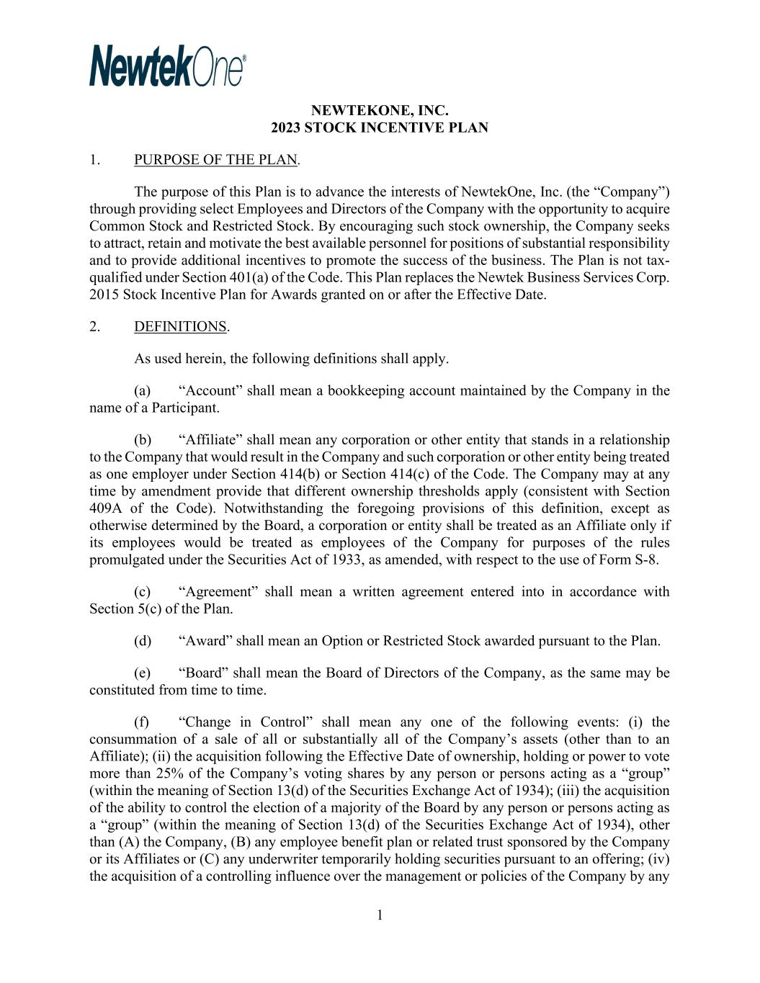
100
1 NEWTEKONE, INC. 2023 STOCK INCENTIVE PLAN 1. PURPOSE OF THE PLAN. The purpose of this Plan is to advance the interests of NewtekOne, Inc. (the “Company”) through providing select Employees and Directors of the Company with the opportunity to acquire Common Stock and Restricted Stock. By encouraging such stock ownership, the Company seeks to attract, retain and motivate the best available personnel for positions of substantial responsibility and to provide additional incentives to promote the success of the business. The Plan is not tax- qualified under Section 401(a) of the Code. This Plan replaces the Newtek Business Services Corp. 2015 Stock Incentive Plan for Awards granted on or after the Effective Date. 2. DEFINITIONS. As used herein, the following definitions shall apply. (a) “Account” shall mean a bookkeeping account maintained by the Company in the name of a Participant. (b) “Affiliate” shall mean any corporation or other entity that stands in a relationship to the Company that would result in the Company and such corporation or other entity being treated as one employer under Section 414(b) or Section 414(c) of the Code. The Company may at any time by amendment provide that different ownership thresholds apply (consistent with Section 409A of the Code). Notwithstanding the foregoing provisions of this definition, except as otherwise determined by the Board, a corporation or entity shall be treated as an Affiliate only if its employees would be treated as employees of the Company for purposes of the rules promulgated under the Securities Act of 1933, as amended, with respect to the use of Form S-8. (c) “Agreement” shall mean a written agreement entered into in accordance with Section 5(c) of the Plan. (d) “Award” shall mean an Option or Restricted Stock awarded pursuant to the Plan. (e) “Board” shall mean the Board of Directors of the Company, as the same may be constituted from time to time. (f) “Change in Control” shall mean any one of the following events: (i) the consummation of a sale of all or substantially all of the Company’s assets (other than to an Affiliate); (ii) the acquisition following the Effective Date of ownership, holding or power to vote more than 25% of the Company’s voting shares by any person or persons acting as a “group” (within the meaning of Section 13(d) of the Securities Exchange Act of 1934); (iii) the acquisition of the ability to control the election of a majority of the Board by any person or persons acting as a “group” (within the meaning of Section 13(d) of the Securities Exchange Act of 1934), other than (A) the Company, (B) any employee benefit plan or related trust sponsored by the Company or its Affiliates or (C) any underwriter temporarily holding securities pursuant to an offering; (iv) the acquisition of a controlling influence over the management or policies of the Company by any

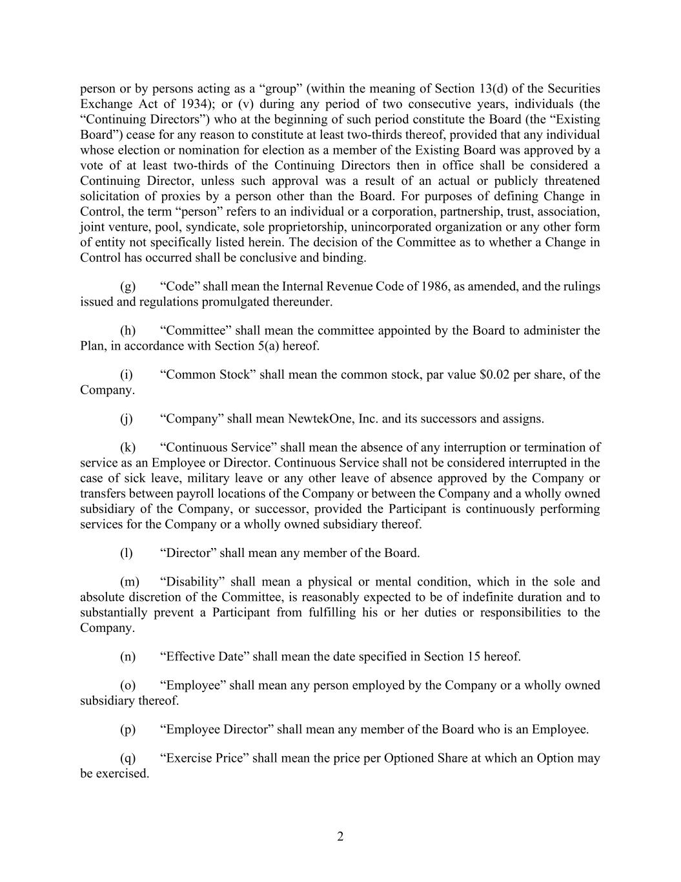
2 person or by persons acting as a “group” (within the meaning of Section 13(d) of the Securities Exchange Act of 1934); or (v) during any period of two consecutive years, individuals (the “Continuing Directors”) who at the beginning of such period constitute the Board (the “Existing Board”) cease for any reason to constitute at least two-thirds thereof, provided that any individual whose election or nomination for election as a member of the Existing Board was approved by a vote of at least two-thirds of the Continuing Directors then in office shall be considered a Continuing Director, unless such approval was a result of an actual or publicly threatened solicitation of proxies by a person other than the Board. For purposes of defining Change in Control, the term “person” refers to an individual or a corporation, partnership, trust, association, joint venture, pool, syndicate, sole proprietorship, unincorporated organization or any other form of entity not specifically listed herein. The decision of the Committee as to whether a Change in Control has occurred shall be conclusive and binding. (g) “Code” shall mean the Internal Revenue Code of 1986, as amended, and the rulings issued and regulations promulgated thereunder. (h) “Committee” shall mean the committee appointed by the Board to administer the Plan, in accordance with Section 5(a) hereof. (i) “Common Stock” shall mean the common stock, par value $0.02 per share, of the Company. (j) “Company” shall mean NewtekOne, Inc. and its successors and assigns. (k) “Continuous Service” shall mean the absence of any interruption or termination of service as an Employee or Director. Continuous Service shall not be considered interrupted in the case of sick leave, military leave or any other leave of absence approved by the Company or transfers between payroll locations of the Company or between the Company and a wholly owned subsidiary of the Company, or successor, provided the Participant is continuously performing services for the Company or a wholly owned subsidiary thereof. (l) “Director” shall mean any member of the Board. (m) “Disability” shall mean a physical or mental condition, which in the sole and absolute discretion of the Committee, is reasonably expected to be of indefinite duration and to substantially prevent a Participant from fulfilling his or her duties or responsibilities to the Company. (n) “Effective Date” shall mean the date specified in Section 15 hereof. (o) “Employee” shall mean any person employed by the Company or a wholly owned subsidiary thereof. (p) “Employee Director” shall mean any member of the Board who is an Employee. (q) “Exercise Price” shall mean the price per Optioned Share at which an Option may be exercised.

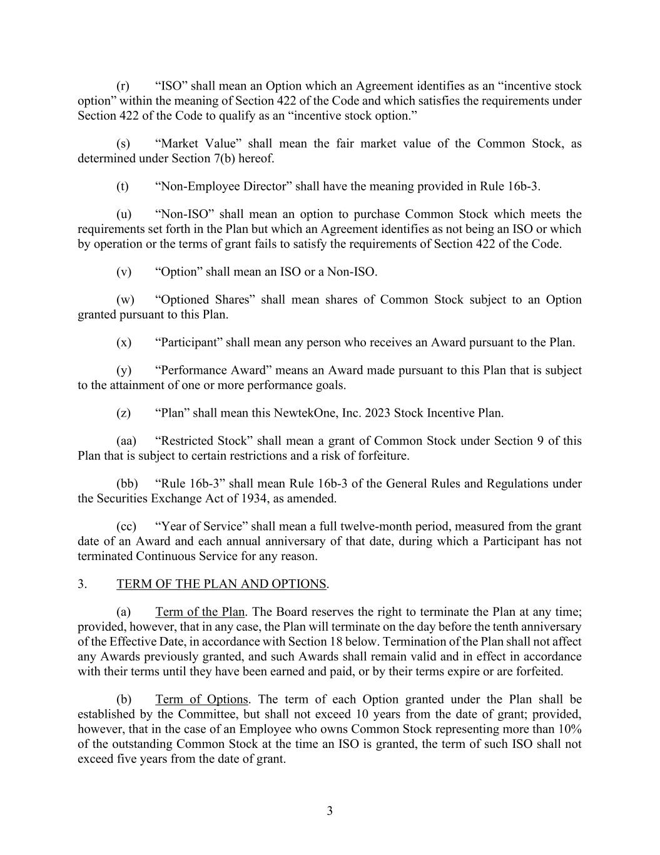
3 (r) “ISO” shall mean an Option which an Agreement identifies as an “incentive stock option” within the meaning of Section 422 of the Code and which satisfies the requirements under Section 422 of the Code to qualify as an “incentive stock option.” (s) “Market Value” shall mean the fair market value of the Common Stock, as determined under Section 7(b) hereof. (t) “Non-Employee Director” shall have the meaning provided in Rule 16b-3. (u) “Non-ISO” shall mean an option to purchase Common Stock which meets the requirements set forth in the Plan but which an Agreement identifies as not being an ISO or which by operation or the terms of grant fails to satisfy the requirements of Section 422 of the Code. (v) “Option” shall mean an ISO or a Non-ISO. (w) “Optioned Shares” shall mean shares of Common Stock subject to an Option granted pursuant to this Plan. (x) “Participant” shall mean any person who receives an Award pursuant to the Plan. (y) “Performance Award” means an Award made pursuant to this Plan that is subject to the attainment of one or more performance goals. (z) “Plan” shall mean this NewtekOne, Inc. 2023 Stock Incentive Plan. (aa) “Restricted Stock” shall mean a grant of Common Stock under Section 9 of this Plan that is subject to certain restrictions and a risk of forfeiture. (bb) “Rule 16b-3” shall mean Rule 16b-3 of the General Rules and Regulations under the Securities Exchange Act of 1934, as amended. (cc) “Year of Service” shall mean a full twelve-month period, measured from the grant date of an Award and each annual anniversary of that date, during which a Participant has not terminated Continuous Service for any reason. 3. TERM OF THE PLAN AND OPTIONS. (a) Term of the Plan. The Board reserves the right to terminate the Plan at any time; provided, however, that in any case, the Plan will terminate on the day before the tenth anniversary of the Effective Date, in accordance with Section 18 below. Termination of the Plan shall not affect any Awards previously granted, and such Awards shall remain valid and in effect in accordance with their terms until they have been earned and paid, or by their terms expire or are forfeited. (b) Term of Options. The term of each Option granted under the Plan shall be established by the Committee, but shall not exceed 10 years from the date of grant; provided, however, that in the case of an Employee who owns Common Stock representing more than 10% of the outstanding Common Stock at the time an ISO is granted, the term of such ISO shall not exceed five years from the date of grant.

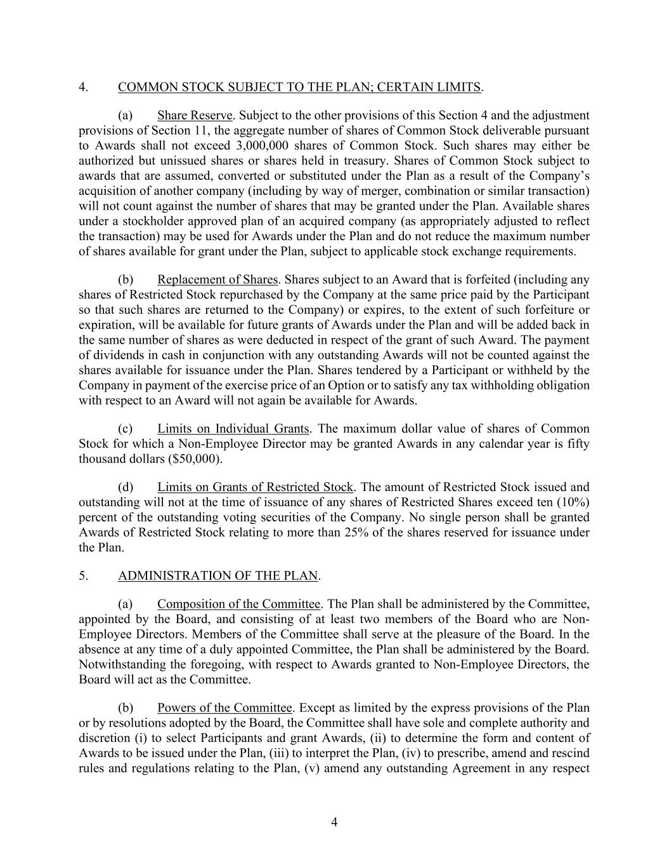
4 4. COMMON STOCK SUBJECT TO THE PLAN; CERTAIN LIMITS. (a) Share Reserve. Subject to the other provisions of this Section 4 and the adjustment provisions of Section 11, the aggregate number of shares of Common Stock deliverable pursuant to Awards shall not exceed 3,000,000 shares of Common Stock. Such shares may either be authorized but unissued shares or shares held in treasury. Shares of Common Stock subject to awards that are assumed, converted or substituted under the Plan as a result of the Company’s acquisition of another company (including by way of merger, combination or similar transaction) will not count against the number of shares that may be granted under the Plan. Available shares under a stockholder approved plan of an acquired company (as appropriately adjusted to reflect the transaction) may be used for Awards under the Plan and do not reduce the maximum number of shares available for grant under the Plan, subject to applicable stock exchange requirements. (b) Replacement of Shares. Shares subject to an Award that is forfeited (including any shares of Restricted Stock repurchased by the Company at the same price paid by the Participant so that such shares are returned to the Company) or expires, to the extent of such forfeiture or expiration, will be available for future grants of Awards under the Plan and will be added back in the same number of shares as were deducted in respect of the grant of such Award. The payment of dividends in cash in conjunction with any outstanding Awards will not be counted against the shares available for issuance under the Plan. Shares tendered by a Participant or withheld by the Company in payment of the exercise price of an Option or to satisfy any tax withholding obligation with respect to an Award will not again be available for Awards. (c) Limits on Individual Grants. The maximum dollar value of shares of Common Stock for which a Non-Employee Director may be granted Awards in any calendar year is fifty thousand dollars ($50,000). (d) Limits on Grants of Restricted Stock. The amount of Restricted Stock issued and outstanding will not at the time of issuance of any shares of Restricted Shares exceed ten (10%) percent of the outstanding voting securities of the Company. No single person shall be granted Awards of Restricted Stock relating to more than 25% of the shares reserved for issuance under the Plan. 5. ADMINISTRATION OF THE PLAN. (a) Composition of the Committee. The Plan shall be administered by the Committee, appointed by the Board, and consisting of at least two members of the Board who are Non- Employee Directors. Members of the Committee shall serve at the pleasure of the Board. In the absence at any time of a duly appointed Committee, the Plan shall be administered by the Board. Notwithstanding the foregoing, with respect to Awards granted to Non-Employee Directors, the Board will act as the Committee. (b) Powers of the Committee. Except as limited by the express provisions of the Plan or by resolutions adopted by the Board, the Committee shall have sole and complete authority and discretion (i) to select Participants and grant Awards, (ii) to determine the form and content of Awards to be issued under the Plan, (iii) to interpret the Plan, (iv) to prescribe, amend and rescind rules and regulations relating to the Plan, (v) amend any outstanding Agreement in any respect

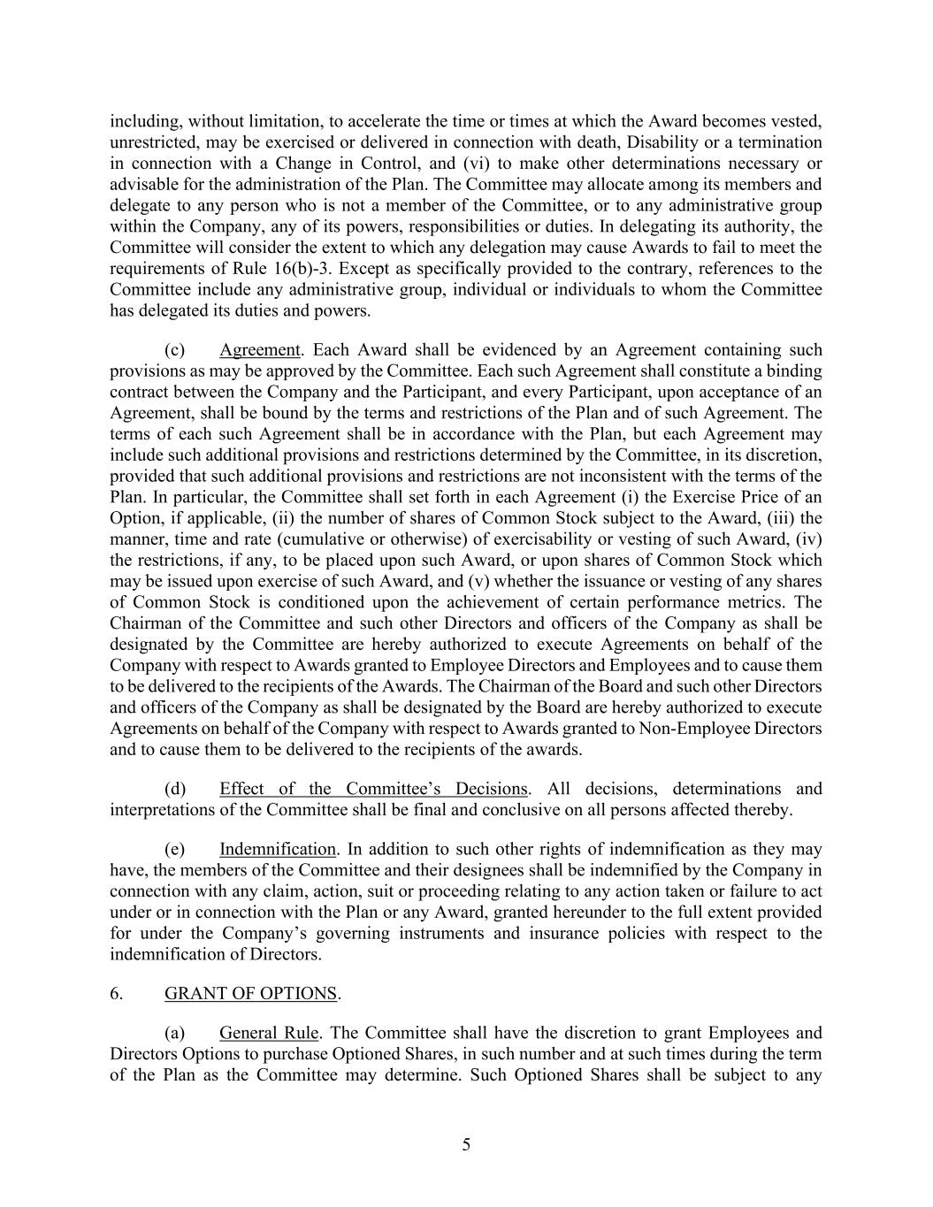
5 including, without limitation, to accelerate the time or times at which the Award becomes vested, unrestricted, may be exercised or delivered in connection with death, Disability or a termination in connection with a Change in Control, and (vi) to make other determinations necessary or advisable for the administration of the Plan. The Committee may allocate among its members and delegate to any person who is not a member of the Committee, or to any administrative group within the Company, any of its powers, responsibilities or duties. In delegating its authority, the Committee will consider the extent to which any delegation may cause Awards to fail to meet the requirements of Rule 16(b)-3. Except as specifically provided to the contrary, references to the Committee include any administrative group, individual or individuals to whom the Committee has delegated its duties and powers. (c) Agreement. Each Award shall be evidenced by an Agreement containing such provisions as may be approved by the Committee. Each such Agreement shall constitute a binding contract between the Company and the Participant, and every Participant, upon acceptance of an Agreement, shall be bound by the terms and restrictions of the Plan and of such Agreement. The terms of each such Agreement shall be in accordance with the Plan, but each Agreement may include such additional provisions and restrictions determined by the Committee, in its discretion, provided that such additional provisions and restrictions are not inconsistent with the terms of the Plan. In particular, the Committee shall set forth in each Agreement (i) the Exercise Price of an Option, if applicable, (ii) the number of shares of Common Stock subject to the Award, (iii) the manner, time and rate (cumulative or otherwise) of exercisability or vesting of such Award, (iv) the restrictions, if any, to be placed upon such Award, or upon shares of Common Stock which may be issued upon exercise of such Award, and (v) whether the issuance or vesting of any shares of Common Stock is conditioned upon the achievement of certain performance metrics. The Chairman of the Committee and such other Directors and officers of the Company as shall be designated by the Committee are hereby authorized to execute Agreements on behalf of the Company with respect to Awards granted to Employee Directors and Employees and to cause them to be delivered to the recipients of the Awards. The Chairman of the Board and such other Directors and officers of the Company as shall be designated by the Board are hereby authorized to execute Agreements on behalf of the Company with respect to Awards granted to Non-Employee Directors and to cause them to be delivered to the recipients of the awards. (d) Effect of the Committee’s Decisions. All decisions, determinations and interpretations of the Committee shall be final and conclusive on all persons affected thereby. (e) Indemnification. In addition to such other rights of indemnification as they may have, the members of the Committee and their designees shall be indemnified by the Company in connection with any claim, action, suit or proceeding relating to any action taken or failure to act under or in connection with the Plan or any Award, granted hereunder to the full extent provided for under the Company’s governing instruments and insurance policies with respect to the indemnification of Directors. 6. GRANT OF OPTIONS. (a) General Rule. The Committee shall have the discretion to grant Employees and Directors Options to purchase Optioned Shares, in such number and at such times during the term of the Plan as the Committee may determine. Such Optioned Shares shall be subject to any

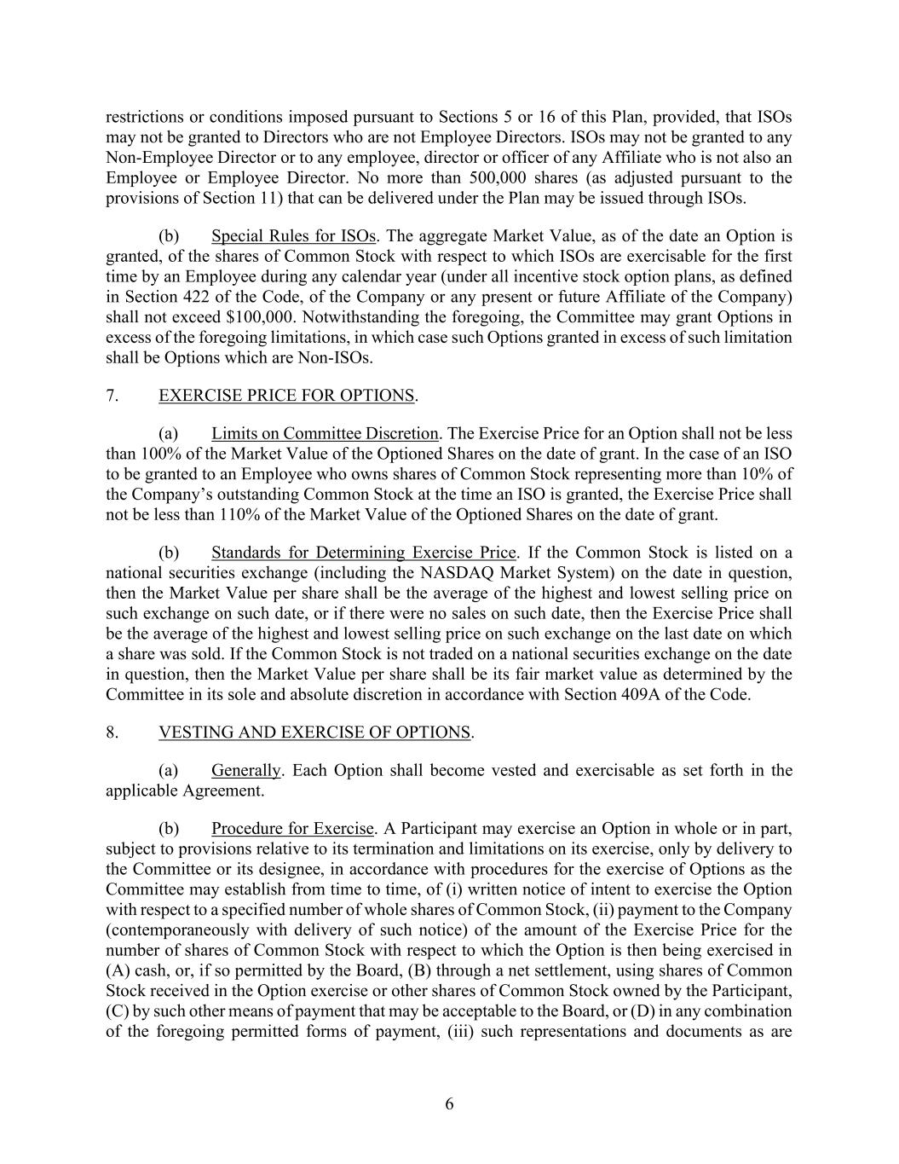
6 restrictions or conditions imposed pursuant to Sections 5 or 16 of this Plan, provided, that ISOs may not be granted to Directors who are not Employee Directors. ISOs may not be granted to any Non-Employee Director or to any employee, director or officer of any Affiliate who is not also an Employee or Employee Director. No more than 500,000 shares (as adjusted pursuant to the provisions of Section 11) that can be delivered under the Plan may be issued through ISOs. (b) Special Rules for ISOs. The aggregate Market Value, as of the date an Option is granted, of the shares of Common Stock with respect to which ISOs are exercisable for the first time by an Employee during any calendar year (under all incentive stock option plans, as defined in Section 422 of the Code, of the Company or any present or future Affiliate of the Company) shall not exceed $100,000. Notwithstanding the foregoing, the Committee may grant Options in excess of the foregoing limitations, in which case such Options granted in excess of such limitation shall be Options which are Non-ISOs. 7. EXERCISE PRICE FOR OPTIONS. (a) Limits on Committee Discretion. The Exercise Price for an Option shall not be less than 100% of the Market Value of the Optioned Shares on the date of grant. In the case of an ISO to be granted to an Employee who owns shares of Common Stock representing more than 10% of the Company’s outstanding Common Stock at the time an ISO is granted, the Exercise Price shall not be less than 110% of the Market Value of the Optioned Shares on the date of grant. (b) Standards for Determining Exercise Price. If the Common Stock is listed on a national securities exchange (including the NASDAQ Market System) on the date in question, then the Market Value per share shall be the average of the highest and lowest selling price on such exchange on such date, or if there were no sales on such date, then the Exercise Price shall be the average of the highest and lowest selling price on such exchange on the last date on which a share was sold. If the Common Stock is not traded on a national securities exchange on the date in question, then the Market Value per share shall be its fair market value as determined by the Committee in its sole and absolute discretion in accordance with Section 409A of the Code. 8. VESTING AND EXERCISE OF OPTIONS. (a) Generally. Each Option shall become vested and exercisable as set forth in the applicable Agreement. (b) Procedure for Exercise. A Participant may exercise an Option in whole or in part, subject to provisions relative to its termination and limitations on its exercise, only by delivery to the Committee or its designee, in accordance with procedures for the exercise of Options as the Committee may establish from time to time, of (i) written notice of intent to exercise the Option with respect to a specified number of whole shares of Common Stock, (ii) payment to the Company (contemporaneously with delivery of such notice) of the amount of the Exercise Price for the number of shares of Common Stock with respect to which the Option is then being exercised in (A) cash, or, if so permitted by the Board, (B) through a net settlement, using shares of Common Stock received in the Option exercise or other shares of Common Stock owned by the Participant, (C) by such other means of payment that may be acceptable to the Board, or (D) in any combination of the foregoing permitted forms of payment, (iii) such representations and documents as are

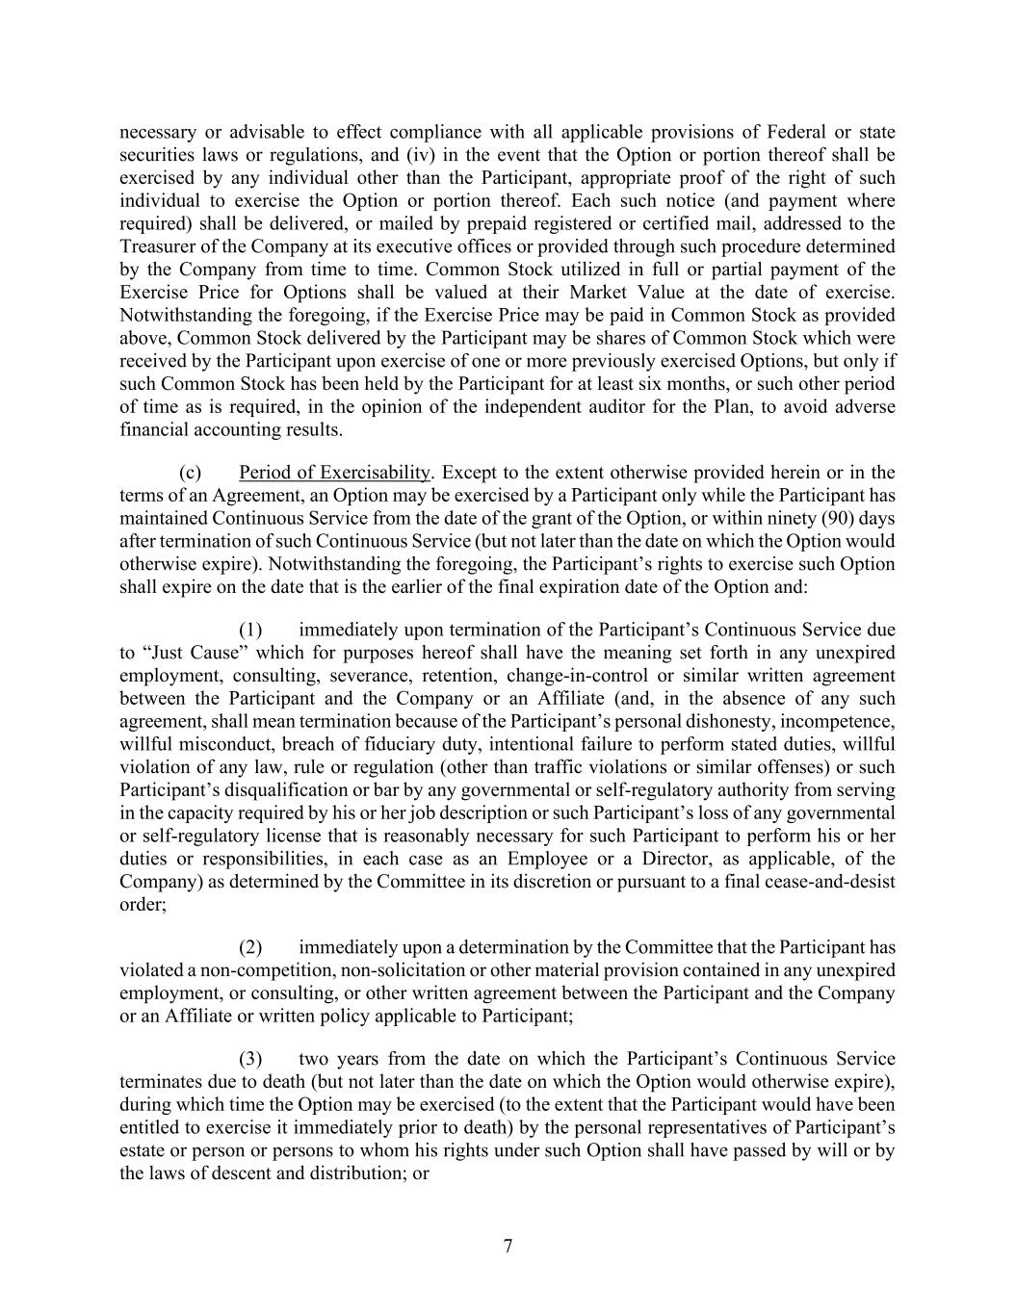
7 necessary or advisable to effect compliance with all applicable provisions of Federal or state securities laws or regulations, and (iv) in the event that the Option or portion thereof shall be exercised by any individual other than the Participant, appropriate proof of the right of such individual to exercise the Option or portion thereof. Each such notice (and payment where required) shall be delivered, or mailed by prepaid registered or certified mail, addressed to the Treasurer of the Company at its executive offices or provided through such procedure determined by the Company from time to time. Common Stock utilized in full or partial payment of the Exercise Price for Options shall be valued at their Market Value at the date of exercise. Notwithstanding the foregoing, if the Exercise Price may be paid in Common Stock as provided above, Common Stock delivered by the Participant may be shares of Common Stock which were received by the Participant upon exercise of one or more previously exercised Options, but only if such Common Stock has been held by the Participant for at least six months, or such other period of time as is required, in the opinion of the independent auditor for the Plan, to avoid adverse financial accounting results. (c) Period of Exercisability. Except to the extent otherwise provided herein or in the terms of an Agreement, an Option may be exercised by a Participant only while the Participant has maintained Continuous Service from the date of the grant of the Option, or within ninety (90) days after termination of such Continuous Service (but not later than the date on which the Option would otherwise expire). Notwithstanding the foregoing, the Participant’s rights to exercise such Option shall expire on the date that is the earlier of the final expiration date of the Option and: (1) immediately upon termination of the Participant’s Continuous Service due to “Just Cause” which for purposes hereof shall have the meaning set forth in any unexpired employment, consulting, severance, retention, change-in-control or similar written agreement between the Participant and the Company or an Affiliate (and, in the absence of any such agreement, shall mean termination because of the Participant’s personal dishonesty, incompetence, willful misconduct, breach of fiduciary duty, intentional failure to perform stated duties, willful violation of any law, rule or regulation (other than traffic violations or similar offenses) or such Participant’s disqualification or bar by any governmental or self-regulatory authority from serving in the capacity required by his or her job description or such Participant’s loss of any governmental or self-regulatory license that is reasonably necessary for such Participant to perform his or her duties or responsibilities, in each case as an Employee or a Director, as applicable, of the Company) as determined by the Committee in its discretion or pursuant to a final cease-and-desist order; (2) immediately upon a determination by the Committee that the Participant has violated a non-competition, non-solicitation or other material provision contained in any unexpired employment, or consulting, or other written agreement between the Participant and the Company or an Affiliate or written policy applicable to Participant; (3) two years from the date on which the Participant’s Continuous Service terminates due to death (but not later than the date on which the Option would otherwise expire), during which time the Option may be exercised (to the extent that the Participant would have been entitled to exercise it immediately prior to death) by the personal representatives of Participant’s estate or person or persons to whom his rights under such Option shall have passed by will or by the laws of descent and distribution; or

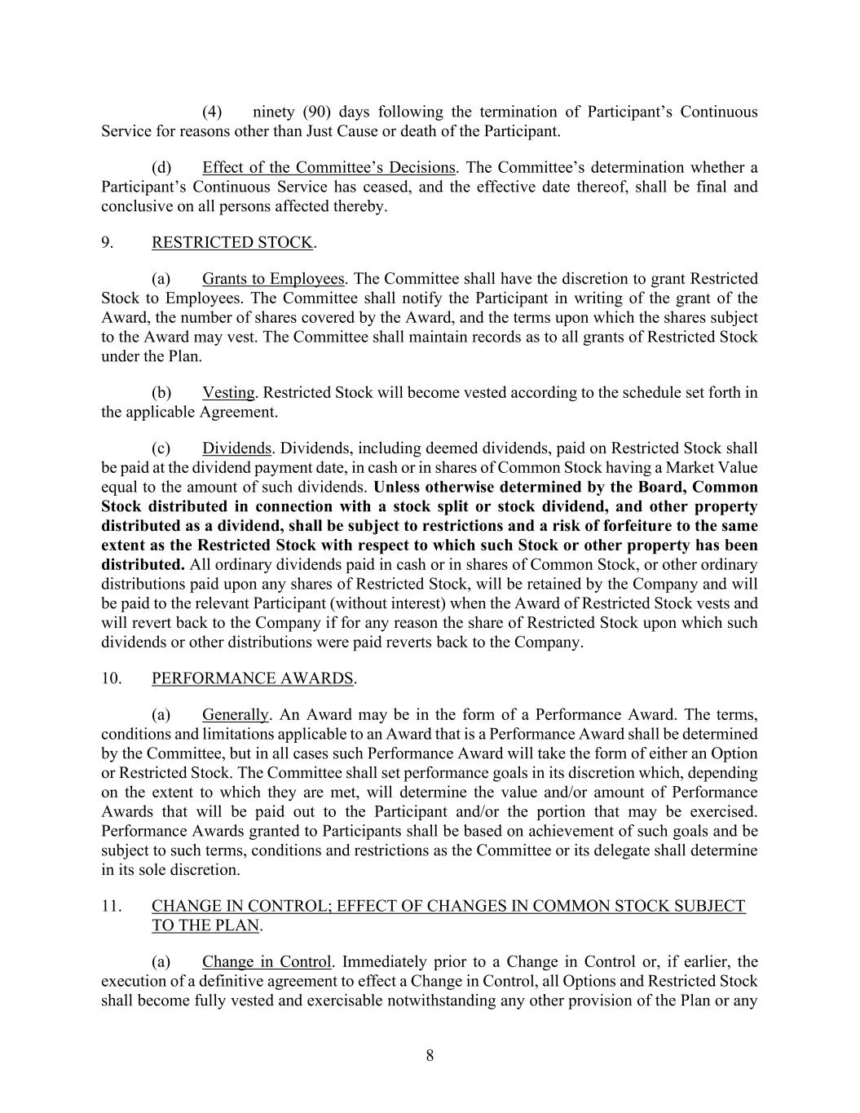
8 (4) ninety (90) days following the termination of Participant’s Continuous Service for reasons other than Just Cause or death of the Participant. (d) Effect of the Committee’s Decisions. The Committee’s determination whether a Participant’s Continuous Service has ceased, and the effective date thereof, shall be final and conclusive on all persons affected thereby. 9. RESTRICTED STOCK. (a) Grants to Employees. The Committee shall have the discretion to grant Restricted Stock to Employees. The Committee shall notify the Participant in writing of the grant of the Award, the number of shares covered by the Award, and the terms upon which the shares subject to the Award may vest. The Committee shall maintain records as to all grants of Restricted Stock under the Plan. (b) Vesting. Restricted Stock will become vested according to the schedule set forth in the applicable Agreement. (c) Dividends. Dividends, including deemed dividends, paid on Restricted Stock shall be paid at the dividend payment date, in cash or in shares of Common Stock having a Market Value equal to the amount of such dividends. Unless otherwise determined by the Board, Common Stock distributed in connection with a stock split or stock dividend, and other property distributed as a dividend, shall be subject to restrictions and a risk of forfeiture to the same extent as the Restricted Stock with respect to which such Stock or other property has been distributed. All ordinary dividends paid in cash or in shares of Common Stock, or other ordinary distributions paid upon any shares of Restricted Stock, will be retained by the Company and will be paid to the relevant Participant (without interest) when the Award of Restricted Stock vests and will revert back to the Company if for any reason the share of Restricted Stock upon which such dividends or other distributions were paid reverts back to the Company. 10. PERFORMANCE AWARDS. (a) Generally. An Award may be in the form of a Performance Award. The terms, conditions and limitations applicable to an Award that is a Performance Award shall be determined by the Committee, but in all cases such Performance Award will take the form of either an Option or Restricted Stock. The Committee shall set performance goals in its discretion which, depending on the extent to which they are met, will determine the value and/or amount of Performance Awards that will be paid out to the Participant and/or the portion that may be exercised. Performance Awards granted to Participants shall be based on achievement of such goals and be subject to such terms, conditions and restrictions as the Committee or its delegate shall determine in its sole discretion. 11. CHANGE IN CONTROL; EFFECT OF CHANGES IN COMMON STOCK SUBJECT TO THE PLAN. (a) Change in Control. Immediately prior to a Change in Control or, if earlier, the execution of a definitive agreement to effect a Change in Control, all Options and Restricted Stock shall become fully vested and exercisable notwithstanding any other provision of the Plan or any

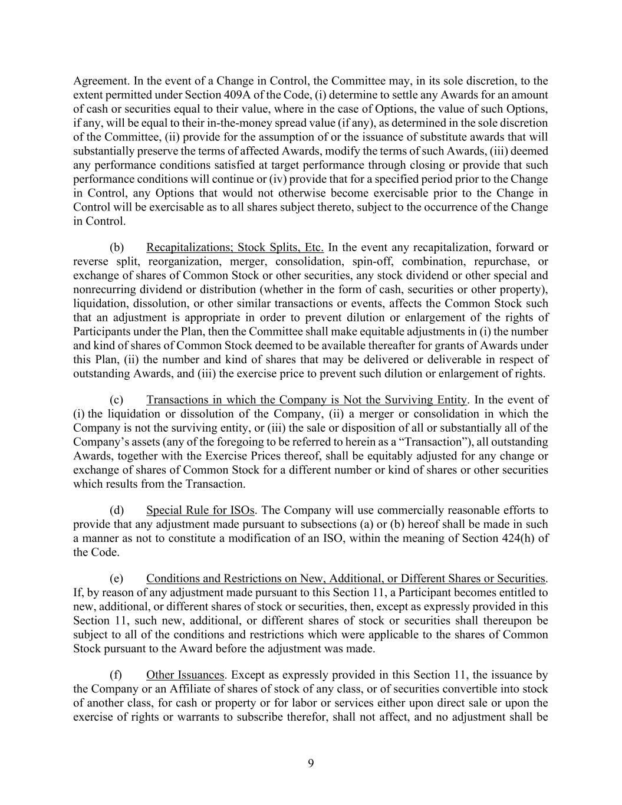
9 Agreement. In the event of a Change in Control, the Committee may, in its sole discretion, to the extent permitted under Section 409A of the Code, (i) determine to settle any Awards for an amount of cash or securities equal to their value, where in the case of Options, the value of such Options, if any, will be equal to their in-the-money spread value (if any), as determined in the sole discretion of the Committee, (ii) provide for the assumption of or the issuance of substitute awards that will substantially preserve the terms of affected Awards, modify the terms of such Awards, (iii) deemed any performance conditions satisfied at target performance through closing or provide that such performance conditions will continue or (iv) provide that for a specified period prior to the Change in Control, any Options that would not otherwise become exercisable prior to the Change in Control will be exercisable as to all shares subject thereto, subject to the occurrence of the Change in Control. (b) Recapitalizations; Stock Splits, Etc. In the event any recapitalization, forward or reverse split, reorganization, merger, consolidation, spin-off, combination, repurchase, or exchange of shares of Common Stock or other securities, any stock dividend or other special and nonrecurring dividend or distribution (whether in the form of cash, securities or other property), liquidation, dissolution, or other similar transactions or events, affects the Common Stock such that an adjustment is appropriate in order to prevent dilution or enlargement of the rights of Participants under the Plan, then the Committee shall make equitable adjustments in (i) the number and kind of shares of Common Stock deemed to be available thereafter for grants of Awards under this Plan, (ii) the number and kind of shares that may be delivered or deliverable in respect of outstanding Awards, and (iii) the exercise price to prevent such dilution or enlargement of rights. (c) Transactions in which the Company is Not the Surviving Entity. In the event of (i) the liquidation or dissolution of the Company, (ii) a merger or consolidation in which the Company is not the surviving entity, or (iii) the sale or disposition of all or substantially all of the Company’s assets (any of the foregoing to be referred to herein as a “Transaction”), all outstanding Awards, together with the Exercise Prices thereof, shall be equitably adjusted for any change or exchange of shares of Common Stock for a different number or kind of shares or other securities which results from the Transaction. (d) Special Rule for ISOs. The Company will use commercially reasonable efforts to provide that any adjustment made pursuant to subsections (a) or (b) hereof shall be made in such a manner as not to constitute a modification of an ISO, within the meaning of Section 424(h) of the Code. (e) Conditions and Restrictions on New, Additional, or Different Shares or Securities. If, by reason of any adjustment made pursuant to this Section 11, a Participant becomes entitled to new, additional, or different shares of stock or securities, then, except as expressly provided in this Section 11, such new, additional, or different shares of stock or securities shall thereupon be subject to all of the conditions and restrictions which were applicable to the shares of Common Stock pursuant to the Award before the adjustment was made. (f) Other Issuances. Except as expressly provided in this Section 11, the issuance by the Company or an Affiliate of shares of stock of any class, or of securities convertible into stock of another class, for cash or property or for labor or services either upon direct sale or upon the exercise of rights or warrants to subscribe therefor, shall not affect, and no adjustment shall be

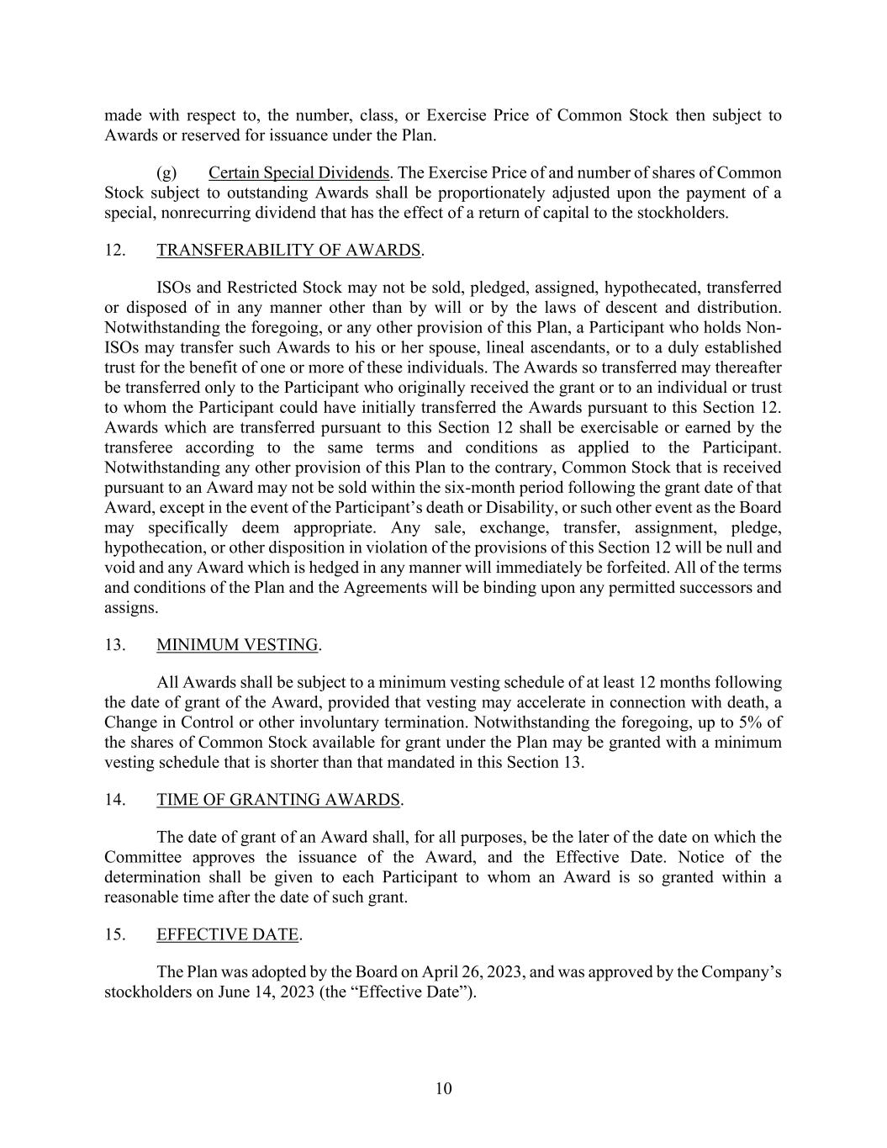
10 made with respect to, the number, class, or Exercise Price of Common Stock then subject to Awards or reserved for issuance under the Plan. (g) Certain Special Dividends. The Exercise Price of and number of shares of Common Stock subject to outstanding Awards shall be proportionately adjusted upon the payment of a special, nonrecurring dividend that has the effect of a return of capital to the stockholders. 12. TRANSFERABILITY OF AWARDS. ISOs and Restricted Stock may not be sold, pledged, assigned, hypothecated, transferred or disposed of in any manner other than by will or by the laws of descent and distribution. Notwithstanding the foregoing, or any other provision of this Plan, a Participant who holds Non- ISOs may transfer such Awards to his or her spouse, lineal ascendants, or to a duly established trust for the benefit of one or more of these individuals. The Awards so transferred may thereafter be transferred only to the Participant who originally received the grant or to an individual or trust to whom the Participant could have initially transferred the Awards pursuant to this Section 12. Awards which are transferred pursuant to this Section 12 shall be exercisable or earned by the transferee according to the same terms and conditions as applied to the Participant. Notwithstanding any other provision of this Plan to the contrary, Common Stock that is received pursuant to an Award may not be sold within the six-month period following the grant date of that Award, except in the event of the Participant’s death or Disability, or such other event as the Board may specifically deem appropriate. Any sale, exchange, transfer, assignment, pledge, hypothecation, or other disposition in violation of the provisions of this Section 12 will be null and void and any Award which is hedged in any manner will immediately be forfeited. All of the terms and conditions of the Plan and the Agreements will be binding upon any permitted successors and assigns. 13. MINIMUM VESTING. All Awards shall be subject to a minimum vesting schedule of at least 12 months following the date of grant of the Award, provided that vesting may accelerate in connection with death, a Change in Control or other involuntary termination. Notwithstanding the foregoing, up to 5% of the shares of Common Stock available for grant under the Plan may be granted with a minimum vesting schedule that is shorter than that mandated in this Section 13. 14. TIME OF GRANTING AWARDS. The date of grant of an Award shall, for all purposes, be the later of the date on which the Committee approves the issuance of the Award, and the Effective Date. Notice of the determination shall be given to each Participant to whom an Award is so granted within a reasonable time after the date of such grant. 15. EFFECTIVE DATE. The Plan was adopted by the Board on April 26, 2023, and was approved by the Company’s stockholders on June 14, 2023 (the “Effective Date”).

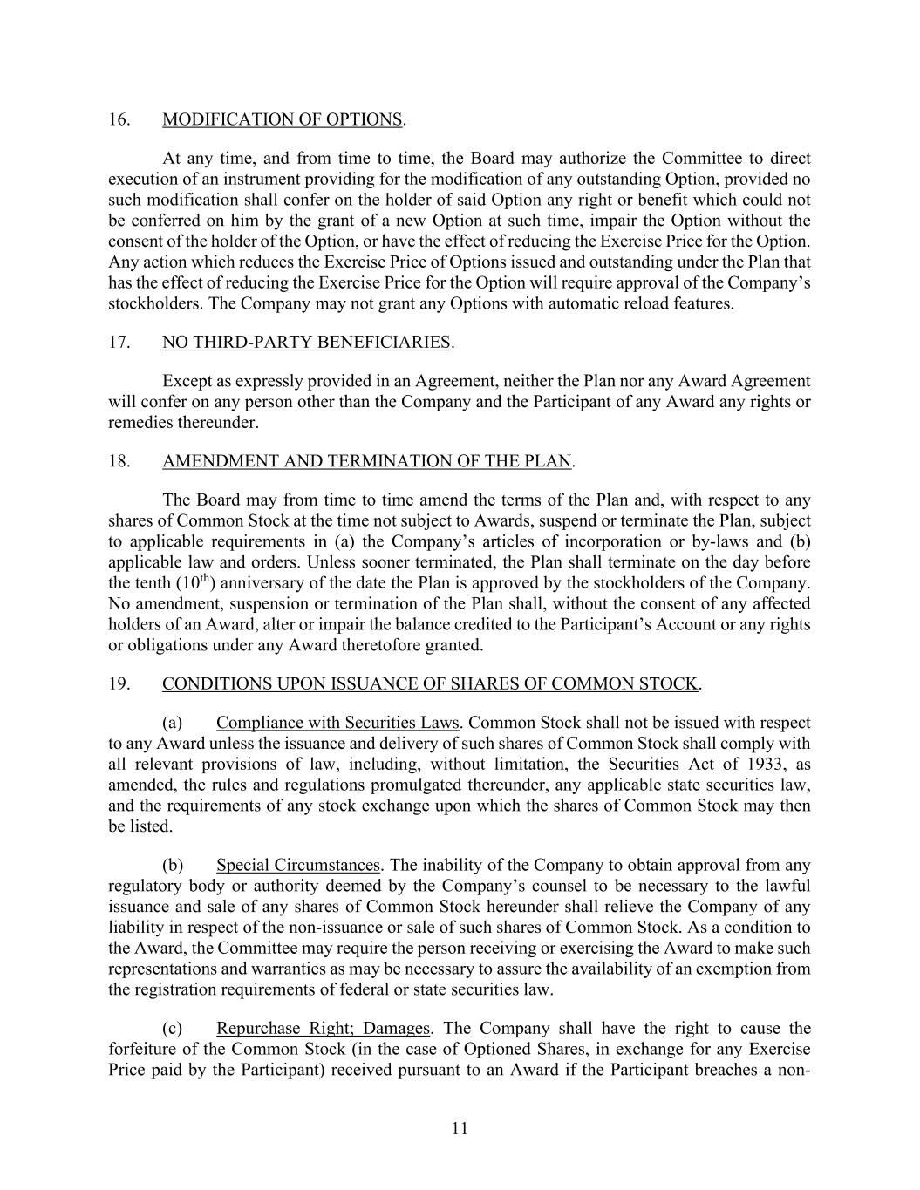
11 16. MODIFICATION OF OPTIONS. At any time, and from time to time, the Board may authorize the Committee to direct execution of an instrument providing for the modification of any outstanding Option, provided no such modification shall confer on the holder of said Option any right or benefit which could not be conferred on him by the grant of a new Option at such time, impair the Option without the consent of the holder of the Option, or have the effect of reducing the Exercise Price for the Option. Any action which reduces the Exercise Price of Options issued and outstanding under the Plan that has the effect of reducing the Exercise Price for the Option will require approval of the Company’s stockholders. The Company may not grant any Options with automatic reload features. 17. NO THIRD-PARTY BENEFICIARIES. Except as expressly provided in an Agreement, neither the Plan nor any Award Agreement will confer on any person other than the Company and the Participant of any Award any rights or remedies thereunder. 18. AMENDMENT AND TERMINATION OF THE PLAN. The Board may from time to time amend the terms of the Plan and, with respect to any shares of Common Stock at the time not subject to Awards, suspend or terminate the Plan, subject to applicable requirements in (a) the Company’s articles of incorporation or by-laws and (b) applicable law and orders. Unless sooner terminated, the Plan shall terminate on the day before the tenth (10th) anniversary of the date the Plan is approved by the stockholders of the Company. No amendment, suspension or termination of the Plan shall, without the consent of any affected holders of an Award, alter or impair the balance credited to the Participant’s Account or any rights or obligations under any Award theretofore granted. 19. CONDITIONS UPON ISSUANCE OF SHARES OF COMMON STOCK. (a) Compliance with Securities Laws. Common Stock shall not be issued with respect to any Award unless the issuance and delivery of such shares of Common Stock shall comply with all relevant provisions of law, including, without limitation, the Securities Act of 1933, as amended, the rules and regulations promulgated thereunder, any applicable state securities law, and the requirements of any stock exchange upon which the shares of Common Stock may then be listed. (b) Special Circumstances. The inability of the Company to obtain approval from any regulatory body or authority deemed by the Company’s counsel to be necessary to the lawful issuance and sale of any shares of Common Stock hereunder shall relieve the Company of any liability in respect of the non-issuance or sale of such shares of Common Stock. As a condition to the Award, the Committee may require the person receiving or exercising the Award to make such representations and warranties as may be necessary to assure the availability of an exemption from the registration requirements of federal or state securities law. (c) Repurchase Right; Damages. The Company shall have the right to cause the forfeiture of the Common Stock (in the case of Optioned Shares, in exchange for any Exercise Price paid by the Participant) received pursuant to an Award if the Participant breaches a non-

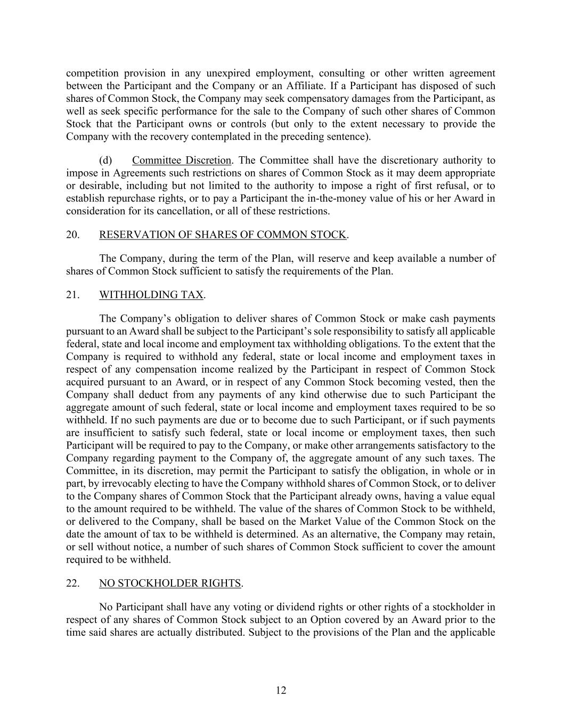
12 competition provision in any unexpired employment, consulting or other written agreement between the Participant and the Company or an Affiliate. If a Participant has disposed of such shares of Common Stock, the Company may seek compensatory damages from the Participant, as well as seek specific performance for the sale to the Company of such other shares of Common Stock that the Participant owns or controls (but only to the extent necessary to provide the Company with the recovery contemplated in the preceding sentence). (d) Committee Discretion. The Committee shall have the discretionary authority to impose in Agreements such restrictions on shares of Common Stock as it may deem appropriate or desirable, including but not limited to the authority to impose a right of first refusal, or to establish repurchase rights, or to pay a Participant the in-the-money value of his or her Award in consideration for its cancellation, or all of these restrictions. 20. RESERVATION OF SHARES OF COMMON STOCK. The Company, during the term of the Plan, will reserve and keep available a number of shares of Common Stock sufficient to satisfy the requirements of the Plan. 21. WITHHOLDING TAX. The Company’s obligation to deliver shares of Common Stock or make cash payments pursuant to an Award shall be subject to the Participant’s sole responsibility to satisfy all applicable federal, state and local income and employment tax withholding obligations. To the extent that the Company is required to withhold any federal, state or local income and employment taxes in respect of any compensation income realized by the Participant in respect of Common Stock acquired pursuant to an Award, or in respect of any Common Stock becoming vested, then the Company shall deduct from any payments of any kind otherwise due to such Participant the aggregate amount of such federal, state or local income and employment taxes required to be so withheld. If no such payments are due or to become due to such Participant, or if such payments are insufficient to satisfy such federal, state or local income or employment taxes, then such Participant will be required to pay to the Company, or make other arrangements satisfactory to the Company regarding payment to the Company of, the aggregate amount of any such taxes. The Committee, in its discretion, may permit the Participant to satisfy the obligation, in whole or in part, by irrevocably electing to have the Company withhold shares of Common Stock, or to deliver to the Company shares of Common Stock that the Participant already owns, having a value equal to the amount required to be withheld. The value of the shares of Common Stock to be withheld, or delivered to the Company, shall be based on the Market Value of the Common Stock on the date the amount of tax to be withheld is determined. As an alternative, the Company may retain, or sell without notice, a number of such shares of Common Stock sufficient to cover the amount required to be withheld. 22. NO STOCKHOLDER RIGHTS. No Participant shall have any voting or dividend rights or other rights of a stockholder in respect of any shares of Common Stock subject to an Option covered by an Award prior to the time said shares are actually distributed. Subject to the provisions of the Plan and the applicable

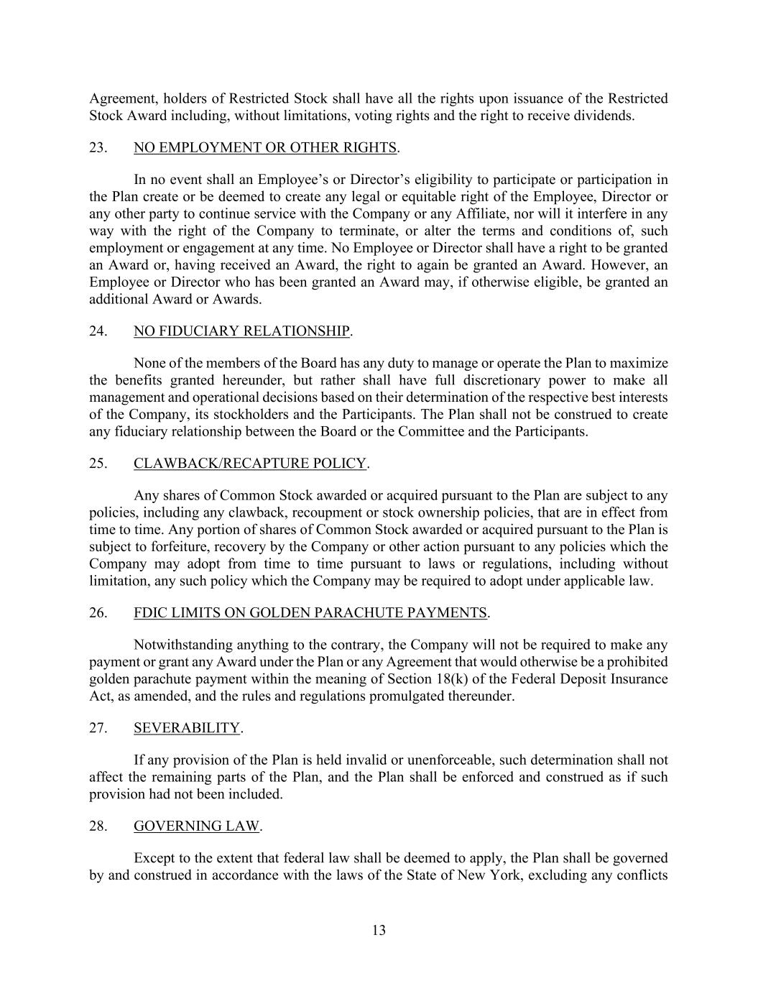
13 Agreement, holders of Restricted Stock shall have all the rights upon issuance of the Restricted Stock Award including, without limitations, voting rights and the right to receive dividends. 23. NO EMPLOYMENT OR OTHER RIGHTS. In no event shall an Employee’s or Director’s eligibility to participate or participation in the Plan create or be deemed to create any legal or equitable right of the Employee, Director or any other party to continue service with the Company or any Affiliate, nor will it interfere in any way with the right of the Company to terminate, or alter the terms and conditions of, such employment or engagement at any time. No Employee or Director shall have a right to be granted an Award or, having received an Award, the right to again be granted an Award. However, an Employee or Director who has been granted an Award may, if otherwise eligible, be granted an additional Award or Awards. 24. NO FIDUCIARY RELATIONSHIP. None of the members of the Board has any duty to manage or operate the Plan to maximize the benefits granted hereunder, but rather shall have full discretionary power to make all management and operational decisions based on their determination of the respective best interests of the Company, its stockholders and the Participants. The Plan shall not be construed to create any fiduciary relationship between the Board or the Committee and the Participants. 25. CLAWBACK/RECAPTURE POLICY. Any shares of Common Stock awarded or acquired pursuant to the Plan are subject to any policies, including any clawback, recoupment or stock ownership policies, that are in effect from time to time. Any portion of shares of Common Stock awarded or acquired pursuant to the Plan is subject to forfeiture, recovery by the Company or other action pursuant to any policies which the Company may adopt from time to time pursuant to laws or regulations, including without limitation, any such policy which the Company may be required to adopt under applicable law. 26. FDIC LIMITS ON GOLDEN PARACHUTE PAYMENTS. Notwithstanding anything to the contrary, the Company will not be required to make any payment or grant any Award under the Plan or any Agreement that would otherwise be a prohibited golden parachute payment within the meaning of Section 18(k) of the Federal Deposit Insurance Act, as amended, and the rules and regulations promulgated thereunder. 27. SEVERABILITY. If any provision of the Plan is held invalid or unenforceable, such determination shall not affect the remaining parts of the Plan, and the Plan shall be enforced and construed as if such provision had not been included. 28. GOVERNING LAW. Except to the extent that federal law shall be deemed to apply, the Plan shall be governed by and construed in accordance with the laws of the State of New York, excluding any conflicts


14 or choice of law principle that might otherwise refer construction or interpretation of the Plan to another jurisdiction. Unless otherwise provided in an Agreement, recipients of an Award under the Plan are deemed to submit to the exclusive jurisdiction and venue of the Federal or state courts of the State of New York to resolve any issue that may arise out of or relate to the Plan or any Award.

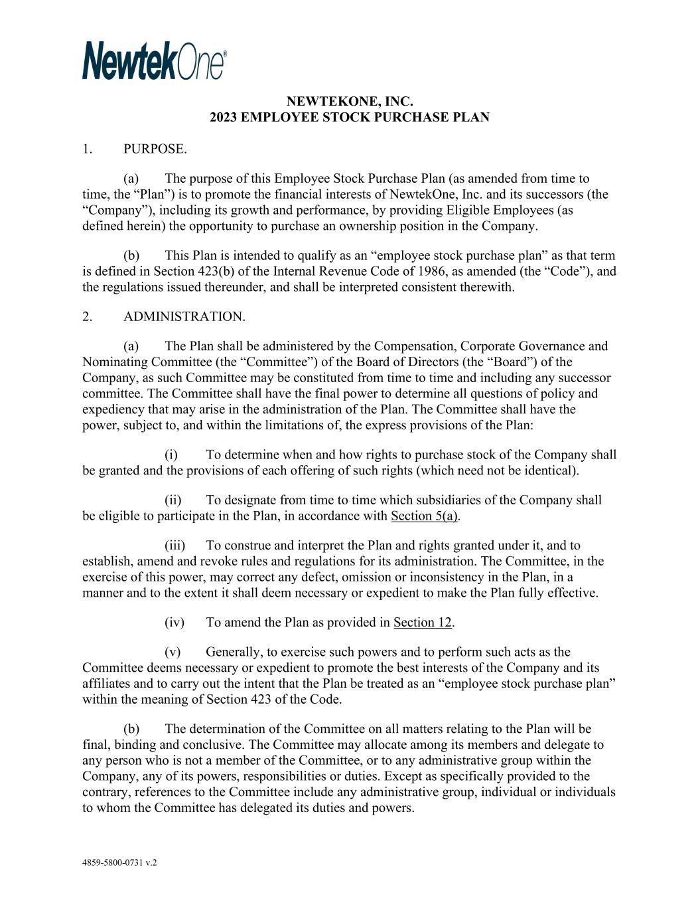
4859-5800-0731 v.2 NEWTEKONE, INC. 2023 EMPLOYEE STOCK PURCHASE PLAN 1. PURPOSE. (a) The purpose of this Employee Stock Purchase Plan (as amended from time to time, the “Plan”) is to promote the financial interests of NewtekOne, Inc. and its successors (the “Company”), including its growth and performance, by providing Eligible Employees (as defined herein) the opportunity to purchase an ownership position in the Company. (b) This Plan is intended to qualify as an “employee stock purchase plan” as that term is defined in Section 423(b) of the Internal Revenue Code of 1986, as amended (the “Code”), and the regulations issued thereunder, and shall be interpreted consistent therewith. 2. ADMINISTRATION. (a) The Plan shall be administered by the Compensation, Corporate Governance and Nominating Committee (the “Committee”) of the Board of Directors (the “Board”) of the Company, as such Committee may be constituted from time to time and including any successor committee. The Committee shall have the final power to determine all questions of policy and expediency that may arise in the administration of the Plan. The Committee shall have the power, subject to, and within the limitations of, the express provisions of the Plan: (i) To determine when and how rights to purchase stock of the Company shall be granted and the provisions of each offering of such rights (which need not be identical). (ii) To designate from time to time which subsidiaries of the Company shall be eligible to participate in the Plan, in accordance with Section 5(a). (iii) To construe and interpret the Plan and rights granted under it, and to establish, amend and revoke rules and regulations for its administration. The Committee, in the exercise of this power, may correct any defect, omission or inconsistency in the Plan, in a manner and to the extent it shall deem necessary or expedient to make the Plan fully effective. (iv) To amend the Plan as provided in Section 12. (v) Generally, to exercise such powers and to perform such acts as the Committee deems necessary or expedient to promote the best interests of the Company and its affiliates and to carry out the intent that the Plan be treated as an “employee stock purchase plan” within the meaning of Section 423 of the Code. (b) The determination of the Committee on all matters relating to the Plan will be final, binding and conclusive. The Committee may allocate among its members and delegate to any person who is not a member of the Committee, or to any administrative group within the Company, any of its powers, responsibilities or duties. Except as specifically provided to the contrary, references to the Committee include any administrative group, individual or individuals to whom the Committee has delegated its duties and powers.

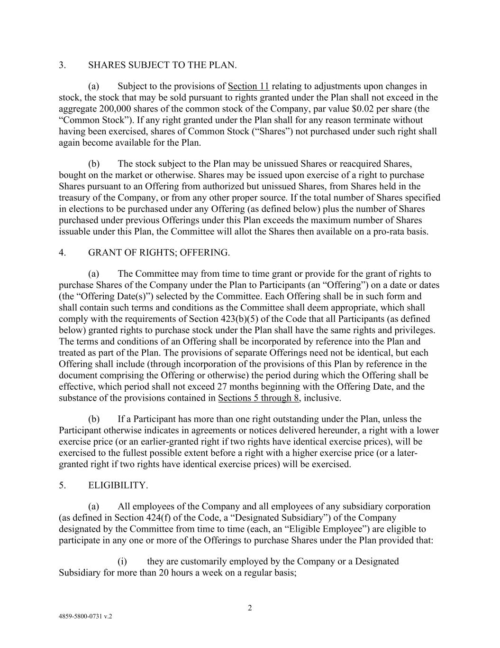
2 4859-5800-0731 v.2 3. SHARES SUBJECT TO THE PLAN. (a) Subject to the provisions of Section 11 relating to adjustments upon changes in stock, the stock that may be sold pursuant to rights granted under the Plan shall not exceed in the aggregate 200,000 shares of the common stock of the Company, par value $0.02 per share (the “Common Stock”). If any right granted under the Plan shall for any reason terminate without having been exercised, shares of Common Stock (“Shares”) not purchased under such right shall again become available for the Plan. (b) The stock subject to the Plan may be unissued Shares or reacquired Shares, bought on the market or otherwise. Shares may be issued upon exercise of a right to purchase Shares pursuant to an Offering from authorized but unissued Shares, from Shares held in the treasury of the Company, or from any other proper source. If the total number of Shares specified in elections to be purchased under any Offering (as defined below) plus the number of Shares purchased under previous Offerings under this Plan exceeds the maximum number of Shares issuable under this Plan, the Committee will allot the Shares then available on a pro-rata basis. 4. GRANT OF RIGHTS; OFFERING. (a) The Committee may from time to time grant or provide for the grant of rights to purchase Shares of the Company under the Plan to Participants (an “Offering”) on a date or dates (the “Offering Date(s)”) selected by the Committee. Each Offering shall be in such form and shall contain such terms and conditions as the Committee shall deem appropriate, which shall comply with the requirements of Section 423(b)(5) of the Code that all Participants (as defined below) granted rights to purchase stock under the Plan shall have the same rights and privileges. The terms and conditions of an Offering shall be incorporated by reference into the Plan and treated as part of the Plan. The provisions of separate Offerings need not be identical, but each Offering shall include (through incorporation of the provisions of this Plan by reference in the document comprising the Offering or otherwise) the period during which the Offering shall be effective, which period shall not exceed 27 months beginning with the Offering Date, and the substance of the provisions contained in Sections 5 through 8, inclusive. (b) If a Participant has more than one right outstanding under the Plan, unless the Participant otherwise indicates in agreements or notices delivered hereunder, a right with a lower exercise price (or an earlier-granted right if two rights have identical exercise prices), will be exercised to the fullest possible extent before a right with a higher exercise price (or a later- granted right if two rights have identical exercise prices) will be exercised. 5. ELIGIBILITY. (a) All employees of the Company and all employees of any subsidiary corporation (as defined in Section 424(f) of the Code, a “Designated Subsidiary”) of the Company designated by the Committee from time to time (each, an “Eligible Employee”) are eligible to participate in any one or more of the Offerings to purchase Shares under the Plan provided that: (i) they are customarily employed by the Company or a Designated Subsidiary for more than 20 hours a week on a regular basis;

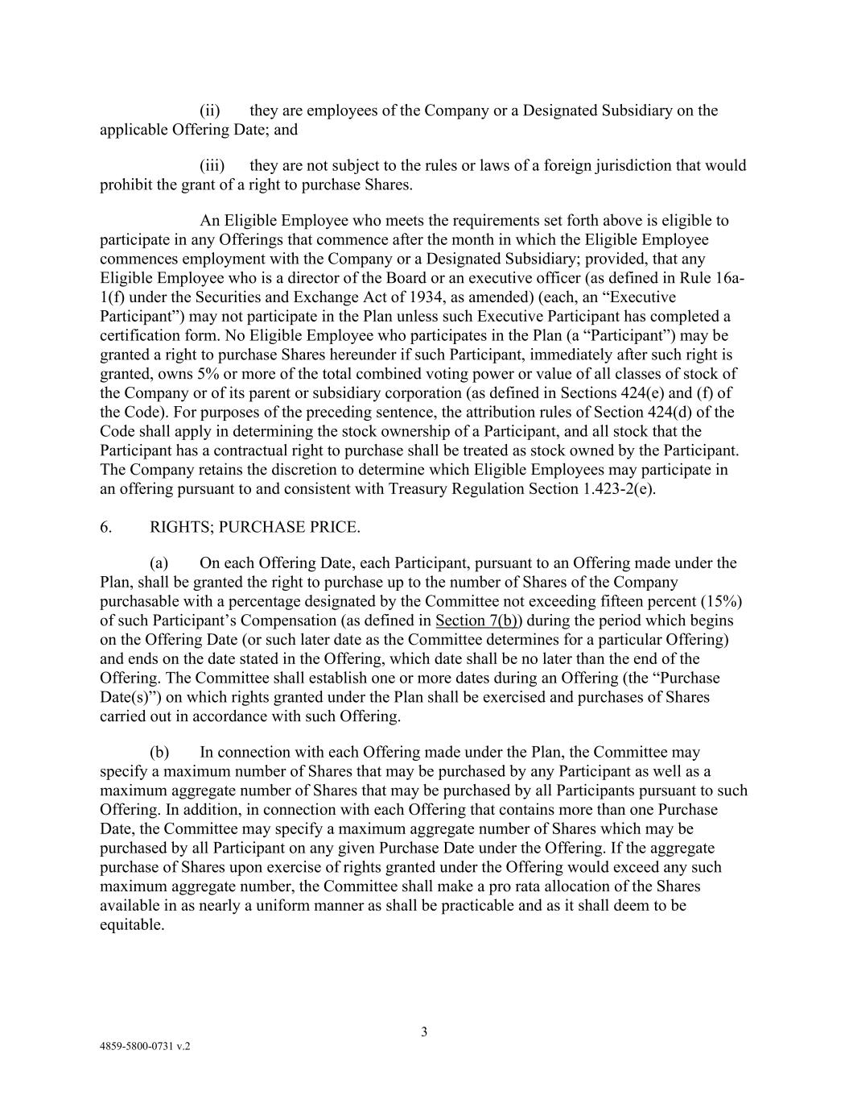
3 4859-5800-0731 v.2 (ii) they are employees of the Company or a Designated Subsidiary on the applicable Offering Date; and (iii) they are not subject to the rules or laws of a foreign jurisdiction that would prohibit the grant of a right to purchase Shares. An Eligible Employee who meets the requirements set forth above is eligible to participate in any Offerings that commence after the month in which the Eligible Employee commences employment with the Company or a Designated Subsidiary; provided, that any Eligible Employee who is a director of the Board or an executive officer (as defined in Rule 16a- 1(f) under the Securities and Exchange Act of 1934, as amended) (each, an “Executive Participant”) may not participate in the Plan unless such Executive Participant has completed a certification form. No Eligible Employee who participates in the Plan (a “Participant”) may be granted a right to purchase Shares hereunder if such Participant, immediately after such right is granted, owns 5% or more of the total combined voting power or value of all classes of stock of the Company or of its parent or subsidiary corporation (as defined in Sections 424(e) and (f) of the Code). For purposes of the preceding sentence, the attribution rules of Section 424(d) of the Code shall apply in determining the stock ownership of a Participant, and all stock that the Participant has a contractual right to purchase shall be treated as stock owned by the Participant. The Company retains the discretion to determine which Eligible Employees may participate in an offering pursuant to and consistent with Treasury Regulation Section 1.423-2(e). 6. RIGHTS; PURCHASE PRICE. (a) On each Offering Date, each Participant, pursuant to an Offering made under the Plan, shall be granted the right to purchase up to the number of Shares of the Company purchasable with a percentage designated by the Committee not exceeding fifteen percent (15%) of such Participant’s Compensation (as defined in Section 7(b)) during the period which begins on the Offering Date (or such later date as the Committee determines for a particular Offering) and ends on the date stated in the Offering, which date shall be no later than the end of the Offering. The Committee shall establish one or more dates during an Offering (the “Purchase Date(s)”) on which rights granted under the Plan shall be exercised and purchases of Shares carried out in accordance with such Offering. (b) In connection with each Offering made under the Plan, the Committee may specify a maximum number of Shares that may be purchased by any Participant as well as a maximum aggregate number of Shares that may be purchased by all Participants pursuant to such Offering. In addition, in connection with each Offering that contains more than one Purchase Date, the Committee may specify a maximum aggregate number of Shares which may be purchased by all Participant on any given Purchase Date under the Offering. If the aggregate purchase of Shares upon exercise of rights granted under the Offering would exceed any such maximum aggregate number, the Committee shall make a pro rata allocation of the Shares available in as nearly a uniform manner as shall be practicable and as it shall deem to be equitable.

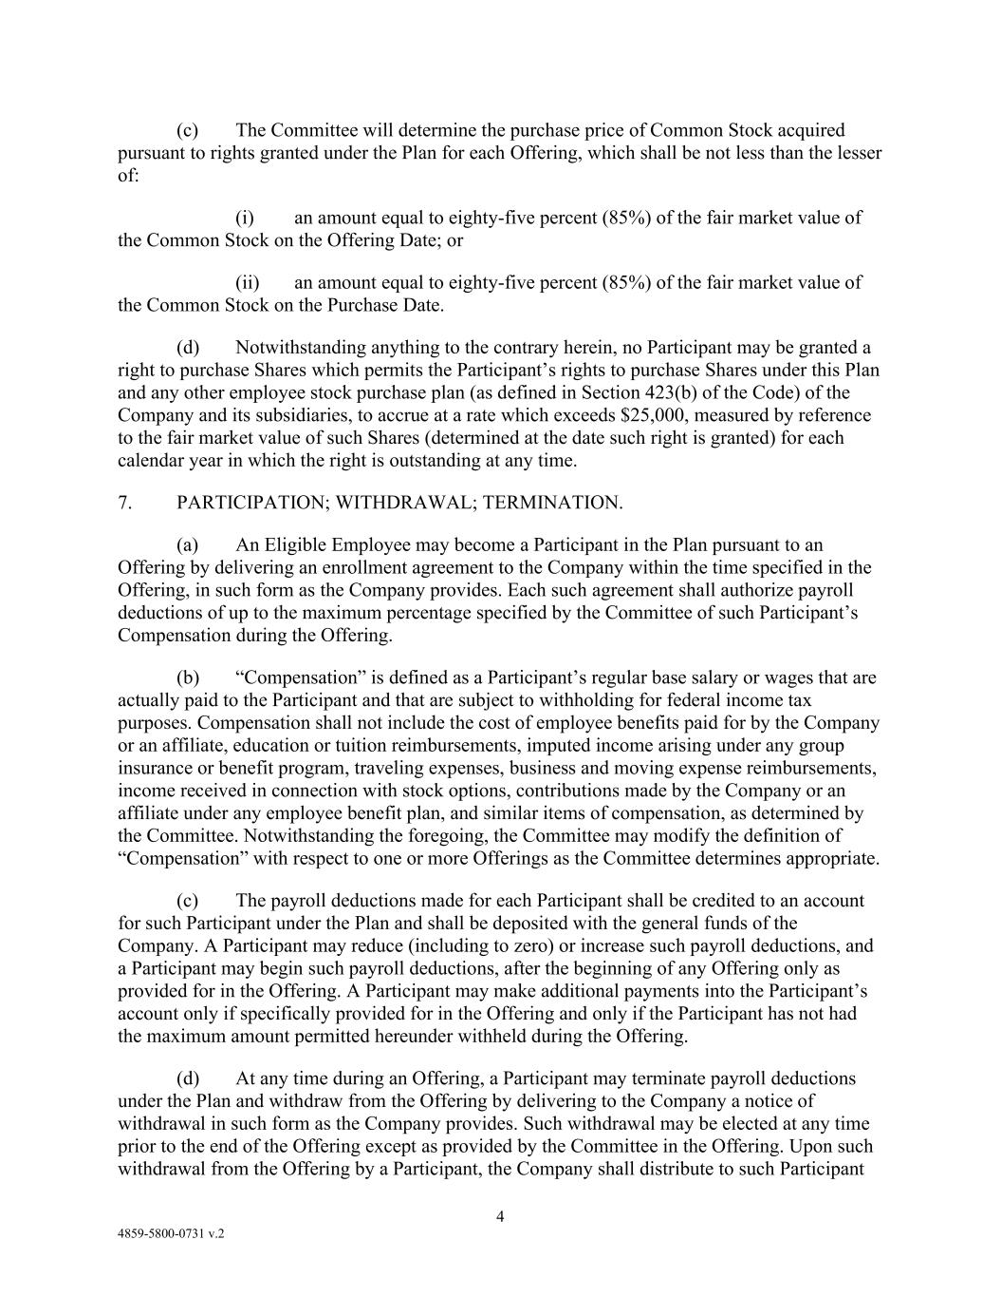
4 4859-5800-0731 v.2 (c) The Committee will determine the purchase price of Common Stock acquired pursuant to rights granted under the Plan for each Offering, which shall be not less than the lesser of: (i) an amount equal to eighty-five percent (85%) of the fair market value of the Common Stock on the Offering Date; or (ii) an amount equal to eighty-five percent (85%) of the fair market value of the Common Stock on the Purchase Date. (d) Notwithstanding anything to the contrary herein, no Participant may be granted a right to purchase Shares which permits the Participant’s rights to purchase Shares under this Plan and any other employee stock purchase plan (as defined in Section 423(b) of the Code) of the Company and its subsidiaries, to accrue at a rate which exceeds $25,000, measured by reference to the fair market value of such Shares (determined at the date such right is granted) for each calendar year in which the right is outstanding at any time. 7. PARTICIPATION; WITHDRAWAL; TERMINATION. (a) An Eligible Employee may become a Participant in the Plan pursuant to an Offering by delivering an enrollment agreement to the Company within the time specified in the Offering, in such form as the Company provides. Each such agreement shall authorize payroll deductions of up to the maximum percentage specified by the Committee of such Participant’s Compensation during the Offering. (b) “Compensation” is defined as a Participant’s regular base salary or wages that are actually paid to the Participant and that are subject to withholding for federal income tax purposes. Compensation shall not include the cost of employee benefits paid for by the Company or an affiliate, education or tuition reimbursements, imputed income arising under any group insurance or benefit program, traveling expenses, business and moving expense reimbursements, income received in connection with stock options, contributions made by the Company or an affiliate under any employee benefit plan, and similar items of compensation, as determined by the Committee. Notwithstanding the foregoing, the Committee may modify the definition of “Compensation” with respect to one or more Offerings as the Committee determines appropriate. (c) The payroll deductions made for each Participant shall be credited to an account for such Participant under the Plan and shall be deposited with the general funds of the Company. A Participant may reduce (including to zero) or increase such payroll deductions, and a Participant may begin such payroll deductions, after the beginning of any Offering only as provided for in the Offering. A Participant may make additional payments into the Participant’s account only if specifically provided for in the Offering and only if the Participant has not had the maximum amount permitted hereunder withheld during the Offering. (d) At any time during an Offering, a Participant may terminate payroll deductions under the Plan and withdraw from the Offering by delivering to the Company a notice of withdrawal in such form as the Company provides. Such withdrawal may be elected at any time prior to the end of the Offering except as provided by the Committee in the Offering. Upon such withdrawal from the Offering by a Participant, the Company shall distribute to such Participant

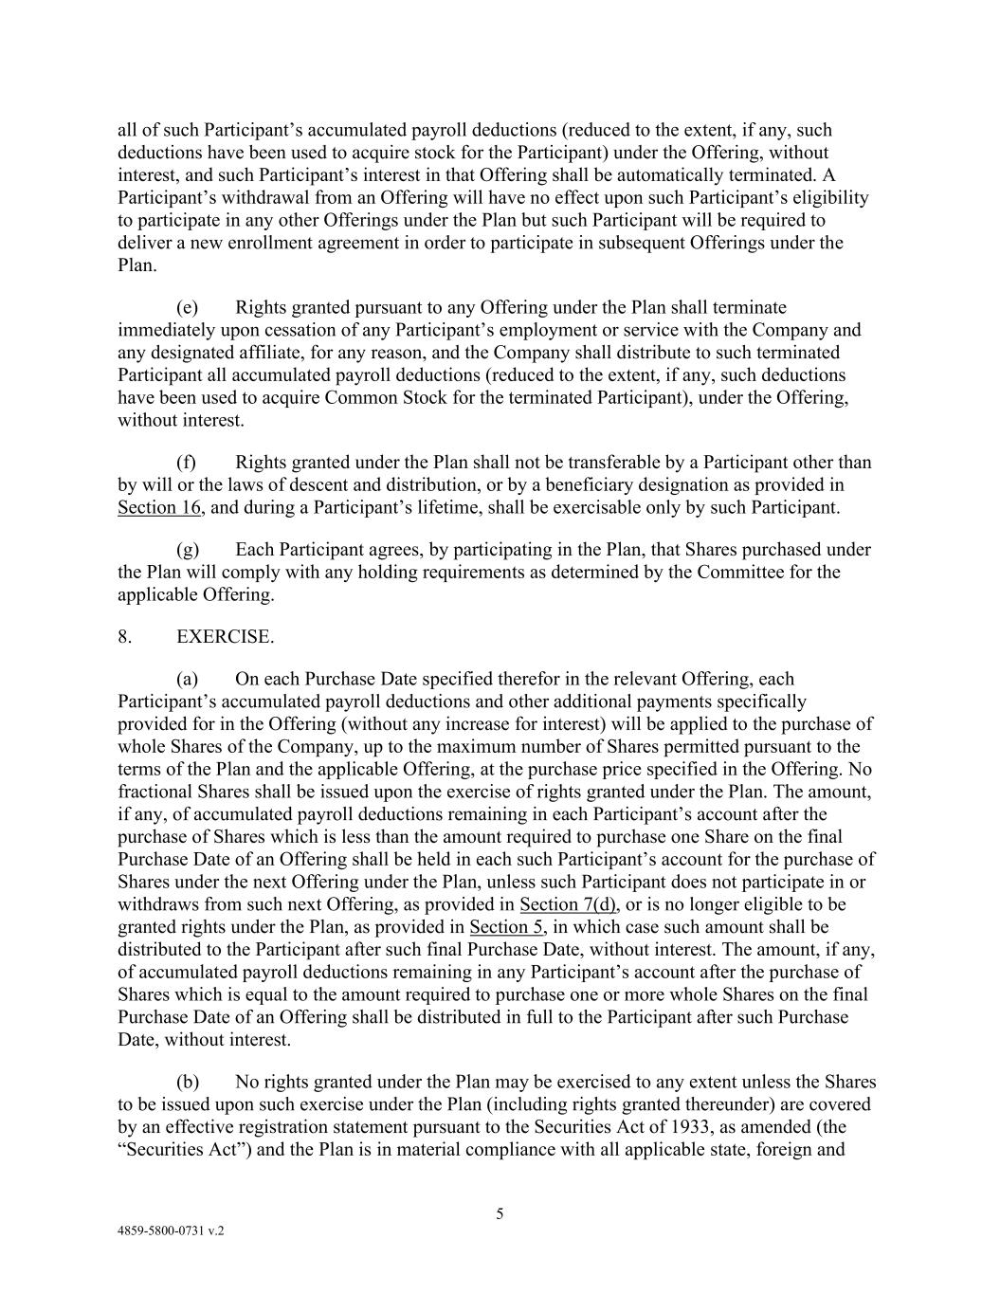
5 4859-5800-0731 v.2 all of such Participant’s accumulated payroll deductions (reduced to the extent, if any, such deductions have been used to acquire stock for the Participant) under the Offering, without interest, and such Participant’s interest in that Offering shall be automatically terminated. A Participant’s withdrawal from an Offering will have no effect upon such Participant’s eligibility to participate in any other Offerings under the Plan but such Participant will be required to deliver a new enrollment agreement in order to participate in subsequent Offerings under the Plan. (e) Rights granted pursuant to any Offering under the Plan shall terminate immediately upon cessation of any Participant’s employment or service with the Company and any designated affiliate, for any reason, and the Company shall distribute to such terminated Participant all accumulated payroll deductions (reduced to the extent, if any, such deductions have been used to acquire Common Stock for the terminated Participant), under the Offering, without interest. (f) Rights granted under the Plan shall not be transferable by a Participant other than by will or the laws of descent and distribution, or by a beneficiary designation as provided in Section 16, and during a Participant’s lifetime, shall be exercisable only by such Participant. (g) Each Participant agrees, by participating in the Plan, that Shares purchased under the Plan will comply with any holding requirements as determined by the Committee for the applicable Offering. 8. EXERCISE. (a) On each Purchase Date specified therefor in the relevant Offering, each Participant’s accumulated payroll deductions and other additional payments specifically provided for in the Offering (without any increase for interest) will be applied to the purchase of whole Shares of the Company, up to the maximum number of Shares permitted pursuant to the terms of the Plan and the applicable Offering, at the purchase price specified in the Offering. No fractional Shares shall be issued upon the exercise of rights granted under the Plan. The amount, if any, of accumulated payroll deductions remaining in each Participant’s account after the purchase of Shares which is less than the amount required to purchase one Share on the final Purchase Date of an Offering shall be held in each such Participant’s account for the purchase of Shares under the next Offering under the Plan, unless such Participant does not participate in or withdraws from such next Offering, as provided in Section 7(d), or is no longer eligible to be granted rights under the Plan, as provided in Section 5, in which case such amount shall be distributed to the Participant after such final Purchase Date, without interest. The amount, if any, of accumulated payroll deductions remaining in any Participant’s account after the purchase of Shares which is equal to the amount required to purchase one or more whole Shares on the final Purchase Date of an Offering shall be distributed in full to the Participant after such Purchase Date, without interest. (b) No rights granted under the Plan may be exercised to any extent unless the Shares to be issued upon such exercise under the Plan (including rights granted thereunder) are covered by an effective registration statement pursuant to the Securities Act of 1933, as amended (the “Securities Act”) and the Plan is in material compliance with all applicable state, foreign and

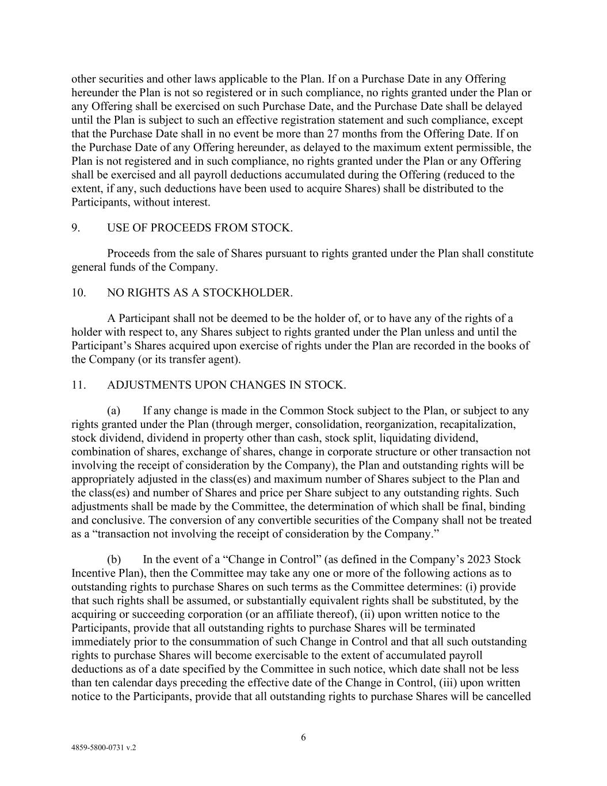
6 4859-5800-0731 v.2 other securities and other laws applicable to the Plan. If on a Purchase Date in any Offering hereunder the Plan is not so registered or in such compliance, no rights granted under the Plan or any Offering shall be exercised on such Purchase Date, and the Purchase Date shall be delayed until the Plan is subject to such an effective registration statement and such compliance, except that the Purchase Date shall in no event be more than 27 months from the Offering Date. If on the Purchase Date of any Offering hereunder, as delayed to the maximum extent permissible, the Plan is not registered and in such compliance, no rights granted under the Plan or any Offering shall be exercised and all payroll deductions accumulated during the Offering (reduced to the extent, if any, such deductions have been used to acquire Shares) shall be distributed to the Participants, without interest. 9. USE OF PROCEEDS FROM STOCK. Proceeds from the sale of Shares pursuant to rights granted under the Plan shall constitute general funds of the Company. 10. NO RIGHTS AS A STOCKHOLDER. A Participant shall not be deemed to be the holder of, or to have any of the rights of a holder with respect to, any Shares subject to rights granted under the Plan unless and until the Participant’s Shares acquired upon exercise of rights under the Plan are recorded in the books of the Company (or its transfer agent). 11. ADJUSTMENTS UPON CHANGES IN STOCK. (a) If any change is made in the Common Stock subject to the Plan, or subject to any rights granted under the Plan (through merger, consolidation, reorganization, recapitalization, stock dividend, dividend in property other than cash, stock split, liquidating dividend, combination of shares, exchange of shares, change in corporate structure or other transaction not involving the receipt of consideration by the Company), the Plan and outstanding rights will be appropriately adjusted in the class(es) and maximum number of Shares subject to the Plan and the class(es) and number of Shares and price per Share subject to any outstanding rights. Such adjustments shall be made by the Committee, the determination of which shall be final, binding and conclusive. The conversion of any convertible securities of the Company shall not be treated as a “transaction not involving the receipt of consideration by the Company.” (b) In the event of a “Change in Control” (as defined in the Company’s 2023 Stock Incentive Plan), then the Committee may take any one or more of the following actions as to outstanding rights to purchase Shares on such terms as the Committee determines: (i) provide that such rights shall be assumed, or substantially equivalent rights shall be substituted, by the acquiring or succeeding corporation (or an affiliate thereof), (ii) upon written notice to the Participants, provide that all outstanding rights to purchase Shares will be terminated immediately prior to the consummation of such Change in Control and that all such outstanding rights to purchase Shares will become exercisable to the extent of accumulated payroll deductions as of a date specified by the Committee in such notice, which date shall not be less than ten calendar days preceding the effective date of the Change in Control, (iii) upon written notice to the Participants, provide that all outstanding rights to purchase Shares will be cancelled

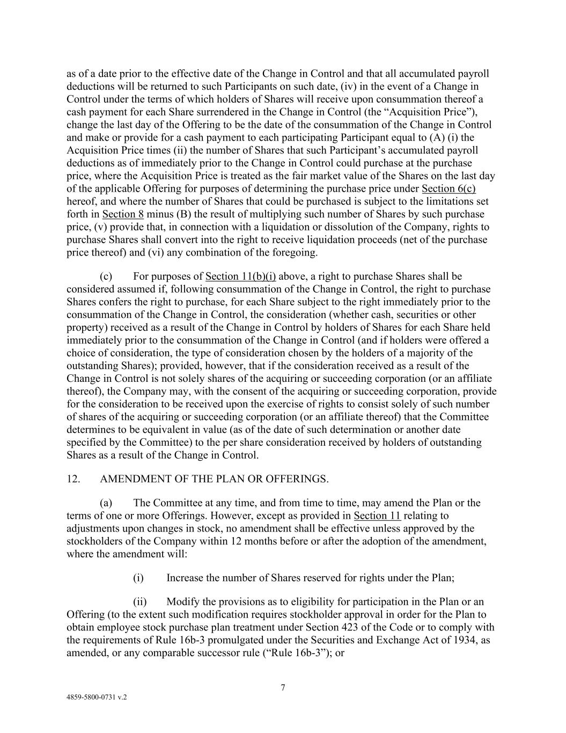
7 4859-5800-0731 v.2 as of a date prior to the effective date of the Change in Control and that all accumulated payroll deductions will be returned to such Participants on such date, (iv) in the event of a Change in Control under the terms of which holders of Shares will receive upon consummation thereof a cash payment for each Share surrendered in the Change in Control (the “Acquisition Price”), change the last day of the Offering to be the date of the consummation of the Change in Control and make or provide for a cash payment to each participating Participant equal to (A) (i) the Acquisition Price times (ii) the number of Shares that such Participant’s accumulated payroll deductions as of immediately prior to the Change in Control could purchase at the purchase price, where the Acquisition Price is treated as the fair market value of the Shares on the last day of the applicable Offering for purposes of determining the purchase price under Section 6(c) hereof, and where the number of Shares that could be purchased is subject to the limitations set forth in Section 8 minus (B) the result of multiplying such number of Shares by such purchase price, (v) provide that, in connection with a liquidation or dissolution of the Company, rights to purchase Shares shall convert into the right to receive liquidation proceeds (net of the purchase price thereof) and (vi) any combination of the foregoing. (c) For purposes of Section 11(b)(i) above, a right to purchase Shares shall be considered assumed if, following consummation of the Change in Control, the right to purchase Shares confers the right to purchase, for each Share subject to the right immediately prior to the consummation of the Change in Control, the consideration (whether cash, securities or other property) received as a result of the Change in Control by holders of Shares for each Share held immediately prior to the consummation of the Change in Control (and if holders were offered a choice of consideration, the type of consideration chosen by the holders of a majority of the outstanding Shares); provided, however, that if the consideration received as a result of the Change in Control is not solely shares of the acquiring or succeeding corporation (or an affiliate thereof), the Company may, with the consent of the acquiring or succeeding corporation, provide for the consideration to be received upon the exercise of rights to consist solely of such number of shares of the acquiring or succeeding corporation (or an affiliate thereof) that the Committee determines to be equivalent in value (as of the date of such determination or another date specified by the Committee) to the per share consideration received by holders of outstanding Shares as a result of the Change in Control. 12. AMENDMENT OF THE PLAN OR OFFERINGS. (a) The Committee at any time, and from time to time, may amend the Plan or the terms of one or more Offerings. However, except as provided in Section 11 relating to adjustments upon changes in stock, no amendment shall be effective unless approved by the stockholders of the Company within 12 months before or after the adoption of the amendment, where the amendment will: (i) Increase the number of Shares reserved for rights under the Plan; (ii) Modify the provisions as to eligibility for participation in the Plan or an Offering (to the extent such modification requires stockholder approval in order for the Plan to obtain employee stock purchase plan treatment under Section 423 of the Code or to comply with the requirements of Rule 16b-3 promulgated under the Securities and Exchange Act of 1934, as amended, or any comparable successor rule (“Rule 16b-3”); or

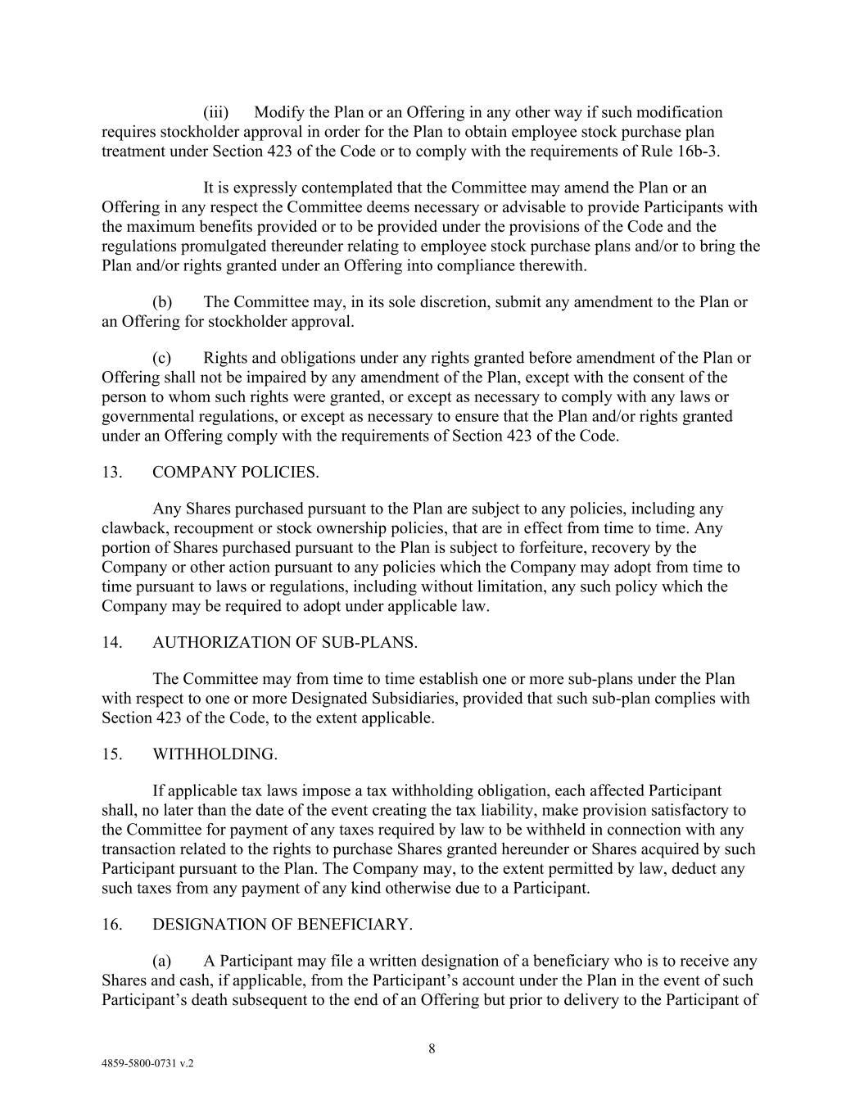
8 4859-5800-0731 v.2 (iii) Modify the Plan or an Offering in any other way if such modification requires stockholder approval in order for the Plan to obtain employee stock purchase plan treatment under Section 423 of the Code or to comply with the requirements of Rule 16b-3. It is expressly contemplated that the Committee may amend the Plan or an Offering in any respect the Committee deems necessary or advisable to provide Participants with the maximum benefits provided or to be provided under the provisions of the Code and the regulations promulgated thereunder relating to employee stock purchase plans and/or to bring the Plan and/or rights granted under an Offering into compliance therewith. (b) The Committee may, in its sole discretion, submit any amendment to the Plan or an Offering for stockholder approval. (c) Rights and obligations under any rights granted before amendment of the Plan or Offering shall not be impaired by any amendment of the Plan, except with the consent of the person to whom such rights were granted, or except as necessary to comply with any laws or governmental regulations, or except as necessary to ensure that the Plan and/or rights granted under an Offering comply with the requirements of Section 423 of the Code. 13. COMPANY POLICIES. Any Shares purchased pursuant to the Plan are subject to any policies, including any clawback, recoupment or stock ownership policies, that are in effect from time to time. Any portion of Shares purchased pursuant to the Plan is subject to forfeiture, recovery by the Company or other action pursuant to any policies which the Company may adopt from time to time pursuant to laws or regulations, including without limitation, any such policy which the Company may be required to adopt under applicable law. 14. AUTHORIZATION OF SUB-PLANS. The Committee may from time to time establish one or more sub-plans under the Plan with respect to one or more Designated Subsidiaries, provided that such sub-plan complies with Section 423 of the Code, to the extent applicable. 15. WITHHOLDING. If applicable tax laws impose a tax withholding obligation, each affected Participant shall, no later than the date of the event creating the tax liability, make provision satisfactory to the Committee for payment of any taxes required by law to be withheld in connection with any transaction related to the rights to purchase Shares granted hereunder or Shares acquired by such Participant pursuant to the Plan. The Company may, to the extent permitted by law, deduct any such taxes from any payment of any kind otherwise due to a Participant. 16. DESIGNATION OF BENEFICIARY. (a) A Participant may file a written designation of a beneficiary who is to receive any Shares and cash, if applicable, from the Participant’s account under the Plan in the event of such Participant’s death subsequent to the end of an Offering but prior to delivery to the Participant of

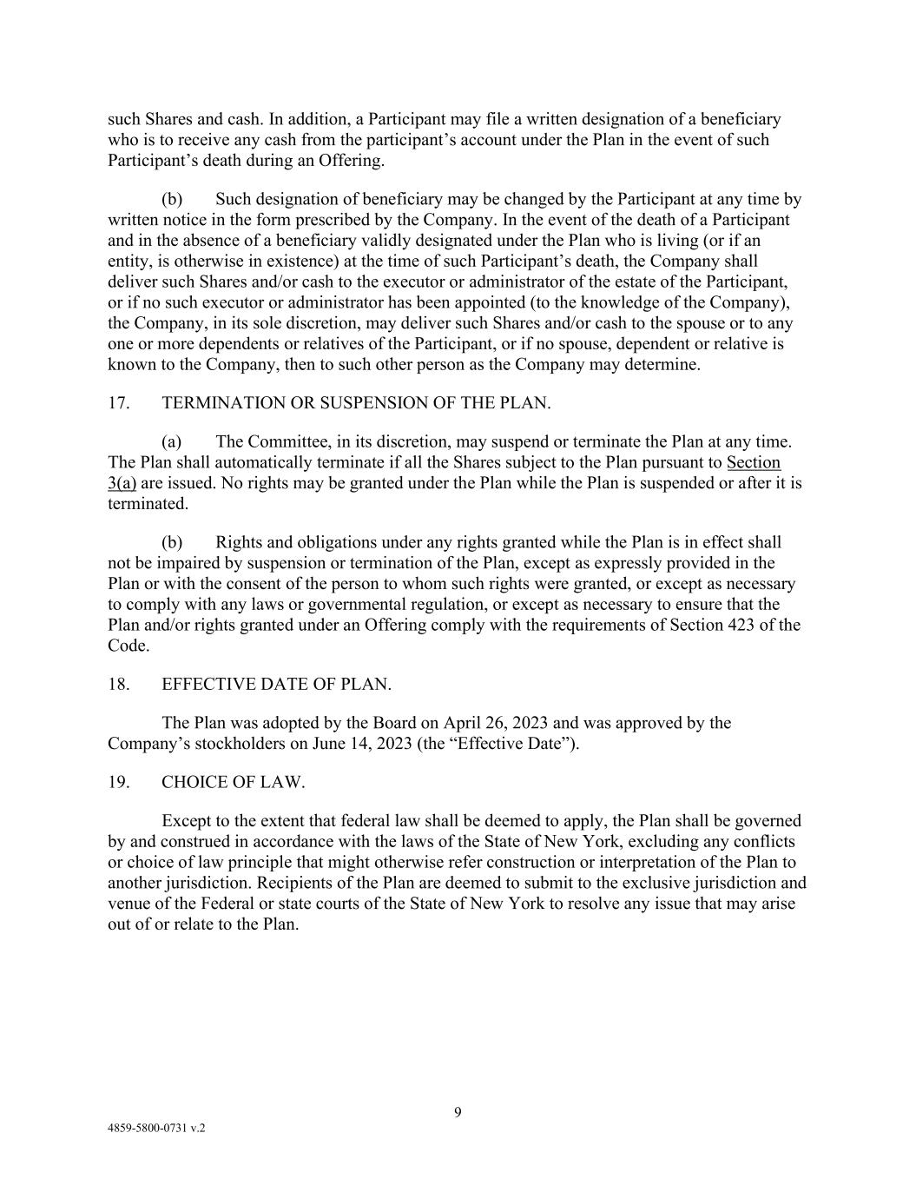
9 4859-5800-0731 v.2 such Shares and cash. In addition, a Participant may file a written designation of a beneficiary who is to receive any cash from the participant’s account under the Plan in the event of such Participant’s death during an Offering. (b) Such designation of beneficiary may be changed by the Participant at any time by written notice in the form prescribed by the Company. In the event of the death of a Participant and in the absence of a beneficiary validly designated under the Plan who is living (or if an entity, is otherwise in existence) at the time of such Participant’s death, the Company shall deliver such Shares and/or cash to the executor or administrator of the estate of the Participant, or if no such executor or administrator has been appointed (to the knowledge of the Company), the Company, in its sole discretion, may deliver such Shares and/or cash to the spouse or to any one or more dependents or relatives of the Participant, or if no spouse, dependent or relative is known to the Company, then to such other person as the Company may determine. 17. TERMINATION OR SUSPENSION OF THE PLAN. (a) The Committee, in its discretion, may suspend or terminate the Plan at any time. The Plan shall automatically terminate if all the Shares subject to the Plan pursuant to Section 3(a) are issued. No rights may be granted under the Plan while the Plan is suspended or after it is terminated. (b) Rights and obligations under any rights granted while the Plan is in effect shall not be impaired by suspension or termination of the Plan, except as expressly provided in the Plan or with the consent of the person to whom such rights were granted, or except as necessary to comply with any laws or governmental regulation, or except as necessary to ensure that the Plan and/or rights granted under an Offering comply with the requirements of Section 423 of the Code. 18. EFFECTIVE DATE OF PLAN. The Plan was adopted by the Board on April 26, 2023 and was approved by the Company’s stockholders on June 14, 2023 (the “Effective Date”). 19. CHOICE OF LAW. Except to the extent that federal law shall be deemed to apply, the Plan shall be governed by and construed in accordance with the laws of the State of New York, excluding any conflicts or choice of law principle that might otherwise refer construction or interpretation of the Plan to another jurisdiction. Recipients of the Plan are deemed to submit to the exclusive jurisdiction and venue of the Federal or state courts of the State of New York to resolve any issue that may arise out of or relate to the Plan.

Exhibit 31.1
CERTIFICATION PURSUANT TO 18 U.S.C. SECTION 1350,
AS ADOPTED PURSUANT TO SECTION 302 OF THE
SARBANES-OXLEY ACT OF 2002
I, Barry Sloane, certify that:
1. I have reviewed this quarterly report on Form 10-Q of NewtekOne, Inc. (the “registrant”).
2. Based on my knowledge, this report does not contain any untrue statement of a material fact or omit to state a material fact necessary to make the statements made, in light of the circumstances under which such statements were made, not misleading with respect to the period covered by this report;
3. Based on my knowledge, the financial statements, and other financial information included in this report, fairly present in all material respects the financial condition, results of operations and cash flows of the registrant as of, and for, the periods presented in this annual report;
4. The registrant’s other certifying officer and I are responsible for establishing and maintaining disclosure controls and procedures (as defined in Exchange Act Rules 13a-15(e) and 15d-15(e)) and internal control over financial reporting (as defined in Exchange Act Rules 13a-15(f) and 15d-15(f) for the registrant and have:
a) designed such disclosure controls and procedures, or caused such disclosure controls and procedures to be designed under our supervision, to ensure that material information relating to the registrant, including its consolidated subsidiaries, is made known to us by others within those entities, particularly during the period in which this report is being prepared;
b) designed such internal control over financial reporting, or caused such internal control over financial reporting to be designed under our supervision, to provide reasonable assurance regarding the reliability of financial reporting and the preparation of financial statements for external purposes in accordance with generally accepted accounting principles;
c) evaluated the effectiveness of the registrant’s disclosure controls and procedures and presented in this report our conclusions about the effectiveness of the disclosure controls and procedures, as of the end of the period covered by this report based on such evaluation; and
d) disclosed in this report any change in the registrant’s internal control over financial reporting that occurred during the registrant’s most recent fiscal quarter (the registrant’s fourth fiscal quarter in the case of an annual report) that has materially affected, or is reasonably likely to materially affect, the registrant’s internal control over financial reporting.
5. The registrant’s other certifying officer and I have disclosed, based on our most recent evaluation of internal control over financial reporting, to the registrant’s auditors and the audit committee of the registrant’s board of directors (or persons performing the equivalent functions):
a) all significant deficiencies and material weaknesses in the design or operation of internal control over financial reporting which are reasonably likely to adversely affect the registrant’s ability to record, process, summarize and report financial information; and
b) any fraud, whether or not material, that involves management or other employees who have a significant role in the registrant’s internal control over financial reporting.

Date: August 7, 2023 |  |  | /S/ BARRY SLOANE
 |  |  | Barry Sloane
 |  |  | Principal Executive Officer

Exhibit 31.2
CERTIFICATION PURSUANT TO 18 U.S.C. SECTION 1350,
AS ADOPTED PURSUANT TO SECTION 302 OF THE
SARBANES-OXLEY ACT OF 2002
I, Nicholas Leger, certify that:
1. I have reviewed this quarterly report on Form 10-Q of NewtekOne, Inc. (the “registrant”).
2. Based on my knowledge, this report does not contain any untrue statement of a material fact or omit to state a material fact necessary to make the statements made, in light of the circumstances under which such statements were made, not misleading with respect to the period covered by this annual report;
3. Based on my knowledge, the financial statements, and other financial information included in this report, fairly present in all material respects the financial condition, results of operations and cash flows of the registrant as of, and for, the periods presented in this report;
4. The registrant’s other certifying officer and I are responsible for establishing and maintaining disclosure controls and procedures (as defined in Exchange Act Rules 13a-15(e) and 15d-15(e)) and internal control over financial reporting (as defined in Exchange Act Rules 13a-15(f) and 15d-15(f) for the registrant and have:
a) designed such disclosure controls and procedures, or caused such disclosure controls and procedures to be designed under our supervision, to ensure that material information relating to the registrant, including its consolidated subsidiaries, is made known to us by others within those entities, particularly during the period in which this report is being prepared;
b) designed such internal control over financial reporting, or caused such internal control over financial reporting to be designed under our supervision, to provide reasonable assurance regarding the reliability of financial reporting and the preparation of financial statements for external purposes in accordance with generally accepted accounting principles;
c) evaluated the effectiveness of the registrant’s disclosure controls and procedures and presented in this report our conclusions about the effectiveness of the disclosure controls and procedures, as of the end of the period covered by this report based on such evaluation; and
d) disclosed in this report any change in the registrant’s internal control over financial reporting that occurred during the registrant’s most recent fiscal quarter (the registrant’s fourth fiscal quarter in the case of an annual report) that has materially affected, or is reasonably likely to materially affect, the registrant’s internal control over financial reporting.
5. The registrant’s other certifying officer and I have disclosed, based on our most recent evaluation of internal control over financial reporting, to the registrant’s auditors and the audit committee of the registrant’s board of directors (or persons performing the equivalent functions):
a) all significant deficiencies and material weaknesses in the design or operation of internal control over financial reporting which are reasonably likely to adversely affect the registrant’s ability to record, process, summarize and report financial information; and
b) any fraud, whether or not material, that involves management or other employees who have a significant role in the registrant’s internal control over financial reporting.

Date: August 7, 2023 |  |  | /S/ NICHOLAS LEGER
 |  |  | Nicholas Leger
 |  |  | Principal Financial Officer

Exhibit 32.1
CERTIFICATION PURSUANT TO 18 U.S.C. SECTION 1350,
AS ADOPTED PURSUANT TO
SECTION 906 OF THE SARBANES-OXLEY ACT OF 2002

In connection with the Quarterly Report on Form 10-Q for the period ended June 30, 2023 (the “Report”) of NewtekOne Inc.(the “Company”), as filed with the Securities and Exchange Commission on the date hereof, I, Barry Sloane, as Principal Executive Officer of the Company, certify, pursuant to 18 U.S.C. §1350, as adopted pursuant to §906 of the Sarbanes-Oxley Act of 2002, that, to the best of my knowledge:
(1) The Report fully complies with the requirements of Section 13(a) or 15(d) of the Securities Exchange Act of 1934; and
(2) The information contained in the Report fairly presents, in all material respects, the financial condition and results of the operations of the Company.

Date: August 7, 2023 |  |  | /S/ BARRY SLOANE
 |  |  | Barry Sloane,
 |  |  | Principal Executive Officer

Exhibit 32.2
CERTIFICATION PURSUANT TO 18 U.S.C. SECTION 1350,
AS ADOPTED PURSUANT TO
SECTION 906 OF THE SARBANES-OXLEY ACT OF 2002

In connection with the Quarterly Report on Form 10-Q for the period ended June 30, 2023 (the “Report”) of NewtekOne, Inc. (the “Company”), as filed with the Securities and Exchange Commission on the date hereof, I, Nicholas Leger, as Principal Financial Officer of the Company, hereby certify pursuant to 18 U.S.C. §1350, as adopted pursuant to §906 of the Sarbanes-Oxley Act of 2002, that, to the best of my knowledge:
(1) The Report fully complies with the requirements of Section 13(a) or 15(d) of the Securities Exchange Act of 1934; and
(2) The information contained in the Report fairly presents, in all material respects, the financial condition and results of the operations of the Company.

Date: August 7, 2023 |  |  | /S/ NICHOLAS LEGER
 |  |  | Nicholas Leger,
 |  |  | Principal Financial Officer

