UNITED STATES
SECURITIES AND EXCHANGE COMMISSION
Washington, D.C. 20549
 | FORM 10-Q
☒ QUARTERLY REPORT PURSUANT TO SECTION 13 OR 15(d) OF THE SECURITIES EXCHANGE ACT OF 1934
For the quarterly period ended March 31, 2025
OR
o TRANSITION REPORT PURSUANT TO SECTION 13 OR 15(d) OF THE SECURITIES EXCHANGE ACT OF 1934
For the transition period from _____to_____
Commission file number: 814-01035
NEWTEKONE, INC.
(Exact name of registrant as specified in its charter)
Maryland |  |  | 46-3755188
(State or other jurisdiction of incorporation or organization) |  |  | (I.R.S. Employer Identification No.)
4800 T Rex Avenue, Suite 120, Boca Raton, Florida |  |  | 33431
(Address of principal executive offices) |  |  | (Zip Code)
 | (212) 356-9500
(Registrant’s telephone number, including area code)

Not Applicable

(Former name, former address and former fiscal year, if changed since last report)

Securities registered pursuant to Section 12(b) of the Act:

Title of each class |  | Trading Symbol(s) |  | Name of each exchange on which registered
Common Stock, par value $0.02 per share |  | NEWT |  | Nasdaq Global Market LLC
5.50% Notes due 2026 |  | NEWTZ |  | Nasdaq Global Market LLC
8.00% Notes due 2028 |  | NEWTI |  | Nasdaq Global Market LLC
8.50% Notes due 2029 |  | NEWTG |  | Nasdaq Global Market LLC
8.625% Notes due 2029 |  | NEWTH |  | Nasdaq Global Market LLC

Indicate by check mark whether the registrant: (1) has filed all reports required to be filed by Section 13 or 15(d) of the Securities Exchange Act of 1934 during the past 12 months (or for such shorter period that the registrant was required to file such reports), and (2) has been subject to such filing requirements for the past 90 days. Yes x No ☐

Indicate by check mark whether the registrant has submitted electronically every Interactive Data File required to be submitted pursuant to Rule 405 of Regulation S-T (Section 232.405 of this chapter) during the preceding 12 months (or for such shorter period that the registrant was required to submit and post such files). Yes x No ☐

Indicate by check mark whether the registrant is a large accelerated filer, an accelerated filer, a non-accelerated filer, a smaller reporting company or an emerging growth company. See definitions of “large accelerated filer,” “accelerated filer,” “smaller reporting company,” and “emerging growth company” in Rule 12b-2 of the Exchange Act.

Large accelerated filer | o | Accelerated Filer | x
Non-accelerated filer | o | Smaller reporting company | o
 |  | Emerging growth company | o

If an emerging growth company, indicate by check mark if the registrant has elected not to use the extended transition period for complying with any new or revised financial or accounting standards provided pursuant to Section 13(a) of the Exchange Act. o

Indicate by check mark whether the registrant is a shell company (as defined in Rule 12b-2 of the Exchange Act). Yes ☐ No x

As of May 9, 2025, there were 26,342,027 shares outstanding of the registrant’s Common Stock, par value $0.02 per share.

TABLE OF CONTENTS

 |  |  |  |  |  |  |  |  |  |  |  |  |  |  |  |  |  |  |  |  |  |  |  |  |  |  |  |  |  | Page
 | Defined Terms |  |  |  |  |  |  |  |  |  |  |  |  |  |  |  |  |  |  |  |  |  |  |  |  |  |  |  |  |  | 4
 |  |  |  |  |  |  |  |  |  |  | PART I - FINANCIAL INFORMATION
Item 1. | Financial Statements:
 | Consolidated Statements of Financial Condition as of March 31, 2025 (Unaudited) and December 31, 2024 |  |  |  |  |  |  |  |  |  |  |  |  |  |  |  |  |  |  |  |  |  |  |  |  |  |  |  |  | 6
 | Consolidated Statements of Income for the three months ended March 31, 2025 and 2024 (Unaudited) |  |  |  |  |  |  |  |  |  |  |  |  |  |  |  |  |  |  |  |  |  |  |  |  |  |  |  |  | 7
 | Consolidated Statements of Comprehensive Income for the three months ended March 31, 2025 and 2024 (Unaudited) |  |  |  |  |  |  |  |  |  |  |  |  |  |  |  |  |  |  |  |  |  |  |  |  |  |  |  |  | 8
 | Consolidated Statements of Changes in Shareholders’ Equity for the three months ended March 31, 2025 and 2024 (Unaudited) |  |  |  |  |  |  |  |  |  |  |  |  |  |  |  |  |  |  |  |  |  |  |  |  |  |  |  |  | 9
 | Consolidated Statements of Cash Flows for the three months ended March 31, 2025 and 2024 (Unaudited) |  |  |  |  |  |  |  |  |  |  |  |  |  |  |  |  |  |  |  |  |  |  |  |  |  |  |  |  | 11
 | Notes to Consolidated Financial Statements (Unaudited) |  |  |  |  |  |  |  |  |  |  |  |  |  |  |  |  |  |  |  |  |  |  |  |  |  |  |  |  | 13
Item 2. | Management’s Discussion and Analysis of Financial Condition and Results of Operations |  |  |  |  |  |  |  |  |  |  |  |  |  |  |  |  |  |  |  |  |  |  |  |  |  |  |  |  | 52
Item 3. | Quantitative and Qualitative Disclosures About Market Risk |  |  |  |  |  |  |  |  |  |  |  |  |  |  |  |  |  |  |  |  |  |  |  |  |  |  |  |  | 83
Item 4. | Controls and Procedures |  |  |  |  |  |  |  |  |  |  |  |  |  |  |  |  |  |  |  |  |  |  |  |  |  |  |  |  | 85
 |  |  |  |  |  |  |  |  |  |  |  | PART II - OTHER INFORMATION
Item 1. | Legal Proceedings |  |  |  |  |  |  |  |  |  |  |  |  |  |  |  |  |  |  |  |  |  |  |  |  |  |  |  |  | 87
Item 1A. | Risk Factors |  |  |  |  |  |  |  |  |  |  |  |  |  |  |  |  |  |  |  |  |  |  |  |  |  |  |  |  | 87
Item 2. | Unregistered Sales of Equity Securities and Use of Proceeds |  |  |  |  |  |  |  |  |  |  |  |  |  |  |  |  |  |  |  |  |  |  |  |  |  |  |  |  | 87
Item 3. | Defaults Upon Senior Securities |  |  |  |  |  |  |  |  |  |  |  |  |  |  |  |  |  |  |  |  |  |  |  |  |  |  |  |  | 87
Item 4. | Mine Safety Disclosures |  |  |  |  |  |  |  |  |  |  |  |  |  |  |  |  |  |  |  |  |  |  |  |  |  |  |  |  | 87
Item 5. | Other Information |  |  |  |  |  |  |  |  |  |  |  |  |  |  |  |  |  |  |  |  |  |  |  |  |  |  |  |  | 87
Item 6. | Exhibits |  |  |  |  |  |  |  |  |  |  |  |  |  |  |  |  |  |  |  |  |  |  |  |  |  |  |  |  | 88
 | Signatures |  |  |  |  |  |  |  |  |  |  |  |  |  |  |  |  |  |  |  |  |  |  |  |  |  |  |  |  | 89

Defined Terms

We have used “we,” “us,” “our,” “our company,” and “the Company” to refer to NewtekOne, Inc. and its subsidiaries in this report. We also have used several other terms in this report, which are explained or defined below:
Terms
1940 | Act | Investment Company Act of 1940, as amended
2017-1 Trust |  | Newtek Small Business Loan Trust, Series 2017-1, terminated in February 2023
2018-1 Trust |  | Newtek Small Business Loan Trust, Series 2018-1, terminated in October 2024
2019-1 Trust |  | Newtek Small Business Loan Trust, Series 2019-1, terminated in October 2024
2021-1 Trust |  | Newtek Small Business Loan Trust, Series 2021-1
2022-1 Trust |  | Newtek Small Business Loan Trust, Series 2022-1
2023-1 Trust |  | Newtek Small Business Loan Trust, Series 2023-1
2024 | Notes | 5.75% Notes due 2024, matured August 1, 2024
2025 | 5.00% Notes | 5.00% Notes due 2025, matured March 31, 2025
2025 | 8.125% Notes | 8.125% Notes due 2025, exchanged for 2027 Notes
2025 | Notes | Collectively, the 2025 5.00% Notes and 2025 8.125% Notes
2026 | Notes | 5.50% Notes due 2026
2027 | Notes | 8.125% Notes due 2027
2028 | Notes | 8.00% Notes due 2028
2029 | 8.50% Notes | 8.50% Notes due 2029
2029 | 8.625% Notes | 8.625% Notes due 2029
2030 | Notes | 8.375% Notes due 2030
2029 | Notes | Collectively, the 2029 8.50% Notes and 2029 8.625% Notes
ABL |  | Asset based lending
ACL |  | Allowance for credit losses
Acquisition |  | The Company’s Acquisition of NBNYC, pursuant to which the Company acquired from the NBNYC shareholders all of the issued and
 |  | outstanding stock of NBNYC
ALP |  | Alternative Lending Program
ASC |  | Accounting Standards Codification, as issued by the FASB
ASU |  | Accounting Standards Updates, as issued by the FASB
ATM Equity Distribution Agreement |  | Equity Distribution Agreement, dated November 17, 2023, by and among the Company and the placement agents
BDC |  | Business Development Company under the 1940 Act
BHCA |  | Bank Holding Company Act of 1956
Board |  | The Company's board of directors
Capital One |  | Capital One Bank, National Association
C&I |  | Conventional commercial and industrial loans
Code |  | Internal Revenue Code of 1986, as amended
CODM |  | Chief Operating Decision Maker
CRE |  | Commercial real estate
Deutsche Bank |  | Deutsche Bank AG
DRIP |  | The Company's former dividend reinvestment plan
EBITDA |  | Earnings before interest, taxes, depreciation and amortization
2015 | Stock Incentive Plan | The Company's 2015 Stock Incentive Plan
2023 | Stock Incentive Plan | The Company’s 2023 Stock Incentive Plan
ESPP |  | Employee Stock Purchase Program
Exchange Act |  | Securities Exchange Act of 1934, as amended
FASB |  | Financial Accounting Standards Board
Federal Reserve |  | Board of Governors of the Federal Reserve System
FDIC |  | Federal Deposit Insurance Corporation
 |  | 4

FV | Fair Value
HFI | Held for investment
HFS | Held for sale
LCM | Lower of amortized cost basis or fair value
LTV | Loan-to-Value
NAV | Net Asset Value
NBNYC | National Bank of New York City, which has been renamed Newtek Bank, National Association
NOO | Non-owner occupied
OCC | Office of the Comptroller of the Currency
PCD | Purchased Financial Assets with Credit Deterioration
PLP | Preferred Lenders Program, as authorized by the SBA
PPP | Paycheck Protection Program
RIC | Regulated investment company under the Code
S&P | Standard and Poor's
SBA | United States Small Business Administration
SEC | U.S. Securities and Exchange Commission
SMB | Small-and-medium sized businesses; revenue from $1.0 million to $100.0 million
SOFR | Secured Overnight Financing Rate
SPV I Capital One Facility | Revolving Credit and Security Agreement between NBL SPV I, LLC, a wholly-owned subsidiary of NALH, and Capital One
SPV II Deutsche Bank Facility | Revolving Credit and Security Agreement between NBL SPV II, LLC, a wholly-owned subsidiary of NALH, and Deutsche Bank
SPV III One Florida Bank Facility | Revolving Credit and Security Agreement between NBL SPV III, LLC, a wholly-owned subsidiary of NALH, and One Florida Bank
Trustee | U.S. Bank, National Association
TSO II | TSO II Booster Aggregator, L.P.
U.S. GAAP or GAAP | Generally accepted accounting principles in the United States
Webster | Webster Bank, N.A.
Consolidated Subsidiaries
NSBF | Newtek Small Business Finance, LLC
NBL | Newtek Business Lending, LLC, a former wholly-owned subsidiary of Newtek Bank, merged into SBL on May 2, 2023
NCL | Newtek Commercial Lending, Inc.
Newtek Bank | Newtek Bank, National Association
NALH or Newtek ALP Holdings | Newtek Business Services Holdco 6, Inc.
NMS | Newtek Merchant Solutions, LLC, a wholly-owned subsidiary of NBC
Mobil Money | Mobil Money, LLC, a wholly-owned subsidiary of NMS
NTS | Newtek Technology Solutions, Inc.
NBC | CDS Business Services, Inc. dba Newtek Business Credit Solutions
SBL | Small Business Lending, LLC, a wholly-owned subsidiary of Newtek Bank
PMT | PMTWorks Payroll, LLC, dba Newtek Payroll and Benefits Solutions
NIA | Newtek Insurance Agency, LLC
TAM | Titanium Asset Management, LLC
POS | POS on Cloud, LLC, dba Newtek Payment Systems, an 88.34% owned consolidated subsidiary
Joint Ventures and Non-Control Investments
NCL JV | Newtek Conventional Lending, LLC, a 50% owned joint venture
TSO JV | Newtek-TSO II Conventional Credit Partners, LP, a 50% owned joint venture
IPM | Intelligent Protection Management Corp.
IPM Preferred Stock | 4.0 million shares of IPM Series A Non-Voting Common Equivalent Stock
 | 5

Table of Contents
 |  | PART I—FINANCIAL INFORMATION
ITEM 1. FINANCIAL STATEMENTS.
 |  | NEWTEKONE, INC. AND SUBSIDIARIES
 |  | CONSOLIDATED STATEMENTS OF FINANCIAL CONDITION
 |  | (In Thousands, except for Per Share Data) |  | March 31, 2025 |  |  | December 31, 2024
 |  | ASSETS
 |  | ASSETS |  | (Unaudited)
 | Cash and due from banks |  | $ | 10,201 |  | $ | 6,941
 | Restricted cash |  |  | 24,151 |  |  | 28,226
 | Interest bearing deposits in banks |  |  | 259,782 |  |  | 346,207
 | Total cash and cash equivalents |  |  | 294,134 |  |  | 381,374
 | Debt securities available-for-sale, at fair value |  |  | 14,127 |  |  | 23,916
 | Loans held for sale, at fair value |  |  | 547,958 |  |  | 372,286
 | Loans held for sale, at LCM |  |  | 35,849 |  |  | 58,803
 | Loans held for investment, at fair value |  |  | 346,794 |  |  | 369,746
 | Loans held for investment, at amortized cost, net of deferred fees and costs |  |  | 711,166 |  |  | 621,651
 | Allowance for credit losses |  |  | (38,649) |  |  | (30,233)
 | Loans held for investment, at amortized cost, net |  |  | 672,517 |  |  | 591,418
 | Federal Home Loan Bank and Federal Reserve Bank stock |  |  | 3,862 |  |  | 3,585
 | Settlement receivable |  |  | 6,089 |  |  | 52,465
 | Joint ventures and other non-control investments, at fair value (cost of $54,493 and $44,039), respectively |  |  | 69,242 |  |  | 57,678
 | Goodwill and intangibles |  |  | 14,711 |  |  | 14,752
 | Right of use assets |  |  | 5,268 |  |  | 5,688
 | Servicing assets, at fair value |  |  | 20,215 |  |  | 22,062
 | Servicing assets, at LCM |  |  | 24,410 |  |  | 24,195
 | Other assets |  |  | 81,561 |  |  | 60,636
 | Assets held for sale |  |  | — |  |  | 21,308
 | Total assets |  | $ | 2,136,737 |  | $ | 2,059,912
 |  | LIABILITIES AND SHAREHOLDERS’ EQUITY
 | Liabilities:
 | Deposits:
 | Noninterest-bearing |  | $ | 11,920 |  | $ | 11,142
 | Interest-bearing |  |  | 954,401 |  |  | 961,910
 | Total deposits |  |  | 966,321 |  |  | 973,052
 | Borrowings |  |  | 773,991 |  |  | 708,041
 | Dividends payable |  |  | 5,235 |  |  | 5,233
 | Lease liabilities |  |  | 6,012 |  |  | 6,498
 | Deferred tax liabilities, net |  |  | 5,041 |  |  | 2,244
 | Due to participants |  |  | 35,580 |  |  | 21,532
 | Accounts payable, accrued expenses and other liabilities |  |  | 42,277 |  |  | 40,806
 | Liabilities directly associated with assets held for sale |  |  | — |  |  | 6,224
 | Total liabilities |  |  | 1,834,457 |  |  | 1,763,630
 | Commitment and contingencies (Note 12)
 | Shareholders' Equity:
 | Preferred stock (par value $0.02 per share; 20 authorized, 20 issued and outstanding) |  |  | 19,738 |  |  | 19,738
 | Common stock (par value $0.02 per share; 199,980 authorized, 26,342 and 24,680 issued and outstanding, respectively) |  |  | 527 |  |  | 526
 | Additional paid-in capital |  |  | 220,468 |  |  | 218,266
 | Retained earnings |  |  | 61,538 |  |  | 57,773
 | Accumulated other comprehensive income (loss), net of income taxes |  |  | 9 |  |  | (21)
 | Total shareholders' equity |  |  | 302,280 |  |  | 296,282
 | Total liabilities and shareholders' equity |  | $ | 2,136,737 |  | $ | 2,059,912
 |  | F-6
 |  | See accompanying notes to consolidated financial statements.

Table of Contents

NEWTEKONE, INC. AND SUBSIDIARIES

CONSOLIDATED STATEMENTS OF INCOME (UNAUDITED)

(In Thousands, except for Per Share Data)

 |  |  | Three Months Ended March 31,
 | Interest income |  | 2025 |  |  | 2024
 | Debt securities available-for-sale | $ |  | 276 |  | $ | 460
 | Loans and fees on loans |  |  | 34,483 |  |  | 24,985
 | Other interest earning assets |  |  | 3,131 |  |  | 1,622
 | Total interest income |  |  | 37,890 |  |  | 27,067
 | Interest expense
 | Deposits |  |  | 9,845 |  |  | 5,576
 | Notes and securitizations |  |  | 10,974 |  |  | 10,827
 | Bank and FHLB borrowings |  |  | 3,138 |  |  | 1,758
 | Total interest expense |  |  | 23,957 |  |  | 18,161
 | Net interest income |  |  | 13,933 |  |  | 8,906
 | Provision for credit losses |  |  | 13,505 |  |  | 4,015
 | Net interest income after provision for credit losses |  |  | 428 |  |  | 4,891
 | Noninterest income
 | Dividend income |  |  | 1,686 |  |  | 386
 | Net loss on loan servicing assets |  |  | (3,652) |  |  | (1,735)
 | Servicing income |  |  | 5,525 |  |  | 5,357
 | Net gains on sales of loans |  |  | 12,961 |  |  | 20,292
 | Net gain on loans under the fair value option |  |  | 18,077 |  |  | 2,798
 | Technology and IT support income |  |  | — |  |  | 5,770
 | Electronic payment processing income |  |  | 10,609 |  |  | 10,987
 | Other noninterest income |  |  | 7,192 |  |  | 5,512
 | Total noninterest income |  |  | 52,398 |  |  | 49,367
 | Noninterest expense
 | Salaries and employee benefits expense |  |  | 21,316 |  |  | 20,506
 | Technology services expense |  |  | — |  |  | 3,408
 | Electronic payment processing expense |  |  | 4,447 |  |  | 4,846
 | Professional services expense |  |  | 3,435 |  |  | 4,565
 | Other loan origination and maintenance expense |  |  | 4,417 |  |  | 2,244
 | Depreciation and amortization |  |  | 146 |  |  | 532
 | Other general and administrative costs |  |  | 7,416 |  |  | 5,058
 | Total noninterest expense |  |  | 41,177 |  |  | 41,159
 | Net income before taxes |  |  | 11,649 |  |  | 13,099
 | Income tax expense |  |  | 2,282 |  |  | 3,449
 | Net income |  |  | 9,367 |  |  | 9,650
 | Dividends to preferred shareholders |  |  | (400) |  |  | (400)
 | Net income available to common shareholders |  | $ | 8,967 |  | $ | 9,250
 | Earnings per Common Share:
 | Basic | $ |  | 0.36 |  | $ | 0.38
 | Diluted |  | $ | 0.35 |  | $ | 0.38
 |  | F-7
 |  | See accompanying notes to consolidated financial statements.

Table of Contents

NEWTEKONE, INC. AND SUBSIDIARIES

CONSOLIDATED STATEMENTS OF COMPREHENSIVE INCOME

(In Thousands)

 |  | Three Months Ended March 31,
 |  | 2025 |  |  | 2024
 | Net income | $ | 9,367 |  | $ | 9,650
 | Other comprehensive gain before tax:
 | Net unrealized gain (loss) on debt securities available-for-sale during the period |  | 28 |  |  | 9
 | Other comprehensive gain before tax |  | 28 |  |  | 9
 | Income tax expense (benefit) |  | 2 |  |  | (2)
 | Other comprehensive income, net of tax |  | 30 |  |  | 7
 | Comprehensive income | $ | 9,397 |  | $ | 9,657
 | F-8
 | See accompanying notes to consolidated financial statements.

Table of Contents

NEWTEKONE, INC. AND SUBSIDIARIES

CONSOLIDATED STATEMENTS OF CHANGES IN SHAREHOLDERS’ EQUITY

(In Thousands, except for Per Share Data)

 |  |  |  |  |  |  |  |  |  |  |  |  |  |  | Accumulated
 | Common stock |  |  |  |  | Preferred stock |  |  |  |  |  | Additional |  |  | other |  |  | Retained
 |  |  |  |  |  |  |  |  |  |  |  |  |  |  | comprehensive |  |  |  |  |  | Total equity
 | Shares |  |  | Amount |  | Shares |  |  | Amount |  | paid-in capital |  |  |  | income (loss) |  |  | earnings |  |  | Total equity
Balance at December 31, 2024 | 26,291 |  | $ | 526 |  | 20 |  | $ | 19,738 |  | $ | 218,266 |  | $ | (21) |  | $ | 57,773 |  | $ | 296,282
Stock-based compensation expense, net of forfeitures | — |  |  | — |  | — |  |  | — |  |  | 1,828 |  |  | — |  |  | — |  |  | 1,828
Dividends declared related to RSA, net of accrued
dividends forfeited | 35 |  |  | 1 |  | — |  |  | — |  |  | 366 |  |  | — |  |  | (367) |  |  | —
Purchase of vested stock for employee payroll tax
withholding | (3) |  |  | — |  | — |  |  | — |  |  | (46) |  |  | — |  |  | — |  |  | (46)
Restricted stock awards, net of forfeitures | 15 |  |  | — |  | — |  |  | — |  |  | — |  |  | — |  |  | — |  |  | —
ESPP issuances | 4 |  |  | — |  | — |  |  | — |  |  | 54 |  |  | — |  |  | — |  |  | 54
Dividends declared common shares ($0.19/share) | — |  |  | — |  | — |  |  | — |  |  | — |  |  | — |  |  | (4,835) |  |  | (4,835)
Dividends declared preferred shares ($20.00/share) | — |  |  | — |  | — |  |  | — |  |  | — |  |  | — |  |  | (400) |  |  | (400)
Net income (loss) | — |  |  | — |  | — |  |  | — |  |  | — |  |  | — |  |  | 9,367 |  |  | 9,367
Other comprehensive income, net of tax | — |  |  | — |  | — |  |  | — |  |  | — |  |  | 30 |  |  | — |  |  | 30
Balance at March 31, 2025 | 26,342 |  | $ | 527 |  | 20 |  | $ | 19,738 |  | $ | 220,468 |  | $ | 9 |  | $ | 61,538 |  | $ | 302,280
 |  |  |  |  |  | F-9
 | See accompanying notes to consolidated financial statements.

Table of Contents

NEWTEKONE, INC. AND SUBSIDIARIES

CONSOLIDATED STATEMENTS OF CHANGES IN SHAREHOLDERS’ EQUITY

(In Thousands, except for Per Share Data)

 |  |  |  |  |  |  |  |  |  |  |  | Additional |  |  | Accumulated |  |  | Accumulated
 | Common stock |  |  |  |  | Preferred stock |  |  |  |  |  |  |  |  | other |  |  |  |  |  | Retained |  |  | Total
 |  |  |  |  |  |  |  |  |  |  |  | paid-in- |  |  | comprehensive |  |  | undistributed |  |  |  |  |  | Total
 | Shares |  |  | Amount |  | Shares |  |  | Amount |  |  | capital |  |  | income (loss) |  |  | earnings |  |  | earnings |  |  | equity
Balance at December 31, 2023 | 24,680 |  | $ | 492 |  | 20 |  | $ | 19,738 |  | $ | 200,913 |  | $ | (148) |  | $ | — |  | $ | 28,051 |  | $ | 249,046
Stock-based compensation expense, net of forfeitures | — |  |  | — |  | — |  |  | — |  |  | 681 |  |  | — |  |  | — |  |  | — |  |  | 681
Dividends declared related to RSA, net of accrued
dividends forfeited | 6 |  |  | — |  | — |  |  | — |  |  | 73 |  |  | — |  |  | — |  |  | (73) |  |  | —
Purchase of vested stock for employee payroll tax
withholding | (21) |  |  | — |  | — |  |  | — |  |  | (253) |  |  | — |  |  | — |  |  | — |  |  | (253)
Restricted stock awards, net of forfeitures | 45 |  |  | 1 |  | — |  |  | — |  |  | — |  |  | — |  |  | — |  |  | — |  |  | 1
ESPP issuances | 5 |  |  | — |  | — |  |  | — |  |  | 56 |  |  | — |  |  | — |  |  | — |  |  | 56
Amortization of offering costs | — |  |  | — |  | — |  |  | — |  |  | (39) |  |  | — |  |  | — |  |  | — |  |  | (39)
Dividends declared common shares ($0.19/share) | — |  |  | — |  | — |  |  | — |  |  | — |  |  | — |  |  | — |  |  | (4,617) |  |  | (4,617)
Dividends declared preferred shares ($20.00/share) | — |  |  | — |  | — |  |  | — |  |  | — |  |  | — |  |  | — |  |  | (400) |  |  | (400)
Net income (loss) | — |  |  | — |  | — |  |  | — |  |  | — |  |  | — |  |  | — |  |  | 9,650 |  |  | 9,650
Other comprehensive loss, net of tax | — |  |  | — |  | — |  |  | — |  |  | — |  |  | 7 |  |  | — |  |  | — |  |  | 7
Balance at March 31, 2024 | 24,715 |  | $ | 493 |  | 20 |  | $ | 19,738 |  | $ | 201,431 |  | $ | (141) |  | $ | — |  | $ | 32,611 |  | $ | 254,132
 |  |  |  |  |  |  | F-10
 | See accompanying notes to consolidated financial statements.

Table of Contents

NEWTEKONE, INC. AND SUBSIDIARIES

CONSOLIDATED STATEMENTS OF CASH FLOWS (UNAUDITED)

(In Thousands)

 | Three Months Ended March 31,
Cash flows from operating activities: | 2025 |  |  | 2024
Net income | $ | 9,367 |  | $ | 9,650
Adjustments to reconcile net income to net cash used in operating activities:
Net appreciation on joint ventures and other non-control investments |  | (1,110) |  |  | (169)
Net (gain) loss on loans accounted for under the fair value option |  | (18,077) |  |  | (2,798)
Loan servicing asset revaluation |  | 3,652 |  |  | 1,735
Net unrealized depreciation (appreciation) on warrants and derivative transactions |  | 1,724 |  |  | (592)
Net gain on sales of loans |  | (12,961) |  |  | (20,292)
Net accretion of premium/discount |  | (905) |  |  | (61)
Amortization of deferred financing costs |  | 983 |  |  | 987
Provision for credit losses |  | 13,505 |  |  | 4,015
Lower of cost or market adjustment on loans held for sale |  | — |  |  | 221
Bad debt expense, net of recoveries |  | 85 |  |  | 167
Stock compensation expense |  | 1,834 |  |  | 681
Deferred income tax expense (benefit) |  | 2,791 |  |  | 2,513
Depreciation and amortization |  | 146 |  |  | 532
Proceeds from sale of loans held for sale |  | 142,933 |  |  | 184,332
Sale (purchase) of loans held for sale from affiliate |  | — |  |  | 22,531
Funding of loans held for sale |  | (247,439) |  |  | (255,727)
Principal received on loans held for sale |  | 2,797 |  |  | 1,638
Changes in operating assets and liabilities:
Settlement receivable |  | 46,376 |  |  | 5,340
Income tax payable |  | (519) |  |  | 874
Due to/from related parties |  | 156 |  |  | —
Other assets |  | (19,170) |  |  | (1,430)
Dividends payable |  | 2 |  |  | 246
Due to participants |  | 14,049 |  |  | 2,852
Accounts payable, accrued expenses and other liabilities |  | (1,176) |  |  | 4,081
Other, net |  | 253 |  |  | —
Net cash used in operating activities |  | (60,704) |  |  | (38,674)
Cash flows from investing activities:
Net decrease in loans held for investment, at fair value |  | 17,702 |  |  | 21,688
Net increase in loans held for investment, at cost |  | (110,671) |  |  | (62,123)
Proceeds from sale of Newtek Technology Solutions, Inc. |  | 4,000 |  |  | —
Contributions to joint ventures and other non-control investments |  | — |  |  | (7,243)
Return of capital from joint ventures and other non-control investments |  | 14 |  |  | 24
Purchase of fixed assets |  | (37) |  |  | (57)
Net increase in Federal Home Loan Bank and Federal Reserve Bank stock |  | (277) |  |  | (138)
Sales (purchases) of available-for-sale securities |  | (1,976) |  |  | 4,044
Maturities of available-for-sale securities |  | 12,000 |  |  | —
Net cash used in investing activities |  | (79,245) |  |  | (43,805)
F-11
See accompanying notes to consolidated financial statements.

Table of Contents

NEWTEKONE, INC. AND SUBSIDIARIES

CONSOLIDATED STATEMENTS OF CASH FLOWS (UNAUDITED)

(In Thousands)

 | Three Months Ended March 31,
Cash flows from financing activities: | 2025 |  |  | 2024
Net borrowings on bank notes payable |  | 85,178 |  |  | 43,814
Net (decrease) increase in deposits |  | (7,001) |  |  | 49,098
Repayment of Federal Home Loan Bank advances |  | (3,500) |  |  | (3,484)
Maturity of 2025 5.00% Notes |  | (30,000) |  |  | —
Proceeds from 2030 Notes |  | 30,000 |  |  | —
Payments on Notes Payable - Securitization Trusts |  | (16,027) |  |  | (22,954)
Dividends paid, net of dividend reinvestment plan |  | (5,233) |  |  | (4,771)
Payments of deferred financing costs |  | (710) |  |  | (24)
Proceeds from common stock issued under ESPP |  | 48 |  |  | —
Purchase of vested stock for employee payroll tax withholding |  | (46) |  |  | —
Net cash provided by financing activities |  | 52,709 |  |  | 61,679
Net decrease in cash and restricted cash |  | (87,240) |  |  | (20,800)
Cash and restricted cash—beginning of period (Note 2) |  | 381,374 |  |  | 184,006
Cash and restricted cash—end of period (Note 2) | $ | 294,134 |  | $ | 163,206
Non-cash operating, investing and financing activities:
Foreclosed real estate acquired | $ | 705 |  | $ | 1,447
Dividends declared but not paid during the period | $ | 5,235 |  | $ | 4,617
IPM stock acquired | $ | 8,200 |  | $ | —
IPM earn-out | $ | 2,268 |  | $ | —
Supplemental disclosure of cash flow information:
Interest paid | $ | 24,788 |  | $ | 19,079
Income taxes paid | $ | 4 |  | $ | 73

F-12

See accompanying notes to consolidated financial statements.

Table of Contents

NEWTEKONE, INC. AND SUBSIDIARIES

NOTES TO CONSOLIDATED FINANCIAL STATEMENTS

NOTE 1—DESCRIPTION OF BUSINESS AND BASIS OF PRESENTATION:

The Company is a financial holding company that is a leading provider of business and financial solutions to independent business owners (SMBs) and provides SMBs with the following Newtek® branded business and financial solutions: Newtek Banking, Newtek Alternative Lending, Newtek Payments, Newtek Insurance, and Newtek Payroll.

NewtekOne reports on a consolidated basis the financial condition and results of operations for the following consolidated subsidiaries: Newtek Bank; NSBF; NMS (and its subsidiary Mobil Money); NBC; PMT; NIA; TAM; POS; NALH; and NCL.

Except as otherwise noted, all financial information included in the tables in the following footnotes is stated in thousands, except per share data.

Consolidation

The consolidated financial statements include the accounts of NewtekOne, its subsidiaries and certain VIEs. Significant intercompany balances and transactions have been eliminated. The Company considers a voting rights entity to be a subsidiary and consolidates it if the Company has a controlling financial interest in the entity. VIEs are consolidated if NewtekOne has the power to direct the activities of the VIE that significantly impact financial performance and has the obligation to absorb losses or the right to receive benefits that could potentially be significant to the VIE (i.e., NewtekOne is the primary beneficiary). The determination of whether the Company is the primary beneficiary of a VIE is reassessed on an ongoing basis. Investments in companies which are not VIEs, but in which the Company has more than minor influence over the operating and financial policies, are accounted for using the equity method of accounting. Investments in VIEs where NewtekOne is not the primary beneficiary of a VIE are accounted for using the equity method of accounting. The maximum potential exposure to losses relative to investments in VIEs is generally limited to the investment balance. Refer to NOTE 3—INVESTMENTS.

Sale of NTS

On January 2, 2025, the Company completed the previously announced sale of its wholly owned subsidiary Newtek Technology Solutions, Inc. (“NTS”) to Paltalk, Inc. (subsequently renamed Intelligent Protection Management Corp. (“IPM”)) (Nasdaq: IPM) (the “NTS Sale”), pursuant to the Agreement and Plan of Merger (the “Agreement”), dated as of August 11, 2024, by and among IPM, PALT Merger Sub 1, Inc., PALT Merger Sub 2, LLC, NTS and the Company. As previously disclosed, in connection with the Company’s acquisition of Newtek Bank and transition to a financial holding company, the Company made a commitment to the Board of Governors of the Federal Reserve System to divest or terminate the activities of NTS.

Under the terms of the Agreement, at the closing of the NTS Sale, IPM acquired NTS for a combination of $4.0 million in cash, subject to certain purchase price adjustments (the “Cash Consideration”) and 4.0 million shares of a newly created series of IPM non-voting preferred stock, the Series A Non-Voting Common Equivalent Stock (the “IPM Preferred Stock”) (the “Stock Consideration” and together with the Cash Consideration, the “Closing Consideration”). Upon the occurrence of certain specified transfers of the IPM Preferred Stock, each share of IPM Preferred Stock will automatically convert into one share of common stock of IPM, subject to certain anti-dilution adjustments. In addition to the Closing Consideration, the Company may be entitled to receive an earn-out amount of up to $5.0 million, payable in cash, IPM Preferred Stock, or a combination thereof (as determined in IPM’s discretion), based on IPM’s achievement of certain cumulative average Adjusted EBITDA thresholds for the 2025 and 2026 fiscal years. Pursuant to the Agreement, the Company is entitled to appoint one representative to the IPM board of directors. Barry Sloane, the Company’s President, Chairman and Chief Executive Officer serves on the IPM board of directors as the Company’s representative. The Company has accounted for our investment in IPM under ASC 321 beginning in the first quarter of 2025 and as such management measured the equity investment at fair value and the carrying amount will be remeasured at each reporting period with changes in fair value recorded in earnings. In addition, the assets, liabilities and operations of NTS were classified as held for sale as of December 31, 2024.

Reclassifications and Restatements

Certain prior period amounts, to the extent comparable, have been reclassified to conform to the current period presentation.

F-13

Table of Contents

NOTE 2—SIGNIFICANT ACCOUNTING POLICIES:

A more detailed description of our accounting policies is included in the Company’s 2024 Form 10-K, which accounting policies remain significantly unchanged. There have been no other significant changes to our accounting policies, or the estimates made pursuant to those policies as described in our 2024 Form 10-K.

Cash and due from banks

The Company considers all highly liquid instruments with maturities of three months or less when purchased to be cash equivalents. Invested cash is held exclusively at financial institutions of high credit quality. As of March 31, 2025, cash deposits in excess of insured amounts totaled $41.0 million. The Company has not experienced any losses with respect to cash balances in excess of insured amounts and management does not believe there was a significant concentration of risk with respect to cash balances as of March 31, 2025.

Restricted cash

Restricted cash includes amounts due on SBA loan-related remittances to third parties, cash reserves established as part of agreements with the SBA, cash reserves associated with consolidated securitization transactions, and cash margin as collateral for derivative instruments.

Interest bearing deposits in banks

The Company’s interest bearing deposits in banks reflects cash held at other financial institutions that earn interest.

The following table provides a reconciliation of cash, restricted cash, and interest bearing deposits in banks as of March 31, 2025 and 2024 and December 31, 2024:

 |  |  | March 31, 2025 |  |  |  | March 31, 2024 |  |  | December 31, 2024
Cash and due from banks | $ |  | 10,201 |  | $ |  | 12,295 |  | $ | 6,941
Restricted cash |  |  | 24,151 |  |  |  | 35,759 |  |  | 28,226
Interest bearing deposits in banks |  |  | 259,782 |  |  |  | 115,152 |  |  | 346,207
Cash and restricted cash | $ |  | 294,134 |  | $ |  | 163,206 |  | $ | 381,374
 |  |  | March 31, 2025 |  |  |  | March 31, 2024 |  |  | December 31, 2024
Cash held at Federal Reserve Bank¹ |  | $ | 259,343 |  |  | $ | 115,137 |  | $ | 345,680
Cash held at other financial institutions |  |  | 34,791 |  |  |  | 48,069 |  |  | 35,694
Total cash and cash equivalents |  | $ | 294,134 |  |  | $ | 163,206 |  | $ | 381,374

- Subject to changes in the Federal Funds rate set by the Federal Open Market Committee

Allowance for Credit Losses – Loans

Accounting Standards Update (“ASU”) 2016-13, Financial Instruments - Credit Losses (Topic 326): Measurement of Credit Losses on Financial Instruments (“CECL”) approach requires an estimate of the credit losses expected over the life of a loan (or pool of loans). The allowance for credit losses is a valuation account that is deducted from the loans’ amortized cost basis to present the net, lifetime amount expected to be collected on the loans. Loan losses are charged off against the allowance when management believes a loan balance is uncollectible. Expected recoveries do not exceed the aggregate of amounts previously charged-off and expected to be charged-off.

The allowance is comprised of reserves measured on a collective (pool) basis based on a lifetime loss-rate model when similar risk characteristics exist. Loans that do not share risk characteristics are evaluated on an individual basis, which generally includes larger non-accruing commercial loans.

The discounted cash flow (“DCF”) method is used to estimate expected credit losses for all loan portfolio segments measured on a collective (pool) basis. For each loan segment, cash flow projections are generated at the instrument level wherein payment expectations are adjusted for estimated prepayment speeds, probability of default, and loss given default. The modeling of prepayment speeds is based on a combination of historical internal data and peer data.

F-14

Table of Contents

Regression analysis of historical internal and peer data is used to determine suitable loss drivers to utilize when modeling lifetime probability of default. This analysis also determines how expected probability of default and loss given default will react to forecasted levels of the loss drivers. For all loan pools utilizing the DCF method, management utilizes various economic indicators such as changes in unemployment rates, gross domestic product, real estate values, and other relevant factors as loss drivers. For all DCF models, management has determined that due to historic volatility in economic data, four quarters currently represents a reasonable and supportable forecast period, followed by a four-quarter reversion to historical mean levels for each of the various economic indicators.

The combination of adjustments for credit expectations (default and loss) and timing expectations (prepayment, curtailment, and time to recovery) produces an expected cash flow stream at the instrument level. Specific instrument effective yields are calculated, net of the impacts of prepayment assumptions, and the instrument expected cash flows are then discounted at that effective yield to produce an instrument-level Net Present Value (“NPV”). An allowance is established for the difference between the instrument’s NPV and amortized cost basis.

The allowance evaluation also considers various qualitative factors, such as: (i) changes to lending policies, underwriting standards and/or management personnel performing such functions, (ii) delinquency and other credit quality trends, (iii) credit risk concentrations, if any, (iv) changes to the nature of the Company's business impacting the loan portfolio, and (v) other external factors, that may include, but are not limited to, results of internal loan reviews, stress testing, examinations by bank regulatory agencies, or other events such as a natural disaster. Significant management judgment is required at each point in the measurement process.

Arriving at an appropriate level of allowance involves a high degree of judgment. The determination of the adequacy of the allowance and provisioning for estimated losses is evaluated regularly based on review of loans, with particular emphasis on non-performing and other loans that management believes warrant special consideration. While management uses available information to recognize losses on loans, changing economic conditions and the economic prospects of the borrowers may necessitate future additions or reductions to the allowance. Management estimates the allowance balance using relevant available information, from internal and external sources, related to past events, current conditions, and reasonable and supportable forecasts. The Company’s historical credit loss experience provides the basis for the estimation of expected credit losses, supplemented with peer loss information, and results in expected probabilities of default and expected losses given default. Adjustments to historical loss information are made for differences in current loan-specific risk characteristics such as differences in underwriting standards, portfolio mix, delinquency level, or term as well as changes in environmental conditions, such as changes in unemployment rates, production metrics, property values, or other relevant factors.

Expected losses are applied to loans grouped in portfolio segments, which are pools of loans aggregated based on type of borrower and collateral, generally based upon federal call report segmentation. Portfolio segments have been combined or sub-segmented as needed to ensure loans of similar risk profiles are appropriately pooled. These portfolio segments are as follows:

CRE: The CRE portfolio is comprised of loans to borrowers on small offices, owner-occupied commercial buildings, industrial/warehouse properties, income producing/investor real estate properties, and multi-family loans secured by first mortgages. The Company’s underwriting standards generally target a loan-to-value ratio of 75%, depending on the type of collateral, and requires debt service coverage of a minimum of 1.2 times.

C&I: The C&I portfolio consists of loans made for general business purposes consisting of short-term working capital loans, equipment loans and unsecured business lines.

SBA 7(a): The SBA 7(a) portfolio includes loans originated under the federal Section 7(a) loan program (the “SBA 7(a) Program”), i.e., SBA 7(a) loans. The SBA is an independent government agency that facilitates one of the nation’s largest sources of SMB financing by providing credit guarantees for its loan programs. SBA 7(a) loans are partially guaranteed by the SBA, with SBA guarantees typically ranging between 50% and 90% of the principal and interest due. Under the SBA’s 7(a) lending program, a bank or other lender licensed by the SBA may underwrite loans between $5.0 thousand and $5.0 million for a variety of general business purposes based on the SBA’s loan program requirements. The guaranteed portion of the loans are HFS and carried at LCM and therefore are not subject to CECL. The unguaranteed portion of the loans that are held on balance sheet at amortized cost are subject to CECL. In the context of CECL, these SBA 7(a) loans are held at Newtek Bank.

F-15

Table of Contents

Individually Evaluated Loans. Loans that do not share risk characteristics with existing pools are evaluated on an individual basis. Management defines these loans as nonaccrual loans with exposure above $50 thousand. In the first quarter of 2025, management began evaluating the remaining PCD loans individually. For loans that are individually evaluated and collateral dependent, financial loans where management has determined that foreclosure of the collateral is probable, or where the borrower is experiencing financial difficulty and management expects repayment of the financial asset to be provided substantially through the sale of the collateral, the ACL is measured based on the difference between the fair value of the collateral and the amortized cost basis of the asset as of the measurement date. When repayment is expected to be from the operation of the collateral or going concern, the specific credit loss reserve is calculated as the amount by which the amortized cost basis of the financial asset exceeds the NPV from the operation of the collateral. When repayment is expected to be from the sale of the collateral, the specific credit loss reserve is calculated as the amount by which the amortized costs basis of the financial asset exceeds the fair value of the underlying collateral less estimated cost to sell. The allowance may be zero if the fair value of the collateral at the measurement date exceeds the amortized cost basis of the financial asset.

Accrued Interest. Upon the Acquisition and adoption of CECL, the Company made the following elections regarding accrued interest receivable: (1) presented accrued interest receivable balances separately within other assets balance sheet line item; (2) excluded interest receivable that is included in amortized cost of financing receivables from related disclosures requirements and (3) continued our policy to write off accrued interest receivable by reversing interest income. For loans, write off typically occurs upon becoming over 90 to 120 days past due. Generally, accrued interest is reversed when a loan is placed on non-accrual or is written-off. Current year accrued interest is reversed through interest income while accrued interest from prior years is written-off through the ACL. Historically, the Company has not experienced uncollectible accrued interest receivable on investment securities.

Allowance for off-balance sheet credit exposures. The exposure is a component of other liabilities in the consolidated balance sheet and represents the estimate for probable credit losses inherent in unfunded commitments to extend credit. Unfunded commitments to extend credit include unused portions of lines of credit and standby and commercial letters of credit. The process used to determine the allowance for these exposures is consistent with the process for determining the allowance for loans, as adjusted for estimated funding probabilities or loan equivalency factors. A charge (credit) to provision for credit losses on the consolidated statements of income is made to account for the change in the allowance on off-balance sheet exposures between reporting periods.

Allowance for Credit Losses – Available-for Sale (“AFS”) Debt Securities

The impairment model for AFS debt securities differs from the CECL approach utilized for financial instruments measured at amortized cost because AFS debt securities are measured at fair value. For AFS debt securities in an unrealized loss position, Newtek Bank first assesses whether it intends to sell, or it is more likely than not that it will be required to sell the security before recovery of its amortized cost basis. If either of the criteria regarding intent or requirement to sell is met, the security’s amortized cost basis is written down to fair value through income. For debt securities AFS that do not meet the aforementioned criteria, in making this assessment, management considers the extent to which fair value is less than amortized cost, any changes to the rating of the security by a rating agency, adverse conditions specifically related to the security, failure of the issuer of the debt security to make scheduled interest or principal payments, among other factors. If this assessment indicates that a credit loss exists, the present value of cash flows expected to be collected from the security are compared to the amortized cost basis of the security. The cash flows should be estimated using information relevant to the collectability of the security, including information about past events, current conditions and reasonable and supportable forecasts. If the present value of cash flows expected to be collected is less than the amortized cost basis, a credit loss exists and an allowance for credit losses is recorded for the credit loss, limited by the amount that the fair value is less than the amortized cost basis. Any impairment that has not been recorded through an allowance for credit losses is recognized in other comprehensive income.

Changes in the allowance for credit losses are recorded as provision for (or reversal of) credit loss expense. Losses are charged against the allowance when management believes the AFS security is uncollectible or when either of the criteria regarding intent or requirement to sell is met. As of March 31, 2025 and 2024, the Company determined that the unrealized loss positions in the AFS securities were not the result of credit losses, and therefore, an allowance for credit losses was not recorded.

Accrued Interest Receivable

Upon the Acquisition and adoption of CECL, the Company made the following elections regarding accrued interest receivable: (1) presented accrued interest receivable balances separately within other assets balance sheet line item; (2) excluded interest receivable that is included in amortized cost of financing receivables from related disclosures requirements and (3) continued our policy to write-off accrued interest receivable by reversing interest income. For loans, write-off typically occurs upon becoming over 90 to 120 days past due. Historically, the Company has not experienced uncollectible accrued interest receivable on investment securities.

F-16

Table of Contents

Settlement Receivable

Settlement receivable represents amounts due from third parties for guaranteed portions of SBA 7(a) loans which have been sold at period-end but have not yet settled. The guaranteed portion of SBA 7(a) loan principal balances that have been sold but not yet settled as of March 31, 2025 and December 31, 2024 was $5.4 million and $47.4 million, respectively. The settlement receivable also includes $0.6 million and $5.0 million of premiums, which have been recognized in Net Gains on Sales of Loans as of March 31, 2025 and December 31, 2024, respectively.

Income Taxes

Deferred tax assets and liabilities are computed based upon the differences between the financial statement and income tax basis of assets and liabilities using the enacted tax rates in effect for the year in which those temporary differences are expected to be realized or settled. If available evidence suggests that it is more likely than not that some portion or all of the deferred tax assets will not be realized, a valuation allowance is required to reduce the deferred tax assets to the amount that is more likely than not to be realized. See NOTE 16—INCOME TAXES.

Our income tax expense, deferred tax assets and liabilities, and reserves for unrecognized tax benefits reflect management’s best assessment of estimated current and future taxes to be paid. We are subject to income taxes in the United States and its political subdivisions. Significant judgments and estimates are required in determining the consolidated income tax expense.

The Company’s U.S. federal and state income tax returns prior to fiscal year 2021 are generally closed, and management continually evaluates expiring statutes of limitations, audits, proposed settlements, changes in tax law and new authoritative rulings. Interest and penalties assessed by tax jurisdictions for income tax matters are presented as income tax expense on the consolidated statement of income.

Recently Adopted Accounting Pronouncements

Business Combinations—Joint Venture Formations (ASU 2023-05): In August 2023, the FASB issued ASU 2023-05, Business Combinations – Joint Venture Formations (Subtopic 805-60). The amendments in this Update address the accounting for contributions made to a joint venture, upon formation, in a joint venture’s separate financial statements. The objectives of the amendments are to (1) provide decision-useful information to investors and other allocators of capital (collectively, investors) in a joint venture’s financial statements and (2) reduce diversity in practice. The amendments in this Update are effective prospectively for all joint venture formations with a formation date on or after January 1, 2025. Additionally, a joint venture that was formed before January 1, 2025, may elect to apply the amendments retrospectively if it has sufficient information. Early adoption is permitted in any interim or annual period in which financial statements have not yet been issued (or made available for issuance), either prospectively or retrospectively. The Company adopted this guidance as of January 1, 2025 and the adoption of this standard is not expected to a have a material impact on its consolidated financial statements.

Improvements to Income Tax Disclosures (ASU 2023-09): In December 2023, the FASB issued ASU 2023-09, Income Taxes (Topic 740): Improvements to Income Tax Disclosures. The purpose of this guidance is to enhance the rate reconciliation and income taxes paid disclosures. This ASU requires that an entity disclose, on an annual basis, specific categories in the rate reconciliation and provide additional information for reconciling items that meet a quantitative threshold. For the state and local income tax category of the rate reconciliation, entities must disclose a qualitative description of the states and local jurisdictions that make up the majority (greater than 50 percent) of the category. For the income taxes paid disclosures, entities will be required to disclose, on an annual basis, the amount of income taxes paid (net of refunds received) disaggregated by federal, state, and foreign taxes. The amendments must be applied using either a prospective or retrospective approach. The Company adopted this guidance as of January 1, 2025, which will result in enhanced income tax disclosures within the consolidated financial statements beginning with its December 31, 2025 Form 10-K.

Compensation—Stock Compensation (ASU 2024-01): In March 2024, the FASB issued ASU 2024-01, Compensation - Stock Compensation (Topic 718), Scope Application of Profits Interest and Similar Awards. This standard provides clarity regarding whether profits interest and similar awards are within the scope of Topic 718 of the Accounting Standards Codification. This standard is effective for fiscal years beginning after December 15, 2024. The amendments should be applied retrospectively to all prior periods presented in the financial statements. Early adoption is permitted. The Company adopted ASU 2024-01 on January 1, 2025 and the adoption of this standard is not expected to a have a material impact on its consolidated financial statements.

F-17

Table of Contents

Accounting Standards Update 2025-02 “Liabilities (405): Amendments to SEC Paragraphs Pursuant to SEC Staff Accounting Bulletin No. 122” (ASU 2025-02) amends the Accounting Standards Codification to remove the text of SEC Staff Accounting Bulletin (“SAB”) 121 “Accounting for Obligations to Safeguard Crypto-Assets an Entity Holds for its Platform Users” as it has been rescinded by the issuance of SAB 122. ASU 2025-02 is effective immediately and is not expected to have an impact on its consolidated financial statements.

New Accounting Standards

Income Statement-Reporting Comprehensive Income-Expense Disaggregation Disclosures (ASU 2024-03): In November 2024, the FASB issued ASU 2024-03, and in January 2025, the FASB issued ASU 2025-01, Income Statement-Reporting Comprehensive Income-Expense Disaggregation Disclosures: Clarifying the Effective Date (ASU 2025-01). ASU 2024-03 requires public business entities to disclose, on an annual and interim basis, disaggregated information about certain income statement expense line items in the notes to the financial statements. Public business entities are required to apply the guidance prospectively and may elect to apply it retrospectively. ASU 2024-03, as clarified by ASU 2025-01, is effective for fiscal years beginning after December 15, 2026, and interim periods within fiscal years beginning after December 15, 2027, with early adoption permitted. The Company is in the process of evaluating the impact of adopting this standard and, at this time, does not anticipate it will have a material impact on its consolidated financial statements.

Debt with Conversion and Other Options (Subtopic 470-20) Induced Conversions of Convertible Debt Instruments (ASU 2024-04): In November 2024, the FASB issued ASU 2024-04, which clarifies the requirements for determining whether certain settlements of convertible debt instruments should be accounted for as induced conversions rather than as debt extinguishments. This update is effective for annual periods beginning after December 15, 2025, including interim periods within those fiscal years, though early adoption is permitted. The Company is in the process of evaluating the impact of adopting this standard and, at this time, does not anticipate it will have a material impact on its consolidated financial statements.

NOTE 3—INVESTMENTS:

Investments consisted of the following at:

 |  | March 31, 2025 |  |  |  |  |  | December 31, 2024
 |  | Cost |  |  | Fair Value |  |  | Cost |  |  | Fair Value
Joint ventures and other non-control investments, at fair value | $ | 54,493 |  | $ | 69,242 |  | $ | 44,039 |  | $ | 57,678
Debt securities available-for-sale, at fair value |  | 14,117 |  |  | 14,127 |  |  | 23,934 |  |  | 23,916
Federal Home Loan Bank and Federal Reserve Bank stock |  | 3,862 |  |  | 3,862 |  |  | 3,585 |  |  | 3,585
Total investments | $ | 72,472 |  | $ | 87,231 |  | $ | 71,558 |  | $ | 85,179

The Company’s Investments in Joint Ventures (JV) and Other Non-Control Investments

NCL JV: On May 20, 2019, the Company and its joint venture partner launched NCL JV to provide ALP loans (formerly referred to as non-conforming conventional commercial and industrial term loans) to U.S. middle-market companies and small businesses. NCL JV is a 50/50 joint venture between NCL, a wholly-owned subsidiary of the Company, and Conventional Lending TCP Holding, LLC, a wholly-owned, indirect subsidiary of BlackRock TCP Capital Corp. (Nasdaq: TCPC). NCL JV ceased funding new ALP loans during 2020. On January 28, 2022, NCL JV closed a securitization with the sale of $56.3 million of Class A Notes, NCL Business Loan Trust 2022-1, Business Loan-Backed Notes, Series 2022-1, secured by a segregated asset pool consisting primarily of NCL JV’s portfolio of ALP loans secured by liens on commercial or residential mortgaged properties, originated by NCL JV and NBL. The Notes were rated “A” (sf) by DBRS Morningstar. The Notes were priced at a yield of 3.209%. The proceeds of the securitization were used, in part, to repay NCL JV’s credit facility and return capital to the NCL JV partners.

F-18

Table of Contents

The following tables show certain summarized financial information for NCL JV:
 | Selected Statements of Assets and Liabilities Information (Unaudited) |  | March 31, 2025 |  |  | December 31, 2024
 | Cash | $ | 498 |  | $ | 587
 | Restricted cash |  | 6,968 |  |  | 5,513
 | Loans, at FV (amortized cost of $47,432 and $52,751, respectively) |  | 49,781 |  |  | 53,895
 | Other assets |  | 977 |  |  | 1,737
 | Total assets | $ | 58,224 |  | $ | 61,732
 | Securitization notes payable | $ | 20,369 |  | $ | 25,322
 | Other liabilities |  | 950 |  |  | 867
 | Total liabilities |  | 21,319 |  |  | 26,189
 | Net assets |  | 36,906 |  |  | 35,543
 | Total liabilities and net assets | $ | 58,225 |  | $ | 61,732
 | Selected Statements of Operations Information (Unaudited)
 | Selected Statements of Operations Information (Unaudited) |  | Three Months Ended March 31,
 |  |  | 2025 |  |  | 2024
 | Interest and other income | $ | 1,342 |  | $ | 1,373
 | Total expenses |  | 310 |  |  | 472
 | Net investment income |  | 1,032 |  |  | 901
 | Unrealized (depreciation) appreciation on investments |  | 1,205 |  |  | (2,131)
 | Net increase (decrease) in net assets resulting from operations | $ | 2,237 |  | $ | (1,230)

TSO JV: On August 5, 2022, NCL and TSO II Booster Aggregator, L.P. (“TSO II”) entered into a joint venture, TSO JV, and began making investments in ALP loans during the fourth quarter of 2022. NCL and TSO II each committed to contribute an equal share of equity funding to the TSO JV and each have equal voting rights on all material matters. On July 23, 2024, TSO JV closed a securitization backed by ALP loans, selling $137.2 million of Class A Notes and $17.2 million of Class B Notes (collectively, the “TSO Notes”) issued by NALP Business Loan Trust 2024-1. The TSO Notes were backed by $190.5 million of collateral, consisting of Company originated ALP loans. The Class A and Class B Notes received Morningstar DBRS ratings of “A (sf)” and “BBB (high) (sf),” respectively. TSO JV ceased investing in new ALP loans in July 2023.

The following tables show certain summarized financial information for TSO JV:
 | Selected Statements of Assets and Liabilities Information (Unaudited) |  |  | March 31, 2025 |  |  | December 31, 2024
 | Cash |  | $ | 2,547 |  | $ | 1,780
 | Restricted cash |  |  | 5,025 |  |  | 18,399
 | Loans, at FV (amortized cost of $172,037 and $173,654, respectively) |  |  | 191,105 |  |  | 183,084
 | Other assets |  |  | 2,750 |  |  | 5,112
 | Total assets |  | $ | 201,427 |  | $ | 208,375
 | Securitization notes payable |  | $ | 121,082 |  | $ | 140,224
 | Dividends Payable |  |  | 2,500 |  |  | —
 | Other liabilities |  |  | 359 |  |  | 427
 | Total liabilities |  |  | 123,941 |  |  | 140,651
 | Net assets |  |  | 77,486 |  |  | 67,724
 | Total net assets |  | $ | 201,427 |  | $ | 208,375
 |  | F-19

Table of Contents

Selected Statements of Operations Information (Unaudited) |  | Three Months Ended March 31,
 |  | 2025 |  |  | 2024
Interest and other income | $ | 5,298 |  | $ | 2,343
Total expenses |  | 2,673 |  |  | 1,464
Net investment income |  | 2,625 |  |  | 879
Unrealized appreciation on investments |  | 9,637 |  |  | 872
Realized gain on derivative transactions |  | — |  |  | 265
Unrealized gain on derivative transactions |  | — |  |  | 574
Net increase in net assets resulting from operations | $ | 12,262 |  | $ | 2,590

Intelligent Protection Management Corp.: In connection with the NTS Sale (See NOTE 1—DESCRIPTION OF BUSINESS AND BASIS OF PRESENTATION; Sale of NTS), the Company received the Closing Consideration consisting of the $4.0 million Cash Consideration and 4.0 million shares of IPM Preferred Stock. Upon the occurrence of certain specified transfers of the IPM Preferred Stock, each share of IPM Preferred Stock will automatically convert into one share of common stock of IPM, subject to certain anti-dilution adjustments. In addition to the Closing Consideration, the Company may be entitled to receive the Earn-out in an amount of up to $5.0 million, payable in cash, IPM Preferred Stock, or a combination thereof (as determined in IPM’s discretion), based on IPM’s achievement of certain cumulative average Adjusted EBITDA thresholds for the 2025 and 2026 fiscal years.

Investments in Affiliated Companies

An affiliated company is an unconsolidated entity in which the Company has an ownership of 5% or more of its voting securities. Investments related to our joint ventures and other non-controlled investments for the three months ended March 31, 2025 and 2024 were as follows:

Company |  |  | Fair Value at December 31, |  |  | Purchases (Cost) |  |  | Return of |  | Net Gains/(Losses) |  |  | Fair Value at March 31, 2025 |  |  |  | Dividend
 |  |  | 2024 |  |  | Purchases (Cost) |  |  | Investment |  |  |  |  |  |  |  |  | Income
Joint Ventures
NCL JV |  | $ | 18,800 |  | $ | — | $ |  | — |  | $ | 200 |  | $ | 19,000 |  | $ | 1,249
TSO JV |  |  | 38,100 |  |  | — |  |  | — |  |  | 1,900 |  |  | 40,000 |  |  | 437
Total Joint Ventures |  | $ | 56,900 |  | $ | — |  | $ | — |  | $ | 2,100 |  | $ | 59,000 |  | $ | 1,686
Other Non-Control Investments
EMCAP Loan Holdings, LLC |  | $ | 320 |  | $ | — | $ |  | (14) |  | $ | — |  | $ | 306 |  | $ | —
Biller Genie Software, LLC |  |  | 458 |  |  | — |  |  | — |  |  | 250 |  |  | 708 |  |  | —
Intelligent Protection Management Corp. |  |  | — |  |  | 10,468 | 1 |  | — |  |  | (1,240) |  |  | 9,228 |  |  | —
Total Other Non-Control Investments |  | $ | 778 |  | $ | 10,468 |  | $ | (14) |  | $ | (990) |  | $ | 10,242 |  | $ | —
Total |  | $ | 57,678 |  | $ | 10,468 |  | $ | (14) |  | $ | 1,110 |  | $ | 69,242 |  | $ | 1,686

- Four million shares of IPM Preferred Stock valued at $2.05 per share, which was the closing price of IPM’s common shares on January 2, 2025; plus the fair value of the Earn-out of $2.268 million as of March 31, 2025, valued in accordance with ASC 805 and ASC 820

 | Company |  |  | Fair Value at December 31, |  | Purchases (Cost) |  |  |  | Return of |  | Net Gains/(Losses) |  |  |  | Fair Value at March 31, 2024 |  |  | Dividend
 |  |  |  | 2023 |  |  |  |  |  | Investment |  |  |  |  |  |  |  |  | Income
 | Joint Ventures
 | NCL JV |  | $ | 19,400 | $ |  | — |  | $ | — |  | $ | (1,150) |  | $ | 18,250 |  | $ | 379
 | TSO JV |  |  | 21,459 |  |  | 7,243 |  |  | — |  |  | 1,295 |  |  | 29,997 |  |  | —
 | Total Joint Ventures |  | $ | 40,859 |  | $ | 7,243 |  | $ | — |  | $ | 145 |  | $ | 48,247 |  | $ | 379
 | Other Non-Control Investments
 | EMCAP Loan Holdings, LLC |  | $ | 368 | $ |  | — |  | $ | (24) |  | $ | 24 |  | $ | 368 |  | $ | 7
 | Biller Genie Software, LLC |  |  | 360 |  |  | — |  |  | — |  |  | — |  |  | 360 |  |  | —
 | Total Other Non-Control Investments |  | $ | 728 |  | $ | — |  | $ | (24) |  | $ | 24 |  | $ | 728 |  | $ | 7
 | Total |  | $ | 41,587 |  | $ | 7,243 |  | $ | (24) |  | $ | 169 |  | $ | 48,975 |  | $ | 386
 |  |  |  |  | F-20

Table of Contents

Debt Securities Available-for-Sale

The following tables summarize the amortized cost and fair value of debt securities available-for-sale by major type as of March 31, 2025 and December 31, 2024:

 |  |  |  |  | March 31, 2025 |  |  |  |  |  |  |  |  |  |  |  | December 31, 2024
 |  | Amortized Cost |  | Unrealized Gains |  |  | Unrealized Losses |  |  |  | Fair Value |  |  | Amortized Cost |  | Unrealized Gains |  |  | Unrealized Losses |  |  |  | Fair Value
U.S. Treasury notes | $ | 14,117 |  | $ | 11 |  | $ | 1 |  | $ | 14,127 |  | $ | 23,934 |  | $ | 11 |  | $ | 29 |  | $ | 23,916

As of March 31, 2025 and December 31, 2024, there was none and $30.4 thousand of accrued interest receivable on available-for-sale securities, respectively, included in Other assets in the accompanying Consolidated Statements of Financial Condition.

During the three months ended March 31, 2025 and 2024, securities sold or settled were as follows:

 |  | Three Months Ended March 31,
 |  | 2025 |  |  | 2024
 | # | $ |  | # | $
Securities sold or settled | 4 | $(10,024) |  | — | $—

Unrealized Losses

The following tables summarize the gross unrealized losses and fair value of debt securities available-for-sale by length of time each major security type has been in a continuous unrealized loss position:

 |  |  |  |  |  |  |  |  |  |  | March 31, 2025
 |  | Less Than 12 Months |  |  |  |  |  | 12 Months or More |  |  |  |  |  |  |  | Total
 |  |  |  |  |  |  |  |  |  |  |  |  | Number of
 |  | Fair Value |  | Unrealized Losses |  |  |  | Fair Value |  | Unrealized Losses |  |  | Holdings |  |  | Fair Value |  | Unrealized Losses
U.S. Treasury notes | $ | 1,987 |  | $ | 1 |  | $ | — |  | $ | — |  | 1 |  | $ | 1,987 |  | $ | 1

 |  |  |  |  |  |  |  |  | December 31, 2024
 |  | Less Than 12 Months |  |  |  |  |  | 12 Months or More |  |  |  |  |  |  |  | Total
 |  |  |  |  |  |  |  |  |  |  |  |  | Number of
 |  | Fair Value |  | Unrealized Losses |  |  |  | Fair Value |  | Unrealized Losses |  |  | Holdings |  |  | Fair Value |  | Unrealized Losses
U.S. Treasury notes | $ | 12,061 |  | $ | 27 |  | $ | — |  | $ | — |  | 2 |  | $ | 12,061 |  | $ | 27

Management evaluates debt securities available-for-sale debt to determine whether the unrealized loss is due to credit-related factors or non-credit-related factors. The evaluation considers the extent to which the security’s fair value is less than cost, the financial condition and near-term prospects of the issuer, and intent and ability of the Company to retain its investment in the security for a period of time sufficient to allow for any anticipated recovery in fair value. These unrealized losses are primarily the result of non-credit-related volatility in the market and market interest rates. Since none of the unrealized losses relate to marketability of the securities or the issuers' ability to honor redemption obligations and the Company has the intent and ability to hold the securities for a sufficient period of time to recover unrealized losses, none of the losses have been recognized in the Company’s Consolidated Statements of Income.

F-21

Table of Contents

Contractual Maturities

The following table summarizes the amortized cost and fair value of debt securities available-for-sale by contractual maturity:

 |  | March 31, 2025 |  |  |  |  |  | December 31, 2024
 |  | Amortized Cost |  |  | Fair Value |  |  | Amortized Cost |  |  | Fair Value
Maturing within 1 year | $ | 14,114 |  | $ | 14,127 |  | $ | 15,833 |  | $ | 15,838
After 1 year through 5 years |  | — |  |  | — |  |  | 8,101 |  |  | 8,078
Total | $ | 14,114 |  | $ | 14,127 |  | $ | 23,934 |  | $ | 23,916

Other information

The following table summarizes Newtek Bank’s debt securities available-for-sale pledged for deposits, borrowings, and other purposes:

 | March 31, 2025 |  |  |  | December 31, 2024
Pledged for deposits | $ | — |  | $ | —
Pledged for borrowings and other |  | 14,127 |  |  | 23,916
Total pledged | $ | 14,127 |  | $ | 23,916

F-22

Table of Contents

NOTE 4—LOANS:

Loans held for investment (HFI), at fair value

Loans HFI, at fair value, includes SBA 7(a) loans originated by NSBF. On occasion, NSBF has distributed loans to NewtekOne that were originated as SBA 7(a) loans by NSBF where the SBA guarantee has been subsequently repurchased by NSBF. The following table shows the Company’s loan portfolio by collateral type for loans HFI, at fair value:

 |  |  |  |  | Loans HFI, at Fair Value
 |  | March 31, 2025 |  |  |  |  |  | December 31, 2024
 |  | Cost |  |  | Fair Value |  |  | Cost |  |  | Fair Value
CRE | $ | 155,411 |  | $ | 165,747 |  | $ | 162,894 |  | $ | 175,353
Residential Real Estate |  | 65,394 |  |  | 63,344 |  |  | 69,667 |  |  | 67,474
Machinery and Equipment¹ |  | 57,184 |  |  | 52,042 |  |  | 60,460 |  |  | 56,454
Accounts Receivable and Inventory |  | 56,126 |  |  | 50,677 |  |  | 59,449 |  |  | 54,267
Unsecured |  | 5,437 |  |  | 5,393 |  |  | 5,643 |  |  | 5,644
Other² |  | 12,072 |  |  | 9,591 |  |  | 13,033 |  |  | 10,554
Total | $ | 351,624 |  | $ | 346,794 |  | $ | 371,146 |  | $ | 369,746

- Machinery and Equipment includes one loan at NewtekOne at $4.7 million Cost and $4.5 million Fair value as of March 31, 2025, and $4.7 million Cost and $4.6 million Fair Value as of December

31, 2024.
- Other includes one loan at NewtekOne at $2.0 million Cost and $1.1 million Fair Value as of March 31, 2025, and one loan at $2.0 million Cost and $1.1 million Fair Value as of December 31, 2024.

Loans HFI, at amortized cost, net of deferred fees and costs

Loans HFI, at amortized cost, net of deferred fees and costs, includes unguaranteed portions of SBA 7(a) loans, CRE, and C&I loans originated and held by Newtek Bank. The following table shows the Company’s loan portfolio by loan type for loans HFI, at amortized cost:

 | Loans HFI, at Amortized Cost
 | March 31, 2025 |  |  | December 31, 2024
SBA | $ | 428,496 |  | $ | 380,981
CRE |  | 230,626 |  |  | 191,831
C&I |  | 50,450 |  |  | 47,558
Total Loans |  | 709,572 |  |  | 620,370
Deferred fees and costs, net |  | 1,594 |  |  | 1,281
Loans held for investment, at amortized cost, net of deferred fees and costs | $ | 711,166 |  | $ | 621,651

Past Due and Non-Accrual Loans HFI

Loans HFI, at fair value

The following tables summarize the aging of accrual and non-accrual loans HFI, at fair value by class:

 |  |  |  |  |  |  |  |  |  |  | As of March 31, 2025
 |  |  | Past Due and Accruing |  |  |  |  |  |  |  |  |  |  | Total Past Due and Non- |  |  |  |  |  | Total Accounted for Under the FV
 |  | 30-59 Days |  |  | 60-89 Days |  |  | 90+ Days |  |  | Non- accrual |  |  | accrual |  |  | Current |  |  | Option
SBA, at fair value | $ | 32,701 |  | $ | 4,565 |  | $ | — |  | $ | 69,038 |  | $ | 106,304 |  | $ | 240,490 |  | $ | 346,794

 |  |  |  |  |  |  |  |  |  |  | As of December 31, 2024
 |  |  | Past Due and Accruing |  |  |  |  |  |  |  |  |  |  | Total Past Due and Non- |  |  |  |  |  | Total Accounted for Under the FV
 |  | 30-59 Days |  |  | 60-89 Days |  |  | 90+ Days |  |  | Non- accrual |  |  | accrual |  |  | Current |  |  | Option
SBA, at fair value | $ | 23,158 |  | $ | 18,400 |  | $ | 9,268 |  | $ | 67,304 |  | $ | 118,130 |  | $ | 251,616 |  | $ | 369,746

F-23

Table of Contents

Loans HFI, at amortized cost, net of deferred fees and costs

The following tables summarize the aging of accrual and non-accrual loans HFI, at amortized cost by class:

 |  |  |  |  |  |  |  |  |  | As of March 31, 2025
 |  |  | Past Due and Accruing |  |  |  |  |  |  |  |  |  |  | Total Past Due and Non- |  |  |  |  | Total Carried at Amortized
At amortized cost |  | 30-59 Days |  |  | 60-89 Days |  |  | 90+ Days |  |  | Non- accrual |  |  | accrual |  |  | Current |  |  | Cost
SBA | $ | 8,605 | $ |  | — |  | $ | — |  | $ | 34,008 |  | $ | 42,613 |  | $ | 385,883 |  | $ | 428,496
CRE |  | 323 |  |  | — |  |  | — |  |  | 3,350 |  |  | 3,673 |  |  | 226,953 |  |  | 230,626
C&I |  | 780 |  |  | — |  |  | — |  |  | 767 |  |  | 1,547 |  |  | 48,903 |  |  | 50,450
Total, at amortized cost | $ | 9,708 |  | $ | — |  | $ | — |  | $ | 38,125 |  | $ | 47,833 |  | $ | 661,739 |  | $ | 709,572
Deferred fees and costs |  |  |  |  |  |  |  |  |  |  |  |  |  |  |  |  |  |  |  | 1,594
Total, at amortized cost net of deferred fees and costs |  |  |  |  |  |  |  |  |  |  |  |  |  |  |  |  |  |  | $ | 711,166
Allowance for credit losses |  |  |  |  |  |  |  |  |  |  |  |  |  |  |  |  |  |  |  | (38,649)
Total, at amortized cost, net |  |  |  |  |  |  |  |  |  |  |  |  |  |  |  |  |  |  | $ | 672,517

 |  |  |  |  |  |  |  |  | As of December 31, 2024
 |  |  |  | Past Due and Accruing |  |  |  |  |  |  |  |  |  |  | Total Past Due and Non- |  |  |  |  | Total Carried at Amortized
At amortized cost |  | 30-59 Days |  |  | 60-89 Days |  |  | 90+ Days |  |  | Non- accrual |  |  |  | accrual |  |  | Current |  |  | Cost
SBA | $ | 11,264 |  | $ | 9,046 |  | $ | — | $ |  |  | 21,706 |  | $ | 42,016 |  | $ | 338,965 |  | $ | 380,981
CRE |  | — |  |  | — |  |  | — |  |  |  | 2,635 |  |  | 2,635 |  |  | 189,196 |  |  | 191,831
C&I |  | 275 |  |  | — |  |  | — |  |  |  | — |  |  | 275 |  |  | 47,283 |  |  | 47,558
Total, at amortized cost | $ | 11,539 |  | $ | 9,046 |  | $ | — |  |  | $ | 24,341 |  | $ | 44,926 |  | $ | 575,444 |  | $ | 620,370
Deferred fees and costs |  |  |  |  |  |  |  |  |  |  |  |  |  |  |  |  |  |  |  |  | 1,281
Total, at amortized cost net of deferred fees and costs |  |  |  |  |  |  |  |  |  |  |  |  |  |  |  |  |  |  |  | $ | 621,651
Allowance for credit losses |  |  |  |  |  |  |  |  |  |  |  |  |  |  |  |  |  |  |  |  | (30,233)
Total, at amortized cost, net |  |  |  |  |  |  |  |  |  |  |  |  |  |  |  |  |  |  |  | $ | 591,418

Credit Quality Indicators

The Company uses internal loan reviews to assess the performance of individual loans. In addition, an independent review of the loan portfolio is performed annually by an external firm. The goal of the Company’s annual review of each borrower’s financial performance is to validate the adequacy of the risk grade assigned.

The Company uses a grading system to rank the quality of each loan. The grade is periodically evaluated and adjusted as performance dictates. Loan grades 1 through 4 are passing grades and grade 5 is special mention. Collectively, grades 6 through 7 represent classified loans in Newtek Bank’s portfolio. The following guidelines govern the assignment of these risk grades:

Exceptional (1 Rated): These loans are of the highest quality, with strong, well-documented sources of repayment. These loans will typically have multiple demonstrated sources of repayment with no significant identifiable risk to collection, exhibit well-qualified management, and have liquid financial statements relative to both direct and indirect obligations.

Quality (2 Rated): These loans are of very high credit quality, with strong, well-documented sources of repayment. These loans exhibit very strong, well defined primary and secondary sources of repayment, with no significant identifiable risk of collection and have internally generated cash flow that more than adequately covers current maturities of long-term debt.

Satisfactory (3 Rated): These loans exhibit satisfactory credit risk and have excellent sources of repayment, with no significant identifiable risk of collection. These loans have documented historical cash flow that meets or exceeds required minimum Bank guidelines, or that can be supplemented with verifiable cash flow from other sources. They have adequate secondary sources to liquidate the debt, including combinations of liquidity, liquidation of collateral, or liquidation value to the net worth of the borrower or guarantor.

F-24

Table of Contents

Acceptable (4 Rated): These loans show signs of weakness in either adequate sources of repayment or collateral but have demonstrated mitigating factors that minimize the risk of delinquency or loss. These loans may have unproved, insufficient or marginal primary sources of repayment that appear sufficient to service the debt at this time. These loans also include loans underwritten using projected and/or proforma financial information provided by the borrower. Repayment weaknesses may be due to minor operational issues, financial trends, or reliance on projected performance. They may also contain marginal or unproven secondary sources to liquidate the debt, including combinations of liquidation of collateral and liquidation value to the net worth of the borrower or guarantor.

Special mention (5 Rated): These loans show signs of weaknesses in either adequate sources of repayment or collateral. These loans may contain underwriting guideline tolerances and/or exceptions with no mitigating factors; and/or instances where adverse economic conditions develop subsequent to origination that do not jeopardize liquidation of the debt but substantially increase the level of risk.

Substandard (6 Rated): Loans graded Substandard are inadequately protected by current sound net worth, paying capacity of the obligor, or pledged collateral. Loans classified as Substandard must have a well-defined weakness or weaknesses that jeopardize the liquidation of the debt; are characterized by the distinct possibility that the Bank will sustain some loss if the deficiencies are not corrected. These loans are consistently not meeting the repayment schedule.

Doubtful (7 Rated): Loans graded Doubtful have all the weaknesses inherent in those classified as Substandard, plus the added characteristic that the weaknesses make collection or liquidation in full on the basis of currently existing facts, conditions, and values highly questionable and improbable. The ability of the borrower to service the debt is extremely weak, overdue status is constant, the debt has been placed on non-accrual status, and no definite repayment schedule exists. Once the loss position is determined, the amount is charged off.

Loss (8 Rated): Loss rated loans are considered uncollectible and of such little value that their continuance as assets is not warranted. This classification does not mean that the asset has absolutely no recovery or salvage value, but rather that it is not practical or desirable to defer writing off this credit even though partial recovery may be affected in the future.

The following tables present asset quality indicators by portfolio class and origination year at March 31, 2025 and December 31, 2024:

 | March 31, 2025 |  |  |  |  |  |  |  |  | Term Loans HFI by Origination Year
 | SBA, at fair value |  |  | 2025 |  |  | 2024 |  |  | 2023 |  |  | 2022 |  |  | 2021 |  |  | Prior |  |  | Total
 | Risk Grades 1-4 |  | $ | — |  | $ | — |  | $ | 22,039 |  | $ | 105,150 |  | $ | 36,534 |  | $ | 111,344 |  | $ | 275,067
 | Risk Grades 5-6 |  |  | — |  |  | — |  |  | 3,836 |  |  | 18,700 |  |  | 6,147 |  |  | 42,864 |  |  | 71,547
 | Risk Grade 7 |  |  | — |  |  | — |  |  | — |  |  | — |  |  | — |  |  | — |  |  | —
 | Risk Grade 8 |  |  | — |  |  | — |  |  | — |  |  | 142 |  |  | — |  |  | 38 |  |  | 180
 | Total |  | $ | — |  | $ | — |  | $ | 25,875 |  | $ | 123,992 |  | $ | 42,681 |  | $ | 154,246 |  | $ | 346,794
 | SBA, at amortized cost, net of deferred fees and |  | costs
 | Risk Grades 1-4 |  | $ | 53,784 |  | $ | 215,080 |  | $ | 102,342 |  | $ | — |  | $ | — |  | $ | — |  | $ | 371,206
 | Risk Grades 5-6 |  |  | — |  |  | 17,798 |  |  | 29,468 |  |  | — |  |  | — |  |  | — |  |  | 47,266
 | Risk Grade 7 |  |  | — |  |  | 2,200 |  |  | 7,187 |  |  | — |  |  | — |  |  | — |  |  | 9,387
 | Risk Grade 8 |  |  | — |  |  | 294 |  |  | 343 |  |  | — |  |  | — |  |  | — |  |  | 637
 | Total |  | $ | 53,784 |  | $ | 235,372 |  | $ | 139,340 |  | $ | — |  | $ | — |  | $ | — |  | $ | 428,496
 | CRE, at amortized cost, net of deferred fees and costs
 | Risk Grades 1-4 |  | $ | 41,175 |  | $ | 51,756 |  | $ | 25,631 |  | $ | 31,351 |  | $ | 15,711 |  | $ | 59,886 |  | $ | 225,510
 | Risk Grades 5-6 |  |  | — |  |  | — |  |  | — |  |  | 1,766 |  |  | — |  |  | 3,350 |  |  | 5,116
 | Risk Grade 7 |  |  | — |  |  | — |  |  | — |  |  | — |  |  | — |  |  | — |  |  | —
 | Total |  | $ | 41,175 |  | $ | 51,756 |  | $ | 25,631 |  | $ | 33,117 |  | $ | 15,711 |  | $ | 63,236 |  | $ | 230,626
 | C&I, at amortized cost, net of deferred fees and |  | costs
 | Risk Grades 1-4 |  | $ | 21,413 |  | $ | 23,275 |  | $ | 4,261 |  | $ | — |  | $ | — |  | $ | — |  | $ | 48,949
 | Risk Grades 5-6 |  |  | — |  |  | 688 |  |  | 46 |  |  | — |  |  | — |  |  | — |  |  | 734
 | Risk Grade 7 |  |  | — |  |  | 500 |  |  | 267 |  |  | — |  |  | — |  |  | — |  |  | 767
 | Total |  | $ | 21,413 |  | $ | 24,463 |  | $ | 4,574 |  | $ | — |  | $ | — |  | $ | — |  | $ | 50,450
 | Total |  | $ | 116,372 |  | $ | 311,591 |  | $ | 195,420 |  | $ | 157,109 |  | $ | 58,392 |  | $ | 217,482 |  | $ | 1,056,366
 |  |  |  |  |  |  |  |  |  | F-25

Table of Contents

 | December 31, 2024 |  |  |  |  |  |  |  |  | Term Loans HFI by Origination Year
 | SBA, at fair value |  |  | 2024 |  |  | 2023 |  |  | 2022 |  |  | 2021 |  |  | 2020 |  |  | Prior |  |  | Total
 | Risk Grades 1-4 |  | $ | — |  | $ | 24,061 |  | $ | 112,058 |  | $ | 40,641 |  | $ | 20,379 |  | $ | 102,569 |  | $ | 299,708
 | Risk Grades 5-6 |  |  | — |  |  | 3,469 |  |  | 18,592 |  |  | 5,365 |  |  | 3,188 |  |  | 39,225 |  |  | 69,839
 | Risk Grade 7 |  |  | — |  |  | — |  |  | — |  |  | — |  |  | — |  |  | — |  |  | —
 | Risk Grade 8 |  |  | — |  |  | — |  |  | 144 |  |  | 17 |  |  | 22 |  |  | 16 |  |  | 199
 | Total |  | $ | — |  | $ | 27,530 |  | $ | 130,794 |  | $ | 46,023 |  | $ | 23,589 |  | $ | 141,810 |  | $ | 369,746
 | SBA, at amortized cost, net of deferred fees and costs
 | Risk Grades 1-4 |  | $ | 224,958 |  | $ | 110,735 |  | $ | — |  | $ | — |  | $ | — |  | $ | — |  | $ | 335,693
 | Risk Grades 5-6 |  |  | 7,475 |  |  | 32,753 |  |  | — |  |  | — |  |  | — |  |  | — |  |  | 40,228
 | Risk Grade 7 |  |  | 588 |  |  | 4,132 |  |  | — |  |  | — |  |  | — |  |  | — |  |  | 4,720
 | Risk Grade 8 |  |  | 85 |  |  | 255 |  |  | — |  |  | — |  |  | — |  |  | — |  |  | 340
 | Total |  | $ | 233,106 |  | $ | 147,875 |  | $ | — |  | $ | — |  | $ | — |  | $ | — |  | $ | 380,981
 | CRE, at amortized cost, net of deferred fees and costs
 | Risk Grades 1-4 |  | $ | 51,889 |  | $ | 25,697 |  | $ | 33,235 |  | $ | 15,763 |  | $ | 395 |  | $ | 60,614 |  | $ | 187,593
 | Risk Grades 5-6 |  |  | — |  |  | — |  |  | — |  |  | — |  |  | 883 |  |  | 3,355 |  |  | 4,238
 | Risk Grade 7 |  |  | — |  |  | — |  |  | — |  |  | — |  |  | — |  |  | — |  |  | —
 | Total |  | $ | 51,889 |  | $ | 25,697 |  | $ | 33,235 |  | $ | 15,763 |  | $ | 1,278 |  | $ | 63,969 |  | $ | 191,831
 | C&I, at amortized cost, net of deferred fees and costs
 | Risk Grades 1-4 |  | $ | 44,251 |  | $ | 1,532 |  | $ | — |  | $ | — |  | $ | — |  | $ | 1,500 |  | $ | 47,283
 | Risk Grades 5-6 |  |  | — |  |  | 275 |  |  | — |  |  | — |  |  | — |  |  | — |  |  | 275
 | Risk Grade 7 |  |  | — |  |  | — |  |  | — |  |  | — |  |  | — |  |  | — |  |  | —
 | Total |  | $ | 44,251 |  | $ | 1,807 |  | $ | — |  | $ | — |  | $ | — |  | $ | 1,500 |  | $ | 47,558
 | Total |  | $ | 329,246 |  | $ | 202,909 |  | $ | 164,029 |  | $ | 61,786 |  | $ | 24,867 |  | $ | 207,279 |  | $ | 990,116

Allowance for Credit Losses

See NOTE 2—SIGNIFICANT ACCOUNTING POLICIES for a description of the methodologies used to estimate the ACL.

The following table details activity in the ACL for the periods ended March 31, 2025 and 2024:

 |  |  |  |  | March 31, 2025 |  |  |  |  |  |  |  |  |  |  |  | March 31, 2024
 |  | CRE |  |  | C&I |  |  | SBA |  |  | Total |  |  | CRE |  |  | C&I |  |  | SBA |  |  | Total
Beginning balance | $ | 1,430 |  | $ | 315 |  | $ | 28,488 |  | $ | 30,233 |  | $ | 1,408 |  | $ | 314 |  | $ | 10,852 |  | $ | 12,574
Charge offs |  | — |  |  | — |  |  | (5,131) |  |  | (5,131) |  |  | — |  |  | — |  |  | (370) |  |  | (370)
Recoveries |  | — |  |  | — |  |  | 5 |  |  | 5 |  |  | — |  |  | — |  |  | — |  |  | —
Provision for credit losses¹ |  | 407 |  |  | 294 |  |  | 12,841 |  |  | 13,542 |  |  | (130) |  |  | (17) |  |  | 4,069 |  |  | 3,922
Ending balance | $ | 1,837 |  | $ | 609 |  | $ | 36,203 |  | $ | 38,649 |  | $ | 1,278 |  | $ | 297 |  | $ | 14,551 |  | $ | 16,126

- Excludes $37.0 thousand and $93.0 thousand of Provision for credit losses relating to unfunded commitments for the three months ended March 31, 2025 and March 31, 2024, respectively, which is recorded within Accounts payable, accrued expenses and other liabilities in accordance with ASC 326.

The Company identified 282 and 145 loans as of March 31, 2025 and December 31, 2024, respectively, that did not share similar risk characteristics with the loan segments identified in NOTE 2— SIGNIFICANT ACCOUNTING POLICIES and evaluated them for impairment individually.

F-26

Table of Contents

The following table presents the individually evaluated and collectively evaluated ACL by segment:

 |  |  |  |  | March 31, 2025 |  |  |  |  |  |  |  |  |  |  |  | December 31, 2024
ACL |  | CRE |  |  | C&I |  |  | SBA |  |  | Total |  |  | CRE |  |  | C&I |  |  | SBA |  |  | Total
Individually Evaluated | $ | — |  | $ | — |  | $ | 12,303 |  | $ | 12,303 |  | $ | — |  | $ | — |  | $ | 7,019 |  | $ | 7,019
Collectively Evaluated |  | 1,837 |  |  | 609 |  |  | 23,900 |  |  | 26,346 |  |  | 1,430 |  |  | 315 |  |  | 21,469 |  |  | 23,214
Total | $ | 1,837 |  | $ | 609 |  | $ | 36,203 |  | $ | 38,649 |  | $ | 1,430 |  | $ | 315 |  | $ | 28,488 |  | $ | 30,233

The following table presents the recorded investment in loans individually evaluated and collectively evaluated by segment:

 |  |  |  |  | March 31, 2025 |  |  |  |  |  |  |  |  |  |  |  | December 31, 2024
Recorded Investment |  | CRE |  |  | C&I |  |  | SBA |  |  | Total |  |  | CRE |  |  | C&I |  |  | SBA |  |  | Total
Individually Evaluated | $ | 19,293 |  | $ | 767 |  | $ | 34,008 |  | $ | 54,068 |  | $ | 2,635 |  | $ | — |  | $ | 21,706 |  | $ | 24,341
Collectively Evaluated |  | 211,333 |  |  | 49,683 |  |  | 394,488 |  |  | 655,504 |  |  | 189,196 |  |  | 47,558 |  |  | 359,275 |  |  | 596,029
Total | $ | 230,626 |  | $ | 50,450 |  | $ | 428,496 |  | $ | 709,572 |  | $ | 191,831 |  | $ | 47,558 |  | $ | 380,981 |  | $ | 620,370

The amortized cost basis of loans on nonaccrual status and the individually assessed ACL are as follows:
 |  |  |  |  |  |  | March 31, 2025 |  |  |  |  |  |  |  |  |  |  |  |  |  |  |  |  |  | December 31, 2024
 |  |  | Nonaccrual without |  |  |  | Nonaccrual with |  |  |  |  |  |  |  | ACL |  |  |  |  | Nonaccrual without |  |  |  |  | Nonaccrual with |  |  |  |  |  |  |  | ACL
 |  |  | Allowance |  |  |  | Allowance |  |  |  |  |  |  |  |  |  |  |  |  | Allowance |  |  |  |  | Allowance |  |  |  |  |  |  |  | ACL
SBA |  | $ |  | 6,786 |  |  | $ |  |  | 22,885 |  | $ |  |  | 11,536 |  |  |  | $ |  | 7,264 |  |  | $ |  |  | 14,444 |  |  | $ |  |  | 7,019
CRE |  |  |  | 23,631 |  |  |  |  |  | — |  |  |  |  | — |  |  |  |  |  | 2,635 |  |  |  |  |  | — |  |  |  |  |  | —
C&I |  |  |  |  | — |  |  |  |  | 767 |  |  |  |  | 767 |  |  |  |  |  |  | — |  |  |  |  | — |  |  |  |  |  | —
Total |  | $ |  | 30,417 |  |  | $ |  |  | 23,652 |  | $ |  |  | 12,303 |  |  |  | $ |  | 9,899 |  |  | $ |  |  | 14,444 |  |  | $ |  |  | 7,019
The unpaid contractual principal balance and recorded investment for the loans individually assessed is shown in the table below by type:
 |  |  |  |  |  |  | March 31, 2025 |  |  |  |  |  |  |  |  |  |  |  |  |  |  |  |  |  | December 31, 2024
 |  |  | Real Estate |  | Non-Real Estate |  |  |  |  | Total |  |  |  |  | ACL |  |  |  |  | Real Estate |  | Non-Real Estate |  |  |  |  | Total |  |  |  |  |  | ACL
 |  |  | Collateral |  | Collateral |  |  |  |  |  |  |  |  |  |  |  |  |  |  | Collateral |  | Collateral |  |  |  |  |  |  |  |  |  |  | ACL
SBA | $ |  | 31,128 | $ |  |  | 2,880 |  | $ | 34,008 |  |  |  | $ | 11,536 |  |  | $ |  | 19,586 |  | $ |  |  | 2,120 |  | $ | 21,706 |  |  |  | $ | 7,019
CRE |  |  | 19,293 |  |  |  | — |  |  | 19,293 |  |  |  |  | — |  |  |  |  | 2,635 |  |  |  |  | — |  |  | 2,635 |  |  |  |  | —
C&I |  |  | — |  |  |  | 767 |  |  |  |  | 767 |  |  | 767 |  |  |  |  | — |  |  |  |  | — |  |  |  |  | — |  |  | —
Total | $ |  | 50,421 |  |  |  | 3,647 |  |  | 54,068 |  |  |  |  | 12,303 |  |  | $ |  | 22,221 |  |  |  |  | 2,120 |  |  | 24,341 |  |  |  |  | 7,019

Accrued interest on loans totaled $16.0 million and $15.5 million as of March 31, 2025 and December 31, 2024, respectively, and is excluded from the estimate of credit losses. The Company writes off accrued interest receivable by reversing interest income and typically occurs upon loans becoming 90 to 120 days past due.

Loan Modifications Made to Borrowers Experiencing Financial Difficulty

The Company did not make any loan modifications to borrowers experiencing financial difficulty that would require disclosure, such as principal forgiveness, term extension, or interest rate reductions during the three months ended March 31, 2025 and 2024. Additionally, there were no troubled debt restructurings under legacy U.S. GAAP during the three months ended March 31, 2025 and 2024.

F-27

Table of Contents

Loans held for sale, at fair value
 |  | March 31, 2025 |  |  |  | December 31, 2024
SBA 504 | First Lien | $ | 148,929 |  | $ | 128,255
SBA 504 | Second Lien |  | 21,274 |  |  | 26,678
SBA 7(a) |  |  | 64,976 |  |  | 4,855
SBA 7(a) Partials¹ |  |  | 18,311 |  |  | —
ALP |  |  | 294,468 |  |  | 212,498
Loans held for sale, at fair value |  | $ | 547,958 |  | $ | 372,286

- Reclassified from Loans held for sale, at LCM.

The following tables summarize the aging of accrual and non-accrual loans HFS, at fair value by class:

 |  |  |  |  |  |  |  |  |  |  | As of March 31, 2025
 |  |  | Past Due and Accruing |  |  |  |  |  |  |  |  |  |  | Total Past Due and Non- |  |  |  |  | Total Accounted for Under the FV
 |  | 30-59 Days |  |  | 60-89 Days |  |  | 90+ Days |  |  | Non- accrual |  |  | accrual |  |  | Current |  |  | Option
SBA, at fair value | $ | 38,297 | $ |  | 7,315 |  | $ | — |  | $ | 4,248 |  | $ | 49,860 |  | $ | 203,630 |  | $ | 253,490
ALP, at fair value |  | 8,732 |  |  | — |  |  | 2,538 |  |  | — |  |  | 11,270 |  |  | 283,198 |  |  | 294,468
Total | $ | 47,029 | $ |  | 7,315 |  | $ | 2,538 |  | $ | 4,248 |  | $ | 61,130 |  | $ | 486,828 |  | $ | 547,958

 |  |  |  |  |  |  |  |  |  |  | As of December 31, 2024
 |  |  | Past Due and Accruing |  |  |  |  |  |  |  |  |  |  |  | Total Past Due and Non- |  |  |  |  |  | Total Accounted for Under the FV
 |  | 30-59 Days |  |  | 60-89 Days |  |  | 90+ Days |  |  | Non- accrual |  |  |  | accrual |  | Current |  |  |  | Option
SBA, at fair value | $ | 29,119 | $ |  | 13,367 |  | $ | — |  | $ | 250 |  |  | $ | 42,736 | $ |  |  | 117,052 | $ |  | 159,788
ALP, at fair value |  | — |  |  | 2,492 |  |  | — |  |  |  | — |  |  | 2,492 |  |  |  | 210,006 |  |  | 212,498
Total | $ | 29,119 | $ |  | 15,859 |  | $ | — |  | $ | 250 |  |  | $ | 45,228 | $ |  |  | 327,058 | $ |  | 372,286
Loans held for sale, at LCM
 |  |  |  |  |  |  |  |  |  |  |  |  |  |  | March 31, 2025 |  |  |  |  | December 31, 2024
SBA 504 First Lien |  |  |  |  |  |  |  |  |  |  |  | $ |  |  |  | 29,602 |  |  | $ |  |  | 36,783
SBA 504 Second Lien |  |  |  |  |  |  |  |  |  |  |  |  |  |  |  | 6,247 |  |  |  |  |  | 8,203
SBA 7(a) Partials¹ |  |  |  |  |  |  |  |  |  |  |  |  |  |  |  |  | — |  |  |  |  | 13,817
Loans held for sale, at LCM |  |  |  |  |  |  |  |  |  |  |  |  |  |  |  | 35,849 |  |  |  |  |  | 58,803

¹Reclassified to Loans held for sale, at fair value.

The following tables summarize the aging of accrual and non-accrual loans HFS, at LCM by class:

 |  |  |  |  |  |  |  |  |  |  |  |  |  |  |  |  |  | As of March 31, 2025
 |  |  |  |  |  |  | Past Due and Accruing |  |  |  |  |  |  |  |  |  |  |  |  |  |  |  |  | Total Past Due and |  |  |  |  |  |  |  |  |  |  |  |  | Total Carried at
 |  | 30-59 Days |  |  |  |  |  |  | 60-89 Days |  |  |  |  |  | 90+ Days |  |  |  |  | Non- accrual |  |  |  |  |  |  | Non-accrual |  |  |  |  | Current |  |  |  |  | Amortized Cost
SBA | $ |  |  | 5,692 |  |  | $ |  |  | — |  | $ |  |  | — |  | $ | 2,505 |  |  |  |  |  |  |  |  | 8,197 |  | $ |  |  | 27,652 |  | $ |  |  | 35,849
 |  |  |  |  |  |  |  |  |  |  |  |  |  |  |  |  |  | As of December 31, 2024
 |  |  |  |  |  |  |  | Past Due and Accruing |  |  |  |  |  |  |  |  |  |  |  |  |  |  |  |  |  | Total Past Due and |  |  |  |  |  |  |  |  |  |  | Total Carried at
 |  |  |  | 30-59 Days |  |  |  |  |  | 60-89 Days |  |  |  |  | 90+ Days |  |  |  |  | Non- accrual |  |  |  |  |  |  | Non-accrual |  |  |  |  | Current |  |  |  |  | Amortized Cost
SBA |  |  | $ |  | 2,164 |  |  |  | $ | 1,099 |  |  |  | $ |  | — |  |  |  | $ | — |  |  |  |  | $ | 3,263 |  |  |  | $ | 55,540 |  |  |  | $ | 58,803
 |  |  |  |  |  |  |  |  |  |  |  |  |  |  |  |  | F-28

Table of Contents

NOTE 5—TRANSACTIONS WITH AFFILIATED COMPANIES AND RELATED PARTY TRANSACTIONS:

Due to/from affiliated companies

The following table summarizes the amounts due to and due from affiliated companies as of March 31, 2025 and December 31, 2024:

 | March 31, 2025 |  |  |  | December 31, 2024
Due to affiliated companies¹ | $ | 157 |  | $ | 242
Due from affiliated companies² |  | 71 |  |  | —
Total due to/due from affiliated companies | $ | 86 |  | $ | 242

- Included within Accounts payable, accrued expenses, and other liabilities

² Included within Other assets

Transactions with joint ventures and other non-control investments

Refer to NOTE 3—INVESTMENTS for a schedule of transactions with our joint ventures and other non-control equity investments.

The following table summarizes the income earned from our joint ventures and other non-control investments for the periods ended March 31, 2025 and 2024:

 | Three Months Ended March 31,
 | 2025 |  |  | 2024
Servicing income | $ | 494 |  | $ | 348
Dividend income |  | 1,687 |  |  | 379
Total income | $ | 2,181 |  | $ | 727
Expenses |  | 1,329 |  |  | —
Net income/(expense) | $ | 852 |  | $ | 727

Newtek Bank Deposits

In the normal course of business, Newtek Bank holds FDIC insured deposits from certain of the Company’s officers, directors and their associated companies. The following table summarizes the amounts due of deposits from related parties and their affiliated companies as of March 31, 2025 and December 31, 2024:

 |  | March 31, 2025 |  |  |  | December 31, 2024
FDIC insured deposits |  | $ | 4,793 |  | $ | 4,732
Non-FDIC insured deposits |  |  | 1,118 |  |  | 1,098
Total deposits from related parties and their affiliated companies |  | $ | 5,911 |  | $ | 5,830
 | F-29

Table of Contents

NOTE 6—SERVICING ASSETS:

Servicing assets held by NSBF are measured at fair value and the Company performs valuations on a quarterly basis. Servicing assets held by Newtek Bank, including Newtek Bank’s subsidiary SBL, are measured at lower of cost or market where the assets are initially recorded at fair value, then subsequently amortized, and assessed for impairment each reporting period.

The Company earns servicing fees from the guaranteed portions of SBA 7(a) loans it originates and sells, for the unguaranteed portions of SBA 7(a) loans in the NSBF sponsored securitizations, and for the portfolios of ALP loans SBL services for the NCL JV and TSO JV sponsored securitizations.

The following table summarizes the unpaid principle balance of loans serviced at March 31, 2025 and December 31, 2024:

 | March 31, 2025 |  |  |  | December 31, 2024
SBA 7(a) | $ | 1,942,097 |  | $ | 1,996,715
ALP |  | 168,214 |  |  | 169,842
504 |  | 12,427 |  |  | 12,475
Total loans serviced | $ | 2,122,738 |  | $ | 2,179,032

The following table summarizes the fair value and valuation assumptions related to servicing assets at March 31, 2025 and December 31, 2024:

 |  |  |  |  | March 31, 2025 |  |  |  |  |  |  |  |  | December 31, 2024
 |  |  |  |  | Weighted |  | Range |  |  |  |  |  |  | Weighted |  | Range
Unobservable Input |  |  | Amount |  | Average |  | Minimum |  |  | Maximum |  |  | Amount | Average |  | Minimum |  |  | Maximum
Servicing assets at FV: |  | $ | 20,215 |  |  |  |  |  |  |  |  | $ | 22,062
Discount factor¹ |  |  |  | 12.00 % |  |  | 12.00 % |  |  | 12.00 % |  |  |  | 12.00 % |  | 12.00 % |  |  | 12.00 %
Cumulative prepayment rate |  |  |  | 22.50 % |  |  | 22.50 % |  |  | 22.50 % |  |  |  | 22.50 % |  | 22.50 % |  |  | 22.50 %
Average cumulative default rate |  |  |  | 21.00 % |  |  | 21.00 % |  |  | 21.00 % |  |  |  | 21.00 % |  | 21.00 % |  |  | 21.00 %
Servicing assets at LCM: |  |  | 24,410 |  |  |  |  |  |  |  |  |  | 24,195
Discount factor¹ |  |  |  | 12.00 % |  |  | 12.00 % |  |  | 12.00 % |  |  |  | 12.97 % |  | 12.00 % |  |  | 13.50 %
Cumulative prepayment rate |  |  |  | 22.50 % |  |  | 22.50 % |  |  | 22.50 % |  |  |  | 34.65 % |  | 22.50 % |  |  | 75.00 %
Average cumulative default rate |  |  |  | 21.00 % |  |  | 21.00 % |  |  | 21.00 % |  |  |  | 18.90 % |  | 5.00 % |  |  | 20.00 %
Total |  | $ | 44,625 |  |  |  |  |  |  |  |  | $ | 46,257

- Determined based on risk spreads and observable secondary market transactions.

Refer to NOTE 8—FAIR VALUE MEASUREMENTS for a rollforward of servicing assets, at fair value. The following tables show a rollforward of servicing assets, at LCM for the three months ended March 31, 2025 and 2024:

Servicing Assets, at LCM |  | March 31, 2025
December 31, 2024 | $ | 24,195
Amortization¹ |  | (1,805)
Additions² |  | 2,020
Impairment assessment |  | —
March 31, 2025 | $ | 24,410

¹ Included within Net loss on loan servicing assets in the Consolidated Statements of Income
² Included within Net gains on sales of loans in the Consolidated Statements of Income

F-30

Table of Contents

Servicing Assets, at LCM |  | March 31, 2024
December 31, 2023 | $ | 10,389
Amortization¹ |  | (589)
Additions² |  | 3,771
Impairment assessment |  | —
March 31, 2024 | $ | 13,571
¹ Included within Net loss on loan servicing assets in the Consolidated Statements of Income
² Included within Net gains on sales of loans in the Consolidated Statements of Income
Servicing fee income earned for the three months ended March 31, 2025 and 2024 was as follows:

 | Three Months Ended March 31, 2025
 | 2025 |  | 2024
Servicing fee income | $5,525 |  | $5,357

F-31

Table of Contents

NOTE 7—GOODWILL AND INTANGIBLE ASSETS:
Goodwill
The following table summarizes the carrying amount of goodwill:
 |  | March 31, 2025 |  |  |  | December 31, 2024
 | Banking | $ | 271 |  | $ | 271
 | Payments |  | 13,814 |  |  | 13,814
 | Total goodwill | $ | 14,085 |  | $ | 14,085

Banking: The goodwill in the banking segment was generated from the Acquisition, representing the the excess of the purchase price over the fair value of the net assets acquired.

Payments: The goodwill in the payments segment was generated from acquisitions by the legal entities within this segment prior to the consolidation of those entities into NewtekOne following the Acquisition.

Intangible Assets
The following table summarizes intangible assets:
 |  |  |  |  | At March 31, 2025 |  |  |  |  |  |  |  | At December 31, 2024
 |  | Gross carrying |  |  | Accumulated |  |  | Net Carrying |  |  | Gross carrying |  |  | Accumulated |  |  | Net Carrying
 |  | Amount |  |  | Amortization |  |  | amount |  |  | Amount |  |  | Amortization |  |  | amount
Banking - Core Deposits | $ | 1,040 |  | $ | (414) |  | $ | 626 |  | $ | 1,040 |  | $ | (373) |  | $ | 667

Core Deposits Intangible. CDI is a measure of the value of non-interest-bearing and interest-bearing checking accounts, savings accounts, and money market accounts that are acquired in a business combination. The fair value of the CDI stemming from any given business combination is based on the present value of the expected cost savings attributable to the core deposit funding, relative to an alternative source of funding. The CDI relating to the NBNYC Acquisition will be amortized over an estimated useful life of 10 years using the sum of years digits depreciation method. The Company evaluates such identifiable intangibles for impairment when an indication of impairment exists.

Amortization expense for the three months ended March 31, 2025 and 2024 is as follows, and is included in Depreciation and amortization on the Consolidated Statements of Income:

 |  | Three Months Ended March 31,
 | 2025 | 2024
Amortization expense | $41 |  |  | $208
The remaining estimated aggregate future amortization expense for intangible assets as of March 31, 2025 is as follows:
 |  |  |  | Amortization Expense
2025 |  |  |  | $ | 115
2026 |  |  |  |  | 135
2027 |  |  |  |  | 114
2028 |  |  |  |  | 94
2029 |  |  |  |  | 73
Thereafter |  |  |  |  | 95
Total |  |  |  | $ | 626
F-32

Table of Contents

NOTE 8—FAIR VALUE MEASUREMENTS:

The following tables present fair value measurements of certain of the Company’s assets and liabilities measured at fair value and indicates the fair value hierarchy of the valuation techniques utilized by the Company to determine such fair values as of March 31, 2025 and December 31, 2024:

 |  |  |  |  | Fair Value Measurements at March 31, 2025
 |  | Total |  |  | Level 1 |  |  | Level 2 |  |  | Level 3
Assets:
Debt securities available-for-sale
U.S. Treasury notes | $ | 14,127 |  | $ | 14,127 | $ |  | — |  | $ | —
Loans held for sale, at fair value |  | 547,958 |  |  | — |  |  | — |  |  | 547,958
Loans held for investment, at fair value |  | 346,794 |  |  | — |  |  | — |  |  | 346,794
Other real estate owned, at fair value¹ |  | 4,306 |  |  | — |  |  | — |  |  | 4,306
Servicing assets, at fair value |  | 20,215 |  |  | — | 4 |  | — |  |  | 20,215
Joint ventures and other non-control investments |  | 69,242 |  |  | 6,960 | 4 |  | — |  |  | 62,282
Total assets measured at fair value | $ | 1,002,642 |  | $ | 21,087 |  | $ | — |  | $ | 981,555
Liabilities:
Equity warrants² | $ | 102 |  | $ | — | $ |  | — |  | $ | 102
Derivative instruments^{2,3} |  | 1,040 |  |  | — |  |  | 1,040 |  |  | —
Total liabilities measured at fair value | $ | 1,142 |  | $ | — |  | $ | 1,040 |  | $ | 102

- Included in Other assets on the Consolidated Statements of Financial Condition.
- Measured at fair value on a recurring basis with the net unrealized gains or losses recorded in current period earnings.
- Included in Accounts payable, accrued expenses, and other liabilities on the Consolidated Statements of Financial Condition.
- Four million shares of IPM Preferred Stock valued at the closing price per share of IPM common stock of $1.74 on March 31, 2025.

 |  |  | Fair Value Measurements at December 31, 2024
 |  | Total |  |  | Level 1 |  |  | Level 2 |  |  | Level 3
Assets:
Debt securities available-for-sale
U.S. Treasury notes | $ | 23,916 | $ |  | 23,916 |  | $ | — |  | $ | —
Loans held for sale, at fair value |  | 372,286 |  |  | — |  |  | — |  |  | 372,286
Loans held for investment, at fair value |  | 369,746 |  |  | — |  |  | — |  |  | 369,746
Other real estate owned ¹ |  | 3,764 |  |  | — |  |  | — |  |  | 3,764
Servicing assets, at fair value |  | 22,062 |  |  | — |  |  | — |  |  | 22,062
Joint ventures and other non-control investments |  | 57,678 |  |  | — |  |  | — |  |  | 57,678
Assets held for sale² |  | 21,308 |  |  | — |  |  | — |  |  | 21,308
Derivative instruments^{1,3} |  | 715 |  |  | — |  |  | 715 |  |  | —
Total assets measured at fair value | $ | 871,475 |  | $ | 23,916 |  | $ | 715 |  | $ | 846,844
Liabilities:
Equity warrants³ | $ | 133 | $ |  | — |  | $ | — |  | $ | 133
Total liabilities measured at fair value | $ | 133 |  | $ | — |  | $ | — |  | $ | 133

- Included in Other assets on the Consolidated Statements of Financial Condition.

² Non-recurring.
³ Measured at fair value on a recurring basis with the net unrealized gains or losses recorded in current period earnings.

F-33

Table of Contents

The following tables represents the changes in the investments, servicing assets and liabilities measured at fair value using Level 3 inputs for the three months ended March 31, 2025 and 2024:

 |  |  |  |  |  |  |  | Three Months Ended March 31, 2025
 |  | Loans HFI, |  |  | Loans HFS, |  |  | Joint Ventures and |  |  | Servicing Assets, |  |  |  |  |  | Other Real Estate
 |  |  |  |  |  |  |  | Other Non-Control |  |  |  |  |  | Warrant Liabilities¹ |  |  | Other Real Estate
 |  | at FV |  |  | at FV |  |  | Investments |  |  | at FV |  |  |  |  |  | Owned²
Fair value, December 31, 2024 | $ | 369,746 |  | $ | 372,286 |  | $ | 57,678 |  | $ | 22,062 |  | $ | 133 |  | $ | 3,764
Reclasses between loans at FV and LCM |  | — |  |  | 20,949 |  |  | — |  |  | — |  |  | — |  |  | —
Reclasses between loans HFS and HFI |  | — |  |  | (2,550) |  |  | — |  |  | — |  |  | — |  |  | —
Sales |  | 33 |  |  | (109,246) |  |  | — |  |  | — |  |  | — |  |  | (75)
Principal payments received |  | (18,606) |  |  | (1,667) |  |  | — |  |  | — |  |  | — |  |  | —
Foreclosed real estate acquired |  | (705) |  |  | — |  |  | — |  |  | — |  |  | — |  |  | 705
SBA loans, funded |  | — |  |  | 177,030 |  |  | — |  |  | — |  |  | — |  |  | —
ALP loans, funded |  | — |  |  | 68,500 |  |  | — |  |  | — |  |  | — |  |  | —
Purchases and repurchases of loans |  | 905 |  |  | — |  |  | — |  |  | — |  |  | — |  |  | —
Additions³ |  | — |  |  | — |  |  | 3,508 |  |  | — |  |  | — |  |  | —
Capital contributions/(distributions) |  | — |  |  | — |  |  | (14) |  |  | — |  |  | — |  |  | —
Change in valuation due to:
Changes in valuation inputs or assumptions |  | (24) |  |  | 22,656 |  |  | 1,110 |  |  | — |  |  | (31) |  |  | (88)
Other factors |  | (4,555) |  |  | — |  |  | — |  |  | (1,847) |  |  | — |  |  | —
Fair value, March 31, 2025 | $ | 346,794 |  | $ | 547,958 |  | $ | 62,282 |  | $ | 20,215 |  | $ | 102 |  | $ | 4,306

- Included in Accounts payable, accrued expenses, and other liabilities on the Consolidated Statements of Financial Condition.

² Included in Other assets on the Consolidated Statements of Financial Condition.
- Investment in IPM

 |  |  |  |  |  |  |  | Three Months Ended March 31, 2024
 |  |  |  |  | Loans HFS, |  |  | Joint Ventures and |  |  | Servicing Assets, |  |  |  |  |  | Other Real Estate
 |  | Loans HFI, at FV |  |  |  |  |  | Other Non-Control |  |  |  |  |  | Warrant Liabilities¹ |  |  | Other Real Estate
 |  |  |  |  | at FV |  |  | Investments |  |  | at FV |  |  |  |  |  | Owned2
Fair value, December 31, 2023 | $ | 469,801 |  | $ | 118,867 |  | $ | 41,587 |  | $ | 29,336 |  | $ | 141 |  | $ | 1,110
Sales |  | (1,848) |  |  | (31,323) |  |  | — |  |  | — |  |  | — |  |  | (74)
Principal payments received |  | (21,713) |  |  | (166) |  |  | — |  |  | — |  |  | — |  |  | —
Foreclosed real estate acquired |  | (1,447) |  |  | — |  |  | — |  |  | — |  |  | — |  |  | 1,447
SBA loans, funded |  | 27 |  |  | 4,203 |  |  | — |  |  | — |  |  | — |  |  | —
ALP loans, funded |  | — |  |  | 66,905 |  |  | — |  |  | — |  |  | — |  |  | —
Mortgage loans, funded |  | — |  |  | 24,179 |  |  | — |  |  | — |  |  | — |  |  | —
Additions |  | — |  |  | — |  |  | — |  |  | — |  |  | — |  |  | —
Purchases and repurchases of loans |  | — |  |  | — |  |  | — |  |  | — |  |  | — |  |  | —
Capital contributions/(distributions) |  | — |  |  | — |  |  | 7,243 |  |  | — |  |  | — |  |  | —
Change in valuation due to:
Changes in valuation inputs or assumptions |  | — |  |  | 4,426 |  |  | 145 |  |  | — |  |  | (65) |  |  | (45)
Other factors |  | (1,892) |  |  | 13 |  |  | — |  |  | (1,735) |  |  | — |  |  | —
Fair Value, March 31, 2024 | $ | 442,928 |  | $ | 187,104 |  | $ | 48,975 |  | $ | 27,601 |  | $ | 76 |  | $ | 2,438

- Included in Accounts payable, accrued expenses, and other liabilities on the Consolidated Statements of Financial Condition.

² Included in Other assets on the Consolidated Statements of Financial Condition.

F-34

Table of Contents

The following tables provide a summary of quantitative information about the Company’s Level 3 fair value measurements as of March 31, 2025 and December 31, 2024. In addition to the inputs noted in the table below, according to our valuation policy we may also use other valuation techniques and methodologies when determining our fair value measurements. The tables below are not intended to be all-inclusive, but rather provide information on the significant Level 3 inputs as they relate to the Company’s fair value measurements at March 31, 2025 and December 31, 2024.

 |  | Fair Value as of |  |  |  | Weighted |  | Range
 |  | March 31, 2025 |  | Unobservable Input |  | Average |  | Minimum |  |  | Maximum
Assets:
Loans HFI, at FV - accrual | $ | 277,756 |  | Market yields |  | 6.55 % |  | 6.55 % |  |  | 6.55 %
 |  |  |  | Cumulative prepayment rate |  | 22.50 % |  | 22.50 % |  |  | 22.50 %
 |  |  |  | Average cumulative default rate |  | 21.00 % |  | 21.00 % |  |  | 21.00 %
Loans HFI, at FV - non-accrual | $ | 69,038 |  | Market yields |  | 7.42 % |  | 7.42 % |  |  | 7.42 %
 |  |  |  | Cumulative prepayment rate |  | — % |  | — % |  |  | — %
 |  |  |  | Average cumulative default rate |  | 30.00 % |  | 30.00 % |  |  | 30.00 %
Loans HFS, at FV | $ | 547,958 |  | Market yields |  | 7.33 % |  | 6.66 % |  |  | 7.86 %
 |  |  |  | Cumulative prepayment rate |  | 58.39 % |  | 50.00 % |  |  | 65.00 %
 |  |  |  | Average cumulative default rate |  | 10.60 % |  | 5.00 % |  |  | 15.00 %
Joint ventures and other non-control investments | $ | 62,282 |  | Market yields |  | 8.10 % |  | 8.00 % |  |  | 12.00 %
 |  |  |  | Cost of equity |  | 11.00 % |  | 8.00 % |  |  | 14.00 %
 |  |  |  | Weighted average cost of capital |  | 7.46 % |  | 6.00 % |  |  | 21.90 %
Servicing assets, at FV | $ | 20,215 |  | Market yields |  | 12.00 % |  | 12.00 % |  |  | 12.00 %
 |  |  |  | Cumulative prepayment rate |  | 22.50 % |  | 22.50 % |  |  | 22.50 %
 |  |  |  | Average cumulative default rate |  | 21.00 % |  | 21.00 % |  |  | 21.00 %
Other real estate owned, at FV | $ | 4,306 |  | Appraised value |  | N/A |  | N/A |  |  | N/A
Liabilities:
Equity warrants | $ | 102 |  | Expected volatility |  | 46.00 % |  | 46.00 % |  |  | 46.00 %
 |  |  |  | Dividend yield |  | 6.40 % |  | 6.40 % |  |  | 6.40 %
 |  |  |  | Risk free rate |  | 4.13 % |  | 4.13 % |  |  | 4.13 %
 |  |  |  | F-35

Table of Contents

 |  | Fair Value as of |  |  |  | Weighted |  | Range
 |  | December 31, 2024 |  | Unobservable Input |  | Average |  | Minimum |  |  | Maximum
Assets:
Loans HFI, at FV - accrual | $ | 302,442 |  | Market yields |  | 6.55 % |  | 6.55 % |  |  | 6.55 %
 |  |  |  | Cumulative prepayment rate |  | 22.50 % |  | 22.50 % |  |  | 22.50 %
 |  |  |  | Average cumulative default rate |  | 21.00 % |  | 21.00 % |  |  | 21.00 %
Loans HFI, at FV - non-accrual | $ | 67,304 |  | Market yields |  | 7.30 % |  | 7.30 % |  |  | 7.30 %
 |  |  |  | Cumulative prepayment rate |  | — % |  | — % |  |  | — %
 |  |  |  | Average cumulative default rate |  | 30.00 % |  | 30.00 % |  |  | 30.00 %
Loans HFS, at FV | $ | 372,286 |  | Market yields |  | 7.62 % |  | 7.08 % |  |  | 8.18 %
 |  |  |  | Cumulative prepayment rate |  | 59.78 % |  | 50.00 % |  |  | 70.00 %
 |  |  |  | Average cumulative default rate |  | 9.89 % |  | 5.00 % |  |  | 15.00 %
Joint ventures and other non-control investments | $ | 57,678 |  | Market yields |  | 8.40 % |  | 8.00 % |  |  | 12.00 %
 |  |  |  | Cost of equity |  | 11.00 % |  | 8.00 % |  |  | 14.00 %
 |  |  |  | Weighted average cost of capital |  | 7.72 % |  | 6.00 % |  |  | 23.98 %
Servicing assets, at FV | $ | 22,062 |  | Market yields |  | 12.00 % |  | 12.00 % |  |  | 12.00 %
 |  |  |  | Cumulative prepayment rate |  | 22.50 % |  | 22.50 % |  |  | 22.50 %
 |  |  |  | Average cumulative default rate |  | 21.00 % |  | 21.00 % |  |  | 21.00 %
Assets held for sale | $ | 21,308 |  | Present value factor |  | 90.70 % |  | 89.50 % |  |  | 93.20 %
 |  |  |  | Discount rate |  | 10.23 % |  | 7.27 % |  |  | 11.71 %
Other real estate owned | $ | 3,764 |  | Appraised value |  | N/A |  | N/A |  |  | N/A
Liabilities:
Equity warrants | $ | 133 |  | Expected volatility |  | 48.00 % |  | 48.00 % |  |  | 48.00 %
 |  |  |  | Dividend yield |  | 6.00 % |  | 6.00 % |  |  | 6.00 %
 |  |  |  | Risk free rate |  | 4.52 % |  | 4.52 % |  |  | 4.52 %

F-36

Table of Contents

Estimated Fair Value of Other Financial Instruments

GAAP also requires disclosure of the fair value of financial instruments carried at book value on the Consolidated Statements of Financial Condition. The carrying amounts and estimated fair values of the Company’s financial instruments not measured at fair value on a recurring or non-recurring basis are as follows:

 |  |  |  |  |  |  |  | March 31, 2025
 |  |  |  |  |  | Fair Value Amount by Level:
 |  | Carrying Amount |  |  | Level 1 |  |  | Level 2 |  |  | Level 3 |  |  | Total Fair Value
Financial Assets:
Cash and due from banks | $ | 10,201 |  | $ | 10,201 | $ |  | — $ |  |  | — $ |  |  | 10,201
Restricted cash |  | 24,151 |  |  | 24,151 |  |  | — |  |  | — |  |  | 24,151
Interest bearing deposits in banks |  | 259,782 |  |  | 259,782 |  |  | — |  |  | — |  |  | 259,782
Debt securities available-for-sale, at FV |  | 14,127 |  |  | 14,127 |  |  | — |  |  | — |  |  | 14,127
Loans HFS, at FV |  | 547,958 |  |  | — |  |  | — |  |  | 547,958 |  |  | 547,958
Loans HFS, at LCM |  | 35,849 |  |  | — |  |  | — |  |  | 35,849 |  |  | 35,849
Loans HFI, at FV |  | 346,794 |  |  | — |  |  | — |  |  | 346,794 |  |  | 346,794
Loans HFI, at amortized cost, net of deferred fees and
costs |  | 711,166 |  |  | — |  |  | — |  |  | 760,857 |  |  | 760,857
Federal Home Loan Bank and Federal Reserve Bank
stock |  | 3,862 |  |  | — |  |  | 3,862 |  |  | — |  |  | 3,862
Joint ventures and other non-control investments, at FV |  | 69,242 |  |  | 6,960 |  |  | — |  |  | 62,282 |  |  | 69,242
Financial Liabilities:
Time deposits |  | 402,265 |  |  | — |  |  | 403,284 |  |  | — |  |  | 403,284
Borrowings |  | 773,991 |  |  | — |  |  | 300,655 |  |  | 478,821 |  |  | 779,476

 |  |  |  |  |  |  |  | December 31, 2024
 |  |  |  |  |  | Fair Value Amount by Level:
 |  | Carrying Amount |  |  | Level 1 |  |  | Level 2 |  |  | Level 3 |  |  | Total Fair Value
Financial Assets:
Cash and due from banks | $ | 6,941 |  | $ | 6,941 | $ |  | — $ |  |  | — $ |  |  | 6,941
Restricted cash |  | 28,226 |  |  | 28,226 |  |  | — |  |  | — |  |  | 28,226
Interest bearing deposits in banks |  | 346,207 |  |  | 346,207 |  |  | — |  |  | — |  |  | 346,207
Debt securities available-for-sale, at FV |  | 23,916 |  |  | 23,916 |  |  | — |  |  | — |  |  | 23,916
Loans HFS, at FV |  | 372,286 |  |  | — |  |  | — |  |  | 372,286 |  |  | 372,286
Loans HFS, at LCM |  | 58,803 |  |  | — |  |  | — |  |  | 58,856 |  |  | 58,856
Loans HFI, at FV |  | 369,746 |  |  | — |  |  | — |  |  | 369,746 |  |  | 369,746
Loans HFI, at amortized cost, net of deferred fees and
costs |  | 621,651 |  |  | — |  |  | — |  |  | 668,687 |  |  | 668,687
Federal Home Loan Bank and Federal Reserve Bank
stock |  | 3,585 |  |  | — |  |  | 3,585 |  |  | — |  |  | 3,585
Joint ventures and other non-control investments, at FV |  | 57,678 |  |  | — |  |  | — |  |  | 57,678 |  |  | 57,678
Financial Liabilities:
Time deposits |  | 409,251 |  |  | — |  |  | 410,442 |  |  | — |  |  | 410,442
Borrowings |  | 708,041 |  |  | — |  |  | 306,549 |  |  | 413,818 |  |  | 720,367
 |  |  |  |  | F-37

Table of Contents

NOTE 9—DEPOSITS:

The following table summarizes deposits by type:

 |  |  |  | March 31, 2025 |  |  |  | December 31, 2024
 | Non-interest-bearing:
 | Demand | $ |  | 11,920 |  | $ |  | 11,142
 | Interest-bearing:
 | Checking |  |  | 109,129 |  |  |  | 103,978
 | Money market |  |  | 36,062 |  |  |  | 62,001
 | Savings |  |  | 406,945 |  |  |  | 386,680
 | Time deposits |  |  | 402,265 |  |  |  | 409,251
 | Total interest-bearing |  |  | 954,401 |  |  |  | 961,910
 | Total deposits |  | $ | 966,321 |  | $ |  | 973,052
 | Time deposits, money market, and interest-bearing checking obtained through brokers | $ |  | 27,100 |  | $ |  | 27,100
 | Aggregate amount of deposit accounts that exceeded the FDIC limit | $ |  | 127,867 |  | $ |  | 140,679
 | Demand deposit overdrafts reclassified as loan balances | $ |  | 1 |  | $ |  | 17
 | Certificates of deposit in excess of $0.25 million | $ |  | 104,113 |  | $ |  | 99,231
The following table summarizes the scheduled maturities of time deposits:
 | 2025 |  |  |  |  | $ |  | 338,423
 | 2026 |  |  |  |  |  |  | 41,170
 | 2027 |  |  |  |  |  |  | 22,170
 | 2028 |  |  |  |  |  |  | 359
 | 2029 |  |  |  |  |  |  | 117
 | Thereafter |  |  |  |  |  |  | 26
 | Total time deposits |  |  |  |  |  | $ | 402,265
 |  | F-38

Table of Contents

NOTE 10—BORROWINGS:

At March 31, 2025 and December 31, 2024, the Company had borrowings composed of the following:

 |  |  |  |  | March 31, 2025 |  |  |  |  |  |  |  | December 31, 2024
 |  | Commitments |  |  | Borrowings |  | Weighted Avg Interest Rate |  |  | Commitments |  |  | Borrowings |  | Weighted Avg Interest Rate
 |  |  |  |  | Outstanding |  |  |  |  |  |  |  | Outstanding |  | Weighted Avg Interest Rate
Bank Borrowings¹:
NMS Webster Note | $ | 54,871 |  | $ | 41,709 | 6.92 % |  |  | $ | 54,871 |  | $ | 32,688 |  | 7.30 %
SPV I Capital One Facility |  | 60,000 |  |  | 17,472 | 7.17 % |  |  |  | 60,000 |  |  | 21,192 |  | 7.22 %
SPV II Deutsche Bank Facility |  | 130,000 |  |  | 127,495 | 7.52 % |  |  |  | 120,000 |  |  | 54,036 |  | 7.57 %
SPV III One Florida Bank Facility |  | 30,000 |  |  | 29,574 | 8.50 % |  |  |  | 30,000 |  |  | 23,011 |  | 8.50 %
FHLB Advances² |  | 17,000 |  |  | 11,857 | 2.35 % |  |  |  | 20,000 |  |  | 15,330 |  | 2.19 %
Parent Company Notes¹:
2025 Notes³ |  | — |  |  | — | 5.00 % |  |  |  | 30,000 |  |  | 29,913 |  | 5.00 %
2026 Notes |  | 115,000 |  |  | 114,461 | 5.50 % |  |  |  | 115,000 |  |  | 114,282 |  | 5.50 %
2027 Notes⁴ |  | 50,000 |  |  | 49,951 | 8.125 % |  |  |  | 50,000 |  |  | 49,944 |  | 8.125 %
2028 Notes |  | 40,000 |  |  | 38,812 | 8.00 % |  |  |  | 40,000 |  |  | 38,726 |  | 8.00 %
2029 Notes |  | 71,875 |  |  | 69,750 | 8.50 % |  |  |  | 71,875 |  |  | 69,622 |  | 8.50 %
2029 Notes |  | 75,000 |  |  | 72,784 | 8.625 % |  |  |  | 75,000 |  |  | 72,662 |  | 8.625 %
2030 Notes⁵ |  | 30,000 |  |  | 29,299 | 8.375 % |  |  |  | — |  |  | — |  | — %
Notes payable - Securitization Trusts⁶ |  | 173,204 |  |  | 170,827 | 6.95 % |  |  |  | 189,231 |  |  | 186,635 |  | 7.32 %
Total borrowings | $ | 846,950 |  | $ | 773,991 | 7.31 % |  |  | $ | 855,977 |  | $ | 708,041 |  | 7.22 %

- Net of deferred financing costs.
- At March 31, 2025 and December 31, 2024, the carrying amount of Newtek Bank’s FHLB borrowings includes a $0.02 million and $0.04 million purchase accounting adjustment, respectively.

³ On March 31, 2025, the 2025 5.00% Notes matured.

- Effective December 11, 2024, the Company entered into Note Amendment and Exchange Agreements (the “Agreements”) with each of the holders of the 2025 8.125% Notes, pursuant to which the Company and the holders of the 2025 8.125% Notes agreed to exchange the 2025 8.125% Notes for the 2027 Notes, effecting amendments solely to (i) extend the February 1, 2025 maturity date of the 2025 8.125% Notes to the new maturity date of February 1, 2027 (the “New Maturity Date”) and (ii) provide that the 2027 Notes will be redeemable in whole, but not in part, at any time, at the option of the Company, from November 1, 2026 to the New Maturity Date, at a redemption price of 100% of the outstanding principal amount being redeemed plus any accrued but unpaid interest, to but excluding the redemption date.

- On March 19, 2025, the Company closed an exempt offering of $30.0 million in aggregate principal amount of its 2030 Notes. The 2030 Notes bear interest at a rate of 8.375% per year payable semiannually on April 1 and October 1 each year, beginning October 1, 2025.

- At March 31, 2025 and December 31, 2024, the net assets of the consolidated Trusts totaled $8.7 million and $8.9 million, respectively. F-39

Table of Contents

Outstanding borrowings that are presented net of deferred financing costs, which include the bank borrowings, the Parent Company Notes, and the Notes payable - Securitization Trusts, consisted of the following:

 |  |  |  |  |  | March 31, 2025 |  |  |  |  |  |  |  |  | December 31, 2024
 |  |  |  |  | Unamortized deferred |  |  |  | Net carrying |  |  |  |  | Unamortized deferred |  |  |  | Net carrying
Bank Borrowings: |  |  | Principal balance |  |  | financing costs |  |  | amount¹ |  | Principal balance |  |  |  | financing costs |  |  | amount¹
NMS Webster Note |  | $ | 41,896 |  | $ | (187) |  | $ | 41,709 |  | $ | 32,894 |  | $ | (206) |  | $ | 32,688
SPV I Capital One Facility |  |  | 17,550 |  |  | (78) |  |  | 17,472 |  |  | 21,300 |  |  | (108) |  |  | 21,192
SPV II Deutsche Bank Facility |  |  | 128,200 |  |  | (705) |  |  | 127,495 |  |  | 54,800 |  |  | (764) |  |  | 54,036
SPV III One Florida Bank Facility |  |  | 29,600 |  |  | (26) |  |  | 29,574 |  |  | 23,075 |  |  | (64) |  |  | 23,011
Parent Company Notes:
2025 Notes (5.00%)² |  |  | — |  |  | — |  |  | — |  |  | 30,000 |  |  | (87) |  |  | 29,913
2026 | Notes (5.50%) |  | 115,000 |  |  | (539) |  |  | 114,461 |  |  | 115,000 |  |  | (718) |  |  | 114,282
2027 | Notes (8.125%)³ |  | 50,000 |  |  | (49) |  |  | 49,951 |  |  | 50,000 |  |  | (56) |  |  | 49,944
2028 | Notes (8.00%) |  | 40,000 |  |  | (1,188) |  |  | 38,812 |  |  | 40,000 |  |  | (1,274) |  |  | 38,726
2029 | Notes (8.50%) |  | 71,875 |  |  | (2,125) |  |  | 69,750 |  |  | 71,875 |  |  | (2,253) |  |  | 69,622
2029 | Notes (8.625%) |  | 75,000 |  |  | (2,216) |  |  | 72,784 |  |  | 75,000 |  |  | (2,338) |  |  | 72,662
2030 Notes (8.375%) |  |  | 30,000 |  |  | (701) |  |  | 29,299 |  |  | — |  |  | — |  |  | —
Notes Payable - Securitization Trusts |  |  | 173,204 |  |  | (2,377) |  |  | 170,827 |  |  | 189,231 |  |  | (2,596) |  |  | 186,635

- Net of deferred financing costs.
- On March 31, 2025, the 2025 5.00% Notes matured.

- Effective December 11, 2024, the Company entered into the Agreements with each of the holders of the 2025 8.125% Notes, pursuant to which the Company and the holders of the 2025 8.125% Notes agreed to exchange the 2025 8.125% Notes for the 2027 Notes.

2030 Notes

On March 19, 2025, the Company closed an exempt offering of $30.0 million in aggregate principal amount of its 2030 Notes. The offering was consummated pursuant to the terms of a purchase agreement dated March 19, 2025 among the Company and eleven institutional accredited investors (each a “Purchaser”). The purchase agreement provided for the 2030 Notes to be issued to the Purchaser in a private placement in reliance on Section 4(a)(2) of the Securities Act of 1933, as amended (the “Securities Act”). The 2030 Notes are scheduled to mature on April 1, 2030 and could be redeemed in whole or in part at any time. The 2030 Notes bear interest at a rate of 8.375% per year payable semiannually on April 1 and October 1 each year, beginning October 1, 2025. Total net proceeds received after deducting structuring fees and estimated offering expenses was approximately $29.25 million.

Total interest expense including unused line fees and amortization of deferred financing costs related to borrowings for the three months ended March 31, 2025 and 2024 were as follows:

Three Months Ended March 31,

2025 2024

Total interest expense $ 14,112 $ 12,585

F-40

Table of Contents

NOTE 11—DERIVATIVE INSTRUMENTS:

The Company historically uses derivative instruments primarily to economically manage the fair value variability of certain fixed rate assets caused by interest rate fluctuations and overall portfolio market risk. The following is a breakdown of the derivatives outstanding as of March 31, 2025 and December 31, 2024:

 |  |  |  |  |  | March 31, 2025 |  |  |  |  |  |  |  |  |  |  | December 31, 2024
 |  |  |  |  |  | Fair Value |  |  |  |  | Remaining |  |  |  |  |  | Fair Value |  |  |  |  | Remaining
Contract Type |  |  | Notional1 |  |  | Asset2 |  |  | Liability3 |  | Maturity (years) |  |  | Notional1 |  |  | Asset2 |  |  | Liability |  | Maturity (years)
5-year Treasury Futures |  | $ | (180,121) |  | $ | — |  | $ | 1,040 |  | 0.25 years |  | $ | (153,049) |  | $ | 715 |  | $ | — |  | 0.25 years

- Shown as a negative number when the position is sold short.
- Shown in Other assets in the accompanying Consolidated Statements of Financial Condition.
- Shown in Accounts payable, accrued expenses, and other liabilities in the accompanying Consolidated Statements of Financial Condition.

The following table indicates the net realized gains (losses) and unrealized appreciation (depreciation) on derivatives as included in Other noninterest income in the Consolidated Statements of

Income for the three months ended March 31, 2025 and 2024:

 |  |  |  |  |  | Three Months Ended
 |  |  | March 31, 2025 |  |  |  |  |  | March 31, 2024
Contract Type |  |  | Unrealized |  |  | Realized Gain/(Loss) |  | Unrealized |  |  |  | Realized Gain/(Loss)
 |  | Appreciation/(Depreciation) |  |  |  |  |  | Appreciation/(Depreciation) |  |  |  | Realized Gain/(Loss)
5-year Treasury Futures |  | $ | (1,755) |  | $ | (869) |  | $ | 592 |  | $ | (268)

Collateral posted with our futures counterparty is segregated in the Company’s books and records. Historically, the Company’s counterparty has held cash margin as collateral for derivatives, which is included in restricted cash in the consolidated balance sheets. Interest rate futures are centrally cleared by the Chicago Mercantile Exchange (“CME”) through a futures commission merchant. The Company is required to post initial margin and daily variation margin for interest rate futures that are centrally cleared by CME. CME determines the fair value of our centrally cleared futures, including daily variation margin. Variation margin pledged on the Company’s centrally cleared interest rate futures is settled against the realized results of these futures.

NOTE 12—COMMITMENTS AND CONTINGENCIES:

Operating and Employment Commitments

The Company leases office space and other office equipment in several states under operating lease agreements which expire at various dates through 2027. Those office space leases which are for more than one year generally contain scheduled rent increases or escalation clauses. In addition, during 2025, the Company entered into one-year employment agreements with its named executive officers.

The following summarizes the Company’s obligations and commitments, as of March 31, 2025 for future minimum cash payments required under operating lease and employment agreements:

 | Year |  | Operating Leases |  |  | Employment Agreements¹ |  |  |  | Total
2025 |  |  | $ | 1,142 |  | $ | 1,908 |  | $ | 3,050
2026 |  |  |  | 499 |  |  | 702 |  |  | 1,201
2027 |  |  |  | 329 |  |  | — |  |  | 329
2028 |  |  |  | 242 |  |  | — |  |  | 242
2029 |  |  |  | 249 |  |  | — |  |  | 249
 | Thereafter |  |  | 2,237 |  |  | — |  |  | 2,237
 | Total |  | $ | 4,698 |  | $ | 2,610 |  | $ | 7,308

- Employment agreements with the Company’s named executive officers.

F-41

Table of Contents

Legal Matters

The Company and its subsidiaries are routinely subject to actual or threatened legal proceedings, including litigation and regulatory matters, arising in the ordinary course of business. Litigation matters range from individual actions involving a single plaintiff to class action lawsuits and can involve claims for substantial or indeterminate alleged damages or for injunctive or other relief. Regulatory investigations and enforcement matters may involve formal or informal proceedings and other inquiries initiated by various governmental agencies, law enforcement authorities, and self-regulatory organizations, and can result in fines, penalties, restitution, changes to the Company’s business practices, and other related costs, including reputational damage. At any given time, these legal proceedings are at varying stages of adjudication, arbitration, or investigation, and may relate to a variety of topics.

Assessment of exposure that could result from legal proceedings is complex because these proceedings often involve inherently unpredictable factors, including, but not limited to, the following: whether the proceeding is in early stages; whether damages or the amount of potential fines, penalties, and restitution are unspecified, unsupported, or uncertain; whether there is a potential for punitive or other pecuniary damages; whether the matter involves legal uncertainties, including novel issues of law; whether the matter involves multiple parties and/or jurisdictions; whether discovery or other investigation has begun or is not complete; whether material facts may be disputed or unsubstantiated; whether meaningful settlement discussions have commenced; and whether the matter involves class allegations. As a result of these complexities, the Company may be unable to develop an estimate or range of loss.

The Company evaluates legal proceedings based on information currently available, including advice of counsel. The Company establishes accruals for those matters, pursuant to ASC 450, when a loss is considered probable and the related amount is reasonably estimable. While the final outcomes of legal proceedings are inherently unpredictable, management is currently of the opinion that the outcomes of pending and threatened matters will not have a material effect on the Company’s business, consolidated financial position, results of operations or cash flows as a whole.

As available information changes, the matters for which the Company is able to estimate, as well as the estimates themselves, will be adjusted accordingly. The Company’s estimates are subject to significant judgment and uncertainties, and the matters underlying the estimates will change from time to time. In the event of unexpected future developments, it is possible that an adverse outcome in any such matter could be material to the Company’s business, consolidated financial position, results of operations, or cash flows as a whole for any particular reporting period of occurrence.

In addition. as a result of a litigation brought by the Federal Trade Commission (the “FTC”) in October 2012, NMS voluntarily entered into, and continues to operate under, a permanent injunction with respect to certain of its business practices.

Unfunded Commitments

At March 31, 2025, the Company had $97.1 million of unfunded commitments consisting of $20.8 million in connection with its SBA 7(a) loans, $70.5 million in connection with its SBA 504 loans, and $5.8 million relating to commercial and industrial loans. The Company funds these commitments from the same sources it uses to fund its other loan commitments.

NOTE 13—SHAREHOLDERS EQUITY:

Preferred Stock

On February 3, 2023, the Company entered into a Securities Purchase Agreement (the “Securities Purchase Agreement”) with Patriot Financial Partners IV, L.P., and Patriot Financial Partners Parallel IV, L.P. (collectively, “Patriot”) in respect of 20 thousand shares of the Company’s Series A Convertible Preferred Stock, par value $0.02 per share (the “Series A Preferred Stock”), in a private placement transaction. The aggregate purchase price was $20.0 million. Each share of Series A Preferred Stock was issued at a price of $1.0 thousand per share and is convertible at the holder’s option into 47.54 shares of the Company’s Common Stock. The Company had not issued preferred stock prior to February 3, 2023 and has not subsequently issued any Preferred Stock.

F-42

Table of Contents

Warrants for Common Stock

On February 3, 2023, pursuant to the Securities Purchase Agreement, the Company issued warrants to Patriot to purchase, in the aggregate, 47.54 thousand shares of Common Stock for $21.03 per share. The Warrants are exercisable in whole or in part until the ten year anniversary of the entry into the Securities Purchase Agreement and may be exercised for cash or on a “net share” basis, with the number of shares withheld determined based on the closing price of the Common Stock on the date of such exercise. Warrants are included in Accounts payable, accrued expenses and other liabilities on the Consolidated Statements of Financial Condition.

Common Stock

2023 ATM Program

The Company’s shelf registration statement on Form S-3 was declared effective by the SEC on July 27, 2023. On November 17, 2023, the Company entered into the ATM Equity Distribution Agreement. The ATM Equity Distribution Agreement provides that the Company may offer and sell up to 3.0 million shares of Common Stock from time to time through the placement agents (the “ATM Program”). The Company may, subject to market conditions, engage in activity under the ATM Program. There was no activity under the ATM Distribution Agreement during the three months ended March 31, 2025 and 2024.

Dividends and Distributions

The following table summarizes dividend declarations and distributions on the Series A Preferred Stock during the three months ended March 31, 2025 and 2024:

 | Date Declared |  |  | Record Date |  | Payment Date |  |  | Amount Per Share |  |  | Cash Distribution
 | Three months ended March 31, 2025
 | March 31, 2025 |  |  | March 30, 2025 |  | April 1, 2025 |  | $ | 20.00 |  | $ | 400
 | Three months ended March 31, 2024
 | March 18, 2024 |  |  | March 28, 2024 |  | April 1, 2024 |  | $ | 20.00 |  | $ | 400

The Company’s dividends and distributions on the Company’s Common Stock are recorded on the declaration date. Effective December 8, 2023, the Company terminated the DRIP. The following table summarizes the Company’s dividend declarations and distributions, including dividend shares issued on vested restricted stock awards, during the three months ended March 31, 2025 and 2024:

 |  |  |  |  |  |  |  |  |  |  |  |  |  |  | Dividend Shares Issued
 |  |  |  |  |  |  |  |  |  |  |  |  |  |  | on Unvested RSAs
 | Date Declared |  |  | Record Date |  |  | Payment Date |  | Amount Per Share |  |  |  | Cash Distribution |  | # |  | $
 | Three months ended March 31, 2025
 | March 31, 2025 |  |  | April 15, 2025 |  |  | April 30, 2025 |  | $ | 0.19 |  | $ | 4,835 |  | 35 | $ | 367
 | Three months ended March 31, 2024
 | March 19, 2024 |  |  | April 1, 2024 |  |  | April 15, 2024 |  | $ | 0.19 |  | $ | 4,617 |  | 6 | $ | 73
 |  |  |  |  | F-43

Table of Contents

NOTE 14—EARNINGS PER SHARE:

Basic and diluted earnings per share are computed based on the weighted average number of shares outstanding during each period. Diluted earnings per share reflects the potential dilution that could occur upon the exercise of stock options, to the extent outstanding, or upon the vesting of restricted stock grants, any of which would result in the issuance of common stock that would then share in the net income of the Company.

Three Months Ended
March 31,

 | 2025 |  |  |  | 2024
Basic earnings per share:
Net income available to common shareholders | $ | 8,967 |  | $ | 9,250
Weighted-average basic shares outstanding |  | 25,156 |  |  | 24,287
Basic earnings per share | $ | 0.36 |  | $ | 0.38
Diluted earnings per share:
Net income, for diluted earnings per share | $ | 8,967 |  | $ | 9,250
Add: Preferred dividends on dilutive Series A convertible preferred stock¹ |  | — |  |  | —
Net income, for diluted earnings per share |  | 8,967 |  |  | 9,250
Total weighted-average basic shares outstanding
Total weighted-average basic shares outstanding |  | 25,156 |  |  | 24,287
Add effect of dilutive restricted stock awards² |  | 394 |  |  | 71
Total weighted-average diluted shares outstanding³ |  | 25,550 |  |  | 24,358
Diluted earnings per share | $ | 0.35 |  | $ | 0.38
Anti-dilutive warrants, restricted stock awards, and Series A convertible preferred stock |  | 998 |  |  | 1,065

- For periods presented, the Series A convertible preferred stock was antidilutive and, therefore, the preferred dividends have not been added back to the numerator of Net income, for diluted

earnings per share.
- Incremental diluted shares from restricted stock awards under the treasury stock method.

- For the three months ended March 31, 2025 and March 31, 2024, the Warrants were not included in the diluted share count because the results would have been anti-dilutive under the if-converted method.
NOTE 15—BENEFIT PLANS:

Defined Contribution Plan

The Company’s employees participate in a defined contribution 401(k) plan (the “Plan”) adopted in 2004 which covers substantially all employees based on eligibility. The Plan is designed to encourage savings on the part of eligible employees and qualifies under Section 401(k) of the Code. Under the Plan, eligible employees may elect to have a portion of their pay, including overtime and bonuses, reduced each pay period, as pre-tax contributions up to the maximum allowed by law. The Company may elect to make a matching contribution equal to a specified percentage of the participant’s contribution, on their behalf as a pre-tax contribution.

Stock-based Compensation Plans

Restricted Stock Awards

The Company accounts for its stock-based compensation plan using the fair value method, as prescribed by ASC 718, Compensation—Stock Compensation. Accordingly, for restricted stock awards, the Company measures the grant date fair value based upon the market price of its Common Stock on the date of the grant and amortizes the fair value of the awards as stock-based compensation expense over the requisite service period, which is generally the vesting term.

F-44

Table of Contents

The Compensation, Corporate Governance and Nominating Committee of the Board approves the issuance of awards of restricted stock to employees and directors pursuant to the 2023 Stock Incentive Plan, which was approved by the Board in April 2023 and the Company’s shareholders on June 14, 2023. No new awards may be granted under the 2015 Stock Incentive Plan, which was terminated by the Board in April 2023. The following table summarizes the restricted stock issuances under the 2015 and 2023 Stock Incentive Plans, net of shares forfeited, if any:

 | 2023 Plan¹ |  | 2015 Plan
Restricted Stock authorized under the plan² | 3.0 million |  | 1.5 million
Net restricted stock (granted)/forfeited during:
Year ended December 31, 2021 and prior | — |  | (438)
Year ended December 31, 2022 | — |  | (251)
Year ended December 31, 2023 | (82) |  | 28
Year ended December 31, 2024 | (497) |  | —
Three months ended March 31, 2025 | (10) |  | —
Total net restricted stock (granted)/forfeited | (589) |  | (661)

- The 2023 Stock Incentive Plan provides for an initial share reserve of up to 3.0 million shares of Common Stock.

² No stock options were granted under the 2015 or 2023 Stock Incentive Plans.

Awards of restricted stock granted under the 2015 and 2023 Stock Incentive Plans generally vest over a one- to three-year periods from the grant date; awards of restricted stock granted under the 2023 Stock Incentive Plan to non-employee directors generally vest over a one-year period. The grant date fair value is expensed over the service period, starting on the grant date.

Details of the Company’s outstanding shares related to restricted stock awards as of March 31, 2025 and December 31, 2024 are outlined below:

 | March 31, 2025 |  | December 31, 2024
Shares outstanding related to grants of restricted stock awards | 775 |  | 771
Weighted average grant date fair value of awards | $14.44 |  | $14.51
Additional shares outstanding related to dividends on awards | 92 |  | 59

As of March 31, 2025 and December 31, 2024, the Company’s total unrecognized compensation expense related to unvested shares of restricted stock granted was as follows.

 | March 31, 2025 |  | December 31, 2024
Unrecognized compensation expense on unvested awards | $4,299 |  | $5,929
Weighted-average period of unrecognized compensation expense | 0.9 years |  | 1.0 year
Employee Stock Purchase Plan (ESPP)

On June 14, 2023, the Company's stockholders approved the ESPP. The initial aggregate number of shares of Common Stock that may be purchased under the ESPP will not exceed 0.2 million shares. Under the terms of the ESPP, employees may authorize the withholding of up to 15% of their eligible compensation to purchase our shares of Common Stock, not to exceed $25 thousand of Common Stock for any calendar year. The purchase price per shares acquired under the ESPP will never be less than 85% of the fair market value of the lesser of our Common Stock on the offering date or purchase date. The Compensation, Corporate Governance and Nominating Committee of our Board of Directors, in its discretion, may terminate the ESPP at any time with respect to any shares for which options have not been granted and has the right to amend the ESPP with stockholder approval within 12 months before or after the adoption of the amendment. The difference between the Common Stock’s fair value and the employee’s discounted purchase price is expensed at the time of purchase.

F-45

Table of Contents

The following table summarizes the Company’s ESPP activity from inception through March 31, 2025:

 |  | Period Ended March 31, 2025 |  |  |  |  |  |  |  | Year Ended December 31, 2024
 |  | Offering Period |  |  | Total |  |  |  |  | Offering Period |  |  |  |  | Total
Commencement date |  | 10/1/2024 |  |  |  |  |  | 10/1/2024 |  | 4/1/2024 |  | 10/1/2023
End date |  | 3/15/2025 |  |  |  |  |  | 12/15/2024 |  | 9/15/2024 |  | 3/15/2024
Shares purchased |  | 4 |  |  | 4 |  |  | 5 |  | 10 |  | 5 |  |  | 20
Weighted average share price | $ | 10.97 |  | $ | 10.97 |  | $ | 11.03 | $ | 10.21 | $ | 9.83 |  | $ | 10.32
Total purchased, net of discount | $ | 48 |  | $ | 48 |  | $ | 55 | $ | 101 | $ | 51 |  | $ | 207
The ESPP share activity is as follows:
 |  |  |  |  |  |  |  |  |  |  |  |  |  | Shares
ESPP shares authorized under the plan |  |  |  |  |  |  |  |  |  |  |  |  |  |  | 200
ESPP shares purchased during:
Year ended December 31, 2023 |  |  |  |  |  |  |  |  |  |  |  |  |  |  | (4)
Year ended December 31, 2024 |  |  |  |  |  |  |  |  |  |  |  |  |  |  | (20)
Period ended March 31, 2025 |  |  |  |  |  |  |  |  |  |  |  |  |  |  | (4)
Available for future purchases, March 31, 2025 |  |  |  |  |  |  |  |  |  |  |  |  |  |  | 172

The Company’s total stock-based compensation expense included within Salaries and employee benefits expense in the Consolidated Statements of Income for the three months ended March 31, 2025 and 2024 is summarized below:

 | Three Months Ended March 31,
 | 2025 |  |  | 2024
Restricted stock awards | $ | 1,828 |  | $ | 681
ESPP |  | 6 |  |  | —
Total compensation cost recognized for stock-based compensation plans | $ | 1,834 |  | $ | 681

F-46

Table of Contents

NOTE 16—INCOME TAXES:

The Company elected to be treated as a RIC under the Code beginning with the 2015 tax year and, through the year ended December 31, 2022, operated in a manner so as to continue to qualify for the tax treatment applicable to RICs. The Company filed its final RIC tax return for the year ended December 31, 2022. Beginning with 2023, the Company no longer qualifies as a RIC and instead will file a consolidated U.S. federal income tax return. Financial holding companies are subject to federal and state income taxes in essentially the same manner as other corporations.

One of the Company’s wholly owned subsidiaries is undergoing a federal income tax audit for the fiscal year ended December 31, 2022.

Effective Tax Rate and Net Operating Losses

The effective tax rate was 19.59% for the three months ended March 31, 2025. The effective tax rate differs from the federal tax rate of 21% for the three months ended March 31, 2025, due primarily to the recognition of the difference in basis in the Company’s investment in NTS.

At December 31, 2024, the Company has $4.1 million of state net operating loss carryforwards. Of the $4.1 million, $4.0 million is expected to expire at various dates through 2043 with the remainder of the net operating losses having indefinite lives. If substantial changes in the Company’s ownership occur, there would be an annual limitation on the amount of carryforward(s) that can be utilized.

The Company continually evaluates expiring statutes of limitations, audits, proposed settlements, changes in tax law and new authoritative rulings. The Company files tax returns in federal and certain state and local jurisdictions. The periods subject to examination are generally for tax years ended in 2020 and beyond, including the following major jurisdictions: U.S. Federal, New York, and Florida. However, the Company’s net operating losses continue to be subject to review by tax authorities in the period utilized notwithstanding origination in closed periods.

The Company does not have any material interest and penalties recorded in the income statement for the three months ended March 31, 2025 and 2024.

NOTE 17—SEGMENTS:

The Company's management reporting process measures the performance of its operating segments based on internal operating structure, which is subject to change from time to time. The Company's segment reporting process begins with the assignment of all loans directly to the segments where these products are originated and/or serviced. All deposit accounts are allocated to the Banking segment as our wholly owned FDIC insured depository is included within the Banking segment. Equity capital is assigned to each segment based on the risk profile of their assets and liabilities. With the exception of goodwill, which is assigned a 100% weighting, equity capital allocations ranged from 0% to 25% during the year. Any excess or deficient equity not allocated to segments based on risk is assigned to the Corporate & Other segment.

Net interest income, provision for credit losses, and non-interest expense amounts are recorded in their respective segments to the extent the amounts are directly attributable to those segments. The net income amount for each reportable segment is further derived by the use of expense allocations. Certain expenses not directly attributable to a specific segment are allocated across all segments based on key metrics, such as number of employees. These types of expenses include information technology, operations, human resources, finance, risk management, credit administration, legal, and marketing.

The assignment and allocation methodologies used in the segment reporting process discussed above change from time to time as systems are enhanced, methods for evaluating segment performance or product lines change or as business segments are realigned.

The Company operates four reportable segments for management reporting purposes with their operating and financial results reviewed by the chief operating decision maker (“CODM”), which is the Chief Executive Officer of the Company. The CODM assesses overall segment performance based on pre-tax income and uses this metric to allocate resources for each segment, focusing on budgeting and forecasting. The Company has four segments, as discussed below:

Banking

Newtek Bank originates, services and sells SBA 7(a) loans in a similar manner to NSBF’s historic business model (see Non-Bank Lending below) and originates and services SBA 504 loans, C&I loans, CRE loans and ABL loans. In addition, Newtek Bank offers depository services.

F-47

Table of Contents

Alternative Lending

Alternative Lending includes NALH and its subsidiaries. The Company has originated loans under its alternative lending program since 2019. Prior to July 1, 2024, the Company originated ALP loans with the intent to sell to a JV. While the Company continues to source JV partners to participate in the ALP, the Company’s subsidiary Newtek ALP Holdings (NALH) also originates ALP loans designated as HFI. The Company does not expect any significant changes to the underwriting or terms of loans in its ALP.

NSBF

NSBF relates to NSBF’s legacy portfolio of SBA 7(a) loans held outside Newtek Bank; no new loan origination activity takes place. A material portion of NSBF’s legacy portfolio of SBA 7(a) loans reside in securitization trusts.
Payments

Payments includes NMS, POS and Mobil Money. NMS markets credit and debit card processing services, check approval services, processing equipment, and software and:

– Assist merchants with initial installation of equipment and on-going service, as well as any other special processing needs that they may have.

– Handles payment processing for Mobil Money’s merchant portfolio of taxi cabs and related licensed payment processing software.
– POS is a provider of a cloud based Point of Sale (POS) system for a variety of restaurant, retail, assisted living, parks and golf course businesses, which provides not only payments and purchase technology solutions, but also inventory, customer management, reporting, employee time clock, table and menu layouts, and ecommerce solutions as the central operating system for an SMB.

Corporate and Other

The information provided under the caption “Corporate and Other” represents operations not considered to be reportable segments and/or general operating expenses of the Company, and includes the parent company, other non-bank subsidiaries including NIA and PMT, and elimination adjustments to reconcile the results of the operating segments to the condensed consolidated financial statements prepared in conformity with GAAP.

Former Reportable Segment

Technology

NTS provided website hosting, web design and development, dedicated server hosting, cloud hosting, internet marketing, ecommerce, data storage, backup and disaster recovery, and other related services including consulting and implementing technology solutions for enterprise and commercial clients across the U.S. As a result of commitments made to the Federal Reserve in connection with the Acquisition, the Company divested of NTS on January 2, 2025. As a result of the Company’s completion of the NTS Sale, Technology will no longer be reported as a reportable segment. See NOTE 1—DESCRIPTION OF BUSINESS AND BASIS OF PRESENTATION: Sale of NTS.

F-48

Table of Contents

The following tables provide financial information for the Company's segments:

As of and for the three months ended March 31, 2025
 |  | Banking |  |  |  |  | Alternative Lending |  |  |  |  | NSBF |  |  |  |  | Payments |  |  |  |  | Corporate & Other |  |  |  |  | Consolidated
 |  | Segment |  | Elim |  |  | Segment |  | Elim |  |  | Segment |  | Elim |  |  | Segment |  | Elim |  |  | Segment |  | Elim
Interest income | $ | 22,878 | $ | (2) |  | $ | 8,077 | $ | (11) |  | $ | 6,960 | $ | (122) |  | $ | 566 | $ | (553) |  | $ | 511 | $ | (414) |  | $ | 37,890
Interest expense |  | 10,138 |  | (189) |  |  | 2,421 |  | — |  |  | 3,366 |  | — |  |  | 629 |  | (16) |  |  | 8,506 |  | (898) |  |  | 23,957
Net interest income/(loss) |  | 12,740 |  | 187 |  |  | 5,656 |  | (11) |  |  | 3,594 |  | (122) |  |  | (63) |  | (537) |  |  | (7,995) |  | 484 |  |  | 13,933
Provision for loan credit losses |  | 13,505 |  | — |  |  | — |  | — |  |  | — |  | — |  |  | — |  | — |  |  | — |  | — |  |  | 13,505
Net interest income after provision for loan
credit losses |  | (765) |  | 187 |  |  | 5,656 |  | (11) |  |  | 3,594 |  | (122) |  |  | (63) |  | (537) |  |  | (7,995) |  | 484 |  |  | 428
Noninterest income |  | 32,806 |  | (7,309) |  |  | 20,311 |  | — |  |  | (3,248) |  | — |  |  | 11,412 |  | (605) |  |  | 22,945 |  | (23,914) |  |  | 52,398
Electronic payment processing expense |  | — |  | — |  |  | — |  | — |  |  | — |  | — |  |  | 4,801 |  | (354) |  |  | — |  | — |  |  | 4,447
Salaries and employee benefits expense |  | 12,849 |  | (787) |  |  | 406 |  | (406) |  |  | 87 |  | 171 |  |  | 1,746 |  | — |  |  | 6,228 |  | 1,022 |  |  | 21,316
Professional services expense |  | 743 |  | — |  |  | 67 |  | — |  |  | 602 |  | — |  |  | 38 |  | — |  |  | 1,985 |  | — |  |  | 3,435
Other loan origination and maintenance
expense |  | 6,584 |  | (3,786) |  |  | 1,633 |  | (1,137) |  |  | 3,257 |  | (2,360) |  |  | — |  | — |  |  | 248 |  | (22) |  |  | 4,417
Depreciation and amortization |  | 43 |  | — |  |  | — |  | — |  |  | 17 |  | — |  |  | 86 |  | — |  |  | — |  | — |  |  | 146
Other general and administrative costs |  | 3,701 |  | (92) |  |  | 732 |  | (43) |  |  | 1,337 |  | (2) |  |  | 503 |  | (91) |  |  | 1,524 |  | (153) |  |  | 7,416
Income before taxes |  | 8,121 |  | (2,457) |  |  | 23,129 |  | 1,575 |  |  | (4,954) |  | 2,069 |  |  | 4,175 |  | (697) |  |  | 4,965 |  | (24,277) |  |  | 11,649
Income tax expense (benefit) |  | 2,094 |  | — |  |  | — |  | — |  |  | — |  | — |  |  | (3) |  | — |  |  | 191 |  | — |  |  | 2,282
Net income | $ | 6,027 | $ | (2,457) |  | $ | 23,129 | $ | 1,575 |  | $ | (4,954) | $ | 2,069 |  | $ | 4,178 | $ | (697) |  | $ | 4,774 | $ | (24,277) |  | $ | 9,367
Assets | $ | 1,276,432 | $ | (34,974) |  | $ | 542,124 | $ | (116,887) |  | $ | 470,702 | $ | (73,817) |  | $ | 73,832 | $ | (50,380) |  | $ | 650,581 | $ | (600,876) |  | $ | 2,136,737
Goodwill & intangible assets | $ | 898 |  |  |  | $ | — |  |  |  | $ | — |  |  |  | $ | 13,813 |  |  |  | $ | — |  |  |  | $ | 14,711
Amortization of intangible assets | $ | 41 |  |  |  | $ | — |  |  |  | $ | — |  |  |  | $ | — |  |  |  | $ | — |  |  |  | $ | 41
 |  |  |  |  |  |  |  |  | F-49

Table of Contents

As of and for the three months ended March 31, 2024
 |  | Banking |  |  |  |  | Alternative Lending |  |  |  |  | Technology |  |  |  |  | NSBF |  |  |  |  | Payments |  |  |  |  | Corporate & Other |  |  |  |  | Consolidated
 |  | Segment |  | Elim |  |  | Segment |  | Elim |  |  | Segment |  | Elim |  |  | Segment |  | Elim |  |  | Segment |  | Elim |  |  | Segment |  | Elim
Interest income | $ | 13,571 | $ | — |  | $ | 2,721 | $ | (3) |  | $ | 1 | $ | (1) |  | $ | 10,744 | $ | (104) |  | $ | 545 | $ | (533) |  | $ | 604 | $ | (478) |  | $ | 27,067
Interest expense |  | 5,853 |  | (132) |  |  | 844 |  | — |  |  | — |  | — |  |  | 5,966 |  | — |  |  | 796 |  | (27) |  |  | 5,819 |  | (958) |  |  | 18,161
Net interest
income/(loss) |  | 7,718 |  | 132 |  |  | 1,877 |  | (3) |  |  | 1 |  | (1) |  |  | 4,778 |  | (104) |  |  | (251) |  | (506) |  |  | (5,215) |  | 480 |  |  | 8,906
Provision for loan credit
losses |  | 4,015 |  | — |  |  | — |  | — |  |  | — |  | — |  |  | — |  | — |  |  | — |  | — |  |  | — |  | — |  |  | 4,015
Net interest income after
provision for loan credit
losses |  | 3,703 |  | 132 |  |  | 1,877 |  | (3) |  |  | 1 |  | (1) |  |  | 4,778 |  | (104) |  |  | (251) |  | (506) |  |  | (5,215) |  | 480 |  |  | 4,891
Noninterest income |  | 29,982 |  | (6,554) |  |  | 8,430 |  | — |  |  | 7,318 |  | (1,544) |  |  | (1,212) |  | — |  |  | 11,749 |  | (530) |  |  | 9,341 |  | (7,613) |  |  | 49,367
Technology services
expense |  | — |  | — |  |  |  |  |  |  |  | 3,570 |  | (162) |  |  | — |  | — |  |  | — |  | — |  |  | — |  | — |  |  | 3,408
Electronic payment
processing expense |  | — |  | — |  |  |  |  |  |  |  | — |  | — |  |  | — |  | — |  |  | 5,139 |  | (293) |  |  | — |  | — |  |  | 4,846
Salaries and employee
benefits expense |  | 11,659 |  | — |  |  |  |  |  |  |  | 2,245 |  | — |  |  | 153 |  | — |  |  | 2,033 |  | — |  |  | 4,416 |  | — |  |  | 20,506
Professional services
expense |  | 1,024 |  | — |  |  | 81 |  |  |  |  | 62 |  | — |  |  | 717 |  | — |  |  | 127 |  | — |  |  | 2,554 |  | — |  |  | 4,565
Other loan origination
and maintenance expense |  | 4,011 |  | (2,852) |  |  | 1,135 |  | (798) |  |  | 4 |  | — |  |  | 3,747 |  | (3,061) |  |  | — |  | — |  |  | 83 |  | (25) |  |  | 2,244
Depreciation and
amortization |  | 48 |  | — |  |  |  |  |  |  |  | 353 |  | — |  |  | 24 |  | — |  |  | 97 |  | — |  |  | 10 |  | — |  |  | 532
Other general and
administrative costs |  | 3,507 |  | (556) |  |  | 29 |  |  |  |  | 978 |  | (61) |  |  | (155) |  | (3) |  |  | 706 |  | (437) |  |  | 1,559 |  | (509) |  |  | 5,058
Income before taxes |  | 13,436 |  | (3,014) |  |  | 9,062 |  | 795 |  |  | 107 |  | (1,322) |  |  | (920) |  | 2,960 |  |  | 3,396 |  | (306) |  |  | (4,496) |  | (6,599) |  |  | 13,099
Income tax expense
(benefit) |  | 4,035 |  | (4,035) |  |  | — |  | — |  |  | — |  | — |  |  | — |  | — |  |  | — |  | — |  |  | (586) |  | 4,035 |  |  | 3,449
Net income | $ | 9,401 | $ | 1,021 |  | $ | 9,062 | $ | 795 |  | $ | 107 | $ | (1,322) |  | $ | (920) | $ | 2,960 |  | $ | 3,396 | $ | (306) |  | $ | (3,910) | $ | (10,634) |  | $ | 9,650
Other Segment Disclosures:
Assets | $ | 736,100 | $ | (29,136) |  | $ | 252,325 | $ | (51,820) |  | $ | 22,523 | $ | (884) |  | $ | 600,877 | $ | (97,683) |  | $ | 56,892 | $ | (27,154) |  | $ | 534,095 | $ | (486,558) |  | $ | 1,509,577
Goodwill & intangible
assets | $ | 1,068 |  |  |  | $ | — |  |  |  | $ | 15,062 |  |  |  | $ | — |  |  |  | $ | 13,814 |  |  |  | $ | — |  |  |  | $ | 29,944
Amortization of
intangible assets | $ | 208 |  |  |  | $ | — |  |  |  | $ | — |  |  |  | $ | — |  |  |  | $ | — |  |  |  | $ | — |  |  |  | $ | 208
 |  |  |  |  |  |  |  |  |  |  |  |  |  | F-50

Table of Contents

NOTE 18—SUBSEQUENT EVENTS:

Securitization

On April 23, 2025, NewtekOne. Inc. (the “Company” ) closed a securitization pursuant to which the Company’s subsidiary, Newtek ALP Holdings sold $155,930,000 of Class A Notes, $23,820,000

of Class B Notes, and $4,330,000 of a Class C Note (collectively, the “Notes”) issued by NALP Business Loan Trust 2025-1. The Notes are backed by $216,564,700 of collateral, consisting of

$184,414,700 of Newtek ALP Holdings originated ALP loans and a $32,150,000 prefunding account to acquire additional ALP loans originated by the Newtek ALP Holdings. The Class A Notes

received a Morningstar DBRS rating of “A (low) (sf)” and were priced at a yield of 6.338%; the Class B Notes received a Morningstar DBRS rating of “BBB (sf)” and were priced at a yield of

7.838%; and the Class C Note received a Morningstar DBRS rating of “BB (sf)” and was priced at a yield of 10.338%. The Notes had a weighted average yield of 6.62% and an 85% advance rate.

Lease Terminations

On April 10, 2025, NSBF entered into a Lease Termination and Surrender Agreement with respect to office space leased at 1981 Marcus Avenue, Lake Success, NY 11042, which lease had an expiration date of March 31, 2027, to terminate the lease effective April 30, 2025. In addition, on April 11, 2025, NSBF entered into an Early Termination Agreement to terminate an additional lease for office space at 1985 Marcus Avenue, Lake Success, NY 11042, which lease had an expiration date of March 31, 2027, to terminate the lease effective April 11, 2025.

F-51

Table of Contents

ITEM 2. MANAGEMENT'S DISCUSSION AND ANALYSIS OF FINANCIAL CONDITION AND RESULTS OF OPERATIONS.

Forward-Looking Statements

The matters discussed in this report, as well as in future oral and written statements by Company management that are forward-looking statements, are based on current management expectations that involve substantial risks and uncertainties which could cause actual results to differ materially from the results expressed in, or implied by, these forward-looking statements. These forward-looking statements are not historical facts, but rather are based on current expectations, estimates and projections about us, our industry, our beliefs, and our assumptions. Words such as “may,” “will,” “should,” “expects,” “plans,” “anticipates,” “could,” “intends,” “target,” “projects,” “contemplates,” “believes,” “estimates,” “predicts,” “potential” or “continue” or the negative of these terms or variations of these words and similar expressions are intended to identify forward-looking statements. Important assumptions include our ability to originate new investments, achieve certain margins and levels of profitability, the availability of additional capital, and the ability to maintain certain debt to asset ratios. In light of these and other uncertainties, including recent economic and market events and unrelated bank failures and declines in depositor confidence in certain types of depository institutions, the inclusion of a projection or forward-looking statement in this report should not be regarded as a representation by us that our plans or objectives will be achieved. The forward-looking statements contained in this report, including the documents we incorporate by reference, involve risks and uncertainties, including statements as to:

- our future operating results;

- our business prospects and the prospects of our subsidiaries;

- our contractual arrangements and relationships with third parties;

- the dependence of our future success on the general economy and its impact on the industries in which we and our borrowers operate;

- the ability of our business to achieve its objectives;

- the impact of a protracted decline in the liquidity of credit markets on our business;

- the adequacy of our cash resources and working capital;

- our ability to operate as a financial holding company and our ability to operate our subsidiary Newtek Bank, a national bank regulated and supervised by the OCC, and the increased compliance and other costs associated with such operations;
- our ability to adequately manage liquidity, deposits, capital levels and interest rate risk;

- the timing of cash flows, if any, from the operations of our subsidiaries;

These statements are not guarantees of future performance and are subject to risks, uncertainties, and other factors, some of which are beyond our control and difficult to predict and could cause actual results to differ materially from those expressed or forecasted in any and all of the forward-looking statements, including without limitation:

- an economic downturn, which could impair our subsidiaries’ ability to continue to operate or repay their borrowings, which could adversely affect our results;

- a contraction of available credit and/or an inability to access the equity markets could impair our lending and business activities;

- impacts to financial markets and the global macroeconomic and geopolitical environment, including higher inflation, tariffs and their impacts;

- higher interest rates and the impacts on macroeconomic conditions and our funding costs;
- changes to the SBA 7(a) loan program, including recent revisions to SBA Standard Operating Procedure (“SOP”); and
- the risks, uncertainties and other factors we identify in “Risk Factors” and elsewhere in this report and in our filings with the SEC, including the documents we incorporate by reference.

52

The following discussion should be read in conjunction with our consolidated financial statements and related notes and other financial information appearing elsewhere in this report. In addition to historical information, the following discussion and other parts of this report contain forward-looking information that involves risks and uncertainties. Although we believe that the assumptions on which these forward-looking statements are based are reasonable, any of those assumptions could prove to be inaccurate, and as a result, the forward-looking statements based on those assumptions also could be inaccurate. Important assumptions include the ability of Newtek Bank to originate loans under the SBA 7(a) program, maintain PLP status, sell SBA guaranteed portions of SBA 7(a) loans at premiums and grow deposits; our ability to originate new loans; our subsidiaries’ ability to generate revenue and obtain and maintain certain margins and levels of profitability; and the availability of additional capital. In light of these and other uncertainties, the inclusion of a projection or forward-looking statement in this report, including the documents that we incorporate by reference herein, should not be regarded as a representation by us that our plans and objectives will be achieved. Our actual results could differ materially from those anticipated by such forward-looking information due to the factors discussed under Part II “Item 1A. Risk Factors” of this quarterly report on Form 10-Q and “Item 1A. Risk Factors” of our 2024 Form 10-K, and in any subsequent filings we have made with the SEC that are incorporated by reference into this report.

You should not place undue reliance on these forward-looking statements, which apply only as of the date of this report. And while we believe such information forms, or will form, a reasonable basis for such statements, such information may be limited or incomplete, and our statements should not be read to indicate that we have conducted an exhaustive inquiry into, or review of, all potentially available relevant information. These statements are inherently uncertain and investors are cautioned not to unduly rely on these statements. Any forward-looking statements made by or on behalf of the Company speak only as to the date they are made, and the Company does not undertake to update forward-looking statements to reflect the impact of circumstances or events that arise after the date the forward-looking statements were made, except as required by applicable law.

Executive Overview

We are a financial holding company owning a branchless OCC nationally chartered bank. In 2023, we converted to a financial holding company from a BDC and a non-bank lender (see below). Our target market is owners and prospective owners of SMBs and our services are offered online and in some cases delivered and fulfilled by our staff via video and voice calls. We offer lending products, FDIC insured deposit products and services, payments processing, payroll services and insurance brokerage services. We source our business through our alliance partner network and our marketing database, which is facilitated through our patented NewTracker® platform. Our loan products include SBA 7(a), ALP, SBA 504, and traditional C&I and CRE bank loans. Our deposit products primarily include consumer high yield savings accounts, high yield certificates of deposit, zero-fee business checking, and business money market accounts. We offer business and financial solutions under the Newtek® and NewtekOne® brands to the independent business owner (SMB) market.

Our process to extend credit to borrowers begins with technology but finishes with credit committee approval. We record CECL reserves on loans held for investment at amortized cost, which for unguaranteed SBA 7(a) loans exceeds 6%. For SBA7(a) loans, we hold the unguaranteed portion and sell the portion guaranteed by the SBA, typically within thirty to forty-five days of origination (or we may hold the guaranteed portions for longer periods), for premiums that have historically generally exceeded 10%, depending on loan characteristics and market conditions. Unlike traditional financial and bank holding companies, the majority of our income is driven and influenced by noninterest income, specifically gains on sales and market value adjustments on loans. We sell certain loans servicing retained, in which case we record a servicing asset that increases our gain on sale and provides a stream of future income to the extent the loan balance continues to be outstanding.

We fund our activities at Newtek Bank primarily through the aforementioned deposit products. We also offer loans outside of our bank (primarily ALP loans that have been funded by our JVs and our non-bank subsidiary Newtek ALP Holdings) that are initially funded with lines of credit and hedged until a sufficient volume is attained at which time the loans are securitized. We are required by law to hold risk retention in securitization transactions, and the majority of our interests in securitizations are designed to absorb first loss on the loans held in the securitization trusts. Historically, we have participated in joint ventures as additional sources of funding and risk diversification for our ALP loans, and these joint ventures have also securitized their loans. We have also continued to actively issue bonds in the public and private capital markets.

We are subject to the regulation and supervision of the Federal Reserve and the Federal Reserve Bank of Atlanta. In addition Newtek Bank is regulated by the OCC and we are required to follow SBA rules and guidelines in the origination, servicing and sale of our SBA loans. Complying with this level of regulation requires investments in technology and process and personnel costs.

53

Conversion to a Financial Holding Company

As of January 6, 2023, we are a financial holding company that, together with our consolidated subsidiaries, provides a wide range of business and financial solutions under the Newtek® and NewtekOne® brands to the independent business owner (SMB) market. Effective January 6, 2023, following authorization by our shareholders, we withdrew our previous election to be regulated as a BDC under the 1940 Act. Contemporaneously with withdrawing our election to be regulated as a BDC, on January 6, 2023, we completed the Acquisition of NBNYC, a national bank regulated and supervised by the OCC, pursuant to which we acquired from NBNYC’s shareholders all of the issued and outstanding stock of NBNYC. NBNYC has been renamed Newtek Bank and has become our wholly owned bank subsidiary. As a result of the Acquisition, we are now a financial holding company subject to the regulation and supervision of the Federal Reserve and the Federal Reserve Bank of Atlanta. We no longer qualify as a RIC under Subchapter M of the Code for federal income tax purposes and no longer qualify for accounting treatment as an investment company. As a result, in addition to Newtek Bank and its consolidated subsidiary SBL, the following former portfolio companies and subsidiaries have been consolidated non-bank subsidiaries in our financial statements as of March 31, 2023: NSBF; NMS; Mobil Money; NBC; PMT; NIA; TAM; NALH; NCL; and POS. In addition, as a result of commitments made to the Federal Reserve, we divested of NTS on January 2, 2025, and, as a result, the assets, liabilities and operations of NTS were classified as held for sale as of December 31, 2024. See NOTE 1—DESCRIPTION OF BUSINESS AND BASIS OF PRESENTATION: Sale of NTS.

Effective January 13, 2023, we filed Articles of Amendment amending our Charter to change the name of the Company to “NewtekOne, Inc.”

On April 13, 2023, the Company, NSBF and the SBA entered into the Wind-down Agreement, pursuant to which NSBF is winding-down its operations and NSBF’s SBA 7(a) pipeline of new loans was transitioned to Newtek Bank. During this wind-down process, NSBF continues to own the SBA 7(a) loans and PPP Loans currently in its SBA loan portfolio to maturity, liquidation, charge-off or (subject to SBA’s prior written approval) sale or transfer. SBL is servicing and liquidating NSBF’s SBA loan portfolio pursuant to an SBA approved lender service provider agreement. In addition, during the wind-down process, NSBF is subject to minimum capital requirements established by the SBA, required to continue to maintain certain amounts of restricted cash available to meet any obligations to the SBA, has restrictions on its ability to make dividends and distributions to the Company, and remains liable to the SBA for post-purchase denials and repairs on the guaranteed portions of SBA 7(a) loans originated and sold by NSBF, from the proceeds generated by NSBF’s SBA loan portfolio. The Company has guaranteed certain of NSBF’s obligations to the SBA and has funded a $10.0 million account to secure these potential obligations.

Historical Business Regulation and Taxation

Prior to January 6, 2023, we operated as an internally managed non-diversified closed-end management investment company that elected to be regulated as a BDC under the 1940 Act. As a BDC under the 1940 Act we were not permitted to acquire any asset other than assets of the type listed in Section 55(a) of the 1940 Act, which are referred to as qualifying assets, unless, at the time the acquisition is made, qualifying assets represent at least 70% of the company’s total assets, and we were not permitted to issue senior securities unless the ratio of our total assets (less total liabilities other than indebtedness represented by senior securities) to our total indebtedness represented by senior securities plus preferred stock, if any, was at least 150%. As of December 31 2022, our asset coverage was 169%. Although we are no longer regulated as a BDC, certain covenants in our outstanding 2026 Notes require us to maintain an asset coverage of at least 150% as long as the 2026 Notes are outstanding. See 2024 Form 10-K, “ITEM 1A. RISK FACTORS – Risks Related to our Outstanding Indebtedness – We are subject to 150% asset coverage requirements due to covenants contained in certain of our outstanding debt.”

Additionally, prior to January 6, 2023, due to our status as a BDC, we elected to be treated as a RIC for U.S. federal income tax purposes, beginning with our 2015 tax year. As an entity electing to be treated as a RIC, we generally did not have to pay U.S. federal income taxes at corporate rates on any ordinary income or capital gains that we distributed to our shareholders as dividends. To

maintain our qualification as a RIC for U.S. federal income tax purposes, we were required to, among other things, meet certain source-of-income and asset diversification requirements (as described below). In addition, in order to obtain tax benefits applicable to an entity treated as a RIC for U.S. federal income tax purposes, we were required to distribute to our shareholders, for each taxable year, at least 90% of our “investment company taxable income,” which is generally our ordinary income plus the excess of realized net short-term capital gains over realized net long-term capital losses.

54

The Company and its subsidiaries no longer qualify as a RIC for U.S. federal income tax purposes and filed a consolidated U.S. federal income tax return beginning with the 2023 fiscal year. Financial holding companies are subject to federal and state income taxes in essentially the same manner as other corporations. Taxable income is generally calculated under applicable sections of the Internal Revenue Code of 1986, as amended (the “Code”), including Sections 581 through 597 that apply specifically to financial institutions. Some modifications are required by state law and the 2017 tax legislation commonly referred to as the Tax Cuts and Jobs Act (the "Tax Act"). Among other things, the Tax Act (i) established a new, flat corporate federal statutory income tax rate of 21%,

- eliminates the corporate alternative minimum tax and allowed the use of any such carryforwards to offset regular tax liability for any taxable year, (iii) limited the deduction for net interest expense incurred by U.S. corporations, (iv) allowed businesses to immediately expense, for tax purposes, the cost of new investments in certain qualified depreciable assets, (v) eliminated or reduced certain deductions related to meals and entertainment expenses, (vi) modified the limitation on excessive employee remuneration to eliminate the exception for performance-based compensation and clarified the definition of a covered employee and (vii) limited the deductibility of deposit insurance premiums. There can be no assurance as to the actual effective rate because it will be dependent upon the nature and amount of future income and expenses as well as actual investments generating investment tax credits and transactions with discrete tax effects.

From 2012 through December 31, 2022, NSBF was consistently the largest non-bank SBA 7(a) lender in the U.S. based on dollar volume of loan approvals, and, as of December 31, 2022, was the third largest SBA 7(a) lender in the United States. Currently, Newtek Bank is ranked as the second largest SBA 7(a) lender based on dollar volume of loans approved. Historically, NSBF structured its loans so that it could both sell the government guaranteed portions of SBA 7(a) loans and securitize the unguaranteed portions. This structure generally allowed NSBF to recover its capital and earn excess capital on each loan, typically within a year. Pursuant to the Wind-down Agreement described above, in April 2023 NSBF transitioned its SBA 7(a) loan originations to Newtek Bank and is in the process of winding down its operations and will continue to own the 7(a) Loans and PPP Loans in its SBA loan portfolio to maturity, liquidation, charge-off or (subject to SBA’s prior written approval) sale or transfer.

Additionally, we and our subsidiaries provide a wide range of business and financial solutions to independent business owner relationships, including Business Lending, which includes SBA 7(a) loans, SBA 504 loans, ALP loans, C&I loans, CRE loans and ABL loans; Electronic Payment Processing, personal and commercial lines Insurance Services, and Payroll and Benefits Solutions to independent business owner relationships nationwide across all industries. With the divestiture of NTS, we will no longer provide Managed Technology Solutions to our clients, however, we anticipate referring our clients to IPM for its offering of Managed Technology Solutions, and earning a finders fee pursuant to a referral promotion agreement. We support the operations of our subsidiaries by providing access to our proprietary and patented technology platform, including NewTracker®, our patented prospect management software. We have historically defined independent business owners (SMBs) as companies having revenues of $1 million to $100 million, and we have generally estimated the SMB market to be over 34 million businesses in the United States. We make loans and provide business and financial solutions to the SMB market through our bank and non-bank subsidiaries. In addition, we now offer the Newtek Advantage®, the One Dashboard for All of Your Business Needs®, which provides independent business owners with instant access to a team of NewtekOne business and financial solutions experts in the areas of Business Lending, Electronic Payment Processing, personal and commercial lines Insurance Services and Payroll and Benefits Solutions. Moreover, we believe the Newtek Advantage provides our independent business owner clients with analytics on their businesses, as well as transactional capabilities, including free unlimited document storage, free real-time updated traffic analytics, free real-time credit card processing and chargeback batch information for merchant solutions clients and the ability for PMT clients to make payroll directly from the Newtek Advantage business portal.

The Company has originated loans under its ALP since 2019. These loans have terms between 10 and 25 years, bear fixed interest rates that reset every five years, and have prepayment penalties. The criteria evaluated in underwriting ALP loans and the terms of these loans have been generally consistent over the ALP’s existence. Prior to July 1, 2024, the Company originated ALP loans with the intent to sell the loans to a JV. While the Company continues to source JV partners to participate in this program, during the third quarter of 2024, we made the decision to originate with the intent to securitize ALP loans with our subsidiary Newtek ALP Holdings as the originator and sponsor. The Company could also originate ALP loans designated as HFI. The Company does not expect any significant changes to the underwriting or terms of loans in its ALP.

55

NCL JV: In 2019, we launched a 50/50 joint venture, NCL JV, between NCL, a wholly-owned subsidiary of Newtek, and Conventional Lending TCP Holding, LLC, a wholly-owned, indirect subsidiary of BlackRock TCP Capital Corp. (Nasdaq:TCPC). NCL JV provided ALP loans to U.S. middle-market companies and small businesses. NCL JV ceased funding new loans during 2020. On January 28, 2022, NCL JV closed an ALP loan securitization with the sale of $56.3 million Class A Notes, NCL Business Loan Trust 2022-1, Business Loan-Backed Notes, Series 2022-1, secured by a segregated asset pool consisting primarily of NCL JV’s portfolio of ALP loans, including loans secured by liens on commercial or residential mortgaged properties, originated by NCL JV and NBL. The Notes were rated “A” (sf) by DBRS Morningstar. The Notes were priced at a yield of 3.209%. The proceeds of the securitization were used, in part, to repay the Deutsche Bank credit facility and return capital to the NCL partners. Refer to NOTE 3—INVESTMENTS for selected financial information and a schedule of investments of NCL as of March 31, 2025.

TSO JV: On August 5, 2022, NCL and TSO II Booster Aggregator, L.P. (“TSO II”) entered into a joint venture, TSO JV, with NCL and TSO II each committed to contribute an equal share of equity funding to the TSO JV and each have equal voting rights on all material matters. The TSO JV deployed capital with additional leverage supported by a warehouse line of credit for the purpose of investing in ALP loans made to middle-market companies as well as small businesses. TSO JV began making investments in ALP loans during the fourth quarter of 2022 and on July 23, 2024, closed a securitization backed by Company originated ALP loans, selling $137.2 million of Class A Notes and $17.2 million of Class B Notes issued by NALP Business Loan Trust 2024-1. The Class A and Class B Notes received Morningstar DBRS ratings of “A (sf)” and “BBB (high) (sf),” respectively. TSO JV ceased investing in new ALP loans in July 2024. Refer to NOTE 3—INVESTMENTS for selected financial information and a schedule of investments of TSO JV as of March 31, 2025.

Following the Acquisition, there can be no assurance regarding our continued lending prospects or operations as a financial holding company. See “ITEM 1A. RISK FACTORS – Risks Related to Operation as a Financial Holding Company – We are subject to extensive regulation and supervision as a financial holding company, which may adversely affect our business.”

Our common shares are currently listed on the Nasdaq Global Market under the symbol “NEWT”.

Newtek Bank is a national bank and nationally licensed SBA lender under the SBA 7(a) Program, and originates, sells and services SBA 7(a) loans. Newtek Bank has been granted PLP status and is authorized to place SBA guarantees on loans without seeking prior SBA review and approval. Being a national lender with PLP status allows Newtek Bank to expedite the origination of loans since Newtek Bank is not required to present applications to the SBA for concurrent review and approval. The loss of PLP status would adversely impact our marketing efforts and ultimately our loan origination volume, which would negatively impact our results of operations. See “ITEM 1A. RISK FACTORS - Risks Related to SBA Lending - There can be no guarantee that Newtek Bank will be able to maintain its SBA 7(a) lending license and PLP status.” and “ITEM 1A. RISK FACTORS - Risks Related to SBA Lending - A governmental failure to fund the SBA could adversely affect Newtek Bank’s SBA 7(a) loan originations and our results of operations.”

Economic Developments

We have observed and continue to observe commodity inflation, rising interest rates, unrelated bank failures and declines in depositor confidence in certain types of depository institutions. In addition, the conflicts in the Middle East and the war between Russia and Ukraine, and resulting market volatility, could adversely affect our business, financial condition or results of operations. The ongoing conflicts have negatively affected the global economy and business activity and could have a material adverse effect on our business, financial condition, cash flows and results of operations. The severity and duration of conflicts and their impact on global economic and market conditions are impossible to predict. In 2024, numerous elections were held globally, including the recent U.S. presidential election. The outcomes of the elections are expected to result in changes in policy, which could also have adverse effects on us or the business environment in which we operate more generally. For example, the new U.S. presidential administration has imposed or increased tariffs, including on imports from China, and proposed imposing or increasing tariffs on U.S. trading partners, which could adversely affect markets, the business environment and our business. Any of the above factors, including sanctions, export controls, tariffs, trade wars and other governmental actions, could have a material adverse effect on our business, financial condition, cash flows and results of operations and could cause the market value of our common shares and/or debt securities to decline. We monitor developments and seek to manage our investments in a manner consistent with achieving our investment objective, but there can be no assurance that we will be successful in doing so.

56

Income

For the quarterly period ended March 31, 2025, we generated income in the form of interest, net gains on the sales of loans originated (which primarily include sales of SBA 7(a) and ALP loans) and related servicing assets on such sales, dividends, electronic payment processing income, technology and IT support income, servicing income, and other fee income generated by loan originations and by our subsidiaries. We originated loans that typically have terms of 10 to 25 years and bear interest at prime plus a margin. In some instances, we received payments on our loans based on scheduled amortization of the outstanding balances. In addition, we received repayments of some of our loans prior to their scheduled maturity date. The frequency or volume of these repayments fluctuated significantly from period to period. Our portfolio activity for the quarterly period ended March 31, 2025, also reflects the proceeds of sales of guaranteed portions of SBA 7(a) loans we originated. In addition, we received servicing income related to the guaranteed portions of SBA 7(a) loans which we originated and sold into the secondary market as well as on the portfolios of ALP loans owned and then securitized by NCL JV and TSO JV. These recurring fees are outlined in servicing agreements and were recorded when earned. In addition, we generated revenue in the form of loan origination fees (packaging and legal fees) as well as loan prepayment and late fees. We recorded such fees related to loans held for sale as other income. Distributions of earnings from our joint ventures were evaluated to determine if the distribution was income, return of capital or realized gain.

We recognized realized gains or losses on loans based on the difference between (1) the net proceeds from the disposition and any servicing assets recognized and (2) the cost basis of the loan without regard to unrealized gains or losses previously recognized. We recorded current period changes in fair value of loans and assets that were measured at fair value as a component of the net change in unrealized appreciation (depreciation) on the loans or servicing assets, as appropriate, as well as amortization and impairment, if any, of LCM servicing rights in the consolidated statements of operations.

Expenses

For the quarterly period ended March 31, 2025, our primary operating expenses were salaries and benefits, interest expense including interest on deposits, electronic payment processing expense, loan origination and servicing expenses, and other general and administrative costs, such as professional fees, marketing, referral fees, servicing costs and rent.

57

Discussion and Analysis of Financial Condition

March 31, 2025 vs. December 31, 2024

ASSETS

Total assets at March 31, 2025 were $2.1 billion, an increase of $76.8 million, or 3.7%, compared to total assets of $2.1 billion at December 31, 2024. As of December 31, 2024, the Company held the assets and liabilities of NTS for sale. Refer to NOTE 1—DESCRIPTION OF BUSINESS AND BASIS OF PRESENTATION: Sale of NTS.

Loans
 |  | March 31, 2025 |  |  | December 31, 2024 |  |  | Change
Loans held for sale, at fair value | $ | 547,958 |  | $ | 372,286 |  | $ | 175,672
Loans held for sale, at LCM |  | 35,849 |  |  | 58,803 |  |  | (22,954)
Loans held for investment, at fair value |  | 346,794 |  |  | 369,746 |  |  | (22,952)
Loans held for investment, at amortized cost, net of deferred fees and costs |  | 711,166 |  |  | 621,651 |  |  | 89,515
Allowance for credit losses |  | (38,649) |  |  | (30,233) |  |  | (8,416)
Loans held for investment, at amortized cost, net |  | 672,517 |  |  | 591,418 |  |  | 81,099
Total Loans | $ | 1,603,118 |  | $ | 1,392,253 |  | $ | 210,865

Loans held for sale

Loans HFS, at fair value increased $175.7 million during the three months ended March 31, 2025. The overall increase was primarily the result of holding guaranteed portions of SBA 7(a) loans for longer periods of time as well as new loan originations during the first quarter of 2025, in the amount of $82.0 million for ALP loans and $93.7 million in SBA loans.

 |  |  | March 31, 2025 |  |  | December 31, 2024 |  |  | Change
SBA 504 | First Lien | $ | 148,929 |  | $ | 128,255 |  | $ | 20,674
SBA 504 | Second Lien |  | 21,274 |  |  | 26,678 |  |  | (5,404)
SBA 7(a) |  |  | 64,976 |  |  | 4,855 |  |  | 60,121
SBA 7(a) Partials¹ |  |  | 18,311 |  |  | — |  |  | 18,311
Total SBA loans |  |  | 253,490 |  |  | 159,788 |  |  | 93,702
ALP |  |  | 294,468 |  |  | 212,498 |  |  | 81,970
Loans held for sale, at fair value |  | $ | 547,958 |  | $ | 372,286 |  | $ | 175,672

- Reclassified from Loans held for sale, at LCM.

Loans HFS, at LCM decreased $23.0 million during the same period. The overall decrease was primarily the result of new loan originations during 2025, net of sales.

 |  |  | March 31, 2025 |  |  | December 31, 2024 |  |  | Change
SBA 504 | First Lien | $ | 29,602 |  | $ | 36,783 |  | $ | (7,181)
SBA 504 | Second Lien |  | 6,247 |  |  | 8,203 |  |  | (1,956)
SBA 7(a) Partials¹ |  |  | — |  |  | 13,817 |  |  | (13,817)
Loans HFS, at LCM |  | $ | 35,849 |  | $ | 58,803 |  | $ | (22,954)

- Reclassified to Loans held for sale, at fair value.

58

Loans held for investment

At Fair value: Loans HFI, at fair value were $346.8 million at March 31, 2025 compared to $369.7 million at December 31, 2024. The balance consists primarily of SBA 7(a) loans as well as $6.7 million of loans that the Company owns 100% as a result of originating the loan and subsequently repurchasing the guaranteed portion from the SBA. As previously discussed, NSBF ceased originating loans during 2023, resulting in the decrease in the balance of loans held for investment from December 31, 2024 to March 31, 2025, primarily due to the principal payments of existing loans held by NSBF.

At Amortized Cost: Loans HFI, at amortized cost consist of loans originated at or purchased by Newtek Bank. The $89.5 million increase in loans HFI, at amortized cost is the result of an increase in originations for the three months ended March 31, 2025 over 2024.

Credit Quality: The following table presents an analysis of loans HFI with credit metrics, including a breakdown by days aged:

Credit Quality Ratios |  | March 31, 2025 |  |  |  |  | December 31, 2024
 | $ | % |  |  |  | $ | %
At Amortized Cost
Current | $ | 661,739 |  | 93.2 % |  | $ | 575,444 |  | 92.8 %
Past Due 30-89 Days and accruing |  | 9,708 |  | 1.4 % |  |  | 20,585 |  | 3.3 %
Nonaccrual loans |  | 38,125 |  | 5.4 % |  |  | 24,341 |  | 3.9 %
Total, at amortized cost | $ | 709,572 |  | 100.0 % |  | $ | 620,370 |  | 100.0 %
Deferred fees and costs |  | 1,594 |  |  |  |  | 1,281
Total, at amortized cost, net of deferred fees and costs | $ | 711,166 |  |  |  | $ | 621,651
Allowance for credit losses | $ | (38,649) |  | 5.4 % |  | $ | (30,233) |  | 4.9 %
At Fair Value
Current | $ | 240,490 |  | 69.4 % |  | $ | 251,616 |  | 68.1 %
Past Due 30-89 Days and accruing |  | 37,266 |  | 10.7 % |  |  | 41,558 |  | 11.2 %
Past Due 90 and more Days and accruing |  | — |  | — % |  |  | 9,268 |  | 2.5 %
Nonaccrual loans |  | 69,038 |  | 19.9 % |  |  | 67,304 |  | 18.2 %
Total | $ | 346,794 |  | 100.0 % |  | $ | 369,746 |  | 100.0 %
Past due and nonaccrual loans as % of Outstanding UPB | $ | 106,304 |  | 30.7 % |  | $ | 118,130 |  | 31.9 %
Nonperforming Assets, as a percentage of total assets
Loans HFI, at amortized cost | $ | 38,125 |  | 1.8 % |  | $ | 24,341 |  | 1.2 %
Loans HFI, at fair value |  | 69,038 |  | 3.2 % |  |  | 67,304 |  | 3.2 %
Other real estate owned |  | 5,852 |  | 0.3 % |  |  | 3,764 |  | 0.2 %
Total Nonperforming Assets | $ | 113,015 |  | 5.3 % |  | $ | 95,409 |  | 4.6 %

CRE exposure

The Company’s loan portfolio consists of loans to independent business owners (SMBs). The Company’s Loans HFI at amortized cost and Loans HFS at LCM include a total of $315.0 million of loans, including unfunded commitments, backed by CRE and considered non-owner occupied as of March 31, 2025. The average loan-to-value for this CRE portfolio was 57.9%.

59

The table below presents detail of the loans considered non-owner occupied CRE that are not carried at fair value:

 |  |  |  |  | March 31, 2025 |  |  |  |  |  |  |  |  |  |  | December 31, 2024
 | HFI at amortized cost, |  |  |  |  |  |  |  |  | LTV |  | HFI at amortized cost, |  |  |  |  |  |  |  |  | LTV
 | net of deferred fees and |  |  |  | HFS at LCM |  |  | Total |  |  |  | net of deferred fees and |  |  |  | HFS at LCM |  |  | Total |  | LTV
 |  |  |  |  |  |  |  | Total |  | by CRE type |  |  |  |  |  |  |  |  | Total |  | by CRE type
 |  | costs |  |  |  |  |  |  |  |  |  |  | costs |  |  |  |  |  |  |  | by CRE type
Loans not backed by NOO CRE | $ | 480,540 |  | $ | — |  | $ | 480,540 |  |  |  | $ | 429,820 |  | $ | — |  | $ | 429,820
Loans backed by NOO CRE |  | 230,626 |  |  | 35,849 |  |  | 266,475 |  |  |  |  | 191,831 |  |  | 58,803 |  |  | 250,634
Total loans | $ | 711,166 |  | $ | 35,849 |  | $ | 747,015 |  |  |  | $ | 621,651 |  | $ | 58,803 |  | $ | 680,454
Loans backed by NOO CRE by type:
Retail | $ | 65,314 |  | $ | — |  | $ | 65,314 | 51.4 % |  |  | $ | 45,594 |  | $ | — |  | $ | 45,594 | 51.4 %
1-4 Family |  | 23,395 |  |  | — |  |  | 23,395 | 56.1 % |  |  |  | 25,139 |  |  | — |  |  | 25,139 | 56.1 %
Multifamily |  | 48,780 |  |  | — |  |  | 48,780 | 52.6 % |  |  |  | 35,713 |  |  | — |  |  | 35,713 | 52.6 %
Industrial |  | 27,802 |  |  | — |  |  | 27,802 | 50.1 % |  |  |  | 27,866 |  |  | — |  |  | 27,866 | 50.1 %
Office |  | 28,524 |  |  | — |  |  | 28,524 | 47.7 % |  |  |  | 21,586 |  |  | — |  |  | 21,586 | 47.7 %
Construction and land development¹ |  | 4,646 |  |  | 29,369 |  |  | 34,015 | 65.1 % |  |  |  | 22,775 |  |  | 44,986 |  |  | 67,761 | 65.1 %
Hotel |  | 14,644 |  |  | 6,480 |  |  | 21,124 | 66.2 % |  |  |  | — |  |  | 13,817 |  |  | 13,817 | 66.2 %
Other |  | 17,521 |  |  | — |  |  | 17,521 | 61.5 % |  |  |  | 13,158 |  |  | — |  |  | 13,158 | 61.5 %
Total NOO CRE | $ | 230,626 |  | $ | 35,849 |  | $ | 266,475 | 57.9 % |  |  | $ | 191,831 |  | $ | 58,803 |  | $ | 250,634 | 57.9 %
Unfunded Commitments
Construction and land development¹ | $ | — |  | $ | 48,225 |  | $ | 48,225 |  |  |  | $ | — |  | $ | 48,402 |  | $ | 48,402
Hotel |  | — |  |  | 331 |  |  | 331 |  |  |  |  | — |  |  | 13 |  |  | 13
Total unfunded commitments |  | — |  |  | 48,556 |  |  | 48,556 |  |  |  |  | — |  |  | 48,415 |  |  | 48,415
Total CRE Loans | $ | 230,626 |  | $ | 84,405 |  | $ | 315,031 |  |  |  | $ | 191,831 |  | $ | 107,218 |  | $ | 299,049

- Construction and land development includes SBA 504 first and second lien loans. The LTV on first lien is generally 65%. Second liens are typically taken out by the SBA following project completion and occupancy by the borrower. The LTV calculated is based on total exposure.

Goodwill and Intangibles

The table below presents detail of the Company’s Goodwill and intangibles:

 |  |  |  | March 31, 2025 |  |  |  |  |  |  |  |  |  | December 31, 2024
 |  | Goodwill |  | Intangible Assets |  |  | Total |  |  |  | Goodwill |  |  | Intangible Assets |  |  | Total
Banking segment | $ | 271 |  | $ | 626 |  | $ | 897 |  | $ | 271 |  | $ | 667 |  | $ | 938
Payments segment |  | 13,814 |  |  | — |  |  | 13,814 |  |  | 13,814 |  |  | — |  |  | 13,814
Total | $ | 14,085 |  | $ | 626 |  | $ | 14,711 |  | $ | 14,085 |  | $ | 667 |  | $ | 14,752

The change in goodwill and intangible assets for the Payments segment and NBNYC Acquisition relates to amortization of intangible assets during the three months ended March 31, 2025.

60

A sensitivity analysis of the loan servicing assets at fair value to adverse changes in significant assumptions as of March 31, 2025 and December 31, 2024 is as follows:

 | March 31, 2025 |  |  |  | December 31, 2024
Discount factor
Effect on fair value of a 100 basis point adverse change | $ | (766) |  | $ | (831)
Effect on fair value of a 200 basis point adverse change |  | (1,477) |  |  | (1,604)
Cumulative prepayment rate
Effect on fair value of a 100 basis point adverse change | $ | (72) |  | $ | (85)
Effect on fair value of a 500 basis point adverse change |  | (359) |  |  | (423)
Average cumulative default rate
Effect on fair value of a 100 basis point adverse change | $ | (58) |  | $ | (72)
Effect on fair value of a 500 basis point adverse change |  | (290) |  |  | (358)

The sensitivity analysis presents the hypothetical effect on fair value of the servicing assets due to the change in significant assumptions. Changes in fair value based on adverse changes in assumptions generally cannot be extrapolated because the relationship of the change in assumption to the change in fair value is not linear. Additionally, the sensitivity analysis shocks each significant assumption individually, while keeping all other assumptions unchanged. In practice, changes in one assumption generally impact other assumptions, which could increase or lessen the effect of the change.

Settlement Receivable

Settlement receivables were $6.1 million as of March 31, 2025, a decrease of $46.4 million compared to December 31, 2024. The settlement receivable arises from the guaranteed portions of SBA 7(a) loans that were traded in the period but did not settle during the current period end and the cash was not received from the purchasing broker during the current period; the amount varies depending on loan origination volume and timing of sales at quarter end. The reduction in the settlement receivable was primarily the result of our holding guaranteed portions of SBA 7(a) loans for longer periods of time.

LIABILITIES

Total liabilities at March 31, 2025, were $1.8 billion, an increase of $70.8 million, or 4.0%, compared to total liabilities of $1.8 billion at December 31, 2024.

Deposits

Total deposits were $966.3 million at March 31, 2025, consisting of $11.9 million in non-interest bearing deposits and $954.4 million in interest bearing deposits, a $7.0 million decrease from the balance as of December 31, 2024. As of March 31, 2025 and December 31, 2024, insured deposits represent 79.1% and 80.3%, respectively.

61

Borrowings
Borrowings Outstanding |  |  | March 31, 2025 |  |  | December 31, 2024 |  |  | Change
Bank Borrowings¹:
NMS Webster Note |  | $ | 41,709 |  | $ | 32,688 |  | $ | 9,021
SPV I Capital One Facility |  |  | 17,472 |  |  | 21,192 |  |  | (3,720)
SPV II Deutsche Bank Facility |  |  | 127,495 |  |  | 54,036 |  |  | 73,459
SPV III One Florida Bank Facility |  |  | 29,574 |  |  | 23,011 |  |  | 6,563
FHLB Advances² |  |  | 11,857 |  |  | 15,330 |  |  | (3,473)
Total Lines of Credit |  |  | 228,107 |  |  | 146,257 |  |  | 81,850
Parent Company Notes¹:
2025 | Notes (5.00%)³ |  | — |  |  | 29,913 |  |  | (29,913)
2026 | Notes (5.50%) |  | 114,461 |  |  | 114,282 |  |  | 179
2027 | Notes (8.125%)⁴ |  | 49,951 |  |  | 49,944 |  |  | 7
2028 | Notes (8.00%) |  | 38,812 |  |  | 38,726 |  |  | 86
2029 | Notes (8.50%) |  | 69,750 |  |  | 69,622 |  |  | 128
2029 | Notes (8.625%) |  | 72,784 |  |  | 72,662 |  |  | 122
2030 | Notes (8.375%) |  | 29,299 |  |  | — |  |  | 29,299
Total Parent Company Notes |  |  | 375,057 |  |  | 375,149 |  |  | (92)
Notes Payable - Securitization Trusts¹ |  |  | 170,827 |  |  | 186,635 |  |  | (15,808)
Total |  | $ | 773,991 |  | $ | 708,041 |  | $ | 65,950

- Net of deferred financing costs.
- At March 31, 2025 and December 31, 2024, the carrying amount of Newtek Bank’s FHLB borrowings includes a $0.03 million and $0.04 million purchase accounting adjustment, respectively.

³ On March 31, 2025, the 2025 5.00% Notes matured.

- Effective December 11, 2024, the Company entered into the Agreements with each of the holders of the 2025 8.125% Notes, pursuant to which the Company and the holders of the 2025 8.125% Notes agreed to exchange the 2025 8.125% Notes for the 2027 Notes.

Borrowings were $774.0 million at March 31, 2025, compared to $708.0 million at December 31, 2024. This increase was primarily due to a $29.3 million issuance of the 2030 Notes and $9.0 million of additional borrowings under the NMS Webster Note, as well as additional borrowings of $73.5 million, and $6.6 million on the SPV II and III facilities, respectively. These increases were partially offset by the maturity of $29.9 million of the 2025 5.00% Notes, $15.8 million reduction in the notes payable on securitization trusts, a $3.7 million repayment of borrowings on the SPV I facility, and $3.5 million in maturities of FHLB advances.

Deferred Taxes

The deferred tax liability, net, represents the cumulative timing differences between book and tax to the extent such assets or liabilities give rise to taxable income or expense in future periods. Within this balance is the deferred tax asset on net operating loss (NOL) carryforwards not expected to be utilized in the current year. The Company evaluated all NOLs for a valuation allowance and determined that none were required.

62

Results of Operations

Set forth below is a comparison of the results of operations for the three months ended March 31, 2025 and 2024.

Summary

For the three months ended March 31, 2025, the Company reported net income of $9.4 million, or $0.36 per basic and $0.35 per diluted share, compared to net income of $9.7 million, or $0.38 per basic and $0.38 per diluted share, for the three months ended March 31, 2024.

The net decrease in net income before taxes was due to a $9.5 million increase of provision for credit losses, a $4.3 million increase of interest expense on deposits, and a $3.0 million decrease in noninterest income primarily related to the sale of NTS (refer to NOTE 1—DESCRIPTION OF BUSINESS AND BASIS OF PRESENTATION: Sale of NTS), partially offset by a $9.5 million increase of interest income on loans. Below is a summary of changes in the components of Net income:

 |  | Three Months Ended March 31,
 | 2025 |  |  |  | 2024 |  |  |  |  |  | Change
Net interest income after provision for credit losses | $ |  | 428 |  | $ | 4,891 |  |  |  | $ | (4,463)
Noninterest income |  |  | 52,398 |  |  | 49,367 |  |  |  |  | 3,031
Noninterest expense |  |  | 41,177 |  |  | 41,159 |  |  |  |  | 18
Net income before taxes |  |  | 11,649 |  |  | 13,099 |  |  |  |  | (1,450)
Income tax expense |  |  | 2,282 |  |  | 3,449 |  |  |  |  | (1,167)
Net income | $ |  | 9,367 |  | $ | 9,650 |  |  |  | $ | (283)
Net Interest Income
 |  | Three Months Ended March 31,
 |  | 2025 |  |  | 2024 |  |  |  |  |  | Change
Interest income
Debt securities available-for-sale | $ |  | 276 |  | $ | 460 |  | $ |  |  | (184)
Loans and fees on loans |  |  | 34,483 |  |  | 24,985 |  |  |  |  | 9,498
Other interest earning assets |  |  | 3,131 |  |  | 1,622 |  |  |  |  | 1,509
Total interest income |  |  | 37,890 |  |  | 27,067 |  |  |  |  | 10,823
Interest expense
Deposits |  |  | 9,845 |  |  | 5,576 |  |  |  |  | 4,269
Notes and securitizations |  |  | 10,974 |  |  | 10,827 |  |  |  |  | 147
Bank and FHLB borrowings |  |  | 3,138 |  |  | 1,758 |  |  |  |  | 1,380
Total interest expense |  |  | 23,957 |  |  | 18,161 |  |  |  |  | 5,796
Net interest income |  |  | 13,933 |  |  | 8,906 |  |  |  |  | 5,027
Provision for credit losses |  |  | 13,505 |  |  | 4,015 |  |  |  |  | 9,490
Net interest income after provision for credit losses |  | $ | 428 |  | $ | 4,891 |  |  | $ |  | (4,463)

In response to market conditions and consistent with its business plan, Newtek Bank has been focused on increasing its liquidity position by raising additional deposits and maintaining a significant portion of its liquidity in the form of cash held at the Federal Reserve, approximately $259.3 million as of March 31, 2025, as opposed to long-term investments. In addition, Newtek Bank management continues to closely monitor market conditions with a focus on its asset liability management policies, as well as closely monitoring, among other things, capital levels, to ensure compliance with regulatory guidelines and the OCC Operating Agreement.

63

Interest Income

Loans and fees on loans: The $9.5 million increase in interest income on the Company’s loan portfolio was attributable to increases in the average balances of loans HFI and HFS, which increased $98.2 million and $255.7 million, respectively, as well as the average outstanding accrual portfolio of loans held for investment increasing to $558.8 million from $275.1 million for the three months ended March 31, 2025 and 2024, respectively. The increase in the average balance of loans HFS was attributable to originations of SBA 504 and ALP loans, and the increase in the average outstanding accrual loan portfolio resulted from the origination of new SBA 7(a) loans period over period.

Other interest earning assets: The $1.5 million increase in interest income from other interest earnings assets was attributable to higher interest rates on cash and due from banks, as well as interest bearing deposits in banks, including Newtek Bank earning interest on Federal Reserve Bank cash deposits.

Interest Expense

The following is a summary of interest expense by facility for the three months ended March 31, 2025 and 2024:

 |  |  | Three Months Ended
 |  |  | March 31, 2025 |  |  | March 31, 2024 |  |  | Change
Deposits |  | $ | 9,845 |  | $ | 5,576 |  | $ | 4,269
Notes and securitizations:
Notes payable - Securitization Trusts |  |  | 3,367 |  |  | 5,965 |  |  | (2,598)
2024 | Notes¹ |  | — |  |  | 604 |  |  | (604)
2025 | 5.00% Notes² |  | 462 |  |  | 462 |  |  | —
2025 | 8.125% Notes³ |  | — |  |  | 1,148 |  |  | (1,148)
2026 | Notes |  | 1,761 |  |  | 1,761 |  |  | —
2027 | Notes³ |  | 1,022 |  |  | — |  |  | 1,022
2028 Notes⁴ |  |  | 887 |  |  | 887 |  |  | —
2029 | 8.50% Notes⁵ |  | 1,655 |  |  | — |  |  | 1,655
2029 | 8.625% Notes⁶ |  | 1,739 |  |  | — |  |  | 1,739
2030 Notes⁷ |  |  | 81 |  |  | — |  |  | 81
Total notes and securitizations |  |  | 10,974 |  |  | 10,827 |  |  | 147
Bank and FHLB Borrowings:
Bank notes payable |  |  | 3,034 |  |  | 1,614 |  |  | 1,420
FHLB Advances |  |  | 104 |  |  | 144 |  |  | (40)
Total bank and FHLB borrowings |  |  | 3,138 |  |  | 1,758 |  |  | 1,380
Total interest expense |  | $ | 23,957 |  | $ | 18,161 |  | $ | 5,796

1 On August 1, 2024, the 2024 Notes matured.

2 On March 31, 2025, the 2025 5.00% Notes matured.

- Effective December 11, 2024, the Company entered into the Agreements with each of the holders of the 2025 8.125% Notes, pursuant to which the Company and the holders of the 2025 8.125% Notes agreed to exchange the 2025 8.125% Notes for the 2027 Notes.
- On August 31, 2023, the Company completed a public offering of $40.0 million aggregate principal amount of 8.00% notes due 2028. The Notes will mature on September 1, 2028. The Notes bear interest at a rate of 8.000% per year, payable quarterly on March 1, June 1, September 1, and December 1 each year, commencing on December 1, 2023.
- On May 30, 2024, the Company completed a public offering of $62.5 million aggregate principal amount of 8.500% notes due 2029. On June 3, 2024, the underwriters exercised their option to purchase an additional $9.4 million in aggregate principal amount of the 2029 Notes. The Notes will mature on June 1, 2029. The Notes bear interest at a rate of 8.500% per year, payable quarterly on March 1, June 1, September 1, and December 1 each year, commencing on September 1, 2024.

64

- On September 16, 2024, the Company completed a public offering of $75.0 million aggregate principal amount of 8.625% notes due 2029. The Notes will mature on October 15, 2029. The Notes bear interest at a rate of 8.625% per year, payable quarterly on January 15, April 15, July 15, and October 15 each year, commencing on January 15, 2025.

- On March 19, 2025, the Company completed an exempt offering of $30.0 million aggregate principal amount of notes due 2030. The Notes will mature on April 1, 2030. The Notes bear interest at a rate of 8.375% per year, payable semiannually on April 1 and October 1 each year, commencing on October 1, 2025.

The increase in interest expense period over period is primarily from additional interest expense on deposits of $4.3 million. The Company also completed an exempt offering in March 2019, resulting in an additional $0.1 million of interest relating to the 2030 Notes. The increase is partially offset by a $2.6 million reduction in interest due to securitization payoffs, as well as a $1.4 million reduction in interest on bank and FHLB borrowings.

Provision for Credit Losses

The provision for loan and lease credit losses represents the amount necessary to be charged against the current period’s earnings to maintain the ACL on loans at a level that the Company believes is appropriate in relation to the estimated losses inherent in the loan portfolio.

For the three months ended March 31, 2025 and 2024, there was a provision for credit losses of $13.5 million and $4.0 million, respectively. The increase was due to increases in net charge-offs, specific reserves on impaired loans, and balances of loans held for investment at amortized cost, across all products but specifically SBA 7(a) loans.

65

Net Interest Income and Margin

Average Balances and Yields. The following table presents information regarding average balances for assets and liabilities, the total dollar amounts of interest income and dividends from average interest-earning assets, the total dollar amount of interest expense on average interest-bearing liabilities, and the resulting average yields and costs. The yields and costs for the periods indicated are derived by dividing the income or expense by the average balances for assets or liabilities, respectively, for the periods presented and annualizing that result. Loan fees are included in interest income on loans.

 |  |  |  |  |  |  | Three Months Ended March 31,
 |  |  |  |  | 2025 |  |  |  |  |  |  |  | 2024
 |  |  |  |  |  |  | Average Yield / |  |  |  |  |  |  |  | Average Yield /
 |  | Average Balance |  |  | Interest |  | Rate |  |  | Average Balance |  |  | Interest |  | Rate
Interest-earning assets:
Interest-earning balances in other banks | $ | 292,972 |  | $ | 3,131 |  | 4.33 % | $ |  | 128,117 |  | $ | 1,622 |  | 5.09 %
Investment securities |  | 23,462 |  |  | 276 |  | 4.77 |  |  | 38,883 |  |  | 460 |  | 4.76
Loans held for sale |  | 493,621 |  |  | 13,961 |  | 11.47 |  |  | 154,983 |  |  | 5,027 |  | 13.05
Loans held for investment |  | 1,050,166 |  |  | 20,522 |  | 7.93 |  |  | 903,626 |  |  | 19,958 |  | 8.88
Total interest-earning assets |  | 1,860,221 |  |  | 37,890 |  | 8.26 |  |  | 1,225,609 |  |  | 27,067 |  | 8.88
Less: Allowance for credit losses on loans |  | (33,140) |  |  |  |  |  |  |  | (12,613)
Noninterest earning assets |  | 271,244 |  |  |  |  |  |  |  | 188,558
Total assets | $ | 2,098,325 |  |  |  |  |  |  | $ | 1,401,554
Interest-bearing liabilities
Demand | $ | 121,157 |  | $ | 403 |  | 1.35 % | $ |  | 18,730 |  | $ | 29 |  | 0.62 %
Savings and NOW |  | 402,834 |  |  | 4,278 |  | 4.31 |  |  | 251,766 |  |  | 3,163 |  | 5.05
Money Market |  | 36,630 |  |  | 393 |  | 4.35 |  |  | 16,868 |  |  | 198 |  | 4.72
Time |  | 407,353 |  |  | 4,771 |  | 4.75 |  |  | 177,985 |  |  | 2,186 |  | 4.94
Total deposits |  | 967,974 |  |  | 9,845 |  | 4.12 |  |  | 465,349 |  |  | 5,576 |  | 4.82
Borrowings |  | 712,518 |  |  | 14,112 |  | 8.03 |  |  | 636,523 |  |  | 12,585 |  | 7.95
Total interest-bearing liabilities |  | 1,680,492 |  |  | 23,957 |  | 5.78 |  |  | 1,101,872 |  |  | 18,161 |  | 6.63
Noninterest-bearing deposits |  | — |  |  |  |  |  |  |  | 202
Noninterest-bearing liabilities |  | 118,525 |  |  |  |  |  |  |  | 61,649
Shareholders’ equity |  | 299,308 |  |  |  |  |  |  |  | 237,831
Total liabilities and shareholders' equity | $ | 2,098,325 |  |  |  |  |  |  | $ | 1,401,554
Net interest income and interest rate spread |  |  |  | $ | 13,933 |  | 2.48 % |  |  |  |  | $ | 8,906 |  | 2.25 %
Net interest margin |  |  |  |  |  |  | 3.04 % |  |  |  |  |  |  |  | 2.92 %
Ratio of average interest-earning assets to average interest bearing |  |  |  |  |  |  | 110.70 % |  |  |  |  |  |  |  | 111.23 %
liabilities |  |  |  |  |  |  | 110.70 % |  |  |  |  |  |  |  | 111.23 %

In response to market conditions and consistent with its business plan, Newtek Bank has been focused on increasing its liquidity position by raising additional deposits and maintaining a significant portion of its liquidity in the form of cash held at the Federal Reserve, approximately $259.3 million as of March 31, 2025, as opposed to long-term investments. In addition, Newtek Bank management continues to closely monitor market conditions with a focus on its asset liability management policies, as well as closely monitoring, among other things, capital levels, to ensure compliance with regulatory guidelines and the OCC Operating Agreement. The increase in the average balance of loans HFS was attributable to originations of SBA 504, SBA 7(a) and ALP loans, and the increase in the average outstanding accrual loan portfolio resulted from the origination of new SBA 7(a) loans period over period.

66

Rate/Volume Analysis

The following table sets forth the effects of changing rates and volumes on net interest income. The rate column shows the effects attributable to changes in rate (changes in rate multiplied by prior volume). The volume column shows the effects attributable to changes in volume (changes in volume multiplied by prior rate). The total column represents the sum of the prior columns. For purposes of this table, increases or decreases attributable to changes in both rate and volume that cannot be segregated have been allocated proportionally based on the changes due to rate and the changes due to volume.

 |  |  |  |  |  | Three Months Ended March 31,
 |  |  |  |  |  |  |  |  |  |  | 2025 vs. 2024
 |  |  |  |  |  |  |  | Increase (Decrease) Due to
 |  |  |  |  | Rate |  |  |  |  |  | Volume |  |  |  |  | Total
Interest income:
Interest-earning balances in other banks |  |  |  | $ |  | (578) |  | $ |  |  | 2,087 |  |  |  | $ | 1,509
Investment securities |  |  |  |  |  | (3) |  |  |  |  | (184) |  |  |  |  | (187)
Loans held for sale |  |  |  |  |  | (2,050) |  |  |  |  | 10,984 |  |  |  |  | 8,934
Loans held for investment |  |  |  |  |  | (2,673) |  |  |  |  | 3,237 |  |  |  |  | 564
Total interest income |  |  |  |  |  | (5,304) |  |  |  |  | 16,124 |  |  |  |  | 10,820
Interest expense:
Demand |  |  |  |  |  | 215 |  |  |  |  | 159 |  |  |  |  | 374
Savings and NOW |  |  |  |  |  | (782) |  |  |  |  | 1,897 |  |  |  |  | 1,115
Money Market |  |  |  |  |  | (37) |  |  |  |  | 232 |  |  |  |  | 195
Time |  |  |  |  |  | (232) |  |  |  |  | 2,817 |  |  |  |  | 2,585
Borrowings |  |  |  |  |  | 24 |  |  |  |  | 1,503 |  |  |  |  | 1,527
Total interest expense |  |  |  |  |  | (812) |  |  |  |  | 6,608 |  |  |  |  | 5,796
Net interest income |  |  |  |  | $ | (4,492) |  |  | $ |  | 9,516 |  |  |  | $ | 5,024
Noninterest Income
 | Three months ended March 31, |  |  |  |  |  |  |  |  |  | 2025/2024 Increase/(Decrease)
 | 2025 |  |  | 2024 |  |  |  |  |  |  | Amount |  |  |  |  | Percent
Dividend income | $ | 1,686 |  | $ |  | 386 |  |  |  | $ | 1,300 |  |  |  |  | 336.8 %
Net loss on loan servicing assets |  | (3,652) |  |  |  | (1,735) |  |  |  |  | (1,917) |  |  |  |  | 110.5
Servicing income |  | 5,525 |  |  |  | 5,357 |  |  |  |  | 168 |  |  |  |  | 3.1
Net gains on sales of loans |  | 12,961 |  |  |  | 20,292 |  |  |  |  | (7,331) |  |  |  |  | (36.1)
Net gain on loans under the fair value option |  | 18,077 |  |  |  | 2,798 |  |  |  |  | 15,279 |  |  |  |  | 546.1
Technology and IT support income |  | — |  |  |  | 5,770 |  |  |  |  | (5,770) |  |  |  |  | (100.0)
Electronic payment processing income |  | 10,609 |  |  |  | 10,987 |  |  |  |  | (378) |  |  |  |  | (3.4)
Other noninterest income |  | 7,192 |  |  |  | 5,512 |  |  |  |  | 1,680 |  |  |  |  | 30.5
Total noninterest income | $ | 52,398 |  | $ |  | 49,367 |  |  |  | $ | 3,031 |  |  |  |  | 6.1 %

Dividend Income

For the three months ended March 31, 2025 and 2024, dividend income was dependent on the earnings of our joint ventures.

67

Net Loss on Loan Servicing Assets

The Company accounts for servicing assets in accordance with ASC Topic 860-50 - Transfers and Servicing - Servicing Assets and Liabilities. The Company earns servicing fees from the guaranteed portions of SBA 7(a) loans it originates and sells, from the SBA 7(a) loan securitizations sponsored by NSBF, and from servicing the ALP portfolios in securitizations sponsored by NCL JV and TSO JV. Servicing assets for loans originated by the Company’s nonbank subsidiaries are measured at FV at each reporting date and the Company reports changes in the FV of servicing assets in earnings in the period in which the changes occur. The valuation model for servicing assets incorporates assumptions including, but not limited to, servicing costs, discount rate, prepayment rate, and default rate. Considerable judgment is required to estimate the fair value of servicing assets and, as such, these assets are classified as Level 3 in our fair value hierarchy. Servicing assets for loans originated by Newtek Bank are measured at LCM and amortized based on their estimated life, and impairment is recorded to the extent the amortized cost exceeds the asset’s FV. Net loss on loan servicing assets is shown net of amortization expense.

The larger loss in Net loss on loan servicing assets is due to the decrease in NSBF’s total portfolio of loans during the wind-down.

Servicing Income

The increase in servicing income was related to an increase of $49.8 million in the average total loan portfolio for which we earn servicing income period over period.

Net Gains on Sales of Loans

Net gains on sales of loans for the three months ended March 31, 2025 and 2024 were as follows:

 |  |  |  |  |  | Three Months Ended
 |  |  |  |  | March 31, 2025 |  |  |  |  |  | March 31, 2024
 |  |  |  |  | $ Amount |  |  |  |  |  |  | $ Amount
 | Gains recognized on sales of loans |  | $ |  |  | 13,138 |  |  |  | $ |  |  | 20,777
 | Losses recognized on sales of loans |  |  |  |  | (177) |  |  |  |  |  |  | (485)
 | Net gains on sales of loans |  | $ |  |  | 12,961 |  |  |  | $ |  |  | 20,292
 |  |  |  |  |  | Three Months Ended
 |  |  |  | March 31, 2025 |  |  |  |  |  |  | March 31, 2024
 |  |  | # of Loans |  | $ Amount |  |  |  |  | # of Loans |  |  | $ Amount
 | SBA 7(a) loans originated |  |  | 542 | $ | 213,381 |  |  |  |  | 489 | $ | 211,504
 | SBA 7(a) guaranteed loans sold |  |  | 335 |  | 100,546 |  |  |  |  | 408 |  | 156,417
 | Average net sale price as a percent of principal balance¹ |  |  |  |  | 111.16 % |  |  |  |  |  |  | 111.23 %

- Realized gains greater than 110.00% must be split 50/50 with the SBA in accordance with SBA regulations. The realized gains recognized above reflect amounts net of split with the SBA.

For the three months ended March 31, 2025, the average sale price on SBA 7(a) loans as a percent of principal balance was 111.16% compared to 111.23% for the prior period. The decrease in sales prices in 2025 resulted from lower demand. The decrease in overall net gains on sales of loans resulted from lower volumes of sales compared to the prior year at lower market premiums than the prior year. Additionally, the decrease in SBA 7(a) guaranteed loans sold is primarily due to management holding the loans for a longer period of time.

The table below provides selected statistics on the historical net premiums on sales of guaranteed portions of SBA 7(a) loans realized by NewtekOne:

SBA 7(a) Sales Price as Percent of Principal Balance (%)

 | Average |  |  | High |  | Low |  | Median
Year ended December 31, 2023 |  | 110.20 % |  | 114.04 % |  | 106.00 % |  | 110.42 %
Year ended December 31, 2024 |  | 110.97 % | 114.80 % |  |  | 107.18 % |  | 111.19 %
Period ended March 31, 2025 |  | 111.16 % | 114.06 % |  |  | 109.96 % |  | 111.27 %
Weighted Average |  | 110.61 % |  | 114.80 % |  | 106.00 % |  | 110.87 %
 |  |  | 68

During the wind-down of NSBF’s operations, NSBF is required to continue to own its SBA 7(a) loans and PPP Loans in its SBA loan portfolio to maturity, liquidation, charge-off, or (subject to SBA’s prior written approval) sale or transfer. In addition, SBL will service and liquidate NSBF’s SBA Loan Portfolio, including processing forgiveness and loan reviews for PPP Loans pursuant to an SBA approved lender service provider agreement with SBL. The Company will continue to measure NSBF’s SBA 7(a) loan portfolio at fair value until the portfolio is completely runoff. The Company will report both realized and unrealized gains and losses relating to the fair value adjustments on the legacy NSBF SBA 7(a) portfolio.

Net Gain (Loss) on Loans under the Fair Value Option

Net gain (loss) on loans accounted for under the fair value option for the three months ended March 31, 2025 and 2024 were as follows:

 |  | For the three months ended
 |  | March 31, 2025 |  |  | March 31, 2024 |  |  |  | Change
SBA 7(a) | Unguaranteed Loans | $ | (4,579) |  | $ | (1,891) |  | $ | (2,688)
SBA 7(a) | Guaranteed Loans |  | 7,965 |  |  | 13 |  |  | 7,952
SBA 504 and Non-SBA Loans |  |  | 14,691 |  |  | 4,676 |  |  | 10,015
Net Gain (Loss) on Loans Accounted for Under the Fair Value Option |  | $ | 18,077 |  | $ | 2,798 |  | $ | 15,279

Net unrealized gain (loss) on loans accounted for under the fair value option relates to the guaranteed portions of SBA loans made which the Company sells into a secondary market, the unguaranteed

portions of SBA loans made which the Company holds, SBA 504 loans that are held for sale, and ALP loans that are held for sale. This gain (loss) represents the fair value adjustment of loans. The amount of the unrealized gain (loss) is determined by the quantity of loans held for sale at quarter end, the change in secondary market pricing conditions, and the valuation of the loans that are not held for sale.

During the three months ended March 31, 2025, the Company recorded unrealized losses on SBA 7(a) unguaranteed loans accounted for under the fair value option as the portfolio paid down. During the three months ended March 31, 2024, the Company recorded unrealized gains on SBA 7(a) guaranteed loans accounted for under the fair value option of $8.0 million primarily due to holding guaranteed portions of SBA 7(a) loans for longer periods of time.

The $10.0 million increase in gain on loans accounted for under the fair value option from SBA 504 and Non-SBA loans is primarily volume driven from an increase in ALP and 504 originations.

Technology and IT Support Income

Technology and IT support income was $5.8 million for the three months ended March 31, 2024. There was no Technology and IT support income for the three months ended March 31, 2025, due to the sale of NTS. Refer to NOTE 1—DESCRIPTION OF BUSINESS AND BASIS OF PRESENTATION: Sale of NTS.

Other Noninterest Income

For the three months ended March 31, 2025 and 2024, other noninterest income was related primarily to loan origination fees (legal and packaging) on loans sold or carried at fair value. Other items that contributed to the increase included prepayment and late fees earned from SBA 7(a) loans. The Company originated 542 of SBA 7(a) loans compared to 489 loans for the three months ended March 31, 2025 and 2024, respectively. The increase also includes $1.1 million of net unrealized gains on joint ventures and other non-control investments for the three months ended March 31, 2025 compared to none in the prior period.

69

Non-Interest Expense
 | Three months ended March 31, |  |  |  |  |  |  | 2025/2024 Increase/(Decrease)
 | 2025 |  |  | 2024 |  |  |  | Amount |  | Percent
Salaries and employee benefits expense | $ | 21,316 |  | $ | 20,506 |  | $ | 810 |  | 4.0 %
Technology services expense |  | — |  |  | 3,408 |  |  | (3,408) |  | (100.0)
Electronic payment processing expense |  | 4,447 |  |  | 4,846 |  |  | (399) |  | (8.2)
Professional services expense |  | 3,435 |  |  | 4,565 |  |  | (1,130) |  | (24.8)
Other loan origination and maintenance expense |  | 4,417 |  |  | 2,244 |  |  | 2,173 |  | 96.8
Depreciation and amortization |  | 146 |  |  | 532 |  |  | (386) |  | (72.6)
Other general and administrative costs |  | 7,416 |  |  | 5,058 |  |  | 2,358 |  | 46.6
Total noninterest expense | $ | 41,177 |  | $ | 41,159 |  | $ | 18 |  | — %

Salaries and Employee Benefits Expense

The increase in salaries and employee benefits was primarily attributable to increased benefits costs, primarily bonus accruals, higher medical and other insurance costs.

Technology Services Expense

The $3.4 million decrease in technology services expenses for the three months ended March 31, 2025 corresponded with the NTS Sale. Refer to NOTE 1—DESCRIPTION OF BUSINESS AND BASIS OF PRESENTATION: Sale of NTS.

Professional Services Expense

The decrease in professional services expense period over period is primarily attributable to costs associated with the NTS disposition that occurred on January 2, 2025. Refer to NOTE 1— DESCRIPTION OF BUSINESS AND BASIS OF PRESENTATION: Sale of NTS.

Other Loan Origination and Maintenance Expense

Other loan origination and maintenance expenses during the three months ended March 31, 2025, was $4.4 million compared to $2.2 million for the three months ended March 31, 2024 due to a larger dollar volume and count of loan originations in 2025 compared to 2024.

Depreciation and Amortization

The decrease in depreciation and amortization period over period is primarily attributable to the full amortization of intangible assets during the second half of 2024, which resulted in less amortization in 2025 compared to the prior year.

70

Results of Segment Operations

The Company has four reportable segments Banking, Alternative Lending, NSBF, and Payments. A description of each segment and the methodologies used to measure financial performance is described in NOTE 17—SEGMENTS in the accompanying Notes to the Consolidated Financial Statements. Net income (loss) by operating segment is presented below:

 |  | Three Months Ended |  |  |  |  |  | 2025/2024 Increase/(Decrease)
 | March 31, 2025 |  |  | March 31, 2024 |  |  | Amount |  |  | Percent
Banking | $ | 6,027 |  | $ | 9,401 |  | $ | (3,374) |  |  | (36)%
Alternative Lending |  | 23,129 |  |  | 9,062 |  |  | 14,067 |  |  | 155 %
Technology¹ |  | — |  |  | 107 |  |  | (107) |  |  | (100)%
NSBF |  | (4,954) |  |  | (920) |  |  | (4,034) |  |  | 438 %
Payments |  | 4,178 |  |  | 3,396 |  |  | 782 |  |  | 23 %
Corporate & Other |  | 4,774 |  |  | (3,910) |  |  | 8,684 |  |  | (222)%
Eliminations |  | (23,787) |  |  | (7,486) |  |  | (16,301) |  |  | 218 %
Consolidated net income | $ | 9,367 |  | $ | 9,650 |  | $ | (283) |  |  | (3)%

- As a result of commitments made to the Federal Reserve, the Company divested of NTS on January 2, 2025, and is no longer a reportable segment. See NOTE 1—DESCRIPTION OF BUSINESS AND BASIS OF PRESENTATION: Sale of NTS.

Banking

The banking segment includes Newtek Bank as well as its consolidated subsidiary SBL. The financial results include the origination, sale, and servicing of SBA 7(a) loans, SBA 504 loans, C&I loans, CRE loans and ABL loans. In addition, Newtek Bank offers depository services. The results include $12.7 million of net interest income during the three months ended March 31, 2025 compared to $7.7 million of net interest income during the three months ended March 31, 2024. During 2025, the Company increased the provision for credit losses, resulting in lower net income for the three months ended March 31, 2025 compared to the three months ended March 31, 2024.

Alternative Lending

Alternative Lending includes Newtek ALP Holdings (NALH) and its subsidiaries. The Company has originated loans under its Alternative Lending Program since 2019. Prior to July 1, 2024, the Company originated ALP loans with the intent to sell to a JV. While the Company continues to source JV partners to participate in this program, during the third quarter of 2024, the Company made the decision to originate with the intent to securitize ALP loans with our subsidiary Newtek ALP Holdings as the originator and sponsor without a joint venture partner. The Company could also originate ALP loans designated as HFI. Compared to the three months ended March 31, 2024, there were more loans originations that drove higher income for the three months ended March 31, 2025, as well as larger gains on loans at fair value.

NSBF

NSBF includes NSBF’s legacy portfolio of SBA 7(a) loans held outside Newtek Bank. The decrease in net income is due to the wind-down of NSBF’s operations.

Payments

Payments includes NMS, POS and Mobil Money. Within the segment’s results are $11.4 million of noninterest income for the three months ended March 31, 2025 resulting from marketing credit and debit card processing services, check approval services, processing equipment, and software, compared to $11.7 million during the three months ended March 31, 2024. The net income also included $7.2 million and $8.1 million of noninterest expense for the three months ended March 31, 2025 and 2024, respectively.

Corporate and Other

Corporate and Other represents operations not considered to be reportable segments and/or general operating expenses of the Company, and includes the parent company, other non-bank subsidiaries including NIA, PMT, and elimination adjustments to reconcile the results of the operating segments to the consolidated financial statements prepared in conformity with GAAP.

71

Liquidity and Capital Resources

Overview

Our liquidity and capital resources are derived from our deposits, parent company notes, securitization transactions and earnings and cash flows from operations, including loan sales and repayments. In the three months ended March 31, 2025, our primary use of funds from operations included originations of loans and payments of fees, interest, and other operating expenses we incurred. We may raise additional equity or debt capital through both registered offerings off of a shelf registration, including “at-the-market” (ATM), and private offerings of securities. On January 27, 2023, the Company submitted a Form S-3 with the SEC in order to commence the process of re-establishing an effective shelf registration statement. The registration statement on Form S-3 was declared effective by the SEC on July 27, 2023. On November 17, 2023, the Company entered into the ATM Equity Distribution Agreement. The ATM Equity Distribution Agreement provides that the Company may offer and sell up to 3,000,000 shares of Common Stock from time to time through the placement agents. On November 1, 2024, the Company’s Board of Directors approved a new stock repurchase program granting the Company authority to repurchase up to 1.0 million shares of Company common stock during the next twelve months.

Public Offerings

Equity ATM Program

On November 17, 2023, the Company entered into the ATM Equity Distribution Agreement. The ATM Equity Distribution Agreement provides that the Company may offer and sell up to 3.0 million shares of Common Stock from time to time through the placement agents under the ATM Program. The Company may, subject to market conditions, continue to engage in activity under the Equity ATM Program. There was no activity under the ATM Equity Distribution Agreement during the three months ended March 31, 2025 and 2024.

Stock Repurchase Program

On November 1, 2024, the Company’s Board of Directors approved a new stock repurchase program granting the Company authority to repurchase up to 1.0 million shares of Company common stock during the following twelve months. The actual timing and amount of any repurchases under the plan will be determined by the Company in its discretion, and will depend on a number of factors, including market conditions, applicable legal requirements, the Company's capital needs and whether there is a better alternative use of capital. The Company has no obligation to repurchase any amount of its common stock under its new stock repurchase program. There was no share repurchase activity during the three months ended March 31, 2025 and 2024.

2029 Notes

On May 30, 2024, the Company completed a registered offering of $71.9 million in aggregate principal amount of its 2029 8.50% Notes, which includes the underwriters’ exercise of the option granted by the Company to purchase an additional $9.4 million in aggregate principal amount of the 2029 8.50% Notes. The Company received $69.6 million in proceeds, before expenses, from the sale of the 2029 8.50% Notes. The 2029 8.50% Notes bear interest at a rate of 8.50% per year payable quarterly on March 1, June 1, September 1 and December 1 of each year, commencing on September 1, 2024, and trade on the Nasdaq Global Market under the trading symbol “NEWTG.” At March 31, 2025, the Company was in compliance with all covenants related to the 2029 8.50% Notes.

On September 16, 2024, the Company completed a registered offering of $75.0 million aggregate principal amount of 2029 8.625% Notes. The 2029 8.625% Notes will mature on October 15, 2029. The Company received $72.8 million in proceeds, before expenses, from the sale of the 2029 8.625% Notes. These Notes bear interest at a rate of 8.625% per year, payable quarterly on January 15, April 15, July 15, and October 15 each year, commencing on January 15, 2025. , and trade on the Nasdaq Global Market under the trading symbol “NEWTH.” At March 31, 2025, the Company was in compliance with all covenants related to the 2029 8.625% Notes.

2028 Notes

On August 31, 2023, the Company completed a registered offering of $40.0 million in aggregate principal amount of its 8.00% 2028 Notes. The Company received $38.0 million in proceeds, before expenses, from the sale of the 2028 Notes. The 2028 Notes bear interest at a rate of 8.00% per year payable quarterly on March 1, June 1, September 1 and December 1 of each year, commencing on December 1, 2023, and trade on the Nasdaq Global Market under the trading symbol “NEWTI.” At March 31, 2025, the Company was in compliance with all covenants related to the 2028 Notes.

72

2026 Notes

In January 2021, the Company completed a registered offering of $115.0 million aggregate principal amount of 5.50% 2026 Notes. The sale of the 2026 Notes generated proceeds of approximately $111.3 million, net of underwriter's fees and expenses. The 2026 Notes will mature on February 1, 2026 and may be redeemed in whole or in part at any time or from time to time at the Company’s option upon not less than 30 days nor more than 60 days written notice by mail prior to the date fixed for redemption thereof, at a redemption price equal to 100% of the principal amount of the 2026 Notes to be redeemed, plus accrued and unpaid interest, if any, to, but excluding, the date of redemption. The 2026 Notes bear interest at a rate of 5.50% per year payable quarterly on February 1, May 1, August 1 and November 1 of each year, commencing on May 1, 2021, and trade on the Nasdaq Global Market under the trading symbol “NEWTZ.” At March 31, 2025, the Company was in compliance with all covenants related to the 2026 Notes.

The 2029, 2028 and 2026 Notes are the Company’s direct unsecured obligations and rank: (i) pari passu with the Company’s other outstanding and future unsecured indebtedness; (ii) senior to any of the Company’s future indebtedness that expressly provides it is subordinated to these Notes; (iii) effectively subordinated to all the Company’s existing and future secured indebtedness (including indebtedness that is initially unsecured to which the Company subsequently grants security), to the extent of the value of the assets securing such indebtedness; and (iv) structurally subordinated to all existing and future indebtedness and other obligations of any of the Company’s subsidiaries. The Base Indenture, and each supplemental indenture thereto, contains certain covenants. The Base Indenture provides for customary events of default and further provides that the Trustee or the holders of 25% in aggregate principal amount of the outstanding Notes may declare such Notes immediately due and payable upon the occurrence of any event of default after expiration of any applicable grace period. In addition, the supplemental indenture for the 2026 Notes includes covenants requiring the Company to comply with (regardless of whether it is subject to) the asset coverage requirements set forth in Section 18(a)(1)(A) of the 1940 Act as modified by Section 61(a) of the 1940 Act (or any successor provisions), to comply with (regardless of whether it is subject to) the restrictions on dividends, distributions and purchase of capital stock set forth in Section 18(a)

(1)(B) of the 1940 Act as modified by Section 61(a) of the 1940 Act and to provide financial information to the holders of the 2026 Notes and the Trustee if the Company should no longer be subject to the reporting requirements under the Exchange Act (“BDC Covenants”). These covenants are subject to important limitations and exceptions that are described in the Base Indenture, as supplemented by the supplemental indentures. At March 31, 2025, the Company was in compliance with all covenants related to the Notes.

2024 Notes

In July 2019, the Company completed a registered offering of $63.25 million aggregate principal amount of 5.75% 2024 Notes. On February 16, 2021 and May 20, 2021, the Company issued an additional $5.0 million and $10.0 million in aggregate principal amount of the 2024 Notes, respectively. On December 29, 2021, the Company redeemed $40.0 million in aggregate principal amount of the $78.25 million of principal amount of 2024 Notes outstanding at 100% of their principal amount ($25 per Note), plus the accrued and unpaid interest thereon from November 1, 2021 through, but excluding, the redemption date. The 2024 Notes traded on the Nasdaq Global Market under the trading symbol “NEWTL” until the 2024 Notes matured on August 1, 2024.

Private Placements

2030 Notes

On March 19, 2025, the Company closed an exempt offering of $30.0 million in aggregate principal amount of its 2030 Notes. The offering was consummated pursuant to the terms of a purchase agreement dated March 19, 2025 among the Company and eleven institutional accredited investors. The purchase agreement provided for the 2030 Notes to be issued to the Purchaser in a private placement in reliance on Section 4(a)(2) of the Securities Act of 1933, as amended (the “Securities Act”). The 2030 Notes are scheduled to mature on April 1, 2030 and could be redeemed in whole or in part at any time. The 2030 Notes bear interest at a rate of 8.375% per year payable semiannually on April 1 and October 1 each year, beginning October 1, 2025.

73

2027 Notes

On January 23, 2023, we completed a private placement offering of $50.0 million aggregate principal amount of 8.125% notes due 2025. The net proceeds from the sale of the notes were approximately $48.94 million after deducting estimated offering expenses payable by the Company. The Notes were scheduled to mature on February 1, 2025. Effective December 11, 2024, the Company entered into Note Amendment and Exchange Agreements (the “Agreements”) with each of the holders of the 2025 8.125% Notes, pursuant to which the Company and the holders of the 2025 8.125% Notes agreed to exchange the 2025 8.125% Notes for the 2027 Notes, effecting amendments solely to (i) extend the February 1, 2025 maturity date of the 2025 8.125% Notes to the new maturity date of February 1, 2027 (the “New Maturity Date”) and (ii) provide that the 2027 Notes will be redeemable in whole, but not in part, at any time, at the option of the Company, from November 1, 2026 to the New Maturity Date, at a redemption price of 100% of the outstanding principal amount being redeemed plus any accrued but unpaid interest, to but excluding the redemption date. The Notes bear interest at a rate of 8.125% per year payable semiannually on February 1 and August 1 each year, commencing on August 1, 2023.

2025 Notes

On March 31, 2022, the Company completed a private placement of $15.0 million aggregate principal amount of its 2025 5.00% Notes. The offering was consummated pursuant to the terms of a purchase agreement dated March 31, 2022 among the Company and an accredited investor, which provided for the 2025 5.00% Notes to be issued to the purchaser in a transaction that relied on Section 4(a)(2) of the Securities Act to be exempt from registration under the Securities Act. The net proceeds from the sale of the notes were approximately $14.5 million, after deducting structuring fees and estimated offering expenses. On May 2, 2022, the Company issued an additional $15.0 million in aggregate principal amount of the 2025 5.0% Notes. The 2025 5.00% Notes were issued under the Base Indenture and the Tenth Supplemental Indenture, dated as of March 31, 2022. The 2025 5.00% Notes matured on March 31, 2025.

SPV I, II, and III Facilities

Newtek ALP Holdings’ subsidiaries (our indirect subsidiaries) SPV I, II, and III maintain credit facilities with third party lenders. SPV I has a Capital One facility with maximum borrowings of $60.0 million. The lender’s commitments terminate in May 2025, with all amounts due under the SPV I Facility maturing in November 2025. At March 31, 2025, total principal owed by SPV I was $17.6 million. SPV II has a Deutsche Bank facility with maximum borrowings $130.0 million. The Deutsche Bank Facility matures in December 2027. At March 31, 2025, total principal owed by SPV II was $128.2 million. SPV III has a One Florida Bank facility with maximum borrowings of $30.0 million. The One Florida Bank Facility matures in May 2025. At March 31, 2025, total principal owed by SPV III was $29.6 million.

NMS Webster Bank Facility

NMS has a term loan facility with Webster Bank with an aggregate principal amount up to $54.9 million. The Webster Facility matures in November 2027. At March 31, 2025, total principal outstanding was $41.9 million.

Securitization Transactions

From 2010 through June 2023, NSBF engaged in thirteen (13) securitizations of the unguaranteed portions of its SBA 7(a) loans. In the securitizations, NSBF used a special purpose entity (the “Trust”) which is considered a variable interest entity. Applying the consolidation requirements for VIEs under the accounting rules in ASC Topic 860, Transfers and Servicing, and ASC Topic 810, Consolidation, which became effective January 1, 2010, the Company determined that as the primary beneficiary of the securitization vehicle, based on its power to direct activities through its role as servicer for the Trust and its obligation to absorb losses and right to receive benefits, it needed to consolidate the Trusts. NSBF therefore consolidated the entity using the carrying amounts of the Trust’s assets and liabilities. NSBF reflects the legacy portfolio of SBA 7(a) loans and reflects the associated financing in Notes Payable - Securitization trusts on the Consolidated Statements of Financial Condition.

In June 2023, NSBF completed its thirteenth securitization which resulted in the transfer of $103.9 million of unguaranteed portions of SBA loans to the 2023-1 Trust. The 2023-1 Trust in turn issued securitization notes for the par amount of $103.9 million, consisting of $84.3 million of Class A notes and $19.6 million Class B notes, against the 2023-1 Trust assets in a private placement. The Class A and Class B notes received an “A-” and “BBB-” rating by S&P, respectively, and the final maturity date of the notes is October 2049. The Class A and Class B notes bear interest at an average rate of 30-day average compounded SOFR plus 3.24% across both classes. At such time as the sum of the principal amount of the Class A Notes and the Class B Notes is less than or equal to 20.00% of the sum of the principal amount of the Class A Notes and Class B Notes as of the closing date of the transaction, NSBF has the right, with the consent of the SBA, to terminate the 2023-1 Trust by purchasing the 2023-1 Trust assets, with the Class A and B noteholders receiving the redemption price from the proceeds.

74

In September 2022, NSBF completed its twelfth securitization which resulted in the transfer of $116.2 million of unguaranteed portions of SBA loans to the 2022-1 Trust. The 2022-1 Trust in turn issued securitization notes for the par amount of $116.2 million, consisting of $95.4 million of Class A notes and $20.8 million Class B notes, against the 2022-1 Trust assets in a private placement. The Class A and Class B notes received an “A-” and “BBB-” rating by S&P, respectively, and the final maturity date of the notes is October 2049. The Class A and Class B notes bear interest at an average rate of 30-day average compounded SOFR plus 2.97% across both classes. At such time as the sum of the principal amount of the Class A Notes and the Class B Notes is less than or equal to 20.00% of the sum of the principal amount of the Class A Notes and Class B Notes as of the closing date of the transaction, NSBF has the right, with the consent of the SBA, to terminate the 2022-1 Trust by purchasing the 2022-1 Trust assets, with the Class A and B noteholders receiving the redemption price from the proceeds.

In December 2021, NSBF completed its eleventh securitization which resulted in the transfer of $103.4 million of unguaranteed portions of SBA loans to the 2021-1 Trust. The 2021-1 Trust in turn issued securitization notes for the par amount of $103.4 million, consisting of $79.7 million of Class A notes and $23.8 million Class B notes, against the 2021-1 Trust assets in a private placement. The Class A and Class B notes received an “A” and “BBB-” rating by S&P, respectively, and the final maturity date of the notes is December 2048. The Class A and Class B notes bear interest at an average rate of adjusted SOFR plus 1.92% across both classes. At such time as the sum of the principal amount of the Class A Notes and the Class B Notes is less than or equal to 20.00% of the sum of the principal amount of the Class A Notes and Class B Notes as of the closing date of the transaction, NSBF has the right, with the consent of the SBA, to terminate the 2021-1 Trust by purchasing the 2021-1 Trust assets, with the Class A and B noteholders receiving the redemption price from the proceeds.

In October 2019, NSBF completed its tenth securitization which resulted in the transfer of $118.9 million of unguaranteed portions of SBA loans to the 2019-1 Trust. The 2019-1 Trust in turn issued securitization notes for the par amount of $118.9 million, consisting of $93.5 million of Class A notes and $25.4 million Class B notes, against the 2019-1 Trust assets in a private placement. The Class A and Class B notes received an “A” and “BBB-” rating by S&P, respectively, and the final maturity date of the notes is December 2044. The Class A and Class B notes bear interest at an average rate of adjusted SOFR plus 1.83% across both classes. In October, 2024, the 2019-1 Trust was terminated as a result of NSBF purchasing the 2019-1 Trust assets, with the 2019-1 Trust’s noteholders receiving the redemption price.

In November 2018, NSBF completed its ninth securitization which resulted in the transfer of $108.6 million of unguaranteed portions of SBA loans to the 2018-1 Trust. The 2018-1 Trust in turn issued securitization notes for the par amount of $108.6 million, consisting of $82.9 million Class A notes and $25.7 million of Class B notes, against the assets in a private placement. The Class A and Class B notes received an “A” and “BBB-” rating by S&P, respectively, and the final maturity date of the notes is February 2044. In October, 2024, the 2018-1 Trust was terminated as a result of NSBF purchasing the 2018-1 Trust assets, with the 2018-1 Trust’s noteholders receiving the redemption price.

In December 2017, NSBF completed its eighth securitization which resulted in the transfer of $76.2 million of unguaranteed portions of SBA loans to the 2017-1 Trust. The 2017-1 Trust in turn issued securitization notes for the par amount of $75.4 million, consisting of $58.1 million Class A notes and $17.3 million of Class B notes, against the assets in a private placement. The Class A and Class B notes received an “A” and “BBB-” rating by S&P, respectively, and the final maturity date of the notes is February 2043. On February 27, 2023, the 2017-1 Trust was terminated as a result of NSBF purchasing the 2017-1 Trust assets, with the 2017-1 Trust’s noteholders receiving the redemption price.

75

Regulatory Capital

The Company strives to maintain prudent capital levels to absorb risk and maximizing returns to shareholders. The Company and Newtek Bank are primarily constrained by the Total Capital and Leverage ratios given the mix of assets vis-a-vis capital.

Capital amounts and ratios for the Company as of March 31, 2025 and 2024 are presented in the table below:

 |  |  | Actual |  |  |  |  |  | For Capital Adequacy Purposes¹ |  |  |  | For Consideration as Well-Capitalized
NewtekOne, Inc. - March 31, 2025 |  |  | Amount |  |  | Ratio |  |  | Amount |  | Ratio |  | Amount |  | Ratio
Tier 1 | Capital (to Average Assets) | $ | 251,880 |  |  | 12.2 % |  | $ | 82,707 |  | 4.0 % |  | N/A |  | N/A
Common Equity Tier 1 (to Risk-Weighted Assets) |  |  | 251,880 |  |  | 17.3 % |  |  | 65,527 |  | 4.5 % |  | N/A |  | N/A
Tier 1 | Capital (to Risk-Weighted Assets) |  | 251,880 |  |  | 17.3 % |  |  | 87,369 |  | 6.0 % |  | N/A |  | N/A
Total Capital (to Risk-Weighted Assets) |  |  | 290,072 |  |  | 19.9 % |  |  | 116,492 |  | 8.0 % |  | N/A |  | N/A
NewtekOne, Inc. - March 31, 2024
Tier 1 | Capital (to Average Assets) | $ | 185,313 |  |  | 13.7 % |  | $ | 54,106 |  | 4.0 % |  | N/A |  | N/A
Common Equity Tier 1 (to Risk-Weighted Assets) |  |  | 185,313 |  |  | 17.2 % |  |  | 48,483 |  | 4.5 % |  | N/A |  | N/A
Tier 1 | Capital (to Risk-Weighted Assets) |  | 185,313 |  |  | 17.2 % |  |  | 64,644 |  | 6.0 % |  | N/A |  | N/A
Total Capital (to Risk-Weighted Assets) |  |  | 218,574 |  |  | 20.3 % |  |  | 86,138 |  | 8.0 % |  | N/A |  | N/A

- Exclusive of the capital conservation buffer of 2.5% of risk-weighted assets.

Capital amounts and ratios for Newtek Bank as of March 31, 2025, and 2024 are presented in the table below. As of March 31, 2025 and 2024, Newtek Bank was categorized as “well-capitalized” under the prompt corrective action measures and met the capital conservation buffer requirements.

 |  |  | Actual |  |  |  |  |  | For Capital Adequacy Purposes¹ |  |  |  |  | For Consideration as Well-Capitalized
Newtek Bank - March 31, 2025 |  |  | Amount |  |  | Ratio |  |  | Amount |  | Ratio |  |  | Amount |  | Ratio
Tier 1 | Capital (to Average Assets) | $ | 126,404 |  |  | 10.5 % |  | $ | 48,317 |  | 4.0 % |  | $ | 60,396 |  | 5.0 %
Common Equity Tier 1 (to Risk-Weighted Assets) |  |  | 126,404 |  |  | 13.4 % |  |  | 42,607 |  | 4.5 % |  |  | 61,544 |  | 6.5 %
Tier 1 | Capital (to Risk-Weighted Assets) |  | 126,404 |  |  | 13.4 % |  |  | 56,810 |  | 6.0 % |  |  | 75,747 |  | 8.0 %
Total Capital (to Risk-Weighted Assets) |  |  | 138,576 |  |  | 14.6 % |  |  | 75,746 |  | 8.0 % |  |  | 94,683 |  | 10.0 %
Newtek Bank - March 31, 2024
Tier 1 | Capital (to Average Assets) | $ | 100,383 |  |  | 15.5 % |  |  | 25,905 |  | 4.0 % |  | $ | 32,382 |  | 5.0 %
Common Equity Tier 1 (to Risk-Weighted Assets) |  |  | 100,383 |  |  | 17.7 % |  |  | 25,521 |  | 4.5 % |  |  | 36,864 |  | 6.5 %
Tier 1 | Capital (to Risk-Weighted Assets) |  | 100,383 |  |  | 17.7 % |  |  | 34,028 |  | 6.0 % |  |  | 45,371 |  | 8.0 %
Total Capital (to Risk-Weighted Assets) |  |  | 107,603 |  |  | 18.9 % |  |  | 45,546 |  | 8.0 % |  |  | 56,933 |  | 10.0 %

- Exclusive of the capital conservation buffer of 2.5% of risk-weighted assets.

Cash Flows and Liquidity
The following table summarizes the Company’s available sources of liquidity as of March 31, 2025 and December 31, 2024:
 |  | Availability as of
 |  | March 31, 2025 |  |  | December 31, 2024
Unrestricted cash | $ | 10,201 |  | $ | 6,941
Lines of credit at other commercial banks¹ |  | 184 |  |  | 60,903
Newtek Bank:
Interest bearing deposits in banks |  | 259,782 |  |  | 346,207
FHLB borrowing availability¹ |  | 41,063 |  |  | 39,780
Lines of credit at other financial institutions |  | 30,000 |  |  | 30,000
Total liquidity sources | $ | 341,230 |  | $ | 483,831

¹ Availability as of March 31, 2025 and December 31, 2024 is based on collateral pledged as of that date.

76

The Company has restricted cash of $24.2 million as of March 31, 2025. NSBF holds $5.0 million of the Company’s restricted cash, which includes reserves in the event payments are insufficient to cover interest and/or principal with respect to securitizations and loan principal and interest collected which are due to loan participants. In addition, the Company has funded a $10.0 million account at Newtek Bank to fund certain of NSBF’s potential obligations to the SBA pursuant to the Wind-down Agreement. of which the Company is a guarantor. The majority of the Company’s remaining restricted cash is held by the parent company.

The Company generated and used cash as follows:

 | Three Months Ended March 31, 2025 |  |  |  | Three Months Ended
 |  |  |  |  | March 31, 2024
Net cash used in operating activities | $ | (60,704) |  | $ | (38,674)
Net cash used in investing activities |  | (79,245) |  |  | (43,805)
Net cash provided by financing activities |  | 52,709 |  |  | 61,679
Net decrease in cash and restricted cash |  | (87,240) |  |  | (20,800)
Cash and restricted cash—beginning of period (Note 2) |  | 381,374 |  |  | 184,006
Cash and restricted cash—end of period (Note 2) | $ | 294,134 |  | $ | 163,206

During the three months ended March 31, 2025, operating activities used cash of $60.7 million, consisting primarily of $247.4 million of funding loans held for sale. This use of cash was offset by (i) $142.9 million of proceeds from the sale of loans; and (ii) $46.4 million from the payment of settlement receivables.

Cash used by investing activities was $79.2 million primarily comprised (i) $110.7 million in the net increase in loans held for investment, at cost; and (ii) $2.0 million in purchases of available-for-sale securities. These uses were partially offset by (i) a $17.7 million net decrease in loans held for investment, at fair value; and (ii) $12.0 million in maturities of available-for-sale securities.

Net cash provided by financing activities was $52.7 million consisting primarily of a (i) $85.2 million of borrowings on bank notes payable; and (ii) $30.0 million of net proceeds from the 2030 Notes.These sources of cash were offset by (i) $30.0 million maturity of the 2025 5.0% Notes; (ii) $16.0 million of principal payments related to securitization notes payable; (iii) $7.0 million net decrease in deposits; and (iv) $5.2 million of dividends paid.

77

Contractual Obligations

The following table represents the Company’s obligations and commitments as of March 31, 2025. Amounts represent principal only and are not shown net of unamortized debt issuance costs. See NOTE 10—BORROWINGS.

 |  |  |  |  |  |  |  |  |  | Payments due by period
 | Contractual Obligations |  |  | Total |  |  | 2025 |  |  | 2026 |  |  | 2027 |  |  | 2028 |  |  | 2029 |  |  | Thereafter
 | Deposits:
 | Demand |  | $ | 11,920 |  | $ | 11,920 |  | $ | — |  | $ | — |  | $ | — |  | $ | — |  | $ | —
 | Checking |  |  | 109,129 |  |  | 109,129 |  |  | — |  |  | — |  |  | — |  |  | — |  |  | —
 | Money market |  |  | 36,062 |  |  | 36,062 |  |  | — |  |  | — |  |  | — |  |  | — |  |  | —
 | Savings |  |  | 406,945 |  |  | 406,945 |  |  | — |  |  | — |  |  | — |  |  | — |  |  | —
 | Time deposits |  |  | 402,265 |  |  | 338,423 |  |  | 41,170 |  |  | 22,170 |  |  | 359 |  |  | 117 |  |  | 26
 | Webster NMS Note¹ |  |  | 41,897 |  |  | 12,990 |  |  | 5,981 |  |  | 22,926 |  |  |  |  |  | — |  |  | —
 | FHLB Advances |  |  | 11,856 |  |  | 4,508 |  |  | 2,094 |  |  | 5,254 |  |  | — |  |  | — |  |  | —
 | SPV I Capital One Facility¹ |  |  | 17,550 |  |  | 17,550 |  |  | — |  |  | — |  |  | — |  |  | — |  |  | —
 | SPV II Deutsche Bank Facility¹ |  |  | 128,200 |  |  | — |  |  | — |  |  | 128,200 |  |  | — |  |  | — |  |  | —
 | SPV III One Florida Bank Facility¹ |  |  | 29,600 |  |  | 29,600 |  |  | — |  |  | — |  |  | — |  |  | — |  |  | —
 | Securitization Notes Payable |  |  | 173,204 |  |  | — |  |  | — |  |  | — |  |  | — |  |  | — |  |  | 173,204
 | Parent Company Notes:
 | 2026 Notes |  |  | 115,000 |  |  | — |  |  | 115,000 |  |  |  |  |  | — |  |  | — |  |  | —
 | 2027 Notes² |  |  | 50,000 |  |  | — |  |  | — |  |  | 50,000 |  |  |  |  |  | — |  |  | —
 | 2028 Notes |  |  | 40,000 |  |  | — |  |  | — |  |  | — |  |  | 40,000 |  |  |  |  |  | —
 | 2029 8.625% Notes |  |  | 75,000 |  |  | — |  |  | — |  |  | — |  |  | — |  |  | 75,000 |  |  | —
 | 2029 8.50% Notes |  |  | 71,875 |  |  | — |  |  | — |  |  | — |  |  | — |  |  | 71,875 |  |  | —
 | 2030 Notes |  |  | 30,000 |  |  | — |  |  | — |  |  | — |  |  | — |  |  | — |  |  | 30,000
 | Employment Agreements |  |  | 2,610 |  |  | 1,908 |  |  | 702 |  |  | — |  |  | — |  |  | — |  |  | —
 | Operating Leases |  |  | 4,698 |  |  | 1,142 |  |  | 499 |  |  | 329 |  |  | 242 |  |  | 249 |  |  | 2,237
 | Totals |  | $ | 1,757,811 |  | $ | 970,177 |  | $ | 165,446 |  | $ | 228,879 |  | $ | 40,601 |  | $ | 147,241 |  | $ | 205,467

- Guaranteed by the parent company

- Effective December 11, 2024, the Company entered into the Agreements with each of the holders of the 2025 8.125% Notes, pursuant to which the Company and the holders of the 2025 8.125% Notes agreed to exchange the 2025 8.125% Notes for the 2027 Notes.

Guarantees

The Company is a guarantor on several warehouse lines of credit as noted in the above table under Contractual Obligations. Refer to NOTE 10—BORROWINGS to the consolidated financial statements for the amounts outstanding, line availability, and term. The Company is also a guarantor on an NMS term loan facility. At March 31, 2025, the Company determined that it is not probable that payments would be required to be made under the guarantees. The Company is also a guarantor on certain of NSBF’s potential obligations to the SBA pursuant to the Wind-down Agreement. Specifically, pursuant to the Wind-down Agreement, the Company has guaranteed NSBF’s obligations to the SBA for post-purchase repairs or denials on the guaranteed portion of 7(a) Loans sold by NSBF on the secondary market or servicing/liquidation post-purchase repairs or denial, and has funded a $10.0 million account at Newtek Bank to secure these potential obligations.

Critical Accounting Policies and Estimates

The preparation of financial statements and related disclosures in conformity with GAAP requires management to make estimates and assumptions that affect the reported amounts of assets and liabilities, disclosure of contingent assets and liabilities at the date of the financial statements and revenues and expenses during the periods reported. Actual results could materially differ from those estimates. We have identified the following items as critical accounting policies for the quarterly period ended March 31, 2025.

78

Valuation of Loans at Fair Value

Fair value is defined as the price that would be received to sell an asset or paid to transfer a liability (i.e., the “exit price”) in an orderly transaction between market participants at the measurement date. In determining fair value, management used various valuation approaches. ASC 820 establishes a fair value hierarchy that prioritizes the inputs to valuation techniques used to measure fair value into three levels for disclosure purposes. We consider our loans HFI, at fair value and HFS, at fair value to be Level 3 within the fair value hierarchy as described in Note 10. Determining the fair value of the Level 3 loans held for sale and loans held for investment, which are measured at fair value requires management to make significant judgments about the valuation methodologies and inputs and assumptions used in the fair value calculation, including, but not limited to, historical credit losses, discounts for lack of marketability, underlying cash flows, and the impact of economic conditions.

On a quarterly basis, management determines the fair values of the retained unguaranteed portions of SBA 7(a) loans HFI, and unrealized changes in FV are recognized in the income statement. The loans within this portfolio were originated by NSBF. NSBF ceased originating new loans in April 2023 when all new SBA 7(a) loan originations were transitioned to Newtek Bank. (See Historical Business Regulation and Taxation, for a discussion of the wind-down of NSBF’s operations.)

The Company originated SBA 504 loans HFS prior to the Acquisition through its nonbank subsidiaries. SBA 504 loans HFS held at NALH are accounted for under the FV option. Additionally, the existing government guaranteed portion of SBA 7(a) loans held at NSBF and certain SBA 504 loans held at Newtek Bank are also HFS at FV.

The Company also originates ALP loans (formerly referred to as our nonconforming conventional loans), which are either HFS or HFI, via its nonbank subsidiary. ALP loans are carried at FV. ALP loans are held at NALH, NCL JV, and TSO JV and are also accounted for under the FV option.

The fair value hierarchy gives the highest priority (Level 1) to quoted prices in active markets for identical assets or liabilities and gives the lowest priority to unobservable inputs (Level 3). The levels of the fair value hierarchy are as follows:

Level 1 Quoted prices in active markets for identical assets or liabilities. Level 1 assets and liabilities include debt and equity securities and derivative contracts that are traded in an active

exchange market, as well as certain U.S. Treasury, other U.S. Government and agency mortgage-backed debt securities that are highly liquid and are actively traded in over-the-counter markets.

Level 2 Observable inputs other than Level 1 prices, such as quoted prices for similar assets or liabilities, quoted prices in markets that are not active, or other inputs that are observable or

can be corroborated by observable market data for substantially the full term of the assets or liabilities. Level 2 assets and liabilities include debt securities with quoted prices that are traded less frequently than exchange-traded instruments and derivative contracts whose value is determined using a pricing model with inputs that are observable in the market or can be derived principally from or corroborated by observable market data. This category generally includes certain U.S. Government and agency mortgage-backed debt

securities, derivative contracts and loans held-for-sale.

Level 3 Unobservable inputs that are supported by little or no market activity and that are significant to the fair value of the assets or liabilities. Level 3 assets and liabilities include

financial instruments whose value is determined using pricing models, discounted cash flow methodologies, or similar techniques, as well as instruments for which the determination of fair value requires significant management judgment or estimation. This category generally includes certain private equity investments, retained residual interests in securitizations, residential mortgage servicing assets, warrant liabilities, joint ventures, guaranteed loans held at fair value, and highly structured or long-term derivative contracts.

Valuation of Instruments

Level 1 assets and liabilities were valued using quoted market prices. Level 2 assets and liabilities were valued using market consensus prices that are corroborated by observable market data and quoted market prices for similar assets and liabilities. Level 3 assets and liabilities were valued at fair value as determined in good faith by the Board, based on input of management, the audit committee and independent valuation firms that were engaged at the direction of the Board to assist in the valuation of certain portfolio investments without a readily available market quotation at least once during a trailing twelve-month period under a valuation policy and a consistently applied valuation process.

Due to the inherent uncertainty of determining the fair value of Level 3 investments that do not have a readily available market value, the fair value of the investments may differ significantly from the values that would have been used had a ready market existed for such investments and may differ materially from the values that may ultimately be received or settled. Further, such investments are generally subject to legal and other restrictions or otherwise are less liquid than publicly traded instruments. If the Company were required to liquidate a portfolio investment in a forced or liquidation sale, the Company may realize significantly less than the value at which such investment had previously been recorded.

79

The Company’s investments are subject to market risk. Market risk is the potential for changes in the value due to market changes. Market risk is directly impacted by the volatility and liquidity in the markets in which the investments are traded. See NOTE 1—DESCRIPTION OF BUSINESS AND BASIS OF PRESENTATION under the heading “Fair Value Measurements” and NOTE 8—FAIR VALUE MEASUREMENTS for a detailed discussion of determining fair value, including pricing validation processes.

We believe our portfolio as of March 31, 2025 and December 31, 2024 approximates fair value as of those dates based on the markets in which we operate and other conditions in existence on those reporting dates.

Allowance for Credit Losses

The allowance for credit losses consists of the allowance for credit losses and the reserve for unfunded commitments. As a result of the Company’s Acquisition the adoption of ASU 2016-13, Financial Instruments - Credit Losses (Topic 326): Measurement of Credit Losses on Financial Instruments (“CECL”) and its related amendments, we developed a methodology for estimating the reserve for credit losses. The standard replaced the “incurred loss” approach with an “expected loss” approach known as current expected credit loss. The CECL approach requires an estimate of the credit losses expected over the life of an exposure (or pool of exposures). It removes the incurred loss approach’s threshold that delayed the recognition of a credit loss until it was “probable” a loss event was “incurred.” The estimate of expected credit losses under the CECL approach is based on relevant information about past events, current conditions, and reasonable and supportable forecasts that affect the collectability of the reported amounts. Historical loss experience is generally the starting point for estimating expected credit losses. The Company then considers whether the historical loss experience should be adjusted for asset-specific risk characteristics or current conditions at the reporting date that did not exist over the period from which historical experience was used. Finally, the Company considers forecasts about future economic conditions that are reasonable and supportable. The reserve for unfunded commitments represents the expected credit losses on off-balance sheet commitments such as unfunded commitments to extend credit and standby letters of credit. However, a liability is not recognized for commitments unconditionally cancellable by the Company. The reserve for unfunded commitments is determined by estimating future draws and applying the expected loss rates on those draws.

Management of the Company considers the accounting policy relating to the allowance for credit losses to be a critical accounting policy given the uncertainty in evaluating the level of the allowance required to cover management’s estimate of all expected credit losses over the expected contractual life of our loan portfolio. Determining the appropriateness of the allowance is complex and requires judgment by management about the effect of matters that are inherently uncertain. Subsequent evaluations of the then-existing loan portfolio and other financial assets to which CECL applies, in light of the factors then prevailing, may result in significant changes in the allowance for credit losses in those future periods. While management’s current evaluation of the allowance for credit losses indicates that the allowance is appropriate, the allowance may need to be increased under adversely different conditions or assumptions. Going forward, the impact of utilizing the CECL approach to calculate the reserve for credit losses will be significantly influenced by the composition, characteristics, and quality of our loan portfolio, as well as the prevailing economic conditions and forecasts utilized. Material changes to these and other relevant factors may result in greater volatility in the reserve for credit losses, and therefore, greater volatility to our reported earnings.

Consideration of losses occurs when serious doubt regarding the repayment of the loan is present. For real estate loans, current appraisals will aid in determining the amount to be charged off. For commercial loans, collateral valuations and borrower guarantees should be considered; however, weight to these two sources should be limited. Once a deficiency in collateral is determined, a reserve equal to the deficiency should be made immediately to the Allowance for Credit Losses (ACL). A charge off should be made within 90 days if a full analysis confirms the deficiency cannot be covered via additional collateral or resources of the borrower or guarantors.

Nonaccrual Loans

As a general rule, the Company does not accrue interest, amortize deferred net loan fees or costs, or accrete discount on any loan (1) which is maintained on a cash basis because of deterioration in the financial condition of the borrower, (2) for which payment in full of principal or interest is not expected, or (3) upon which principal or interest has been in default for a period of 90 days or more unless the asset is both well secured and in the process of collection.

80

A loan is “well secured” if it is secured (1) by collateral in the form of liens on or pledges of real or personal property, including securities, that have a realizable value sufficient to discharge the debt (including accrued interest) in full, or (2) by the guarantee of a financially responsible party. A loan is “in the process of collection” if collection of the asset is proceeding in due course either (1) through legal action, including judgment enforcement procedures, or (2) in appropriate circumstances, through collections efforts not involving legal action which are reasonably expected to result in repayment of the debt or in its restoration to a current status in the near future.

A non-accrual loan may be restored to accrual status when (1) none of its principal and interest is due and unpaid, and the Company expects repayment of the remaining contractual principal and interest, or (2) when it otherwise becomes well secured in the process of collection. If any interest payments received while the asset was in nonaccrual status were applied to reduce the recorded investment in, or the amortized cost basis of, the asset, as applicable, the application of these payments to the asset’s recorded investment or amortize cost basis, as applicable should not be reversed (and interest income should not be credited) when the asset is returned to accrual status.

Valuation of Servicing Assets

For the quarterly period ended March 31, 2025, the Company accounted for servicing assets in accordance with ASC Topic 860-50 - Transfers and Servicing - Servicing Assets and Liabilities. The Company and Newtek Bank earn servicing fees primarily from the guaranteed portions of SBA 7(a) loans and to a lesser extent ALP and SBA 504 loans they originate and sell. Servicing assets for loans originated by the Company’s nonbank subsidiaries are measured at FV at each reporting date and the Company reports changes in the FV of servicing assets in earnings in the period in which the changes occur. The valuation model for servicing assets incorporates assumptions including, but not limited to, servicing costs, discount rate, prepayment rate, and default rate. Considerable judgment is required to estimate the fair value of servicing assets and as such these assets are classified as Level 3 in our fair value hierarchy. Servicing assets for loans originated by Newtek Bank are measured at LCM and amortized based on their estimated life and impairment is recorded to the extent the amortized cost exceeds the asset’s FV.

Income Recognition

For the quarterly period ended March 31, 2025, management reviewed all loans that became 90 days or more past due on principal or interest or when there was reasonable doubt that principal or interest would be collected for possible placement on management’s designation of non-accrual status. Interest receivable was analyzed regularly and reserved against when deemed uncollectible. Interest payments received on non-accrual loans were recognized as income or applied to principal depending upon management’s judgment regarding collectability. Non-accrual loans were restored to accrual status when past due principal and interest was paid and, in management’s judgment, were likely to remain current, although there may have been exceptions to this general rule if the loan had sufficient collateral value and was in the process of collection.

For the quarterly period ended March 31, 2025, we received servicing income related to the guaranteed portions of SBA loans which we sell into the secondary market. These recurring fees were earned and recorded daily. Servicing income was earned for the full term of the loan or until the loan is repaid.

For the quarterly period ended March 31, 2025, we received a variety of fees from borrowers in the ordinary course of conducting our business, including packaging fees, legal fees, late fees and prepayment fees. All other income was recorded when earned.

For the quarterly period ended March 31, 2025, distributions of earnings from our joint ventures were evaluated to determine if the distribution is income, return of capital or realized gain.

Following our January 2023 conversion to a financial holding company, we generate income in the form of interest, servicing and other fee income on the loans we originate. In addition, our portfolio companies became consolidating subsidiaries of the Company in 2023 and therefore, under the new organizational structure, their income is consolidated within the statement of operations along with our joint ventures. With the inclusion of NMS, NIA, and PMT (and the exclusion of NTS following the January 2025 sale of NTS), we now report Electronic payment processing income on our Consolidated Statements of Income and we include insurance commissions income and payroll processing income within Other noninterest income. For the year ended December 31, 2024, we reported Technology and IT support income prior to the sale of NTS. Refer to NOTE 1—DESCRIPTION OF BUSINESS AND BASIS OF PRESENTATION: Sale of NTS.

81

Determination of Provision for Income Taxes and Related Accounts

Our income tax expense, deferred tax assets and liabilities, and reserves for unrecognized tax benefits reflect management’s best assessment of estimated current and future taxes to be paid. We are subject to income taxes in the United States. We file income tax returns in approximately 43 jurisdictions: federal, state, and local. The laws and regulations of each jurisdiction are complex and may be subject to different interpretations. Significant judgments and estimates are required in determining consolidated income tax expense for each jurisdiction. Our interpretations of tax laws are subject to audits by various jurisdictions. Potential difference in the interpretation or changes in the tax laws may result in additional accrual of income tax expense or benefit, which could be material to our reported results. We consistently monitor new and reassess existing tax laws for changes and adjust our tax estimates accordingly.

Our provision for income taxes is comprised of current and deferred income taxes. Deferred income taxes arise from temporary differences between the tax and financial statement recognition of revenue and expense. In evaluating our ability to recover our deferred tax assets within the jurisdiction from which they arise, we consider all available positive and negative evidence, including scheduled reversals of deferred tax liabilities, projected future taxable income, tax planning strategies, and recent results of operations. In projecting future taxable income, we begin with historical results adjusted for changes in accounting policies and incorporate assumptions about the amount of future state, federal, and foreign pretax operating income, the reversal of temporary differences, and the implementation of feasible and prudent tax planning strategies. These assumptions about future taxable income require significant judgment and are consistent with the plans and estimates we are using to manage the underlying businesses. In evaluating the objective evidence that historical results provide, we consider three years of cumulative operating income (loss).

At least annually, we consider existing evidence, both positive and negative, that could impact our view with regard to future realization of deferred tax assets. We currently hold deferred tax asset attributes related to net operating tax loss carryforwards. We perform regular assessments to determine whether our tax attributes are realizable. As of December 31, 2024, we continue to believe it is more likely than not that the benefit for certain state net operating loss carryforwards will not be realized.

For additional information regarding our provision for income taxes, refer to NOTE 16—INCOME TAXES.

Recently Adopted Accounting Pronouncements and New Accounting Standards

Refer to NOTE 2—SIGNIFICANT ACCOUNTING POLICIES for information on recently adopted accounting pronouncements and new accounting standards.

Off Balance Sheet Arrangements

In the normal course of business, the Company enters into various transactions to meet the financing needs of clients, which, in accordance with GAAP, are not included in the consolidated balance sheets. These transactions may include commitments to extend credit, standby letters of credit, and the construction phase of SBA 504 loans, which involve, to varying degrees, elements of credit risk and interest rate risk in excess of the amounts recognized in the consolidated balance sheets. The SBA 504 loans are expected to partially draw, if not fully draw. All off-balance sheet commitments are included in the determination of the amount of risk-based capital that the Company and Newtek Bank are required to hold.

The Company’s exposure to credit loss in the event of non-performance by the other party to the financial instrument for commitments to extend credit, standby letters of credit, and commercial letters of credit is represented by the contractual or notional amount of those instruments. The Company manages risk of exposure to credit losses under these commitments by subjecting them to credit approval and monitoring procedures. The Company assesses the credit risk associated with certain commitments to extend credit and establishes a liability for credit losses.

Further information related to financial instruments can be found in NOTE 12—COMMITMENTS AND CONTINGENCIES.

82

Recent Developments

Securitization

On April 23, 2025, NewtekOne. Inc. (the “Company” ) closed a securitization pursuant to which the Company’s subsidiary, Newtek Business Service Holdco 6, Inc. (“Newtek ALP Holdings”) sold $155,930,000 of Class A Notes, $23,820,000 of Class B Notes, and $4,330,000 of a Class C Note (collectively, the “Notes”) issued by NALP Business Loan Trust 2025-1. The Notes are backed by $216,564,700 of collateral, consisting of $184,414,700 of Newtek ALP Holdings originated alternative loan program (“ALP”) loans and a $32,150,000 prefunding account to acquire additional ALP loans originated by the Newtek ALP Holdings. The Class A Notes received a Morningstar DBRS rating of “A (low) (sf)” and were priced at a yield of 6.338%; the Class B Notes received a Morningstar DBRS rating of “BBB (sf)” and were priced at a yield of 7.838%; and the Class C Note received a Morningstar DBRS rating of “BB (sf)” and was priced at a yield of 10.338%. The Notes had a weighted average yield of 6.62% and an 85% advance rate.

Lease Terminations

On April 10, 2025, NSBF entered into a Lease Termination and Surrender Agreement with respect to office space leased at 1981 Marcus Avenue, Lake Success, NY 11042, which lease had an expiration date of March 31, 2027, to terminate the lease effective April 30, 2025. In addition, on April 11, 2025, NSBF entered into an Early Termination Agreement to terminate an additional lease for office space at 1985 Marcus Avenue, Lake Success, NY 11042, which lease had an expiration date of March 31, 2027, to terminate the lease effective April 11, 2025.

83

ITEM 3. QUANTITATIVE AND QUALITATIVE DISCLOSURES ABOUT MARKET RISK.

We consider the principal types of risk in our business activities to be fluctuations in interest rates, the ability to raise funds (deposits, debt, and or equity) to fund our operations, and the availability of the secondary market for our SBA loans. Risk management systems and procedures are designed to identify and analyze our risks, to set appropriate policies and limits and to continually monitor these risks and limits by means of reliable administrative and information systems and other policies and programs.

The Company’s interest rate profile on loans is based on a mix of fixed and variable rates. The same is true for its sources of funding (deposits, warehouse lines of credit, securitization trust notes, public notes, etc.). Some of our assets and liabilities are match funded, meaning that the interest rate and duration profiles are closely linked. Managing interest rate risk with matched funding means

that movements in interest rates are expected to largely offset between income from assets and expenses on liabilities. For the remainder of our balance sheet, we largely take a portfolio approach to managing interest rate and liquidity risk that is inherently imprecise.

The Company depends on the availability of secondary market purchasers of our loans held for sale, but primarily for the guaranteed portions of SBA loans and the premium received on such sales to support its lending operations. Sale prices for guaranteed portions of SBA 7(a) loans could be negatively impacted by market conditions, in particular a higher interest rate environment, which typically lead to higher prepayments during the period, resulting in lower sale prices in the secondary market. A reduction in the price of guaranteed portions of SBA 7(a) loans or disruptions in the markets to which we sell could negatively impact our business.

The Company has cash and cash equivalents, which includes cash and due from banks, restricted cash, and interest bearing deposits in banks, of $294.1 million. We do not purchase or hold derivative financial instruments for trading purposes. All of our transactions are conducted in U.S. dollars and we do not have any foreign currency or foreign exchange risk. We do not trade commodities or have any commodity price risk.

We believe that we have placed our cash investments and their equivalents, which include deposits at other institutions, with high credit-quality financial institutions. As of March 31, 2025, cash deposits in excess of insured amounts totaled approximately $41.0 million. The Company and its non-bank subsidiaries have deposit accounts at Newtek Bank that total $100.6 million, of which $97.5 million is uninsured.

Interest rate risk is a significant market risk and can result from timing and volume differences in the repricing of rate-sensitive assets and liabilities, widening or tightening of credit spreads, changes in the general level of market interest rates and changes in the shape and level of market yield curves. The Company manages the interest rate sensitivity of interest-bearing liabilities and interest-earning assets in an effort to minimize the adverse effects of changes in the interest rate environment balanced against maximizing profit. Management of interest rate risk is carried out primarily through strategies involving cash, loan portfolio, and available funding sources.

The Newtek Bank board of directors has established an Asset/Liability Committee (the “ALCO Committee”) to oversee the implementation of an effective process for managing the risk profile inherent in Newtek Bank’s balance sheet and related business activities as well as the ongoing monitoring and reporting thereon. Risks inherent in Newtek Bank’s balance sheet include interest rate risk (i.e., the risk to liquidity and capital resulting from changes in interest rates), liquidity risk (the risk to the availability of funds to execute its business strategy and meet its obligations), and similar risks. The ALCO Committee, subject to Newtek Bank board approval, is responsible for establishing policies, risk limits and capital levels (collectively “ALM Policies”) as well overseeing and monitoring compliance therewith. Newtek Bank’s ALM Policies set forth a risk management framework relating to managing liquidity, managing fluctuations in interest rates, capital management, investments, and hedging and the use of derivatives. The ALCO Committee and Newtek Bank’s board may implement additional policies and procedures relating to these areas in order to manage risk to an appropriate level.

The matching of assets and liabilities may be analyzed by examining the extent to which such assets and liabilities are “interest rate sensitive.” An asset or liability is said to be interest rate sensitive within a specific time period if it will mature or reprice within that time period. The Company analyzes interest rate sensitivity position to manage the risk associated with interest rate movements through the use of two simulation models: economic value of equity (“EVE”) and net interest income (“NII”) simulations. These simulations project both short-term and long-term interest rate risk under a variety of instantaneous parallel rate shocks applied to a static balance sheet. The EVE simulation provides a long-term view of interest rate risk because it analyzes all of the Company’s future cash flows. EVE is defined as the present value of the Company’s assets, less the present value of its liabilities, adjusted for any off-balance sheet items. The results show a theoretical change in the economic value of shareholders’ equity as interest rates change.

84

EVE and NII simulations are completed routinely on Newtek Bank’s balance sheet and presented to the ALCO Committee. Other positions outside of Newtek Bank are typically match funded or hedged with instruments that have similar terms and/or interest rate features. The simulations provide an estimate of the impact of changes in interest rates on equity and net interest income under a range of assumptions. The numerous assumptions used in the simulation process are provided to the ALCO Committee on at least an annual basis. Changes to these assumptions can significantly affect the results of the simulation. The simulation incorporates assumptions regarding the potential timing in the repricing of certain assets and liabilities when market rates change and the changes in spreads between different market rates. The simulation analysis incorporates management’s current assessment of the risk that pricing margins will change adversely over time due to competition or other factors. Simulation analysis is only an estimate of interest rate risk exposure at a particular point in time. The Company regularly models various forecasted rate projections with non-parallel shifts that are reflective of potential current rate environment outcomes. Under these scenarios, the Company’s interest rate risk profile may increase in asset sensitivity, decrease in asset sensitivity, or depending on the scenario and timing of anticipated rate changes, may transition to a liability sensitive interest rate risk profile. Regular, robust modeling of various interest rate outcomes allows the Company to properly assess and manage potential risks from various rate shifts.

Estimated Changes in EVE and NII. The table below sets forth, as of March 31, 2025, the estimated changes in our (i) EVE that would result from the designated instantaneous changes in the forward rate curves; and (ii) NII that would result from the designated instantaneous changes in the U.S. Treasury yield curve, Prime Rate and the Secured Overnight Finance Rate. Computations of prospective effects of hypothetical interest rate changes are based on numerous assumptions including relative levels of market interest rates, loan prepayments and deposit decay, and should not be relied on as indicative of actual results.

Basis Point ("bp") Change in |  | Estimated Increase/Decrease in Net Interest Income |  |  |  | Estimated Percentage Change in EVE
Interest Rates |  | 12 Months Beginning March 31, 2025 |  | 12 Months Beginning March 31, 2026 |  | As of March 31, 2025
+200 |  | 10.3% |  | 17.5% |  | 0.6%
+100 |  | 5.1 |  | 8.9 |  | 0.2
-100 |  | (5.5) |  | (8.2) |  | —
-200 |  | (11.2) |  | (17.0) |  | 0.2

Rates are increased instantaneously at the beginning of the projection. The Company is asset sensitive, as the Company’s variable rate loan portfolio reprices the full amount of the assumed change in interest rates, while fixed-rate Company notes will reprice on maturity and the retail savings and short-term retail certificates of deposits portfolio will reprice with an assumed beta. Interest rates do not normally move all at once or evenly over time, but management believes that the analysis is useful to understanding the potential direction and magnitude of net interest income changes due to changing interest rates.

The EVE analysis shows that the Company would theoretically modestly increase market value in a rising rate environment. The EVE asset sensitivity results from the combination of fixed-rate debt and variable-rate debt which funds the variable-rate loan portfolio outside of Newtek Bank.

85

ITEM 4. CONTROLS AND PROCEDURES.

Evaluation of Disclosure Controls and Procedures:

Our management, under the supervision and with the participation of the Chief Executive Officer (who is our principal executive officer) and Chief Financial Officer (who is our principal financial officer), evaluated the effectiveness of our disclosure controls and procedures, as defined in Rule 13a-15(e) and 15d15(e) of the Securities Exchange Act of 1934, as amended (the "Exchange Act"), as of March 31, 2025. The term "disclosure controls and procedures" means controls and other procedures of a company that are designed to ensure that information required to be disclosed by a company in the reports that it files or submits under the Exchange Act is recorded, processed, summarized and reported, within the time periods specified in the SEC’s rules and forms. Disclosure controls and procedures include, without limitation, controls and procedures designed to ensure that information required to be disclosed by a company in the reports that it files or submits under the Exchange Act is accumulated and communicated to the issuer's management, including its principal executive and principal financial officers, or persons performing similar functions, as appropriate to allow timely decisions regarding required disclosure.

Based on that evaluation, our Chief Executive Officer and Chief Financial Officer concluded that as of March 31, 2025, our disclosure controls and procedures were effective.

Changes in Internal Control over Financial Reporting:

There were no changes in the Company’s internal control over financial reporting during the quarter ended March 31, 2025 that have materially affected, or are reasonably likely to materially affect, the Company’s internal control over financial reporting.

86

Table of Contents

PART II—OTHER INFORMATION

ITEM 1. LEGAL PROCEEDINGS.

Refer to “NOTE 12—COMMITMENTS AND CONTINGENCIES” within the accompanying Notes to the Consolidated Financial Statements, which is incorporated by reference herein. While the final outcomes of legal proceedings are inherently unpredictable, management is currently of the opinion that the outcomes of pending and threatened matters will not have a material effect on the Company’s business, consolidated financial position, results of operations or cash flows as a whole.

In addition, as a result of a litigation brought by the Federal Trade Commission (the “FTC”) in October 2012, NMS voluntarily entered into, and is presently operating under, a permanent injunction with respect to certain of its business practices.

ITEM 1A. RISK FACTORS.

In addition to the other information set forth in this report, you should carefully consider the factors discussed in Part I, “Item 1A. Risk Factors” in our 2024 Form 10-K, which could materially affect our business, financial condition and/or operating results. The risks described in our 2024 Form 10-K are not the only risks we face. Additional risks and uncertainties that are not currently known to us or that we currently deem to be immaterial also may materially adversely affect our business, financial condition and/or operating results. There have been no material changes from the risk factors set forth in our 2024 Form 10-K.

ITEM 2. UNREGISTERED SALES OF EQUITY SECURITIES AND USE OF PROCEEDS.

We issue shares of common stock that are not subject to the registration requirements of the Securities Act in connection with dividends on unvested restricted stock awards. A breakdown of the shares related to dividends on unvested restricted stock awards is presented below:

 |  |  |  | Three Months Ended March 31,
 | 2025 |  |  |  |  | 2024
 | # |  |  | $ |  | # |  | $
Dividend shares on unvested RSAs | 35 |  | $ | 367 |  | 6 | $ | 73

ITEM 3. DEFAULTS UPON SENIOR SECURITIES.

None.

ITEM 4. MINE SAFETY DISCLOSURES.

None.

ITEM 5. OTHER INFORMATION.

None.

87

Table of Contents

ITEM 6. EXHIBITS.

Number |  |  |  |  |  |  | Description
3.1 |  |  |  |  | Amended and Restated Articles of Incorporation of Newtek Business Services Corp. (Previously filed in connection with Pre-Effective Amendment No. 3 to the Registration
 |  |  |  |  | Statement on Form N-2 (File No. 333-191499) filed on November 3, 2014, and incorporated by reference herein).
3.2 |  |  |  |  | Amended Bylaws of NewtekOne, Inc. (Incorporated by reference to Exhibit 99.1 of NewtekOne, Inc’s Current Report on Form 8-K, filed January 24, 2023).
3.3 |  |  |  |  | Articles Supplementary to the Amended and Restated Articles of Incorporation of NewtekOne, Inc (Incorporated by reference to Exhibit 3.1 to Newtek’s Current Report on
 |  |  |  |  | Form 8-K filed February 7, 2023).
3.4 |  |  |  |  | Articles of Amendment to the Amended and Restated Articles of Incorporation of NewtekOne, Inc. (Incorporated by reference to Exhibit 99.1 to Newtek’s Current Report on
 |  |  |  |  | Form 8-K, filed June 18, 2024).
10.1 |  |  |  |  | Amendment to Employment Agreement by and between NewtekOne, Inc. and Barry Sloane dated as of January 1, 2025, filed herewith.
10.2 |  |  |  |  | Employment Agreement by and between Newtek Bank N.A., and Peter Downs dated as of April 22, 2025, filed herewith.
10.3 |  |  |  |  | Employment Agreement by and between NewtekOne, Inc., and Michael Schwartz dated as of April 22, 2025, filed herewith.
10.4 |  |  |  |  | Employment Agreement by and between NewtekOne, Inc., and Frank DeMaria dated as of April 22, 2025, filed herewith.
31.1* |  |  |  |  | Certification by Principal Executive Officer required by Rules 13a-14 and 15d-14(a) under the Securities Exchange Act of 1934, as amended, filed herewith.
31.2* |  |  |  |  | Certification by Principal Financial Officer required by Rule 13a-14 under the Securities Exchange Act of 1934, as amended, furnished herewith.
32.1** |  |  |  |  | Certification by Principal Executive Officer pursuant to 18 U.S.C. Section 1350, as adopted pursuant to Section 906 of the Sarbanes-Oxley Act of 2002 filed herewith.
32.2** |  |  |  |  | Certification by Principal Financial Officer pursuant to 18 U.S.C. Section 1350, as adopted pursuant to Section 906 of the Sarbanes-Oxley Act of 2002 filed herewith.

- Interactive Data Files Pursuant to Rule 405 of Regulation S-T: (i) the Consolidated Balance Sheets as of March 31, 2025 and December 31, 2024; (ii) the Consolidated Statements of Operations for the three months ended March 31, 2025 and 2024; (iii) the Consolidated Statements of Changes in Shareholders’ Equity for the three months ended March 31, 2025 and 2024; (iv) the Consolidated Statements of Cash Flows for the three months ended March 31, 2025 and 2024; and (v) the Notes to the Consolidated Financial Statements.

  - Cover Page Interactive Data File (formatted in inline XBRL and contained in Exhibit 101)

* Filed herewith

- Furnished herewith

88

Table of Contents

SIGNATURES

Pursuant to the requirements of Section 13 or 15(d) of the Securities Exchange Act of 1934, the registrant has duly caused this report to be signed on its behalf by the undersigned, thereunto duly authorized.

NEWTEKONE, INC.

Date: May 12, 2025 By: /S/ BARRY SLOANE

Barry Sloane

Chief Executive Officer, President and Chairman of the Board
(Principal Executive Officer)

Date: May 12, 2025 By: /S/ FRANK M. DEMARIA

Frank M. DeMaria

Chief Financial Officer
(Principal Financial Officer)

89

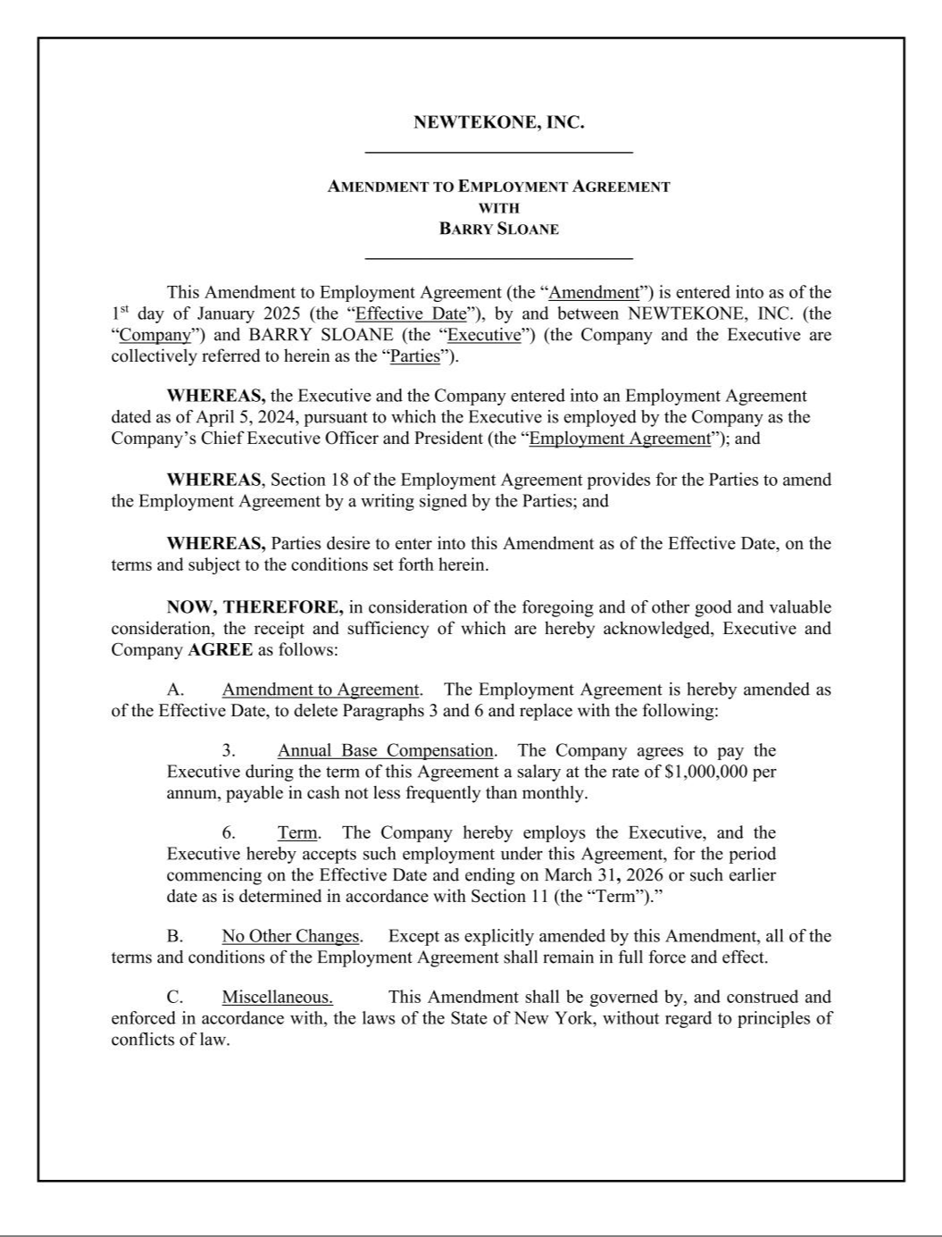

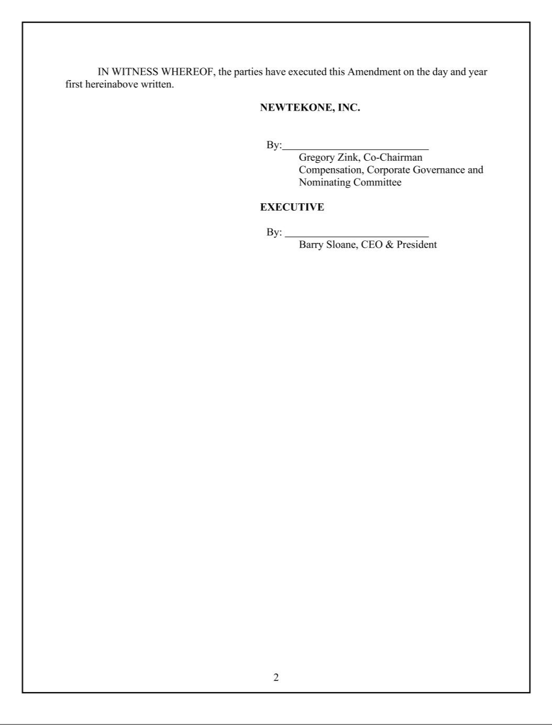

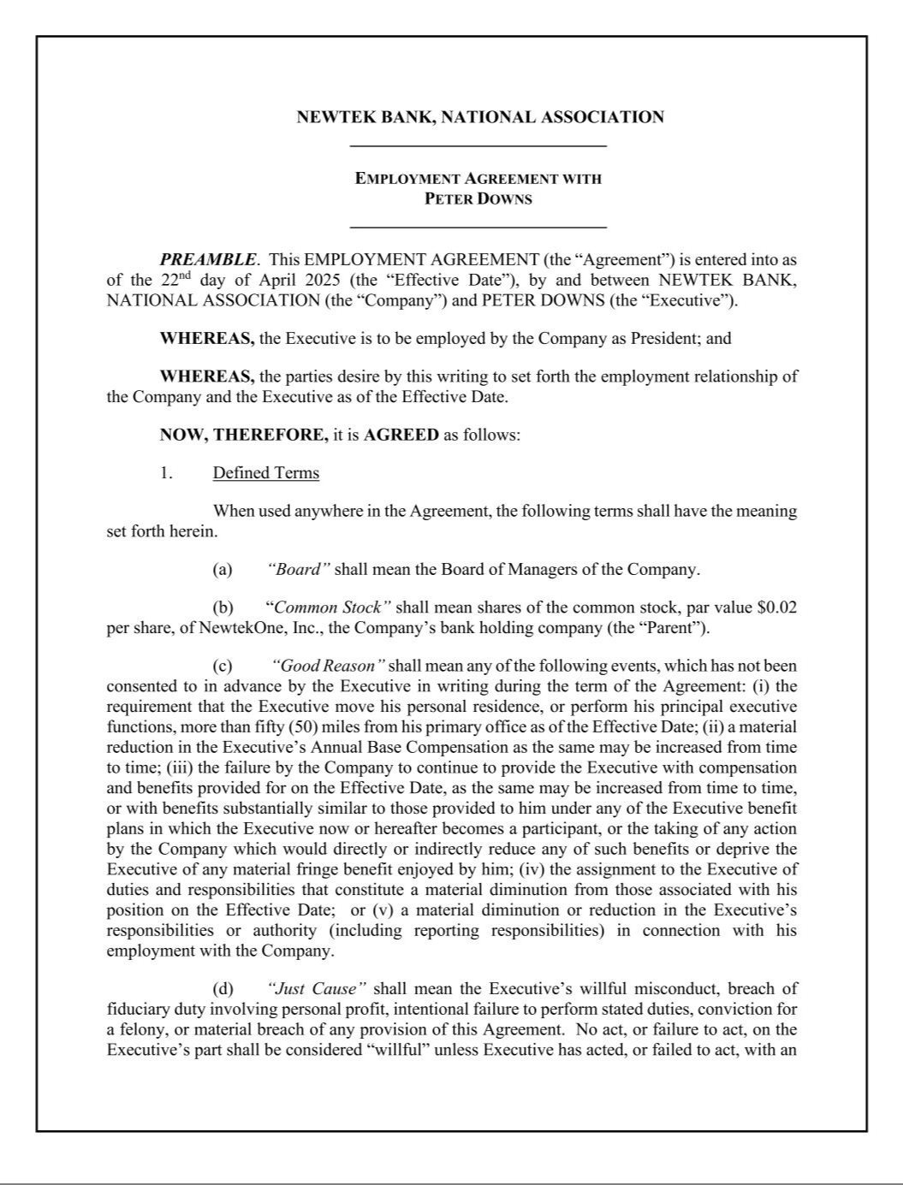

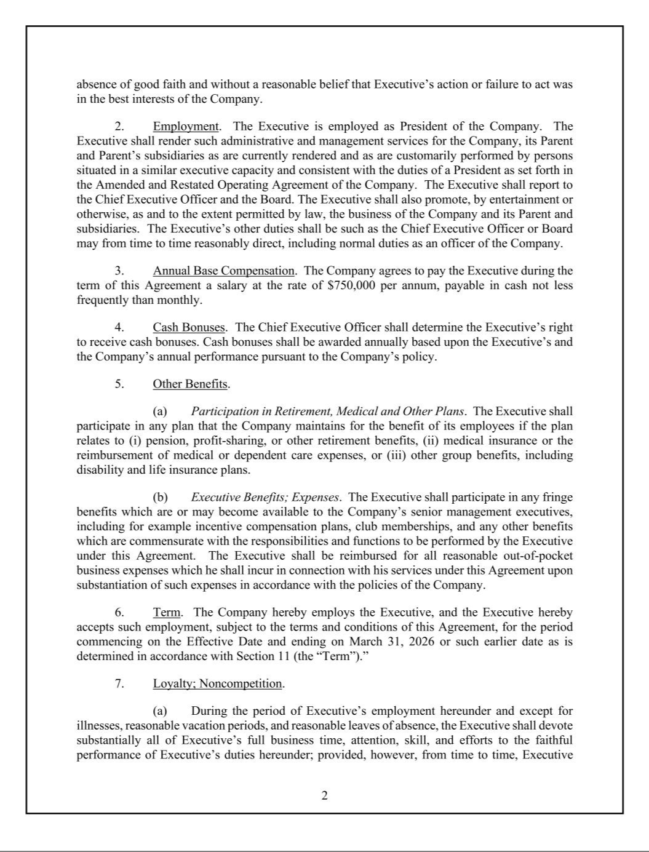

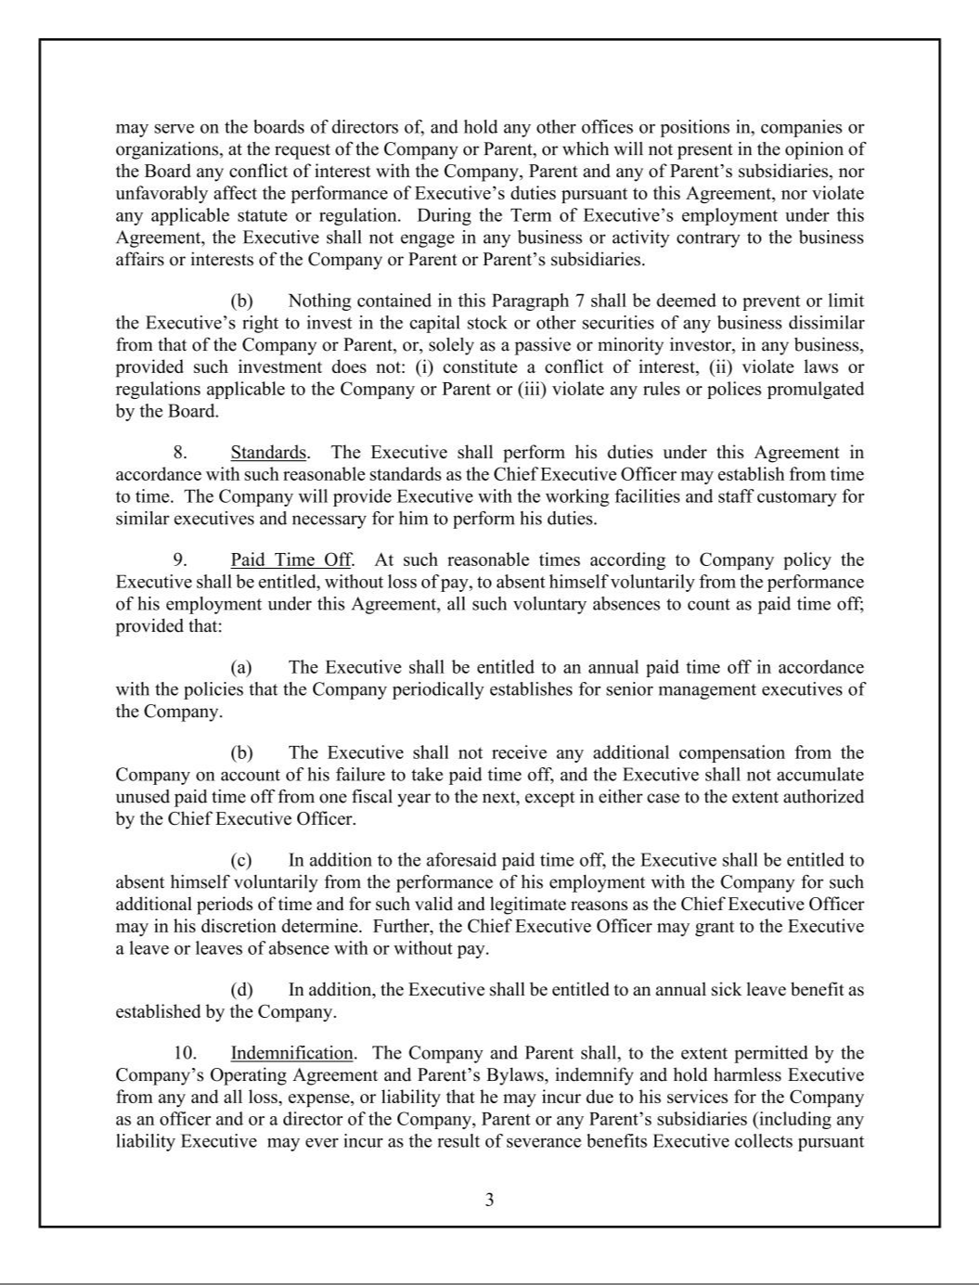

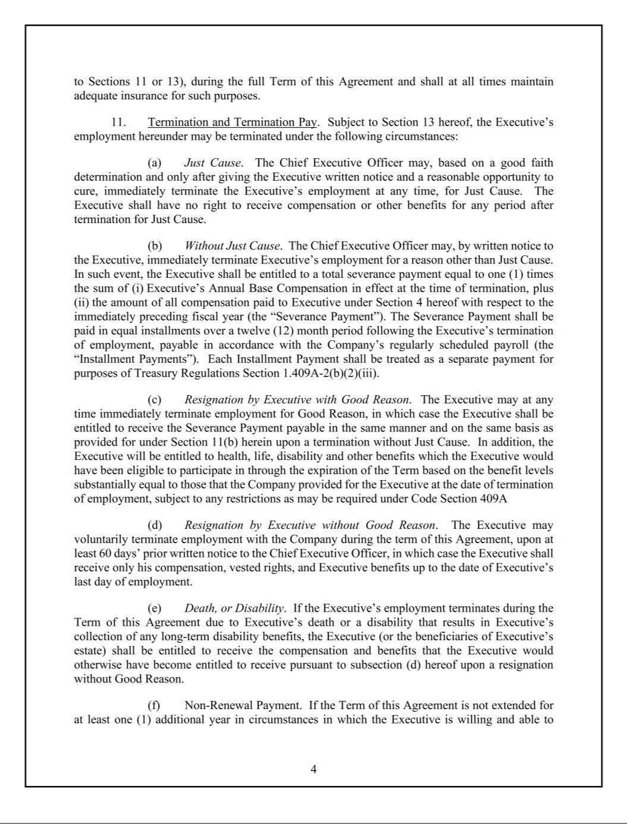

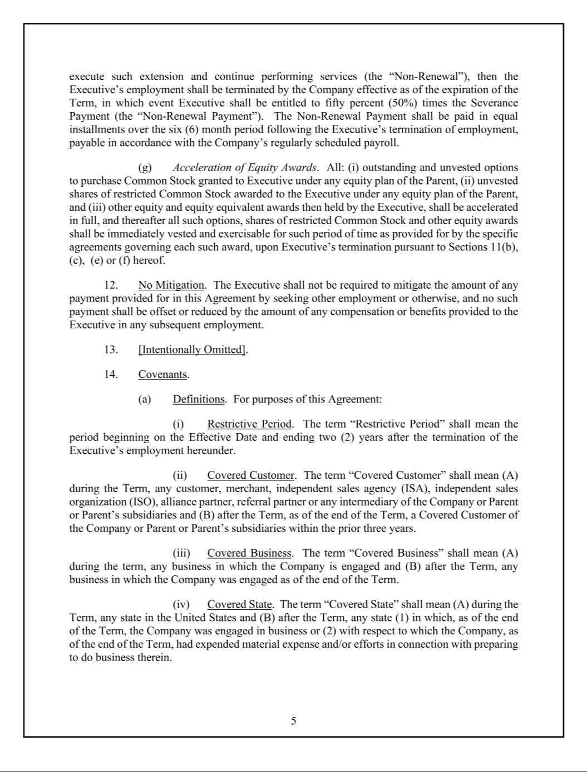

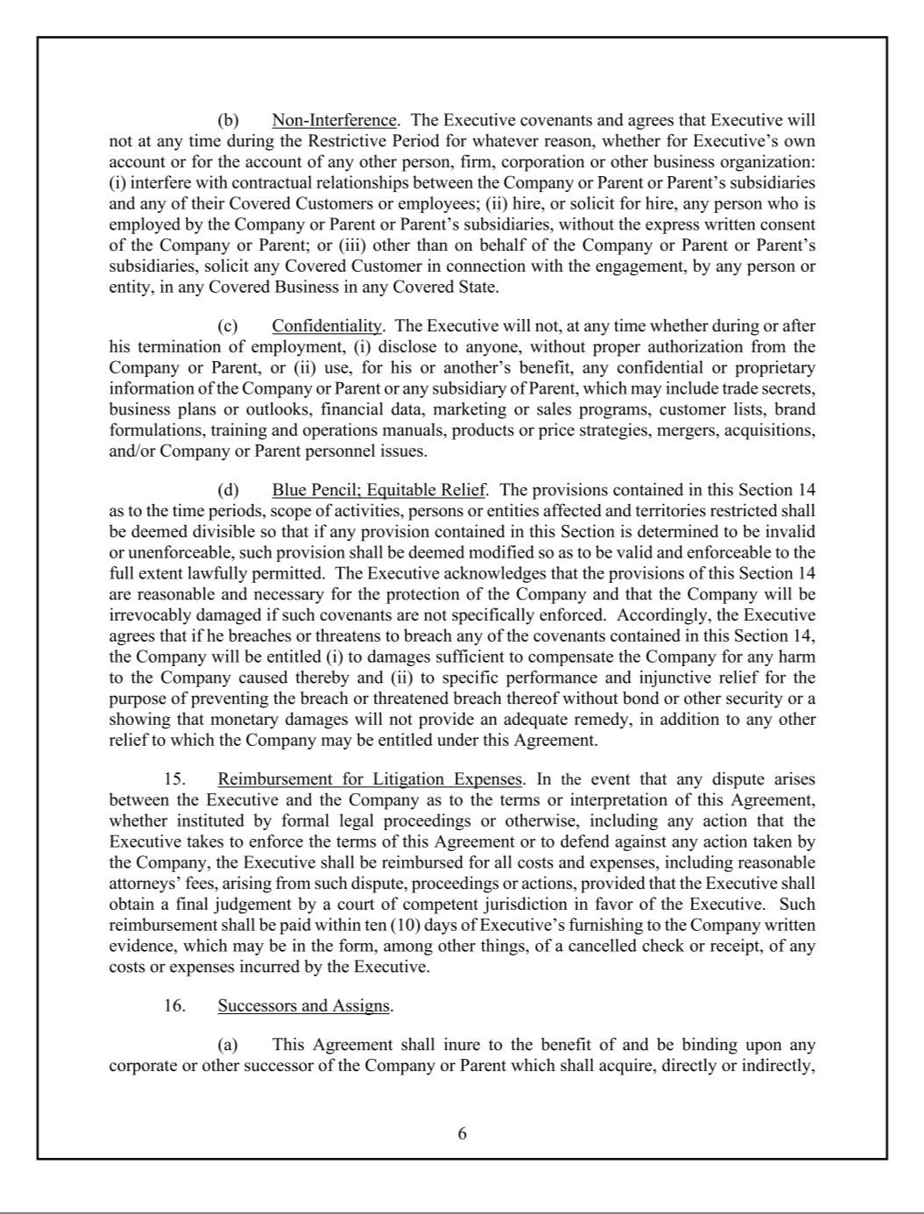

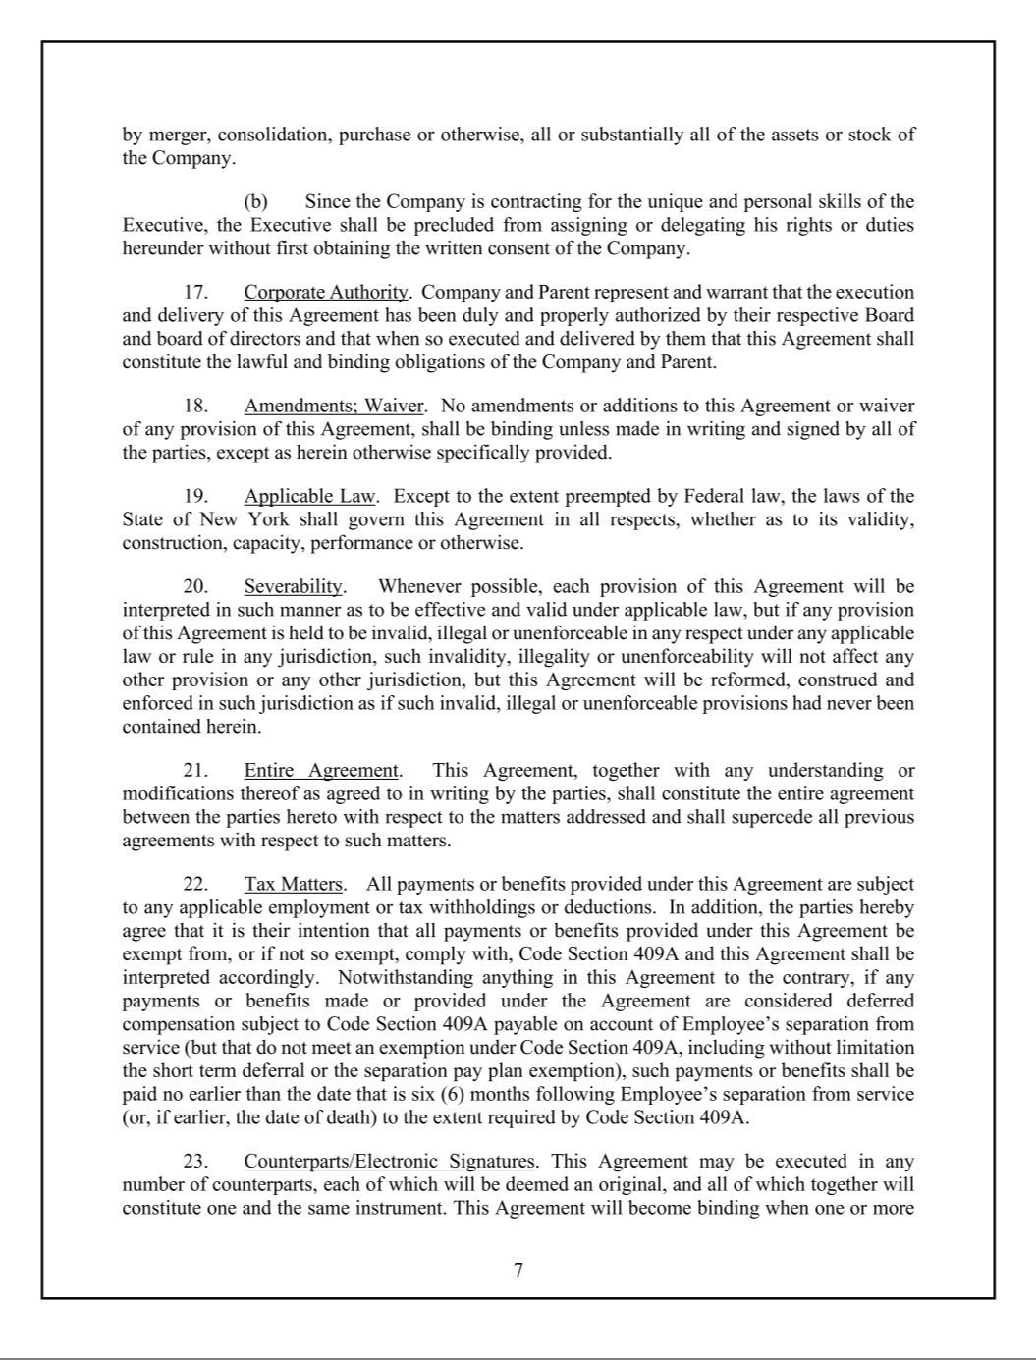

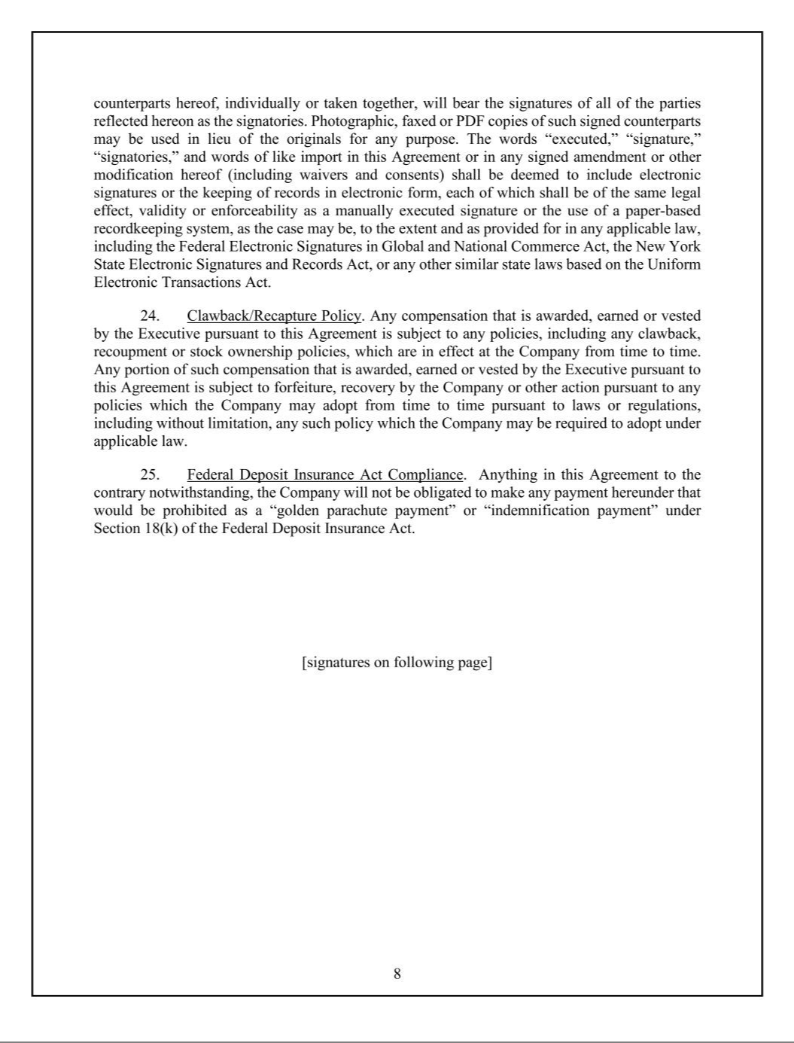

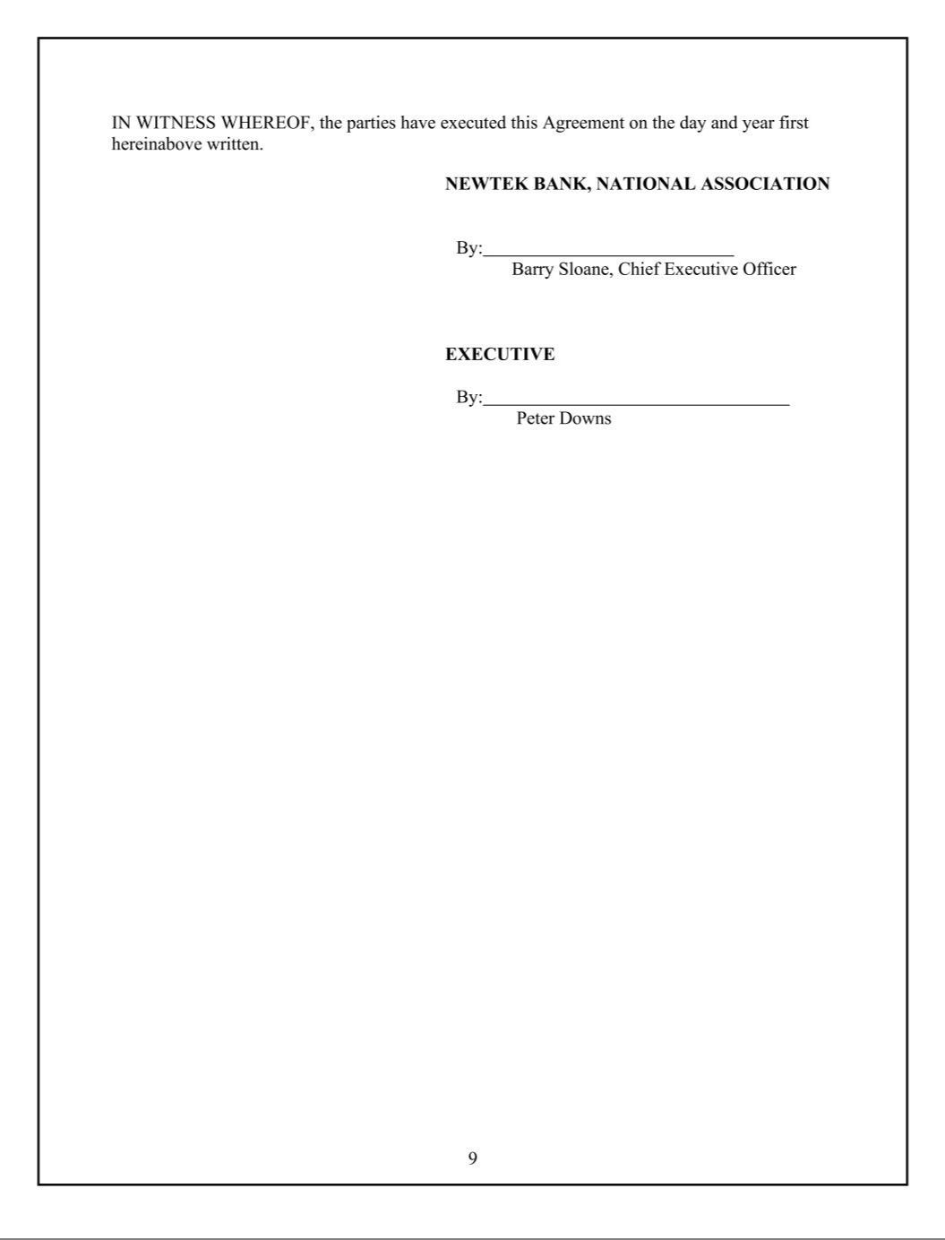

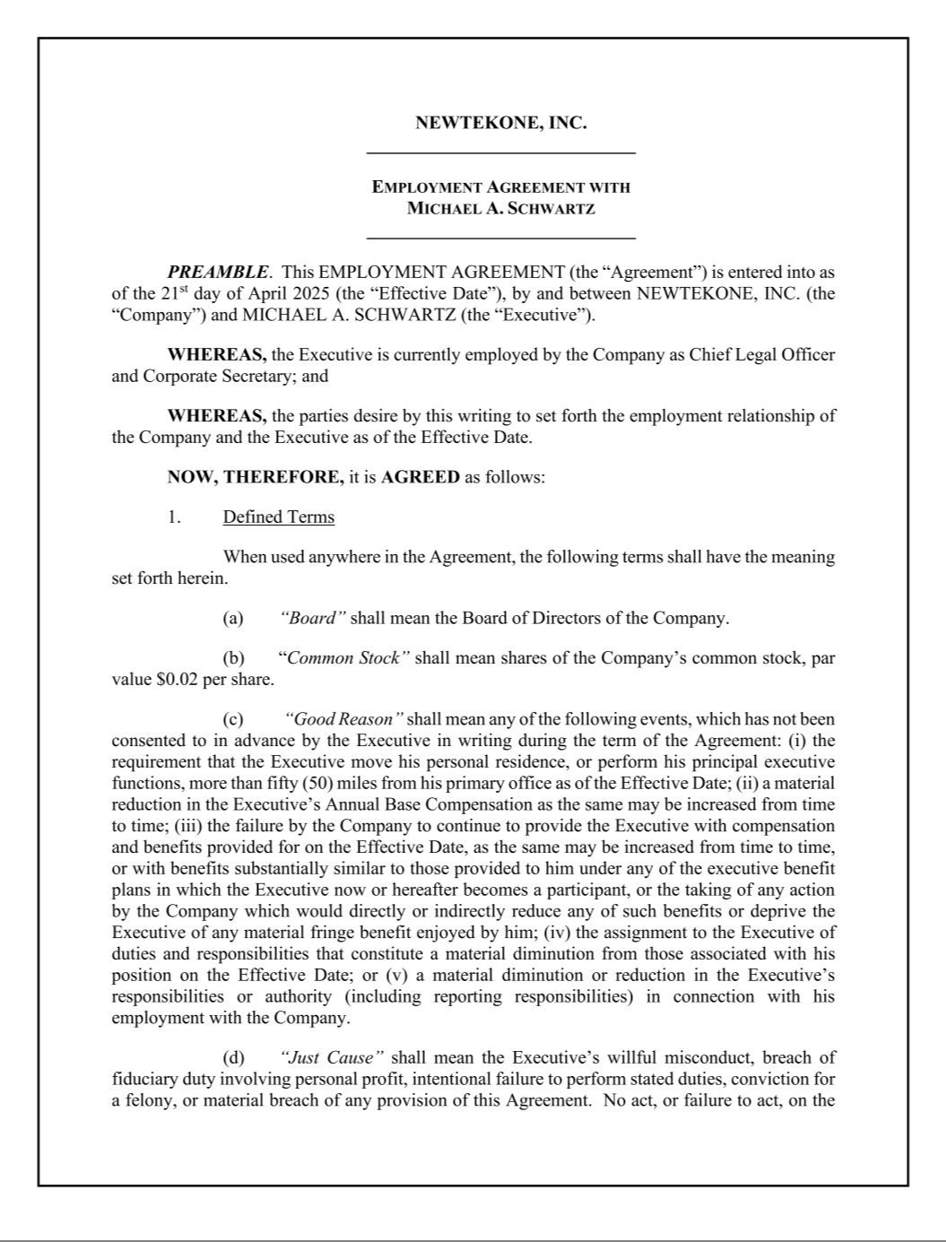

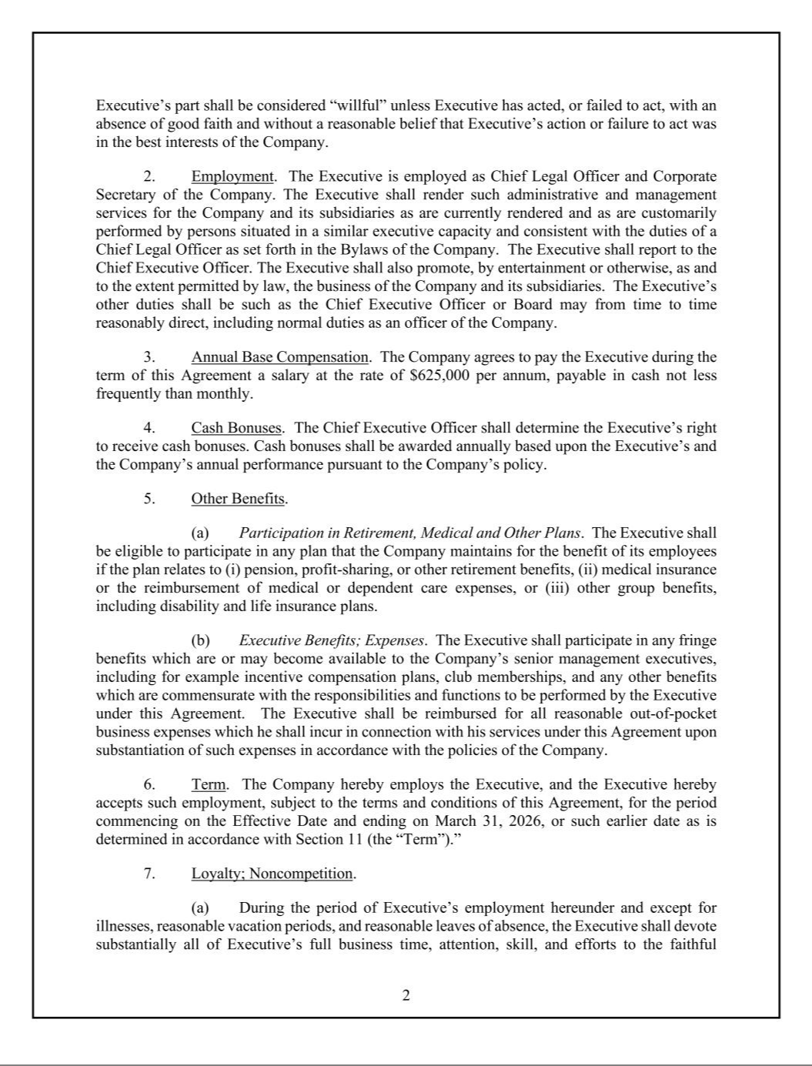

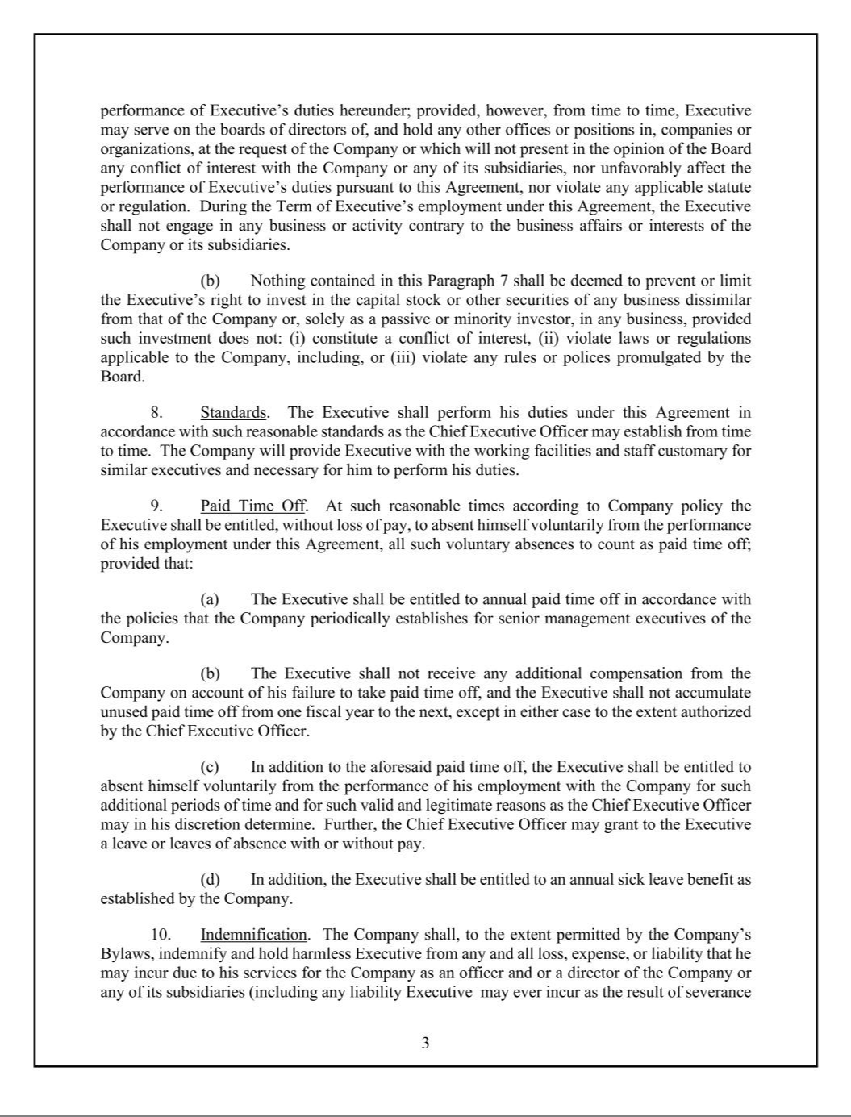

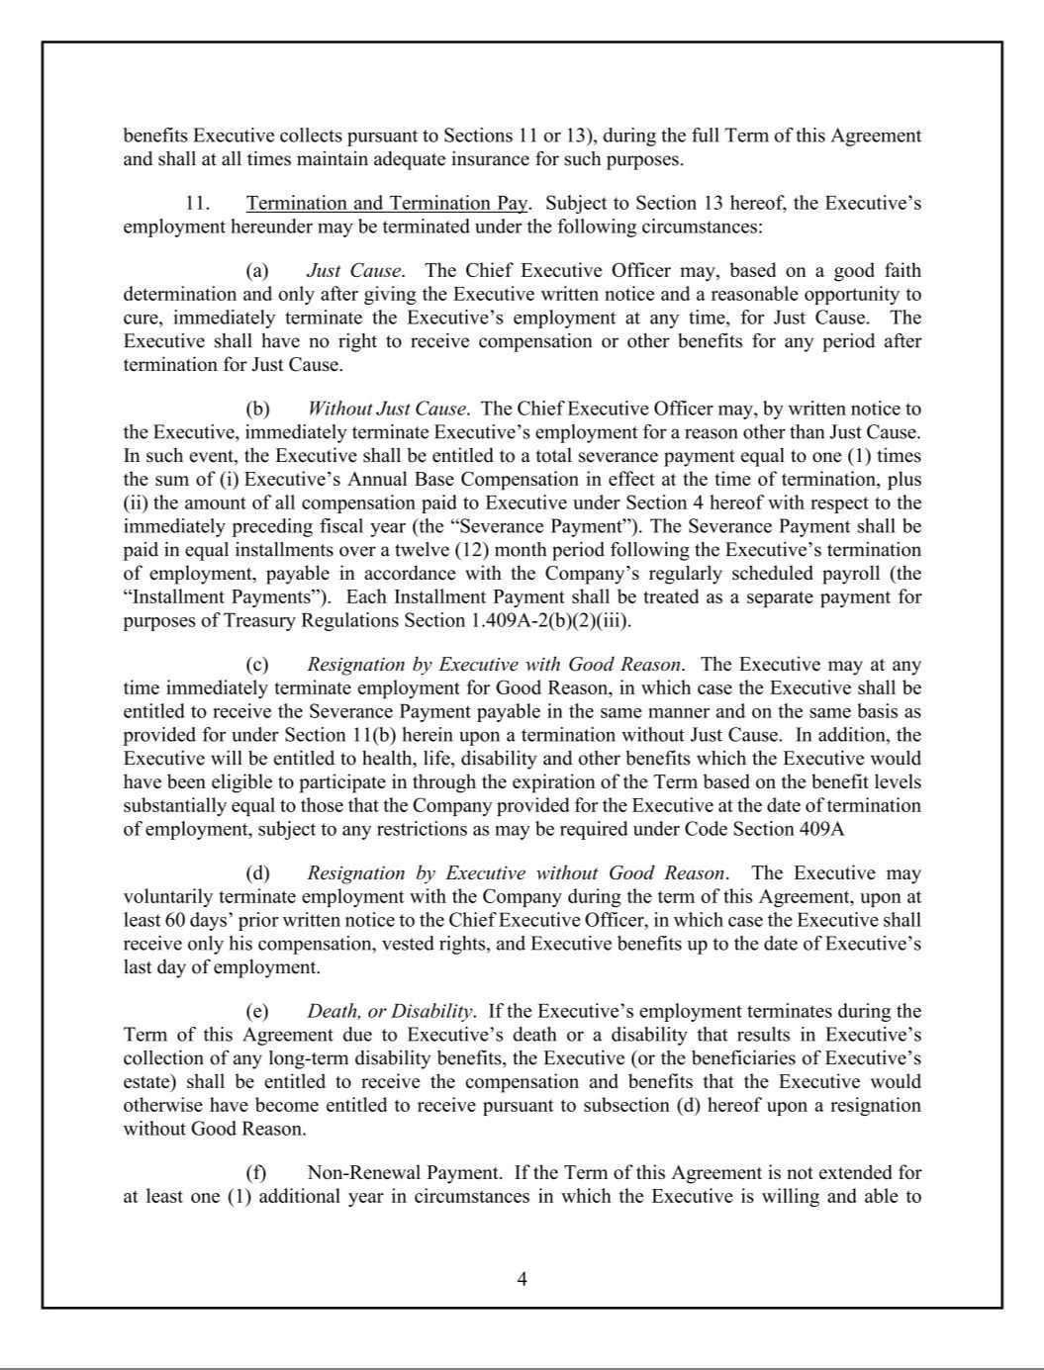

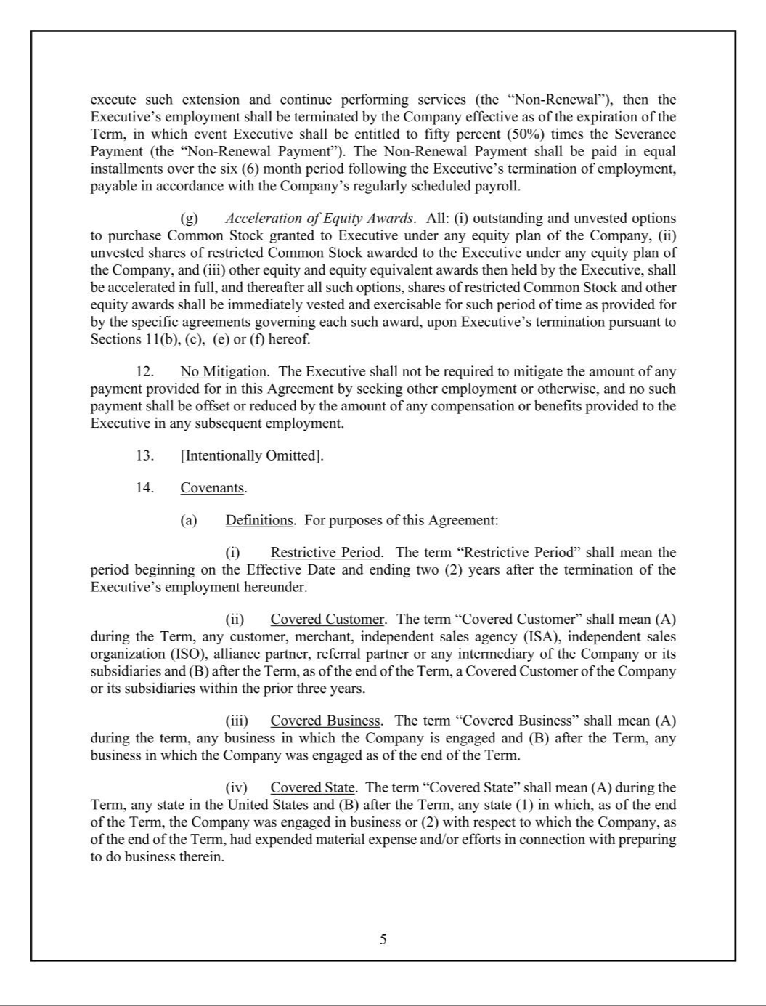

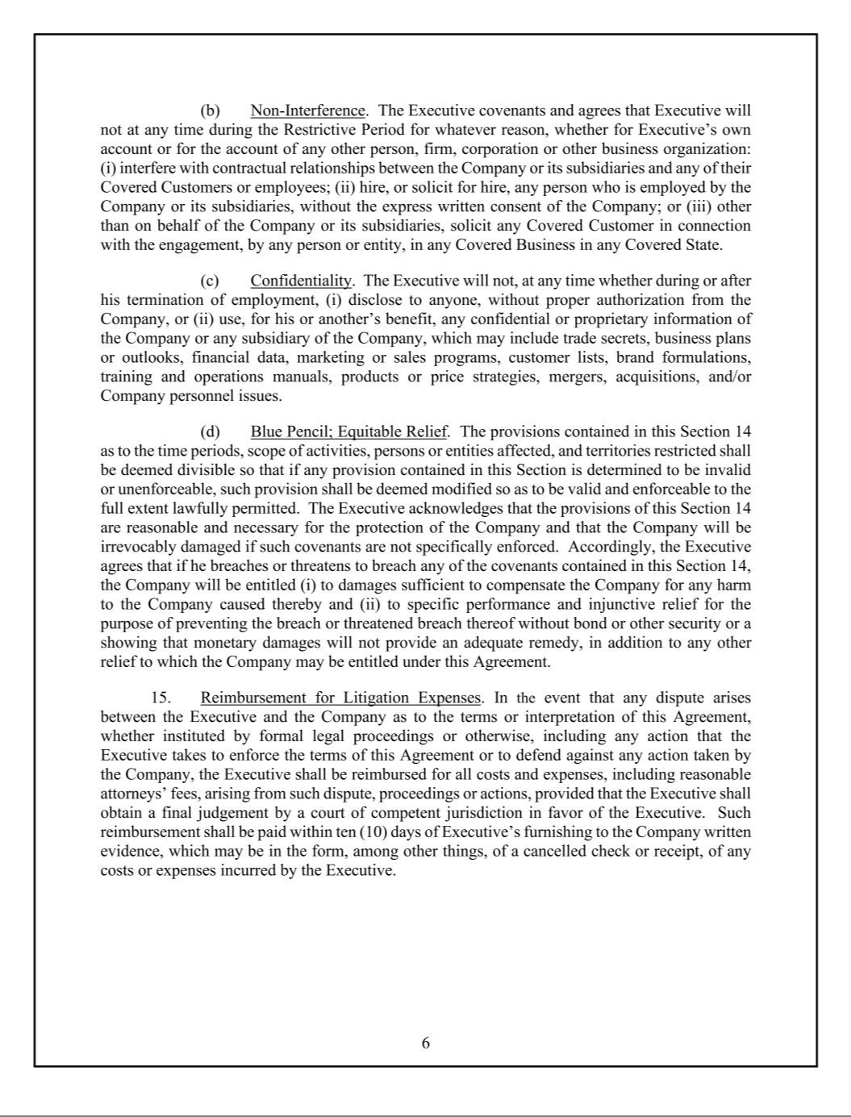

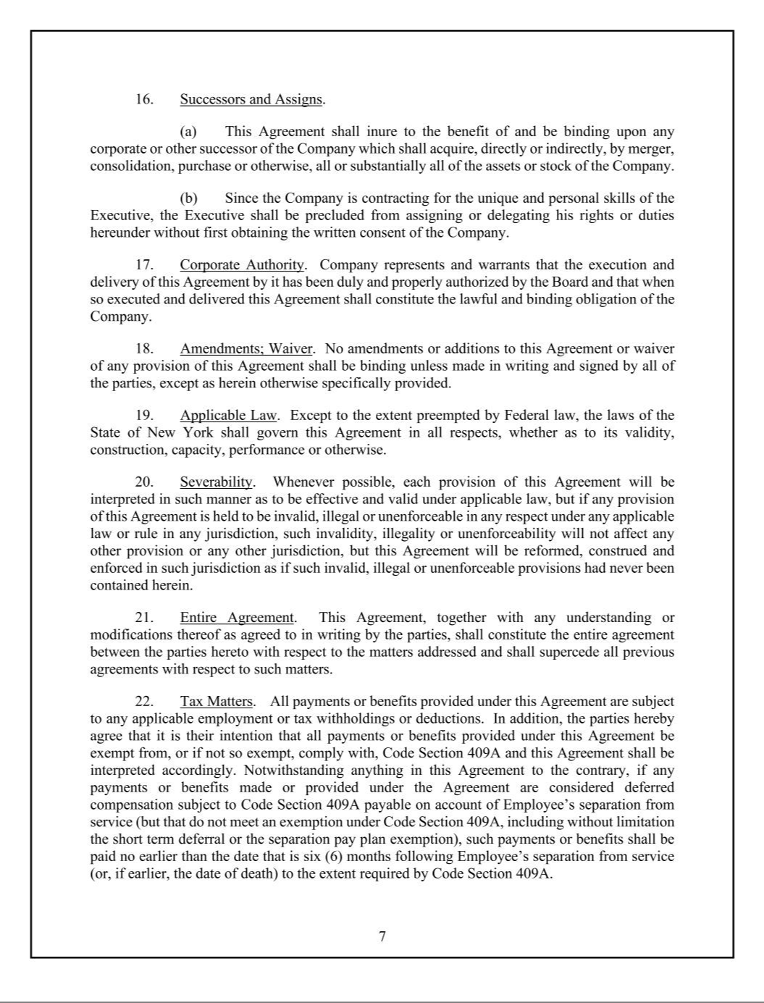

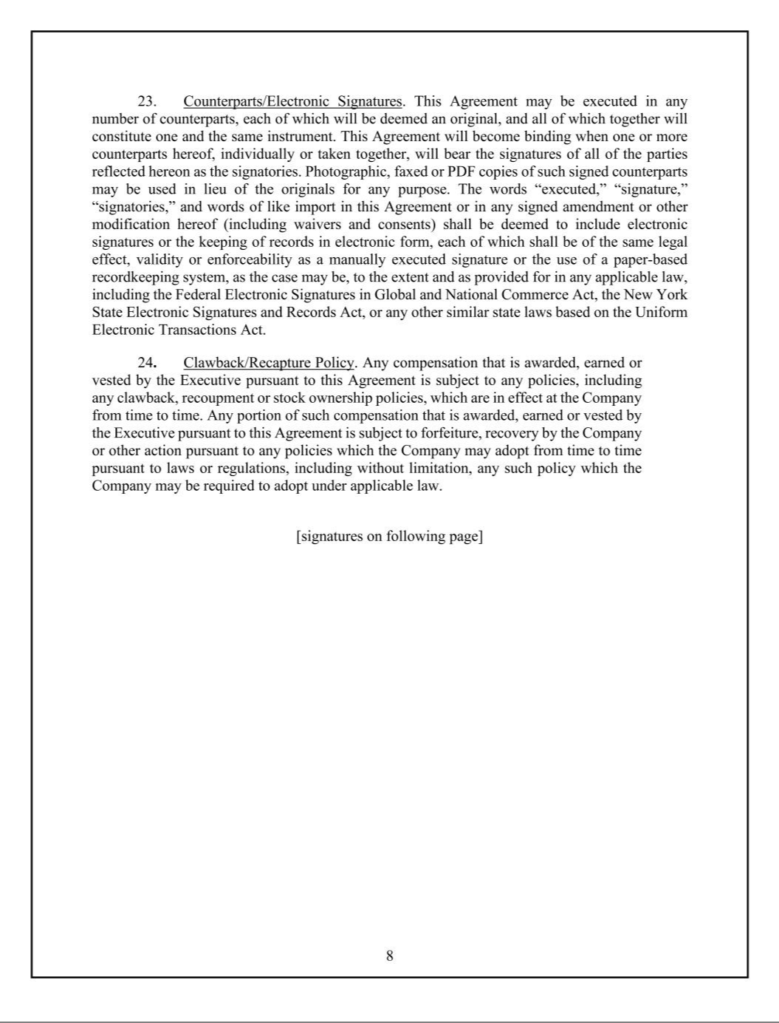

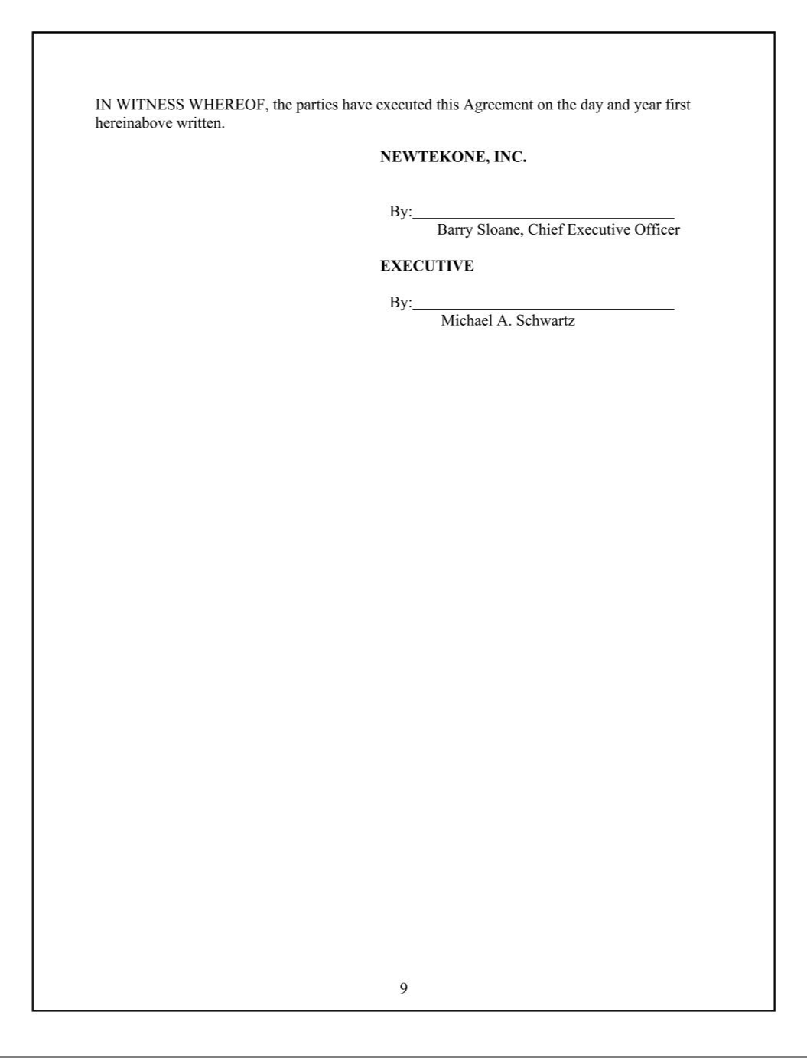

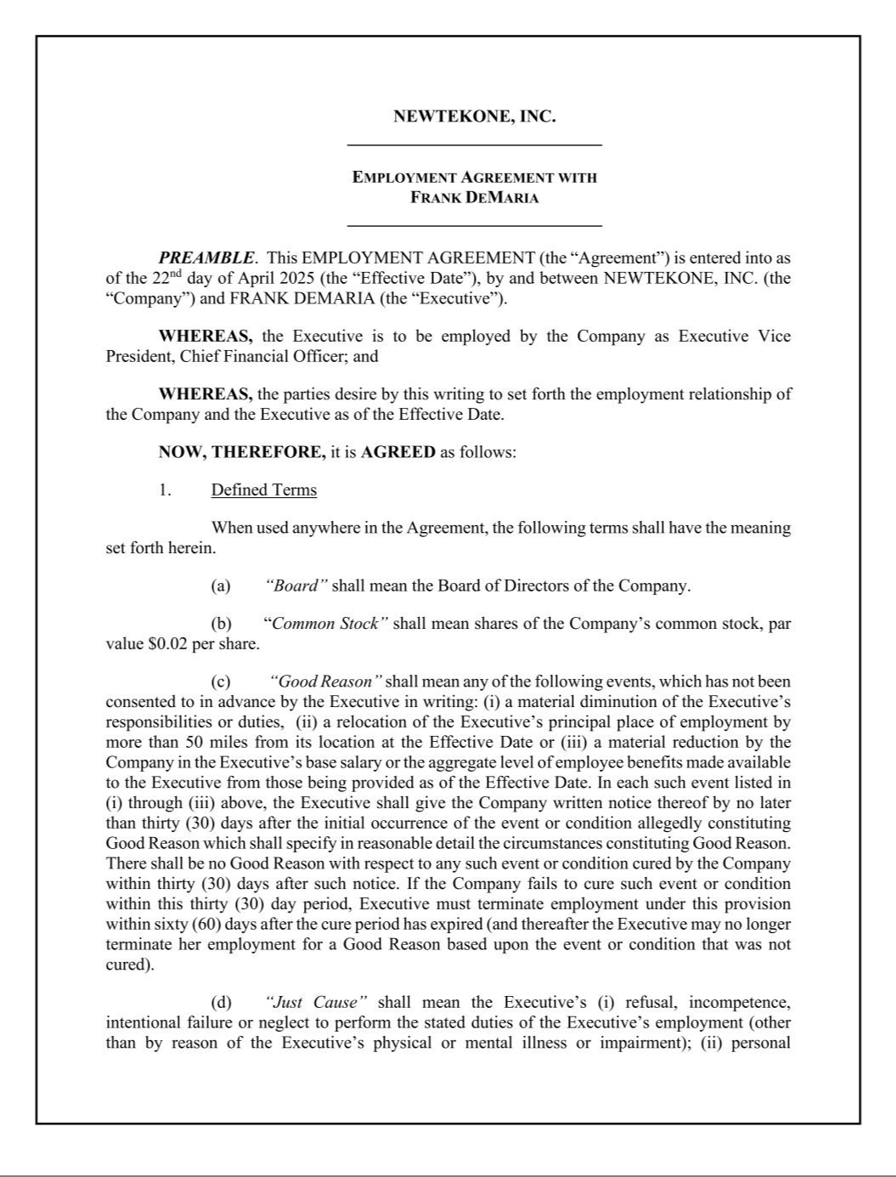

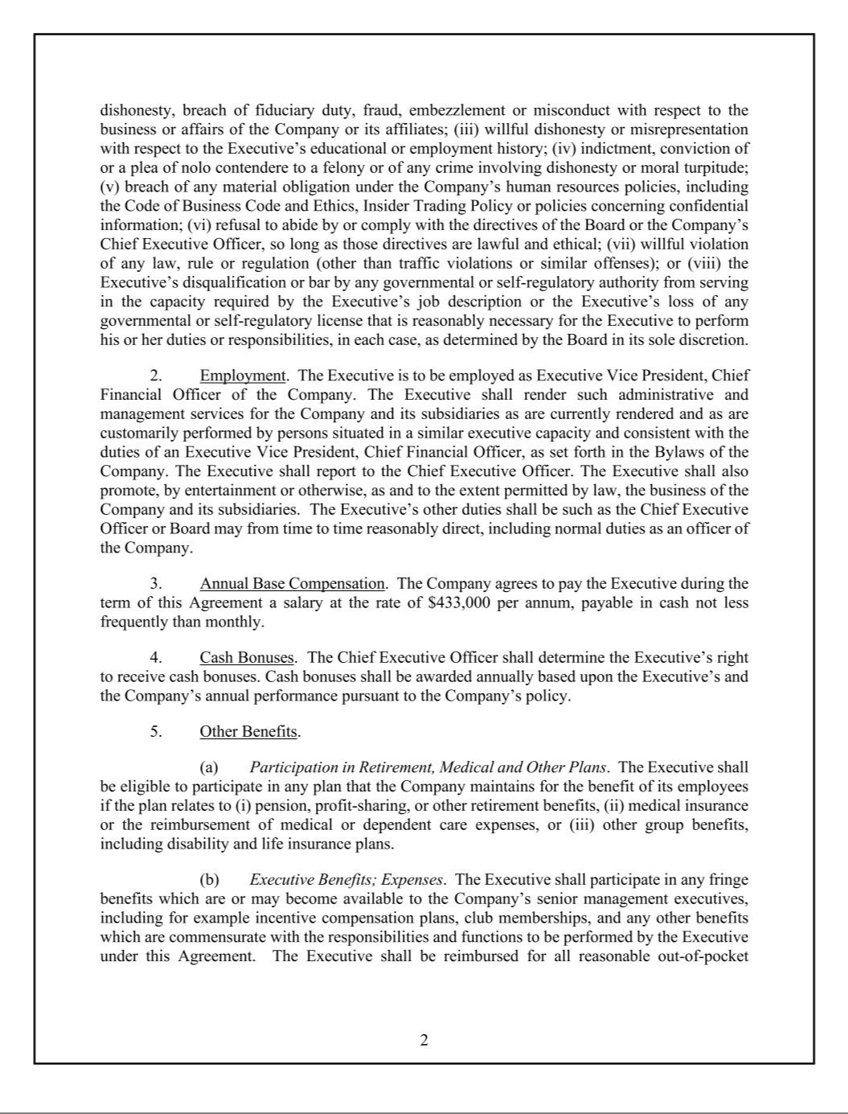

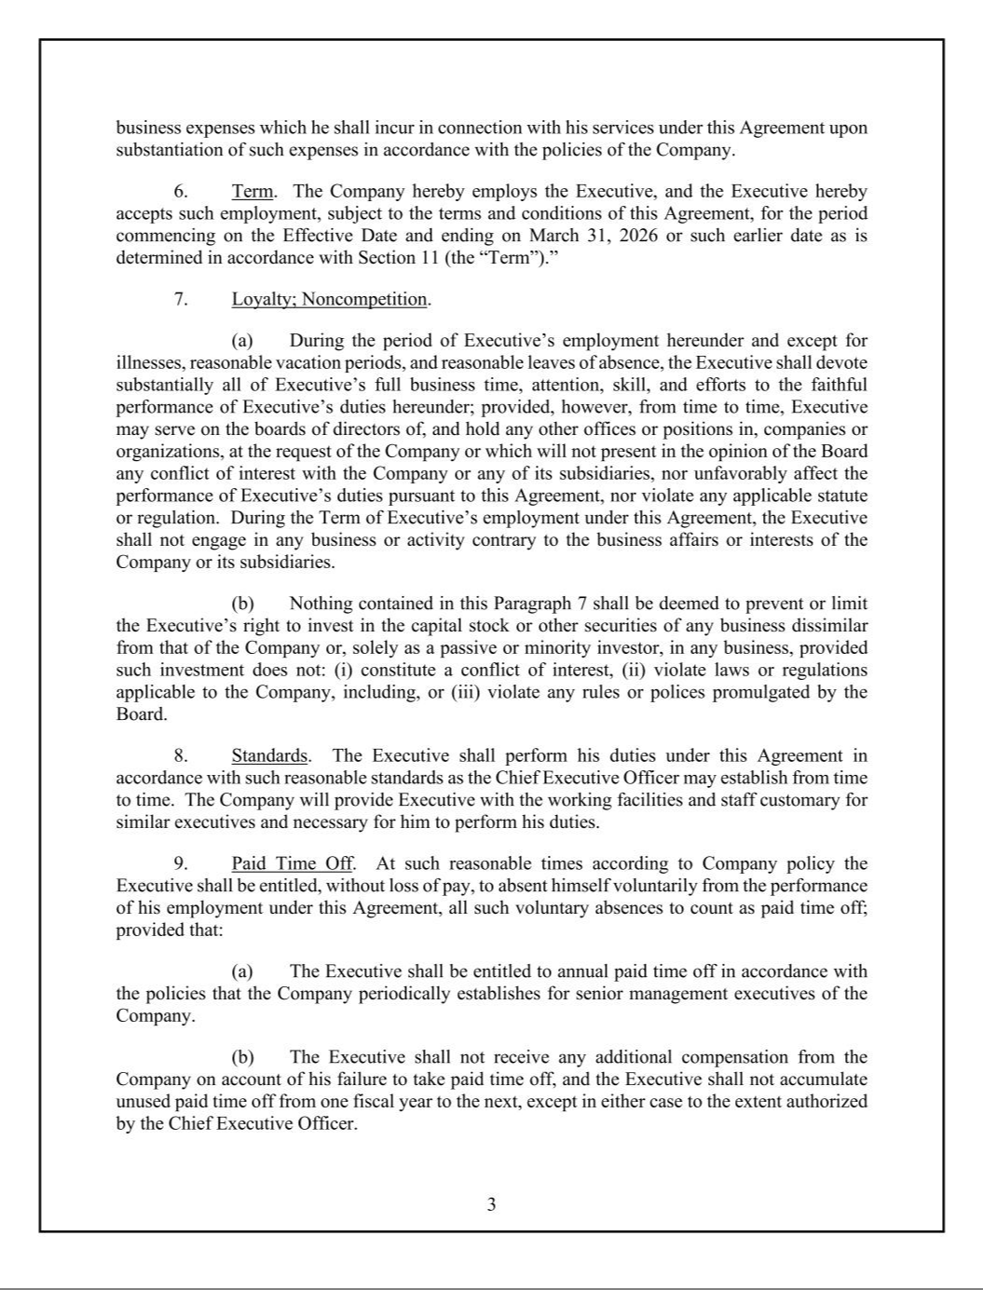

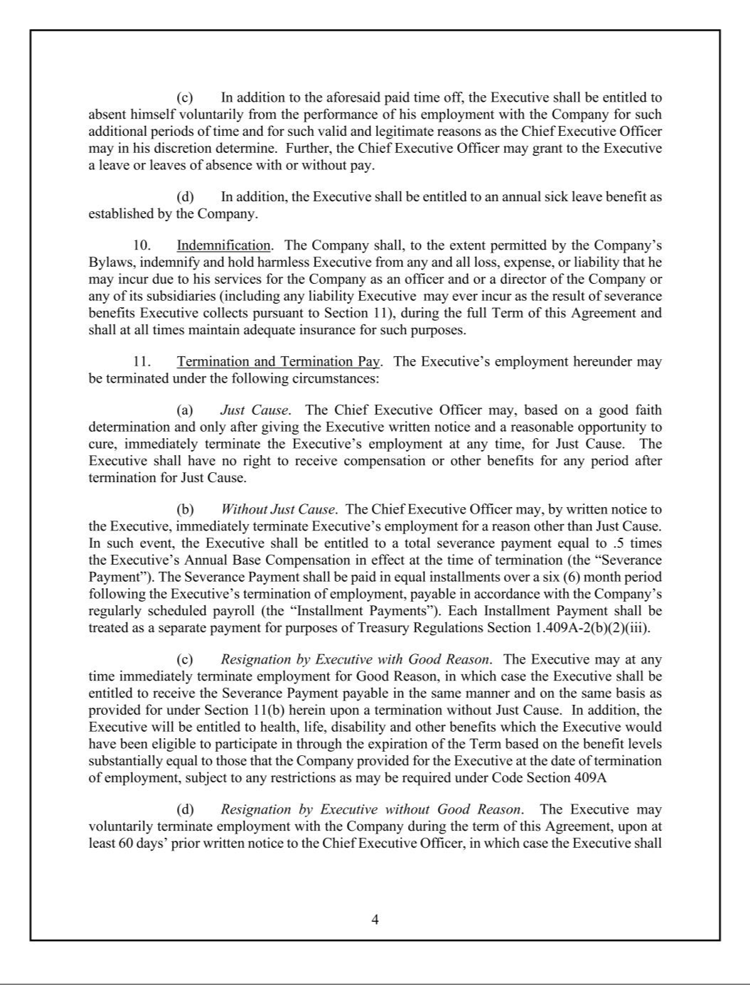

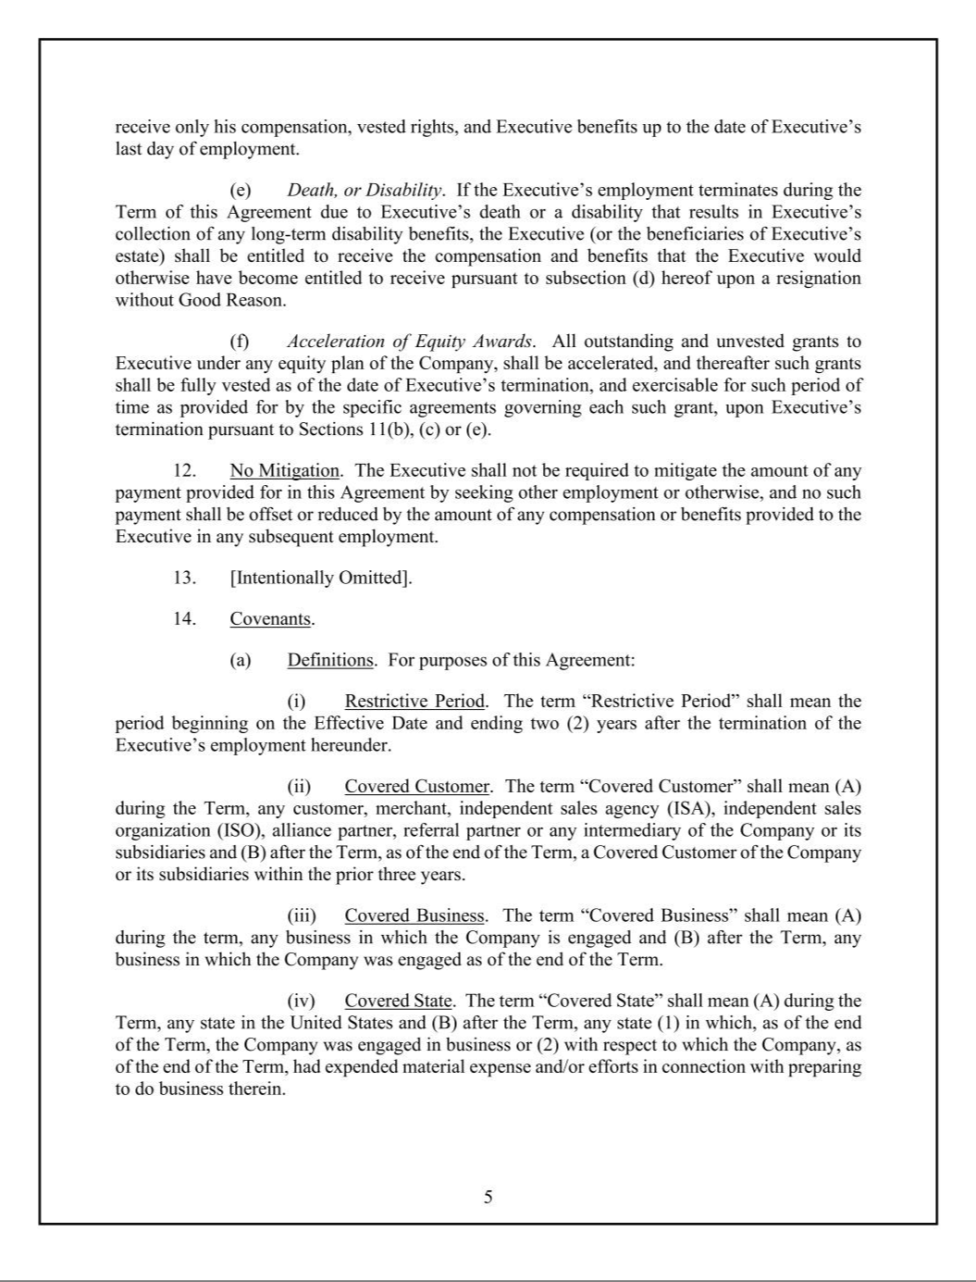

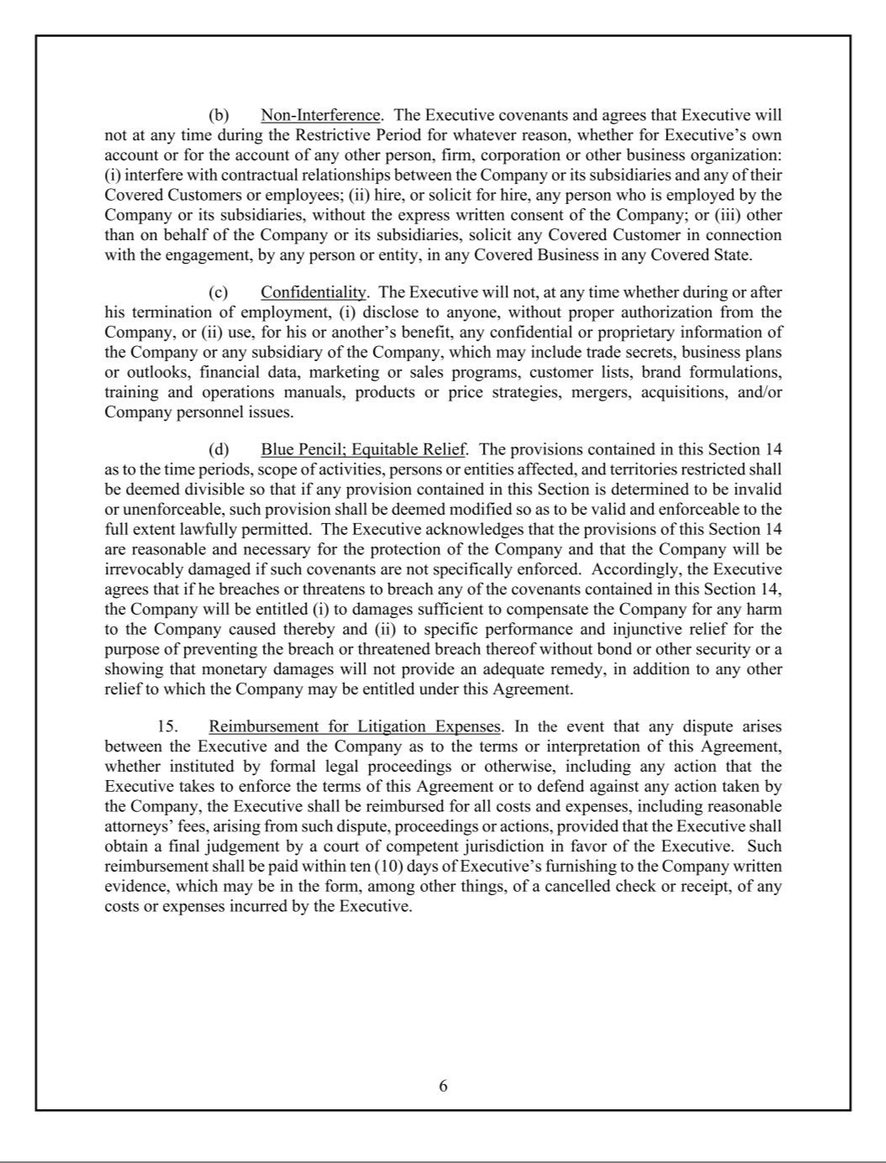

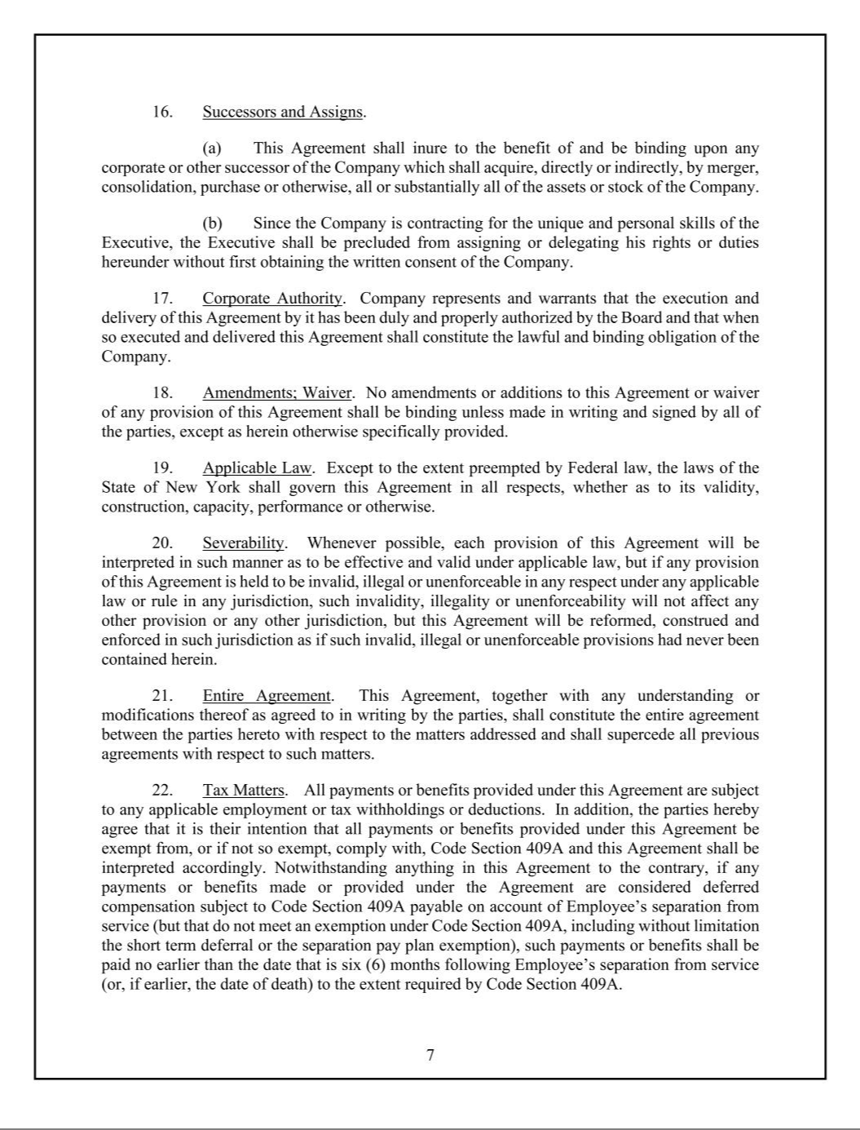

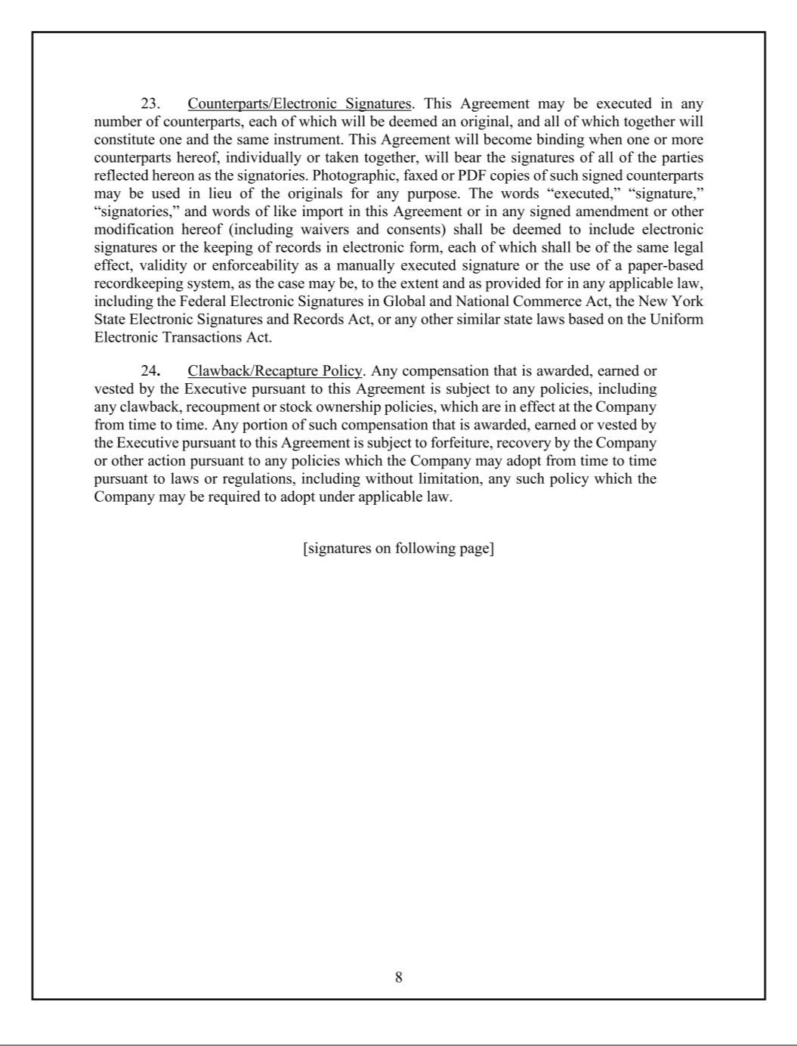

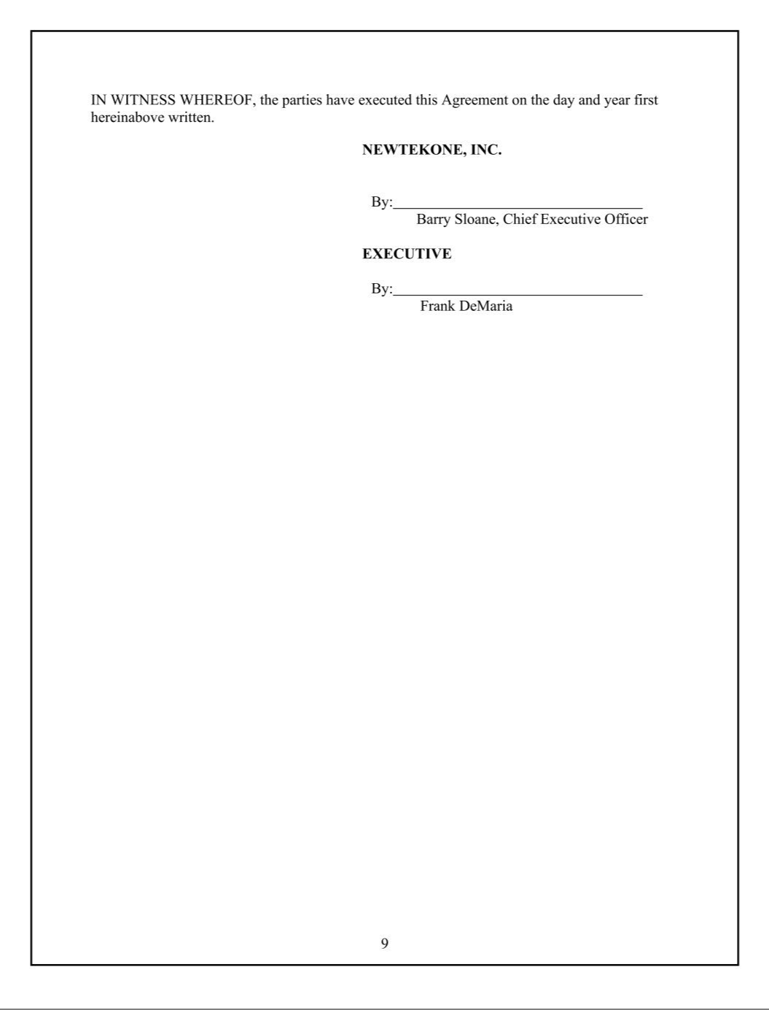

Exhibit 31.1

CERTIFICATION PURSUANT TO 18 U.S.C. SECTION 1350,

AS ADOPTED PURSUANT TO SECTION 302 OF THE

SARBANES-OXLEY ACT OF 2002

I, Barry Sloane, certify that:

- I have reviewed this quarterly report on Form 10-Q of NewtekOne, Inc. (the “registrant”).

- Based on my knowledge, this report does not contain any untrue statement of a material fact or omit to state a material fact necessary to make the statements made, in light of the circumstances under which such statements were made, not misleading with respect to the period covered by this report;

- Based on my knowledge, the financial statements, and other financial information included in this report, fairly present in all material respects the financial condition, results of operations and cash flows of the registrant as of, and for, the periods presented in this annual report;

- The registrant’s other certifying officers and I are responsible for establishing and maintaining disclosure controls and procedures (as defined in Exchange Act Rules 13a-15(e) and 15d-15(e)) and internal control over financial reporting (as defined in Exchange Act Rules 13a-15(f) and 15d-15(f) for the registrant and have:

  - designed such disclosure controls and procedures, or caused such disclosure controls and procedures to be designed under our supervision, to ensure that material information relating to the registrant, including its consolidated subsidiaries, is made known to us by others within those entities, particularly during the period in which this report is being prepared;

  - designed such internal control over financial reporting, or caused such internal control over financial reporting to be designed under our supervision, to provide reasonable assurance regarding the reliability of financial reporting and the preparation of financial statements for external purposes in accordance with generally accepted accounting principles;

  - evaluated the effectiveness of the registrant’s disclosure controls and procedures and presented in this report our conclusions about the effectiveness of the disclosure controls and procedures, as of the end of the period covered by this report based on such evaluation; and

  - disclosed in this report any change in the registrant’s internal control over financial reporting that occurred during the registrant’s most recent fiscal quarter (the registrant’s fourth fiscal quarter in the case of an annual report) that has materially affected, or is reasonably likely to materially affect, the registrant’s internal control over financial reporting.

- The registrant’s other certifying officers and I have disclosed, based on our most recent evaluation of internal control over financial reporting, to the registrant’s auditors and the audit committee of the registrant’s board of directors (or persons performing the equivalent functions):

  - all significant deficiencies and material weaknesses in the design or operation of internal control over financial reporting which are reasonably likely to adversely affect the registrant’s ability to record, process, summarize and report financial information; and

  - any fraud, whether or not material, that involves management or other employees who have a significant role in the registrant’s internal control over financial reporting.

Date: May 12, 2025 /S/ BARRY SLOANE

Barry Sloane

Principal Executive Officer

Exhibit 31.2

CERTIFICATION PURSUANT TO 18 U.S.C. SECTION 1350,

AS ADOPTED PURSUANT TO SECTION 302 OF THE

SARBANES-OXLEY ACT OF 2002

I, Frank M. DeMaria, certify that:

- I have reviewed this quarterly report on Form 10-Q of NewtekOne, Inc. (the “registrant”).

- Based on my knowledge, this report does not contain any untrue statement of a material fact or omit to state a material fact necessary to make the statements made, in light of the circumstances under which such statements were made, not misleading with respect to the period covered by this annual report;

- Based on my knowledge, the financial statements, and other financial information included in this report, fairly present in all material respects the financial condition, results of operations and cash flows of the registrant as of, and for, the periods presented in this report;

- The registrant’s other certifying officers and I are responsible for establishing and maintaining disclosure controls and procedures (as defined in Exchange Act Rules 13a-15(e) and 15d-15(e)) and internal control over financial reporting (as defined in Exchange Act Rules 13a-15(f) and 15d-15(f) for the registrant and have:

  - designed such disclosure controls and procedures, or caused such disclosure controls and procedures to be designed under our supervision, to ensure that material information relating to the registrant, including its consolidated subsidiaries, is made known to us by others within those entities, particularly during the period in which this report is being prepared;

  - designed such internal control over financial reporting, or caused such internal control over financial reporting to be designed under our supervision, to provide reasonable assurance regarding the reliability of financial reporting and the preparation of financial statements for external purposes in accordance with generally accepted accounting principles;

  - evaluated the effectiveness of the registrant’s disclosure controls and procedures and presented in this report our conclusions about the effectiveness of the disclosure controls and procedures, as of the end of the period covered by this report based on such evaluation; and

  - disclosed in this report any change in the registrant’s internal control over financial reporting that occurred during the registrant’s most recent fiscal quarter (the registrant’s fourth fiscal quarter in the case of an annual report) that has materially affected, or is reasonably likely to materially affect, the registrant’s internal control over financial reporting.

- The registrant’s other certifying officers and I have disclosed, based on our most recent evaluation of internal control over financial reporting, to the registrant’s auditors and the audit committee of the registrant’s board of directors (or persons performing the equivalent functions):

  - all significant deficiencies and material weaknesses in the design or operation of internal control over financial reporting which are reasonably likely to adversely affect the registrant’s ability to record, process, summarize and report financial information; and

  - any fraud, whether or not material, that involves management or other employees who have a significant role in the registrant’s internal control over financial reporting.

Date: May 12, 2025 /S/ FRANK M. DEMARIA

Frank M. DeMaria

Principal Financial Officer

Exhibit 32.1

CERTIFICATION PURSUANT TO 18 U.S.C. SECTION 1350,

AS ADOPTED PURSUANT TO

SECTION 906 OF THE SARBANES-OXLEY ACT OF 2002

In connection with the Quarterly Report on Form 10-Q for the period ended March 31, 2025 (the “Report”) of NewtekOne Inc.(the “Company”), as filed with the Securities and Exchange Commission on the date hereof, I, Barry Sloane, as Principal Executive Officer of the Company, certify, pursuant to 18 U.S.C. §1350, as adopted pursuant to §906 of the Sarbanes-Oxley Act of 2002, that, to the best of my knowledge:

- The Report fully complies with the requirements of Section 13(a) or 15(d) of the Securities Exchange Act of 1934; and

- The information contained in the Report fairly presents, in all material respects, the financial condition and results of the operations of the Company.

Date: May 12, 2025 /S/ BARRY SLOANE

Barry Sloane,

Principal Executive Officer

Exhibit 32.2

CERTIFICATION PURSUANT TO 18 U.S.C. SECTION 1350,

AS ADOPTED PURSUANT TO

SECTION 906 OF THE SARBANES-OXLEY ACT OF 2002

In connection with the Quarterly Report on Form 10-Q for the period ended March 31, 2025 (the “Report”) of NewtekOne, Inc. (the “Company”), as filed with the Securities and Exchange Commission on the date hereof, I, Frank M. DeMaria, as Principal Financial Officer of the Company, hereby certify pursuant to 18 U.S.C. §1350, as adopted pursuant to §906 of the Sarbanes-Oxley Act of 2002, that, to the best of my knowledge:

- The Report fully complies with the requirements of Section 13(a) or 15(d) of the Securities Exchange Act of 1934; and

- The information contained in the Report fairly presents, in all material respects, the financial condition and results of the operations of the Company.

Date: May 12, 2025 /S/ FRANK M. DEMARIA

Frank M. DeMaria

Principal Financial Officer

