UNITED STATES
SECURITIES AND EXCHANGE COMMISSION
Washington, D.C. 20549
 | FORM 10-K
☒ ANNUAL REPORT PURSUANT TO SECTION 13 OR 15(d) OF THE SECURITIES EXCHANGE ACT OF 1934
For the fiscal year ended December 31, 2025
OR
o TRANSITION REPORT PURSUANT TO SECTION 13 OR 15(d) OF THE SECURITIES EXCHANGE ACT OF 1934
For the transition period from _____to_____
Commission file number: 814-01035
NEWTEKONE, INC.
(Exact name of registrant as specified in its charter)
Maryland |  |  | 46-3755188
(State or other jurisdiction of incorporation or organization) |  |  | (I.R.S. Employer Identification No.)
4800 T Rex Avenue, Suite 120, Boca Raton, Florida |  |  | 33431
(Address of principal executive offices) |  |  | (Zip Code)
 | (212) 356-9500
(Registrant’s telephone number, including area code)

Not Applicable

(Former name, former address and former fiscal year, if changed since last report)

Securities registered pursuant to Section 12(b) of the Act:

Title of each class |  | Trading Symbol(s) |  | Name of each exchange on which registered
Common Stock, par value $0.02 per share |  | NEWT |  | Nasdaq Global Market LLC
8.00% Notes due 2028 |  | NEWTI |  | Nasdaq Global Market LLC
8.50% Notes due 2029 |  | NEWTG |  | Nasdaq Global Market LLC
8.625% Notes due 2029 |  | NEWTH |  | Nasdaq Global Market LLC
8.50% Notes due 2031 |  | NEWTO |  | Nasdaq Global Market LLC
Depositary Shares, each representing a 1/40th interest in a share of 8.500% Fixed- |  | NEWTP |  | Nasdaq Global Market LLC
Rate Reset Non-Cumulative Perpetual Preferred Stock, Series B

Indicate by check mark if the registrant is a well-known seasoned issuer, as defined in Rule 405 of the Securities Act. Yes ☐ No x

Indicate by check mark if the registrant is not required to file reports pursuant to Section 13 or 15(d) of the Act. Yes ☐ No x

Indicate by check mark whether the registrant: (1) has filed all reports required to be filed by Section 13 or 15(d) of the Securities Exchange Act of 1934 during the past 12 months (or for such shorter period that the registrant was required to file such reports), and (2) has been subject to such filing requirements for the past 90 days. Yes x No ☐

Indicate by check mark whether the registrant has submitted electronically every Interactive Data File required to be submitted pursuant to Rule 405 of Regulation S-T (Section 232.405 of this chapter) during the preceding 12 months (or for such shorter period that the registrant was required to submit and post such files). Yes x No ☐

Indicate by check mark whether the registrant is a large accelerated filer, an accelerated filer, a non-accelerated filer, a smaller reporting company or an emerging growth company. See definitions of “large accelerated filer,” “accelerated filer,” “smaller reporting company,” and “emerging growth company” in Rule 12b-2 of the Exchange Act.

Large accelerated filer | o | Accelerated Filer | x
Non-accelerated filer | o | Smaller reporting company | o
 |  | Emerging growth company | o

If an emerging growth company, indicate by check mark if the registrant has elected not to use the extended transition period for complying with any new or revised financial or accounting standards provided pursuant to Section 13(a) of the Exchange Act. o

Indicate by check mark whether the registrant has filed a report on and attestation to its management’s assessment of the effectiveness of its internal control over financial reporting under Section 404(b) of the Sarbanes-Oxley Act (15 USC. 7262(b)) by the registered public accounting firm that prepared or issued its audit report. Yes ☒ No ☐

Indicate by check mark whether the registrant is a shell company (as defined in Rule 12b-2 of the Exchange Act). Yes ☐ No x

If securities are registered pursuant to Section 12(b) of the Act, indicate by check mark whether the financial statements of the registrant included in the filing reflect the correction of an error to previously issued financial statements. ☐

Indicate by check mark whether any of those error corrections are restatements that required a recovery analysis of incentive-based compensation received by any of the registrant’s executive officers during the relevant recovery period pursuant to §240.10D-1(b). ☐

The aggregate market value of the voting and non-voting common equity held by non-affiliates of the registrant was approximately $276.5 million as of the last business day of the registrant’s second fiscal quarter of 2025, based on a closing price on that date of $11.28 on the Nasdaq Global Market. For the purposes of calculating this amount only, all directors and executive officers of the Registrant have been treated as affiliates.

As of March 9, 2026, there were 28,831,491 shares outstanding of the registrant’s Common Stock, par value $0.02 per share.

 |  |  |  |  |  |  |  |  |  |  |  |  |  |  |  |  |  |  |  | NEWTEKONE, INC. AND SUBSIDIARIES
 |  |  |  |  |  |  |  |  |  |  |  |  |  |  |  |  |  |  |  |  | TABLE OF CONTENTS
 | Item |  |  |  |  |  |  |  |  |  |  |  |  |  |  |  |  |  |  |  |  |  |  |  |  |  |  |  |  |  |  |  |  | Page
 |  |  |  |  |  |  |  |  |  |  |  |  |  |  |  |  |  |  |  |  |  |  |  | PART I
1. |  |  | Business |  |  |  |  |  |  |  |  |  |  |  |  |  |  |  |  |  |  |  |  |  |  |  |  |  |  |  |  |  |  | 8
 | 1A. |  | Risk Factors |  |  |  |  |  |  |  |  |  |  |  |  |  |  |  |  |  |  |  |  |  |  |  |  |  |  |  |  |  |  | 36
 | 1B. |  | Unresolved Staff Comments |  |  |  |  |  |  |  |  |  |  |  |  |  |  |  |  |  |  |  |  |  |  |  |  |  |  |  |  |  |  | 65
 | 1C. |  | Cybersecurity |  |  |  |  |  |  |  |  |  |  |  |  |  |  |  |  |  |  |  |  |  |  |  |  |  |  |  |  |  |  | 65
2. |  |  | Properties |  |  |  |  |  |  |  |  |  |  |  |  |  |  |  |  |  |  |  |  |  |  |  |  |  |  |  |  |  |  | 68
3. |  |  | Legal Proceedings |  |  |  |  |  |  |  |  |  |  |  |  |  |  |  |  |  |  |  |  |  |  |  |  |  |  |  |  |  |  | 68
4. |  |  | Mine Safety Disclosures |  |  |  |  |  |  |  |  |  |  |  |  |  |  |  |  |  |  |  |  |  |  |  |  |  |  |  |  |  |  | 68
 |  |  |  |  |  |  |  |  |  |  |  |  |  |  |  |  |  |  |  |  |  |  |  | PART II
5. |  |  | Market for the Registrant’s Common Equity and Related Stockholder Matters and Issuer Purchases of Equity Securities |  |  |  |  |  |  |  |  |  |  |  |  |  |  |  |  |  |  |  |  |  |  |  |  |  |  |  |  |  |  | 69
6. |  |  | [Reserved] |  |  |  |  |  |  |  |  |  |  |  |  |  |  |  |  |  |  |  |  |  |  |  |  |  |  |  |  |  |  | 71
7. |  |  | Management’s Discussion and Analysis of Financial Condition and Results of Operations |  |  |  |  |  |  |  |  |  |  |  |  |  |  |  |  |  |  |  |  |  |  |  |  |  |  |  |  |  |  | 72
 | 7A. |  | Quantitative and Qualitative Disclosures About Market Risk |  |  |  |  |  |  |  |  |  |  |  |  |  |  |  |  |  |  |  |  |  |  |  |  |  |  |  |  |  |  | 102
8. |  |  | Consolidated Financial Statements and Supplementary Data |  |  |  |  |  |  |  |  |  |  |  |  |  |  |  |  |  |  |  |  |  |  |  |  |  |  |  |  |  |  | 104
9. |  |  | Changes in and Disagreements with Accountants on Accounting and Financial Disclosure |  |  |  |  |  |  |  |  |  |  |  |  |  |  |  |  |  |  |  |  |  |  |  |  |  |  |  |  |  |  | 104
 | 9A. |  | Controls and Procedures |  |  |  |  |  |  |  |  |  |  |  |  |  |  |  |  |  |  |  |  |  |  |  |  |  |  |  |  |  |  | 105
 | 9B. |  | Other Information |  |  |  |  |  |  |  |  |  |  |  |  |  |  |  |  |  |  |  |  |  |  |  |  |  |  |  |  |  |  | 107
 | 9C. |  | Disclosure Regarding Foreign Jurisdictions that Prevent Inspections |  |  |  |  |  |  |  |  |  |  |  |  |  |  |  |  |  |  |  |  |  |  |  |  |  |  |  |  |  |  | 107
 |  |  |  |  |  |  |  |  |  |  |  |  |  |  |  |  |  |  |  |  |  | PART III
10. |  |  | Directors, Executive Officers and Corporate Governance |  |  |  |  |  |  |  |  |  |  |  |  |  |  |  |  |  |  |  |  |  |  |  |  |  |  |  |  |  |  | 107
11. |  |  | Executive Compensation |  |  |  |  |  |  |  |  |  |  |  |  |  |  |  |  |  |  |  |  |  |  |  |  |  |  |  |  |  |  | 107
12. |  |  | Security Ownership of Certain Beneficial Owners and Management and Related Stockholder Matters |  |  |  |  |  |  |  |  |  |  |  |  |  |  |  |  |  |  |  |  |  |  |  |  |  |  |  |  |  |  | 107
13. |  |  | Certain Relationships, Related Party Transactions and Director Independence |  |  |  |  |  |  |  |  |  |  |  |  |  |  |  |  |  |  |  |  |  |  |  |  |  |  |  |  |  |  | 107
14. |  |  | Principal Accounting Fees and Services |  |  |  |  |  |  |  |  |  |  |  |  |  |  |  |  |  |  |  |  |  |  |  |  |  |  |  |  |  |  | 107
 |  |  |  |  |  |  |  |  |  |  |  |  |  |  |  |  |  |  |  |  |  |  | PART IV
15. |  |  | Exhibits and Financial Statement Schedules |  |  |  |  |  |  |  |  |  |  |  |  |  |  |  |  |  |  |  |  |  |  |  |  |  |  |  |  |  |  | 108
 |  |  | Exhibits Index |  |  |  |  |  |  |  |  |  |  |  |  |  |  |  |  |  |  |  |  |  |  |  |  |  |  |  |  |  |  | 108
 |  |  | Signatures |  |  |  |  |  |  |  |  |  |  |  |  |  |  |  |  |  |  |  |  |  |  |  |  |  |  |  |  |  |  | 110
 |  |  | Financial Statements |  |  |  |  |  |  |  |  |  |  |  |  |  |  |  |  |  |  |  |  |  |  |  |  |  |  |  |  |  |  |  | F-1

Table of Contents

Defined Terms

We have used “we,” “us,” “our,” “our company,” and “the Company” to refer to NewtekOne, Inc. and its subsidiaries in this report. We also have used several other terms in this report, which are explained or defined below:
Terms
1940 | Act | Investment Company Act of 1940, as amended
2017-1 Trust |  | Newtek Small Business Loan Trust, Series 2017-1, terminated in February 2023
2018-1 Trust |  | Newtek Small Business Loan Trust, Series 2018-1, terminated in October 2024
2019-1 Trust |  | Newtek Small Business Loan Trust, Series 2019-1, terminated in October 2024
2021-1 Trust |  | Newtek Small Business Loan Trust, Series 2021-1
2022-1 Trust |  | Newtek Small Business Loan Trust, Series 2022-1
2023-1 Trust |  | Newtek Small Business Loan Trust, Series 2023-1
2025-1 Trust |  | NALP Business Loan Trust, Series 2025-1
2024 | Notes | 5.75% Notes due 2024, matured August 1, 2024
2025 | 5.00% Notes | 5.00% Notes due 2025, matured March 31, 2025
2025 | 8.125% Notes | 8.125% Notes due 2025, exchanged for 2027 Notes
2025 | Notes | Collectively, the 2025 5.00% Notes and 2025 8.125% Notes
2026 | Notes | 5.50% Notes due 2026, matured February 1, 2026
2027 | Notes | 8.125% Notes due 2027
2028 | Notes | 8.00% Notes due 2028
2029 | 8.50% Notes | 8.50% Notes due 2029
2029 | 8.625% Notes | 8.625% Notes due 2029
2029 | Notes | Collectively, the 2029 8.50% Notes and 2029 8.625% Notes
2030 | Notes | 8.375% Notes due 2030
2031 | Notes | 8.50% Notes due 2031
2033 | Notes | 8.375% Notes due 2033
ABL |  | Asset based lending
ACL |  | Allowance for credit losses
Acquisition |  | The Company’s Acquisition of NBNYC, pursuant to which the Company acquired from the NBNYC shareholders all of the issued and outstanding
 |  | stock of NBNYC
ALP |  | Alternative Lending Program
ASC |  | Accounting Standards Codification, as issued by the FASB
ASU |  | Accounting Standards Updates, as issued by the FASB
Original ATM Equity Distribution Agreement |  | The Original ATM Equity Distribution Agreement, dated November 17, 2023, by and among the Company and the placement agents
Amended and Restated Equity Distribution
Agreement |  | The Amended and Restated Equity Distribution Agreement, dated June 6, 2025, by and among the Company and the placement agents
BDC |  | Business Development Company under the 1940 Act
BHCA |  | Bank Holding Company Act of 1956
Board |  | The Company's board of directors
Capital One |  | Capital One Bank, National Association
C&I |  | Conventional commercial and industrial loans
Code |  | Internal Revenue Code of 1986, as amended
CODM |  | Chief Operating Decision Maker
CRE |  | Commercial real estate
Deutsche Bank |  | Deutsche Bank AG
EBITDA |  | Earnings before interest, taxes, depreciation and amortization
ESPP |  | Employee Stock Purchase Plan
Exchange Act |  | Securities Exchange Act of 1934, as amended
FASB |  | Financial Accounting Standards Board
Federal Reserve |  | Board of Governors of the Federal Reserve System
 |  | 4

Table of Contents

FDIC | Federal Deposit Insurance Corporation
FV | Fair Value
HFI | Held for investment
HFS | Held for sale
LCM | Lower of amortized cost basis or fair value
LTV | Loan-to-Value
NAV | Net Asset Value
NBNYC | National Bank of New York City, renamed Newtek Bank, National Association
NOO | Non-owner occupied
OCC | Office of the Comptroller of the Currency
PCD | Purchased Financial Assets with Credit Deterioration
PLP | Preferred Lenders Program, as authorized by the SBA
RIC | Regulated investment company under the Code
S&P | Standard and Poor's
SBA | United States Small Business Administration
SEC | U.S. Securities and Exchange Commission
SMB | Small-and-medium sized businesses; revenue from $1.0 million to $100.0 million
SOFR | Secured Overnight Financing Rate
SPV I Capital One Facility | Revolving Credit and Security Agreement between NBL SPV I, LLC, a wholly-owned subsidiary of NALH, and Capital One
SPV II Deutsche Bank Facility | Revolving Credit and Security Agreement between NBL SPV II, LLC, a wholly-owned subsidiary of NALH, and Deutsche Bank
SPV III One Florida Bank Facility | Revolving Credit and Security Agreement between NBL SPV III, LLC, a wholly-owned subsidiary of NALH, and One Florida Bank
Trustee | U.S. Bank, National Association
TSO II | TSO II Booster Aggregator, L.P.
U.S. GAAP or GAAP | Generally accepted accounting principles in the United States
VIE | Variable Interest Entity
Webster | Webster Bank, N.A.
Consolidated Subsidiaries, Joint Ventures and Other Investments
NSBF | Newtek Small Business Finance, LLC
NCL | Newtek Commercial Lending, Inc., a former wholly-owned subsidiary of NewtekOne Inc., merged into NALH on May 13, 2025
Newtek Bank | Newtek Bank, National Association
NALH or Newtek ALP Holdings | Newtek Business Services Holdco 6, Inc.
NMS | Newtek Merchant Solutions, LLC, a wholly-owned subsidiary of NBC
Mobil Money | Mobil Money, LLC, a wholly-owned subsidiary of NMS
NTS | Newtek Technology Solutions, Inc., a former wholly-owned subsidiary of the Company, sold to IPM on January 2, 2025
NBC | CDS Business Services, Inc. dba Newtek Business Credit Solutions
SBL | Small Business Lending, LLC, a wholly-owned subsidiary of Newtek Bank
PMT | PMTWorks Payroll, LLC, dba Newtek Payroll and Benefits Solutions
NIA | Newtek Insurance Agency, LLC
TAM | Titanium Asset Management, LLC
POS | POS on Cloud, LLC, dba Newtek Payment Systems, a 95.49% owned consolidated subsidiary
NCL JV | Newtek Conventional Lending, LLC, a former 50% owned joint venture, 100% Company owned as of August 27, 2025 and dissolved on September
 | 30, 2025
TSO JV | Newtek-TSO II Conventional Credit Partners, LP, a 50% owned joint venture
IPM | Intelligent Protection Management Corp., formerly Paltalk, Inc.
IPM Preferred Stock | 4.0 million shares of IPM Series A Non-Voting Common Equivalent Stock
 | 5

Table of Contents

CAUTIONARY STATEMENT REGARDING

FORWARD-LOOKING STATEMENTS AND PROJECTIONS

This report contains forward-looking statements that involve substantial risks and uncertainties, including the impacts of changes in base interest rates and significant market volatility on our business, our subsidiaries, our industry, and the global economy. These forward-looking statements are not historical facts, but rather are based on current expectations, estimates and projections about the Company, our industry, our beliefs, and our assumptions. Words such as “anticipates,” “expects,” “intends,” “plans,” “will,” “may,” “continue,” “believes,” “seeks,” “estimates,” “would,” “could,” “should,” “targets,” “projects,” and variations of these words and similar expressions are intended to identify forward-looking statements.

The forward-looking statements contained in this report involve risks and uncertainties, including statements as to:

- our future operating results;

- our business prospects and the prospects of our subsidiaries;

- our contractual arrangements and relationships with third parties;

- the dependence of our future success on the general economy and its impact on the industries in which we and our borrowers operate;

- the ability of our business to achieve its objectives;

- the impact of a protracted decline in the liquidity of credit markets on our business;

- the adequacy of our cash resources and working capital;

- our ability to operate as a financial holding company and our ability to operate our subsidiary Newtek Bank, a national bank regulated and supervised by the OCC, and the increased compliance and other costs associated with such operations;
- Our ability to adequately manage liquidity, deposits, capital levels and interest rate risk; and

- the timing of cash flows, if any, from the operations of our subsidiaries.

These statements are not guarantees of future performance and are subject to risks, uncertainties, and other factors, some of which are beyond our control and difficult to predict and could cause actual results to differ materially from those expressed or forecasted in the forward-looking statements, including without limitation:

- an economic downturn could impair our and our subsidiaries’ ability to continue to operate or repay borrowings, which could adversely affect our results;

- a contraction of available credit and/or an inability to access the equity markets, which could impair our lending activities;

- changing interest rates (including credit spreads) and the impacts on macroeconomic conditions and Company’s profitability, returns, and results of operations, which include but are not limited to, interest income and expense and valuations of assets measured at fair value;
- interest rate volatility, which could adversely affect our results;

- changes to the federal Section 7(a) loan program (the “SBA 7(a) Program”), including recent revisions to SBA Standard Operating Procedure (“SOP”) as well as the impacts of any Federal government shutdown on the SBA, including the SBA 7(a) Program and SBA 504 program, each of which were frozen as a result of the recently ended Federal government shutdown and could materially and adversely affect Newtek Bank’s lending business;
- impacts to financial markets and the global macroeconomic and geopolitical environment, including higher inflation and its impacts; and

- the risks, uncertainties and other factors we identify in “Risk Factors” and elsewhere in this report and in our filings with the SEC.

6

Table of Contents

Although we believe that the assumptions on which these forward-looking statements are based are reasonable, any of those assumptions could prove to be inaccurate, and as a result, the forward-looking statements based on those assumptions also could be inaccurate. Important assumptions include the ability of Newtek Bank to continue to originate loans under the SBA 7(a) Program, i.e., SBA 7(a) loans, maintain PLP status, sell guaranteed portions of SBA 7(a) loans at premiums and grow deposits; our ability to originate new loans; our subsidiaries’ ability to generate revenue and obtain and maintain certain margins and levels of profitability; and the availability of additional capital. In light of these and other uncertainties, the inclusion of a projection or forward-

looking statement in this report should not be regarded as a representation by us that our plans and objectives will be achieved. These risks and uncertainties include those described or identified in “Item 1A. Risk Factors” and elsewhere in this report. You should not place undue reliance on these forward-looking statements, which apply only as of the date of this report, and while we believe such information forms, or will form, a reasonable basis for such statements, such information may be limited or incomplete, and our statements should not be read to indicate that we have conducted an exhaustive inquiry into, or review of, all potentially available relevant information. These statements are inherently uncertain and investors are cautioned not to unduly rely on these statements The forward-looking statements in this report are excluded from the safe harbor protection provided by Section 27A of the Securities Act and Section 21E of the Exchange Act.

7

Table of Contents

PART I

ITEM 1. BUSINESS.

We are a financial holding company subject to the regulation and supervision of the Federal Reserve and the Federal Reserve Bank of Atlanta that, together with our consolidated subsidiaries, provides a wide range of business and financial solutions under the Newtek® and NewtekOne® brands to the independent business owner (SMB) market.

Prior to January 6, 2023 when we acquired Newtek Bank and converted to a financial holding company, we operated as an internally managed non-diversified closed-end management investment company that was regulated as a BDC under the 1940 Act, and was treated as a RIC under the Code for U.S. federal income tax purposes. See “Executive Overview - Conversion to a Financial Holding Company.”

In addition to our bank subsidiary, Newtek Bank and its consolidated subsidiary, SBL, the following are our consolidated non-bank direct and indirect subsidiaries: Newtek Small Business Finance, LLC (NSBF); Newtek Business Services Holdco 6, Inc. d/b/a Newtek ALP Holdings (NALH); Newtek Merchant Solutions, LLC (NMS) and its subsidiary Mobil Money, LLC; CDS Business Services, Inc. d/b/a Newtek Business Credit Solutions (NBC); PMTWorks Payroll, LLC d/b/a Newtek Payroll and Benefits Solutions (PMT); Newtek Insurance Agency, LLC (NIA); Titanium Asset Management LLC (TAM); and POS on Cloud, LLC, d/b/a Newtek Payment Systems (POS).

NewtekOne is a Technology Enabled Financial Holding Company Offering Business and Financials Solutions to its Client Base of Independent Business Owners

NewTracker®

NewTracker is our primary tool for acquiring business referrals without traditional bankers, bank branches, brokers or business development officers. We have an established and reliable platform that is not limited by client size, industry type, or location. As a result, we believe we have a strong and diversified client base across the United States and across a variety of different industries. In addition, we have developed a financial and technology based business model that enables us to acquire and process our independent business owner (SMB) clients in a cost effective manner. This capability is supported in large part by NewTracker®, our patented prospect management technology software, which is similar to, but we believe better suited for our needs than, the system popularized by Salesforce.com and similar providers.

In 2003, we began instituting and developing our strategy of acquiring clients primarily through a network of alliance-based relationships and managing customer inquiry through our patented NewTracker system. Our network includes hundreds of alliance partners who have entered into Referral Promotion Agreements or BizExec Agreements. Under these arrangements, the alliance partners are eligible for a referral fee when their referral leads to the creation of a new account. This account may encompass, but is not limited to, services such as loans, merchant processing accounts, payroll solutions, insurance policies or bank accounts.

Through our NewTracker platform, we have historically received hundreds of unique referrals a day from alliance partners which include large commercial banks, community banks, credit unions, trade associations, accounting firms, law firms, and small business client aggregators. We process these referrals using non-traditional bankers that we refer to as Business Service Specialists (BSS). By utilizing NewTracker, we provide complete transparency to our alliance partners who can track and view the processing of their referral through the close of the transaction, whether it is a loan, the opening of a merchant processing account or payroll account, or an insurance policy. In addition, we leverage software and artificial intelligence (“AI”) to extract, process and exchange information from borrowers and businesses in need of a business or financial solution.

In addition, our strategy and platform for client acquisition without the expense of bank branches, traditional bankers, brokers, or business development officers, enables Newtek Bank to operate at efficiency ratios that are typically and traditionally lower than Newtek Bank’s competitors in the banking industry. Our platform also allows us to track the efficiency of our staff by analyzing, among other things, customer connect rates, close rates, and the number of transactions that each BSS can process with a client daily, weekly, monthly and quarterly.

8

Table of Contents

Additionally, through NewTracker we maintain a database of what products have been offered to potential clients even if a deal is not closed. That information allows us to revisit that referral over the course of time and continue to solicit business targeting independent business owners as we continue to develop what we view as new best in class business and financial solutions. We regularly contact current and prospective clients in our database through email, videos and outbound calling efforts. By connecting with clients in our database regularly and consistently, on camera and with educational videos, webinars, and podcasts, we believe we have developed an efficient way to grow our sales and marketing plan and improve Newtek® and NewtekOne^{(R)} brands awareness and recognition.

Newtek Advantage®

In addition, we offer the Newtek Advantage® (patent pending), the One Dashboard for All of Your Business Needs®, which we believe is a differentiating business tool that business owners can use in one or more areas of their core business operations. For example, the Newtek Advantage provides independent business owners with instant access to a team of NewtekOne business and financial solutions experts, who are available on camera 24/7/365 (with the ability to share videos, presentations, and analytical data), in the areas of Business Lending, Electronic Payment Processing, personal and commercial lines Insurance Services and Payroll and Benefits Solutions. Moreover, the Newtek Advantage provides our independent business owner clients with analytics on their businesses, as well as transactional capabilities, including free unlimited document storage, free real-time updated traffic analytics, free real-time credit card processing and chargeback batch information for merchant solutions clients and the ability for our Newtek Payroll (PMT) clients to make payroll directly from the Newtek Advantage business portal. In addition, the Newtek Advantage integrates with Intuit QuickBooks®, providing independent business owners with a real-time snapshot into their finances. We believe the Newtek Advantage can, among other things, enable Newtek Bank to grow core business transactional deposits, and provide our existing and new clients with an “advantage” in successfully running their businesses.

We believe that our NewTracker and Newtek Advantage technological innovations support our business strategy of being a true technology enabled financial holding company, without branches, traditional bankers, brokers or business development officers. We believe that our technology and business platform distinguishes us from our competitors.

NewtekOne’s Business and Financial Solutions Ecosystem

NewtekOne and its subsidiaries provide independent business owners with the following Newtek® branded business and financial solutions: Newtek Banking, Newtek Lending, Newtek Payments, Newtek Insurance and Newtek Payroll. In addition, since the divestiture of NTS to IPM, we offer our clients the Technology Solutions (Cloud Computing, Data Backup, Storage and Retrieval, IT Consulting and Web Services) provided by Intelligent Protection Management Corp. (IPM.com) (formerly known as NTS).

Newtek Banking

We have centralized our Newtek Lending Platform within Newtek Bank, our commercial bank, except for our ALP lending business, discussed herein. Newtek Bank originates, services and sells SBA 7(a) loans in a similar manner to NSBF’s historic business model and originates and services SBA 504 loans, C&I loans (including ABL), and owner occupied CRE and investor CRE loans.

Prior to the Acquisition of Newtek Bank in 2023, our SBA 7(a) lending operations were conducted by NSBF, our SBA licensed non-bank lender. Following the acquisition of Newtek Bank, all SBA 7(a) loan originations were transitioned to Newtek Bank in April 2023, and NSBF ceased originations of SBA 7(a) loans. To that end, on April 13, 2023, the Company, NSBF and the SBA entered into an agreement to, among other things, transition NSBF’s SBA 7(a) pipeline of new loans to Newtek Bank and wind-down NSBF’s operations (the "Wind-down Agreement"). NSBF is in the process of winding-down its operations and will continue to own the SBA 7(a) loans currently in its loan portfolio to maturity, liquidation, charge-off or (subject to SBA’s prior written approval) sale or transfer. Newtek Bank’s subsidiary SBL now services and liquidates NSBF’s SBA loan portfolio, including processing forgiveness, pursuant to an SBA approved lender service provider agreement. In addition, during the wind-down process, NSBF is subject to minimum capital requirements established by the SBA, is required to continue to maintain certain amounts of restricted cash available to meet any obligations to the SBA, has restrictions on its ability to make dividends and distributions to the Company, and remains liable to the SBA for post-purchase denials and repairs on the guaranteed portions of SBA 7(a) loans previously originated and sold by NSBF. The Company has guaranteed NSBF’s obligations to the SBA and has funded a $10.0 million account to secure these potential obligations.

Newtek Bank also offers depository services and solutions. Newtek Bank’s commercial banking clients can take advantage of our full offerings of business and financial solutions via the Newtek Advantage business portal.

9

Table of Contents

Newtek Bank's Business and Financial Solutions Include:

SBA 7(a) Lending

Newtek Bank’s Lending platform, which generates a material portion of our revenues, includes loans originated under the SBA 7(a) Program, i.e., SBA 7(a) loans. The SBA is an independent government agency that facilitates one of the nation’s largest sources of financing to independent business owners of SMBs by providing credit guarantees for its loan programs. SBA 7(a) loans are partially guaranteed by the SBA, with SBA guarantees typically ranging between 50% and 90% of the principal and interest due on SBA 7(a) loans. Under the SBA 7(a) Program, a bank, such as Newtek Bank, or a nonbank lender licensed by the SBA, such as NSBF, underwrites a loan between $2,500 and $5.0 million for a variety of general business purposes based on the SBA’s loan program requirements. Receipts of principal and interest (and in situations involving default recoveries and expenses) on a SBA 7(a) loan are shared pari passu between the SBA and the lender, which substantially can reduce the loss severity on the unguaranteed portion of a loan held by the originators of SBA 7(a) loans. SBA 7(a) loans are typically between ten and 25 years in maturity and bear interest at the prime rate plus a spread from 3.00% to 6.50%. The Company estimates the duration of these loans to be between four and five years. Since the guaranteed portions of SBA 7(a) loans carry the full faith and credit of the U.S. government, lenders may, and frequently do, sell the guaranteed portion of SBA 7(a) loans (subject to certain conditions) in the capital markets, hold the unguaranteed portion and retain all loan servicing rights.

From 2012 through December 31, 2022, our subsidiary NSBF, was consistently the largest non-bank SBA 7(a) lender in the U.S. based on dollar volume of loan approvals. Newtek Bank received PLP status in April 2023, a designation whereby the SBA authorizes the most experienced SBA lenders to place SBA guarantees on loans without seeking prior SBA review and approval. PLP status has allowed Newtek Bank (and historically NSBF) to serve our clients in an expedited manner since we are not required to present applications to the SBA for concurrent review and approval. All new SBA 7(a) loan originations were transitioned to Newtek Bank in April 2023.

As of February 10, 2026, Newtek Bank was the third largest SBA 7(a) lender in the U.S. by dollar loan approval volume, approving over $355 million of SBA 7(a) during the SBA’s fiscal year 2026, which began on October 1, 2025, according to SBA.gov statistics.

NewtekOne has a dedicated Senior Lending Team (as defined below) that supports Newtek Bank’s origination and servicing of SBA 7(a) loans to qualifying independent business owners. Our SBA 7(a) business model is to originate SBA 7(a) loans, sell the guaranteed portions of the SBA 7(a) loans, typically within 180 days of origination, and retain the unguaranteed portions. Historically, NSBF would accumulate sufficient unguaranteed portions of SBA 7(a) loans for securitization. In a securitization, the unguaranteed portions of SBA 7(a) loans are transferred to a special purpose vehicle (a “Trust”), which in turn issues and sells notes against the Trust’s assets in private placements. The Trust’s primary source of income for repaying the securitization notes is the cash flows generated from the unguaranteed portion of SBA 7(a) loans owned by the Trust. Principal on the securitization notes is paid by cash flows in excess of that needed to pay various fees related to the operation of the Trust and interest on the debt. Securitization notes have an expected maturity of approximately five years, and the Trust is dissolved when the securitization notes are paid in full, either at or prior to maturity. NSBF completed eleven (11) securitizations with Standard & Poor’s AA or A ratings and advance rates as high as 83.5% of par value. NSBF’s last securitization occurred in June 2023, when it sold (and we increased our secured borrowings by) $103.9 million of Unguaranteed SBA 7(a) Loan-Backed Notes, Series 2023-1, consisting of $84.3 million of Class A Notes and $19.6 million Class B Notes, rated “A-” and “BBB-”, respectively, by S&P Global, Inc. Newtek Bank intends to use core deposits to fund SBA 7(a) loans and does not currently plan to securitize the unguaranteed portions of SBA 7(a) loans it originates, but may do so in the future. In addition, Newtek Bank may determine to retain the government guaranteed portions of SBA 7(a) loans for longer periods, pending deployment of excess capital.

We believe our more than twenty years of experience as one of the largest SBA 7(a) lenders provides us with a distinct competitive advantage over other lenders that have not overcome the significant barriers-to-entry into our primary loan market. We originated $767.8 million of SBA 7(a) loans during 2025 and $943.0 million of SBA 7(a) loans during 2024. Our 2025 SBA 7(a) loan origination volume was negatively impacted by, among other things, the U.S. government shutdown during the fourth quarter of 2025 and recent changes to the SBA 7(a) Program. We believe that we will continue to be introduced to a variety of high-quality lending opportunities through our existing loan sourcing channels and our subsidiaries’ relationships with their clients.

10

Table of Contents

We have a dedicated capital markets team that sells the guaranteed portions of our SBA 7(a) loans, and we retain the unguaranteed portions. Historically, we have sold SBA guaranteed portions of SBA 7(a) loans at premiums. See MD&A “Net Gains on Sales of Loans.” Any portion of the premium that is above 110% of par value is shared equally between us and the SBA. However, there is no guarantee that Newtek Bank will be able to continue to earn premiums within our historical range, or will be able to maintain PLP status. See “Item 1A. Risk Factors - Risks Related to SBA Lending - We have specific risks associated with our secondary market sales of the guaranteed portions of SBA loans.”

We have focused on making smaller SBA 7(a) loans, approximately $1.0 million or less, in order to maintain a diversified pool of loans that are dispersed both geographically and among industries, with a goal of limiting our exposure to regional and industry-specific economic downturns. Specifically, as of December 31, 2025, the Company’s SBA 7(a) loan portfolio consisted of 8,431 loans originated across 50 states in 82 different industries as defined by the North American Industry Classification System (“NAICS”).

As discussed below, in addition to SBA 7(a) lending, our Newtek Lending Platform includes the following loan products originated by Newtek Bank: SBA 504 loans, investor commercial real estate (CRE) and C&I loans (including ABL and owner occupied CRE); and as discussed below, alternative lending program (“ALP”) loans (which are C&I loans with longer amortization schedules held for sale) originated by our non-bank lender Newtek ALP Holdings and our joint ventures; and SBA 504 loans originated by Newtek ALP Holdings.

SBA 504 Lending

Newtek Bank originates SBA 504 loans which provide long-term fixed rate financing for major fixed assets such as real estate (including construction) or equipment. The maximum loan amount for a SBA 504 loan is typically not more than $5.5 million.

C&I Lending, CRE Lending and ABL Lending

Newtek Bank also originates C&I loans to its commercial customers, which includes ABL loans; owner occupied CRE loans and investor CRE loans.

Third Party Loan Servicing and Loan Origination Services

SBL, Newtek Bank’s subsidiary, provides our affiliates, subsidiaries and third-parties, including banks, credit unions and government agencies, including the FDIC, with loan servicing for SBA and non-SBA loans. In addition, SBL provides our affiliates, subsidiaries and third-parties with outsourced solutions for the entire loan origination process, including credit analysis, structuring and eligibility, packaging, closing compliance and servicing. For example, SBL originates and services ALP and 504 loans for our Newtek ALP Holdings subsidiary and has done so for our joint ventures (see below).

Deposits and Depository Services

We are focused on growing and retaining a stable deposit base and deepening relationships with Newtek Bank’s current and prospective deposit customers by leveraging Newtek Bank’s customer-direct, easy-to-use, digital account opening platform. Newtek Bank is a digital direct bank with no branch network that obtains retail deposits directly from customers. Following the Acquisition of Newtek Bank and its $137 million deposit portfolio, we launched our High Yield Savings and Retail CD product offerings in March and April of 2023. Since that time, we have grown Newtek Bank’s deposit base rapidly and have offered competitive market rates using a digital account opening process that is straightforward with limited interaction. In December of 2023 we launched our Business Checking product offering and were successful in growing Newtek Bank’s business banking deposit base, which helped us surpass $1.4 billion in total deposits as of December 31, 2025. Newtek Bank has maintained strong customer acquisition and retention rates and expects to continue to drive growth in retail and business banking deposits. Additionally, we implemented a suite of software solutions that facilitates gathering and servicing deposits from our existing and prospective independent business owner clients, further diversifying our client base. We supplement Newtek Bank’s customer deposit base with a series of wholesale funding options, which consist of product offerings to community banks and credit unions, as well as fundings in the brokered CD market. Refer to NOTE 11—DEPOSITS for a breakdown of deposits and deposit growth.

11

Table of Contents

Newtek ALP Holdings

The mission of the Newtek ALP is to generally provide access to capital to independent business owners that may not have qualified under the SBA 7(a) Program due to issues of program eligibility, loan size or a loan maturity that exceeds SBA guidelines. ALP Loans are intended for independent business owners who prefer 10-25 year amortizing loans C&I loans with no balloon payments and limited loan covenants, and who are willing to provide personal guarantees, liens on business and personal assets and pay higher interest rates. ALP loans have been funded by the Company at origination utilizing a combination of capital contributions from our financial holding company and warehouse lines of credit from unaffiliated third party financial institutions through NBL SPV I, II and III, LLC. ALP loans have typically been sold individually or securitized after reaching a necessary size on our balance sheet. As described below, we have sold individual loans to joint ventures in order to free up funds to originate new ALP loans and to share in the risk and rewards of our ALP loans. The loans are typically transferred with servicing retained.

On May 20, 2019, the Company and a joint venture partner launched Newtek Conventional Lending, LLC (NCL JV) to provide our ALP loans to U.S. middle-market companies and small businesses. NCL JV was a 50/50 joint venture between Newtek Commercial Lending, Inc. (NCL) a wholly-owned subsidiary of NewtekOne, and Conventional Lending TCP Holding, LLC, a wholly-owned, indirect subsidiary of BlackRock TCP Capital Corp. (Nasdaq: TCPC). NCL JV ceased funding new ALP loans during 2020. On January 28, 2022, NCL JV closed a securitization with the sale of $56.3 million of Class A Notes, NCL Business Loan Trust 2022-1, Business Loan-Backed Notes, Series 2022-1, secured by a segregated asset pool consisting primarily of NCL JV’s portfolio of ALP loans, including loans secured by liens on commercial or residential mortgaged properties, originated by NCL JV and NBL. The Notes were rated “A” (sf) by DBRS Morningstar. The Notes were priced at a yield of 3.209%. The proceeds of the securitization were used, in part, to repay a Deutsche Bank credit facility and return capital to the NCL JV partners. In August 2025 the NCL Business Loan Trust 2022-1 was terminated when the Class A Noteholders were re-paid in full. On August 27, 2025, NCL entered into an interest purchase agreement between NCL and TCP to acquire TCP’s 50% ownership interest in NCL JV for $15.75 million. Since the assets acquired did not meet the definition of a business under ASC 805-10-55, the transaction was accounted for as an asset acquisition under ASC 805-50. On September 30, 2025, NALH caused the dissolution of NCL JV.

On August 5, 2022, NewtekOne launched its second joint venture to invest in ALP loans, Newtek-TSO II Conventional Credit Partners, LP (Newtek-TSO JV). NCL and TSO II entered into a joint venture, Newtek-TSO JV, pursuant to which NCL and TSO II each committed to contribute an equal share of equity funding to the Newtek-TSO JV and with each having equal voting rights on all material matters. Newtek-TSO JV deployed capital with additional leverage supported by a warehouse line of credit. From the fourth quarter of 2022 through the third quarter of 2024, Newtek-TSO JV made investments in ALP loans originated by Newtek ALP Holdings to middle-market companies as well as independent business owners. On July 23, 2024, Newtek- TSO JV closed a securitization backed by ALP loans, selling $137.2 million of Class A Notes and $17.2 million of Class B Notes (collectively, the “TSO Notes”) issued by NALP Business Loan Trust 2024-1. The TSO Notes were backed by $190.5 million of collateral consisting of ALP loans originated by Newtek ALP Holdings. The Class A and Class B Notes received Morningstar DBRS ratings of “A (sf)” and “BBB (high) (sf),” respectively.

Newtek Payments

NewtekOne’s business and financial solutions ecosystem also includes its Newtek Payments businesses, which includes our subsidiaries Newtek Merchant Solutions, LLC (NMS), Mobil Money, LLC (an NMS subsidiary) and POS on Cloud, LLC, d/b/a Newtek Payment Systems (POS).

NMS

NMS markets credit and debit card processing services, check approval services, ACH services, processing equipment, and software. NMS utilizes a multi-pronged sales approach of both direct and indirect sales. NMS’ primary sales efforts focus on direct sales through our Newtek® and Your Business Solutions Company® brands. Our indirect sales channels consist of alliance partners and independent sales agents across the United States. These referring organizations and associations are typically paid a percentage of the processing revenue derived from the respective merchants that they successfully refer to NMS. In 2025, NMS processed merchant transactions with sales volumes of $5.2 billion.

We believe NMS has a number of competitive advantages that enables it to effectively compete in this market. These are:

- focus on non-traditional business generation: referral relationships, wholesale solicitations and financial institutions rather than independent sales agents; 12

Table of Contents

- seeking to be a market leader in the implementation of technology in the payment processing business;

- maintaining its own staff of trained and skilled customer service representatives; and

- marketing and selling the latest in point-of-sale technology hardware with related cyber-security features.

Mobil Money

Mobil Money, a subsidiary of NMS, generates revenues from providing payment processing for a merchant portfolio of taxi cabs and related licensed payment processing software.

POS

POS is a majority owned subsidiary which sells its cloud based Point of Sale system for a variety of restaurant, retail, assisted living, parks and golf course businesses. POS’ Point of Sale system provides not only payments and purchase technology solutions, but also inventory, customer management, accounting integrations, reporting, employee time clock, table and menu layouts, and e-commerce solutions as the central operating system for an independent business owner.

Newtek Technology

On January 2, 2025, we completed the divestiture of our wholly-owned subsidiary Newtek Technology Solutions, Inc. (NTS) to IPM. We intend to continue to offer our clients IPM’s technology solutions on a referral fee basis. Refer to “NOTE 4—INVESTMENTS”.

Newtek Payroll, Insurance, and Other

PMT d/b/a Newtek Payroll and Benefits Solutions, is a wholly-owned subsidiary which offers an array of industry standard and competitively priced payroll management, and related payment and tax reporting services to independent business owners. We are focused on PMT customers being a source for the generation of depository accounts for Newtek Bank, which we believe can provide Newtek Bank with business deposits that are not only sticky, but also would allow us to improve the client experience from being able to make payroll directly from the Newtek Advantage.

Newtek Insurance Agency (NIA), a wholly-owned subsidiary, is a retail and wholesale brokerage insurance agency licensed in all 50 states, specializing in the sale of commercial and health/benefits lines insurance products to independent business owners, as well as the sale of various personal lines of insurance. NIA has experienced success in the area of technological innovation, whereby NIA provides key man life insurance on our loan products without requiring a medical exam or the client filling out lengthy applications. NIA is able to accomplish this by automatically transferring data from loan applications to populate an insurance application. We anticipate further automating the sale of property and casualty insurance on lending opportunities.

In addition, our subsidiary TAM provides inbound and outbound calling services to all of our affiliates. TAM’s client success and service specialists answer all inbound communications to our 1-800 lines and connect with our clients who visit www.newtekone.com through video and digital chat. TAM has two primary initiatives: (1) telemarketing into our existing database of referrals for the purpose of introducing our business and financial solutions, and (2) monitoring and improving client experience and ensuring any client issues or complaints are tracked and resolved. We are focused on growing this unit over time and improving its productivity in selling our business and financial solutions directly to our client database and creating warm referrals for our BSS in each vertical. We require that TAM’s client success and service specialists, as well as our BSS teams in each of our businesses, appear on camera on all client interactions, either utilizing our licensed Glia technology or our phone system. Our strategy is to operate without traditional bankers, brokers, business development officers or physical branches, and in their stead, use client success and service specialists who are U.S. based and available on camera to give our clients the opportunity to speak with a live person 24/7/365.

13

Table of Contents

Newtek® and NewtekOne® Branding

We have developed our Newtek and NewtekOne branded line of business and financial solutions to offer a full service suite for independent business owners in the United States. We reach potential customers through our integrated multi-channel approach featuring indirect and direct outbound solicitation efforts. We continue to utilize and grow our primary marketing channel of strategic alliance partners as well as a direct marketing strategy to independent business owner customers through our “go to market” brand, Your Business Solutions Company® and One Solution for All Your Business Needs®. Through our web presence, www.newtekone.com and newtekbank.com, we believe we are establishing ourselves as a preferred “go-to” provider for independent business owner financial and business solutions offered under the Newtek® and NewtekOne® brands.

Market Opportunity

We believe that the limited amount of capital and financial products available to independent business owners, coupled with the desire of these businesses for flexible and partnership-oriented sources of capital and other financial products, creates an attractive environment for us to further expand our business and financial products ecosystem and overall brand. We believe the following factors can continue to provide us with opportunities to grow and deliver attractive returns to shareholders.

The independent business owner (SMB) market represents a large, underserved market. According to a 2025 Small Business Profile published by the SBA, the U.S. independent business owner/SMB market includes 36.2 million businesses. We believe that SMBs, most of which are privately-held, are relatively underserved by traditional capital providers such as commercial banks, finance companies, hedge funds and collateralized loan obligation funds. Further, we believe that such businesses generally possess conservative capital structures with significant enterprise value cushions, as compared to larger companies with more financing options. While the largest originators of SBA 7(a) loans have traditionally been regional and national banks, from 2012 through 2022, our subsidiary NSBF was consistently the largest non-bank originator of SBA 7(a) loans, and ranked as the third largest SBA 7(a) lender in the United States, including banks. Newtek Bank now ranks as the third largest SBA 7(a) lender based on dollar volume of loan approvals. As a result, we believe we are well positioned to continue to provide financing to the types of independent business owners that we have historically targeted and further, that we have the technology and infrastructure in place presently to do so cost effectively in all 50 states and across many industries.

Increased demand for comprehensive, business-critical SMB solutions. Increased competition and rapid technological innovation are creating an increasingly competitive business environment that requires independent business owners to fundamentally change the way they manage critical business processes. This environment is characterized by greater focus on increased quality, lower costs, faster turnaround and heightened regulatory scrutiny. To make necessary changes and adequately address these needs, we believe that companies need to focus on their core competencies and utilize cost-effective outsourced solutions to improve productivity, lower costs and manage operations more efficiently. We provide what we view as critical business and financial solutions such as commercial loans, electronic payment processing, personal and commercial insurance services and full-service payroll and benefit solutions. We believe that each of these market segments are underserved for independent business owners and since we are able to provide comprehensive financial and business solutions under one (the Newtek) platform, we believe that we are well positioned to continue to realize growth from these product offerings. Most importantly, our pledge and goal is to enhance our clients’ business through our business and financial solutions that we believe can make them more successful.

Competitive Advantages

We believe that we are well positioned to take advantage of opportunities to provide business and financial solutions to independent business owners due to the following competitive advantages:

Senior Lending Team and Executive Officers. We rely on our Senior Lending Team and executive officers, some of whom have worked together for more than twenty years and have decades of experience in related fields. These professionals have screened opportunities, underwritten new loans and investments and managed a portfolios of SMB loans through two recessions, a credit crunch, the dot-com boom and bust, a historic, leverage-fueled asset valuation bubble, and the COVID-19 pandemic. Each member brings a complementary component to a team well-rounded in commercial lending, finance, accounting, operations, strategy, business law and executive management. We are led by our executive officers under the supervision of our Board. Our executive officers have significant experience in our fields of operations.

14

Table of Contents

Business Model Enables Attractive Risk-Adjusted Returns on Investment in SBA 7(a) Lending. Our SBA 7(a) loans are structured so as to permit the sale of the U.S. government guaranteed portions following origination. Newtek Bank has determined to retain the unguaranteed portions of SBA 7(a) loans it funds through its consumer and retail deposit bases. Selling the guaranteed portion provides Newtek Bank the ability to efficiently manage its balance sheet and returns, by reducing the funding needed for future originations and recording premiums that typically provide revenue that have historically more than offset the provision for credit losses on the retained unguaranteed portion. Prior to the acquisition of Newtek Bank, we successfully securitized the unguaranteed portions of SBA 7(a) loans. Newtek Bank may seek to securitize or otherwise finance these loans in the future. The return of principal and premium may result in an advantageous risk-weighted return on our original investment in each loan.

State of the Art Technology. Our patented NewTracker® software enables us to acquire an SMB customer cost effectively, process the application or inquiry, assemble necessary documents, complete the transaction and create a daily reporting system that is sufficiently unique as to receive a U.S. patent. NewTracker® enables us to identify a transaction, similar to a merchandise barcode or the customer management system used by SalesForce.com, then process a business transaction and generate internal reports used by management and external reports for strategic referral partners. NewTracker® provides our referral partners with digital access into our back office and allows them to follow on a real time, 24/7 basis the processing of their referred customers. NewTracker® is used Company-wide across each of the business and financial solutions we offer directly or through our subsidiaries. In addition, the Newtek Advantage®, the One Dashboard for All of Your Business Needs®, provides independent business owners with, among other things, a business tool they can use in one or more areas of their core business operations, including instant access to each of our business and financial solutions and to a team of NewtekOne business and financial solutions experts.

Established Direct Origination Platform with Extensive Deal Sourcing Infrastructure. We have established a direct loan origination pipeline for opportunities without brokers and with broad marketing channels that we believe allow for selective underwriting. We believe the combination of our alliance relationships, Newtek brand, lending portal, patented NewTracker® technology, and brand presence as Your Business Solutions Company® have created an extensive deal sourcing infrastructure. Although we pay fees for loan originations that are referred to us by our alliance partners, our lending team works directly with the borrower to assemble and underwrite loans. We rarely invest in pre-assembled loans that are sold by investment banks or brokers. As a result, we believe that our unique national origination platform allows us to originate attractive credits at a low cost. We anticipate that our principal loan originations and other business opportunities will continue to be the same types of independent business owners to which we currently provide financing. Our executive officers and Senior Lending Team also seek to leverage our extensive network of additional referral sources, including law firms, accounting firms, financial, operational and strategic consultants and financial institutions, with whom we have closed opportunities. We believe our current infrastructure and expansive relationships will continue to provide us with direct (or non-brokered) business opportunities.

Flexible, Customized Financial Solutions for Seasoned, Independent Business Owners. While Newtek Bank’s primary focus is to expand its lending activities by providing a full suite of commercial loans to independent business owners, we also seek to offer independent business owners a variety of attractive cost effective and efficient business and financial solutions to meet their capital needs through Newtek Bank and our nonbank subsidiaries. In particular, we offer larger loans, between $5.0 million and $15.0 million, but with higher interest rates to compensate for the increased risk of loans that do not qualify for an SBA guarantee. Unlike many of our competitors, we believe we have the business finance ecosystem that allows us to provide a complete package of business and financial solutions for independent business owners, which allows for cross-selling opportunities and improved client retention. We expect that a large portion of our capital will be loaned to companies that need growth capital, acquisition financing or funding to recapitalize or refinance existing debt facilities. Our lending will continue to focus on making loans to independent business owners that:

- have 3 to 10 years of operational history;

- significant experience in management;

- credit worthy owners who must provide a personal guarantee that are joint and several for every 20% owner for our loans;

- show a strong balance sheet to collateralize our loans; and

- show sufficient cash flow to be able to service the payments on our loans comfortably.

15

Table of Contents

Although we may make loans to start-up businesses, we generally seek to avoid lending to high-risk, early-stage enterprises that are only beginning to develop their market share or build their management and operational infrastructure with limited collateral. These types of loans comprise a small percentage of our loan originations.

Disciplined Underwriting Policies and Rigorous Portfolio Management. We pursue rigorous due diligence of all prospective loans originated through our Business Lending Platform. Our Senior Lending Team has developed what we believe to be an extensive underwriting due diligence process, which includes a review of the operational, financial, legal, industry, performance and outlook for the prospective loan, including quantitative and qualitative stress tests and review of industry data. We acquire appraisals on CRE, residential real estate, equipment, and business valuations to assist in underwriting a loan and credit decisioning. These processes continue during the portfolio monitoring process, when we will conduct field examinations, when appropriate, review compliance certificates and assess the financial and business conditions and prospects of our borrowers. In addition, Newtek Bank’s subsidiary SBL, an S&P rated servicer, is a third-party servicer for commercial loans, including SBA 7(a) and other government guaranteed loans, whose exceptional servicing capabilities with compact timelines for loan resolutions and dispositions has attracted third-party portfolios to SBL for servicing. SBL services the loans funded by Newtek Bank, Newtek ALP Holdings, NSBF, our joint ventures and loans held in our securitization trusts, and provides loan origination and closing services to our joint ventures and affiliates.

Prior Business Development Company History

Our predecessor was formed on June 29, 1999 under the laws of the State of New York and, on November 12, 2014, in connection with our election to be regulated as a BDC, merged with and into us for the purpose of reincorporating under the laws of the State of Maryland.

From November 12, 2014 to January 6, 2023, we operated as a BDC and a RIC. As a RIC, we generally did not have to pay corporate-level U.S. federal income taxes on any ordinary income or capital gains that we timely distribute to our shareholders. Although we maintained our status as a BDC and a RIC through the entirety of our 2022 fiscal and tax years, upon completing the Acquisition of Newtek Bank, we filed with the SEC Form N-54C, Notification of Withdrawal of Election to be Subject to the 1940 Act, and ceased to be a BDC. As a result, as of January 2023 we ceased to be subject to regulation as a BDC under the 1940 Act, and no longer qualified for tax treatment as a RIC under the Code.

16

Table of Contents

Regulation and Supervision

General

The U.S. financial services and banking industry is highly regulated. The bank regulatory regime is intended primarily for the protection of customers, the public, the financial system and the Deposit Insurance Fund (DIF) maintained by the FDIC, and support of the community and economic development, rather than our stockholders or creditors.

The legal and regulatory regime affects virtually all aspects of our operations. Statutes, regulations and policies govern, among other things, the scope of activities that we may conduct and the manner in which we may conduct them; our business plan and growth; our board, management, and risk management infrastructure; the type, terms, and pricing of our products and services; our loan and investment portfolio; our capital and liquidity levels; our reserves against deposits; our ability to pay dividends, repurchase our stock or distribute capital; and our ability to engage in mergers, acquisitions and other strategic initiatives. The legal and regulatory regime is continually under review by legislatures, regulators and other governmental bodies, and changes regularly occur through the enactment or amendment of laws and regulations or through shifts in policy, implementation or enforcement. Changes are difficult to predict and could have significant effects on our business. See “Item 1A. Risk Factors - Risks Related to Operation as a Financial Holding Company - The banking industry is highly regulated, and the regulatory framework, together with any future legislative or regulatory changes, may have a significant adverse effect on our operations.”

The material regulatory requirements that are applicable to us and our subsidiaries are summarized below. The description below, as well as other descriptions of laws and regulations in this Form 10-K, are not intended to summarize all laws and regulations applicable to us and our subsidiaries, and are based upon the statutes, regulations, policies, interpretive letters and other written guidance that are in effect as of the date of this Form 10-K.

Regulatory Framework

We are subject to regulation and supervision by multiple regulatory bodies. As a bank holding company electing financial holding company status, the Company is subject to certain banking laws and regulations, including under the Bank Holding Company Act of 1956 (“BHCA”), and to ongoing and comprehensive supervision, regulation, examination and enforcement by the Federal Reserve. The Federal Reserve’s jurisdiction also extends to any company that is directly or indirectly controlled by a bank holding company.

As a national bank, Newtek Bank is subject to ongoing and comprehensive supervision, regulation, examination and enforcement by the OCC. The OCC charges fees to national banks, including Newtek Bank, in connection with its supervisory activities.

Newtek Bank’s deposits are insured by the DIF up to applicable legal limits. As an FDIC-insured depository institution, Newtek Bank is subject under certain circumstances to supervision, regulation and examination by the FDIC. The FDIC charges deposit insurance assessments to FDIC-insured institutions, including Newtek Bank, to fund and support the DIF. The rate of these deposit insurance assessments is based on, among other things, the risk characteristics of Newtek Bank. The FDIC has the power to terminate Newtek Bank’s deposit insurance if it determines Newtek Bank is engaging in unsafe or unsound practices. Federal banking laws provide for the appointment of the FDIC as receiver in the event Newtek Bank were to fail, such as in connection with undercapitalization, insolvency, unsafe or unsound condition or other financial distress. In a receivership, the claims of Newtek Bank’s depositors (and those of the FDIC as subrogee of Newtek Bank) would have priority over other general unsecured claims against Newtek Bank.

During the COVID-19 pandemic, the amount of total estimated insured deposits grew very rapidly while the funds in the DIF grew at a normal rate, causing the DIF reserve ratio to fall below the statutory minimum of 1.35%. The FDIC adopted a restoration plan in September 2020, which it amended in June 2022, to restore the DIF reserve ratio to at least 1.35% by September 30, 2028. On October 18, 2022, the FDIC adopted a final rule to increase initial base deposit insurance assessment rates for insured depository institutions by 2 basis points, beginning with the first quarterly assessment period of 2023. The increased assessment rate schedules will remain in effect unless and until the reserve ratio of the DIF meets or exceeds 2%. As a result of this rule, the FDIC insurance costs of insured depository institutions, including Newtek Bank, have generally increased.

17

Table of Contents

On November 29, 2023, the FDIC issued a final rule that imposes a special deposit insurance assessment on insured depository institutions in order to recover losses that the DIF has incurred in the receiverships of Silicon Valley Bank and Signature Bank. The rule requires the payment of the special assessment over eight quarterly assessment periods beginning in the first quarter of 2024, subject to adjustments if the total amount collected is insufficient to cover the DIF’s costs. Each quarterly special assessment is equal to 3.36 basis points (0.0336%) of the amount of an institution’s estimated uninsured deposits that exceeded $5 billion as of December 31, 2023. For all quarterly periods from December 31, 2023 through December 31, 2025, Newtek Bank’s estimated amount of uninsured deposits did not exceed $5.0 billion and therefore, Newtek Bank is not required to pay any amount of the special assessment.

We are subject to the disclosure and regulatory requirements of the Securities Act and the Exchange Act, both as administered by the SEC. Our common stock is listed on the Nasdaq Global Market under the ticker symbol “NEWT” and therefore we are also subject to the rules of Nasdaq Global Market for listed companies. We have adopted certain policies and procedures intended to comply with the Nasdaq Global Market’s corporate governance rules. We will continue to monitor our compliance with all future listing standards that are approved by the SEC and will take actions necessary to ensure that we are in compliance therewith. See “Item 1A. Risk Factors - Risks Related to Operation as a Financial Holding Company - The banking industry is highly regulated, and the regulatory framework, together with any future legislative or regulatory changes, may have a significant adverse effect on our operations.”

Broad Powers to Ensure Safety and Soundness

A principal objective of the U.S. bank regulatory system is to ensure the safety and soundness of banking organizations. Safety and soundness is a broad concept that includes financial, operational and compliance considerations, including matters such as capital, asset quality, quality of board and management oversight, earnings, liquidity and sensitivity to market and interest rate risk. As part of its commitment to maintain safety and soundness, at the time we acquired Newtek Bank, Newtek Bank entered into an Operating Agreement with the OCC (the “Operating Agreement”), which set forth key parameters, such as with respect to its business plan, minimum capital, minimum liquidity, risk management and compliance, which then ceased in January 2026.

The banking and financial regulators have broad examination and enforcement authority. The regulators require banking organizations to file detailed periodic reports and regularly examine the operations of banking organizations. Banking organizations that do not meet the regulators’ supervisory expectations can be subjected to increased scrutiny and supervisory criticism. The regulators have various remedies available, which may be public or of a confidential supervisory nature, if they determine that an institution’s condition, management, operations or risk profile is unsatisfactory. The regulators may also take action if they determine that the banking organization or its management is violating or has violated any law or regulation. The regulators have the power to, among other things:

- require affirmative actions to correct any violation or practice;

- issue administrative orders that can be judicially enforced;

- direct increases in capital;

- direct the sale of subsidiaries or other assets;

- limit dividends and distributions;

- restrict growth and activities;

- set forth parameters, obligations and/or limitations with respect to the operation of our business;

- assess civil monetary penalties;

- remove officers and directors; and

- terminate deposit insurance.

Engaging in unsafe or unsound practices or failing to comply with applicable laws, regulations and supervisory agreements could subject us and our subsidiaries or their officers, directors and institution-affiliated parties to a broad variety of sanctions or remedies, including those described above.

18

Table of Contents

Limits on Activities and Approval Requirements

The BHCA generally restricts the Company’s ability, directly or indirectly, to engage in, or acquire more than 5% of any class of voting securities of a company engaged in activities other than those determined by the Federal Reserve to be so closely related to banking as to be a proper incident thereto. The Gramm-Leach-Bliley Act of 1999 authorized a bank holding company that meets specified conditions, including being “well capitalized” and “well managed,” to opt to become a “financial holding company” and thereby engage in a broader array of financial activities than previously permitted. The Company elected to become a financial holding company, allowing it to engage in a broader array of financial activities than bank holding companies.

The bank regulatory regime requires that we obtain prior approval of one or more regulators for various initiatives or corporate actions, including acquisitions or minority investments, the establishment of branches, certain dividends or capital distributions, and significant deviations from Newtek Bank’s previously approved business plan. Regulators take into account a range of factors in determining whether to grant a requested approval, including the supervisory status of the applicant and its affiliates. Thus, there is no guarantee that a particular proposal by us would receive the required regulatory approvals.

The Community Reinvestment Act (CRA), enacted in 1977, requires the Federal Reserve and other federal banking regulators to encourage financial institutions to help meet the credit needs of the communities in which they do business, including low- and moderate-income (LMI) neighborhoods. The CRA requires federal banking regulators, in their review of certain applications by banking organizations, to take into account the applicant’s record in helping meet the credit needs of its community, including low- and moderate-income neighborhoods. Newtek Bank is subject to periodic examination under the CRA by the OCC, which will assign ratings based on the methodologies set forth in its regulations and guidance. Less favorable CRA ratings, or concerns raised under the CRA, may adversely affect Newtek Bank’s ability to obtain approval for certain types of applications. Newtek Bank’s latest rating by the OCC under the CRA is “Satisfactory”.

See “Item 1A. Risk Factors - Risks Related to Operation as a Financial Holding Company - The banking industry is highly regulated, and the regulatory framework, together with any future legislative or regulatory changes, may have a significant adverse effect on our operations.”

The Company as a Source of Strength for Newtek Bank

Federal law and Federal Reserve policy require that a bank holding company serve as a source of financial and managerial strength for any FDIC-insured depository institution that it controls. Thus, if Newtek Bank were to be in financial distress or to otherwise be viewed by the regulators as in an unsatisfactory condition, then the regulators could require the Company to provide additional capital or liquidity support, or take other action, in support of Newtek Bank, even if doing so is not otherwise in the best interest of the Company.

Regulatory Capital Requirements and Prompt Corrective Action

The banking regulators view capital levels as important indicators of an institution’s financial soundness. As a general matter, FDIC-insured depository institutions and their holding companies are required to maintain a specified level of capital relative to the amount and types of assets they hold. While capital can serve as an important cushion against losses, higher capital requirements can also adversely affect an institution’s ability to grow and/or increase leverage through deposit-gathering or other sources of funding.

The Company and Newtek Bank are each subject to generally similar capital requirements adopted by the Federal Reserve and the OCC, respectively. These requirements establish required minimum ratios for common equity tier 1 risk-based capital, Tier 1 risk-based capital, total risk-based capital and a Tier 1 leverage ratio; set risk-weighting for assets and certain other items for purposes of the risk-based capital ratios; require an additional capital conservation buffer over the minimum required capital ratios in order to avoid certain limitations on paying dividends, engaging in share repurchases, and paying discretionary bonuses; and define what qualifies as capital for purposes of meeting the capital requirements. Specifically, the capital thresholds in order to be regarded as a well-capitalized institution under the Basel Committee on Banking Supervision standardized approach for U.S. banking organizations are as follows: a common equity tier 1 risk-based capital ratio of 6.5%, a Tier 1 risk-based capital ratio of 8.0%, a total risk-based capital ratio of 10.0% and a Tier 1 leverage ratio of 5.0%.

The regulators assess any particular institution’s capital adequacy based on numerous factors and may require a particular banking organization to maintain capital at levels higher than the generally applicable minimums.

19

Table of Contents

The Federal Deposit Insurance Act provides for a system of “prompt corrective action” (“PCA”). The PCA regime provides for capitalization categories ranging from “well-capitalized” to “critically undercapitalized.” An institution’s PCA category is determined primarily by its regulatory capital ratios. The PCA regime requires remedial actions and imposes limitations that become increasingly stringent as an institution’s condition deteriorates and its PCA capitalization category declines. Among other things, institutions that are less than well-capitalized become subject to increasingly stringent restrictions on their ability to accept and/or rollover brokered deposits.

In addition to capital requirements, depository institutions are required to maintain non-interest bearing reserves at specified levels against their transaction accounts and certain non-personal time deposits.

Regulatory Limits on Dividends and Distributions

The ability of the Company or Newtek Bank to pay dividends, repurchase stock and make other capital distributions is limited by regulatory capital rules and other aspects of the regulatory regime. For example, a policy statement of the Federal Reserve provides that, among other things, a bank holding company generally should not pay dividends if its net income for the past year is not sufficient to cover both the cash dividends and a rate of earnings retention that is consistent with the company’s capital needs, asset quality, and overall financial condition.

Dividends and capital distributions by Newtek Bank are also limited by the regulatory regimes. For example, relevant laws and regulations generally applicable to national banks limit the amount of dividends and capital distributions that may be made by a national bank and/or require prior approval of the OCC.

Federal Home Loan Bank System

Newtek Bank is a member of the Federal Home Loan Bank System (“FHLB”), which consists of 11 regional Federal Home Loan Banks. The FHLB provides a central credit facility primarily for member institutions. Newtek Bank, as a member of the FHLB of Atlanta, is required to acquire and hold shares of capital stock in the FHLB. Newtek Bank is in compliance with this requirement with an investment in FHLB capital stock of $897 thousand as of December 31, 2025.

Consumer Protection

We are subject to a broad array of federal, state and local laws and regulations that govern almost every aspect of our business relationships with consumers. These laws relate to, among other things, the content and adequacy of disclosures, pricing and fees, fair lending, anti-discrimination, privacy, cybersecurity, usury, mortgages and housing finance, lending to service members, escheatment, debt collection, loan servicing, collateral secured lending, and unfair, deceptive or abusive acts or practices.

The Consumer Financial Protection Bureau (“CFPB”) is generally responsible for rulemaking with respect to certain federal laws related to the provision of financial products and services to consumers. In addition, the CFPB has examination and primary enforcement authority with respect to federal consumer financial protection laws with respect to banking organizations with assets of $10 billion or more. As of December 31, 2025, Newtek Bank has assets less than $10 billion; therefore, we are not currently subject to the examination and enforcement jurisdiction of the CFPB. However, many consumer protection rules adopted or amended by the CFPB do apply to us and are the subject of examination and enforcement with respect to us by the OCC.

If we fail to comply with these laws and regulations, we may be subject to significant penalties, judgments, other monetary or injunctive remedies, lawsuits (including putative class action lawsuits and actions by state and local attorneys general or other officials), customer rescission rights, supervisory or enforcement actions, and civil or criminal liability. See “Item 1A. Risk Factors - Risks Related to Operation as a Financial Holding Company - The banking industry is highly regulated, and the regulatory framework, together with any future legislative or regulatory changes, may have a significant adverse effect on our operations.”

20

Table of Contents

Anti-Money Laundering, Sanctions and Financial Crime

We are subject to a wide range of laws related to anti-money laundering, economic sanctions and prevention of financial crime, including the Bank Secrecy Act, the USA PATRIOT Act and economic sanctions programs. We are required to, among other things, maintain an effective anti-money laundering and counter-terrorist compliance program, identify and file suspicious activity and currency transaction reports, and block transactions with sanctioned persons or jurisdictions. Compliance with these laws requires significant investment of management attention and resources. These laws are enforced by a number of regulatory authorities, including the Federal Reserve, OCC, Office of Foreign Assets Control, the Financial Crimes Enforcement Network, the U.S. Department of Justice, Drug Enforcement Administration, and Internal Revenue Service. Failure to comply with these laws, or to meet our regulators’ supervisory expectations in connection with these laws, could subject us to supervisory or enforcement action, significant financial penalties, criminal liability and/or reputational harm.

Third-Party Relationship Risk Management

We utilize third-party service providers to perform a wide range of operations and other functions, which may present various risks. Our regulators will expect us to maintain an effective program for managing risk arising from third-party relationships, which should be commensurate with the level of risk and complexity of our business and our third-party relationships. If not managed effectively, the use of third-party service providers may expose us to risks that could result in regulatory action, financial loss, litigation and reputational harm. On June 6, 2023, the FDIC, the Federal Reserve and the OCC issued final guidance providing sound principles that support a risk-based approach to third-party risk management.

Privacy, Information Technology and Cybersecurity

We are subject to various laws related to the privacy of consumer information. For example, we and our subsidiaries are required under federal law periodically to disclose to their retail clients our policies and practices with respect to the sharing of nonpublic client information with our affiliates and others, and the confidentiality and security of that information. In some cases, Newtek Bank must obtain a consumer’s consent before sharing information with an unaffiliated third party, and Newtek Bank must allow a consumer to opt out of Newtek Bank’s sharing of information with its affiliates for marketing and certain other purposes. We are also subject to laws and regulatory requirements related to information technology and cybersecurity. For example, the Federal Financial Institutions Examination Council's (“FFIEC”), which is a council comprised of the primary federal banking regulators, has issued guidance and supervisory expectations for banking organizations with respect to information technology and cybersecurity. In addition, the SEC enacted rules, effective as of December 18, 2023, requiring public companies to disclose material cybersecurity incidents that they experience on Form 8-K within four business days of determining that a material cybersecurity incident has occurred and to disclose on an annual basis material information regarding their cybersecurity risk management, strategy and governance. Our regulators will regularly examine us for compliance with applicable laws, and adherence to industry best practices, with respect to these topics. For example, they will evaluate our security of user and customer credentials, business continuity planning, and the ability to identify and thwart cyber-attacks.

State regulators have also been increasingly active in implementing privacy and cybersecurity standards and regulations. Recently, several states have adopted regulations requiring certain financial institutions to implement cybersecurity programs and providing detailed requirements with respect to these programs, including data encryption requirements. Many states have also recently implemented or modified their data breach notification and data privacy requirements. For example, the California Privacy Rights Act of 2020 became fully operative on January 1, 2023. We expect this trend of state-level activity in those areas to continue, and are continually monitoring developments in the states in which our clients are located.

21

Table of Contents

Limitations on Transactions with Affiliates and Loans to Insiders

Banks are subject to restrictions on their ability to conduct transactions with affiliates and other related parties under federal banking laws. For example, federal banking laws impose quantitative limits, qualitative requirements, and collateral standards on certain extensions of credit and other transactions by an insured depository institution with, or for the benefit of, its affiliates. In addition, most types of transactions by an insured depository institution with, or for the benefit of, an affiliate must be on terms substantially the same or at least as favorable to the insured depository institution as if the transaction were conducted with an unaffiliated third party. Federal banking laws also impose restrictions and procedural requirements in connection with the extension of credit by an insured depository institution to directors, executive officers, principal stockholders (including the Company) and their related interests. In addition, purchases and sales of assets between an insured depository institution and its executive officers, directors, and principal stockholders may also be limited under such laws. The Sarbanes-Oxley Act generally prohibits loans by public companies to their executive officers and directors. However, there is a specific exception for loans by financial institutions, such as Newtek Bank, to its executive officers and directors that are made in compliance with federal banking laws.

Acquisition of a Significant Interest in the Company

Banking laws impose various regulatory requirements on parties that may seek to acquire a significant interest in the Company. For example, the Change in Bank Control Act of 1978 would generally require that any party file a formal notice with, and obtain non-objection of, the Federal Reserve prior to acquiring (directly or indirectly, whether alone or acting in concert with any other party) 10% or more of any class of voting securities of the Company. Further approval requirements and significant ongoing regulatory consequences would apply to any company that (directly or indirectly, whether alone or as part of an association with another company) seeks to acquire “control” of the Company or Newtek Bank for purposes of the BHCA. The determination whether a party “controls” a depository institution or its holding company for purposes of these laws is based on applicable regulations and all of the facts and circumstances surrounding the investment. See “Item 1A. Risk Factors - Risks Related to Operation as a Financial Holding Company - Federal law may discourage certain acquisitions of our common stock which could have a material adverse effect on our shareholders.”

Effect on Economic Environment

The policies of regulatory authorities, including the monetary policy of the Federal Reserve, have a significant effect on the operating results of bank holding companies and their subsidiaries. Among the means available to the Federal Reserve to affect the money supply are open market operations in U.S. government securities, changes in the discount rate on borrowings and changes in reserve requirements with respect to deposits. These means are used in varying combinations to influence overall growth and distribution of bank loans, investments and deposits, and their use may affect interest rates charged on loans or paid for deposits. The Federal Reserve monetary policies have materially affected the operating results of commercial banks in the past and are expected to continue to do so in the future. Although we conduct stress tests to measure and prepare for the impact of potential changes in monetary policy, we cannot predict with certainty the nature of future monetary policies and the effect of such policies on our business and earnings.

SBA Oversight and Regulation of NSBF’s and Newtek Bank’s participation in the SBA 7(a) Program

NewtekOne’s subsidiaries (NSBF from 2003 to April 2023 and Newtek Bank since April 2023) have been originating loans under the SBA 7(a) Program for 23 years. By making SBA 7(a) guaranteed loans and SBA 504 loans, SBA lenders automatically agree to the terms, conditions, and remedies in SBA Loan Program Requirements, as promulgated or issued from time to time. SBA Lenders further agree that a violation of SBA Loan Program Requirements constitutes default under their respective agreements with SBA. An SBA lender may be subject to an enforcement action for any number of grounds, including: (i) a failure to maintain eligibility requirements for specific SBA programs and delegated authorities, including but not limited to: the SBA 7(a) Program and PLP status; (ii) failure to comply materially with any requirement imposed by SBA Loan Program Requirements; or (iii) not performing underwriting, closing, disbursing, servicing, liquidation, litigation or other actions in a commercially reasonable and prudent manner for SBA 7(a) or 504 loans, respectively, as applicable.

22

Table of Contents

Newtek Bank is licensed by the SBA to originate and service loans pursuant to the SBA 7(a) Program. Following the acquisition of Newtek Bank, in April 2023 all SBA 7(a) loan originations were transitioned from NSBF to Newtek Bank, and NSBF ceased the origination of SBA 7(a) loans, relinquished its PLP status and is winding-down its operations. During this wind-down process, NSBF is required to continue to own the SBA 7(a) loans in its SBA loan portfolio to maturity, liquidation, charge-off, or (subject to SBA’s prior written approval) sale or transfer. NSBF is further required to continue to service and liquidate its SBA loan portfolio pursuant to an SBA approved lender service provider agreement with SBL. During the wind down process, NSBF is required to maintain minimum capital requirements established by the SBA, required to maintain certain amounts of restricted cash available to meet any obligations to the SBA, and has restrictions on its ability to make dividends and distributions to its parent, and will remain liable to SBA for post-purchase denials and repairs, from the proceeds generated by NSBF’s SBA loan portfolio. The Company has guaranteed NSBF’s obligations to the SBA and has funded a $10.0 million account to secure these potential obligations. Any future post-purchase denials and repairs demands on NSBF could negatively impact our results of operations.

Newtek Bank has been granted PLP (SBA Preferred Lender Program) status. The SBA grants PLP status to certain lenders originating SBA 7(a) loans based on achievement of certain standards in lending which are regularly monitored by the SBA. As a PLP lender, Newtek Bank has delegated authority to place SBA guarantees on SBA 7(a) loans subject only to a brief eligibility review and assignment of a loan number by SBA) and process, close, service, and liquidate most SBA guaranteed loans without seeking prior SBA review and approval. An SBA lender’s PLP status is renewed by the SBA on an annual basis, or more frequently at the SBA’s discretion. If Newtek Bank fails to maintain PLP status, it would have a material adverse impact on Newtek Bank’s ability to originate SBA 7(a) loans at its current levels. See “Item 1A. Risk Factors - Risks Related to SBA Lending - There can be no guarantee that Newtek Bank will be able to maintain its SBA 7(a) lending license and PLP status.”

Participation in the SBA Secondary Market

In addition, the SBA regulates an SBA lender’s, including Newtek Bank’s, participation in the secondary market for sales of the guaranteed portions of SBA 7(a) loans. The SBA secondary market consists of the sale of certificates, representing either a fractional undivided interest in some or all of the guaranteed portion of an individual SBA 7(a) guaranteed loan or a fractional undivided interest in a pool consisting of the SBA guaranteed portions of a number of SBA 7(a) guaranteed loans. For example, when a lender such as Newtek Bank sells the guaranteed portion of a SBA 7(a) loan in the secondary market, the lender must perform all necessary servicing and liquidation actions for such loan even after SBA has purchased the guaranteed portion of such loan from a purchaser of a guaranteed portion, i.e., a registered holder, typically in the case where a borrower defaults on the loan. In the event that SBA purchases a guaranteed portion of such a loan from the registered holder, the lender must provide SBA with a loan status report within 15 business days of such purchase. This report typically includes, but is not limited to, a status report on the borrower and current condition of the collateral, plans for any type of loan workout or loan restructuring, existing liquidation activities including the sale of loan collateral, or the status of ongoing foreclosure proceedings. Moreover, the lender is required to provide documentation that SBA deems sufficient to be able to review the lender’s administration of the SBA 7(a) loan under the SBA Loan Program Requirements. Newtek Bank’s failure to provide sufficient documentation may constitute a material failure to comply with SBA Loan Program Requirements, and may lead to initiation of an action for recovery from Newtek Bank of all or some of the moneys SBA paid to a registered holder on a guarantee. SBA will also evaluate Newtek Bank’s continued participation in the secondary market and may restrict sales of guaranteed portions into the secondary market until SBA determines that Newtek Bank has provided sufficient documentation for purchases or demonstrates compliance with any requirement imposed by SBA Loan Program Requirements.

23

Table of Contents

Pursuant to the SBA’s regulations, the SBA is released from liability on its guaranty of an SBA 7(a) loan and may, in its sole discretion, refuse to honor a guaranty purchase request in full or in part, or recover all or part of the funds already paid in connection with a guaranty purchase, if the lender failed to comply materially with an SBA Loan Program Requirement; failed to make, close, service or liquidate the loan in a prudent manner; placed the SBA at risk through improper action or inaction; failed to disclose a material fact to the SBA in a timely manner; or misrepresented a material fact to the SBA regarding the loan. In certain instances, the SBA may refuse to honor a guaranty purchase request in full (referred to by the SBA as a “denial”) or in part (referred to by the SBA as a “repair”), or recover all or part of the funds already paid in connection with a guaranty purchase. In the event of a repair or denial, liability on the guaranty, in whole or in part, would be transferred to Newtek Bank (or NSBF) as the originator of the loan, as the case may be. Even though NSBF has ceased originating new SBA 7(a) loans, it has retained and may be exposed to repair and denial liability to the SBA for the SBA 7(a) loans in NSBF’s portfolio. The incurrence of repairs and denials while NSBF is no longer generating income from the sales of guaranteed portions of SBA 7(a) loans can have a material negative impact on our financial results and liquidity. In addition, changes in SBA regulations and economic factors may adversely impact Newtek Bank’s or NSBF’s repair and denial rates. Pursuant to agreement with the SBA, NSBF has established a segregated restricted cash account at Newtek Bank in the amount of $10 million to account for potential post-purchase repairs and denials of guaranteed portions of SBA 7(a) loans, and agreed to take certain actions to, among other things, demonstrate the sufficiency of NSBF’s liquidity.

On March 30, 2023, the CFPB finalized a rule under Section 1071 of the Dodd-Frank Act requiring lenders to collect and report data regarding small business lending activity. The rule was scheduled to take effect on August 29, 2023, and would have required compliance by October 1, 2024, April 1, 2025, or January 1, 2026, depending on the number of covered small business loans that a covered lender originates. The U.S Court of Appeals for the Fifth Circuit has stayed enforcement of this rule against the parties to the litigation, and in addition, the CFPB initially requested a 90-day pause for review by the new administration. Under the new administration, the CFPB has suspended almost all CFPB operations, including rulemaking, enforcement actions and public communications, and directed CFPB counsel to seek pauses in ongoing litigation. We continue to monitor the potential impacts.

Lending Activities

We engage in various business and lending strategies in order to achieve our overall business objectives. See “Item 1A. Risk Factors – Risks Related to Our Business and Structure.”

Lending Opportunity Characteristics

We have and will continue to target loans that generate both current income and capital appreciation. In each case, the following criteria and guidelines are applied to the review of a potential lending opportunity; however, not all criteria are met in every single loan, nor do we guarantee that all criteria will be met in the loans we will make in the future. We have and will continue to limit our lending to the independent business owner/SMB market.

Experienced Management with Meaningful Investment. We seek to lend to businesses in which senior or key managers have significant company-or industry-level experience and have significant equity ownership. We have found that these more seasoned managers are more committed to the businesses’ success and more likely to manage the business in a manner that protects our investments.

Significant Invested Capital. We believe that the existence of an appropriate amount of equity in the businesses we lend to provides valuable support for our loans. In addition, the degree to which the particular loan is a meaningful one for the businesses’ owners (and their ability and willingness to invest additional equity capital as and to the extent necessary) are also important considerations.

Appropriate Capital Structures. We seek to lend to businesses that are appropriately capitalized. First, we examine the amount of equity that is being invested by the business’ equity owners to determine whether there is a sufficient capital cushion beneath our loans. We also analyze the amount of senior debt and collateral with lien priority over the loan. A key consideration is a strong balance sheet and sufficient historical or projected free cash flow to service any debt we may invest.

Strong Competitive Position. We seek to lend to businesses that have developed strong, defensible product or service offerings within their respective market segment(s). These businesses should be well positioned to capitalize on organic and strategic growth opportunities, and should compete in industries with strong fundamentals and meaningful barriers to entry. We further analyze prospective lending opportunities in order to identify competitive advantages within their industry, which may result in superior operating margins or industry-leading growth.

24

Table of Contents

Customer and Supplier Diversification. We seek to lend to businesses with sufficiently diverse customer and supplier bases. We believe these businesses will be better able to endure industry consolidation, economic contraction and increased competition than those that are not sufficiently diversified. However, we also recognize that from time to time, an attractive lending opportunity with some concentration among its customer base or supply chain will present itself. We believe that concentration issues can be evaluated and, in some instances (whether due to supplier or customer product or platform diversification, the existence and quality of long-term agreements with such customers or suppliers or other select factors), mitigated, thus presenting a superior risk-weighted pricing scenario.

We target our loans made through our business finance ecosystem under the SBA 7(a) program, to produce generally, a coupon rate of prime plus 3.00% to 6.50% which enables us to generate sales of the guaranteed portions of SBA 7(a) loans in the secondary market, which have historically produced gains and a yield on investment.

Collateral and Sources of Repayment. We typically structure our loans with the maximum seniority and collateral along with personal guarantees from business owners, in many cases collateralized by other assets including real estate. In most cases, our loans will be collateralized by a first lien on the assets of the business and a first or second lien on assets of guarantors, in both cases primarily real estate. All SBA 7(a) loans are made with personal guarantees from any owner(s) of 20% or more of the business’ equity. As of December 31, 2025, substantially all of our SBA 7(a) loans consisted of loans that were secured by first or second priority liens on the assets of the business. In all categories we are a business lender and the business, not the collateral, at underwriting must be the primary source of repayment. All loans must cash flow on a historic or a projected basis if a SBA 7(a) loan, 504 loan, or ALP loan.

- First Lien Loans. Our first lien loans generally have terms of one to 25 years, provide for a variable interest rate, contain no prepayment penalties (however, the SBA will charge the borrower a prepayment fee if the loan has a maturity of 15 or more years and is prepaid during the first three years) and are secured by a first priority security interest in all existing and future assets of the borrower. Our first lien loans may take many forms, including revolving lines of credit, term loans.

- Second Lien Loans. Our second lien loans generally have terms of five to 25 years, also primarily provide for a variable interest rate, contain no prepayment penalties (however, the SBA will charge the borrower a prepayment fee if the loan has a maturity of 15 or more years and is prepaid during the first three years) and are secured by a second priority security interest in all existing and future assets of the borrower. We typically take second lien positions on additional collateral when first lien positions exist. All loans are secured by a lien on all available collateral of the business or any owner 20% or greater.

We typically structure our loans to include non-financial covenants that seek to minimize our risk of capital loss such as lien protection and prohibitions against change of control. Our loans are typically structured to have strong protections, including default penalties, information rights and, in some cases, affirmative, negative and financial covenants.

In addition to loans originated under the SBA 7(a) program, our Newtek Lending Platform includes the following loan products originated by Newtek Bank: SBA 504 loans, C&I loans (including ABL and owner occupied CRE and investor CRE). In addition, our ALP loans (formerly referred to as non-conforming conventional loans) are originated by Newtek ALP Holdings, our non-bank subsidiary, and have been originated or acquired by our joint ventures.

SBA 504 loans provide long-term fixed rate financing for major fixed assets such as real estate or equipment. The maximum loan amount for a SBA 504 loan is typically not more than $5.5 million.

C&I Lending, CRE Lending and ABL. Newtek Bank provides C&I loans, which includes ABL and owner occupied CRE and investor CRE loans, to its commercial customers.

For more information, see “ITEM 7. MANAGEMENT'S DISCUSSION AND ANALYSIS OF FINANCIAL CONDITION AND RESULTS OF OPERATIONS.”

25

Table of Contents

Equity Investments to Expand or Enhance the NewtekOne Business and Financial Solutions Ecosystem

While the vast majority of our lending opportunities have been structured as loans, we have in the past and may in the future, make selective equity investments primarily as either strategic investments to enhance the integrated operating platform or, to a lesser degree, under our Certified Capital Company (“Capco”) programs (see below). Historically, for investments in our subsidiaries, we focused more on tailoring them to the long-term growth needs of the subsidiaries, rather than to immediate return. Our objective with these subsidiaries was to foster the development of the businesses as a part of the integrated operational platform of serving the independent business owner market, so we may have sought to reduce the burden on these companies to enable them to grow faster than they would otherwise as another means of supporting their development and that of the integrated whole.

Under state-created Capco programs, states have provided a Capco with tax credits generally equal to the amount of funds the Capco raises from insurance company investors. The Capcos would then issue the tax credits to its investors — a process which was designed to reduce the Capco’s investors’ state tax liabilities. In exchange for receiving the tax credits, the Capco is then obligated to invest the funds raised in certain qualified businesses, which generally are defined by statute to include only businesses that meet certain criteria. If a Capco fails to comply with the performance requirements of each state’s different Capco program, the tax credits can be subject to forfeiture. Under state laws, a Capco that has invested in qualified businesses in an amount equal to 100% of its initial certified capital, is able to decertify (i.e., terminate its status as a Capco) and no longer be subject to any state Capco regulation. Our Capcos have historically invested in SMBs. We have de-emphasized our Capco business and do not anticipate creating any new Capcos. As our Capcos reach 100% investment, we seek to decertify them as Capcos, liquidate their remaining assets and thereby reduce their operational costs, particularly the legal and accounting costs associated with compliance. Twelve of our original seventeen Capcos have reached this stage and been de-certified and liquidated. See “RISKS RELATED TO OUR CAPCO BUSINESS.”

Loan Origination Process

The following discussion relates to the Company’s loan origination selection process in connection with SBA 7(a) lending. For more information, see “Item 7. — Management's Discussion and Analysis of Financial Condition and Results of Operations.” The members of our Senior Lending Team and our executive officers are responsible for all aspects of our loan origination selection process. The discussion below describes our procedures. The stages of our selection process for loan originations are as follows:

Loan and Deal Generation/Origination

We believe that the combination of our Newtek and NewtekOne brands, our lending portal, our patented NewTracker® technology, and our web presence as Your Business Solutions Company® have created an extensive loan and deal sourcing infrastructure. This is maximized through long-standing and extensive relationships with our referral partners, including industry contacts, commercial and investment bankers, entrepreneurs, services providers (such as lawyers and accountants), as well as current and former clients and our extensive network of strategic alliance partners. We supplement our relationships by the selective use of advertising aimed primarily at lending to the SMB market. We believe we have developed a reputation as a knowledgeable and reliable source of capital, providing value-added advice, prompt processing, and management and operations support to our clients.

We market our business and financial solutions through referrals from our alliance partners such as Credit Union National Association, ENT Federal Credit Union, Morgan Stanley Smith Barney, Flagstar Bank, Raymond James, Randolph Brooks Federal Credit Union, UBS, Meineke Dealers Purchasing Cooperative, Regions Bank, Hartford Insurance, Bank United, Figure Technology Solutions, US Century Bank, Anderson Capital Advisors, Transworld Business Advisors, Army Navy Federal Credit Union, Teachers Federal Credit Union, Aamco, 1800 Accountants, Henry Schein, Stearns Bank, California Coast Credit Union, and True Value Company, among others using our patented NewTracker® referral system as well as direct referrals from our web

presence, www.newtekone.com and newtekbank.com. The patent for our NewTracker® referral system is a software application patent covering the systems and methods for tracking, reporting and performing processing activities and transactions in association with referral data and related information for a variety of product and service offerings in a business-to-business environment providing for security and transparency between referring parties. NewTracker® allows us and our alliance partners to review in real time the status of any referral as well as to provide real time compliance oversight by the respective alliance partner, which we believe creates confidence between the referred business client, the referring alliance partner and us.

26

Table of Contents

Additional deal sourcing and referrals are obtained from individual professionals in geographic markets that have signed up to provide referrals and earn commissions through our BizExec and TechExec Programs. The BizExecs and TechExecs are traditionally information technology professionals, CPAs, independent insurance agents and sales and/or marketing professionals. In addition, electronic payment processing services are marketed through independent sales representatives. A common thread across all of our business lines relates to acquiring customers at low cost. We seek to bundle our marketing efforts through our brand, our portal, NewTracker®, our web presence as Your Business Solutions Company® and one easy entry point of contact. We expect that this approach will allow us to continue to cross-sell our business and financial solutions to our customers, and to build upon our extensive deal sourcing infrastructure.

Screening

We screen all potential loan opportunities that we receive for suitability and consistency with our underwriting criteria. See “Lending Opportunity Characteristics,” above. In screening potential loan opportunities, we utilize a value-oriented lending philosophy and commit resources to managing downside exposure. If a potential lending opportunity meets our basic underwriting criteria, a business service specialist or other member of our team is assigned to perform preliminary due diligence.

SBA Lending Procedures

Newtek Bank originates (and prior to April 2023, for 20 years NSBF originated) loans under the SBA 7(a) Program, in accordance with our credit and underwriting policy, which incorporates by reference the applicable regulations and the SBA Standard Operating Procedures, Lender and Development Company Loan Program (collectively, “SBA Loan Program Requirements”) as they relate to the financing and servicing of such loans. Following the Acquisition, NBSF continues to service its current portfolio of SBA 7(a) loans via a lender service provider agreement with SBL, and new SBA 7(a) loan originations are being made by Newtek Bank. However, there can be no guarantee that Newtek Bank and NSBF will be able to maintain their SBA 7(a) lending licenses. See “Risk Factors - Risks Related to SBA Lending - There can be no guarantee that Newtek Bank and NSBF will be able to maintain their SBA 7(a) lending licenses.”

During the initial application process for a loan originated under the SBA 7(a) Program, a business services specialist (BSS) assists and guides the applicant through the application process, beginning with the submission of an online form through our customized loan portal. The online loan processing system collects required information and ensures that all necessary forms are provided to the applicant and filled out. The system conducts automatic screenings that focus primarily on whether (i) the requested loan is for an eligible purpose, (ii) the requested loan is for an eligible amount and
- the applicant is an eligible borrower. If the applicant is eligible to fill out the entire application, the online system pre-qualifies the applicant based on preset credit parameters meeting the standards of the Company and the SBA.

Once the online form and the application materials are completed, our underwriting department (the “Underwriting Department”) becomes primarily responsible for reviewing and analyzing the application in order to accurately assess the level of risk that would be undertaken in making a loan. The Underwriting Department is responsible for assuring that all information necessary to prudently analyze the risk associated with a loan application has been obtained and considered. Credit files are developed and maintained with the documentation received during the application process in such a manner as to facilitate file review during subsequent developments during the life of the loan.

Required Information

For a loan originated under the SBA 7(a) Program, the primary application document to assess eligibility is SBA Form 1919 (Borrower Information Form) (“Form 1919”). Among other things, Form 1919 requires identifying information about the applicant, loan request, indebtedness, principals, beneficial owners, current and/or previous government financing, and certain other certifications used to determine the applicant’s eligibility. For loans submitted using a Lender’s delegated authority, the Lender may now accept the eligibility information provided by the applicant as true when submitting a loan to SBA for validation using the Risk Mitigation Framework.

In addition to Form 1919, the following additional information is required in order for our Underwriting Department to have the necessary information to make a decision on the loan application:

- an SBA Form 413 (Personal Financial Statement), signed and dated with 120 days of submission to the SBA, for all owners of 20% or more (including the assets of the owner’s spouse and any minor children), and proposed guarantors;

27

Table of Contents

- tax transcripts in accordance with SBA Loan Program Requirements and either business financial statements or tax returns for the prior three years for the applicant and any affiliates, dated within 120 days prior to submission to SBA. Financials should consist of (a) year-end balance sheets for the last three years, including detailed debt schedule, (b) year-end profit & loss (P&L) statements for the last three years, (c) reconciliation of net worth, (d) interim balance sheet, including a detailed debt schedule, and (e) interim P&L statements;

- formation documents for all obligor entities to validate existence and structure;

- the applicant’s original business license or certificate of doing business;

- records of any loans the applicant may have applied for in the past;

- signed personal and business U.S. federal income tax returns of the principals of the applicant’s business for previous three years;

- personal resumes for each principal;

- a brief history of the business and its challenges, including an explanation of why the SBA loan is needed and how it will help the business;

- a copy of the applicant’s business lease, or note from the applicant’s landlord, giving terms of proposed lease; and

- if purchasing an existing business, (a) current balance sheet and P&L statement of business to be purchased, (b) previous two years’ U.S. federal income tax returns of the business, (c) proposed Bill of Sale including Terms of Sale, and (d) asking price with schedule of inventory, machinery and equipment, furniture and fixtures.

We view current financial information as the foundation of sound credit analysis. To that end, verification of all business income tax returns with the Internal Revenue Service is required, and after the loan closes, we request financial statements be submitted on an annual basis. For business entities or business guarantors, we request U.S. federal income tax returns for each fiscal year-end to meet the prior three-year submission requirement. For interim periods, management-prepared financial statements are accepted. The most recent financial information may not be more than 120 days old at the time of submission to the SBA for approval of the loan, but we generally request that the most recent financial information not be older than 90 days in order to provide time for underwriting and submission to SBA for guaranty approval, if required. For individuals or personal guarantors, we require a personal financial statement dated within 120 days of the application (sixty days is preferred) and personal income tax returns for the prior three years. In connection with each yearly update of business financial information, the personal financial information of each principal must also be updated. Spouses are required to sign all personal financial statements in order for the Underwriting Department to verify compliance with the SBA’s personal resource test. In addition, the Underwriting Department will ensure that there has been no adverse impact on the financial condition of the applicant or its principals since the approval of the loan. If closing does not occur within ninety days of the date on which the loan is approved, updated business and personal financial statements must be obtained and any adverse change must be addressed before the proceeds of the loan may be disbursed. If closing does not occur within six months of the date on which the loan is approved, the applicant is generally required to reapply for the loan.

Stress Test

The standard underwriting process requires a stress test on the applicant’s interest rate to gauge the amount of increase that the applicant’s cash flow can withstand and still provide sufficient cash to service the debt. The applicant’s cash flow is tested up to a 2% increase in interest rate. If the applicant’s debt service coverage ratio decreases to 1:1 or less than 1:1, the loan may only be made as an exception to our Underwriting Guidelines and would require the approval of our credit committee.

Required Site Visit

No loan will be funded without an authorized representative of Newtek Bank first making a site visit to the business premises. We generally use a contracted vendor to make the required site visit but may from time to time send our own employees to perform this function. Each site visit will generate a narrative of the business property as well as photographs of the business property. Additional site visits will be made when a physical on-site inspection is warranted.

28

Table of Contents

Credit Assessment of Applicant

Loan requests are assessed primarily based upon an analysis of the character, cash flow, capital, liquidity and collateral involved in the transaction.

Character: We require a personal credit report to be obtained on any principal or guarantor involved in a loan transaction. Emphasis is placed upon the importance of individual credit histories, as this is a primary indicator of an individual’s willingness and ability to repay debt. Any material negative credit information must be explained in writing by the principal, and must be attached to the personal credit report in the credit file. No loan will be made where an individual’s credit history calls into question the repayment ability of the business operation. A loan request from an applicant who has declared bankruptcy within the ten years preceding the loan application will require special consideration. A thorough review of the facts behind the bankruptcy and impact on creditors will be undertaken in determining whether the principal has demonstrated the necessary willingness and ability to repay debts. In addition, we will examine whether the applicant and its principals and guarantors have abided by the laws of their community. Any situation where a serious question concerning a principal’s character exists will be reviewed on a case-by-case basis. Unresolved character issues are grounds for declining a loan request regardless of the applicant’s financial condition or performance.

Cash Flow: We recognize that cash flow is the primary and desired source of repayment on any loan, and therefore is the primary focus of the credit decision. Any transaction in which the repayment is not reasonably assured through cash flow will be declined, regardless of other possible credit strengths. At a minimum, combined EBITDA will be used to evaluate repayment ability. Other financial analysis techniques will be employed as needed to establish the reasonableness of repayment. Where repayment is based on past experience, the applicant must demonstrate minimum combined cash flow coverage of 1.15 times based upon the most recent fiscal year-end financial statement. A determination of the ability to repay will not be based solely upon interim operating results. Where repayment ability is not evident from historical combined earnings (including new businesses and changes of ownership), projections will be analyzed to determine whether repayment ability is reasonably assured. For changes in ownership, monthly cash flow forecasts will be analyzed to determine adequacy to meet all of the borrower’s needs.

For business acquisition applications, the applicant will be required to submit projections and support such projections by detailed assumptions made for all major revenue and expense categories and an explanation of how the projections will be met. Analysis must include comparisons with relevant Risk Management Association (“RMA”) industry averages. EBITDA must be reasonably forecast to exceed debt service requirements by at least 1.15 times, after accounting for the initial phase of operations. For change of ownership applications, projections will also be measured against the actual historical financial results of the seller of the business concern. Projections must demonstrate repayment ability of not less than 1.15 times.

Capital: Capital is a strong traditional indicator of the financial health of a business. For going concern entities, the pro-forma leverage position, as measured by the debt to tangible net worth ratio, may not exceed the RMA industry median or 4 to 1, whichever is greater. For change of ownership transactions, generally 25% of total project costs should be contributed as equity resulting in debt to tangible net worth ratio of 3 to 1.

In determining the legitimacy of the business value, the loan underwriter reviews a third-party valuation prepared by a Company approved valuation firm. If the business value is found to be acceptable, and the equity injection into the project is within our requirements as outlined herein, then the capital position will be considered satisfactory.

As a general rule, shareholder and affiliate loans may be added back to net worth only if such loans will be subordinated for the life of the SBA loan, with no principal or interest payments to be made. Financing by the seller of the business may also be considered as equity if the loan will be placed on full standby for the life of the SBA loan. Adjustments to net worth to account for the difference between the book value and appraised value of fixed assets may be made only when supported by a current appraisal. Appraisals on a “subject to” basis are not acceptable.

Liquidity: Liquidity, as measured by the current ratio, must be in line with the RMA industry average. An assessment of the adequacy of working capital is required. An assessment of the liquidity of a business is essential in determining the ability to meet future obligations. Lending to cash businesses such as hotels and restaurants requires less analysis of the liquidity of the business due to the timing of cash receipts. Industries with large receivables, payables, and inventory accounts require thorough review of the cash cycle of the business and evaluation of the applicant’s ability to manage these accounts. The current and quick ratios and turnover of receivables, payables and inventory are measured against the RMA industry median in determining the adequacy of these liquidity measures.

29

Table of Contents

Collateral: We are required to reasonably secure each loan transaction with all worthwhile and available assets. Pursuant to SBA SOP 50 10, we may not (and will not) decline a loan if the only weakness in the application is the value of collateral in relation to the loan amount, provided that all assets available to the business and its principals have been pledged. As set forth in SBA SOP 50 10, the SBA considers a loan to be fully secured if the lender has taken a security interest in all available fixed assets with a combined “net book value” adjusted up to the loan amounts below. For 7(a) loans, “fixed assets” means real estate, including land and structures and machinery and equipment owned by the business. “Net book value” is defined as an asset’s original price minus depreciation and amortization.

We attempt to secure each loan transaction with as much real estate and liquid asset collateral as necessary; however, all fixed assets must be evaluated. Fixed assets are evaluated on the basis of the net book value to determine the realizable value among collateral types. In addition to an assessment of the criteria specified above, there are certain special industry-specific requirements that will be considered in the loan application decision.

Change of Ownership: The minimum equity injection required in a change of ownership transaction is 10%.

In the event of financing from the seller of the business, the applicant must inject not less than 10% of the project cost; the seller of the business may provide the balance on a complete standby basis for the life of the SBA loan. Exceptions to the equity requirement are reviewed on a case-by-case basis.

For a change of ownership transaction, the application must be accompanied by a business plan including reasonable financial projections. The financial performance of the seller of the business must be evaluated based upon three years of corporate income tax returns and a current interim financial statement. Projections for the applicant must be in line with the historical financial performance at the business location. In cases where financial performance of the seller of the business is poor, a satisfactory explanation must be provided to detail the circumstances of performance. Projections for the applicant must be accompanied by detailed assumptions and be supported by information contained in the business plan.

Management should have related experience in the industry and demonstrate the ability to successfully operate the business. In the absence of satisfactory related experience, an assessment of management’s experience and capabilities, given the complexity and nature of the business, will be made. In the case of a franchise, we will generally take into account the reputation of a franchisor for providing worthwhile management assistance to its franchisees.

We carefully review change of ownership transactions. The loan underwriter will review the contract for sale, which will be included in the credit file. The contract for sale must include a complete breakdown of the purchase price, which must be justified through either a third party appraisal or directly by the loan underwriter through an approved valuation method specified in SBA SOP 50 10. The contract of sale must evidence an arm’s length transaction (but transactions between related parties are permitted so long as they are on an arm’s-length basis) which will preserve the existence of the small business or promote its sound development. In addition, a satisfactory reason for the sale of the business must be provided. The seller of the business must provide the prior three years of business tax returns and a current interim financial statement, as applicable.

As part of due diligence for a change of ownership transaction, the closing department will order and review lien searches run on the seller as well as the borrower/buyer. If such a search identifies any adverse information or unexpected liens, the credit will be referred back to underwriting so that a prudent credit decision may be made on the application in light of the new information.

Real Estate Transactions: Loan proceeds for the acquisition or refinancing of land or an existing building or for renovation or reconstruction of an existing building must meet the following criteria:

- the property must be at least 51% owner-occupied pursuant to SBA policies; and

- loan proceeds may not be used to remodel or convert any rental space in the property.

For new construction, the applicant must occupy 60% of the rentable property, may permanently lease to a third party up to 20% and temporarily lease an additional 20% with the intention of using some of the additional 20% within 3 years and all of it within 10 years.

30

Table of Contents

Newtek Bank’s policy regarding the use of real estate appraisals and environmental reports is intended to provide for a secure, orderly and independent process for the ordering, receipt and approval of independent valuation and environmental reports. CRE appraisals are required on all primary collateral prior to the loan closing. In general, appraisals will be required as follows:

- For loans greater than $500,000 secured by commercial real property; or

- For loans $500,000 or less secured by commercial real property, an appraisal will be required if such appraisal is necessary for appropriate evaluation of creditworthiness.

- The appraiser must be either State-licensed or State-certified (except when the property’s estimated value is over $1,000,000, when the appraiser must be State-certified) and the appraisal report must conform to Uniform Standards of Professional Appraisal Practice (USPAP);

- Appraisal reviews are required for all CRE with an appraised value of $500,000 or more conducted by a licensed/certified and independent MAI appraiser.

An environmental investigation is performed of all commercial properties upon which a security interest such as a mortgage, deed of trust, or leasehold deed of trust is offered as security for a loan or debenture when SBA loan proceeds are used to acquire, refinance, or improve the real estate.

The type and depth of an environmental investigation to be performed varies with the risks of Contamination.

In general, environmental reports are required as follows:

- If there is a NAICS code match to an environmentally sensitive industry identified in the applicable Appendix of SBA SOP 50 10, the environmental investigation must begin with a Phase I, regardless of the amount of the loan. If the NAICS code begins with 457 (gas stations with or without convenience stores), the environmental investigation must begin with a Phase I and the SBA lender must also refer to and, if applicable, comply with “Environmental Investigation Requirements for Gas Station Loans” in the applicable Appendix of SBA SOP 50 10;

- If there is not a NAICS code match to an environmentally sensitive industry, or if the property is a unit in a multi-unit building, the SBA lender must proceed as follows:

  - If the loan amount is up to and including $250,000, the environmental investigation may begin with an environmental questionnaire.

  - If the loan amount is more than $250,000, the environmental investigation must, at a minimum, begin with an environmental questionnaire and records search with risk assessment.

Medical Professionals: In connection with a loan application relating to the financing of a medical business, all medical licenses will be verified, with the loss or non-renewal of license constituting grounds for denial of the application. In addition, medical professionals must provide evidence of malpractice liability insurance of at least $2.0 million or the loan amount, whichever is higher. Malpractice insurance must be maintained for the life of the loan.

Credit Package

For each loan application, the loan underwriter will prepare a credit package (the “Credit Package”). All credit and collateral issues are addressed in the Credit Package, including but not limited to, the terms and conditions of the loan request, use of proceeds, collateral adequacy, financial condition of the applicant and business, management strength, repayment ability and conditions precedent. The Underwriting Department will recommend approval, denial or modification of the loan application. The Credit Package is submitted to our credit committee for further review and final decision regarding the loan application.

Other than rejections for ineligibility of the applicant, the type of business or the loan purpose, we may decline a loan application for the following reasons:

- after taking into consideration prior liens and considered along with other credit factors, the net value of the collateral offered as security is not sufficient to protect the interest of the U.S. Government;
- lack of reasonable assurance of ability to repay loan (and other obligations) from earnings;

31

Table of Contents

- lack of reasonable assurance that the business can be operated at a rate of profit sufficient to repay the loan (and other obligations) from earnings;

- disproportion of loan requested and of debts to tangible net worth before and after the loan;

- inadequate working capital after the disbursement of the loan;

- the result of granting the financial assistance requested would be to replenish funds distributed to the owners, partners, or shareholders;

- the major portion of the loan requested would be to refinance existing indebtedness presently financed through normal lending channels;

- credit commensurate with applicant’s tangible net worth is already being provided on terms considered reasonable;

- gross disproportion between owner’s actual investment and the loan requested;

- lack of reasonable assurance that applicant will comply with the terms of the loan agreement;

- unsatisfactory experience on an existing loan; or

- economic or physical injury not substantiated.

If a loan application is accepted, we enter the terms and conditions of the proposed SBA 7(a) loan into SBA’s ETRAN portal for review and approval. SBA will take on the responsibility for verification of the applicant eligibility requirements using SBA’s Risk Mitigation Framework, which uses processes in place across the financial services industry. SBA’s Risk Mitigation Framework will conduct compliance checks and should an error code be returned, we must clear the code in order to proceed. Once the code is cleared and SBA has issued an SBA loan number, we may continue processing the loan.

The closing of a loan is handled by SBL’s closing and legal department, consisting of loan closers, in-house attorneys and paralegals, whose primary responsibility is to close the loan in accordance with prudent lending standards and in compliance with SBA requirements thereby seeking to preserve SBA’s guaranty of repayment. Before loan proceeds are disbursed, the closing staff will review all required documentation (including but not limited to entity documentation, proof of insurance and licensing, environmental reports and appraisals), and will verify the applicant’s required capital injection, ensure that loan proceeds are being used as authorized and obtain required lien positions.

Maintenance of Credit Files

Loan files (consisting of credit files, due diligence, loan closing documentation) are maintained and administered in the Newtek Loan Portal and permanently stored in the Newtek File Vault. The loan file contains all documentation necessary to show: (a) the basis and purpose of the loan, (b) compliance with policy, regulation, loan conditions (such as rate, terms of repayment, collateral), and (c) the authority for granting the loan. The loan file is subject to review or audit by the SBA at any time. The files are organized pursuant to a specified format which facilitates the consistency and readability of the documentation for reviewers and/or auditors. Portfolio and servicing documentation are also administered in the Newtek Loan Portal and permanently stored in the Newtek File Vault.

Sales of Guaranteed Portions of SBA 7(a) Loans in the Secondary Market

We have a dedicated capital markets team that sells the guaranteed portions of Newtek Bank’s SBA 7(a) loans after origination and Newtek Bank retains the unguaranteed portions, Historically, we have sold SBA guaranteed portions of SBA 7(a) loans at premiums. Any portion of the premium that is above 110% of par value is shared equally with the SBA. However, there is no guarantee that we will be able to continue to earn premiums on future sales of the guaranteed portions of SBA 7(a) loans or that Newtek Bank will be able to maintain PLP status. See “Item 1A. Risk Factors - Risks Related to SBA Lending - We have specific risks associated with our secondary market sales of the guaranteed portions of SBA loans.”

Competition

We compete for SBA 7(a) and other SMB commercial loans with other financial institutions and various nonbank lenders, as well as other sources of funding. Additionally, competition has emerged among alternative investment vehicles, such as collateralized loan obligations, some of which are sponsored by other alternative asset investors, as these entities have begun to focus on making investments in SMBs. As a result of these new entrants, competition for our lending opportunities may intensify. Many of these entities have greater financial and managerial resources than we do, but we believe that they invariably lack the ability to process loans as quickly as we can and do not have the depth of our customer service capabilities. We believe we will be able to compete with these entities primarily on the basis of our financial technology infrastructure, our experience and reputation, our deep industry knowledge and ability to provide customized business and financial solutions, our willingness to make smaller loans than specialty finance companies, the breadth of our contacts, our responsive and efficient underwriting analysis and decision-making processes, and the lending terms we offer.

32

Table of Contents

We and our subsidiaries compete in a large number of markets for the sale of financial and business solutions to independent business owners. We compete not only against suppliers in its particular state or region of the country, but also against suppliers operating on a national or even a multi-national scale.

Our electronic payment processing subsidiaries compete with entities including Fiserv, Global Payments, Worldpay, Elavon, and Paymentech, L.P.

Our business finance ecosystem competes with regional and national banks and non-bank lenders. Other companies, including Intuit®, are bundling electronic payment processing and payroll services similar to ours in offerings that compete in the same SMB market. In addition, Newtek Bank competes with national banks, regional banks and digital banks to acquire and retain deposits. During 2023, the growing competition for deposits in general saw U.S. banks raising rates offered on deposits, which tended to increase weighted average deposit rates. To the extent that competition for deposits remains elevated relative to historical norms, we believe that our deposit costs could increase. Deposit costs are based on multiple factors that impact businesses and consumers and can diverge from observed market indices (e.g. US Treasuries, Prime or SOFR). To the extent deposit costs increase without a corresponding increase in the Prime rate, our profitability and net interest margins can be negatively impacted.

In many cases, we believe that our competitors are not as able as we are to take advantage of changes in business practices due to technological developments and, for those with a larger size, are unable to offer the personalized service that many independent business owners and operators desire.

While we compete with many different providers in our various businesses, we have been unable to identify any direct and comprehensive competitors that deliver the same broad suite of services focused on the needs of the independent business owner market with the same marketing strategy as we do. We believe that some of the competitive advantages of our platform include:

- our patented NewTracker® referral system, which allows us to process new business utilizing a web-based, centralized processing point and provides back end scalability, and allows our alliance partners to offer a centralized access point for their independent business owner clients as part of their larger strategic approach to marketing, thus demonstrating their focus on providing a suite of services to this market in addition to their core service;

- our focus on developing and marketing business and financial solutions and services aimed at the independent business owner market;

- scalability, which allows us to size our solutions’ capabilities quickly to meet customer and market needs;

- the ability to offer personalized service and competitive rates;

- a strategy of multiple channel distribution, which gives us maximum exposure in the marketplace;

- high quality customer service 24/7/365 across all business lines, with a focus primarily on customer service;

- the Newtek Advantage® (patent pending), which provides our independent business owner clients with analytics on their businesses, as well as transactional capabilities, including free unlimited document storage, free real-time updated traffic analytics, free real-time credit card processing and chargeback batch information for merchant solutions clients and the ability for our Newtek Payroll clients to make payroll directly from the Newtek Advantage business portal;
- a telephonic and video interview process, as opposed to requiring handwritten or data-typing processes, which allows us to offer high levels of customer service and satisfaction, particularly for independent business owners who do not get this service from our competitors.

Human Capital including Senior Lending Team and Executive Officers

Our long-term success depends on our people. Our team comprises experienced lending professionals, executive officers and treasury, finance, risk management, administrative support and human resources professionals.

The key members of our Senior Lending Team, many of whom have worked together for more than ten years, have over 25 years of experience in the businesses in which we operate. These professionals have worked together to screen opportunities, underwrite new loans and manage a portfolio of loans made to independent business owners through two recessions, a credit crunch, the dot-com boom and bust, a leverage-fueled asset valuation bubble, and the COVID-19 pandemic. Each member brings a complementary component to a team well-rounded in lending, finance, accounting, operations, strategy, business law and executive management.

33

Table of Contents

Our executive officers also oversee our subsidiaries and, to the extent that we may make additional equity investments in the future, the executive officers will also have primary responsibility for the identification, screening, review and completion of such investments. We do not expect to focus our resources on investing in additional stand-alone equity investments, but may elect to do so from time to time on an opportunistic basis, if such opportunities arise. Our CEO and the President of Newtek Bank, Messrs. Sloane and Downs, respectively, have been involved together in the structuring and management of loans and equity investments for over 20 years.

The retention of our Senior Lending Team and executive officers is material to the management of our business. The departure of key management personnel could adversely affect our business. As such, we believe that we offer a competitive compensation and benefits structure that we believe is attractive to our current and prospective professionals. As we hire and develop individuals, we take succession planning into account and have succession plans in place for each of our senior leaders.

As of December 31, 2025, our workforce consisted of 572 professionals. We strive to continue to create a welcoming and inclusive work environment for our employees. We are committed to recruiting, motivating and developing a diversity of talent and to creating an inclusive community where all individuals are welcomed, valued, respected, and heard. In order to support a culture of learning, we provide many training opportunities for our employees to continue to build their skills and increase their effectiveness as members of a team, including offering access to a variety of classes and training sessions as well as hands-on learning and one-on-one mentorship. We continue to encourage dialogue between managers and employees.

We are committed to fostering a workplace conducive to the open communication of any concerns regarding unethical, fraudulent or illegal activities. Feedback from employees on matters related to their employment or our operations, including its financial statement disclosures, accounting, internal accounting controls or auditing matters, is greatly appreciated and helps to build a stronger organization. Each director, officer, regular full-time, part-time and temporary employee of the Company has the ability to report confidentially under the Company’s whistleblower policy: (a) questionable or improper accounting, internal controls, auditing matters, disclosure, or fraudulent business practices and (b) illegal or unethical behavior that has occurred, is ongoing, or is about to occur of an applicable law, rule, regulation or policy of the Company. We protect the confidentiality of those making reports of possible misconduct to the maximum extent permitted by law. Our no retaliation policy prohibits retaliation against those who report activities believed in good faith to be a violation of any law, rule, regulation or internal policy.

We aim to provide a safe environment at work. We maintain and support a remote work policy as an option for our employees. In addition to protecting the physical safety of our employees, we seek to promote a safe environment that is free of harassment or bullying. We do not tolerate discrimination and harassment of any kind including but not limited to sexual, gender identity, race, religion, ethnicity, age, or disability, among others. We emphasize employee engagement by encouraging ongoing dialogue with managers, colleagues and leaders. Communications are frequent and help us understand our employees’ diverse needs. We monitor our attrition and analyze reasons for leaving the Company. We value employee feedback and make adjustments to employees’ needs and concerns as they are raised.

Available Information

We are subject to the informational requirements of the SEC and in accordance with those requirements file reports, proxy statements and other information with the SEC. The SEC maintains a web site that contains reports, proxy and information statements and other information regarding registrants that file electronically with the SEC. The address of the SEC’s web site is http://www.sec.gov. Our principal offices are located at 4800 T Rex Avenue, Suite 120, Boca Raton, Florida and our telephone number is (212) 356-9500. Our website may be directly accessed at http://www.newtekone.com. We make available through our website, free of charge, our Annual Reports on Form 10-K, Quarterly Reports on Form 10-Q, Current Reports on Form 8-K and amendments to those reports filed or furnished pursuant to Section 13(a) or 15(d) of the Securities Exchange Act of 1934, as amended, as soon as reasonably practicable after we electronically file such material with, or furnish it to, the SEC. These documents may be directly accessed at https://investor.newtekbusinessservices.com. Information contained on our website is not a part of this report.

34

Table of Contents

Code of Ethics

We maintain and ensure compliance of all directors, officers and employees to our Code of Business Conduct and Ethics (the “Code of Ethics”) which is acknowledged in writing upon joining the Company and annually by all our employees, as a continued condition of employment. Our Code of Ethics establishes applicable policies, guidelines, and procedures that promote ethical practices and conduct by the Company and all its employees, officers, and directors. The Code of Ethics, which complies with Section 5610 of the Nasdaq Corporate Governance Requirements, establishes procedures for personal investments and restricts certain transactions by our personnel. The code of ethics is published and available on the Company’s website at https://investor.newtekbusinessservices.com/corporate-governance, is attached as an exhibit and is available on the EDGAR Database on the SEC’s Internet site at www.sec.gov. You may also obtain copies of the Code of Ethics, after paying a duplicating fee, by electronic request at the following email address: publicinfo@sec.gov.

Privacy Principles

We are committed to maintaining the privacy of our shareholders and to safeguarding their non-public personal information. The following information is provided to help you understand what personal information we collect, how we protect that information and why, in certain cases, we may share information with select other parties.

Generally, we do not receive any non-public personal information relating to our shareholders, although certain non-public personal information of our shareholders may become available to us. We do not disclose any non-public personal information about our shareholders or former shareholders to anyone, except as permitted by law or as is necessary in order to service shareholder accounts (for example, to a transfer agent).

Sarbanes-Oxley Act of 2002

The Sarbanes-Oxley Act of 2002 (the “Sarbanes-Oxley Act”) imposes a wide variety of regulatory requirements on publicly-held companies and their insiders. Many of these requirements affect us.

For example:

- pursuant to Rule 13a-14 of the Exchange Act, our Chief Executive Officer and Chief Financial Officer must certify the accuracy of the consolidated financial statements contained in our periodic reports;
- pursuant to Item 307 of Regulation S-K, our periodic reports must disclose our conclusions about the effectiveness of our disclosure controls and procedures;

- pursuant to Rule 13a-15 of the Exchange Act, our management must prepare a report regarding its assessment of our internal controls over financial reporting; and

- pursuant to Item 308 of Regulation S-K and Rule 13a-15 of the Exchange Act, our periodic reports must disclose whether there were significant changes in our internal controls or in other factors that could significantly affect these controls subsequent to the date of their evaluation, including any corrective actions with regard to significant deficiencies and material weaknesses.

The Sarbanes-Oxley Act requires us to review our current policies and procedures to determine whether we comply with the Sarbanes-Oxley Act and the regulations promulgated thereunder. We will continue to monitor our compliance with all regulations that are adopted under the Sarbanes-Oxley Act and will take actions necessary to ensure that we are in compliance therewith.

Other

We will be periodically examined by the SEC for compliance with the Exchange Act.

Nasdaq Global Market Requirements

We have adopted certain policies and procedures intended to comply with the Nasdaq Global Market’s corporate governance rules. We will continue to monitor our compliance with all future listing standards that are approved by the SEC and will take actions necessary to ensure that we are in compliance therewith.

35

Table of Contents

Taxation as a Financial Holding Company

Prior to our conversion on January 6, 2023 to a financial holding company from a BDC, for any taxable year in which we qualified as a RIC and satisfied the Annual Distribution Requirement, we generally were not subject to U.S. federal income tax on the portion of our income we distributed to our stockholders. In order to comply with these requirements, we maintained a dividend policy of making quarterly distributions in an amount that approximated 90 - 100% of the Company's annual taxable income. Beginning with 2023, the Company and its subsidiaries no longer qualify as a RIC and file a consolidated U.S. federal income tax return. Financial holding companies are subject to federal and state income taxes in essentially the same manner as other corporations. Taxable income is generally calculated under applicable sections of the Internal Revenue Code of 1986, as amended (the “Code”), including Sections 581 through 597 that apply specifically to financial institutions. Some modifications are required by state law and the One Big Beautiful Bill Act ("OBBBA") that was enacted in the U.S on July 4, 2025. The OBBBA includes significant tax related provisions, such as the permanent extension of certain expiring provisions of the Tax Cuts and Jobs Act, modifications to the international tax framework and the restoration of favorable tax treatment for certain business provisions. The legislation has multiple effective dates, with certain provisions effective in the Company's fiscal year 2025 and others to be implemented through 2027. There can be no assurance as to the actual effective income tax rates impacting the amounts and timing of cash flows and the amounts of income tax expense recorded by the Company, because such rates will be dependent upon the nature and amount of future income and expenses as well as actual investments generating investment tax credits and transactions with discrete tax effects.

36

Table of Contents

ITEM 1A. RISK FACTORS.

The following is a summary of the risk factors that we believe are most relevant to our business. These are factors that, individually or in the aggregate, we think could cause our actual results to differ significantly from anticipated or historical results. If any of the following risks occur, our business, financial condition and results of operations could be materially and adversely affected. In that case, the value of our common stock could decline and shareholders may lose all or part of their investment. You should understand that it is not possible to predict or identify all such factors. Consequently, you should not consider the following to be a complete discussion of all potential risks or uncertainties. We undertake no obligation to publicly update forward-looking statements, whether as a result of new information, future events, or otherwise, unless required by law.

An investment in our securities involves risks. The following is a summary of the principal risks that you should carefully consider before investing in our securities.

Risks Related to Operation as a Financial Holding Company

- We operate in a highly regulated environment and are subject to extensive regulation and supervision as a financial holding company, and if we are found to be in violation of any of the federal, state or local laws or regulations applicable to us, our business could suffer.
- Changes in laws or regulations governing our operations may adversely affect our business or cause us to alter our business strategy.

- We are subject to extensive regulation and supervision as a financial holding company, which may adversely affect our business.

- We may be adversely affected by increased governmental and regulatory scrutiny or negative publicity.

- Failure to comply with applicable laws, regulations or commitments, or to satisfy our regulators’ supervisory expectations, could subject us to, among other things, supervisory or enforcement action, which could adversely affect our business, financial condition and results of operations.
- Federal law may discourage certain acquisitions of our common stock which could have a material adverse effect on our shareholders.

- If we are deemed to be an investment company under the Investment Company Act of 1940, we will not be able to successfully execute our business strategy.

Risks Related to the Economy

- Global economic, political, social and market conditions, including uncertainty about the financial stability of the United States could have a significant adverse effect on our business, operating results and financial condition.
- Any public health emergency, or the threat thereof, and the resulting financial and economic market uncertainty could have a significant adverse impact on us and the fair value of our investments, our subsidiaries and our clients.
- Economic recessions or downturns could impair our clients and our operating results.

- Inflation may adversely affect our business, operating results and financial condition.

- Terrorist attacks, acts of war, global health emergencies or natural disasters may impact the businesses in which we lend to and/or operate, and harm our business, operating results and financial condition.
- If we cannot obtain additional capital because of either regulatory or market price constraints, we could be forced to curtail or cease our new lending activities and the value of our loan portfolio value could decrease and our level of liquidity and distributions could be affected adversely.

Risks Related to Our Business and Structure

- We are dependent upon our Senior Lending Team and our executive officers for our future success, and if we are unable to hire and retain qualified personnel or if we lose any member of our Senior Lending Team or our executive officers our ability to execute on our business plan could be significantly harmed.
- We could be adversely affected by the soundness of other financial institutions.

- We operate in a highly competitive market for clients, which could reduce returns and result in losses.

- If we are unable to acquire and process clients effectively, we may be unable to achieve our business objectives.

- Our business may be adversely affected if our risk management framework does not effectively identify, assess and mitigate risk.

- Indebtedness could adversely affect our business and financial results.

- We may expose ourselves to risks as we engage in hedging transactions.

- The impact of artificial intelligence on our business

- An inability to maintain adequate liquidity could jeopardize our business and financial condition.

37

Table of Contents

- Our acquisitions and other strategic transactions, including the acquisition of Newtek Bank, may not yield the intended benefits.

- Internal control deficiencies could impact the accuracy of our financial results or prevent the detection of fraud. As a result, shareholders could lose confidence in our financial and other public reporting, which would harm our business and the trading price of our common stock.
- Our business is subject to increasingly complex governance, public disclosure and accounting requirements that are costly and could adversely affect our business and financial results.

- Our clients may be concentrated in a limited number of industries, which may subject us to a risk of significant loss if there is a downturn in a particular industry in which a number of our loans are concentrated.
- If we and our subsidiaries are unable to protect our intellectual property rights, our business and prospects could be harmed.

- The development and use of Artificial Intelligence (“AI”) present risks and challenges that may adversely impact our business.

Risks Related to SBA Lending

- Changes to the SBA 7(a) Program can negatively impact our SBA 7(a) loan origination volume.

- There can be no guarantee that Newtek Bank will be able to maintain its SBA 7(a) lending license and PLP status.

- NSBF will remain subject to SBA regulation as it winds down its operations.

- We have specific risks associated with our secondary market sales of the guaranteed portions of SBA loans.

- If NSBF or Newtek Bank fail to comply with SBA regulations in connection with the origination, servicing, or liquidation of an SBA 7(a) loan, liability on the SBA guaranty, in whole or in part, could be transferred to NSBF or Newtek Bank.
- Curtailment of the government-guaranteed loan programs could adversely affect our results of operations.

- Our loans under the SBA 7(a) Program involve a high risk of default and such default could adversely impact our results of operations.

- The loans we make under the SBA 7(a) Program face competition.

- A governmental failure to fund the SBA could adversely affect Newtek Bank’s SBA 7(a) loan originations and our results of operations.

- We could be adversely affected by weakness in the residential housing and CRE markets.

Risks Related to Payment Processing

- We could be adversely affected if any bank sponsorship is terminated.

- If NMS or its processors or bank sponsors fail to adhere to the standards of the Visa® and Mastercard® bankcard associations, its registrations with these associations could be terminated and it could be required to stop providing payment processing services for Visa® and Mastercard®.
- On occasion, NMS experiences increases in interchange and sponsorship fees. If it cannot pass along these increases to its merchants, its profit margins will be reduced.

- NMS is liable if its processing merchants refuse or cannot reimburse charge-backs resolved in favor of their customers.

- NMS has potential liability for customer or merchant fraud.

- NMS and others in the payment processing industry have come under increasing pressures from various regulatory agencies seeking to use the leverage of the payment processing business to limit or modify the practices of merchants which could lead to increased costs.
- Increased regulatory focus on the payments industry may result in costly new compliance burdens on NMS’ clients and on NMS itself, leading to increased costs and decreased payments volume and revenues.

Risks Related to Newtek Bank

- If the credit loss forecasting and scoring models we use contain errors, do not adequately assess risk, or are otherwise ineffective, our reputation and relationships with customers could be harmed, our market share could decline and the value of loans held on our balance sheet may be adversely affected.
- If collection efforts on delinquent loans are ineffective or unsuccessful, the return on investment for investors in those loans would be adversely affected and investors may not find investing through our marketplace bank desirable.

38

Table of Contents

Risks Related to Payroll Processing

- Newtek Payroll and Benefit Solutions (“PMT”) is subject to risks surrounding Automated Clearing House (“ACH”) payments.

- PMT could incur unreimbursed costs or damages due to delays in processing inherent in the banking system.

Risks Related to our Capco Business

- The Capco programs and the tax credits they provided were created by state legislation and implemented through regulation, and such laws and rules are subject to possible action to repeal or retroactively revise the programs for political, economic or other reasons. Such an attempted repeal or revision would create substantial difficulty for the Capco programs and could, if ultimately successful, cause us material financial harm.
- Because our Capcos are subject to requirements under state law, a failure of any of them to meet these requirements could subject the Capco and our shareholders to the loss of one or more Capcos.

Risks Related to our Securities

- Future issuances of our common stock or other securities, including preferred shares, may dilute the per share book value of our common stock or have other adverse consequences to our common shareholders.
- The authorization and issuance of “blank check” preferred shares could have an anti-takeover effect detrimental to the interests of our shareholders.

- Our business and operation could be negatively affected if we become subject to any securities litigation or shareholder activism, which could cause us to incur significant expense, hinder execution of investment strategy and impact our stock price.
- Provisions of the Maryland General Corporation Law and of our charter and bylaws could deter takeover attempts and have an adverse impact on the price of our common stock.

Risks Related to Cybersecurity, Data and Our Intellectual Property

- We and our third party IT servicer could be adversely affected by information security breaches or cyber security attacks.

- The failure in cyber-security systems, as well as the occurrence of events unanticipated in our disaster recovery systems and management continuity planning could impair our ability to conduct business effectively.
- We and our subsidiaries are subject to risks associated with “phishing” and other cyber-attack.

- The impact of cyber-attacks suffered by third parties.

- The collection, storage and use of personal data.

- Protecting our intellectual property rights, including our patents and trademarks;

- The development and our use of artificial intelligence (“AI”).

- Technological advances such as AI that may enable malicious actors to develop more advanced social engineering attacks, including targeted phishing attacks.

General Risk Factors

- Our common stock price may be volatile and may decrease substantially.

- We may experience fluctuations in our quarterly and annual results.

- We cannot predict how new tax legislation will affect us, our investments, or our stockholders, and any such legislation could adversely affect our business.

- We are subject to risks related to corporate social responsibility.

- The effect of global climate change may impact our operations and the operations of our subsidiaries and clients.

39

Table of Contents

RISKS RELATED TO OPERATION AS A FINANCIAL HOLDING COMPANY

The banking industry is highly regulated, and the regulatory framework, together with any future legislative or regulatory changes, may have a significant adverse effect on our operations.

The banking industry is extensively regulated and supervised under both federal and state laws and regulations that are intended primarily for the protection of depositors, customers, federal deposit insurance funds, and the banking system as a whole, not for the protection of security holders. We are subject to regulation and supervision by the FDIC, OCC and Federal Reserve. The laws and regulations applicable to us govern a variety of matters, including permissible types, amounts, and terms of loans and investments we may make, the maximum interest rate that may be charged, the amount of reserves we must hold against deposits we take, the types of deposits we may accept, maintenance of adequate capital and liquidity, changes in the control of Newtek Bank and us, restrictions on dividends, and establishment of new offices. We must obtain approval from our regulators before engaging in certain activities or acquisitions, and there is the risk that such approvals may not be obtained, either in a timely manner or at all. Our regulators also have the ability to compel us to take, or restrict us from taking, certain actions entirely, such as actions that our regulators deem to constitute an unsafe or unsound banking practice. Our failure to comply with any applicable laws or regulations, or regulatory policies and interpretations of such laws and regulations, could result in sanctions by regulatory agencies, civil money penalties, or damage to our reputation, all of which could have a material adverse effect on our business, financial condition or results of operations.

Federal and state banking laws and regulations, as well as interpretations and implementations of these laws and regulations, are continually undergoing substantial review and change. Financial institutions generally have also been subject to increased scrutiny from regulatory authorities. These changes and increased scrutiny have resulted and may continue to result in increased costs of doing business and may in the future result in decreased revenues and net income, reduce our ability to effectively compete to attract and retain customers, or make it less attractive for us to continue providing certain products and services. Any future changes in federal and state law and regulations, as well as the interpretations and implementations, or modifications or repeals, of such laws and regulations, could affect us in substantial and unpredictable ways, including those listed above or other ways that could have a material adverse effect on our business, financial condition or results of operations.

Our inability to remain in compliance with regulatory requirements could have a material adverse effect on our operations in that market and on our reputation generally. No assurance can be given that applicable laws or regulations will not be amended or construed differently or that new laws and regulations will not be adopted, either of which could materially adversely affect our business, financial condition or results of operations.
The USA PATRIOT Act of 2001 and the Bank Secrecy Act, or the BSA, require financial institutions to design and implement programs to prevent financial institutions from being used for money laundering and terrorist activities. Federal and state bank regulators also have focused on compliance with Bank Secrecy Act and anti-money laundering regulations. Failure to comply with these regulations could result in fines or sanctions, including restrictions on conducting acquisitions or expanding activities. During the last several years, several banking institutions have received large fines for non-compliance with these laws and regulations. Although we have policies and procedures designed to assist in compliance with the BSA and other anti-money laundering laws and regulations, there can be no assurance that such policies or procedures will work effectively all of the time or protect us against liability for actions taken by our employees, agents, and intermediaries with respect to our business or any businesses that we may acquire. Failure to maintain and implement adequate programs to combat money laundering and terrorist financing could also have serious reputational consequences for us, which could have a material adverse effect on our business, financial condition or results of operations.

Changes in laws, regulations, or policies may adversely affect our business.

We are unable to predict all of the ways in which any change in the regulatory environment could impact our anticipated business models or objectives. The laws and regulations governing lending, servicing, and debt collection activities or the regulatory or enforcement environment at the federal level or in any of the states in which we anticipate operating may change at any time which may have an adverse effect on our current or anticipated business.

40

Table of Contents

The level of regulatory scrutiny may also fluctuate over time based on numerous factors, including changes in the U.S. presidential administrations or one or both houses of Congress and public sentiment regarding financial institutions (which can be influenced by scandals and other incidents that involve participants in the industry). Recent political developments, including the current U.S. presidential administration, have added additional uncertainty with respect to new laws or regulations or changes in the interpretations or enforcement of existing laws or regulations, including potential deregulation in some areas. We are unable to predict the form or nature of any future changes to the laws, rules, regulations, or supervisory guidance and policies, including the interpretation or implementation thereof. Changes in laws and regulations may increase our operating costs or reduce our revenues, limit the types of financial services and products we may offer, alter the investments we may make, affect the way we conduct our business and operations, increase our litigation and regulatory costs, and enhance the ability of others to offer more competitive financial services and products. We continue to devote substantial time and resources to risk management, compliance, regulatory-change management, cybersecurity and other technology initiatives, each of which—whether successful or not—also may adversely affect our ability to operate profitably or to pursue advantageous business opportunities.

Our inability to comply with regulatory requirements in a particular jurisdiction could have a material adverse effect on our anticipated operations in that market and on our reputation generally. No assurance can be given that applicable laws or regulations will not be amended or construed differently or that new laws and regulations will not be adopted, either of which could materially adversely affect our anticipated business.

We are subject to extensive regulation and supervision as a financial holding company, which may adversely affect our business.

Upon becoming a financial holding company, we became subject to a wide range of statutory and regulatory restrictions and requirements that will affect many aspects of our business, including our lending practices, capital structure, investment practices, dividend policy and growth. We may be required to restructure, terminate or divest certain of our businesses to comply with applicable requirements, which may impose additional costs and adversely affect our business, results of operations or financial condition. Failure to comply with laws, regulations, policies or other regulatory guidance could result in civil or criminal sanctions by regulatory agencies, civil monetary penalties and damage to our reputation. In addition, we will be required to serve as a “source of strength” to Newtek Bank.

We may be adversely affected by increased governmental and regulatory scrutiny or negative publicity.

Political and public sentiment regarding financial institutions has in the past resulted and may in the future result in a significant amount of adverse press coverage, as well as adverse statements or charges by regulators or other government officials. Press coverage and other public statements that assert some form of wrongdoing (including, in some cases, press coverage and public statements that do not directly involve us) often result in some type of investigation by regulators, legislators and law enforcement officials or in lawsuits. Adverse publicity, governmental scrutiny and legal and enforcement proceedings can also have a negative impact on our reputation and on the morale and performance of our employees, which could adversely affect our business and results of operations.

The financial services industry generally has been subject to negative publicity. Our reputation and business may be adversely affected by negative publicity or information regarding our business and personnel, whether or not accurate or true, that may be posted on social media or other internet forums or published by news organizations. Postings on these types of forums may also adversely impact risk positions of our clients and other parties that owe us money, securities or other assets and increase the chance that they will not perform their obligations to us or reduce the revenues we receive from their use of our services. The speed and pervasiveness with which information can be disseminated through these channels, in particular social media, may magnify risks relating to negative publicity.

The rapid dissemination of negative information through social media, in part, is believed to have led to the collapse of Silicon Valley Bank, Signature Bank and First Republic Bank. These banks suffered a level of deposit withdrawals within a time period not previously experienced by a financial institution. We could also be subject to rapid deposit withdrawals or other outflows as a result of negative social media posts or other negative publicity.

41

Table of Contents

Failure to comply with applicable laws, regulations or commitments, or to satisfy our regulators’ supervisory expectations, could subject us to, among other things, supervisory or enforcement action, which could adversely affect our business, financial condition and results of operations.

If we do not comply with applicable laws, regulations or commitments, if we are deemed to have engaged in unsafe or unsound conduct, or if we do not satisfy our regulators’ supervisory expectations, then we may be subject to increased scrutiny, supervisory criticism, governmental or private litigation and/or a wide range of potential monetary penalties or consequences, enforcement actions, criminal liability and/or reputational harm. Such actions could be public or of a confidential nature, and arise even if we are acting in good faith or operating under a reasonable interpretation of the law and could include, for example, monetary penalties, payment of damages or other monetary relief, restitution or disgorgement of profits, directives to take remedial action or to cease or modify practices, restrictions on growth or expansionary proposals, denial or refusal to accept applications, removal of officers or directors, prohibition on dividends or capital distributions (both from Newtek Bank to its parent, NewtekOne, and/or from NewtekOne to its stockholders), increases in capital or liquidity requirements and/or termination of Newtek Bank’s deposit insurance. Additionally, compliance with applicable laws, regulations and commitments requires significant investment of management attention and resources. Any failure to comply with applicable laws, regulations or commitments could have an adverse effect on our business, financial condition and results of operations.

Federal law may discourage certain acquisitions of our common stock which could have a material adverse effect on our shareholders.

Federal law may make it more difficult for someone to acquire our common stock in certain circumstances. Under federal law and subject to certain exemptions, a person, entity or group must notify the federal banking agencies before acquiring control of a bank holding company. An acquisition of 10% or more of any class of voting stock of a bank holding company generally creates a rebuttable presumption that the acquirer will “control” the bank holding company. In addition, a bank holding company must obtain the prior approval of the Board of Governors of the Federal Reserve System before, among other things, acquiring direct or indirect ownership or control of more than 5 percent of the voting shares of any bank or bank holding company. These provisions could delay or prevent a third party from acquiring us, despite the possible benefit to our shareholders, or otherwise adversely affect the market price of our common stock.

If we are deemed to be an investment company under the Investment Company Act of 1940, we will not be able to successfully execute our business strategy.

Certain of our subsidiaries rely on Rule 3a-7 under the 1940 Act to exclude their securitization activities from their meeting the definition of an “investment company” under the 1940 Act. Additionally, the Company has determined that, after withdrawing its election to be treated as a business development company, it is not an “investment company” because it neither holds more than 40% of its assets in “investment securities,” nor is it primarily engaged in, or holding itself out as being primarily engaged in, the business of investing, reinvesting or trading in securities. As a part of its determination, the Company has determined that certain of the loans held by its subsidiaries are neither securities nor “investment securities” under the 1940 Act. However, the staff of the SEC may disagree with our conclusions that (i) loans held by us and our subsidiaries are not securities as defined in the Act and that (ii) the Company did not meet the definition of an investment company

under section 3 of the 1940 Act subsequent to our withdrawal of the election to be regulated as a BDC. If the SEC or a court determines that one or more of our subsidiaries’ activities cause us to fall within the definition of an “investment company,” and if no exemption is available, we could be required to register under the 1940 Act. Compliance with the 1940 Act, as a registered investment company, would require us to significantly alter our business and could impair our ability to operate as financial holding company, with potential adverse impacts on our business, and, thus, our shareholders.

42

Table of Contents

RISKS RELATED TO THE ECONOMY

Global economic, political, social and market conditions, including uncertainty about the financial stability of the United States could have a significant adverse effect on our business, operating results and financial condition

The current worldwide financial markets situation, as well as various social, political, economic and other conditions and events (including political tensions in the United States and around the world, wars and other forms of conflict, terrorist acts, security operations and catastrophic events such as natural disasters, epidemics and pandemics) may create uncertainty and have significant impacts on issuers, industries, governments and other systems, including the financial markets, to which companies and their investments are exposed. As global systems, economies and financial markets are increasingly interconnected, events that once had only local impact are now more likely to have regional or even global effects. Events that occur in one country, region or financial market will, more frequently, adversely impact issuers in other countries, regions or markets, including in established markets such as the United States. These impacts can be exacerbated by failures of governments and societies to adequately respond to an emerging event or threat.

The U.S. economy has been undergoing a period of change and significant uncertainty. A number of factors have been causing this change and uncertainty, including changing inflation and interest rates, evolving government policies and changing U.S. consumer spending patterns. Our business is sensitive to and may be adversely impacted by uncertainty with respect to changes in the inflation and interest rate environment. Among other things, as inflation and interest rates increase existing borrowers may negatively, thereby potentially increasing their risk of default by reducing their ability to make loan payments, which may lead to us taking additional provision for credit losses; the rates at which we offer on our deposit products may be elevated to achieve desired levels of deposits and thereby increase our cost of funding; and the returns our loans generate may be lower. Uncertainty can result in or coincide with, among other things: increased volatility in the financial markets for securities, derivatives, loans, credit and currency; a decrease in the reliability of market prices and difficulty in valuing assets; greater fluctuations in spreads on debt investments and currency exchange rates; increased risk of default (by both government and private obligors and issuers); further social, economic, and political instability; nationalization of private enterprise; greater governmental involvement in the economy or in social factors that impact the economy; changes to governmental regulation and supervision of the loan, securities, derivatives and currency markets and market participants and decreased or revised monitoring of such markets by governments or self-regulatory organizations and reduced enforcement of regulations; limitations on the activities of investors in such markets; controls or restrictions on foreign investment, capital controls and limitations on repatriation of invested capital; the significant loss of liquidity and the inability to purchase, sell and otherwise fund investments or settle transactions (including, but not limited to, a market freeze); unavailability of currency hedging techniques; substantial, and in some periods extremely high rates of inflation, which can last many years and have substantial negative effects on credit and securities markets as well as the economy as a whole; recessions; and difficulties in obtaining and/or enforcing legal judgments.

In addition, the conflicts in the Middle East and the war between Russia and Ukraine, and resulting market volatility, could adversely affect our business, financial condition or results of operations. The ongoing conflicts has negatively affected the global economy and business activity and could have a material adverse effect on our business, financial condition, cash flows and results of operations. The severity and duration of conflicts and their impact on global economic and market conditions are impossible to predict. In 2024, numerous elections were held globally, including the recent U.S. presidential election. The outcomes of the elections could result in changes in policy, which could have adverse effects on us or the business environment in which we operate more generally. For example, the current U.S. presidential administration has imposed or increased tariffs, including on imports from China, and proposed imposing or increasing tariffs on U.S. trading partners, which could adversely affect markets, the business environment and our business.

Any of the above factors, including sanctions, export controls, tariffs, trade wars and other governmental actions, could have a material adverse effect on our business, financial condition, cash flows and results of operations and could cause the market value of our common shares and/or debt securities to decline. We monitor developments and seek to manage our investments in a manner consistent with achieving our investment objective, but there can be no assurance that we will be successful in doing so.

43

Table of Contents

Any public health emergency, or the threat thereof, and the resulting financial and economic market uncertainty could have a significant adverse impact on us and the fair value of our investments, our subsidiaries and our clients.

The extent of the impact of any public health emergency, such as the COVID-19 pandemic, on our operational and financial performance will depend on many factors, including the duration and scope of such public health emergency, the actions taken by governmental authorities to contain its financial and economic impact, the extent of any related travel advisories and restrictions implemented, the impact of such public health emergency on overall supply and demand, goods and services, investor liquidity, consumer confidence and levels of economic activity and the extent of its disruption to important global, regional and local supply chains and economic markets, all of which are highly uncertain and cannot be predicted. In addition, our operations may be significantly impacted, or even temporarily or permanently halted, as a result of government quarantine measures, voluntary and precautionary restrictions on travel or meetings and other factors related to a public health emergency, including its potential adverse impact on the health of any of our personnel. This could create widespread business continuity issues for us.

A number of factors related to a public health emergency impacting us or our borrowers, customers or business partners could materially adversely affect our business, results of operations, and financial condition, including but not limited to:

- increases in loan delinquencies, losses and charge-offs;

- increases in borrowers seeking and being granted deferments of principal and interest payments;

- collateral for loans, including real estate, may decline in value, which could cause loan losses to increase;

- demand for our business products and solutions may decline, making it difficult to grow or maintain our assets and income;

- net worth and liquidity of the guarantors on our loans may decline, which could cause loan losses to increase;

- our risk management policies and practices may be negatively impacted by, among other things, changes in the SBA 7(a) Program, including changes to SBA rules, regulations and SBA standard operating procedures;
- increases in cyber risk as criminals may take advantage of the changes of business practices necessitated by a public health emergency.

If the economy is unable to substantially reopen or remain open after a public health emergency, and high levels of unemployment continue for an extended period of time, loan delinquencies, loan non-accruals, problem assets, and bankruptcies may increase. In addition, collateral for our loans may decline in value, which could cause loan losses to increase and the net worth and liquidity of loan guarantors could decline, impairing their ability to honor commitments to us. An increase in loan delinquencies and non-accruals or a decrease in loan collateral and guarantor net worth could result in increased costs and reduced income which would have a material adverse effect on our business, financial condition or results of operations.

Any public health emergency, pandemic or any outbreak of other existing or new epidemic diseases, or the threat thereof, and the resulting financial and economic market uncertainty could have a significant adverse impact on us.

Economic recessions or downturns could impair our clients and our operating results.

Many of our clients may be susceptible to economic slowdowns, a prolonged period of high interest rates or recessions and may be unable to repay our debt investments during these periods. In the past, instability in the global capital markets resulted in disruptions in liquidity in the debt capital markets, significant write-offs in the financial services sector, the re-pricing of credit risk in the broadly syndicated credit market and the failure of major domestic and international financial institutions. In particular, in past periods of instability, the financial services sector was negatively impacted by significant write-offs as the value of the assets held by financial firms declined, impairing their capital positions and abilities to lend and invest.

In an economic downturn or a prolonged period of high interest rates, we may have non-performing assets or non-performing assets may increase, and the value of our portfolio is likely to decrease during these periods. Adverse economic conditions may also decrease the value of any collateral securing our loans. A severe recession may further decrease the value of such collateral and result in losses of value in our portfolio and a decrease in our revenues, net income, assets and net worth. Unfavorable economic conditions also could increase our funding costs, limit our access to the capital markets or result in a decision by lenders not to extend credit to us on terms we deem acceptable. These events could prevent us from increasing investments and harm our operating results.

44

Table of Contents

The occurrence of recessionary conditions and/or negative developments in the domestic and international credit markets may

significantly affect the markets in which we do business, the value of our investments, and our ongoing operations, costs and profitability. Any such unfavorable economic conditions, including rising interest rates or a prolonged period of high interest rates, may also increase our funding costs, limit our access to capital markets or negatively impact our ability to obtain financing, particularly from the debt markets. In addition, any future financial market uncertainty could lead to financial market disruptions and could further impact our ability to obtain financing.

These events could limit our investment originations, limit our ability to grow and negatively impact our operating results and financial condition.

Inflation and changes in interest rates may adversely affect our business, results of operations and financial condition.

Recent inflationary pressures have increased the costs of capital, labor, energy and raw materials and have adversely affected consumer spending, economic growth and our clients’ operations. Certain of our clients may be in industries that have been, or are expected to be, impacted by inflation. If such clients are unable to pass any increases in their costs along to their customers, it could adversely affect their results and impact their ability to pay interest and principal on our loans. In addition, any projected future decreases in our clients’ operating results due to inflation could adversely impact the fair value of those investments. Any deterioration in the quality of our assets could result in future unrealized losses and require increased loan loss reserves and therefore negatively impact our financial condition or results of operations. A meaningful rise in inflation during 2021 and through 2022 prompted the Federal Reserve to sharply increase the federal funds rate during 2022 and 2023 before it decreased the rate at the end of 2024 and throughout 2025. The Federal Reserve may further raise or lower interest rates in response to economic conditions, particularly inflationary pressures and unemployment statistics. Future changes to the Federal Reserve’s monetary policy and the timing of them are not certain.

Our earnings depend substantially on our interest rate spread, which is the difference between (i) the rates Newtek Bank earns on loans, securities and other earning assets and (ii) the interest rates Newtek Bank pays on deposits and other borrowings, and its costs of capital. These rates are highly sensitive to many factors, some of which are beyond our control (e.g., general economic conditions, geopolitical events, competition for loans and deposits, and the policies of various governmental and regulatory authorities) and others of which we can influence over time (e.g. the amounts and mix of fixed and variable assets and liabilities and related durations). We are increasingly exposed to varying levels and types of basis risk (e.g., Prime based assets partially funded with SOFR- and/or US Treasury-based liabilities). In periods of rising interest rates, our cost of funds would increase, which could reduce our net interest margin. Further, rising interest rates could also adversely affect our performance if we hold loans with floating interest rates, subject to specified minimum interest rates, while at the same time engaging in borrowings subject to floating interest rates not subject to such minimums. In such a scenario, rising interest rates may increase our interest expense, even though our interest income is not increasing in a corresponding manner as a result of such minimum interest rates. Rising interest rates could also cause clients to shift cash from other productive uses to the payment of interest, which may have a material adverse effect on their business and operations and could, over time, lead to increased defaults. In addition, rising interest rates may increase pressure on us to provide fixed rate loans, which could adversely affect our net interest margin, as increases in our cost of borrowed funds would not be accompanied by increased interest income from such fixed-rate loans. Also, an increase in interest rates available to investors could make an investment in our common stock less attractive if we are not able to increase our dividend rate, which could reduce the value of our common stock. If the shape of the yield curve continues to twist towards an upward sloping yield curve, our net interest margin could be negatively impacted. Refer to “Item 7, Management Discussion and Analysis of Financial Results” and “Item 7A, Quantitative and Qualitative Disclosures About Market Risk.” For risks related to SBA lending, see “We have specific risks associated with our secondary market sales of the guaranteed portions of SBA loans.”

45

Table of Contents

While the United States and other developed economies have recently experienced higher-than-normal inflation rates, it remains uncertain whether substantial inflation will be sustained over an extended period of time or have a significant effect on the U.S. economy or other economies. During periods of rising inflation, interest and dividend rates of any instruments we or our subsidiaries may have issued could increase, which would tend to reduce returns to our investors. Inflationary expectations or periods of rising inflation could also be accompanied by the rising prices of commodities which are critical to the operation of our clients as noted above. Clients may have fixed income streams and, therefore, be unable to pay their debts when they become due. The market value of such investments may decline in value in times of higher inflation rates. Some of our investments may have income linked to inflation through contractual rights or other means. However, as inflation may affect both income and expenses, any increase in income may not be sufficient to cover increases in expenses. Governmental efforts to curb inflation, including by raising of interest rates, often have negative effects on the level of economic activity. There can be no assurance that continued and more widespread inflation in the United States and/or other economies or the maintenance of higher interest rests in an effort to curb inflation will not become a serious problem in the future and have a material adverse impact on us.

In addition, concerns regarding the escalation in protectionist policies, including the imposition of punitive tariffs by the United States on foreign made goods, including those imported from China, Canada, Mexico, Russia and the EU among other countries, and the retaliatory tariffs imposed or threatened by China, Canada, Mexico, Russia and the EU on U.S. made products could have a significantly negative impact on global trade and on the economic growth and prosperity of the countries involved. In addition, these tariffs could cause significant economic damage to the specific businesses and industries being targeted with these punitive tariffs, and could in the long run result in higher consumer prices but it could also result in an increase in the cost of manufactured and imported goods. Volatility in exchange rates of the major currencies, including that of China, and the price of crude oil and natural gas and of other commodity prices, among other factors, could adversely impact the financial and credit markets, including the availability of debt and equity capital. Increases in U.S. and global interest rates in response to accelerating economic growth in the United States and in Europe and Asia may also adversely impact credit markets and could make borrowing more costly. Furthermore, many state and local governments in the United States are

experiencing, and are expected to continue to experience, severe budgetary strain. One or more states could default on their debt, or one or more significant local governments could default on their debt or seek relief from their debt under the Bankruptcy Code or by agreement with their creditors. Any or all of the circumstances described above may lead to further volatility in or disruption of the credit markets at any time.

Terrorist attacks, acts of war, global health emergencies or natural disasters may impact the businesses in which we invest and harm our business, operating results and financial condition.

Terrorist attacks, acts of war, global health emergencies or natural disasters, may disrupt our operations, as well as the operations of the businesses in which we invest. Such acts have created, and continue to create, economic and political uncertainties and have contributed to global economic instability. Future terrorist activities, military or security operations, global health emergencies or natural disasters could further weaken the domestic/global economies and create additional uncertainties, which may negatively impact the businesses in which we invest directly or indirectly and, in turn, could have a material adverse impact on our business, operating results and financial condition. Losses from terrorist attacks, global health emergencies and natural disasters are generally uninsurable.

46

Table of Contents

A failure or the perceived risk of a failure to raise the statutory debt limit of the U.S. could have a material adverse effect on our business, financial condition and results of operations.

In recent years, the U.S. government has approached its statutory debt limit, which required specific measures taken by the U.S. Treasury Department to prevent the U.S. government’s default on its payment obligations. In the future, delays to raise or suspend the federal debt ceiling in similar circumstances could have severe repercussions within the United States and to global credit and financial markets and could result in a variety of adverse effects for our business, results of operations, liquidity and financial condition. A default by the United States could result in unprecedented market volatility and illiquidity, heightened operational risks relating to the clearance and settlement of transactions, margin and other disputes with clients and counterparties, an adverse impact to investors including money market funds that invest in U.S. Treasuries, downgrades in the U.S. credit rating, further increases in interest rates and borrowing costs and a recession in the United States or other economies. Continued uncertainty relating to the debt ceiling could result in downgrades of the U.S. credit rating, which could adversely affect market conditions, lead to margin disputes, further increases in interest rates and borrowing costs and necessitate significant operational changes among market participants, including us. A downgrade of the U.S. federal government’s credit rating could also materially and adversely affect the market for repurchase agreements, securities borrowing and lending, and other financings typically collateralized by U.S. Treasury or agency obligations. Further, the fair value, liquidity and credit ratings of securities issued by, or other obligations of, agencies of the U.S. government or related to the U.S. government or its agencies, as well as municipal bonds could be similarly adversely affected. An increasing frequency of government shutdowns, or near shutdowns, in the United States could also lead to uncertainty as to the continued funding of the U.S. government, which could, in turn, adversely affect the credit ratings of the United States and the market for U.S. Treasury or agency obligations. Continued adverse political and economic conditions could have a material adverse effect on our business, financial condition and results of operations.

If we cannot obtain additional capital because of either regulatory or market price constraints, we could be forced to curtail or cease our new lending activities and our level of distributions and liquidity could be affected adversely.

Our ability to secure additional financing and satisfy our financial obligations under indebtedness outstanding from time to time will depend upon our future operating performance, which is subject to the prevailing general economic and credit market conditions, including interest rate levels and the availability of credit generally, and financial, business and other factors, many of which are beyond our control. The prolonged continuation or worsening of current economic and capital market conditions could have a material adverse effect on our ability to secure financing on favorable terms, if at all.

RISKS RELATED TO OUR BUSINESS AND STRUCTURE

We are dependent upon our Senior Lending Team and our executive officers for our future success, and if we are unable to hire and retain qualified personnel or if we lose any member of our Senior Lending Team or our executive officers our business could be significantly harmed.

We depend on our Senior Lending Team and executive officers as well as other key personnel for the management of our and our subsidiaries’ businesses. These executive officers and employees have critical industry experience and relationships that we rely on to implement our business plan. Our future success depends on the continued service of our Senior Lending Team and our executive officers and the replacement of any departing individuals with others of comparable skills and experience. The departure of any of the members of our Senior Lending Team, our executive officers or a significant number of our senior personnel could have a material adverse effect on our business. As a result, we may not be able to operate our business as we expect, and our ability to compete could be harmed, which could cause our operating results to suffer.

47

Table of Contents

We operate in a highly competitive market for clients, which could reduce returns and result in losses.

The commercial lending market and the electronic payment processing market to independent business owners is very competitive and is served by a variety of entities, including commercial banks, savings and loan associations, credit unions, independent finance companies, and nonbank lenders, including financial technology companies. The lending market and the electronic payment processing market to independent business owners are also highly fragmented, with a small number of players capturing large shares of each market and many smaller players competing for the remaining market share. We compete for clients with other financial institutions and various SMB lenders, as well as other sources of funding. Additionally, competition for clients has emerged among alternative investment vehicles, such as collateralize loan obligations (CLOs), some of which are sponsored by other alternative asset investors, as these entities have begun to focus on making investments in SMBs. As a result of these new entrants, competition for our clients may intensify. Many of our competitors will be substantially larger and have considerably greater financial and marketing resources than us. For example, some competitors may have a lower cost of capital and access to funding sources that will not be available to us. Our competitors often seek to provide financing on terms more favorable to independent business owners than we offer. Many of these competitors also have long-standing relationships with independent business owners and may offer other forms of financing that we do not offer. In addition, some of our competitors may have higher risk tolerances or different risk assessments than we will have. Additionally, some of our competitors may also be subject to less burdensome licensing and other regulatory requirements and, as a result, these competitors may have advantages in conducting certain business and providing certain services and may be more aggressive in their loan origination activities. These characteristics could allow our competitors to establish more relationships and offer better pricing and more flexible structuring than we will be able to offer. The introduction of new technologies could dramatically change the competitive environment and require significant changes and costs for us to remain competitive. We may lose clients if we do not match our competitors’ pricing, terms, structure or service. If we are forced to match our competitors’ pricing, terms, structure and service, we may not be able to achieve acceptable returns or may bear substantial risk of capital loss.

We may encounter greater competition as we expand our operations, and competition may also increase in more stable or favorable economic conditions. Increasing competition could also require us to lower the rates we charge on loans in order to maintain our desired loan origination volume, which could also have a material adverse effect on our business, financial condition and results of operations.

We could be adversely affected by the soundness of other financial institutions.

Financial services institutions are interrelated as a result of trading, clearing, counterparty or other relationships. We have exposure to many different industries and counterparties, and routinely execute transactions with counterparties in the financial services industry, including commercial banks, brokers and dealers, investment banks and other institutional clients. Many of these transactions expose us to credit risk in the event of a default by a counterparty or client. In addition, our credit risk may be exacerbated when our collateral cannot be foreclosed upon or is liquidated at prices not sufficient to recover the full amount of the credit or derivative exposure due. Any such losses could adversely affect our business, financial condition and results of operations.

Moreover, we may be adversely affected by the soundness of other financial institutions even when we are not directly exposed to those institutions. For example, the failures of Silicon Valley Bank, Signature Bank and First Republic Bank in 2023 resulted in significant disruption in the financial services industry and negative media attention, which has also adversely impacted the volatility and market prices of the securities of financial institutions and resulted in outflows of deposits for many financial institutions. Defaults by, declines in the financial condition of, or even rumors or questions about, one or more financial institutions, financial service companies or the financial services industry generally, may lead to difficulties related to liquidity, asset quality or other problems and could lead to losses or defaults by us or by other institutions. These problems, losses or defaults could have an adverse effect on our business, financial condition or results of operations.

If we are unable to acquire and process clients effectively, we may be unable to achieve our objectives.

Our ability to achieve our objectives depends on our Senior Lending Team’s and our executive officers’ ability to acquire clients. Accomplishing this result on a cost-effective basis is largely a function of our marketing capabilities, our management of our client processing, our ability to provide efficient services and our access to financing sources on acceptable terms. To grow, we need to continue to hire, train, supervise and manage new employees and to implement computer and other systems capable of effectively accommodating our growth. However, we cannot provide assurance that any such employees will contribute to the success of our business or that we will implement such systems effectively. Failure to manage our future growth effectively could have a material adverse effect on our business, financial condition and results of operations.

48

Table of Contents

Our business model depends to a significant extent upon strong referral relationships, and our inability to maintain or further develop these relationships, as well as the failure of these relationships to generate investment opportunities, could adversely affect our business.

We expect that members of our Senior Lending Team and our Executive Committee will maintain their relationships with intermediaries, financial institutions, investment bankers, commercial bankers, financial advisors, attorneys, accountants, consultants, alliance partners, and other individuals within their networks, and we will rely, to a significant extent, upon these relationships to provide us with potential clients. If our Senior Lending Team and our executive officers fail to maintain its existing relationships or develop new relationships with potential clients, we may not be able to acquire new clients. In addition, individuals with whom members of our Senior Lending Team and our executive officers have relationships are not obligated to provide us with client opportunities, and, therefore, there is no assurance that such relationships will generate opportunities for us.

Indebtedness could adversely affect our business and financial results.

In the past, we have had a significant amount of indebtedness. If our debt service obligations increase, whether due to the increased cost of existing indebtedness or the incurrence of additional indebtedness, more of our cash flow from operations, including dividends our holding company receives from its subsidiaries, would need to be allocated to the payment of principal of, and interest on, our indebtedness, which would reduce the funds available for other purposes. Our indebtedness also could limit our ability to execute our business plans and withstand competitive pressures and could reduce our flexibility in responding to changing business and economic conditions.

Our ability to make payments on our debt, to repay our existing indebtedness when due, and to fund our business, operations and significant planned capital expenditures will depend on our ability to pay with available cash or generate cash in the future. This, to a certain extent, is subject to financial, competitive, legislative, regulatory and other factors that are beyond our control. In addition, if we cannot service our indebtedness, we may have to take actions such as utilizing available capital, limiting the origination of loans, selling assets, selling equity or reducing, delaying, or eliminating capital expenditures or returns of capital, strategic acquisitions, investments and alliances, any of which could impede the implementation of our business strategy, prevent us from entering into transactions that would otherwise benefit our business and/or adversely affect our business and financial results. We also may not be able to refinance our indebtedness or take such other actions, if necessary, on commercially reasonable terms, or at all.

We may expose ourselves to risks as we engage in hedging transactions.

We use derivatives to hedge interest rate exposure on specific fixed rate loans originated by us or our subsidiaries until such fixed rate loans are sold or securitized. We may continue to enter into such hedging transactions in an effort to mitigate our exposure to adverse fluctuations in interest rates and we may increase our floating rate investments to position the portfolio for rate increases. However, we cannot assure you that such transactions will be successful in mitigating our exposure to interest rate risk or if we will continue to enter into such interest rate hedges. Hedging transactions may also limit our ability to participate in the benefits of lower interest rates with respect to our loans. Moreover, as we engage in hedging transactions, we expose ourselves to certain risks associated with such transactions. We may utilize instruments such as forward contracts, currency options and interest rate swaps, caps, collars and floors to seek to hedge against fluctuations in the relative values of certain of our portfolio positions from changes in market interest rates. Hedging against a decline in the values of our positions does not eliminate the possibility of fluctuations in the values of such positions or prevent losses if the values of such positions decline. However, such hedging can establish other positions designed to gain from those same developments, thereby offsetting the decline in the value of such positions. Such hedging transactions may also limit the opportunity for gain if the values of the underlying portfolio positions increase. It may not be possible to hedge against an exchange rate or interest rate fluctuation that is so generally anticipated that we are not able to enter into a hedging transaction at an acceptable price. Moreover, for a variety of reasons, we may not seek to establish a perfect correlation between such hedging instruments and the holdings being hedged. Any such imperfect correlation may prevent us from achieving the intended hedge and expose us to risk of loss. In addition, it may not be possible to hedge fully or perfectly against interest rate fluctuations affecting the value of securities in our portfolio.

49

Table of Contents

We are subject to stringent capital and liquidity regulations and requirements.

NewtekOne is the parent company of and a separate and distinct legal entity from Newtek Bank. Legal entity liquidity is an important consideration as there are legal, regulatory, contractual and other limitations on our ability to utilize liquidity from one legal entity to satisfy the liquidity requirements of another, which could result in adverse liquidity events at either NewtekOne and/or Newtek

Bank. Applicable laws and regulations, including capital and liquidity requirements could restrict our ability to transfer funds between Newtek Bank and NewtekOne, which could adversely affect our cash flow and financial condition. Additionally, applicable laws and regulations may restrict what NewtekOne is able to do with the liquidity it does possess, which may adversely affect our business and results of operations.

Further, Newtek Bank is required to remain “well capitalized” under the applicable standards, which could impact the Company’s ability to invest in and grow assets. From time to time, regulators may implement changes to these capital adequacy and liquidity requirements. If we fail to meet these minimum capital adequacy and liquidity guidelines and other regulatory requirements, our business activities, including lending, and its ability to expand could be limited. It could also result in the Company being required to take steps to increase its regulatory capital that may be dilutive or adverse to stockholders, including limiting the Company’s ability to pay dividends to stockholders or limiting the Company’s ability to invest in assets even if deemed more desirable from a financial and business perspective.

Federal law and Federal Reserve policy require that a bank holding company serve as a source of financial and managerial strength for any FDIC-insured depository institution that it controls. Thus, if Newtek Bank were to be in financial distress or to otherwise be viewed by the regulators as in an unsatisfactory condition, then the federal banking regulators could require the Company to provide additional capital or liquidity support, or take other action, in support of Newtek Bank, even if doing so is not otherwise in the best interest of the Company or its shareholders.

An inability to maintain adequate liquidity could jeopardize our business and financial condition.

Liquidity is essential to our business. Although we believe that we currently have an adequate amount of liquidity to support our business, there are a number of factors that could reduce and/or deplete our existing liquidity position, including results of operations that are reduced relative to our projections, costs related to existing or future litigation or regulatory matters, the pursuit of strategic business opportunities (whether through acquisition or organic) and unanticipated liabilities. Additionally, as noted above, we are subject to stringent capital and liquidity regulations and requirements and need to manage our liquidity position at both NewtekOne and Newtek Bank within the parameters and terms set forth by applicable regulations and regulators. Newtek Bank is subject to various legal, regulatory and other restrictions on its ability to make distributions and payments to the Company. Any inability to maintain an adequate liquidity position could adversely affect our operations, our compliance with applicable regulations and the performance of our business.

Further, our ability to raise additional capital, should that be deemed beneficial and/or necessary, depends on conditions in the capital markets, economic conditions and a number of other factors, including investor perceptions regarding the financial services and banking industry, market conditions, governmental activities, and our financial condition and performance. Accordingly, we may be unable to raise additional capital if needed or on acceptable terms, which may adversely affect our liquidity, business, financial condition and results of operations.

Our acquisitions and other strategic transactions may not yield the intended benefits.

We have historically and may continue to evaluate and consider strategic transactions, combinations, acquisitions, dispositions or alliances. These transactions could be material to our financial condition and results of operations if consummated. If we are able to identify an appropriate business opportunity, we may not be successful in negotiating favorable terms and/or consummating the transaction and, even if we do consummate such a transaction, we may be unable to obtain the benefits or avoid the difficulties and risks of such transaction.

Any acquisition, disposition or other strategic transaction involve risks and may not be successful, may not benefit our business strategy, may not generate sufficient revenue to offset the associated costs or may not otherwise result in the intended benefits. Additionally, it may take us longer than expected to fully realize the anticipated benefits and synergies of these transactions, and those benefits and synergies may ultimately be smaller than anticipated or may not be realized at all, which could adversely affect our business and operating results.

50

Table of Contents

Any transactions, combinations, acquisitions, dispositions or alliances may also require us to issue additional equity securities, spend our cash, or incur debt (and increased interest expense), liabilities and amortization expenses related to intangible assets or write-offs of goodwill, which could adversely affect our results of operations and dilute the economic and voting rights of our stockholders and the interests of holders of our indebtedness.

In addition, we cannot assure you that any acquisition of new businesses or technology will lead to the successful development of new or enhanced products and services or that any new or enhanced products and services, if developed, will achieve market acceptance or prove to be profitable.

Finally, we may also choose to divest certain businesses or product lines that no longer fit with our strategic objectives or whose divestiture are required by regulators. If we decide to sell assets or a business, we may have difficulty obtaining terms acceptable to us in a timely manner, or at all. Additionally, the terms of such potential transactions may expose us to ongoing obligations and liabilities.

As a result of commitments made to the Federal Reserve, the Company divested of NTS on January 2, 2025. The divestiture of NTS may negatively impact the Company’s revenue and income and our ability to effectively manage our information technology systems and infrastructure and cybersecurity risk. See also “ITEM I.C Cybersecurity.”

In addition, pursuant to the terms of Agreement to sell NTS to IPM, we received $4.0 million in cash and 4.0 million shares of a newly created series of IPM non-voting preferred stock, the Series A Non-Voting Common Equivalent Stock (the “Preferred

Stock”). Refer to NOTE 4—INVESTMENTS. We retain the Preferred Stock and our investment in the Preferred Stock is reflected on our balance sheet and valued on a quarterly basis in accordance with ASC 321. IPM common shares have historically been thinly traded and may not be easily sold or exchanged without a significant change in price, which can lead to volatile changes in the market price for IPM common shares. Volatile changes in the market price for IPM common shares could have a material impact on the value of the Preferred Stock, up or down, as reflected on our balance sheet on a quarter to quarter basis.

Also pursuant to the terms of the Agreement to sell NTS to IPM, we received the right to receive additional cash or shares of IPM in the future, provided that IPM earns certain levels of “Adjusted EBITDA” over a two to three year period following the sale (“IPM Earnout”). We are required to recognize an estimate of value associated with the IPM Earnout in 2025 and

remeasure it on a recurring basis, which could positively or negatively impact our earnings and further compound the volatility associated with the value of IPM stock referenced above. Additionally, while we are IPM’s largest customer, there can be no assurances that IPM will earn the levels of Adjusted EBITDA. In the event IPM fails to earn such levels, our earnings and capital could be negatively impacted.

Our development and use of AI presents risks that could adversely impact our business, financial condition and results of operations.

We have been and continue to incorporate AI technology in certain business processes, including our loan origination processes, and we or our third-party service providers may develop or incorporate AI in additional business processes, products or services. The use of AI may present a number of risks and challenges, including how the legal and regulatory environment relating to AI is rapidly evolving, with new laws being adopted and regulations on the use of AI being promulgated, which could require changes to our use of AI technology. Furthermore. these new laws and regulations could limit our ability to integrate AI, specifically in the areas of lending, which could raise concerns for regulators or result in litigation.

AI technology that we use or may use could result in us taking action that is inaccurate or incomplete, infringes on intellectual property rights of others or is otherwise harmful. There can be no assurance that any products or services that utilize AI will be successful nor is there any assurance that our use of AI will improve our business or that anticipated benefits of AI will be realized. An inability to effectively implement AI may negatively impact our business, financial condition and results of operations.

51

Table of Contents

Our business may be adversely affected if our risk management framework does not effectively identify, assess and mitigate risk.

Our Risk Management Framework may not effectively identify, assess, or mitigate all risks, which could adversely affect our business, financial condition, and results of operations. We maintain an enterprise-wide risk management framework designed to identify, assess, monitor, and mitigate the various risks inherent in our business, including credit, market, liquidity, operational, compliance, and strategic risks. Although we continuously enhance our risk management processes, policies, and systems, there can be no assurance that our framework will be effective in all market environments or against all emerging or unforeseen risks. Our risk management framework relies on a combination of risk assessments, internal controls, reporting processes, and the judgment of management. These elements are inherently limited and may not always accurately or fully capture the nature, severity, or likelihood of risks we face. Risk Assessments may be based on historical data or assumptions that prove inaccurate under stress or in rapidly changing economic conditions. Further, these assessments may be incomplete or influenced by human error. Control processes may fail or be overridden.

In addition, our framework depends on timely and accurate information from across the organization, and incomplete, delayed, or inaccurate data can impair our ability to identify or react to risks promptly. Furthermore, new risks may emerge, and existing risks may evolve in ways that our current policies and procedures may not anticipate. For example, technological disruptions, cybersecurity threats, changes in customer behavior, regulatory developments, or adverse economic conditions may expose limitations in our risk identification and mitigation capabilities. If our controls, monitoring tools, or governance structures fail to detect or address such risks in a timely and effective manner, we could experience unexpected losses, operational disruptions, regulatory scrutiny, or reputational damage. If our risk management framework does not effectively identify, assess, or mitigate the full range of risks to which we are exposed, our business, financial condition, capital and liquidity position, and results of operations could be materially and adversely affected.

Finally, our risk management framework may be deemed insufficient or inadequate by our regulators, which have in the past required, and we expect to continue to require, that we invest additional resources into remediating any deficiencies and adversely impact our ability to operate our business until such time as the revised framework is deemed sufficient and adequate by our regulators.

Internal control deficiencies could impact the accuracy of our financial results or prevent the detection of fraud. As a result, shareholders could lose confidence in our financial and other public reporting, which would harm our business and the trading price of our common stock.

Effective internal controls over financial reporting are necessary for us to provide reliable financial reports and, together with adequate disclosure controls and procedures, are designed to prevent fraud. A material weakness is a deficiency, or a combination of deficiencies, in internal control over financial reporting such that there is a reasonable possibility that a material misstatement of the Company’s annual or interim financial statements will not be prevented or detected on a timely basis. Any failure by us to identify future deficiencies in our internal control over financial reporting in a timely manner or remediate any such deficiencies, could prevent us from accurately and timely reporting our financial results. Inferior internal controls could also cause investors to lose confidence in our reported financial information, which could have a negative effect on the trading price of our common stock.

We review and update our internal controls, disclosure controls and procedures and corporate governance policies as our Company continues to evolve. In addition, we are required to comply with the internal control evaluation and certification requirements of Section 404 of the Sarbanes-Oxley Act of 2002 (SOX). We are required to disclose changes made in our internal control and procedures on a quarterly basis and our management is required to assess the effectiveness of these controls annually. An independent assessment of the effectiveness of our internal controls could detect problems that our management’s assessment might not have detected. Undetected material weaknesses in our internal controls could lead to financial statement restatements and require us to incur the expense of remediation. In the event that we are unable to maintain or achieve compliance with Section 404 of the SOX and related rules, the market price of our common stock may be adversely affected.

52

Table of Contents

During 2023 and 2024, we identified and remediated material weaknesses in our internal controls over financial reporting which, if not remediated, could have adversely affected our ability to report our financial condition and results of operations in a timely and accurate manner, investor confidence in our Company and, as a result, the value of our common stock.

During 2023 and 2024, we identified and remediated material weaknesses in certain of our internal controls over financial reporting. We can give no assurance that additional material weaknesses or significant deficiencies in our internal controls over financial reporting will not be identified in the future. A failure by us to timely and effectively remediate any future material weaknesses or significant deficiencies in our internal controls could prevent us from accurately and timely reporting our financial results and could also cause investors to lose confidence in our reported financial information, which could have a negative effect on the trading price of our common stock.

Our business is subject to increasingly complex corporate governance, public disclosure and accounting requirements that are costly and could adversely affect our business and financial results.

We are subject to changing rules and regulations of federal and state government as well as the stock exchange on which our common stock is listed. These entities, including the Public Company Accounting Oversight Board, the SEC, the OCC and the Nasdaq Global Market, have issued a significant number of new and increasingly complex requirements and regulations over the course of the last several years and continue to develop additional regulations and requirements in response to laws enacted by Congress. Our efforts to comply with existing requirements, or any revised or amended requirements, have resulted in, and may continue to result in, an increase in expenses and a diversion of management’s time from other business activities.

In addition, our failure to keep pace with any such rules, or for our management to appropriately address compliance with such rules fully and in a timely manner, exposes us to an increasing risk of inadvertent non-compliance. While our management team takes reasonable efforts to ensure that we are in full compliance with all laws applicable to its operations, the increasing rate and extent of regulatory change increases the risk of a failure to comply, which may result in our ability to operate our business in the ordinary course or may subject us to potential fines, regulatory findings or other matters that may materially impact our business.

Our clients may be concentrated in a limited number of industries, which may subject us to a risk of significant loss if there is a downturn in a particular industry in which a number of our loans are concentrated.

Our clients may be concentrated in a limited number of industries. A downturn in any particular industry in which we provide loans could significantly impact the aggregate returns we realize. If an industry to which we provide significant loans suffers from adverse business or economic conditions, as these industries have to varying degrees, a material portion of our business could be affected adversely, which, in turn, could adversely affect our financial position and results of operations.

If we and our subsidiaries are unable to protect our intellectual property rights, our business and prospects could be harmed.

The proprietary software and trademarks essential to our business, including NewTracker^{(R)} and Newtek Advantage^{(R)}, and that of our subsidiaries, is owned by us and made available to them for their use. Our future success and competitive position will depend in part upon our ability to maintain and protect proprietary technology used in our products and services. We will rely, in part, on patent, trade secret and trademark law to protect that technology, but competitors may misappropriate our intellectual property, and disputes as to ownership of intellectual property may arise. We may, from time to time, be required to institute litigation to enforce the patents, copyrights or other intellectual property rights, protect trade secrets, determine the validity and scope of the proprietary rights of others or defend against claims of infringement. Such litigation could result in substantial costs and diversion of resources.

53

Table of Contents

The development and use of Artificial Intelligence (“AI”) present risks and challenges that may adversely impact our business.

We or our third-party vendors, clients or counterparties may develop or incorporate AI technology in certain business processes, services or products. The development and use of AI present a number of risks and challenges to our business. The legal and regulatory environment relating to AI is uncertain and rapidly evolving, both in the United States and internationally, and includes regulatory schemes targeted specifically at AI as well as provisions in intellectual property, privacy, consumer protection, employment and other laws applicable to the use of AI. These evolving laws and regulations could require changes in our implementation of AI technology and increase our compliance costs and the risk of non-compliance. AI models, particularly generative AI models, may produce output or take action that is incorrect, that result in the release of private, confidential or proprietary information, that reflect biases included in the data on which they are trained, infringe on the intellectual property rights of others, or that is otherwise harmful. In addition, the complexity of many AI models makes it challenging to understand why they are generating particular outputs. This limited transparency increases the challenges associated with assessing the proper operation of AI models, understanding and monitoring the capabilities of the AI models, reducing erroneous output, eliminating bias and complying with regulations that require documentation or explanation of the basis on which decisions are made. Further, we may rely on AI models developed by third parties, and, to that extent, would be dependent in part on the manner in which those third parties develop and train their models, including risks arising from the inclusion of any unauthorized material in the training data for their models, and the effectiveness of the steps these third parties have taken to limit the risks associated with the output of their models, matters over which we may have limited visibility. Any of these risks could expose us to liability or adverse legal or regulatory consequences and harm our reputation and the public perception of our business or the effectiveness of our security measures.

In addition to our use of AI technologies, we are exposed to risks arising from the use of AI technologies by bad actors to commit fraud and misappropriate funds and to facilitate cyberattacks.

Generative AI, if used to perpetrate fraud or launch cyberattacks, could create panic at a particular financial institution or exchange, which could pose a threat to financial stability.

RISKS RELATED TO SBA LENDING

Changes to the SBA 7(a) Program can negatively impact our SBA 7(a) loan origination volume.

Changes to the SBA 7(a) Program, including revisions to SBA Standard Operating Procedures (“SOP”), may negatively impact, among other things, the volume of SBA 7(a) loans originated by PLP lenders, including Newtek Bank, which could have an adverse impact on the Company’s business, financial condition and/or operating results.

There can be no guarantee that Newtek Bank will be able to maintain its SBA 7(a) lending license and PLP status.

Newtek Bank has been granted an SBA 7(a) lending license and PLP status, which allows it to place SBA guarantees on loans without seeking prior SBA review and approval. PLP status allows Newtek Bank to expedite loans since they are not required to present applications to the SBA for concurrent review and approval. There can be no guarantee that Newtek Bank will be able to maintain its SBA 7(a) lending license. The loss of Newtek Bank’s SBA 7(a) lending license would negatively impact our results of operations.

Further, there can be no assurance that Newtek Bank will be able to maintain its status as a PLP. Newtek Bank’s loss of PLP status would adversely impact our marketing efforts and ultimately loan origination volume which would negatively impact our results of operations.

54

Table of Contents

NSBF will remain subject to SBA regulation as it winds down its operations.

As a result of the Acquisition, all SBA 7(a) loan originations were transitioned to Newtek Bank in April 2023, and NSBF has ceased origination of SBA 7(a) loans, relinquished its PLP status and is winding-down its operations. During this wind down process, NSBF is required to continue to own the SBA 7(a) loans in its SBA loan portfolio to maturity, liquidation, charge-off, or (subject to SBA’s prior written approval), sale or transfer. NSBF is required to continue to service and liquidate its SBA Loan Portfolio, pursuant to an SBA approved lender service provider agreement with SBL. During the wind down process NSBF is required to maintain minimum capital requirements established by the SBA, required to maintain certain amounts of restricted cash available to meet any obligations to the SBA, has restrictions on its ability to make dividends and distributions to its parent, and remains liable to SBA for post-purchase denials and repairs, from the proceeds generated by NSBF’s SBA loan portfolio. Any post-purchase denials and repairs demands on NSBF could negatively impact our results of operations. In addition, the Company has agreed to guarantee NSBF’s obligations to the SBA and has established a reserve account of $10.0 million to secure NSBF’s potential obligations to the SBA.

We have specific risks associated with our secondary market sales of the guaranteed portions of SBA loans.

The SBA regulates an SBA lender’s, including Newtek Bank’s, participation in the secondary market for sales of the guaranteed portions of SBA 7(a) loans. The SBA secondary market consists of the sale of certificates, representing either a fractional undivided interest in some or all of the guaranteed portion of an individual SBA 7(a) guaranteed loan or a fractional undivided interest in a pool consisting of the SBA guaranteed portions of a number of 7(a) guaranteed loans. For example, when a lender such as Newtek Bank sells the guaranteed portion of a SBA 7(a) loan in the secondary market, the lender must perform all necessary servicing and liquidation actions for such loan even after the SBA has purchased the guaranteed portion of such loan from a purchaser of a guaranteed portion, i.e., a registered holder. In the event that SBA purchases a guaranteed portion of such a loan from the registered holder, the lender must provide SBA with a loan status report within 15 business days of such purchase. This report typically includes, but is not limited to, a status report on the borrower and current condition of the collateral, plans for any type of loan workout or loan restructuring, existing liquidation activities including the sale of loan collateral, or the status of ongoing foreclosure proceedings. Moreover, the lender is required to provide documentation that SBA deems sufficient to be able to review the lender’s administration of the SBA 7(a) loan under the SBA Loan Program Requirements. Newtek Bank’s failure to provide sufficient documentation may constitute a material failure to comply with SBA Loan Program Requirements, and may lead to initiation of an action for recovery from Newtek Bank of all or some of the moneys SBA paid to a registered holder on a guarantee. SBA also has the ability evaluate Newtek Bank’s continued participation in the secondary market and may restrict further sale of guaranteed portions into the secondary market until SBA determines that Newtek Bank has provided sufficient documentation for purchases.

Newtek Bank generally sells the guaranteed portion of SBA loans in the secondary market. Such sales have resulted in our earning premiums and creating a stream of servicing income. Sale prices for guaranteed portions of SBA 7(a) loans can be negatively impacted by market conditions, in particular a higher interest rate environment, which can lead to higher prepayments during the period, resulting in lower sale prices in the secondary market. A reduction in the price of guaranteed SBA 7(a) loans could negatively impact our business. Moreover, there can be no assurance that we will be able to continue originating these loans, or that a secondary market will exist for, that we will continue to realize premiums upon the sale of the guaranteed portions of the SBA 7(a) loans, that Newtek Bank will continue to sell the guaranteed portions of the SBA 7(a) loans or that the SBA will not place constraints on Newtek Bank’s ability to access the secondary market. We may hold the guaranteed portions of the SBA 7(a) loans for longer periods, which may reduce or delay any future sales of guaranteed SBA 7(a) and related premiums, which could reduce or delay future investment in new assets, adversely impact liquidity and capital, and produce lower returns.

If NSBF or Newtek Bank fail to comply with SBA regulations in connection with the origination, servicing, or liquidation of an SBA 7(a) loan, liability on the SBA guaranty, in whole or in part, could be transferred to NSBF or Newtek Bank.

Since we sell the guaranteed portion of our SBA 7(a) loan portfolio, we retain credit risk on the non-guaranteed portion of the SBA loans. We share pro rata with the SBA in any recoveries. In the event of default on an SBA loan, our pursuit of remedies against a borrower is subject to SBA approval.

55

Table of Contents

If we fail to comply with certain of the SBA’s regulations in connection with the origination, servicing, or liquidation of an SBA 7(a) loan, the SBA may be released from liability on its guaranty of a 7(a) loan, and may refuse to honor a guaranty purchase request in full (referred to by SBA as a “denial”) or in part (referred to by SBA as a “repair”), or recover all or part of the funds already paid in connection with a guaranty purchase. In the event of a repair or denial, liability on the guaranty, in whole or part, would be transferred to NSBF or Newtek Bank. In addition, the growth in the number of loans made by Newtek Bank, changes in SBA regulations and economic factors may adversely impact our current repair and denial rate. In connection with NSBF’s 2018 examination by the SBA, NSBF entered into a voluntary agreement with the SBA pursuant to which NSBF established a segregated restricted cash account in the amount of $10.0 million to account for potential post-purchase repairs and denials of guaranteed portions of SBA 7(a) loans, and take certain actions to demonstrate the sufficiency of NSBF’s liquidity and establish certain additional reporting and compliance procedures. In addition, if we fail to comply with SBA Loan Program Requirements in connection with the origination and servicing of SBA 7(a) loans, the SBA could restrict, in whole or part, our ability to sell the guaranteed portions of the SBA 7(a) loans in the secondary market, which could negatively impact our future results of operations.

Curtailment of the government-guaranteed loan programs could adversely affect our results of operations.

Although the SBA 7(a) Program has been in existence since 1953, there can be no assurance that the federal government will maintain the SBA 7(a) Program or the SBA 504 loan program, or that it will continue to guarantee loans at current levels. If we cannot continue originating and selling government-guaranteed loans, we will generate fewer origination fees and our ability to generate gains on the sale of loans will decrease. From time-to-time, the government agencies that guarantee these loans reach their internal budgeted limits and cease to guarantee loans for a stated time period. In addition, these agencies may change their rules for extending loans. Also, Congress may adopt legislation that would have the effect of discontinuing or changing the SBA’s programs. Non-governmental programs could replace government programs for some borrowers, but the terms might not be equally acceptable. If these changes occur, the volume of loans to SMBs and industrial borrowers of the types that now qualify for government-guaranteed loans could decline, as could the profitability of these loans.

Our loans under the SBA 7(a) Program involve a high risk of default and such default could adversely impact our results of operations.

Loans to small businesses involve a high risk of default. Such loans are generally not rated by any statistical rating organization. Small businesses usually have smaller product lines and market shares than larger companies and therefore may be more vulnerable to competition and general economic conditions. These businesses’ success typically depends on their management talents and efforts of one person or a small group of persons whose death, disability or resignation would adversely affect the business. Because these businesses frequently have highly leveraged capital structures, reduced cash flow resulting from economic downturns can severely impact the businesses’ ability to meet their obligations, which could impact our results of operations. The unguaranteed portions of SBA 7(a) loans to be retained by us do not benefit directly from any SBA guarantees; in an event of default, however, we and the SBA typically cooperate in collateral foreclosure or other work-out efforts and share in any resulting collections.

The loans we make under the SBA 7(a) Program face competition.

There are a large number of banks and several non-bank lenders that participate in the SBA 7(a) Program. All of these participants compete for the business of eligible borrowers. Accordingly, we may be at a competitive disadvantage with regard to other lenders or financial institutions that may be able to achieve greater leverage at a lower cost.

A governmental failure to fund the SBA could adversely affect Newtek Bank’s SBA 7(a) loan originations and our results of operations.

We are dependent upon the Federal government to maintain the SBA 7(a) Program. Newtek Bank’s lending business could be materially and adversely affected by circumstances or events limiting the availability of funds for this program. In October 2013, Congress failed to approve a budget, which, in turn, eliminated availability of funds for the SBA 7(a) program. At the time, the government shutdown affected SBA 7(a) lenders’ ability to originate SBA 7(a) loans. More recently, the government shut down in January 2018 and for 43 days from October to November 2025 (the longest shutdown in U.S. history) due to a lapse in appropriations, and the SBA closed all non-disaster related programs and activities, including the SBA 7(a) program. The government could again fail to fund the SBA which would affect Newtek Bank’s ability to originate government guaranteed loans and to sell the government guaranteed portions of those loans in the secondary market. Any failure to fund the SBA could adversely affect Newtek Bank’s SBA 7(a) loan originations and our results of operations.

56

Table of Contents

We could be adversely affected by weakness in the residential housing and CRE markets.

Weakness in residential home and CRE values could impair our ability to collect on defaulted loans, as real estate is pledged in many of our loans as part of the collateral package. Weakness in real estate markets could result in higher net charge-offs, nonperforming assets, provision for credit losses, and losses on loans accounted for at fair value in addition to delayed and/or lower reinvestment of proceeds into earning assets or repayment of debt or other obligations.

RISKS RELATED TO PAYMENT PROCESSING

We could be adversely affected if any bank sponsorship is terminated.

Newtek Merchant Solutions (NMS) relies on bank sponsorships for payment processing. Because NMS is not a bank, it is unable to belong to and directly access the Visa® and Mastercard® bankcard associations. The Visa and Mastercard operating regulations require NMS to be sponsored by a bank in order to process bankcard transactions. NMS is currently sponsored by two banks. If either of the sponsorships is terminated, and NMS is not able to secure or transfer the respective merchant portfolio to a new bank sponsor or sponsors, the business, financial condition, results of operations and cash flows of the electronic payment processing business could be materially adversely affected. If both the sponsorships are terminated and NMS is unable to secure a bank sponsor for the merchant portfolios, it will not be able to process bankcard transactions for the affected portfolios. Consequently, the loss of both of NMS’ sponsorships would have a material adverse effect on our business. Furthermore, NMS’ agreements with sponsoring banks gives the sponsoring banks substantial discretion in approving certain elements of its business practices, including its solicitation, application and qualification procedures for merchants, the terms of their agreements with merchants, the processing fees that they charge, their customer service levels and its use of independent sales organizations and independent sales agents. We cannot guarantee that NMS’ sponsoring banks’ actions under these agreements would not be detrimental to us.

Other service providers, some of whom are NMS’ competitors, are necessary for the conduct of NMS’ business. The termination by service providers of these arrangements with NMS or their failure to perform these services efficiently and effectively may adversely affect NMS’ relationships with the merchants whose accounts it serves and may cause those merchants to terminate their processing agreements with NMS.

If NMS or its processors or bank sponsors fail to adhere to the standards of the Visa® and Mastercard® bankcard associations, its registrations with these associations could be terminated and it could be required to stop providing payment processing services for Visa® and Mastercard®.

Substantially all of the transactions NMS processes involve Visa or Mastercard. If NMS, its bank sponsors or its processors fail to comply with the applicable requirements of the Visa® and Mastercard® bankcard associations, Visa or Mastercard could suspend or terminate its registration. The termination of NMS’ registration or any changes in the Visa or Mastercard rules that would impair its registration could require it to stop providing payment processing services, which would have a material adverse effect on its business and could be detrimental to us.

On occasion, NMS experiences increases in interchange and sponsorship fees. If it cannot pass along these increases to its merchants, its profit margins will be reduced.

NMS pays interchange fees or assessments to bankcard associations for each transaction it processes using their credit and debit cards. From time to time, the bankcard associations increase the interchange fees that they charge processors and the sponsoring banks, which generally pass on such increases to NMS. From time to time, the sponsoring banks increase their fees as well. If NMS is not able to pass these fee increases along to merchants through corresponding increases in its processing fees, its profit margins in this line of business will be reduced.

57

Table of Contents

NMS is liable if its processing merchants refuse or cannot reimburse charge-backs resolved in favor of their customers.

If a billing dispute between a merchant and a cardholder is not ultimately resolved in favor of the merchant, the disputed transaction is “charged back” to the merchant’s bank and credited to the account of the cardholder. If NMS or its processing banks are unable to collect the charge-back from the merchant’s account, or if the merchant refuses or is financially unable due to bankruptcy or other reasons to reimburse the merchant’s bank for the charge-back, NMS must bear the loss for the amount of the refund paid to the cardholder’s bank. Most of NMS’ merchants deliver products or services when purchased, so a contingent liability for charge-backs is unlikely to arise, and credits are issued on returned items. However, some of its merchants do not provide services until sometime after a purchase, which increases the potential for contingent liability and future charge-backs. NMS and the sponsoring bank can require that merchants maintain cash reserves under its control to cover charge-back liabilities but such reserves may not be sufficient to cover the liability or may not even be available to them in the event of a bankruptcy or other legal action.

NMS has potential liability for customer or merchant fraud.

Credit card fraud occurs when a merchant’s customer uses a stolen card (or a stolen card number in a card-not-present transaction) to purchase merchandise or services. In a traditional card-present transaction, if the merchant swipes the card, receives authorization for the transaction from the card issuing bank and verifies the signature on the back of the card against the paper receipt signed by the customer, the card issuing bank remains liable for any loss. In a fraudulent card-not-present transaction, even if the merchant receives authorization for the transaction, the merchant is liable for any loss arising from the transaction. Many NMS customers are small and transact a substantial percentage of their sales over the Internet or by telephone or mail orders. Because their sales are card-not-present transactions, these merchants are more vulnerable to customer fraud than larger merchants, and NMS could experience charge-backs arising from cardholder fraud more frequently with these merchants.

Anytime a merchant is unable to satisfy a charge-back, NMS is ultimately responsible for that charge-back unless it has required that a cash reserve be established. We cannot assure that the systems and procedures NMS has established to detect and reduce the impact of merchant fraud are or will be effective. Failure to effectively manage risk and prevent fraud could increase NMS charge-back liability and adversely affect its results of operations.

NMS and others in the payment processing industry have come under increasing pressures from various regulatory agencies seeking to use the leverage of the payment processing business to limit or modify the practices of merchants which could lead to increased costs.

Various agencies, particularly the Federal Trade Commission (“FTC”), have within the past few years attempted to pressure merchants to discontinue or modify various sales or other practices. As a part of the payment processing industry, processors such as NMS could experience pressure and/or litigation aimed at restricting access to credit card sales by such merchants. These efforts could cause an increase in the cost to NMS of doing business or otherwise make its business less profitable and may subject NMS to assess penalties for not taking actions deemed sufficiently aggressive to limit such practices. As a result of a litigation brought by the FTC in October 2012, NMS voluntarily entered into, and is presently operating under, a permanent injunction with respect to certain of its business practices. NMS’s failure to comply with the terms of the permanent injunction could result in FTC seeking penalties against NMS and/or negatively impact NMS’ ability to conduct its business.

Increased regulatory focus on the payments industry may result in costly new compliance burdens on NMS’ clients and on NMS itself, leading to increased costs and decreased payments volume and revenues.

Regulation of the payments industry has increased significantly in recent years, with regulations covering privacy, data security, anti-money laundering and money transfer rules at both the state and federal level. Complying with these and other regulations increases costs and can reduce revenue opportunities. Similarly, the impact of such regulations on clients may reduce the volume of payments processed. Moreover, such regulations can limit the types of products and services that are offered. Any of these occurrences can materially and adversely affect NMS’ business, prospects for future growth, financial condition and results of operations.

If NMS is suspected of violating government statutes, governmental agencies may formally investigate NMS. As a result of such a formal investigation, criminal or civil charges could be filed against NMS and it could be required to pay significant fines or penalties in connection with such investigation or other governmental investigations. Any criminal or civil charges by a governmental agency, including any fines or penalties, could materially harm NMS’ business, results of operations, financial position and cash flows. Currently, NMS is operating under an order for injunctive relief it voluntarily entered into with the FTC.

58

Table of Contents

ADDITIONAL RISKS RELATED TO NEWTEK BANK

If the credit loss forecasting and scoring models we use contain errors, do not adequately assess risk, or are otherwise ineffective, our reputation and relationships with customers could be harmed, our market share could decline and the value of loans held on our balance sheet may be adversely affected.

Our ability to attract clients and referral partners to, and build trust in, Newtek Bank is significantly dependent on our ability to effectively evaluate a borrower’s credit profile and likelihood of default. One of the tools we use to conduct this evaluation, is a credit scoring model that assigns each loan we originate a score. Our models are based on algorithms that evaluate a number of factors, including performance, transactional, bank and employment information, which may not effectively predict future loan losses. If we are unable to effectively segment borrowers into relative risk profiles, this may negatively affect our ability to offer appropriate risk-adjusted returns for our investors.

Additionally, if these models fail to adequately assess the creditworthiness of our borrowers, that may contribute to higher than forecasted losses. Furthermore, as stated above, we hold loans on our balance sheet. We periodically assess the appropriateness of the carrying value of these loans and in doing so we review and incorporate a number of factors including forecasted losses. Accordingly, if we fail to adequately assess the creditworthiness of our borrowers such that we experience higher than forecasted losses, the carrying value of the loans held on our balance sheet may be adversely affected.

We continually refine these algorithms and assessments based on new data and changing macroeconomic conditions and engage independent third party partners to test and assess their effectiveness. However, there is no guarantee that the credit scoring models that we use have and will continue to accurately assist in the assessment of the creditworthiness of our borrowers, or will be effective in assessing creditworthiness in the future.

Similarly, if any of these models contain programming or other errors that are outside of the representations and warranties of our scoring model provider, are ineffective or the data provided by borrowers or third parties is incorrect or stale, our approval process could be negatively affected, resulting in misclassified loans or incorrect approvals or denials of loans.

If collection efforts on delinquent loans are ineffective or unsuccessful, the return on investment for investors in those loans would be adversely affected and investors may not find investing through our marketplace bank desirable.

Many of our loan products are unsecured obligations of borrowers, and they are not secured by any collateral. None of the non-SBA loans facilitated on our platform are guaranteed or insured by any third party or backed by any governmental authority in any way. We are the loan servicer for all non-SBA loans supporting notes, all certificates and certain secured borrowings, and we are the loan servicer for most, though not all, loans sold as whole loans. The ability to collect on the loans is dependent on the borrower’s continuing financial stability, and consequently, collections can be adversely affected by a number of factors, including bankruptcy or the economic and/or social factors. Furthermore, the application of various federal and state laws, including federal and state bankruptcy and insolvency laws, may limit the amount that can be recovered on these loans. Accordingly, we are limited in our ability to collect loans.

In addition, because our servicing fees depend on the collectability of the loans, if we experience a significant increase in the number of delinquent or charged-off loans we will be unable to collect our entire servicing fee for such loans and our revenue could be adversely affected.

RISKS RELATED TO PAYROLL PROCESSING

Newtek Payroll and Benefit Solutions (“PMT”) is subject to risks surrounding Automated Clearing House (“ACH”) payments.

PMT provides payroll and benefit solutions services. Credit risk in ACH payments arises when a party to a contract fails to deposit funds required to settle the contract. This can occur if a client of PMT suffers losses, enters into bankruptcy or defrauds PMT. In such an event, PMT could bear the financial burden of settling the customer’s contract.

59

Table of Contents

PMT could incur unreimbursed costs or damages due to delays in processing inherent in the banking system.

PMT generally determines the availability of customer (employer) funds prior to making payments to employees or taxing authorities, and such employer funds are generally transferred in to its accounts prior to making payments out. Due to the structure of the banking system however, there are times when PMT may make payroll or tax payments and not immediately receive the funds to do so from the employer. There can be no assurance that the procedures PMT has in place to prevent these occurrences or mitigate the damages will be sufficient to prevent loss to its business. In addition, PMT could incur unreimbursed costs or damages due to delays in processing customer payrolls or payroll taxes in a timely manner.

RISKS RELATED TO OUR CAPCO BUSINESS

The Capco programs and the tax credits they provided were created by state legislation and implemented through regulation, and such laws and rules are subject to possible action to repeal or retroactively revise the programs for political, economic or other reasons. Such an attempted repeal or revision would create substantial difficulty for the Capco programs and could, if ultimately successful, cause us material financial harm.

The tax credits associated with the Capco programs and provided to our Capcos’ investors are to be utilized by the investors over a period of time, which is typically ten years. Much can change during such a period and it is possible that one or more states may revise or eliminate the tax credits. Any such revision or repeal could have a material adverse economic impact on our Capcos, either directly or as a result of the Capco’s insurer’s actions. Any such final state action that jeopardizes the tax credits could result in the provider of our Capco insurance assuming partial or full control of the particular Capco in order to minimize its liability under the Capco insurance policies issued to our investors.

Because our Capcos are subject to requirements under state law, a failure of any of them to meet these requirements could subject the Capco and our shareholders to the loss of one or more Capcos.

Despite the fact that we have met all applicable minimum requirements of the Capco programs in which we still participate, each Capco remains subject to state regulation until it has invested 100% of its funds and otherwise remains in full legal compliance. There can be no assurance that we will continue to be able to do so. A major regulatory violation, while not fatal to our Capco business, would materially increase the cost of operating the Capcos.

RISKS RELATED TO OUR SECURITIES

Future issuances of our common stock or other securities, including preferred shares, may dilute the per share book value of our common stock or have other adverse consequences to our common shareholders.

Our Board has the authority, without the action or vote of our shareholders but subject to applicable exchange listing rules, to issue all or part of the approximately 171,342,215 authorized but unissued shares of our common stock. Our business strategy relies in part upon the originations of loans using the resources available to us, including our common stock. Additionally, we anticipate granting additional options or restricted stock awards to our employees and directors in the future pursuant to the Company’s 2023 Stock Incentive Plan, which has reserved a maximum of 3,000,000 shares of common stock for issuance to our employees and directors, and 2,439,344 shares of common stock remain available for issuance as of December 31, 2025.

We may also issue additional securities, through public or private offerings, in order to raise capital. Future issuances of our common stock will dilute the percentage of ownership interest of current shareholders and could decrease the per share book value of our common stock.

Pursuant to our amended and restated charter, our Board is authorized to classify any unissued shares of stock and reclassify any previously classified but unissued shares of stock of any class or series from time to time, into one or more classes or series of stock, including preferred stock. If we issue preferred stock, the preferred stock would rank “senior” to common stock in our capital structure, preferred shareholders could have separate voting rights on certain matters and might have other rights, preferences, or privileges more favorable than those of our common shareholders, and the issuance of preferred stock could have the effect of delaying, deferring or preventing a transaction or a change of control that might involve a premium price for holders of our common stock or otherwise be in your best interest. If we raise additional funds by issuing more common stock or senior securities convertible into, or exchangeable for, our common stock, then the percentage ownership of our shareholders at that time will decrease, and shareholders may experience dilution.

60

Table of Contents

The authorization and issuance of “blank check” preferred shares could have an anti-takeover effect detrimental to the interests of our shareholders.

Our certificate of incorporation allows our Board to issue preferred shares with rights and preferences set by the Board without further shareholder approval. The issuance of these “blank check” preferred shares could have an anti-takeover effect detrimental to the interests of our shareholders. For example, in the event of a hostile takeover attempt, it may be possible for management and the Board to impede the attempt by issuing the preferred shares, thereby diluting or impairing the voting power of the other outstanding common shares and increasing the potential costs to acquire control of us. Under our certificate of incorporation, our Board has the right to issue any new shares, including preferred shares, without first offering them to the holders of common shares, as they have no preemptive rights.

Our business and operation could be negatively affected if we become subject to any securities litigation or shareholder activism, which could cause us to incur significant expense, hinder execution of investment strategy and impact our stock price.

In the past, following periods of volatility in the market price of a company’s securities, securities class action litigation has often been brought against that company. Stockholder activism, which could take many forms or arise in a variety of situations, has been increasing recently. While we are currently not subject to any securities litigation or shareholder activism, due to the potential volatility of our stock price and for a variety of other reasons, we may in the future become the target of securities litigation or shareholder activism. Securities litigation and shareholder activism, including potential proxy contests, could result in substantial costs and divert management’s and our board of directors’ attention and resources from our business. Additionally, such securities litigation and shareholder activism could give rise to perceived uncertainties as to our future, adversely affect our relationships with service providers and make it more difficult to attract and retain qualified personnel. Also, we may be required to incur significant legal fees and other expenses related to any securities litigation and activist shareholder matters. Further, our stock price could be subject to significant fluctuation or otherwise be adversely affected by the events, risks and uncertainties of any securities litigation and shareholder activism.

Provisions of the Maryland General Corporation Law and of our charter and bylaws could deter takeover attempts and have an adverse impact on the price of our common stock.

The Maryland General Corporation Law and our charter and bylaws contain provisions that may discourage, delay or make more difficult a change in control of the Company or the removal of our directors. We are subject to the Maryland Business Combination Act. Our Board has adopted a resolution exempting from the Business Combination Act any business combination between us and any other person, subject to prior approval of such business combination by our Board, including approval by a majority of our independent directors. If the resolution exempting business combinations is repealed or our Board does not approve a business combination, the Business Combination Act may discourage third parties from trying to acquire control of us and increase the difficulty of consummating such an offer. Our bylaws exempt from the Maryland Control Share Acquisition Act acquisitions of our stock by any person. If we amend our Bylaws to repeal the exemption from the Maryland Control Share Acquisition Act, the Maryland Control Shares Acquisition Act may make it more difficult for a third party to obtain control of us and increase the difficulty of consummating such a transaction.

We have also adopted measures that may make it difficult for a third party to obtain control of us, including provisions of our charter classifying our Board in three classes serving staggered three-year terms and authorizing our Board to classify or reclassify shares of our stock in one or more classes or series, to cause the issuance of additional shares of our stock and to increase or decrease the number of shares of stock that we have authority to issue. These provisions, as well as other provisions of our charter and bylaws, may delay, defer or prevent a transaction or a change in control that might otherwise be in the best interests of our shareholders.

61

Table of Contents

RISKS RELATED TO CYBERSECURITY

We and our third party IT servicer could be adversely affected by information security breaches or cyber security attacks.

Our business operations and our subsidiaries’ business operations rely upon secure information technology systems for data processing, storage and reporting. Such information technology systems could become subject to cyber-attacks. Network, system, application and data breaches could result in operational disruptions or information misappropriation, which could have a material adverse effect on our business, results of operations and financial condition. For example, we collect and store sensitive data about borrowers, merchants and cardholders, and we collect and store sensitive employee and payroll data. If anyone penetrates our network security or otherwise misappropriates sensitive customer, merchant or cardholder data, we could be subject to liability or business interruption.

In addition, our business operations involve the storage and transmission of Company, customer and employee proprietary information. Our businesses rely on our digital technologies, computer and email systems, software, and networks to conduct operations. Our technologies, systems and networks may become the target of criminal cyber-attacks or information security breaches that could result in the unauthorized release, gathering, monitoring, misuse, loss or destruction of confidential, proprietary and other information of us or third parties with whom we deal, or otherwise disrupt our or our customers’ or other third parties’ business operations. In the event of any breach of any third-party data processors’ system, we may also be subject to class action lawsuits or other liability. SMBs are less prepared for the complexities of safeguarding cardholder data than their larger counterparts. In the event of noncompliance by a customer or other third-party of data safety and data privacy laws and regulations, we could face fines from governmental or non-governmental agencies. Further, the use of AI by cybercriminals may increase the frequency and severity of cyber-attacks against us or our third-party vendors and clients. It is critical to our business strategy that our facilities and infrastructure remain secure and are perceived by the marketplace to be secure.

Although we believe we and our IT providers employ security technologies (including data encryption processes, intrusion detection systems), and conduct comprehensive risk assessments and other internal control procedures designed to assure the security of our and our customers’ data, we cannot guarantee that these measures will be sufficient for this purpose. If our and our IT provider’s security measures are breached as a result of third-party action, employee error or otherwise, and as a result our or our customers’ data becomes available to unauthorized parties, we could incur liability and our reputation would be damaged, which could lead to the loss of current and potential customers. If we experience any breaches of our network security or sabotage, we might be required to expend significant capital and other resources to detect, remedy, protect against or alleviate these and related problems, and we may not be able to remedy these problems in a timely manner, or at all. Because techniques used by outsiders to obtain unauthorized network access or to sabotage systems change frequently and generally are not recognized until launched against a target, we may be unable to anticipate these techniques or implement adequate preventative measures.

Additionally, the increased use of mobile and cloud technologies due to the increased amount of remote work could heighten these and other operational risks as certain aspects of the security of such technologies may be complex and unpredictable.

Prior to the January 2025 divestiture of NTS to IPM, we relied on our subsidiary NTS to manage our IT, including software, hardware and cybersecurity. In connection with the sale of NTS to IPM, we entered into an agreement for IPM to continue to manage the Company’s IT. There can be no assurance that IPM will continue to provide the Company with the same level of service or cybersecurity as a third-party provider that NTS provided as a wholly owned subsidiary.

As cyber threats continue to evolve, we may be required to expend significant additional resources to continue to modify or enhance our protective measures or to investigate and remediate any information security vulnerabilities. Although we have insurance in place that covers such incidents, the cost of a breach or cyber-attack could well exceed any such insurance coverage.

The failure in cyber-security systems, as well as the occurrence of events unanticipated in our disaster recovery systems and management continuity planning could impair our ability to conduct business effectively.

The occurrence of a disaster, such as a cyber-attack against us or against a third-party that has access to our data or networks, a natural catastrophe, an industrial accident, failure of our disaster recovery systems, or consequential employee error, could have an adverse effect on our ability to communicate or conduct business, negatively impacting our operations and financial condition. This adverse effect can become particularly acute if those events affect our electronic data processing, transmission, storage, and retrieval systems, or impact the availability, integrity, or confidentiality of our data.

62

Table of Contents

We and our subsidiaries depend heavily upon computer systems to perform necessary business functions. Despite our implementation of a variety of security measures, our computer systems, networks, and data, like those of other companies, could be subject to cyber-attacks and unauthorized access, use, alteration, or destruction, such as from physical and electronic break-ins or unauthorized tampering. If one or more of these events occurs, it could potentially jeopardize the confidential, proprietary, and other information processed, stored in, and transmitted through our computer systems and networks. Such an attack could cause interruptions or malfunctions in our operations, which could result in financial losses, litigation, regulatory penalties, client dissatisfaction or loss, reputational damage, and increased costs associated with mitigation of damages and remediation. If unauthorized parties gain access to such information and technology systems, they may be able to steal, publish, delete or modify private and sensitive information, including nonpublic personal information related to stockholders (and their beneficial owners) and material nonpublic information. The systems we have implemented to manage risks relating to these types of events could prove to be inadequate and, if compromised, could become inoperable for extended periods of time, cease to function properly or fail to adequately secure private information. Breaches such as those involving covertly introduced malware, impersonation of authorized users and industrial or other espionage may not be identified even with sophisticated prevention and detection systems, potentially resulting in further harm and preventing them from being addressed appropriately. The failure of these systems or of disaster recovery plans for any reason could cause significant interruptions in our and our subsidiaries’ operations and result in a failure to maintain the security, confidentiality or privacy of sensitive data, including personal information relating to stockholders, material nonpublic information and other sensitive information in our possession.

A disaster or a disruption in the infrastructure that supports our business, including a disruption involving electronic communications or other services used by us or third parties with whom we conduct business, or directly affecting our headquarters, could have a material adverse impact on our ability to continue to operate our business without interruption. Our disaster recovery programs may not be sufficient to mitigate the harm that may result from such a disaster or disruption. In addition, insurance and other safeguards might only partially reimburse us for our losses, if at all.

Third parties with which we do business may also be sources of cybersecurity or other technological risk. We outsource certain functions and these relationships allow for the storage and processing of our information, as well as client, counterparty, employee, and borrower information. While we engage in actions to reduce our exposure resulting from outsourcing, ongoing threats may result in unauthorized access, loss, exposure, destruction, or other cybersecurity incident that affects our data, resulting in increased costs and other consequences as described above. Any failure or interruption of the systems we rely on, including as a result of the termination of an agreement with any such third party service provider, could cause delays or other problems in our activities. This, in turn, could have a material adverse effect on our operating results and negatively affect the market price of our securities and our ability to make distributions to our shareholders.

In addition, cybersecurity has become a top priority for regulators around the world, and some jurisdictions have enacted laws requiring companies to notify individuals of data security breaches involving certain types of personal data. For example, the SEC enacted rules, effective as of December 18, 2023, requiring public companies to disclose material cybersecurity incidents that they experience on Form 8-K within four business days of determining that a material cybersecurity incident has occurred and to disclose on annual basis material information regarding their cybersecurity risk management, strategy, and governance. If we fail to comply with the relevant laws and regulations, we could suffer financial losses, a disruption of our businesses, liability to investors, regulatory intervention or reputational damage.

We have adopted a remote working environment for a majority of our employees. Policies regarding remote working, whether by us or by our service providers, can introduce operational risks and otherwise heighten the risks described above. Remote working environments may be less secure and more susceptible to hacking attacks, including phishing and social engineering attempts. Accordingly, the risks described above may be heightened under our remote working environment.

63

Table of Contents

We and our subsidiaries are subject to risks associated with “phishing” and other cyber-attack.

Our business and the business of our subsidiaries relies upon secure information technology systems for data processing, storage and reporting. Despite careful security and controls design, implementation and updating, ours and our subsidiaries’ information technology systems could become subject to cyber-attacks. Cyber-attacks include, but are not limited to, gaining unauthorized access to digital systems (e.g., through “hacking”, malicious software coding, social engineering or “phishing” attempts) for purposes of misappropriating assets or sensitive information, corrupting data, or causing operational disruption. Cyber-attacks may also be carried out in a manner that does not require gaining unauthorized access, such as causing denial-of service attacks on websites (i.e., efforts to make network services unavailable to intended users). Our employees have been and expect to continue to be the target of fraudulent calls, emails and other forms of activities. The result of these incidents may include disrupted operations, misstated or unreliable financial data, liability for stolen information, misappropriation of assets, increased cybersecurity protection and insurance costs, litigation and damage to our business relationships, regulatory fines or penalties, or other adverse effects on our business, financial condition or results of operations. In addition, we may be required to expend significant additional resources to modify our protective measures and to investigate and remediate vulnerabilities or other exposures arising from operational and security risks related to cyber-attacks.

Our and our service providers’ increased use of mobile and cloud technologies could heighten the risk of a cyber-attack as well as other operational risks, as certain aspects of the security of such technologies may be complex, unpredictable or beyond their control. Our and other service providers’ reliance on mobile or cloud technology or any failure by mobile technology and cloud service providers to adequately safeguard their systems and prevent cyber-attacks could disrupt their operations and result in misappropriation, corruption or loss of personal, confidential or proprietary information. In addition, there is a risk that encryption and other protective measures against cyber-attacks may be circumvented, particularly to the extent that new computing technologies increase the speed and computing power available.

GENERAL RISK FACTORS

Our common stock price may be volatile and may decrease substantially.

The trading price of our common stock may fluctuate substantially. The price of our common stock may be higher or lower depending on many factors, some of which are beyond our control and may not be directly related to our operating performance. These factors include, but are not limited to, the following:

- price and volume fluctuations in the overall stock market from time to time;

- investor demand for our stock;

- significant volatility in the market price and trading volume of securities of other companies in our sector, which are not necessarily related to the operating performance of these companies;

- changes in regulatory policies or tax guidelines with respect to financial holding companies;

- any shortfall in revenue or net income or any increase in losses from levels expected by investors or securities analysts;

- changes, or perceived changes, in the value of our loan portfolios;

- departures of key Company personnel;

- operating performance of companies comparable to us; or

- general economic conditions and trends and other external factors.

In the past, following periods of volatility in the market price of a company’s securities, securities class action litigation has often been brought against that company. Due to the potential volatility of our stock price, we may become the target of securities litigation in the future. Securities litigation could result in substantial costs and divert management’s attention and resources from our business.

We may experience fluctuations in our quarterly and annual results.

We may experience fluctuations in our quarterly and annual operating results due to a number of factors, including our ability or inability to make loans that meet our investment criteria, the default rate of such loans, the level of dividend, interest and fee income, the level of our expenses, variations in and the timing of the recognition of realized and unrealized gains or losses, the degree to which we encounter competition in our markets and general economic conditions. As a result of these factors, results for any period should not be relied upon as being indicative of performance in future periods.

64

Table of Contents

We cannot predict how new tax legislation will affect us, our investments, or our stockholders, and any such legislation could adversely affect our business.

Legislative or other actions relating to taxes could have a negative effect on us. The rules dealing with U.S. federal income taxation are constantly under review by persons involved in the legislative process and by the Internal Revenue Service and the U.S. Treasury Department. Significant changes to the existing U.S. tax rules have been enacted in recent years, and there are a number of proposals in Congress that would similarly modify the existing U.S. tax rules. The likelihood of any such legislation being enacted is uncertain, but new legislation and any U.S. Treasury regulations, administrative interpretations or court decisions interpreting such legislation could significantly and negatively affect the U.S. federal income tax consequences to us and our stockholders of such qualification, or could have other adverse consequences. Stockholders are urged to consult with their tax advisor regarding tax legislative, regulatory, or administrative developments and proposals and their potential effect on an investment in our securities.

We are subject to risks related to corporate social responsibility.

Our business may continue to face increasing public scrutiny related to environmental, social and governance (“ESG”) activities. We may risk damage to our brand and reputation if we fail to act responsibly in a number of areas, such as environmental stewardship, corporate governance and transparency and considering ESG factors in our investment processes. Adverse incidents with respect to ESG activities could impact the value of our brand, the cost of our operations and relationships with investors, all of which could adversely affect our business and results of operations. A variety of organizations measure the performance of companies on ESG topics, and the results of these assessments are widely publicized. In addition, investment in funds that specialize in companies that perform well in such assessments are increasingly popular, and major institutional investors have publicly emphasized the importance of such ESG measures to their investment decisions.

Views about ESG are diverse, dynamic and rapidly changing, with a number of competing constituencies, and there has been an increased focus by investors and other stakeholders on topics related to corporate policies and approaches regarding ESG and diversity, equity and inclusion issues. Due to divergent stakeholder views on these matters, we are at increased risk that any action, or lack thereof, concerning these matters will be perceived negatively by some stakeholders. If our ESG practices, oversight and disclosures were perceived to be inadequate or inappropriate by governmental officials, supervisory authorities, investors, customers or other constituencies with the ability to affect our business and financial results, we could suffer reputational damage, a loss of customer and investor confidence, increased litigation risk and regulatory scrutiny, and adverse effects on our results of operations and prospects.

The effect of global climate change may impact our operations and the operations of our subsidiaries and clients.

Climate change is widely considered to be a significant threat to the global economy. Climate change creates physical and financial risk and we, our subsidiaries or our clients may be adversely affected by climate change. For example, the needs of customers of energy companies vary with weather conditions, primarily temperature and humidity. To the extent weather conditions are affected by climate change, energy use could increase or decrease depending on the duration and magnitude of any changes. Increases in the cost of energy could adversely affect the cost of operations of our subsidiaries or clients if the use of energy products or services is material to their business. A decrease in energy use due to weather changes may affect some of our subsidiaries’ or clients’ financial condition, through decreased revenues. Extreme weather conditions in general require more system backup, adding to costs, and can contribute to increased system stresses, including service interruptions.

Governments and policymakers at the federal, state and international levels are increasingly focused on climate change and related environmental, social and governance issues, and the potential for climate-related risks to impact the safety and soundness of large financial institutions. For example, in March 2024, the SEC finalized a rule requiring certain public issuers to provide certain climate-related disclosures in their SEC filings beginning in 2026 with respect to fiscal year 2025; however, the rule is currently stayed by the SEC pending the completion of judicial review of litigation challenging the rule. The risks associated with climate change are rapidly changing and evolving in an escalating fashion, making them difficult to assess due to limited data. We, our subsidiaries or our clients may become subject to new or strengthened regulations or legislation, which could increase their operating costs and/or decrease their revenues.

65

Table of Contents

ITEM 1B. UNRESOLVED STAFF COMMENTS.

None.

ITEM 1C. CYBERSECURITY.

Risk Management and Strategy

NewtekOne maintains a Risk Management framework to identify, measure, mitigate, monitor and report material risks to the Risk Committee of our Board. Our Risk Management process includes participation by our senior management and employees across NewtekOne and its consolidated subsidiaries and is overseen by our Chief Risk Officer who reports to the Risk Committee and our CEO. The Risk Committee sets the risk appetite across NewtekOne while the executive leadership team and our associates identify and monitor current and emerging risks and manage those risks within our risk appetite. Cybersecurity has been identified among the material risks in our business and the following approach has been developed to address cybersecurity.

IPM, a third-party provider, manages our IT infrastructure and cybersecurity program under the oversight of our Chief Technology and Chief Information Security Officer (“CTO/CISO”), and collaborates with us to develop and implement our enterprise-wide cybersecurity risk management program (“Program”). This Program is designed to safeguard our assets and operations, protect the confidentiality of nonpublic, sensitive personal and business information, and ensure the integrity, security, and availability of our information and information systems, as follows:

Assessment, Identification, and Management of Material Risks:

- Comprehensive Risk Assessments: We conduct regular and comprehensive assessments to identify potential cybersecurity risks to our organization. These assessments encompass identification of internal and external threats and vulnerabilities facing our internal systems and applications, networks, and data repositories within our digital ecosystem.
- Threat Intelligence Monitoring: We continuously monitor threat intelligence sources to stay abreast of emerging cyber threats and trends. This proactive approach enables us to anticipate potential risks and take preemptive measures for timely mitigation.
- Risk Prioritization: Following the assessment phase, we prioritize identified risks based on their potential impact on our operations, data integrity, confidentiality, and reputation. This risk-based approach allows us to allocate resources effectively and prioritize remediation efforts.
- Mitigation Strategies: We develop and implement robust mitigation strategies tailored to address identified cybersecurity risks. These strategies may include the deployment of new or enhancement of existing technical controls, such as firewalls, intrusion detection systems, and encryption protocols, as well as the implementation of policies, procedures, and employee training programs to promote cybersecurity awareness and adherence to internal and industry best practices.

Integration into Overall Risk Management System:

Our cybersecurity risk management processes are fully integrated into our overall risk management program and corporate governance framework. This integration ensures that cybersecurity considerations are embedded within our strategic decision-making processes and are aligned with our broader business objectives. By integrating cybersecurity into our overall risk management system, we promote a comprehensive approach to risk mitigation and resilience-building across the organization.

66

Table of Contents

Engagement of Assessors, Consultants, and Auditors:

- Internal Expertise: Our CTO/CISO is responsible for overseeing the Company’s IT infrastructure and cybersecurity program and reports to our executive management team and the Technology Steering Committee of our Board. Our CTO/CISO has over 25 years of experience in enterprise technology solutions, with expertise in managed services, private cloud, service operations, and security. He is committed to driving reliability of services while prioritizing robust security measures.
- External Expertise: We recognize the value of external expertise in assessing and enhancing our cybersecurity posture. As of the January 2, 2025 close of our divestiture of Newtek Technology Services (“NTS”) to IPM, we and IPM entered into a Master Services Agreement pursuant to which IPM provides us with the same services NTS provided to the Company prior to the divestiture. Our CTO/CISO is responsible for overseeing IPM’s provisioning of the managed technology and security services, including cybersecurity, to us and all of our subsidiaries. In addition, we engage assessors, consultants, auditors, and other third-party experts with specialized knowledge in cybersecurity to conduct independent assessments, penetration testing, vulnerability scans, and audits to evaluate the effectiveness of our cybersecurity controls and identify areas for improvement.
- Continuous Improvement: The insights and recommendations provided by external assessors, consultants, and auditors inform our ongoing efforts to strengthen our cybersecurity defenses and continually mature the Program. We prioritize the implementation of their recommendations, to ensure our cybersecurity measures remain robust and adaptive to evolving threats.

Oversight of Third-Party Service Providers:

Our management is actively engaged in overseeing our third-party service providers. Our Enterprise Third Party Risk Management (“TPRM”) Policy establishes requirements and practices used to oversee and manage the activities of third parties with whom we have a relationship, under which we identify, measure, monitor, and manage third-party risk (including information cybersecurity risks) in alignment with our strategic objectives and in compliance with applicable law. Any identified threats, vulnerabilities, weaknesses, or cybersecurity incidents are addressed as appropriate through our CTO/CISO and IPM, as needed.

Governance

Our Board oversees material risks facing the Company. For some categories of risk, the Board has empowered committees to provide more focused oversight. In the case of cybersecurity and technology risk, in 2024 the Board formed the Technology Steering Committee which has that responsibility.

The Technology Steering Committee is informed of risks from cybersecurity threats through regular reports from the Company’s management, including our CTO/CISO, who is responsible for overseeing our cybersecurity risk management program. Our CTO/CISO is chiefly responsible for developing, maintaining, and enforcing cybersecurity and cyber risk-related policies and standards; ensuring the Company and its subsidiaries satisfy requirements of relevant regulations, industry, and third-party risk assessment requirements; keeping abreast of developing security threats, and helping both the Board and the Technology Steering Committee understand potential security concerns that could arise from the changing threat landscape; overseeing and implementing regular security awareness training of all employees on cybersecurity; and supporting effective communication with users to minimize potential security issues. Our CTO/CISO reports to the Technology Steering Committee on a quarterly basis or more frequently as needed, on the state of our cybersecurity risk management program through updates in connection with cybersecurity matters.

The Technology Steering Committee also receives regular reports on how management identifies, assesses, and manages cybersecurity and broader technology risks. The Technology Steering Committee reviews these reports and discusses them with management. The Technology Steering Committee reports to the full Board on key aspects of management’s presentations regarding cybersecurity and broader technology risks. All members of the Board have access to written cybersecurity reports that are provided to the Technology Steering Committee.

67

Table of Contents

While our Board and Technology Steering Committee oversee cybersecurity and technology risk, our senior leadership is responsible for identifying, assessing, and managing our exposure to risks from cybersecurity threats. Accountability of our cybersecurity program is housed within IPM, with oversight by our CTO/CISO. Our CTO/CISO is responsible for assessing and managing material risks from cybersecurity threats, including oversight and monitoring of the prevention, detection, mitigation and remediation of cybersecurity threats. Our CTO/CISO oversees the IPM team that is responsible for the prevention, detection, mitigation and remediation of cybersecurity threats and incidents. The IPM team consists of individuals that have the requisite knowledge, skills and expertise necessary to appropriately respond to a cybersecurity incident. Our CTO/CISO coordinates with our and our subsidiaries’ executive officers relating to potentially material cybersecurity incidents and regularly discusses with the Technology Steering Committee the effectiveness of the Company’s technological security capabilities associated with disaster recovery, data protection, cyber threat detection and response and, management and mitigation of technology-related compliance risks.

ITEM 2. PROPERTIES.

We conduct our principal business activities in facilities leased from unrelated parties at market rates. Our headquarters are located in Boca Raton, Florida. Our operating subsidiaries have properties which are material to the conduct of their business as noted below. In addition, our Capcos maintain offices in each of the states in which they operate.

Below is a list of our leased offices and space as of December 31, 2025, which are material to the conduct of our business:

Location |  | Lease expiration |  | Purpose |  | Approximate square feet
4800 T Rex Avenue |  | June 2029 |  | Corporate headquarters, lending operations and subsidiaries’ offices |  | 7,800
Boca Raton, FL 33431
200 and 250 South Orange Avenue, Orlando, FL 32801 |  | February 2030 |  | Lending operations |  | 5,800
1111 Brickell Avenue, Suite 135 |  | February 2027 |  | Main office of Newtek Bank |  | 1,800
Miami, FL 33131
1410 Commonwealth Dr, Ste 201 A Wilmington, NC |  | October 2027 |  | Newtek Bank operations |  | 3,000
28403

ITEM 3. LEGAL PROCEEDINGS.

Refer to “NOTE 15—COMMITMENTS AND CONTINGENCIES” within the accompanying Notes to the Consolidated Financial Statements, which is incorporated by reference herein. While the final outcomes of legal proceedings are inherently unpredictable, management is currently of the opinion that the outcomes of pending and threatened matters will not have a material effect on the Company’s business, consolidated financial position, results of operations or cash flows as a whole.

In addition, as a result of a litigation brought by the Federal Trade Commission (the “FTC”) in October 2012, NMS voluntarily entered into, and is presently operating under, a permanent injunction with respect to certain of its business practices.

ITEM 4. MINE SAFETY DISCLOSURES.

None.

68

Table of Contents

PART II

ITEM 5. MARKET FOR THE REGISTRANT'S COMMON EQUITY AND RELATED STOCKHOLDER MATTERS AND ISSUER PURCHASES OF EQUITY SECURITIES.

Market Information

Our common stock is traded on the Nasdaq Global Market under the symbol “NEWT.” The last reported price for our common stock on March 9, 2026 was $12.11 per share.

Holders

As of March 9, 2026, there were approximately 84 holders of record of our common stock.

Sales of Unregistered Securities

On September 16, 2025, the Company, entered into a Securities Purchase and Exchange Agreement (the “Purchase and Exchange Agreement”) with Patriot Financial Partners IV, L.P. and Patriot Financial Partners Parallel IV, L.P. (together, “Patriot”). Pursuant to the Purchase and Exchange Agreement, Patriot and the Company agreed that in exchange (the “Exchange”) for (i) all of the 20,000 outstanding shares of the Company’s Series A Convertible Preferred Stock, par value $0.02 per share (the “Series A Preferred Stock”) originally issued to Patriot for an aggregate purchase price of $20 million (the “Original Transaction”) and (ii) $10 million in cash, the Company issued to Patriot 2,307,692 shares (the “Shares”) of the Company’s common stock, par value $0.02 per share (“Common Stock”).

The Exchange was undertaken as a private placement transaction in reliance on Section 4(a)(2) of the Securities Act of 1933, as amended (the “Securities Act”). The Company relied upon this exemption from registration based in part on representations made by Patriot in the Purchase and Exchange Agreement. The Shares have not been registered under the Securities Act and may not be offered or sold absent registration or an applicable exemption from registration. Pursuant to the Purchase and Exchange Agreement, Patriot is subject to restrictions on transferring the Shares for two years following the date of the Purchase and Exchange Agreement without the Company’s consent, subject to certain customary exceptions. The Purchase and Exchange Agreement also contains customary representations, warranties and covenants. The Exchange closed concurrently with execution of the Purchase and Exchange Agreement. The Purchase and Exchange Agreement also made certain non-substantive amendments to the Investor Rights Agreement, dated as of February 3, 2023, entered into by and between the Company and Patriot (the “Investor Rights Agreement”) and the Registration Rights Agreement, dated as of February 3, 2023, entered into by and between the Company and Patriot (the “Registration Rights Agreement”) in order to reflect the occurrence of the Exchange. The Investor Rights Agreement and the Registration Rights Agreement are described in greater detail in Company’s Current Report on Form 8-K filed on February 7, 2023 (the “February 7 8-K”) and exhibits 4.1 and 4.2 to the Company’s Quarterly Report on Form 10-Q for the quarterly period ended March 31, 2023. The Exchange had no effect on Patriot’s outstanding warrants to purchase, in the aggregate, 47,540 shares of Common Stock which are also described in greater detail in the February 7 8-K.

Issuer Purchases of Equity Securities

On November 1, 2024, the Company’s Board of Directors approved a new stock repurchase program granting the Company authority to repurchase up to 1.0 million shares of Company common stock during the following twelve months. On November 7, 2025, the Company’s Board of Directors approved a twelve month extension of the stock repurchase program.

69

Table of Contents
 |  |  | (a) |  |  |  |  | (c) |  | (d)
 |  |  |  |  |  | (b) |  | Total Number of Shares |  | Maximum Number of Shares
Period |  |  | Total Number of Shares |  |  | (b) |  | Purchased as Part of Publicly |  | that May Yet Be Purchased
 |  |  | Purchased |  | Average Price Paid per Share |  |  | Announced Plans or Programs |  | Under the Plans or Programs
January 1, 2025 - January 31, 2025 |  |  | — |  | $ | — |  | — |  | 970
February 1, 2025 - February 28, 2025 |  |  | — |  |  | — |  | — |  | 970
March 1, 2025 - March 31, 2025 |  |  | — |  |  | — |  | — |  | 970
April 1, 2025 - April 30, 2025 |  |  | — |  |  | — |  | — |  | 970
May 1, 2025 - May 31, 2025 |  |  | — |  |  | — |  | — |  | 970
June 1, 2025 - June 30, 2025 |  |  | 16 |  |  | 10.42 | 16 |  |  | 954
July 1, 2025 - July 31, 2025 |  |  | — |  |  | — |  | — |  | 954
August 1, 2025 - August 31, 2025 |  |  | — |  |  | — |  | — |  | 954
September 1, 2025 - September 30, 2025 |  |  | — |  |  | — |  | — |  | 954
October 1, 2025 - October 31, 2025 |  |  | — |  |  | — |  | — |  | 954
November 1, 2025 - November 30, 2025 |  |  | 101 |  |  | 10.18 | 101 |  |  | 853
December 1, 2025 - December 31, 2025 |  |  | 26 |  |  | 11.40 | 26 |  |  | 827
Total |  |  | 143 |  | $ | 10.43

Dividends

The Company declared common dividends of $0.19 per share for the first, second, third and fourth quarters of 2025 and 2024. The Company’s ability to continue to pay common stock dividends is subject to, among other things, Board approval and limitations on capital distributions in the event of a breach of any regulatory capital buffers, with the degree of such restrictions based on the extent to which the buffers are breached.

We can offer no assurance that we will achieve results that will permit the payment of any cash distributions. See “Item 1. Business.”

Securities Authorized for Issuance Under Equity Compensation Plans

The Company has a stock-based compensation plan as discussed in NOTE 20—BENEFIT PLANS. Securities authorized for issuance under equity compensation plans as of December 31, 2025:

 |  | (a) |  | (b) |  | (c)
 |  |  |  |  |  | Number of securities remaining available
 |  | Number of securities to be issued |  | Weighted-average exercise |  | for future issuance under equity
Plan Category |  | upon exercise of outstanding |  | price of outstanding options, |  | compensation plans (excluding securities
Plan Category |  | options, warrants and rights |  | warrants and rights |  | reflected in column (a))
Equity compensation plans approved by security holders |  | None |  | None |  | 1,783,940 shares
Equity compensation plans not approved by security holders |  | None |  | None |  | None
 | 70

Table of Contents

Stock Performance Graph

The following graph compares the return on our common stock with that of the Standard & Poor’s 500 Stock Index, the NASDAQ Composite Index, the Russell 2000, and S&P Small Cap 600 for the period from December 31, 2020 through December 31, 2025. The graph assumes that, on January 1, 2021, a person invested $100 in each of our common stock, the Nasdaq Composite, S&P 500 Index, Russell 2000 and S&P Small Cap 600. The graph measures total shareholder return, which takes into account both changes in stock price and dividends. It assumes that dividends paid are invested in like securities.
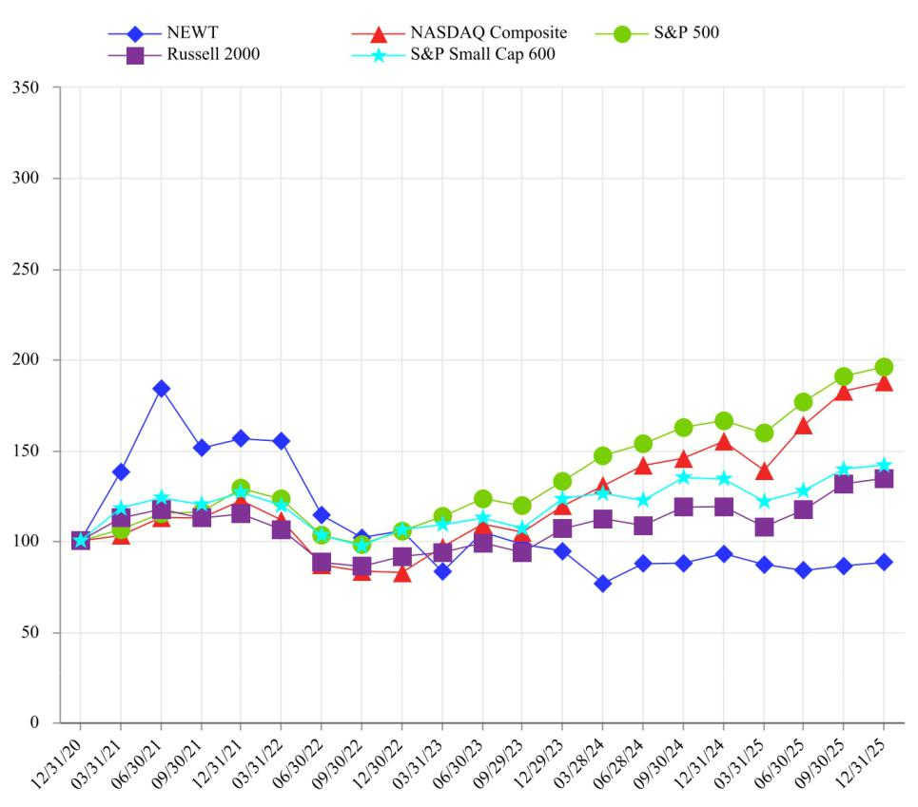

Source: Bloomberg

ITEM 6. [RESERVED].

71

Table of Contents

ITEM 7. MANAGEMENT'S DISCUSSION AND ANALYSIS OF FINANCIAL CONDITION AND RESULTS OF OPERATIONS.

Introduction and Certain Cautionary Statements

The following discussion and analysis of our financial condition and results of operations is intended to assist in the understanding and assessment of significant changes and trends related to the results of operations and financial position of the Company together with its subsidiaries. This discussion and analysis should be read in conjunction with the consolidated financial statements and the accompanying notes as well as Item 1 - Business.

The statements in this Annual Report may contain forward-looking statements relating to such matters as anticipated future financial performance, business prospects, legislative developments and similar matters. We note that a variety of factors could cause our actual results to differ materially from the anticipated results expressed in the forward-looking statements such as intensified competition and/or operating problems in our operating business projects and their impact on revenues and profit margins or additional factors as described under “Risk Factors” above.

Executive Overview

We are a financial holding company owning Newtek Bank - a branchless OCC nationally chartered bank. In 2023, we converted to a financial holding company from a BDC and a non-bank lender (see below). Our target market is owners and prospective owners of SMBs and our services are offered online and in some cases delivered and fulfilled by our staff via video and voice calls. We offer lending products, FDIC insured deposit products and services, payments processing, payroll services and insurance brokerage services. We source our business through our NewtekOne.com and NewtekBank.com web sites, our alliance partner network and our marketing database, which is facilitated through our patented NewTracker® platform. Our loan products include SBA 7(a), ALP, SBA 504, and traditional C&I and CRE bank loans. Our deposit products primarily include consumer high yield savings accounts, high yield certificates of deposit, zero-fee business checking, and business money market accounts. We offer business and financial solutions under the Newtek® and NewtekOne® brands to the independent business owner (SMB) market.

Our process to extend credit to borrowers begins with technology, but finishes with credit committee approval. We record CECL reserves on loans held for investment at amortized cost, which for unguaranteed SBA 7(a) loans exceeds 6%. For SBA7(a) loans, we hold the unguaranteed portion and sell portions guaranteed by the SBA, within approximately 180 days of origination (or we may hold guaranteed portions for longer periods), for premiums that have historically exceeded 10%, depending on loan characteristics and market conditions. Unlike traditional financial and bank holding companies, the majority of our income is driven and influenced by noninterest income, specifically gains on sales and market value adjustments on loans. We sell certain loans servicing retained, in which case we record a servicing asset that increases our gain on sale and provides a stream of future income to the extent the loan balance continues to be outstanding.

We fund our activities at Newtek Bank primarily through the aforementioned deposit products. We have also offered loans outside of our bank (primarily ALP loans that have been funded by our JVs and our non-bank subsidiary Newtek ALP Holdings) that have been initially funded with capital and lines of credit and hedged until a sufficient volume is attained at which time the loans are securitized. We are required by law to hold risk retention in securitization transactions, and the majority of our interests in securitizations are designed to absorb first loss on the loans held in the securitization trusts. Prior to July 1, 2024, the Company originated ALP loans with the intent to sell the loans to a JV. While the Company may continue to source JV partners to participate in the ALP, during the third quarter of 2024, we made the decision to originate with the intent to securitize ALP loans with our subsidiary Newtek ALP Holdings as the originator and sponsor. The Company could also originate ALP loans (i.e., long amortizing C&I loans) designated as HFI. We have also continued to actively issue bonds in the public and private capital markets.

We are subject to the regulation and supervision of the Federal Reserve and the Federal Reserve Bank of Atlanta. In addition Newtek Bank is regulated by the OCC and we are required to follow SBA rules and guidelines in the origination, servicing and sale of our SBA loans. Complying with this level of regulation requires investments in technology and process and personnel costs.

72

Table of Contents

Conversion to a Financial Holding Company

As of January 6, 2023, we became a financial holding company that, together with our consolidated subsidiaries, provide a wide range of business and financial solutions under the Newtek® and NewtekOne® brands to the independent business owner (SMB) market. Effective January 6, 2023, following authorization by our shareholders, we withdrew our previous election to be regulated as a BDC under the 1940 Act. Contemporaneously with withdrawing our election to be regulated as a BDC, on January 6, 2023, we completed the Acquisition of NBNYC, a national bank regulated and supervised by the OCC, pursuant to which we acquired from NBNYC’s shareholders all of the issued and outstanding stock of NBNYC. NBNYC was renamed Newtek Bank and became our wholly owned bank subsidiary. As a result of the Acquisition, we became a financial holding company subject to the regulation and supervision of the Federal Reserve and the Federal Reserve Bank of Atlanta. We no longer qualified as a RIC under Subchapter M of the Code for federal income tax purposes and no longer qualified for accounting treatment as an investment company. As a result, in addition to Newtek Bank and its consolidated subsidiary SBL, the following former portfolio companies and subsidiaries are consolidated non-bank subsidiaries in our financial statements: NSBF; NMS; Mobil Money; NBC; PMT; NIA; TAM; NALH; and POS. In addition, as a result of commitments made to the Federal Reserve, we divested of NTS on January 2, 2025. Refer to NOTE 4— INVESTMENTS: Intelligent Protection Management Corp.

Effective January 13, 2023, we filed Articles of Amendment amending our Charter to change the name of the Company to “NewtekOne, Inc.”

On April 13, 2023, the Company, NSBF and the SBA entered into the Wind-down Agreement, pursuant to which NSBF is winding-down its operations and NSBF’s SBA 7(a) pipeline of new loans was transitioned to Newtek Bank. During this wind-down process, NSBF continues to own the SBA 7(a) loans in its loan portfolio to maturity, liquidation, charge-off or (subject to SBA’s prior written approval) sale or transfer. SBL is servicing and liquidating NSBF’s SBA loan portfolio pursuant to an SBA approved lender service provider agreement. In addition, during the wind-down process, NSBF is subject to minimum capital requirements established by the SBA, required to continue to maintain certain amounts of restricted cash available to meet any obligations to the SBA, has restrictions on its ability to make dividends and distributions to the Company, and remains liable to the SBA for post-purchase denials and repairs on the guaranteed portions of SBA 7(a) loans originated and sold by NSBF, from the proceeds generated by NSBF’s SBA loan portfolio. The Company has guaranteed certain of NSBF’s obligations to the SBA and has funded a $10.0 million account to secure these potential obligations.

Historical Business Regulation and Taxation

Prior to January 6, 2023, we operated as an internally managed non-diversified closed-end management investment company that elected to be regulated as a BDC under the 1940 Act. Additionally, prior to January 6, 2023, due to our status as a BDC, we elected to be treated as a RIC for U.S. federal income tax purposes, beginning with our 2015 tax year. As an entity electing to be treated as a RIC, we generally did not have to pay U.S. federal income taxes at corporate rates on any ordinary income or capital gains that we distributed to our shareholders as dividends. The Company and its subsidiaries no longer qualify as a RIC for U.S. federal income tax purposes and files a consolidated U.S. federal income tax return beginning with the 2023 fiscal year. Financial holding companies are subject to federal and state income taxes in essentially the same manner as other corporations. Taxable income is generally calculated under applicable sections of the Internal Revenue Code of 1986, as amended (the “Code”), including Sections 581 through 597 that apply specifically to financial institutions. Some modifications are required by state law and the One Big Beautiful Bill Act (“OBBBA”) that was enacted in the U.S on July 4, 2025. The OBBBA includes significant tax related provisions, such as the permanent extension of certain expiring provisions of the Tax Cuts and Jobs Act, modifications to the international tax framework and the restoration of favorable tax treatment for certain business provisions. The legislation has multiple effective dates, with certain provisions effective in the Company's fiscal year 2025 and others to be implemented through 2027. There can be no assurance as to the actual effective income tax rates impacting the amounts and timing of cash flows and the amounts of income tax expense recorded by the Company, because such rates will be dependent upon the nature and amount of future income and expenses as well as actual investments generating investment tax credits and transactions with discrete tax effects.

From 2012 through December 31, 2022, NSBF was consistently the largest non-bank SBA 7(a) lender in the U.S. based on dollar volume of loan approvals, and, as of December 31, 2022, was the third largest SBA 7(a) lender in the United States. Currently, Newtek Bank is ranked as the third largest SBA 7(a) lender based on dollar volume of loans approved. Historically, NSBF structured its loans so that it could both sell the government guaranteed portions of SBA 7(a) loans and securitize the unguaranteed portions. This structure generally allowed NSBF to recover its capital and earn excess capital on each loan, typically within a year. Pursuant to the Wind-down Agreement described above, in April 2023 NSBF transitioned its SBA 7(a) loan originations to Newtek Bank and is in the process of winding down its operations and will continue to own the 7(a) Loans in its loan portfolio to maturity, liquidation, charge-off or (subject to SBA’s prior written approval) sale or transfer.

73

Table of Contents

Additionally, we and our subsidiaries provide a wide range of business and financial solutions to independent business owner relationships, including Business Lending, which includes SBA 7(a) loans, SBA 504 loans, ALP loans, C&I loans, CRE loans and ABL loans; Electronic Payment Processing, personal and commercial lines Insurance Services, and Payroll and Benefits Solutions to independent business owner relationships nationwide across all industries. With the divestiture of NTS, we no longer provide Managed Technology Solutions to our clients, however, we are currently referring our clients to IPM for its offering of Managed Technology Solutions and can earn a finder’s fee pursuant to a referral promotion agreement. We support the operations of our subsidiaries by providing access to our proprietary and patented technology platform, including NewTracker®, our patented prospect management software. We have historically defined independent business owners (SMBs) as companies having revenues of $1 million to $100 million, and we have generally estimated the SMB market to be over 34 million businesses in the United States. We make loans and provide business and financial solutions to the SMB market through our bank and non-bank subsidiaries. In addition, we now offer the Newtek Advantage®, the One Dashboard for All of Your Business Needs®, which provides independent business owners with instant access to a team of NewtekOne business and financial solutions experts in the areas of Business Lending, Electronic Payment Processing, personal and commercial lines Insurance Services and Payroll and Benefits Solutions. Moreover, the Newtek Advantage provides our independent business owner clients with analytics on their businesses, as well as transactional capabilities, including free unlimited document storage, free real-time updated traffic analytics, free real-time credit card processing and chargeback batch information for merchant solutions clients and the ability for PMT clients to make payroll directly from the Newtek Advantage business portal.

The Company has originated loans under its ALP since 2019. These loans have terms between 10 and 25 years, bear fixed interest rates that reset every five years, and have prepayment penalties. The criteria evaluated in underwriting ALP loans and the terms of these loans have been generally consistent over the ALP’s existence. Prior to July 1, 2024, the Company originated ALP loans with the intent to sell the loans to a JV. While the Company may continue to source JV partners to participate in the ALP, during the third quarter of 2024, we made the decision to originate with the intent to securitize ALP loans with our subsidiary Newtek ALP Holdings as the originator and sponsor. For example, during the second quarter of 2025, Newtek ALP Holdings closed a securitization backed by $216.6 million of ALP loans. The Company could also originate ALP loans designated as HFI.

Following the Acquisition, there can be no assurance regarding our continued lending prospects or operations as a financial holding company. See “Item 1A. Risk Factors – Risks Related to Operation as a Financial Holding Company – We are subject to extensive regulation and supervision as a financial holding company, which may adversely affect our business.”

Our common shares are currently listed on the Nasdaq Global Market under the symbol “NEWT”.

Newtek Bank is a national bank and nationally licensed SBA lender under the SBA 7(a) Program, and originates, sells and services SBA 7(a) loans. Newtek Bank has been granted PLP status and is authorized to place SBA guarantees on loans without seeking prior SBA review and approval. Being a national lender with PLP status allows Newtek Bank to expedite the origination of SBA 7(a) loans since Newtek Bank is not required to present applications to the SBA for concurrent review and approval. The loss of PLP status would adversely impact our marketing efforts and ultimately our loan origination volume, which would negatively impact our results of operations. See “Item 1A. Risk Factors - Risks Related to SBA Lending - There can be no guarantee that Newtek Bank will be able to maintain its SBA 7(a) lending license and PLP status.” and “Item 1A. Risk Factors - Risks Related to SBA Lending - A governmental failure to fund the SBA could adversely affect Newtek Bank’s SBA 7(a) loan originations and our results of operations.”

74

Table of Contents

Economic Developments

We have observed and continue to observe commodity inflation, rising interest rates, unrelated bank failures and declines in depositor confidence in certain types of depository institutions. In addition, the conflicts in the Middle East and the war between Russia and Ukraine, and resulting market volatility and impacts on energy prices, could adversely affect our business, financial condition and results of operations, as well as the financial condition of our borrowers. The ongoing conflicts have negatively affected the global economy and business activity and could have a material adverse effect on our business, financial condition, cash flows and results of operations, as well as those of our borrowers. The severity and duration of conflicts and their impact on global economic and market conditions are impossible to predict. In 2024, numerous elections were held globally, including the recent U.S. presidential election. The outcomes of the elections are expected to result in changes in policy, which could also have adverse effects on us or the business environment in which we operate more generally. For example, the current U.S. presidential administration has imposed or increased tariffs, including on imports from China, and proposed imposing or increasing tariffs on U.S. trading partners, which could adversely affect markets, the business environment and our business. On July 4, 2025, federal legislation generally referred to as H.R. 1 - One Big Beautiful Bill Act (the “Act” or “OBBBA”) was signed into law. The Act includes a variety of tax provisions including permanently extending and modifying certain key aspects of existing federal tax law. U.S. GAAP requires the effects of changes in tax laws and rates to be recognized in its financial statements in the period in which legislation is enacted. The Company evaluated the OBBBA and there is no material impact on its financial position or results of operations in the current year. Any of the above factors, including sanctions, export controls, tariffs, trade wars and other governmental actions, could have a material adverse effect on our business, financial condition, cash flows and results of operations and could cause the market value of our common shares and/or debt securities to decline. We monitor developments and seek to manage our investments in a manner consistent with achieving our investment objective, but there can be no assurance that we will be successful in doing so.

Income

For the fiscal year ended December 31, 2025, we generated income in the form of interest, net gains on the sales of loans originated (which primarily include sales of SBA 7(a) and ALP loans) and related servicing assets on such sales, dividends, electronic payment processing income, servicing income, and other fee income generated by loan originations and by our subsidiaries. We originated loans that typically have terms of 10 to 25 years and bear interest at prime plus a margin. In some instances, we received payments on our loans based on scheduled amortization of the outstanding balances. In addition, we received repayments of some of our loans prior to their scheduled maturity date. The frequency or volume of these repayments fluctuated significantly from period to period. Our portfolio activity for the fiscal year ended December 31, 2025, also reflects the proceeds of sales of guaranteed portions of SBA 7(a) loans we originated. In addition, we received servicing income related to the guaranteed portions of SBA 7(a) loans which we originated and sold into the secondary market as well as on the portfolios of ALP loans owned and then securitized by NCL JV (dissolved in September 2025), TSO JV and Newtek ALP Holdings. These recurring fees are outlined in servicing agreements and were recorded when earned. In addition, we generated revenue in the form of loan origination fees (packaging and legal fees) as well as loan prepayment and late fees. We recorded such fees related to loans held for sale as other income. Distributions of earnings from our joint ventures were evaluated to determine if the distribution was income, return of capital or realized gain.

We recognized realized gains or losses on loans based on the difference between (1) the net proceeds from the disposition and any servicing assets recognized and (2) the cost basis of the loan without regard to unrealized gains or losses previously recognized. We recorded current period changes in fair value of loans and assets that were measured at fair value as a component of the net change in unrealized appreciation (depreciation) on the loans or servicing assets, as appropriate, as well as amortization and impairment, if any, of LCM servicing rights in the consolidated statements of income.

Expenses

For the fiscal year ended December 31, 2025, our primary operating expenses were salaries and benefits, interest expense including interest on deposits, electronic payment processing expense, loan origination and servicing expenses, and other general and administrative costs, such as professional fees, marketing, referral fees, servicing costs and rent.

75

Table of Contents

Discussion and Analysis of Financial Condition

December 31, 2025 vs. December 31, 2024

ASSETS

Total assets at December 31, 2025 were $2.7 billion, an increase of $684.9 million, or 33.2%, compared to total assets of $2.1 billion at December 31, 2024. As of December 31, 2024, the Company held the assets and liabilities of NTS for sale. Refer to NOTE 4—INVESTMENTS: Intelligent Protection Management Corp.

Loans
 |  | December 31, 2025 |  |  | December 31, 2024 |  |  | Change
Loans held for sale, at fair value | $ | 971,837 |  | $ | 372,286 |  | $ | 599,551
Loans held for sale, at LCM |  | 26,532 |  |  | 58,803 |  |  | (32,271)
Loans held for investment, at fair value |  | 281,198 |  |  | 369,746 |  |  | (88,548)
Loans held for investment, at amortized cost, net of deferred fees and costs |  | 896,689 |  |  | 621,651 |  |  | 275,038
Allowance for credit losses |  | (45,226) |  |  | (30,233) |  |  | (14,993)
Loans held for investment, at amortized cost, net |  | 851,463 |  |  | 591,418 |  |  | 260,045
Total Loans | $ | 2,131,030 |  | $ | 1,392,253 |  | $ | 738,777

Loans held for sale

Loans HFS, at fair value increased $599.6 million during the year ended December 31, 2025. The overall increase was the result of an increase of $202.7 million for ALP loans, which were included in the $284.4 million of loans in the securitization transaction that did not close until January 2026. In addition, holding guaranteed portions of SBA 7(a) loans for longer periods of time as well as new loan originations during 2025, in the amount of $396.9 million in SBA loans also contributed to the increase.

 |  |  | December 31, 2025 |  |  | December 31, 2024 |  |  | Change
SBA 504 | First Lien | $ | 201,013 |  | $ | 128,255 |  | $ | 72,758
SBA 504 | Second Lien |  | 31,207 |  |  | 26,678 |  |  | 4,529
SBA 7(a) |  |  | 303,716 |  |  | 4,855 |  |  | 298,861
SBA 7(a) Partials¹ |  |  | 20,753 |  |  | — |  |  | 20,753
Total SBA loans |  |  | 556,689 |  |  | 159,788 |  |  | 396,901
ALP |  |  | 415,148 |  |  | 212,498 |  |  | 202,650
Loans HFS, at fair value |  | $ | 971,837 |  | $ | 372,286 |  | $ | 599,551

- Reclassified from Loans HFS, at LCM

Loans HFS, at LCM decreased $32.3 million during the same period. The overall decrease was primarily the result of loan sales that occurred in 2025.

 |  |  | December 31, 2025 |  |  | December 31, 2024 |  |  | Change
SBA 504 | First Lien | $ | 19,075 |  | $ | 36,783 |  | $ | (17,708)
SBA 504 | Second Lien |  | 7,457 |  |  | 8,203 |  |  | (746)
SBA 7(a) Partials¹ |  |  | — |  |  | 13,817 |  |  | (13,817)
Loans HFS, at LCM |  | $ | 26,532 |  | $ | 58,803 |  | $ | (32,271)

- Reclassified to Loans HFS, at fair value

76

Table of Contents

Loans held for investment

At Fair value: Loans HFI, at fair value were $281.2 million at December 31, 2025 compared to $369.7 million at December 31, 2024. The balance consists primarily of SBA 7(a) loans as well as $5.7 million of loans that the Company owns 100% as a result of originating the loan and subsequently repurchasing the guaranteed portion from the SBA. As previously discussed, NSBF ceased originating loans during 2023, resulting in the decrease in the balance of loans held for investment from December 31, 2024 to December 31, 2025, primarily due to the principal payments of existing loans held by NSBF.

At Amortized Cost: Loans HFI, at amortized cost consist of loans originated at or purchased by Newtek Bank. The $275.0 million increase in loans HFI, at amortized cost is the result of an increase in originations for the year ended December 31, 2025 over 2024.

Credit Quality: Overall credit quality remained stable during the year. The increase in nonperforming loans HFI is adequately covered by the allowance for credit losses and in line with the seasoning of the portfolio. The Company continues to focus on prudent underwriting and portfolio diversification across its lending activities. The following table presents an analysis of loans HFI with credit metrics, including a breakdown by days aged:

Credit Quality Ratios |  | December 31, 2025 |  |  |  |  | December 31, 2024
At Amortized Cost
Current | $ | 794,951 |  | 88.9 % |  | $ | 575,444 |  | 92.8 %
Past Due 30-89 Days and accruing |  | 20,555 |  | 2.3 % |  |  | 20,585 |  | 3.3 %
Past Due 90 and more Days and accruing |  | — |  | — % |  |  | — |  | — %
Nonaccrual loans |  | 78,814 |  | 8.8 % |  |  | 24,341 |  | 3.9 %
Total, at amortized cost | $ | 894,320 |  | 100.0 % |  | $ | 620,370 |  | 100.0 %
Deferred fees and costs |  | 2,369 |  |  |  |  | 1,281
Total, at amortized cost, net of deferred fees and costs | $ | 896,689 |  |  |  | $ | 621,651
Allowance for credit losses | $ | (45,226) |  | 5.0 % |  | $ | (30,233) |  | 4.9 %
At Fair Value
Current | $ | 189,177 |  | 67.2 % |  | $ | 251,616 |  | 68.1 %
Past Due 30-89 Days and accruing |  | 16,746 |  | 6.0 % |  |  | 41,558 |  | 11.2 %
Past Due 90 and more Days and accruing |  | 2,732 |  | 1.0 % |  |  | 9,268 |  | 2.5 %
Nonaccrual loans |  | 72,543 |  | 25.8 % |  |  | 67,304 |  | 18.2 %
Total | $ | 281,198 |  | 100.0 % |  | $ | 369,746 |  | 100.0 %
Past due and nonaccrual loans as % of Outstanding UPB | $ | 92,021 |  | 32.7 % |  | $ | 118,130 |  | 31.9 %
Nonperforming Assets, as a percentage of total assets
Loans HFI, at amortized cost | $ | 78,814 |  | 2.9 % |  | $ | 24,341 |  | 1.2 %
Loans HFI, at fair value |  | 72,543 |  | 2.6 % |  |  | 67,304 |  | 3.2 %
Other real estate owned |  | 8,856 |  | 0.3 % |  |  | 3,764 |  | 0.2 %
Total Nonperforming Assets | $ | 160,213 |  | 5.8 % |  | $ | 95,409 |  | 4.6 %

CRE exposure

The Company’s loan portfolio consists of loans to independent business owners (SMBs). The Company’s Loans HFI at amortized cost and Loans HFS at LCM include a total of $355.9 million of loans, including unfunded commitments, backed by CRE and considered non-owner occupied as of December 31, 2025. The average loan-to-value for this CRE portfolio was 57.5%. The CRE portfolio is diversified by property type and geography, and management actively monitors concentration levels, loan to value ratios, and debt service coverage metrics as part of its ongoing credit risk management process. Furthermore, there is limited exposure to office space.

77

Table of Contents

The table below presents detail of the loans considered non-owner occupied CRE that are not carried at fair value:

 |  |  |  |  | December 31, 2025 |  |  |  |  |  |  |  |  |  |  | December 31, 2024
 | HFI at amortized cost, |  |  |  |  |  |  |  |  | LTV |  | HFI at amortized cost, |  |  |  |  |  |  |  |  | LTV
 | net of deferred fees and |  |  |  | HFS at LCM |  |  | Total |  |  |  | net of deferred fees and |  |  |  | HFS at LCM |  |  | Total |  | LTV
 |  |  |  |  |  |  |  | Total |  | by CRE type |  |  |  |  |  |  |  |  | Total |  | by CRE type
 |  | costs |  |  |  |  |  |  |  |  |  |  | costs |  |  |  |  |  |  |  | by CRE type
Loans not backed by NOO CRE | $ | 622,495 |  | $ | — |  | $ | 622,495 |  |  |  | $ | 429,820 |  | $ | — |  | $ | 429,820
Loans backed by NOO CRE |  | 274,194 |  |  | 26,532 |  |  | 300,726 |  |  |  |  | 191,831 |  |  | 58,803 |  |  | 250,634
Total loans | $ | 896,689 |  | $ | 26,532 |  | $ | 923,221 |  |  |  | $ | 621,651 |  | $ | 58,803 |  | $ | 680,454
Loans backed by NOO CRE by type:
Retail | $ | 63,013 |  | $ | — |  | $ | 63,013 | 54.0 % |  |  | $ | 45,594 |  | $ | — |  | $ | 45,594 | 51.4 %
1-4 Family |  | 22,187 |  |  | — |  |  | 22,187 | 54.5 % |  |  |  | 25,139 |  |  | — |  |  | 25,139 | 56.1 %
Multifamily |  | 80,263 |  |  | — |  |  | 80,263 | 58.6 % |  |  |  | 35,713 |  |  | — |  |  | 35,713 | 52.6 %
Industrial |  | 34,416 |  |  | — |  |  | 34,416 | 50.5 % |  |  |  | 27,866 |  |  | — |  |  | 27,866 | 50.1 %
Office |  | 40,638 |  |  | — |  |  | 40,638 | 52.6 % |  |  |  | 21,586 |  |  | — |  |  | 21,586 | 47.7 %
Construction and land development¹ |  | 12,869 |  |  | 19,075 |  |  | 31,944 | 63.7 % |  |  |  | 22,775 |  |  | 44,986 |  |  | 67,761 | 65.1 %
Hotel |  | 7,709 |  |  | 7,457 |  |  | 15,166 | 48.2 % |  |  |  | — |  |  | 13,817 |  |  | 13,817 | 66.2 %
Other |  | 13,099 |  |  | — |  |  | 13,099 | 61.8 % |  |  |  | 13,158 |  |  | — |  |  | 13,158 | 61.5 %
Total NOO CRE | $ | 274,194 |  | $ | 26,532 |  | $ | 300,726 | 57.5 % |  |  | $ | 191,831 |  | $ | 58,803 |  | $ | 250,634 | 57.9 %
Unfunded Commitments
Construction and land development¹ | $ | — |  | $ | 55,149 |  | $ | 55,149 |  |  |  | $ | — |  | $ | 48,402 |  | $ | 48,402
Hotel |  | — |  |  | — |  |  | — |  |  |  |  | — |  |  | 13 |  |  | 13
Total unfunded commitments |  | — |  |  | 55,149 |  |  | 55,149 |  |  |  |  | — |  |  | 48,415 |  |  | 48,415
Total CRE Loans | $ | 274,194 |  | $ | 81,681 |  | $ | 355,875 |  |  |  | $ | 191,831 |  | $ | 107,218 |  | $ | 299,049

- Construction and land development includes SBA 504 first and second lien loans. The LTV on first lien is generally 65%. Second liens are typically taken out by the SBA following project completion and occupancy by the borrower. The LTV calculated is based on total exposure.

Goodwill and Intangibles

The table below presents detail of the Company’s Goodwill and intangibles:

 |  |  |  | December 31, 2025 |  |  |  |  |  |  |  |  |  | December 31, 2024
 |  | Goodwill |  | Intangible Assets |  |  | Total |  |  |  | Goodwill |  |  | Intangible Assets |  |  | Total
Banking segment | $ | 271 |  | $ | 512 |  | $ | 783 |  | $ | 271 |  | $ | 667 |  | $ | 938
Payments segment |  | 13,814 |  |  | — |  |  | 13,814 |  |  | 13,814 |  |  | — |  |  | 13,814
Total | $ | 14,085 |  | $ | 512 |  | $ | 14,597 |  | $ | 14,085 |  | $ | 667 |  | $ | 14,752

The change in goodwill and intangible assets relates to amortization of intangible assets during the year ended December 31, 2025.

78

Table of Contents

Residuals in Securitizations, at Fair Value

The residuals in securitizations, at fair value arise from the NALP Business Loan Trust 2025-1 ALP securitization that the Company closed on April 23, 2025. Residuals in securitizations were $76.7 million as of December 31, 2025. The Securitization Trust meets the definition of a VIE. The Company holds a variable interest in the VIE, however, the Company is not considered the primary beneficiary of the VIE, because the power over the activities that have the most significant impact on the economic performance of the Securitization Trust is held by the Class C Noteholder, and therefore, the Company is not required to consolidate the Securitization Trust. The Company’s beneficial interest in the Securitization Trust is evidenced by sole ownership of the Ownership Certificate and its beneficial interest in the credit risk of the securitized ALP Loans. As the Sponsor is a wholly owned subsidiary of the Company, the Company effectively owns 100% of the equity interest in the Trust. Refer to NOTE 3—SECURITIZATIONS AND VARIABLE INTEREST ENTITIES in the accompanying notes to the consolidated financial statements for additional information.

Settlement Receivable

Settlement receivables were $0.4 million as of December 31, 2025, a decrease of $52.0 million compared to December 31, 2024. The settlement receivable arises from the guaranteed portions of SBA 7(a) loans that were traded in the period but did not settle during the current period end and the cash was not received from the purchasing broker during the current period; the amount varies depending on loan origination volume and timing of sales at period end.

LIABILITIES

Total liabilities at December 31, 2025, were $2.3 billion, an increase of $583.6 million, or 33.1%, compared to total liabilities of $1.8 billion at December 31, 2024.

Deposits

Total deposits were $1.4 billion at December 31, 2025, consisting of $53.9 million in non-interest bearing deposits and $1.4 billion in interest bearing deposits, a $444.4 million increase from the balance as of December 31, 2024. The increase in deposits is a result of increases in all of our deposit products due to our competitive interest rates well above the risk free rate and the sticky deposit relationships we foster by providing value to our depositors via the Newtek Advantage. As of December 31, 2025 and December 31, 2024, insured deposits represent 73.6% and 80.3%, respectively, of deposits.

Borrowings
Borrowings Outstanding |  |  | December 31, 2025 |  |  | December 31, 2024 |  |  | Change
Bank Borrowings¹:
NMS Webster Note² |  | $ | — |  | $ | 32,688 |  | $ | (32,688)
NMS Goldman Facility³ |  |  | 88,352 |  |  | — |  |  | 88,352
SPV I Capital One Facility |  |  | 16,085 |  |  | 21,192 |  |  | (5,107)
SPV II Deutsche Bank Facility |  |  | 169,146 |  |  | 54,036 |  |  | 115,110
SPV III One Florida Bank Facility |  |  | 33,259 |  |  | 23,011 |  |  | 10,248
FHLB Advances |  |  | 7,349 |  |  | 15,330 |  |  | (7,981)
Total Lines of Credit |  |  | 314,191 |  |  | 146,257 |  |  | 167,934
Parent Company Notes¹:
2025 | Notes (5.00%)⁴ |  | — |  |  | 29,913 |  |  | (29,913)
2026 | Notes (5.50%)⁵ |  | 95,000 |  |  | 114,282 |  |  | (19,282)
2027 | Notes (8.125%)⁶ |  | 49,967 |  |  | 49,944 |  |  | 23
2028 | Notes (8.00%) |  | 39,073 |  |  | 38,726 |  |  | 347
2029 | Notes (8.50%) |  | 70,066 |  |  | 69,622 |  |  | 444
2029 | Notes (8.625%) |  | 73,150 |  |  | 72,662 |  |  | 488
2030 | Notes (8.375%)^{5,7} |  | 51,391 |  |  | — |  |  | 51,391
Total Parent Company Notes |  |  | 378,647 |  |  | 375,149 |  |  | 3,498
Notes Payable - Securitization Trusts¹ |  |  | 127,050 |  |  | 186,635 |  |  | (59,585)
Total |  | $ | 819,888 |  | $ | 708,041 |  | $ | 111,847
 |  |  | 79

Table of Contents

- Net of deferred financing costs.
- On September 26, 2025, the NMS Webster Note was repaid in full.

- On September 26, 2025, NMS entered into the Goldman Facility. ⁴ On March 31, 2025, the 2025 5.00% Notes matured.

- On October 21, 2025, the Company entered into agreements with two institutional investors that were existing holders of the Company’s 2026 Notes to exchange the $20.0 million in total principal amount of the Company’s 2026 Notes held by such investors for an equal principal amount of the Company’s 2030 Notes. On February 1, 2026, the 2026 Notes matured. See “NOTE 24 —SUBSEQUENT EVENTS - Exchange of 2026 Notes for 2031 Notes and Repayment of 2026 Notes” for additional information.
- Effective December 11, 2024, the Company entered into the Amendment and Exchange Agreements with each of the holders of the 2025 8.125% Notes, pursuant to which the Company and the holders of the 2025 8.125% Notes agreed to exchange the 2025 8.125% Notes for the 2027 Notes, effecting amendments solely to (i) extend the February 1, 2025 maturity date of the 2025 8.125% Notes to the new maturity date of February 1, 2027 (the “New Maturity Date”) and (ii) provide that the 2027 Notes will be redeemable in whole, but not in part, at any time, at the option of the Company, from November 1, 2026 to the New Maturity Date, at a redemption price of 100% of the outstanding principal amount being redeemed plus any accrued but unpaid interest, to but excluding the redemption date.

- On March 19, 2025, the Company closed an exempt offering of $30.0 million in aggregate principal amount of its 2030 Notes. The 2030 Notes bear interest at a rate of 8.375% per year payable semiannually on April 1 and October 1 each year, beginning October 1, 2025.

Borrowings were $819.9 million at December 31, 2025, compared to $708.0 million at December 31, 2024. This increase was primarily due to $88.4 million of new borrowings under the NMS Goldman Facility, additional borrowings of $115.1 million on the SPV II facility as well as $51.4 million issuance of the 2030 Notes. These increases were partially offset by $32.7 million repayment in full of the NMS Webster Note, the maturity of $29.9 million of the 2025 5.00% Notes, $59.6 million reduction in the notes payable on securitization trusts, and $10.2 million repayments of borrowings on the SPV III facility, and $8.0 million in maturities of FHLB advances.

Deferred Taxes

The deferred tax liability, net, represents the cumulative timing differences between book and tax to the extent such assets or liabilities give rise to taxable income or expense in future periods. Within this balance is the deferred tax asset on net operating loss (NOL) carryforwards not expected to be utilized in the current year. The Company evaluated all NOLs for a valuation allowance and determined that none were required. The increase in the deferred tax liability is driven by the increase in the fair value measurements on loans held for sale.

80

Table of Contents

Results of Operations

Set forth below is a comparison of the results of operations for the years ended December 31, 2025 and 2024.

For a comparison of the results of operations for the year ended December 31, 2023, see the Company's Form 10-K for the year ended December 31, 2024, as filed with the SEC on March 17, 2025.

Summary

For the year ended December 31, 2025, the Company reported net income of $60.5 million, or $2.21 per basic and $2.18 per diluted share, compared to net income of $50.9 million, or $1.97 per basic and 1.96 per diluted share, for the year ended December 31, 2024.

The net increase in net income before taxes was due to a $35.4 million increase of interest income on loans, and a $7.6 million increase in noninterest income, partially offset by a $12.5 million increase of provision for credit losses, a $13.2 million increase of interest expense on deposits. Below is a summary of changes in the components of Net income:

 |  |  | Year Ended December 31,
 | 2025 |  |  |  |  | 2024 |  |  |  |  | Change
Net interest income after provision for credit losses | $ |  | 21,156 |  | $ | 14,089 |  |  |  | $ | 7,067
Noninterest income |  |  | 224,914 |  |  | 217,312 |  |  |  |  | 7,602
Noninterest expense |  |  | 166,093 |  |  | 162,709 |  |  |  |  | 3,384
Net income before taxes |  |  | 79,977 |  |  | 68,692 |  |  |  |  | 11,285
Income tax expense |  |  | 19,465 |  |  | 17,839 |  |  |  |  | 1,626
Net income | $ |  | 60,512 |  | $ | 50,853 |  |  |  | $ | 9,659
Net Interest Income
 |  |  | Year Ended December 31,
 |  | 2025 |  |  |  | 2024 |  |  |  |  | Change
Interest income
Debt securities available-for-sale | $ |  | 924 |  | $ | 1,482 |  | $ |  |  | (558)
Loans and fees on loans |  |  | 146,274 |  |  | 110,892 |  |  |  |  | 35,382
Other interest earning assets |  |  | 11,217 |  |  | 9,044 |  |  |  |  | 2,173
Total interest income |  |  | 158,415 |  |  | 121,418 |  |  |  |  | 36,997
Interest expense
Deposits |  |  | 41,894 |  |  | 28,690 |  |  |  |  | 13,204
Notes and securitizations |  |  | 42,846 |  |  | 45,454 |  |  |  |  | (2,608)
Bank and FHLB borrowings |  |  | 13,790 |  |  | 6,969 |  |  |  |  | 6,821
Total interest expense |  |  | 98,530 |  |  | 81,113 |  |  |  |  | 17,417
Net interest income |  |  | 59,885 |  |  | 40,305 |  |  |  |  | 19,580
Provision for credit losses |  |  | 38,729 |  |  | 26,216 |  |  |  |  | 12,513
Net interest income after provision for credit losses |  | $ | 21,156 |  | $ | 14,089 |  |  | $ |  | 7,067

Interest Income

Loans and fees on loans: The $35.4 million increase in interest income on the Company’s loan portfolio was attributable to increases in the average balances of loans HFI and HFS, which increased $148.9 million and $362.5 million, respectively, as well as the average outstanding accrual portfolio of loans held for investment increasing to $1.6 billion from $1.1 billion for the year ended December 31, 2025 and 2024, respectively. The increase in the average balance of loans HFS was attributable to originations of SBA 504 and ALP loans, and the increase in the average outstanding accrual loan portfolio resulted from the origination of new SBA 7(a) loans period over period.

81

Table of Contents

Interest Expense

The following is a summary of interest expense by facility for the year ended December 31, 2025 and 2024:

 |  |  | Year Ended
 |  |  | December 31, 2025 |  |  | December 31, 2024 |  |  | Change
Deposits |  | $ | 41,894 |  | $ | 28,690 |  | $ | 13,204
Notes and securitizations:
Notes payable - Securitization Trusts |  |  | 12,012 |  |  | 21,097 |  |  | (9,085)
2024 | Notes¹ |  | — |  |  | 1,409 |  |  | (1,409)
2025 | 5.00% Notes² |  | 462 |  |  | 1,850 |  |  | (1,388)
2026 | Notes³ |  | 6,757 |  |  | 7,043 |  |  | (286)
2027 | Notes⁴ |  | 4,091 |  |  | 4,599 |  |  | (508)
2028 | Notes⁵ |  | 3,548 |  |  | 3,548 |  |  | —
2029 | 8.50% Notes⁶ |  | 6,618 |  |  | 3,879 |  |  | 2,739
2029 | 8.625% Notes⁷ |  | 6,957 |  |  | 2,029 |  |  | 4,928
2030 | Notes⁸ |  | 2,401 |  |  | — |  |  | 2,401
Total notes and securitizations |  |  | 42,846 |  |  | 45,454 |  |  | (2,608)
Bank and FHLB Borrowings:
Bank notes payable |  |  | 13,494 |  |  | 6,446 |  |  | 7,048
FHLB Advances |  |  | 296 |  |  | 523 |  |  | (227)
Total bank and FHLB borrowings |  |  | 13,790 |  |  | 6,969 |  |  | 6,821
Total interest expense |  | $ | 98,530 |  | $ | 81,113 |  | $ | 17,417

- On August 1, 2024, the 2024 Notes matured.
- On March 31, 2025, the 2025 5.00% Notes matured.

- On October 21, 2025, the Company entered into agreements with two institutional investors that were existing holders of the Company’s 2026 Notes to exchange the $20.0 million in total principal amount of the Company’s 2026 Notes held by such investors for an equal principal amount of the Company’s 2030 Notes. On February 1, 2026, the 2026 Notes matured. See “NOTE 24 —SUBSEQUENT EVENTS - Exchange of 2026 Notes for 2031 Notes and Repayment of 2026 Notes” for additional information.
- Effective December 11, 2024, the Company entered into the Amendment and Exchange Agreements with each of the holders of the 2025 8.125% Notes, pursuant to which the Company and the holders of the 2025 8.125% Notes agreed to exchange the 2025 8.125% Notes for the 2027 Notes.

- On August 31, 2023, the Company completed a public offering of $40.0 million aggregate principal amount of 8.00% notes due 2028. The Notes will mature on September 1, 2028. The Notes bear interest at a rate of 8.000% per year, payable quarterly on March 1, June 1, September 1, and December 1 each year, commencing on December 1, 2023.

- On May 30, 2024, the Company completed a public offering of $62.5 million aggregate principal amount of 8.500% notes due 2029. On June 3, 2024, the underwriters exercised their option to purchase an additional $9.4 million in aggregate principal amount of the 2029 Notes. The Notes will mature on June 1, 2029. The Notes bear interest at a rate of 8.500% per year, payable quarterly on March 1, June 1, September 1, and December 1 each year, commencing on September 1, 2024.
- On September 16, 2024, the Company completed a public offering of $75.0 million aggregate principal amount of 8.625% notes due 2029. The Notes will mature on October 15, 2029. The Notes bear interest at a rate of 8.625% per year, payable quarterly on January 15, April 15, July 15, and October 15 each year, commencing on January 15, 2025.

- On March 19, 2025, the Company completed an exempt offering of $30.0 million aggregate principal amount of notes due 2030. The Notes will mature on April 1, 2030. The Notes bear interest at a rate of 8.375% per year, payable semiannually on April 1 and October 1 each year, commencing on October 1, 2025. On October 21, 2025, the Company entered into agreements with two institutional investors that were existing holders of the Company’s 2026 Notes to exchange $20.0 million in total principal amount of the Company’s 2026 Notes held by such investors for an equal principal amount of the Company’s 2030 Notes. One of the investors also agreed to purchase $2.0 million in newly issued additional principal amount of the Company’s 2030 Notes.

82

Table of Contents

The increase in interest expense period over period is primarily from additional interest expense on deposits of $13.2 million, additional interest expense of $6.8 million on bank and FHLB borrowings, and additional interest expense of $2.7 million, $4.9 million, and $2.4 million on the 2029 8.50% Notes, the 2029 8.625% Notes, and the 2030 Notes, respectively. The increase is partially offset by a $9.1 million reduction in interest due to securitization payoffs, as well as a $1.4 million and $1.4 million reduction in interest expense on the 2024 Notes and the 2025 5.00% Notes, respectively.

Net Interest Income and Margin

Average Balances and Yields. The following table presents information regarding average balances for assets and liabilities, the total dollar amounts of interest income and dividends from average interest-earning assets, the total dollar amount of interest expense on average interest-bearing liabilities, and the resulting average yields and costs. The yields and costs for the periods indicated are derived by dividing the income or expense by the average balances for assets or liabilities, respectively, for the periods presented and annualizing that result. Loan fees are included in interest income on loans.

 |  |  |  |  |  |  | Year Ended December 31,
 |  |  |  |  | 2025 |  |  |  |  |  |  |  | 2024
 |  | Average Balance |  |  | Interest |  | Average Yield / |  | Average Balance |  |  |  | Interest |  | Average Yield /
 |  |  |  |  |  |  | Rate |  |  |  |  |  |  |  | Rate
Interest-earning assets:
Other interest-earning assets | $ | 271,021 |  | $ | 11,217 |  | 4.14 % |  | $ | 180,753 |  | $ | 9,044 |  | 5.00 %
Investment securities |  | 15,875 |  |  | 924 |  | 5.82 |  |  | 31,847 |  |  | 1,482 |  | 4.65
Loans held for sale |  | 600,404 |  |  | 57,195 |  | 9.53 |  |  | 237,903 |  |  | 26,692 |  | 11.22
Loans held for investment |  | 1,100,869 |  |  | 89,079 |  | 8.09 |  |  | 951,988 |  |  | 84,200 |  | 8.84
Total interest-earning assets |  | 1,988,169 |  |  | 158,415 |  | 7.97 |  |  | 1,402,491 |  |  | 121,418 |  | 8.66
Less: Allowance for credit losses on loans |  | (40,624) |  |  |  |  |  |  |  | (19,033)
Noninterest earning assets |  | 230,210 |  |  |  |  |  |  |  | 204,655
Total assets | $ | 2,177,755 |  |  |  |  |  |  | $ | 1,588,113
Interest-bearing liabilities:
Demand | $ | 141,845 |  | $ | 1,106 |  | 0.78 % | $ |  | 51,759 |  | $ | 461 |  | 0.89 %
Savings and NOW |  | 511,682 |  |  | 19,188 |  | 3.75 |  |  | 273,640 |  |  | 13,803 |  | 5.04
Money Market |  | 62,684 |  |  | 2,217 |  | 3.54 |  |  | 27,471 |  |  | 1,141 |  | 4.15
Time |  | 354,316 |  |  | 19,383 |  | 5.47 |  |  | 261,174 |  |  | 13,285 |  | 5.09
Total deposits |  | 1,070,527 |  |  | 41,894 |  | 3.91 |  |  | 614,044 |  |  | 28,690 |  | 4.67
Borrowings |  | 701,316 |  |  | 56,636 |  | 8.08 |  |  | 643,234 |  |  | 52,423 |  | 8.15
Total interest-bearing liabilities |  | 1,771,843 |  |  | 98,530 |  | 5.56 |  |  | 1,257,278 |  |  | 81,113 |  | 6.45
Noninterest-bearing deposits |  | — |  |  |  |  |  |  |  | 600
Noninterest-bearing liabilities |  | 65,749 |  |  |  |  |  |  |  | 67,405
Shareholders’ equity |  | 340,163 |  |  |  |  |  |  |  | 262,830
Total liabilities and shareholders' equity | $ | 2,177,755 |  |  |  |  |  |  | $ | 1,588,113
Net interest income and interest rate spread |  |  |  | $ | 59,885 |  | 2.41 % |  |  |  |  | $ | 40,305 |  | 2.21 %
Net interest margin |  |  |  |  |  |  | 3.01 % |  |  |  |  |  |  |  | 2.87 %
Ratio of average interest-earning assets to average interest bearing |  |  |  |  |  |  | 112.21 % |  |  |  |  |  |  |  | 111.55 %
liabilities |  |  |  |  |  |  | 112.21 % |  |  |  |  |  |  |  | 111.55 %
 |  |  |  | 83

Table of Contents

In response to market conditions and consistent with its business plan, Newtek Bank has been focused on increasing its liquidity position by raising additional deposits and maintaining a significant portion of its liquidity in the form of cash held at the Federal Reserve, approximately $277.8 million as of December 31, 2025, as opposed to long-term investments. In addition, Newtek Bank management continues to closely monitor market conditions with a focus on its asset liability management policies, as well as closely monitoring, among other things, capital levels, to ensure compliance with regulatory guidelines. The increase in the average balance of loans HFS was attributable to originations of SBA 504, SBA 7(a) and ALP loans, and the increase in the average outstanding accrual loan portfolio resulted from the origination of new SBA 7(a) loans period over period.

Rate/Volume Analysis

The following table sets forth the effects of changing rates and volumes on net interest income. The rate column shows the effects attributable to changes in rate (changes in rate multiplied by prior volume). The volume column shows the effects attributable to changes in volume (changes in volume multiplied by prior rate). The total column represents the sum of the prior columns. For purposes of this table, increases or decreases attributable to changes in both rate and volume that cannot be segregated have been allocated proportionally based on the changes due to rate and the changes due to volume.

 |  |  | Year Ended December 31,
 |  |  |  |  | 2025 vs. 2024
 |  |  | Increase (Decrease) Due to
 | Rate |  |  |  | Volume |  |  | Total
Interest income:
Other interest-earning assets | $ | (2,344) | $ |  | 4,517 |  | $ | 2,173
Investment securities |  | 185 |  |  | (743) |  |  | (558)
Loans held for sale |  | (10,174) |  |  | 40,675 |  |  | 30,501
Loans held for investment |  | (8,289) |  |  | 13,168 |  |  | 4,879
Total interest income |  | (20,622) |  |  | 57,617 |  |  | 36,995
Interest expense:
Demand |  | (157) |  |  | 802 |  |  | 645
Savings and NOW |  | (6,621) |  |  | 12,007 |  |  | 5,386
Money Market |  | (387) |  |  | 1,463 |  |  | 1,076
Time |  | 1,360 |  |  | 4,738 |  |  | 6,098
Borrowings |  | (521) |  |  | 4,734 |  |  | 4,213
Total interest expense |  | (6,326) |  |  | 23,744 |  |  | 17,418
Net interest income | $ | (14,296) |  | $ | 33,873 |  | $ | 19,577

Provision for Credit Losses

The provision for loan and lease credit losses represents the amount necessary to be charged against the current period’s earnings to maintain the ACL on loans at a level that the Company believes is appropriate in relation to the estimated losses inherent in the loan portfolio.

For the year ended December 31, 2025 and 2024, there was a provision for credit losses of $38.7 million and $26.2 million, respectively. The increase was due to increases in net charge-offs, specific reserves on individually evaluated loans, and balances of loans held for investment at amortized cost, across all products but specifically SBA 7(a) loans.

84

Table of Contents

Noninterest Income
 | Year ended December 31, |  |  |  |  |  |  | 2025/2024 Increase/(Decrease)
 | 2025 |  |  | 2024 |  |  |  | Amount |  | Percent
Dividend income | $ | 3,211 |  | $ | 1,519 |  | $ | 1,692 |  | 111.4 %
Net loss on loan servicing assets |  | (16,692) |  |  | (12,665) |  |  | (4,027) |  | 31.8
Servicing income |  | 22,850 |  |  | 20,087 |  |  | 2,763 |  | 13.8
Net gains on sales of loans |  | 47,555 |  |  | 97,183 |  |  | (49,628) |  | (51.1)
Net gain on residuals in securitizations |  | 30,015 |  |  | — |  |  | 30,015 |  | 100.0
Net gain on loans under the fair value option |  | 61,157 |  |  | 5,200 |  |  | 55,957 |  | 1,076.1
Technology and IT support income |  | — |  |  | 19,643 |  |  | (19,643) |  | (100.0)
Electronic payment processing income |  | 43,849 |  |  | 46,049 |  |  | (2,200) |  | (4.8)
Other noninterest income |  | 32,969 |  |  | 40,296 |  |  | (7,327) |  | (18.2)
Total noninterest income | $ | 224,914 |  | $ | 217,312 |  | $ | 7,602 |  | 3.5 %

Net Loss on Loan Servicing Assets

The Company accounts for servicing assets in accordance with ASC Topic 860-50 - Transfers and Servicing - Servicing Assets and Liabilities. The Company earns servicing fees from the guaranteed portions of SBA 7(a) loans it originates and sells, from the SBA 7(a) loan securitizations sponsored by NSBF, and from servicing the ALP portfolios in securitizations sponsored by NCL JV (terminated in August 2025), TSO JV and Newtek ALP Holdings. Servicing assets for loans originated by the Company’s nonbank subsidiaries are measured at FV at each reporting date and the Company reports changes in the FV of servicing assets in earnings in the period in which the changes occur. The valuation model for servicing assets incorporates assumptions including, but not limited to, servicing costs, discount rate, prepayment rate, and default rate. Considerable judgment is required to estimate the fair value of servicing assets and, as such, these assets are classified as Level 3 in our fair value hierarchy. Servicing assets for loans originated by Newtek Bank are measured at LCM and amortized based on their estimated life, and impairment is recorded to the extent the amortized cost exceeds the asset’s FV. Net loss on loan servicing assets is shown net of amortization expense.

The larger loss in Net loss on loan servicing assets is due to the decrease in NSBF’s total portfolio of loans during the wind-down.

A sensitivity analysis of the loan servicing assets at fair value to adverse changes in significant assumptions as of December 31, 2025 and December 31, 2024 is as follows:

 |  | December 31, 2025 |  |  |  | December 31, 2024
Discount factor
Effect on fair value of a 100 basis point adverse change | $ |  | (588) |  | $ | (831)
Effect on fair value of a 200 basis point adverse change |  |  | (1,134) |  |  | (1,604)
Cumulative prepayment rate
Effect on fair value of a 100 basis point adverse change | $ |  | (54) |  | $ | (85)
Effect on fair value of a 500 basis point adverse change |  |  | (269) |  |  | (423)
Average cumulative default rate
Effect on fair value of a 100 basis point adverse change | $ |  | (34) |  | $ | (72)
Effect on fair value of a 500 basis point adverse change |  |  | (168) |  |  | (358)
 | 85

Table of Contents

The sensitivity analysis presents the hypothetical effect on fair value of the servicing assets due to the change in significant assumptions. Changes in fair value based on adverse changes in assumptions generally cannot be extrapolated because the relationship of the change in assumption to the change in fair value is not linear. Additionally, the sensitivity analysis shocks each significant assumption individually, while keeping all other assumptions unchanged. In practice, changes in one assumption generally impact other assumptions, which could increase or lessen the effect of the change.

Servicing Income

The increase in servicing income was related to an increase of $99.9 million in the average total loan portfolio for which we earn servicing income period over period.

Net Gains on Sales of Loans

Net gains on sales of loans for the year ended December 31, 2025 and 2024 were as follows:
 |  |  | Year Ended
 |  | December 31, 2025 |  |  |  | December 31, 2024
 | Gains recognized on sales of loans | $ | 47,744 |  | $ | 100,422
 | Losses recognized on sales of loans |  | (189) |  |  | (3,239)
 | Net gains on sales of loans | $ | 47,555 |  | $ | 97,183

 |  |  |  | Year Ended
 | December 31, 2025 |  |  |  |  |  | December 31, 2024
 | # of Loans |  |  | $ Amount |  |  | # of Loans |  |  | $ Amount
SBA 7(a) loans originated | 2,269 |  | $ | 767,776 |  |  | 2,427 |  | $ | 943,024
SBA 7(a) guaranteed loans sold | 1,045 |  |  | 290,205 |  |  | 2,041 |  |  | 694,750
Average net sale price as a percent of principal balance¹ |  |  |  | 111.05 % |  |  |  |  |  | 110.97 %

- Realized gains greater than 110.00% must be split 50/50 with the SBA in accordance with SBA regulations. The realized gains recognized above reflect amounts net of split with the SBA.

For the year ended December 31, 2025, the average sale price on SBA 7(a) loans as a percent of principal balance was 111.05% compared to 110.97% for the prior period. The increase in sales prices in 2025 resulted from higher demand. The decrease in overall net gains on sales of loans resulted from lower volumes of sales compared to the prior year at higher market premiums than the prior year. Additionally, the decrease in SBA 7(a) guaranteed loans sold is primarily due to management holding the loans for a longer period of time.

The table below provides selected statistics on the historical net premiums on sales of guaranteed portions of SBA 7(a) loans realized by NewtekOne:

SBA 7(a) Sales Price as Percent of Principal Balance (%)

 | Average |  |  | High |  |  | Low |  | Median
Year ended December 31, 2023 |  | 110.20 % |  |  | 114.04 % |  | 106.00 % |  | 110.42 %
Year ended December 31, 2024 |  | 110.97 % |  |  | 114.80 % |  | 107.18 % |  | 111.19 %
Year ended December 31, 2025 |  | 111.05 % |  |  | 114.06 % |  | 107.80 % |  | 110.46 %
Weighted Average |  | 110.58 % |  |  | 114.80 % |  | 106.00 % |  | 110.76 %

During the wind-down of NSBF’s operations, NSBF is required to continue to own its SBA 7(a) loans in its loan portfolio to maturity, liquidation, charge-off, or (subject to SBA’s prior written approval) sale or transfer. In addition, SBL will service and liquidate NSBF’s SBA Loan Portfolio, pursuant to an SBA approved lender service provider agreement with SBL. The Company will continue to measure NSBF’s SBA 7(a) loan portfolio at fair value until the portfolio is completely runoff. The Company will report both realized and unrealized gains and losses relating to the fair value adjustments on the legacy NSBF SBA 7(a) portfolio.

86

Table of Contents

Net Gain on Residuals in Securitizations

Net gains on residuals in securitizations for the year ended December 31, 2025 were $30.0 million. There were no net gains on residuals in securitizations for the year ended December 31, 2024. This resulted from the Company’s equity interest in the 2025-1 Securitization Trust which closed on April 23, 2025. To consummate the transaction, $216.6 million of ALP loans held for sale at fair value were sold into the securitization trust at par. This resulted in $35.4 million of previously recorded gains on ALP loans under the fair value option to be reversed. The residual in the securitization (represented by the ownership certificate) was then valued resulting in a gain that was netted against the transaction costs. Refer to NOTE 3—SECURITIZATIONS AND VARIABLE INTEREST ENTITIES in the accompanying notes to the consolidated financial statements for additional information.

Net Gain (Loss) on Loans under the Fair Value Option

Net gain (loss) on loans accounted for under the fair value option for the year ended December 31, 2025 and 2024 were as follows:

 |  |  | Year ended December 31,
 |  | 2025 |  |  | 2024 |  |  |  | Change
SBA 7(a) | Unguaranteed Loans | $ | (16,089) |  | $ | (26,346) |  | $ | 10,257
SBA 7(a) | Guaranteed Loans |  | 34,654 |  |  | 493 |  |  | 34,161
SBA 504 and Non-SBA Loans |  |  | 42,592 |  |  | 31,053 |  |  | 11,539
Net Gain (Loss) on Loans Accounted for Under the Fair Value Option |  | $ | 61,157 |  | $ | 5,200 |  | $ | 55,957

Net unrealized gain (loss) on loans accounted for under the fair value option relates to the guaranteed portions of SBA loans made which the Company sells into a secondary market, the unguaranteed portions of SBA loans made which the Company holds, SBA 504 loans that are held for sale, and ALP loans that are held for sale. This unrealized gain (loss) represents the fair value adjustment of loans. The amount of the unrealized gain (loss) is determined by the quantity of loans held for sale at quarter end, the change in secondary market pricing conditions, and the valuation of the loans that are not held for sale.

During the year ended December 31, 2025 and 2024, the Company recorded unrealized losses on SBA 7(a) unguaranteed loans accounted for under the fair value option as the portfolio paid down. During the year ended December 31, 2025 and 2024, the Company recorded unrealized gains on SBA 7(a) guaranteed loans accounted for under the fair value option primarily due to holding guaranteed portions of SBA 7(a) loans for longer periods of time.

The $11.5 million increase in unrealized gain (loss) on loans accounted for under the fair value option from SBA 504 and Non-SBA loans is primarily volume driven by an increase in ALP loans held as of December 31, 2025 that were sold into a securitization trust and securitized in January 2026. Refer to NOTE 24—SUBSEQUENT EVENTS: Securitization.

Technology and IT Support Income

Technology and IT support income was $19.6 million for the year ended December 31, 2024. There was no Technology and IT support income for the year ended December 31, 2025, due to the sale of NTS. Refer to NOTE 4—INVESTMENTS: Intelligent Protection Management Corp.

Other Noninterest Income

For the year ended December 31, 2025 and 2024, other noninterest income was related primarily to loan origination fees (legal and packaging) on loans sold or carried at fair value. Other items that contributed to the $7.3 million decrease included a decrease on prepayment and late fees earned from SBA 7(a) loans. The Company originated 2,269 of SBA 7(a) loans compared to 2,427 loans for the year ended December 31, 2025 and 2024, respectively. In addition, there was $4.4 million of net unrealized losses on joint ventures and other investments for the year ended December 31, 2025 compared to $10.7 million in gains in the prior period.

87

Table of Contents

Non-Interest Expense
 |  | Year ended December 31, |  |  |  |  |  | 2025/2024 Increase/(Decrease)
 | 2025 |  |  |  | 2024 |  |  | Amount |  | Percent
Salaries and employee benefits expense | $ | 84,770 |  | $ | 77,931 |  | $ | 6,839 |  | 8.8 %
Technology services expense |  | — |  |  | 12,261 |  |  | (12,261) |  | (100.0)
Electronic payment processing expense |  | 17,809 |  |  | 19,878 |  |  | (2,069) |  | (10.4)
Professional services expense |  | 15,461 |  |  | 15,813 |  |  | (352) |  | (2.2)
Other loan origination and maintenance expense |  | 18,565 |  |  | 13,770 |  |  | 4,795 |  | 34.8
Depreciation and amortization |  | 668 |  |  | 1,784 |  |  | (1,116) |  | (62.6)
Loss on extinguishment of debt |  | 179 |  |  | — |  |  | 179 |  | 100.0
Other general and administrative costs |  | 28,641 |  |  | 21,272 |  |  | 7,369 |  | 34.6
Total noninterest expense | $ | 166,093 |  | $ | 162,709 |  | $ | 3,384 |  | 2.1 %

Salaries and Employee Benefits Expense

The increase in salaries and employee benefits was primarily attributable to higher benefit costs, including medical and other insurance expenses, as well as an increase in stock-based compensation expense.

Technology Services Expense

The $12.3 million decrease in technology services expenses for the year ended December 31, 2025 corresponded with the NTS Sale. Refer to NOTE 4—INVESTMENTS: Intelligent Protection Management Corp.

Professional Services Expense

The decrease in professional services expense period over period is primarily attributable to costs associated with the NTS disposition that occurred on January 2, 2025. Refer to NOTE 4— INVESTMENTS: Intelligent Protection Management Corp.

Other Loan Origination and Maintenance Expense

Other loan origination and maintenance expenses during the year ended December 31, 2025, was $18.6 million compared to $13.8 million for the year ended December 31, 2024 due to a larger dollar volume and count of loan originations in 2025 compared to 2024.

Depreciation and Amortization

The decrease in depreciation and amortization period over period is primarily attributable to the full amortization of intangible assets during the second half of 2024, which resulted in less amortization in 2025 compared to the prior year.

Loss on Extinguishment of Debt

The increase in loss on extinguishment of debt period over period is attributable to the repayment in full of the NMS Webster Note on September 26, 2025.

Other General and Administrative Costs

The increase in other general and administrative costs of $7.4 million is primarily driven by higher technology-related costs following the sale of NTS in 2025. These costs were previously eliminated in consolidation but are now recognized as standalone expenses post-divestiture.

88

Table of Contents

Results of Segment Operations

The Company has four reportable segments Banking, Alternative Lending, NSBF, and Payments. A description of each segment and the methodologies used to measure financial performance is described in NOTE 22—SEGMENTS in the accompanying Notes to the Consolidated Financial Statements. Net income (loss) by operating segment is presented below:

 |  | Year Ended |  |  |  |  |  | 2025/2024 Increase/(Decrease)
 |  | December 31, 2025 |  |  | December 31, 2024 |  |  | Amount |  | Percent
Banking | $ | 41,263 |  | $ | 51,997 |  | $ | (10,734) |  | (20.6)%
Alternative Lending |  | 88,481 |  |  | 59,724 |  |  | 28,757 |  | 48.1 %
Technology¹ |  | — |  |  | 86 |  |  | (86) |  | (100.0)%
NSBF |  | (19,972) |  |  | (28,684) |  |  | 8,712 |  | (30.4)%
Payments |  | 16,302 |  |  | 16,199 |  |  | 103 |  | 0.6 %
Corporate & Other |  | 11,450 |  |  | 5,612 |  |  | 5,838 |  | 104.0 %
Eliminations |  | (77,012) |  |  | (54,081) |  |  | (22,931) |  | 42.4 %
Consolidated net income | $ | 60,512 |  | $ | 50,853 |  | $ | 9,659 |  | 19.0 %

- As a result of commitments made to the Federal Reserve, the Company divested of NTS on January 2, 2025, and is no longer a reportable segment. See NOTE 4—INVESTMENTS: Intelligent Protection Management Corp.

Banking

The banking segment includes Newtek Bank as well as its consolidated subsidiary SBL. The financial results include the origination, sale, and servicing of SBA 7(a) loans, SBA 504 loans, C&I loans, CRE loans and ABL loans. In addition, Newtek Bank offers depository services. The results include $62.2 million of net interest income during the year ended December 31, 2025 compared to $39.7 million of net interest income during the year ended December 31, 2024. During 2025, the Company increased the average balances of loans HFI and HFS as well as the average outstanding accrual portfolio of loans HFI, which was offset by an increase in the provision for credit losses and salaries and benefits, resulting in decrease in net income for the year ended December 31, 2025 compared to the year ended December 31, 2024.

Alternative Lending

Alternative Lending includes Newtek ALP Holdings (NALH) and its subsidiaries. The Company has originated loans under its Alternative Lending Program since 2019. Prior to July 1, 2024, the Company originated ALP loans with the intent to sell to a JV. While the Company continues to source JV partners to participate in this program, during the third quarter of 2024, the Company made the decision to originate with the intent to securitize ALP loans with our subsidiary Newtek ALP Holdings as the originator and sponsor without a joint venture partner; the Company’s first such securitization transaction was consummated during the second quarter of 2025. The Company could also originate ALP loans designated as HFI. On August 27, 2025, NALH entered into an interest purchase agreement with TCP to acquire TCP’s 50% ownership interest in NCL JV for $15.75 million, resulting in NALH owning 100% of NCL JV. Compared to the year ended December 31, 2024, there were more loans originations that drove higher income for the year ended December 31, 2025, as well as larger gains on loans at fair value.

NSBF

NSBF includes NSBF’s legacy portfolio of SBA 7(a) loans held outside Newtek Bank. The change in net income is due to the wind-down of NSBF’s operations.

Payments

Payments includes NMS, POS and Mobil Money. Within the segment’s results are $47.2 million of noninterest income for the year ended December 31, 2025 resulting from marketing credit and debit card processing services, check approval services, processing equipment, and software, compared to $48.9 million during the year ended December 31, 2024. The net income also included $30.2 million and $32.0 million of noninterest expense for the year ended December 31, 2025 and 2024, respectively.

89

Table of Contents

Corporate and Other

Corporate and Other represents operations not considered to be reportable segments and/or general operating expenses of the Company, and includes the parent company, other non-bank subsidiaries including NIA, PMT, and elimination adjustments to reconcile the results of the operating segments to the consolidated financial statements prepared in conformity with GAAP.

90

Table of Contents

Liquidity and Capital Resources

Overview

The Company actively manages liquidity to support business operations and meet obligations through ongoing monitoring of deposit trends and funding sources. In addition, the Company performs stress testing designed to assess our ability to meet both expected and unexpected cash flow needs. Management believes current liquidity levels are sufficient to support planned operations and react to reasonably foreseeable market volatility.

Our liquidity and capital resources are derived from our deposits, Company notes, securitization transactions and earnings and cash flows from operations, including loan sales and repayments. The Company maintains a diversified deposit base across its customers. In the year ended December 31, 2025, our primary use of funds from operations included originations of loans and payments of fees, interest, and other operating expenses we incurred. We may raise additional equity or debt capital through both registered offerings off of a shelf registration, including “at-the-market” (ATM), and private offerings of securities. On January 27, 2023, the Company submitted a Form S-3 with the SEC in order to commence the process of re-establishing an effective shelf registration statement. The registration statement on Form S-3 was declared effective by the SEC on July 27, 2023. On November 17, 2023, the Company entered into the Original ATM Equity Distribution Agreement, which was amended and restated on June 6, 2025. The Amended and Restated Equity Distribution Agreement provides that the Company may offer and sell up to 5,000,000 shares of Common Stock from time to time through the placement agents. On November 1, 2024, the Company’s Board of Directors approved a new stock repurchase program granting the Company authority to repurchase up to 1.0 million shares of Company common stock during the next twelve months. On November 7, 2025, the Company’s Board of Directors approved a twelve month extension of the stock repurchase program. In addition, on September 11, 2025, the Board approved a debt repurchase program granting the Company authority to repurchase up to $5.0 million aggregate principal amount of the Company’s 2029 Notes during the following six months.

Based on management’s assessment as of the reporting date, the Company has not identified trends or uncertainties related to credit quality, liquidity, or capital that are reasonably likely to have a material adverse effect on its financial condition or results of operations.

Regulatory Capital

The Company strives to maintain prudent capital levels to absorb risk and maximizing returns to shareholders. The Company and Newtek Bank are primarily constrained by the Total Capital and Leverage ratios given the mix of assets vis-a-vis capital. The Company and Newtek Bank are subject to various regulatory capital requirements administered by the Federal banking agencies. The Company and the Bank manage their capital to comply with their internal planning targets and regulatory capital standards administered by federal banking agencies.

Capital amounts and ratios for the Company as of December 31, 2025 and 2024 are presented in the table below:

 |  |  | Actual |  |  |  |  |  | For Capital Adequacy Purposes¹ |  |  |  | For Consideration as Well-Capitalized
NewtekOne, Inc. - December 31, 2025 |  |  | Amount |  |  | Ratio |  |  | Amount |  | Ratio |  | Amount |  | Ratio
Tier 1 | Capital (to Average Assets) | $ | 363,935 |  |  | 15.2 % |  | $ | 95,588 |  | 4.0 % |  | N/A |  | N/A
Common Equity Tier 1 (to Risk-Weighted Assets) |  |  | 315,754 |  |  | 17.8 % |  |  | 79,924 |  | 4.5 % |  | N/A |  | N/A
Tier 1 | Capital (to Risk-Weighted Assets) |  | 363,935 |  |  | 20.5 % |  |  | 106,565 |  | 6.0 % |  | N/A |  | N/A
Total Capital (to Risk-Weighted Assets) |  |  | 386,428 |  |  | 21.8 % |  |  | 142,087 |  | 8.0 % |  | N/A |  | N/A
NewtekOne, Inc. - December 31, 2024
Tier 1 | Capital (to Average Assets) | $ | 231,899 |  |  | 13.3 % |  | $ | 69,727 |  | 4.0 % |  | N/A |  | N/A
Common Equity Tier 1 (to Risk-Weighted Assets) |  |  | 231,899 |  |  | 17.0 % |  |  | 61,492 |  | 4.5 % |  | N/A |  | N/A
Tier 1 | Capital (to Risk-Weighted Assets) |  | 231,899 |  |  | 17.0 % |  |  | 81,990 |  | 6.0 % |  | N/A |  | N/A
Total Capital (to Risk-Weighted Assets) |  |  | 268,887 |  |  | 19.7 % |  |  | 109,320 |  | 8.0 % |  | N/A |  | N/A

- Exclusive of the capital conservation buffer of 2.5% of risk-weighted assets.

91

Table of Contents

Under the applicable regulatory capital standards, Newtek Bank remained “well-capitalized” under the prompt corrective action measures as of the reporting date, with capital ratios exceeding minimum regulatory requirements and surpassing the capital conservation buffer requirements.

Capital amounts and ratios for Newtek Bank as of December 31, 2025, and 2024 are presented in the table below.

 |  |  | Actual |  |  |  |  |  | For Capital Adequacy Purposes¹ |  |  |  |  | For Consideration as Well-Capitalized
Newtek Bank - December 31, 2025 |  |  | Amount |  |  | Ratio |  |  | Amount |  | Ratio |  |  | Amount |  | Ratio
Tier 1 | Capital (to Average Assets) | $ | 155,000 |  |  | 10.3 % |  | $ | 60,368 |  | 4.0 % |  | $ | 75,460 |  | 5.0 %
Common Equity Tier 1 (to Risk-Weighted Assets) |  |  | 155,000 |  |  | 12.1 % |  |  | 57,528 |  | 4.5 % |  |  | 83,096 |  | 6.5 %
Tier 1 | Capital (to Risk-Weighted Assets) |  | 155,000 |  |  | 12.1 % |  |  | 76,704 |  | 6.0 % |  |  | 102,272 |  | 8.0 %
Total Capital (to Risk-Weighted Assets) |  |  | 171,348 |  |  | 13.4 % |  |  | 102,272 |  | 8.0 % |  |  | 127,840 |  | 10.0 %
Newtek Bank - December 31, 2024
Tier 1 | Capital (to Average Assets) | $ | 120,078 |  |  | 11.9 % |  |  | 40,197 |  | 4.0 % |  | $ | 50,246 |  | 5.0 %
Common Equity Tier 1 (to Risk-Weighted Assets) |  |  | 120,078 |  |  | 14.2 % |  |  | 38,151 |  | 4.5 % |  |  | 55,107 |  | 6.5 %
Tier 1 | Capital (to Risk-Weighted Assets) |  | 120,078 |  |  | 14.2 % |  |  | 50,868 |  | 6.0 % |  |  | 67,823 |  | 8.0 %
Total Capital (to Risk-Weighted Assets) |  |  | 130,924 |  |  | 15.4 % |  |  | 67,824 |  | 8.0 % |  |  | 84,779 |  | 10.0 %

- Exclusive of the capital conservation buffer of 2.5% of risk-weighted assets.

Public Offerings

Equity ATM Program

The Company’s shelf registration statement on Form S-3 was declared effective by the SEC on July 27, 2023. On November 17, 2023, the Company entered into the Original ATM Equity Distribution Agreement. The Original ATM Equity Distribution Agreement provided that the Company may offer and sell up to 3.0 million shares of Common Stock from time to time through the placement agents thereunder. The Original ATM Equity Distribution Agreement was amended and restated on June 6, 2025. The Amended and Restated Equity Distribution Agreement provides that the Company may offer and sell up to 5.0 million shares of Common Stock from time to time through the placement agents thereunder (inclusive of shares of Common Stock sold under the Original ATM Distribution Agreement) and added certain additional placement agents. The Company may, subject to market conditions, engage in activity under the ATM Program.

The following table summarizes the total shares sold and net proceeds received under the ATM Equity Distribution Agreement:

 |  |  |  |  |  |  | Year ended December 31,
 | 2023 ATM Program |  |  | 2025 |  |  | 2024 |  |  | 2023
 | Shares sold |  |  | 425 |  |  | 1,100 |  |  | —
 | Net weighted average price per share | $ |  | 12.22 |  | $ | 12.56 |  | $ | —
 | Net proceeds | $ |  | 5,090 |  | $ | 13,818 |  | $ | —
 | Placement agent fees paid | $ |  | 104 |  | $ | 282 |  | $ | —
 |  | 92

Table of Contents

Stock and Debt Repurchase Programs

On November 1, 2024, the Company’s Board approved a new stock repurchase program granting the Company authority to repurchase up to 1.0 million shares of Company common stock during the following twelve months. The actual timing and amount of any repurchases under the plan will be determined by the Company in its discretion, and will depend on a number of factors, including market conditions, applicable legal requirements, the Company's capital needs and whether there is a better alternative use of capital. The Company has no obligation to repurchase any amount of its common stock under its new stock repurchase program. In addition, on September 11, 2025, the Board approved a debt repurchase program granting the Company authority to repurchase up to $5.0 million aggregate principal amount of the Company’s 2029 Notes during the following six months. The actual timing and amount of any repurchases under the debt repurchase plan will be determined by the Company in its discretion, and will depend on a number of factors, including market conditions, applicable legal requirements, the Company's capital needs and whether there is a better alternative use of capital. The Company has no obligation to repurchase any amount of its debt securities under this debt repurchase program. Pursuant to the debt repurchase program, the Company repurchased 2,700 shares of its 2029 8.50% Notes on September 22, 2025.

The following table summarizes the total shares repurchased and net proceeds received under the stock repurchase program:

 |  |  |  |  | Year Ended December 31,
 | 2025 |  |  |  | 2024 |  |  | 2023
Shares repurchased |  | 143 |  |  | 30 |  |  | —
Net weighted average price per share | $ | 10.43 |  | $ | 13.35 |  | $ | —
Net purchase price | $ | 1,487 |  | $ | 402 |  | $ | —

2029 Notes

On May 30, 2024, the Company completed a registered offering of $71.9 million in aggregate principal amount of its 2029 8.50% Notes, which includes the underwriters’ exercise of the option

granted by the Company to purchase an additional $9.4 million in aggregate principal amount of the 2029 8.50% Notes. The 2029 8.5% Notes will mature on June 1, 2029. The Company received

$69.6 million in proceeds, before expenses, from the sale of the 2029 8.50% Notes. The 2029 8.50% Notes bear interest at a rate of 8.50% per year payable quarterly on March 1, June 1, September 1

and December 1 of each year, commencing on September 1, 2024, and trade on the Nasdaq Global Market under the trading symbol “NEWTG.” At December 31, 2025, the Company was in

compliance with all covenants related to the 2029 8.50% Notes.

On September 16, 2024, the Company completed a registered offering of $75.0 million aggregate principal amount of 2029 8.625% Notes. The 2029 8.625% Notes are scheduled to mature on October 15, 2029. The Company received $72.8 million in proceeds, before expenses, from the sale of the 2029 8.625% Notes. These Notes bear interest at a rate of 8.625% per year, payable quarterly on January 15, April 15, July 15, and October 15 each year, commencing on January 15, 2025. , and trade on the Nasdaq Global Market under the trading symbol “NEWTH.” At December 31, 2025, the Company was in compliance with all covenants related to the 2029 8.625% Notes.

2028 Notes

On August 31, 2023, the Company completed a registered offering of $40.0 million in aggregate principal amount of its 8.00% 2028 Notes. The 2028 Notes are scheduled to mature on September 1, 2028. The Company received $38.0 million in proceeds, before expenses, from the sale of the 2028 Notes. The 2028 Notes bear interest at a rate of 8.00% per year payable quarterly on March 1, June 1, September 1 and December 1 of each year, commencing on December 1, 2023, and trade on the Nasdaq Global Market under the trading symbol “NEWTI.” At December 31, 2025, the Company was in compliance with all covenants related to the 2028 Notes.

93

Table of Contents

2026 Notes

In January 2021, the Company completed a registered offering of $115.0 million aggregate principal amount of 5.50% 2026 Notes. The sale of the 2026 Notes generated proceeds of approximately $111.3 million, net of underwriter's fees and expenses. The 2026 Notes are scheduled to mature on February 1, 2026 and may be redeemed in whole or in part at any time or from time to time at the Company’s option upon not less than 30 days nor more than 60 days written notice by mail prior to the date fixed for redemption thereof, at a redemption price equal to 100% of the principal amount of the 2026 Notes to be redeemed, plus accrued and unpaid interest, if any, to, but excluding, the date of redemption. The 2026 Notes bear interest at a rate of 5.50% per year payable quarterly on February 1, May 1, August 1 and November 1 of each year, commencing on May 1, 2021, and trade on the Nasdaq Global Market under the trading symbol “NEWTZ.” At December 31, 2025, the Company was in compliance with all covenants related to the 2026 Notes.

On October 21, 2025, the Company entered into agreements with two institutional investors that were existing holders of the Company’s 2026 Notes to exchange the $20.0 million in total principal amount of the Company’s 2026 Notes held by such investors for an equal principal amount of the Company’s 2030 Notes. The transactions were conducted pursuant to exemptions from the registration requirements of the Securities Act.

On February 1, 2026, the 2026 Notes matured. See “NOTE 24—SUBSEQUENT EVENTS - Exchange of 2026 Notes for 2031 Notes and Repayment of 2026 Notes” for additional information.

The 2029, 2028 and 2026 Notes are the Company’s direct unsecured obligations and rank: (i) pari passu with the Company’s other outstanding and future unsecured indebtedness; (ii) senior to any of the Company’s future indebtedness that expressly provides it is subordinated to these Notes; (iii) effectively subordinated to all the Company’s existing and future secured indebtedness (including indebtedness that is initially unsecured to which the Company subsequently grants security), to the extent of the value of the assets securing such indebtedness; and (iv) structurally subordinated to all existing and future indebtedness and other obligations of any of the Company’s subsidiaries. The Base Indenture, and each supplemental indenture thereto, contains certain covenants. The Base Indenture provides for customary events of default and further provides that the Trustee or the holders of 25% in aggregate principal amount of the outstanding Notes may declare such Notes immediately due and payable upon the occurrence of any event of default after expiration of any applicable grace period. In addition, the supplemental indenture for the 2026 Notes included covenants requiring the Company to comply with (regardless of whether it is subject to), amongst other things, the asset coverage requirements set forth in Section 18(a)(1)(A) of the 1940 Act as modified by Section 61(a) of the 1940 Act (or any successor provisions). At December 31, 2025, the Company was in compliance with all covenants related to the Notes.

2024 Notes

In July 2019, the Company completed a registered offering of $55.0 million aggregate principal amount of 5.75% 2024 Notes. In August 2019, the underwriters exercised their option to purchase an additional $8.25 million in aggregate principal amount of the 2024 Notes. On February 16, 2021 and May 20, 2021, the Company issued an additional $5.0 million and $10.0 million in aggregate principal amount of the 2024 Notes, respectively. On December 29, 2021, the Company redeemed $40.0 million in aggregate principal amount of the $78.25 million of principal amount of 2024 Notes outstanding at 100% of their principal amount ($25 per Note), plus the accrued and unpaid interest thereon from November 1, 2021 through, but excluding, the redemption date. The 2024 Notes traded on the Nasdaq Global Market under the trading symbol “NEWTL” until the 2024 Notes matured on August 1, 2024.

Private Placements

2030 Notes

On March 19, 2025, the Company closed an exempt offering of $30.0 million in aggregate principal amount of its 2030 Notes. The offering was consummated pursuant to the terms of a purchase agreement dated March 19, 2025 among the Company and 11 institutional accredited investors. The purchase agreement provided for the 2030 Notes to be issued to the Purchaser in a private placement in reliance on Section 4(a)(2) of the Securities Act. The 2030 Notes are scheduled to mature on April 1, 2030 and could be redeemed in whole or in part at any time. The 2030 Notes bear interest at a rate of 8.375% per year payable semiannually on April 1 and October 1 each year, beginning October 1, 2025.

94

Table of Contents

On October 21, 2025, the Company entered into agreements with two institutional investors that were existing holders of the Company’s 2026 Notes to exchange $20.0 million in total principal amount of the Company’s 2026 Notes held by such investors for an equal principal amount of the Company’s 2030 Notes. One of the investors also agreed to purchase $2.0 million in newly issued additional principal amount of the Company’s 2030 Notes. The transactions were conducted pursuant to exemptions from the registration requirements of the Securities Act.

2027 Notes

On January 23, 2023, we completed a private placement offering of $50.0 million aggregate principal amount of 8.125% notes due 2025. The net proceeds from the sale of the notes were approximately $48.94 million after deducting estimated offering expenses payable by the Company. The Notes were scheduled to mature on February 1, 2025. Effective December 11, 2024, the Company entered into the Amendment and Exchange Agreements with each of the holders of the 2025 8.125% Notes, pursuant to which the Company and the holders of the 2025 8.125% Notes agreed to exchange the 2025 8.125% Notes for the 2027 Notes, effecting amendments solely to (i) extend the February 1, 2025 maturity date of the 2025 8.125% Notes to the new maturity date of February 1, 2027 (the “New Maturity Date”) and (ii) provide that the 2027 Notes will be redeemable in whole, but not in part, at any time, at the option of the Company, from November 1, 2026 to the New Maturity Date, at a redemption price of 100% of the outstanding principal amount being redeemed plus any accrued but unpaid interest, to but excluding the redemption date. The Notes bear interest at a rate of 8.125% per year payable semiannually on February 1 and August 1 each year.

2025 Notes

On March 31, 2022, the Company completed a private placement of $15.0 million aggregate principal amount of its 2025 5.00% Notes. The offering was consummated pursuant to the terms of a purchase agreement dated March 31, 2022 among the Company and an accredited investor, which provided for the 2025 5.00% Notes to be issued to the purchaser in a transaction that relied on Section 4(a)(2) of the Securities Act to be exempt from registration under the Securities Act. The net proceeds from the sale of the notes were approximately $14.5 million, after deducting structuring fees and estimated offering expenses. On May 2, 2022, the Company issued an additional $15.0 million in aggregate principal amount of the 2025 5.0% Notes. The 2025 5.00% Notes were issued under the Base Indenture and the Tenth Supplemental Indenture, dated as of March 31, 2022. The 2025 5.00% Notes matured on March 31, 2025.

NMS Webster Note

On September 26, 2025, the Company’s wholly-owned subsidiary NMS repaid in full all of the outstanding obligations under the Webster Credit Agreement, dated as of November 8, 2018. As a result, the Webster Credit Agreement and the other loan documents executed in connection therewith have been terminated, including the Parent Guaranty Agreement, dated as of November 8, 2018, by and between the Company and Webster Bank. No early termination penalties were incurred by the Company or the Loan Parties as a result of the termination. As a result of the termination, the Company recognized a $0.2 million loss on extinguishment of debt.

NMS Goldman Facility

On September 26, 2025, NMS and its wholly-owned subsidiary, Mobil Money, LLC (collectively, the “Borrowers”), together with NBSH Holdings, LLC, the direct sole member of NMS, as guarantor, entered into a Credit and Guaranty Agreement (the “Goldman Credit Agreement”), with Private Credit at Goldman Sachs Alternatives ("Goldman") as Administrative Agent and Collateral Agent thereunder and the lenders party thereto from time to time (the “Lenders”). Pursuant to the terms of the Goldman Credit Agreement, the Lenders made available to the Borrowers term loans up to an aggregate principal amount of $90.0 million (the “Term Loans”) and a revolving facility up to an aggregate principal amount of $5.0 million (together with the Term Loans, collectively the “Goldman Facility”). The Goldman Facility will mature on September 26, 2030. At December 31, 2025, total principal outstanding was $88.4 million. The Company incurred approximately $1.4 million of deferred financing costs in connection with the Goldman Facility.

95

Table of Contents

SPV I, II, and III Facilities

Newtek ALP Holdings’ subsidiaries (our indirect subsidiaries) SPV I, II, and III maintain credit facilities with third party lenders. SPV I has a Capital One facility with maximum borrowings of

$100.0 million. Capital One’s commitment terminates in July 2027, with all amounts due under the SPV I Facility maturing in July 2028. At December 31, 2025, total principal owed by SPV I was

$16.6 million. SPV II has a Deutsche Bank facility with maximum borrowings $170.0 million. The Deutsche Bank Facility matures in December 2027. At December 31, 2025, total principal owed by SPV II was $169.8 million. SPV III has a One Florida Bank facility with maximum borrowings of $35.0 million. On August 7, 2025, the One Florida Bank Facility was amended and upsized to maximum borrowings of $35.0 million; One Florida Bank’s facility matures in August 2028. At December 31, 2025, total principal owed by SPV III was $33.3 million.

Securitization Transactions

On April 23, 2025, the Company’s subsidiary Newtek ALP Holdings closed a securitization pursuant to which it sold $155.9 million of Class A Notes, $23.8 million of Class B Notes, and $4.3 million of a Class C Note (collectively, the “2025-1 Notes”) issued by NALP Business Loan Trust 2025-1 (the “2025-1Trust”). The 2025-1 Notes were backed by $216.6 million of collateral, consisting of Newtek ALP Holdings originated ALP loans. The Class A Notes received a Morningstar DBRS rating of “A (low) (sf)” and were priced at a yield of 6.338%; the Class B Notes received a Morningstar DBRS rating of “BBB (sf)” and were priced at a yield of 7.838%; and the Class C Note received a Morningstar DBRS rating of “BB (sf)” and was priced at a yield of 10.338%. The 2025-1 Notes had a weighted average yield of 6.62% and an 85% advance rate.

The 2025-1 Trust meets the definition of a VIE and the Company holds a variable interest in the 2025-1 Trust, however, the Company is not considered the primary beneficiary of the 2025-1 Trust, because the power over the activities that have the most significant impact on the economic performance of the 2025-1 Trust is held by a single noteholder who has the ability to remove the Company as decision maker over the activities that most significantly impact the economic performance of the 2025-1 Trust. Consequently the Company is not required to consolidate the 2025-1 Trust. Refer to NOTE 3—SECURITIZATIONS AND VARIABLE INTEREST ENTITIES for further detail.

From 2010 through June 2023, NSBF engaged in thirteen (13) securitizations of the unguaranteed portions of its SBA 7(a) loans. In the securitizations, NSBF used a special purpose entity (the “Trust”) which is considered a variable interest entity. Applying the consolidation requirements for VIEs under the accounting rules in ASC Topic 860, Transfers and Servicing, and ASC Topic 810, Consolidation, which became effective January 1, 2010, the Company determined that as the primary beneficiary of the securitization vehicle, based on its power to direct activities through its role as servicer for the Trust and its obligation to absorb losses and right to receive benefits, it needed to consolidate the Trusts. NSBF therefore consolidated the entity using the carrying amounts of the Trust’s assets and liabilities. NSBF reflects the legacy portfolio of SBA 7(a) loans and reflects the associated financing in Notes Payable - Securitization trusts on the Consolidated Statements of Financial Condition.

In June 2023, NSBF completed its thirteenth securitization which resulted in the transfer of $103.9 million of unguaranteed portions of SBA loans to the 2023-1 Trust. The 2023-1 Trust in turn issued securitization notes for the par amount of $103.9 million, consisting of $84.3 million of Class A notes and $19.6 million Class B notes, against the 2023-1 Trust assets in a private placement. The Class A and Class B notes received an “A-” and “BBB-” rating by S&P, respectively, and the final maturity date of the notes is October 2049. The Class A and Class B notes bear interest at an average rate of 30-day average compounded SOFR plus 3.24% across both classes. At such time as the sum of the principal amount of the Class A Notes and the Class B Notes is less than or equal to 20.00% of the sum of the principal amount of the Class A Notes and Class B Notes as of the closing date of the transaction, NSBF has the right, with the consent of the SBA, to terminate the 2023-1 Trust by purchasing the 2023-1 Trust assets, with the Class A and B noteholders receiving the redemption price from the proceeds.

In September 2022, NSBF completed its twelfth securitization which resulted in the transfer of $116.2 million of unguaranteed portions of SBA loans to the 2022-1 Trust. The 2022-1 Trust in turn issued securitization notes for the par amount of $116.2 million, consisting of $95.4 million of Class A notes and $20.8 million Class B notes, against the 2022-1 Trust assets in a private placement. The Class A and Class B notes received an “A-” and “BBB-” rating by S&P, respectively, and the final maturity date of the notes is October 2049. The Class A and Class B notes bear interest at an average rate of 30-day average compounded SOFR plus 2.97% across both classes. At such time as the sum of the principal amount of the Class A Notes and the Class B Notes is less than or equal to 20.00% of the sum of the principal amount of the Class A Notes and Class B Notes as of the closing date of the transaction, NSBF has the right, with the consent of the SBA, to terminate the 2022-1 Trust by purchasing the 2022-1 Trust assets, with the Class A and B noteholders receiving the redemption price from the proceeds.

96

Table of Contents

In December 2021, NSBF completed its eleventh securitization which resulted in the transfer of $103.4 million of unguaranteed portions of SBA loans to the 2021-1 Trust. The 2021-1 Trust in turn issued securitization notes for the par amount of $103.4 million, consisting of $79.7 million of Class A notes and $23.8 million Class B notes, against the 2021-1 Trust assets in a private placement. The Class A and Class B notes received an “A” and “BBB-” rating by S&P, respectively, and the final maturity date of the notes is December 2048. The Class A and Class B notes bear interest at an average rate of adjusted SOFR plus 1.92% across both classes. At such time as the sum of the principal amount of the Class A Notes and the Class B Notes is less than or equal to 20.00% of the sum of the principal amount of the Class A Notes and Class B Notes as of the closing date of the transaction, NSBF has the right, with the consent of the SBA, to terminate the 2021-1 Trust by purchasing the 2021-1 Trust assets, with the Class A and B noteholders receiving the redemption price from the proceeds.

In October 2019, NSBF completed its tenth securitization which resulted in the transfer of $118.9 million of unguaranteed portions of SBA loans to the 2019-1 Trust. The 2019-1 Trust in turn issued securitization notes for the par amount of $118.9 million, consisting of $93.5 million of Class A notes and $25.4 million Class B notes, which received an “A” and “BBB-” rating by S&P, respectively. In October, 2024, the 2019-1 Trust was terminated as a result of NSBF purchasing the 2019-1 Trust assets, with the 2019-1 Trust’s noteholders receiving the redemption price.

In November 2018, NSBF completed its ninth securitization which resulted in the transfer of $108.6 million of unguaranteed portions of SBA loans to the 2018-1 Trust. The 2018-1 Trust in turn issued securitization notes for the par amount of $108.6 million, consisting of $82.9 million Class A notes and $25.7 million of Class B notes, which received an “A” and “BBB-” rating by S&P, respectively. In October, 2024, the 2018-1 Trust was terminated as a result of NSBF purchasing the 2018-1 Trust assets, with the 2018-1 Trust’s noteholders receiving the redemption price.

In December 2017, NSBF completed its eighth securitization which resulted in the transfer of $76.2 million of unguaranteed portions of SBA loans to the 2017-1 Trust. The 2017-1 Trust in turn issued securitization notes for the par amount of $75.4 million, consisting of $58.1 million Class A notes and $17.3 million of Class B notes, which received an “A” and “BBB-” rating by S&P, respectively. On February 27, 2023, the 2017-1 Trust was terminated as a result of NSBF purchasing the 2017-1 Trust assets, with the 2017-1 Trust’s noteholders receiving the redemption price.

Cash Flows and Liquidity

The following table summarizes the Company’s available sources of liquidity as of December 31, 2025 and December 31, 2024:

 |  | Availability as of
 |  | December 31, 2025 |  |  | December 31, 2024
Unrestricted cash | $ | 4,196 |  | $ | 6,941
Lines of credit at other commercial banks¹ |  | 9,591 |  |  | 60,903
Newtek Bank:
Interest bearing deposits in banks |  | 279,618 |  |  | 346,207
FHLB borrowing availability¹ |  | 63,296 |  |  | 39,780
Lines of credit at other financial institutions |  | 30,000 |  |  | 30,000
Total liquidity sources | $ | 386,701 |  | $ | 483,831

- Availability as of December 31, 2025 and December 31, 2024 is based on collateral pledged as of that date.

The Company has restricted cash of $26.5 million as of December 31, 2025. NSBF holds $6.7 million of the Company’s restricted cash, which includes reserves in the event payments are insufficient to cover interest and/or principal with respect to securitizations and loan principal and interest collected which are due to loan participants. In addition, the Company has funded a $10.0 million account to fund certain of NSBF’s potential obligations to the SBA pursuant to the Wind-down Agreement. of which the Company is a guarantor. The majority of the Company’s remaining restricted cash is held by the parent company.

97

Table of Contents

The Company generated and used cash as follows:
 |  | Year Ended December 31,
 | 2025 |  |  |  | 2024
Net cash used in operating activities | $ | (579,241) |  | $ | (153,014)
Net cash used in investing activities |  | (245,292) |  |  | (209,051)
Net cash provided by financing activities |  | 753,450 |  |  | 560,897
Net (decrease) increase in cash and restricted cash |  | (71,083) |  |  | 198,832
Cash and restricted cash—beginning of period (NOTE 2) |  | 381,374 |  |  | 184,006
Deconsolidation of cash and restricted cash from controlled investments related to business dispositions |  | — |  |  | (1,464)
Cash and restricted cash—end of period (NOTE 2) | $ | 310,291 |  | $ | 381,374

During the year ended December 31, 2025, operating activities used cash of $579.2 million, consisting primarily of $1.1 billion of funding loans held for sale. This use of cash was partially offset by (i) $404.5 million of proceeds from the sale of loans; and (ii) $52.0 million from the payment of settlement receivables.

Cash used by investing activities was $245.3 million primarily comprised (i) $313.3 million in the net increase in loans held for investment, at cost; (ii) $0.1 million in contributions to joint ventures and other investments; and (iii) $19.9 million in purchases of available-for-sale securities. These uses were partially offset by (i) a $71.8 million principal received on loans held for investment, at fair value; and (ii) $27.7 million in maturities of available-for-sale securities.

Net cash provided by financing activities was $753.5 million consisting primarily of a (i) $531.2 million of borrowings on bank notes payable; (ii) $444.4 million net increase in deposits; (iii) $169.4 million of proceeds related to residuals in securitizations; (iv) $48.2 million of proceeds from preferred stock, net of offering costs; and (v) $32.0 million of proceeds from the 2030 Notes. These sources of cash were partially offset by (i) $353.8 million repayment of bank notes payable; (ii) $60.4 million of principal payments related to Notes Payable - Securitization Trusts; (iii) $30.0 million maturity of the 2025 5.00% Notes; and (iv) $28.0 million of dividends paid.

Contractual Obligations

The Company’s obligations and commitments representing required and potential cash outflows include demand deposits, time deposits, short-term and long-term advances from FHLB, unsecured senior notes, notes payable - securitization trusts, bank borrowings, operating leases and other commitments as of December 31, 2025. Refer to “NOTE 11—DEPOSITS,” “NOTE 13— BORROWINGS,” and “NOTE 15—COMMITMENTS AND CONTINGENCIES.”

Unfunded Commitments

At December 31, 2025, the Company had $108.7 million of unfunded commitments consisting of $37.2 million in connection with its SBA 7(a) loans, $66.5 million in connection with its SBA 504 loans, and $5.0 million relating to commercial and industrial loans. The Company funds these commitments from the same sources it uses to fund its other loan commitments.

Guarantees

The Company is a guarantor on several warehouse lines of credit as noted in the above table under Contractual Obligations. Refer to NOTE 13—BORROWINGS to the consolidated financial statements for the amounts outstanding, line availability, and term. The Company is also a guarantor on an NMS term loan facility. At December 31, 2025, the Company determined that it is not probable that payments would be required to be made under the guarantees. The Company is also a guarantor on certain of NSBF’s potential obligations to the SBA pursuant to the Wind-down Agreement. Specifically, pursuant to the Wind-down Agreement, the Company has guaranteed NSBF’s obligations to the SBA for post-purchase repairs or denials on the guaranteed portion of 7(a) Loans sold by NSBF on the secondary market or servicing/liquidation post-purchase repairs or denial, and has funded a $10.0 million account to secure these potential obligations.

98

Table of Contents

Critical Accounting Policies and Estimates

The preparation of financial statements and related disclosures in conformity with GAAP requires management to make estimates and assumptions that affect the reported amounts of assets and liabilities, disclosure of contingent assets and liabilities at the date of the financial statements and revenues and expenses during the periods reported. Actual results could materially differ from those estimates. We have identified the following items as critical accounting policies for the fiscal year ended December 31, 2025.

Valuation of Loans at Fair Value

Fair value is defined as the price that would be received to sell an asset or paid to transfer a liability (i.e., the “exit price”) in an orderly transaction between market participants at the measurement date. In determining fair value, management used various valuation approaches. ASC 820 establishes a fair value hierarchy that prioritizes the inputs to valuation techniques used to measure fair value into three levels for disclosure purposes. We consider our loans HFI, at fair value and HFS, at fair value to be Level 3, with the exception of the guaranteed portion of SBA 7(a) loans HFS at FV which we categorize as Level 2, within the fair value hierarchy as described in Note 10. Determining the fair value of the Level 3 loans held for sale and loans held for investment, which are measured at fair value requires management to make significant judgments about the valuation methodologies and inputs and assumptions used in the fair value calculation, including, but not limited to, historical credit losses, discounts for lack of marketability, underlying cash flows, and the impact of economic conditions.

On a quarterly basis, management determines the fair values of the retained unguaranteed portions of SBA 7(a) loans HFI, and unrealized changes in FV are recognized in the income statement. The loans within this portfolio were originated by NSBF and are currently originated by Newtek Bank. NSBF ceased originating new loans in April 2023 when all new SBA 7(a) loan originations were transitioned to Newtek Bank. (See Historical Business Regulation and Taxation, for a discussion of the wind-down of NSBF’s operations.)

The Company originated SBA 504 loans HFS prior to the Acquisition through its nonbank subsidiaries. SBA 504 loans HFS held at NALH are accounted for under the FV option. Additionally, the existing government guaranteed portion of SBA 7(a) loans and certain SBA 504 loans held at Newtek Bank are also HFS at FV.

The Company also originates ALP loans (formerly referred to as our nonconforming conventional loans), which are either HFS or HFI, via its nonbank subsidiary. ALP loans are carried at FV. ALP loans are held at NALH and TSO JV and are also accounted for under the FV option.

Allowance for Credit Losses

The allowance for credit losses consists of the allowance for credit losses and the reserve for unfunded commitments. As a result of the Company’s Acquisition the adoption of ASU 2016-13, Financial Instruments - Credit Losses (Topic 326): Measurement of Credit Losses on Financial Instruments (“CECL”) and its related amendments, we developed a methodology for estimating the reserve for credit losses. The standard replaced the “incurred loss” approach with an “expected loss” approach known as current expected credit loss. The CECL approach requires an estimate of the credit losses expected over the life of an exposure (or pool of exposures). It removes the incurred loss approach’s threshold that delayed the recognition of a credit loss until it was “probable” a loss event was “incurred.” The estimate of expected credit losses under the CECL approach is based on relevant information about past events, current conditions, and reasonable and supportable forecasts that affect the collectability of the reported amounts. Historical loss experience is generally the starting point for estimating expected credit losses. The Company then considers whether the historical loss experience should be adjusted for asset-specific risk characteristics or current conditions at the reporting date that did not exist over the period from which historical experience was used. Finally, the Company considers forecasts about future economic conditions that are reasonable and supportable. The reserve for unfunded commitments represents the expected credit losses on off-balance sheet commitments such as unfunded commitments to extend credit and standby letters of credit. However, a liability is not recognized for commitments unconditionally cancellable by the Company. The reserve for unfunded commitments is determined by estimating future draws and applying the expected loss rates on those draws.

99

Table of Contents

Management of the Company considers the accounting policy relating to the allowance for credit losses to be a critical accounting policy given the uncertainty in evaluating the level of the allowance required to cover management’s estimate of all expected credit losses over the expected contractual life of our loan portfolio. Determining the appropriateness of the allowance is complex and requires judgment by management about the effect of matters that are inherently uncertain. Subsequent evaluations of the then-existing loan portfolio and other financial assets to which CECL applies, in light of the factors then prevailing, may result in significant changes in the allowance for credit losses in those future periods. While management’s current evaluation of the allowance for credit losses indicates that the allowance is appropriate, the allowance may need to be increased under adversely different conditions or assumptions. Going forward, the impact of utilizing the CECL approach to calculate the reserve for credit losses will be significantly influenced by the composition, characteristics, and quality of our loan portfolio, as well as the prevailing economic conditions and forecasts utilized. Material changes to these and other relevant factors may result in greater volatility in the reserve for credit losses, and therefore, greater volatility to our reported earnings.

Consideration of losses occurs when serious doubt regarding the repayment of the loan is present. For real estate loans, current appraisals will aid in determining the amount to be charged off. For commercial loans, collateral valuations and borrower guarantees should be considered; however, weight to these two sources should be limited. Once a deficiency in collateral is determined, a reserve equal to the deficiency should be made immediately to the Allowance for Credit Losses (ACL). A charge off should be made within 90 days if a full analysis confirms the deficiency cannot be covered via additional collateral or resources of the borrower or guarantors.

Valuation of Servicing Assets

For the fiscal year ended December 31, 2025, the Company accounted for servicing assets in accordance with ASC Topic 860-50 - Transfers and Servicing - Servicing Assets and Liabilities. The Company and Newtek Bank earn servicing fees primarily from the guaranteed portions of SBA 7(a), ALP, and SBA 504 loans they originate and sell. Servicing assets for loans originated by the Company’s nonbank subsidiaries are measured at FV at each reporting date and the Company reports changes in the FV of servicing assets in earnings in the period in which the changes occur. The valuation model for servicing assets incorporates assumptions including, but not limited to, servicing costs, discount rate, prepayment rate, and default rate. Considerable judgment is required to estimate the fair value of servicing assets and as such these assets are classified as Level 3 in our fair value hierarchy. Servicing assets for loans originated by Newtek Bank are measured at LCM and amortized based on their estimated life and impairment is recorded to the extent the amortized cost exceeds the asset’s FV.

Recently Adopted Accounting Pronouncements and New Accounting Standards

Refer to NOTE 2—SIGNIFICANT ACCOUNTING POLICIES for information on recently adopted accounting pronouncements and new accounting standards.

Off Balance Sheet Arrangements

In the normal course of business, the Company enters into various transactions to meet the financing needs of clients, which, in accordance with GAAP, are not included in the consolidated balance sheets. These transactions may include commitments to extend credit, standby letters of credit, and the construction phase of SBA 504 loans, which involve, to varying degrees, elements of credit risk and interest rate risk in excess of the amounts recognized in the consolidated balance sheets. The SBA 504 loans are expected to partially draw, if not fully draw. All off-balance sheet commitments are included in the determination of the amount of risk-based capital that the Company and Newtek Bank are required to hold.

The Company’s exposure to credit loss in the event of non-performance by the other party to the financial instrument for commitments to extend credit, standby letters of credit, and commercial letters of credit is represented by the contractual or notional amount of those instruments. The Company manages risk of exposure to credit losses under these commitments by subjecting them to credit approval and monitoring procedures. The Company assesses the credit risk associated with certain commitments to extend credit and establishes a liability for credit losses.

Further information related to financial instruments can be found in NOTE 15—COMMITMENTS AND CONTINGENCIES.

100

Table of Contents

Residuals in Securitizations, at Fair Value

On April 23, 2025, the Company’s subsidiary Newtek ALP Holdings closed a securitization pursuant to which it sold $155.9 million of Class A Notes, $23.8 million of Class B Notes, and $4.3 million of a Class C Note (collectively, the “2025-1 Notes”) issued by NALP Business Loan Trust 2025-1 (the “Securitization Trust”). The 2025-1 Notes were backed by $216.6 million of collateral, consisting of Newtek ALP Holdings originated ALP loans. The Class A Notes received a Morningstar DBRS rating of “A (low) (sf)” and were priced at a yield of 6.338%; the Class B Notes received a Morningstar DBRS rating of “BBB (sf)” and were priced at a yield of 7.838%; and the Class C Note received a Morningstar DBRS rating of “BB (sf)” and was priced at a yield of 10.338%. The 2025-1 Notes had a weighted average yield of 6.62% and an 85% advance rate.

The 2025-1 Trust meets the definition of a VIE and the Company holds a variable interest in the 2025-1 Trust, however, the Company is not considered the primary beneficiary of the 2025-1 Trust, because the power over the activities that have the most significant impact on the economic performance of the Securitization Trust is held by a single noteholder who has the ability to remove the Company as decision maker over the activities that most significantly impact the economic performance of the 2025-1 Trust. Consequently the Company is not required to consolidate the 2025-1 Trust. The Company’s beneficial interest in the 2025-1 Trust is evidenced by sole ownership of the Ownership Certificate and its beneficial interest in the credit risk of the securitized ALP Loans. Newtek ALP Holdings, the sponsor of the Securitization Trust, is a wholly owned subsidiary of the Company, therefore the Company effectively owns 100% of the equity interest in the 2025-1 Trust.

Further information related to financial instruments can be found in NOTE 3—SECURITIZATIONS AND VARIABLE INTEREST ENTITIES.

101

Table of Contents

Recent Developments

Securitization

On January 21, 2026, the Company’s subsidiary Newtek ALP Holdings closed a securitization pursuant to which it sold $251.9 million of Class A Notes, $35.9 million of Class B Notes, and $6.8 million of a Class C Note (collectively, the “2026-1 Notes”) issued by NALP Business Loan Trust 2026-1. The Notes are backed by $341.8 million of collateral, consisting of $284.4 million of Company originated ALP loans and a prefunding account to acquire additional ALP loans originated by the Company. The Class A Notes received a Morningstar DBRS rating of “A (low) (sf)” and were priced at a yield of 5.796%; the Class B Notes received a Morningstar DBRS rating of “BBB (sf)” and were priced at a yield of 7.296%; and the Class C Note received a Morningstar DBRS rating of “BB (sf)” and was priced at a yield of 10.146%. The 2026-1 Notes had a weighted average yield of 6.08% and an 86% advance rate.

Exchange of 2026 Notes for 2031 Notes and Repayment of 2026 Notes

On January 28, 2026, the Company closed on its offer to exchange any and all of its 2026 Notes for its newly issued 2031 Notes, and thereby exchanged $7.9 million in aggregate principal amount of outstanding 2026 Notes for an equal principal amount of 2031 Notes. The 2031 Notes bear interest at a rate of 8.50% per year payable quarterly on February 1, May 1, August 1 and November 1 of each year, will mature on February 1, 2031, and may be redeemed at the Company’s option, in whole or in part at any time or from time to time on or after February 1, 2028 at a redemption price of 100% of the outstanding principal amount of the 20231 Notes to be redeemed plus accrued and unpaid interest payments otherwise payable thereon for the then-current quarterly interest period accrued to, but excluding, the date fixed for redemption. The 2031 Notes trade on the Nasdaq Global Market under the trading symbol “NEWTO.”

On February 1, 2026, the Company repaid the remaining $87.1 million aggregate principal amount of 2026 Notes outstanding on the 2026 Notes maturity date.

Issuance of 2033 Notes

On February 18, 2026, the Company completed an exempt offering of $15.0 million aggregate principal amount of its 8.375% note due 2033 (the “ 2033 Notes” and the "Offering"). The Offering was consummated pursuant to the terms of a purchase agreement (the “Purchase Agreement”) dated February 17, 2026 between the Company and an institutional accredited investor (the “Purchaser”). The Purchase Agreement provided for the Note to be issued to the Purchaser in a private placement in reliance on Section 4(a)(2) of the Securities Act of 1933, as amended (the “Securities Act”). The Company relied upon this exemption from registration based in part on representations made by the Purchaser. The 2033 Notes have not been registered under the Securities Act and may not be offered or sold in the United States absent registration or an applicable exemption from registration. The net proceeds from the sale of the 2033 Notes were approximately $14.9 million. The Company intends to use the net proceeds from the sale of the 2033 Notes for general corporate purposes.

The 2033 Notes will mature on March 1, 2033. The 2033 Notes may be redeemed by the Company, at its option, at a make-whole price at any time prior to January 1, 2033, or at a price equal to 100% of the principal amount of the 2033 Notes to be redeemed, plus accrued and unpaid interest, if any, thereafter. The 2033 Notes bear interest at a rate of 8.375% per year payable semiannually on February 1 and August 1 each year, beginning on August 1, 2026. The 2033 Notes will be the Company’s direct unsecured obligation and ranks pari passu, or equal, with all outstanding and future unsecured unsubordinated indebtedness issued by the Company. The 2033 Notes will be effectively subordinated to the Company’s existing and future secured indebtedness to the extent of the value of the assets securing such indebtedness, and structurally subordinated to all existing and future indebtedness and other obligations of any of the Company’s subsidiaries.

102

Table of Contents

ITEM 7A. QUANTITATIVE AND QUALITATIVE DISCLOSURES ABOUT MARKET RISK.

We consider the principal types of risk in our business activities to be fluctuations in interest rates, the ability to raise funds (deposits, debt, and or equity) to fund our operations, and the availability of the secondary market for our SBA loans. Risk management systems and procedures are designed to identify and analyze our risks, to set appropriate policies and limits and to continually monitor these risks and limits by means of reliable administrative and information systems and other policies and programs.

The Company’s interest rate profile on loans is based on a mix of fixed and variable rates. The same is true for its sources of funding (deposits, warehouse lines of credit, securitization trust notes, public notes, etc.). Some of our assets and liabilities are match funded, meaning that the interest rate and duration profiles are closely linked. Managing interest rate risk with matched funding means

that movements in interest rates are expected to largely offset between income from assets and expenses on liabilities. For the remainder of our balance sheet, we largely take a portfolio approach to managing interest rate and liquidity risk that is inherently imprecise.

The Company depends on the availability of secondary market purchasers of our loans held for sale, but primarily for the guaranteed portions of SBA loans and the premium received on such sales to support its lending operations. Sale prices for guaranteed portions of SBA 7(a) loans could be negatively impacted by market conditions, in particular a higher interest rate environment, which typically lead to higher prepayments during the period, resulting in lower sale prices in the secondary market. A reduction in the price of guaranteed portions of SBA 7(a) loans or disruptions in the markets to which we sell could negatively impact our business.

The Company has cash and cash equivalents, which includes cash and due from banks, restricted cash, and interest bearing deposits in banks, of $310.3 million. We do not purchase or hold derivative financial instruments for trading purposes. All of our transactions are conducted in U.S. dollars and we do not have any foreign currency or foreign exchange risk. We do not trade commodities or have any commodity price risk.

We believe that we have placed our cash investments and their equivalents, which include deposits at other institutions, with high credit-quality financial institutions. As of December 31, 2025, cash deposits in excess of insured amounts totaled approximately $32.5 million. The Company and its non-bank subsidiaries have deposit accounts at Newtek Bank that total $94.5 million, of which $89.5 million is uninsured.

Interest rate risk is a significant market risk and can result from timing and volume differences in the repricing of rate-sensitive assets and liabilities, widening or tightening of credit spreads, changes in the general level of market interest rates and changes in the shape and level of market yield curves. The Company manages the interest rate sensitivity of interest-bearing liabilities and interest-earning assets in an effort to minimize the adverse effects of changes in the interest rate environment balanced against maximizing profit. Management of interest rate risk is carried out primarily through strategies involving cash, loan portfolio, and available funding sources.

The Newtek Bank board of directors has established an Asset/Liability Committee (the “ALCO Committee”) to oversee the implementation of an effective process for managing the risk profile inherent in Newtek Bank’s balance sheet and related business activities as well as the ongoing monitoring and reporting thereon. Risks inherent in Newtek Bank’s balance sheet include interest rate risk (i.e., the risk to liquidity and capital resulting from changes in interest rates), liquidity risk (the risk to the availability of funds to execute its business strategy and meet its obligations), and similar risks. The ALCO Committee, subject to Newtek Bank board approval, is responsible for establishing policies, risk limits and capital levels (collectively “ALM Policies”) as well overseeing and monitoring compliance therewith. Newtek Bank’s ALM Policies set forth a risk management framework relating to managing liquidity, managing fluctuations in interest rates, capital management, investments, and hedging and the use of derivatives. The ALCO Committee and Newtek Bank’s board may implement additional policies and procedures relating to these areas in order to manage risk to an appropriate level.

103

Table of Contents

The matching of assets and liabilities may be analyzed by examining the extent to which such assets and liabilities are “interest rate sensitive.” An asset or liability is said to be interest rate sensitive within a specific time period if it will mature or reprice within that time period. The Company analyzes interest rate sensitivity position to manage the risk associated with interest rate movements through the use of two simulation models: economic value of equity (“EVE”) and net interest income (“NII”) simulations. These simulations project both short-term and long-term interest rate risk under a variety of instantaneous parallel rate shocks applied to a static balance sheet. The EVE simulation provides a long-term view of interest rate risk because it analyzes all of the Company’s future cash flows. EVE is defined as the present value of the Company’s assets, less the present value of its liabilities, adjusted for any off-balance sheet items. The results show a theoretical change in the economic value of shareholders’ equity as interest rates change.

EVE and NII simulations are completed routinely on Newtek Bank’s balance sheet and presented to the ALCO Committee. Other positions outside of Newtek Bank are typically match funded or hedged with instruments that have similar terms and/or interest rate features. The simulations provide an estimate of the impact of changes in interest rates on equity and net interest income under a range of assumptions. The numerous assumptions used in the simulation process are provided to the ALCO Committee on at least an annual basis. Changes to these assumptions can significantly affect the results of the simulation. The simulation incorporates assumptions regarding the potential timing in the repricing of certain assets and liabilities when market rates change and the changes in spreads between different market rates. The simulation analysis incorporates management’s current assessment of the risk that pricing margins will change adversely over time due to competition or other factors. Simulation analysis is only an estimate of interest rate risk exposure at a particular point in time. The Company regularly models various forecasted rate projections with non-parallel shifts that are reflective of potential current rate environment outcomes. Under these scenarios, the Company’s interest rate risk profile may increase in asset sensitivity, decrease in asset sensitivity, or depending on the scenario and timing of anticipated rate changes, may transition to a liability sensitive interest rate risk profile. Regular, robust modeling of various interest rate outcomes allows the Company to properly assess and manage potential risks from various rate shifts.

Estimated Changes in EVE and NII. The table below sets forth, as of December 31, 2025, the estimated changes in our (i) EVE that would result from the designated instantaneous changes in the forward rate curves; and (ii) NII that would result from the designated instantaneous changes in the U.S. Treasury yield curve, Prime Rate and the Secured Overnight Finance Rate. Computations of prospective effects of hypothetical interest rate changes are based on numerous assumptions including relative levels of market interest rates, loan prepayments and deposit decay, and should not be relied on as indicative of actual results.

Basis Point ("bp") Change in |  | Estimated Increase/Decrease in Net Interest Income |  |  |  | Estimated Percentage Change in EVE
Interest Rates |  | 12 Months Beginning December 31, 2025 |  | 12 Months Beginning December 31, 2026 |  | As of December 31, 2025
+200 |  | 11.7% |  | 12.7% |  | 0.9%
+100 |  | 5.7 |  | 6.1 |  | 0.4
-100 |  | (6.8) |  | (7.1) |  | (0.2)
-200 |  | (13.4) |  | (14.0) |  | (0.2)

Rates are increased instantaneously at the beginning of the projection. The Company is asset sensitive, as the Company’s variable rate loan portfolio reprices the full amount of the assumed change in interest rates, while fixed-rate Company notes will reprice on maturity and the retail savings and short-term retail certificates of deposits portfolio will reprice with an assumed beta. Interest rates do not normally move all at once or evenly over time, but management believes that the analysis is useful to understanding the potential direction and magnitude of net interest income changes due to changing interest rates.

The EVE analysis shows that the Company would theoretically modestly increase market value in a rising rate environment. The EVE asset sensitivity results from the combination of fixed-rate debt and variable-rate debt which funds the variable-rate loan portfolio outside of Newtek Bank.

ITEM 8. CONSOLIDATED FINANCIAL STATEMENTS AND SUPPLEMENTARY DATA.

Our consolidated financial statements and related notes begin on Page F-1, which are included in this Annual Report on Form 10-K.

ITEM 9. CHANGES IN AND DISAGREEMENTS WITH ACCOUNTANTS ON ACCOUNTING AND FINANCIAL DISCLOSURE.

None.

104

Table of Contents

ITEM 9A. CONTROLS AND PROCEDURES.

(a) Evaluation of Disclosure Controls and Procedures:

Our management, under the supervision and with the participation of the Chief Executive Officer (who is our principal executive officer) and Chief Financial Officer (who is our principal financial officer), evaluated the effectiveness of our disclosure controls and procedures, as defined in Rule 13a-15(e) and 15d15(e) of the Securities Exchange Act of 1934, as amended (the "Exchange Act"), as of December 31, 2025. The term "disclosure controls and procedures" means controls and other procedures of a company that are designed to ensure that information required to be disclosed by a company in the reports that it files or submits under the Exchange Act is recorded, processed, summarized and reported, within the time periods specified in the SEC’s rules and forms. Disclosure controls and procedures include, without limitation, controls and procedures designed to ensure that information required to be disclosed by a company in the reports that it files or submits under the Exchange Act is accumulated and communicated to the issuer's management, including its principal executive and principal financial officers, or persons performing similar functions, as appropriate to allow timely decisions regarding required disclosure.

Based on that evaluation, our Chief Executive Officer and Chief Financial Officer concluded that as of December 31, 2025, our disclosure controls and procedures were effective.

Changes in Internal Control over Financial Reporting:

There were no changes in the Company’s internal control over financial reporting during the annual ended December 31, 2025 that have materially affected, or are reasonably likely to materially affect, the Company’s internal control over financial reporting.

(b) Management’s Report on Internal Control over Financial Reporting

Our management is responsible for establishing and maintaining adequate internal control over financial reporting (as defined in Rules 13a-15(f) and 15d-15(f) under the Exchange Act). Internal control over financial reporting is a process designed by, or under the supervision of, a company’s principal executive and principal financial officers, or persons performing similar functions, and effected by a company’s board of directors, management and other personnel, to provide reasonable assurance regarding the reliability of financial reporting and the preparation of financial statements for external purposes in accordance with GAAP. It includes those policies and procedures that:

- pertain to the maintenance of records that in reasonable detail accurately and fairly reflect the transactions and dispositions of the assets of a company;

- provide reasonable assurance that transactions are recorded as necessary to permit preparation of financial statements in accordance with GAAP, and that receipts and expenditures of a company are being made only in accordance with authorizations of management and directors of the company; and

- provide reasonable assurance regarding prevention or timely detection of unauthorized acquisition, use or disposition of a company's assets that could have a material effect on the financial statements.

Our management conducted an assessment, under the supervision and with the participation of our Chief Executive Officer and Chief Financial Officer, under the oversight of our Board of Directors, of the effectiveness of our internal control over financial reporting as of December 31, 2025, based on criteria established in Internal Control - Integrated Framework (2013) issued by the Committee of Sponsoring Organizations of the Treadway Commission (COSO).

Based on this evaluation, our management concluded that our internal control over financial reporting (“ICFR”) was effective at December 31, 2025.

105

Table of Contents

Limitations on Effectiveness of Controls and Procedures

Because of its inherent limitations, management does not expect that our disclosure controls and procedures or our ICFR will prevent or detect all error and fraud. Any control system, no matter how well designed and operated, is based upon certain assumptions and can provide only reasonable, not absolute, assurance that its objectives will be met. Also, projections of any evaluation of effectiveness to future periods are subject to the risk that controls may become inadequate because of changes in conditions, or that the degree of compliance with the policies or procedures may deteriorate. Further, no evaluation of controls can provide absolute assurance that misstatements due to error or fraud will not occur or that all control issues and instances of fraud, if any, within the Company have been detected.

(c) Audit Report of the Registered Public Accounting Firm.

The Company’s independent registered public accounting firm, RSM US LLP, has issued an unqualified opinion on the effectiveness of the Company’s internal control over financial reporting as of December 31, 2025, as stated in its report, which appears below under the heading “Report of Independent Registered Public Accounting Firm.”

106

Table of Contents

ITEM 9B. OTHER INFORMATION.

None.

ITEM 9C. DISCLOSURE REGARDING FOREIGN JURISDICTIONS THAT PREVENT INSPECTIONS

Not Applicable.

PART III

ITEM 10. DIRECTORS, EXECUTIVE OFFICERS AND CORPORATE GOVERNANCE.

The information required by Item 10 is hereby incorporated by reference from our definitive Proxy Statement relating to our 2026 Annual Meeting of Shareholders, to be filed with the Securities and Exchange Commission not later than 120 days following the end of our fiscal year.

We have adopted an insider trading policy governing the purchase, sale and/or other disposition of our securities by our directors, officers and employees and other covered persons, as well as the Company itself, that we believe is reasonably designed to promote compliance with insider trading laws, rules and regulations and Nasdaq listing standards, as applicable. A copy of our insider trading policy is filed as Exhibit 19.1 to this Annual Report on Form 10-K.

ITEM 11. EXECUTIVE COMPENSATION.

The information required by Item 11 is hereby incorporated by reference from our definitive Proxy Statement relating to our 2026 Annual Meeting of Shareholders, to be filed with the Securities and Exchange Commission not later than 120 days following the end of our fiscal year.

ITEM 12. SECURITY OWNERSHIP OF CERTAIN BENEFICIAL OWNERS AND MANAGEMENT AND RELATED STOCKHOLDER MATTERS.

The information required by Item 12 is hereby incorporated by reference from our definitive Proxy Statement relating to our 2026 Annual Meeting of Shareholders, to be filed with the Securities and Exchange Commission not later than 120 days following the end of our fiscal year.

ITEM 13. CERTAIN RELATIONSHIPS, RELATED PARTY TRANSACTIONS AND DIRECTOR INDEPENDENCE.

The information required by Item 13 is hereby incorporated by reference from our definitive Proxy Statement relating to our 2026 Annual Meeting of Shareholders, to be filed with the Securities and Exchange Commission not later than 120 days following the end of our fiscal year.

ITEM 14. PRINCIPAL ACCOUNTING FEES AND SERVICES.

The information required by Item 14 is hereby incorporated by reference from our definitive Proxy Statement relating to our 2026 Annual Meeting of Shareholders, to be filed with the Securities and Exchange Commission not later than 120 days following the end of our fiscal year.

107

Table of Contents

PART IV

ITEM 15. EXHIBITS AND FINANCIAL STATEMENT SCHEDULES.

(a)(1) Financial Statements.

(a)(2) No financial statement schedules are filed herewith because (1) such schedules are not required or (2) the information has been presented in the aforementioned financial statements.

(a)(3) Exhibits.

The following exhibits are filed herewith or are incorporated by reference to exhibits previously filed with the Securities and Exchange Commission.

 | Number |  |  |  |  |  |  |  |  |  |  |  |  |  |  | Description
3.1 |  |  |  |  |  | Amended and Restated Articles of Incorporation of Newtek Business Services Corp. (Previously filed in connection with Pre-Effective Amendment No. 3 to the Registrant’s
 |  |  |  |  |  |  | Registration Statement on Form N-2 (File No. 333-191499) filed on November 3, 2014, and incorporated by reference herein).
3.2 |  |  |  |  |  | Amended Bylaws of NewtekOne, Inc., filed herewith.
3.3 |  |  |  |  |  | Newtek Conventional Lending II, LLC Limited Liability Company Agreement (Incorporated by reference to Exhibit 3.3 to Newtek’s Form 10-Q for the quarter ended March
 |  |  |  |  |  |  | 31, 2021 (File No. 814-01035), filed May 13, 2021.
4.1 |  |  |  |  |  | Form of Common Stock Certificate (Incorporated by reference to Exhibit 99.5 to Registrant’s Registration Statement on Form N-14 (File No. 333-195998), filed September 24,
 |  |  |  |  |  | 2014).
4.2 |  |  |  |  |  | Description of Securities filed herewith.
4.3 |  |  |  |  |  | Base Indenture, dated as of September 23, 2015, between Newtek, as issuer, and U.S. Bank National Association, as trustee (Incorporated by reference to Exhibit d.2 to
 |  |  |  |  |  | Newtek’s Post-Effective Amendment No. 1 to its Registration Statement on Form N-2, No. 333-204915, filed September 23, 2015).
4.4 |  |  |  |  |  | Fourth Supplemental Indenture, dated as of July 29, 2019, between Newtek, as issuer, and U.S. Bank, National Association, as trustee (Incorporated by reference to Exhibit d.8
 |  |  |  |  |  |  | to Newtek’s Post-Effective Amendment No. 7 to its Registration Statement on Form N-2, No. 333-224976, filed July 29, 2019).
4.5 |  |  |  |  |  | Form of Global Note with respect to the 5.75% Notes due 2024 (Incorporated by reference to Exhibit d.9 to Newtek’s Post-Effective Amendment No. 7 to its Registration
 |  |  |  |  |  |  | Statement on Form N-2, No. 333-224976, filed July 29, 2019).
4.6 |  |  |  |  |  | Fifth Supplemental Indenture, dated as of November 27, 2020, relating to the 6.85% Notes due 2025, by and between the Company and U.S. Bank, National Association, as
 |  |  |  |  |  |  | trustee (Incorporated by reference to Exhibit 4.2 to Newtek’s Current Report on Form 8-K, filed November 27, 2020).
4.7 |  |  |  |  |  | Sixth Supplemental Indenture, dated as of January 6, 2021, relating to the 6.85% Notes due 2025, by and between the Company and U.S. Bank, National Association, as trustee
 |  |  |  |  |  |  | (Incorporated by reference to Exhibit 4.3 to Newtek’s Current Report on Form 8-K filed January 6, 2021).
4.8 |  |  |  |  |  | Seventh Supplemental Indenture dated of January 22, 2021 between Newtek Business Services Corp. and U.S. Bank National Association, as trustee (Incorporated by reference
 |  |  |  |  |  |  | to Exhibit 4.1 to Newtek’s Current Report on Form 8-K filed January 22, 2021).
4.9 |  |  |  |  |  | Form of 5.50 % Notes due 2026 (Incorporated by reference to Exhibit 4.2 to Newtek’s Current Report on Form 8-K filed January 22, 2021).
4.10 |  |  |  |  |  | Eighth Supplement Indenture dated of February 16, 2021 between Newtek Business Services Corp. and U.S. Bank National Association, as trustee (Incorporated by reference
 |  |  |  |  |  | to Exhibit 4.3 to Newtek’s Current Report on Form 8-K filed February 16, 2021).
4.11 |  |  |  |  |  | Form of 5.75 % Notes due 2024 (Incorporated by reference to Exhibit 4.4 to Newtek’s Current Report on Form 8-K filed February 16, 2021).
4.12 |  |  |  |  |  | Tenth Supplemental Indenture, dated as of March 31, 2022 relating to the 5.00% Notes due 2025, by and between the Company and U.S. Bank, National Association, as trustee
 |  |  |  |  |  |  | (incorporated by reference to Exhibit 4.2 to Newtek’s Current Report on Form 8-K, filed March 31, 2022).
10.1 |  |  |  |  |  | Form of Dividend Reinvestment Plan (Previously filed in connection with Pre-Effective Amendment No. 3 to the Registrant’s Registration Statement on Form N-2 (File No.
 |  |  |  |  |  |  | 333-191499) filed on November 3, 2014, and incorporated by reference herein).
 |  |  |  |  |  |  | 108

Table of Contents

10.2 |  |  |  | Stock Purchase Agreement by and among Newtek Business Services Corp. and the Sellers named in Schedule A thereto (incorporated by reference to the Company’s Current
 |  |  |  |  | Report on Form 8-K, filed August 2, 2021).
10.3 |  |  |  | Mortgage Warehouse Loan and Security Agreement, by and between NBL SPV III, LLC and One Florida Bank, dated September 21, 2021 (incorporated by reference to
 |  |  |  |  | Exhibit 10.1 to Newtek’s Quarterly Report on Form 10-Q for the quarter ended September 30, 2021 (File No. 814-010305), filed November 12, 2021).
10.4 |  |  |  | Master Repurchase Agreement, by and between NBL SPV II, LLC and Deutsche Bank AG, dated March 18, 2021 (incorporated by reference to Exhibit 10.1 to Newtek’s
 |  |  |  |  | Quarterly Report on Form 10-Q for the quarter ended September 30, 2021 (File No. 814-010305), filed November 12, 2021).
10.5 |  |  |  | Newtek Business Services Corp. 2015 Stock Incentive Plan (incorporated by reference to Exhibit 4.4 to Newtek’s Registration Statement on Form S-8 (File No. 333-212679),
 |  |  |  |  | filed July 26, 2016).
10.6 |  |  |  | Form of Restricted Stock Award Agreement - 2015 Stock Incentive Plan (incorporated by reference to Exhibit 10.19 to Newtek’s Annual Report on Form 10-K for the year
 |  |  |  | ended December 31, 2023 (File No. 001-36742), filed April 1, 2024).
10.7 |  |  |  | NewtekOne 2023 Stock Incentive Plan (incorporated by reference to Exhibit 10.1 to Newtek’s Quarterly Report on Form 10-Q for the quarter ended June 30, 2023 (File No.
 |  |  |  |  | 001-36742), filed August 7, 2023).
10.8 |  |  |  | Form of Restricted Stock Award Agreement - 2023 Stock Incentive Plan (incorporated by reference to Exhibit 10.3 to Newtek’s Quarterly Report on Form 10-Q for the quarter
 |  |  |  |  | ended September 30, 2023 (File No. 001-36742), filed November 9, 2023).
10.9 |  |  |  | NewtekOne 2023 Employee Stock Purchase Plan (incorporated by reference to Exhibit 10.2 to Newtek’s Quarterly Report on Form 10-Q for the quarter ended June 30, 2023
 |  |  |  |  | (File No. 001-36742), filed August 7, 2023).
10.10 |  |  |  | Employment Agreement by and between NewtekOne, Inc., Newtek Bank N.A., and M. Scott Price dated as of May 16, 2023 (incorporated by reference to Exhibit 10.1 to
 |  |  |  |  | Newtek’s Quarterly Report on Form 10-Q for the quarter ended September 30, 2023 (File No. 001-36742), filed November 9, 2023).
10.11 |  |  |  | Amendment to Employment Agreement by and between NewtekOne, Inc., Newtek Bank N.A., and M. Scott Price dated as of July 1, 2023 (incorporated by reference to Exhibit
 |  |  |  |  | 10.2 to Newtek’s Quarterly Report on Form 10-Q for the quarter ended September 30, 2023 (File No. 001-36742), filed November 9, 2023).
10.12 |  |  |  | Form of Change in Control Agreement (incorporated by reference to Exhibit 10.25 to Newtek’s Annual Report on Form 10-K for the year ended December 31, 2023 (File No.
 |  |  |  |  | 001-36742), filed April 1, 2024).
10.13 |  |  |  | Amendment to Employment Agreement by and between NewtekOne, Inc. and Barry Sloane dated as of January 1, 2025 (incorporated by reference to Item 5.02 to Newtek’s
 |  |  |  | Current Report on Form 8-K (File No. 001-36742), filed January 3, 2025).
14.1 |  |  |  | Code of Ethics (Previously filed in connection with Pre-Effective Amendment No. 3 to the Registrant’s Registration Statement on Form N-2 (File No. 333-191499) filed on
 |  |  |  |  | November 3, 2014, and incorporated by reference herein).
19.1 |  |  |  | NewtekOne, Inc. Statement of Policy on Insider Trading
21.1 |  |  |  | Subsidiaries of the Registrant filed herewith.
23.1 |  |  |  | Consent of Independent Registered Public Accounting Firm.
31.1 |  |  |  | Certification by Principal Executive Officer required by Rule 13a-14 under the Securities Exchange Act of 1934, as amended, furnished herewith.
31.2 |  |  |  | Certification by Principal Financial Officer required by Rule 13a-14 under the Securities Exchange Act of 1934, as amended, furnished herewith.
31.3 |  |  |  | Certification by Principal Accounting Officer required by Rule 13a-14 under the Securities Exchange Act of 1934, as amended, furnished herewith.
32.1 |  |  |  | Certification by Principal Executive Officer pursuant to 18 U.S.C. Section 1350, as adopted pursuant to Section 906 of the Sarbanes-Oxley Act of 2002 filed herewith.
32.2 |  |  |  | Certification by Principal Financial Officer pursuant to 18 U.S.C. Section 1350, as adopted pursuant to Section 906 of the Sarbanes-Oxley Act of 2002 filed herewith.
32.3 |  |  |  | Certification by Principal Accounting Officer pursuant to 18 U.S.C. Section 1350, as adopted pursuant to Section 906 of the Sarbanes-Oxley Act of 2002 filed herewith.
97.1 |  |  |  | NewtekOne Clawback Policy (incorporated by reference to Exhibit 97.1 to Newtek’s Annual Report on Form 10-K for the year ended December 31, 2023 (File No. 001-
 |  |  |  | 36742), filed April 1, 2024).
 |  |  |  |  |  |  | 109

Table of Contents

SIGNATURES

Pursuant to the requirements of Section 13 or 15(d) of the Securities Exchange Act of 1934, the registrant has duly caused this report to be signed on its behalf by the undersigned, thereunto duly authorized.

NEWTEKONE, INC.

Date: March 10, 2026 By: /S/ BARRY SLOANE

Barry Sloane

Chief Executive Officer, President and Chairman of the Board
(Principal Executive Officer)

Date: March 10, 2026 By: /S/ FRANK M. DEMARIA

Frank M. DeMaria

Executive Vice President, Chief Financial Officer
(Principal Financial Officer and Principal Accounting Officer)

In accordance with the Exchange Act, this report has been signed below by the following persons on behalf of the registrant and in the capacities and on the dates indicated.

 |  |  | Signature |  |  | Title |  |  | Date
 | /S/ | BARRY SLOANE |  |  | Chief Executive Officer, President and Chairman of the Board (Principal Executive |  |  | March 10, 2026
 |  | Barry Sloane |  |  | Officer)
 | /S/ FRANK M. DEMARIA |  |  |  | Executive Vice President, Chief Financial Officer |  |  | March 10, 2026
 | Frank M. DeMaria |  |  |  | (Principal Financial Officer and Principal Accounting Officer)
 | /S/ | RICHARD SALUTE |  |  | Director |  |  | March 10, 2026
 |  | Richard Salute
 | /S/ | GREGORY ZINK |  |  | Director |  |  | March 10, 2026
 |  | Gregory Zink
 | /S/ | CRAIG BRUNET |  |  | Director |  |  | March 10, 2026
 |  | Craig Brunet
 | /S/ PETER DOWNS |  |  |  | Director |  |  | March 10, 2026
 |  | Peter Downs
/S/ | FERNANDO PEREZ-HICKMAN |  |  |  | Director |  |  | March 10, 2026
 | Fernando Perez-Hickman
/S/ | HALLI RAZON-FEINGOLD |  |  |  | Director |  |  | March 10, 2026
 | Halli Razon-Feingold
 | /S/ | THOMAS CESTARE |  |  | Director |  |  | March 10, 2026
 |  | Thomas Cestare
 |  |  |  |  | 110

Table of Contents

NEWTEKONE, INC. AND SUBSIDIARIES

INDEX TO CONSOLIDATED FINANCIAL STATEMENTS

Table of Contents

Report of Independent Registered Public Accounting Firm (PCAOB ID: 49)

Report of Independent Registered Public Accounting Firm on Internal Control Over Financial Reporting

Consolidated Statements of Financial Condition as of December 31, 2025 and 2024

Consolidated Statements of Income for the years ended December 31, 2025, 2024 and 2023

Consolidated Statements of Comprehensive Income for the years ended December 31, 2025, 2024 and 2023

Consolidated Statements of Changes in Shareholders’ Equity for the years ended December 31, 2025, 2024 and 2023

Consolidated Statements of Cash Flows for the years ended December 31, 2025, 2024 and 2023

Notes to Consolidated Financial Statements

F-1

PAGE NO.

F-2

F-5

F-6

F-8

F-9

F-10

F-13

F-16

Table of Contents

Report of Independent Registered Public Accounting Firm

To the Shareholders and the Board of Directors of NewtekOne, Inc.

Opinion on the Financial Statements

We have audited the accompanying consolidated statements of financial condition of NewtekOne, Inc. and subsidiaries (the Company) as of December 31, 2025 and 2024, the related consolidated statements of income, comprehensive income, changes in shareholders' equity and cash flows for each of the three years in the period ended December 31, 2025, and the related notes to the consolidated financial statements (collectively, the financial statements). In our opinion, the financial statements present fairly, in all material respects, the financial position of the Company as of December 31, 2025 and 2024, and the results of its operations and its cash flows for each of the three years in the period ended December 31, 2025, in conformity with accounting principles generally accepted in the United States of America.

We have also audited, in accordance with the standards of the Public Company Accounting Oversight Board (United States) (PCAOB), the Company’s internal control over financial reporting as of December 31, 2025, based on criteria established in Internal Control—Integrated Framework issued by the Committee of Sponsoring Organizations of the Treadway Commission in 2013, and our report dated March 10, 2026, expressed an unqualified opinion on the effectiveness of the Company’s internal control over financial reporting.

Basis for Opinion

These financial statements are the responsibility of the Company’s management. Our responsibility is to express an opinion on the Company’s financial statements based on our audits. We are a public accounting firm registered with the PCAOB and are required to be independent with respect to the Company in accordance with U.S. federal securities laws and the applicable rules and regulations of the Securities and Exchange Commission and the PCAOB.

We conducted our audits in accordance with the standards of the PCAOB. Those standards require that we plan and perform the audit to obtain reasonable assurance about whether the financial statements are free of material misstatement, whether due to error or fraud. Our audits included performing procedures to assess the risks of material misstatement of the financial statements, whether due to error or fraud, and performing procedures that respond to those risks. Such procedures included examining, on a test basis, evidence regarding the amounts and disclosures in the financial statements. Our audits also included evaluating the accounting principles used and significant estimates made by management, as well as evaluating the overall presentation of the financial statements. We believe that our audits provide a reasonable basis for our opinion.

Critical Audit Matters

The critical audit matters communicated below are matters arising from the current period audit of the financial statements that were communicated or required to be communicated to the audit committee and that: (1) relate to accounts or disclosures that are material to the financial statements and (2) involved our especially challenging, subjective or complex judgments. The communication of critical audit matters does not alter in any way our opinion on the financial statements, taken as a whole, and we are not, by communicating the critical audit matters below, providing separate opinions on the critical audit matters or on the accounts or disclosures to which they relate.

Valuation of level 3 loans held for sale and loans held for investment, measured at fair value

As described in Notes 2, 5, and 10 to the consolidated financial statements, the Company has loans held for sale and loans held for investment, which are measured at fair value. With the exception of the guaranteed portion of SBA 7(a) loans held for sale at fair value, which are classified as level 2 within the fair value hierarchy, loans held for sale and loans held for investment, are measured at fair value as of December 31, 2025 and are classified as level 3 within the fair value hierarchy as they are valued using unobservable inputs and assumptions as described in Note 10. Determining the fair value of the Level 3 loans held for sale and loans held for investment, which are measured at fair value requires management to make significant judgments about the valuation methodologies and inputs and assumptions used in the fair value calculation, including, but not limited to, historical credit losses, discounts for lack of marketability, underlying cash flows, and the impact of economic conditions. As of December 31, 2025, total Level 3 loans held for sale and loans held for investment, which are measured at fair value had a fair value of $647.4 and $281.2 million, respectively.

We identified the valuation of level 3 loans held for sale and loans held for investment, which are measured at fair value as a critical audit matter because of the judgments necessary for management to select and apply valuation techniques and assumptions, the high degree of auditor judgment involved, and the extensive audit effort involved in testing the valuations. Our audit procedures related to the valuation of the Company’s level 3 loans held for sale and loans held for investment, which are measured at fair value included the following, among others:

F-2

Table of Contents

- We obtained an understanding of and evaluated the methods and assumptions management uses to value the loans held for sale and loans held for investment, which are measured at fair value and tested the design and operating effectiveness of relevant controls.

- We tested the completeness and accuracy of information used in the valuations by agreeing the total amount of schedules to the trial balance.

- With the assistance of our valuation specialists, we evaluated the reasonableness of the methods and assumptions used by management in the valuation of accrual loans (discount rate, default rate, prepayment rate, cost of servicing, etc.) and performed a recalculation for a sample of loans to ensure validity of the valuation model.

- With the assistance of our valuation specialists, we evaluated the reasonableness of the methods and assumptions used by management in the valuation of non-accrual loans (prepayment rate, probability of default, time to liquidate and discount rate).

- We tested management’s estimates to evaluate the reasonableness of the fair market value of collateral used by management in the valuation of non-accrual loans for a sample of loans, by validating the source of information used by management with the relevant internal or external information from which it was derived. Additionally, we recalculated the present value of expected cashflows and compared it with the value of loans determined by management.

Valuation of servicing assets, at fair value

As described in Notes 2, 7 and 10 to the consolidated financial statements, servicing assets for loans originated by the Company’s nonbank subsidiaries are measured at fair value at each reporting date and the Company reports changes in the fair value of servicing assets in earnings in the period in which the changes occur. The Company’s servicing assets, at fair value are measured at fair value using unobservable inputs and assumptions. As such the Company’s servicing assets for the nonbank subsidiaries as of December 31, 2025 is classified as Level 3 within the fair value hierarchy as described in Note 10. Determining the fair value of the Level 3 servicing assets, at fair value requires management to make significant judgments about the valuation methodologies and inputs and assumptions used in the fair value calculation, including, but not limited to, discount rate, servicing costs, default rate, prepayment rate, and the impact of economic conditions. As of December 31, 2025, total Level 3 servicing assets recorded at fair value had a balance of $15.4 million.

We identified the valuation of servicing assets, at fair value as a critical audit matter because of the judgments necessary for management to select and apply valuation techniques and assumptions, the high degree of auditor judgment involved, and the extensive audit effort involved in testing the valuations. Our audit procedures related to the valuation of the servicing assets included the following, among others:

- We obtained an understanding of and evaluated the methods and assumptions management uses to value the servicing assets, at fair value and tested the design and operating effectiveness of relevant controls.

- We tested the completeness and accuracy of information used in the valuations by agreeing the total principal balance, interest rate, interest type, and maturity date of the loans sold in the schedules to the loan subledger.

- With the assistance of valuation specialists, developed an independent estimate of fair value for servicing assets or tested management’s fair value estimates as of December 31, 2025.

- We reviewed the significant assumptions (e.g. discount rate, prepayment rate, default rate and servicing cost) used by externally engaged and internal valuation specialist for reasonableness.

Allowance for credit losses on loans

As described in Notes 2 and 5 to the consolidated financial statements, the allowance for credit losses on loans is established through a provision for credit losses and represents an amount which, in management’s judgment, will be adequate to absorb losses on existing loans. The Company’s consolidated allowance for credit losses on loan balances was $45.2 million at December 31, 2025. The allowance for credit losses on loans is comprised of reserves measured on a collective (pool) basis based on a lifetime loss-rate model when similar risk characteristics exist. Loans that do not share risk characteristics are evaluated on an individual basis.

F-3

Table of Contents

The Company uses the discounted cash flow method to estimate expected credit losses for all loan portfolio segments measured on a pool basis wherein payment expectations are adjusted for estimated prepayment speeds, probability of default (PD), and loss given default (LGD). The Company uses regression analysis of historical internal and peer data to determine suitable loss drivers to utilize when modeling lifetime PD. This analysis also determines how expected PD and LGD will react to forecasted levels of the loss drivers. Management utilizes various economic indicators such as changes in unemployment rates, gross domestic product (GDP), and other relevant factors as loss drivers and has determined that, due to historical volatility in economic data, four quarters currently represents a reasonable and supportable forecast period, followed by a four-period reversion to historical mean levels for each of the various economic indicators. The allowance evaluation also considers various qualitative factors, such as: (i) changes to lending policies, underwriting standards and/or management personnel performing such functions, (ii) delinquency and other credit quality trends, (iii) credit risk concentrations, if any, (iv) changes to the nature of the Company’s business impacting the loan portfolio, (v) and other external factors, that may include, but are not limited to, results of internal loan reviews, stress testing, examinations by bank regulatory agencies, or other events such as a natural disaster. The development of the loan loss allocation for pools of loans with similar risk characteristics requires a significant amount of judgment by management and the assumptions utilized are subject to changing economic conditions.

We identified the Company’s allowance for credit losses on loans as a critical audit matter, specifically the economic forecasts and qualitative factors, because they involved complex auditor judgment in the evaluation of the Company’s assumptions. Additionally, complex auditor judgment was required to examine the methodology that underpins the allowance for credit losses on pools of loans with similar risk characteristics. This includes modeling of PD, LGD, economic forecasts, and qualitative factors.

Our audit procedures related to this critical audit matter included the following, among others:

- We obtained an understanding of the relevant controls related to the model and evaluation of the establishment of the economic forecasts and qualitative factor assumptions of the allowance and tested such controls for design and operating effectiveness.

- We tested the completeness and accuracy of data used by management in determining inputs to the PD and LGD by agreeing those inputs to internal or external information sources.

- We evaluated management’s judgments used in the identification of peer banks for PD and LGD calculations by comparing peer banks to external information sources.

- We evaluated management’s forecasts of future economic indicators for reasonableness, which included unemployment, housing price index, and national GDP growth, among others, by comparing these forecasts to external and internal information sources.

- We evaluated management’s judgments and assumptions used in the development of the qualitative factors for reasonableness and tested the reliability of the underlying data on which these factors are based, by comparing information to source documents and external information sources.

/s/ RSM US LLP

We have served as the Company’s auditor since 2013.

Hartford, Connecticut

March 10, 2026

F-4

Table of Contents

Report of Independent Registered Public Accounting Firm

To the Shareholders and the Board of Directors of NewtekOne, Inc.

Opinion on the Internal Control Over Financial Reporting

We have audited NewtekOne, Inc. and subsidiaries’ (the Company) internal control over financial reporting as of December 31, 2025, based on criteria established in Internal Control—Integrated Framework issued by the Committee of Sponsoring Organizations of the Treadway Commission in 2013. In our opinion, the Company maintained, in all material respects, effective internal control over financial reporting as of December 31, 2025, based on criteria established in Internal Control—Integrated Framework issued by the Committee of Sponsoring Organizations of the Treadway Commission in 2013.

We have also audited, in accordance with the standards of the Public Company Accounting Oversight Board (United States) (PCAOB), the consolidated statements of financial condition of the Company as of December 31, 2025 and 2024, the related consolidated statements of income, comprehensive income, changes in shareholders’ equity and cash flows for each of the three years in the period ended December 31, 2025, and the related notes to the consolidated financial statements and our report dated March 10, 2026, expressed an unqualified opinion.

Basis for Opinion

The Company’s management is responsible for maintaining effective internal control over financial reporting and for its assessment of the effectiveness of internal control over financial reporting in the accompanying Management’s Report on Internal Control Over Financial Reporting. Our responsibility is to express an opinion on the Company’s internal control over financial reporting based on our audit. We are a public accounting firm registered with the PCAOB and are required to be independent with respect to the Company in accordance with U.S. federal securities laws and the applicable rules and regulations of the Securities and Exchange Commission and the PCAOB.

We conducted our audit in accordance with the standards of the PCAOB. Those standards require that we plan and perform the audit to obtain reasonable assurance about whether effective internal control over financial reporting was maintained in all material respects. Our audit included obtaining an understanding of internal control over financial reporting, assessing the risk that a material weakness exists, and testing and evaluating the design and operating effectiveness of internal control based on the assessed risk. Our audit also included performing such other procedures as we considered necessary in the circumstances. We believe that our audit provides a reasonable basis for our opinion.

Definition and Limitations of Internal Control Over Financial Reporting

A company’s internal control over financial reporting is a process designed to provide reasonable assurance regarding the reliability of financial reporting and the preparation of financial statements for external purposes in accordance with generally accepted accounting principles. A company’s internal control over financial reporting includes those policies and procedures that (1) pertain to the maintenance of records that, in reasonable detail, accurately and fairly reflect the transactions and dispositions of the assets of the company; (2) provide reasonable assurance that transactions are recorded as necessary to permit preparation of financial statements in accordance with generally accepted accounting principles, and that receipts and expenditures of the company are being made only in accordance with authorizations of management and directors of the company; and (3) provide reasonable assurance regarding prevention or timely detection of unauthorized acquisition, use or disposition of the company’s assets that could have a material effect on the financial statements.

Because of its inherent limitations, internal control over financial reporting may not prevent or detect misstatements. Also, projections of any evaluation of effectiveness to future periods are subject to the risk that controls may become inadequate because of changes in conditions, or that the degree of compliance with the policies or procedures may deteriorate.

/s/ RSM US LLP

Hartford, Connecticut

March 10, 2026

F-5

Table of Contents

NEWTEKONE, INC. AND SUBSIDIARIES
CONSOLIDATED STATEMENTS OF FINANCIAL CONDITION
(In Thousands, except for Per Share Data)

 |  |  | December 31, 2025 |  |  | December 31, 2024
 | ASSETS
 | Cash and due from banks | $ | 4,196 |  | $ | 6,941
 | Restricted cash (amounts related to VIEs of $6.3 million and $6.3 million, respectively) |  | 26,477 |  |  | 28,226
 | Interest bearing deposits in banks |  | 279,618 |  |  | 346,207
 | Total cash and cash equivalents |  | 310,291 |  |  | 381,374
 | Debt securities available-for-sale, at fair value |  | 16,829 |  |  | 23,916
 | Loans held for sale, at fair value |  | 971,837 |  |  | 372,286
 | Loans held for sale, at LCM |  | 26,532 |  |  | 58,803
 | Loans held for investment, at fair value (amounts related to VIEs of $198.4 million and $257.2 million, respectively) |  | 281,198 |  |  | 369,746
 | Loans held for investment, at amortized cost, net of deferred fees and costs |  | 896,689 |  |  | 621,651
 | Allowance for credit losses |  | (45,226) |  |  | (30,233)
 | Loans held for investment, at amortized cost, net |  | 851,463 |  |  | 591,418
 | Federal Home Loan Bank and Federal Reserve Bank stock |  | 4,234 |  |  | 3,585
 | Settlement receivable |  | 438 |  |  | 52,465
 | Residuals in securitizations, at fair value |  | 76,701 |  |  | —
 | Joint ventures and other investments, at fair value (cost of $36,692 and $44,039), respectively |  | 47,719 |  |  | 57,678
 | Goodwill and intangibles |  | 14,597 |  |  | 14,752
 | Right of use assets |  | 2,790 |  |  | 5,688
 | Servicing assets, at fair value |  | 15,358 |  |  | 22,062
 | Servicing assets, at LCM |  | 29,564 |  |  | 24,195
 | Other assets |  | 95,268 |  |  | 60,636
 | Assets held for sale |  | — |  |  | 21,308
 | Total assets | $ | 2,744,819 |  | $ | 2,059,912
 | F-6
 | See accompanying notes to consolidated financial statements.

Table of Contents

NEWTEKONE, INC. AND SUBSIDIARIES
CONSOLIDATED STATEMENTS OF FINANCIAL CONDITION
(In Thousands, except for Per Share Data)

 |  |  | December 31, 2025 |  |  | December 31, 2024
 | LIABILITIES AND SHAREHOLDERS’ EQUITY
 | Liabilities:
 | Deposits:
 | Noninterest-bearing | $ | 53,873 |  | $ | 11,142
 | Interest-bearing |  | 1,364,535 |  |  | 961,910
 | Total deposits |  | 1,418,408 |  |  | 973,052
 | Borrowings (including borrowings of VIEs of $127.1 million and $186.6 million, respectively) |  | 819,888 |  |  | 708,041
 | Dividends payable |  | — |  |  | 5,233
 | Lease liabilities |  | 2,874 |  |  | 6,498
 | Deferred tax liabilities, net |  | 10,728 |  |  | 2,244
 | Due to participants |  | 52,389 |  |  | 21,532
 | Accounts payable, accrued expenses and other liabilities |  | 42,962 |  |  | 40,806
 | Liabilities directly associated with assets held for sale |  | — |  |  | 6,224
 | Total liabilities |  | 2,347,249 |  |  | 1,763,630
 | Commitment and contingencies (Note 14)
 | Shareholders' Equity:
 | Series A Preferred stock (par value $0.02 per share; 0 and 20 authorized, 0 and 20 issued and outstanding, respectively) |  | — |  |  | 19,738
 | Series B Preferred stock (par value $0.02 per share; 54 and 0 authorized, 50 and 0 issued and outstanding, respectively) |  | 48,181 |  |  | —
 | Common stock (par value $0.02 per share; 199,980 authorized, 28,658 and 26,291 issued and outstanding, respectively) |  | 573 |  |  | 526
 | Retained earnings |  | 94,990 |  |  | 57,773
 | Additional paid-in capital |  | 253,830 |  |  | 218,266
 | Accumulated other comprehensive loss, net of income taxes |  | (4) |  |  | (21)
 | Total shareholders' equity |  | 397,570 |  |  | 296,282
 | Total liabilities and shareholders' equity | $ | 2,744,819 |  | $ | 2,059,912
 | F-7
 | See accompanying notes to consolidated financial statements.

Table of Contents
 |  |  | NEWTEKONE, INC. AND SUBSIDIARIES
 |  |  | CONSOLIDATED STATEMENTS OF INCOME
 |  |  | (In Thousands, except for Per Share Data)
 |  |  |  |  |  | Year Ended December 31,
 | Interest income |  |  | 2025 |  |  |  | 2024 |  |  | 2023
 | Debt securities available-for-sale |  | $ |  | 924 | $ |  | 1,482 |  | $ | 1,518
 | Loans and fees on loans |  |  |  | 146,274 |  |  | 110,892 |  |  | 84,001
 | Other interest earning assets |  |  |  | 11,217 |  |  | 9,044 |  |  | 8,854
 | Total interest income |  |  |  | 158,415 |  |  | 121,418 |  |  | 94,373
 | Interest expense
 | Deposits |  |  |  | 41,894 |  |  | 28,690 |  |  | 15,849
 | Notes and securitizations |  |  |  | 42,846 |  |  | 45,454 |  |  | 40,217
 | Bank and FHLB borrowings |  |  |  | 13,790 |  |  | 6,969 |  |  | 11,673
 | Total interest expense |  |  |  | 98,530 |  |  | 81,113 |  |  | 67,739
 | Net interest income |  |  |  | 59,885 |  |  | 40,305 |  |  | 26,634
 | Provision for credit losses |  |  |  | 38,729 |  |  | 26,216 |  |  | 11,704
 | Net interest income after provision for credit losses |  |  |  | 21,156 |  |  | 14,089 |  |  | 14,930
 | Noninterest income
 | Dividend income |  |  |  | 3,211 |  |  | 1,519 |  |  | 1,757
 | Net loss on loan servicing assets |  |  |  | (16,692) |  |  | (12,665) |  |  | (4,282)
 | Servicing income |  |  |  | 22,850 |  |  | 20,087 |  |  | 18,289
 | Net gains on sales of loans |  |  |  | 47,555 |  |  | 97,183 |  |  | 51,467
 | Net gain on residuals in securitizations |  |  |  | 30,015 |  |  | — |  |  | —
 | Net gain on loans under the fair value option |  |  |  | 61,157 |  |  | 5,200 |  |  | 18,008
 | Technology and IT support income |  |  |  | — |  |  | 19,643 |  |  | 24,916
 | Electronic payment processing income |  |  |  | 43,849 |  |  | 46,049 |  |  | 42,855
 | Other noninterest income |  |  |  | 32,969 |  |  | 40,296 |  |  | 23,762
 | Total noninterest income |  |  |  | 224,914 |  |  | 217,312 |  |  | 176,772
 | Noninterest expense
 | Salaries and employee benefits expense |  |  |  | 84,770 |  |  | 77,931 |  |  | 65,708
 | Technology services expense |  |  |  | — |  |  | 12,261 |  |  | 14,272
 | Electronic payment processing expense |  |  |  | 17,809 |  |  | 19,878 |  |  | 18,327
 | Professional services expense |  |  |  | 15,461 |  |  | 15,813 |  |  | 13,077
 | Other loan origination and maintenance expense |  |  |  | 18,565 |  |  | 13,770 |  |  | 9,433
 | Depreciation and amortization |  |  |  | 668 |  |  | 1,784 |  |  | 2,884
 | Loss on extinguishment of debt |  |  |  | 179 |  |  | — |  |  | 271
 | Other general and administrative costs |  |  |  | 28,641 |  |  | 21,272 |  |  | 22,357
 | Total noninterest expense |  |  |  | 166,093 |  |  | 162,709 |  |  | 146,329
 | Net income before taxes |  |  |  | 79,977 |  |  | 68,692 |  |  | 45,373
 | Income tax expense |  |  |  | 19,465 |  |  | 17,839 |  |  | (1,956)
 | Net income |  |  |  | 60,512 |  |  | 50,853 |  |  | 47,329
 | Dividends to preferred shareholders |  |  |  | (2,335) |  |  | (1,600) |  |  | (1,454)
 | Net income available to common shareholders |  |  | $ | 58,177 |  | $ | 49,253 |  | $ | 45,875
 | Earnings per Common Share:
 | Basic |  | $ |  | 2.21 | $ |  | 1.97 |  | $ | 1.89
 | Diluted |  |  | $ | 2.18 |  | $ | 1.96 |  | $ | 1.88
 |  |  | F-8
 |  |  | See accompanying notes to consolidated financial statements.

Table of Contents
 |  |  | NEWTEKONE, INC. AND SUBSIDIARIES
 |  |  | CONSOLIDATED STATEMENTS OF COMPREHENSIVE INCOME
 |  |  | (In Thousands)
 |  |  |  |  |  | Year Ended December 31,
 |  |  |  | 2025 |  |  |  | 2024 |  |  | 2023
 | Net income |  |  | $ | 60,512 |  | $ | 50,853 |  | $ | 47,329
 | Other comprehensive income (loss) before tax:
 | Net unrealized gain (loss) on debt securities available-for-sale during the period |  |  |  | 11 |  |  | 183 |  |  | (201)
 | Other comprehensive income (loss) before tax |  |  |  | 11 |  |  | 183 |  |  | (201)
 | Income tax expense (benefit) |  |  |  | 6 |  |  | (56) |  |  | 53
 | Other comprehensive income (loss) net of tax |  |  |  | 17 |  |  | 127 |  |  | (148)
 | Comprehensive income |  |  | $ | 60,529 | $ |  | 50,980 |  | $ | 47,181
 |  |  | F-9
 |  |  | See accompanying notes to consolidated financial statements.

Table of Contents

NEWTEKONE, INC. AND SUBSIDIARIES

CONSOLIDATED STATEMENTS OF CHANGES IN SHAREHOLDERS’ EQUITY

(In Thousands, except for Per Share Data)

 | Series A |  |  |  |  | Series B
 | Preferred stock |  |  |  |  | Preferred stock
 | Shares |  |  | Amount |  | Shares |  |  | Amount
Balance at December 31, 2024 | 20 |  | $ | 19,738 |  | — |  |  | —
Stock-based compensation expense,
net of forfeitures | — |  |  | — |  | — |  |  | —
Dividends declared related to RSA,
net of accrued dividends forfeited | — |  |  | — |  | — |  |  | —
Purchase of vested stock for
employee payroll tax withholding | — |  |  | — |  | — |  |  | —
Restricted stock awards, net of
forfeitures | — |  |  | — |  | — |  |  | —
Retirement of common shares | — |  |  | — |  | — |  |  | —
ESPP issuances | — |  |  | — |  | — |  |  | —
Issuance of common stock, net of
offering costs | — |  |  | — |  | — |  |  | —
Issuance of preferred stock, net of
issuance costs | — |  |  | — |  | 50 |  |  | 48,181
Securities purchase and exchange
agreement | (20) |  |  | (19,738) |  | — |  |  | —
Amortization of offering costs
related to ATM Program | — |  |  | — |  | — |  |  | —
Dividends declared common shares
($0.76/share) | — |  |  | — |  | — |  |  | —
Dividends declared preferred shares
($70.69/share) | — |  |  | — |  | — |  |  | —
Net income | — |  |  | — |  | — |  |  | —
Other comprehensive income, net of
tax | — |  |  | — |  | — |  |  | —
Balance at December 31, 2025 | — |  | $ | — |  | 50 |  | $ | 48,181

 |  |  |  |  |  |  |  |  |  |  |  | Accumulated
 |  |  |  |  |  |  |  |  | Additional |  |  | other |  |  | Total
Common stock |  |  |  |  |  |  |  |  |  |  |  | comprehensive |  |  | Total
 |  |  |  |  |  | Retained |  |  | paid-in |  | income (loss), net |  |  |  | shareholders'
Shares |  |  | Amount |  |  | earnings |  |  | capital |  |  | of income taxes |  |  | equity
26,291 |  | $ | 526 |  | $ | 57,773 |  | $ | 218,266 |  | $ | (21) |  | $ | 296,282
— |  |  | — |  |  | — |  |  | 4,052 |  |  | — |  |  | 4,052
27 |  |  | 1 |  |  | (472) |  |  | 472 |  |  | — |  |  | 1
(188) |  |  | (2) |  |  | — |  |  | (2,169) |  |  | — |  |  | (2,171)
(37) |  |  | (2) |  |  | — |  |  | — |  |  | — |  |  | (2)
(141) |  |  | (4) |  |  | — |  |  | (1,484) |  |  | — |  |  | (1,488)
27 |  |  | — |  |  | — |  |  | 313 |  |  | — |  |  | 313
425 |  |  | 9 |  |  | — |  |  | 5,081 |  |  | — |  |  | 5,090
(54) |  |  | (1) |  |  | — |  |  | 1 |  |  | — |  |  | 48,181
2,308 |  |  | 46 |  |  | — |  |  | 29,447 |  |  | — |  |  | 9,755
— |  |  | — |  |  | — |  |  | (149) |  |  | — |  |  | (149)
— |  |  | — |  |  | (20,488) |  |  | — |  |  | — |  |  | (20,488)
— |  |  | — |  |  | (2,335) |  |  | — |  |  | — |  |  | (2,335)
— |  |  | — |  |  | 60,512 |  |  | — |  |  | — |  |  | 60,512
— |  |  | — |  |  | — |  |  | — |  |  | 17 |  |  | 17
28,658 |  | $ | 573 |  | $ | 94,990 |  | $ | 253,830 |  | $ | (4) |  | $ | 397,570

F-10

See accompanying notes to consolidated financial statements.

Table of Contents

NEWTEKONE, INC. AND SUBSIDIARIES

CONSOLIDATED STATEMENTS OF CHANGES IN SHAREHOLDERS’ EQUITY

(In Thousands, except for Per Share Data)

 | Series A
 | Preferred stock
 | Shares |  |  |  | Amount
Balance at December 31, 2023 |  | 20 |  | $ | 19,738
Stock-based compensation expense, net of forfeitures |  | — |  |  | —
Dividends declared related to RSA, net of accrued
dividends forfeited |  | — |  |  | —
Purchase of vested stock for employee payroll tax
withholding |  | — |  |  | —
Restricted stock awards, net of forfeitures |  | — |  |  | —
Retirement of common shares |  | — |  |  | —
ESPP issuances |  | — |  |  | —
Issuance of common stock, net of offering costs |  | — |  |  | —
Dividends declared common shares ($0.76/share) |  | — |  |  | —
Dividends declared preferred shares ($80.00/share) |  | — |  |  | —
Net income |  | — |  |  | —
Other comprehensive income, net of tax |  | — |  |  | —
Balance at December 31, 2024 |  | 20 |  | $ | 19,738

 |  |  |  |  |  |  |  |  |  |  |  | Accumulated
 |  |  |  |  |  |  |  |  |  |  |  | other |  |  | Total
Common stock |  |  |  |  |  |  |  |  |  |  |  | comprehensive |  |  | Total
 |  |  |  |  |  | Retained |  |  | Additional |  | income (loss), net |  |  |  | shareholders'
Shares |  |  | Amount |  |  | earnings |  | paid-in capital |  |  |  | of income taxes |  |  | equity
24,680 |  | $ | 492 |  | $ | 28,051 |  | $ | 200,913 |  | $ | (148) |  | $ | 249,046
— |  |  | — |  |  | — |  |  | 4,040 |  |  | — |  |  | 4,040
33 |  |  | — |  |  | (420) |  |  | 420 |  |  | — |  |  | —
(25) |  |  | — |  |  | — |  |  | (299) |  |  | — |  |  | (299)
513 |  |  | 12 |  |  | — |  |  | — |  |  | — |  |  | 12
(30) |  |  | (1) |  |  | — |  |  | (401) |  |  | — |  |  | (402)
20 |  |  | — |  |  | — |  |  | 227 |  |  | — |  |  | 227
1,100 |  |  | 23 |  |  | — |  |  | 13,366 |  |  | — |  |  | 13,389
— |  |  | — |  |  | (19,111) |  |  | — |  |  | — |  |  | (19,111)
— |  |  | — |  |  | (1,600) |  |  | — |  |  | — |  |  | (1,600)
— |  |  | — |  |  | 50,853 |  |  | — |  |  | — |  |  | 50,853
— |  |  | — |  |  | — |  |  | — |  |  | 127 |  |  | 127
26,291 |  | $ | 526 |  | $ | 57,773 |  | $ | 218,266 |  | $ | (21) |  | $ | 296,282

F-11

See accompanying notes to consolidated financial statements.

Table of Contents
 |  |  |  |  |  |  |  | NEWTEKONE, INC. AND SUBSIDIARIES
 |  |  | CONSOLIDATED STATEMENTS OF CHANGES IN SHAREHOLDERS’ EQUITY
 |  |  |  |  |  |  |  | (In Thousands, except for Per Share Data)
 |  |  |  |  |  |  |  |  |  |  |  |  |  |  |  |  |  |  |  | Accumulated
 |  | Series A |  |  |  |  |  |  |  |  |  |  |  |  |  |  |  |  |  | other
 |  |  |  |  |  |  |  |  |  |  |  |  |  |  |  |  |  |  |  | comprehensive |  |  | Accumulated |  |  | Total
 |  | Preferred stock |  |  |  |  |  | Common stock |  |  |  |  |  |  |  |  |  |  |  |  |  |  |  |  |  | Total
 |  |  |  |  |  |  |  |  |  |  |  |  |  | Retained |  |  | Additional |  | income (loss), net |  |  |  | undistributed |  |  | shareholders'
 |  | Shares |  |  |  | Amount |  | Shares |  |  | Amount |  |  | earnings |  | paid-in capital |  |  |  | of income taxes |  |  | earnings |  |  | equity
Balance at December 31, 2022 |  |  | — |  | $ | — |  | 24,609 |  | $ | 492 |  | $ | — |  | $ | 354,243 |  | $ | — |  | $ | 20,623 |  | $ | 375,358
Conversion from BDC to Bank
Holding Company Adjustments:
Change in presentation |  |  | — |  |  | — |  | — |  |  | — |  |  | — |  |  | 20,623 |  |  | — |  |  | (20,623) |  |  | —
Removal of fair value adjustments |  |  | — |  |  | — |  | — |  |  | — |  |  | — |  |  | (138,043) |  |  | — |  |  |  |  |  | (138,043)
Consolidation of controlled
investments |  |  | — |  |  | 245 |  | — |  |  | — |  |  | (143) |  |  | (57,961) |  |  | — |  |  |  |  |  | (57,859)
Reassessment of deferred tax
assets and liabilities |  |  | — |  |  | — |  | — |  |  | — |  |  | — |  |  | 19,266 |  |  | — |  |  |  |  |  | 19,266
Dividend reinvestment plan shares
issued |  |  | — |  |  | — |  | 16 |  |  | — |  |  | — |  |  | 216 |  |  | — |  |  | — |  |  | 216
Stock-based compensation expense,
net of forfeitures |  |  | — |  |  | — |  | — |  |  | — |  |  | — |  |  | 2,828 |  |  | — |  |  | — |  |  | 2,828
Dividends declared related to RSA,
net of accrued dividends forfeited |  |  | — |  |  | — |  | 16 |  |  | — |  |  | (218) |  |  | 218 |  |  | — |  |  | — |  |  | —
Purchase of vested stock for
employee payroll tax withholding |  |  | — |  |  | — |  | (17) |  |  | (1) |  |  | — |  |  | (533) |  |  | — |  |  | — |  |  | (534)
Restricted stock awards, net of
forfeitures |  |  | — |  |  |  |  | 52 |  |  | 1 |  |  | — |  |  | — |  |  | — |  |  | — |  |  | 1
ESPP issuances |  |  | — |  |  | — |  | 4 |  |  | — |  |  | — |  |  | 56 |  |  | — |  |  | — |  |  | 56
Issuance of preferred stock |  |  | 20 |  |  | 20,000 |  | — |  |  | — |  |  | — |  |  | — |  |  | — |  |  | — |  |  | 20,000
Preferred stock issuance costs |  |  | — |  |  | (507) |  | — |  |  | — |  |  | — |  |  | — |  |  | — |  |  | — |  |  | (507)
Dividends declared common shares
($0.72/share) |  |  | — |  |  | — |  | — |  |  | — |  |  | (17,463) |  |  | — |  |  | — |  |  | — |  |  | (17,463)
Dividends declared preferred shares
($72.69/share) |  |  | — |  |  | — |  | — |  |  | — |  |  | (1,454) |  |  | — |  |  | — |  |  | — |  |  | (1,454)
Net income (loss) |  |  | — |  |  | — |  | — |  |  | — |  |  | 47,329 |  |  | — |  |  | — |  |  | — |  |  | 47,329
Other comprehensive loss, net of tax |  |  | — |  |  | — |  | — |  |  | — |  |  | — |  |  | — |  |  | (148) |  |  | — |  |  | (148)
Balance at December 31, 2023 |  |  | 20 |  | $ | 19,738 |  | 24,680 |  | $ | 492 |  | $ | 28,051 |  | $ | 200,913 |  | $ | (148) |  | $ | — |  | $ | 249,046
 |  |  |  |  |  |  |  |  |  |  | F-12
 |  |  |  |  |  | See accompanying notes to consolidated financial statements.

Table of Contents

NEWTEKONE, INC. AND SUBSIDIARIES

CONSOLIDATED STATEMENTS OF CASH FLOWS

(In Thousands)

 |  |  |  |  | Year Ended December 31,
Cash flows from operating activities: |  |  | 2025 |  |  | 2024 |  |  | 2023
Net income | $ |  | 60,512 |  | $ | 50,853 |  | $ | 47,329
Adjustments to reconcile net income to net cash used in operating activities:
Net unrealized depreciation (appreciation) on joint ventures and other investments |  |  | 4,405 |  |  | (10,712) |  |  | (3,219)
Net gain on loans accounted for under the fair value option |  |  | (61,157) |  |  | (5,200) |  |  | (18,008)
Net gain on residuals in securitizations |  |  | (30,015) |  |  | — |  |  | —
Net loss on loan servicing assets |  |  | 16,692 |  |  | 12,665 |  |  | 4,282
Net unrealized (appreciation) depreciation on warrants and derivative transactions |  |  | (74) |  |  | (1,344) |  |  | 699
Unrealized loss on assets classified as held for sale |  |  | — |  |  | 616 |  |  | —
Net gain on sales of loans |  |  | (47,555) |  |  | (97,183) |  |  | (51,467)
Net accretion of premium/discount on debt securities available-for-sale and loans |  |  | (1,319) |  |  | (836) |  |  | (675)
Loss on extinguishment of debt, deferred financing costs expensed |  |  | 158 |  |  | — |  |  | 271
Amortization of deferred financing costs and deferred loan fees and costs |  |  | 4,396 |  |  | 4,564 |  |  | 4,052
Provision for credit losses |  |  | 38,729 |  |  | 26,216 |  |  | 11,704
Lower of cost or market adjustment on loans held for sale |  |  | (12) |  |  | (73) |  |  | —
Bad debt expense, net of recoveries |  |  | 283 |  |  | 1,059 |  |  | 3,637
Stock compensation expense |  |  | 4,097 |  |  | 4,062 |  |  | 2,828
Deferred income tax expense (benefit) |  |  | 8,482 |  |  | 10,403 |  |  | (4,800)
Depreciation and amortization |  |  | 668 |  |  | 1,784 |  |  | 2,884
Proceeds from sale of loans held for sale |  |  | 404,547 |  |  | 817,869 |  |  | 695,461
Sale of loans held for sale from affiliate |  |  | — |  |  | 140,009 |  |  | (5,279)
Funding of loans held for sale |  |  | (1,062,896) |  |  | (1,125,131) |  |  | (783,035)
Principal received on loans held for sale |  |  | 23,128 |  |  | 18,898 |  |  | 12,235
Principal received from non-control investments |  |  | — |  |  | (230) |  |  | —
Other, net |  |  | (1,249) |  |  | — |  |  | —
Changes in operating assets and liabilities:
Settlement receivable |  |  | 52,027 |  |  | 9,765 |  |  | (62,230)
Dividends receivable |  |  | — |  |  | — |  |  | 493
Other assets |  |  | (21,104) |  |  | (13,660) |  |  | 7,432
Assets classified as held for sale |  |  | — |  |  | (1,497) |  |  | —
Liabilities directly associated with assets classified as held for sale |  |  | — |  |  | (174) |  |  | —
Dividends payable |  |  | — |  |  | 441 |  |  | 4,776
Due to participants |  |  | 30,857 |  |  | (2,264) |  |  | (11,832)
Accounts payable, accrued expenses and other liabilities |  |  | (2,841) |  |  | 6,086 |  |  | (26,757)
Net cash used in operating activities |  |  | (579,241) |  |  | (153,014) |  |  | (169,219)
 | F-13
See accompanying notes to consolidated financial statements.

Table of Contents

NEWTEKONE, INC. AND SUBSIDIARIES

CONSOLIDATED STATEMENTS OF CASH FLOWS

(In Thousands)

Year Ended December 31,

 | 2025 |  |  | 2024 |  | 2023
Cash flows from investing activities:
Principal received on loans held for investment, at fair value |  | 71,830 |  | 71,576 |  | 39,601
Repurchases of loans held for investment, at fair value |  | (4,669) |  | (4,759) |  | (10,252)
Net increase in loans held for investment, at cost |  | (313,270) |  | (278,539) |  | (169,003)
Proceeds from sale of Newtek Technology Solutions, Inc. |  | 4,000 |  | — |  | —
Asset purchase of controlling interest in NCL JV, net of cash acquired |  | (10,120) |  | — |  | —
Contributions to joint ventures and other investments |  | (85) |  | (25,680) |  | (14,550)
Return of capital from joint ventures and other investments |  | 14 |  | 20,301 |  | 564
Purchase of fixed assets |  | (106) |  | (439) |  | (458)
Sales of Federal Home Loan Bank and Federal Reserve Bank stock |  | 361 |  | 1,071 |  | 1,330
Purchases of Federal Home Loan Bank and Federal Reserve Bank stock |  | (1,010) |  | (1,021) |  | (3,442)
Purchases of available-for-sale securities |  | (19,937) |  | (33,021) |  | (28,668)
Maturities of available-for-sale securities |  | 27,700 |  | 41,460 |  | 1,501
Acquisitions, net of cash acquired |  | — |  | — |  | 11,142
Net cash used in investing activities |  | (245,292) |  | (209,051) |  | (172,235)
Cash flows from financing activities:
Borrowing on bank notes payable |  | 531,200 |  | 277,240 |  | 249,017
Repayment on bank notes payable |  | (353,803) |  | (205,627) |  | (327,680)
Net increase in deposits |  | 444,352 |  | 508,577 |  | 324,705
Repayment of Federal Home Loan Bank advances |  | (8,026) |  | (7,959) |  | (4,895)
Proceeds from common shares sold, net of offering costs |  | 5,091 |  | 13,818 |  | —
Proceeds from preferred stock, net of offering costs |  | 48,181 |  | — |  | 19,493
Securities purchase and exchange agreement |  | 10,000 |  | — |  | —
Repurchase of common shares under share repurchase plan |  | (1,491) |  | — |  | —
Proceeds from 2025 8.125% Notes |  | — |  | — |  | 50,000
Proceeds from 2028 8.00% Notes |  | — |  | — |  | 40,000
Redemption of 2024 Notes |  | — |  | (38,250) |  | —
Maturity of 2025 5.00% Notes |  | (30,000) |  | — |  | —
Proceeds from 2029 8.50% Notes |  | — |  | 71,875 |  | —
Proceeds from 2029 8.625% Notes |  | — |  | 75,000 |  | —
Proceeds from 2030 Notes |  | 32,000 |  | — |  | —
Purchase of 2029 8.50% Notes |  | (67) |  | — |  | —
Payments on Notes Payable - Securitization Trusts |  | (60,404) |  | (106,992) |  | (90,780)
Proceeds related to residuals in securitizations |  | 169,420 |  | — |  | —
Issuance of Notes Payable - Securitization Trusts |  | — |  | — |  | 103,860
Dividends paid, net of dividend reinvestment plan |  | (28,044) |  | (20,252) |  | (14,147)
Payments of deferred financing costs |  | (3,056) |  | (6,039) |  | (4,650)
Proceeds from common stock issued under ESPP, net of discount |  | 268 |  | 207 |  | 51
Purchase of vested stock for employee payroll tax withholding |  | (2,171) |  | (299) |  | —
Retirement of common shares |  | — |  | (402) |  | —
Net cash provided by financing activities |  | 753,450 |  | 560,897 |  | 344,974
Net (decrease) increase in cash and restricted cash |  | (71,083) |  | 198,832 |  | 3,520
Cash and restricted cash—beginning of period (NOTE 2) |  | 381,374 |  | 184,006 |  | 125,606
F-14
See accompanying notes to consolidated financial statements.

Table of Contents

NEWTEKONE, INC. AND SUBSIDIARIES

CONSOLIDATED STATEMENTS OF CASH FLOWS

(In Thousands)

 |  |  |  | Year Ended December 31,
 | 2025 |  |  |  | 2024 |  |  | 2023
Consolidation/(deconsolidation) of cash and restricted cash from controlled investments related to business
combinations and dispositions, net of cash paid |  | — |  |  | (1,464) |  |  | 54,880
Cash and restricted cash—end of period (NOTE 2) | $ | 310,291 |  | $ | 381,374 |  | $ | 184,006
Non-cash operating, investing and financing activities:
Foreclosed real estate acquired | $ | 11,423 |  | $ | 4,569 |  | $ | 2,978
Dividends declared but not paid during the period | $ | — |  | $ | 5,237 |  | $ | 4,363
IPM stock acquired | $ | 8,200 |  | $ | — |  | $ | —
IPM earn-out | $ | 2,268 |  | $ | — |  | $ | —
Loans and accrued interest acquired through asset acquisition | $ | 26,213 |  | $ | — |  | $ | —
Securities purchase and exchange agreement conversion | $ | 19,738 |  | $ | — |  | $ | —
Issuance of common shares under dividend reinvestment plan | $ | — |  | $ | — |  | $ | 219
Supplemental disclosure of cash flow information:
Interest paid | $ | 97,479 |  | $ | 79,192 |  | $ | 66,471
Income taxes paid | $ | 12,502 |  | $ | 7,429 |  | $ | 6,884

F-15

See accompanying notes to consolidated financial statements.

Table of Contents

NEWTEKONE, INC. AND SUBSIDIARIES

NOTES TO CONSOLIDATED FINANCIAL STATEMENTS

NOTE 1—DESCRIPTION OF BUSINESS AND BASIS OF PRESENTATION:

The Company is a financial holding company that is a leading provider of business and financial solutions to independent business owners (SMBs) and provides SMBs with the following Newtek® branded business and financial solutions: Newtek Banking, Newtek Alternative Lending, Newtek Payments, Newtek Insurance and Newtek Payroll.

NewtekOne reports on a consolidated basis the financial condition and results of operations for the following consolidated subsidiaries: Newtek Bank; NSBF; NMS (and its subsidiary Mobil Money); NBC; PMT; NIA; TAM; POS; and NALH.

Except as otherwise noted, all financial information included in the tables in the following footnotes is stated in thousands, except per share data.

Consolidation

The consolidated financial statements include the accounts of NewtekOne, its subsidiaries and certain VIEs. Significant intercompany balances and transactions have been eliminated. The Company consolidates a subsidiary if the Company has a controlling financial interest in the entity as a result of holding a majority of the voting rights. VIEs are consolidated if NewtekOne has the power to direct the activities of the VIE that significantly impact financial performance and has the obligation to absorb losses or the right to receive benefits that could potentially be significant to the VIE (i.e., NewtekOne is the primary beneficiary). The determination of whether the Company is the primary beneficiary of a VIE is reassessed on an ongoing basis. Investments in companies which are not VIEs, but in which the Company has more than minor influence over the operating and financial policies, are accounted for using the equity method of accounting. Investments in VIEs where NewtekOne is not the primary beneficiary of a VIE are accounted for using the equity method of accounting. The maximum potential exposure to losses relative to investments in VIEs is generally limited to the investment balance. Refer to NOTE 3—SECURITIZATIONS AND VARIABLE INTEREST ENTITIES

NTS Sale

On August 11, 2024, the Company entered into a definitive agreement (the “NTS Sale Agreement”) to sell NTS (the “NTS Sale”) to Paltalk, Inc. (“Paltalk”). As previously disclosed, in connection with the Acquisition and transition to a financial holding company, the Company made a commitment to the Board of Governors of the Federal Reserve System to divest or terminate the activities of NTS.

Pursuant to the NTS Sale Agreement, Paltalk agreed, at the closing of the NTS Sale, to (i) pay to the Company $4.0 million in cash, subject to certain purchase price adjustments (the “Cash Consideration”) and (ii) issue to the Company 4.0 million shares of a newly created series of Paltalk non-voting preferred stock, the Series A Non-Voting Common Equivalent Stock (the “Preferred Stock”) (the “Stock Consideration,” and together with the Cash Consideration, the “Closing Consideration”). Upon the occurrence of certain specified transfers of the Preferred Stock, each transferred share of Preferred Stock will automatically convert into one share of common stock of Paltalk, subject to certain anti-dilution adjustments. In addition to the Closing Consideration, the Company may be entitled to receive an earn-out amount of up to $5.0 million, payable in cash or Preferred Stock (or a combination thereof, determined in Paltalk’s discretion), based on the achievement of certain cumulative average Adjusted EBITDA thresholds for the 2025 and 2026 fiscal years. The issuance of Preferred Stock to the Company as Stock Consideration or as consideration for the earn-out, if any, will be subject to the limitation that any such issuance of Preferred Stock may not result in the Company’s equity interest in Paltalk exceeding one third of Paltalk’s “total equity,” determined in accordance with the Bank Holding Company Act of 1956, as amended, and to the extent necessary a corresponding increase in the Cash Consideration or cash paid in respect of the earn-out will be made. Following the closing of the NTS Sale, the Company is entitled to one representative on the Paltalk board of directors. At the closing of the NTS Sale, based on the number of shares of Paltalk common stock outstanding as of November 8, 2024, the Company’s equity interest in Paltalk represented, on an as-converted and fully-diluted basis, approximately 30.2% of Paltalk’s total equity.

Reclassifications

Certain prior period amounts, which are normal and reoccurring in nature, to the extent comparable, have been reclassified to conform to the current period presentation.

F-16

Table of Contents

The previous net presentation of cash flows from investing and financing activities within the consolidated statements of cash flows has been revised to reflect a gross presentation of repayments and borrowings, principal received on and repurchases of loans held for investment, purchases and redemptions of Federal Home Loan Bank stock and Federal Reserve Bank stock, contributions and return of capital on joint venture investments, as well as purchases, sales and maturities of available-for-sale securities for all comparative periods. In addition, the supplemental disclosure of cash flow information for interest paid was restated for December 31, 2023 as previously disclosed and described in the 2023 Annual Report on Form 10-K.

These reclassifications did not result in any changes to previously reported net income, shareholder’s equity or net cash used in investing or financing activities.

NOTE 2—SIGNIFICANT ACCOUNTING POLICIES:

Use of Estimates in the Preparation of Financial Statements

The preparation of consolidated financial statements in conformity with U.S. GAAP requires management to make estimates and assumptions that affect the reported amounts of assets and liabilities and disclosures of contingent assets and liabilities at the date of the consolidated financial statements, and the reported amounts of revenue and expense during the reporting period. The level of uncertainty in estimates and assumptions increases with the length of time until the underlying transactions are complete. Actual results could differ from those estimates.

Cash and due from banks

The Company considers all highly liquid instruments with maturities of three months or less when purchased to be cash equivalents. Invested cash is held exclusively at financial institutions of high credit quality. As of December 31, 2025, cash deposits in excess of insured amounts totaled $32.5 million. The Company has not experienced any losses with respect to cash balances in excess of insured amounts and management does not believe there was a significant concentration of risk with respect to cash balances as of December 31, 2025.

Restricted cash

Restricted cash includes amounts due on SBA loan-related remittances to third parties, cash reserves established as part of agreements with the SBA, cash reserves associated with consolidated securitization transactions, and cash margin as collateral for derivative instruments.

Interest bearing deposits in banks

The Company’s interest bearing deposits in banks reflects cash held at other financial institutions that earn interest.

The following table provides a reconciliation of cash, restricted cash, and interest bearing deposits in banks as of December 31, 2025 and 2024:

 |  | December 31, 2025 |  |  | December 31, 2024
Cash and due from banks | $ | 4,196 |  | $ | 6,941
Restricted cash |  | 26,477 |  |  | 28,226
Interest bearing deposits in banks |  | 279,618 |  |  | 346,207
Cash and restricted cash | $ | 310,291 |  | $ | 381,374
 |  | December 31, 2025 |  |  | December 31, 2024
Cash held at Federal Reserve Bank¹ | $ | 277,828 |  | $ | 345,680
Cash held at other financial institutions |  | 32,463 |  |  | 35,694
Total cash and cash equivalents | $ | 310,291 |  | $ | 381,374

- Subject to changes in the Federal Funds rate set by the Federal Open Market Committee

F-17

Table of Contents

Debt securities, available for sale, at fair value

The Company’s securities portfolio primarily consists of available for sale debt securities held by Newtek Bank that are classified as “available for sale” and carried at their estimated fair value, with any unrealized gains or losses, net of taxes, reported as accumulated other comprehensive income or loss in stockholders’ equity. The fair values of our instruments are affected by changes in market interest rates and credit spreads. In general, as interest rates rise and/or credit spreads widen, the fair value of instruments will decline. As interest rates fall and/or credit spreads tighten, the fair value of instruments will rise. The Company evaluates available-for-sale instruments in unrealized loss positions at least quarterly to determine if an allowance for credit losses is required.

Purchases and sales of debt securities are accounted for on a trade-date basis.

Loans

Held for Investment

Loans receivable that management has the intent and ability to hold for the foreseeable future or until maturity or pay-off are classified as held for investment.

At amortized cost, net of deferred fees and costs: Loans are reported at their principal amount outstanding, net of charge-offs, deferred origination costs and fees and purchase premiums and discounts. Loan origination and commitment fees and certain direct and indirect costs incurred in connection with loan originations are deferred and amortized to income over the life of the related loans as an adjustment to yield. Premiums or discounts on purchased portfolios are amortized or accreted to income using the level yield method over the remaining period to contractual maturity. Currently, all LHI at amortized cost, net of deferred fees and costs, are originated and carried at Newtek Bank and have a weighted average life of five years. Newtek Bank originates SBA 7(a) loans, under its PLP status, and typically sells the guaranteed portions and holds the unguaranteed portions for investment. Newtek Bank also holds CRE and C&I loans for investment.

At fair value: On a quarterly basis, management determines the fair values of the retained unguaranteed portions of SBA 7(a) loans HFI, and unrealized changes in FV are recognized in the income statement. The loans within this portfolio were originated by NSBF. NSBF ceased originating new loans in April 2023 when all new SBA 7(a) loan originations were transitioned to Newtek Bank. (See Historical Business Regulation and Taxation, for a discussion of the wind-down of NSBF’s operations.) Refer to the “Fair Value and the Fair Value Option” section below for further information on loans HFI carried at FV under the FV option.

Held for Sale

Management designates loans as HFS based on its intent to sell loans, or portions of loans, in established secondary markets or to participant banks and credit unions. Salability requirements of government guaranteed portions include, but are not limited to, full disbursement of the loan commitment amount. The Company occasionally transfers loans between the HFS and HFI classifications based on its intent and ability to hold or sell loans. Management’s intent to sell may be impacted by secondary market conditions, loan credit quality, or other factors.

At lower of amortized cost basis or fair value: Both mortgage and non-mortgage loans classified as HFS are carried at the LCM. If the amortized cost basis of a loan exceeds FV, a valuation allowance should be established for the difference. Currently, HFS loans at LCM are carried at Newtek Bank. This includes the government guaranteed portion of SBA 7(a) loans and SBA 504 loans. Management may also make a determination to market for sale certain CRE and C&I loans on a loan by loan basis.

At fair value: The Company originates ALP loans (formerly referred to as our nonconforming conventional loans), which are either HFS or HFI, via its nonbank subsidiary and joint ventures. ALP loans are carried at FV. The Company also originated SBA 504 loans HFS prior to the Acquisition through its nonbank subsidiaries. SBA 504 loans HFS held at NALH and at Newtek Bank are accounted for under the FV option. ALP loans are held at NALH and TSO JV and are also accounted for under the FV option. Additionally, the existing government guaranteed portion of SBA 7(a) loans held at Newtek Bank are also HFS at FV. Refer to the “Fair Value and the Fair Value Option” section below for further information on loans HFS carried at FV under the FV option.

F-18

Table of Contents

Nonaccrual Loans

As a general rule, the Company does not accrue interest, amortize deferred net loan fees or costs, or accrete discount on any loan (1) which is maintained on a cash basis because of deterioration in the financial condition of the borrower, (2) for which payment in full of principal or interest is not expected, or (3) upon which principal or interest has been in default for a period of 90 days or more unless the asset is both well secured and in the process of collection.

A loan is “well secured” if it is secured (1) by collateral in the form of liens on or pledges of real or personal property, including securities, that have a realizable value sufficient to discharge the debt (including accrued interest) in full, or (2) by the guarantee of a financially responsible party. A loan is “in the process of collection” if collection of the asset is proceeding in due course either (1) through legal action, including judgment enforcement procedures, or (2) in appropriate circumstances, through collections efforts not involving legal action which are reasonably expected to result in repayment of the debt or in its restoration to a current status in the near future.

A non-accrual loan may be restored to accrual status when (1) none of its principal and interest is due and unpaid, and the Company expects repayment of the remaining contractual principal and interest, or (2) when it otherwise becomes well secured in the process of collection. If any interest payments received while the asset was in nonaccrual status were applied to reduce the recorded investment in, or the amortized cost basis of, the asset, as applicable, the application of these payments to the asset’s recorded investment or amortize cost basis, as applicable should not be reversed (and interest income should not be credited) when the asset is returned to accrual status.

Fair Value and the Fair Value Option

Fair value is defined as the price that would be received to sell an asset or paid to transfer a liability (i.e., the “exit price”) in an orderly transaction between market participants at the measurement date. In determining fair value, management used various valuation approaches. In accordance with GAAP, a fair value hierarchy for inputs is used in measuring fair value that maximizes the use of observable inputs and minimizes the use of unobservable inputs by requiring that the most observable inputs be used when available.
The fair value hierarchy gives the highest priority (Level 1) to quoted prices in active markets for identical assets or liabilities and gives the lowest priority to unobservable inputs (Level 3). The levels of the fair value hierarchy are as follows:

Level 1 Quoted prices in active markets for identical assets or liabilities. Level 1 assets and liabilities include debt and equity securities and derivative contracts that are traded in an active exchange market, as well as certain U.S. Treasury, other U.S. Government and agency mortgage-backed debt securities that are highly liquid and are actively traded in over-the-counter markets.

Level 2 Observable inputs other than Level 1 prices, such as quoted prices for similar assets or liabilities, quoted prices in markets that are not active, or other inputs that are observable or can be corroborated by observable market data for substantially the full term of the assets or liabilities. Level 2 assets and liabilities include debt securities with quoted prices that are traded less frequently than exchange-traded instruments and derivative contracts whose value is determined using a pricing model with inputs that are observable in the market or can be derived principally from or corroborated by observable market data. This category generally includes certain U.S. Government and agency mortgage-backed debt securities, derivative contracts and loans held-for-sale.

Level 3 Unobservable inputs that are supported by little or no market activity and that are significant to the fair value of the assets or liabilities. Level 3 assets and liabilities include financial instruments whose value is determined using pricing models, discounted cash flow methodologies, or similar techniques, as well as instruments for which the determination of fair value requires significant management judgment or estimation. This category generally includes certain private equity investments, retained residual interests in securitizations, residential mortgage servicing assets, warrant liabilities, joint ventures, guaranteed loans held at fair value, and highly structured or long-term derivative contracts.

F-19

Table of Contents

In certain cases, the inputs used to measure fair value may fall into different levels of the fair value hierarchy. In such cases, an asset or a liability’s categorization within the fair value hierarchy is based on the lowest level of input that is significant to the fair value measurement. The Company’s assessment of the significance of a particular input to the fair value measurement in its entirety requires judgment, and considers factors specific to the asset or liability. The Company assesses the levels of assets and liabilities at each measurement date. There were no transfers to or from Level 3 of the fair value hierarchy for assets and liabilities during the year ended December 31, 2025, other than disclosed below. As of April 1, 2025, the Company is using broker quotes to calculate the $4.9 million fair value of its unguaranteed portions of its SBA 7(a) loans moving them from Level 3 to Level 2. As of October 1, 2025, the Company is using the sales offering agreement to calculate the $1.5 million fair value of its investment in Biller Genie, moving it from Level 3 to Level 2. The sale of Biller Genie was completed in January 2026 at the anticipated pricing that was used in the December 31, 2025 valuation model. There were no transfers to or from Level 3 of the fair value hierarchy for assets and liabilities during the year ended December 31, 2024.

Level 1 investments were valued using quoted market prices. Level 2 investments were valued using market consensus prices that are corroborated by observable market data and quoted market prices for similar assets and liabilities.

As of December 31, 2025, the Company has one joint venture investment, TSO JV. On September 30, 2025, NALH dissolved NCL JV, which was in existence as of December 31, 2024. The Company uses a discounted cash flow methodology and adjusts the NAV of the entity by a fair value adjustment for the fixed rate debt liability.

Due to the inherent uncertainty of determining the fair value of Level 3 investments that do not have a readily available market value, the fair value of the investments may differ significantly from the values that would have been used had a ready market existed for such investments and may differ materially from the values that may ultimately be received or settled. Further, such investments are generally subject to legal and other restrictions or otherwise are less liquid than publicly traded instruments. If the Company were required to liquidate a portfolio investment in a forced or liquidation sale, the Company may realize significantly less than the value at which such investment had previously been recorded.

The Company’s investments are subject to market risk. Market risk is the potential for changes in the value due to market changes. Market risk is directly impacted by the volatility and liquidity in the markets in which the investments are traded. In addition recent changes in inflation and base interest rates, supply chain disruptions, significant market volatility, risk of recession, recent economic and market events, unrelated bank failures and declines in depositor confidence in depository institutions, the ongoing war between Russia and Ukraine and general uncertainty surrounding the financial and political stability of the United States, United Kingdom, the European Union and China could further negatively impact the fair value of the Company’s investments after December 31, 2025, in addition to other circumstances and events that are not yet known.

The Company applies fair value accounting to certain of its financial instruments in accordance with ASC Topic 820 — Fair Value Measurement (“ASC Topic 820”). ASC Topic 820 defines fair value, establishes a framework used to measure fair value and requires disclosures for fair value measurements. In accordance with ASC Topic 820, the Company has categorized its financial instruments carried at fair value, based on the priority of the valuation technique, into a three-level fair value hierarchy. Fair value is a market-based measure considered from the perspective of the market participant who holds the financial instrument rather than an entity-specific measure. Therefore, when market assumptions are not readily available, the Company’s own assumptions reflect those that management believe market participants would use in pricing the financial instrument at the measurement date.

The availability of observable inputs can vary depending on the financial instrument and is affected by a wide variety of factors, including, for example, the type of product, whether the product is new, whether the product is traded on an active exchange or in the secondary market and the current market conditions. To the extent that the valuation is based on models or inputs that are less observable or unobservable in the market the determination of fair value requires more judgment. Accordingly, the degree of judgment exercised by the Company in determining fair value was greatest for financial instruments classified as Level 3.

Any changes to the valuation methodology are reviewed by management to confirm that the changes are appropriate. As markets change, new products develop and the pricing for products becomes more or less transparent, the Company will continue to refine its valuation methodologies. See further description of fair value methodology in NOTE 10—FAIR VALUE MEASUREMENTS.

F-20

Table of Contents

Loans for which the FV option were elected are measured at FV and classified as either HFS or HFI, as outlined above. Not electing FV generally results in a larger discount being recorded on the date of the sale. This discount will subsequently be accreted into interest income over the underlying loan’s remaining term using the effective interest method. Management made this election in alignment with its ongoing effort to reduce volatility and drive more predictable revenue. In accordance with accounting standards, any loans for which FV was previously elected continue to be measured as such. Interest income is recognized in the same manner on loans reported at FV as on non-FV loans, except in regard to origination fees and costs which are recognized immediately upon FV election. The changes in FV of loans are reported in noninterest income as Net gain (loss) on loans accounted for under the fair value option. FV of loans includes adjustments for historical credit losses, market liquidity, and economic conditions.

Fair value is defined as the price that would be received to sell an asset or paid to transfer a liability in an orderly transaction between market participants at the measurement date, reflecting assumptions that a market participant would use when pricing an asset or liability. In some cases, the estimation of fair values requires management to make estimates about discount rates, future expected cash flows, market conditions, and other future events that are highly subjective in nature and are subject to change.

Allowance for Credit Losses – Loans

Accounting Standards Update (“ASU”) 2016-13, Financial Instruments - Credit Losses (Topic 326): Measurement of Credit Losses on Financial Instruments (“CECL”) approach requires an estimate of the credit losses expected over the life of a loan (or pool of loans). The allowance for credit losses is a valuation account that is deducted from the loans’ amortized cost basis to present the net, lifetime amount expected to be collected on the loans. Loan losses are charged off against the allowance when management believes a loan balance is uncollectible. Expected recoveries do not exceed the aggregate of amounts previously charged-off and expected to be charged-off.

The allowance is comprised of reserves measured on a collective (pool) basis based on a lifetime loss-rate model when similar risk characteristics exist. Loans that do not share risk characteristics are evaluated on an individual basis, which generally includes larger non-accruing loans.

The discounted cash flow (“DCF”) method is used to estimate expected credit losses for all loan portfolio segments measured on a collective (pool) basis. For each loan segment, cash flow projections are generated at the instrument level wherein payment expectations are adjusted for estimated prepayment speeds, probability of default, and loss given default. The modeling of prepayment speeds is based on a combination of historical internal data and peer data.

Regression analysis of historical internal and peer data is used to determine suitable loss drivers to utilize when modeling lifetime probability of default. This analysis also determines how expected probability of default and loss given default will react to forecasted levels of the loss drivers. For all loan pools utilizing the DCF method, management utilizes various economic indicators such as changes in unemployment rates, gross domestic product, real estate values, and other relevant factors as loss drivers. For all DCF models, management has determined that due to historic volatility in economic data, four quarters currently represents a reasonable and supportable forecast period, followed by a four-quarter reversion to historical mean levels for each of the various economic indicators.

The combination of adjustments for credit expectations (default and loss) and timing expectations (prepayment, curtailment, and time to recovery) produces an expected cash flow stream at the instrument level. Specific instrument effective yields are calculated, net of the impacts of prepayment assumptions, and the instrument expected cash flows are then discounted at that effective yield to produce an instrument-level Net Present Value (“NPV”). An allowance is established for the difference between the instrument’s NPV and amortized cost basis.

The allowance evaluation also considers various qualitative factors, such as: (i) changes to lending policies, underwriting standards and/or management personnel performing such functions, (ii) delinquency and other credit quality trends, (iii) credit risk concentrations, if any, (iv) changes to the nature of the Company's business impacting the loan portfolio, and (v) other external factors, that may include, but are not limited to, results of internal loan reviews, stress testing, examinations by bank regulatory agencies, or other events such as a natural disaster. Significant management judgment is required at each point in the measurement process.

F-21

Table of Contents

Arriving at an appropriate level of allowance involves a high degree of judgment. The determination of the adequacy of the allowance and provisioning for estimated losses is evaluated regularly based on review of loans, with particular emphasis on non-performing and other loans that management believes warrant special consideration. While management uses available information to recognize losses on loans, changing economic conditions and the economic prospects of the borrowers may necessitate future additions or reductions to the allowance. Management estimates the allowance balance using relevant available information, from internal and external sources, related to past events, current conditions, and reasonable and supportable forecasts. The Company’s historical credit loss experience provides the basis for the estimation of expected credit losses, supplemented with peer loss information, and results in expected probabilities of default and expected losses given default. Adjustments to historical loss information are made for differences in current loan-specific risk characteristics such as differences in underwriting standards, portfolio mix, delinquency level, or term as well as changes in environmental conditions, such as changes in unemployment rates, production metrics, property values, or other relevant factors.

Expected losses are applied to loans grouped in portfolio segments, which are pools of loans aggregated based on type of borrower and collateral, generally based upon federal call report segmentation. Portfolio segments have been combined or sub-segmented as needed to ensure loans of similar risk profiles are appropriately pooled. These portfolio segments are as follows:

CRE: The CRE portfolio is comprised of loans to borrowers on small offices, owner-occupied commercial buildings, industrial/warehouse properties, income producing/investor real estate properties, and multi-family loans secured by first mortgages. The Company’s underwriting standards generally target a loan-to-value ratio of 75%, depending on the type of collateral, and requires debt service coverage of a minimum of 1.2 times.

C&I: The C&I portfolio consists of loans made for general business purposes consisting of short-term working capital loans, equipment loans and unsecured business lines.

SBA 7(a): The SBA 7(a) portfolio includes loans originated under the federal Section 7(a) loan program (the “SBA 7(a) Program”), i.e., SBA 7(a) loans. The SBA is an independent government agency that facilitates one of the nation’s largest sources of SMB financing by providing credit guarantees for its loan programs. SBA 7(a) loans are partially guaranteed by the SBA, with SBA guarantees typically ranging between 50% and 90% of the principal and interest due. Under the SBA’s 7(a) Program, a bank or other lender licensed by the SBA may underwrite loans between $5.0 thousand and $5.0 million for a variety of general business purposes based on the SBA’s loan program requirements. The Company applies the zero loss expectation exemption under CECL to the guaranteed portion of the loans. The unguaranteed portion of the loans that are held on balance sheet at amortized cost are subject to an ACL. In the context of CECL, these SBA 7(a) loans are held at Newtek Bank.

Individually Evaluated Loans. Loans that do not share risk characteristics with existing pools are evaluated on an individual basis. Management defines these loans as nonaccrual loans with exposure above $100 thousand. In the first quarter of 2025, management began evaluating the remaining PCD loans individually, regardless of accrual status. For loans that are individually evaluated and collateral dependent, financial loans where management has determined that foreclosure of the collateral is probable, or where the borrower is experiencing financial difficulty and management expects repayment of the financial asset to be provided substantially through the sale of the collateral, the ACL is measured based on the difference between the fair value of the collateral and the amortized cost basis of the asset as of the measurement date. When repayment is expected to be from the operation of the collateral or going concern, the specific credit loss reserve is calculated as the amount by which the amortized cost basis of the financial asset exceeds the NPV from the operation of the collateral. When repayment is expected to be from the sale of the collateral, the specific credit loss reserve is calculated as the amount by which the amortized costs basis of the financial asset exceeds the fair value of the underlying collateral less estimated cost to sell. The allowance may be zero if the fair value of the collateral at the measurement date exceeds the amortized cost basis of the financial asset.

Accrued Interest. Upon the Acquisition and adoption of CECL, the Company made the following elections regarding accrued interest receivable: (1) presented accrued interest receivable balances separately within other assets balance sheet line item; (2) excluded interest receivable that is included in amortized cost of financing receivables from related disclosures requirements and (3) continued our policy to write off accrued interest receivable by reversing interest income. For loans, write off typically occurs upon becoming over 90 to 120 days past due. Generally, accrued interest is reversed when a loan is placed on non-accrual or is written-off. Current year accrued interest is reversed through interest income while accrued interest from prior years is written-off through the ACL. Historically, the Company has not experienced uncollectible accrued interest receivable on investment securities.

F-22

Table of Contents

Allowance for off-balance sheet credit exposures. The exposure is a component of other liabilities in the consolidated balance sheet and represents the estimate for probable credit losses inherent in unfunded commitments to extend credit. Unfunded commitments to extend credit include unused portions of lines of credit and standby and commercial letters of credit. The process used to determine the allowance for these exposures is consistent with the process for determining the allowance for loans, as adjusted for estimated funding probabilities or loan equivalency factors. A charge (credit) to provision for credit losses on the consolidated statements of income is made to account for the change in the allowance on off-balance sheet exposures between reporting periods.

Allowance for Credit Losses – Available-for Sale (“AFS”) Debt Securities

The impairment model for AFS debt securities differs from the CECL approach utilized for financial instruments measured at amortized cost because AFS debt securities are measured at fair value. For AFS debt securities in an unrealized loss position, Newtek Bank first assesses whether it intends to sell, or it is more likely than not that it will be required to sell the security before recovery of its amortized cost basis. If either of the criteria regarding intent or requirement to sell is met, the security’s amortized cost basis is written down to fair value through income. For debt securities AFS that do not meet the aforementioned criteria, in making this assessment, management considers the extent to which fair value is less than amortized cost, any changes to the rating of the security by a rating agency, adverse conditions specifically related to the security, failure of the issuer of the debt security to make scheduled interest or principal payments, among other factors. If this assessment indicates that a credit loss exists, the present value of cash flows expected to be collected from the security are compared to the amortized cost basis of the security. The cash flows should be estimated using information relevant to the collectability of the security, including information about past events, current conditions and reasonable and supportable forecasts. If the present value of cash flows expected to be collected is less than the amortized cost basis, a credit loss exists and an allowance for credit losses is recorded for the credit loss, limited by the amount that the fair value is less than the amortized cost basis. Any impairment that has not been recorded through an allowance for credit losses is recognized in other comprehensive income.

Changes in the allowance for credit losses are recorded as provision for (or reversal of) credit loss expense. Losses are charged against the allowance when management believes the AFS security is uncollectible or when either of the criteria regarding intent or requirement to sell is met. As of December 31, 2025 and 2024, the Company determined that the unrealized loss positions in the AFS securities were not the result of credit losses, and therefore, an allowance for credit losses was not recorded.

Settlement Receivable

Settlement receivable represents amounts due from third parties for guaranteed portions of SBA 7(a) loans which have been sold at year-end but have not yet settled. The guaranteed portion of SBA 7(a) loan principal balances that have been sold but not yet settled as of December 31, 2025 and 2024 was $0.4 million and $47.4 million, respectively. The settlement receivable also includes $41.0 thousand and $5.0 million of premiums, which have been recognized in Net Gains on Sales of Loans as of December 31, 2025 and 2024, respectively.

Assets Held for Sale and Liabilities Directly Associated with Assets Held for Sale

The Company classifies assets and related liabilities as held for sale when: (i) management has committed to a plan to sell the disposal group, (ii) the disposal group is available for immediate sale,

- there is an active program to locate a buyer, (iv) the sale and transfer of the disposal group is probable within one year, (v) the disposal group is being actively marketed for sale at a price that is reasonable in relation to its current fair value, and (vi) it is unlikely that significant changes will be made to the plan to sell the disposal group.

Assets and liabilities held for sale are presented separately within the consolidated balance sheets with any adjustments necessary to measure the disposal group at the lower of its carrying value or fair value less costs to sell. Depreciation of property and equipment and amortization of intangible and right-of-use assets are not recorded while these assets are classified as held for sale. For each period the disposal group remains classified as held for sale, its recoverability is reassessed and any necessary adjustments are made to its carrying value. Refer to NOTE 9—ASSETS AND LIABILITIES DIRECTLY ASSOCIATED WITH ASSETS HELD FOR SALE for a discussion of assets and liabilities associated with assets held for sale at December 31, 2024. There were no assets and liabilities associated with assets held for sale at December 31, 2025.

F-23

Table of Contents

Goodwill and Intangible Assets

Goodwill is an indefinite lived asset, which is not amortized and is instead subject to impairment testing, at least annually. Intangible assets, which are core deposits intangibles, have finite lives are amortized over an estimated useful life of 120 months. (See NOTE 8—GOODWILL AND INTANGIBLE ASSETS.)

The Company considers the following to be some examples of indicators that may trigger an impairment review outside of its annual impairment review: (i) significant under-performance or loss of key contracts acquired in an acquisition relative to expected historical or projected future operating results; (ii) significant changes in the manner or use of the acquired assets or in the Company’s overall strategy with respect to the manner or use of the acquired assets or changes in the Company’s overall business strategy; (iii) significant negative industry or economic trends; (iv) increased competitive pressures; (v) a significant decline in the Company’s fair value for a sustained period of time; and (vi) regulatory changes. In assessing the recoverability of the Company’s goodwill and customer merchant accounts, the Company must make assumptions regarding estimated future cash flows and other factors to determine the fair value of the respective assets. These include estimation of future cash flows, which is dependent on internal forecasts, estimation of the long-term rate of growth for the Company, the period over which cash flows will occur, and determination of the Company’s cost of capital. Changes in these estimates and assumptions could materially affect the determination of fair value and conclusions on impairment.

Leases - Right of use assets and lease liabilities

Under ASC 842, operating lease expense is generally recognized on a straight-line basis over the term of the lease. The Company has entered into operating lease agreements for office space with remaining contractual terms up to fourteen years, some of which include renewal options that extend the leases for up to 10 years. These renewal options are not considered in the remaining lease term unless it is reasonably certain the Company will exercise such options. The operating lease agreements do not contain any material residual value guarantees or material restrictive covenants.

As the rate implicit in the leases generally is not readily determinable for our operating leases, the discount rates used to determine the present value of our lease liability are based on our incremental borrowing rate at the lease commencement date and commensurate with the remaining lease term. Our incremental borrowing rate for a lease is the rate of interest we would have to pay to borrow on a collateralized basis over a similar term an amount equal to the lease payments in a similar economic environment. Leases with an initial term of 12 months or less are not recorded on the balance sheet and are excluded from our weighted-average remaining lease term.

Transfers and Servicing of Financial Assets

For a transfer of financial assets to be considered a sale, the transfer must meet the sale criteria of ASC 860, which, at the time of the transfer, requires that the transferred assets qualify as recognized financial assets and the Company surrender control over the assets. Such surrender requires that the assets be isolated from the Company, even in bankruptcy or other receivership, the purchaser have the right to pledge or sell the assets transferred and the Company not have an option or obligation to reacquire the assets.

Assets related to transactions that do not meet ASC Topic 860 — Transfers and Servicing (“ASC Topic 860”) requirements for accounting sale treatment are reflected in the Company’s consolidated statements of financial condition as investments and the sale proceeds are recognized as a liability.

The Company accounts for servicing assets in accordance with ASC Topic 860-50 - Transfers and Servicing - Servicing Assets and Liabilities. The Company and Newtek Bank earn servicing fees from the guaranteed portions of SBA 7(a) loans they originate and sell. The Company has also recorded servicing assets/liabilities on loans sold where the Company retained an obligation to service the loan sold. Servicing assets for loans originated by the Company’s nonbank subsidiaries are measured at FV at each reporting date and the Company reports changes in the FV of servicing assets in earnings in the period in which the changes occur. The valuation model for servicing assets incorporates assumptions including, but not limited to, servicing costs, discount rate, prepayment rate, and default rate. Considerable judgment is required to estimate the fair value of servicing assets and as such these assets are classified as Level 3 in our fair value hierarchy. Servicing assets for loans originated by Newtek Bank are initially measured at FV and subsequently measured at LCM and amortized based on their estimated life and impairment is recorded to the extent the amortized cost exceeds the asset’s FV.

F-24

Table of Contents

Variable Interest Entities

A variable interest entity (“VIE”) is an entity in which equity investors lack the characteristics of a controlling financial interest, do not have sufficient equity at risk for the entity to finance its activities without additional subordinated financial support, or substantially all of the activities of the entity are conducted on behalf of an investor with disproportionally few voting rights. VIEs are consolidated by the primary beneficiary, which is the party who has the power to direct the activities of a VIE that most significantly impact the VIE’s economic performance and who has an obligation to absorb losses of the VIE or a right to receive benefits from the VIE that could potentially be significant to the VIE. The Company determines whether it is the primary beneficiary of a VIE upon initial involvement with a VIE and reassesses whether it is the primary beneficiary of a VIE on an ongoing basis. The determination of whether an entity is a VIE and whether the Company is the primary beneficiary of a VIE is based upon the facts and circumstances for the VIE and requires significant judgments such as whether the Company’s interest in a VIE is a variable interest, whether the Company controls the activities that most significantly impact the economic performance of the VIE, and whether the Company has the obligation to absorb losses or the right to receive benefits of the VIE that could be significant to the VIE. A VIE is consolidated if management determines the Company, is the primary beneficiary.

Residuals in Securitizations, at Fair Value

The residuals in securitizations, at fair value arise from the NALP Business Loan Trust 2025-1 ALP securitization that the Company closed on April 23, 2025. Residuals in securitizations were $76.7 million as of December 31, 2025. The Securitization Trust meets the definition of a VIE. The Company holds a variable interest in the VIE, however, the Company is not considered the primary beneficiary of the VIE, because the power over the activities that have the most significant impact on the economic performance of the Securitization Trust is held by the Class C Noteholder, and therefore, the Company is not required to consolidate the Securitization Trust. The Company’s beneficial interest in the Securitization Trust is evidenced by sole ownership of the Ownership Certificate and its beneficial interest in the credit risk of the securitized ALP Loans. As the Sponsor is a wholly owned subsidiary of the Company, the Company effectively owns 100% of the equity interest in the Trust. Refer to NOTE 3—SECURITIZATIONS AND VARIABLE INTEREST ENTITIES in the accompanying notes to the consolidated financial statements for additional information.

Derivative Instruments

The Company uses derivative instruments primarily to economically manage the fair value variability of fixed rate assets and liabilities caused by interest rate fluctuations. Derivative instruments consist of interest rate futures and are held at fair value on the balance sheet. Collateral posted with our futures counterparties is segregated in the Company’s books and records. Interest rate futures are centrally cleared by the Chicago Mercantile Exchange (“CME”) through a futures commission merchant. Interest rate futures that are governed by an ISDA agreement provide for bilateral collateral pledging based on the counterparties’ market value. The counterparties have the right to re-pledge the collateral posted but have the obligation to return the pledged collateral, or, if the Company agrees, substantially the same collateral as the market value of the interest rate futures change.

The Company is required to post initial margin and daily variation margin for interest rate futures that are centrally cleared by CME. CME determines the fair value of our centrally cleared futures, including daily variation margin. Effective January 3, 2017, CME amended its rulebooks to legally characterize daily variation margin payments for centrally cleared interest rate futures as settlement rather than collateral. As a result of this rule change, variation margin pledged on the Company’s centrally cleared interest rate futures is settled against the realized results of these futures.

Due to Participants

Due to participants represents amounts due to third party investors in the SBA guaranteed portion of SBA 7(a) loans. When the Company receives principal payments, after the loan has been either partially or fully sold to the participant, the remittances received by the Company are either owed in part or in full to the participant and amounts are recorded as a liability on the consolidated statements of financial condition.

Dividends to Shareholders

Dividends and distributions to the Company's stockholders are recorded on the declaration date. The timing and amount to be paid out as a dividend or distribution is determined by the Company's Board each quarter.

F-25

Table of Contents

Loan Interest Income Recognition and Changes in Fair Value

Held for Investment

At Amortized Cost, net of deferred loan fees and costs: Interest on loans is generally recognized on a daily accrual basis at the applicable interest rate. Interest is not accrued on loans that are more than 90 days delinquent on payments, and any interest that was accrued but unpaid on such loans is reversed from interest income at that time, or when deemed to be uncollectible. Interest subsequently received on such loans is recorded as interest income or alternatively as a reduction in the amortized cost of the loan if there is significant doubt as to the collectability of the unpaid principal balance. Loans are returned to accrual status when principal and interest amounts contractually due are brought current and future payments are reasonably assured.

At FV: In accordance with accounting standards, any loans for which FV was previously elected continue to be measured as such. Interest income is recognized in the same manner on loans reported at FV as on non-FV loans, except in regard to origination fees and costs which are recognized immediately upon FV election. The changes in FV of loans are reported within noninterest income as Net gain (loss) on loans accounted for under the fair value option. FV of loans includes adjustments for historical credit losses, market liquidity, and economic conditions. The Company values performing accrual loans on a pool basis. Loans that have experienced credit deterioration are valued individually based on resolution plans developed by the Company based on timing and amount of expected future cash flows from all sources of repayment, including both cash flows of the borrower as a going concern as well as the liquidation of collateral and pursuit of personal guarantees.

Held for Sale

At LCM: Net unrealized losses, if any, on loans without a FV election, are recognized through a valuation allowance and recorded as a charge to Other noninterest income. The cost basis of loans HFS includes unamortized loan origination fees and costs. The pro-rata portion, based on the percent of the total loan sold, of the remaining deferred fees and costs are recognized as an adjustment to the gain on sale. Not electing FV generally results in a larger discount being recorded on the origination date. This discount will subsequently be accreted into interest income over the underlying loan’s remaining term using the effective interest method. Management made this change of election in alignment with its ongoing effort to reduce volatility and drive more predictable revenue.

If the transfer is accounted for as a sale, the loans are derecognized from the Company’s consolidated balance sheet and a gain or loss is recognized in net gains on sales of loans line item on the consolidated statements of income. The gain on sale recognized in income is the sum of the premium on the guaranteed loan and the FV of the servicing assets recognized, less the discount recorded on the unguaranteed portion of the loan retained. If the transfer does not satisfy the aforementioned control criteria, the transaction is recorded as a secured borrowing with the transferred loans remaining on the Company’s consolidated balance sheet and proceeds recognized as a liability.

At FV: In accordance with accounting standards, any loans for which FV was previously elected continue to be measured as such. Interest income is recognized in the same manner on loans reported at FV as on non-FV loans, except in regard to origination fees and costs which are recognized immediately upon FV election. The changes in FV of loans are reported within noninterest income as Net gain (loss) on loans accounted for under the fair value option. FV of loans includes adjustments for historical credit losses, market liquidity, and economic conditions.

Non-Interest Income

Dividend income

Dividend income is recognized on an accrual basis for equity securities to the extent that such amounts are expected to be collected or realized. In determining the amount of dividend income to recognize, if any, from cash distributions on equity securities, we assess many factors, including the joint ventures’ and other equity investments’ cumulative undistributed income and operating cash flow. Cash distributions from equity securities received in excess of such undistributed amounts are recorded first as a reduction of our investment and then as a realized gain on investment.

Servicing income

The Company earns servicing income related to the guaranteed portions of SBA 7(a) and ALP loans sold into the secondary market. These recurring servicing fees are earned and recorded daily.

Servicing income is earned for the full term of the loan or until the loan is repaid.

F-26

Table of Contents

Technology and IT support income

Our former technology segment (NTS) sold a range of services and goods, including managed IT services, product and procurement services, professional services, webhosting, secure private cloud hosting, and backup and disaster recovery. Additionally, it sold hardware and software products on both a stand-alone basis without any services and as solutions bundled with services. When it provided a combination of hardware and software products with the provision of services, it separately identified its performance obligations under its contract with the customer as the distinct goods (hardware and/or software products) or services that will be provided. The total transaction price for an arrangement with multiple performance obligations is allocated at contract inception to each distinct performance obligation in proportion to its stand-alone selling price. The stand-alone selling price is the price at which it would sell a promised good or service separately to a customer. It estimated the price based on observable inputs, including direct labor hours and allocatable costs, or uses observable stand-alone prices when they are available. Our technology segment’s professional services include the design and implementation of a wide range of IT products and services. Such services are typically provided by us or third-party sub-contractor vendors on a stand-alone basis.

Revenue is measured based on the consideration specified in a contract with a customer. Contracts with customers often include promises to transfer multiple products and services to a customer. Determining whether products and services are considered distinct performance obligations that should be accounted for separately versus together may require significant judgment. When a cloud-based service includes both on-premises software licenses and cloud services, judgment is required to determine whether the software license is considered distinct and accounted for separately, or not distinct and accounted for together with the cloud service and recognized over time. Certain cloud services depend on a significant level of integration, interdependency, and interrelation between the desktop applications and cloud services, and are accounted for together as one performance obligation. Revenue from such cloud services is recognized ratably over the period in which the cloud services are provided. Revenue is otherwise recognized when it satisfies a performance obligation by transferring control of a product or service or by arranging for the sale of a vendor’s products or service to a customer. Revenue from sale of services is recognized as the underlying services are performed, typically based on time and materials basis based upon hours incurred for the performance completed to date for which we have the right to consideration. Revenue on sales of goods are recognized at a point in time when customer takes control of goods, which typically occurs when title and risk of loss have passed to the customer. Revenue is recognized on a gross basis for each of its services and product offerings principally because it is primarily responsible for fulfilling the promise to provide specified goods or service and it has discretion in establishing the price of specified good or service.

The right to consideration in exchange for deliverables is classified as either a receivable or a contract asset (unbilled receivable). A receivable is a right to consideration that is unconditional (i.e. only the passage of time is required before payment is due). For example, a receivable is recognized for revenue related to transaction or volume-based contracts when earned regardless of whether amounts have been billed. Such receivables are presented in accounts receivable, net in our consolidated balance sheets. An allowance for credit losses is maintained to provide for the estimated amount of receivables that may not be collected. The allowance is based upon an assessment of customer creditworthiness, historical payment experience, the age of outstanding receivables, judgment, and other applicable factors.

A contract asset is a right to consideration that is conditional upon factors other than the passage of time. Contract assets are presented in current and other assets in our consolidated balance sheets and primarily relate to unbilled amounts on fixed-price contracts utilizing the output method of revenue recognition. Contract assets and liabilities are reported at the end of each reporting period. The difference between the opening and closing balances of our contract assets and deferred revenue primarily results from the timing difference between performance obligations and the customer’s payment. Payments are received from customers based on the terms established in the contracts, which may vary generally by contract type.

On January 2, 2025, the Company completed the NTS Sale to Paltalk. Refer to NOTE 4—INVESTMENTS: Intelligent Protection Management Corp.

Electronic payment processing income

Revenues are recognized when control of the promised goods or services is transferred to the Company's customers, in an amount that reflects the consideration the Company expects to be entitled to in exchange for those goods or services. To achieve this core principle, the Company applies the following five steps:

- Identify the contract with a customer

- Identify the performance obligations in the contract

- Determine the transaction price

- Allocate the transaction price to the performance obligations in the contract

- Recognize revenue when or as the Company satisfies a performance obligation

F-27

Table of Contents

Revenue is recognized net of taxes collected from customers, which are subsequently remitted to governmental authorities.

NMS’s revenue is primarily derived from electronic payment processing and related fee income.

Electronic payment processing and fee income is derived from NMS’s electronic processing of credit and debit card transactions that are authorized and captured through third-party networks. Typically, merchants are charged for these processing services by applying a percentage to the dollar amount of each transaction plus a flat fee per transaction. Certain merchant customers are charged miscellaneous fees, including fees for handling charge-backs or returns, monthly minimum fees, statement fees and fees for other miscellaneous services. Revenues derived from the electronic processing of MasterCard®, Visa®, American Express® and Discover® sourced credit and debit card transactions are reported net of certain transaction-related costs.

NMS's performance obligations are to stand ready to provide holistic electronic payment processing services consisting of a series of distinct elements that are substantially the same and have the same pattern of transfer over time. NMS’s promise to its customers is to perform an unknown or unspecified quantity of tasks and the consideration received is contingent upon the customers’ use (i.e., number of payment transactions processed, number of cards on file, etc.); as such, the total transaction price is variable. The Company allocates the variable fees charged to the day in which it has the contractual right to bill under the contract.

ASU 2014-09, "Revenues from Contracts with Customers (“Topic 606”)" (“ASC 606”) requires that the Company determine for each customer arrangement whether revenue should be recognized at a point in time or over time. For the years ended December 31, 2025 and 2024, substantially all of the Company’s revenues were recognized at a point in time.

ASC 606 requires disclosure of the aggregate amount of the transaction price allocated to unsatisfied performance obligations; however, as permitted by ASC 606, the Company has elected to exclude from this disclosure any contracts with an original duration of one year or less and any variable consideration that meets specified criteria. As described above, the Company’s most significant performance obligations consist of variable consideration under a stand-ready series of distinct days of service. Such variable consideration meets the specified criteria for the disclosure exclusion; therefore, the majority of the aggregate amount of transaction price that is allocated to performance obligations that have not yet been satisfied is variable consideration that is not required for this disclosure. The aggregate fixed consideration portion of customer contracts with an initial contract duration greater than one year is not material.

Receivable fees: Receivable fees are derived from the funding (purchase) of receivables from the Company’s finance clients. The Company recognizes revenue on the date receivables are purchased at a percentage of face value as agreed to by the client. The Company also has arrangements with certain of its clients whereby it purchases the client’s receivables and charges a fee at a specified rate based on the amount of funds advanced against such receivables. The funds provided are collateralized and the income is recognized as earned which occurs as time passes.

Realized gains or losses on joint ventures: Realized gains or losses on joint ventures are measured by the difference between the net proceeds from the disposition and the cost basis of investment, without regard to unrealized gains or losses previously recognized. The Company reports current period changes in the fair value of joint venture investments as a component of the net change in unrealized appreciation (depreciation) on joint ventures in the consolidated statements of income.

Non-Interest Expense

Electronic Payment Processing Costs

Electronic payment processing costs consist principally of costs directly related to the processing of merchant sales volume, bank processing fees, amounts paid to NMS’ sponsoring banks and costs paid to third-party processing networks. Such costs are recognized at the time the merchant transactions are processed or when the services are performed.

In addition to costs directly related to the processing of merchant sales volume, electronic payment processing costs also include residual expenses. Residual expenses represent fees paid to third-party sales referral sources. Residual expenses are paid in accordance with contracted terms. These are generally linked to revenues derived from merchants successfully referred to the Company and that begin using the Company for merchant processing services. Such residual expenses are recognized in the Company’s consolidated statements of income.

F-28

Table of Contents

Technology Services Expenses

Costs of services and goods sold include product costs, outbound and inbound freight costs, and direct time and materials in delivering service and goods to customers. Selling and administrative expenses include salaries and wages for staff who are not directly associated with delivering services, bonuses and incentives, employee-related expenses, facility-related expenses, marketing and advertising expense, depreciation of property and equipment, professional fees, amortization of intangible assets, provisions for losses on accounts receivable and other operating expenses.

Stock – Based Compensation

The Company accounts for its equity-based compensation plans using the fair value method, as prescribed by ASC Topic 718 – Stock Compensation. Accordingly, for restricted stock awards, the Company measures the grant date fair value based upon the market price of the Company’s Common Stock on the date of the grant and amortizes this fair value to salaries and benefits ratably over the requisite service period or vesting term on a straight line basis. Forfeitures are recognized as incurred.

Income Taxes

Deferred tax assets and liabilities are computed based upon the differences between the financial statement and income tax basis of assets and liabilities using the enacted tax rates in effect for the year in which those temporary differences are expected to be realized or settled. If available evidence suggests that it is more likely than not that some portion or all of the deferred tax assets will not be realized, a valuation allowance is required to reduce the deferred tax assets to the amount that is more likely than not to be realized. See NOTE 21—INCOME TAXES.

Our income tax expense, deferred tax assets and liabilities, and reserves for unrecognized tax benefits reflect management’s best assessment of estimated current and future taxes to be paid. We are subject to income taxes in the United States and its political subdivisions. Significant judgments and estimates are required in determining the consolidated income tax expense.

The Company’s U.S. federal and state income tax returns prior to fiscal year 2022 are generally closed, and management continually evaluates expiring statutes of limitations, audits, proposed settlements, changes in tax law and new authoritative rulings. Interest and penalties assessed by tax jurisdictions for income tax matters are presented as income tax expense on the consolidated statements of income.

Segments

Operating segments are components of an enterprise about which separate financial information is available that is evaluated regularly by the chief operating decision maker in deciding how to allocate resources and in assessing performance. Management has determined that the Company has four reportable operating segments: Banking, NALH, NSBF, and Payments as discussed more fully in NOTE 22—SEGMENTS. In determining the appropriateness of a segment definition, the Company considers the criteria of FASB ASC 280, Segment Reporting.

Business Combinations

Business combinations are accounted for under the acquisition method, in which the identifiable assets acquired and liabilities assumed are generally measured and recognized at fair value as of the acquisition date, with the excess of the purchase price over the fair value of the net assets acquired recognized as goodwill. Items such as acquired income-tax related balances are recognized in accordance with other applicable GAAP, which may result in measurements that differ from fair value. Business combinations are included in the consolidated financial statements from the respective dates of acquisition. Historical reporting periods reflect only the results of legacy Company operations. Acquisition-related costs are expensed in the period incurred and presented within the applicable non-interest expense category. There were no acquisitions during 2024 or 2025.

F-29

Table of Contents

Recently Adopted Accounting Pronouncements

Business Combinations—Joint Venture Formations (ASU 2023-05): In August 2023, the FASB issued ASU 2023-05, Business Combinations – Joint Venture Formations (Subtopic 805-60). The amendments in this Update address the accounting for contributions made to a joint venture, upon formation, in a joint venture’s separate financial statements. The objectives of the amendments are to (1) provide decision-useful information to investors and other allocators of capital (collectively, investors) in a joint venture’s financial statements and (2) reduce diversity in practice. The amendments in this Update are effective prospectively for all joint venture formations with a formation date on or after January 1, 2025. Additionally, a joint venture that was formed before January 1, 2025, may elect to apply the amendments retrospectively if it has sufficient information. Early adoption is permitted in any interim or annual period in which financial statements have not yet been issued (or made available for issuance), either prospectively or retrospectively. The Company adopted this guidance as of January 1, 2025 and the adoption of this standard did not have a material impact on its consolidated financial statements.

Improvements to Income Tax Disclosures (ASU 2023-09): In December 2023, the FASB issued ASU 2023-09, Income Taxes (Topic 740): Improvements to Income Tax Disclosures. The purpose of this guidance is to enhance the rate reconciliation and income taxes paid disclosures. This ASU requires that an entity disclose, on an annual basis, specific categories in the rate reconciliation and provide additional information for reconciling items that meet a quantitative threshold. For the state and local income tax category of the rate reconciliation, entities must disclose a qualitative description of the states and local jurisdictions that make up the majority (greater than 50 percent) of the category. For the income taxes paid disclosures, entities are required to disclose, on an annual basis, the amount of income taxes paid (net of refunds received) disaggregated by federal, state, and foreign taxes. The amendments must be applied using either a prospective or retrospective approach. The Company adopted this guidance as of January 1, 2025 using a retrospective approach, which resulted in enhanced income tax disclosures within the consolidated financial statements beginning with this Annual Report on Form 10-K.

Compensation—Stock Compensation (ASU 2024-01): In March 2024, the FASB issued ASU 2024-01, Compensation - Stock Compensation (Topic 718), Scope Application of Profits Interest and Similar Awards. This standard provides clarity regarding whether profits interest and similar awards are within the scope of Topic 718 of the Accounting Standards Codification. This standard is effective for fiscal years beginning after December 15, 2024. The amendments should be applied retrospectively to all prior periods presented in the financial statements. Early adoption is permitted. The Company adopted ASU 2024-01 on January 1, 2025 and the adoption of this standard did not have a material impact on its consolidated financial statements.

Liabilities (405): Amendments to SEC Paragraphs Pursuant to SEC Staff Accounting Bulletin No. 122 (ASU 2025-02): In March 2025, the FASB issued ASU 2025-02. The purpose of this guidance is to amend the Accounting Standards Codification to remove the text of SEC Staff Accounting Bulletin (“SAB”) 121 “Accounting for Obligations to Safeguard Crypto-Assets an Entity Holds for its Platform Users” as it has been rescinded by the issuance of SAB 122. ASU 2025-02 is effective immediately and did not have an impact on its consolidated financial statements.

New Accounting Standards

Income Statement-Reporting Comprehensive Income-Expense Disaggregation Disclosures (ASU 2024-03): In November 2024, the FASB issued ASU 2024-03, and in January 2025, the FASB issued ASU 2025-01, Income Statement-Reporting Comprehensive Income-Expense Disaggregation Disclosures: Clarifying the Effective Date (ASU 2025-01). ASU 2024-03 requires public business entities to disclose, on an annual and interim basis, disaggregated information about certain income statement expense line items in the notes to the financial statements. Public business entities are required to apply the guidance prospectively and may elect to apply it retrospectively. ASU 2024-03, as clarified by ASU 2025-01, is effective for fiscal years beginning after December 15, 2026, and interim periods within fiscal years beginning after December 15, 2027, with early adoption permitted. The Company is in the process of evaluating the impact of adopting this standard and, at this time, does not anticipate it will have a material impact on its consolidated financial statements.

Debt with Conversion and Other Options (Subtopic 470-20) Induced Conversions of Convertible Debt Instruments (ASU 2024-04): In November 2024, the FASB issued ASU 2024-04, which clarifies the requirements for determining whether certain settlements of convertible debt instruments should be accounted for as induced conversions rather than as debt extinguishments. This update is effective for annual periods beginning after December 15, 2025, including interim periods within those fiscal years, though early adoption is permitted. The Company is in the process of evaluating the impact of adopting this standard and, at this time, does not anticipate it will have a material impact on its consolidated financial statements.

F-30

Table of Contents

Business Combinations (Topic 805) and Consolidation (Topic 810)—Determining the Accounting Acquirer in the Acquisition of a Variable Interest Entity (ASU 2025-03): In May 2025, the FASB issued ASU No. 2025-03, which revises current guidance for determining the accounting acquirer for a transaction effected primarily by exchanging equity interests in which the legal acquiree is a variable interest entity that meets the definition of a business. The amendments require that an entity consider the same factors that are currently required for determining which entity is the accounting acquirer in other acquisition transactions. ASU 2025-03 is effective for the Company’s annual reporting periods beginning after December 15, 2026, and interim reporting periods within those annual reporting periods, with early adoption permitted. ASU 2025-03 is required to be applied prospectively. The Company is evaluating adoption timing and the impact ASU 2025-03 will have on its financial statements and related disclosures.

Compensation—Stock Compensation (Topic 718) and Revenue from Contracts with Customers (Topic 606)—Clarifications to Share-Based Consideration Payable to a Customer(ASU 2025-04): In May 2025, the FASB issued ASU 2025-04, to reduce diversity in practice and improve the decision usefulness and operability of the guidance for share-based consideration payable to a customer in conjunction with selling goods or services. This update is effective for annual reporting periods (including interim reporting periods within annual reporting periods) beginning after December 15, 2026, though early adoption is permitted. The Company has not engaged in providing share-based compensation to a customer and does not presently anticipate doing so.

Financial Instruments—Credit Losses (Topic 326): Measurement of Credit Losses for Accounts Receivable and Contract Assets: In July 2025, the FASB issued ASU No. 2025-05, which provides a practical expedient when estimating expected credit losses on current accounts receivable and/or current contract assets arising from Transactions under Topic 606, including those assets acquired in a transaction accounted for under Topic 805, Business Combinations. The amendments require that an entity may elect a practical expedient that assumes that current conditions as of the balance sheet date do not change for the remaining life of the asset. ASU 2025-05 is effective for the Company’s annual reporting periods beginning after December 15, 2025, and interim reporting periods within those annual reporting periods, with early adoption permitted. ASU 2025-05 is required to be applied prospectively. The Company is evaluating adoption timing and the impact ASU 2025-05 will have on its financial statements and at this time, does not anticipate it will have a material impact on its consolidated financial statements.

Intangibles—Goodwill and Other—Internal-Use Software (Subtopic 350-40): Targeted Improvements to the Accounting for Internal-Use Software. In September 2025, the FASB issued ASU No. 2025-06, which modernizes the accounting for internal-use software costs under ASC 350-40 by aligning it with current development practices, especially agile and iterative methods. It clarifies when to begin capitalizing costs, improves operability across different development approaches, and enhances disclosure requirements. ASU 2025-06 is effective for fiscal years beginning after December 15, 2027, and for interim periods within those annual reporting periods, with early adoption permitted. The Company is evaluating adoption timing and the impact ASU 2025-06 will have on its consolidated financial statements and, at this time, does not anticipate it will have a material impact.

Derivatives and Hedging (Topic 815) and Revenue from Contracts with Customers (Topic 606): Derivatives Scope Refinements and Scope Clarification for Share-Based Noncash Consideration from a Customer in a Revenue Contract. In September 2025, the FASB issued ASU No. 2025-07, which refines the scope of derivative accounting under Topic 815 and clarifies the treatment of share-based noncash consideration under ASC 606. This update is effective for annual periods beginning after December 15, 2025, including interim periods within those annual periods, with early adoption permitted. Entities may apply the amendments prospectively to new contracts or retrospectively with a cumulative-effect adjustment. The Company is evaluating adoption timing and the impact ASU 2025-07 will have on its consolidated financial statements and, at this time, does not anticipate it will have a material impact.

Financial Instruments—Credit Losses (Topic 326): Purchased Loans. In November 2025, the FASB issued ASU 2025-08 which amended guidance related to the accounting for purchased loans. Under this new guidance, loans acquired without credit deterioration and deemed “seasoned” will be considered purchased seasoned loans and accounted for using the gross-up approach at acquisition (i.e., record the loan at its purchase price and separately record an allowance for expected credit losses). Seasoned loans include all loans acquired in a business combination, that do not have “more-than-insignificant” deterioration of credit quality since origination, as well as loans purchased at least 90 days after origination, where the purchaser was not involved in the origination of the loans. This new guidance is effective for annual and interim periods beginning after December 15, 2026 with early adoption permitted. This guidance will be applied using a prospective transition approach. The Company is in the process of analyzing the impact of the ASU on its consolidated financial statements and related disclosures.

F-31

Table of Contents

Derivatives and Hedging (Topic 815): Hedge Accounting Improvements. In November 2025, the FASB issues ASU 2025-09, which includes amendments to more closely align hedge accounting with the economics of an entities risk management activities. This new guidance is effective for fiscal years beginning after December 15, 2026 and interim periods within those fiscal years, with early adoption permitted, and should be applied prospectively. The Company is currently evaluating the ASU to determine its impact on the Company’s consolidated financial statements and related disclosures.

Government Grants (Topic 832): Accounting for Government Grants Received by Business Entities. In December 2025, the FASB issued ASU 2025-10, to provide guidance on how business entities should recognize, measure, and present government grants received. This new guidance is effective for fiscal years beginning after December 15, 2028 and interim periods within those fiscal years. Early adoption is permitted. The amendments in this ASU may be applied using a modified prospective, modified retrospective, or retrospective approach. The Company is in the process of analyzing the impact of the ASU on its consolidated financial statements and related disclosures.

Interim Reporting (Topic 270): Narrow-Scope Improvements. In December 2025, the FASB issued ASU 2025-11, relating to interim disclosure requirements. The amendments in this update clarify certain interim disclosure requirements and provide a comprehensive list of required interim disclosures. The ASU also incorporates a disclosure principle that requires entities to disclose events that occur after the end of the last annual reporting period. The ASU is effective for interim periods within annual periods beginning after December 15, 2027, though early adoption is permitted. The Company is in the process of analyzing the impact of the ASU on its consolidated financial statements and related disclosures.

Codification Improvements. In December 2025, the FASB issued ASU 2025-12, to address suggestions received from stakeholders on the Accounting Standards Codification and to make other incremental improvements to U.S. GAAP. The updates represents changes to the Codification that (1) clarity, (2) correct errors, or (3) make minor improvements. The amendments make the Codification easier to understand and apply. The guidance is effective for fiscal years beginning after December 15, 2026, including interim periods within those fiscal years. The Company will adopt this guidance in fiscal 2027 and does not expect the adoption to have a material impact on its consolidated financial statements and related disclosures.

NOTE 3—SECURITIZATIONS AND VARIABLE INTEREST ENTITIES:

SBA 7(a) Loan Securitizations

In a securitization, the unguaranteed portions of SBA 7(a) loans are transferred to a special purpose vehicle (a “Trust”), which in turn issues notes against the Trust’s assets in private placements. The Trust’s primary source of income for repaying the securitization notes is the cash flows generated from the unguaranteed portion of SBA 7(a) loans owned by the Trust. A Trust is considered to be a VIE.

Assets owned by securitization Trusts, which are VIEs, are included in the Company’s consolidated financial statements when the Company has concluded that it is the primary beneficiary of the Trust. The Company therefore consolidates the entities using the carrying amounts of the Trusts’ assets and liabilities and reflects the assets in Restricted cash and Loans held for investment, at fair value and reflects the associated financing in Borrowings on the Consolidated Statements of Financial Condition. The creditors or other beneficial interest holders of Trusts for which the Company is the primary beneficiary generally have recourse only to the assets and cash flows of the Trust and do not have recourse to the Company.

From 2010 through June 2023, NSBF engaged in thirteen (13) securitizations of the unguaranteed portions of its SBA 7(a) loans where management determined the Company was the primary beneficiary and thus consolidated the Trusts. Three (3) of these securitizations remain consolidated as of December 31, 2025. Risks associated with the Company’s involvement with the consolidated Trusts includes potential losses of residual interests in the Trusts.

F-32

Table of Contents

The following table presents the total assets and total liabilities associated with the Company’s variable interests in consolidated Trusts, as classified in the consolidated statements of financial condition:

 | December 31, 2025 |  |  |  | December 31, 2024
Restricted cash | $ | 6,303 |  | $ | 6,303
Loans held for investment, at fair value |  | 198,434 |  |  | 257,179
Total assets | $ | 204,737 |  | $ | 263,482
Borrowings | $ | 127,050 |  | $ | 186,635
Total liabilities | $ | 127,050 |  | $ | 186,635

ALP Loan Securitizations

Assets owned by securitization Trusts, which are VIEs, are not included in the Company’s consolidated financial statements when the Company has concluded that it is not the primary beneficiary of the Trust and the transfer of the financial assets meet the sale criteria of ASC 860. As the beneficial interests in these securitizations meet the definition of a debt security, pertain to securitized financial assets and based on other criteria met, it falls under the scope of ASC 325-40. This guidance also permits an entity to elect to account for the beneficial interests under the fair value option. The Company has made the irrevocable decision to measure the beneficial interests using the fair value option under ASC 825 with changes in fair value recognized in earnings each reporting period.

On April 23, 2025, the Company’s subsidiary Newtek ALP Holdings closed a securitization pursuant to which it sold $155.9 million of Class A Notes, $23.8 million of Class B Notes, and $4.3 million of a Class C Note (collectively, the “2025-1 Notes”) issued by NALP Business Loan Trust 2025-1 (the “Securitization Trust”). The 2025-1 Notes were backed by $216.6 million of collateral, consisting of Newtek ALP Holdings originated ALP loans. The Class A Notes received a Morningstar DBRS rating of “A (low) (sf)” and were priced at a yield of 6.338%; the Class B Notes received a Morningstar DBRS rating of “BBB (sf)” and were priced at a yield of 7.838%; and the Class C Note received a Morningstar DBRS rating of “BB (sf)” and was priced at a yield of 10.338%. The 2025-1 Notes had a weighted average yield of 6.62% and an 85% advance rate.

The 2025-1 Trust meets the definition of a VIE and the Company holds a variable interest in the 2025-1 Trust, however, the Company is not considered the primary beneficiary of the 2025-1 Trust, because the power over the activities that have the most significant impact on the economic performance of the Securitization Trust is held by a single noteholder who has the ability to remove the Company as decision maker over the activities that most significantly impact the economic performance of the 2025-1 Trust. Consequently the Company is not required to consolidate the 2025-1 Trust. The Company’s beneficial interest in the 2025-1 Trust is evidenced by sole ownership of the Ownership Certificate and its beneficial interest in the credit risk of the securitized ALP Loans. Newtek ALP Holdings, the sponsor of the Securitization Trust, is a wholly owned subsidiary of the Company, therefore the Company effectively owns 100% of the equity interest in the 2025-1 Trust.

The Company’s continuing involvement with and exposure to loss from the VIEs includes the carrying value of the retained interest, and obligations under representations and warranties contained in the loan sale agreements. Creditors of the 2025-1 Trust have no recourse to the Company’s assets or general credit. The underlying performance of the ALP loans transferred to the Trust has a direct impact on the fair values and cash flows of the beneficial interests held and the servicing asset recognized.

The Company’s investments in the unconsolidated 2025-1 Trust is accounted for using the fair value option under ASC 825, with changes in fair value recognized in earnings each reporting period, and is classified in Residuals in securitizations, at fair value in the Company’s consolidated statements of financial condition, and consisted of the following:

 |  |  |  |  | December 31, 2025
 |  |  | Carrying Value |  |  |  |  | Maximum Exposure
Transfer of loans - sale treatment |  | Assets |  |  | Liabilities |  |  | to Loss |  |  |  | Total Assets in VIE
Retained interests | $ |  | 76,701 |  | $ | — $ |  |  | 76,701 |  | $ | 202,015
 | F-33

Table of Contents

NOTE 4—INVESTMENTS:

Investments consisted of the following at:

 |  | December 31, 2025 |  |  |  |  |  | December 31, 2024
 | Cost |  |  |  | Fair Value |  |  | Cost |  |  | Fair Value
Residuals in securitizations, at fair value (NOTE 3) | $ | 32,481 |  | $ | 76,701 |  | $ | — |  | $ | —
Joint ventures and other investments, at fair value |  | 36,692 |  |  | 47,719 |  |  | 44,039 |  |  | 57,678
Debt securities available-for-sale, at fair value |  | 16,836 |  |  | 16,829 |  |  | 23,934 |  |  | 23,916
Federal Home Loan Bank and Federal Reserve Bank stock |  | 4,234 |  |  | 4,234 |  |  | 3,585 |  |  | 3,585
Total investments | $ | 90,243 |  | $ | 145,483 |  | $ | 71,558 |  | $ | 85,179

The Company’s Investments in Joint Ventures (JV) and Other Investments

NCL JV: On May 20, 2019, the Company and its joint venture partner launched NCL JV to provide ALP loans (formerly referred to as non-conforming conventional commercial and industrial term loans) to U.S. middle-market companies and small businesses. NCL JV is a 50/50 joint venture between NCL, a wholly-owned subsidiary of the Company, and Conventional Lending TCP Holding, LLC (“TCP”), a wholly-owned, indirect subsidiary of BlackRock TCP Capital Corp. (Nasdaq: TCPC). NCL JV ceased funding new ALP loans during 2020. On January 28, 2022, NCL JV closed a securitization with the sale of $56.3 million of Class A Notes, NCL Business Loan Trust 2022-1, Business Loan-Backed Notes, Series 2022-1, secured by a segregated asset pool consisting primarily of NCL JV’s portfolio of ALP loans secured by liens on commercial or residential mortgaged properties, originated by NCL JV and NBL. The Notes were rated “A” (sf) by DBRS Morningstar. The Notes were priced at a yield of 3.209%. The proceeds of the securitization were used, in part, to repay NCL JV’s credit facility and return capital to the NCL JV partners. On August 25, 2025, the Class A Noteholders were re-paid in full, the assets owned by the NCL Business Loan Trust 2022-1 were distributed to NCL JV and the NCL Business Loan Trust 2022-1 was subsequently terminated. On August 27, 2025, NALH entered into an interest purchase agreement with TCP to acquire TCP’s 50% ownership interest in NCL JV for $15.75 million, resulting in NALH owning 100% of NCL JV. Since the assets acquired did not meet the definition of a business under ASC 805-10-55, the transaction was accounted for as an asset acquisition under ASC 805-50. On September 30, 2025, NALH dissolved NCL JV.

TSO JV: On August 5, 2022, NCL and TSO II Booster Aggregator, L.P. (“TSO II”) entered into a joint venture, TSO JV, and began making investments in ALP loans during the fourth quarter of 2022. NCL and TSO II each committed to contribute an equal share of equity funding to the TSO JV and each have equal voting rights on all material matters. On July 23, 2024, TSO JV closed a securitization backed by ALP loans, selling $137.2 million of Class A Notes and $17.2 million of Class B Notes (collectively, the “TSO Notes”) issued by NALP Business Loan Trust 2024-1. The TSO Notes were backed by $190.5 million of collateral, consisting of Company originated ALP loans. The Class A and Class B Notes received Morningstar DBRS ratings of “A (sf)” and “BBB (high) (sf),” respectively. TSO JV ceased investing in new ALP loans in July 2023.

Intelligent Protection Management Corp.

On January 2, 2025, the Company completed the sale of its wholly owned subsidiary Newtek Technology Solutions, Inc. (“NTS”) to Paltalk, Inc. (subsequently renamed Intelligent Protection Management Corp. (“IPM”)) (Nasdaq: IPM) (the “NTS Sale”). In connection with the NTS Sale, the Company received the Closing Consideration consisting of $4.0 million Cash Consideration and 4.0 million shares of IPM Preferred Stock. Upon the occurrence of certain specified transfers of the IPM Preferred Stock, each share of IPM Preferred Stock will automatically convert into one share of common stock of IPM, subject to certain anti-dilution adjustments. In addition to the Closing Consideration, the Company may be entitled to receive an earn-out in an amount of up to $5.0 million, payable in cash, IPM Preferred Stock, or a combination thereof (as determined in IPM’s discretion), based on IPM’s achievement of certain cumulative average Adjusted EBITDA thresholds for the 2025 and 2026 fiscal years. The Company is entitled to appoint one representative to the IPM board of directors. Barry Sloane, the Company’s President, Chairman and Chief Executive Officer serves on the IPM board of directors as the Company’s representative. The Company has accounted for its investment in IPM under ASC 321 beginning in the first quarter of 2025 and as such management measured the equity investment at fair value and the carrying amount will be remeasured at each reporting period with changes in fair value recorded in earnings. In addition, the assets, liabilities and operations of NTS were classified as held for sale as of December 31, 2024.

F-34

Table of Contents

Investments related to our joint ventures and other investments for the years ended December 31, 2025 and 2024 were as follows:

 |  |  | December 31, 2025 |  |  |  |  |  | December 31, 2024
Company |  |  | Year End |  |  | Net Gains/(Losses) |  |  | Year End |  |  | Net Gains/(Losses)
 |  |  | Fair Value |  |  |  |  |  | Fair Value |  |  | Net Gains/(Losses)
Joint Ventures
NCL JV |  | $ | — |  | $ | (2,792) |  | $ | 18,800 |  | $ | (600)
TSO JV |  |  | 37,250 |  |  | (850) |  |  | 38,100 |  |  | 11,184
Total Joint Ventures |  | $ | 37,250 |  | $ | (3,642) |  | $ | 56,900 |  | $ | 10,584
Other Investments
EMCAP Loan Holdings, LLC |  | $ | 306 |  | $ | — |  | $ | 320 |  | $ | 68
Biller Genie Software, LLC |  |  | 1,983 |  |  | 1,525 |  |  | 458 |  |  | 60
Intelligent Protection Management Corp.
IPM Earnout¹ |  |  | 1,300 |  |  | (968) |  |  | — |  |  | —
IPM Stock² |  |  | 6,880 |  |  | (1,320) |  | $ | — |  |  | —
Total Other Investments |  | $ | 10,469 |  | $ | (763) |  | $ | 778 |  | $ | 128
Total |  | $ | 47,719 |  | $ | (4,405) |  | $ | 57,678 |  | $ | 10,712

- Fair value of the Earn-out of $2.268 million as of January 2, 2025, valued in accordance with ASC 805 and ASC 820.

- Four million shares of IPM Preferred Stock initially valued at $2.05 per share, which was the closing price of IPM’s common shares on January 2, 2025, with net gains/(losses) calculated based on a closing price of $1.72 on December 31, 2025.

Debt Securities Available-for-Sale

The following tables summarize the amortized cost and fair value of debt securities available-for-sale by major type as of December 31, 2025 and December 31, 2024:

 |  |  |  |  | December 31, 2025 |  |  |  |  |  |  |  |  |  |  |  | December 31, 2024
 |  | Amortized Cost |  | Unrealized Gains |  |  | Unrealized Losses |  |  |  | Fair Value |  |  | Amortized Cost |  | Unrealized Gains |  |  | Unrealized Losses |  |  |  | Fair Value
U.S. Treasury notes | $ | 16,836 |  | $ | — |  | $ | 7 |  | $ | 16,829 |  | $ | 23,934 |  | $ | 11 |  | $ | 29 |  | $ | 23,916

As of December 31, 2025 and December 31, 2024, there was no accrued interest receivable and $30.4 thousand of accrued interest receivable on available-for-sale securities, respectively, included in Other assets in the accompanying Consolidated Statements of Financial Condition.

During the years ended December 31, 2025, 2024 and 2023, securities sold or settled were as follows:

 |  |  |  |  | Year Ended December 31,
 | 2025 |  | 2024 |  |  |  |  | 2023
 | # of Securities | $ |  |  | # of Securities | $ |  | # of Securities | $
Securities sold or settled | eight settled | $27,700 |  |  | five settled | $42,500 |  | none | $—
 |  |  | F-35

Table of Contents

Unrealized Losses

The following tables summarize the gross unrealized losses and fair value of debt securities available-for-sale by length of time each major security type has been in a continuous unrealized loss position:

 |  |  |  |  |  |  |  |  | December 31, 2025
 |  | Less Than 12 Months |  |  |  |  |  | 12 Months or More |  |  |  |  |  |  |  | Total
 |  |  |  |  |  |  |  |  |  |  |  |  | Number of
 |  | Fair Value |  | Unrealized Losses |  |  |  | Fair Value |  | Unrealized Losses |  |  | Holdings |  |  | Fair Value |  | Unrealized Losses
U.S. Treasury notes | $ | 16,829 |  | $ | 7 |  | $ | — |  | $ | — |  | 3 |  | $ | 16,829 |  | $ | 7

 |  |  |  |  |  |  |  |  | December 31, 2024
 |  | Less Than 12 Months |  |  |  |  |  | 12 Months or More |  |  |  |  |  |  |  | Total
 |  |  |  |  |  |  |  |  |  |  |  |  | Number of
 |  | Fair Value |  | Unrealized Losses |  |  |  | Fair Value |  | Unrealized Losses |  |  | Holdings |  |  | Fair Value |  | Unrealized Losses
U.S. Treasury notes | $ | 12,061 |  | $ | 29 |  | $ | — |  | $ | — |  | 2 |  | $ | 12,061 |  | $ | 29

Management evaluates debt securities available-for-sale debt to determine whether the unrealized loss is due to credit-related factors or non-credit-related factors. The evaluation considers the extent to which the security’s fair value is less than cost, the financial condition and near-term prospects of the issuer, and intent and ability of the Company to retain its investment in the security for a period of time sufficient to allow for any anticipated recovery in fair value. These unrealized losses are primarily the result of non-credit-related volatility in the market and market interest rates. Since none of the unrealized losses relate to marketability of the securities or the issuers' ability to honor redemption obligations and the Company has the intent and ability to hold the securities for a sufficient period of time to recover unrealized losses, none of the losses have been recognized in the Company’s Consolidated Statements of Income.

Contractual Maturities

The following table summarizes the amortized cost and fair value of debt securities available-for-sale by contractual maturity:

 |  | December 31, 2025 |  |  |  |  |  | December 31, 2024
 |  | Amortized Cost |  | Fair Value |  |  |  | Amortized Cost |  |  | Fair Value
Maturing within 1 year | $ | 16,836 |  | $ | 16,829 |  | $ | 15,833 |  | $ | 15,838
After 1 year through 5 years |  | — |  |  | — |  |  | 8,101 |  |  | 8,078
Total | $ | 16,836 |  | $ | 16,829 |  | $ | 23,934 |  | $ | 23,916

Other information

The following table summarizes Newtek Bank’s debt securities available-for-sale pledged for deposits, borrowings, and other purposes:

 |  | December 31, 2025 |  |  |  | December 31, 2024
Pledged for deposits |  | $ | — |  | $ | —
Pledged for borrowings and other:
FRB borrowings |  |  | 7,383 |  |  | 2,980
FHLB borrowings |  |  | 9,446 |  |  | 20,937
Total pledged |  | $ | 16,829 |  | $ | 23,917
 | F-36

Table of Contents

NOTE 5—LOANS:

Loans held for investment (HFI), at fair value

Loans HFI, at fair value, includes SBA 7(a) loans originated by NSBF. On occasion, NSBF has distributed loans to NewtekOne that were originated as SBA 7(a) loans by NSBF where the SBA guarantee has been subsequently repurchased by NSBF. The following table shows the Company’s loan portfolio by collateral type for loans HFI, at fair value:

Loans HFI, at Fair Value

 |  | December 31, 2025 |  |  |  |  |  | December 31, 2024
 |  | Cost |  |  | Fair Value |  |  | Cost |  |  | Fair Value
CRE | $ | 131,015 |  | $ | 138,110 |  | $ | 162,894 |  | $ | 175,353
Residential Real Estate |  | 52,229 |  |  | 50,539 |  |  | 69,667 |  |  | 67,474
Machinery and Equipment¹ |  | 46,552 |  |  | 43,266 |  |  | 60,460 |  |  | 56,454
Accounts Receivable and Inventory |  | 43,944 |  |  | 38,670 |  |  | 59,449 |  |  | 54,267
Unsecured |  | 4,295 |  |  | 4,259 |  |  | 5,643 |  |  | 5,644
Other² |  | 8,619 |  |  | 6,354 |  |  | 13,033 |  |  | 10,554
Total | $ | 286,654 |  | $ | 281,198 |  | $ | 371,146 |  | $ | 369,746

- Machinery and Equipment includes one loan at NewtekOne at $4.7 million Cost and $4.7 million Fair value as of December 31, 2025, and $4.7 million Cost and $4.6 million Fair Value as of December 31, 2024.
- Other includes one loan at NewtekOne at $1.0 million Cost and $0.2 million Fair Value as of December 31, 2025, and one loan at $2.0 million Cost and $1.1 million Fair Value as of December 31, 2024.

Loans HFI, at amortized cost, net of deferred fees and costs

Loans HFI, at amortized cost, net of deferred fees and costs, includes unguaranteed portions of SBA 7(a) loans, guaranteed portions of SBA 7(a) loans repurchased from the secondary market, CRE, and C&I loans originated and held by Newtek Bank. The following table shows the Company’s loan portfolio by loan type for loans HFI, at amortized cost:

Loans HFI, at Amortized Cost

 | December 31, 2025 |  |  |  | December 31, 2024
SBA | $ | 539,746 |  | $ | 380,981
CRE |  | 274,194 |  |  | 191,831
C&I |  | 80,380 |  |  | 47,558
Total Loans |  | 894,320 |  |  | 620,370
Deferred fees and costs, net |  | 2,369 |  |  | 1,281
Loans held for investment, at amortized cost, net of deferred fees and costs | $ | 896,689 |  | $ | 621,651

Past Due and Non-Accrual Loans HFI

Loans HFI, at fair value

The following tables summarize the aging of accrual and non-accrual loans HFI, at fair value by class:

 |  |  |  |  |  |  |  |  |  |  | As of December 31, 2025
 |  |  | Past Due and Accruing |  |  |  |  |  |  |  |  |  |  | Total Past Due and Non- |  |  |  |  |  | Total Accounted for Under the FV
 |  | 30-59 Days |  |  | 60-89 Days |  |  | 90+ Days |  |  | Non- accrual |  |  | accrual |  |  | Current |  |  | Option
SBA, at fair value | $ | 10,843 |  | $ | 5,903 |  | $ | 2,732 |  | $ | 72,543 |  | $ | 92,021 |  | $ | 189,177 |  | $ | 281,198

 |  |  |  |  |  |  |  |  |  |  | As of December 31, 2024
 |  |  | Past Due and Accruing |  |  |  |  |  |  |  |  |  |  | Total Past Due and Non- |  |  |  |  |  | Total Accounted for Under the FV
 |  | 30-59 Days |  |  | 60-89 Days |  |  | 90+ Days |  |  | Non- accrual |  |  | accrual |  |  | Current |  |  | Option
SBA, at fair value | $ | 23,158 |  | $ | 18,400 |  | $ | 9,268 |  | $ | 67,304 |  | $ | 118,130 |  | $ | 251,616 |  | $ | 369,746

F-37

Table of Contents

Loans HFI, at amortized cost, net of deferred fees and costs

The following tables summarize the aging of accrual and non-accrual loans HFI, at amortized cost by class:

 |  |  |  |  |  |  |  |  | As of December 31, 2025
 |  |  | Past Due and Accruing |  |  |  |  |  |  |  |  |  |  | Total Past Due and Non- |  |  |  |  | Total Carried at Amortized
At amortized cost |  | 30-59 Days |  |  | 60-89 Days |  |  | 90+ Days |  |  | Non- accrual |  |  | accrual |  |  | Current |  |  | Cost
SBA | $ | 9,740 | $ |  | 5,628 |  | $ | — | $ |  | 74,008 |  | $ | 89,376 |  | $ | 450,370 |  | $ | 539,746
CRE |  | — |  |  | — |  |  | — |  |  | 2,976 |  |  | 2,976 |  |  | 271,218 |  |  | 274,194
C&I |  | 5,089 |  |  | 98 |  |  | — |  |  | 1,830 |  |  | 7,017 |  |  | 73,363 |  |  | 80,380
Total, at amortized cost | $ | 14,829 |  | $ | 5,726 |  | $ | — |  | $ | 78,814 |  | $ | 99,369 |  | $ | 794,951 |  | $ | 894,320
Deferred fees and costs |  |  |  |  |  |  |  |  |  |  |  |  |  |  |  |  |  |  |  | 2,369
Total, at amortized cost net of deferred fees and costs |  |  |  |  |  |  |  |  |  |  |  |  |  |  |  |  |  |  | $ | 896,689
Allowance for credit losses |  |  |  |  |  |  |  |  |  |  |  |  |  |  |  |  |  |  |  | (45,226)
Total, at amortized cost, net |  |  |  |  |  |  |  |  |  |  |  |  |  |  |  |  |  |  | $ | 851,463

 |  |  |  |  |  |  |  |  | As of December 31, 2024
 |  |  |  | Past Due and Accruing |  |  |  |  |  |  |  |  |  |  | Total Past Due and Non- |  |  |  |  | Total Carried at Amortized
At amortized cost |  | 30-59 Days |  |  | 60-89 Days |  |  | 90+ Days |  |  | Non- accrual |  |  |  | accrual |  |  | Current |  |  | Cost
SBA | $ | 11,264 |  | $ | 9,046 |  | $ | — | $ |  |  | 21,706 |  | $ | 42,016 |  | $ | 338,965 |  | $ | 380,981
CRE |  | — |  |  | — |  |  | — |  |  |  | 2,635 |  |  | 2,635 |  |  | 189,196 |  |  | 191,831
C&I |  | 275 |  |  | — |  |  | — |  |  |  | — |  |  | 275 |  |  | 47,283 |  |  | 47,558
Total, at amortized cost | $ | 11,539 |  | $ | 9,046 |  | $ | — |  |  | $ | 24,341 |  | $ | 44,926 |  | $ | 575,444 |  | $ | 620,370
Deferred fees and costs |  |  |  |  |  |  |  |  |  |  |  |  |  |  |  |  |  |  |  |  | 1,281
Total, at amortized cost net of deferred fees and costs |  |  |  |  |  |  |  |  |  |  |  |  |  |  |  |  |  |  |  | $ | 621,651
Allowance for credit losses |  |  |  |  |  |  |  |  |  |  |  |  |  |  |  |  |  |  |  |  | (30,233)
Total, at amortized cost, net |  |  |  |  |  |  |  |  |  |  |  |  |  |  |  |  |  |  |  | $ | 591,418

Credit Quality Indicators

The Company uses internal loan reviews to assess the performance of individual loans. In addition, an independent review of the loan portfolio is performed annually by an external firm. The goal of the Company’s annual review of each borrower’s financial performance is to validate the adequacy of the risk grade assigned.

The Company uses a grading system to rank the quality of each loan. The grade is periodically evaluated and adjusted as performance dictates. Loan grades 1 through 4 are passing grades and grade 5 is special mention. Collectively, grades 6 through 7 represent classified loans in Newtek Bank’s portfolio. The following guidelines govern the assignment of these risk grades:

Exceptional (1 Rated): These loans are of the highest quality, with strong, well-documented sources of repayment. These loans will typically have multiple demonstrated sources of repayment with no significant identifiable risk to collection, exhibit well-qualified management, and have liquid financial statements relative to both direct and indirect obligations.

Quality (2 Rated): These loans are of very high credit quality, with strong, well-documented sources of repayment. These loans exhibit very strong, well defined primary and secondary sources of repayment, with no significant identifiable risk of collection and have internally generated cash flow that more than adequately covers current maturities of long-term debt.

Satisfactory (3 Rated): These loans exhibit satisfactory credit risk and have excellent sources of repayment, with no significant identifiable risk of collection. These loans have documented historical cash flow that meets or exceeds required minimum Bank guidelines, or that can be supplemented with verifiable cash flow from other sources. They have adequate secondary sources to liquidate the debt, including combinations of liquidity, liquidation of collateral, or liquidation value to the net worth of the borrower or guarantor.

F-38

Table of Contents

Acceptable (4 Rated): These loans show signs of weakness in either adequate sources of repayment or collateral but have demonstrated mitigating factors that minimize the risk of delinquency or loss. These loans may have unproved, insufficient or marginal primary sources of repayment that appear sufficient to service the debt at this time. These loans also include loans underwritten using projected and/or proforma financial information provided by the borrower. Repayment weaknesses may be due to minor operational issues, financial trends, or reliance on projected performance. They may also contain marginal or unproven secondary sources to liquidate the debt, including combinations of liquidation of collateral and liquidation value to the net worth of the borrower or guarantor.

Special mention (5 Rated): These loans show signs of weaknesses in either adequate sources of repayment or collateral. These loans may contain underwriting guideline tolerances and/or exceptions with no mitigating factors; and/or instances where adverse economic conditions develop subsequent to origination that do not jeopardize liquidation of the debt but substantially increase the level of risk.

Substandard (6 Rated): Loans graded Substandard are inadequately protected by current sound net worth, paying capacity of the obligor, or pledged collateral. Loans classified as Substandard must have a well-defined weakness or weaknesses that jeopardize the liquidation of the debt; are characterized by the distinct possibility that the Bank will sustain some loss if the deficiencies are not corrected. These loans are consistently not meeting the repayment schedule.

Doubtful (7 Rated): Loans graded Doubtful have all the weaknesses inherent in those classified as Substandard, plus the added characteristic that the weaknesses make collection or liquidation in full on the basis of currently existing facts, conditions, and values highly questionable and improbable. The ability of the borrower to service the debt is extremely weak, overdue status is constant, the debt has been placed on non-accrual status, and no definite repayment schedule exists. Once the loss position is determined, the amount is charged off.

Loss (8 Rated): Loss rated loans are considered uncollectible and of such little value that their continuance as assets is not warranted. This classification does not mean that the asset has absolutely no recovery or salvage value, but rather that it is not practical or desirable to defer writing off this credit even though partial recovery may be affected in the future.

The following tables present asset quality indicators by portfolio class and origination year at December 31, 2025 and December 31, 2024:

 | December 31, 2025 |  |  |  |  |  |  |  |  | Term Loans HFI by Origination Year
 | SBA, at fair value |  |  | 2025 |  |  | 2024 |  |  | 2023 |  |  | 2022 |  |  | 2021 |  |  | Prior |  |  | Total
 | Risk Grades 1-4 |  | $ | — |  | $ | — |  | $ | 17,823 |  | $ | 78,437 |  | $ | 27,409 |  | $ | 82,954 |  | $ | 206,623
 | Risk Grades 5-6 |  |  | — |  |  | — |  |  | 3,861 |  |  | 19,677 |  |  | 7,498 |  |  | 43,431 |  |  | 74,467
 | Risk Grade 7 |  |  | — |  |  | — |  |  | 33 |  |  | 50 |  |  | — |  |  | — |  |  | 83
 | Risk Grade 8 |  |  | — |  |  | — |  |  | — |  |  | 25 |  |  | — |  |  | — |  |  | 25
 | Total |  | $ | — |  | $ | — |  | $ | 21,717 |  | $ | 98,189 |  | $ | 34,907 |  | $ | 126,385 |  | $ | 281,198
 | SBA, at amortized cost, net of deferred fees and costs
 | Risk Grades 1-4 |  | $ | 189,147 |  | $ | 168,558 |  | $ | 74,500 |  | $ | — |  | $ | — |  | $ | — |  | $ | 432,205
 | Risk Grades 5-6 |  |  | 3,454 |  |  | 39,769 |  |  | 35,032 |  |  | — |  |  | — |  |  | — |  |  | 78,255
 | Risk Grade 7 |  |  | 332 |  |  | 11,069 |  |  | 10,205 |  |  | — |  |  | — |  |  | — |  |  | 21,606
 | Risk Grade 8 |  |  | 46 |  |  | 2,371 |  |  | 5,263 |  |  | — |  |  | — |  |  | — |  |  | 7,680
 | Total |  | $ | 192,979 |  | $ | 221,767 |  | $ | 125,000 |  | $ | — |  | $ | — |  | $ | — |  | $ | 539,746
 | CRE, at amortized cost, net of deferred fees and costs
 | Risk Grades 1-4 |  | $ | 100,724 |  | $ | 52,167 |  | $ | 25,429 |  | $ | 30,508 |  | $ | 15,753 |  | $ | 42,090 |  | $ | 266,671
 | Risk Grades 5-6 |  |  | 1,800 |  |  | 885 |  |  | — |  |  | 1,742 |  |  | — |  |  | 3,096 |  |  | 7,523
 | Risk Grade 7 |  |  | — |  |  | — |  |  | — |  |  | — |  |  | — |  |  | — |  |  | —
 | Total |  | $ | 102,524 |  | $ | 53,052 |  | $ | 25,429 |  | $ | 32,250 |  | $ | 15,753 |  | $ | 45,186 |  | $ | 274,194
 | C&I, at amortized cost, net of deferred fees and costs
 | Risk Grades 1-4 |  | $ | 58,284 |  | $ | 12,367 |  | $ | 3,315 |  | $ | — |  | $ | — |  | $ | — |  | $ | 73,966
 | Risk Grades 5-6 |  |  | 711 |  |  | 5,383 |  |  | 36 |  |  | — |  |  | — |  |  | — |  |  | 6,130
 | Risk Grade 7 |  |  | — |  |  | 284 |  |  | — |  |  | — |  |  | — |  |  | — |  |  | 284
 | Total |  | $ | 58,995 |  | $ | 18,034 |  | $ | 3,351 |  | $ | — |  | $ | — |  | $ | — |  | $ | 80,380
 | Total |  | $ | 354,498 |  | $ | 292,853 |  | $ | 175,497 |  | $ | 130,439 |  | $ | 50,660 |  | $ | 171,571 |  | $ | 1,175,518
 |  |  |  |  |  |  |  |  |  | F-39

Table of Contents

 | December 31, 2024 |  |  |  |  |  |  |  |  | Term Loans HFI by Origination Year
 | SBA, at fair value |  |  | 2024 |  |  | 2023 |  |  | 2022 |  |  | 2021 |  |  | 2020 |  |  | Prior |  |  | Total
 | Risk Grades 1-4 |  | $ | — |  | $ | 24,061 |  | $ | 112,058 |  | $ | 40,641 |  | $ | 20,379 |  | $ | 102,569 |  | $ | 299,708
 | Risk Grades 5-6 |  |  | — |  |  | 3,469 |  |  | 18,592 |  |  | 5,365 |  |  | 3,188 |  |  | 39,225 |  |  | 69,839
 | Risk Grade 7 |  |  | — |  |  | — |  |  | — |  |  | — |  |  | — |  |  | — |  |  | —
 | Risk Grade 8 |  |  | — |  |  | — |  |  | 144 |  |  | 17 |  |  | 22 |  |  | 16 |  |  | 199
 | Total |  | $ | — |  | $ | 27,530 |  | $ | 130,794 |  | $ | 46,023 |  | $ | 23,589 |  | $ | 141,810 |  | $ | 369,746
 | SBA, at amortized cost, net of deferred fees and costs
 | Risk Grades 1-4 |  | $ | 224,958 |  | $ | 110,735 |  | $ | — |  | $ | — |  | $ | — |  | $ | — |  | $ | 335,693
 | Risk Grades 5-6 |  |  | 7,475 |  |  | 32,753 |  |  | — |  |  | — |  |  | — |  |  | — |  |  | 40,228
 | Risk Grade 7 |  |  | 588 |  |  | 4,132 |  |  | — |  |  | — |  |  | — |  |  | — |  |  | 4,720
 | Risk Grade 8 |  |  | 85 |  |  | 255 |  |  | — |  |  | — |  |  | — |  |  | — |  |  | 340
 | Total |  | $ | 233,106 |  | $ | 147,875 |  | $ | — |  | $ | — |  | $ | — |  | $ | — |  | $ | 380,981
 | CRE, at amortized cost, net of deferred fees and costs
 | Risk Grades 1-4 |  | $ | 51,889 |  | $ | 25,697 |  | $ | 33,235 |  | $ | 15,763 |  | $ | 395 |  | $ | 60,614 |  | $ | 187,593
 | Risk Grades 5-6 |  |  | — |  |  | — |  |  | — |  |  | — |  |  | 883 |  |  | 3,355 |  |  | 4,238
 | Risk Grade 7 |  |  | — |  |  | — |  |  | — |  |  | — |  |  | — |  |  | — |  |  | —
 | Total |  | $ | 51,889 |  | $ | 25,697 |  | $ | 33,235 |  | $ | 15,763 |  | $ | 1,278 |  | $ | 63,969 |  | $ | 191,831
 | C&I, at amortized cost, net of deferred fees and costs
 | Risk Grades 1-4 |  | $ | 44,251 |  | $ | 1,532 |  | $ | — |  | $ | — |  | $ | — |  | $ | 1,500 |  | $ | 47,283
 | Risk Grades 5-6 |  |  | — |  |  | 275 |  |  | — |  |  | — |  |  | — |  |  | — |  |  | 275
 | Risk Grade 7 |  |  | — |  |  | — |  |  | — |  |  | — |  |  | — |  |  | — |  |  | —
 | Total |  | $ | 44,251 |  | $ | 1,807 |  | $ | — |  | $ | — |  | $ | — |  | $ | 1,500 |  | $ | 47,558
 | Total |  | $ | 329,246 |  | $ | 202,909 |  | $ | 164,029 |  | $ | 61,786 |  | $ | 24,867 |  | $ | 207,279 |  | $ | 990,116

Allowance for Credit Losses

See NOTE 2—SIGNIFICANT ACCOUNTING POLICIES for a description of the methodologies used to estimate the ACL.

The following table details activity in the ACL for the years ended December 31, 2025 and 2024:

 |  |  |  |  | December 31, 2025 |  |  |  |  |  |  |  |  |  |  |  | December 31, 2024
 |  | CRE |  |  | C&I |  |  | SBA |  |  | Total |  |  | CRE |  |  | C&I |  |  | SBA |  |  | Total
Beginning balance | $ | 1,430 |  | $ | 315 |  | $ | 28,488 |  | $ | 30,233 |  | $ | 1,408 |  | $ | 314 |  | $ | 10,852 |  | $ | 12,574
Charge offs |  | (299) |  |  | (1,775) |  |  | (21,735) |  |  | (23,809) |  |  | (236) |  |  | — |  |  | (7,836) |  |  | (8,072)
Recoveries |  | — |  |  | — |  |  | 199 |  |  | 199 |  |  | — |  |  | — |  |  | — |  |  | —
Provision for credit losses¹ |  | 742 |  |  | 4,742 |  |  | 33,119 |  |  | 38,603 |  |  | 258 |  |  | 1 |  |  | 25,472 |  |  | 25,731
Ending balance | $ | 1,873 |  | $ | 3,282 |  | $ | 40,071 |  | $ | 45,226 |  | $ | 1,430 |  | $ | 315 |  | $ | 28,488 |  | $ | 30,233

- Excludes $126 thousand and $0.5 million of Provision for credit losses relating to unfunded commitments for the year ended December 31, 2025 and December 31, 2024, respectively, which is recorded within Accounts payable, accrued expenses and other liabilities in accordance with ASC 326.

The Company identified 445 and 145 loans as of December 31, 2025 and December 31, 2024, respectively, that did not share similar risk characteristics with the loan segments identified in NOTE 2 —SIGNIFICANT ACCOUNTING POLICIES and evaluated them for impairment individually.

F-40

Table of Contents

The following table presents the individually evaluated and collectively evaluated ACL by segment:

 |  |  |  |  | December 31, 2025 |  |  |  |  |  |  |  |  |  |  |  | December 31, 2024
ACL |  | CRE |  |  | C&I |  |  | SBA |  |  | Total |  |  | CRE |  |  | C&I |  |  | SBA |  |  | Total
Individually Evaluated | $ | — |  | $ | 1,328 |  | $ | 12,311 |  | $ | 13,639 |  | $ | — |  | $ | — |  | $ | 7,019 |  | $ | 7,019
Collectively Evaluated |  | 1,873 |  |  | 1,954 |  |  | 27,760 |  |  | 31,587 |  |  | 1,430 |  |  | 315 |  |  | 21,469 |  |  | 23,214
Total | $ | 1,873 |  | $ | 3,282 |  | $ | 40,071 |  | $ | 45,226 |  | $ | 1,430 |  | $ | 315 |  | $ | 28,488 |  | $ | 30,233

The following table presents the recorded investment in loans individually evaluated and collectively evaluated by segment:

 |  |  |  |  | December 31, 2025 |  |  |  |  |  |  |  |  |  |  |  | December 31, 2024
Recorded Investment |  | CRE |  |  | C&I |  |  | SBA |  |  | Total |  |  | CRE |  |  | C&I |  |  | SBA |  |  | Total
Individually Evaluated | $ | 18,487 |  | $ | 1,827 |  | $ | 74,008 |  | $ | 94,322 |  | $ | 2,635 |  | $ | — |  | $ | 21,706 |  | $ | 24,341
Collectively Evaluated |  | 255,707 |  |  | 78,553 |  |  | 465,738 |  |  | 799,998 |  |  | 189,196 |  |  | 47,558 |  |  | 359,275 |  |  | 596,029
Total | $ | 274,194 |  | $ | 80,380 |  | $ | 539,746 |  | $ | 894,320 |  | $ | 191,831 |  | $ | 47,558 |  | $ | 380,981 |  | $ | 620,370

The amortized cost basis of loans on nonaccrual status and the associated ACL are as follows:
 |  |  |  |  | December 31, 2025 |  |  |  |  |  |  |  |  | December 31, 2024
 |  | Nonaccrual without |  |  | Nonaccrual with |  | ACL |  |  |  | Nonaccrual without |  |  | Nonaccrual with |  |  | ACL
 |  | Allowance |  |  | Allowance |  | ACL |  |  |  | Allowance |  |  | Allowance |  |  | ACL
SBA | $ | 34,058 |  | $ | 39,950 |  | $ | 12,311 |  | $ | 7,264 |  | $ | 14,442 |  | $ | 7,019
CRE |  | 2,979 |  |  | — |  |  | — |  |  | 2,635 |  |  | — |  |  | —
C&I |  | 419 |  |  | 1,408 |  |  | 1,328 |  |  | — |  |  | — |  |  | —
Total | $ | 37,456 |  | $ | 41,358 |  | $ | 13,639 |  | $ | 9,899 |  | $ | 14,442 |  | $ | 7,019

The unpaid contractual principal balance and recorded investment for the loans individually assessed is shown in the table below by type:

 |  |  |  |  | December 31, 2025 |  |  |  |  |  |  |  |  |  |  |  | December 31, 2024
 |  | Real Estate |  |  | Non-Real Estate |  |  | Total |  |  | ACL |  |  | Real Estate |  |  | Non-Real Estate |  |  | Total |  |  | ACL
 |  | Collateral |  |  | Collateral |  |  |  |  |  |  |  |  | Collateral |  |  | Collateral |  |  |  |  |  | ACL
SBA | $ | 44,066 |  | $ | 29,942 |  | $ | 74,008 |  | $ | 12,311 |  | $ | 19,586 |  | $ | 2,120 |  | $ | 21,706 |  | $ | 7,019
CRE |  | 18,487 |  |  | — |  |  | 18,487 |  |  | — |  |  | 2,635 |  |  | — |  |  | 2,635 |  |  | —
C&I |  | 419 |  |  | 1,408 |  |  | 1,827 |  |  | 1,328 |  |  | — |  |  | — |  |  | — |  |  | —
Total | $ | 62,972 |  | $ | 31,350 |  | $ | 94,322 |  | $ | 13,639 |  | $ | 22,221 |  | $ | 2,120 |  | $ | 24,341 |  | $ | 7,019

Accrued interest on loans totaled $22.4 million and $15.5 million as of December 31, 2025 and December 31, 2024, respectively, and is excluded from the estimate of credit losses. The Company writes off accrued interest receivable by reversing interest income and typically occurs upon loans becoming 90 to 120 days past due.

Loan Modifications Made to Borrowers Experiencing Financial Difficulty

During the year ended December 31, 2025, the Company executed 3 loan modifications involving borrowers experiencing financial difficulty. No loan modifications to borrowers experiencing financial difficulty were executed during the years ended 2024 and 2023. The following table summarizes the amortized cost basis of loans that were modified:

F-41

Table of Contents

Year Ended December 31, 2025

 |  | Other-Than-Insignificant Payment Delay |  | Term Extension |  |  |  | Interest Rate Reduction |  |  | Principal Forgiveness |  |  | % of Total Class of Financing
 |  |  |  | Term Extension |  |  |  |  |  |  |  |  |  | Receivable
SBA | $ | 458 |  | $ | — |  | $ | — |  | $ | — |  | $ | —
CRE |  | — |  |  | — |  |  | — |  |  | — |  |  | —
C&I |  | — |  |  | — |  |  | — |  |  | — |  |  | —
Total Modifications | $ | 458 |  | $ | — |  | $ | — |  | $ | — |  | $ | —

The following table provides the amortized cost basis of loans that had a payment default during the period and were modified in the 12 months before default, consisting of 2 loans for the year ended

December 31, 2025:

Year Ended December 31, 2025

 |  | Other-Than-Insignificant Payment Delay |  | Term Extension |  |  |  | Interest Rate Reduction |  |  | Principal Forgiveness |  |  | % of Total Class of Financing
 |  |  |  | Term Extension |  |  |  |  |  |  |  |  |  | Receivable
SBA | $ | 299 |  | $ | — |  | $ | — |  | $ | — |  | $ | —
CRE |  | — |  |  | — |  |  | — |  |  | — |  |  | —
C&I |  | — |  |  | — |  |  | — |  |  | — |  |  | —
Total Defaults | $ | 299 |  | $ | — |  | $ | — |  | $ | — |  | $ | —

As of December 31, 2025, the amortized cost basis of modified loans that remain outstanding was $152 thousand.
Loans held for sale, at fair value
 |  | December 31, 2025 |  |  |  | December 31, 2024
SBA 504 | First Lien | $ | 201,013 |  | $ | 128,255
SBA 504 | Second Lien |  | 31,207 |  |  | 26,678
SBA 7(a) |  |  | 303,716 |  |  | 4,855
SBA 7(a) Partials¹ |  |  | 20,753 |  |  | —
ALP |  |  | 415,148 |  |  | 212,498
Loans held for sale, at fair value |  | $ | 971,837 |  | $ | 372,286

- Reclassified from Loans held for sale, at LCM

The following tables summarize the aging of accrual and non-accrual loans HFS, at fair value by class:

 |  |  |  |  |  |  |  |  |  |  |  | As of December 31, 2025
 |  |  | Past Due and Accruing |  |  |  |  |  |  |  |  |  |  |  | Total Past Due and Non- |  |  |  |  | Total Accounted for Under the FV
 |  | 30-59 Days |  |  | 60-89 Days |  |  |  | 90+ Days¹ |  |  | Non- accrual |  |  | accrual |  |  | Current |  |  | Option
SBA, at fair value | $ | 21,441 | $ |  | 5,018 |  |  | $ | 8,713 |  | $ | 12,580 |  | $ | 47,752 |  | $ | 508,937 |  | $ | 556,689
ALP, at fair value |  | 9,049 |  |  | — |  |  |  | — |  |  | 11,634 |  |  | 20,683 |  |  | 394,465 |  |  | 415,148
Total | $ | 30,490 | $ |  | 5,018 |  |  | $ | 8,713 |  | $ | 24,214 |  | $ | 68,435 |  | $ | 903,402 |  | $ | 971,837

- Loans are well collateralized and in the process of collection.

 |  |  |  |  |  |  |  |  |  |  |  | As of December 31, 2024
 |  |  | Past Due and Accruing |  |  |  |  |  |  |  |  |  |  |  | Total Past Due and Non- |  |  |  |  | Total Accounted for Under the FV
 |  | 30-59 Days |  |  | 60-89 Days |  |  |  | 90+ Days |  |  | Non- accrual |  |  | accrual |  |  | Current |  |  | Option
SBA, at fair value | $ | 29,119 | $ |  | 13,367 |  |  | $ | — |  | $ | 250 |  | $ | 42,736 |  | $ | 117,052 |  | $ | 159,788
ALP, at fair value |  | — |  |  | 2,492 |  |  |  | — |  |  | — |  |  | 2,492 |  |  | 210,006 |  |  | 212,498
Total | $ | 29,119 | $ |  | 15,859 |  |  | $ | — |  | $ | 250 |  | $ | 45,228 |  | $ | 327,058 |  | $ | 372,286
 |  |  |  |  |  |  |  |  | F-42

Table of Contents

Loans held for sale, at LCM
 |  | December 31, 2025 |  |  |  | December 31, 2024
SBA 504 | First Lien | $ | 19,075 |  | $ | 36,783
SBA 504 | Second Lien |  | 7,457 |  |  | 8,203
SBA 7(a) Partials¹ |  |  | — |  |  | 13,817
Loans held for sale, at LCM |  | $ | 26,532 |  | $ | 58,803

- Reclassified to Loans held for sale, at fair value

The following tables summarize the aging of accrual and non-accrual loans HFS, at LCM by class:

 |  |  |  |  |  |  |  |  | As of December 31, 2025
 |  |  | Past Due and Accruing |  |  |  |  |  |  |  |  |  | Total Past Due and |  |  |  |  |  |  | Total Carried at
 |  | 30-59 Days |  |  | 60-89 Days |  |  | 90+ Days |  |  | Non- accrual |  |  | Non-accrual |  |  | Current |  |  | Amortized Cost
SBA | $ | — |  | $ | — |  | $ | — |  | $ | 2,435 |  |  | 2,435 |  | $ | 24,097 |  | $ | 26,532
 |  |  |  |  |  |  |  |  | As of December 31, 2024
 |  |  | Past Due and Accruing |  |  |  |  |  |  |  |  |  | Total Past Due and |  |  |  |  |  |  | Total Carried at
 |  | 30-59 Days |  |  | 60-89 Days |  |  | 90+ Days |  |  | Non- accrual |  |  | Non-accrual |  |  | Current |  |  | Amortized Cost
SBA | $ | 2,164 |  | $ | 1,099 |  | $ | — |  | $ | — |  | $ | 3,263 |  | $ | 55,540 |  | $ | 58,803
 |  |  |  |  |  |  |  | F-43

Table of Contents

NOTE 6—TRANSACTIONS WITH AFFILIATED COMPANIES AND RELATED PARTY TRANSACTIONS:
Due to/from affiliated companies
The following table summarizes the amounts due to and due from affiliated companies as of December 31, 2025 and 2024:
 | December 31, 2025 |  |  |  | December 31, 2024
Due from affiliated companies¹ |  | 100 |  |  | 242
Due to affiliated companies² |  | — |  |  | —
Total due to/due from affiliated companies, net | $ | 100 |  | $ | 242

- Included within Other assets
- Included within Accounts payable, accrued expenses, and other liabilities

Transactions with joint ventures and other investments

Refer to NOTE 4—INVESTMENTS for a schedule of transactions with our joint ventures and other equity investments.

The following table summarizes the income earned from our joint ventures and other investments for the years ended December 31, 2025, 2024 and 2023:

 |  |  |  | Year Ended December 31,
 | 2025 |  |  |  | 2024 |  |  | 2023
Servicing income | $ | 1,591 |  | $ | 1,997 |  | $ | 1,240
Dividend income |  | 3,211 |  |  | 1,503 |  |  | 1,641
Total income | $ | 4,802 |  | $ | 3,500 |  | $ | 2,881

There were no expenses related to our joint ventures and other investments for the years ended December 31, 2025, 2024 and 2023.

Newtek Bank Deposits

In the normal course of business, Newtek Bank holds FDIC insured deposits from certain of the Company’s officers, directors and their associated companies. The following table summarizes the amounts due of deposits from related parties and their affiliated companies as of December 31, 2025 and December 31, 2024:

 | December 31, 2025 |  |  |  | December 31, 2024
FDIC insured deposits | $ | 4,054 |  | $ | 4,732
Non-FDIC insured deposits |  | 322 |  |  | 1,098
Total deposits from related parties and their affiliated companies | $ | 4,376 |  | $ | 5,830

Other Transactions with Related Parties

The nephew of the Chief Executive Officer of the Company is employed by one of the Company’s consolidated subsidiaries and earned annual compensation in excess of $125 thousand during 2025, 2024 and 2023. The sister of the Chief Admin Officer and Chief Human Resources Officer is employed by one of the Company’s consolidated subsidiaries and earned annual compensation in excess of $125 thousand during 2025, 2024 and 2023.

F-44

Table of Contents

NOTE 7—SERVICING ASSETS:

Servicing assets held by NSBF are measured at fair value and the Company performs valuations on a quarterly basis. Servicing assets held by Newtek Bank, including Newtek Bank’s subsidiary SBL, are measured at lower of cost or market where the assets are initially recorded at fair value, then subsequently amortized, and assessed for impairment each reporting period.

The Company earns servicing fees from the guaranteed portions of SBA 7(a) loans it originates and sells, for the unguaranteed portions of SBA 7(a) loans in the NSBF sponsored securitizations, and for the portfolios of ALP loans SBL services for the NCL JV (dissolved in September 2025), TSO JV sponsored securitization and Newtek ALP Holdings and its sponsored securitization.

The following table summarizes the unpaid principle balance of loans serviced at December 31, 2025 and December 31, 2024:

 |  | December 31, 2025 |  |  | December 31, 2024
SBA 7(a) | $ | 1,698,866 |  | $ | 1,996,715
ALP |  | 345,856 |  |  | 169,842
504 |  | 48,302 |  |  | 12,475
Total loans serviced | $ | 2,093,024 |  | $ | 2,179,032

The following table summarizes the fair value and valuation assumptions related to servicing assets at December 31, 2025 and December 31, 2024:

 |  |  |  |  | December 31, 2025 |  |  |  |  |  |  |  |  | December 31, 2024
 |  |  |  |  | Weighted |  | Range |  |  |  |  |  |  | Weighted |  | Range
Unobservable Input |  |  | Amount |  | Average |  | Minimum |  |  | Maximum |  |  | Amount | Average |  | Minimum |  |  | Maximum
Servicing assets at FV: |  | $ | 15,358 |  |  |  |  |  |  |  |  | $ | 22,062
Discount factor¹ |  |  |  | 11.25 % |  |  | 11.25 % |  |  | 11.25 % |  |  |  | 12.00 % |  | 12.00 % |  |  | 12.00 %
Cumulative prepayment rate |  |  |  | 22.50 % |  |  | 22.50 % |  |  | 22.50 % |  |  |  | 22.50 % |  | 22.50 % |  |  | 22.50 %
Average cumulative default rate |  |  |  | 21.00 % |  |  | 21.00 % |  |  | 21.00 % |  |  |  | 21.00 % |  | 21.00 % |  |  | 21.00 %
Servicing assets at LCM: |  |  | 29,564 |  |  |  |  |  |  |  |  |  | 24,195
Discount factor¹ |  |  |  | 11.27 % |  |  | 10.75 % |  |  | 12.00 % |  |  |  | 12.97 % |  | 12.00 % |  |  | 13.50 %
Cumulative prepayment rate |  |  |  | 33.72 % |  |  | 22.50 % |  |  | 50.00 % |  |  |  | 34.65 % |  | 22.50 % |  |  | 75.00 %
Average cumulative default rate |  |  |  | 16.95 % |  |  | 5.00 % |  |  | 21.00 % |  |  |  | 18.90 % |  | 5.00 % |  |  | 20.00 %
Total |  | $ | 44,922 |  |  |  |  |  |  |  |  | $ | 46,257

- Determined based on risk spreads and observable secondary market transactions.

Refer to NOTE 10—FAIR VALUE MEASUREMENTS for a rollforward of servicing assets, at fair value. The following tables show a rollforward of servicing assets, at LCM for the years ended

December 31, 2025 and 2024:

Servicing Assets, at LCM |  | December 31, 2025 |  |  | December 31, 2024
Balance at beginning of the year | $ | 24,195 |  | $ | 10,389
Amortization¹ |  | (9,989) |  |  | (5,378)
Additions² |  | 15,358 |  |  | 19,184
Impairment assessment |  | — |  |  | —
Balance at end of the year | $ | 29,564 |  | $ | 24,195

- Included within Net loss on loan servicing assets in the Consolidated Statements of Income

² Included within Net gains on sales of loans in the Consolidated Statements of Income

Servicing income earned for the years ended December 31, 2025, 2024 and 2023 was as follows:

 |  |  | Year Ended December 31,
 | 2025 |  | 2024 |  | 2023
Servicing income | $22,850 |  | $20,087 |  | $18,289
 | F-45

Table of Contents

NOTE 8—GOODWILL AND INTANGIBLE ASSETS:

Goodwill

In accordance with U.S. GAAP, the Company performs an annual test as of October 1 to identify potential impairment of goodwill, or more frequently if events or circumstances indicate a potential impairment may exist. If the carrying amount of a reporting unit, including goodwill, exceeds its fair value, an impairment loss is recognized in an amount equal to that excess up to the amount of the recorded goodwill. The Company performed its annual test based upon market data as of October 1, 2025 and estimates and assumptions that the Company believes most appropriate for the analysis. Based on the qualitative analysis performed in accordance with ASC 350, the Company determined it more likely than not that goodwill was not impaired as of October 1, 2025. Changes in certain assumptions used in the Company's assessment could result in significant differences in the results of the impairment test. Should market conditions or management’s assumptions change significantly in the future, an impairment to goodwill is possible.

The Company considers the following to be some examples of indicators that may trigger an impairment review outside of its annual impairment review: (i) significant under-performance or loss of key contracts acquired in an acquisition relative to expected historical or projected future operating results; (ii) significant changes in the manner or use of the acquired assets or in the Company’s overall strategy with respect to the manner or use of the acquired assets or changes in the Company’s overall business strategy; (iii) significant negative industry or economic trends; (iv) increased competitive pressures; (v) a significant decline in the Company’s fair value for a sustained period of time; and (vi) regulatory changes. In assessing the recoverability of the Company’s goodwill and customer merchant accounts, the Company must make assumptions regarding estimated future cash flows and other factors to determine the fair value of the respective assets. These include estimation of future cash flows, which is dependent on internal forecasts, estimation of the long-term rate of growth for the Company, the period over which cash flows will occur, and determination of the Company’s cost of capital. Changes in these estimates and assumptions could materially affect the determination of fair value and conclusions on impairment.

The following table summarizes the carrying amount of goodwill:
 |  | December 31, 2025 |  |  |  | December 31, 2024
 | Banking | $ | 271 |  | $ | 271
 | Payments |  | 13,814 |  |  | 13,814
 | Total goodwill | $ | 14,085 |  | $ | 14,085

Banking: The goodwill in the banking segment was generated from the Acquisition, representing the excess of the purchase price over the fair value of the net assets acquired.

Payments: The goodwill in the payments segment was generated from acquisitions by the legal entities within this segment prior to the consolidation of those entities into NewtekOne following the Acquisition.

Intangible Assets
The following table summarizes intangible assets:
 |  |  |  | At December 31, 2025 |  |  |  |  |  |  |  |  | At December 31, 2024
 |  | Gross carrying |  |  | Accumulated |  |  | Net Carrying |  |  | Gross carrying |  |  | Accumulated |  |  | Net Carrying
 |  | Amount |  |  | Amortization |  |  | amount |  |  | Amount |  |  | Amortization |  |  | amount
Banking - Core Deposits | $ | 1,040 |  | $ | 528 |  | $ | 512 |  | $ | 1,040 |  | $ | 373 |  | $ | 667

Core Deposits Intangible. CDI is a measure of the value of non-interest-bearing and interest-bearing checking accounts, savings accounts, and money market accounts that are acquired in a business combination. The fair value of the CDI stemming from any given business combination is based on the present value of the expected cost savings attributable to the core deposit funding, relative to an alternative source of funding. The CDI relating to the NBNYC Acquisition will be amortized over an estimated useful life of 10 years using the sum of years digits depreciation method. The Company evaluates such identifiable intangibles for impairment when an indication of impairment exists.

F-46

Table of Contents

Amortization expense for the years ended December 31, 2025, 2024 and 2023 is as follows, and is included in Depreciation and amortization on the Consolidated Statements of Income:

 |  |  |  |  | Year Ended December 31,
 |  | 2025 |  |  | 2024 |  | 2023
Amortization expense | $ | 170 |  | $ | 539 |  | $1,468

The remaining estimated aggregate future amortization expense for intangible assets as of December 31, 2025 is as follows:

 |  |  | Amortization Expense
2026 |  | $ | 135
2027 |  |  | 114
2028 |  |  | 94
2029 |  |  | 73
2030 |  |  | 52
Thereafter |  |  | 44
Total |  | $ | 512
 | F-47

Table of Contents

NOTE 9—ASSETS AND LIABILITIES DIRECTLY ASSOCIATED WITH ASSETS HELD FOR SALE:

The net assets of our technology segment, which consisted of NTS, are represented as held-for-sale as of December 31, 2024 as a result of our entry into the NTS Sale Agreement and our divestiture of NTS on January 2, 2025 (consistent with our commitments to the Federal Reserve). Refer to “NOTE 1—DESCRIPTION OF BUSINESS AND BASIS OF PRESENTATION” - NTS Sale. There were no assets and liabilities directly associated with assets held for sale as of December 31, 2025.

The following tables present the assets classified as held for sale and the liabilities directly associated with assets classified as held for sale as of December 31, 2024:

ASSETS |  |  | LIABILITIES
Held for Sale |  |  | Directly Associated with Assets Held for Sale
Cash and due from banks | $ | 325 | Lease liabilities | $ | 685
Goodwill |  | 11,800 | Deferred tax liabilities, net |  | 2,975
Intangibles |  | 3,030 | Accounts payable, accrued expenses and other liabilities |  | 2,564
Right of use assets |  | 619
Other assets |  | 6,150
Valuation allowance¹ |  | (616)
 | $ | 21,308 |  | $ | 6,224

- The associated expense is included in Other general and administrative costs in the consolidated statements of income for the year ended December 31, 2024.

Goodwill

The goodwill in the technology segment was generated from acquisitions by the legal entities within that segment prior to the consolidation of those entities into NewtekOne following the 2023 Acquisition.

Intangibles

The intangible asset for customer lists within the technology segment existed prior to the consolidation of the technology segment into NewtekOne following the Acquisition.

 |  |  |  |  | As of December 31, 2024
 |  | Gross carrying Amount |  |  | Accumulated Amortization |  |  | Net Carrying amount
Technology Customer Lists | $ | 6,525 |  | $ | (3,495) |  | $ | 3,030

Right of use assets and lease liabilities

Under ASC 842, operating lease expense is generally recognized on a straight-line basis over the term of the lease. The Company’s technology segment had entered into operating lease agreements for office space with remaining contractual terms up to 0.7 years, some of which include renewal options. These renewal options are not considered in the remaining lease term unless it is reasonably certain the Company will exercise such options. The operating lease agreements did not contain any material residual value guarantees or material restrictive covenants.

As the rate implicit in the leases generally is not readily determinable for our operating leases, the discount rates used to determine the present value of our lease liability are based on our incremental borrowing rate at the lease commencement date and commensurate with the remaining lease term. Our incremental borrowing rate for a lease is the rate of interest we would have to pay to borrow on a collateralized basis over a similar term an amount equal to the lease payments in a similar economic environment. Leases with an initial term of 12 months or less are not recorded on the balance sheet and are excluded from our weighted-average remaining lease term.

F-48

Table of Contents

NOTE 10—FAIR VALUE MEASUREMENTS:

The following tables present fair value measurements of certain of the Company’s assets and liabilities measured at fair value and indicates the fair value hierarchy of the valuation techniques utilized by the Company to determine such fair values as of December 31, 2025 and December 31, 2024:

 |  |  |  | Fair Value Measurements at December 31, 2025
 |  | Total |  |  | Level 1 |  |  | Level 2 |  |  | Level 3
Assets:
Debt securities available-for-sale, at fair value
U.S. Treasury notes | $ | 16,829 |  | $ | 16,829 | $ |  | — | $ |  | —
Loans held for sale, at fair value |  | 971,837 |  |  | — |  |  | 324,467 |  |  | 647,370
Loans held for investment, at fair value |  | 281,198 |  |  | — |  |  | — |  |  | 281,198
Individually evaluated loans¹ |  | 94,322 |  |  | — |  |  | — |  |  | 94,322
Other real estate owned, at fair value² |  | 7,570 |  |  | — |  |  | — |  |  | 7,570
Other real estate owned, at LCM^{1,2} |  | 1,286 |  |  | — |  |  | — |  |  | 1,286
Residuals in securitizations, at fair value³ |  | 76,701 |  |  | — |  |  | — |  |  | 76,701
Servicing assets, at fair value |  | 15,358 |  |  | — |  |  | — |  |  | 15,358
Servicing assets, at LCM¹ |  | 29,564 |  |  | — |  |  | — |  |  | 29,564
Joint ventures and other investments, at fair value |  | 47,719 |  |  | 6,880 | 5 |  | 1,983 | 6 |  | 38,856
Derivative instruments^{1,2,3} |  | 737 |  |  | — |  |  | 737 |  |  | —
Total assets measured at fair value | $ | 1,543,121 |  | $ | 23,709 |  | $ | 327,187 |  | $ | 1,192,225
Liabilities:
Equity warrants^{3,4} | $ | 81 |  | $ | — | $ |  | — | $ |  | 81
Total liabilities measured at fair value | $ | 81 |  | $ | — |  | $ | — |  | $ | 81

- Non-recurring.
- Included in Other assets on the Consolidated Statements of Financial Condition.
- Measured at fair value on a recurring basis with the net unrealized gains or losses recorded in current period earnings.
- Included in Accounts payable, accrued expenses, and other liabilities on the Consolidated Statements of Financial Condition.
- Includes four million shares of IPM Preferred Stock valued at the closing price per share of IPM common stock of $1.72 on December 31, 2025
- Includes the Biller Genie investment valued at the price that settled in January 2026.

 |  |  | Fair Value Measurements at December 31, 2024
 |  | Total |  |  | Level 1 |  |  | Level 2 |  |  | Level 3
Assets:
Debt securities available-for-sale
U.S. Treasury notes | $ | 23,916 | $ |  | 23,916 |  | $ | — |  | $ | —
Loans held for sale, at fair value |  | 372,286 |  |  | — |  |  | — |  |  | 372,286
Loans held for investment, at fair value |  | 369,746 |  |  | — |  |  | — |  |  | 369,746
Individually evaluated loans² |  | 24,341 |  |  | — |  |  | — |  |  | 24,341
Other real estate owned, at fair value¹ |  | 3,764 |  |  | — |  |  | — |  |  | 3,764
Servicing assets, at fair value |  | 22,062 |  |  | — |  |  | — |  |  | 22,062
Servicing assets, at LCM¹ |  | 24,195 |  |  | — |  |  | — |  |  | 24,195
Joint ventures and other investments |  | 57,678 |  |  | — |  |  | — |  |  | 57,678
Derivative instruments^{1,3} |  | 715 |  |  | — |  |  | 715 |  |  | —
Total assets measured at fair value | $ | 898,703 |  | $ | 23,916 |  | $ | 715 |  | $ | 874,072
Liabilities:
Equity warrants^{3,4} | $ | 133 | $ |  | — |  | $ | — |  | $ | 133
Total liabilities measured at fair value | $ | 133 |  | $ | — |  | $ | — |  | $ | 133

- Included in Other assets on the Consolidated Statements of Financial Condition.

² Non-recurring.

F-49

Table of Contents

- Measured at fair value on a recurring basis with the net unrealized gains or losses recorded in current period earnings.
- Included in Accounts payable, accrued expenses, and other liabilities on the Consolidated Statements of Financial Condition.

The following tables represents the changes in the investments, servicing assets and liabilities measured at fair value using Level 3 inputs for the years ended December 31, 2025 and 2024:

 |  |  |  |  |  |  |  | Year Ended December 31, 2025
 |  | Loans HFI, |  |  | Loans HFS, |  | Joint Ventures and Other |  |  |  | Residuals in |  |  | Servicing Assets,
 |  | at FV |  |  | at FV |  |  | Investments |  |  | Securitizations, at FV |  |  | at FV |  |  | Equity Warrants¹ |  | Other Real Estate Owned²
Fair value, December 31, 2024 | $ | 369,746 |  | $ | 372,286 |  | $ | 57,678 |  | $ | — |  | $ | 22,062 |  | $ | 133 |  | $ | 3,764
Reclasses between loans at FV and LCM |  | — |  |  | 7,133 |  |  | — |  |  | — |  |  | — |  |  | — |  |  | —
Sales |  | 483 |  |  | (270,910) |  |  | — |  |  | — |  |  | — |  |  | — |  |  | (2,371)
Principal payments received |  | (71,830) |  |  | (12,293) |  |  | — |  |  | — |  |  | — |  |  | — |  |  | —
Foreclosed real estate acquired |  | (5,781) |  |  | — |  |  | — |  |  | — |  |  | — |  |  | — |  |  | 7,778
SBA loans, funded |  | — |  |  | 125,262 |  |  | — |  |  | — |  |  | — |  |  | — |  |  | —
ALP loans, funded |  | — |  |  | 363,410 |  |  | — |  |  | — |  |  | — |  |  | — |  |  | —
Purchases and repurchases of loans |  | 4,669 |  |  | 25,094 |  |  | — |  |  | — |  |  | — |  |  | — |  |  | —
Residuals in securitizations, notional |  | — |  |  | — |  |  | — |  |  | 32,481 |  |  | — |  |  | — |  |  | —
Additions³ |  | — |  |  | — |  |  | 2,268 |  |  | — |  |  | — |  |  | — |  |  | —
Asset purchase of controlling interest, net of cash
acquired |  |  |  |  |  |  |  | 10,120
Capital contributions |  | — |  |  | — |  |  | 85 |  |  | — |  |  | — |  |  | — |  |  | —
Returns of capital⁴ |  | — |  |  | — |  |  | (26,227) |  |  | — |  |  | — |  |  | — |  |  | —
Change in valuation due to:
Changes in valuation inputs or assumptions |  | (1,468) |  |  | 42,244 |  |  | (3,568) |  |  | 44,220 |  |  | (19) |  |  | (52) |  |  | (1,601)
Other factors |  | (14,621) |  |  | — |  |  | — |  |  | — |  |  | (6,685) |  |  | — |  |  | —
Transfers out of Level 3 |  | — |  |  | (4,856) ⁵ |  |  | (1,500) | 6 |  | — |  |  | — |  |  | — |  |  | —
Fair value, December 31, 2025 | $ | 281,198 |  | $ | 647,370 |  | $ | 38,856 |  | $ | 76,701 |  | $ | 15,358 |  | $ | 81 |  | $ | 7,570

- Included in Accounts payable, accrued expenses, and other liabilities on the Consolidated Statements of Financial Condition.

² Included in Other assets on the Consolidated Statements of Financial Condition.
- Investment in IPM.
- Includes $26.2 million of loans and accrued interest returned as part of the asset purchase of controlling interest in NCL JV.
- As of April 1, 2025, the Company is using broker quotes to calculate the fair value of its unguaranteed portions of its SBA 7(a) loans moving them from Level 3 to Level 2.
- As of October 1, 2025, the Company is using the sales offering agreement to calculate the fair value of its investment in Biller Genie, moving it from Level 3 to Level 2. The sale of Biller Genie was completed in January 2026 at the anticipated pricing that was used in the December 31, 2025 valuation model.

F-50

Table of Contents

 |  |  |  |  |  |  |  | Year Ended December 31, 2024
 |  | Loans HFI, at FV |  |  | Loans HFS, |  |  | Joint Ventures and |  |  | Servicing Assets, |  |  | Assets HFS |  |  | Equity Warrants¹ |  |  | Other Real Estate
 |  |  |  |  | at FV |  |  | Other Investments |  |  | at FV |  |  |  |  |  |  |  |  | Owned²
Fair value, December 31, 2023 | $ | 469,801 |  | $ | 118,867 |  | $ | 41,587 |  | $ | 29,336 |  |  | — |  | $ | 141 |  | $ | 1,110
Reclasses between loans HFS and HFI |  | — |  |  | (599) |  |  | — |  |  | — |  |  | — |  |  | — |  |  | —
Reclasses between loans at FV and LCM |  | 263 |  |  | 4,077 |  |  | — |  |  | — |  |  | — |  |  | — |  |  | —
Sales |  | (2,586) |  |  | (179,949) |  |  | — |  |  | — |  |  | — |  |  | — |  |  | (1,446)
Principal payments received |  | (71,791) |  |  | (16,178) |  |  | — |  |  | — |  |  | — |  |  | — |  |  | —
Foreclosed real estate acquired |  | (4,569) |  |  | — |  |  | — |  |  | — |  |  | — |  |  | — |  |  | 4,569
SBA loans, funded |  | 122 |  |  | 26,863 |  |  | — |  |  | — |  |  | — |  |  | — |  |  | —
ALP loans, funded |  | — |  |  | 283,822 |  |  | — |  |  | — |  |  | — |  |  | — |  |  | —
Mortgage loans, funded |  | — |  |  | 103,838 |  |  | — |  |  | — |  |  | — |  |  | — |  |  | —
Additions |  | — |  |  | — |  |  | — |  |  | 14 |  |  | 21,924 |  |  | — |  |  | —
Purchases and repurchases of loans |  | 4,851 |  |  | — |  |  | — |  |  | — |  |  | — |  |  | — |  |  | —
Capital contributions/(distributions) |  | — |  |  | — |  |  | 5,379 |  |  | — |  |  | — |  |  | — |  |  | —
Change in valuation due to:
Changes in valuation inputs or assumptions |  | 597 |  |  | 31,569 |  |  | 10,712 |  |  | 924 |  |  | (616) |  |  | (8) |  |  | (469)
Other factors |  | (26,942) |  |  | (24) |  |  | — |  |  | (8,212) |  |  | — |  |  | — |  |  | —
Fair Value, December 31, 2024 | $ | 369,746 |  | $ | 372,286 |  | $ | 57,678 |  | $ | 22,062 |  | $ | 21,308 |  | $ | 133 |  | $ | 3,764

- Included in Accounts payable, accrued expenses, and other liabilities on the Consolidated Statements of Financial Condition.

² Included in Other assets on the Consolidated Statements of Financial Condition.

F-51

Table of Contents

The following tables provide a summary of quantitative information about the Company’s Level 3 fair value measurements as of December 31, 2025 and December 31, 2024. In addition to the inputs noted in the table below, according to our valuation policy we may also use other valuation techniques and methodologies when determining our fair value measurements. The tables below are not intended to be all-inclusive but rather provide information on the significant Level 3 inputs as they relate to the Company’s fair value measurements at December 31, 2025 and December 31, 2024.

 |  | Fair Value as of |  |  |  | Weighted |  | Range
 |  | December 31, 2025 |  | Unobservable Input |  | Average |  | Minimum |  |  | Maximum
Assets:
Loans HFI, at FV - accrual | $ | 208,655 |  | Market yields |  | 6.55 % |  | 6.55 % |  |  | 6.55 %
 |  |  |  | Cumulative prepayment rate |  | 22.50 % |  | 22.50 % |  |  | 22.50 %
 |  |  |  | Average cumulative default rate |  | 21.00 % |  | 21.00 % |  |  | 21.00 %
Loans HFI, at FV - non-accrual | $ | 72,543 |  | Market yields |  | 7.00 % |  | 7.00 % |  |  | 7.00 %
 |  |  |  | Average cumulative default rate |  | 30.00 % |  | 30.00 % |  |  | 30.00 %
Loans HFS, at FV | $ | 647,370 |  | Market yields |  | 7.19 % |  | 6.43 % |  |  | 8.13 %
 |  |  |  | Cumulative prepayment rate |  | 56.17 % |  | 50.00 % |  |  | 60.00 %
 |  |  |  | Average cumulative default rate |  | 11.17 % |  | 5.00 % |  |  | 15.00 %
Joint ventures and other investments | $ | 38,856 |  | Market yields |  | 7.40 % |  | 6.71 % |  |  | 12.49 %
 |  |  |  | Cost of equity |  | 14.00 % |  | 12.00 % |  |  | 16.00 %
 |  |  |  | Weighted average cost of capital |  | 9.00 % |  | 7.00 % |  |  | 11.00 %
Residuals in securitizations, at FV | $ | 76,701 |  | Market yields |  | 7.58 % |  | 7.58 % |  |  | 7.58 %
 |  |  |  | Cost of equity |  | 14.00 % |  | 12.00 % |  |  | 16.00 %
 |  |  |  | Weighted average cost of capital |  | 9.00 % |  | 7.00 % |  |  | 11.00 %
Servicing assets, at FV¹ | $ | 15,358 |  | Market yields |  | 11.25 % |  | 11.25 % |  |  | 11.25 %
 |  |  |  | Cumulative prepayment rate |  | 22.50 % |  | 22.50 % |  |  | 22.50 %
 |  |  |  | Average cumulative default rate |  | 21.00 % |  | 21.00 % |  |  | 21.00 %
Other real estate owned, at FV | $ | 7,570 |  | Appraised value |  | N/A |  | N/A |  |  | N/A
Liabilities:
Equity warrants | $ | 81 |  | Expected volatility |  | 45.00 % |  | 45.00 % |  |  | 45.00 %
 |  |  |  | Dividend yield |  | 6.70 % |  | 6.70 % |  |  | 6.70 %
 |  |  |  | Risk free rate |  | 3.95 % |  | 3.95 % |  |  | 3.95 %

- $15.4 million of servicing assets held at FV and $29.6 million of servicing assets held at LCM. Refer to NOTE 7—SERVICING ASSETS. F-52

Table of Contents

 |  | Fair Value as of |  |  |  | Weighted |  | Range
 |  | December 31, 2024 |  | Unobservable Input |  | Average |  | Minimum |  |  | Maximum
Assets:
Loans HFI, at FV - accrual | $ | 302,442 |  | Market yields |  | 6.55 % |  | 6.55 % |  |  | 6.55 %
 |  |  |  | Cumulative prepayment rate |  | 22.50 % |  | 22.50 % |  |  | 22.50 %
 |  |  |  | Average cumulative default rate |  | 21.00 % |  | 21.00 % |  |  | 21.00 %
Loans HFI, at FV - non-accrual | $ | 67,304 |  | Market yields |  | 7.30 % |  | 7.30 % |  |  | 7.30 %
 |  |  |  | Average cumulative default rate |  | 30.00 % |  | 30.00 % |  |  | 30.00 %
Loans HFS, at FV | $ | 372,286 |  | Market yields |  | 7.62 % |  | 7.08 % |  |  | 8.18 %
 |  |  |  | Cumulative prepayment rate |  | 59.78 % |  | 50.00 % |  |  | 70.00 %
 |  |  |  | Average cumulative default rate |  | 9.89 % |  | 5.00 % |  |  | 15.00 %
Joint ventures and other investments | $ | 57,678 |  | Market yields |  | 8.40 % |  | 8.00 % |  |  | 12.00 %
 |  |  |  | Cost of equity |  | 11.00 % |  | 8.00 % |  |  | 14.00 %
 |  |  |  | Weighted average cost of capital |  | 7.72 % |  | 6.00 % |  |  | 23.98 %
Servicing assets, at FV¹ | $ | 22,062 |  | Market yields |  | 12.00 % |  | 12.00 % |  |  | 12.00 %
 |  |  |  | Cumulative prepayment rate |  | 22.50 % |  | 22.50 % |  |  | 22.50 %
 |  |  |  | Average cumulative default rate |  | 21.00 % |  | 21.00 % |  |  | 21.00 %
Assets held for sale | $ | 21,308 |  | Present value factor |  | 90.70 % |  | 89.50 % |  |  | 93.20 %
 |  |  |  | Discount rate |  | 10.23 % |  | 7.27 % |  |  | 11.71 %
Other real estate owned, at FV | $ | 3,764 |  | Appraised value |  | N/A |  | N/A |  |  | N/A
Liabilities:
Equity warrants | $ | 133 |  | Expected volatility |  | 48.00 % |  | 48.00 % |  |  | 48.00 %
 |  |  |  | Dividend yield |  | 6.00 % |  | 6.00 % |  |  | 6.00 %
 |  |  |  | Risk free rate |  | 4.52 % |  | 4.52 % |  |  | 4.52 %

- $22.1 million of servicing assets held at FV and $24.2 million of servicing assets held at LCM. Refer to NOTE 7—SERVICING ASSETS.

F-53

Table of Contents

Estimated Fair Value of Other Financial Instruments

GAAP also requires disclosure of the fair value of financial instruments carried at book value on the Consolidated Statements of Financial Condition. The carrying amounts and estimated fair values of the Company’s financial instruments not measured at fair value on a recurring or non-recurring basis are as follows:

 |  |  |  |  |  |  |  |  | December 31, 2025
 |  |  |  |  |  | Fair Value Amount by Level:
Financial Assets: |  | Carrying Amount |  |  | Level 1 |  |  |  | Level 2 |  |  | Level 3 |  |  | Total Fair Value
Cash and due from banks | $ | 4,196 |  | $ | 4,196 | $ |  |  | — $ |  |  | — $ |  |  | 4,196
Restricted cash |  | 26,477 |  |  | 26,477 |  |  |  | — |  |  | — |  |  | 26,477
Interest bearing deposits in banks |  | 279,618 |  |  | 279,618 |  |  |  | — |  |  | — |  |  | 279,618
Loans HFS, at LCM |  | 26,532 |  |  | — |  |  |  | — |  |  | 26,532 |  |  | 26,532
Loans HFI, at amortized cost, net of deferred fees and
costs |  | 896,689 |  |  | — |  |  |  | — |  |  | 1,012,200 |  |  | 1,012,200
Federal Home Loan Bank and Federal Reserve Bank
stock |  | 4,234 |  |  | — |  |  |  | 4,234 |  |  | — |  |  | 4,234
Financial Liabilities:
Time deposits |  | 439,805 |  |  | — |  |  |  | 440,688 |  |  | — |  |  | 440,688
Borrowings |  | 819,888 |  |  | — |  |  |  | 283,999 |  |  | 543,999 |  |  | 827,998

 |  |  |  |  |  |  |  |  | December 31, 2024
 |  |  |  |  |  | Fair Value Amount by Level:
Financial Assets: |  | Carrying Amount |  |  | Level 1 |  |  |  | Level 2 |  |  | Level 3 |  |  | Total Fair Value
Cash and due from banks | $ | 6,941 |  | $ | 6,941 | $ |  |  | — $ |  |  | — $ |  |  | 6,941
Restricted cash |  | 28,226 |  |  | 28,226 |  |  |  | — |  |  | — |  |  | 28,226
Interest bearing deposits in banks |  | 346,207 |  |  | 346,207 |  |  |  | — |  |  | — |  |  | 346,207
Loans HFS, at LCM |  | 58,803 |  |  | — |  |  |  | — |  |  | 58,856 |  |  | 58,856
Loans HFI, at amortized cost, net of deferred fees and
costs |  | 621,651 |  |  | — |  |  |  | — |  |  | 668,687 |  |  | 668,687
Federal Home Loan Bank and Federal Reserve Bank
stock |  | 3,585 |  |  | — |  |  |  | 3,585 |  |  | — |  |  | 3,585
Financial Liabilities:
Time deposits |  | 409,251 |  |  | — |  |  |  | 410,442 |  |  | — |  |  | 410,442
Borrowings |  | 708,041 |  |  | — |  |  |  | 306,549 |  |  | 413,818 |  |  | 720,367
 |  |  |  |  | F-54

Table of Contents

The fair values of the components of Borrowings are included in the chart below:
 |  |  | December 31, 2025 |  |  |  |  |  | December 31, 2024
 |  |  | Closing Price |  |  | Fair Value |  |  | Closing Price |  |  | Fair Value
Public Parent Company Notes¹:
2026 | Notes (5.50%)² | $ | 25.19 |  | $ | 95,722 | $ |  | 25.21 |  | $ | 115,966
2028 | Notes (8.00%) |  | 25.20 |  |  | 40,320 |  |  | 25.28 |  |  | 40,448
2029 | Notes (8.50%) |  | 25.16 |  |  | 72,267 |  |  | 25.32 |  |  | 72,795
2029 | Notes (8.625%) |  | 25.23 |  |  | 75,690 |  |  | 25.78 |  |  | 77,340
Subtotal (Level 2) |  |  |  |  | $ | 283,999 |  |  |  |  | $ | 306,549
Private Parent Company Notes³ |  |  |  |  | $ | 102,758 |  |  |  |  | $ | 80,926
Securitizations⁴ |  |  |  |  |  | 127,050 |  |  |  |  |  | 186,635
FHLB Borrowings⁴ |  |  |  |  |  | 7,349 |  |  |  |  |  | 15,330
Bank Borrowings⁴ |  |  |  |  |  | 306,842 |  |  |  |  |  | 130,927
Subtotal (Level 3) |  |  |  |  | $ | 543,999 |  |  |  |  | $ | 413,818
Total Borrowings |  |  |  |  | $ | 827,998 |  |  |  |  | $ | 720,367

- Fair values are based on the closing public share price on the date of measurement.
- On February 1, 2026, the 2026 Notes matured. See “NOTE 24—SUBSEQUENT EVENTS - Exchange of 2026 Notes for 2031 Notes and Repayment of 2026 Notes” for additional information.

- Not recorded at fair value on a recurring basis. The fixed rate private Notes are held at par as of December 31, 2025 and December 31, 2024. Fair value calculations are performed based on implied treasury rates as of year end.
- Fair value is calculated as the Borrowings Outstanding. Refer to NOTE 13—BORROWINGS.

F-55

Table of Contents

NOTE 11—DEPOSITS:

The following table summarizes deposits by type:

 |  | December 31, 2025 |  |  | December 31, 2024
Non-interest-bearing:
Demand | $ | 53,873 |  | $ | 11,142
Interest-bearing:
Checking |  | 150,025 |  |  | 103,978
Money market |  | 93,341 |  |  | 62,001
Savings |  | 681,364 |  |  | 386,680
Time deposits |  | 439,805 |  |  | 409,251
Total interest-bearing |  | 1,364,535 |  |  | 961,910
Total deposits | $ | 1,418,408 |  | $ | 973,052

Time deposits, money market, and interest-bearing checking obtained through brokers | $ | 70,015
Aggregate amount of deposit accounts that exceeded the FDIC limit | $ | 394,346
Deposit overdrafts reclassified as loan balances | $ | 142
Certificates of deposit in excess of $0.25 million | $ | 92,372

The following table summarizes the scheduled maturities of time deposits:

2026

2027

2028
2029

2030
Thereafter

Total time deposits

NOTE 12—ACCOUNTS PAYABLE, ACCRUED EXPENSES AND OTHER LIABILITES:

The following table details the components of accounts payable, accrued expenses and other liabilities at December 31, 2025 and December 31, 2024:

 |  | December 31, 2025
Loan related remittances due to SBA and participants | $ | 3,764
Accrued payroll and related payables |  | 295
Accrued interest |  | 7,086
Funds in process to PMT's payroll customers |  | 9,453
Loan processing, servicing and other loan related payables |  | 2,329
SBA repair & denial reserve¹ |  | 3,736
Good faith deposits |  | 895
Other |  | 15,404
Total accounts payable, accrued expenses and other liabilities | $ | 42,962

- 27,100

- 140,679

$ 17

- 99,231

- 348,649

45,133

20,760

16,538

8,725

—

- 439,805

December 31, 2024

- 2,203

332

6,035

5,700

3,185

3,573

1,499

18,279

40,806

- The Company may be exposed to repair and denial liability to the SBA for SBA 7(a) loans in its portfolio. The Company established a loss contingency reserve in accordance with ASC 450-20. To determine the reserve the Company utilizes probability of default and loss given default rates, which are consistent with the assumptions used in its cash flow projections when estimating the fair value of loans. These factors are applied to the outstanding balances of guaranteed SBA 7(a) loans as well as a rate of repurchase based on historical experience.

F-56

Table of Contents

NOTE 13—BORROWINGS:

At December 31, 2025 and December 31, 2024, the Company had borrowings composed of the following:

 |  |  |  |  | December 31, 2025 |  |  |  |  |  |  |  | December 31, 2024
 |  | Commitments |  |  | Borrowings |  | Weighted Avg Interest Rate |  |  | Commitments |  |  | Borrowings |  | Weighted Avg Interest Rate
 |  |  |  |  | Outstanding |  |  |  |  |  |  |  | Outstanding |  | Weighted Avg Interest Rate
Bank Borrowings¹:
NMS Webster Note² | $ | — |  | $ | — |  | — % |  | $ | 54,871 |  | $ | 32,688 |  | 7.30 %
NMS Goldman Facility³ |  | 95,000 |  |  | 88,352 |  | 9.42 % |  |  | — |  |  | — |  | — %
SPV I Capital One Facility |  | 100,000 |  |  | 16,085 |  | 6.59 % |  |  | 60,000 |  |  | 21,192 |  | 7.22 %
SPV II Deutsche Bank Facility |  | 170,000 |  |  | 169,146 |  | 7.32 % |  |  | 120,000 |  |  | 54,036 |  | 7.57 %
SPV III One Florida Bank Facility |  | 35,000 |  |  | 33,259 |  | 7.75 % |  |  | 30,000 |  |  | 23,011 |  | 8.50 %
FHLB Advances |  | 14,000 |  |  | 7,349 |  | 2.75 % |  |  | 20,000 |  |  | 15,330 |  | 2.19 %
Parent Company Notes¹:
2025 Notes⁴ |  | — |  |  | — |  | 5.00 % |  |  | 30,000 |  |  | 29,913 |  | 5.00 %
2026 Notes^{5,6} |  | 95,000 |  |  | 95,000 |  | 5.50 % |  |  | 115,000 |  |  | 114,282 |  | 5.50 %
2027 Notes⁷ |  | 50,000 |  |  | 49,967 |  | 8.125 % |  |  | 50,000 |  |  | 49,944 |  | 8.125 %
2028 Notes |  | 40,000 |  |  | 39,073 |  | 8.00 % |  |  | 40,000 |  |  | 38,726 |  | 8.00 %
2029 Notes |  | 71,808 |  |  | 70,066 |  | 8.50 % |  |  | 71,875 |  |  | 69,622 |  | 8.50 %
2029 Notes |  | 75,000 |  |  | 73,150 |  | 8.625 % |  |  | 75,000 |  |  | 72,662 |  | 8.625 %
2030 Notes^{5,8} |  | 52,000 |  |  | 51,391 |  | 8.375 % |  |  | — |  |  | — |  | — %
Notes payable - Securitization Trusts¹ |  | 128,827 |  |  | 127,050 |  | 6.42 % |  |  | 189,231 |  |  | 186,635 |  | 7.32 %
Total borrowings | $ | 926,635 |  | $ | 819,888 |  | 7.53 % |  | $ | 855,977 |  | $ | 708,041 |  | 7.22 %

Outstanding borrowings that are presented net of deferred financing costs, which include the bank borrowings, the Parent Company Notes, and the Notes payable - Securitization Trusts, consisted of the following:

 |  |  |  |  |  | December 31, 2025 |  |  |  |  |  |  |  |  | December 31, 2024
 |  | Principal balance |  |  | Unamortized deferred financing |  |  |  | Net carrying |  | Principal balance |  |  | Unamortized deferred financing |  |  |  | Net carrying
 |  |  |  |  |  | costs |  |  | amount¹ |  |  |  |  |  | costs |  |  | amount¹
Bank Borrowings:
NMS Webster Note² |  | $ | — |  | $ | — $ |  |  | — |  | $ | 32,894 |  | $ | (206) |  | $ | 32,688
NMS Goldman Facility³ |  |  | 89,775 |  |  | (1,423) |  |  | 88,352 |  |  | — |  |  | — |  |  | —
SPV I Capital One Facility |  |  | 16,600 |  |  | (515) |  |  | 16,085 |  |  | 21,300 |  |  | (108) |  |  | 21,192
SPV II Deutsche Bank Facility |  |  | 169,791 |  |  | (645) |  |  | 169,146 |  |  | 54,800 |  |  | (764) |  |  | 54,036
SPV III One Florida Bank Facility |  |  | 33,300 |  |  | (41) |  |  | 33,259 |  |  | 23,075 |  |  | (64) |  |  | 23,011
Parent Company Notes:
2025 Notes (5.00%)⁴ |  |  | — |  |  | — |  |  | — |  |  | 30,000 |  |  | (87) |  |  | 29,913
2026 | Notes (5.50%)⁵ |  | 95,000 |  |  | — |  |  | 95,000 |  |  | 115,000 |  |  | (718) |  |  | 114,282
2027 | Notes (8.125%)⁶ |  | 50,000 |  |  | (33) |  |  | 49,967 |  |  | 50,000 |  |  | (56) |  |  | 49,944
2028 | Notes (8.00%) |  | 40,000 |  |  | (927) |  |  | 39,073 |  |  | 40,000 |  |  | (1,274) |  |  | 38,726
2029 | Notes (8.50%) |  | 71,808 |  |  | (1,742) |  |  | 70,066 |  |  | 71,875 |  |  | (2,253) |  |  | 69,622
2029 | Notes (8.625%) |  | 75,000 |  |  | (1,850) |  |  | 73,150 |  |  | 75,000 |  |  | (2,338) |  |  | 72,662
2030 Notes (8.375%)^{5,7} |  |  | 52,000 |  |  | (609) |  |  | 51,391 |  |  | — |  |  | — |  |  | —
Notes Payable - Securitization Trusts¹ |  |  | 128,828 |  |  | (1,778) |  |  | 127,050 |  |  | 189,231 |  |  | (2,596) |  |  | 186,635
- Net of deferred financing costs.
- On September 26, 2025, the NMS Webster Note was repaid in full. Refer to more detailed information below.
- On September 26, 2025, NMS entered into the Goldman Facility. Refer to more detailed information below.
- On March 31, 2025, the 2025 5.00% Notes matured.
- On October 21, 2025, the Company entered into agreements with two institutional investors that were existing holders of the Company’s 2026 Notes to exchange $20.0 million in total principal amount of the Company’s 2026 Notes held by such investors for an equal principal amount of the Company’s 2030 Notes. One of the investors also agreed to purchase

F-57

Table of Contents

$2.0 million in newly issued additional principal amount of the Company’s 2030 Notes. The transactions were conducted pursuant to exemptions from the registration requirements of the Securities Act. On February 1, 2026, the 2026 Notes matured. See “NOTE 24—SUBSEQUENT EVENTS - Exchange of 2026 Notes for 2031 Notes and Repayment of 2026 Notes” for additional information.
- Effective December 11, 2024, the Company entered into the Amendment and Exchange Agreements with each of the holders of the 2025 8.125% Notes, pursuant to which the Company and the holders of the 2025 8.125% Notes agreed to exchange the 2025 8.125% Notes for the 2027 Notes, effecting amendments solely to (i) extend the February 1, 2025 maturity date of the 2025 8.125% Notes to the new maturity date of February 1, 2027 (the “New Maturity Date”) and (ii) provide that the 2027 Notes will be redeemable in whole, but not in part, at any time, at the option of the

Company, from November 1, 2026 to the New Maturity Date, at a redemption price of 100% of the outstanding principal amount being redeemed plus any accrued but unpaid interest, to but excluding the redemption date.

- On March 19, 2025, the Company closed an exempt offering of $30.0 million in aggregate principal amount of its 2030 Notes. The 2030 Notes bear interest at a rate of 8.375% per year payable semiannually on April 1 and October 1 each year, beginning October 1, 2025.

2030 Notes

On March 19, 2025, the Company closed an exempt offering of $30.0 million in aggregate principal amount of its 2030 Notes. The offering was consummated pursuant to the terms of a purchase agreement dated March 19, 2025 among the Company and 11 institutional accredited investors (each a “Purchaser”). Pursuant to the purchase agreement, the 2030 Notes were issued to the Purchaser in a private placement in reliance on Section 4(a)(2) of the Securities Act of 1933, as amended (the “Securities Act”). The 2030 Notes are scheduled to mature on April 1, 2030 and can be redeemed in whole or in part at any time, at a make-whole price prior to January 1, 2030, or at a price equal to 100% of the principal amount of the Notes to be redeemed, plus accrued and unpaid interest, if any, thereafter. The 2030 Notes bear interest at a rate of 8.375% per year payable semiannually on April 1 and October 1 each year, beginning October 1, 2025. Total net proceeds received after deducting structuring fees and estimated offering expenses was approximately $29.25 million. At December 31, 2025, the Company was in compliance with all covenants related to the 2030 8.375% Notes. On October 21, 2025, the Company entered into agreements with two institutional investors that were existing holders of the Company’s 2026 Notes to exchange $20.0 million in total principal amount of the Company’s 2026 Notes held by such investors for an equal principal amount of the Company’s 2030 Notes. One of the investors also agreed to purchase $2.0 million in newly issued additional principal amount of the Company’s 2030 Notes. The transactions were conducted pursuant to exemptions from the registration requirements of the Securities Act.

For the year ended December 31, 2025 interest expense including amortization of related deferred financing costs was $2.4 million. There was no interest expense for the years ended December 31, 2024 and 2023.

2029 Notes

On May 30, 2024, the Company completed a registered offering of $71.9 million in aggregate principal amount of its 8.50% 2029 Notes, which includes the underwriters’ exercise of the option granted by the Company to purchase an additional $9.4 million in aggregate principal amount of the 2029 8.50% Notes. The Company received $69.6 million in proceeds, before expenses, from the sale of the 2029 8.50% Notes. The 2029 8.50% Notes bear interest at a rate of 8.50% per year payable quarterly on March 1, June 1, September 1 and December 1 of each year, commencing on September 1, 2024, and trade on the Nasdaq Global Market under the trading symbol “NEWTG.” At December 31, 2025, the Company was in compliance with all covenants related to the 2029 8.50% Notes.

For the years ended December 31, 2025 and 2024 interest expense including amortization of related deferred financing costs was $6.6 million and $3.9 million. There was no interest expense for the years ended December 31, 2023.

On September 16, 2024, the Company completed a public offering of $75.0 million aggregate principal amount of 8.625% notes due 2029. The Notes will mature on October 15, 2029. The Company received $72.8 million in proceeds, before expenses, from the sale of the 2029 Notes. The Notes bear interest at a rate of 8.625% per year, payable quarterly on January 15, April 15, July 15, and October 15 each year, commencing on January 15, 2025, and trade on the Nasdaq Global Market under the trading symbol “NEWTH.” At December 31, 2025, the Company was in compliance with all covenants related to the 2029 8.625% Notes.

For the years ended December 31, 2025 and 2024 interest expense including amortization of related deferred financing costs was $7.0 million and $2.0 million. There was no interest expense for the year ended December 31, 2023.

F-58

Table of Contents

2028 Notes

On August 31, 2023, the Company completed a registered offering of $40.0 million in aggregate principal amount of its 8.00% 2028 Notes, which includes the underwriters’ exercise of the option granted by the Company to purchase an additional $5.0 million in aggregate principal amount of the 2028 Notes. The Company received $38.0 million in proceeds, before expenses, from the sale of the 2028 Notes. The 2028 Notes bear interest at a rate of 8.00% per year payable quarterly on March 1, June 1, September 1 and December 1 of each year, commencing on December 1, 2023, and trade on the Nasdaq Global Market under the trading symbol “NEWTI.” At December 31, 2025, the Company was in compliance with all covenants related to the 2028 Notes.

For the years ended December 31, 2025, 2024 and 2023 interest expense including amortization of related deferred financing costs was $3.5 million, $3.5 million and $1.2 million, respectively.

2027 Notes

Effective December 11, 2024, the Company entered into the Amendment and Exchange Agreements with each of the holders of the 2025 8.125% Notes, pursuant to which the Company and the holders of the 2025 8.125% Notes agreed to exchange the 2025 8.125% Notes for the 2027 Notes, effecting amendments solely to (i) extend the February 1, 2025 maturity date of the 2025 8.125% Notes to the new maturity date of February 1, 2027 (the “New Maturity Date”) and (ii) provide that the 2027 Notes will be redeemable in whole, but not in part, at any time, at the option of the Company, from November 1, 2026 to the New Maturity Date, at a redemption price of 100% of the outstanding principal amount being redeemed plus any accrued but unpaid interest, to but excluding the redemption date.

For the years ended December 31, 2025 and 2024, interest expense including amortization of related deferred financing costs was $4.1 million and $4.6 million, respectively. There was no interest expense on the 2027 Notes in 2023.

2026 Notes

In January 2021, the Company closed a public offering of $115.0 million aggregate principal amount of 5.50% Notes due 2026, including $15.0 million in aggregate principal amount sold pursuant to a fully-exercised overallotment option. The sale of the 2026 Notes generated proceeds of approximately $111.3 million, net of underwriter's fees and expenses. The 2026 Notes will mature on February 1, 2026 and may be redeemed in whole or in part at any time or from time to time at the Company’s option on or after February 1, 2022. The 2026 Notes bear interest at a rate of 5.50% per year payable quarterly on February 1, May 1, August 1 and November 1 of each year, commencing on May 1, 2021, and trade on the Nasdaq Global Market under the trading symbol “NEWTZ.” On October 21, 2025, the Company entered into agreements with two institutional investors that were existing holders of the Company’s 2026 Notes to exchange $20.0 million in total principal amount of the Company’s 2026 Notes held by such investors for an equal principal amount of the Company’s 2030 Notes. The transactions were conducted pursuant to exemptions from the registration requirements of the Securities Act.

For the years ended December 31, 2025, 2024 and 2023, interest expense including amortization of related deferred financing costs was $6.8 million, $7.0 million and $7.0 million, respectively.

See “NOTE 24—SUBSEQUENT EVENTS - Exchange of 2026 Notes for 2031 Notes and Repayment of 2026 Notes” for additional information.

2025 Notes

On March 31, 2022, the Company completed a private placement of $15.0 million aggregate principal amount of its 5.00%

notes due 2025 (2025 5.00% Notes). Under the purchase agreement, the Company also issued an additional $15.0 million in aggregate principal amount of the 2025 5.0% Notes to the purchaser on May 2, 2022. The 2025 5.00% Notes were
issued under the Base Indenture and the Tenth Supplemental Indenture, dated as of March 31, 2022. The 2025 5.00% Notes matured on March 31, 2025.

For the years ended December 31, 2025, 2024 and 2023, interest expense on the 5.00% notes including amortization of related deferred financing costs was $0.5 million, $1.9 million and $1.8 million, respectively.

F-59

Table of Contents

On January 23, 2023 the Company completed a private placement offering of $50.0 million aggregate principal amount of 8.125% notes due 2025. The net proceeds from the sale of the notes were approximately $48.94 million, after deducting estimated offering expenses payable by the Company. Effective December 11, 2024, the Company entered into the Amendment and Exchange Agreements with each of the holders of the 2025 8.125% Notes, pursuant to which the Company and the holders of the 2025 8.125% Notes agreed to exchange the 2025 8.125% Notes for the 2027 Notes.

For the year ended 2023, before the exchange to the 2027 Notes, interest expense on the 8.125% notes due 2025 was $4.3 million.

2024 Notes

On July 25, 2019, the Company closed a public offering of $55.0 million in aggregate principal amount of its 2024 Notes. The 2024 Notes matured on August 1, 2024. The 2024 Notes bore interest at a rate of 5.75% per year payable quarterly on August 1, November 1, February 1 and May 1, of each year, beginning November 1, 2019. Total net proceeds received after deducting underwriters’ discount and expenses was $53.3 million. The 2024 Notes were listed on the Nasdaq Global Market under the trading symbol “NEWTL” and were rated “A-“ by Egan-Jones. In August 2019, the underwriters exercised their option to purchase an additional $8.25 million in aggregate principal amount of the 2024 Notes resulting in an additional $8.0 million in net proceeds.

On February 16, 2021 and May 20, 2021, the Company issued an additional $5.0 million and $10.0 million in aggregate principal amount of its 2024 Notes, respectively. The new 2024 Notes are treated as a single series with the prior 2024 Notes and have the same terms as the prior 2024 Notes. The existing 2024 Notes have the same CUSIP number and are fungible and rank equally with the prior 2024 Notes.

On December 29, 2021, the Company redeemed $40.0 million in aggregate principal amount of the $78.25 million in aggregate principal amount of the Notes on the redemption date of December 29, 2021 at 100% of their principal amount ($25 per Note), plus the accrued and unpaid interest thereon from November 1, 2021, through, but excluding, the redemption date. As a result of the partial redemption of the 2024 Notes, the Company recorded a $0.6 million loss on extinguishment of debt during the year ended December 31, 2021, equivalent to the redeemed portion of the remaining balance of unamortized deferred financing costs as of the redemption date.

For the years ended December 31, 2025, 2024 and 2023, interest expense including amortization of related deferred financing costs was none, $1.4 million, and $2.4 million, respectively.

Notes Payable - Securitization Trusts

Since 2010, NSBF has engaged in securitizations of the unguaranteed portions of its SBA 7(a) loans. In the securitization, it uses a special purpose entity (the “Trust”) which is considered a variable interest entity. Applying the consolidation requirements for VIEs under the accounting rules in ASC Topic 860, Transfers and Servicing, and ASC Topic 810, Consolidation, which became effective January 1, 2010, the Company determined that as the primary beneficiary of the securitization vehicle, based on its power to direct activities through its role as servicer for the Trust and its obligation to absorb losses and right to receive benefits, it needed to consolidate the Trusts. NSBF therefore consolidated the entity using the carrying amounts of the Trust’s assets and liabilities. NSBF reflects the assets in SBA 7(a) Unguaranteed Non-Affiliate Investments and reflects the associated financing in Borrowings on the Consolidated Statements of Financial Condition.

In December 2017, NSBF completed its eighth securitization which resulted in the transfer of $76.2 million of unguaranteed portions of SBA loans to the 2017-1 Trust. The 2017-1 Trust in turn issued securitization notes for the par amount of $75.4 million, consisting of $58.1 million Class A notes and $17.3 million of Class B notes, against the assets in a private placement. The Class A and Class B notes received an “A” and “BBB-” rating by S&P, respectively, with a final maturity date of the notes is February 2043. On February 27, 2023, the 2017-1 Trust was terminated as a result of NSBF purchasing the 2017-1 Trust assets, with the 2017-1 Trust’s noteholders receiving the redemption price.

In November 2018, NSBF completed its ninth securitization which resulted in the transfer of $108.6 million of unguaranteed portions of SBA loans to the 2018-1 Trust. The 2018-1 Trust in turn issued securitization notes for the par amount of $108.6 million, consisting of $82.9 million Class A notes and $25.7 million of Class B notes, against the assets in a private placement. The Class A and Class B notes received an “A” and “BBB-” rating by S&P, respectively, and the final maturity date of the notes is February 2044. In October 2024, the 2018-1 Trust was terminated as a result of NSBF purchasing the 2018-1 Trust assets, with the 2018-1 Trust’s noteholders receiving the redemption price.

F-60

Table of Contents

In October 2019, NSBF completed its tenth securitization which resulted in the transfer of $118.9 million of unguaranteed portions of SBA loans to the 2019-1 Trust. The 2019-1 Trust in turn issued securitization notes for the par amount of $118.9 million, consisting of $93.5 million of Class A notes and $25.4 million Class B notes, against the assets in a private placement. The Class A and Class B notes received an “A” and “BBB-” rating by S&P, respectively, and the final maturity date of the notes is December 2044. In October 2024, the 2019-1 Trust was terminated as a result of NSBF purchasing the 2019-1 Trust assets, with the 2019-1 Trust’s noteholders receiving the redemption price.

In December 2021, NSBF completed its eleventh securitization which resulted in the transfer of $103.4 million of unguaranteed portions of SBA loans to the 2021-1 Trust. The 2021-1 Trust in turn issued securitization notes for the par amount of $103.4 million, consisting of $79.7 million of Class A notes and $23.8 million Class B notes, against the assets in a private placement. The Class A and Class B notes received an “A” and “BBB-” rating by S&P, respectively, and the final maturity date of the notes is December 2044. The Class A and Class B notes bear interest at a rate of adjusted SOFR plus 1.92% across both classes. NSBF has the right to call the 2021-1 Class A and B notes at such time as the sum of the principal amount of the Class A Notes and the Class B Notes is less than or equal to 20.00% of the sum of the principal amount of the Class A Notes and Class B Notes as of the closing date of the transaction, with the prior written consent of the SBA.

In September 2022, NSBF completed its twelfth securitization which resulted in the transfer of $116.2 million of unguaranteed portions of SBA loans to the 2022-1 Trust. The 2022-1 Trust in turn issued securitization notes for the par amount of $116.2 million, consisting of $95.4 million of Class A notes and $20.8 million Class B notes, against the 2022-1 Trust assets in a private placement. The Class A and Class B notes received an “A-” and “BBB-” rating by S&P, respectively, and the final maturity date of the notes is October 2049. The Class A and Class B notes bear interest at an average rate of 30-day average compounded SOFR plus 2.97% across both classes. NSBF has the right to call the 2022-1 Class A and B notes at such time as the sum of the principal amount of the Class A Notes and the Class B Notes is less than or equal to 20.00% of the sum of the principal amount of the Class A Notes and Class B Notes as of the closing date of the transaction, with the prior written consent of the SBA.

In June 2023, NSBF completed its thirteenth securitization which resulted in the transfer of $103.9 million of unguaranteed portions of SBA loans to the 2023-1 Trust. The 2023-1 Trust in turn issued securitization notes for the par amount of $103.9 million, consisting of $84.3 million of Class A notes and $19.6 million Class B notes, against the 2023-1 Trust assets in a private placement. The Class A and Class B notes received an “A-” and “BBB-” rating by S&P, respectively, and the final maturity date of the notes is October 2049. The Class A and Class B notes bear interest at an average rate of 30-day average compounded SOFR plus 3.24% across both classes. NSBF has the right to call the 2023-1 Class A and B notes at such time as the sum of the principal amount of the Class A Notes and the Class B Notes is less than or equal to 20.00% of the sum of the principal amount of the Class A Notes and Class B Notes as of the closing date of the transaction, with the prior written consent of the SBA.

For the years ended December 31, 2025, 2024 and 2023, interest expense including amortization of related deferred financing costs and discount was $12.0 million, $21.1 million, and $23.5 million, respectively.

At December 31, 2025 and 2024, the assets of the consolidated Trusts totaled $206.5 million and $272.4 million, respectively. The liabilities of the consolidated Trusts totaled $128.8 million and $189.2 million, respectively.

Bank Borrowings

NMS Webster Note

On September 26, 2025, the Company’s wholly-owned subsidiary NMS repaid in full all of the outstanding obligations under that certain Credit Agreement, dated as of November 8, 2018. As a result, the Webster Credit Agreement and the other loan documents executed in connection therewith have been terminated, including that certain Parent Guaranty Agreement, dated as of November 8, 2018, by and between the Company and Webster Bank. No early termination penalties were incurred by the Company or the Loan Parties as a result of the termination.

F-61

Table of Contents

NMS Goldman Facility

On September 26, 2025, NMS and its wholly-owned subsidiary, Mobil Money, LLC (collectively, the “Borrowers”), together with NBSH Holdings, LLC, the direct sole member of NMS, as guarantor, entered into a Credit and Guaranty Agreement (the “Goldman Credit Agreement”), with Private Credit at Goldman Sachs Alternatives ("Goldman") as Administrative Agent and Collateral Agent thereunder and the lenders party thereto from time to time (the “Lenders”). Pursuant to the terms of the Goldman Credit Agreement, the Lenders made available to the Borrowers term loans up to an aggregate principal amount of $90.0 million (the “Term Loans”) and a revolving facility up to an aggregate principal amount of $5.0 million (together with the Term Loans, collectively the “Goldman Facility”). The Goldman Facility will mature on September 26, 2030. The Company incurred approximately $1.4 million of deferred financing costs in connection with the Goldman Facility.

On September 26, 2025, the Borrowers drew down the full $90.0 million in Term Loans and used the proceeds to repay in full the outstanding amounts under the Webster Facility and pay transaction expenses related to the closing of the Goldman Facility. In addition, the Borrowers intend to use the proceeds to fund $58.5 million of loans to the Company. The Company intends to use the proceeds of such loans to repay and reduce the Company’s outstanding unsecured debt, repurchase Company common shares (subject to market conditions and the terms of existing or any future share repurchase authorizations by the Company’s board of directors) and for other general corporate purposes.

Pursuant to the terms of the guaranty under the Goldman Credit Agreement, NBSH has unconditionally guaranteed the prompt and unconditional payment of all of the Borrowers’ obligations under the Goldman Credit Agreement.

SPV I, II, and III Facilities

Newtek ALP Holdings’ subsidiaries (our indirect subsidiaries) SPV I, II, and III maintain credit facilities with third party lenders. SPV I has a Capital One facility with maximum borrowings of

$100.0 million. Capital One’s commitment terminates in July 2027, with all amounts due under the SPV I Facility maturing in July 2028. At December 31, 2025, total principal owed by SPV I was

$16.6 million. SPV II has a Deutsche Bank facility with maximum borrowings $170.0 million. The Deutsche Bank Facility matures in December 2027. At December 31, 2025, total principal owed by SPV II was $169.8 million. SPV III has a One Florida Bank facility with maximum borrowings of $35.0 million. On August 7, 2025, the One Florida Bank Facility was amended and upsized to maximum borrowings of $35.0 million; One Florida Bank’s facility matures in August 2028. At December 31, 2025, total principal owed by SPV III was $33.3 million.

For the years ended December 31, 2025, 2024 and 2023, interest expense including amortization of related deferred financing costs was $13.5 million, $6.4 million and $11.0 million, respectively.

Total expected principal repayments on the Company’s borrowings for the next five fiscal years and thereafter are as follows:

 | Year Ending December 31, |  |  | Borrowings
2026 |  |  | $ | 97,989
2027 |  |  |  | 225,932
2028 |  |  |  | 90,777
2029 |  |  |  | 147,675
2030 |  |  |  | 138,251
 | Thereafter |  |  | 128,828
 |  |  | $ | 829,452

Total interest expense including unused line fees and amortization of deferred financing costs related to borrowings for the years ended December 31, 2025, 2024 and 2023 were as follows:

 |  |  |  |  | Year Ended December 31,
 |  | 2025 |  |  |  | 2024 |  | 2023
Total interest expense |  | $ | 56,636 |  | $ | 52,423 |  | $51,890
 | F-62

Table of Contents

NOTE 14—DERIVATIVE INSTRUMENTS:

The Company historically uses derivative instruments primarily to economically manage the fair value variability of certain fixed rate assets caused by interest rate fluctuations and overall portfolio market risk. The following is a breakdown of the derivatives outstanding as of December 31, 2025 and December 31, 2024:

 |  |  |  |  |  | December 31, 2025 |  |  |  |  |  |  |  |  |  |  | December 31, 2024
 |  |  |  |  |  | Fair Value |  |  |  |  | Remaining |  |  |  |  |  | Fair Value |  |  |  |  | Remaining
Contract Type |  |  | Notional¹ |  |  | Asset² |  |  | Liability³ |  | Maturity (years) |  |  | Notional¹ |  |  | Asset² |  |  | Liability³ |  | Maturity (years)
5-year Treasury Futures |  | $ | (211,805) |  | $ | 737 |  | $ | — |  | 0.25 years |  | $ | (153,049) |  | $ | 715 |  | $ | — |  | 0.25 years

- Shown as a negative number when the position is sold short.
- Shown in Other assets in the accompanying Consolidated Statements of Financial Condition.
- Shown in Accounts payable, accrued expenses, and other liabilities in the accompanying Consolidated Statements of Financial Condition.

The following table indicates the net realized gains (losses) and unrealized appreciation (depreciation) on derivatives as included in Other Noninterest Income in the consolidated statements of income for the years ended December 31, 2025, 2024 and 2023:

 |  |  |  |  |  |  |  | Year Ended
 |  | December 31, 2025 |  |  |  |  |  | December 31, 2024 |  |  |  |  |  | December 31, 2023
 |  | Unrealized |  |  |  |  |  | Unrealized |  |  |  |  |  | Unrealized
Contract Type | Appreciation/(Depreciation) |  |  |  | Realized Gain/(Loss) |  | Appreciation/(Depreciation) |  |  |  | Realized Gain/(Loss) |  | Appreciation/(Depreciation) |  |  | Realized Gain/(Loss)
5-year Treasury Futures | $ | 23 |  | $ | (3,956) |  | $ | 1,344 |  | $ | (51) |  | $ | (699) | $ | 834

Collateral posted with our futures counterparty is segregated in the Company’s books and records. Historically, the Company’s counterparty has held cash margin as collateral for derivatives, which is included in restricted cash in the consolidated balance sheets. Interest rate futures are centrally cleared by the Chicago Mercantile Exchange (“CME”) through a futures commission merchant. The Company is required to post initial margin and daily variation margin for interest rate futures that are centrally cleared by CME. CME determines the fair value of our centrally cleared futures, including daily variation margin. Variation margin pledged on the Company’s centrally cleared interest rate futures is settled against the realized results of these futures.

NOTE 15—COMMITMENTS AND CONTINGENCIES:

Operating and Employment Commitments

The Company leases office space and other office equipment in several states under operating lease agreements which expire at various dates through 2030. Those office space leases which are for more than one year generally contain scheduled rent increases or escalation clauses. In addition, during 2025, the Company entered into one-year employment agreements with its named executive officers.

Lease Terminations

On April 10, 2025, NSBF entered into a Lease Termination and Surrender Agreement with respect to office space leased at 1981 Marcus Avenue, Lake Success, NY 11042, which lease had an expiration date of March 31, 2027, to terminate the lease effective April 30, 2025. In addition, on April 11, 2025, NSBF entered into an Early Termination Agreement to terminate an additional lease for office space at 1985 Marcus Avenue, Lake Success, NY 11042, which lease had an expiration date of March 31, 2027, to terminate the lease effective April 11, 2025.

F-63

Table of Contents

The following summarizes the Company’s obligations and commitments, as of December 31, 2025 for future minimum cash payments required under operating leases and employment agreements with the Company’s named executive officers:

 | Year |  | Operating Leases |  |  | Employment Agreements |  |  |  | Total
2026 |  |  | $ | 660 |  | $ | 702 |  | $ | 1,362
2027 |  |  |  | 552 |  |  | — |  |  | 552
2028 |  |  |  | 476 |  |  | — |  |  | 476
2029 |  |  |  | 367 |  |  | — |  |  | 367
2030 |  |  |  | 225 |  |  | — |  |  | 225
 | Thereafter |  |  | 2,012 |  |  | — |  |  | 2,012
 | Total |  | $ | 4,292 |  | $ | 702 |  | $ | 4,994

Legal Matters

The Company and its subsidiaries are routinely subject to actual or threatened legal proceedings, including litigation and regulatory matters, arising in the ordinary course of business. Litigation matters range from individual actions involving a single plaintiff to class action lawsuits and can involve claims for substantial or indeterminate alleged damages or for injunctive or other relief. Regulatory investigations and enforcement matters may involve formal or informal proceedings and other inquiries initiated by various governmental agencies, law enforcement authorities, and self-regulatory organizations, and can result in fines, penalties, restitution, changes to the Company’s business practices, and other related costs, including reputational damage. At any given time, these legal proceedings are at varying stages of adjudication, arbitration, or investigation, and may relate to a variety of topics.

Assessment of exposure that could result from legal proceedings is complex because these proceedings often involve inherently unpredictable factors, including, but not limited to, the following: whether the proceeding is in early stages; whether damages or the amount of potential fines, penalties, and restitution are unspecified, unsupported, or uncertain; whether there is a potential for punitive or other pecuniary damages; whether the matter involves legal uncertainties, including novel issues of law; whether the matter involves multiple parties and/or jurisdictions; whether discovery or other investigation has begun or is not complete; whether material facts may be disputed or unsubstantiated; whether meaningful settlement discussions have commenced; and whether the matter involves class allegations. As a result of these complexities, the Company may be unable to develop an estimate or range of loss.

The Company evaluates legal proceedings based on information currently available, including advice of counsel. The Company establishes accruals for those matters, pursuant to ASC 450, when a loss is considered probable and the related amount is reasonably estimable. While the final outcomes of legal proceedings are inherently unpredictable, management is currently of the opinion that the outcomes of pending and threatened matters will not have a material effect on the Company’s business, consolidated financial position, results of operations or cash flows as a whole.

As available information changes, the matters for which the Company is able to estimate, as well as the estimates themselves, will be adjusted accordingly. The Company’s estimates are subject to significant judgment and uncertainties, and the matters underlying the estimates will change from time to time. In the event of unexpected future developments, it is possible that an adverse outcome in any such matter could be material to the Company’s business, consolidated financial position, results of operations, or cash flows as a whole for any particular reporting period of occurrence.

In addition. as a result of a litigation brought by the Federal Trade Commission (the “FTC”) in October 2012, NMS voluntarily entered into, and continues to operate under, a permanent injunction with respect to certain of its business practices.

F-64

Table of Contents

Unfunded Commitments

At December 31, 2025 and 2024, the Company had unfunded commitments as follows that the Company anticipates funding from the same sources it used to fund its other loan commitments:

 |  | December 31, 2025 |  |  | December 31, 2024
SBA 7(a) loans | $ | 37,162 |  | $ | 25,032
SBA 504 loans |  | 66,503 |  |  | 72,557
C&I loans |  | 5,048 |  |  | 9,542
Total unfunded commitments | $ | 108,713 |  | $ | 107,131

NOTE 16—SHAREHOLDERS EQUITY:

Preferred Stock

Series A Preferred Stock

On February 3, 2023, the Company entered into a Securities Purchase Agreement (the “Securities Purchase Agreement”) with Patriot Financial Partners IV, L.P., and Patriot Financial Partners Parallel IV, L.P. (collectively, “Patriot”) in respect of 20 thousand shares of the Company’s Series A Convertible Preferred Stock, par value $0.02 per share (the “Series A Preferred Stock”), in a private placement transaction. The aggregate purchase price was $20.0 million. Each share of Series A Preferred Stock was issued at a price of $1.0 thousand per share and was convertible at Patriot’s option into 47.54 shares of the Company’s Common Stock. The Company had not issued preferred stock prior to February 3, 2023.

On September 16, 2025, the Company entered into a Securities Purchase and Exchange Agreement (the “Purchase and Exchange Agreement”) with Patriot, pursuant to which Patriot exchanged (i) the 20 thousand outstanding shares of the Company’s Series A Preferred Stock originally issued to Patriot for an aggregate purchase price of $20.0 million and (ii) $10 million in cash, for 2,307,692 shares of the Company’s Common Stock (the “Shares”). Patriot is subject to restrictions on transferring the Shares for two years following the date of the Purchase and Exchange Agreement without the Company’s consent, subject to certain customary exceptions.

Series B Preferred Stock

On August 20, 2025, the Company closed an offering of 2,000,000 depository shares (the “Depository Shares”), each representing a 1/40th interest in a share of the Company’s 8.500% Fixed-Rate Reset Non-Cumulative Perpetual Preferred Stock, Series B (the “Series B Preferred Stock”), with a liquidation preference of $1,000 per share (equivalent to $25.00 per Depositary Share). The offering generated approximately $48.357 million in net proceeds to the Company. The newly issued Series B Preferred Stock will pay (and the holders of the Depository Shares will correspondingly receive) a non-cumulative 8.500% per annum cash dividend (payable quarterly when, as and if declared by the Company’s Board, on January 1, April 1, July 1 and October 1 of each year, beginning on October 1, 2025) through October 1, 2030, at which time the dividend rate will reset based on the five-year US treasury rate on the relevant determination date plus a fixed spread and thereafter will reset on the fifth anniversary of the preceding reset date, with the dividend rate determined in the same manner. The Depository Shares are listed on the Nasdaq Global Market® under the ticker symbol “NEWTP.” The Company has not subsequently issued any preferred stock.

Warrants for Common Stock

On February 3, 2023, pursuant to the Securities Purchase Agreement, the Company issued warrants to Patriot to purchase, in the aggregate, 47.54 thousand shares of Common Stock for $21.03 per share. The Warrants are exercisable in whole or in part until the ten year anniversary of the entry into the Securities Purchase Agreement and may be exercised for cash or on a “net share” basis, with the number of shares withheld determined based on the closing price of the Common Stock on the date of such exercise. Warrants are included in Accounts payable, accrued expenses and other liabilities on the Consolidated Statements of Financial Condition.

F-65

Table of Contents

Common Stock

ATM Program

The Company’s shelf registration statement on Form S-3 was declared effective by the SEC on July 27, 2023. On November 17, 2023, the Company entered into an ATM equity distribution agreement (the “Original ATM Equity Distribution Agreement”). The Original ATM Equity Distribution Agreement provided that the Company may offer and sell up to 3.0 million shares of Common Stock from time to time through the placement agents thereunder (the “ATM Program”). The Original ATM Equity Distribution Agreement was amended and restated on June 6, 2025 (the “Amended and Restated Equity Distribution Agreement”). The Amended and Restated Equity Distribution Agreement provides that the Company may offer and sell up to 5.0 million shares of Common Stock from time to time through the placement agents thereunder (inclusive of shares of Common Stock sold under the Original ATM Distribution Agreement) and added certain additional placement agents. The Company may, subject to market conditions, engage in activity under the ATM Program.

The following table summarizes the total shares sold and net proceeds received under the ATM Program:

 |  |  |  |  | Year Ended December 31,
2023 ATM Program |  | 2025 |  |  | 2024 |  |  | 2023
Shares sold |  | 425 |  |  | 1,100 |  |  | —
Net weighted average price per share | $ | 12.22 |  | $ | 12.56 |  | $ | —
Net proceeds | $ | 5,090 |  | $ | 13,818 |  | $ | —
Placement agent fees paid | $ | 104 |  | $ | 282 |  | $ | —

We used the net proceeds for funding investments in accordance with our investment objective and strategies and for general corporate purposes including repaying outstanding indebtedness and other general corporate purposes.

Stock and Debt Repurchase Programs

On November 1, 2024, the Company’s Board of Directors approved a new stock repurchase program granting the Company authority to repurchase up to 1.0 million shares of Company common stock during the following twelve months. On November 7, 2025, the Company’s Board of Directors approved a twelve month extension of the stock repurchase program. The actual timing and amount of any repurchases under the plan will be determined by the Company in its discretion, and will depend on a number of factors, including market conditions, applicable legal requirements, the Company's capital needs and whether there is a better alternative use of capital. The Company has no obligation to repurchase any amount of its common stock under its new stock repurchase program.

F-66

Table of Contents

The following tables summarizes the Company’s repurchase activity under the stock repurchase program:
Period |  |  | Shares |  | Amount¹
Authorizations remaining as of December 31, 2024 |  |  | 970
Repurchases:
June 1, 2025 - June 30, 2025 |  |  | 16 | 167
November 1, 2025 - November 30, 2025 |  |  | 101 | 1,025
December 1, 2025 - December 31, 2025 |  |  | 26 | 295
Authorizations remaining as of December 31, 2025 |  |  | 827
1 | Amount excludes commissions paid associated with share repurchases.
Period |  |  | Shares |  | Amount¹
Authorizations remaining as of November 1, 2024 |  |  | 1,000
Repurchases:
December 1, 2024 - December 31, 2024 |  |  | 30 | 402
Authorizations remaining as of December 31, 2024 |  |  | 970
1 | Amount excludes commissions paid associated with share repurchases.

In addition, on September 11, 2025, the Board approved a debt repurchase program granting the Company authority to repurchase up to $5.0 million aggregate principal amount of the Company’s 2029 Notes during the following six months. The actual timing and amount of any repurchases under the plan will be determined by the Company in its discretion, and will depend on a number of factors, including market conditions, applicable legal requirements, the Company's capital needs and whether there is a better alternative use of capital. The Company has no obligation to repurchase any amount of its debt securities under this debt repurchase program. Pursuant to the debt repurchase program, the Company repurchased 2,700 shares of its 2029 8.50% Notes on September 22, 2025.

Dividends and Distributions

Preferred Stock

The Company’s dividends and distributions on its Preferred Stock are recorded on the declaration date. The following table summarizes dividend declarations and distributions on the Series A and

Series B Preferred Stock during the years ended December 31, 2025 and 2024:

 | Date Declared |  |  | Series¹ |  | Record Date |  | Payment Date |  |  | Amount Per Share |  |  | Cash Distribution
 | Year ended December 31, 2025
 | March 31, 2025 |  |  | A |  | March 30, 2025 |  | April 1, 2025 |  | $ | 20.00 |  | $ | 400
 | June 30, 2025 |  |  | A |  | June 30, 2025 |  | July 1, 2025 |  | $ | 20.00 |  | $ | 400
 | September 29, 2025 |  |  | B |  | September 29, 2025 |  | October 1, 2025 |  | $ | 9.44 | 2 | $ | 472 | 2
 | December 10, 2025 |  |  | B |  | December 22, 2025 |  | January 1, 2026 |  | $ | 21.25 |  | $ | 1,063
 | Year ended December 31, 2024
 | March 18, 2024 |  |  | A |  | March 28, 2024 |  | April 1, 2024 |  | $ | 20.00 |  | $ | 400
 | June 26, 2024 |  |  | A |  | June 28, 2024 |  | July 1, 2024 |  | $ | 20.00 |  | $ | 400
 | September 16, 2024 |  |  | A |  | September 30, 2024 |  | October 1, 2024 |  | $ | 20.00 |  | $ | 400
 | December 31, 2024 |  |  | A |  | January 1, 2025 |  | January 2, 2025 |  | $ | 20.00 |  | $ | 400

- Series A Preferred Stock exchanged for Common Stock and cash on September 16, 2025.
- Prorated for the initial dividend period from the date of the issuance of the Series B preferred stock on August 20, 2025.

F-67

Table of Contents

Common Stock

The Company’s dividends and distributions on the Common Stock are recorded on the declaration date. The following table summarizes the Company’s dividend declarations and distributions, including dividend shares issued on vested restricted stock awards, during the years ended December 31, 2025 and 2024:

 |  |  |  |  |  |  |  |  |  |  |  |  |  | Dividend Shares Issued on
 |  |  |  |  |  |  |  |  | Amount Per |  |  |  |  | Unvested RSAs
 | Date Declared |  |  | Record Date |  | Payment Date |  |  | Share |  |  | Cash Distribution |  | # |  | $
 | Year ended December 31, 2025
 | March 31, 2025 |  |  | April 15, 2025 |  | April 30, 2025 |  | $ | 0.19 |  | $ | 4,835 |  | 35 | $ | 367
 | June 25, 2025 |  |  | July 9, 2025 |  | July 21, 2025 |  | $ | 0.19 |  | $ | 4,836 |  | — | $ | —
 | September 30, 2025 |  |  | October 14, 2025 |  | October 24, 2025 |  | $ | 0.19 |  | $ | 5,387 |  | 3 | $ | 54
 | December 10, 2025 |  |  | December 22, 2025 |  | January 2, 2026 |  | $ | 0.19 |  | $ | 5,419 |  | 5 | $ | 52
 | Year ended December 31, 2024
 | March 19, 2024 |  |  | April 1, 2024 |  | April 15, 2024 |  | $ | 0.19 |  | $ | 4,617 |  | 6 | $ | 71
 | June 27, 2024 |  |  | July 9, 2024 |  | July 19, 2024 |  | $ | 0.19 |  | $ | 4,827 |  | 5 | $ | 78
 | September 16, 2024 |  |  | October 10, 2024 |  | October 21, 2024 |  | $ | 0.19 |  | $ | 4,837 |  | 8 | $ | 114
 | December 13, 2024 |  |  | December 31, 2024 |  | January 13, 2025 |  | $ | 0.19 |  | $ | 4,833 |  | 13 | $ | 155

NOTE 17—REGULATORY CAPITAL:

The maintenance of appropriate levels of capital is a management priority and is monitored on a regular basis. The Company’s principal goals related to the maintenance of capital are the following: to provide adequate capital to support the Company’s risk profile consistent with the risk appetite approved by the Board of Directors; to provide financial flexibility to support future growth and client needs; comply with relevant laws, regulations, and supervisory guidance; to achieve optimal ratings for the Company and its subsidiaries; and to provide a competitive return to shareholders. Management regularly monitors the capital position of the Company on both a consolidated and bank level basis. Risk-based capital ratios, which include Tier 1 Capital, Total Capital and Common Equity Tier 1 Capital, are calculated based on regulatory guidance related to the measurement of capital and risk-weighted assets.

Regulatory capital rules adopted in July 2013 and fully phased in as of January 1, 2019, which are referred to as the Basel III rules, impose minimum capital requirements for bank holding companies and banks. The Basel III rules apply to all national and state banks and savings associations regardless of size and bank holding companies and savings and loan holding companies with consolidated assets of more than $3 billion. In order to avoid restrictions on capital distributions or discretionary bonus payments to executives, a covered banking organization must maintain the fully phased in “capital conservation buffer” of 2.5% on top of its minimum risk-based capital requirements. This buffer must consist solely of common equity Tier 1 risk-based capital, but the buffer applies to all three measurements (common equity Tier 1 risk-based capital, Tier 1 capital and total capital). The capital conservation is equal to 2.5% of risk-weighted assets.

Capital amounts and ratios for NewtekOne, Inc. as of December 31, 2025 and 2024 are presented in the table below:

 |  |  | Actual |  |  |  |  |  | For Capital Adequacy Purposes¹ |  |  |  | For Consideration as Well-Capitalized
NewtekOne, Inc. - December 31, 2025 |  |  | Amount |  |  | Ratio |  |  | Amount |  | Ratio |  | Amount |  | Ratio
Tier 1 | Capital (to Average Assets) | $ | 363,935 |  |  | 15.2 % |  |  | 95,588 |  | 4.0 % |  | N/A |  | N/A
Common Equity Tier 1 (to Risk-Weighted Assets) |  |  | 315,754 |  |  | 17.8 % |  |  | 79,924 |  | 4.5 % |  | N/A |  | N/A
Tier 1 | Capital (to Risk-Weighted Assets) |  | 363,935 |  |  | 20.5 % |  |  | 106,565 |  | 6.0 % |  | N/A |  | N/A
Total Capital (to Risk-Weighted Assets) |  |  | 386,428 |  |  | 21.8 % |  |  | 142,087 |  | 8.0 % |  | N/A |  | N/A
NewtekOne, Inc. - December 31, 2024
Tier 1 | Capital (to Average Assets) | $ | 231,899 |  |  | 13.3 % $ |  |  | 69,727 |  | 4.0 % |  | N/A |  | N/A
Common Equity Tier 1 (to Risk-Weighted Assets) |  |  | 231,899 |  |  | 17.0 % |  |  | 61,492 |  | 4.5 % |  | N/A |  | N/A
Tier 1 | Capital (to Risk-Weighted Assets) |  | 231,899 |  |  | 17.0 % |  |  | 81,990 |  | 6.0 % |  | N/A |  | N/A
Total Capital (to Risk-Weighted Assets) |  |  | 268,887 |  |  | 19.7 % |  |  | 109,320 |  | 8.0 % |  | N/A |  | N/A

¹ Exclusive of the capital conservation buffer of 2.5% of risk-weighted assets.

F-68

Table of Contents

Capital amounts and ratios for Newtek Bank as of December 31, 2025 and 2024, are presented in the table below. As of December 31, 2025 and 2024, Newtek Bank was categorized as “well-capitalized” under the prompt corrective action measures and met the capital conservation buffer requirements.

 |  |  | Actual |  |  |  |  |  | For Capital Adequacy Purposes¹ |  |  |  | For Consideration as Well-Capitalized
Newtek Bank - December 31, 2025 |  |  | Amount |  |  | Ratio |  |  | Amount |  | Ratio |  | Amount | Ratio
Tier 1 | Capital (to Average Assets) | $ | 155,000 |  |  | 10.3 % |  | $ | 60,368 |  | 4.0 % |  | 75,460 | 5.0 %
Common Equity Tier 1 (to Risk-Weighted Assets) |  |  | 155,000 |  |  | 12.1 % |  |  | 57,528 |  | 4.5 % |  | 83,096 | 6.5 %
Tier 1 | Capital (to Risk-Weighted Assets) |  | 155,000 |  |  | 12.1 % |  |  | 76,704 |  | 6.0 % |  | 102,272 | 8.0 %
Total Capital (to Risk-Weighted Assets) |  |  | 171,348 |  |  | 13.4 % |  |  | 102,272 |  | 8.0 % |  | 127,840 | 10.0 %
Newtek Bank - December 31, 2024
Tier 1 | Capital (to Average Assets) | $ | 120,078 |  |  | 11.9 % |  |  | 40,197 |  | 4.0 % $ |  | 50,246 | 5.0 %
Common Equity Tier 1 (to Risk-Weighted Assets) |  |  | 120,078 |  |  | 14.2 % |  |  | 38,151 |  | 4.5 % |  | 55,107 | 6.5 %
Tier 1 | Capital (to Risk-Weighted Assets) |  | 120,078 |  |  | 14.2 % |  |  | 50,868 |  | 6.0 % |  | 67,823 | 8.0 %
Total Capital (to Risk-Weighted Assets) |  |  | 130,924 |  |  | 15.4 % |  |  | 67,824 |  | 8.0 % |  | 84,779 | 10.0 %

- Exclusive of the capital conservation buffer of 2.5% of risk-weighted assets.

NOTE 18—EARNINGS PER SHARE:

Basic and diluted earnings per share are computed based on the weighted average number of shares outstanding during each period. Diluted earnings per share reflects the potential dilution that could occur upon the exercise of stock options, to the extent outstanding, or upon the vesting of restricted stock grants, any of which would result in the issuance of Common Stock that would then share in the net income of the Company.

 |  |  | Year Ended December 31,
Basic earnings per share: | 2025 |  |  |  |  | 2024 |  |  | 2023
Net income available to common shareholders | $ | 58,177 | $ |  |  | 49,253 |  | $ | 45,875
Weighted-average basic shares outstanding |  | 26,324 |  |  |  | 24,945 |  |  | 24,263
Basic earnings per share | $ | 2.21 |  |  | $ | 1.97 |  | $ | 1.89
Diluted earnings per share:
Net income, for diluted earnings per share^{1,2} | $ | 58,177 | $ |  |  | 49,253 |  | $ | 45,875
Total weighted-average basic shares outstanding |  | 26,324 |  |  |  | 24,945 |  |  | 24,263
Add effect of dilutive restricted stock awards³ |  | 391 |  |  |  | 241 |  |  | 85
Total weighted-average diluted shares outstanding^{4,5} |  | 26,715 |  |  |  | 25,186 |  |  | 24,348
Diluted earnings per share | $ | 2.18 |  |  | $ | 1.96 |  | $ | 1.88
Anti-dilutive warrants, restricted stock awards, and Series A convertible preferred stock |  | 48 |  |  |  | 998 |  |  | 1,153

- For periods presented the Series A convertible preferred stock was anti-dilutive and, therefore, the preferred dividends have not been added back to the numerator of Net income, for diluted

earnings per share.
- Series A Preferred Stock exchanged for Common Stock and cash on September 16, 2025. ³ Incremental diluted shares from restricted stock awards under the treasury stock method.

- For the years ended December 31, 2025, 2024 and 2023, the incremental diluted shares from Series A convertible preferred stock were not included in the diluted earnings per share count because the results would have been anti-dilutive under the treasury stock method.
- For the years ended December 31, 2025, 2024 and 2023, the warrants were not included in the diluted share count because the results would have been anti-dilutive under the if-converted method.

F-69

Table of Contents

NOTE 19—LEASES:

Under ASC 842, operating lease expense is generally recognized on a straight-line basis over the term of the lease. The Company has entered into operating lease agreements for office space with remaining contractual terms up to fourteen years, some of which include renewal options that extend the leases for up to 10 years. These renewal options are not considered in the remaining lease term unless it is reasonably certain the Company will exercise such options. The operating lease agreements do not contain any material residual value guarantees or material restrictive covenants.

As the rate implicit in the leases generally is not readily determinable for our operating leases, the discount rates used to determine the present value of our lease liability are based on our incremental borrowing rate at the lease commencement date and commensurate with the remaining lease term. Our incremental borrowing rate for a lease is the rate of interest we would have to pay to borrow on a collateralized basis over a similar term an amount equal to the lease payments in a similar economic environment. Leases with an initial term of 12 months or less are not recorded on the balance sheet and are excluded from our weighted-average remaining lease term.

The following table summarizes supplemental cash flow and other information related to our operating leases:

 |  |  |  |  |  | Year Ended December 31,
 |  |  |  | 2025 |  | 2024 |  |  | 2023
 | Cash paid for amounts included in the measurement of lease liabilities (operating cash flows) |  |  | $596 |  | $2,874 |  |  | $2,693
 | Weighted-average remaining lease term - operating leases |  |  | 10.19 years |  | 5.87 years |  |  | 2.88 years
 | Weighted-average discount rate - operating leases |  |  | 7.58% |  | 5.94% |  |  | 5.50%
 | Total lease costs¹ |  |  | $1,537 |  | $3,115 |  |  | $3,124
¹ Included in Other general and administrative costs on the consolidated statements of income.
The following table represents the maturity of the Company’s operating lease liabilities as of December 31, 2025:
 |  | Maturity of Lease Liabilities
 |  | 2026 |  |  |  | $ |  |  | 660
 |  | 2027 |  |  |  |  |  |  | 552
 |  | 2028 |  |  |  |  |  |  | 476
 |  | 2029 |  |  |  |  |  |  | 367
 |  | 2030 |  |  |  |  |  |  | 225
 |  | Thereafter |  |  |  |  |  |  | 2,012
 |  | Total future minimum lease payments |  |  |  |  | $ |  | 4,292
 |  | Less: Imputed interest |  |  |  |  |  |  | (1,418)
 |  | Present value of future minimum lease payments |  |  |  |  | $ |  | 2,874

NOTE 20—BENEFIT PLANS:

Defined Contribution Plan

The Company’s employees participate in a defined contribution 401(k) plan (the “Plan”) adopted in 2004 which covers substantially all employees based on eligibility. The Plan is designed to encourage savings on the part of eligible employees and qualifies under Section 401(k) of the Code. Under the Plan, eligible employees may elect to have a portion of their pay, including overtime and bonuses, reduced each pay period, as pre-tax contributions up to the maximum allowed by law. The Company may elect to make a matching contribution equal to a specified percentage of the participant’s contribution, on their behalf as a pre-tax contribution.

For the years ended December 31, 2025, 2024 and 2023, the Company matched 50% of the first 2% of employee contributions, resulting in $0.5 million, $0.6 million and $0.4 million in expense, respectively.

F-70

Table of Contents

Stock-based Compensation Plans

Restricted Stock Awards

The Company accounts for its stock-based compensation plan using the fair value method, as prescribed by ASC 718, Compensation—Stock Compensation. Accordingly, for restricted stock awards, the Company measures the grant date fair value based upon the market price of its Common Stock on the date of the grant and amortizes the fair value of the awards as stock-based compensation expense over the requisite service period, which is generally the vesting term.

The Compensation, Corporate Governance and Nominating Committee of the Board approves the issuance of awards of restricted stock to employees and directors pursuant to the Company’s 2023 Stock Incentive Plan, which was approved by the Board in April 2023 and the Company’s shareholders on June 14, 2023. No new awards may be granted under the Company’s 2015 Stock Incentive Plan, which was terminated by the Board in April 2023. The following table summarizes the restricted stock issuances under the Company’s 2015 and 2023 Stock Incentive Plans, net of shares forfeited, if any:

 | 2023 Plan¹ |  | 2015 Plan
Restricted Stock authorized under the plan² | 3.0 million |  | 1.5 million
Net restricted stock (granted)/forfeited during:
Year ended December 31, 2021 and prior | — |  | (438)
Year ended December 31, 2022 | — |  | (251)
Year ended December 31, 2023 | (82) |  | 28
Year ended December 31, 2024 | (497) |  | —
Year ended December 31, 2025 | 18 |  | 25
Total net restricted stock (granted)/forfeited | (561) |  | (636)

- The Company’s 2023 Stock Incentive Plan provides for an initial share reserve of up to 3.0 million shares of Common Stock.

² No stock options were granted under the Company’s 2015 or 2023 Stock Incentive Plans.

Awards of restricted stock granted under the Company’s 2015 and 2023 Stock Incentive Plans generally vest over a one- to three-year periods from the grant date; awards of restricted stock granted under the Company’s 2023 Stock Incentive Plan to non-employee directors generally vest over a one-year period. The grant date fair value is expensed over the service period, starting on the grant date.

Details of the Company’s outstanding shares related to restricted stock awards as of December 31, 2025 and December 31, 2024 are outlined below:

 | December 31, 2025 |  | December 31, 2024
Shares outstanding related to grants of restricted stock awards | 245 |  | 771
Weighted average grant date fair value of awards | $13.41 |  | $14.51
Additional shares outstanding related to dividends on awards | 31 |  | 59

As of December 31, 2025 and December 31, 2024, the Company’s total unrecognized compensation expense related to unvested shares of restricted stock granted was as follows:

 |  | December 31, 2025 |  | December 31, 2024
Unrecognized compensation expense on unvested awards |  | $2,680 |  | $5,929
Weighted-average period of unrecognized compensation expense |  | 1.3 years |  | 1.0 year
 | F-71

Table of Contents

Employee Stock Purchase Plan (ESPP)

On June 14, 2023, the Company's stockholders approved the ESPP. The initial aggregate number of shares of Common Stock that may be purchased under the ESPP will not exceed 0.2 million shares. Under the terms of the ESPP, employees may authorize the withholding of up to 15% of their eligible compensation to purchase our shares of Common Stock, not to exceed $25 thousand of Common Stock for any calendar year. The purchase price per shares acquired under the ESPP will never be less than 85% of the fair market value of the lesser of our Common Stock on the offering date or purchase date. The Compensation, Corporate Governance and Nominating Committee of our Board, in its discretion, may terminate the ESPP at any time with respect to any shares for which options have not been granted and has the right to amend the ESPP with stockholder approval within 12 months before or after the adoption of the amendment. The difference between the Common Stock’s fair value and the employee’s discounted purchase price is expensed at the time of purchase.

The following table summarizes the Company’s ESPP activity from inception through December 31, 2025:

 |  |  |  |  |  |  |  |  |  |  | Year Ended December 31,
 |  |  |  |  |  | 2025 |  |  |  |  |  |  |  | 2024 |  |  |  |  |  |  |  | 2023
Offering Period Dates |  |  |  |  |  | Weighted avg |  | Total purchased, |  |  |  |  |  | Weighted avg |  | Total purchased, |  |  |  |  |  | Weighted avg |  | Total purchased,
Commencement | End |  | Shares purchased |  |  | share price |  |  | net of discount |  | Shares purchased |  |  | share price |  |  | net of discount |  | Shares purchased |  |  | share price |  |  | net of discount
10/1/2023 | 3/15/2024 |  | — |  | $ | — |  |  | — |  | 5 |  | $ | 9.83 |  |  | 51 |  | 4 |  | $ | 13.05 |  |  | 51
4/1/2024 | 9/15/2024 |  | — |  | $ | — |  |  | — |  | 10 |  | $ | 10.21 |  |  | 101 |  | — |  | $ | — |  |  | —
10/1/2024 | 3/15/2025 |  | 4 |  | $ | 10.97 |  | $ | 48 |  | 5 |  | $ | 11.03 |  |  | 55 |  | — |  | $ | — |  |  | —
4/1/2025 | 9/15/2025 |  | 14 |  | $ | 9.95 |  | $ | 142 |  | — |  | $ | — |  |  | — |  | — |  | $ | — |  |  | —
10/1/2025 | 12/15/2025 |  | 8 |  | $ | 10.23 |  | $ | 77 |  | — |  | $ | — |  |  | — |  | — |  | $ | — |  |  | —
Totals |  |  | 26 |  | $ | 10.19 |  | $ | 267 |  | 20 |  | $ | 10.32 |  | $ | 207 |  | 4 |  | $ | 10.32 |  | $ | 51

The ESPP share activity is as follows:

Shares

ESPP shares authorized under the plan

ESPP shares purchased during:

Year ended December 31, 2023
Year ended December 31, 2024

Year ended December 31, 2025

Available for future purchases, December 31, 2025

200

(4)

(20)

(26)

150

The Company’s total stock-based compensation expense included within Salaries and employee benefits expense in the Consolidated Statements of Income for the years ended December 31, 2025, 2024 and 2023 is summarized below:

 |  |  | Year Ended December 31,
 | 2025 |  |  |  | 2024 |  |  | 2023
Restricted stock awards | $ | 4,052 | $ |  | 4,040 |  | $ | 2,828
ESPP |  | 45 |  |  | 22 |  |  | —
Total compensation cost recognized for stock-based compensation plans | $ | 4,097 |  | $ | 4,062 |  | $ | 2,828

F-72

Table of Contents

NOTE 21—INCOME TAXES:

The components of income tax expense for the years ended December 31, 2025, 2024 and 2023 were as follows:

 |  |  |  | Years ended December 31,
Current income tax expense: | 2025 |  |  |  | 2024 |  |  | 2023
Federal | $ | 8,144 |  | $ | 4,637 |  | $ | 1,251
State |  | 2,839 |  |  | 2,799 |  |  | 1,593
Total current expense |  | 10,983 |  |  | 7,436 |  |  | 2,844
Deferred income tax expense/(benefit):
Federal |  | 7,501 |  |  | 9,076 |  |  | (4,318)
State |  | 981 |  |  | 1,327 |  |  | (482)
Total deferred expense/(benefit) |  | 8,482 |  |  | 10,403 |  |  | (4,800)
Total income tax expense/(benefit) | $ | 19,465 |  | $ | 17,839 |  | $ | (1,956)
The components of income taxes paid for the years ended December 31, 2025, 2024 and 2023 were as follows:
 |  |  |  | Years ended December 31,
 | 2025 |  |  |  | 2024 |  |  | 2023
Total Incomes Taxes Paid |  | 12,502 |  |  | 7,429 |  |  | 6,884
Federal |  | 8,471 |  |  | 3,904 |  |  | 4,650
State:
Florida |  | 615 |  |  | — |  |  | —
New York:
New York City |  | — |  |  | 314 |  |  | —
New York State |  | 1,544 |  |  | 1,704 |  |  | 1,128
Other |  | 1,872 |  |  | 1,507 |  |  | 1,106

For the years ended December 31, 2025, 2024 and 2023, income taxes for financial reporting purposes differ from the amount computed by applying the statutory federal income tax rate of 21% as shown in the following table:

 |  |  |  |  | Years ended December 31,
 |  | 2025 |  |  | 2024 |  |  | 2023
US federal statutory income tax rate | $ | 16,795 | 21.00 % |  | 14,425 | 21.00 % |  | 9,528 | 21.00 %
State and local income taxes, net of federal effect |  | 3,125 | 3.91 % |  | 3,538 | 5.15 % |  | 911 | 2.01 %
Domestic federal reconciling items
Nontaxable and nondeductible items, net |  | 531 | 0.66 % |  | (148) | (0.22)% |  | 788 | 1.74 %
Other |  | (986) | (1.23)% |  | 24 | 0.04 % |  | (203) | (0.45)%
Realization of net operating loss carryforwards |  | — | — % |  | — | — % |  | (7,430) | (16.38)%
DTA realization due to change in taxpayer status |  | — | — % |  | — | — % |  | (5,550) | (12.23)%
Income tax expense/(benefit) | $ | 19,465 | 24.34 % |  | 17,839 | 25.97 % |  | (1,956) | (4.31)%

For the years ended December 31, 2025, state income taxes in Florida and New York comprise the majority of the state income tax expense, net of federal effect category. For the years ended December 31, 2024 and 2023, state income taxes in New York comprise the majority of the state income tax expense, net of federal effect category.

F-73

Table of Contents

Significant components of the Company’s net deferred tax asset at December 31, 2025 and 2024 are listed below:
 |  | December 31, 2025 |  |  | December 31, 2024
Deferred tax assets:
Allowance for credit losses | $ | 11,599 |  | $ | 7,914
Lease liabilities |  | 747 |  |  | 1,737
Other |  | 1,865 |  |  | 2,757
Purchase accounting, net |  | 9 |  |  | 183
Stock compensation |  | 21 |  |  | 1,134
Goodwill and intangible assets |  | — |  |  | 217
Federal and state net operating losses, net of federal tax effect |  | 832 |  |  | 201
Total deferred tax assets |  | 15,073 |  |  | 14,143
Deferred tax liabilities:
Investments |  | 1,076 |  |  | 2,481
Servicing rights |  | 7,484 |  |  | 6,234
Right of use assets |  | 725 |  |  | 1,488
Goodwill and intangible assets |  | 1,128 |  |  | —
Loans |  | 15,381 |  |  | 6,069
Other |  | 7 |  |  | 115
Total deferred tax liabilities |  | 25,801 |  |  | 16,387
Net deferred tax liability | $ | (10,728) |  | $ | (2,244)

At December 31, 2025 and December 31, 2024, the Company has $19.1 million and $4.1 million of state net operating loss carryforwards, respectively.

The Company continually evaluates expiring statutes of limitations, audits, proposed settlements, changes in tax law and new authoritative rulings. The Company files tax returns in federal and certain state and local jurisdictions. The periods subject to examination are generally for tax years ended in 2022 and beyond, including the following major jurisdictions: U.S. Federal, New York, and Florida. However, the Company’s net operating losses continue to be subject to review by tax authorities in the period utilized notwithstanding origination in closed periods.

The following table provides details of the expiration dates for Company’s net operating loss carryforwards at December 31, 2025 and 2024:

Expiring: |  |  | December 31, 2025 |  |  | December 31, 2024
Years ended 2029 - 2035 |  | $ | 38 |  | $ | 154
Years ended 2036 - 2043 |  |  | 18,944 |  |  | 3,872
Never |  |  | 86 |  |  | 86
Total |  | $ | 19,068 |  | $ | 4,112

As of December 31, 2025, the Company had no uncertain tax positions. The Company has elected to recognize interest and penalties related to income tax matters as a component of income tax expense, of which no interest or penalties were recorded for the years ended December 31, 2025, 2024 and 2023.

F-74

Table of Contents

NOTE 22—SEGMENTS:

The Company's management reporting process measures the performance of its operating segments based on internal operating structure, which is subject to change from time to time. The Company's segment reporting process begins with the assignment of all loans directly to the segments where these products are originated and/or serviced. All deposit accounts are allocated to the Banking segment as our wholly owned FDIC insured depository is included within the Banking segment. Equity capital is assigned to each segment based on the risk profile of their assets and liabilities. With the exception of goodwill, which is assigned a 100% weighting, equity capital allocations ranged from 0% to 25% during the year. Any excess or deficient equity not allocated to segments based on risk is assigned to Corporate & Other.

Net interest income, provision for credit losses, and non-interest expense amounts are recorded in their respective segments to the extent the amounts are directly attributable to those segments. The net income amount for each reportable segment is further derived by the use of expense allocations. Certain expenses not directly attributable to a specific segment are allocated across all segments based on key metrics, such as number of employees. These types of expenses include information technology, operations, human resources, finance, risk management, credit administration, legal, and marketing.

The assignment and allocation methodologies used in the segment reporting process discussed above change from time to time as systems are enhanced, methods for evaluating segment performance or product lines change or as business segments are realigned.

The Company operates four reportable segments for management reporting purposes with their operating and financial results reviewed by the chief operating decision maker (“CODM”), which is the Chief Executive Officer of the Company. The CODM assesses overall segment performance based on pre-tax income and uses this metric to allocate resources for each segment, focusing on budgeting and forecasting. The Company has four segments, as discussed below:

Banking

Newtek Bank originates, services and sells SBA 7(a) loans in a similar manner to NSBF’s historic business model (see NSBF below) and originates and services SBA 504 loans, C&I loans, CRE loans and ABL loans. In addition, Newtek Bank offers depository services.

Alternative Lending

Alternative Lending includes NALH (Newtek ALP Holdings) and its subsidiaries. The Company has originated loans under its Alternative Lending Program (ALP) since 2019. Prior to July 1, 2024, the Company originated ALP loans with the intent to sell to a JV. While the Company may continue to source JV partners to participate in the ALP, the Company’s subsidiary Newtek ALP Holdings (NALH) currently originates ALP loans designated as HFI. The Company does not expect any significant changes to the underwriting or terms of loans in its ALP.

NSBF

NSBF relates to NSBF’s legacy portfolio of SBA 7(a) loans held outside Newtek Bank; no new loan origination activity takes place. A material portion of NSBF’s legacy portfolio of SBA 7(a) loans reside in three securitization trusts.

Payments

Payments includes NMS, POS and Mobil Money. NMS markets credit and debit card processing services, check approval services, processing equipment, and software and:

– Assist merchants with initial installation of equipment and on-going service, as well as any other special processing needs that they may have.

– Handles payment processing for Mobil Money’s merchant portfolio of taxi cabs and related licensed payment processing software.

– POS is a provider of a cloud based Point of Sale (POS) system for a variety of restaurant, retail, assisted living, parks and golf course businesses, which provides not only payments and purchase technology solutions, but also inventory, customer management, reporting, employee time clock, table and menu layouts, and ecommerce solutions as the central operating system for an SMB.

F-75

Table of Contents

Corporate and Other

The information provided under the caption “Corporate and Other” represents operations not considered to be reportable segments and/or general operating expenses of the Company, and includes the parent company, other non-bank subsidiaries including NIA and PMT, and elimination adjustments to reconcile the results of the operating segments to the condensed consolidated financial statements prepared in conformity with GAAP.

Former Reportable Segment

Technology

NTS provided website hosting, web design and development, dedicated server hosting, cloud hosting, internet marketing, ecommerce, data storage, backup and disaster recovery, and other related services for commercial clients. As a result of commitments made to the Federal Reserve in connection with the Acquisition, the Company divested of NTS on January 2, 2025. As a result of the Company’s completion of the NTS Sale, Technology is no longer be reported as a reportable segment. See NOTE 4—INVESTMENTS: Intelligent Protection Management Corp.

F-76

Table of Contents

The following tables provide financial information for the Company's segments:

As of and for the year ended December 31, 2025
 |  | Banking |  |  |  |  | Alternative Lending |  |  |  |  | NSBF |  |  |  |  | Payments |  |  |  |  | Corporate & Other |  |  |  |  | Consolidated
 |  | Segment |  | Elim |  |  | Segment |  | Elim |  |  | Segment |  | Elim |  |  | Segment |  | Elim |  |  | Segment |  | Elim
Interest income | $ | 105,287 | $ | (8) |  | $ | 28,956 | $ | (116) |  | $ | 24,369 | $ | (509) |  | $ | 3,712 | $ | (3,671) |  | $ | 1,168 | $ | (773) |  | $ | 158,415
Interest expense |  | 43,080 |  | (889) |  |  | 9,188 |  | — |  |  | 12,011 |  | — |  |  | 4,372 |  | (66) |  |  | 34,956 |  | (4,122) |  |  | 98,530
Net interest income/(loss) |  | 62,207 |  | 881 |  |  | 19,768 |  | (116) |  |  | 12,358 |  | (509) |  |  | (660) |  | (3,605) |  |  | (33,788) |  | 3,349 |  |  | 59,885
Provision for loan credit losses |  | 38,729 |  | — |  |  | — |  | — |  |  | — |  | — |  |  | — |  | — |  |  | — |  | — |  |  | 38,729
Net interest income after provision for loan
credit losses |  | 23,478 |  | 881 |  |  | 19,768 |  | (116) |  |  | 12,358 |  | (509) |  |  | (660) |  | (3,605) |  |  | (33,788) |  | 3,349 |  |  | 21,156
Noninterest income |  | 136,306 |  | (29,250) |  |  | 81,102 |  | — |  |  | (12,214) |  | — |  |  | 47,211 |  | (2,517) |  |  | 81,647 |  | (77,371) |  |  | 224,914
Electronic payment processing expense |  | — |  | — |  |  | — |  | — |  |  | — |  | — |  |  | 19,161 |  | (1,517) |  |  | 165 |  | — |  |  | 17,809
Salaries and employee benefits expense |  | 57,918 |  | (4,706) |  |  | 1,439 |  | (1,439) |  |  | 418 |  | 55 |  |  | 8,245 |  | (1,205) |  |  | 16,750 |  | 7,295 |  |  | 84,770
Professional services expense |  | 5,127 |  | — |  |  | 309 |  | — |  |  | 1,775 |  | — |  |  | 528 |  | — |  |  | 7,722 |  | — |  |  | 15,461
Other loan origination and maintenance
expense |  | 25,253 |  | (14,778) |  |  | 8,131 |  | (5,551) |  |  | 14,263 |  | (8,824) |  |  | — |  | — |  |  | 155 |  | (84) |  |  | 18,565
Depreciation and amortization |  | 169 |  | — |  |  | — |  | — |  |  | 155 |  | — |  |  | 344 |  | — |  |  | — |  | — |  |  | 668
Loss on extinguishment of debt |  | — |  | — |  |  | — |  | — |  |  | — |  | — |  |  | 179 |  | — |  |  | — |  | — |  |  | 179
Other general and administrative costs |  | 14,544 |  | (457) |  |  | 2,510 |  | (82) |  |  | 3,505 |  | (3) |  |  | 1,792 |  | (292) |  |  | 7,662 |  | (538) |  |  | 28,641
Income before taxes |  | 56,773 |  | (8,428) |  |  | 88,481 |  | 6,956 |  |  | (19,972) |  | 8,263 |  |  | 16,302 |  | (3,108) |  |  | 15,405 |  | (80,695) |  |  | 79,977
Income tax expense (benefit) |  | 15,510 |  | (15,510) |  |  | — |  | — |  |  | — |  | — |  |  | — |  | — |  |  | 3,955 |  | 15,510 |  |  | 19,465
Net income | $ | 41,263 | $ | 7,082 |  | $ | 88,481 | $ | 6,956 |  | $ | (19,972) | $ | 8,263 |  | $ | 16,302 | $ | (3,108) |  | $ | 11,450 | $ | (96,205) |  | $ | 60,512
Assets | $ | 1,769,573 | $ | (45,506) |  | $ | 744,113 | $ | (141,549) |  | $ | 410,234 | $ | (68,629) |  | $ | 119,175 | $ | (98,332) |  | $ | 744,124 | $ | (688,384) |  | $ | 2,744,819
Goodwill & intangible assets | $ | 783 |  |  |  | $ | — |  |  |  | $ | — |  |  |  | $ | 13,814 |  |  |  | $ | — |  |  |  | $ | 14,597
Amortization of intangible assets | $ | 170 |  |  |  | $ | — |  |  |  | $ | — |  |  |  | $ | — |  |  |  | $ | — |  |  |  | $ | 170

F-77

Table of Contents

As of and for the year ended December 31, 2024
 |  | Banking |  |  |  |  | Alternative Lending |  |  |  |  | Technology |  |  |  |  | NSBF |  |  |  |  | Payments |  |  |  |  | Corporate & Other |  |  |  |  | Consolidated
 |  | Segment |  | Elim |  |  | Segment |  | Elim |  |  | Segment |  | Elim |  |  | Segment |  | Elim |  |  | Segment |  | Elim |  |  | Segment |  | Elim
Interest income | $ | 69,576 | $ | (2) |  | $ | 15,073 | $ | (12) |  | $ | 6 | $ | (6) |  | $ | 36,655 | $ | (421) |  | $ | 2,362 | $ | (2,310) |  | $ | 2,364 | $ | (1,867) |  | $ | 121,418
Interest expense |  | 29,855 |  | (643) |  |  | 3,539 |  | — |  |  | — |  | — |  |  | 21,097 |  | — |  |  | 2,984 |  | (77) |  |  | 28,256 |  | (3,898) |  |  | 81,113
Net interest
income/(loss) |  | 39,721 |  | 641 |  |  | 11,534 |  | (12) |  |  | 6 |  | (6) |  |  | 15,558 |  | (421) |  |  | (622) |  | (2,233) |  |  | (25,892) |  | 2,031 |  |  | 40,305
Provision for loan credit
losses |  | 26,216 |  | — |  |  | — |  | — |  |  | — |  | — |  |  | — |  | — |  |  | — |  | — |  |  | — |  | — |  |  | 26,216
Net interest income after
provision for loan credit
losses |  | 13,505 |  | 641 |  |  | 11,534 |  | (12) |  |  | 6 |  | (6) |  |  | 15,558 |  | (421) |  |  | (622) |  | (2,233) |  |  | (25,892) |  | 2,031 |  |  | 14,089
Noninterest income |  | 136,080 |  | (28,068) |  |  | 55,824 |  | — |  |  | 27,020 |  | (7,139) |  |  | (23,410) |  | — |  |  | 48,852 |  | (2,028) |  |  | 65,242 |  | (55,061) |  |  | 217,312
Technology services
expense |  | — |  | — |  |  | — |  | — |  |  | 12,575 |  | (314) |  |  | — |  | — |  |  | — |  | — |  |  | — |  | — |  |  | 12,261
Electronic payment
processing expense |  | — |  | — |  |  | — |  | — |  |  | — |  | — |  |  | — |  | — |  |  | 21,046 |  | (1,168) |  |  | — |  | — |  |  | 19,878
Salaries and employee
benefits expense |  | 45,346 |  | (2,531) |  |  | 1,202 |  | (1,202) |  |  | 8,690 |  | — |  |  | 219 |  | 682 |  |  | 7,188 |  | 11 |  |  | 15,285 |  | 3,041 |  |  | 77,931
Professional services
expense |  | 3,941 |  | — |  |  | 165 |  | — |  |  | 678 |  | — |  |  | 2,482 |  | — |  |  | 684 |  | — |  |  | 7,863 |  | — |  |  | 15,813
Other loan origination
and maintenance
expense |  | 20,385 |  | (14,060) |  |  | 6,095 |  | (4,044) |  |  | 38 |  | — |  |  | 16,069 |  | (11,020) |  |  | — |  | — |  |  | 402 |  | (95) |  |  | 13,770
Depreciation and
amortization |  | 182 |  | — |  |  | — |  | — |  |  | 1,062 |  | — |  |  | 114 |  | — |  |  | 356 |  | — |  |  | 70 |  | — |  |  | 1,784
Other general and
administrative costs |  | 12,426 |  | (2,548) |  |  | 172 |  | — |  |  | 3,794 |  | (271) |  |  | 1,948 |  | (11) |  |  | 2,757 |  | (1,769) |  |  | 7,690 |  | (2,916) |  |  | 21,272
Income before taxes |  | 67,305 |  | (8,288) |  |  | 59,724 |  | 5,234 |  |  | 189 |  | (6,560) |  |  | (28,684) |  | 9,928 |  |  | 16,199 |  | (1,335) |  |  | 8,040 |  | (53,060) |  |  | 68,692
Income tax expense
(benefit) |  | 15,308 |  | (15,308) |  |  | — |  | — |  |  | 103 |  | (103) |  |  | — |  | — |  |  | — |  | — |  |  | 2,428 |  | 15,411 |  |  | 17,839
Net income | $ | 51,997 | $ | 7,020 |  | $ | 59,724 | $ | 5,234 |  | $ | 86 | $ | (6,457) |  | $ | (28,684) | $ | 9,928 |  | $ | 16,199 | $ | (1,335) |  | $ | 5,612 | $ | (68,471) |  | $ | 50,853
Other Segment Disclosures:
Assets | $ | 1,238,899 | $ | (29,932) |  | $ | 439,101 | $ | (97,352) |  | $ | 23,317 | $ | (1,393) |  | $ | 479,896 | $ | (55,488) |  | $ | 60,347 | $ | (36,707) |  | $ | 644,867 | $ | (605,643) |  | $ | 2,059,912
Goodwill & intangible
assets | $ | 938 |  |  |  | $ | — |  |  |  | $ | — |  |  |  | $ | — |  |  |  | $ | 13,814 |  |  |  | $ | — |  |  |  | $ | 14,752
Amortization of
intangible assets | $ | 176 |  |  |  | $ | — |  |  |  | $ | 350 |  |  |  | $ | — |  |  |  | $ | 13 |  |  |  | $ | — |  |  |  | $ | 539

F-78

Table of Contents

As of and for the year ended December 31, 2023
 |  | Banking |  |  |  |  | Alternative Lending |  |  |  |  | Technology |  |  |  |  | NSBF |  |  |  |  | Payments |  |  |  |  | Corporate & Other |  |  |  |  | Consolidated
 |  | Segment |  | Elim |  |  | Segment |  | Elim |  |  | Segment |  | Elim |  |  | Segment |  | Elim |  |  | Segment |  | Elim |  |  | Segment |  | Elim
Interest income | $ | 34,349 | $ | — |  | $ | 8,198 | $ | (3) |  | $ | — $ |  | — |  | $ | 50,823 | $ | (75) |  | $ | 2,087 | $ | (2,053) |  | $ | 3,427 | $ | (2,380) |  | $ | 94,373
Interest expense |  | 16,625 |  | (99) |  |  | 4,035 |  | — |  |  | 246 |  | (246) |  |  | 26,796 |  | — |  |  | 3,577 |  | (132) |  |  | 20,971 |  | (4,034) |  |  | 67,739
Net interest
income/(loss) |  | 17,724 |  | 99 |  |  | 4,163 |  | (3) |  |  | (246) |  | 246 |  |  | 24,027 |  | (75) |  |  | (1,490) |  | (1,921) |  |  | (17,544) |  | 1,654 |  |  | 26,634
Provision for loan credit
losses |  | 11,704 |  | — |  |  | — |  | — |  |  | — |  | — |  |  | — |  | — |  |  | — |  | — |  |  | — |  | — |  |  | 11,704
Net interest income after
provision for loan credit
losses |  | 6,020 |  | 99 |  |  | 4,163 |  | (3) |  |  | (246) |  | 246 |  |  | 24,027 |  | (75) |  |  | (1,490) |  | (1,921) |  |  | (17,544) |  | 1,654 |  |  | 14,930
Noninterest income |  | 92,129 |  | (26,091) |  |  | 12,278 |  | — |  |  | 31,692 |  | (6,660) |  |  | 25,142 |  | — |  |  | 46,422 |  | (2,893) |  |  | 79,781 |  | (75,028) |  |  | 176,772
Technology services
expense |  | — |  | — |  |  | — |  | — |  |  | 14,794 |  | (522) |  |  | — |  | — |  |  | — |  | — |  |  | — |  | — |  |  | 14,272
Electronic payment
processing expense |  | — |  | — |  |  | — |  | — |  |  | — |  | — |  |  | — |  | — |  |  | 19,680 |  | (1,353) |  |  | — |  | — |  |  | 18,327
Salaries and employee
benefits expense |  | 35,385 |  | — |  |  | — |  | — |  |  | 8,989 |  | — |  |  | 973 |  | — |  |  | 7,152 |  | — |  |  | 13,209 |  | — |  |  | 65,708
Professional services
expense |  | 2,903 |  | — |  |  | 294 |  | — |  |  | 468 |  | — |  |  | 1,508 |  | — |  |  | 660 |  | — |  |  | 7,244 |  | — |  |  | 13,077
Other loan origination
and maintenance
expense |  | 9,373 |  | (7,133) |  |  | 2,222 |  | (1,469) |  |  | 11 |  | — |  |  | 24,327 |  | (18,100) |  |  | — |  | — |  |  | 273 |  | (71) |  |  | 9,433
Loss on extinguishment
of debt |  | — |  | — |  |  | — |  | — |  |  | — |  | — |  |  | 271 |  | — |  |  | — |  | — |  |  | — |  | — |  |  | 271
Depreciation and
amortization |  | 208 |  | — |  |  | — |  | — |  |  | 1,498 |  | — |  |  | 123 |  | — |  |  | 1,021 |  | — |  |  | 34 |  | — |  |  | 2,884
Other general and
administrative costs |  | 10,506 |  | (2,266) |  |  | 117 |  | — |  |  | 4,090 |  | (236) |  |  | 4,906 |  | (24) |  |  | 3,087 |  | (1,910) |  |  | 5,872 |  | (1,785) |  |  | 22,357
Income before taxes |  | 39,774 |  | (16,593) |  |  | 13,808 |  | 1,466 |  |  | 1,596 |  | (5,656) |  |  | 17,061 |  | 18,049 |  |  | 13,332 |  | (1,551) |  |  | 35,605 |  | (71,518) |  |  | 45,373
Income tax expense
(benefit) |  | 11,647 |  | — |  |  | (150) |  | — |  |  | 229 |  | — |  |  | — |  | — |  |  | 1,178 |  | — |  |  | (14,860) |  | — |  |  | (1,956)
Net income | $ | 28,127 | $ | (16,593) |  | $ | 13,958 | $ | 1,466 |  | $ | 1,367 | $ | (5,656) |  | $ | 17,061 | $ | 18,049 |  | $ | 12,154 | $ | (1,551) |  | $ | 50,465 | $ | (71,518) |  | $ | 47,329
Other Segment Disclosures:
Assets | $ | 683,202 | $ | (29,136) |  | $ | 196,062 | $ | (51,820) |  | $ | 23,403 | $ | (884) |  | $ | 633,206 | $ | (97,683) |  | $ | 51,819 | $ | (27,154) |  | $ | 529,941 | $ | (481,443) |  | $ | 1,429,513
Goodwill & intangible
assets | $ | 1,114 |  |  |  | $ | — |  |  |  | $ | 15,179 |  |  |  | $ | — |  |  |  | $ | 13,827 |  |  |  | $ | — |  |  |  | $ | 30,120
Amortization of
intangible assets | $ | 197 |  |  |  | $ | — |  |  |  | $ | 466 |  |  |  | $ | — |  |  |  | $ | 805 |  |  |  | $ | — |  |  |  | $ | 1,468
 |  |  |  |  |  |  |  |  |  |  |  |  |  | F-79

Table of Contents

NOTE 23—NEWTEKONE, INC. - PARENT COMPANY ONLY:

The following statements of financial condition, statements of income and statements of cash flows are for NewtekOne, Inc. and should be read in conjunction with the consolidated financial statements and the notes thereto.

Statements of Financial Condition

 |  | As of December 31,
Assets | 2025 |  |  |  | 2024
Cash and balances due from depository institutions: | $ | 20,707 |  | $ | 19,123
Loans and lease financing receivable |  | 4,921 |  |  | 5,715
Investments in and receivables due from subsidiaries and associated companies |  | 858,874 |  |  | 699,059
Other assets |  | 16,145 |  |  | 9,617
Total assets |  | 900,647 |  |  | 733,514
Liabilities and shareholders' equity
Borrowings with a remaining maturity of one year or less: |  | 95,000 |  |  | 79,856
Other borrowed money with a remaining maturity of more than one year |  | 372,647 |  |  | 325,418
Other liabilities |  | 25,344 |  |  | 22,083
Balances due to subsidiaries and related institutions |  | 10,086 |  |  | 9,876
Total liabilities |  | 503,077 |  |  | 437,233
Preferred stock |  | 48,181 |  |  | 19,738
Common stock |  | 573 |  |  | 525
Additional paid in capital |  | 253,830 |  |  | 218,266
Accumulated other comprehensive income |  | (4) |  |  | (21)
Retained earnings |  | 94,990 |  |  | 57,773
Total shareholders’ equity |  | 397,570 |  |  | 296,281
Total liabilities and shareholder's equity | $ | 900,647 |  | $ | 733,514

F-80

Table of Contents

 | Statements of Income
 |  |  | For the year ended December 31,
 |  | 2025 |  |  |  | 2024 |  |  | 2023
Interest income |  | $ | 722 |  | $ | 1,851 |  | $ | 2,319
Interest expense |  |  | 34,438 |  |  | 26,647 |  |  | 18,797
Net interest loss |  |  | (33,716) |  |  | (24,796) |  |  | (16,478)
Noninterest income:
Dividends |  |  | 54,012 |  |  | 42,107 |  |  | 60,317
All other operating income (loss) |  |  | 361 |  |  | 2,970 |  |  | (2,345)
Total noninterest income |  |  | 54,373 |  |  | 45,077 |  |  | 57,972
Noninterest expense:
Salaries and employee benefits |  |  | 10,984 |  |  | 10,476 |  |  | 9,365
Other expenses |  |  | 16,795 |  |  | 13,627 |  |  | 10,962
Total noninterest expense |  |  | 27,779 |  |  | 24,103 |  |  | 20,327
Net Income (loss) before equity in undistributed income of subsidiaries |  |  | (7,122) |  |  | (3,822) |  |  | 21,167
Income tax expense (benefit) |  |  | 3,955 |  |  | 2,428 |  |  | (14,837)
Income (loss) before undistributed income of subsidiaries |  |  | (11,077) |  |  | (6,250) |  |  | 36,004
Equity in undistributed income of subsidiaries and associated companies: |  |  | 71,589 |  |  | 57,103 |  |  | 26,813
Net income |  | $ | 60,512 |  | $ | 50,853 |  | $ | 62,817
 | F-81

Table of Contents

 | Statements of Cash Flows
 |  |  | For the year ended December 31,
Cash flows from operating activities: |  | 2025 |  |  |  | 2024 |  |  | 2023
Net income | $ |  | 60,512 |  | $ | 50,853 |  | $ | 62,817
Provisions for deferred income taxes |  |  | 8,339 |  |  | 13,110 |  |  | (5,814)
Gain (loss) on sale of assets |  |  | (179) |  |  | (1,135) |  |  | 539
Equity in Undistributed (earnings) losses of subs |  |  | (71,589) |  |  | (57,103) |  |  | (26,813)
Net change in other liabilities |  |  | 364 |  |  | (35,489) |  |  | (40,414)
Net change in other asset |  |  | (2,161) |  |  | 5,215 |  |  | (10,759)
Other, net |  |  | 4,825 |  |  | 6,634 |  |  | 7,570
Net cash provided by (used in) operating activities |  |  | 111 |  |  | (17,915) |  |  | (12,874)
Cash flow from investing activities
Purchases of held-to-maturity and available-for-sale securities |  |  | — |  |  | (19,899) |  |  | —
Sales and maturities of held-to-maturity and available-for-sale securities |  |  | — |  |  | 20,000 |  |  | —
Payments for investments in and advances to subsidiaries |  |  | (153,915) |  |  | (176,333) |  |  | (96,265)
Sale or repayment of investments in and advances to subsidiaries |  |  | 63,416 |  |  | 95,543 |  |  | —
Outlays for business acquisitions |  |  | — |  |  | — |  |  | (21,322)
Other, net |  |  | — |  |  | 39 |  |  | 14
Net cash used in investing activities |  |  | (90,499) |  |  | (80,650) |  |  | (117,573)
Cash flow from financing activities
Proceeds from issuance of long-term debt |  |  | 90,875 |  |  | 154,050 |  |  | 90,000
Repayment of long-term debt |  |  | (30,000) |  |  | (38,250) |  |  | —
Proceeds from issuance of common stock |  |  | 5,090 |  |  | 14,036 |  |  | —
Proceeds from issuance of preferred stock |  |  | 58,181 |  |  | — |  |  | 19,493
Payment to repurchase common stock |  |  | (1,557) |  |  | (711) |  |  | —
Dividends paid |  |  | (28,044) |  |  | (20,252) |  |  | (14,147)
Other, net |  |  | (2,572) |  |  | (5,056) |  |  | (2,826)
Net cash provided by financing activities |  |  | 91,973 |  |  | 103,817 |  |  | 92,520
Net increase (decrease) in cash and restricted cash |  |  | 1,585 |  |  | 5,252 |  |  | (37,927)
Cash and restricted cash - beginning of period |  |  | 19,123 |  |  | 13,871 |  |  | 51,798
Cash and restricted cash - end of period |  | $ | 20,708 |  | $ | 19,123 |  | $ | 13,871

Borrowings and Maturities

Refer to NOTE 13—BORROWINGS for a schedule of borrowings that includes the notes issued by the parent company. Refer to the Liquidity and Capital Resources section of the MD&A under the Contractual Obligations section for a schedule of maturities.

Guarantees

The Company is a guarantor on the SPV I Capital One Facility. Maximum borrowings under the SPV I Facility are $100.0 million. The lender’s commitments terminate in July 2027, with all amounts due under the SPV I Facility maturing in July 2028. At December 31, 2025, total principal owed by SPV I was $16.6 million. At December 31, 2025, the Company determined that it is not probable that payments would be required to be made under the guarantee.

F-82

Table of Contents

The Company is a guarantor on the SPV II Deutsche Bank Facility. Maximum borrowings under the SPV II Deutsche Bank Facility are $170.0 million. The Deutsche Bank Facility matures in December 2027. At December 31, 2025, total principal owed by SPV II was $169.8 million. At December 31, 2025, the Company determined that it is not probable that payments would be required to be made under the guarantee.

The Company is a guarantor on the SPV III One Florida Bank Facility. Maximum borrowings under the SPV III One Florida Bank Facility are $35.0 million. The One Florida Bank Facility matures in August 2028. At December 31, 2025, total principal owed by SPV III was $33.3 million. At December 31, 2025, the Company determined that it is not probable that payments would be required to be made under the guarantee. On August 7, 2025, the SPV III One Florida Bank Facility was amended to increase maximum borrowings under the line to $30.0 million.

The Company is a guarantor on the Goldman Facility, a term loan facility between NMS with Goldman with an aggregate principal amount up to $95.0 million. The Goldman Facility matures in September 2030. At December 31, 2025, total principal outstanding was $89.8 million. At December 31, 2025, the Company determined that it is not probable that payments would be required to be made under the guarantee.

The Company is a guarantor on certain of NSBF’s potential obligations to the SBA pursuant to the Wind-down Agreement. Specifically, pursuant to the Wind-down Agreement, the Company has guaranteed NSBF’s obligations to the SBA for post-purchase repairs or denials on the guaranteed portion of 7(a) Loans sold by NSBF on the secondary market or servicing/liquidation post-purchase repairs or denial, and has funded a $10.0 million restricted cash account to secure these potential obligations.

The Company is a guarantor on NMS’s potential obligations to Synovus Bank (“Synovus”) pursuant to the credit card processing bank sponsorship agreement between NMS and Synovus. Synovus may not seek to enforce the guaranty unless and until NMS has materially defaulted on the guaranteed obligations and failed to cure such default(s) within thirty (30) days of receipt of written notice of such default(s) from Synovus. At December 31, 2025, the Company determined that it is not probable that payments would be required to be made under the guarantee.

F-83

Table of Contents

NOTE 24—SUBSEQUENT EVENTS:

Securitization

On January 21, 2026, the Company’s subsidiary Newtek ALP Holdings closed a securitization pursuant to which it sold $251.9 million of Class A Notes, $35.9 million of Class B Notes, and $6.8 million of a Class C Note (collectively, the “2026-1 Notes”) issued by NALP Business Loan Trust 2026-1. The Notes are backed by $341.8 million of collateral, consisting of $284.4 million of Company originated ALP loans and a prefunding account to acquire additional ALP loans originated by the Company. The Class A Notes received a Morningstar DBRS rating of “A (low) (sf)” and were priced at a yield of 5.796%; the Class B Notes received a Morningstar DBRS rating of “BBB (sf)” and were priced at a yield of 7.296%; and the Class C Note received a Morningstar DBRS rating of “BB (sf)” and was priced at a yield of 10.146%. The 2026-1 Notes had a weighted average yield of 6.08% and an 86% advance rate.

Exchange of 2026 Notes for 2031 Notes and Repayment of 2026 Notes

On January 28, 2026, the Company closed on its offer to exchange any and all of its 2026 Notes for its newly issued 2031 Notes, and thereby exchanged $7.9 million in aggregate principal amount of outstanding 2026 Notes for an equal principal amount of 2031 Notes. The 2031 Notes bear interest at a rate of 8.50% per year payable quarterly on February 1, May 1, August 1 and November 1 of each year, will mature on February 1, 2031, and may be redeemed at the Company’s option, in whole or in part at any time or from time to time on or after February 1, 2028 at a redemption price of 100% of the outstanding principal amount of the 20231 Notes to be redeemed plus accrued and unpaid interest payments otherwise payable thereon for the then-current quarterly interest period accrued to, but excluding, the date fixed for redemption. The 2031 Notes trade on the Nasdaq Global Market under the trading symbol “NEWTO.”

On February 1, 2026, the Company repaid the remaining $87.1 million aggregate principal amount of 2026 Notes outstanding on the 2026 Notes maturity date.

Issuance of 2033 Notes

On February 18, 2026, the Company completed an exempt offering of $15.0 million aggregate principal amount of its 8.375% Notes due 2033 (the “ 2033 Notes” and the "Offering"). The Offering was consummated pursuant to the terms of a purchase agreement (the “Purchase Agreement”) dated February 17, 2026 between the Company and an institutional accredited investor (the “Purchaser”). The Purchase Agreement provided for the Note to be issued to the Purchaser in a private placement in reliance on Section 4(a)(2) of the Securities Act of 1933, as amended (the “Securities Act”). The Company relied upon this exemption from registration based in part on representations made by the Purchaser. The 2033 Notes have not been registered under the Securities Act and may not be offered or sold in the United States absent registration or an applicable exemption from registration. The net proceeds from the sale of the 2033 Notes were approximately $14.9 million. The Company intends to use the net proceeds from the sale of the 2033 Notes for general corporate purposes.

The 2033 Notes will mature on March 1, 2033. The 2033 Notes may be redeemed by the Company, at its option, at a make-whole price at any time prior to January 1, 2033, or at a price equal to 100% of the principal amount of the 2033 Notes to be redeemed, plus accrued and unpaid interest, if any, thereafter. The 2033 Notes bear interest at a rate of 8.375% per year payable semiannually on February 1 and August 1 each year, beginning on August 1, 2026. The 2033 Notes will be the Company’s direct unsecured obligation and ranks pari passu, or equal, with all outstanding and future unsecured unsubordinated indebtedness issued by the Company. The 2033 Notes will be effectively subordinated to the Company’s existing and future secured indebtedness to the extent of the value of the assets securing such indebtedness, and structurally subordinated to all existing and future indebtedness and other obligations of any of the Company’s subsidiaries.

F-84

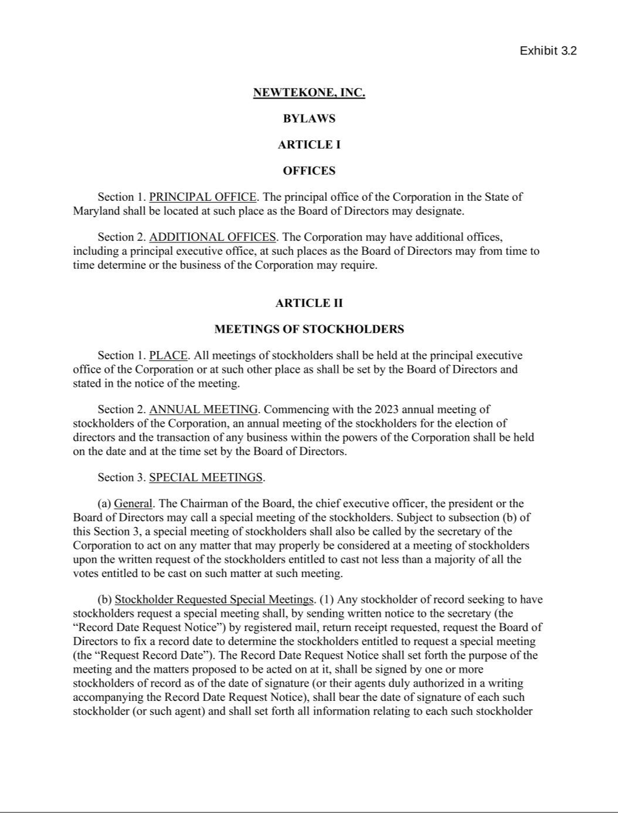

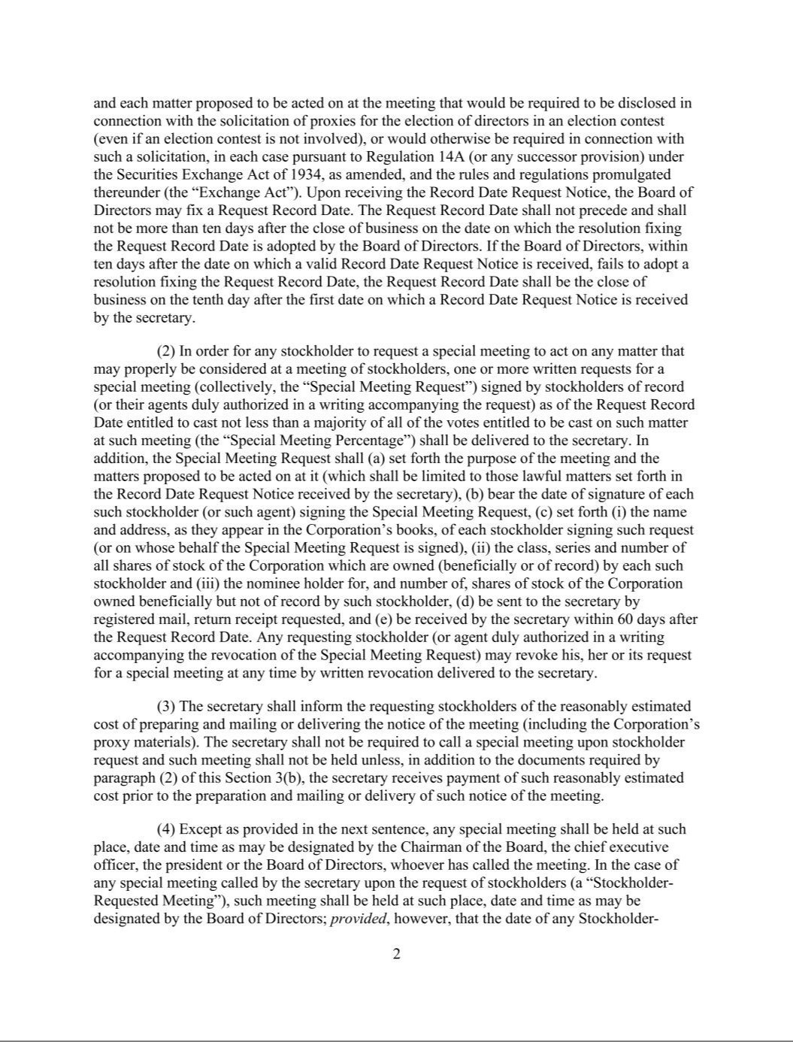

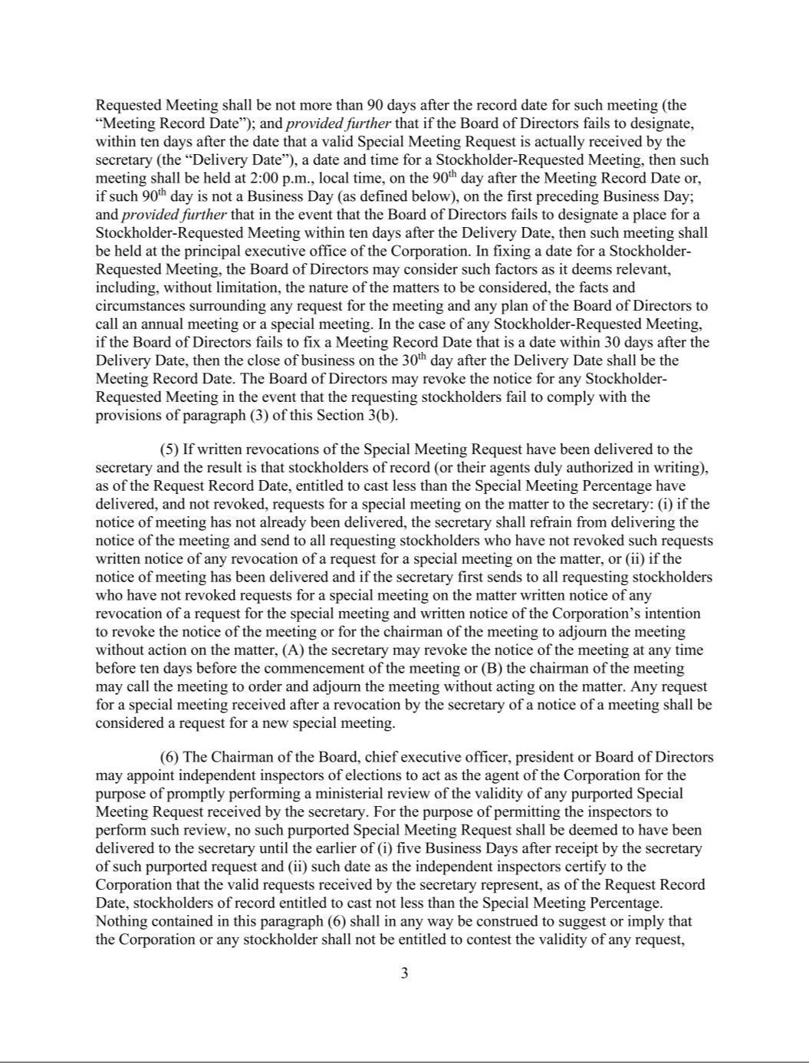

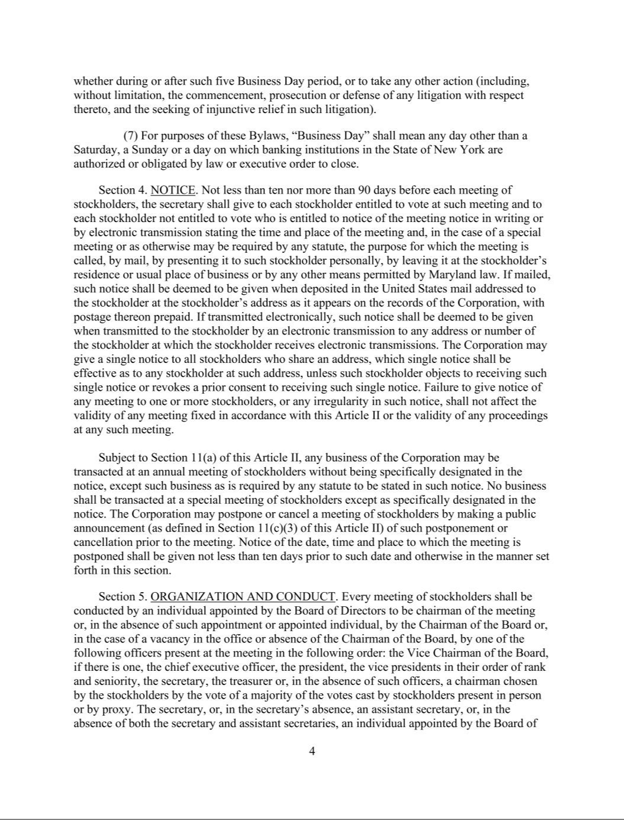

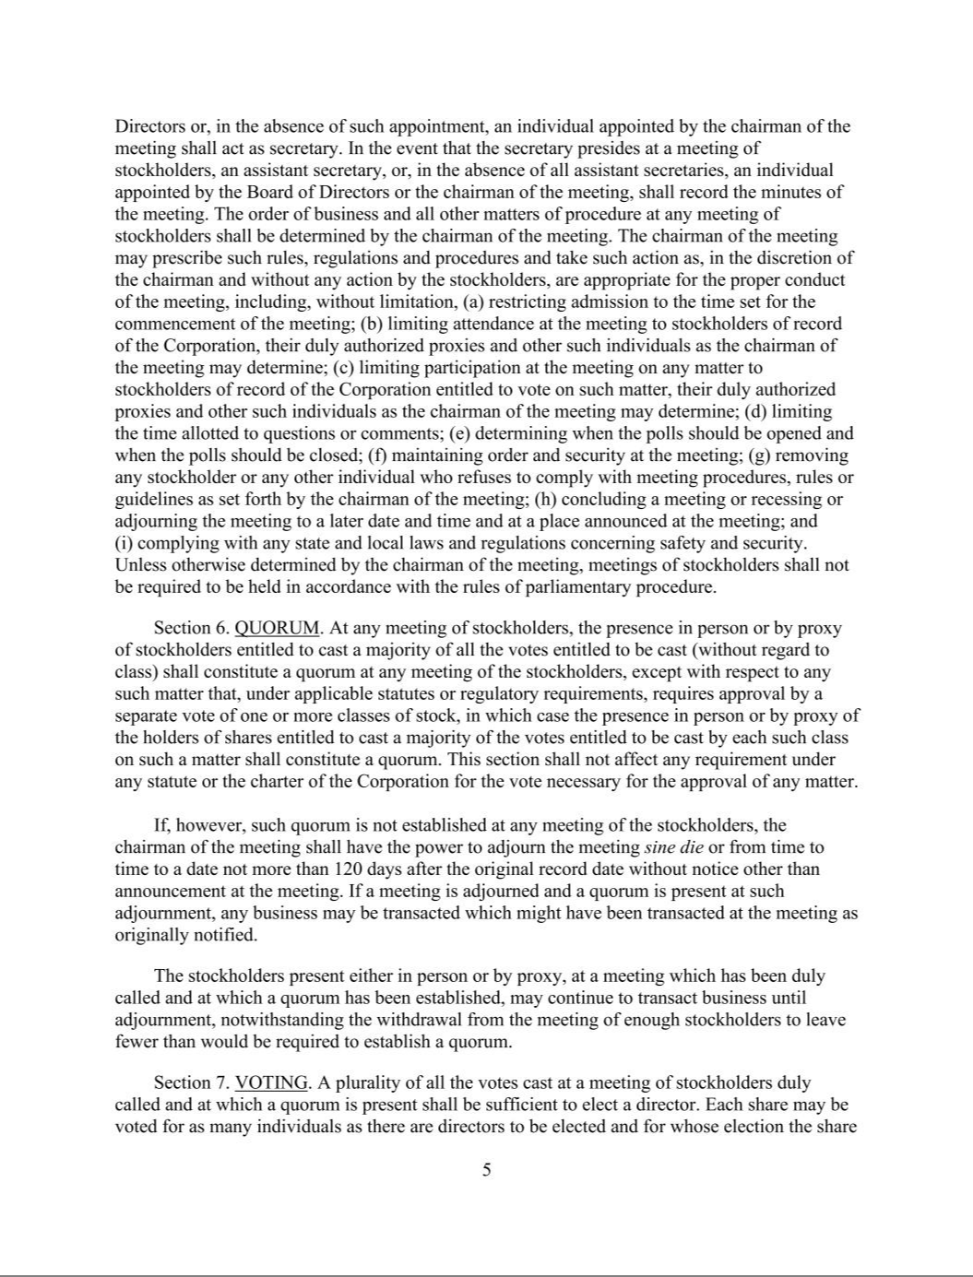

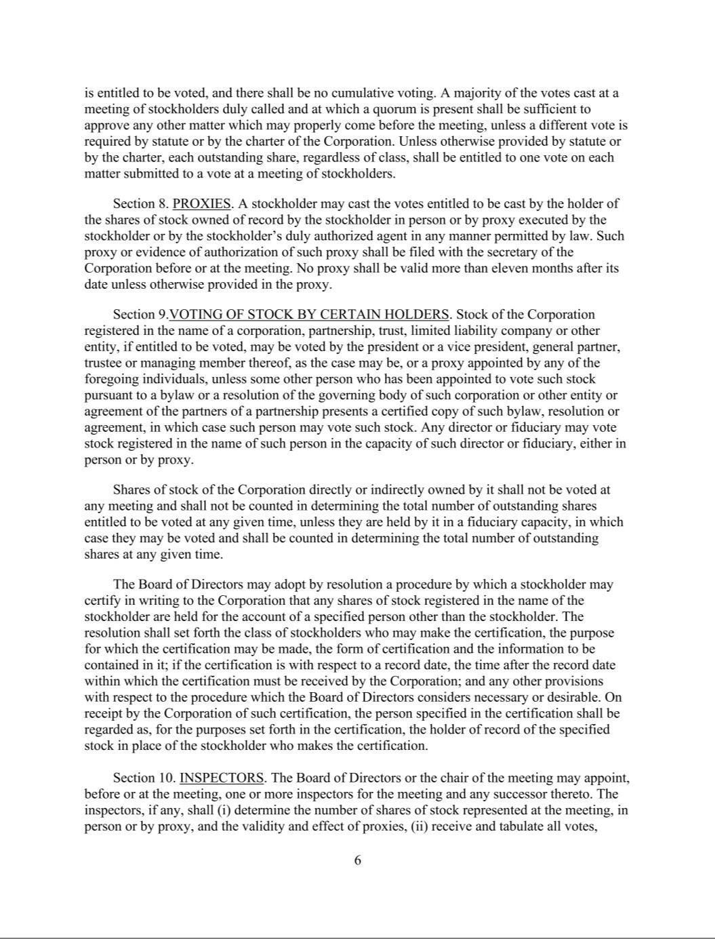

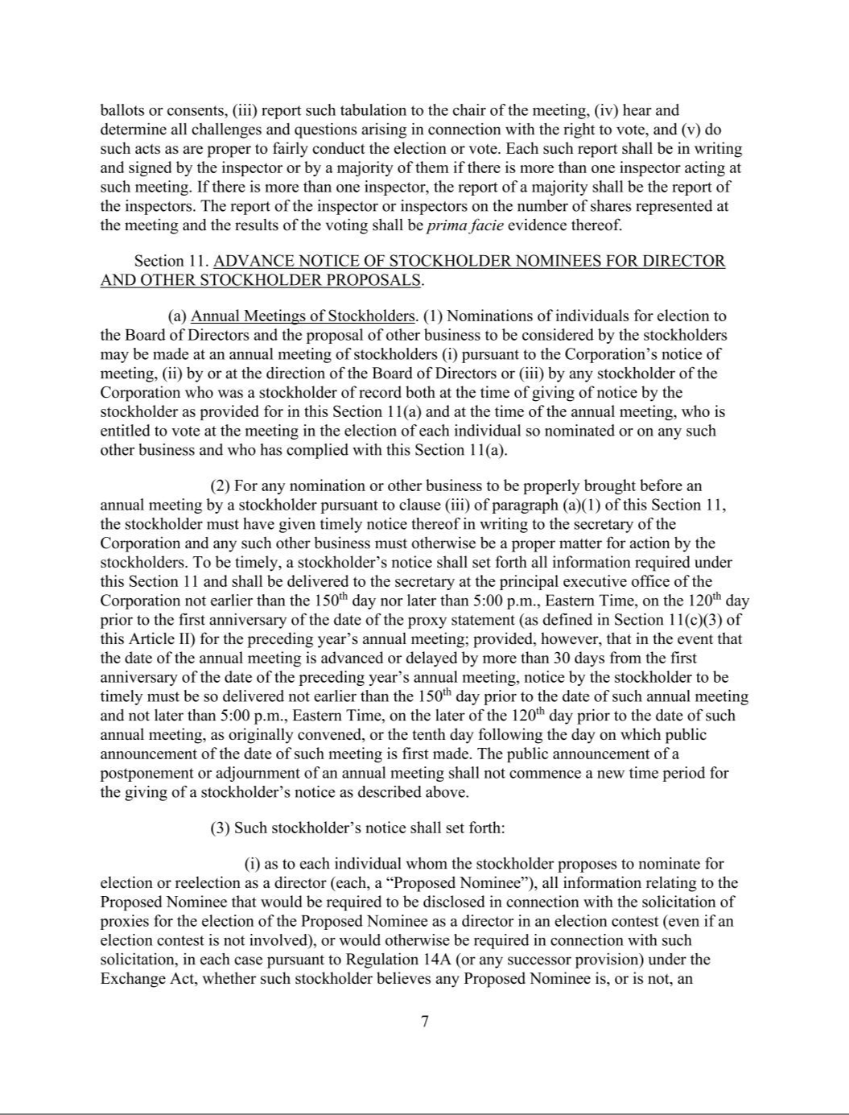

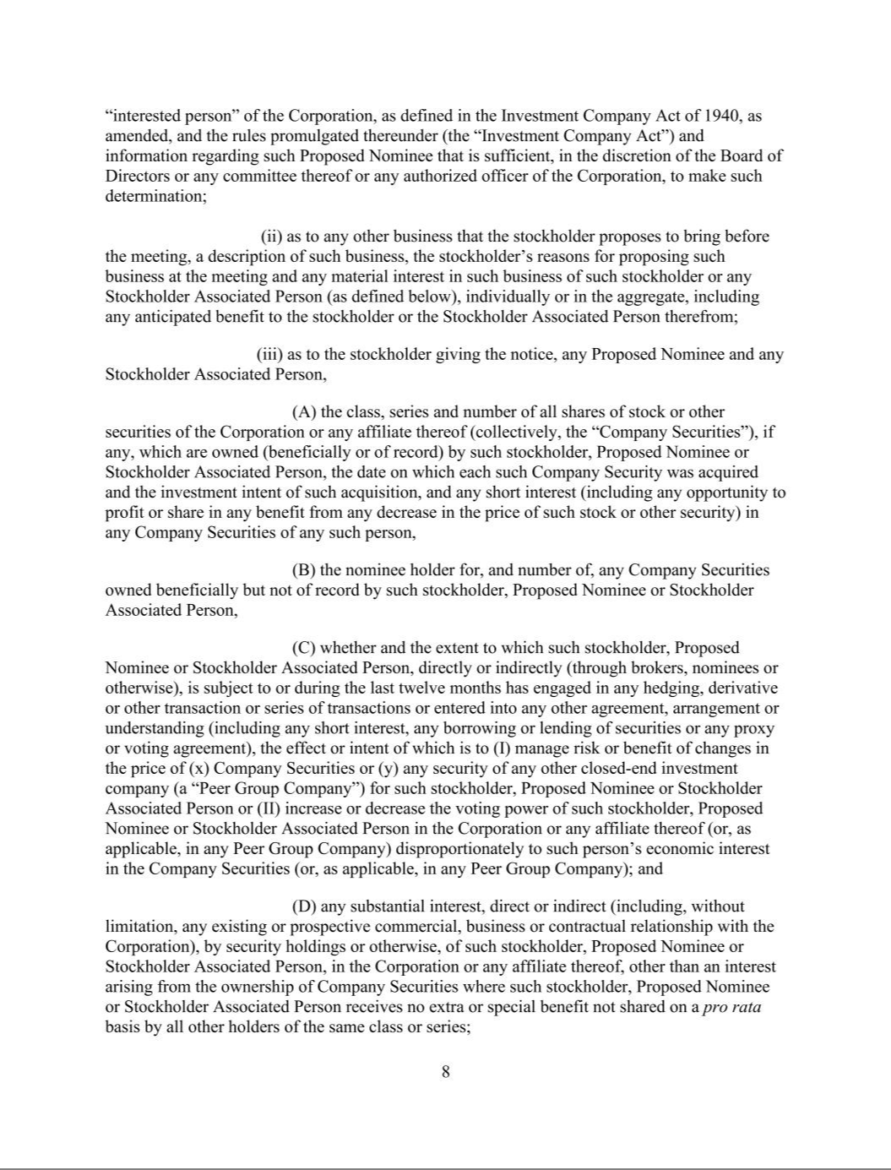

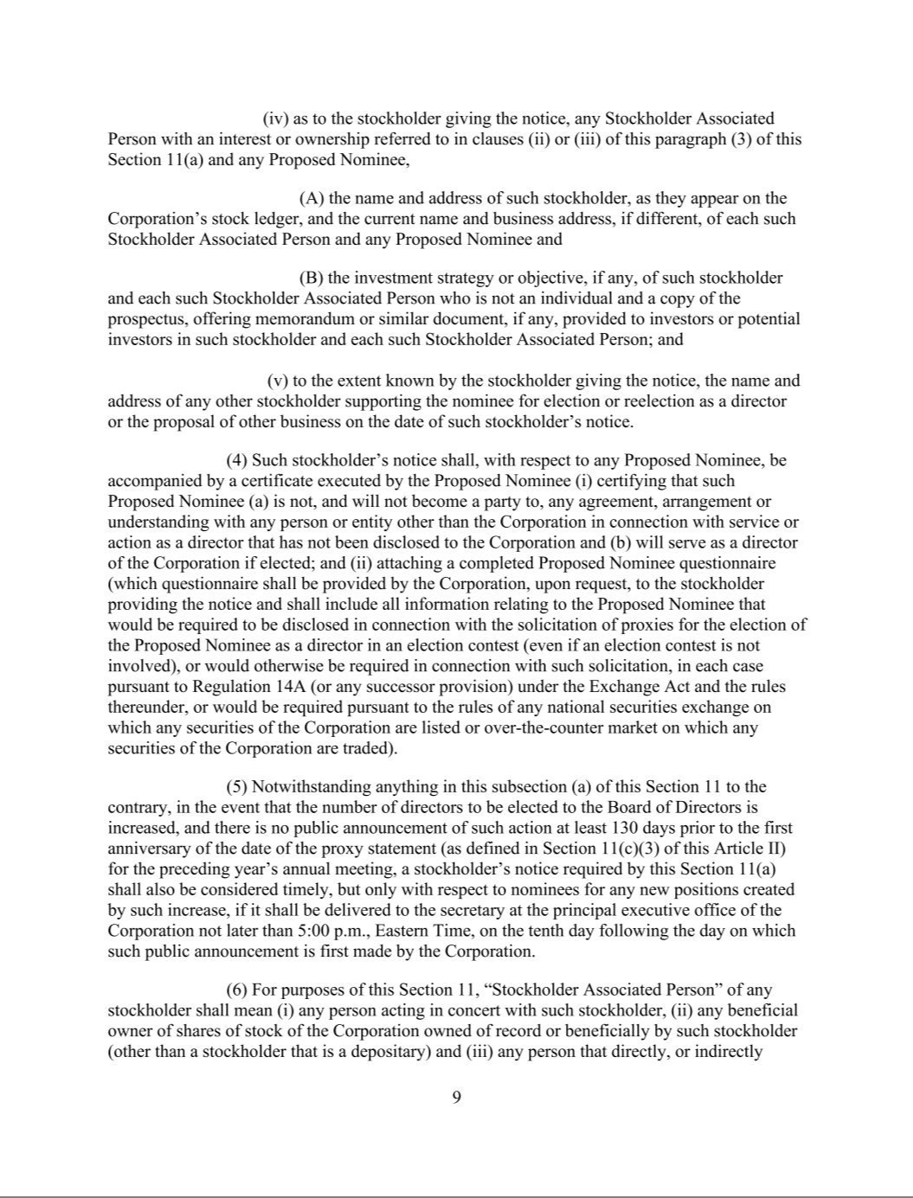

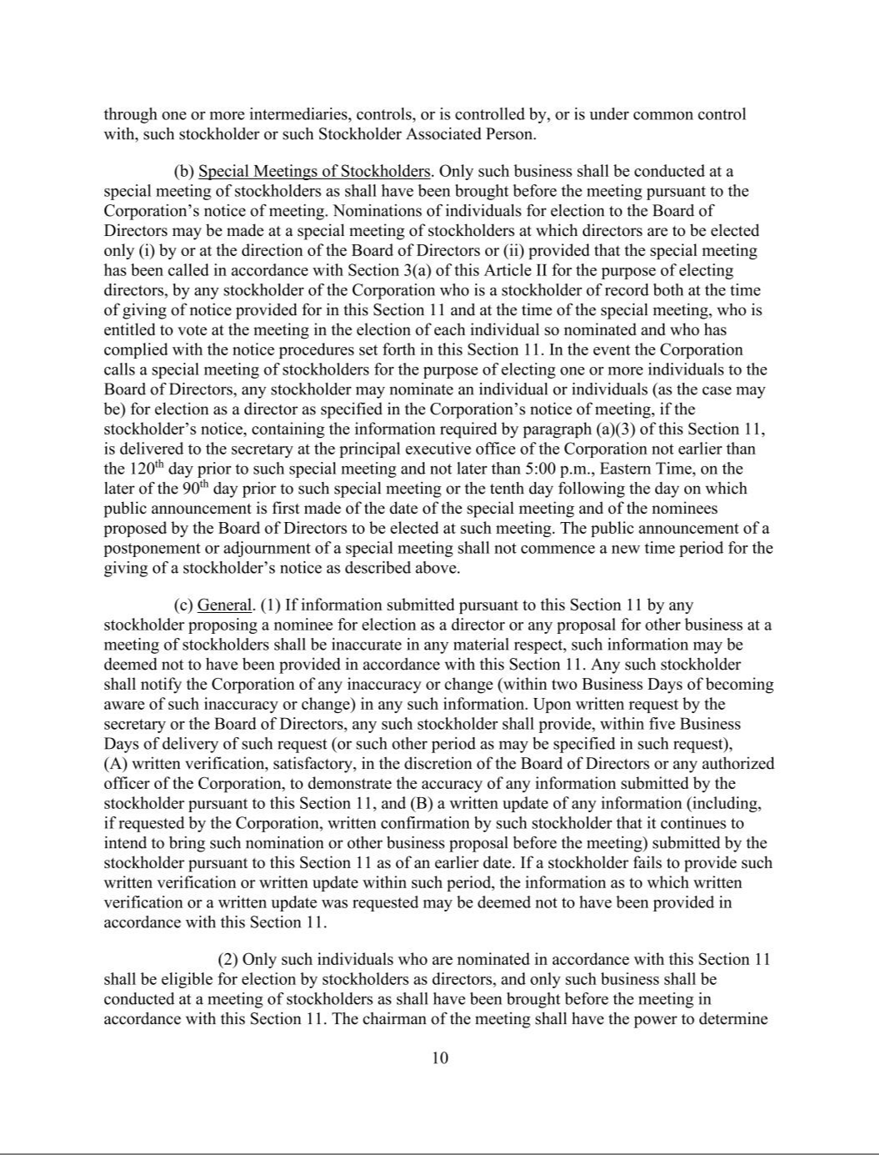

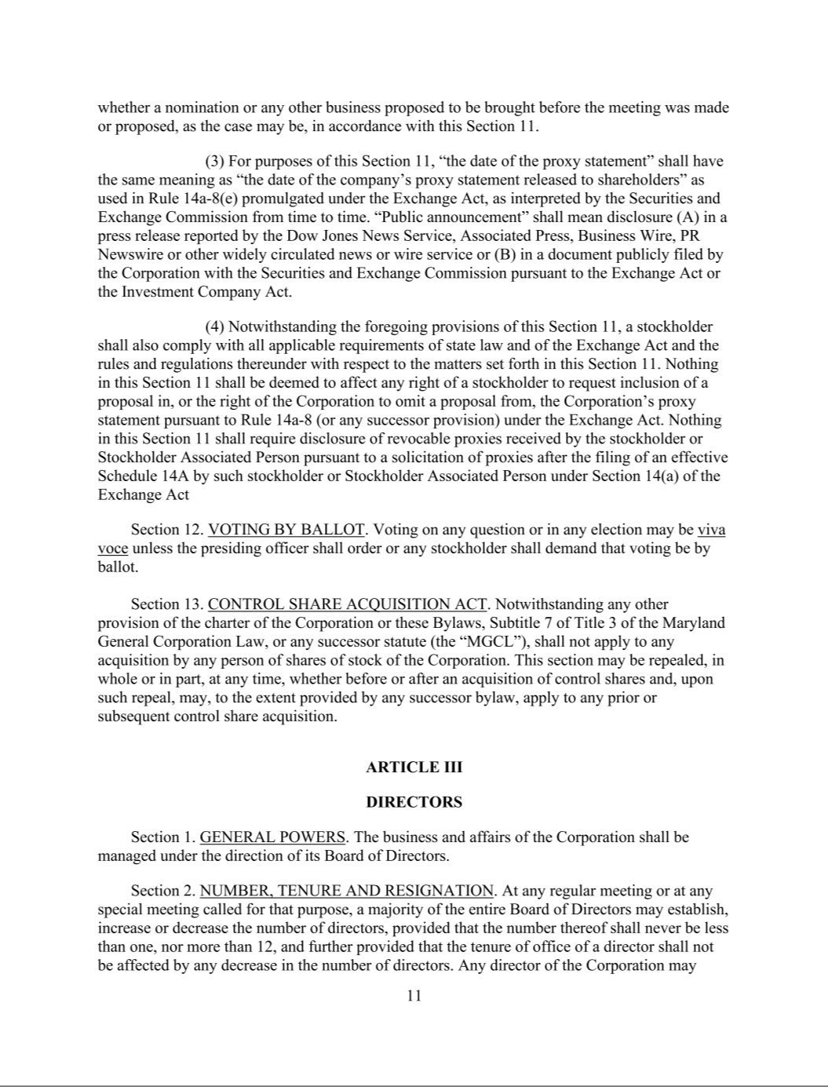

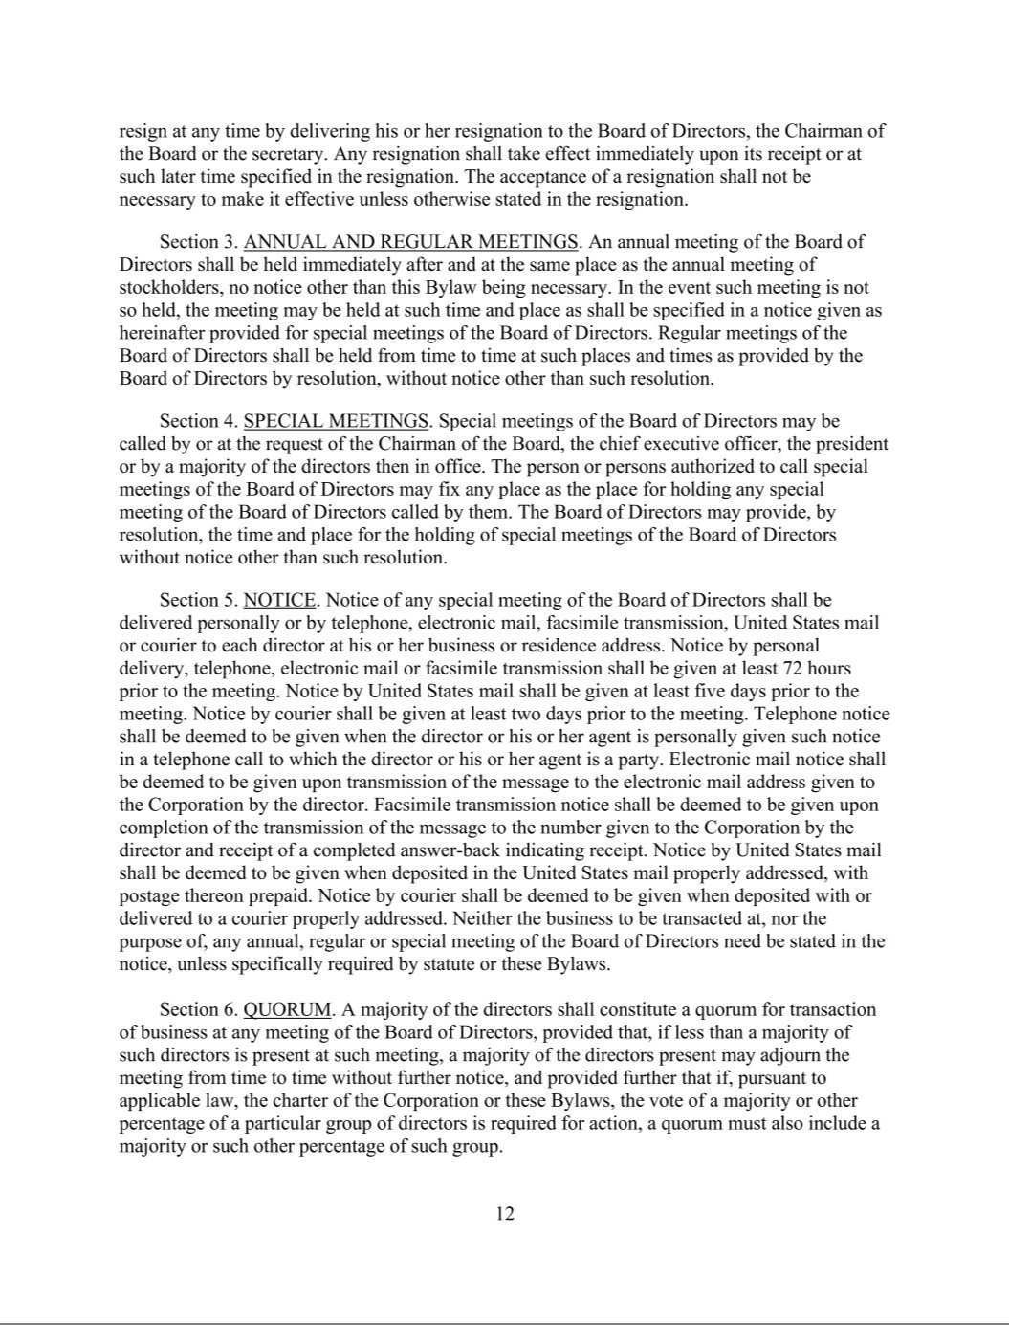

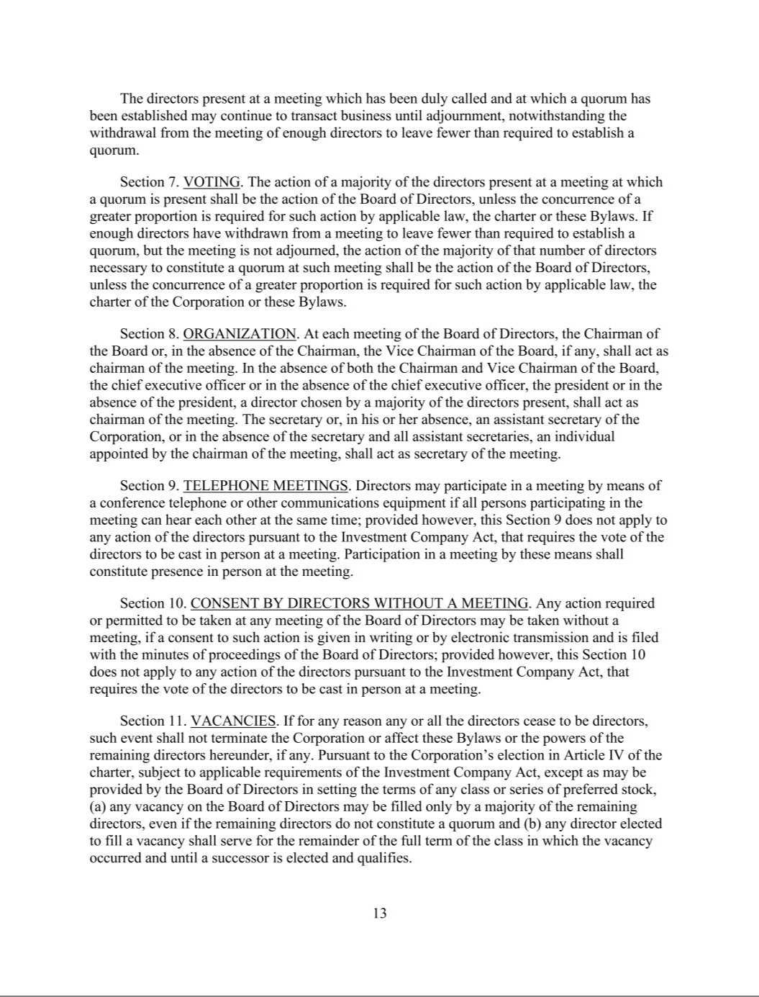

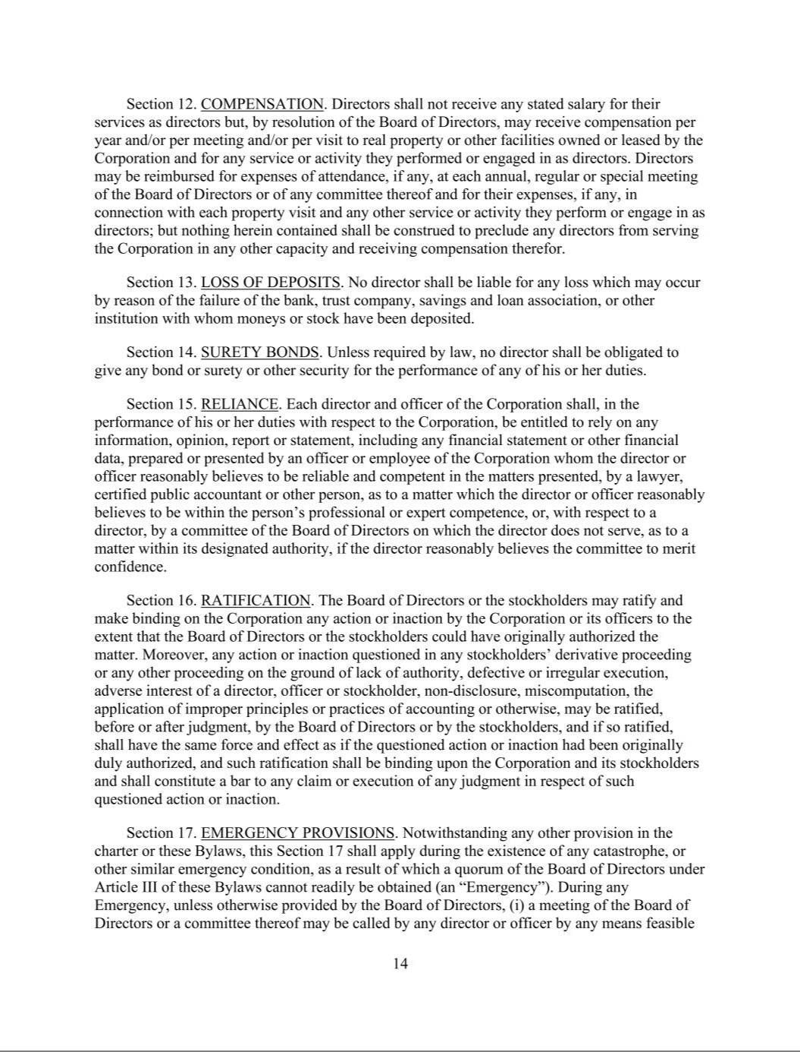

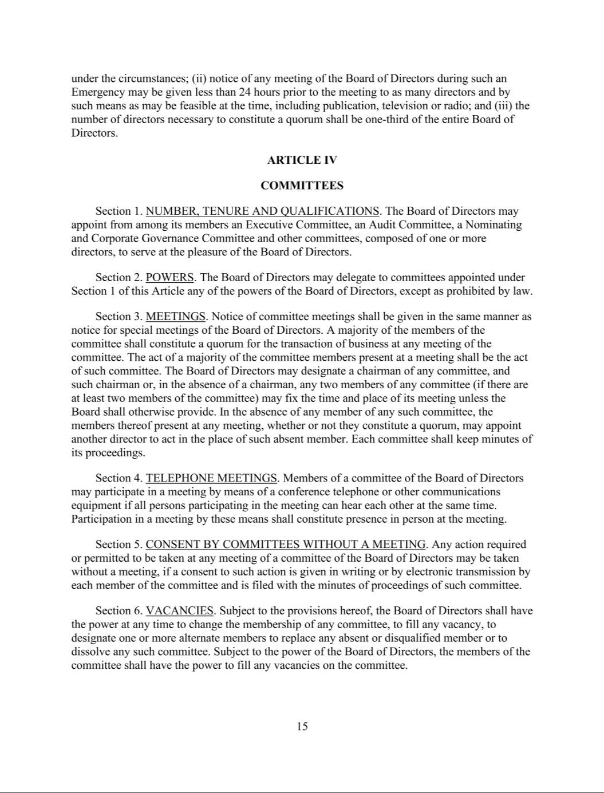

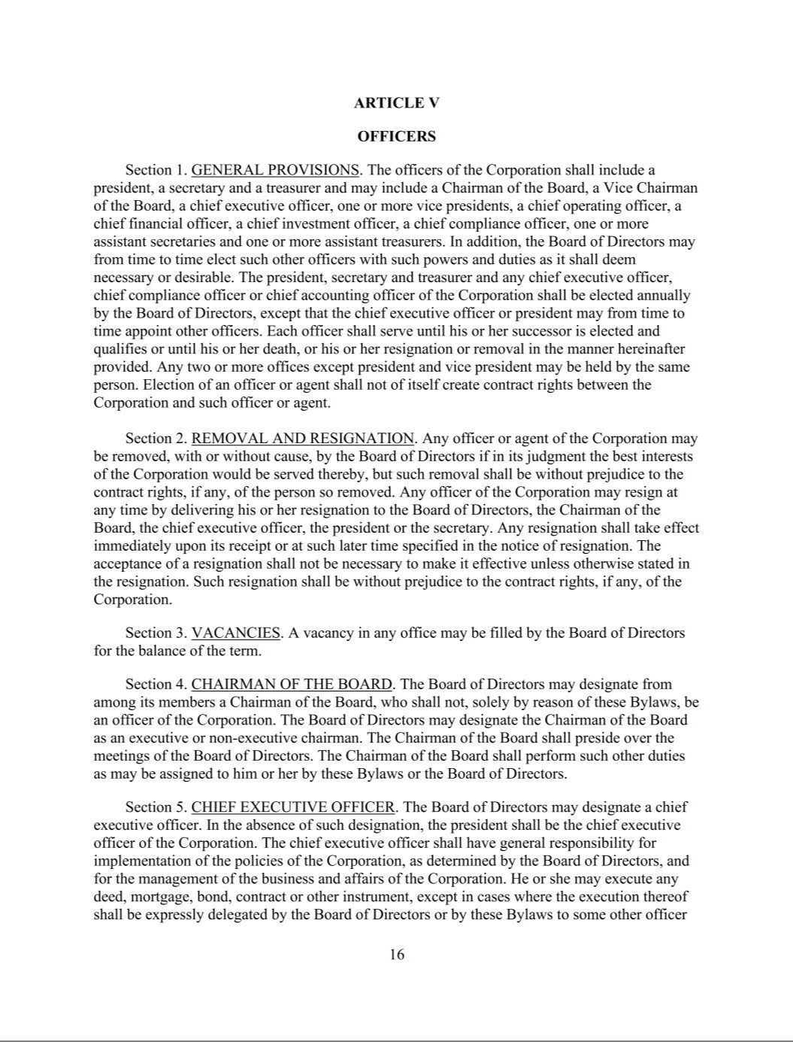

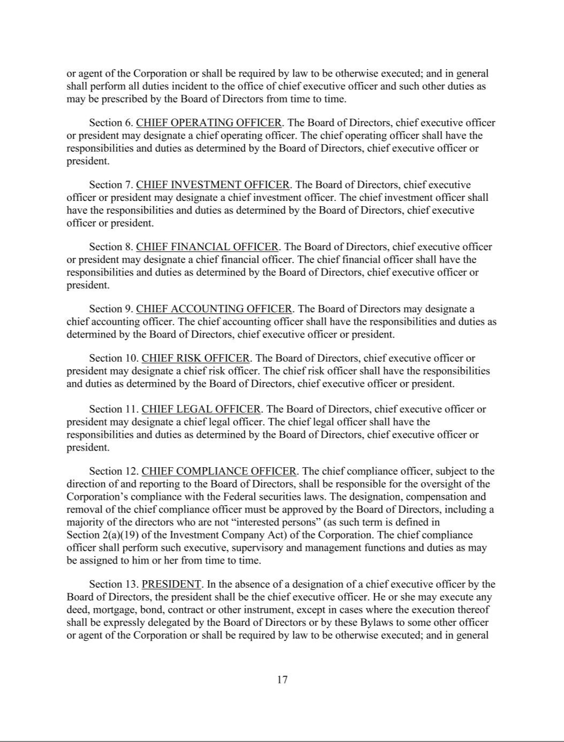

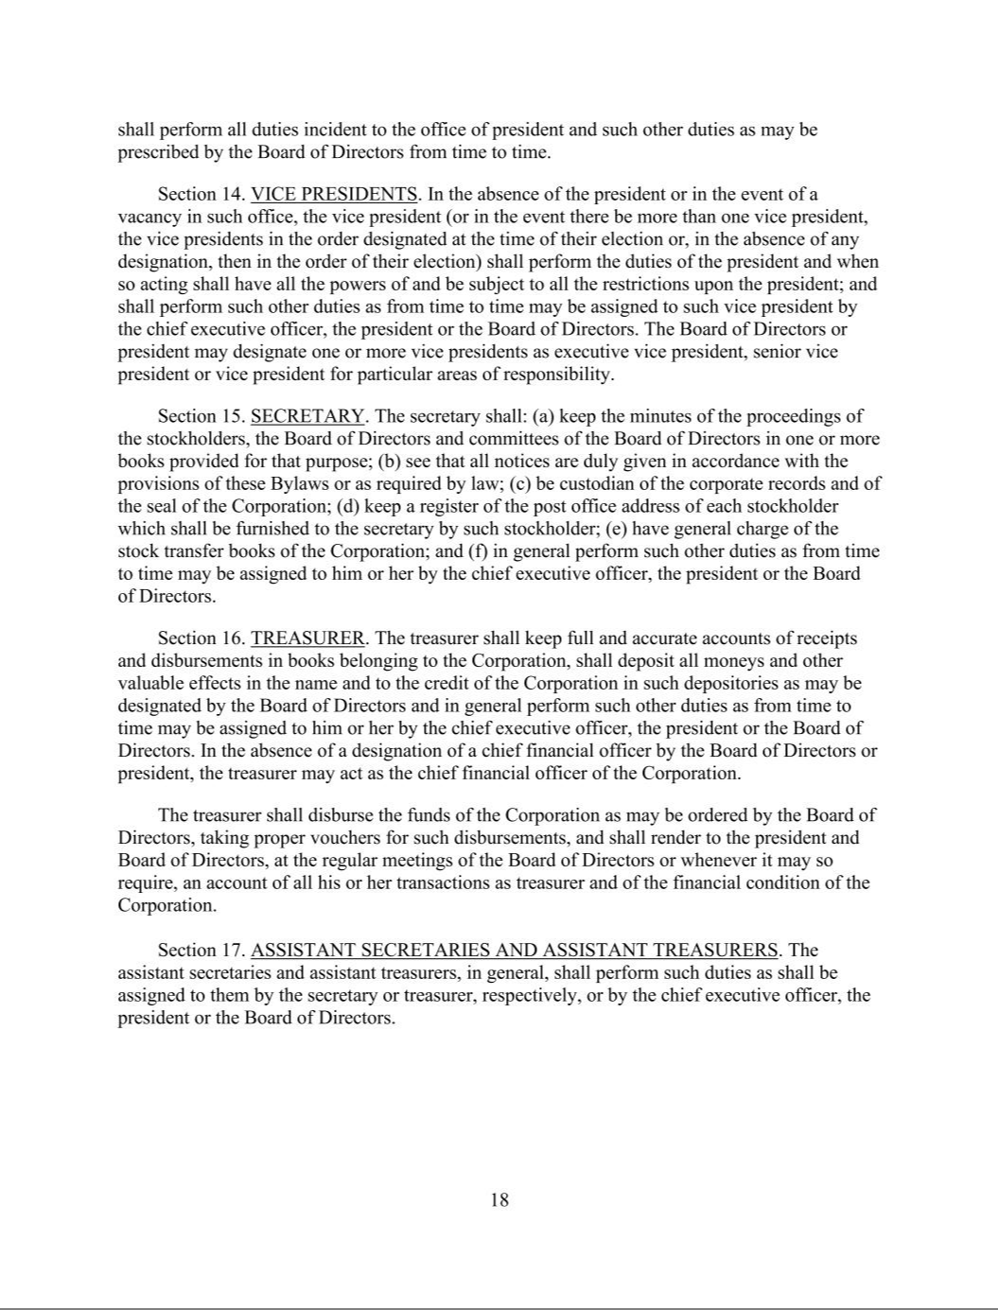

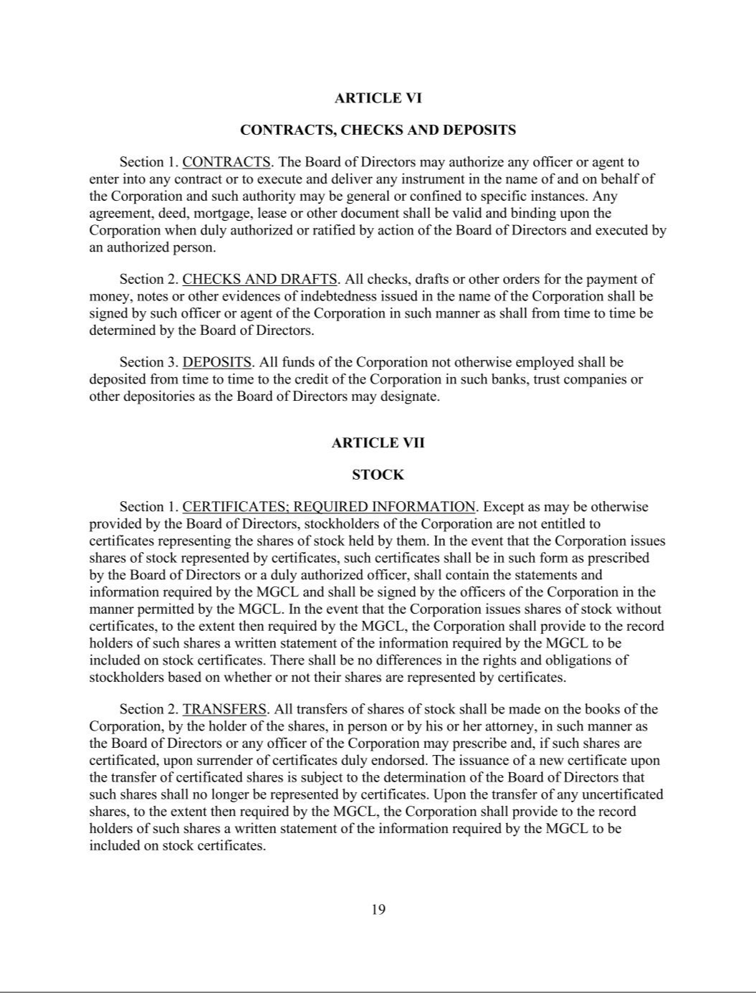

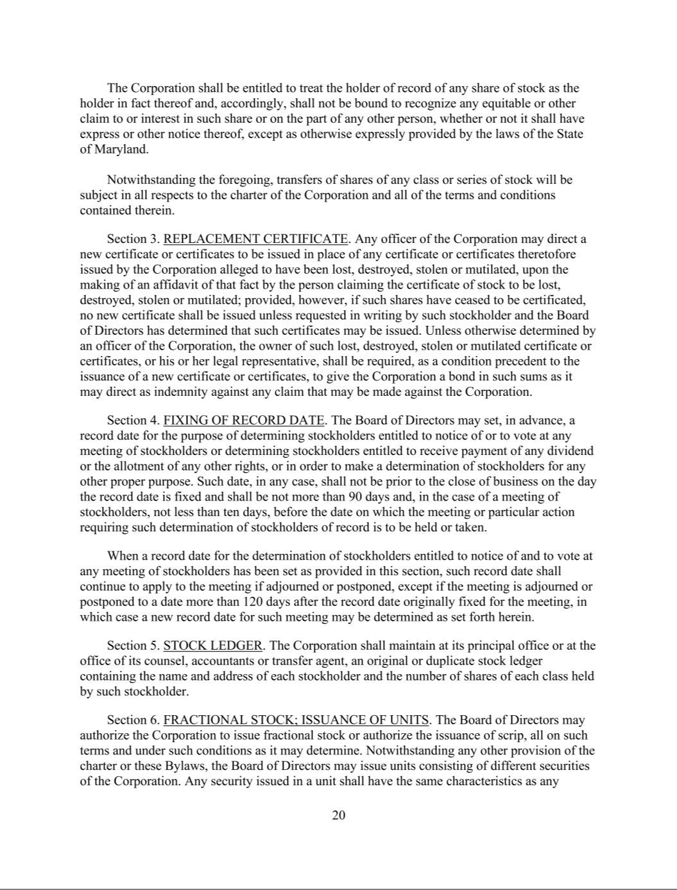

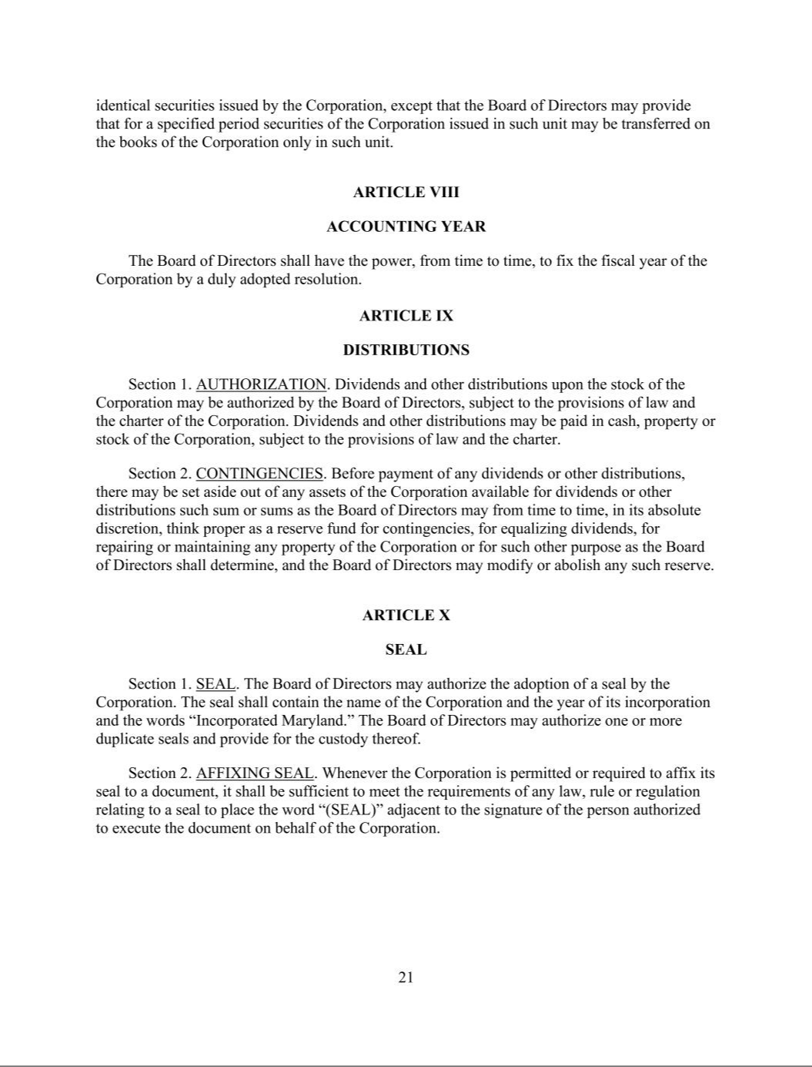

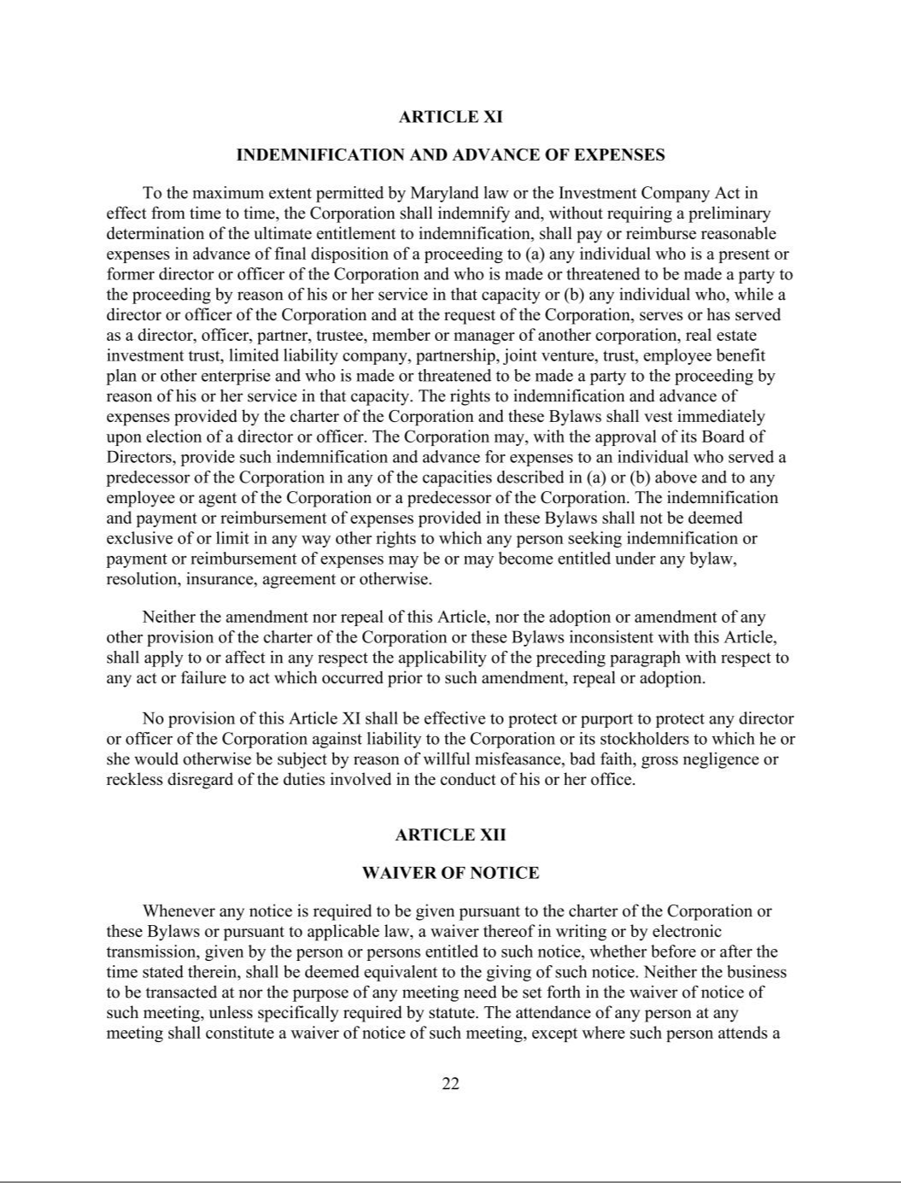

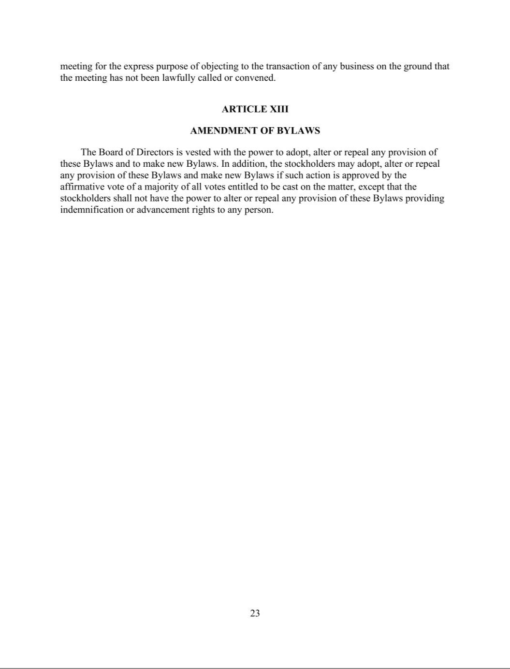

Exhibit 4.2

DESCRIPTION OF SECURITIES

As of December 31, 2025, NewtekOne, Inc. (the “Company,” “we,” “our,” or “us”) had three classes of securities registered under Section 12 of the Securities Exchange Act of 1934, as amended: (1) our common stock; (2) our debt securities; and (3) our 8.500% Fixed-Rate Reset Non-Cumulative Perpetual Preferred Stock, Series B.

Capitalized terms used but not defined herein shall have the meaning ascribed to them in the Annual Report on Form 10-K to which this Description of Securities is attached as an exhibit.

A. Common Stock, $0.02 par value per share

As of December 31, 2025, the authorized capital stock of the Company consisted of 200,000,000 shares of stock, par value $0.02 per share, of which all are designated as common stock except for the 50,000 shares which are designated as Series B Preferred Stock. Our common stock is traded on the Nasdaq Global Market under the ticker symbol “NEWT.”

All shares of our common stock have equal rights as to earnings, assets, voting, and distributions and, when they are issued, will be duly authorized, validly issued, fully paid and non-assessable. Distributions may be paid to the holders of our common stock if, as and when authorized by our Board and declared by us out of assets legally available therefor. Shares of our common stock have no preemptive, conversion or redemption rights and are freely transferable, except where their transfer is restricted by federal and state securities laws or by contract. In the event of our liquidation, dissolution or winding up, each share of our common stock would be entitled to share ratably in all of our assets that are legally available for distribution after we pay all debts and other liabilities and subject to any preferential rights of holders of our preferred stock, if any preferred stock is outstanding at such time. Each share of our common stock is entitled to one vote on all matters submitted to a vote of stockholders, including the election of directors. Except as provided with respect to any other class or series of stock, the holders of our common stock will possess exclusive voting power. There is no cumulative voting in the election of directors, which means that holders of a majority of the outstanding shares of common stock can elect all of our directors, and holders of less than a majority of such shares will be unable to elect any director.

Under our charter, our Board is authorized to classify and reclassify any unissued shares of stock into other classes or series of stock without obtaining stockholder approval. Our charter also provides that the Board, without any action by our stockholders, may amend the charter from time to time to increase or decrease the aggregate number of shares of stock or the number of shares of stock of any class or series that we have authority to issue.

Options and Restricted Stock

The Compensation, Corporate Governance and Nominating Committee of the Board approves the issuance of awards of restricted stock to employees and directors pursuant to the 2023 Stock Incentive Plan, which was approved by the Board in April 2023 and the Company’s stockholders on June 14, 2023.

The 2023 Stock Plan permits us to issue awards of stock options and restricted shares of common stock in an aggregate amount of up to 3,000,000 issued and outstanding shares of common stock as of the effective date of the 2023 Plan. The Compensation, Corporate Governance and Nominating Committee believes that restricted shares of common stock is the best method of encouraging stock ownership in the Company by eligible participants by giving them a proprietary interest in the Company’s performance, which more closely aligns compensation with the

Company’s performance and provides a means to attract and retain persons of outstanding ability in key positions with the Company.

Maryland law permits a Maryland corporation to include in its charter a provision limiting the liability of its directors and officers to the corporation and its stockholders for money damages except for liability resulting from (a) actual receipt of an improper benefit or profit in money, property or services or (b) active and deliberate dishonesty established by a final judgment as being material to the cause of action. Our charter contains such a provision which eliminates directors’ and officers’ liability to the maximum extent permitted by Maryland law.

Limitation on Liability of Directors and Officers; Indemnification and Advance of Expenses

Our charter authorizes us, to the maximum extent permitted by Maryland law to indemnify any present or former director or officer or any individual who, while serving as our director or officer and at our request, serves or has served another corporation, real estate investment trust, partnership, joint venture, trust, employee benefit plan or other enterprise as a director, officer, partner or trustee, from and against any claim or liability to which that person may become subject or which that person may incur by reason of his or her service in such capacity and to pay or reimburse their reasonable expenses in advance of final disposition of a proceeding. Our bylaws obligate us, to the maximum extent permitted by Maryland law, to indemnify any present or former director or officer or any individual who, while serving as our director or officer and at our request, serves or has served another corporation, real estate investment trust, partnership, joint venture, trust, employee benefit plan or other enterprise as a director, officer, partner or trustee and who is made, or threatened to be made, a party to the proceeding by reason of his or her service in that capacity from and against any claim or liability to which that person may become subject or which that person may incur by reason of his or her service in any such capacity and to pay or reimburse his or her reasonable expenses in advance of final disposition of a proceeding. The charter and bylaws also permit us to indemnify and advance expenses to any person who served a predecessor of us in any of the capacities described above and any of our employees or agents or any employees or agents of our predecessor.

Maryland law requires a corporation (unless its charter provides otherwise, which our charter does not) to indemnify a director or officer who has been successful in the defense of any proceeding to which he or she is made, or threatened to be made, a party by reason of his or her service in that capacity. Maryland law permits a corporation to indemnify its present and former directors and officers, among others, against judgments, penalties, fines, settlements and reasonable expenses actually incurred by them in connection with any proceeding to which they may be made a party by reason of their service in those or other capacities unless it is established that (a) the act or omission of the director or officer was material to the matter giving rise to the proceeding and (1) was committed in bad faith or (2) was the result of active and deliberate dishonesty, (b) the director or officer actually received an improper personal benefit in money, property or services or (c) in the case of any criminal proceeding, the director or officer had reasonable cause to believe that the act or omission was unlawful. However, under Maryland law, a Maryland corporation may not indemnify for an adverse judgment in a suit by or in the right of the corporation or for a judgment of liability on the basis that a personal benefit was improperly received unless, in either case, a court orders indemnification, and then only for expenses. In addition, Maryland law permits a corporation to advance reasonable expenses to a director or officer upon the corporation’s receipt of (a) a written affirmation by the director or officer of his or her good faith belief that he or she has met the standard of conduct necessary for indemnification by the corporation and (b) a written undertaking by him or her or on his or her behalf to repay the amount paid or reimbursed by the corporation if it is ultimately determined that the standard of conduct was not met.

Certain Provisions of the Maryland General Corporation Law and Our Charter and Bylaws

The Maryland General Corporation Law and our charter and bylaws contain provisions that could make it more difficult for a potential acquirer to acquire us by means of a tender offer, proxy contest or otherwise. These provisions are expected to discourage certain coercive takeover practices and inadequate takeover bids and to encourage persons seeking to acquire control of us to negotiate first with our Board. We believe that the benefits of these provisions outweigh the potential disadvantages of discouraging any such acquisition proposals because, among other things, the negotiation of such proposals may improve their terms.

Classified Board of Directors

Our Board is divided into three classes of directors serving staggered three-year terms. Upon expiration of their current terms, directors of each class will be elected to serve for three-year terms and until their successors are duly elected and qualify and each year one class of directors will be elected by the stockholders. A classified board may render a change in control of us or removal of our incumbent management more difficult. We believe, however, that the longer time required to elect a majority of a classified board of directors will help to ensure the continuity and stability of our management and policies.

Election of Directors

Our charter and bylaws provide that the affirmative vote of the holders of a plurality of the outstanding shares of stock entitled to vote in the election of directors cast at a meeting of stockholders duly called and at which a quorum is present will be required to elect a director. Pursuant to our charter our Board may amend the bylaws to alter the vote required to elect directors.

Number of Directors; Vacancies; Removal

Our charter provides that the number of directors will be set only by the Board in accordance with our bylaws. Our bylaws provide that a majority of our entire Board may at any time increase or decrease the number of directors. However, unless our bylaws are amended, the number of directors may never be less than one nor more than twelve. Our charter provides that, at such time as we have at least three independent directors and our common stock is registered under the Securities Exchange Act of 1934, as amended, we elect to be subject to the provision of Subtitle 8 of Title 3 of the Maryland General Corporation Law regarding the filling of vacancies on the board of directors. Accordingly, at such time, except as may be provided by the Board in setting the terms of any class or series of preferred stock, any and all vacancies on the Board may be filled only by the affirmative vote of a majority of the remaining directors in office, even if the remaining directors do not constitute a quorum, and any director elected to fill a vacancy will serve for the remainder of the full term of the directorship in which the vacancy occurred and until a successor is elected and qualifies. Our charter provides that a director may be removed only for cause, as defined in our charter, and then only by the affirmative vote of at least two-thirds of the votes entitled to be cast in the election of directors.

Action by Stockholders

Under the Maryland General Corporation Law, stockholder action can be taken only at an annual or special meeting of stockholders or (unless the charter provides for stockholder action by less than unanimous written consent, which our charter does not) by unanimous written consent in lieu of a meeting. These provisions, combined with the requirements of our bylaws regarding the calling of a stockholder-requested special meeting of stockholders

discussed below, may have the effect of delaying consideration of a stockholder proposal until the next annual meeting.

Advance Notice Provisions for Stockholder Nominations and Stockholder Proposals

Our bylaws provide that with respect to an annual meeting of stockholders, nominations of persons for election to the Board and the proposal of business to be considered by stockholders may be made only (a) pursuant to our notice of the meeting, (b) by the Board or (c) by a stockholder who is entitled to vote at the meeting and who has complied with the advance notice procedures of our bylaws. With respect to special meetings of stockholders, only the business specified in our notice of the meeting may be brought before the meeting. Nominations of persons for election to the Board at a special meeting may be made only (1) pursuant to our notice of the meeting, (2) by the Board or (3) provided that the Board has determined that directors will be elected at the meeting, by a stockholder who is entitled to vote at the meeting and who has complied with the advance notice provisions of the bylaws.

The purpose of requiring stockholders to give us advance notice of nominations and other business is to afford our Board a meaningful opportunity to consider the qualifications of the proposed nominees and the advisability of any other proposed business and, to the extent deemed necessary or desirable by our Board, to inform stockholders and make recommendations about such qualifications or business, as well as to provide a more orderly procedure for conducting meetings of stockholders. Although our bylaws do not give our Board any power to disapprove stockholder nominations for the election of directors or proposals recommending certain action, they may have the effect of precluding a contest for the election of directors or the consideration of stockholder proposals if proper procedures are not followed and of discouraging or deterring a third party from conducting a solicitation of proxies to elect its own slate of directors or to approve its own proposal without regard to whether consideration of such nominees or proposals might be harmful or beneficial to us and our stockholders.

Calling of Special Meetings of Stockholders

Our bylaws provide that special meetings of stockholders may be called by our Board and certain of our officers. Additionally, our bylaws provide that, subject to the satisfaction of certain procedural and informational requirements by the stockholders requesting the meeting, a special meeting of stockholders will be called by the secretary of the corporation upon the written request of stockholders entitled to cast not less than a majority of all the votes entitled to be cast at such meeting.

Approval of Extraordinary Corporate Action; Amendment of Charter and Bylaws

Under Maryland law, a Maryland corporation generally cannot dissolve, amend its charter, merge, sell all or substantially all of its assets, engage in a share exchange or engage in similar transactions outside the ordinary course of business, unless approved by the affirmative vote of stockholders entitled to cast at least two-thirds of the votes entitled to be cast on the matter. However, a Maryland corporation may provide in its charter for approval of these matters by a lesser percentage, but not less than a majority of all of the votes entitled to be cast on the matter. Our charter generally provides for approval of charter amendments and extraordinary transactions by the stockholders entitled to cast at least a majority of the votes entitled to be cast on the matter. Our charter also provides that certain charter amendments, any proposal for our conversion, whether by charter amendment, merger or otherwise and any proposal for our liquidation or dissolution requires the approval of the stockholders entitled to cast at least a majority of the votes entitled to be cast on such matter. However, if such amendment or proposal is approved by a majority of our continuing directors (in addition to approval by our Board), such amendment or proposal may be approved by a majority of the votes entitled to be cast on such a matter. The “continuing directors” are defined in our charter as (1) our current directors, (2) those directors whose nomination for election by the

stockholders or whose election by the directors to fill vacancies is approved by a majority of our current directors then on the Board or (3) any successor directors whose nomination for election by the stockholders or whose election by the directors to fill vacancies is approved by a majority of continuing directors or the successor continuing directors then in office.

At a meeting of our stockholders held on June 13, 2025, the Company’s stockholders followed our Board’s recommendation and approved an amendment to the Company’s Articles of Amendment and Restatement (the “Charter Amendment”). The Charter Amendment provides that the Company’s bylaws may be amended by either our Board or by the Company stockholders by the affirmative vote of the holders of a majority of all votes entitled to be cast.

No Appraisal Rights

Except with respect to appraisal rights arising in connection with the Control Share Act discussed below, as permitted by the Maryland General Corporation Law, our charter provides that stockholders will not be entitled to exercise appraisal rights unless a majority of the Board shall determine such rights apply.

Control Share Acquisitions

The Maryland General Corporation Law provides that control shares of a Maryland corporation acquired in a control share acquisition have no voting rights except to the extent approved by a vote of two-thirds of the votes entitled to be cast on the matter (the “Control Share Act”). Shares owned by the acquirer, by officers or by directors who are employees of the corporation are excluded from shares entitled to vote on the matter. Control shares are voting shares of stock which, if aggregated with all other shares of stock owned by the acquirer or in respect of which the acquirer is able to exercise or direct the exercise of voting power (except solely by virtue of a revocable proxy), would entitle the acquirer to exercise voting power in electing directors within one of the following ranges of voting power:

- one-tenth or more but less than one-third;

- one-third or more but less than a majority; or

- a majority or more of all voting power.

The requisite stockholder approval must be obtained each time an acquirer crosses one of the thresholds of voting power set forth above. Control shares do not include shares the acquiring person is then entitled to vote as a result of having previously obtained stockholder approval. A control share acquisition means the acquisition of control shares, subject to certain exceptions.

A person who has made or proposes to make a control share acquisition may compel the Board of the corporation to call a special meeting of stockholders to be held within 50 days of demand to consider the voting rights of the shares. The right to compel the calling of a special meeting is subject to the satisfaction of certain conditions, including an undertaking to pay the expenses of the meeting. If no request for a meeting is made, the corporation may itself present the question at any stockholders meeting.

If voting rights are not approved at the meeting or if the acquiring person does not deliver an acquiring person statement as required by the statute, then the corporation may redeem for fair value any or all of the control shares, except those for which voting rights have previously been approved. The right of the corporation to redeem control shares is subject to certain conditions and limitations. Fair value is determined, without regard to the absence of voting rights for the control shares, as of the date of the last control share acquisition by the acquirer or of any

meeting of stockholders at which the voting rights of the shares are considered and not approved. If voting rights for control shares are approved at a stockholders meeting and the acquirer becomes entitled to vote a majority of the shares entitled to vote, all other stockholders may exercise appraisal rights. The fair value of the shares as determined for purposes of appraisal rights may not be less than the highest price per share paid by the acquirer in the control share acquisition.

The Control Share Act does not apply (a) to shares acquired in a merger, consolidation or share exchange if the corporation is a party to the transaction or (b) to acquisitions approved or exempted by the charter or bylaws of the corporation. Our bylaws contain a provision exempting from the Control Share Act any and all acquisitions by any person of our shares of stock. There can be no assurance that such provision will not be amended or eliminated at any time in the future. As a result, we will amend our bylaws to be subject to the Control Share Act only if the Board determines that it would be in our best interests and, after notification.

Business Combinations

Under Maryland law, “business combinations” between a Maryland corporation and an interested stockholder or an affiliate of an interested stockholder are prohibited for five years after the most recent date on which the interested stockholder becomes an interested stockholder (the “Business Combination Act”). These business combinations include a merger, consolidation, share exchange or, in circumstances specified in the statute, an asset transfer or issuance or reclassification of equity securities. An interested stockholder is defined as:

- any person who beneficially owns 10% or more of the voting power of the corporation’s outstanding voting stock; or

- an affiliate or associate of the corporation who, at any time within the two-year period prior to the date in question, was the beneficial owner of 10% or more of the voting power of the then outstanding voting stock of the corporation.

A person is not an interested stockholder under this statute if the board of directors approved in advance the transaction by which the stockholder otherwise would have become an interested stockholder. However, in approving a transaction, the board of directors may provide that its approval is subject to compliance, at or after the time of approval, with any terms and conditions determined by the board.

After the five-year prohibition, any business combination between the Maryland corporation and an interested stockholder generally must be recommended by the board of directors of the corporation and approved by the affirmative vote of at least:

- 80% of the votes entitled to be cast by holders of outstanding shares of voting stock of the corporation; and

- two-thirds of the votes entitled to be cast by holders of voting stock of the corporation other than shares held by the interested stockholder with whom or with whose affiliate the business combination is to be effected or held by an affiliate or associate of the interested stockholder.

These super-majority vote requirements do not apply if the corporation’s common stockholders receive a minimum price, as defined under Maryland law, for their shares in the form of cash or other consideration in the same form as previously paid by the interested stockholder for its shares.

The statute permits various exemptions from its provisions, including business combinations that are exempted by the board of directors before the time that the interested stockholder becomes an interested stockholder. Our Board has adopted a resolution that any business combination between us and any other person is exempted from the provisions of the Business Combination Act, provided that the business combination is first approved by Board. This resolution may be altered or repealed in whole or in part at any time; however, our Board will adopt resolutions so as to make us subject to the provisions of the Business Combination Act only if the Board determines

that it would be in our best interests If this resolution is repealed, or the Board does not otherwise approve a business combination, the statute may discourage others from trying to acquire control of us and increase the difficulty of consummating any offer.

- Debt Securities

  - 5.50% Notes due 2026 (the “2026 Notes,” which matured on February 1, 2026);

  - 8.00% Notes due 2028 (the “2028 Notes”);

  - 8.50% Notes due 2029 (the “8.50% 2029 Notes”);

  - 8.625% Notes due 2029 (the “8.625% 2029 Notes” and collectively with the 8.50% 2029 Notes, the “2029 Notes”); and

  - 8.50% Notes due 2031(the "2031 Notes, ).

The 2026 Notes

In January 2021, the Company completed a registered offering of $115.0 million in aggregate principal amount of the 2026 Notes. The 2026 Notes matured on February 1, 2026 and were redeemed in whole or in part at any time or from time to time at the Company’s option upon not less than 30 days nor more than 60 days written notice by mail prior to the date fixed for redemption thereof, at a redemption price equal to 100% of the principal amount of the 2026 Notes to be redeemed, plus accrued and unpaid interest, if any, to, but excluding, the date of redemption. The 2026 Notes bore a rate of 5.50% per year payable quarterly on February 1, May 1, August 1 and November 1 of each year and trade on the Nasdaq Global Market under the trading symbol “NEWTZ.”

The 2028 Notes

On August 31, 2023, the Company completed a registered offering of $40.0 million in aggregate principal amount of the 2028 Notes. The Notes will mature on September 1, 2028, and may be redeem at the Company’s option, in whole or in part at any time or from time to time on or after September 1, 2025 at a redemption price of 100% of the outstanding principal amount of the Notes to be redeemed plus accrued and unpaid interest payments otherwise payable thereon for the then-current quarterly interest period accrued to, but excluding, the date fixed for redemption The 2028 Notes bear interest at a rate of 8.00% per year payable quarterly on March 1, June 1, September 1 and December 1 of each year and trade on the Nasdaq Global Market under the trading symbol “NEWTI.”

The 2029 Notes

On May 30, 2024, the Company completed a registered offering of $71.9 million in aggregate principal amount of its 8.50% 2029 Notes, The 8.50% 2029 Notes will mature on June 1, 2029, and may be redeemed at the Company’s option, in whole or in part at any time or from time to time on or after June 1, 2027 at a redemption price of 100% of the outstanding principal amount of the 8.50% 2029 Notes to be redeemed plus accrued and unpaid interest payments otherwise payable thereon for the then-current quarterly interest period accrued to, but excluding, the date fixed for redemption. The 8.50% 2029 Notes bear interest at a rate of 8.50% per year payable quarterly on March 1, June 1, September 1 and December 1 of each year and trade on the Nasdaq Global Market under the trading symbol “NEWTG.”

On September 16, 2024, the Company completed a registered offering of $75.0 million aggregate principal amount of 8.625% 2029 Notes. These Notes will mature on October 15, 2029, and may be redeemed at the Company’s option, in whole or in part at any time or from time to time on or after October 15, 2026 at a redemption price of 100% of the outstanding principal amount of the 8.625% 2029 Notes to be redeemed plus accrued and unpaid interest payments otherwise payable thereon for the then-current quarterly interest period accrued to, but excluding, the date fixed for redemption. The 8.625% 2029 Notes bear interest at a rate of 8.625% per year, payable quarterly on January 15, April 15, July 15, and October 15 each year and trade on the Nasdaq Global Market under the trading symbol “NEWTH.”

The 2031 Notes

On January 28, 2026, the Company completed a registered offering of $7.9 million in aggregate principal amount of the 2031 Notes. The 2031 Notes will mature on February 1, 2031, and may be redeemed at the Company’s option, in whole or in part at any time or from time to time on or after February 1, 2028 at a redemption price of 100% of the outstanding principal amount of the 20231 Notes to be redeemed plus accrued and unpaid interest payments otherwise payable thereon for the then-current quarterly interest period accrued to, but excluding, the date fixed for redemption. The 2031 Notes bear interest at a rate of 8.50% per year payable quarterly on February 1, May 1, August 1 and November of each year and trade on the Nasdaq Global Market under the trading symbol “NEWTO.”

Set forth below is a summary of the material terms of the 2026 Notes, 2028 Notes, 2029 Notes and 2031 Notes. All references to the “Notes” refer to the 2026 Notes, 2028 Notes, 2029 Notes and 2031 Notes and to the “Indenture” refer to the 2026 Notes Indenture, the 2028 Notes Indenture, the 2029 Notes Indentures and the 2031 Notes Indenture, collectively, unless otherwise indicated.

General

The Indenture provides that any debt securities proposed to be sold may be issued under the Indenture in one or more series.

The Indenture does not limit the amount of debt securities that may be issued thereunder from time to time. Debt securities issued under the Indenture, when a single trustee is acting for all debt securities issued under the Indentures, are called the “indenture securities.” The Indenture also provides that there may be more than one trustee thereunder, each with respect to one or more different series of indenture securities. See “— Resignation of Trustee” below. At a time when two or more trustees are acting under the Indenture, each with respect to only certain series, the term “indenture securities” means the one or more series of debt securities with respect to which each respective trustee is acting. In the event that there is more than one trustee under the Indenture, the powers and trust obligations of each trustee will extend only to the one or more series of indenture securities for which it is acting as trustee. If two or more trustees are acting under the Indenture, then the indenture securities for which each trustee is acting would be treated as if issued under separate indenture.

We refer you to the applicable prospectus supplement for information with respect to any deletions from, modifications of or additions to the Events of Default or our covenants, as applicable, that are described below, including any addition of a covenant or other provision providing event risk protection or similar protection.

We have the ability to issue indenture securities with terms different from those of indenture securities previously issued and, without the consent of the holders thereof, to reopen a previous issue of a series of indenture securities and issue additional indenture securities of that series unless the reopening was restricted when that series was created.

Optional Redemption

The Notes of each series may be redeemed in whole or in part at any time or from time to time at our option, as set forth above. If we redeem only some of the Notes of any series, the trustee or, with respect to global securities, DTC will determine the method for selection of the particular Notes to be redeemed, in accordance with the Indenture and in accordance with the rules of any national securities exchange or quotation system on which the Notes are listed. Unless we default in payment of the redemption price, on and after the date of redemption, interest will cease to accrue on the Notes called for redemption.

Global Securities

Each Note was issued in book-entry form and represented by a global security that we deposited with and registered in the name of The Depository Trust Company, New York, New York, known as DTC, or its nominee. A

global security may not be transferred to or registered in the name of anyone other than the depositary or its nominee, unless special termination situations arise. As a result of these arrangements, the depositary, or its nominee, is the sole registered owner and holder of all the Notes represented by a global security, and investors are permitted to own only beneficial interests in a global security. For more information about these arrangements, see “Description of Notes — Book-Entry Procedures” below.

Events of Default

Holders will have rights if an Event of Default occurs in respect of the Notes, as described later in this subsection. The term “Event of Default” in respect of the Notes includes any of the following:

- We do not pay the principal of (or premium, if any, on) any Note on its due date and such default is not cured within 5 days of its due date.

- We do not pay interest on any Note when due, and such default is not cured within 30 days of its due date.

- We remain in breach of any other covenant with respect to the Notes for 60 days after we receive a written notice of default stating we are in breach. The notice must be sent by either the trustee or holders of at least 25.0% of the principal amount of the Notes.

- We file for bankruptcy, or certain other events of bankruptcy, insolvency, or reorganization occur and, in the case of certain orders or decrees entered against us under any bankruptcy law, such order or decree remains undischarged or unstayed for a period of 90 days.

- With respect to the 2026 Notes only, on the last business day of each of twenty-four consecutive calendar months, the Notes have an asset coverage, as defined in the 1940 Act, of less than 100% after giving effect to any exemptive relief granted to us by the SEC.

An Event of Default for one series of the Notes does not necessarily constitute an Event of Default for any other series of debt securities issued under the same or any other Indenture. The trustee may withhold notice to the holders of the Notes of any default, except in the payment of principal or interest, if it in good faith considers the withholding of notice to be in the best interests of the holders.

Remedies if an Event of Default Occurs

If an Event of Default has occurred and is continuing, the trustee or the holders of not less than 25% in principal amount of any series of the Notes may declare the entire principal amount of all the Notes to be due and immediately payable. This is called a declaration of acceleration of maturity. In certain circumstances, a declaration of acceleration of maturity may be canceled by the holders of a majority in principal amount of the Notes of any series if (1) we have deposited with the trustee all amounts due and owing with respect to such Notes (other than principal that has become due solely by reason of such acceleration) and certain other amounts, (2) any other Events of Default have been cured or waived, and (3) we have deposited with the trustee a sum sufficient to pay all sums paid or advanced by the trustee and the reasonable compensation, expenses, disbursements, and advances of the trustee, its agents, and counsel as required under the Indenture in connection with the rescinded Event of Default.

The trustee is not required to take any action under an Indenture at the request of any holders unless the holders offer the trustee protection from expenses and liability reasonably satisfactory to it (called an “indemnity”). If indemnity reasonably satisfactory to the trustee is provided, the holders of a majority in principal amount of the Notes of such series may direct the time, method and place of conducting any lawsuit or other formal legal action seeking any remedy available to the trustee. The trustee may refuse to follow those directions in certain circumstances. No delay or omission in exercising any right or remedy will be treated as a waiver of that right, remedy or Event of Default.

Before a holder is allowed to bypass the trustee and bring its own lawsuit or other formal legal action or take other steps to enforce its rights or protect its interests relating to any series of the

Notes, the following must occur:

- a holder must give the trustee written notice that an Event of Default has occurred and remains uncured;

- the holders of at least 25% in principal amount of all such Notes must make a written request that the trustee take action because of the default and must offer the trustee indemnity, security or both reasonably satisfactory to it against the cost and other liabilities of taking that action;

- the trustee must not have taken action for 60 days after receipt of the above notice and offer of indemnity and/or security; and

- the holders of a majority in principal amount of such Notes must not have given the trustee a direction inconsistent with the above notice during that 60-day period.

Waiver of Default

The holders of a majority in principal amount of the Notes of any series may waive any past defaults other than a default:

- in the payment of principal (or premium, if any) or interest; or

- in respect of a covenant that cannot be modified or amended without the consent of each holder of the affected series.

Merger or Consolidation

Under the terms of the Indenture, we are generally permitted to consolidate or merge with another entity. We are also permitted to sell all or substantially all of our assets to another entity.

However, we may not take any of these actions unless all the following conditions are met:

- where we merge out of existence or convey or transfer our assets substantially as an entirety, the resulting entity must agree, in a supplemental indenture, to be legally responsible for our obligations under the Notes and the Indenture;

- the merger or sale of assets must not cause a default on the Notes and we must not already be in default (unless the merger or sale would cure the default). For purposes of this no-default test, a default would include an Event of Default that has occurred and has not been cured, as described under “Events of Default” above. A default for this purpose would also include any event that would be an Event of Default if the requirements for giving us a notice of default or our default having to exist for a specific period of time were disregarded; and

- we must deliver to the trustee certain certificates and documents and an opinion of counsel.

Modification or Waiver

There are three types of changes we can make to the Indenture and the Notes issued thereunder.

Changes Requiring Holders’ Approval

First, there are changes that we cannot make to the Notes without holders’ specific approval. The following is a list of those types of changes:

- change the stated maturity of the principal of or interest on the Notes;

- reduce any amounts due on the Notes;

- reduce the amount of principal payable upon acceleration of the maturity of a Note following a default;

- change the place or currency of payment on a Note;

- impair a holders right to sue for payment;

- reduce the percentage of holders of Notes whose consent is needed to modify or amend the Indenture; and

- reduce the percentage of holders of Notes whose consent is needed to waive compliance with certain provisions of the Indenture or to waive certain defaults.

Changes Not Requiring Approval

The second type of change does not require any vote by the holders of the Notes. This type is limited to clarifications and certain other changes that would not adversely affect holders of the Notes in any material respect.

Changes Requiring Majority Approval

Any other change to the Indenture and the Notes would require the following approval:

- if the change affects only the Notes, it must be approved by the holders of a majority in principal amount of the Notes; and

  - if the change affects more than one series of debt securities issued under the same indenture, it must be approved by the holders of a majority in principal amount of all of the series affected by the change, with all affected series voting together as one class for this purpose.

In each case, the required approval must be given by written consent.

The holders of a majority in principal amount of any series of debt securities issued under an indenture, voting together as one class for this purpose, may waive our compliance with some of our covenants in that indenture. However, we cannot obtain a waiver of a payment default or of any of the matters covered by the bullet points included above under “Description of Notes — Modification or Waiver — Changes Requiring Holders’ Approval.”

Defeasance

The following defeasance provisions will be applicable to the Notes. “Defeasance” means that, by depositing with a trustee an amount of cash and/or government securities sufficient to pay all principal and interest, if any, on the Notes when due and satisfying any additional conditions noted below, we will be deemed to have been discharged from our obligations under the Notes. In the event of a “covenant defeasance,” upon depositing such funds and satisfying similar conditions discussed below we would be released from certain covenants under the Indenture relating to the Notes. The consequences to the holders of the Notes would be that, while they would no longer benefit from certain covenants under the Indenture, and while the Notes could not be accelerated for any reason, the holders of Notes nonetheless would be guaranteed to receive the principal and interest owed to them.

Covenant Defeasance

Under current U.S. federal income tax law and the Indenture, we can make the deposit described below and be released from some of the restrictive covenants in the Indenture under which the Notes were issued. This is called “covenant defeasance.” In that event, holders would lose the protection of those restrictive covenants but would gain the protection of having money and government securities set aside in trust to repay Notes. In order to achieve covenant defeasance, the following must occur:

- since the Notes are denominated in U.S. dollars, we must deposit in trust for the benefit of all holders of the Notes a combination of cash and U.S. government or U.S. government agency notes or bonds that will, in the written opinion of a nationally recognized accounting firm, generate enough cash to make interest, principal and any other payments on the Notes on their various due dates;

  - we must deliver to the trustee a legal opinion of our counsel confirming that, under current U.S. federal income tax law, we may make the above deposit without causing the holder be taxed on the Notes any differently than if we did not make the deposit;

- we must deliver to the trustee a legal opinion of our counsel stating that the above deposit does not require registration by us under the 1940 Act, and a legal opinion and officers’ certificate stating that all conditions precedent to covenant defeasance have been complied with;

- defeasance must not result in a breach or violation of, or result in a default under, the Indenture or any of our other material agreements or instruments;

- no default or event of default with respect to the Notes shall have occurred and be continuing and no defaults or events of default related to bankruptcy, insolvency, or reorganization shall occur during the next 90 days.

If we accomplish covenant defeasance, holders can still look to us for repayment of the Notes if there were a shortfall in the trust deposit or the trustee is prevented from making payment. In fact, if one of the remaining Events of Default occurred (such as our bankruptcy) and the Notes became immediately due and payable, there might be a shortfall. Depending on the event causing the default, holders may not be able to obtain payment of the shortfall.

Full Defeasance

If there is a change in U.S. federal income tax law, as described below, we can legally release ourselves from all payment and other obligations on the Notes (called “full defeasance”) if we put in place the following other arrangements for holders to be repaid:

- since the Notes are denominated in U.S. dollars, we must deposit in trust for the benefit of all holders of the Notes a combination of money and U.S. government or U.S. government agency notes or bonds that will, in the written opinion of a nationally recognized accounting firm, generate enough cash to make interest, principal and any other payments on the Notes on their various due dates;

  - we must deliver to the trustee a legal opinion confirming that there has been a change in current U.S. federal income tax law or an IRS ruling that allows us to make the above depo without causing the holders to be taxed on the Notes any differently than if we did not make the deposit. Under current U.S. federal income tax law the deposit and our legal release from the Notes would be treated as though we paid a holder its share of the cash and notes or bonds at the time the cash and notes or bonds were deposited in trust in exchange for Notes and holders would recognize gain or loss on the Notes at the time of the deposit;

- we must deliver to the trustee a legal opinion of our counsel stating that the above deposit does not require registration by us under the 1940 Act, and a legal opinion and officers’ certificate stating that all conditions precedent to defeasance have been complied with;

- defeasance must not result in a breach or violation of, or constitute a default under, the Indenture or any of our other material agreements or instruments; and

- no default or event of default with respect to the Notes shall have occurred and be continuing and no defaults or events of default related to bankruptcy, insolvency, or reorganization shall occur during the next 90 days.

If we ever did accomplish full defeasance, as described above, holders would have to rely solely on the trust deposit for repayment of the Notes. Holders could not look to us for repayment in the unlikely event of any shortfall. Conversely, the trust deposit would most likely be protected from claims of our lenders and other creditors if we ever became bankrupt or insolvent. If the Notes were subordinated as described later under “Description of Notes — Indenture Provisions — Ranking,” such subordination would not prevent the trustee under the Indenture from applying the funds available to it from the deposit referred to in the first bullet of the preceding paragraph to the payment of amounts due in respect of such Notes for the benefit of the subordinated debtholders.

Certain Covenants Applicable to the 2026 Notes (redeemed February 1, 2026)

- With respect to the 2026 Notes, we agreed that for the period of time during which the 2026 Notes were outstanding, we would not violate Section 18(a)(1)(A) as modified by Section 61(a) of the 1940 Act or any successor provisions, but giving effect to any exemptive relief granted to us by the SEC. Currently, these provisions generally prohibit us from incurring additional borrowings, including through the issuance of additional debt securities, unless our asset coverage, as defined in the 1940 Act, equals at least 150% after such borrowings.

- We agreed that for the period of time during which the 2026 Notes are outstanding, pursuant to Section 18(a)(1)(B) as modified by Section 61(a) of the Investment Company Act or any successor provisions thereto of the Investment Company Act, the Company will not declare any dividend (except a dividend payable in stock of the issuer), or declare any other distribution, upon a class of the capital stock of the Company, or purchase any such capital stock, unless, in every such case, at the time of the declaration of any such dividend or distribution, or at the time of any such purchase, the Company has an asset coverage (as defined in the Investment Company Act) of at least the threshold specified in Section 18(a)(1)

(B) as modified by Section 61(a) of the Investment Company Act or any successor provisions thereto of the Investment Company Act, as such obligation may be amended or
superseded, after deducting the amount of such dividend, distribution or purchase price, as the case may be, and in each case giving effect to (i) any exemptive relief granted to the Company by the Commission, and (ii) any SEC no-action relief granted by the Commission to another business development company (or to the Company if it determines to seek such similar no-action or other relief) permitting the business development company to declare any cash dividend or distribution notwithstanding the prohibition contained in Section 18(a)

(1)(B) as modified by Section 61(a) of the Investment Company Act, as such obligation may be amended or superseded, in order to maintain such business development company’s status as a regulated investment company under Subchapter M of the Code.
- If, at any time, we are not subject to the reporting requirements of Sections 13 or 15(d) of the Exchange Act to file any periodic reports with the SEC, we agree to furnish to holders of the Notes and the trustee, for the period of time during which the Notes are outstanding, our audited annual consolidated financial statements, within 90 days of our fiscal year end, and unaudited interim consolidated financial statements, within 45 days of our fiscal quarter end (other than our fourth fiscal quarter). All such financial statements will be prepared, in all material respects, in accordance with applicable U.S. GAAP.

Certain Covenants Applicable to the 2028 Notes and the 2029 Notes

Sale or Issuance of Voting Stock of the Bank

The Indenture provides that the Company may not effect a “Sale of the Bank.” For purposes of the Indenture:

“Sale of the Bank” means (i) the sale, transfer, lease or conveyance by the Company, or an issuance of stock by the Material Bank Subsidiary, in either case resulting in ownership by the Company of securities that provides it with less than 80% of the Material Bank Subsidiary’s outstanding voting equity securities, calculated on the basis of voting power; provided, that, a merger of the Company or the conveyance, transfer or lease of all or substantially all of the Company’s properties and assets will not constitute a Sale of the Bank so long as the Company satisfies the conditions described under the heading “—Consolidation, Merger and Sale of Assets” or (ii) the lease, sale, assignment or transfer of all or substantially all of the Material Bank Subsidiary’ properties and assets to any person (other than the Company) in a single transaction or series of related transactions, unless, upon such lease, sale, assignment or transfer, the Company will own, directly or indirectly, at least 80% of the issued and outstanding Voting Stock of that person.

“Voting Stock” means stock which ordinarily has voting power for the election of directors, managers, trustees or equivalent of such corporation, whether at all times or only so long as no senior class of stock has such voting power by reason of any contingency.

“Material Bank Subsidiary” for purposes of the Indenture means Newtek Bank, National Association or any successor thereof and any other subsidiary of the Company that (x) is a “bank” as defined in Section 3 of the Federal Deposit Insurance Act and (y) that has consolidated assets equal to 30% or more of the Company’s consolidated assets.

Limitation Upon Liens on Certain Capital Stock

The applicable Indenture provides that the Company will not create, assume, incur or suffer to be created, assumed or incurred or to exist, any pledge, encumbrance or lien, as security for indebtedness for borrowed money upon any shares of Voting Stock of a Material Bank Subsidiary (or securities convertible into, or options, warrants or rights to subscribe for or purchase shares of such Voting Stock), directly or indirectly (except for directors’ qualifying shares), without making effective provision whereby the Notes will be equally and ratably secured with any and all such indebtedness if, treating such pledge, encumbrance or lien as a transfer of the shares of, or securities convertible into or options, warrants or rights to subscribe for or purchase shares of, Voting Stock of a Material Bank Subsidiary subject thereto to the secured party and after giving effect to the issuance of the maximum number of shares of Voting Stock of a Material Bank Subsidiary issuable upon the exercise of all such convertible securities, options, warrants or rights, the Company would not continue to own at least 80% of the issued and outstanding Voting Stock of a Material Bank Subsidiary; provided, however, that, notwithstanding the foregoing, the Company may incur or suffer to be incurred or to exist upon such capital stock:

- liens upon any such shares of Voting Stock to secure indebtedness of the Company or a Material Bank Subsidiary as part of the purchase price of such shares of Voting Stock, or incurred prior to, at the time of or within 120 days after acquisition thereof for the purpose of financing all or any part of the purchase price thereof;

- liens for taxes, assessments or other government charges or levies (A) which are not yet due or payable without penalty, (B) which the Company is contesting in good faith by appropriate proceedings so long as the Company has set aside on its books such reserves as shall be required in respect thereof in accordance with generally accepted accounting principles or (C) which secure obligations of less than $1,000,000 in amount;

- lien of any judgment, if that judgment (A) is discharged, or stayed on appeal or otherwise, within 60 days, (B) is currently being contested in good faith by appropriate proceedings so long as the Company has set aside on its books such reserves as shall be required in respect thereof in conformity with generally accepted accounting principles or (C) involves claims of less than $1,000,000; or

- any pledge or lien on the Voting Stock of a Material Bank Subsidiary to secure a loan or other extension of credit by a Material Bank Subsidiary.

In case the Company proposes to create, assume, incur or suffer to be created, assumed or incurred or to exist, any pledge, encumbrance or lien, as security for indebtedness for borrowed money, upon any shares of Voting Stock of a Material Bank Subsidiary (or securities convertible into, or options, warrants or rights to subscribe or purchase shares of such Voting Stock), directly or indirectly, other than as permitted by the Indenture, the Company will give prior written notice to the Trustee, and will prior to or simultaneously with such pledge, encumbrance or lien, by a future supplemental indenture delivered to the Trustee, in form satisfactory to it, effectively secure all the Notes equally and ratably with such indebtedness, by pledge, encumbrance or lien of such Voting Stock. Such supplemental indenture must contain the provisions, concerning the possession, control, release and substitution of encumbered and pledge property and securities and other appropriate matters which are required or permitted by the Trust Indenture Act (as in effect at the date of execution of such supplemental indenture) to be included in a secured indenture qualified under the Trust Indenture Act and may also contain such additional and mandatory provisions permitted by the Trust Indenture Act as the Company will deem advisable or appropriate.

Waiver of Covenants

The Company may omit in any particular instance to comply with any term, provision or condition described under headings “—Sale or Issuance of Voting Stock of the Bank” and “— Limitation Upon Liens on Certain Capital Stock” with respect to the Notes if before the time for such compliance, the Holders of at least a majority in principal amount of the Notes outstanding, by act of such Holders, either waive such compliance in such instance or generally waive compliance with such term, provision or condition, but no such waiver will extend to or affect such term, provision or condition except to the extent so expressly waived, and, until such waiver becomes effective, the obligations of the Company and the rights and protections of the Trustee in respect of any such term, provision or condition will remain in full force and effect.

Resignation of Trustee

The trustee may resign or be removed with respect to the Notes provided that a successor trustee is appointed to act with respect to the Notes. In the event that two or more persons are acting as trustee with respect to different series of Indenture securities under the Indenture, each of the trustees will be a trustee of a trust separate and apart from the trust administered by any other trustee.

Ranking of the Notes

The Notes are the senior unsecured obligations of the Company and rank equally in right of payment with any other existing or future senior unsecured obligations (including the 2026 Notes, the 2028 Notes and the 2029 Notes). The Notes are effectively subordinated to all of the Company’s future secured indebtedness to the extent of the value of the Company’s assets securing such

indebtedness. The Notes are senior in right of payment to any unsecured and subordinated indebtedness of the Company that is subordinated in right of payment to the Notes.

Notices

Notices to holders of Notes will be given by first-class mail to the addresses of such holders as they appear in the note register. Where notices are to be provided to a holder of a global security, the notice will be deemed sufficiently given if provided to the depositary for such security pursuant to its applicable procedures.

Governing Law

The Notes and the Indenture are governed by and construed in accordance with the laws of the State of New York.

C. 8.500% Fixed-Rate Reset Non-Cumulative Perpetual Preferred Stock, Series B

General

On August 19, 2025, the Company filed Articles Supplementary with the Maryland State Department of Assessments and Taxation amending the amended and restated articles of incorporation of the Company, as amended. The Articles Supplementary created the Company's 8.500% Fixed-Rate Reset Non-Cumulative Perpetual Preferred Stock, Series B (the “Series B Preferred Stock”) out of the authorized and unissued shares of stock of the Company, established the terms of the Series B Preferred Stock, fixed the authorized number of shares of Series B Preferred Stock to 53,750, and provided for certain other preferences, rights, voting powers, restrictions and limitations of the Series B Preferred Stock.

On August 20, 2025, the Company completed an offering of 2,000,000 depository shares (the “Depository Shares”), each representing a 1/40th interest in a share of the Series B Preferred Stock, with a liquidation preference of $1,000 per share (equivalent to $25.00 per Depositary Share). The Series B Preferred Stock pay (and the holders of the Depository Shares will correspondingly receive) a non-cumulative 8.500% per annum cash dividend (payable quarterly when, as and if declared by the Company’s Board, on January 1, April 1, July 1 and October 1 of each year, beginning on October 1, 2025) through October 1, 2030, at which time the dividend rate will reset based on the five-year US treasury rate on the relevant determination date plus a fixed spread and thereafter will reset on the fifth anniversary of the preceding reset date, with the dividend rate determined in the same manner. The Depository Shares are listed on the Nasdaq Global Market® under the ticker symbol “NEWTP.”

Voting rights and procedures

The holders of Series B Preferred Stock do not have any voting rights except, the right to right to elect two directors upon a nonpayment event, defined as the failure by the Company to declare and pay a dividend for the equivalent of six or more dividend periods, whether or not consecutive, or as otherwise from time to time required by Maryland law or as may be required by the rules of the Nasdaq Stock Market. Each holder of Series B Preferred Stock shall have one vote per share on any matter in which holders of such shares are entitled to vote.

Dividend rights and payment terms

Holders of Series B Preferred Stock are entitled to receive, only when, as, and if declared by the Board out of assets of the Company legally available therefor, non-cumulative cash dividends on the Liquidation Preference of $1,000 per share, at a rate equal to (i) from the date the first shares of such Series B Preferred Stock are originally issued to, but excluding, the First Reset Date, a fixed rate per annum of 8.500%, and (ii) from, and including, the First Reset Date, during each Reset Period, a rate per annum equal to the Five-Year Treasury Rate as of the most recent Reset Dividend Determination Date, plus 4.735%. If declared by the Board, dividends shall be payable, quarterly, in arrears on a Dividend Payment Date. Dividends on the Series B Preferred Stock are not cumulative.

Conversion or redemption features

The Series B Preferred Stock may not be redeemed. On and after October 1, 2030, the Company may, at its option, on any dividend payment date, subject to the prior approval of the Federal Reserve or other appropriate federal banking agency, if required, and to the satisfaction of any conditions precedent to redemption set forth in the capital guidelines or regulations of the Federal Reserve or other appropriate federal banking agency, if any, redeem, in whole or in part, at any time and from time to time, out of assets legally available therefor, the shares of Series B Preferred Stock at the time outstanding.

The Series B Preferred Stock shall be perpetual unless redeemed in accordance with the Articles Supplementary. The holders of Series B Preferred Stock shall not have any rights to convert shares of Series B Preferred Stock into, or exchange shares of Series B Preferred Stock for, shares of any other class of capital stock of the Company.

Liquidation preferences

In the event the Company voluntarily or involuntarily liquidates, dissolves or winds up, the holders of the Series B Preferred Stock at the time shall be entitled to receive a liquidating distribution in the amount of $1,000 per share of Series B Preferred Stock, plus any declared and unpaid dividends thereon (without accumulation of any undeclared dividends) to and including the date of such liquidation, out of assets legally available for distribution to the Company's shareholders , before any distribution of assets is made to the holders of the Common Stock.

Material terms or agreements

The terms of the Series B Preferred Stock are set forth in the Articles Supplementary filed with the Maryland State Department of Assessments and Taxation amending the amended and restated articles of incorporation of the Company, as amended. The Articles Supplementary have been filed as Exhibit 3.1 to the Company's Form 8-K filed with the SEC on August 21, 2025 and are incorporated by reference herein.

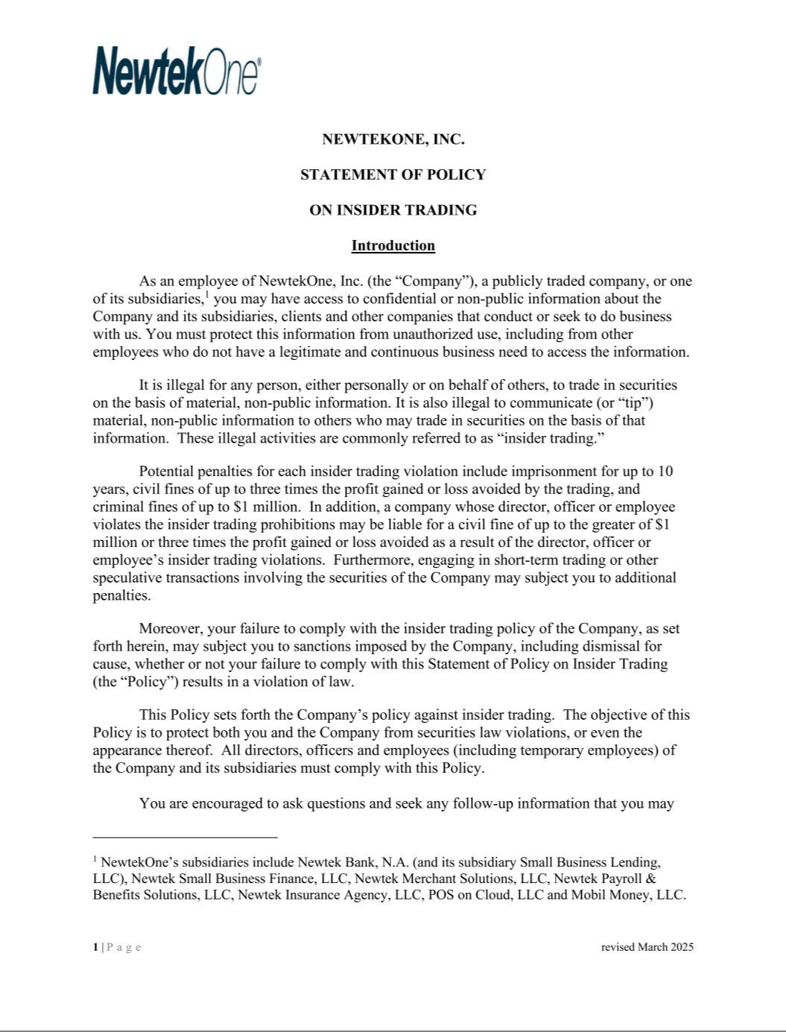

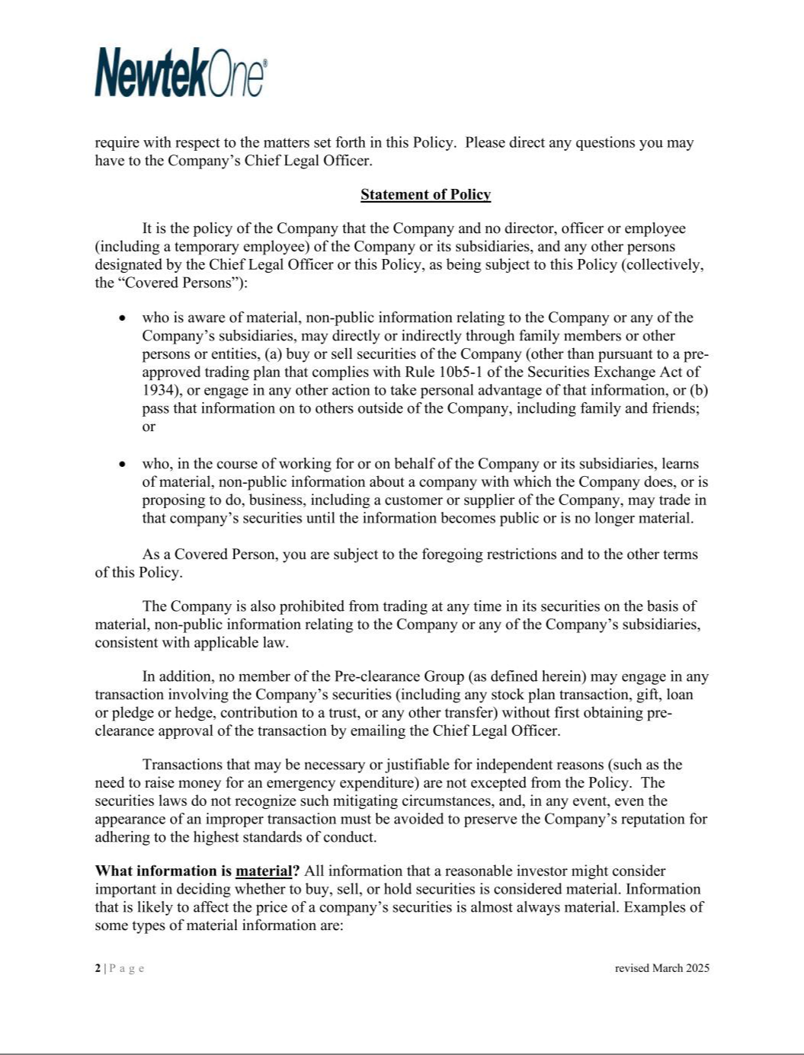

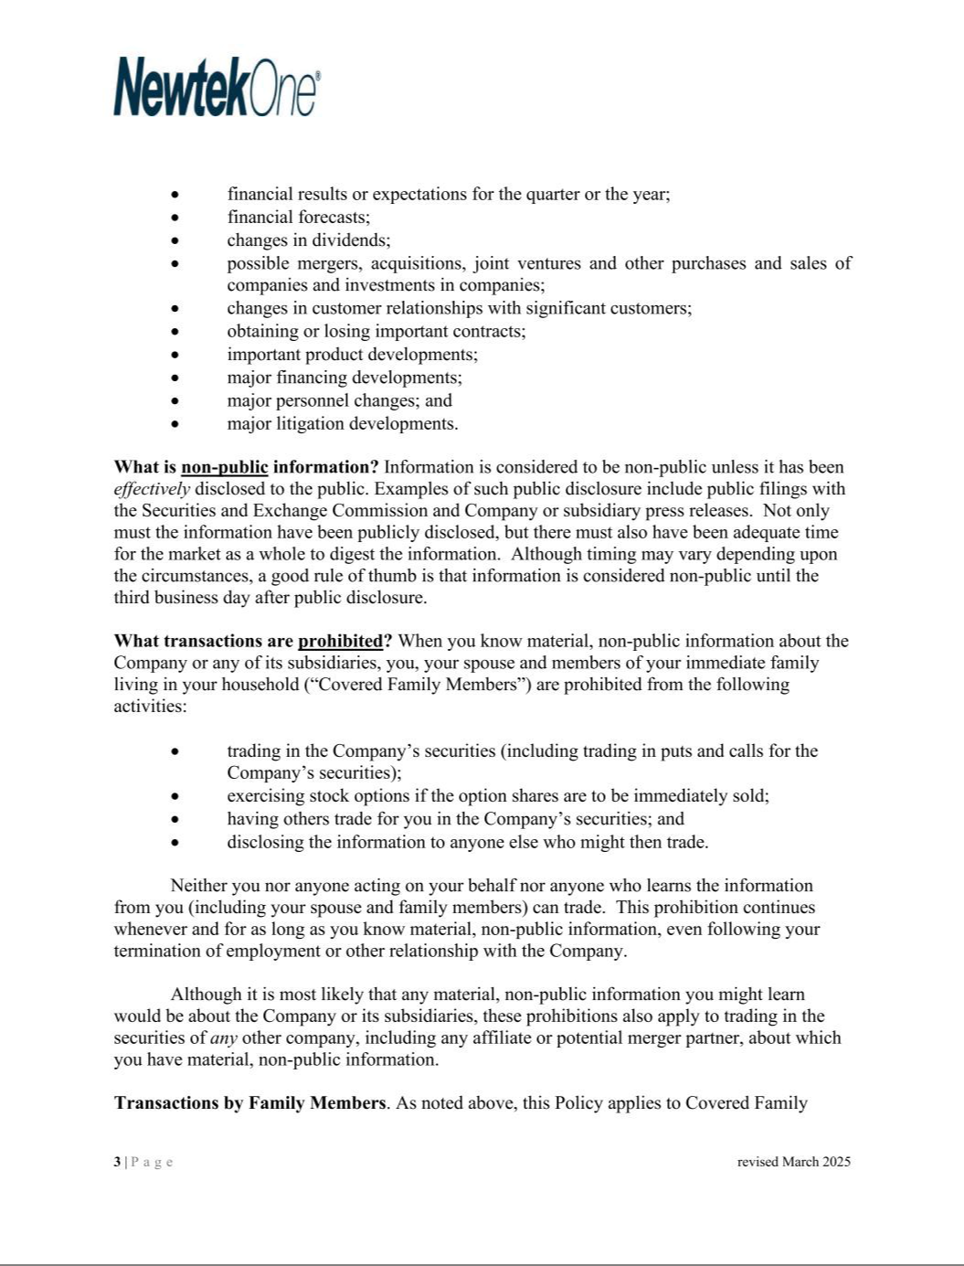

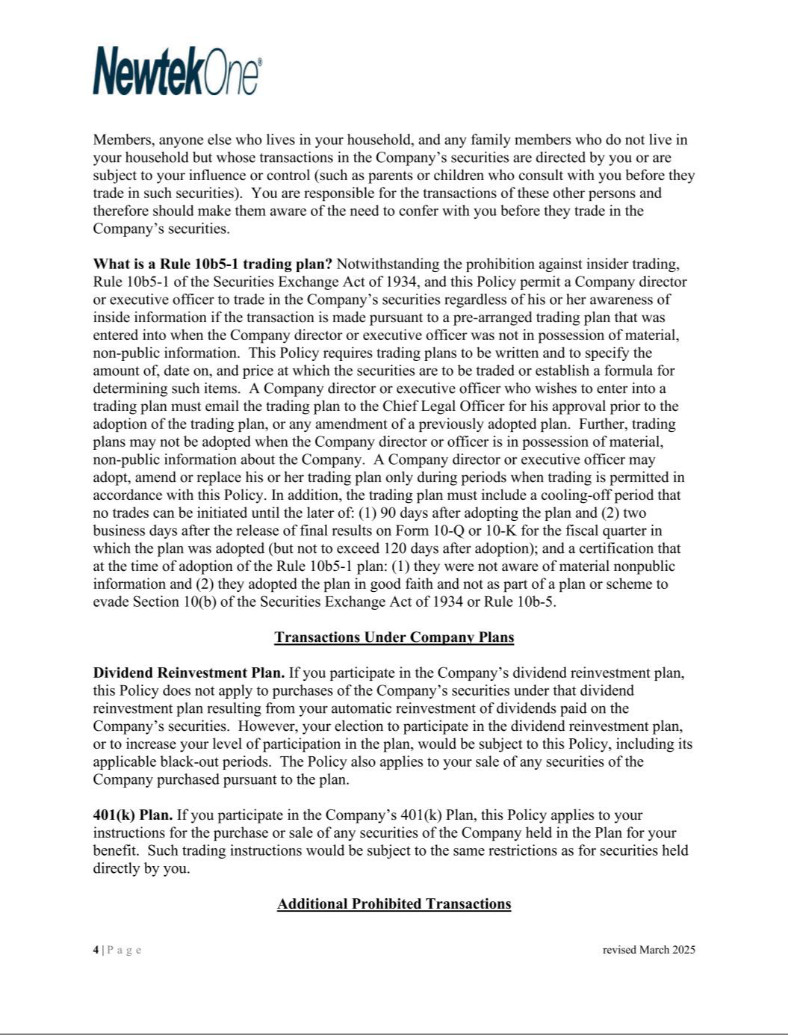

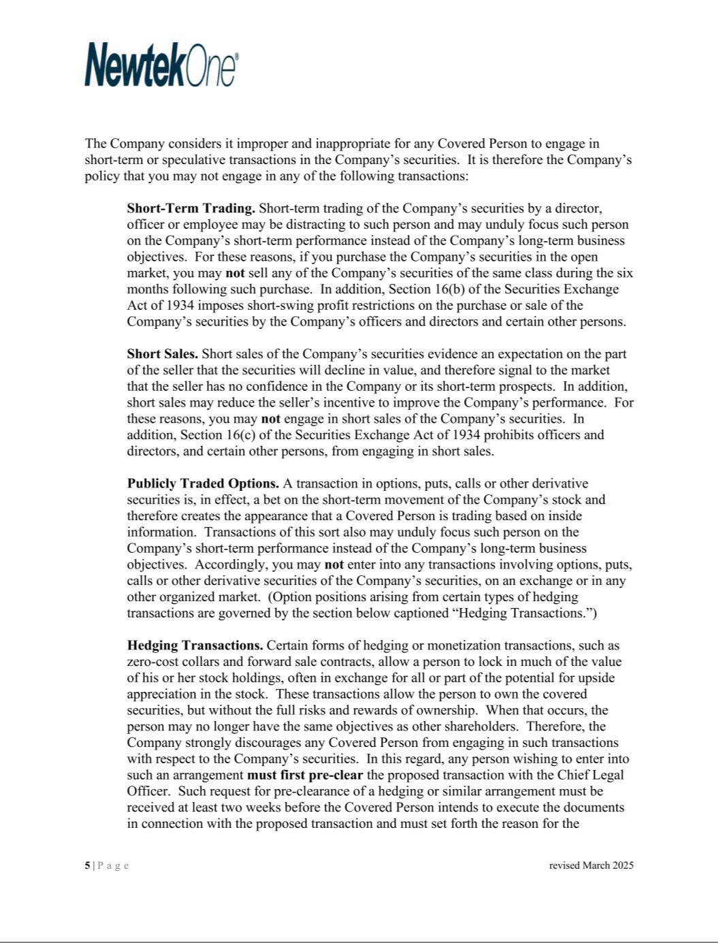

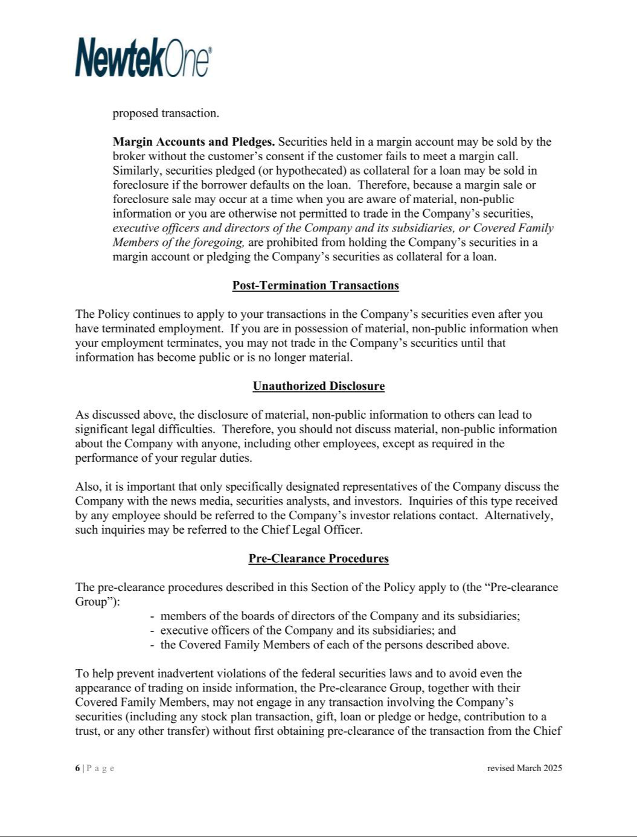

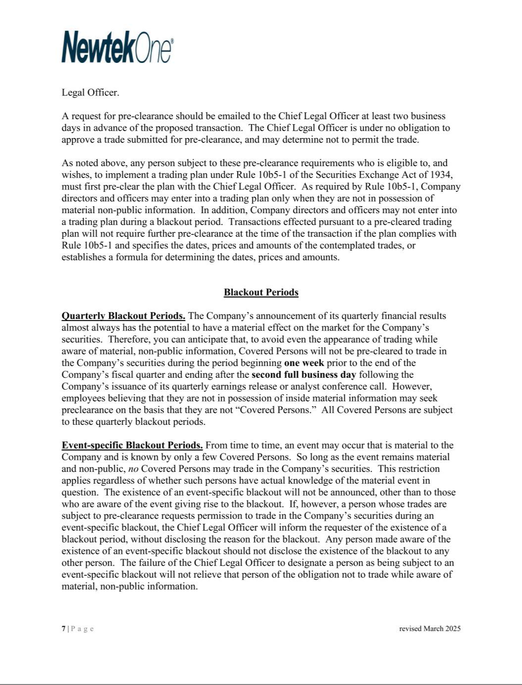

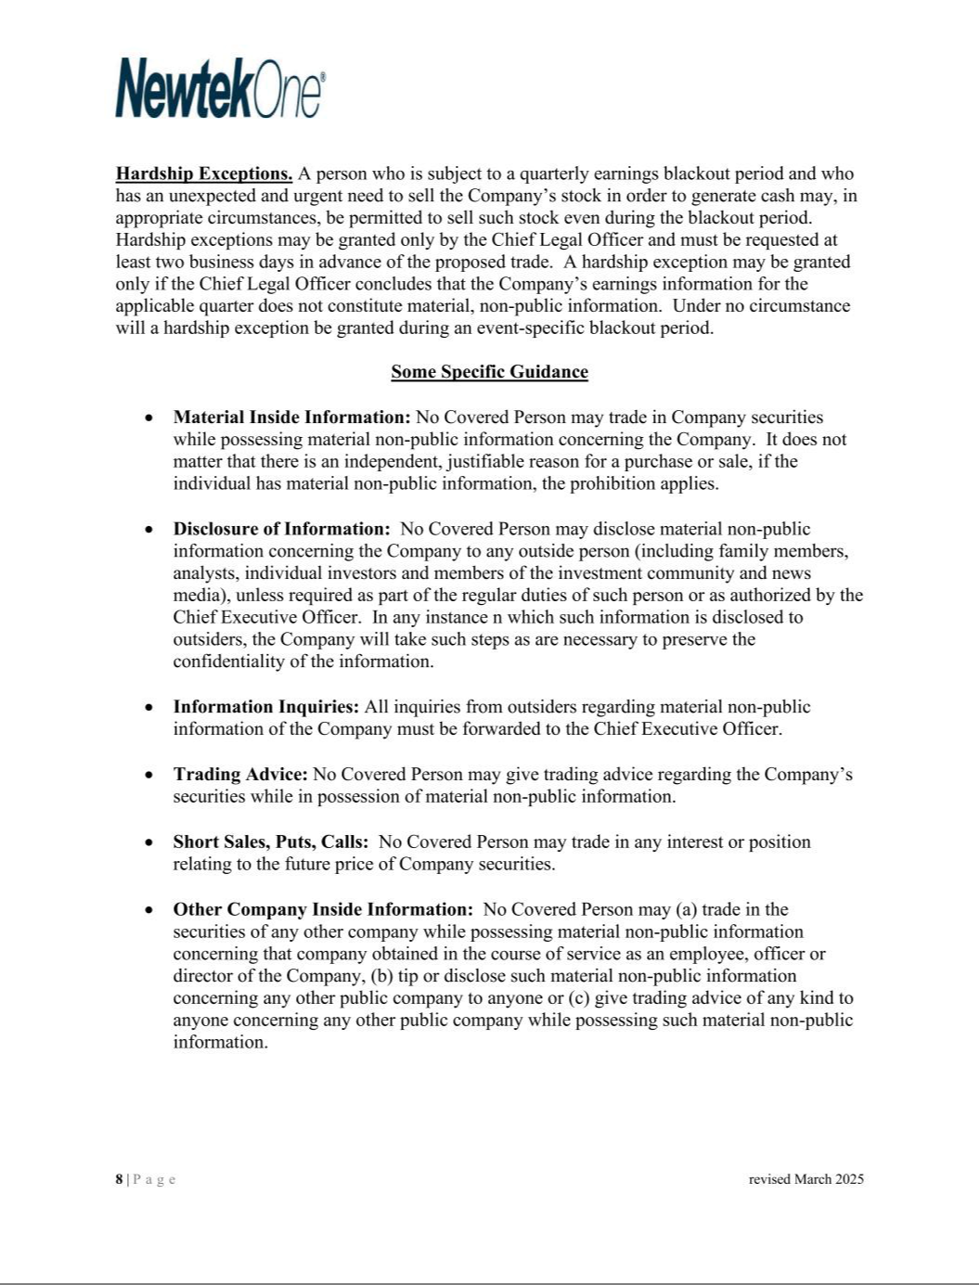

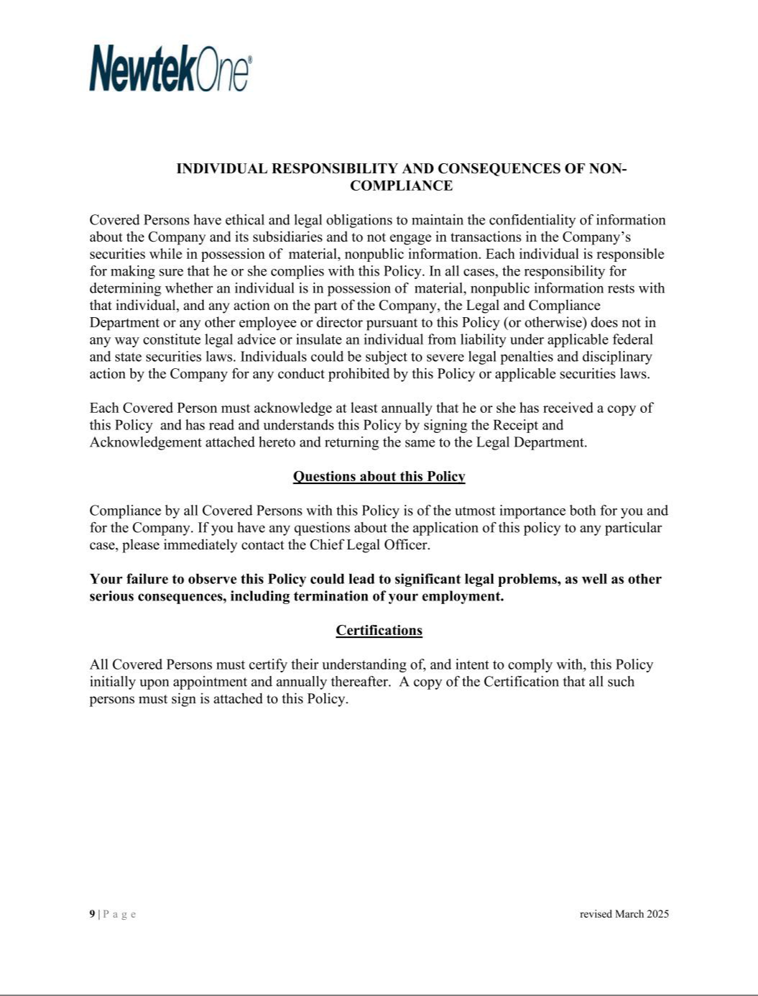



NEWTEKONE, INC.

SUBSIDIARIES

Name of Company |  | State of Incorporation/Organization
CCC Real Estate Holdings, LLC |  | Delaware
CDS Business Services, Inc. dba Newtek Business Credit
Solutions |  | Delaware
Mobil Money, LLC |  | New York
Newtek Bank, National Association |  | Florida
NBL SPV I, LLC |  | Delaware
NBL SPV II, LLC |  | Delaware
NBL SPV III, LLC |  | Delaware
NBSH Holdings, LLC |  | New York
Newtek Asset Backed Securities, LLC |  | New York
Newtek Business Services Holdco 6, Inc. |  | New York
Newtek Commercial Lending, Inc. |  | New York
Newtek Insurance Agency, LLC |  | District of Columbia
Newtek Merchant Solutions, LLC |  | New York
Newtek Small Business Finance, LLC |  | New York
PMTWorks Payroll, LLC dba Newtek Payroll and Benefits
Solutions |  | New York
POS on Cloud, LLC, dba Newtek Payment Systems |  | Kentucky
Small Business Lending, LLC |  | New York
Titanium Asset Management, LLC |  | New York
Wilshire DC Partners, LLC |  | District of Columbia
Wilshire Louisiana BIDCO, LLC |  | Louisiana
Wilshire Louisiana Partners II, LLC |  | Louisiana
Wilshire Louisiana Partners III, LLC |  | Louisiana
Wilshire New York Partners III, LLC |  | New York
NB Real Estate Holdco, LLC |  | Florida
NALP Asset Backed Securities, LLC |  | Delaware
NH6 Real Estate Holdco, LLC |  | Florida

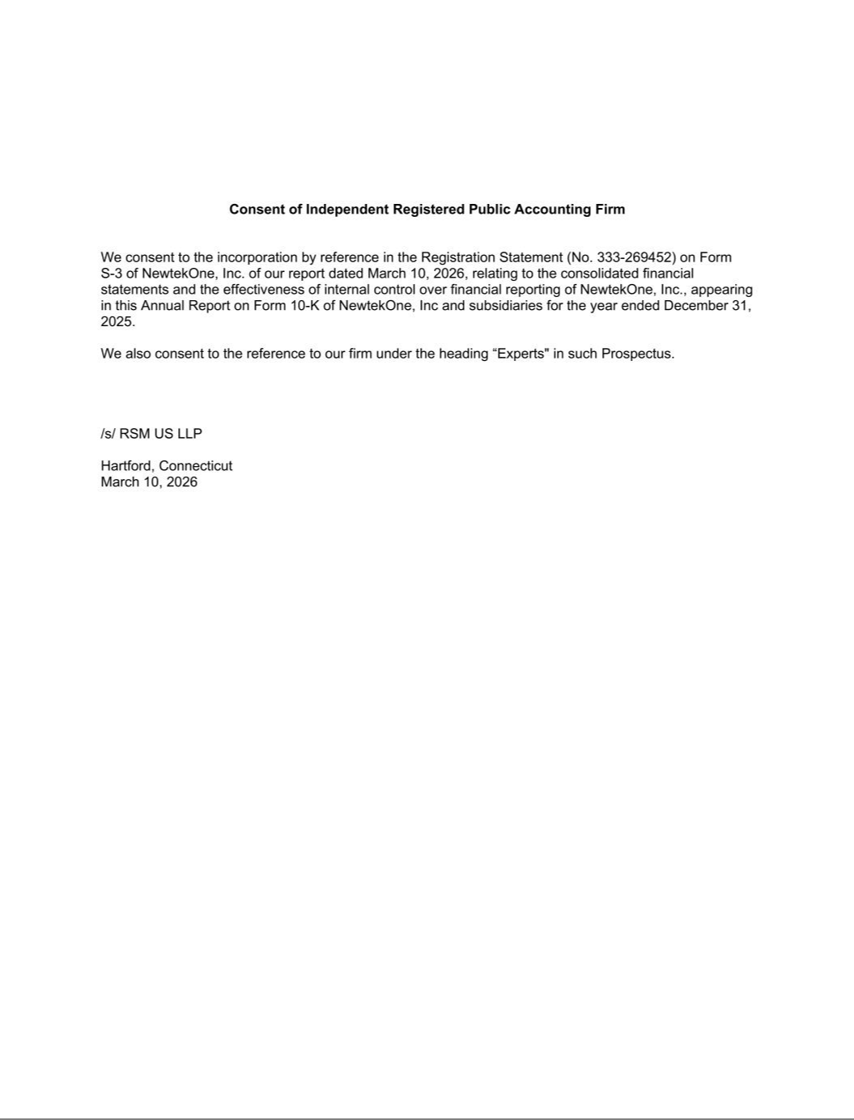

Exhibit 31.1

CERTIFICATION PURSUANT TO 18 U.S.C. SECTION 1350,

AS ADOPTED PURSUANT TO SECTION 302 OF THE

SARBANES-OXLEY ACT OF 2002

I, Barry Sloane, certify that:

- I have reviewed this annual report on Form 10-K of NewtekOne, Inc. (the “registrant”).

- Based on my knowledge, this report does not contain any untrue statement of a material fact or omit to state a material fact necessary to make the statements made, in light of the circumstances under which such statements were made, not misleading with respect to the period covered by this report;

- Based on my knowledge, the financial statements, and other financial information included in this report, fairly present in all material respects the financial condition, results of operations and cash flows of the registrant as of, and for, the periods presented in this annual report;

- The registrant’s other certifying officers and I are responsible for establishing and maintaining disclosure controls and procedures (as defined in Exchange Act Rules 13a-15(e) and 15d-15(e)) and internal control over financial reporting (as defined in Exchange Act Rules 13a-15(f) and 15d-15(f) for the registrant and have:

  - designed such disclosure controls and procedures, or caused such disclosure controls and procedures to be designed under our supervision, to ensure that material information relating to the registrant, including its consolidated subsidiaries, is made known to us by others within those entities, particularly during the period in which this report is being prepared;

  - designed such internal control over financial reporting, or caused such internal control over financial reporting to be designed under our supervision, to provide reasonable assurance regarding the reliability of financial reporting and the preparation of financial statements for external purposes in accordance with generally accepted accounting principles;

  - evaluated the effectiveness of the registrant’s disclosure controls and procedures and presented in this report our conclusions about the effectiveness of the disclosure controls and procedures, as of the end of the period covered by this report based on such evaluation; and

  - disclosed in this report any change in the registrant’s internal control over financial reporting that occurred during the registrant’s most recent fiscal quarter (the registrant’s fourth fiscal quarter in the case of an annual report) that has materially affected, or is reasonably likely to materially affect, the registrant’s internal control over financial reporting.

- The registrant’s other certifying officers and I have disclosed, based on our most recent evaluation of internal control over financial reporting, to the registrant’s auditors and the audit committee of the registrant’s board of directors (or persons performing the equivalent functions):

  - all significant deficiencies and material weaknesses in the design or operation of internal control over financial reporting which are reasonably likely to adversely affect the registrant’s ability to record, process, summarize and report financial information; and

  - any fraud, whether or not material, that involves management or other employees who have a significant role in the registrant’s internal control over financial reporting.

Date: March 10, 2026 /S/ BARRY SLOANE

Barry Sloane

Principal Executive Officer

Exhibit 31.2

CERTIFICATION PURSUANT TO 18 U.S.C. SECTION 1350,

AS ADOPTED PURSUANT TO SECTION 302 OF THE

SARBANES-OXLEY ACT OF 2002

I, Frank M. DeMaria, certify that:

- I have reviewed this annual report on Form 10-K of NewtekOne, Inc. (the “registrant”).

- Based on my knowledge, this report does not contain any untrue statement of a material fact or omit to state a material fact necessary to make the statements made, in light of the circumstances under which such statements were made, not misleading with respect to the period covered by this annual report;

- Based on my knowledge, the financial statements, and other financial information included in this report, fairly present in all material respects the financial condition, results of operations and cash flows of the registrant as of, and for, the periods presented in this report;

- The registrant’s other certifying officers and I are responsible for establishing and maintaining disclosure controls and procedures (as defined in Exchange Act Rules 13a-15(e) and 15d-15(e)) and internal control over financial reporting (as defined in Exchange Act Rules 13a-15(f) and 15d-15(f) for the registrant and have:

  - designed such disclosure controls and procedures, or caused such disclosure controls and procedures to be designed under our supervision, to ensure that material information relating to the registrant, including its consolidated subsidiaries, is made known to us by others within those entities, particularly during the period in which this report is being prepared;

  - designed such internal control over financial reporting, or caused such internal control over financial reporting to be designed under our supervision, to provide reasonable assurance regarding the reliability of financial reporting and the preparation of financial statements for external purposes in accordance with generally accepted accounting principles;

  - evaluated the effectiveness of the registrant’s disclosure controls and procedures and presented in this report our conclusions about the effectiveness of the disclosure controls and procedures, as of the end of the period covered by this report based on such evaluation; and

  - disclosed in this report any change in the registrant’s internal control over financial reporting that occurred during the registrant’s most recent fiscal quarter (the registrant’s fourth fiscal quarter in the case of an annual report) that has materially affected, or is reasonably likely to materially affect, the registrant’s internal control over financial reporting.

- The registrant’s other certifying officers and I have disclosed, based on our most recent evaluation of internal control over financial reporting, to the registrant’s auditors and the audit committee of the registrant’s board of directors (or persons performing the equivalent functions):

  - all significant deficiencies and material weaknesses in the design or operation of internal control over financial reporting which are reasonably likely to adversely affect the registrant’s ability to record, process, summarize and report financial information; and

  - any fraud, whether or not material, that involves management or other employees who have a significant role in the registrant’s internal control over financial reporting.

Date: March 10, 2026 /S/ FRANK M. DEMARIA

Frank M. DeMaria

Principal Financial Officer

Exhibit 31.3

CERTIFICATION PURSUANT TO 18 U.S.C. SECTION 1350,

AS ADOPTED PURSUANT TO SECTION 302 OF THE

SARBANES-OXLEY ACT OF 2002

I, Frank M. DeMaria, certify that:

- I have reviewed this annual report on Form 10-K of NewtekOne, Inc. (the “registrant”).

- Based on my knowledge, this report does not contain any untrue statement of a material fact or omit to state a material fact necessary to make the statements made, in light of the circumstances under which such statements were made, not misleading with respect to the period covered by this annual report;

- Based on my knowledge, the financial statements, and other financial information included in this report, fairly present in all material respects the financial condition, results of operations and cash flows of the registrant as of, and for, the periods presented in this report;

- The registrant’s other certifying officers and I are responsible for establishing and maintaining disclosure controls and procedures (as defined in Exchange Act Rules 13a-15(e) and 15d-15(e)) and internal control over financial reporting (as defined in Exchange Act Rules 13a-15(f) and 15d-15(f) for the registrant and have:

  - designed such disclosure controls and procedures, or caused such disclosure controls and procedures to be designed under our supervision, to ensure that material information relating to the registrant, including its consolidated subsidiaries, is made known to us by others within those entities, particularly during the period in which this report is being prepared;

  - designed such internal control over financial reporting, or caused such internal control over financial reporting to be designed under our supervision, to provide reasonable assurance regarding the reliability of financial reporting and the preparation of financial statements for external purposes in accordance with generally accepted accounting principles;

  - evaluated the effectiveness of the registrant’s disclosure controls and procedures and presented in this report our conclusions about the effectiveness of the disclosure controls and procedures, as of the end of the period covered by this report based on such evaluation; and

  - disclosed in this report any change in the registrant’s internal control over financial reporting that occurred during the registrant’s most recent fiscal quarter (the registrant’s fourth fiscal quarter in the case of an annual report) that has materially affected, or is reasonably likely to materially affect, the registrant’s internal control over financial reporting.

- The registrant’s other certifying officers and I have disclosed, based on our most recent evaluation of internal control over financial reporting, to the registrant’s auditors and the audit committee of the registrant’s board of directors (or persons performing the equivalent functions):

  - all significant deficiencies and material weaknesses in the design or operation of internal control over financial reporting which are reasonably likely to adversely affect the registrant’s ability to record, process, summarize and report financial information; and

  - any fraud, whether or not material, that involves management or other employees who have a significant role in the registrant’s internal control over financial reporting.

Date: March 10, 2026 /S/ FRANK M. DEMARIA

Frank M. DeMaria

Principal Accounting Officer

Exhibit 32.1

CERTIFICATION PURSUANT TO 18 U.S.C. SECTION 1350,

AS ADOPTED PURSUANT TO

SECTION 906 OF THE SARBANES-OXLEY ACT OF 2002

In connection with the Annual Report on Form 10-K for the year ended December 31, 2025 (the “Report”) of NewtekOne Inc.(the “Company”), as filed with the Securities and Exchange Commission on the date hereof, I, Barry Sloane, as Principal Executive Officer of the Company, certify, pursuant to 18 U.S.C. §1350, as adopted pursuant to §906 of the Sarbanes-Oxley Act of 2002, that, to the best of my knowledge:

- The Report fully complies with the requirements of Section 13(a) or 15(d) of the Securities Exchange Act of 1934; and

- The information contained in the Report fairly presents, in all material respects, the financial condition and results of the operations of the Company.

Date: March 10, 2026 /S/ BARRY SLOANE

Barry Sloane,

Principal Executive Officer

Exhibit 32.2

CERTIFICATION PURSUANT TO 18 U.S.C. SECTION 1350,

AS ADOPTED PURSUANT TO

SECTION 906 OF THE SARBANES-OXLEY ACT OF 2002

In connection with the Annual Report on Form 10-K for the year ended December 31, 2025 (the “Report”) of NewtekOne, Inc. (the “Company”), as filed with the Securities and Exchange Commission on the date hereof, I, Frank M. DeMaria, as Principal Financial Officer of the Company, hereby certify pursuant to 18 U.S.C. §1350, as adopted pursuant to §906 of the Sarbanes-Oxley Act of 2002, that, to the best of my knowledge:

- The Report fully complies with the requirements of Section 13(a) or 15(d) of the Securities Exchange Act of 1934; and

- The information contained in the Report fairly presents, in all material respects, the financial condition and results of the operations of the Company.

Date: March 10, 2026 /S/ FRANK M. DEMARIA

Frank M. DeMaria

Principal Financial Officer

Exhibit 32.3

CERTIFICATION PURSUANT TO 18 U.S.C. SECTION 1350,

AS ADOPTED PURSUANT TO

SECTION 906 OF THE SARBANES-OXLEY ACT OF 2002

In connection with the Annual Report on Form 10-K for the year ended December 31, 2025 (the “Report”) of NewtekOne, Inc. (the “Company”), as filed with the Securities and Exchange Commission on the date hereof, I, Frank M. DeMaria, as Principal Accounting Officer of the Company, hereby certify pursuant to 18 U.S.C. §1350, as adopted pursuant to §906 of the Sarbanes-Oxley Act of 2002, that, to the best of my knowledge:

- The Report fully complies with the requirements of Section 13(a) or 15(d) of the Securities Exchange Act of 1934; and

- The information contained in the Report fairly presents, in all material respects, the financial condition and results of the operations of the Company.

Date: March 10, 2026 /S/ FRANK M. DEMARIA

Frank M. DeMaria

Principal Accounting Officer

