As filed with the Securities and Exchange Commission on July 17, 2026
Registration No. 333-297037

UNITED STATES
SECURITIES AND EXCHANGE COMMISSION
Washington, D.C. 20549

AMENDMENT NO. 1
TO
FORM S-3
REGISTRATION STATEMENT
UNDER
THE SECURITIES ACT OF 1933
NEWTEKONE, INC.
(Exact Name of registrant as specified in its charter)

Maryland |  |  |  |  |  | 46-3755188
(State or Other Jurisdiction of  Incorporation or Organization) |  |  |  |  |  | (I.R.S. Employer  Identification Number)

4800 T Rex Avenue, Suite 120
Boca Raton, Florida 33431
(212) 356-9500
(Address and telephone number of registrant’s principal executive offices)

Barry Sloane
Chief Executive Officer and President
NewtekOne, Inc.
4800 T Rex Avenue, Suite 120
Boca Raton, FL 33431
(212) 356-9500

(Name, address, including ZIP code, and telephone number, including area code, of agent for service)

Copies to:
Jared M. Fishman
Sullivan & Cromwell LLP
125 Broad Street
New York, New York 10004-2497
(212) 558-4000

Approximate date of commencement of proposed sale to the public: From time to time after the effective date of this Registration Statement, as determined by the registrant.

If the only securities being registered on this Form are being offered pursuant to dividend or interest reinvestment plans, please check the following box. o

If any of the securities being registered on this Form are to be offered on a delayed or continuous basis pursuant to Rule 415 under the Securities Act of 1933, other than securities offered only in connection with dividend or interest reinvestment plans, check the following box. x
If this Form is filed to register additional securities for an offering pursuant to Rule 462(b) under the Securities Act, please check the following box and list the Securities Act registration statement number of the earlier effective registration statement for the same offering. o

If this Form is a post-effective amendment filed pursuant to Rule 462(c) under the Securities Act, check the following box and list the Securities Act registration statement number of the earlier effective registration statement for the same offering. o

If this Form is a registration statement pursuant to General Instruction I.D. or a post-effective amendment thereto that shall become effective upon filing with the Commission pursuant to Rule 462(e) under the Securities Act, check the following box. o

If this Form is a post-effective amendment to a registration statement filed pursuant to General Instruction I.D. filed to register additional securities or additional classes of securities pursuant to Rule 413(b) under the Securities Act, check the following box. o

Indicate by check mark whether the registrant is a large accelerated filer, an accelerated filer, a non-accelerated filer, a smaller reporting company, or an emerging growth company. See the definitions of “large accelerated filer,” “accelerated filer,” “smaller reporting company” and “emerging growth company” in Rule 12b-2 of the Exchange Act.

Large accelerated filer |  |  | o |  |  |  |  |  | Accelerated filer |  |  | x
Non-accelerated filer |  |  | o |  |  |  |  |  | Smaller reporting company |  |  | o
 |  |  |  |  |  |  |  |  | Emerging Growth Company |  |  | o

If an emerging growth company, indicate by checkmark if the registrant has elected not to use the extended transition period for complying with any new or revised financial accounting standards provided pursuant to Section 7(a)(2)(b) of the Securities Act:

The Registrant hereby amends this Registration Statement on such date or dates as may be necessary to delay its effective date until the Registrant shall file a further amendment which specifically states that this Registration Statement shall thereafter become effective in accordance with Section 8(a) of the Securities Act or until the Registration Statement shall become effective on such date as the Securities and Exchange Commission, acting pursuant to said Section 8(a), may determine.

PROSPECTUS



NewtekOne, Inc.

$650,000,000
Common Stock
Preferred Stock
Depositary Shares
Subscription Rights
Warrants
Debt Securities
Units

This prospectus relates to the offer, from time to time, in one or more offerings or series, of up to $650,000,000 of common stock, preferred stock, depositary shares, subscription rights, warrants, debt securities and/or units consisting of some or all of these securities, which we refer to, collectively, as the “securities.” The securities offered hereby may be convertible or exchangeable into shares of common stock. The securities may be offered at prices and on terms to be described in one or more supplements to this prospectus.

We may sell our securities through underwriters or dealers, “at-the-market” to or through a market maker into an existing trading market or otherwise directly to one or more purchasers or through agents or through a combination of methods of sale. Each prospectus supplement relating to an offering will identify any agents or underwriters involved in the sale of the securities, and will disclose any applicable purchase price, fee, discount or commissions arrangement between us and our agents or underwriters or among our underwriters or the basis upon which such amount may be calculated. See “Plan of Distribution”. We may not sell any of the securities through agents, underwriters or dealers without delivery of this prospectus and a prospectus supplement describing the method and terms of the offering of such securities.

Our common shares are currently traded on the Nasdaq Global Market under the symbol “NEWT.” As of July 16, 2026, the last reported closing price of our common shares on the Nasdaq Global Market was $15.56.
__________________

An investment in our securities is subject to various risks See the sections entitled “Risk Factors” beginning on Page 4 of this prospectus, “Item 1A. Risk Factors” in our most recent Annual Report on Form 10-K, “Part II – Item 1A. Risk Factors” as well as in any of our subsequent filings with the Securities and Exchange Commission (“SEC”), and in, or incorporated by reference into, the applicable prospectus supplement and in any free writing prospectuses we may authorize for use in connection with a specific offering, and under similar headings in the other documents that are incorporated by reference into this prospectus, to read about factors you should consider, before investing in our securities.

Neither the SEC nor any state securities commission has approved or disapproved of these securities or determined if this prospectus is truthful or complete. Any representation to the contrary is a criminal offense.
__________________

This prospectus may not be used to consummate sales of our securities unless accompanied by a prospectus supplement.
__________________

This prospectus describes some of the general terms that may apply to an offering of our securities. We will provide the specific terms of these offerings and securities in one or more supplements to this prospectus. We may also authorize one or more free writing prospectuses to be provided to you in connection with these offerings. The prospectus supplement and any related free writing prospectus may also add, update, or change information contained in this prospectus. You should carefully read this prospectus, the applicable prospectus supplement, and any related free writing prospectus, and the documents incorporated by reference, before buying any of the securities being offered. We file annual, quarterly and current reports, proxy statements and other information about us with the SEC. This information is available free of charge by contacting us by mail at 4800 T Rex Avenue, Suite 120, Boca Raton, Florida 33431, by telephone at (212) 356-9500 or on our website at http://www.NewtekOne.com. The SEC also maintains a website at http://www.sec.gov that contains such information. Information contained on our website or on the SEC’s web site about us is not incorporated into this prospectus and you should not consider information contained on our website or on the SEC’s website to be part of this prospectus.

The date of this prospectus is July 17, 2026.

You should rely only on the information contained in this prospectus and any accompanying prospectus supplement. We have not authorized any dealer, salesman or other person to give any information or to make any representation other than those contained in this prospectus or any prospectus supplement to this prospectus. You must not rely upon any information or representation not contained in this prospectus or any such supplements as if we had authorized it. This prospectus and any such supplements do not constitute an offer to sell or a solicitation of any offer to buy any security other than the registered securities to which they relate, nor do they constitute an offer to sell or a solicitation of an offer to buy any securities in any jurisdiction to any person to whom it is unlawful to make such an offer or solicitation in such jurisdiction. The information contained in, or incorporated by reference in, this prospectus, any such supplements, or free writing prospectuses is, or will be, accurate as of the dates on their respective covers. Our business, financial condition, results of operations and prospects may have changed since then.

ABOUT THIS PROSPECTUS |  |  | 2
PROSPECTUS SUMMARY |  |  | 3
RISK FACTORS |  |  | 4
CAUTIONARY STATEMENT REGARDING FORWARD-LOOKING STATEMENTS AND PROJECTIONS |  |  | 5
USE OF PROCEEDS |  |  | 6
SUMMARY OF THE SECURITIES WE MAY OFFER |  |  | 7
DESCRIPTION OF OUR CAPITAL STOCK |  |  | 8
DESCRIPTION OF OUR PREFERRED STOCK |  |  | 14
DESCRIPTION OF OUR DEPOSITARY SHARES |  |  | 15
DESCRIPTION OF OUR SUBSCRIPTION RIGHTS |  |  | 17
DESCRIPTION OF OUR WARRANTS |  |  | 19
DESCRIPTION OF OUR DEBT SECURITIES |  |  | 20
DESCRIPTION OF UNITS |  |  | 33
PLAN OF DISTRIBUTION |  |  | 34
LEGAL MATTERS |  |  | 36
EXPERTS |  |  | 37
AVAILABLE INFORMATION |  |  | 38
INCORPORATION OF CERTAIN INFORMATION BY REFERENCE |  |  | 39

1

ABOUT THIS PROSPECTUS

This prospectus is part of a registration statement that we have filed with the SEC, using the “shelf” registration process. Under the shelf registration process, which constitutes a delayed offering in reliance on Rule 415 under the Securities Act of 1933 (the “Securities Act”), NewtekOne, Inc. may offer, from time to time, in one or more offerings, up to $650,000,000 of common stock, preferred stock, depositary shares, warrants, subscription rights, debt securities and/or units consisting of some or all of these securities, on terms to be determined at the time of each offering. We may sell our securities through underwriters or dealers, “at-the-market” to or through a market maker, into an existing trading market or otherwise directly to one or more purchasers or through agents or through a combination of methods of sale. The identities of such underwriters, dealers, market makers or agents, as the case may be, will be described in one or more supplements to this prospectus. The securities may be offered at prices and on terms described in one or more supplements to this prospectus. This prospectus provides you with a general description of the securities that we may offer. Each time we use this prospectus to offer securities, we will provide a prospectus supplement that will contain specific information about the terms of that offering.

We may also authorize one or more free writing prospectuses to be provided to you that may contain material information relating to these offerings. In a prospectus supplement or free writing prospectus, we may also add, update, or change any of the information contained in this prospectus or in the documents we incorporate by reference into this prospectus. This prospectus, together with the applicable prospectus supplement, any related free writing prospectus, and the documents incorporated by reference into this prospectus and the applicable prospectus supplement, will include all material information relating to the applicable offering. Before buying any of the securities being offered, you should carefully read both this prospectus and the applicable prospectus supplement and any related free writing prospectus, together with any exhibits and the additional information described in the sections titled “Available Information,” “Incorporation of Certain Information By Reference,” “Prospectus Summary” and “Risk Factors” before making an investment decision.

This prospectus includes summaries of certain provisions contained in some of the documents described in this prospectus, but reference is made to the actual documents for complete information. All of the summaries are qualified in their entirety by the actual documents. Copies of some of the documents referred to herein have been filed, will be filed, or will be incorporated by reference as exhibits to the registration statement of which this prospectus is a part, and you may obtain copies of those documents as described in the section titled “Available Information.”

2

PROSPECTUS SUMMARY

The following summary contains basic information about offerings pursuant to this prospectus. It may not contain all the information that is important to you. For a more complete understanding of offerings pursuant to this prospectus, we encourage you to read this entire prospectus and the documents to which we have referred in this prospectus, together with any accompanying prospectus supplements or free writing prospectuses, including the risks set forth under the captions “Risk Factors” in this prospectus, “Item 1A. Risk Factors” in our most recent Annual Report on Form 10-K and in any subsequent filings we have made with the SEC that are incorporated by reference into this prospectus, together with other information in this prospectus, the documents incorporated by reference, and any free writing prospectus that we may authorize for use in connection with this offering. See “Available Information” for more information. Throughout this prospectus, we refer to NewtekOne, Inc., its consolidated subsidiaries and its predecessor, Newtek Business Services Corp., as the “Company,” “we,” “us,” “our,” and “NewtekOne.”

Our Business
We are a financial holding company subject to the regulation and supervision of the Federal Reserve and the Federal Reserve Bank of Atlanta that, together with our consolidated subsidiaries, provides a wide range of business and financial solutions under the Newtek® and NewtekOne® brands to the independent business owner (“SMB”) market.
We define SMBs as companies having revenues of $1.0 million to $100.0 million, and we estimate the SMB market to be over 36 million businesses in the U.S. as of June 2025, according to the SBA.
In addition to Newtek Bank, National Association (“Newtek Bank”) and its consolidated subsidiary, Small Business Lending, LLC, the following are our consolidated non-bank direct and indirect operating subsidiaries: Newtek Small Business Finance, LLC; Newtek Merchant Solutions, LLC, d/b/a Newtek Real-Time Payments Solutions, and its subsidiary Mobil Money, LLC; PMTWorks Payroll, LLC d/b/a Newtek Payroll and Benefits Solutions; Newtek Insurance Agency, LLC; Titanium Asset Management LLC; Newtek Business Services Holdco 6, Inc. d/b/a Newtek ALP Holdings; and POS on Cloud, LLC, d/b/a Newtek Payment Systems. We have an established and reliable platform that is not limited by client size, industry type, or location. We expect to generate revenue from the business operations of our subsidiaries, including a combination of realized gains on the sale of the government guaranteed portions of SBA 7(a) loans, servicing income and other income, including revenue generated from our business lines Newtek Lending, Newtek Payments, Newtek Insurance, Newtek Payroll and Newtek Bank.
As of March 31, 2026, we had consolidated total assets of $2.9 billion, deposits of $1.9 billion and shareholders’ equity of $404.7 million.
General Information
Our principal executive offices are located at 4800 T Rex Avenue, Suite 120, Boca Raton, Florida 33431, our telephone number is (212) 356-9500 and our website may be found at http://www.NewtekOne.com. Information contained in our website is not incorporated by reference into this prospectus, and you should not consider that information to be part of this prospectus.
We are required to file periodic reports, current reports, proxy statements and other information with the SEC. This information is available on the SEC’s website at http://www.sec.gov. This information is also available free of charge by contacting us at NewtekOne, Inc., 4800 T Rex Avenue, Suite 120, Boca Raton, Florida 33431, by telephone at (212) 356-9500 or on our website at http://www.NewtekOne.com. Information contained on our website or on the SEC’s website about us is not incorporated into this prospectus and you should not consider information contained on our website or on the SEC’s website to be part of this prospectus, or the registration statement of which this prospectus is a part.

3

RISK FACTORS

Investing in our securities involves a high degree of risk. Before deciding whether to invest in our securities, you should carefully consider the risks and uncertainties described the section titled “Risk Factors” in the applicable prospectus supplement and any related free writing prospectus, and discussed in the sections titled “Item 1A. Risk Factors” in our most recent Annual Report on Form 10-K and in any subsequent filings we have made with the SEC that are incorporated by reference into this prospectus, together with other information in this prospectus, the documents incorporated by reference, and any free writing prospectus that we may authorize for use in connection with this offering. See “Available Information“ for more information. The risks described these documents are not the only ones we face. Additional risks and uncertainties that we are unaware of, or that we currently believe are not material, may also become important factors that adversely affect our business. Past financial performance may not be a reliable indicator of future performance, and historical trends should not be used to anticipate results or trends in future periods. If any of these risks actually occurs, our business, reputation, financial condition, results of operations, revenue, and future prospects could be seriously harmed. This could cause the trading price of our securities to decline, resulting in a loss of all or part of your investment. Please also read carefully the section titled “Cautionary Statement Regarding Forward-Looking Statements and Projections.”

4

CAUTIONARY STATEMENT REGARDING
FORWARD-LOOKING STATEMENTS AND PROJECTIONS

This prospectus, including the documents that we incorporate by reference herein, contains, and any applicable prospectus supplement or free writing prospectus, including the documents we incorporate by reference therein, may contain, forward-looking statements that involve substantial risks and uncertainties. These forward-looking statements are not historical facts, but rather are based on current expectations, estimates and projections about us, our industry, our beliefs, and our assumptions. Words such as “anticipates,” “expects,” “intends,” “plans,” “will,” “may,” “continue,” “believes,” “seeks,” “estimates,” “would,” “could,” “should,” “targets,” “projects,” and variations of these words and similar expressions are intended to identify forward-looking statements. The forward-looking statements contained in this prospectus, any accompanying prospectus supplement, any related free writing prospectus and any documents we may incorporate by reference herein and therein involve risks and uncertainties, including statements as to:

•our future operating results;
•our business prospects and the prospects of our subsidiaries;
•our contractual arrangements and relationships with third parties;
•the dependence of our future success on the general economy and its impact on the industries in which we and our borrowers operate;
•the ability of our business to achieve its objectives;
•the impact of a protracted decline in the liquidity of credit markets on our business;
•the adequacy of our cash resources and working capital;
•our ability to operate as a financial holding company and our ability to operate our subsidiary Newtek Bank, a national bank regulated and supervised by the Office of the Comptroller of the Currency (“OCC”), and the increased compliance and other costs associated with such operations;
•our ability to adequately manage liquidity, deposits, capital levels and interest rate risk; and
•the timing of cash flows, if any, from the operations of our subsidiaries.
These statements are not guarantees of future performance and are subject to risks, uncertainties, and other factors, some of which are beyond our control and difficult to predict and could cause actual results to differ materially from those expressed or forecasted in the forward-looking statements, including without limitation: an economic downturn, which could impair our and our subsidiaries’ ability to continue to operate or repay their borrowings, which could adversely affect our results; a contraction of available credit and/or an inability to access the equity markets, which could impair our lending and business activities; interest rate volatility, which could adversely affect our results; impacts to financial markets and the global macroeconomic and geopolitical environment, including higher inflation and its impacts; higher interest rates and the impacts on macroeconomic conditions and NewtekOne’s funding costs; changes to the SBA 7(a) loan program, including recent revisions to the SBA Standard Operating Procedure; and the risks and uncertainties and other factors described or identified in “Item 1A. Risk Factors” in our most recent Annual Report on Form 10-K, “Part II – Item 1A. Risk Factors” and in any subsequent filings we have made with the SEC that are incorporated by reference into this prospectus, together with other information in this prospectus, the documents incorporated by reference, and any free writing prospectus that we may authorize for use in connection with this offering. See “Available Information” for more information. You should not place undue reliance on these forward-looking statements, which apply only as of the dates of this prospectus, any applicable prospectus supplement or free writing prospectus, including any documents incorporated by reference, and while we believe such information forms, or will form, a reasonable basis for such statements, such information may be limited or incomplete, and our statements should not be read to indicate that we have conducted an exhaustive inquiry into, or review of, all potentially available relevant information. These statements are inherently uncertain and investors are cautioned not to unduly rely on these statements. The forward-looking statements in this prospectus are excluded from the safe-harbor protection provided by Section 27A of the Securities Act and Section 21E of the Exchange Act.

5

USE OF PROCEEDS
We intend to use the net proceeds from the sale of the securities for general corporate purposes unless otherwise indicated in the prospectus supplement relating to a specific offering of securities.

6

SUMMARY OF THE SECURITIES WE MAY OFFER
We may use this prospectus to offer securities in one or more offerings. The applicable prospectus supplement will describe the amounts, prices and detailed terms of the securities and may describe risks associated with an investment in the securities. We will also include in the prospectus supplement, where applicable, information about material United States federal income tax considerations relating to the securities. Terms used in this prospectus will have the meanings described in this prospectus unless otherwise specified.

Our securities may be offered directly to one or more purchasers, or through agents designated from time to time by us, or to or through underwriters or dealers. The prospectus supplement relating to an offering will identify any agents or underwriters involved in the sale of our securities, and will disclose any applicable purchase price, fee, commission, or discount arrangement between us and our agents or underwriters or among our underwriters or the basis upon which such amount may be calculated. See “Plan of Distribution.” We may not sell any of our securities through agents, underwriters or dealers without delivery of this prospectus and a prospectus supplement describing the method and terms of the offering of securities. This prospectus may not be used to sell securities unless accompanied by the applicable prospectus supplement.

7

DESCRIPTION OF OUR CAPITAL STOCK
The following description is based on relevant portions of the Maryland General Corporation Law and on our charter and bylaws. This summary is not necessarily complete, and we refer you to Maryland Law and our charter and bylaws for a more detailed description of the provisions summarized below.
Stock
Our authorized stock consists of 200,000,000 shares of stock, par value $0.02 per share, of which all are designated as common stock, except for the 53,750 shares which are designated as 8.500% Fixed-Rate Reset Non-Cumulative Perpetual Preferred Stock, Series B. Our common stock is traded on the Nasdaq Global Market under the ticker symbol “NEWT.” Under Maryland law, our stockholders generally are not personally liable for our debts or obligations.
The following are our outstanding classes of stock as of June 24, 2026:
(1) Title of Class |  |  | (2)  Amount  Authorized |  |  | (3)  Amount Held  by Us or for  Our Account |  |  | (4)  Amount  Outstanding  Exclusive of  Amounts Shown  Under (3)
Common stock, par value $0.02 per share |  |  | 199,946,250 |  |  | — |  |  | 28,891,150
8.500% Fixed-Rate Reset Non-Cumulative Perpetual Preferred Stock, Series B, par value $0.02 per share |  |  | 53,750 |  |  | — |  |  | 50,000
(1) An equity compensation plan has been adopted to cover up to 3,000,000 common shares, but no options have been awarded.
Under our charter, our Board is authorized to classify and reclassify any unissued shares of stock into other classes or series of stock without obtaining stockholder approval. Our charter also provides that the Board, without any action by our stockholders, may amend the charter from time to time to increase or decrease the aggregate number of shares of stock or the number of shares of stock of any class or series that we have authority to issue.
Common Stock
All shares of our common stock have equal rights as to earnings, assets, voting, and distributions and, when they are issued, will be duly authorized, validly issued, fully paid and non-assessable. Distributions may be paid to the holders of our common stock if, as and when authorized by our Board and declared by us out of assets legally available therefor. Shares of our common stock have no preemptive, conversion or redemption rights and are freely transferable, except where their transfer is restricted by federal and state securities laws or by contract. In the event of our liquidation, dissolution or winding up, each share of our common stock would be entitled to share ratably in all of our assets that are legally available for distribution after we pay all debts and other liabilities and subject to any preferential rights of holders of our preferred stock, if any preferred stock is outstanding at such time. Each share of our common stock is entitled to one vote on all matters submitted to a vote of stockholders, including the election of directors. Except as provided with respect to any other class or series of stock, the holders of our common stock will possess exclusive voting power. There is no cumulative voting in the election of directors, which means that holders of a majority of the outstanding shares of common stock can elect all of our directors, and holders of less than a majority of such shares will be unable to elect any director.
Preferred Stock
Our charter authorizes our Board to classify and reclassify any unissued shares of stock into other classes or series of stock, including preferred stock. The cost of any such reclassification would be borne by our existing common stockholders. Prior to issuance of shares of each class or series, the Board is required by Maryland law and by our charter to set the terms, preferences, conversion or other rights, voting powers, restrictions, limitations as to distributions, qualifications and terms or conditions of redemption for each class or series. Thus, the Board could authorize the issuance of shares of preferred stock with terms and conditions which could have the effect of delaying, deferring or preventing a transaction or a change in control that might involve a premium price for holders of our common stock or otherwise be in their best interest.
8

On August 20, 2025, the Company closed an offering of 2,000,000 depositary shares (the “Depositary Shares”), each representing a 1/40th interest in a share of the Series B Preferred Stock, with a liquidation preference of $1,000 per share (equivalent to $25.00 per Depositary Share). 50,000 shares of Series B Preferred Stock were issued in connection with offering. The Series B Preferred Stock pays (and the holders of the Depositary Shares correspondingly receive) a non-cumulative 8.500% per annum cash dividend (payable quarterly when, as and if declared by the Company’s Board, on January 1, April 1, July 1 and October 1 of each year) through October 1, 2030, at which time the dividend rate will reset based on the five-year US treasury rate on the relevant determination date plus a fixed spread and thereafter will reset on the fifth anniversary of the preceding reset date, with the dividend rate determined in the same manner.
For more information on the preferred stock that we may offer, see “Description of our Preferred Stock” below.
Options and Restricted Stock
From time to time, at the discretion of the Compensation, Corporate Governance and Nominating Committee of the Company’s Board of Directors, and pursuant to the terms of the Company stockholder approved 2023 Stock Incentive Plan, the Company intends to grant awards of shares of restricted common stock and stock options to the named executive officers and other employees to create a clear and strong alignment between compensation and stockholder return and to enable the named executive officers and other employees to develop and maintain a stock ownership position in the Company that will vest over time and act as an incentive for the employee to remain with the Company. See “Executive Compensation” in our most recent definitive proxy statement for a description of equity-based compensation.
Limitation on Liability of Directors and Officers; Indemnification and Advance of Expenses
Maryland law permits a Maryland corporation to include in its charter a provision limiting the liability of its directors and officers to the corporation and its stockholders for money damages except for liability resulting from (a) actual receipt of an improper benefit or profit in money, property or services or (b) active and deliberate dishonesty established by a final judgment as being material to the cause of action. Our charter contains such a provision which eliminates directors’ and officers’ liability to the maximum extent permitted by Maryland law.
Our charter authorizes us, to the maximum extent permitted by Maryland law to indemnify any present or former director or officer or any individual who, while serving as our director or officer and at our request, serves or has served another corporation, real estate investment trust, partnership, joint venture, trust, employee benefit plan or other enterprise as a director, officer, partner or trustee, from and against any claim or liability to which that person may become subject or which that person may incur by reason of his or her service in such capacity and to pay or reimburse their reasonable expenses in advance of final disposition of a proceeding. Our bylaws obligate us, to the maximum extent permitted by Maryland law to indemnify any present or former director or officer or any individual who, while serving as our director or officer and at our request, serves or has served another corporation, real estate investment trust, partnership, joint venture, trust, employee benefit plan or other enterprise as a director, officer, partner or trustee and who is made, or threatened to be made, a party to the proceeding by reason of his or her service in that capacity from and against any claim or liability to which that person may become subject or which that person may incur by reason of his or her service in any such capacity and to pay or reimburse his or her reasonable expenses in advance of final disposition of a proceeding. The charter and bylaws also permit us to indemnify and advance expenses to any person who served a predecessor of us in any of the capacities described above and any of our employees or agents or any employees or agents of our predecessor.
Maryland law requires a corporation (unless its charter provides otherwise, which our charter does not) to indemnify a director or officer who has been successful in the defense of any proceeding to which he or she is made, or threatened to be made, a party by reason of his or her service in that capacity. Maryland law permits a corporation to indemnify its present and former directors and officers, among others, against judgments, penalties, fines, settlements and reasonable expenses actually incurred by them in connection with any proceeding to which they may be made a party by reason of their service in those or other capacities unless it is established that (a) the act or omission of the director or officer was material to the matter giving rise to the proceeding and (1) was committed in bad faith or (2) was the result of active and deliberate dishonesty, (b) the director or officer actually received an improper personal benefit in money, property or services or (c) in the case of any criminal proceeding, the director or officer had reasonable cause to believe that the act or omission was unlawful. However, under Maryland law, a Maryland corporation may not indemnify for an adverse judgment in a suit by or in the right of the corporation or for a judgment of liability on the basis that a personal benefit was improperly received unless, in either case, a court orders indemnification, and then only for expenses. In addition, Maryland law permits a corporation to advance reasonable expenses to a director or officer upon the corporation’s receipt of (a) a written affirmation by the director or officer of his or her good faith belief that he or she has met the standard of conduct necessary for indemnification by the corporation
9

and (b) a written undertaking by him or her or on his or her behalf to repay the amount paid or reimbursed by the corporation if it is ultimately determined that the standard of conduct was not met.
Certain Provisions of the Maryland General Corporation Law and Our Charter and Bylaws
The Maryland General Corporation Law and our charter and bylaws contain provisions that could make it more difficult for a potential acquirer to acquire us by means of a tender offer, proxy contest or otherwise. These provisions are expected to discourage certain coercive takeover practices and inadequate takeover bids and to encourage persons seeking to acquire control of us to negotiate first with our Board. We believe that the benefits of these provisions outweigh the potential disadvantages of discouraging any such acquisition proposals because, among other things, the negotiation of such proposals may improve their terms.
Classified Board of Directors
Our Board is divided into three classes of directors serving staggered three-year terms. The first class expires in 2027, the second class expires in 2028, and the third class expires in 2029. Upon expiration of their current terms, directors of each class will be elected to serve for three-year terms and until their successors are duly elected and qualify and each year one class of directors will be elected by the stockholders. Barry Sloane, Peter Downs and Thomas Cestare serve in Class I, with terms expiring at the 2027 Annual Meeting; Gregory Zink, Fernando Perez-Hickman and Halli Razon-Feingold serve in Class II, with terms expiring at the 2028 Annual Meeting; and Richard Salute and Craig “CJ” Brunet serve in Class III, with terms expiring at the 2029 Annual Meeting.

A classified board may render a change in control of us or removal of our incumbent management more difficult. We believe, however, that the longer time required to elect a majority of a classified board of directors will help to ensure the continuity and stability of our management and policies.

Election of Directors
Our charter and bylaws provide that the affirmative vote of the holders of a plurality of the outstanding shares of stock entitled to vote in the election of directors cast at a meeting of stockholders duly called and at which a quorum is present will be required to elect a director. Pursuant to our charter our Board may amend the bylaws to alter the vote required to elect directors.
Number of Directors; Vacancies; Removal
Our charter provides that the number of directors will be set only by the Board in accordance with our bylaws. Our bylaws provide that a majority of our entire Board may at any time increase or decrease the number of directors. However, unless our bylaws are amended, the number of directors may never be less than one nor more than twelve. Our charter provides that, at such time as we have at least three independent directors and our common stock is registered under the Securities Exchange Act of 1934, as amended (the “Exchange Act”), we elect to be subject to the provision of Subtitle 8 of Title 3 of the Maryland General Corporation Law regarding the filling of vacancies on the board of directors. Accordingly, at such time, except as may be provided by the Board in setting the terms of any class or series of preferred stock, any and all vacancies on the Board may be filled only by the affirmative vote of a majority of the remaining directors in office, even if the remaining directors do not constitute a quorum, and any director elected to fill a vacancy will serve for the remainder of the full term of the directorship in which the vacancy occurred and until a successor is elected and qualifies.
Our charter provides that a director may be removed only for cause, as defined in our charter, and then only by the affirmative vote of at least two-thirds of the votes entitled to be cast in the election of directors.
Action by Stockholders
Under the Maryland General Corporation Law, stockholder action can be taken only at an annual or special meeting of stockholders or (unless the charter provides for stockholder action by less than unanimous written consent, which our charter does not). These provisions, combined with the requirements of our bylaws regarding the calling of a stockholder-requested special meeting of stockholders discussed below, may have the effect of delaying consideration of a stockholder proposal until the next annual meeting.
10

Advance Notice Provisions for Stockholder Nominations and Stockholder Proposals
Our bylaws provide that with respect to an annual meeting of stockholders, nominations of persons for election to the Board and the proposal of business to be considered by stockholders may be made only (a) pursuant to our notice of the meeting, (b) by the Board or (c) by a stockholder who is entitled to vote at the meeting and who has complied with the advance notice procedures of our bylaws. With respect to special meetings of stockholders, only the business specified in our notice of the meeting may be brought before the meeting. Nominations of persons for election to the Board at a special meeting may be made only (1) pursuant to our notice of the meeting, (2) by the Board or (3) provided that the Board has determined that directors will be elected at the meeting, by a stockholder who is entitled to vote at the meeting and who has complied with the advance notice provisions of the bylaws.
The purpose of requiring stockholders to give us advance notice of nominations and other business is to afford our Board a meaningful opportunity to consider the qualifications of the proposed nominees and the advisability of any other proposed business and, to the extent deemed necessary or desirable by our Board, to inform stockholders and make recommendations about such qualifications or business, as well as to provide a more orderly procedure for conducting meetings of stockholders. Although our bylaws do not give our Board any power to disapprove stockholder nominations for the election of directors or proposals recommending certain action, they may have the effect of precluding a contest for the election of directors or the consideration of stockholder proposals if proper procedures are not followed and of discouraging or deterring a third party from conducting a solicitation of proxies to elect its own slate of directors or to approve its own proposal without regard to whether consideration of such nominees or proposals might be harmful or beneficial to us and our stockholders.
Calling of Special Meetings of Stockholders
Our bylaws provide that special meetings of stockholders may be called by our Board and certain of our officers. Additionally, our bylaws provide that, subject to the satisfaction of certain procedural and informational requirements by the stockholders requesting the meeting, a special meeting of stockholders will be called by the secretary of the corporation upon the written request of stockholders entitled to cast not less than a majority of all the votes entitled to be cast at such meeting.
Approval of Extraordinary Corporate Action; Amendment of Charter and Bylaws
Under Maryland law, a Maryland corporation generally cannot dissolve, amend its charter, merge, sell all or substantially all of its assets, engage in a share exchange or engage in similar transactions outside the ordinary course of business, unless approved by the affirmative vote of stockholders entitled to cast at least two-thirds of the votes entitled to be cast on the matter. However, a Maryland corporation may provide in its charter for approval of these matters by a lesser percentage, but not less than a majority of all of the votes entitled to be cast on the matter. Our charter generally provides for stockholder approval of charter amendments (except that the stockholders shall not have the power to alter or repeal any provision of these Bylaws providing indemnification or advancement rights to any person) and extraordinary transactions by an affirmative vote of at least a majority of the stockholder votes entitled to be cast on the matter. Our charter also provides, among other things, that certain charter amendments and any proposal for our liquidation or dissolution requires the approval of the stockholders entitled to cast at least a majority of the votes entitled to be cast on such matter. However, if such amendment or proposal is approved by a majority of our continuing directors (in addition to approval by our Board), such amendment or proposal may be approved by a majority of the votes entitled to be cast on such a matter. The “continuing directors” are defined in our charter as (1) our current directors, (2) those directors whose nomination for election by the stockholders or whose election by the directors to fill vacancies is approved by a majority of our current directors then on the Board or (3) any successor directors whose nomination for election by the stockholders or whose election by the directors to fill vacancies is approved by a majority of continuing directors or the successor continuing directors then in office.
No Appraisal Rights
Except with respect to appraisal rights arising in connection with the Control Share Act discussed below, as permitted by the Maryland General Corporation Law, our charter provides that stockholders will not be entitled to exercise appraisal rights unless a majority of the Board shall determine such rights apply.
Control Share Acquisitions
The Maryland General Corporation Law provides that control shares of a Maryland corporation acquired in a control share acquisition have no voting rights except to the extent approved by a vote of two-thirds of the votes entitled to be cast on the matter (the “Control Share Act”). Shares owned by the acquirer, by officers or by directors who are employees of the corporation are excluded from shares entitled to vote on the matter. Control shares are voting shares of stock which, if
11

aggregated with all other shares of stock owned by the acquirer or in respect of which the acquirer is able to exercise or direct the exercise of voting power (except solely by virtue of a revocable proxy), would entitle the acquirer to exercise voting power in electing directors within one of the following ranges of voting power:
•one-tenth or more but less than one-third;
•one-third or more but less than a majority; or
•a majority or more of all voting power.
The requisite stockholder approval must be obtained each time an acquirer crosses one of the thresholds of voting power set forth above. Control shares do not include shares the acquiring person is then entitled to vote as a result of having previously obtained stockholder approval. A control share acquisition means the acquisition of control shares, subject to certain exceptions.
A person who has made or proposes to make a control share acquisition may compel the Board of the corporation to call a special meeting of stockholders to be held within 50 days of demand to consider the voting rights of the shares. The right to compel the calling of a special meeting is subject to the satisfaction of certain conditions, including an undertaking to pay the expenses of the meeting. If no request for a meeting is made, the corporation may itself present the question at any stockholders meeting.
If voting rights are not approved at the meeting or if the acquiring person does not deliver an acquiring person statement as required by the statute, then the corporation may redeem for fair value any or all of the control shares, except those for which voting rights have previously been approved. The right of the corporation to redeem control shares is subject to certain conditions and limitations. Fair value is determined, without regard to the absence of voting rights for the control shares, as of the date of the last control share acquisition by the acquirer or of any meeting of stockholders at which the voting rights of the shares are considered and not approved. If voting rights for control shares are approved at a stockholders meeting and the acquirer becomes entitled to vote a majority of the shares entitled to vote, all other stockholders may exercise appraisal rights. The fair value of the shares as determined for purposes of appraisal rights may not be less than the highest price per share paid by the acquirer in the control share acquisition.
The Control Share Act does not apply (a) to shares acquired in a merger, consolidation or share exchange if the corporation is a party to the transaction or (b) to acquisitions approved or exempted by the charter or bylaws of the corporation. Our bylaws contain a provision exempting from the Control Share Act any and all acquisitions by any person of our shares of stock. There can be no assurance that such provision will not be amended or eliminated at any time in the future.
Business Combinations
Under Maryland law, “business combinations” between a Maryland corporation and an interested stockholder or an affiliate of an interested stockholder are prohibited for five years after the most recent date on which the interested stockholder becomes an interested stockholder (the “Business Combination Act”). These business combinations include a merger, consolidation, share exchange or, in circumstances specified in the statute, an asset transfer or issuance or reclassification of equity securities. An interested stockholder is defined as:
•any person who beneficially owns 10% or more of the voting power of the corporation’s outstanding voting stock; or
•an affiliate or associate of the corporation who, at any time within the two-year period prior to the date in question, was the beneficial owner of 10% or more of the voting power of the then outstanding voting stock of the corporation.
A person is not an interested stockholder under this statute if the board of directors approved in advance the transaction by which the stockholder otherwise would have become an interested stockholder. However, in approving a transaction, the board of directors may provide that its approval is subject to compliance, at or after the time of approval, with any terms and conditions determined by the board.
After the five-year prohibition, any business combination between the Maryland corporation and an interested stockholder generally must be recommended by the board of directors of the corporation and approved by the affirmative vote of at least:
•80% of the votes entitled to be cast by holders of outstanding shares of voting stock of the corporation; and
12

•two-thirds of the votes entitled to be cast by holders of voting stock of the corporation other than shares held by the interested stockholder with whom or with whose affiliate the business combination is to be effected or held by an affiliate or associate of the interested stockholder.
These super-majority vote requirements do not apply if the corporation’s common stockholders receive a minimum price, as defined under Maryland law, for their shares in the form of cash or other consideration in the same form as previously paid by the interested stockholder for its shares.
The statute permits various exemptions from its provisions, including business combinations that are exempted by the board of directors before the time that the interested stockholder becomes an interested stockholder. Our Board has adopted a resolution that any business combination between us and any other person is exempted from the provisions of the Business Combination Act, provided that the business combination is first approved by Board, including a majority of the directors who are not interested persons. This resolution may be altered or repealed in whole or in part at any time; however, our Board will adopt resolutions so as to make us subject to the provisions of the Business Combination Act only if the Board determines that it would be in our best interests. If this resolution is repealed, or the Board does not otherwise approve a business combination, the statute may discourage others from trying to acquire control of us and increase the difficulty of consummating any offer.

13

DESCRIPTION OF OUR PREFERRED STOCK

In addition to shares of common stock, our charter authorizes the issuance of preferred stock. We may issue preferred stock from time to time. If we offer preferred stock under this prospectus, we will issue an appropriate prospectus supplement. We may issue preferred stock from time to time in one or more classes or series, without stockholder approval. Prior to issuance of shares of each class or series, our Board is required by Maryland law and by our charter to set the terms, preferences, conversion or other rights, voting powers, restrictions, limitations as to dividends or other distributions, qualifications and terms or conditions of redemption for each class or series.
The following is a general description of the terms of the preferred stock we may issue from time to time. Particular terms of any preferred stock we offer will be described in the prospectus supplement relating to such preferred stock.
If we issue preferred stock, it will pay dividends to the holders of the preferred stock at either a fixed rate or a rate that will be reset frequently based on short-term interest rates, or as otherwise may be described in a prospectus supplement accompanying each offering of preferred stock.
For any series of preferred stock that we may issue, our Board will determine and the articles supplementary and prospectus supplement relating to such series will describe:
•the designation and number of shares of such series;
•the rate, whether fixed or variable, and time at which any dividends will be paid on shares of such series, as well as whether such dividends are participating or non-participating;
•any provisions relating to convertibility or exchangeability of the shares of such series;
•the rights and preferences, if any, of holders of shares of such series upon our liquidation, dissolution or winding up of our affairs;
•the voting powers, if any, of the holders of shares of such series;
•any provisions relating to the redemption of the shares of such series;
•any limitations on our ability to pay dividends or make distributions on, or acquire or redeem, other securities while shares of such series are outstanding;
•any conditions or restrictions on our ability to issue additional shares of such series or other securities;
•if applicable, a discussion of certain U.S. federal income tax considerations; and
•any other relative powers, preferences and participating, optional or special rights of shares of such series, and the qualifications, limitations or restrictions thereof.
All shares of preferred stock that we may issue will be identical and of equal rank except as to the particular terms thereof that may be fixed by our Board, and all shares of each series of preferred stock will be identical and of equal rank except as to the dates from which dividends, if any, thereon will be cumulative.

14

DESCRIPTION OF OUR DEPOSITARY SHARES
General
We may, at our option, elect to offer fractional shares of preferred stock, rather than full shares of preferred stock. In such event, we will issue receipts for depositary shares, each of which will represent a fraction of a share of a particular series of preferred stock.
The shares of any series of preferred stock represented by depositary shares will be deposited under a deposit agreement between us and the depositary we select. Each owner of a depositary share will be entitled to all the rights and preferences of the underlying preferred stock, including any dividend, voting, redemption, conversion and liquidation rights described in the particular prospectus supplement, in proportion to the applicable fraction of a share of preferred stock represented by such depositary share.
The depositary shares will be evidenced by depositary receipts issued pursuant to the deposit agreement. Depositary receipts will be distributed to those persons purchasing the fractional shares of preferred stock in accordance with the terms of the applicable prospectus supplement.
Set forth below is a summary of the general terms and conditions expect to be included in any deposit agreement with respect to the depositary shares, however specific terms and conditions of the deposit agreement related to the depositary shares will be further described in the particular prospectus supplement.
Dividends and Other Distributions
The preferred stock depositary will distribute all cash dividends or other cash distributions received in respect of the deposited preferred stock to the record holders of depositary shares relating to the preferred stock in proportion to the number of depositary shares owned by the holders.
In the case of a distribution other than in cash, the preferred stock depositary will distribute any property received by it other than cash to the record holders of depositary shares entitled to receive it. If the preferred stock depositary determines that it is not feasible to make such a distribution, it may, with our approval, sell the property and distribute the net proceeds from the sale to the holders of the depositary shares.
The amounts distributed in any such distribution, whether in cash or otherwise, will be reduced by any amount required to be withheld by us or the preferred stock depositary on account of taxes.
Redemption, Conversion and Exchange of Preferred Stock
If a series of preferred stock represented by depositary shares is to be redeemed, the depositary shares will be redeemed from the proceeds received by the preferred stock depositary resulting from the redemption, in whole or in part, of that series of preferred stock. The depositary shares will be redeemed by the preferred stock depositary at a price per depositary share equal to the applicable fraction of the redemption price per share payable in respect of the shares of preferred stock redeemed.
Whenever we redeem shares of preferred stock held by the preferred stock depositary, the preferred stock depositary will redeem as of the same date the number of depositary shares representing shares of preferred stock redeemed. If fewer than all the depositary shares are to be redeemed, the depositary shares to be redeemed will be selected by the preferred stock depositary by lot or ratably or by any other equitable method, in each case as we may determine.
If a series of preferred stock represented by depositary shares is to be converted or exchanged, the holder of depositary receipts representing the shares of preferred stock being converted or exchanged will have the right or obligation to convert or exchange the depositary shares evidenced by the depositary receipts.
After the redemption, conversion or exchange date, the depositary shares called for redemption, conversion or exchange will no longer be outstanding. When the depositary shares are no longer outstanding, all rights of the holders will end, except the right to receive money, securities or other property payable upon redemption, conversion or exchange.
Voting Deposited Preferred Stock
Upon receipt of notice of any meeting at which the holders of any series of deposited preferred stock are entitled to vote, the preferred stock depositary will mail the information contained in the notice of meeting to the record holders of the depositary receipts evidencing the depositary shares relating to that series of preferred stock. Each record holder of the depositary receipts on the record date will be entitled to instruct the preferred stock depositary to vote the amount of the preferred stock represented by the holder’s depositary shares. The preferred stock depositary will try, if practical, to vote the amount of such series of preferred stock represented by such depositary shares in accordance with such instructions.
15

We will agree to take all reasonable actions that the preferred stock depositary determines are necessary to enable the preferred stock depositary to vote as instructed. The preferred stock depositary will abstain from voting shares of any series of preferred stock held by it for which it does not receive specific instructions from the holders of depositary shares representing those preferred shares.
Charges of Preferred Stock Depositary; Taxes and Other Governmental Charges
We will pay all transfer and other taxes and governmental charges arising solely from the existence of the depositary arrangements. We also will pay charges of the preferred stock depositary in connection with the initial deposit of preferred stock and any redemption of preferred stock. Holders of depositary receipts will pay other transfer and other taxes and governmental charges and such other charges, including a fee for the withdrawal of shares of preferred stock upon surrender of depositary receipts, as are expressly provided in the deposit agreement to be for their accounts.
Prospective purchasers of depositary shares should be aware that special tax, accounting and other issues may be applicable to instruments such as depositary shares.
Resignation and Removal of Depositary
Following its appointment, the deposit agreement may provide that the preferred stock depositary may resign at any time by delivering to us notice of its intent to do so, and we may at any time remove the preferred stock depositary, any such resignation or removal to take effect upon the appointment of a successor preferred stock depositary meeting the requirements specified in the deposit agreement and its acceptance of such appointment.
Miscellaneous
The preferred stock depositary will forward all reports and communications from us that are delivered to the preferred stock depositary and that we are required to furnish to the holders of the deposited preferred stock.
Neither we nor the preferred stock depositary will be liable if we are or the preferred stock depositary is prevented or delayed by law or any circumstances beyond our or its control in performing our or its obligations under the deposit agreement. Our obligations and the obligations of the preferred stock depositary under the deposit agreement will be limited to performance in good faith of the duties under the deposit agreement and we and the preferred stock depositary will not be obligated to prosecute or defend any legal proceeding in respect of any depositary shares, depositary receipts or shares of preferred stock unless satisfactory indemnity is furnished. We and the preferred stock depositary may rely upon written advice of counsel or accountants, or upon information provided by holders of depositary receipts or other persons believed to be competent and on documents believed to be genuine.

16

DESCRIPTION OF OUR SUBSCRIPTION RIGHTS
General
We may issue subscription rights to our stockholders to purchase common stock or our other securities. Subscription rights may be issued independently or together with any other offered security and may or may not be transferable by the person purchasing or receiving the subscription rights. In connection with a subscription rights offering to our stockholders, we would distribute certificates evidencing the subscription rights and a prospectus supplement to our stockholders on the record date that we set for receiving subscription rights in such subscription rights offering.
The applicable prospectus supplement would describe the following terms of subscription rights in respect of which this prospectus is being delivered:
•the period of time the offering would remain open (which shall be open a minimum number of days such that all record holders would be eligible to participate in the offering and shall not be open longer than 120 days);
•the title of such subscription rights;
•the exercise price for such subscription rights (or method of calculation thereof);
•the ratio of the offering (which, in the case of transferable rights, may require a minimum number of shares to be held of record before a person is entitled to purchase an additional share);
•the number of such subscription rights issued to each stockholder;
•the extent to which such subscription rights are transferable and the market on which they may be traded if they are transferable;
•if applicable, a discussion of certain U.S. federal income tax considerations applicable to the issuance or exercise of such subscription rights;
•the date on which the right to exercise such subscription rights shall commence, and the date on which such right shall expire (subject to any extension);
•the extent to which such subscription rights include an over-subscription privilege with respect to unsubscribed securities and the terms of such over-subscription privilege;
•any termination right we may have in connection with such subscription rights offering; and
•any other terms of such subscription rights, including exercise, settlement and other procedures and limitations relating to the transfer and exercise of such subscription rights.
Exercise of Subscription Rights
Each subscription right would entitle the holder of the subscription right to purchase for cash such amount of shares of common stock or other securities at such exercise price as shall in each case be set forth in, or be determinable as set forth in, the prospectus supplement relating to the subscription rights offered thereby. Subscription rights may be exercised at any time up to the close of business on the expiration date for such subscription rights set forth in the prospectus supplement. After the close of business on the expiration date, all unexercised subscription rights would become void.
Subscription rights may be exercised as set forth in the prospectus supplement relating to the subscription rights offered thereby. Upon receipt of payment and the subscription rights certificate properly completed and duly executed at the corporate trust office of the subscription rights agent or any other office indicated in the prospectus supplement we will forward, as soon as practicable, the shares of common stock or other securities purchasable upon such exercise. To the extent permissible under applicable law, we may determine to offer any unsubscribed offered securities directly to persons other than stockholders, to or through agents, underwriters or dealers or through a combination of such methods, as set forth in the applicable prospectus supplement.
Dilutive Effects
Any stockholder who chooses not to participate in a rights offering should expect to own a smaller interest in the Company upon completion of such rights offering. Any rights offering may dilute the ownership interest and voting power of stockholders who do not fully exercise their subscription rights. The amount of dilution that a stockholder will experience could
17

be substantial, particularly to the extent we engage in multiple rights offerings within a limited time period. In addition, the market price of our common stock could be adversely affected while a rights offering is ongoing as a result of the possibility that a significant number of additional shares may be issued upon completion of such rights offering. All of our stockholders will also indirectly bear the expenses associated with any rights offering we may conduct, regardless of whether they elect to exercise any rights.

18

DESCRIPTION OF OUR WARRANTS
The following is a general description of the terms of the warrants we may issue from time to time. Particular terms of any warrants we offer will be described in the prospectus supplement relating to such warrants.
We may issue warrants to purchase shares of our common stock or other securities. Such warrants may be issued independently or together with shares of common stock or other securities and may be attached or separate from such shares of common stock or other securities. We will issue each series of warrants under a separate warrant agreement to be entered into between us and a warrant agent. The warrant agent will act solely as our agent and will not assume any obligation or relationship of agency for or with holders or beneficial owners of warrants.
A prospectus supplement will describe the particular terms of any series of warrants we may issue, including the following:
•the title of such warrants;
•the aggregate number of such warrants;
•the price or prices at which such warrants will be issued;
•the currency or currencies, including composite currencies, in which the price of such warrants may be payable;
•the number of shares of common stock or other securities issuable upon exercise of such warrants;
•the price at which and the currency or currencies, including composite currencies, in which the shares of common stock or other securities purchasable upon exercise of such warrants may be purchased;
•the date on which the right to exercise such warrants shall commence and the date on which such right will expire;
•whether such warrants will be issued in registered form or bearer form;
•if applicable, the minimum or maximum amount of such warrants which may be exercised at any one time;
•if applicable, the number of such warrants issued with each share of common stock or other securities;
•if applicable, the date on and after which such warrants and the related shares of common stock or other securities will be separately transferable;
•information with respect to book-entry procedures, if any;
•if applicable, a discussion of certain U.S. federal income tax considerations; and
•any other terms of such warrants, including terms, procedures and limitations relating to the exchange and exercise of such warrants.
The Company and the warrant agent may amend or supplement the warrant agreement for a series of warrants without the consent of the holders of the warrants issued thereunder to effect changes that are not inconsistent with the provisions of the warrants and that do not materially and adversely affect the interests of the holders of the warrants.

19

DESCRIPTION OF OUR DEBT SECURITIES
We may issue senior or subordinated debt securities in one or more series. The specific terms of each series of debt securities will be described in the particular prospectus supplement relating to that series. The prospectus supplement may or may not modify the general terms found in this prospectus and will be filed with the SEC. For a complete description of the terms of a particular series of debt securities, you should read both this prospectus and the prospectus supplement relating to that particular series.
As required by federal law for all bonds and notes of companies that are publicly offered, the debt securities are governed by a document called an “indenture.” An indenture is a contract between us and the financial institution acting as trustee on your behalf, and is subject to and governed by the Trust Indenture Act of 1939, as amended. The trustee has two main roles. First, the trustee can enforce your rights against us if we default. There are some limitations on the extent to which the trustee acts on your behalf, described in the second paragraph under “— Events of Default — Remedies if an Event of Default Occurs.” Second, the trustee performs certain administrative duties for us with respect to the debt securities.
Currently, we have the following debt securities outstanding issued pursuant to an Indenture (the “senior notes indenture”), dated as of August 31, 2023 between Newtek, as issuer and U.S. Bank Trust Company, National Association, as trustee (the “trustee”):
•$40.0 million of the 8.00% Notes due 2028;
•$71.8 million of the 8.50% Notes due 2029;
•$75.4 million of the 8.625% Notes due 2029; and
•$7.9 million of the 8.50% Notes due 2031 (together, the “existing notes”).
The senior notes indenture was entered into with the connection with the consummation of the acquisition of the National Bank of New York City and the Company becoming a financial holding company and to the extent the Company were to issue any subordinated debt securities, it plans to enter into a subordinated notes indenture in respect thereof (the “subordinated notes indenture”, and together with the senior indenture, the “indentures” and the securities to be issued thereunder each, “debt securities”). The senior notes indenture and form of subordinated notes indenture are included as exhibits to our Registration Statement on Form S-3 of which this prospectus is a part. We will file a supplemental indenture with the SEC in connection with any debt offering, at which time such supplemental indenture would be publicly available. See “Available Information” for information on how to obtain a copy of the senior notes indenture or any supplemental indenture we may enter into at the time of an offering of debt securities.
This section includes a description of the material provisions of the indentures. Because this section is a summary, however, it does not describe every aspect of the debt securities and the indentures. We urge you to read the indentures because they, and not this description, define your rights as a holder of debt securities.
The prospectus supplement, which will accompany this prospectus, will describe the particular series of debt securities being offered thereby including:
•the designation or title of the series of debt securities;
•the total principal amount of the series of debt securities;
•the percentage of the principal amount at which the series of debt securities will be offered;
•the date or dates on which principal will be payable;
•the rate or rates (which may be either fixed or variable) and/or the method of determining such rate or rates of interest, if any;
•the date or dates from which any interest will accrue, or the method of determining such date or dates, and the date or dates on which any interest will be payable;
20

•whether any interest may be paid by issuing additional securities of the same series in lieu of cash (and the terms upon which any such interest may be paid by issuing additional securities);
•the terms for redemption, extension or early repayment, if any;
•the currencies in which the series of debt securities are issued and payable;
•whether the amount of payments of principal, premium or interest, if any, on a series of debt securities will be determined with reference to an index, formula or other method (which could be based on one or more currencies, commodities, equity indices or other indices) and how these amounts will be determined;
•the place or places, if any, other than or in addition to the Borough of Manhattan in the City of New York, of payment, transfer, conversion and/or exchange of the debt securities;
•the denominations in which the offered debt securities will be issued (if other than $1,000 and any integral multiple thereof);
•the provision for any sinking fund;
•any restrictive covenants;
•any Events of Default (as defined in “Events of Default” below);
•whether the series of debt securities are issuable in certificated form;
•any provisions for defeasance or covenant defeasance;
•any special federal income tax implications, including, if applicable, federal income tax considerations relating to original issue discount;
•whether and under what circumstances we will pay additional amounts in respect of any tax, assessment or governmental charge and, if so, whether we will have the option to redeem the debt securities rather than pay the additional amounts (and the terms of this option);
•any provisions for convertibility or exchangeability of the debt securities into or for any other securities;
•whether the debt securities are subject to subordination and the terms of such subordination;
•whether the debt securities are secured and the terms of any security interest;
•the listing, if any, on a securities exchange; and
•any other terms.
The debt securities may be secured or unsecured obligations.
General
The indentures provide that any debt securities proposed to be sold under this prospectus and the accompanying prospectus supplement (“offered debt securities”) may be issued under the indentures in one or more series.
For purposes of this prospectus, any reference to the payment of principal of, or premium or interest, if any, on debt securities will include additional amounts if required by the terms of the debt securities.
The indentures do not limit the amount of debt securities that may be issued under a particular indenture from time to time. Debt securities issued under an indenture, when a single trustee is acting for all debt securities issued under an indenture, are called the “indenture securities.” The indentures also provide that there may be more than one trustee thereunder, each with respect to one or more different series of indenture securities. See “— Resignation of Trustee” below. At a time when two or more trustees are acting under an indenture, each with respect to only certain series, the term “indenture securities” means the one or more series of debt securities with respect to which each respective trustee is acting. In the event that there is more than one trustee under an indenture, the powers and trust obligations of each trustee described in this prospectus will extend only to the one or more series of indenture securities for which it is trustee. If two or more trustees are acting under an indenture, then the indenture securities for which each trustee is acting would be treated as if issued under separate indentures.
21

Except as described under “— Events of Default” and “— Merger or Consolidation” below, the indentures do not contain any provisions that give you protection in the event we issue a large amount of debt or we are acquired by another entity.
We refer you to the prospectus supplement for information with respect to any deletions from, modifications of or additions to the Events of Default or our covenants, as applicable, that are described below, including any addition of a covenant or other provision providing event risk protection or similar protection.
We have the ability to issue indenture securities with terms different from those of indenture securities previously issued and, without the consent of the holders thereof, to reopen a previous issue of a series of indenture securities and issue additional indenture securities of that series unless the reopening was restricted when that series was created.
Ranking of Debt Securities; Holding Company Structure
Senior Debt Securities. Payment of the principal of, premium, if any, and interest on senior debt securities will rank on a parity with all of our other unsecured and unsubordinated debt.
Subordinated Debt Securities. Payment of the principal of, premium, if any, and interest on subordinated debt securities will be junior in right of payment to the prior payment in full of all of our senior debt, including senior debt securities. We will state in the applicable prospectus supplement relating to any subordinated debt securities the subordination terms of the securities as well as the aggregate amount of outstanding debt, as of the most recent practicable date, that by its terms would be senior to those subordinated debt securities. We will also state in that prospectus supplement limitations, if any, on the incurrence of senior or subordinated indebtedness or general obligations, including indebtedness ranking on an equal basis with the subordinated debt securities offered by such prospectus supplement.
Holding Company Structure. The debt securities will be our exclusive obligations. We are a holding company and substantially all of our consolidated assets are held by our subsidiaries. Accordingly, our cash flows and our ability to service our debt, including the debt securities, are dependent upon the results of operations of our subsidiaries and the distribution of funds by our subsidiaries to us. Various statutory and regulatory restrictions, however, limit directly or indirectly the amount of dividends our subsidiaries can pay, and also restrict certain subsidiaries from making investments in or loans to us.
Because we are a holding company, the debt securities will be effectively subordinated to all existing and future liabilities of our subsidiaries, including indebtedness, bank customer deposits, trade payables, guarantees and lease obligations. Therefore, our rights and the rights of our creditors, including the holders of the debt securities, to participate in the assets of any subsidiary upon that subsidiary’s liquidation or reorganization will be subject to the prior claims of the subsidiary’s creditors and, if applicable, its depositors, except to the extent that we may ourselves be a creditor with recognized claims against the subsidiary, in which case our claims would still be effectively subordinate to any security interest in, or mortgages or other liens on, the assets of the subsidiary and would be subordinate to any indebtedness of the subsidiary senior to that which is held by us. If a receiver or conservator were appointed for Newtek Bank, the Federal Deposit Insurance Act recognizes a priority in favor of the holders of withdrawable deposits (including the FDIC as subrogee or transferee) over general creditors. Claims for customer deposits would have a priority over any claims that we may ourselves have as a creditor of Newtek Bank. Unless otherwise specified in the applicable prospectus supplement, the applicable indenture will not limit the amount of indebtedness or other liabilities that we and our subsidiaries may incur.
Conversion and Exchange
If any debt securities are convertible into or exchangeable for other securities, the prospectus supplement will explain the terms and conditions of the conversion or exchange, including the conversion price or exchange ratio (or the calculation method), the conversion or exchange period (or how the period will be determined), if conversion or exchange will be mandatory or at the option of the holder or us, provisions for adjusting the conversion price or the exchange ratio, and provisions affecting conversion or exchange in the event of the redemption of the underlying debt securities. These terms may also include provisions under which the number or amount of other securities to be received by the holders of the debt securities upon conversion or exchange would be calculated according to the market price of the other securities as of a time stated in the prospectus supplement.
Issuance of Securities in Registered Form
We may issue the debt securities in registered form, in which case we may issue them either in book-entry form only or in “certificated” form. Debt securities issued in book-entry form will be represented by global securities. We expect that we will usually issue debt securities in book-entry only form represented by global securities.
Book-Entry Holders
We will issue registered debt securities in book-entry form only, unless we specify otherwise in the applicable prospectus supplement. This means debt securities will be represented by one or more global securities registered in the name of a depositary that will hold them on behalf of financial institutions that participate in the depositary’s book-entry system. These participating institutions, in turn, hold beneficial interests in the debt securities held by the depositary or its nominee. These institutions may hold these interests on behalf of themselves or customers.
22

Under the indentures, only the person in whose name a debt security is registered is recognized as the holder of that debt security. Consequently, for debt securities issued in book-entry form, we will recognize only the depositary as the holder of the debt securities and we will make all payments on the debt securities to the depositary. The depositary will then pass along the payments it receives to its participants, which in turn will pass the payments along to their customers who are the beneficial owners. The depositary and its participants do so under agreements they have made with one another or with their customers; they are not obligated to do so under the terms of the debt securities.
As a result, investors will not own debt securities directly. Instead, they will own beneficial interests in a global security, through a bank, broker or other financial institution that participates in the depositary’s book-entry system or holds an interest through a participant. As long as the debt securities are represented by one or more global securities, investors will be indirect holders, and not holders, of the debt securities.
Street Name Holders
In the future, we may issue debt securities in certificated form or terminate a global security. In these cases, investors may choose to hold their debt securities in their own names or in “street name.” Debt securities held in street name are registered in the name of a bank, broker or other financial institution chosen by the investor, and the investor would hold a beneficial interest in those debt securities through the account he or she maintains at that institution.
For debt securities held in street name, we will recognize only the intermediary banks, brokers and other financial institutions in whose names the debt securities are registered as the holders of those debt securities, and we will make all payments on those debt securities to them. These institutions will pass along the payments they receive to their customers who are the beneficial owners, but only because they agree to do so in their customer agreements or because they are legally required to do so. Investors who hold debt securities in street name will be indirect holders, and not holders, of the debt securities.
Legal Holders
Our obligations as well as the obligations of the applicable trustee and those of any third parties employed by us or the applicable trustee, run only to the legal holders of the debt securities. We do not have obligations to investors who hold beneficial interests in global securities, in street name or by any other indirect means. This will be the case whether an investor chooses to be an indirect holder of a debt security or has no choice because we are issuing the debt securities only in book-entry form.
For example, once we make a payment or give a notice to the holder, we have no further responsibility for the payment or notice even if that holder is required, under agreements with depositary participants or customers or by law, to pass it along to the indirect holders but does not do so. Similarly, if we want to obtain the approval of the holders for any purpose (for example, to amend an indenture or to relieve us of the consequences of a default or of our obligation to comply with a particular provision of an indenture), we would seek the approval only from the holders, and not the indirect holders, of the debt securities. Whether and how the holders contact the indirect holders is up to the holders.
When we refer to you in this Description of Our Debt Securities, we mean those who invest in the debt securities being offered by this prospectus, whether they are the holders or only indirect holders of those debt securities. When we refer to your debt securities, we mean the debt securities in which you hold a direct or indirect interest.
Special Considerations for Indirect Holders
If you hold debt securities through a bank, broker or other financial institution, either in book-entry form or in street name, we urge you to check with that institution to find out:
•how it handles securities payments and notices;
•whether it imposes fees or charges;
•how it would handle a request for the holders’ consent, if ever required;
•whether and how you can instruct it to send you debt securities registered in your own name so you can be a holder, if that is permitted in the future for a particular series of debt securities;
•how it would exercise rights under the debt securities if there were a default or other event triggering the need for holders to act to protect their interests; and
•if the debt securities are in book-entry form, how the depositary’s rules and procedures will affect these matters.
23

Global Securities
As noted above, we usually will issue debt securities as registered securities in book-entry form only. A global security represents one or any other number of individual debt securities. Generally, all debt securities represented by the same global securities will have the same terms.
Each debt security issued in book-entry form will be represented by a global security that we deposit with and register in the name of a financial institution or its nominee that we select. The financial institution that we select for this purpose is called the depositary. Unless we specify otherwise in the applicable prospectus supplement, The Depository Trust Company, New York, New York, known as DTC, will be the depositary for all debt securities issued in book-entry form.
A global security may not be transferred to or registered in the name of anyone other than the depositary or its nominee, unless special termination situations arise. We describe those situations below under “— Termination of a Global Security.” As a result of these arrangements, the depositary, or its nominee, will be the sole registered owner and holder of all debt securities represented by a global security, and investors will be permitted to own only beneficial interests in a global security. Beneficial interests must be held by means of an account with a broker, bank or other financial institution that in turn has an account with the depositary or with another institution that has an account with the depositary. Thus, an investor whose security is represented by a global security will not be a holder of the debt security, but only an indirect holder of a beneficial interest in the global security.
Special Considerations for Global Securities
As an indirect holder, an investor’s rights relating to a global security will be governed by the account rules of the investor’s financial institution and of the depositary, as well as general laws relating to securities transfers. The depositary that holds the global security will be considered the holder of the debt securities represented by the global security.
If debt securities are issued only in the form of a global security, an investor should be aware of the following:
•an investor cannot cause the debt securities to be registered in his or her name and cannot obtain certificates for his or her interest in the debt securities, except in the special situations we describe below;
•an investor will be an indirect holder and must look to his or her own bank, broker or other financial institution for payments on the debt securities and protection of his or her legal rights relating to the debt securities, as we describe under “— Issuance of Securities in Registered Form” above;
•an investor may not be able to sell interests in the debt securities to some insurance companies and other institutions that are required by law to own their securities in non-book-entry form;
•an investor may not be able to pledge his or her interest in a global security in circumstances where certificates representing the debt securities must be delivered to the lender or other beneficiary of the pledge in order for the pledge to be effective;
•the depositary’s policies, which may change from time to time, will govern payments, transfers, exchanges and other matters relating to an investor’s interest in a global security. We and the trustee have no responsibility for any aspect of the depositary’s actions or for its records of ownership interests in a global security. We and the trustee also do not supervise the depositary in any way;
•if we redeem less than all the debt securities of a particular series being redeemed, DTC’s practice is to determine by lot the amount to be redeemed from each of its participants holding that series;
•an investor is required to give notice of exercise of any option to elect repayment of its debt securities, through its participant, to the applicable trustee and to deliver the related debt securities by causing its participant to transfer its interest in those debt securities, on DTC’s records, to the applicable trustee;
•DTC requires that those who purchase and sell interests in a global security deposited in its book-entry system use immediately available funds, your broker or bank may also require you to use immediately available funds when purchasing or selling interests in a global security;
•financial institutions that participate in the depositary’s book-entry system, and through which an investor holds its interest in a global security, may also have their own policies affecting payments, notices and other matters relating to the debt securities; there may be more than one financial intermediary in the chain of ownership for an investor; we do not monitor, nor are we responsible for the actions of, any of those intermediaries.
Termination of a Global Security
If a global security is terminated for any reason, interests in it will be exchanged for certificates in non-book-entry form (certificated securities). After that exchange, the choice of whether to hold the certificated debt securities directly or in
24

street name will be up to the investor. Investors must consult their own banks, brokers or other financial institution to find out how to have their interests in a global security transferred on termination to their own names, so that they will be holders. We have described the rights of legal holders and street name investors under “— Issuance of Securities in Registered Form” above.
The prospectus supplement may list situations for terminating a global security that would apply only to the particular series of debt securities covered by the prospectus supplement. If a global security is terminated, only the depositary, and not us or the applicable trustee, is responsible for deciding the investors in whose names the debt securities represented by the global security will be registered and, therefore, who will be the holders of those debt securities.
Payment and Paying Agents
We will pay interest to the person listed in the applicable trustee’s records as the owner of the debt security at the close of business on a particular day in advance of each due date for interest, even if that person no longer owns the debt security on the interest due date. That day, usually about two weeks in advance of the interest due date, is called the “record date.” Since we will pay all the interest for an interest period to the holders on the record date, holders buying and selling debt securities must work out between themselves the appropriate purchase price. The most common manner is to adjust the sales price of the debt securities to prorate interest fairly between buyer and seller based on their respective ownership periods within the particular interest period. This prorated interest amount is called “accrued interest.”
Payments on Global Securities
We will make payments on a global security in accordance with the applicable policies of the depositary as in effect from time to time. Under those policies, we will make payments directly to the depositary, or its nominee, and not to any indirect holders who own beneficial interests in the global security. An indirect holder’s right to those payments will be governed by the rules and practices of the depositary and its participants, as described under “— Special Considerations for Global Securities.”
Payments on Certificated Securities
We will make payments on a certificated debt security as follows. We will pay interest that is due on an interest payment date to the holder of debt securities as shown on the trustee’s records as of the close of business on the regular record date at our office in New York, New York, as applicable, and/or at other offices that may be specified in the prospectus supplement. We will make all payments of principal and premium, if any, by check at the office of the applicable trustee in New York, New York and/or at other offices that may be specified in the prospectus supplement or in a notice to holders against surrender of the debt security.
Alternatively, at our option, we may pay any cash interest that becomes due on the debt security by mailing a check to the holder at his, her, or its address shown on the trustee’s records as of the close of business on the regular record date or by transfer to an account at a bank in the United States, in either case, on the due date.
Payment When Offices Are Closed
If any payment is due on a debt security on a day that is not a business day, we will make the payment on the next day that is a business day. Payments made on the next business day in this situation will be treated under the indentures as if they were made on the original due date, except as otherwise indicated in any prospectus supplement. Such payment will not result in a default under any debt security or the indentures, and no interest will accrue on the payment amount from the original due date to the next day that is a business day.
Book-entry and other indirect holders should consult their banks or brokers for information on how they will receive payments on their debt securities.
Events of Default
Unless otherwise indicated in the applicable prospectus supplement, the following are Events of Default under the senior notes indenture with respect to the senior debt securities:
•default in the payment of all or any part of the principal (or premium, if any), if any, on senior debt securities at maturity;
•default in the payment of any interest on the senior debt securities, when it becomes due and payable, and continuance of such default for a period of 30 days which continues for 30 days;
•default in the deposit of any sinking fund payment on the senior debt securities when due;
•default in the performance or breach of any covenant or warranty in the applicable indenture for the benefit of that series of senior debt securities, and continuance of such default or breach for a period of 90 days after written notice has been given of the default or breach in accordance with the senior notes indenture;
25

•specified events of bankruptcy, insolvency or reorganization; and
•any other event of default provided with respect to the senior debt securities of any series.
Unless otherwise indicated in the applicable prospectus supplement, the following will be Events of Default under the subordinated notes indenture with respect to the subordinated debt securities:
•specified events of bankruptcy, insolvency or reorganization; and
•any other event of default provided with respect to the subordinated debt securities of any series.
An Event of Default for a particular series of debt securities does not necessarily constitute an Event of Default for any other series of debt securities issued under the same or any other indenture. The trustee may withhold notice to the holders of debt securities of any default, except in the payment of principal, premium, interest, or sinking or purchase fund installment, if it in good faith considers the withholding of notice to be in the interest of the holders.
Remedies if an Event of Default Occurs
Under the indentures, if an Event of Default has occurred and is continuing, the trustee or the holders of not less than 25.0% in principal amount of the debt securities of the affected series may (and the trustee shall at the request of such holders) declare the entire principal amount of all the outstanding debt securities of that series to be due and immediately payable. This is called a declaration of acceleration of maturity. A declaration of acceleration of maturity may be cancelled by the holders of a majority in principal amount of the outstanding debt securities of the affected series if (1) we have deposited with the trustee all amounts due and owing with respect to the securities (other than principal that has become due solely by reason of such acceleration) and certain other amounts, and (2) any other Events of Default have been cured or waived.
The trustee is not required to take any action under an indenture at the request of any holders unless the holders offer the trustee protection from expenses and liability reasonably satisfactory to it (called an “indemnity”). If indemnity reasonably satisfactory to the trustee is provided, the holders of a majority in principal amount of the outstanding debt securities of the relevant series may direct the time, method and place of conducting any lawsuit or other formal legal action seeking any remedy available to the trustee. The trustee may refuse to follow those directions in certain circumstances. No delay or omission in exercising any right or remedy will be treated as a waiver of that right, remedy or Event of Default.
Before you are allowed to bypass your trustee and bring your own lawsuit or other formal legal action or take other steps to enforce your rights or protect your interests relating to the debt securities, the following must occur:
•you must give the trustee written notice that an Event of Default with respect to the relevant series of debt securities has occurred and remains uncured;
•the holders of at least 25.0% in principal amount of all outstanding debt securities of the relevant series must make a written request that the trustee take action because of the default and must offer a reasonable indemnity to the trustee against the costs, expenses, and other liabilities of taking that action;
•the trustee must not have taken action for 60 days after receipt of the above notice and offer of indemnity; and
•the holders of a majority in principal amount of the debt securities of that series must not have given the trustee a direction inconsistent with the above notice during that 60-day period.
However, you are entitled at any time to bring a lawsuit for the payment of money due on your debt securities on or after the due date.
Book-entry and other indirect holders should consult their banks or brokers for information on how to give notice or direction to or make a request of the trustee and how to declare or cancel an acceleration of maturity.
Each year, we will furnish to each trustee a written statement of certain of our officers certifying that to their knowledge we are in compliance with the indenture and the debt securities, or else specifying any default.
Waiver of Default
Holders of a majority in principal amount of the outstanding debt securities of the affected series may waive any past defaults other than:
•the payment of principal, any premium or interest on the debt securities of such series; or
•in respect of a covenant that cannot be modified or amended without the consent of each holder of the affected series.
26

Merger or Consolidation
Under the terms of the indentures, we are generally permitted to consolidate or merge with another entity that is incorporated under U.S. federal or state law. We are also permitted to sell all or substantially all of our assets to any such entity. However, we may not take any of these actions unless all the following conditions are met:
•where we merge out of existence or sell substantially all of our assets, the resulting entity or transferee must agree to be legally responsible for our obligations under the debt securities;
•immediately after giving effect to the transaction, no event of default under the indenture shall have occurred and be continuing;
•we must deliver certain certificates and documents to the trustee; and
•we must satisfy any other requirements specified in the indenture and/or supplemental indenture relating to a particular series of debt securities.
Modification or Waiver
Unless otherwise indicated in the applicable prospectus supplement, without the consent of any holders of any series of debt securities, the Company, when authorized by a board resolution, and the trustee, at any time and from time to time, may enter into one or more supplemental indentures, in form satisfactory to the trustee, for any of the following purposes:

•to evidence the succession of another person to the Company and the assumption by any such successor of the covenants of the Company in the applicable indenture and in the debt securities; or
•to add to the covenants of the Company for the benefit of the holders of all or any series of debt securities under the applicable indenture (and if such covenants are to be for the benefit of less than all series of debt securities, stating that such covenants are expressly being included solely for the benefit of such series), or to surrender any right or power conferred upon the Company pursuant to an indenture; or
•to add any additional Events of Default for the benefit of the holders of all or any series of debt securities under the applicable indenture (and if such additional Events of Default are to be for the benefit of less than all series of debt securities under the applicable indenture, stating that such additional Events of Default are expressly being included solely for the benefit of such series); or
•to add to or change any of the provisions of an indenture to such extent as will be necessary to permit or facilitate the issuance of debt securities, registrable or not registrable as to principal, and with or without interest coupons, or to permit or facilitate the issuance of debt securities in uncertificated form; or
•to add to, change or eliminate any of the provisions of an indenture in respect of one or more series of debt securities under the applicable indenture, provided that any such addition, change or elimination (i) will neither (A) apply to any such debt securities of any series created prior to the execution of such supplemental indenture and entitled to the benefit of such provision nor (B) modify the rights of the holder of any such securities with respect to such provision or (ii) will become effective only when there is no such securities outstanding; or
•to secure any debt securities or provide for guarantees of any debt securities; or
•to establish the form or terms of debt securities of any series as permitted pursuant to the applicable indenture; or
•to evidence and provide for the acceptance of appointment under an indenture by a successor Trustee with respect to the debt securities of one or more series under such indenture and to add to or change any of the provisions of an indenture as will be necessary to provide for or facilitate the administration of the trusts thereunder by more than one Trustee; or
•to comply with any requirements of the SEC in connection with qualifying an indenture under the Trust Indenture Act; or
•to cure any ambiguity, to correct or supplement any provision in an indenture which may be defective or inconsistent with any other provision therein; or
•to supplement any of the provisions of an indenture to the extent necessary to permit or facilitate the defeasance and discharge of any series of debt securities pursuant to the Indenture; provided that any such action will not adversely affect the interests of the holders of securities of any series in any material respect; or
•to make provisions with respect to conversion or exchange rights of holders of securities of any series; or
•to add, delete from or revise the conditions, limitations or restrictions on issue, authentication and delivery of securities; or
•to conform the terms of the debt securities or an indenture with the description set forth in this prospectus or the applicable prospectus supplement or with the requirements of the Trust Indenture Act; or
•to make any other provisions with respect to matters or questions arising under an indenture, provided that such action pursuant to this clause will not adversely affect the interests of the holders of debt securities of any series under the applicable indenture in any material respect.

27

With the consent of the holders of not less than a majority in principal amount of the outstanding principal amount of each series debt securities affected by such supplemental indenture, by act of such holders delivered to the Company and the trustee, the Company, when authorized by a board resolution, and the Trustee may enter into one or more supplemental indentures for the purpose of adding any provisions to or changing in any manner or eliminating any of the provisions of an indenture or of modifying in any manner the rights of the holders of debt securities under an indenture; provided, however, that no such supplemental indenture will, without the consent of the holder of each outstanding debt security affected thereby:

•change the stated maturity of the principal of, or any installment of principal of or interest on, any debt securities, or reduce the principal amount thereof or the rate of interest thereon or any premium payable upon the redemption thereof, or reduce the amount of the principal of any debt securities which would be due and payable upon a declaration of acceleration of the maturity thereof pursuant to the terms of the applicable indenture, adversely affect any right of repayment at the option of the holder of any debt security, or change any place of payment where any debt securities or any premium or interest thereon is payable, or impair the right to institute suit for the enforcement of any such payment on or after the stated maturity thereof (or, in the case of redemption, on or after the redemption date), or
•reduce the percentage in principal amount of the outstanding holders of any series of debt securities, the consent of whose holders is required for any such supplemental indenture, or the consent of whose holders is required for any waiver (of compliance with certain provisions of an indenture or certain defaults thereunder and their consequences) provided for in the applicable indenture, or
•modify any of the provisions of this paragraph or certain provisions of an indenture relating to waivers of past defaults and waivers of certain covenants, except to increase any such percentage or to provide that certain other provisions of an indenture cannot be modified or waived without the consent of the holder of each outstanding debt security affected thereby; provided, however, that this clause will not be deemed to require the consent of any holder with respect to changes in the references to “the Trustee” and concomitant changes in this paragraph, or the deletion of this proviso, in certain circumstances.

A supplemental indenture which changes or eliminates any covenant or other provision of an indenture which has expressly been included solely for the benefit of one or more particular series of debt securities, or which modifies the rights of the holders of debt securities of such series with respect to such covenant or other provision, will be deemed not to affect the rights under the applicable indenture of the holders of debt securities of any other series.

In connection with any modification, amendment, supplement or waiver in respect of an indenture or debt securities, we must deliver to the trustee an officers’ certificate and an opinion of counsel, each stating (i) that such modification, amendment, supplement or waiver is authorized or permitted pursuant to the terms of the applicable indenture and the debt securities, and (ii) that all related conditions precedent to such modification, amendment, supplement or waiver have been complied with; and (iii) that such supplemental indenture will be valid and binding upon the Company in accordance with its terms.

Further Details Concerning Voting
When taking a vote, we will use the following rules to decide how much principal to attribute to a debt security:
•for original issue discount securities, we will use the principal amount that would be due and payable on the voting date if the maturity of these debt securities were accelerated to that date because of a default;
•for debt securities whose principal amount is not known (for example, because it is based on an index), we will use the principal face amount at original issuance or a special rule for that debt security described in the prospectus supplement; and
•for debt securities denominated in one or more foreign currencies, we will use the U.S. dollar equivalent. Debt securities will not be considered outstanding, and therefore not eligible to vote, if we have deposited or set aside in trust money for their payment or redemption or if we, any other obligor, or any affiliate of us or any obligor own such debt securities. Debt securities will also not be eligible to vote if they have been fully defeased as described later under “— Defeasance — Full Defeasance”.
We will generally be entitled to set any day as a record date for the purpose of determining the holders of outstanding indenture securities that are entitled to vote or take other action under an indenture. However, the record date may not be more than 30 days before the date of the first solicitation of holders to vote on or take such action. If we set a record date for a vote or other action to be taken by holders of one or more series, that vote or action may be taken only by persons who are holders of outstanding indenture securities of those series on the record date and must be taken within 11 months following the record date.
Book-entry and other indirect holders should consult their banks or brokers for information on how approval may be granted or denied if we seek to change the indenture or the debt securities or requests a waiver.
28

Defeasance
The following provisions will be applicable to each series of debt securities unless we state in the applicable prospectus supplement that the provisions of covenant defeasance and full defeasance will not be applicable to that series.
Covenant Defeasance
Under current U.S. federal tax law and the indenture, we can make the deposit described below and be released from some of the restrictive covenants in the indenture under which the particular series was issued. This is called “covenant defeasance”. In that event, you would lose the protection of those restrictive covenants but would gain the protection of having money and government securities set aside in trust to repay your debt securities. If we achieved covenant defeasance and your debt securities were subordinated as described under “— Subordination” below, such subordination would not prevent the trustee under an indenture from applying the funds available to it from the deposit described in the first bullet below to the payment of amounts due in respect of such debt securities for the benefit of the subordinated debt holders however, in the case of subordinated debt securities, no covenant defeasance or full defeasance will be permitted if there is then having occurred or continuing any default or event of default in respect of any senior debt. In order to achieve covenant defeasance, the following must occur:
•we must deposit in trust for the benefit of all holders of a series of debt securities a combination of cash (in such currency in which such securities are then specified as payable at stated maturity) or government obligations applicable to such securities (determined on the basis of the currency in which such securities are then specified as payable at stated maturity) that will generate enough cash to make interest, principal and any other payments on the debt securities on their various due dates and any mandatory sinking fund payments or analogous payments;
•we must deliver to the trustee a legal opinion of our counsel confirming that, under current U.S. federal income tax law, we may make the above deposit without causing you to be taxed on the debt securities any differently than if we did not make the deposit;
•we must deliver to the trustee a legal opinion of our counsel stating that the above deposit does not require registration by us under the 1940 Act and a legal opinion and officers’ certificate stating that all conditions precedent to covenant defeasance have been complied with;
•defeasance must not result in a breach or violation of, or result in a default under, of the indenture or any of our other material agreements or instruments, as applicable;
•no default or event of default with respect to such debt securities shall have occurred and be continuing and no defaults or events of default related to bankruptcy, insolvency or reorganization shall occur during the next 120 days; and
•satisfy the conditions for covenant defeasance contained in any supplemental indentures.
If we accomplish covenant defeasance, you can still look to us for repayment of the debt securities if there were a shortfall in the trust deposit or the trustee is prevented from making payment. For example, if one of the remaining Events of Default occurred (such as our bankruptcy) and the debt securities became immediately due and payable, there might be such a shortfall. However, there is no assurance that we would have sufficient funds to make payment of the shortfall.
Full Defeasance
If there is a change in U.S. federal tax law or we obtain an IRS ruling, as described in the second bullet below, we can legally release ourself from all payment and other obligations on the debt securities of a particular series (called “full defeasance”) if we put in place the following other arrangements for you to be repaid:
•we must deposit in trust for the benefit of all holders of a series of debt securities a combination of cash (in such currency in which such securities are then specified as payable at stated maturity) or government obligations applicable to such securities (determined on the basis of the currency in which such securities are then specified as payable at stated maturity) that will generate enough cash to make interest, principal and any other payments on the debt securities on their various due dates and any mandatory sinking fund payments or analogous payments;
•we must deliver to the trustee a legal opinion confirming that there has been a change in current U.S. federal tax law or an IRS ruling that allows us to make the above deposit without causing you to be taxed on the debt securities any differently than if we did not make the deposit. Under current U.S. federal tax law, the deposit and our legal release from the debt securities would be treated as though we paid you your share of the cash and notes or bonds at the time the cash and notes or bonds were deposited in trust in exchange for your debt securities and you would recognize gain or loss on the debt securities at the time of the deposit;
•we must deliver to the trustee a legal opinion of its counsel stating that the above deposit does not require registration by us under the 1940 Act and a legal opinion and officers’ certificate stating that all conditions precedent to defeasance have been complied with;
29

•defeasance must not result in a breach or violation of, or constitute a default under, the indenture or any of our other material agreements or instruments, as applicable;
•no default or event of default with respect to such debt securities shall have occurred and be continuing and no defaults or events of default related to bankruptcy, insolvency or reorganization shall occur during the next 120 days; and
•satisfy the conditions for full defeasance contained in any supplemental indentures.
If we ever did accomplish full defeasance, as described above, you would have to rely solely on the trust deposit for repayment of the debt securities. You could not look to us for repayment in the unlikely event of any shortfall. Conversely, the trust deposit would most likely be protected from claims of our lenders and other creditors, as applicable, if we ever became bankrupt or insolvent. If your debt securities were subordinated as described later under “— Indenture Provisions — Subordination”, such subordination would not prevent the trustee under the indenture from applying the funds available to it from the deposit referred to in the first bullet of the preceding paragraph to the payment of amounts due in respect of such debt securities for the benefit of the subordinated debt holders.
Form, Exchange and Transfer of Certificated Registered Securities
If registered debt securities cease to be issued in book-entry form, they will be issued:
•only in fully registered certificated form;
•without interest coupons; and
•unless we indicate otherwise in the prospectus supplement, in denominations of $1,000 and amounts that are multiples of $1,000.
Holders may exchange their certificated securities for debt securities of smaller denominations or combined into fewer debt securities of larger denominations, as long as the total principal amount is not changed and as long as the denomination is greater than the minimum denomination for such securities.
Holders may exchange or transfer their certificated securities at the office of the trustee. We have appointed the trustee to act as its agent for registering debt securities in the names of holders transferring debt securities. We may appoint another entity to perform these functions or perform them ourself.
Holders will not be required to pay a service charge to transfer or exchange their certificated securities, but they may be required to pay any tax or other governmental charge associated with the transfer or exchange. The transfer or exchange will be made only if our transfer agent, as applicable, is satisfied with the holder’s proof of legal ownership.
If we have designated additional transfer agents for your debt security, they will be named in the prospectus supplement. We may appoint additional transfer agents or cancel the appointment of any particular transfer agent. We may also approve a change in the office through which any transfer agent acts.
If any certificated securities of a particular series are redeemable and we redeem less than all the debt securities of that series, we may block the transfer or exchange of those debt securities during the period beginning 15 days before the day we mail the notice of redemption and ending on the day of that mailing, in order to freeze the list of holders to prepare the mailing. We may also refuse to register transfers or exchanges of any certificated securities selected for redemption, except that we will continue to permit transfers and exchanges of the unredeemed portion of any debt security that will be partially redeemed.
If a registered debt security is issued in book-entry form, only the depositary will be entitled to transfer and exchange the debt security as described in this subsection, since it will be the sole holder of the debt security.
Resignation of Trustee
Each trustee may resign or be removed with respect to one or more series of indenture securities, provided that a successor trustee is appointed to act with respect to these series and has accepted such appointment. In the event that two or more persons are acting as trustee with respect to different series of indenture securities under the indenture, each of the trustees will be a trustee of a trust separate and apart from the trust administered by any other trustee.
Subordination
The subordinated debt securities will be subordinated in right of payment to all “senior debt,” as defined in the subordinated notes indenture. In certain circumstances relating to our liquidation, dissolution, receivership, reorganization, insolvency or similar proceedings, the holders of all senior debt will first be entitled to receive payment in full before the holders of the subordinated debt securities will be entitled to receive any payment on the subordinated debt securities.
30

In addition, we may make no payment on the subordinated debt securities in the event:
•there is a default with respect to any senior debt which permits the holders of that senior debt to accelerate the maturity of the senior debt; and
•the default is the subject of judicial proceedings or we receive notice of the default from an authorized person under the subordinated indenture.
By reason of this subordination in favor of the holders of senior debt, in the event of an insolvency our creditors who are not holders of senior debt or the subordinated debt securities may recover less, proportionately, than holders of senior debt and may recover more, proportionately, than holders of the subordinated debt securities. Unless otherwise specified in the prospectus supplement relating to the particular series of subordinated debt securities, “senior debt” is defined in the subordinated notes indenture as all indebtedness and obligations of NewtekOne, Inc. as described below, whether any such indebtedness and obligations are outstanding as of the date of the subordinated notes indenture or created, incurred, assumed or guaranteed after such date:
(i) all indebtedness and obligations of, or guaranteed or assumed by, NewtekOne, Inc. that are (a) for borrowed money, (b) evidenced by bonds, debentures, notes or other similar instruments, or (c) deferred obligations for the payment of the purchase price of property or assets;
(ii) obligations of NewtekOne, Inc. that are similar to those in clause (i) and arise from off-balance sheet guarantees and direct credit substitutes;
(iii) all obligations of NewtekOne, Inc. associated with derivative products such as interest rate and foreign exchange contracts, commodity contracts and similar arrangements; and
(iv) all amendments, renewals, extensions, modifications and refundings of such indebtedness and obligations described in any of the preceding clauses (i), (ii) and (iii).
“Senior debt” does not include (1) the subordinated debt securities and (2) other indebtedness of NewtekOne, Inc. as is by its terms expressly stated (a) not to be senior in right of payment to, (b) to rank pari passu with, or (c) to rank junior in right of payment to, the subordinated debt securities.
The subordinated notes indenture does not limit or prohibit the incurrence of additional senior debt, which may include indebtedness that is senior to the subordinated debt securities, but subordinate to our other obligations. Any prospectus supplement relating to a particular series of subordinated debt securities will set forth the aggregate amount of our indebtedness senior to the subordinated debt securities as of a recent practicable date.
The prospectus supplement may further describe the provisions, if any, which may apply to the subordination of the subordinated debt securities of a particular series.
Secured Indebtedness and Ranking
Certain of our indebtedness, including certain series of indenture securities, may be secured. The prospectus supplement for each series of indenture securities will describe the terms of any security interest for such series and will indicate the approximate amount of our secured indebtedness as of a recent date. Any unsecured indenture securities will effectively rank junior to any secured indebtedness, including any secured indenture securities, that we incur in the future to the extent of the value of the assets securing such future secured indebtedness. The debt securities, whether secured or unsecured, will rank structurally junior to all existing and future indebtedness (including trade payables) incurred by any subsidiaries, financing vehicles, or similar facilities we may have.
In the event of our bankruptcy, liquidation, reorganization or other winding up, any of our assets that secure secured debt will be available to pay obligations on unsecured debt securities only after all indebtedness under such secured debt has been repaid in full from such assets. We advise you that there may not be sufficient assets remaining to pay amounts due on any or all unsecured debt securities then outstanding after fulfillment of this obligation. As a result, the holders of unsecured indenture securities may recover less, ratably, than holders of any of our secured indebtedness.
The Trustee under the Indentures
The trustee under the existing notes will remain the trustee under the existing indenture and we expect it will serve as the trustee under the senior notes indenture and the subordinated notes indenture.
Certain Considerations Relating to Foreign Currencies
Debt securities denominated or payable in foreign currencies may entail significant risks. These risks include the possibility of significant fluctuations in the foreign currency markets, the imposition or modification of foreign exchange
31

controls and potential illiquidity in the secondary market. These risks will vary depending upon the currency or currencies involved and will be more fully described in the applicable prospectus supplement.

32

DESCRIPTION OF UNITS
Units will consist of any combination of two or more of the other securities described in this prospectus. The applicable prospectus supplement or supplements will also describe:
•the designation and the terms of the units and of any combination of the securities constituting the units, including whether and under what circumstances those securities may be held or traded separately;
•any additional terms of the agreement governing the units;
•any additional provisions for the issuance, payment, settlement, transfer or exchange of the units or of the securities constituting the units; and
•whether the units will be issued in fully registered form.
The terms and conditions applicable to the securities described above will apply to each unit that includes such securities and to the securities included in each unit, unless otherwise specified in the applicable prospectus supplement.
We may issue the units under one or more unit agreements to be entered into between us and a unit agent. We may issue units in one or more series, which will be described in the applicable prospectus supplement.

33

PLAN OF DISTRIBUTION
We may offer, from time to time, up to $650,000,000 of common stock, preferred stock, depositary shares, warrants, subscription rights, debt securities or and/or units consisting of some or all of these securities in one or more underwritten public offerings, at-the-market offerings, negotiated transactions, block trades, best efforts or a combination of these methods.

We may sell our securities through underwriters or dealers, “at-the-market” to or through a market maker into an existing trading market or otherwise directly to one or more purchasers or through agents or through a combination of methods of sale. In the case of a rights offering, the applicable prospectus supplement will set forth the number of shares of our common stock issuable upon the exercise of each right and the other terms of such rights offering. Any underwriter or agent involved in the offer and sale of the securities will be named in the applicable prospectus supplement. A prospectus supplement or supplements will also describe the terms of the offering of the securities, including: the purchase price of the securities and the proceeds we will receive from the sale; any options under which underwriters may purchase additional securities from us; any agency fees or underwriting discounts and other items constituting agents’ or underwriters’ compensation; the public offering price; any discounts or concessions allowed or re-allowed or paid to dealers; and any securities exchange or market on which the securities may be listed. Only underwriters named in the prospectus supplement will be underwriters of the shares offered by the prospectus supplement.
The distribution of the securities may be effected from time to time in one or more transactions at a fixed price or prices, which may be changed, at prevailing market prices at the time of sale, at prices related to such prevailing market prices, or at negotiated prices. The price at which the securities may be distributed may represent a discount from prevailing market prices.
In connection with the sale of the securities, underwriters or agents may receive compensation from us or from purchasers of the securities, for whom they may act as agents, in the form of discounts, concessions or commissions. Underwriters may sell the securities to or through dealers and such dealers may receive compensation in the form of discounts, concessions or commissions from the underwriters and/or commissions from the purchasers for whom they may act as agents. Underwriters, dealers and agents that participate in the distribution of the securities may be deemed to be underwriters under the Securities Act, and any discounts and commissions they receive from us and any profit realized by them on the resale of the securities may be deemed to be underwriting discounts and commissions under the Securities Act. Any such underwriter or agent will be identified and any such compensation received from us will be described in the applicable prospectus supplement. The maximum aggregate commission or discount to be received by any member of FINRA or independent broker-dealer, including any reimbursements to underwriters or agents for certain fees and legal expenses incurred by them, will not be greater than 10.0% of the gross proceeds of the sale of shares offered pursuant to this prospectus and any applicable prospectus supplement.
Any underwriter may engage in over-allotment, stabilizing transactions, short-covering transactions and penalty bids in accordance with Regulation M under the Exchange Act. Over-allotment involves sales in excess of the offering size, which create a short position. Stabilizing transactions permit bids to purchase the underlying security so long as the stabilizing bids do not exceed a specified maximum price. Syndicate-covering or other short-covering transactions involve purchases of the securities, either through exercise of the option to purchase additional shares from us or in the open market after the distribution is completed, to cover short positions. Penalty bids permit the underwriters to reclaim a selling concession from a dealer when the securities originally sold by the dealer are purchased in a stabilizing or covering transaction to cover short positions. Those activities may cause the price of the securities to be higher than it would otherwise be. If commenced, the underwriters may discontinue any of the activities at any time.
Any underwriters that are qualified market makers on the Nasdaq Global Market may engage in passive market making transactions in our common stock on the Nasdaq Global Market in accordance with Regulation M under the Exchange Act, during the business day prior to the pricing of the offering, before the commencement of offers or sales of our common stock. Passive market makers must comply with applicable volume and price limitations and must be identified as passive market makers. In general, a passive market maker must display its bid at a price not in excess of the highest independent bid for such security; if all independent bids are lowered below the passive market maker’s bid, however, the passive market maker’s bid must then be lowered when certain purchase limits are exceeded. Passive market making may stabilize the market price of the shares at a level above that which might otherwise prevail in the open market and, if commenced, may be discontinued at any time.
We may sell securities directly or through agents we designate from time to time. We will name any agent involved in the offering and sale of securities and we will describe any commissions we will pay the agent in the prospectus supplement. Unless the prospectus supplement states otherwise, our agent will act on a best-efforts basis for the period of its appointment.
Unless otherwise specified in the applicable prospectus supplement, each class or series of securities will be a new issue with no trading market, other than our common stock, which is traded on the Nasdaq Global Market. We may elect to list any other class or series of securities on any exchanges, but we are not obligated to do so. We cannot guarantee the liquidity of the trading markets for any securities.
34

Under agreements that we may enter, underwriters, dealers and agents who participate in the distribution of our securities may be entitled to indemnification by us against certain liabilities, including liabilities under the Securities Act, or contribution with respect to payments that the agents or underwriters may make with respect to these liabilities. Underwriters, dealers and agents may engage in transactions with, or perform services for, us in the ordinary course of business.
If so indicated in the applicable prospectus supplement, we will authorize underwriters or other persons acting as our agents to solicit offers by certain institutions to purchase our securities from us pursuant to contracts providing for payment and delivery on a future date. Institutions with which such contracts may be made include commercial and savings banks, insurance companies, pension funds, investment companies, educational and charitable institutions and others, but in all cases such institutions must be approved by us. The obligations of any purchaser under any such contract will be subject to the condition that the purchase of our securities shall not at the time of delivery be prohibited under the laws of the jurisdiction to which such purchaser is subject. The underwriters and such other agents will not have any responsibility in respect of the validity or performance of such contracts. Such contracts will be subject only to those conditions set forth in the prospectus supplement, and the prospectus supplement will set forth the commission payable for solicitation of such contracts.
We may enter into derivative transactions with third parties, or sell securities not covered by this prospectus to third parties in privately negotiated transactions. If the applicable prospectus supplement indicates, in connection with those derivatives, the third parties may sell securities covered by this prospectus and the applicable prospectus supplement, including in short sale transactions. If so, the third party may use securities pledged by us or borrowed from us or others to settle those sales or to close out any related open borrowings of stock, and may use securities received from us in settlement of those derivatives to close out any related open borrowings of stock. The third parties in such sale transactions will be underwriters and, if not identified in this prospectus, will be identified in the applicable prospectus supplement.
In order to comply with the securities laws of certain states, if applicable, our securities offered hereby will be sold in such jurisdictions only through registered or licensed brokers or dealers.

35

LEGAL MATTERS
Certain legal matters in connection with the securities offered by this prospectus will be passed upon for us by Michael A. Schwartz, our Chief Legal Officer or Robert Fraley, Senior Counsel. Certain legal matters in connection with the offering will be passed upon for the underwriters by the counsel named in the applicable prospectus supplement.

36

EXPERTS
NewtekOne, Inc.

The consolidated financial statements of NewtekOne, Inc. as of December 31, 2025 and 2024, and for each of the years in the three-year period ended December 31, 2025, and the effectiveness of internal control over financial reporting as of December 31, 2025, incorporated by reference in this prospectus from our Annual Report on Form 10-K for the year ended December 31, 2025, have been audited by RSM US LLP, an independent registered public accounting firm, as stated in their reports incorporated by reference herein, and have been so incorporated in reliance upon the reports of such firm given upon their authority as experts in accounting and auditing.

37

AVAILABLE INFORMATION
We have filed with the SEC a registration statement on Form S-3, together with all amendments and related exhibits, under the Securities Act. The registration statement contains additional information about us and our securities being offered by this prospectus. We file with or submit to the SEC annual, quarterly and current reports, proxy statements and other information meeting the informational requirements of the Exchange Act. We maintain a website at www.newtekone.com and intend to make all of our annual, quarterly and current reports, proxy statements and other publicly filed information available, free of charge, on or through our website. You may also obtain such information by contacting us in writing at 4800 T Rex Avenue, Suite 120, Boca Raton, Florida 33431. The SEC maintains a website that contains reports, proxy and information statements and other information we file with the SEC at www.sec.gov. Copies of these reports, proxy and information statements and other information may also be obtained, after paying a duplicating fee, by electronic request at the following e-mail address: publicinfo@sec.gov. Information contained on our website or on the SEC’s website about us is not incorporated into this prospectus and you should not consider information contained on our website or on the SEC’s website to be part of this prospectus, or the registration statement of which this prospectus is a part.

38

INCORPORATION OF CERTAIN INFORMATION BY REFERENCE

This prospectus is part of a registration statement that we have filed with the SEC. We are allowed to “incorporate by reference” the information that we file with the SEC, which means that we can disclose important information to you by referring you to those documents. The information incorporated by reference is considered to comprise a part of this prospectus from the date we file that document. Any reports filed by us with the SEC subsequent to the date of this prospectus and before the date that any offering of any securities by means of this prospectus and any accompanying prospectus supplement is terminated will automatically update and, where applicable, supersede any information contained in this prospectus or incorporated by reference in this prospectus.
We incorporate by reference into this prospectus our filings listed below and all documents subsequently filed by the registrant pursuant to Section 13(a), 13(c), 14 or 15(d) of the Exchange Act,(i) during the period after the date of the initial registration statement and prior to the effectiveness of the registration statement and (ii) subsequent to the date of this prospectus until all of the securities offered by this prospectus and any accompanying prospectus supplement have been sold or we otherwise terminate the offering of these securities; provided, however, that information “furnished” under Item 2.02 or Item 7.01 of Form 8-K or other information “furnished” to the SEC which is not deemed filed is not incorporated by reference in this prospectus and any accompanying prospectus supplement. Information that we file with the SEC subsequent to the date of this prospectus will automatically update and may supersede information in this prospectus, any accompanying prospectus supplement and information previously filed with the SEC.
This prospectus and any accompanying prospectus supplement incorporate by reference the documents set forth below that have previously been filed with the SEC:
•our Annual Report on Form 10-K for the fiscal year ended December 31, 2025, filed with the SEC on March 10, 2026;
•our Quarterly Report on Form 10-Q for the fiscal quarter ended March 31, 2026, filed with the SEC on May 8, 2026;
•our Definitive Proxy Statement on Schedule 14A, filed with the SEC on April 24, 2026;
•our Current Reports on Form 8-K, filed with the SEC on January 12, 2026, January 26, 2026, January 29, 2026, February 19, 2026, March 18, 2026, April 3, 2026, April 29, 2026 and June 15, 2026; and
•the description of our common stock contained in our Registration Statement on Form 8-A (File No. 001-36742), as filed with the SEC on November 12, 2014, including any amendment or report filed for the purpose of updating such description.
To obtain copies of these filings, see “Available Information,” or you may request a copy of these filings (other than exhibits, unless the exhibits are specifically incorporated by reference into these documents) at no cost by writing or calling the following address and telephone number:
NewtekOne, Inc.
4800 T Rex Avenue, Suite 120
Boca Raton, Florida 33431
(212) 356-9500
You should rely only on the information incorporated by reference or provided in this prospectus or any prospectus supplement. We have not authorized anyone to provide you with different or additional information, and you should not rely on such information if you receive it. We are not making an offer of or soliciting an offer to buy, any securities in any state or other jurisdiction where such offer or sale is not permitted. You should not assume that the information in this prospectus or in the documents incorporated by reference is accurate as of any date other than the date on the front of this prospectus or those documents.

39

$650,000,000
Common Stock
Preferred Stock
Depositary Shares
Subscription Rights
Warrants
Debt Securities
Units

NEWTEKONE, INC.
_______________________
PROSPECTUS
July 17, 2026
_______________________

PART II
INFORMATION NOT REQUIRED IN PROSPECTUS
Item 14. Other Expenses of Issuance and Distribution
SEC registration fee |  |  | $ 89,765
FINRA filing fee |  |  | $ [•]*
Nasdaq Global Market |  |  | $ [•]*
Printing and postage |  |  | $ [•]*
Legal fees and expenses |  |  | $ [•]*
Accounting fees and expenses |  |  | $ 15,750
Total |  |  | $ 105,515
* Estimated expenses are not presently known. The foregoing sets forth the general categories of expenses (other than underwriting discounts and commissions) that we anticipate we will incur in connection with the offering of securities under this registration statement. An estimate of the aggregate expenses in connection with the issuance and distribution of the securities being offered will be included in the applicable prospectus supplement.
Item 15. Indemnification of Directors and Officers
Reference is made to Section 2-418 of the Maryland General Corporation Law, Article VII of the Registrant’s charter and Article XI of the Registrant’s bylaws.
Maryland law permits a Maryland corporation to include in its charter a provision limiting the liability of its directors and officers to the corporation and its stockholders for money damages except for liability resulting from (a) actual receipt of an improper benefit or profit in money, property or services or (b) active and deliberate dishonesty established by a final judgment as being material to the cause of action.
The Registrant’s charter authorizes the Registrant, to the maximum extent permitted by Maryland law, to indemnify any present or former director or officer or any individual who, while serving as the Registrant’s director or officer and at the Registrant’s request, serves or has served another corporation, real estate investment trust, partnership, joint venture, trust, employee benefit plan or other enterprise as a director, officer, partner or trustee, from and against any claim or liability to which that person may become subject or which that person may incur by reason of his or her service in any such capacity and to pay or reimburse their reasonable expenses in advance of final disposition of a proceeding. The Registrant’s bylaws obligate the Registrant, to the maximum extent permitted by Maryland law, to indemnify any present or former director or officer or any individual who, while serving as the Registrant’s director or officer and at the Registrant’s request, serves or has served another corporation, real estate investment trust, partnership, joint venture, trust, employee benefit plan or other enterprise as a director, officer, partner or trustee and who is made, or threatened to be made, a party to the proceeding by reason of his or her service in that capacity from and against any claim or liability to which that person may become subject or which that person may incur by reason of his or her service in any such capacity and to pay or reimburse his or her reasonable expenses in advance of final disposition of a proceeding. The charter and bylaws also permit the Registrant to indemnify and advance expenses to any person who served a predecessor of the Registrant in any of the capacities described above and any of the Registrant’s employees or agents or any employees or agents of the Registrant’s predecessor.
Maryland law requires a corporation (unless its charter provides otherwise, which the Registrant’s charter does not) to indemnify a director or officer who has been successful in the defense of any proceeding to which he or she is made, or threatened to be made, a party by reason of his or her service in that capacity. Maryland law permits a corporation to indemnify its present and former directors and officers, among others, against judgments, penalties, fines, settlements and reasonable expenses actually incurred by them in connection with any proceeding to which they may be made, or threatened to be made, a party by reason of their service in those or other capacities unless it is established that (a) the act or omission of the director or officer was material to the matter giving rise to the proceeding and (1) was committed in bad faith or (2) was the result of active and deliberate dishonesty, (b) the director or officer actually received an improper personal benefit in money, property or services or (c) in the case of any criminal proceeding, the director or officer had reasonable cause to believe that the act or omission was unlawful. However, under Maryland law, a Maryland corporation may not indemnify for an adverse judgment in a suit by or in the right of the corporation or for a judgment of liability on the basis that a personal benefit was improperly received unless, in either case, a court orders indemnification, and then only for expenses. In addition, Maryland law permits a corporation to advance reasonable expenses to a director or officer in advance of final disposition of a proceeding upon the corporation’s receipt of (a) a written affirmation by the director or officer of his or her good faith belief that he or she has met the standard of conduct necessary for indemnification by the corporation and (b) a written undertaking by him or her or on his or her behalf to repay the amount paid or reimbursed by the corporation if it is ultimately determined that the standard of conduct was not met.

II-1

Item 16. Exhibits
Exhibit Number |  |  | Description
1.1 |  |  | Form of underwriting agreement.***
4.1 |  |  | Amended and Restated Articles of Incorporation of Newtek (Incorporated by reference to Exhibit A to Newtek’s Pre-Effective Amendment No. 3 to its Registration Statement on Form N-2, No. 333-191499, filed November 3, 2014)
4.2 |  |  | Articles of Amendment to the Amended and Restated Articles of Incorporation of NewtekOne, Inc. (Incorporated by reference to Exhibit 99.1 of NewtekOne, Inc.’s Current Report on Form 8-K, filed January 17, 2023).
4.3 |  |  | Articles Supplementary designating the 8.500% Fixed-Rate Reset Non-Cumulative Perpetual Preferred Stock, Series B, dated August 19, 2025 (Incorporated by reference to Exhibit 3.1 of NewtekOne, Inc.’s Current Report on Form 8-K, filed August 21, 2025)
4.4 |  |  | Amended Bylaws of NewtekOne, Inc. (Incorporated by reference to Exhibit 3.2 of NewtekOne, Inc.’s Form 10-K, filed March 10, 2026).
4.5 |  |  | Form of Common Stock Certificate (Incorporated by reference to Exhibit 99.5 to Newtek’s Registration Statement on Form N-14, No. 333-195998, filed September 24, 2014).
4.6 |  |  | Form of Preferred Stock Certificate***
4.7 |  |  | Form of Deposit Agreement***
4.8 |  |  | Form of Depositary Share (included in Exhibit 4.6)***
4.9 |  |  | Form of Warrant***
4.10 |  |  | Form of Subscription Rights Agreement***
4.11 |  |  | Indenture, dated as of August 31, 2023, between Newtek, as issuer, and U.S. Bank Trust Company, National Association, as trustee (Incorporated by reference to Exhibit 4.1 to Newtek’s Current Report on Form 8-K, filed August 31, 2023).
4.12 |  |  | Form of Subordinated Notes Indenture***
4.13 |  |  | Form of Unit Agreement***
5.1 |  |  | Opinion of Robert Fraley**
5.2 |  |  | Opinion of Michael A. Schwartz**
8.1 |  |  | Opinion of [•] as to certain tax consequences.***
23.1 |  |  | Consent of RSM LLP.*
23.2 |  |  | Consent of Robert Fraley (Incorporated by reference to Exhibit 5.1).**
23.3 |  |  | Consent of Michael A. Schwartz (Incorporated by reference to Exhibit 5.2).**
24.1 |  |  | Powers of Attorney (included on the signature page hereto)**
25.1 |  |  | Statement of Eligibility of Trustee on Form T-1 under the Senior Notes Indenture.*
25.2 |  |  | Statement of Eligibility of Trustee on Form T-1 under the Subordinated Notes Indenture.***
107 |  |  | Filing Fee Table*
* Previously filed.
** Filed herewith.
*** To be filed by amendment or as an exhibit to a current or periodic report we file in connection with the offering of the offered securities.

II-2

Item 17. Undertakings
The Registrant hereby undertakes:
(1) To file, during any period in which offers or sales are being made, a post-effective amendment to the registration statement:
(i) to include any prospectus required by Section 10(a)(3)of the Securities Act;
(ii) to reflect in the prospectus any facts or events after the effective date of the registration statement (or the most recent post-effective amendment thereof) which, individually or in the aggregate, represent a fundamental change in the information set forth in the registration statement. Notwithstanding the foregoing, any increase or decrease in volume of securities offered (if the total dollar value of securities offered would not exceed that which was registered) and any deviation from the low or high end of the estimated maximum offering range may be reflected in the form of prospectus filed with the Commission pursuant to Rule 424(b) if, in the aggregate, the changes in volume and price represent no more than 20% change in the maximum aggregate offering price set forth in the “Calculation of Registration Fee” table in the effective registration statement; and
(iii) to include any material information with respect to the plan of distribution not previously disclosed in the registration statement or any material change to such information in the registration statement.
provided, however, that paragraphs 4(a)(i), (ii), and (iii) of this section do not apply if the information required to be included in a post-effective amendment by those paragraphs is contained in reports filed with or furnished to the Commission by the Registrant pursuant to Section 13 or Section 15(d) of the Exchange Act that are incorporated by reference into the registration statement, or is contained in a form of prospectus filed pursuant to Rule 424(b) that is part of the registration statement;
(2) That, for the purpose of determining any liability under the Securities Act, each such post-effective amendment shall be deemed to be a new registration statement relating to the securities offered herein, and the offering of those securities at that time shall be deemed to be the initial bona fide offering thereof; and
(3) To remove from registration by means of a post-effective amendment any of the securities being registered which remain unsold at the termination of the offering; and
(4) That, for the purpose of determining liability under the Securities Act to any purchaser:
(i) if the Registrant is relying on Rule 430B:
(A) Each prospectus filed by the Registrant pursuant to Rule 424(b)(3) shall be deemed to be part of the registration statement as of the date the filed prospectus was deemed part of and included in the registration statement; and
(B) Each prospectus required to be filed pursuant to Rule 424(b)(2), (b)(5), or (b)(7) as part of a registration statement in reliance on Rule 430B relating to an offering made pursuant to Rule 415(a)(1)(i), (x), or (xi) for the purpose of providing the information required by Section 10(a) of the Securities Act shall be deemed to be part of and included in the registration statement as of the earlier of the date such form of prospectus is first used after effectiveness or the date of the first contract of sale of securities in the offering described in the prospectus. As provided in Rule 430B, for liability purposes of the issuer and any person that is at that date an underwriter, such date shall be deemed to be a new effective date of the registration statement relating to the securities in the registration statement to which that prospectus relates, and the offering of such securities at that time shall be deemed to be the initial bona fide offering thereof; provided, however, that no statement made in a registration statement or prospectus that is part of the registration statement or made in a document incorporated or deemed incorporated by reference into the registration statement or prospectus that is part of the registration statement will, as to a purchaser with a time of contract of sale prior to such effective date, supersede or modify any statement that was made in the
II-3

registration statement or prospectus that was part of the registration statement or made in any such document immediately prior to such effective date; or
(5) The undersigned Registrant undertakes that in a primary offering of securities of the undersigned Registrant pursuant to this registration statement, regardless of the underwriting method used to sell the securities to the purchaser, if the securities are offered or sold to such purchaser by means of any of the following communications, the undersigned Registrant will be a seller to the purchaser and will be considered to offer or sell such securities to the purchaser:
(i) any preliminary prospectus or prospectus of the undersigned Registrant relating to the offering required to be filed pursuant to Rule 497 or Rule 424 under the Securities Act;
(ii) any free writing prospectus relating to the offering prepared by or on behalf of the undersigned Registrant or used or referred to by the undersigned Registrant;
(iii) the portion of any other free writing prospectus or advertisement pursuant to Rule 482 under the Securities Act relating to the offering containing material information about the undersigned Registrant or its securities provided by or on behalf of the undersigned Registrant; and
(iv) any other communication that is an offer in the offering made by the undersigned Registrant to the purchaser.
(6) To file an application for the purpose of determining the eligibility of the trustee to act under subsection (a) of Section 310 of the Trust Indenture Act in accordance with the rules and regulations prescribed by the SEC under Section 305(b)(2) of the Trust Indenture Act.
(7) That, for purposes of determining any liability under the Securities Act, each filing of the Registrant’s annual report pursuant to Section 13(a) or Section 15(d) of the Exchange Act that is incorporated by reference into the registration statement shall be deemed to be a new registration statement relating to the securities offered therein, and the offering of such securities at that time shall be deemed to be the initial bona fide offering thereof.
(8) Insofar as indemnification for liabilities arising under the Securities Act may be permitted to directors, officers and controlling persons of the Registrant pursuant to the foregoing provisions, or otherwise, we have been advised that in the opinion of the Commission such indemnification is against public policy as expressed in the Securities Act and is, therefore, unenforceable. In the event that a claim for indemnification against such liabilities (other than the payment by us of expenses incurred or paid by a director, officer or controlling person of the Registrant in the successful defense of any action, suit or proceeding) is asserted by such director, officer or controlling person in connection with the securities being registered, we will, unless in the opinion of our counsel the matter has been settled by controlling precedent, submit to a court of appropriate jurisdiction the question whether such indemnification by us is against public policy as expressed in the Securities Act and will be governed by the final adjudication of such issue.
II-4

SIGNATURES
Pursuant to the requirements of the Securities Act of 1933, the Registrant certifies that it has reasonable grounds to believe that it meets all of the requirements for filing on Form S-3 and has duly caused this Registration Statement to be signed on its behalf by the undersigned, thereunto duly authorized, in the County of Palm Beach, in the State of Florida, on July 17, 2026.
NEWTEKONE, INC.
BY: /S/ BARRY SLOANE
Barry Sloane
Chief Executive Officer, President and
Chairman of the Board of Directors

POWER OF ATTORNEY

KNOW ALL PERSONS BY THESE PRESENTS, that each person whose signature appears below constitutes and appoints Barry Sloane as true and lawful attorney-in-fact and agent with full power of substitution and resubstitution, for him and in his name, place and stead, in any and all capacities to sign any and all amendments to this Registration Statement (including post-effective amendments, or any abbreviated registration statement and any amendments thereto filed pursuant to Rule 462(b) and otherwise), and to file the same, with all exhibits thereto, and other documents in connection therewith, with the Securities and Exchange Commission granting unto said attorney-in-fact and agent the full power and authority to do and perform each and every act and thing requisite and necessary to be done in and about the foregoing, as to all intents and purposes as either of them might or could do in person, hereby ratifying and confirming all that said attorney-in-fact and agent, or his substitute, may lawfully do or cause to be done by virtue hereof.

Pursuant to the requirements of the Securities Act of 1933, as amended, this Registration Statement on Form S-3 has been signed by the following persons in the capacities and on the dates indicated.
Signature |  |  | Title |  |  | Date
/S/ BARRY SLOANE |  |  | Chief Executive Officer, President and Chairman of the Board of Directors (Principal Executive Officer) |  |  | 7/17/2026
Barry Sloane
/S/ FRANK M. DEMARIA |  |  | Executive Vice President, Chief Financial Officer  (Principal Financial and Accounting Officer) |  |  | 7/17/2026
Frank M. DeMaria
/S/ HALLI RAZON-FEINGOLD |  |  | Director and Chief Administrative Officer |  |  | 7/17/2026
Halli Razon-Feingold
/S/ RICHARD SALUTE |  |  | Director |  |  | 7/17/2026
Richard Salute
/S/ GREGORY ZINK |  |  | Director |  |  | 7/17/2026
Gregory L. Zink
/S/ CRAIG BRUNET |  |  | Director |  |  | 7/17/2026
Craig Brunet
/S/ FERNANDO PEREZ-HICKMAN |  |  | Director |  |  | 7/17/2026
Fernando Perez-Hickman
/S/ PETER DOWNS |  |  | Director and President, Newtek Bank, N.A. |  |  | 7/17/2026
Peter Downs
/S/ THOMAS CESTARE |  |  | Director |  |  | 7/17/2026
Thomas Cestare
II-5

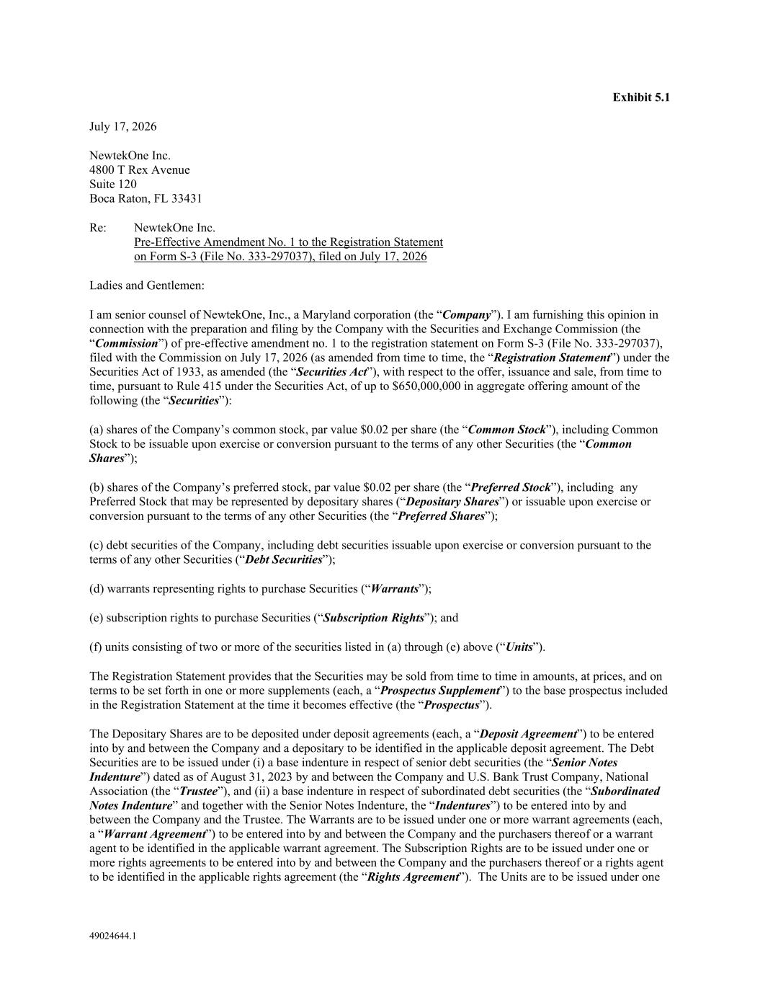
II-6
49024644.1 Exhibit 5.1 July 17, 2026 NewtekOne Inc. 4800 T Rex Avenue Suite 120 Boca Raton, FL 33431 Re: NewtekOne Inc. Pre-Effective Amendment No. 1 to the Registration Statement on Form S-3 (File No. 333-297037), filed on July 17, 2026 Ladies and Gentlemen: I am senior counsel of NewtekOne, Inc., a Maryland corporation (the “Company”). I am furnishing this opinion in connection with the preparation and filing by the Company with the Securities and Exchange Commission (the “Commission”) of pre-effective amendment no. 1 to the registration statement on Form S-3 (File No. 333-297037), filed with the Commission on July 17, 2026 (as amended from time to time, the “Registration Statement”) under the Securities Act of 1933, as amended (the “Securities Act”), with respect to the offer, issuance and sale, from time to time, pursuant to Rule 415 under the Securities Act, of up to $650,000,000 in aggregate offering amount of the following (the “Securities”): (a) shares of the Company’s common stock, par value $0.02 per share (the “Common Stock”), including Common Stock to be issuable upon exercise or conversion pursuant to the terms of any other Securities (the “Common Shares”); (b) shares of the Company’s preferred stock, par value $0.02 per share (the “Preferred Stock”), including any Preferred Stock that may be represented by depositary shares (“Depositary Shares”) or issuable upon exercise or conversion pursuant to the terms of any other Securities (the “Preferred Shares”); (c) debt securities of the Company, including debt securities issuable upon exercise or conversion pursuant to the terms of any other Securities (“Debt Securities”); (d) warrants representing rights to purchase Securities (“Warrants”); (e) subscription rights to purchase Securities (“Subscription Rights”); and (f) units consisting of two or more of the securities listed in (a) through (e) above (“Units”). The Registration Statement provides that the Securities may be sold from time to time in amounts, at prices, and on terms to be set forth in one or more supplements (each, a “Prospectus Supplement”) to the base prospectus included in the Registration Statement at the time it becomes effective (the “Prospectus”). The Depositary Shares are to be deposited under deposit agreements (each, a “Deposit Agreement”) to be entered into by and between the Company and a depositary to be identified in the applicable deposit agreement. The Debt Securities are to be issued under (i) a base indenture in respect of senior debt securities (the “Senior Notes Indenture”) dated as of August 31, 2023 by and between the Company and U.S. Bank Trust Company, National Association (the “Trustee”), and (ii) a base indenture in respect of subordinated debt securities (the “Subordinated Notes Indenture” and together with the Senior Notes Indenture, the “Indentures”) to be entered into by and between the Company and the Trustee. The Warrants are to be issued under one or more warrant agreements (each, a “Warrant Agreement”) to be entered into by and between the Company and the purchasers thereof or a warrant agent to be identified in the applicable warrant agreement. The Subscription Rights are to be issued under one or more rights agreements to be entered into by and between the Company and the purchasers thereof or a rights agent to be identified in the applicable rights agreement (the “Rights Agreement”). The Units are to be issued under one

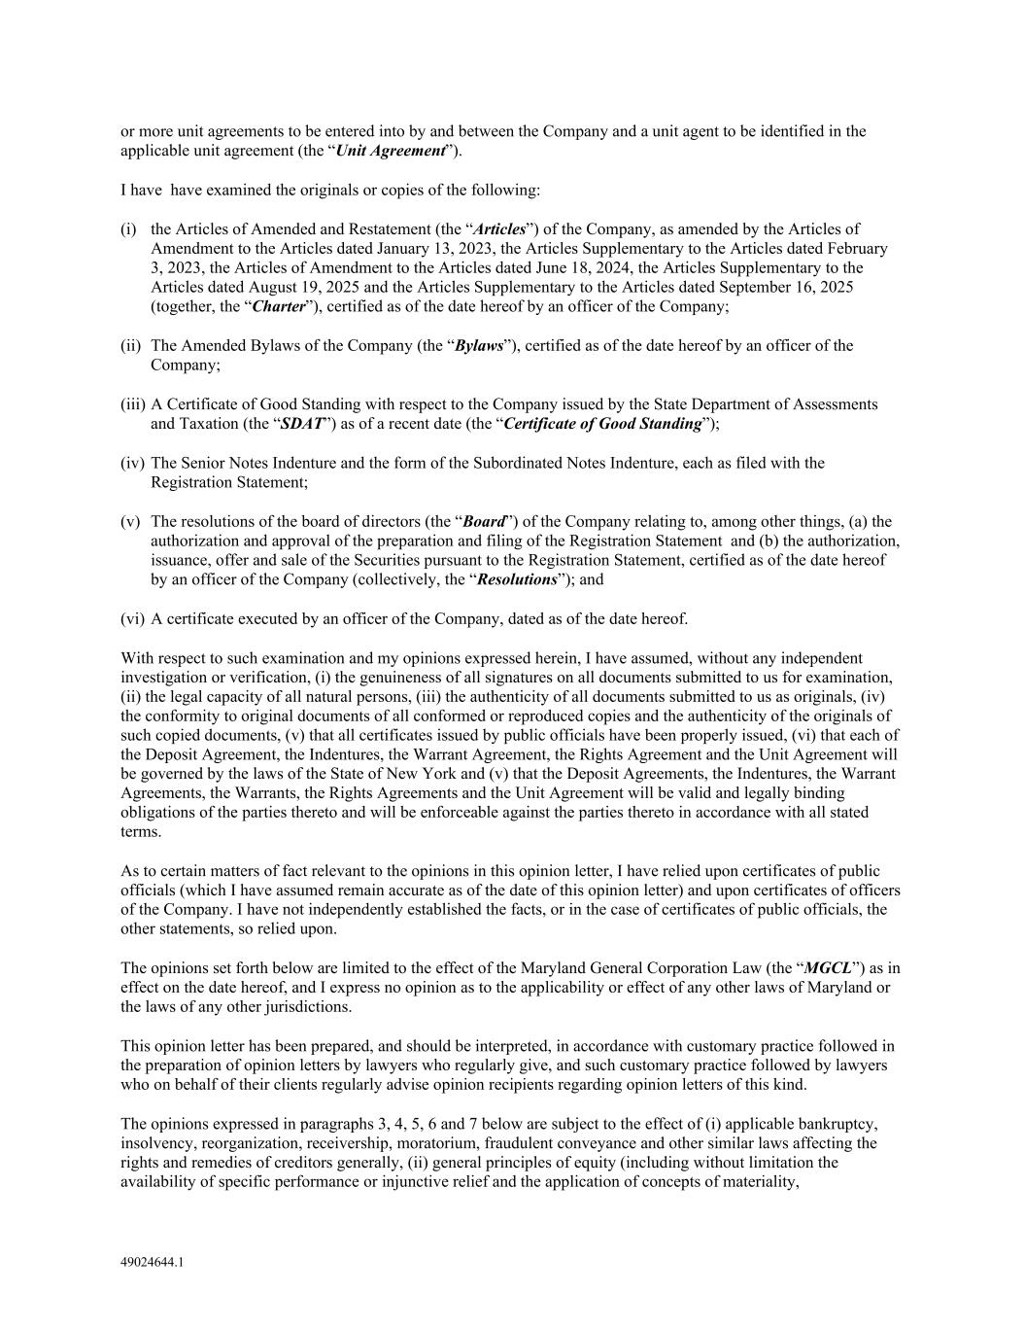
49024644.1 or more unit agreements to be entered into by and between the Company and a unit agent to be identified in the applicable unit agreement (the “Unit Agreement”). I have have examined the originals or copies of the following: (i) the Articles of Amended and Restatement (the “Articles”) of the Company, as amended by the Articles of Amendment to the Articles dated January 13, 2023, the Articles Supplementary to the Articles dated February 3, 2023, the Articles of Amendment to the Articles dated June 18, 2024, the Articles Supplementary to the Articles dated August 19, 2025 and the Articles Supplementary to the Articles dated September 16, 2025 (together, the “Charter”), certified as of the date hereof by an officer of the Company; (ii) The Amended Bylaws of the Company (the “Bylaws”), certified as of the date hereof by an officer of the Company; (iii) A Certificate of Good Standing with respect to the Company issued by the State Department of Assessments and Taxation (the “SDAT”) as of a recent date (the “Certificate of Good Standing”); (iv) The Senior Notes Indenture and the form of the Subordinated Notes Indenture, each as filed with the Registration Statement; (v) The resolutions of the board of directors (the “Board”) of the Company relating to, among other things, (a) the authorization and approval of the preparation and filing of the Registration Statement and (b) the authorization, issuance, offer and sale of the Securities pursuant to the Registration Statement, certified as of the date hereof by an officer of the Company (collectively, the “Resolutions”); and (vi) A certificate executed by an officer of the Company, dated as of the date hereof. With respect to such examination and my opinions expressed herein, I have assumed, without any independent investigation or verification, (i) the genuineness of all signatures on all documents submitted to us for examination, (ii) the legal capacity of all natural persons, (iii) the authenticity of all documents submitted to us as originals, (iv) the conformity to original documents of all conformed or reproduced copies and the authenticity of the originals of such copied documents, (v) that all certificates issued by public officials have been properly issued, (vi) that each of the Deposit Agreement, the Indentures, the Warrant Agreement, the Rights Agreement and the Unit Agreement will be governed by the laws of the State of New York and (v) that the Deposit Agreements, the Indentures, the Warrant Agreements, the Warrants, the Rights Agreements and the Unit Agreement will be valid and legally binding obligations of the parties thereto and will be enforceable against the parties thereto in accordance with all stated terms. As to certain matters of fact relevant to the opinions in this opinion letter, I have relied upon certificates of public officials (which I have assumed remain accurate as of the date of this opinion letter) and upon certificates of officers of the Company. I have not independently established the facts, or in the case of certificates of public officials, the other statements, so relied upon. The opinions set forth below are limited to the effect of the Maryland General Corporation Law (the “MGCL”) as in effect on the date hereof, and I express no opinion as to the applicability or effect of any other laws of Maryland or the laws of any other jurisdictions. This opinion letter has been prepared, and should be interpreted, in accordance with customary practice followed in the preparation of opinion letters by lawyers who regularly give, and such customary practice followed by lawyers who on behalf of their clients regularly advise opinion recipients regarding opinion letters of this kind. The opinions expressed in paragraphs 3, 4, 5, 6 and 7 below are subject to the effect of (i) applicable bankruptcy, insolvency, reorganization, receivership, moratorium, fraudulent conveyance and other similar laws affecting the rights and remedies of creditors generally, (ii) general principles of equity (including without limitation the availability of specific performance or injunctive relief and the application of concepts of materiality,

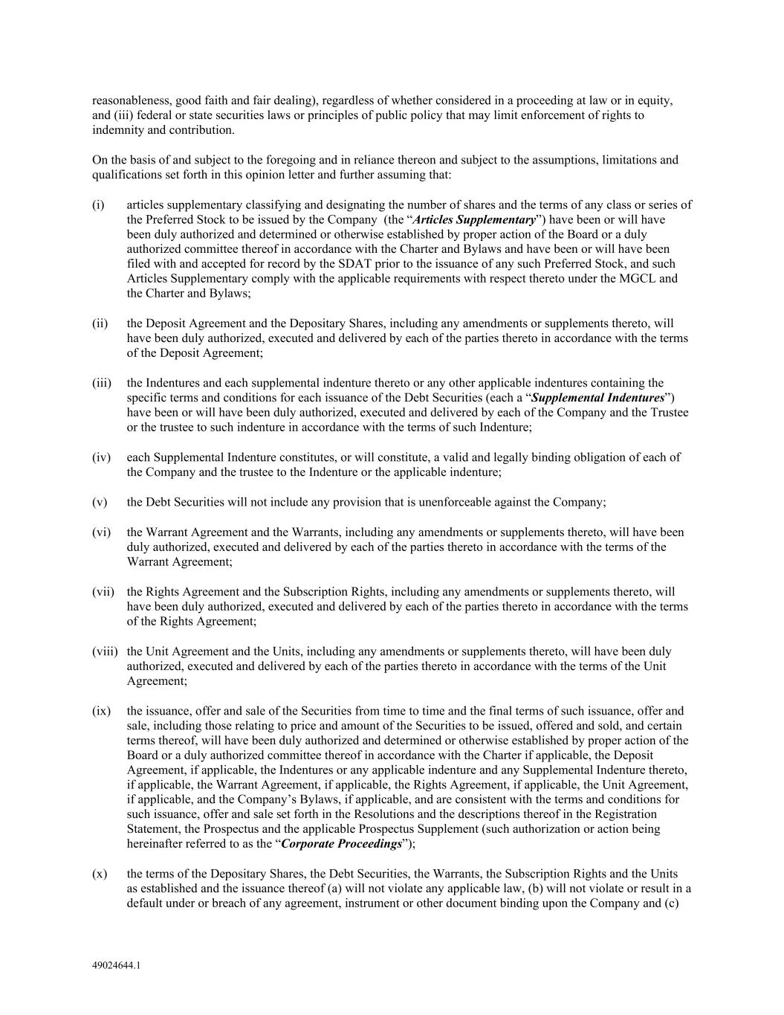
49024644.1 reasonableness, good faith and fair dealing), regardless of whether considered in a proceeding at law or in equity, and (iii) federal or state securities laws or principles of public policy that may limit enforcement of rights to indemnity and contribution. On the basis of and subject to the foregoing and in reliance thereon and subject to the assumptions, limitations and qualifications set forth in this opinion letter and further assuming that: (i) articles supplementary classifying and designating the number of shares and the terms of any class or series of the Preferred Stock to be issued by the Company (the “Articles Supplementary”) have been or will have been duly authorized and determined or otherwise established by proper action of the Board or a duly authorized committee thereof in accordance with the Charter and Bylaws and have been or will have been filed with and accepted for record by the SDAT prior to the issuance of any such Preferred Stock, and such Articles Supplementary comply with the applicable requirements with respect thereto under the MGCL and the Charter and Bylaws; (ii) the Deposit Agreement and the Depositary Shares, including any amendments or supplements thereto, will have been duly authorized, executed and delivered by each of the parties thereto in accordance with the terms of the Deposit Agreement; (iii) the Indentures and each supplemental indenture thereto or any other applicable indentures containing the specific terms and conditions for each issuance of the Debt Securities (each a “Supplemental Indentures”) have been or will have been duly authorized, executed and delivered by each of the Company and the Trustee or the trustee to such indenture in accordance with the terms of such Indenture; (iv) each Supplemental Indenture constitutes, or will constitute, a valid and legally binding obligation of each of the Company and the trustee to the Indenture or the applicable indenture; (v) the Debt Securities will not include any provision that is unenforceable against the Company; (vi) the Warrant Agreement and the Warrants, including any amendments or supplements thereto, will have been duly authorized, executed and delivered by each of the parties thereto in accordance with the terms of the Warrant Agreement; (vii) the Rights Agreement and the Subscription Rights, including any amendments or supplements thereto, will have been duly authorized, executed and delivered by each of the parties thereto in accordance with the terms of the Rights Agreement; (viii) the Unit Agreement and the Units, including any amendments or supplements thereto, will have been duly authorized, executed and delivered by each of the parties thereto in accordance with the terms of the Unit Agreement; (ix) the issuance, offer and sale of the Securities from time to time and the final terms of such issuance, offer and sale, including those relating to price and amount of the Securities to be issued, offered and sold, and certain terms thereof, will have been duly authorized and determined or otherwise established by proper action of the Board or a duly authorized committee thereof in accordance with the Charter if applicable, the Deposit Agreement, if applicable, the Indentures or any applicable indenture and any Supplemental Indenture thereto, if applicable, the Warrant Agreement, if applicable, the Rights Agreement, if applicable, the Unit Agreement, if applicable, and the Company’s Bylaws, if applicable, and are consistent with the terms and conditions for such issuance, offer and sale set forth in the Resolutions and the descriptions thereof in the Registration Statement, the Prospectus and the applicable Prospectus Supplement (such authorization or action being hereinafter referred to as the “Corporate Proceedings”); (x) the terms of the Depositary Shares, the Debt Securities, the Warrants, the Subscription Rights and the Units as established and the issuance thereof (a) will not violate any applicable law, (b) will not violate or result in a default under or breach of any agreement, instrument or other document binding upon the Company and (c)

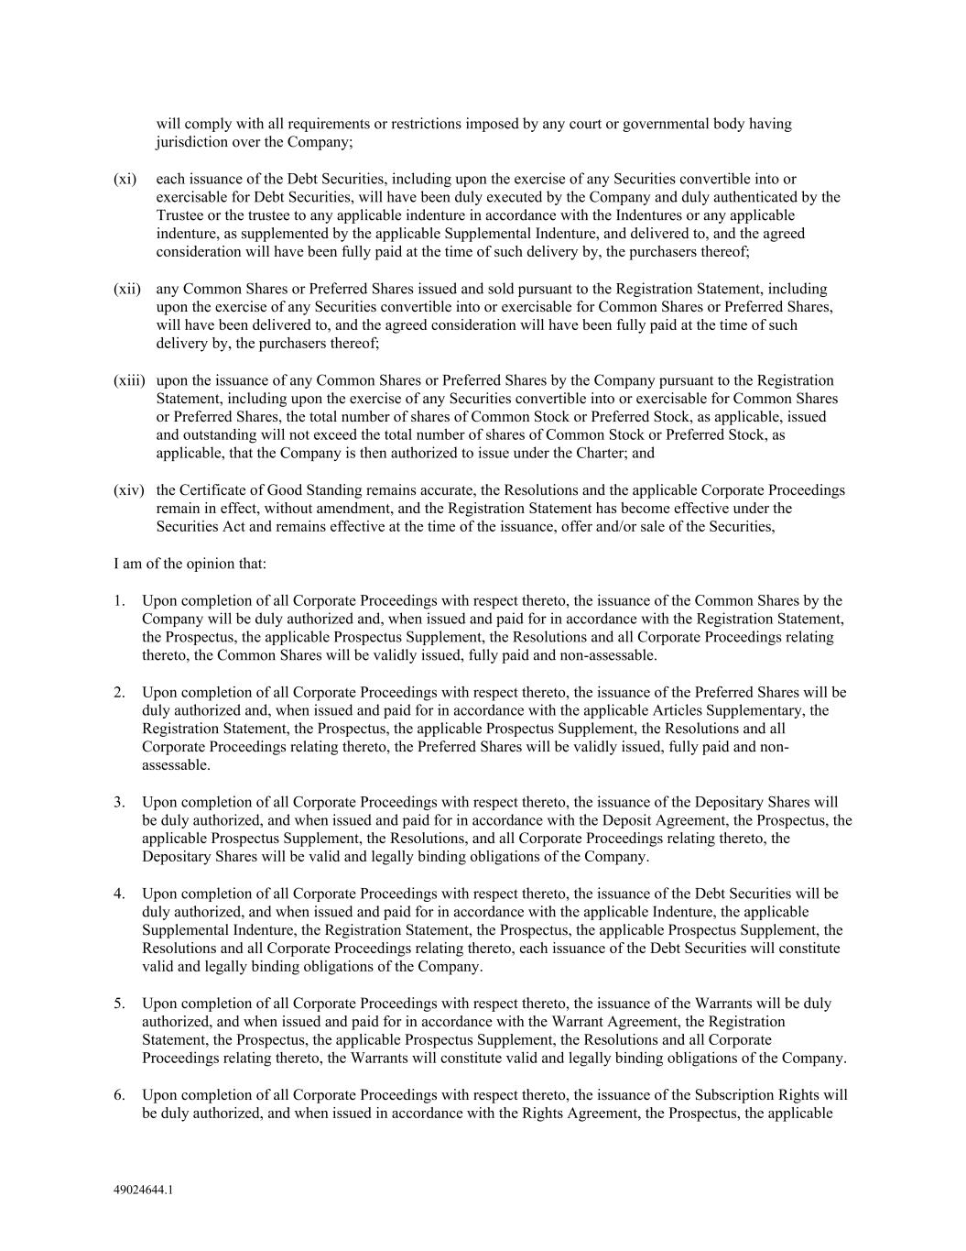
49024644.1 will comply with all requirements or restrictions imposed by any court or governmental body having jurisdiction over the Company; (xi) each issuance of the Debt Securities, including upon the exercise of any Securities convertible into or exercisable for Debt Securities, will have been duly executed by the Company and duly authenticated by the Trustee or the trustee to any applicable indenture in accordance with the Indentures or any applicable indenture, as supplemented by the applicable Supplemental Indenture, and delivered to, and the agreed consideration will have been fully paid at the time of such delivery by, the purchasers thereof; (xii) any Common Shares or Preferred Shares issued and sold pursuant to the Registration Statement, including upon the exercise of any Securities convertible into or exercisable for Common Shares or Preferred Shares, will have been delivered to, and the agreed consideration will have been fully paid at the time of such delivery by, the purchasers thereof; (xiii) upon the issuance of any Common Shares or Preferred Shares by the Company pursuant to the Registration Statement, including upon the exercise of any Securities convertible into or exercisable for Common Shares or Preferred Shares, the total number of shares of Common Stock or Preferred Stock, as applicable, issued and outstanding will not exceed the total number of shares of Common Stock or Preferred Stock, as applicable, that the Company is then authorized to issue under the Charter; and (xiv) the Certificate of Good Standing remains accurate, the Resolutions and the applicable Corporate Proceedings remain in effect, without amendment, and the Registration Statement has become effective under the Securities Act and remains effective at the time of the issuance, offer and/or sale of the Securities, I am of the opinion that: 1. Upon completion of all Corporate Proceedings with respect thereto, the issuance of the Common Shares by the Company will be duly authorized and, when issued and paid for in accordance with the Registration Statement, the Prospectus, the applicable Prospectus Supplement, the Resolutions and all Corporate Proceedings relating thereto, the Common Shares will be validly issued, fully paid and non-assessable. 2. Upon completion of all Corporate Proceedings with respect thereto, the issuance of the Preferred Shares will be duly authorized and, when issued and paid for in accordance with the applicable Articles Supplementary, the Registration Statement, the Prospectus, the applicable Prospectus Supplement, the Resolutions and all Corporate Proceedings relating thereto, the Preferred Shares will be validly issued, fully paid and non- assessable. 3. Upon completion of all Corporate Proceedings with respect thereto, the issuance of the Depositary Shares will be duly authorized, and when issued and paid for in accordance with the Deposit Agreement, the Prospectus, the applicable Prospectus Supplement, the Resolutions, and all Corporate Proceedings relating thereto, the Depositary Shares will be valid and legally binding obligations of the Company. 4. Upon completion of all Corporate Proceedings with respect thereto, the issuance of the Debt Securities will be duly authorized, and when issued and paid for in accordance with the applicable Indenture, the applicable Supplemental Indenture, the Registration Statement, the Prospectus, the applicable Prospectus Supplement, the Resolutions and all Corporate Proceedings relating thereto, each issuance of the Debt Securities will constitute valid and legally binding obligations of the Company. 5. Upon completion of all Corporate Proceedings with respect thereto, the issuance of the Warrants will be duly authorized, and when issued and paid for in accordance with the Warrant Agreement, the Registration Statement, the Prospectus, the applicable Prospectus Supplement, the Resolutions and all Corporate Proceedings relating thereto, the Warrants will constitute valid and legally binding obligations of the Company. 6. Upon completion of all Corporate Proceedings with respect thereto, the issuance of the Subscription Rights will be duly authorized, and when issued in accordance with the Rights Agreement, the Prospectus, the applicable

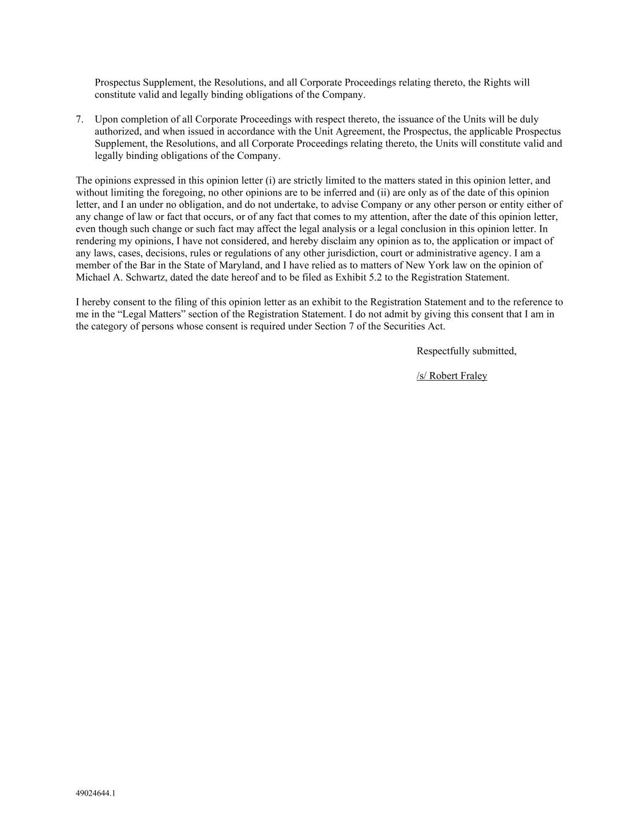
49024644.1 Prospectus Supplement, the Resolutions, and all Corporate Proceedings relating thereto, the Rights will constitute valid and legally binding obligations of the Company. 7. Upon completion of all Corporate Proceedings with respect thereto, the issuance of the Units will be duly authorized, and when issued in accordance with the Unit Agreement, the Prospectus, the applicable Prospectus Supplement, the Resolutions, and all Corporate Proceedings relating thereto, the Units will constitute valid and legally binding obligations of the Company. The opinions expressed in this opinion letter (i) are strictly limited to the matters stated in this opinion letter, and without limiting the foregoing, no other opinions are to be inferred and (ii) are only as of the date of this opinion letter, and I an under no obligation, and do not undertake, to advise Company or any other person or entity either of any change of law or fact that occurs, or of any fact that comes to my attention, after the date of this opinion letter, even though such change or such fact may affect the legal analysis or a legal conclusion in this opinion letter. In rendering my opinions, I have not considered, and hereby disclaim any opinion as to, the application or impact of any laws, cases, decisions, rules or regulations of any other jurisdiction, court or administrative agency. I am a member of the Bar in the State of Maryland, and I have relied as to matters of New York law on the opinion of Michael A. Schwartz, dated the date hereof and to be filed as Exhibit 5.2 to the Registration Statement. I hereby consent to the filing of this opinion letter as an exhibit to the Registration Statement and to the reference to me in the “Legal Matters” section of the Registration Statement. I do not admit by giving this consent that I am in the category of persons whose consent is required under Section 7 of the Securities Act. Respectfully submitted, /s/ Robert Fraley

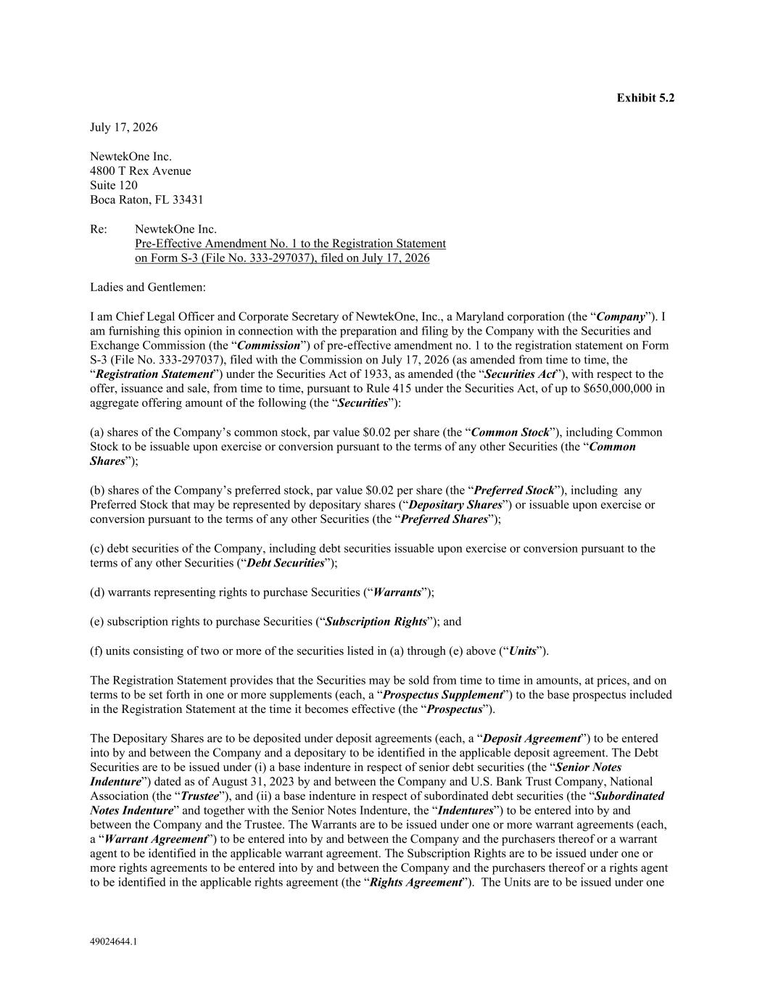
49024644.1 Exhibit 5.2 July 17, 2026 NewtekOne Inc. 4800 T Rex Avenue Suite 120 Boca Raton, FL 33431 Re: NewtekOne Inc. Pre-Effective Amendment No. 1 to the Registration Statement on Form S-3 (File No. 333-297037), filed on July 17, 2026 Ladies and Gentlemen: I am Chief Legal Officer and Corporate Secretary of NewtekOne, Inc., a Maryland corporation (the “Company”). I am furnishing this opinion in connection with the preparation and filing by the Company with the Securities and Exchange Commission (the “Commission”) of pre-effective amendment no. 1 to the registration statement on Form S-3 (File No. 333-297037), filed with the Commission on July 17, 2026 (as amended from time to time, the “Registration Statement”) under the Securities Act of 1933, as amended (the “Securities Act”), with respect to the offer, issuance and sale, from time to time, pursuant to Rule 415 under the Securities Act, of up to $650,000,000 in aggregate offering amount of the following (the “Securities”): (a) shares of the Company’s common stock, par value $0.02 per share (the “Common Stock”), including Common Stock to be issuable upon exercise or conversion pursuant to the terms of any other Securities (the “Common Shares”); (b) shares of the Company’s preferred stock, par value $0.02 per share (the “Preferred Stock”), including any Preferred Stock that may be represented by depositary shares (“Depositary Shares”) or issuable upon exercise or conversion pursuant to the terms of any other Securities (the “Preferred Shares”); (c) debt securities of the Company, including debt securities issuable upon exercise or conversion pursuant to the terms of any other Securities (“Debt Securities”); (d) warrants representing rights to purchase Securities (“Warrants”); (e) subscription rights to purchase Securities (“Subscription Rights”); and (f) units consisting of two or more of the securities listed in (a) through (e) above (“Units”). The Registration Statement provides that the Securities may be sold from time to time in amounts, at prices, and on terms to be set forth in one or more supplements (each, a “Prospectus Supplement”) to the base prospectus included in the Registration Statement at the time it becomes effective (the “Prospectus”). The Depositary Shares are to be deposited under deposit agreements (each, a “Deposit Agreement”) to be entered into by and between the Company and a depositary to be identified in the applicable deposit agreement. The Debt Securities are to be issued under (i) a base indenture in respect of senior debt securities (the “Senior Notes Indenture”) dated as of August 31, 2023 by and between the Company and U.S. Bank Trust Company, National Association (the “Trustee”), and (ii) a base indenture in respect of subordinated debt securities (the “Subordinated Notes Indenture” and together with the Senior Notes Indenture, the “Indentures”) to be entered into by and between the Company and the Trustee. The Warrants are to be issued under one or more warrant agreements (each, a “Warrant Agreement”) to be entered into by and between the Company and the purchasers thereof or a warrant agent to be identified in the applicable warrant agreement. The Subscription Rights are to be issued under one or more rights agreements to be entered into by and between the Company and the purchasers thereof or a rights agent to be identified in the applicable rights agreement (the “Rights Agreement”). The Units are to be issued under one

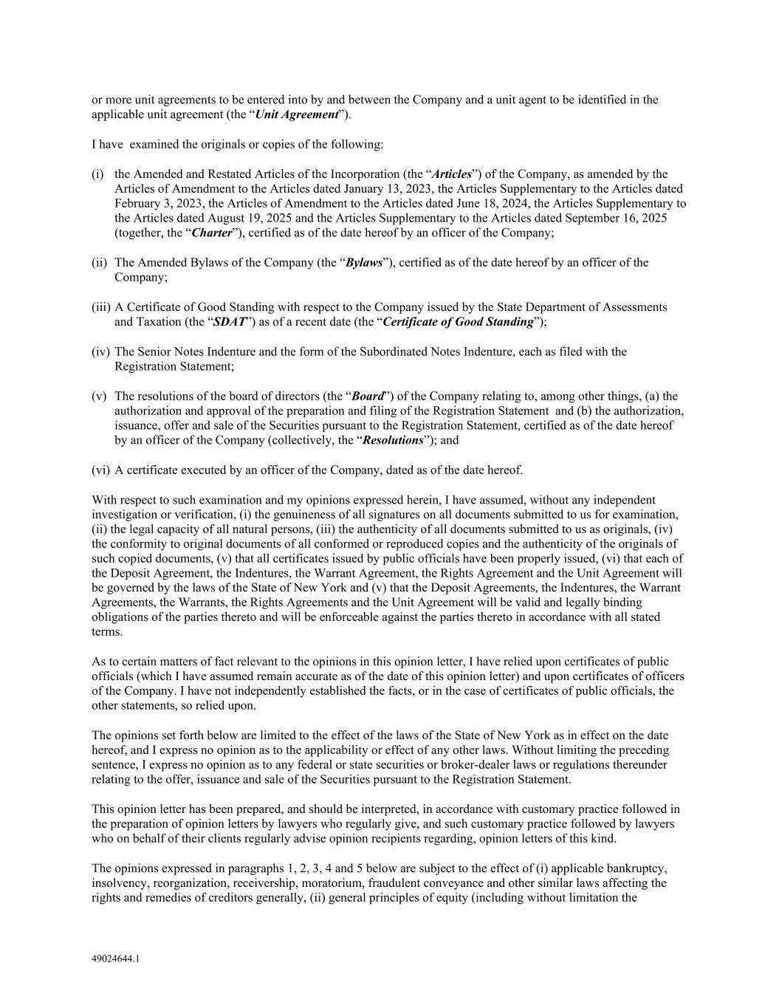
49024644.1 or more unit agreements to be entered into by and between the Company and a unit agent to be identified in the applicable unit agreement (the “Unit Agreement”). I have examined the originals or copies of the following: (i) the Amended and Restated Articles of the Incorporation (the “Articles”) of the Company, as amended by the Articles of Amendment to the Articles dated January 13, 2023, the Articles Supplementary to the Articles dated February 3, 2023, the Articles of Amendment to the Articles dated June 18, 2024, the Articles Supplementary to the Articles dated August 19, 2025 and the Articles Supplementary to the Articles dated September 16, 2025 (together, the “Charter”), certified as of the date hereof by an officer of the Company; (ii) The Amended Bylaws of the Company (the “Bylaws”), certified as of the date hereof by an officer of the Company; (iii) A Certificate of Good Standing with respect to the Company issued by the State Department of Assessments and Taxation (the “SDAT”) as of a recent date (the “Certificate of Good Standing”); (iv) The Senior Notes Indenture and the form of the Subordinated Notes Indenture, each as filed with the Registration Statement; (v) The resolutions of the board of directors (the “Board”) of the Company relating to, among other things, (a) the authorization and approval of the preparation and filing of the Registration Statement and (b) the authorization, issuance, offer and sale of the Securities pursuant to the Registration Statement, certified as of the date hereof by an officer of the Company (collectively, the “Resolutions”); and (vi) A certificate executed by an officer of the Company, dated as of the date hereof. With respect to such examination and my opinions expressed herein, I have assumed, without any independent investigation or verification, (i) the genuineness of all signatures on all documents submitted to us for examination, (ii) the legal capacity of all natural persons, (iii) the authenticity of all documents submitted to us as originals, (iv) the conformity to original documents of all conformed or reproduced copies and the authenticity of the originals of such copied documents, (v) that all certificates issued by public officials have been properly issued, (vi) that each of the Deposit Agreement, the Indentures, the Warrant Agreement, the Rights Agreement and the Unit Agreement will be governed by the laws of the State of New York and (v) that the Deposit Agreements, the Indentures, the Warrant Agreements, the Warrants, the Rights Agreements and the Unit Agreement will be valid and legally binding obligations of the parties thereto and will be enforceable against the parties thereto in accordance with all stated terms. As to certain matters of fact relevant to the opinions in this opinion letter, I have relied upon certificates of public officials (which I have assumed remain accurate as of the date of this opinion letter) and upon certificates of officers of the Company. I have not independently established the facts, or in the case of certificates of public officials, the other statements, so relied upon. The opinions set forth below are limited to the effect of the laws of the State of New York as in effect on the date hereof, and I express no opinion as to the applicability or effect of any other laws. Without limiting the preceding sentence, I express no opinion as to any federal or state securities or broker-dealer laws or regulations thereunder relating to the offer, issuance and sale of the Securities pursuant to the Registration Statement. This opinion letter has been prepared, and should be interpreted, in accordance with customary practice followed in the preparation of opinion letters by lawyers who regularly give, and such customary practice followed by lawyers who on behalf of their clients regularly advise opinion recipients regarding, opinion letters of this kind. The opinions expressed in paragraphs 1, 2, 3, 4 and 5 below are subject to the effect of (i) applicable bankruptcy, insolvency, reorganization, receivership, moratorium, fraudulent conveyance and other similar laws affecting the rights and remedies of creditors generally, (ii) general principles of equity (including without limitation the

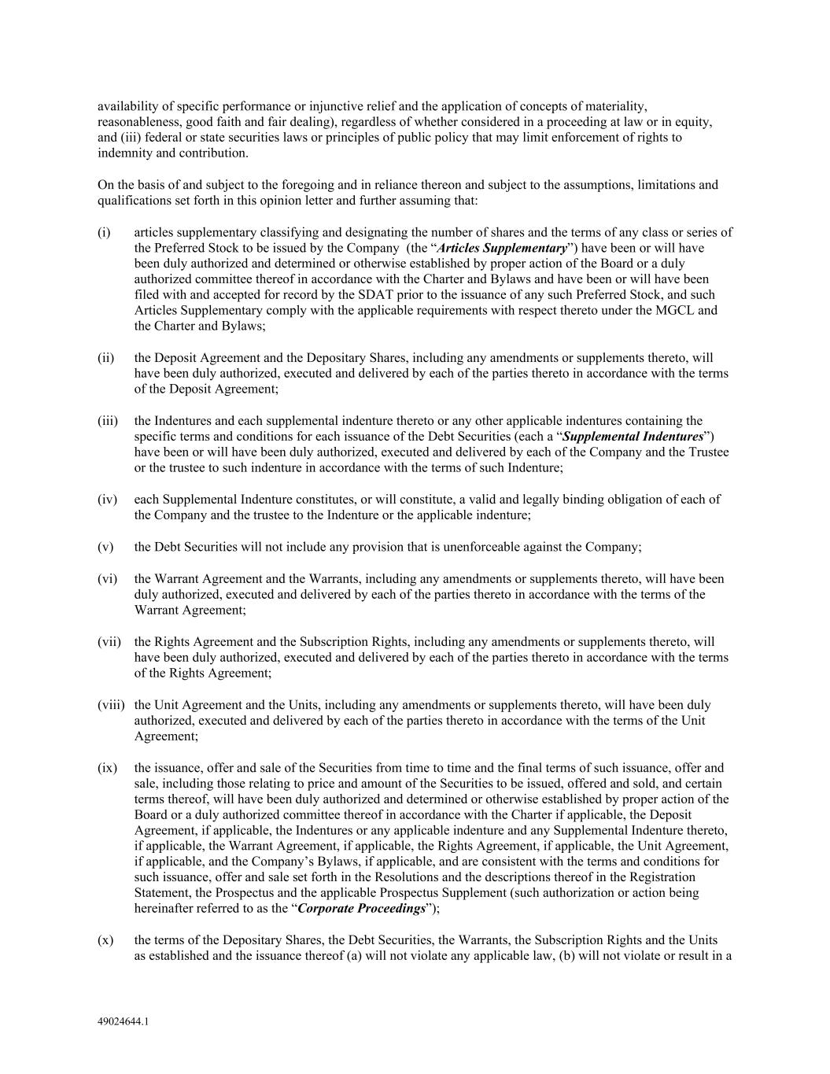
49024644.1 availability of specific performance or injunctive relief and the application of concepts of materiality, reasonableness, good faith and fair dealing), regardless of whether considered in a proceeding at law or in equity, and (iii) federal or state securities laws or principles of public policy that may limit enforcement of rights to indemnity and contribution. On the basis of and subject to the foregoing and in reliance thereon and subject to the assumptions, limitations and qualifications set forth in this opinion letter and further assuming that: (i) articles supplementary classifying and designating the number of shares and the terms of any class or series of the Preferred Stock to be issued by the Company (the “Articles Supplementary”) have been or will have been duly authorized and determined or otherwise established by proper action of the Board or a duly authorized committee thereof in accordance with the Charter and Bylaws and have been or will have been filed with and accepted for record by the SDAT prior to the issuance of any such Preferred Stock, and such Articles Supplementary comply with the applicable requirements with respect thereto under the MGCL and the Charter and Bylaws; (ii) the Deposit Agreement and the Depositary Shares, including any amendments or supplements thereto, will have been duly authorized, executed and delivered by each of the parties thereto in accordance with the terms of the Deposit Agreement; (iii) the Indentures and each supplemental indenture thereto or any other applicable indentures containing the specific terms and conditions for each issuance of the Debt Securities (each a “Supplemental Indentures”) have been or will have been duly authorized, executed and delivered by each of the Company and the Trustee or the trustee to such indenture in accordance with the terms of such Indenture; (iv) each Supplemental Indenture constitutes, or will constitute, a valid and legally binding obligation of each of the Company and the trustee to the Indenture or the applicable indenture; (v) the Debt Securities will not include any provision that is unenforceable against the Company; (vi) the Warrant Agreement and the Warrants, including any amendments or supplements thereto, will have been duly authorized, executed and delivered by each of the parties thereto in accordance with the terms of the Warrant Agreement; (vii) the Rights Agreement and the Subscription Rights, including any amendments or supplements thereto, will have been duly authorized, executed and delivered by each of the parties thereto in accordance with the terms of the Rights Agreement; (viii) the Unit Agreement and the Units, including any amendments or supplements thereto, will have been duly authorized, executed and delivered by each of the parties thereto in accordance with the terms of the Unit Agreement; (ix) the issuance, offer and sale of the Securities from time to time and the final terms of such issuance, offer and sale, including those relating to price and amount of the Securities to be issued, offered and sold, and certain terms thereof, will have been duly authorized and determined or otherwise established by proper action of the Board or a duly authorized committee thereof in accordance with the Charter if applicable, the Deposit Agreement, if applicable, the Indentures or any applicable indenture and any Supplemental Indenture thereto, if applicable, the Warrant Agreement, if applicable, the Rights Agreement, if applicable, the Unit Agreement, if applicable, and the Company’s Bylaws, if applicable, and are consistent with the terms and conditions for such issuance, offer and sale set forth in the Resolutions and the descriptions thereof in the Registration Statement, the Prospectus and the applicable Prospectus Supplement (such authorization or action being hereinafter referred to as the “Corporate Proceedings”); (x) the terms of the Depositary Shares, the Debt Securities, the Warrants, the Subscription Rights and the Units as established and the issuance thereof (a) will not violate any applicable law, (b) will not violate or result in a

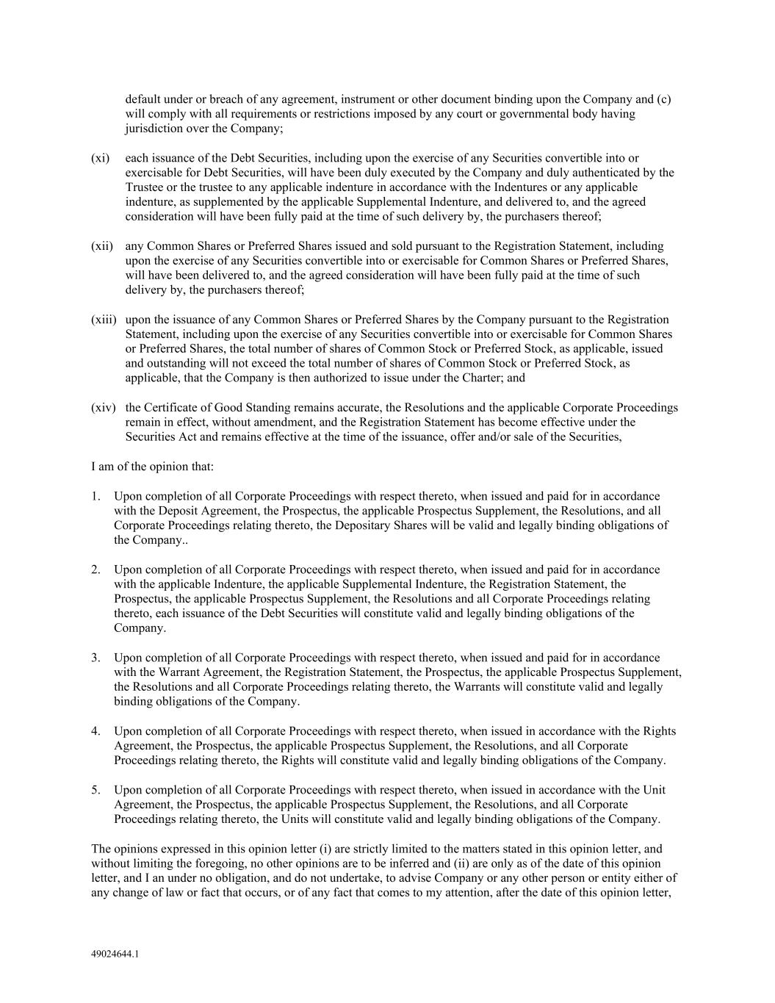
49024644.1 default under or breach of any agreement, instrument or other document binding upon the Company and (c) will comply with all requirements or restrictions imposed by any court or governmental body having jurisdiction over the Company; (xi) each issuance of the Debt Securities, including upon the exercise of any Securities convertible into or exercisable for Debt Securities, will have been duly executed by the Company and duly authenticated by the Trustee or the trustee to any applicable indenture in accordance with the Indentures or any applicable indenture, as supplemented by the applicable Supplemental Indenture, and delivered to, and the agreed consideration will have been fully paid at the time of such delivery by, the purchasers thereof; (xii) any Common Shares or Preferred Shares issued and sold pursuant to the Registration Statement, including upon the exercise of any Securities convertible into or exercisable for Common Shares or Preferred Shares, will have been delivered to, and the agreed consideration will have been fully paid at the time of such delivery by, the purchasers thereof; (xiii) upon the issuance of any Common Shares or Preferred Shares by the Company pursuant to the Registration Statement, including upon the exercise of any Securities convertible into or exercisable for Common Shares or Preferred Shares, the total number of shares of Common Stock or Preferred Stock, as applicable, issued and outstanding will not exceed the total number of shares of Common Stock or Preferred Stock, as applicable, that the Company is then authorized to issue under the Charter; and (xiv) the Certificate of Good Standing remains accurate, the Resolutions and the applicable Corporate Proceedings remain in effect, without amendment, and the Registration Statement has become effective under the Securities Act and remains effective at the time of the issuance, offer and/or sale of the Securities, I am of the opinion that: 1. Upon completion of all Corporate Proceedings with respect thereto, when issued and paid for in accordance with the Deposit Agreement, the Prospectus, the applicable Prospectus Supplement, the Resolutions, and all Corporate Proceedings relating thereto, the Depositary Shares will be valid and legally binding obligations of the Company.. 2. Upon completion of all Corporate Proceedings with respect thereto, when issued and paid for in accordance with the applicable Indenture, the applicable Supplemental Indenture, the Registration Statement, the Prospectus, the applicable Prospectus Supplement, the Resolutions and all Corporate Proceedings relating thereto, each issuance of the Debt Securities will constitute valid and legally binding obligations of the Company. 3. Upon completion of all Corporate Proceedings with respect thereto, when issued and paid for in accordance with the Warrant Agreement, the Registration Statement, the Prospectus, the applicable Prospectus Supplement, the Resolutions and all Corporate Proceedings relating thereto, the Warrants will constitute valid and legally binding obligations of the Company. 4. Upon completion of all Corporate Proceedings with respect thereto, when issued in accordance with the Rights Agreement, the Prospectus, the applicable Prospectus Supplement, the Resolutions, and all Corporate Proceedings relating thereto, the Rights will constitute valid and legally binding obligations of the Company. 5. Upon completion of all Corporate Proceedings with respect thereto, when issued in accordance with the Unit Agreement, the Prospectus, the applicable Prospectus Supplement, the Resolutions, and all Corporate Proceedings relating thereto, the Units will constitute valid and legally binding obligations of the Company. The opinions expressed in this opinion letter (i) are strictly limited to the matters stated in this opinion letter, and without limiting the foregoing, no other opinions are to be inferred and (ii) are only as of the date of this opinion letter, and I an under no obligation, and do not undertake, to advise Company or any other person or entity either of any change of law or fact that occurs, or of any fact that comes to my attention, after the date of this opinion letter,


49024644.1 even though such change or such fact may affect the legal analysis or a legal conclusion in this opinion letter. In rendering my opinions, I have not considered, and hereby disclaim any opinion as to, the application or impact of any laws, cases, decisions, rules or regulations of any other jurisdiction, court or administrative agency. I am a member of the Bar in the State of New York. Robert Fraley is entitled to rely on the foregoing opinions in connection with his opinions, dated the date hereof and to be filed as Exhibit 5.1 to the Registration Statement. I hereby consent to the filing of this opinion letter as an exhibit to the Registration Statement and to the reference to me in the “Legal Matters” section of the Registration Statement. I do not admit by giving this consent that I am in the category of persons whose consent is required under Section 7 of the Securities Act. Respectfully submitted, /s/ Michael A Schwartz

